- Scientific Background
1.1 Polymers and Dynamic Covalent Bonds
Polymeric materials have significantly shaped modern society, playing a crucial role in industries ranging from automotive manufacturing and consumer electronics to clothing and medical devices. Given their widespread use and substantial benefits, continuous research efforts focus on advancing macromolecular science to enhance polymer performance and sustainability. Despite growing public awareness, only about 9% of plastic is recycled globally, leaving a toxic trail in the environment that negatively impacts human health.¹ Today, most recycling efforts are based on mechanical grinding resulting in a decrease in performance and value of the materials.² This pressing issue necessitates innovative solutions to stimulate polymer reuse and efficient recycling and upcycling of waste materials.
The macroscopic thermomechanical properties of polymers are governed by key molecular characteristics, including the chemical composition of the repeating units, molecular weight distribution, chain branching, and crosslinking density. Achieving a comprehensive understanding of how structural features dictate bulk properties, at the molecular and microscopic levels, is crucial for the rational design of next-generation, high performance, recyclable polymers.
Plastics are generally classified into two categories: thermoplastics and thermosets. Thermoplastics are valued for their relatively ease of reprocessing and recyclability, whereas thermosets offer superior thermal and mechanical stability through their crosslinked networks. However, recycling of thermoplastics is limited due to material degradation. The ability to develop polymers that integrate the recyclability of thermoplastics with the robustness of thermosets would represent a significant advancement and impact toward sustainable materials.
The incorporation of dynamic covalent bonds (DCBs) into polymer chains has emerged as a promising strategy for designing degradable thermosets.^{3–5} These covalent yet often easily cleavable linkages can be selectively broken under external stimuli such as heat, light, or changes in pH, thereby providing a controlled pathway for polymer deconstruction. To be effective, such linkers must maintain stability under standard conditions with responsiveness, versatility, and in some cases reversibility. When incorporated during polymerization, the strong covalent interactions between the linker and the monomers preserve the bulk thermomechanical properties of the material. However, upon activation, DCBs undergo cleavage, enabling backbone rearrangement, bond exchange, or breakdown of the crosslinked network, ultimately generating recyclable polymer fragments. Moreover, by tailoring the chemistry of the linker, it is possible not only to enable degradability but also to enhance performance: design of linkers to promote additional crosslinking can reinforce the material, effectively producing a linker-mediated crosslinked polymer with improved mechanical properties and upcycling potential.
DCBs have been explored through a range of reversible chemistries, including imines,⁶ disulfides,⁷ boronic esters,⁸ Diels–Alder adducts,⁹ esters,¹⁰ silyl ethers,¹¹ and acetals,^{12–16} all of which hold promise as linkers in degradable polymers. Generally crosslinking is performed with little guidance as to how structure and density affect the materials property and even less is understood regarding how polymer porosity, crosslink structure and density affect the chemical breakdown of the material. This knowledge gap is largely due to the limitations of conventional thermoset characterization techniques, which rarely provide atomic-level insight into molecular rearrangements within crosslinked networks. The inherent insolubility of thermosets in common solvents further complicates their analysis, making it difficult to track chemical changes directly in the solid state. Moreover, in-situ monitoring of deconstruction poses additional challenges: the process often involves simultaneous phenomena, including polymer swelling in a solvent, diffusion of the triggering agent to the dynamic bonds, and subsequent bond cleavage, rearrangement, or exchange. Capturing these interconnected events requires a specialized characterization strategy that can probe both molecular-level transformations and macroscopic consequences to enable design of degradable, high-performance polymers. We propose that Nuclear Magnetic Resonance (NMR) spectroscopy is uniquely suitable to address this challenge.
1.2 Characterization of polymer materials and dynamic processes with NMR methodologies
NMR, specifically in the solid-state (ssNMR), is a well-established technique for probing polymer materials.^{17–20} This technique is highly powerful due to its exceptional chemical sensitivity, quantitative accuracy, and versatility across different states of matter as it can be applied equally well to liquids, amorphous solids, crystalline materials, and their mixtures. In addition, the variety of magnetic resonance interactions between spins, and between spins and their chemical surroundings, offers a broad span of experimental methods for probing both the structure and the dynamic behavior of materials across multiple length and time scales.
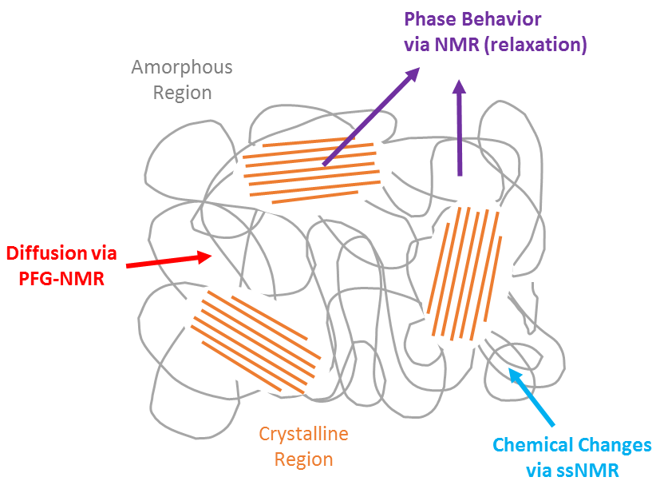
Structural determination of the polymer backbone, side groups, and DCB linkers can be determined with NMR spectroscopic methods.^{17,21–24} For example, ¹H-¹³C CP measurements were employed to uncover the structure of various epoxy thermosets,^{25,26} shedding light on the local bonding of the hardening resin. Relaxation measurements, specifically spin-lattice relaxation (T₁), spin-spin relaxation (T₂), and spin-lattice relaxation in the rotating frame (T_{1ρ}), are well established techniques in polymer science,^{27–32} enabling analysis of chain dynamics³³ and segmental mobility further corresponding to the crystalline-amorphous phases and crosslinking density. ^{34–39} Diffusion NMR techniques (e.g., pulsed-field gradient NMR) add a complementary dimension by characterizing solvent uptake, small-molecule transport, MW determination.^{40,41} For instance, diffusion-ordered spectroscopy (DOSY) monitored the micelle formation of block polymers and extraction of the critical micelle concentration as a function of the diffusion coefficient.^{42–46}
Figure 1. Proposed magnetic resonance techniques to study polymer reactivity.
The combination of these NMR methods provides a unique toolbox for the analysis of polymer-linker microstructure and further monitoring of deconstruction, enabling correlation of chemical transformations with network dynamics and molecular transport. This insight is not accessible with conventional characterization techniques and has not been applied to date.
In this proposed study, we will utilize the capabilities of NMR spectroscopy to elucidate the role of DCB linkers in polymer stability and deconstruction (Figure 1). Our approach will focus on comprehensive characterization of linker-polymer materials to establish structure-property relationships, monitoring of chemical and structural changes, at the molecular level, during deconstruction, and evaluation of key chemical and mechanical parameters that govern deconstruction efficiency. Together, these insights will provide the first set of guiding principles for rational design of optimized polymer-linker architectures, enabling more efficient and controllable pathways for plastic deconstruction.
- Research objectives and expected significance
Global landfills are rapidly approaching capacity, driven in large part by the limited recyclability of conventional plastics. The main goal of this research is to establish a mechanochemical understanding of polymer deconstruction and to identify the mechanical forces and structural features required to make this process more efficient. To achieve this, we will focus on incorporating DCB linkers into polymer systems to enable controlled end-of-life deconstruction under mild conditions.
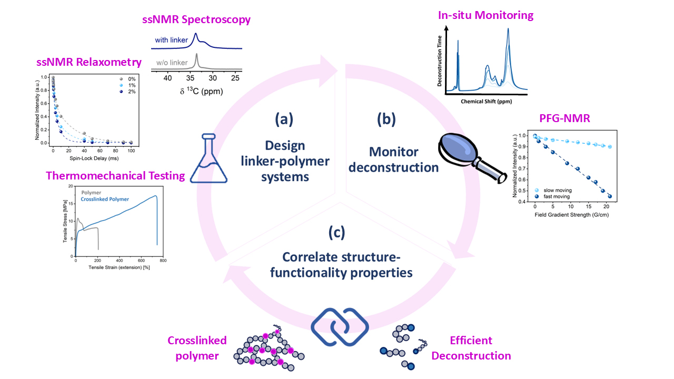
We will probe the microstructure of DCB-containing polymers and establish structure-property relationships by correlating linker chemistry, polymer architecture and local chain dynamics, with the polymer’s macro mechanical properties using conventional polymer thermomechanical methods and ssNMR (Objective 1). We will then monitor the chemical deconstruction of these polymers using magnetic resonance techniques, including in-situ measurements, when possible, to directly observe bond cleavage, rearrangements, and chain breakage (Objective 2). Finally, we will investigate the role of mechanical forces, such as swelling, stress, and stretching, in driving and enhancing chemical transformations, thereby identifying mechanochemical conditions that promote efficient deconstruction (Objective 3, Figure 2).
Figure 2. Illustration of the proposed research: (a) Design and synthesis of linker-polymers and characterization with thermomechanical testing and NMR; (b) monitor deconstruction with NMR methods; and (c) the relationship between the structural mechanical properties and deconstruction functionality will be determined in a stress-swelled system.
The significance of this research extends beyond the individual objectives, providing a pathway to address the escalating crisis of plastic waste. By developing a fundamental, molecular-level framework for understanding how DCB linkers influence polymer mechanical properties and degradability, this project will enable the rational design of polymers that combine upcycled polymers during use, with controlled recyclability at end-of-life. Beyond reducing environmental impact, a critical outcome of this research is to advance the broader field of sustainable polymer science by offering new design principles for high-performance, recyclable materials.
2.1 Objective 1: Synthesis and characterization of diverse polymer architectures
We will investigate three families of polymers derived from strained cyclic olefins, synthesized via ring-opening metathesis polymerization (ROMP).⁴⁷ In parallel, three dynamic covalent linkers with distinct cleavage chemistries will be prepared and incorporated into the polymer networks (Figure 3). A multinuclear solid-state NMR (ssNMR) approach will be employed to probe the composition and structural arrangement of these crosslinked systems. The chemical specificity of NMR will allow differentiation between polymer backbones and linker groups, providing insight into their co-localization within the network.
We anticipate challenges with spectral resolution due to broadened ¹H resonances in solid polymers; in such cases, NMR relaxation measurements (T₁, T₂, T_{1ρ}) will be used to probe chain mobility over multiple timescales. These parameters are sensitive to crosslinking density, local chemical environment, and chain architecture, thereby providing information on polymer morphology, network heterogeneity, and phase composition.
Complementary thermomechanical characterization, including thermogravimetric analysis (TGA), differential scanning calorimetry (DSC), dynamic mechanical analysis (DMA), and, where feasible, gel permeation chromatography (GPC), will be used to benchmark the properties of the crosslinked polymers against their non-crosslinked analogues.
By integrating molecular-level insights from ssNMR with bulk thermomechanical measurements, this objective will establish how linker chemistry influences polymer architecture, morphology, and macroscopic performance. This foundation is critical for identifying the structural features that govern both enhanced mechanical properties and susceptibility to controlled deconstruction.
2.2 Objective 2: Investigation of polymer deconstruction dynamics for better material design
Polymer-linker deconstruction under mild, triggered conditions will be monitored using both ex-situ and in-situ NMR characterization (Figure 3). As cleavage progresses, the crosslinked matrix becomes increasingly soluble, improving spectral resolution and enabling detailed structural analysis. Multinuclear solid-state NMR (ssNMR) will be performed at defined time points to track changes in chemical shifts, peak line shapes, and linewidths, providing insight into evolving local environments. Relaxation measurements will be used to follow the evolution of chain dynamics and polymer morphology during deconstruction, while ¹H pulsed-field gradient (PFG) NMR will track the diffusion of triggering molecules into the polymer matrix and their transport to reactive sites. This combined methodology will further allow monitoring of bond activation, linker-site conformational changes, and reactivity under deconstruction conditions. By integrating information across multiple timescales and length scales, we will establish a comprehensive understanding of the chemical molecular events driving polymer deconstruction. This objective will reveal how chemical cleavage, molecular mobility, and stimulant transport are interrelated. These insights will identify the rate-limiting steps, governing chemical parameters of the deconstruction process and pinpointing what dictates beneficial deconstruction. Utilization of these guidelines results in design of better recyclable polymer materials.
2.3 Objective 3: Elucidating mechanochemical pathways for efficient polymer deconstruction
This objective focuses on disentangling the interplay between mechanical effects and chemical reactivity during polymer deconstruction. Polymer-solvent interactions, such as swelling or applied strain, can generate molecular tension that accelerates early-stage bond cleavage and shapes downstream degradation pathways.^{48,49} By systematically probing these effects, we aim to separate concurrent processes and uncover how mechanochemical transformations influence chemical deconstruction.⁵⁰ Mapping of swelling-induced tension will be performed by modulating various solvents and monitoring the segmental mobility of the chains via relaxation measurements, in addition to studying the deconstruction kinetics with NMR spectroscopy. Furthermore, the mobility/permeability of the chains and solvents evolves in a swelled/strained system and will be detected and followed with diffusion NMR. Supplementary molecular dynamics (MD) simulations of molecular transport and diffusion in polymer networks will be conducted. Ultimately, this approach will establish a mechanistic understanding of how external forces and solvent interactions govern deconstruction pathways, enabling predictive guidelines for engineering mechanochemical conditions for efficient deconstruction.
- Detailed description of the proposed research
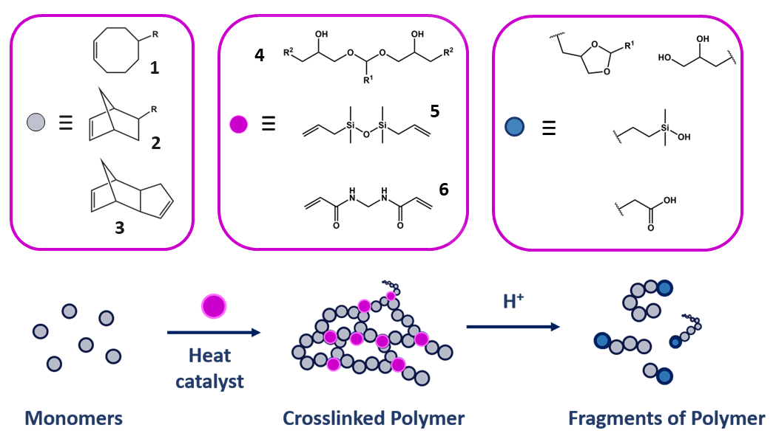
Linker-polymer deconstruction studies will be performed on three cyclic olefin-based monomers, polymerized with a ROMP ruthenium catalyst^{51–53} in a highly controlled method that tolerates a broad range of functional groups. This polymerization strategy permits the direct incorporation of designed linker monomers directly into the polymer backbone without disrupting chain propagation. Cyclooctene (1) yields a soft, flexible, linear elastomer that is soluble in organic solvents. Polynorbornene (2) forms a rigid thermoplastic, though its thermomechanical properties are strongly dependent on the chemical derivatives on the monomer and their microstructural arrangement within the polymer matrix. Dicyclopentadiene (DCPD, 3) polymerizes to form a stiff, high-strength, crosslinked thermoset. Collectively, these monomers span a wide spectrum of mechanical and thermal behaviors, creating an ideal model platform for developing recyclable polymer systems.
Figure 3. Proposed synthesis of linker-polymer system with monomer 1, 2, and 3 (grey circle), deconstruction via acidolysis of the cross-linkers 4, 5, and 6 (purple circle), and possible degradation fragments (blue circle).
3.1 Objective 1: Synthesis and characterization of diverse polymer architectures
3.1.1 Research design and methods. Polymerization protocols will be optimized, including curing conditions and film molding, using the commercially available Grubbs second-generation catalyst to promote polymerization. Three DCB linkers with distinct cleavage chemistries will be synthesized and incorporated. Each linker contains dual linkage bonds that promote crosslinking, while introducing cleavable sites, enabling the formation of networks with both enhanced properties and controlled degradability. Importantly, each linker carries a distinct NMR signature (e.g., ¹H, ¹³C, ¹⁵N, ²⁹Si) allowing direct detection of the bond activation site.
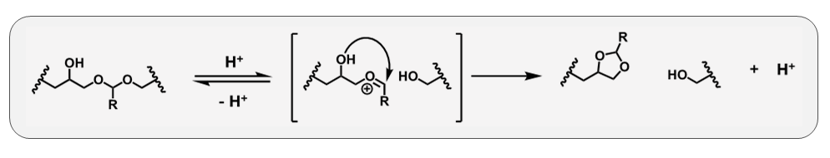
Acetal-based linkers (4): In acidic environments, the acetal bond cleaves to generate an alcohol fragment and a transient oxocarbenium ion that undergoes intramolecular cyclization to form a cyclic acetal (Scheme 1). This Cyclization Triggered Chain (CATCH)⁵⁴ mechanism enables rapid degradation under very mild conditions, producing high-value fragments that can be reused, such as cyclic acetals.⁵⁵ CATCH chemistry has been demonstrated in polyurethanes,⁵⁶ where polymer swelling in suitable solvents allowed acid penetration, chain scission, and intramolecular cyclization, ultimately yielding recyclable fragments. Effective cleavage has been demonstrated in elastic films, rigid solids, and foams, supporting its applicability in ROMP-derived polymers. The olefinic end group (R) of the linker will be tuned to match the monomer type, optimizing copolymerization kinetics.
Scheme 1. CATCH mechanism in acid medium.
Silyl ether-based linkers (5): Silyl ethers are well-established candidates for incorporation into polymers, offering controlled bond cleavage under specific conditions.^{57,58} The Johnson group has extensively advanced this chemistry in DCPD-based thermosets,^{59–62} and recent studies confirm its successful application in polyurethane deconstruction.⁶³
Amide-based linkers (6): Amide derivatives will serve as the third class of DCB linkers. Amide incorporation has been shown to improve the performance of degradable polymers while maintaining environmental compatibility.^{64,65} Understanding this chemistry in olefin-based polymers will provide a pathway toward polyether amide systems with tunable properties.
Linker-monomer synthesis will follow reported procedures, modified as necessary for these systems, using commercially available reagents and starting materials. The resulting polymers will undergo comprehensive characterization: solid-state NMR to probe chemical composition, microstructure, and morphology, complemented by thermomechanical analyses, including thermogravimetric analysis (TGA) and differential scanning calorimetry (DSC) for thermal stability and transitions, dynamic mechanical analysis (DMA) and tensile testing for mechanical performance, and gel permeation chromatography (GPC), when solubility permits, for molecular weight distributions, to benchmark bulk mechanical properties.
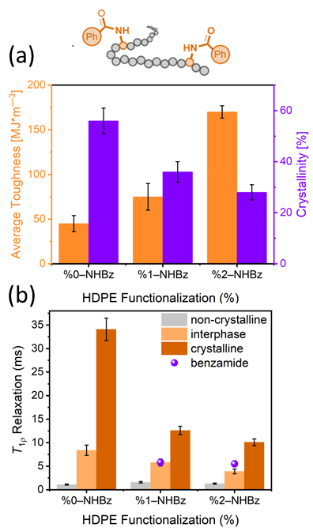
3.1.2 Thermomechanical characterization. Incorporation of DCB crosslinkers is expected to enhance the thermomechanical performance of the polymers. Key parameters, such as the glass transition temperature (T_{g}), melting temperature (T_{m}), and modulus will be measured, as they directly reflect on chain mobility, crystallinity, and crosslinking density. These measurements will establish whether polymer upcycling and enhanced mechanical properties were achieved. Molecular weight analysis will be performed when polymer dissolution in THF is possible. To ensure reproducibility, significant emphasis will be placed on uniform polymer film fabrication, which is essential for generating reliable thermomechanical data. Importantly, macro-scale properties obtained by these methods will be systematically compared with microstructural insights from ssNMR to achieve a complete understanding of the crosslinked systems. Determination of the microstructure of benzamide functionalized high-density polyethylene (HDPE) with ssNMR (Figure 4), shed light on the enhanced performance of the polymer.⁶⁶
Figure 4. The use of ssNMR to study the microstructure of benzamide functionalized high-density polyethylene (HDPE, top). (a) Average toughness calculated from tensile testing (left axis, orange) and percent of crystallinity (right axis, purple) calculated from ssNMR ¹H T_{1ρ} measurements of functionalized HDPE, showing correlation between the polymer’s macro and micro-properties. (b) Deconvoluted ¹H T_{1ρ} relaxation data presenting the chain/molecular mobility of the non-crystalline, interphase, and crystalline regions, and the benzamide functional group. This measurement shed light on the local bonding of the benzamide within the polymer microstructure, placing it specifically in the interphasial region. Adapted from reference 66.
3.1.3 ssNMR characterization of linker-polymer microstructure. Due to the limited solubility of crosslinked samples, solid-state NMR will play a central role in structural characterization. Polymer samples will be cut into small pieces and placed in the desired rotor. To ensure stable spinning, polymer thin films will be prepared and rolled into the rotor with KBr powder packed in the center.
The polymer backbone, rich with C-H bonds, enables fast acquisition of ¹H and ¹³C signals with high sensitivity, however, we presume that strong homonuclear couplings will broaden the peaks. To overcome this, high spinning speeds (40-50 kHz) will be employed for ¹H measurements. Direct ¹³C and ¹H-¹³C cross-polarization (CP) experiments will be performed at lower spinning speeds with high power proton decoupling to achieve improved spectral resolution. Quantitative carbon measurements will be carried out with ¹H-¹³C multiCP sequence,⁶⁷ which is particularly suited for polymer samples. 2D correlation experiments, based on J and dipolar couplings, will further aid spectral assignment.
Chain mobility will be evaluated with ¹H and ¹³C T₁, T₂, and T_{1ρ} relaxation experiments. These measurements are highly sensitive to crosslinking density, in addition to the morphology of the polymer, distinguishing rigid and mobile domains and their coupling. Comparison with unmodified, linker-free polymers will establish the specific contributions of each linker system.
3.2 Objective 2: Investigation of polymer deconstruction dynamics for better material design
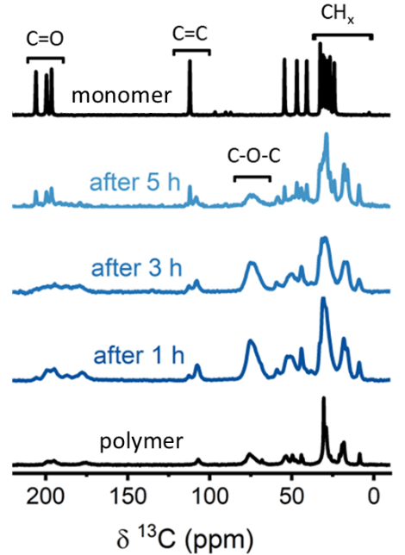
3.2.1 Research design and methods. Deconstruction dynamics will be studied using two complementary approaches: (i) For polymers with a low degree of crosslinking, in-situ NMR will serve as the primary tool to monitor the evolution of chemical environments as a function of deconstruction time. Furthermore, ¹H pulsed field gradient (PFG) NMR, performed with strong gradient fields to probe slow mobility (on the timescale of 10^{–11} to 10^{–12} s), will provide spatially resolved diffusion data. Polymer samples will be immersed in the triggering medium directly within the NMR tube, allowing real-time monitoring of the deconstruction process. By tracking the evolution of diffusion coefficients over time, changes in chain mobility will be mapped as a function of deconstruction. The chemical specificity of NMR enables distinct diffusion profiles to be obtained for different resonances, thereby distinguishing the transport behavior of the reactive linker sites from that of the polymer backbone and enabling insight on the implications of chain mobility on the reactivity of deconstruction.
Figure 5. ¹H–¹³C multi-CP spectra of recovered polymer different deconstruction times in 5 M HBr solution. Evolution of chemical environments is present as acidolysis advances. Acquired at 9.4 T with spinning speed of 11 kHz. Adapted from ref. 68.
(ii) For polymers with high crosslinked density, in-depth analysis of molecular transformations during polymer deconstruction will be performed using high resolution and high sensitivity ¹H and ¹³C ssNMR spectroscopy (Figure 5).⁶⁸ Deconstruction will be quenched at defined time intervals to capture snapshots of the process. Relaxation measurements (T₁, T₂, and T_{1ρ}) will be used to probe local morphological and dynamic changes as deconstruction proceeds, providing insight into the evolution of network structure and chain mobility at different stages and timescales throughout the deconstruction.
3.3 Objective 3: Elucidating the role of cleavable linkers in degradable polymers
Polymer-solvent interactions can generate molecular tension that accelerates early-stage bond cleavage and promotes downstream pathways during chemical deconstruction.⁴⁸ Swelling of polymer chains induces internal stress as solvent uptake expands the matrix, producing forces capable of activating force-sensitive reactions, in a more gentle and non-mechanical way. These forces, arising from local stretching and compression, can be simulated through controlled swelling-induced tension. We hypothesize that depolymerization reactivity is sensitive to such force-coupled effects, and that sufficient swelling can be used to modulate the deconstruction kinetics.
3.3.1 Research design and methods. The swelling ratio, l_{f}/l_{i}, determined by the ratio of the final swollen length to the initial length, will be measured with a caliper and mapped to target solvents that change this ratio without introducing other significant solvent-induced effects.⁴⁸ Furthermore, intrinsic solvent polarity will be taken into consideration when choosing the solvents and monitoring their effects. Local mobility of the swelling-induced tense chains will be measured with relaxation experiments.
After characterization of the swollen matrices, the triggering acid will be introduced and deconstruction kinetics will be monitored with ¹H NMR spectroscopy and diffusometry. These results will be compared to a small molecule study, emphasizing chemical reactivity and molecular mobility without the presence of strained chains. In this way, we will be able to gain insight on chain mobility in a strained system. Our experimental results will be conducted in concert with computational modeling and simulations of diffusion in a deformed polymer system. Theoretical studies combined with molecular dynamics (MD) simulations will reveal the transport properties of a stretched polymer matrix, and together with experimental data, will govern the mechanical principles needed for efficient polymer deconstruction.
- Preliminary results
4.1 Characterization of CATCH linker-polynorbornene polymers.
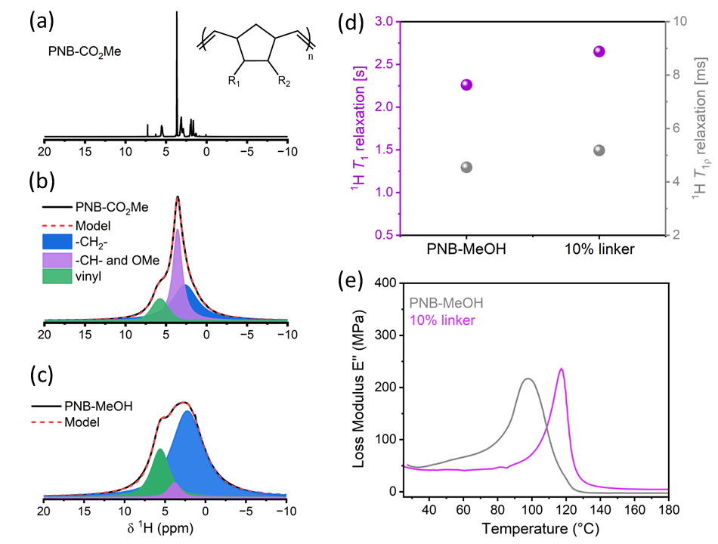
CATCH linkers with a norbornene methanol end group (Fig 3, 2, R = CH₂OH), were synthesized.⁵⁶ 10 mol% of this linker was copolymerized with a norbornene monomer using 0.1 mol% Grubbs 2nd generation catalyst (Fig 6, inset: polynorbornene with R₁ = R₂ = CO₂Me, PNB-CO₂Me, and R₁ = CH₂OH, R₂ = H, PNB-MeOH). The polymer solution was added dropwise into molds and heated rapidly to 90 °C to initiate frontal ring-opening metathesis polymerization (FROMP),^{14,69} followed by curing for 1.5 h at 150 °C, to remove residual solvent and promote internal crosslinking. Linker-free polymers were prepared using the same protocol. Thermomechanical characterization and ¹H ssNMR measurements were performed (Figure 6). PNB-CO₂Me was soluble in organic solvents, enabling solution-state ¹H NMR (Figure 6(a)) and gel permeation chromatogram (GPC) analysis, giving Mn = 117.14 kDa, Ð = 1.3. Incorporation of the CATCH linker reduced solubility as a result of increased crosslinking density, and necessitated ssNMR measurements (Figure 6 (b)). Three main proton environments were observed: vinyl protons (~ 5.6 ppm), -CH- and methyl ester protons (~ 3.6–3.8 ppm), and methylene protons (~ 2.2–2.6 ppm). The methanol terminated monomer formed PNB-MeOH, which was insoluble, likely due to formation of a hydrogen-bonded polymer matrix or increased crosslinking density. ¹H ssNMR of PNB-MeOH, Figure 6(c), showed similar chemical environments to PNB-CO₂Me, with about 10% increase in vinyl proton signal, consistent with higher crosslinking and lower solubility. The methanol derivative also led to a broader, more intense methylene peak resulting from increased site heterogeneity and a decrease in T₂ relaxation (420 μs for PNB-CO₂Me vs 240 μs for PNB-MeOH).
Figure 6. (a) ¹H solution-state zg30 NMR of polynorbornene dimethyl dicarboxylate (PNB-CO₂Me) in CDCl₃. ¹H ssNMR Hahn echo spectra of (b) PNB-CO₂Me and (c) PNB-MeOH. Spectra acquired at 9.4 T with spinning speed of 45 kHz. (d) ¹H relaxation properties, T₁ (purple) and T_{1ρ} (gray), and (e) dynamic mechanical analysis (DMA) loss modulus (E’’) vs temperature for PNB-MeOH with and without 10 mol% linker.
¹H spectra of the linker incorporated polymers were comparable to linker-less samples, with only ~ 2–3% ratio differences. However, ¹H relaxation measurements (Figure 6(d)) revealed that adding CATCH linkers to PNB-MeOH increased T₁ (2.26 s to 2.65 s) and T_{1ρ} relaxation (4.4 ms to 5.2 ms), and is consistent with slower chain mobility due to increased crosslinking density (R_{1ρ} = T_{1ρ}^{–1}).⁷⁰ ¹H T₂ values were largely unchanged between the linker and linker-free polymers.
Thermomechanical measurements (Figure 6(e)) showed an increased glass transition temperature for PNB-MeOH with linkers (97 °C vs 119 °C) further indicating higher crosslinking density.^{71,72} Optimization of the amount of linker content will be conducted to further balance the mechanical properties with efficient deconstruction.
4.2 Monitoring polymer deconstruction in acidic medium.
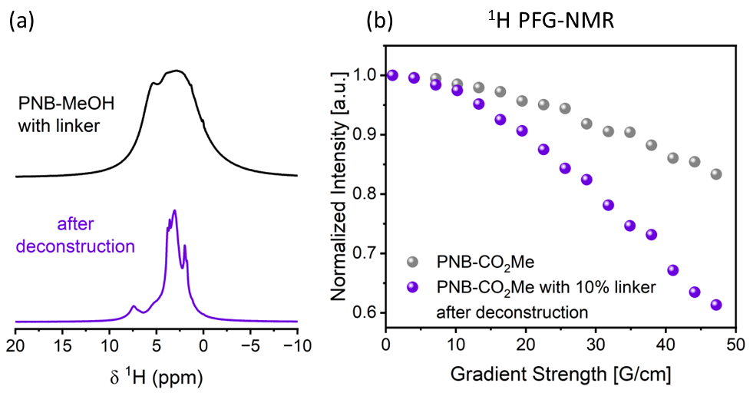
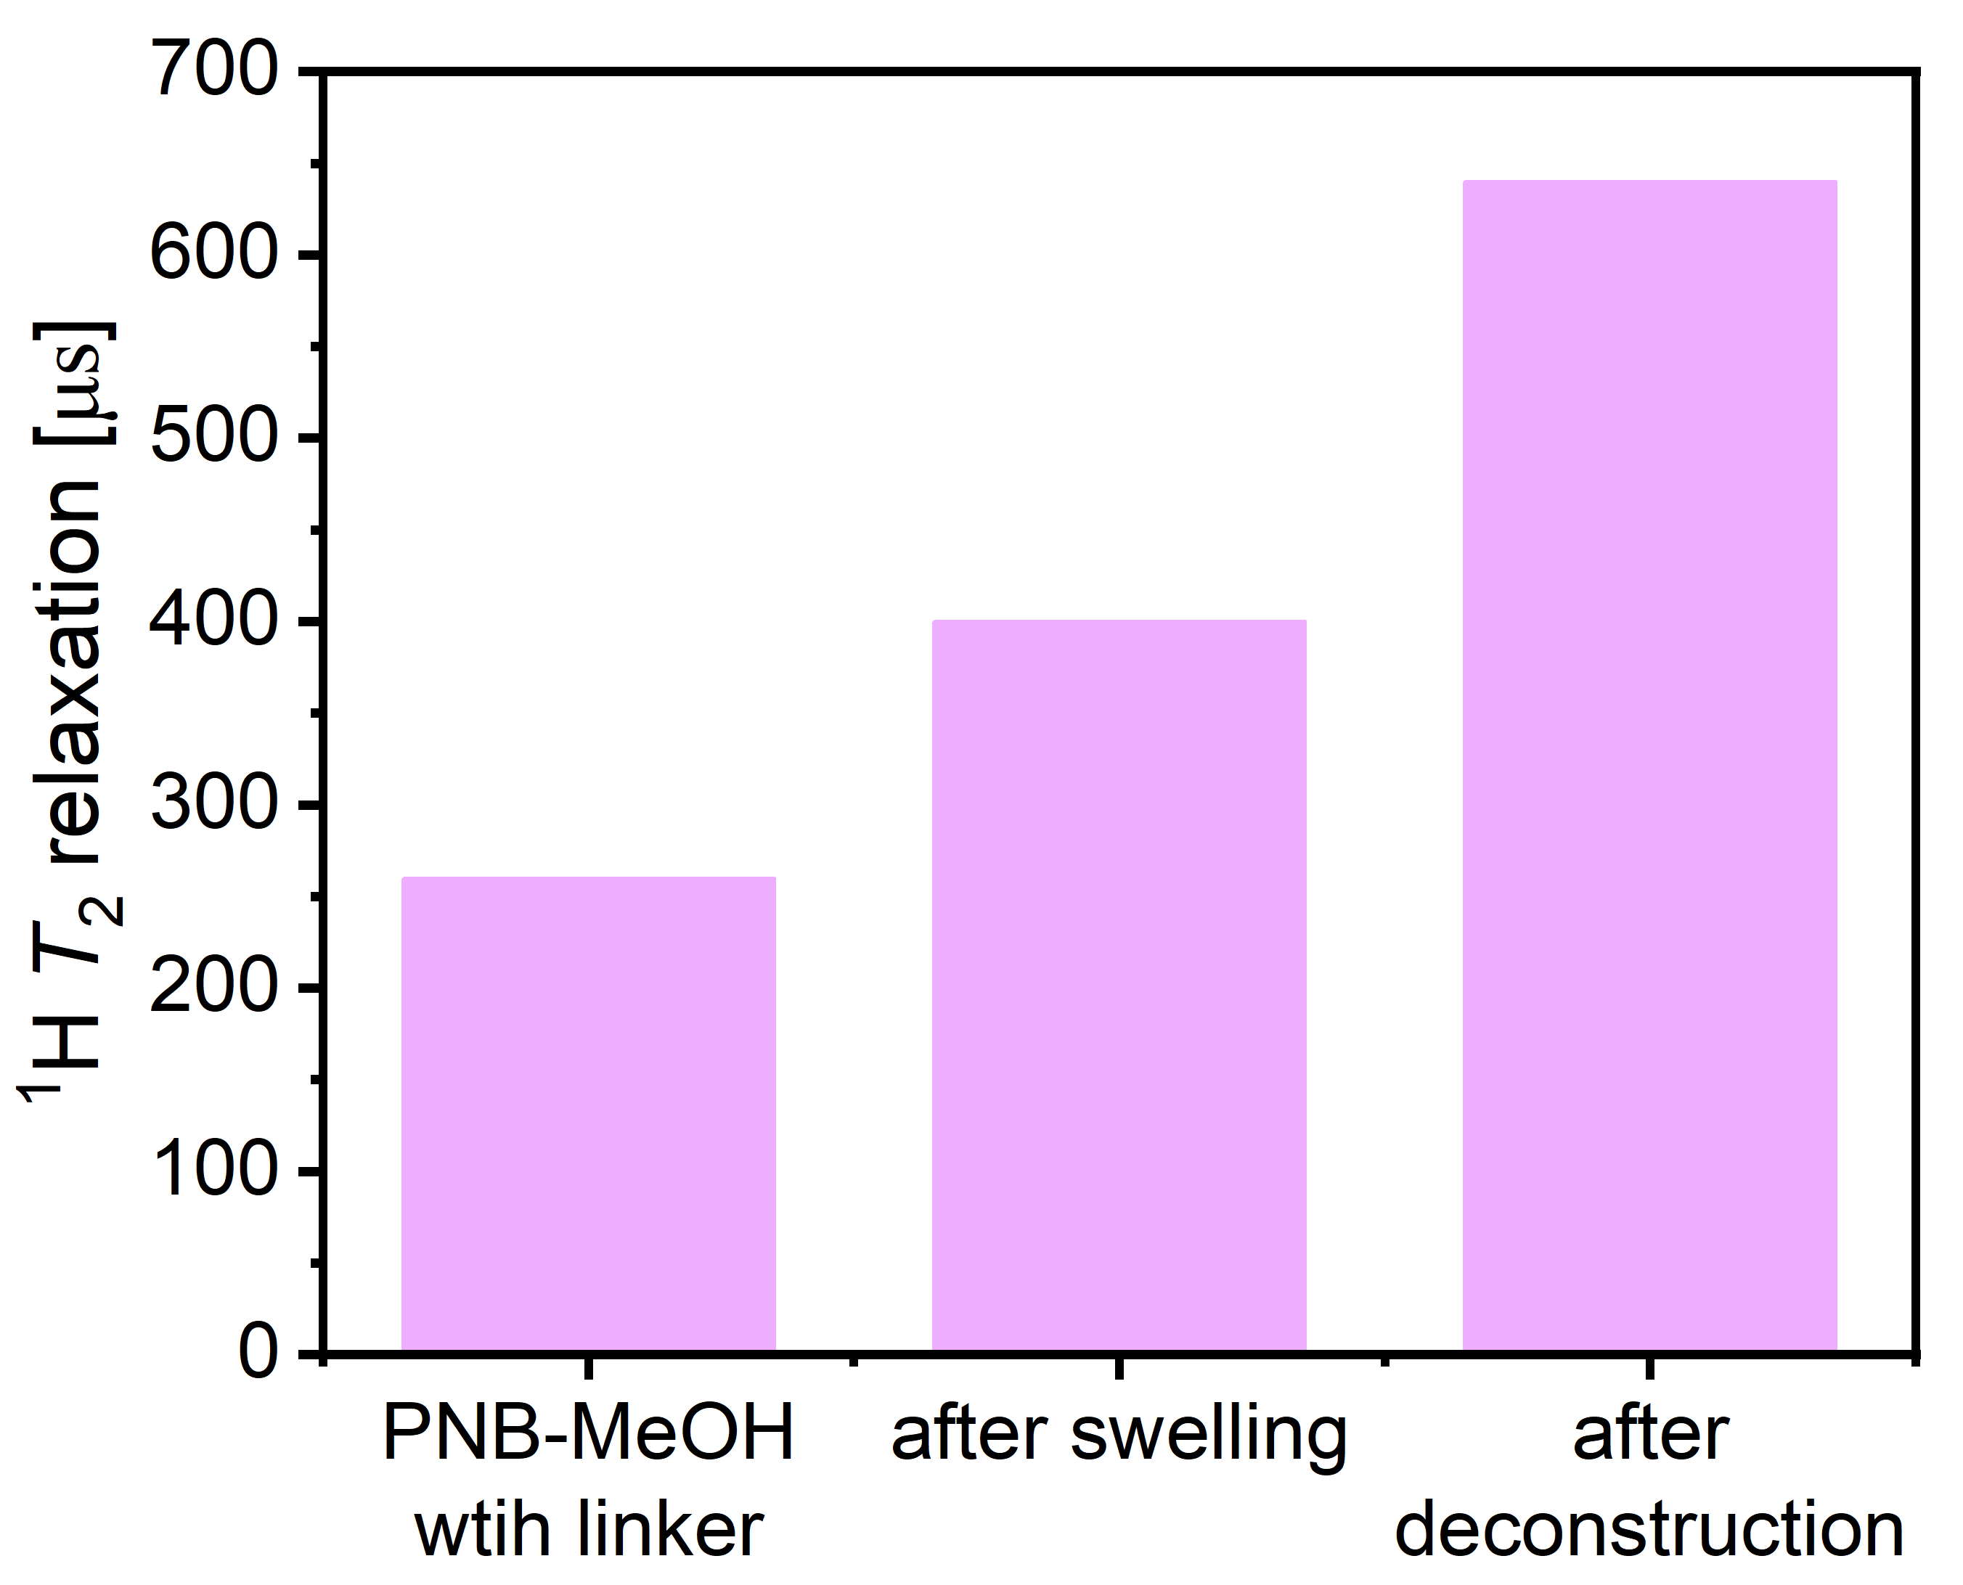
30 mg pieces of 10 mol% linker-polymer and linker-less polymers were immersed in 1 M methanesulfonic acid (MSA) in THF to induce deconstruction via CATCH mechanism.⁵⁶ The linker-less polymers swelled in the organic solvent but did not degrade. Acidolysis was quenched after 24 h for PNB-MeOH, samples were dried and measured with ¹H ssNMR (Fig 7(a)). The chemical environments become more distinct and a narrowing of peaks is apparent after deconstruction. This suggests that the polymer has degraded to shorter, oligomer chains. In addition, ¹H T₂ has increased significantly, from 260 μs to 700 μs for the deconstructed sample, supporting the presence of shorter, more mobile chains. Further analysis of the chemical shifts will be conducted, in addition to optimization of the drying process to ensure removal of all solvents. PNB-CO₂Me completely degraded after 3 h, the residual sample was dissolved in CDCl₃, and diffusion measurements were performed (Figure 7(b)). The diffusion coefficient increased by a factor of 2.4, with diffusion coefficients of 8.8*10^{–11} m²/s and 1.1*10^{–10} m²/s for the pristine and linker-polymer samples, respectively. For polymers in solution, the diffusion follows a power law D ∝ M^{–ν} where D is the diffusion coefficient, M is the molecular weight of the polymer and ν is the polymer-solvent scaling exponent (typically: 0.33 for poor solvent, ~0.5 for theta solvent and ideal chain, ~0.6 for good solvent, ~0.75 for stretched chains).⁷³ Calibrations curves to find the precise ν value will be prepared; however if we plug a ν value between 0.33 and 0.75, we can calculate a decrease in molecular weight between 26% and 49% of the original molecular weight. This is a significant deconstruction and fragmentation of the chains, with just 10 mol% linker. Deconstruction time and acid strength will be evaluated, in addition to further characterization of the fragments.
Figure 7. (a) ¹H Hahn echo of pristine PNB-MeOH with 10 mol% linker incorporation (top) and after 24 h in 1 M methanesulfonic acid (MSA) in THF. Spectra acquired at 9.4 T with spinning speed of 45 kHz. (b) ¹H PFG-NMR diffusion decay curves vs gradient strength, of pristine PNB-CO₂Me polymer (gray) and 10 mol% linker-PNB-CO₂Me after 3 h in 1 M MSA/THF (purple). Measurements run at 11.7 T.
  - Swelling in polymer systems.
The relaxation properties of PNB-MeOH with 10 mol% linker incorporation were measured under three different conditions: pristine film, a swelled matrix, after immersion in THF for 24 h, and a deconstructed polymer, after immersion in 1 M MSA/THF for 24 h (Figure 8). After swelling, polymer chains expand, giving the extended matrix increased mobility, which can be seen with an increased T₂ value. The deconstructed fragments present a higher T₂, due to enhanced mobility of the oligomers. Mapping of T₂ values vs swelling ratio of the polymer in different solvents will be performed to further assist in data analysis.
Figure 8. ¹H T₂ relaxation properties of 10 mol% linker-PNB-MeOH: (a) pristine polymer, (b) after 24 h immersion in THF, (c) after 24 h immersion in 1M MSA/THF.
- Available Resources
This project builds directly on my recent work on polymer characterization and monitoring deconstruction with NMR methodologies, and leverages my multidisciplinary background. I am establishing a new lab, currently consisting of two masters students who have shown interest in continuing to graduate studies.
Synthesis: The lab is equipped with all the equipment necessary to perform linker synthesis and polymer fabrication (chemicals, glass apparatus, vacuum oven, hoods and bench space).
NMR: Bruker MAS 400MHz NMR system with 60A gradient amplifier and water chiller for PFG-NMR measurements. MAS probes include 400MHz 1.9mm DR and 3.2mm TR. Diffusion probe includes 5 mm 400MHz Diff50 high power diffusion probe optimized for very strong gradients and ideal for slow polymer chain mobility (5*10^{–15} m²/s). Additional access to a Bruker 500MHz ssNMR (2.5mm and 4mm probes) at the NMR facility at Bar-Ilan University. In addition, variable temperature measurements and conventional PFG-NMR can be executed on Bruker 400MHz, 500MHz and 700MHz in the NMR Facility.
Additional equipment: The lab is part of the Chemistry Department with access to shared facilities, like TGA and DSC for polymer characterization. DMA will be purchased and, in the meantime, I have the support of Prof. Gabriel Lemcoff from Ben-Gurion University to use the resources available in his lab (GC, DMA, GPC). For the computational part in objective 3, I will collaborate with Dr. Liel Sapir from Bar-Ilan University, an expert in molecular transport in polymer systems, specifically in deformed polymer networks. With my expertise and the collaborative resources available at Bar-Ilan, I am confident in my ability to execute this project successfully.
- Expected Results and Pitfalls
We will determine the relations of diverse DCB-polymers’ architecture and their deconstruction functionality: (i) Quantitative and qualitative insight of the linker-polymer microstructure and further correlation with their upcycled macro-properties. (ii) Determine rates for linker-polymer deconstruction and barriers for chain mobility in these systems. (iii) Benchmark the mechanochemical principles needed for efficient polymer deconstruction.
We do not expect issues with polymer synthesis and fabrication, thermomechanical characterization and the application of ex-situ ssNMR for the study of polymer materials. The main challenges to be addressed:
- Spectral resolution during in-situ solution or ssNMR measurements may be limited by broad, overlapping peaks from multiple chemical environments, complicating real-time monitoring and site-specific diffusion analysis. To address this, we will monitor changes through relaxometry values, focusing on variations in the FID and average signal intensity. Additionally, deconstruction mapping will be performed after a set time, to promote solubility and enhance spectral resolution.
- In highly crosslinked DCPD thermosets, acidolysis may be ineffective due to the hydrophobic nature of the matrix, limiting acid penetration. To overcome this, we will employ an alternative strategy: depolymerizing the network with a suitable ring-closing metathesis Ru-catalyst prior to acid treatment. This preliminary fragmentation into shorter chains will facilitate acid uptake and enable more efficient deconstruction.

Bibliography
(1) Geyer, R.; Jambeck, J. R.; Law, K. L. Production, Use, and Fate of All Plastics Ever Made. Sci Adv 2017, 3, e1700782.
(2) Brinksmeier, E.; Eckebrecht, J.; Buhr, H. Improving Ecological Aspects of the Grinding Process by Effective Waste Management. J. Mater. Process. Technol 1994, 44, 171–178.
(3) Winne, J. M.; Leibler, L.; Du Prez, F. E. Dynamic Covalent Chemistry in Polymer Networks: A Mechanistic Perspective. Polym Chem 2019, 10 (45), 6091–6108.
(4) Si, G.; Chen, C. Cyclic–Acyclic Monomers Metathesis Polymerization for the Synthesis of Degradable Thermosets, Thermoplastics and Elastomers. Nature Synthesis 2022, 1 (12), 956–966.
(5) Zhang, V.; Kang, B.; Accardo, J. V.; Kalow, J. A. Structure-Reactivity-Property Relationships in Covalent Adaptable Networks. J Am Chem Soc 2022, 144 (49), 22358–22377.
(6) Chao, A.; Negulescu, I.; Zhang, D. Dynamic Covalent Polymer Networks Based on Degenerative Imine Bond Exchange: Tuning the Malleability and Self-Healing Properties by Solvent. Macromolecules 2016, 49 (17), 6277–6284.
(7) Deng, Y.; Zhang, Q.; Qu, D. H.; Tian, H.; Feringa, B. L. A Chemically Recyclable Crosslinked Polymer Network Enabled by Orthogonal Dynamic Covalent Chemistry. Angew. Chem. Int. Ed. 2022, 61 (39), e202209100.
(8) Kang, B.; Kalow, J. A. Internal and External Catalysis in Boronic Ester Networks. ACS Macro Lett 2022, 11 (3), 394–401.
(9) Roh, S.; Nam, Y.; Nguyen, M. T. N.; Han, J. H.; Lee, J. S. Dynamic Covalent Bond-Based Polymer Chains Operating Reversibly with Temperature Changes. Molecules 2024, 29 (14), 3261.
(10) Chien, S. Y.; Wang, J.; Liu, Y. L. Biodegradable Polyester-Based Vitrimers Exhibiting Transesterification-Induced Topography Isomerization under Recycling. ACS Appl Polym Mater 2024, 6 (15), 9191–9199.
(11) Johnson, A. M.; Johnson, J. A. Thermally Robust yet Deconstructable and Chemically Recyclable High-Density Polyethylene (HDPE)-Like Materials Based on Si−O Bonds. Angew. Chem. Int. Ed. 2023, 62 (51), e202315085.
(12) Berkovich-Berger, D.; Gabriel Lemcoff, N. Facile Acetal Dynamic Combinatorial Library. Chem. Commun. 2008, 1686–1688.
(13) Fan, B.; Trant, J. F.; Wong, A. D.; Gillies, E. R. Polyglyoxylates: A Versatile Class of Triggerable Self-Immolative Polymers from Readily Accessible Monomers. J Am Chem Soc 2014, 136 (28), 10116–10123.
(14) Robertson, I. D.; Dean, L. M.; Rudebusch, G. E.; Sottos, N. R.; White, S. R.; Moore, J. S. Alkyl Phosphite Inhibitors for Frontal Ring-Opening Metathesis Polymerization Greatly Increase Pot Life. ACS Macro Lett 2017, 6 (6), 609–612.
(15) Murthy, N.; Thng, Y. X.; Schuck, S.; Xu, M. C.; Fréchet, J. M. J. A Novel Strategy for Encapsulation and Release of Proteins: Hydrogels and Microgels with Acid-Labile Acetal Cross-Linkers. J Am Chem Soc 2002, 124 (42), 12398–12399.
(16) Kaitz, J. A.; Lee, O. P.; Moore, J. S. Depolymerizable Polymers: Preparation, Applications, and Future Outlook. MRS Commun 2015, 5 (2), 191–204.
(17) Mirau, P. A. NMR Characterisation of Polymers. In Polymer Characterisation; Hunt, B. J., James, M. I., Eds.; Springer Netherlands, 1993; pp 37–68.
(18) NMR Methods for Characterization of Synthetic and Natural Polymers; Zhang, R., Miyoshi, T., Sun, P., Eds.; The Royal Society of Chemistry, 2019.
(19) Monti, G. A.; Acosta, R. H.; Chattah, A. K.; Linck, Y. G. Solid State Nuclear Magnetic Resonance of Polymers. J Magn Reson Open 2023, 16–17, 100119.
(20) Zhang, R.; Chen, W.; Miyoshi, T. Elucidations of Structure and Molecular Dynamics of Complex Polymers by State-of-the-Art Solid-State NMR Spectroscopy. Macromolecules 2024, 57 (5), 1893–1918.
(21) Mirau, P. A. A Practical Guide to Understanding NMR of Polymers; John Wiley and Sons: Hoboken, New Jersey USA, 2005.
(22) Schmidt-Rohr, K.; Spiess, H. W. Multidimensional Solid-State NMR and Polymers; Academic Press: San Diego, 1994.
(23) Kumar, A.; Kentgens, A. P. M. Unravelling Crosslinking and Molecular Structure in Complex Polyurethanes via Advanced Multinuclear Solid-State NMR. Polymer (Guildf) 2025, 325, 128245.
(24) Jarach, N.; Golani, D.; Asaf, O.; Dodiuk, H.; Shamir, Y.; Goldbourt, A.; Kenig, S.; Naveh, N. Composition Processing Property Relationship of Vitrimers Based on Polyethyleneimine. Polym Chem 2021, 12 (22), 3307–3320.
(25) Longiéras, N.; Sebban, M.; Palmas, P.; Rivaton, A.; Gardette, J. L. Degradation of Epoxy Resins under High Energy Electron Beam Irradiation: Radio-Oxidation. Polym Degrad Stab 2007, 92 (12), 2190–2197.
(26) Alessi, S.; Spinella, A.; Caponetti, E.; Dispenza, C.; Spadaro, G. Structural Investigation of E-Beam Cured Epoxy Resins through Solid State NMR. Radiation Physics and Chemistry 2012, 81 (9), 1328–1331.
(27) McCall, D. W.; Douglass, D. C. Molecular Motion in Polyethylene, IV. Polymer (Guildf) 1963, 4, 433–444.
(28) Punkkinen, M.; Ingman, L. P. Molecular Motion and Spin–Lattice Relaxation in Polyethylene. phys. stat. sol. (a) 1978, 46 (1), 213–216.
(29) Olf, H. G.; Peterlin, A. NMR Study of Molecular Motion in Oriented Long‐chain Alkanes. II. Oriented Mats of Polyethylene Single Crystals. J Polym Sci A-2 Polym Phys 1970, 8 (5), 771–789.
(30) Crist, B.; Peterlin, A. Spin Lattice Relaxation in Linear Polyethylene. J Polym Sci A-2 Polym Phys 1969, 7, 1165–1186.
(31) Allen, G.; Connor, T. M.; Pursey, H. Nuclear Spin-Lattice Relaxation in Polyethylene Glycols. Transactions of the Faraday Society 1963, 59, 1525.
(32) Thiele, S.; Plummer, C. J. G.; Piveteau, L.; Frauenrath, H. Dynamics of Hydrogen-Bonded End Groups in Bulk Polymers Revealed by Solid-State NMR Spectroscopy Relaxation Dispersion Experiments. Commun. Chem. 2025, 8, 217.
(33) Anuar, A.; Schaller, M.; Alamo, R. G.; Saalwächter, K. Chain Dynamics of Halogenated Precision Polyethylenes in Different Crystal Polymorphs. Macromolecules 2025, 58 (8), 3849–3859.
(34) Choi, C.; Bailey, L.; Rudin, A.; Pintar, M. M. Quantitative Analysis of Three Phases of High-Density Polyethylene with 2D Time-Domain Proton NMR. J Polym Sci B Polym Phys 1997, 35, 2551–2558.
(35) Cheng, J.; Fone, M.; Reddy, V. N.; Schwartz, K. B.; Fisher, H. P.; Wunderlich, B. Identification and Quantitative Analysis of the Intermediate Phase in a Linear High‐density Polyethylene. J Polym Sci B Polym Phys 1994, 32, 2683–2693.
(36) Hedesiu, C.; Demco, D. E.; Kleppinger, R.; Buda, A. A.; Blümich, B.; Remerie, K.; Litvinov, V. M. The Effect of Temperature and Annealing on the Phase Composition, Molecular Mobility and the Thickness of Domains in High-Density Polyethylene. Polymer (Guildf) 2007, 48, 763–777.
(37) Kitamaru, R.; Horii, F.; Murayama, K. Phase Structure of Lamellar Crystalline Polyethylene by Solid-State High-Resolution 13C NMR: Detection of the Crystalline-Amorphous Interphase. Macromolecules 1986, 19 (3), 636–643.
(38) Kitamaru, R.; Horii, F.; Zhut, Q.; Bassett, D. C.; Olley, R. H.; Thomson, J. J. The Phase Structure of High-Pressure-Crystallized Polyethylene. Polymer (Guildf) 1994, 35 (6), 1171–1181.
(39) Gentzler, M.; Reimer, J. A. 1H NMR Relaxation Study of Chain Motions and Solid-State Ordering in Stiff, Random Copolymers. Macromolecules 1997, 30, 8365–8374.
(40) Groves, P. Diffusion Ordered Spectroscopy (DOSY) as Applied to Polymers. Polym Chem 2017, 8 (44), 6700–6708.
(41) Hoarfrost, M. L.; Tyagi, M. S.; Segalman, R. A.; Reimer, J. A. Effect of Confinement on Proton Transport Mechanisms in Block Copolymer/Ionic Liquid Membranes. Macromolecules 2012, 45 (7), 3112–3120.
(42) Pietra, N. F.; Korovich, A. G.; Ketkar, P. M.; Epps, T. H.; Madsen, L. A. Role of Intradomain Heterogeneity on Ion and Polymer Dynamics in Block Polymer Electrolytes: Investigating Interfacial Mobility and Ion-Specific Dynamics and Transport. Macromolecules 2023, 56 (21), 8393–8403.
(43) Carrazzone, R. J.; Li, X.; Foster, J. C.; Uppala, V. V. S.; Wall, C. E.; Esker, A. R.; Madsen, L. A.; Matson, J. B. Strong Variation of Micelle-Unimer Coexistence as a Function of Core Chain Mobility. Macromolecules 2021, 54 (14), 6975–6981.
(44) Denkova, P. S.; Van Lokeren, L.; Willem, R. Mixed Micelles of Triton X-100, Sodium Dodecyl Dioxyethylene Sulfate, and Synperonic L61 Investigated by NOESY and Diffusion Ordered NMR Spectroscopy. Journal of Physical Chemistry B 2009, 113 (19), 6703–6709.
(45) Denkova, P. S.; Van Lokeren, L.; Verbruggen, I.; Willem, R. Self-Aggregation and Supramolecular Structure Investigations of Triton X-100 and SDP2S by NOESY and Diffusion Ordered NMR Spectroscopy. Journal of Physical Chemistry B 2008, 112 (35), 10935–10941.
(46) Bakkour, Y.; Darcos, V.; Li, S.; Coudane, J. Diffusion Ordered Spectroscopy (DOSY) as a Powerful Tool for Amphiphilic Block Copolymer Characterization and for Critical Micelle Concentration (CMC) Determination. Polym Chem 2012, 3 (8), 2006–2010.
(47) Xia, Y.; Kornfield, J. A.; Grubbs, R. H. Efficient Synthesis of Narrowly Dispersed Brush Polymers via Living Ring-Opening Metathesis Polymerization of Macromonomers. Macromolecules 2009, 42 (11), 3761–3766.
(48) Zheng, X.; Duan, C.; Widenhoefer, R. A.; Craig, S. L. Improving Catalytic Enantioselectivity of Hydrogenation through Swelling-Induced Molecular Tension in Polymer Networks. J Am Chem Soc 2025, 147 (34), 31085–31090.
(49) Hua, M.; Peng, Z.; Guha, R. D.; Ruan, X.; Ng, K. C.; Demarteau, J.; Haber, S.; Fricke, S. N.; Reimer, J. A.; Salmeron, M. B.; Persson, K. A.; Wang, C.; Helms, B. A. Mechanochemically Accelerated Deconstruction of Chemically Recyclable Plastics. Sci. Adv. 2024, 10, eadq3801.
(50) Li, J.; Nagamani, C.; Moore, J. S. Polymer Mechanochemistry: From Destructive to Productive. Acc Chem Res 2015, 48 (8), 2181–2190.
(51) Fürstner, A. Olefin Metathesis and Beyond. Angew. Chem. Int. Ed. 2000, 39 (17), 3012–3043.
(52) Hoveyda, A. H.; Zhugralin, A. R. The Remarkable Metal-Catalysed Olefin Metathesis Reaction. Nature 2007, 450 (7167), 243–251.
(53) Diesendruck, C. E.; Tzur, E.; Gabriel Lemcoff, N. The Versatile Alkylidene Moiety in Ruthenium Olefin Metathesis Catalysts. Eur J Inorg Chem 2009, No. 28, 4185–4203.
(54) Miller, K. A.; Morado, E. G.; Samanta, S. R.; Walker, B. A.; Nelson, A. Z.; Sen, S.; Tran, D. T.; Whitaker, D. J.; Ewoldt, R. H.; Braun, P. V.; Zimmerman, S. C. Acid-Triggered, Acid-Generating, and Self-Amplifying Degradable Polymers. J Am Chem Soc 2019, 141 (7), 2838–2842.
(55) Beydoun, K.; Klankermayer, J. Efficient Plastic Waste Recycling to Value-Added Products by Integrated Biomass Processing. ChemSusChem 2020, 13 (3), 488–492.
(56) Morado, E. G.; Paterson, M. L.; Ivanoff, D. G.; Wang, H. C.; Johnson, A.; Daniels, D.; Rizvi, A.; Sottos, N. R.; Zimmerman, S. C. End-of-Life Upcycling of Polyurethanes Using a Room Temperature, Mechanism-Based Degradation. Nat Chem 2023, 15 (4), 569–577.
(57) Nishimura, Y.; Chung, J.; Muradyan, H.; Guan, Z. Silyl Ether as a Robust and Thermally Stable Dynamic Covalent Motif for Malleable Polymer Design. J Am Chem Soc 2017, 139 (42), 14881–14884.
(58) Xu, J.; Hadjichristidis, N. Heteroatom-Containing Degradable Polymers by Ring-Opening Metathesis Polymerization. Prog Polym Sci 2023, 139, 101656.
(59) Zhang, S.; Xu, Z.; Husted, K. E. L.; Lundberg, D. J.; Brown, C. M.; Wang, Y.; Shieh, P.; Ko, K.; Moore, J. S.; Johnson, J. A. Cleavable Strand-Fusing Cross-Linkers as Additives for Chemically Deconstructable Thermosets with Preserved Thermomechanical Properties. Angew. Chem. Int. Ed. 2025, 64 (19), e202500104.
(60) Husted, K. E. L.; Shieh, P.; Lundberg, D. J.; Kristufek, S. L.; Johnson, J. A. Molecularly Designed Additives for Chemically Deconstructable Thermosets without Compromised Thermomechanical Properties. ACS Macro Lett 2021, 10 (7), 805–810.
(61) Shieh, P.; Zhang, W.; Husted, K. E. L.; Kristufek, S. L.; Xiong, B.; Lundberg, D. J.; Lem, J.; Veysset, D.; Sun, Y.; Nelson, K. A.; Plata, D. L.; Johnson, J. A. Cleavable Comonomers Enable Degradable, Recyclable Thermoset Plastics. Nature 2020, 583 (7817), 542–547.
(62) Ko, K.; Mejia, E. B.; Fowler, H. E.; Nguyen, S. T.; AlFaraj, Y.; Wang, Y.; Leguizamon, S. C.; Sottos, N. R.; Johnson, J. A. Multi-Generation Recycling of Thermosets Enabled by Fragment Reactivation. J Am Chem Soc 2025, 147 (15), 12503–12510.
(63) Ko, K.; Lundberg, D. J.; Lensch, V. L.; AlFaraj, Y. S.; Husted, K. E. L.; Brutman, J. P.; Alsbaiee, A.; Hamilton, P. N.; Nguyen, S. T.; Johnson, J. A. Cleavable Additives for Deconstructable, Recyclable Polyurethane Thermosets. ACS Cent Sci 2025, 11 (8), 1355–1363.
(64) Baruah, R.; Kumar, A.; Ujjwal, R. R.; Kedia, S.; Ranjan, A.; Ojha, U. Recyclable Thermosets Based on Dynamic Amidation and Aza-Michael Addition Chemistry. Macromolecules 2016, 49 (20), 7814–7824.
(65) Fukushima, K.; Hakozaki, S.; Lang, R.; Haga, Y.; Nakai, S.; Narumi, A.; Tanaka, M.; Kato, T. Hydrolyzable and Biocompatible Aliphatic Polycarbonates with Ether-Functionalized Side Chains Attached via Amide Linkers. Polym J 2024, 56 (4), 431–442.
(66) Haber, S.; Ciccia, N. R.; Peng, Z.; Yang, F.; Im, J.; Hua, M.; Fricke, S. N.; Giovine, R.; Helms, B. A.; Wang, C.; Hartwig, J. F.; Reimer, J. A. Microstructure of Amide-Functionalized Polyethylenes Determined by NMR Relaxometry. ChemRxiv 2025. https://doi.org/10.26434/chemrxiv-2025-82l5w.
(67) Johnson, R. L.; Schmidt-Rohr, K. Quantitative Solid-State 13C NMR with Signal Enhancement by Multiple Cross Polarization. Journal of Magnetic Resonance 2014, 239, 44–49.
(68) Haber, S.; Im, J.; Hua, M.; Epstein, A. R.; Fricke, S. N.; Giovine, R.; Celik, H.; Persson, K. A.; Helms, B. A.; Reimer, J. A. Mechanisms Underpinning Heterogeneous Deconstruction of Circular Polymers: Insight from Magnetic Resonance Methodologies. Macromolecules 2025, 58 (3), 1279–1288.
(69) Robertson, I. D.; Yourdkhani, M.; Centellas, P. J.; Aw, J. E.; Ivanoff, D. G.; Goli, E.; Lloyd, E. M.; Dean, L. M.; Sottos, N. R.; Geubelle, P. H.; Moore, J. S.; White, S. R. Rapid Energy-Efficient Manufacturing of Polymers and Composites via Frontal Polymerization. Nature 2018, 557 (7704), 223–227.
(70) Horii, F. Chapter 3 NMR Relaxations and Dynamics. In Solid State NMR of Polymers; Ando, I., Asakura, T., Eds.; Elsevier Science B.V, 1998; Vol. 84.
(71) Shefer, A.; Gottlieb, M. Effect of Cross-Links on the Glass Transition Temperature of End-Linked Elastomers. Macromolecules 1992, 25, 4036–4042.
(72) Huang, J.; Fu, P.; Li, W.; Xiao, L.; Chen, J.; Nie, X. Influence of Crosslinking Density on the Mechanical and Thermal Properties of Plant Oil-Based Epoxy Resin. RSC Adv 2022, 12 (36), 23048–23056.
(73) Rubinstein, M.; Colby, R. H. Polymer Physics; Oxford University Press: New York, 2003.

