I Look for Meaning: Traditional Immersions and Novel Immersions for Special Times

September 6, 2021

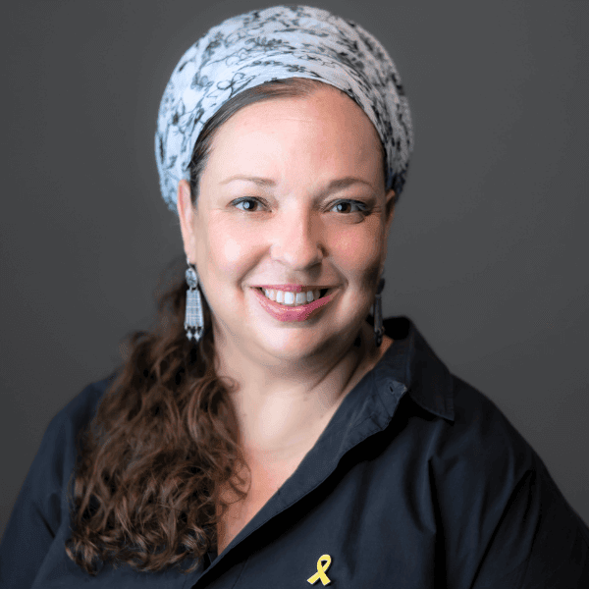

Rabbanit Sarah Segal-Katz

Transitioning from the state of *niddah* to purity requires immersion in the *mikveh*. At the same time, some women wish to immerse for reasons not required by halakhah, such as personal moments or unique events. This article presents a variety of voluntary immersion occasions and offers an invitation to transform one’s immersion into a personal celebration.

*…*

*Please, as   
I go to immerse in your waters that rest upon the structures   
of time, my heart seeks the sweetness  
 of the soul, and my body seeks wings.*

*Hovering in a wail,   
life seeps from all sides toward the abyss.  
You are once again weighing my words on scales;*

*I am seeking*

*meaning.*

From: *Prayer in the Field*, by Rotem Eldar Hibesh

Women who seek meaning during immersion, who seek the sweetness for the soul and wings for the body—may choose to immerse even at times when they are not halakhically obligated, but feel connected to the idea of a special date or personal event *that they express through the act of diving into the depths of the water.*

We primarily associate the *mikveh* with the married woman’s monthly immersion, who goes to purify herself from menstrual impurity and is thus once again permitted to return to the arms of her husband. However, the *mikveh* has long ceased to be a place for purely technical purification; it is increasingly becoming a space where a woman can connect with herself and her desires. Whether in the municipal *mikveh* building or a natural spring or the sea, *the shift in focus from the marital need for immersion to the woman’s personal spiritual need led to the creation of new customs and occasions for immersion.*

Feeling “pure” after immersion in the *mikveh,* or the experience of participating in a private women’s ritual, is often absent in modern times. Therefore, it is not surprising that immersion has become a symbol of celebration or joy. Interestingly, besides turning immersion into a joyous occasion, *this new trend also marks a personal transition from one stage to another*, even if these stages are not distinctly categorized in halakhic terms. This can include the pain or heartbreak of losing parts of ourselves that remained from a previous stage of life, or that we had to shed as we matured spiritually or physically.

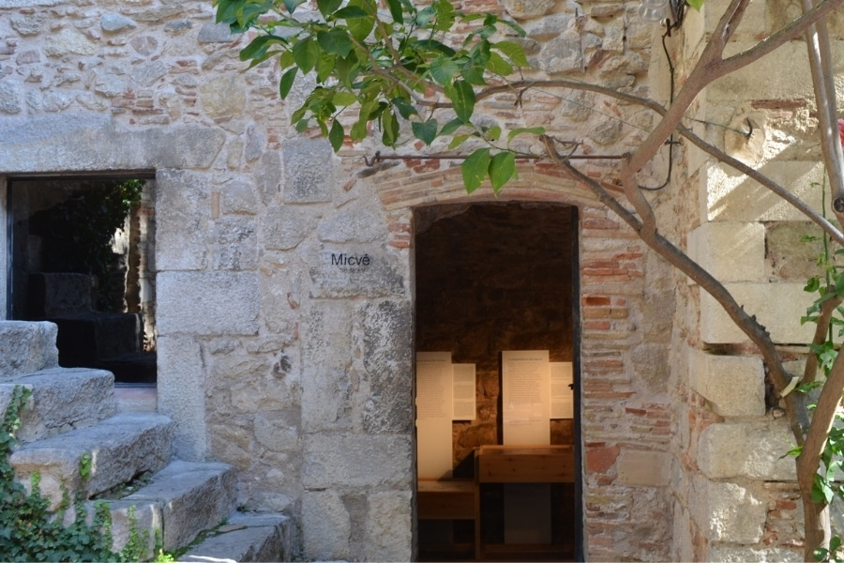The ancient mikveh in Girona. Photo: Sarah Segal-Katz

This article presents several suggestions for unique immersions, some of which are commonly practiced today, while others are proposals for expanding the immersion experience that will allow women to make personal choices. How can we incorporate the *mikveh* into our mindset regarding internal or external change? How can we make immersion present in places where it is possible, in a way that expands the heart and, hopefully, also “gives wings” – as the words of the song above suggest?

It is important to remember that when immersion is performed as a custom, as opposed to a halakhic requirement, it does not carry the same requirements as halakhic immersions. There is no need for the usual preparations of bathing, washing, and inspection, or delving into the minutiae of physical obstructions, such as jewelry or contact lenses. Custom-based (non-obligatory) immersions can take place during the day or night, in a constructed *mikveh*, a spring, or the sea. Since the main motivation is to feel the living waters and experience a sense of renewal, it is not necessary to adhere to the halakhic definitions of a kosher *mikveh*,and one can choose from among different locations. Nevertheless, most women who immerse as a custom prefer to choose a kosher *mikveh* because they perceive it necessary for the spiritual quality they seek. Either way, *it is important to know that every woman has the right to immerse in public mikvehs, and by law, cannot be asked any personal questions about their lifestyle.*

Good luck!

## Here are 12 suggested immersion customs that you can adopt:

# The auspicious immersion of friends and family members immediately after the bride.

Brides immerse in the *mikveh* before their wedding day in preparation for the wedding night. In many communities, this event is a social event that includes many female family members and friends. The bride’s immersion is a halakhic requirement, intended to purify her before having relations with her groom. However, after her immersion, the bride’s companions often enter the *mikveh* as well, for good fortune. *These companions have no halakhic reason for immersing*, as the timing is determined by the bride’s menstrual cycle, which is not necessarily synchronized with that of her companions or with societal events.

*The companions immerse in the hope of gaining a blessing and attaining good fortune*. Often, single women who have not yet found their match, or women struggling with infertility who wish for children, immerse in the mikveh as well. Another reason for immersing on this occasion is to share in the bride’s joy.

According to tradition, the bride, after her immersion, has the power to bestow blessings upon her companions, due to the special status she holds as she approaches the *huppah*.

This is an auspicious time for the companion to also wish well for the bride. Creating a good and loving relationship and family that can overcome crises and difficulties takes a lot of effort, and her companions hope that the new couple will achieve the marital goal of ultimately becoming “one person.” However, this is also an opportunity for the companion to ask, from a place of joy and happiness, for what each lacks and desires.



# Immersion for a birthday

When we transition from one stage of life to another, we leave a part of ourselves behind. We shed a layer that was too small and constricting for us, and “shed a skin” to reveal a more mature and developed version of ourselves. A birthday is one of those stages where we grow and nurture ourselves. It is very natural to include immersion when celebrating such a transition. *Immersion as part of the cycle of purity carries a symbolism very similar to transitioning from one stage of growth to the next.*

Immersion can be combined with a nature outing to a spring or the sea with friends and family members who can connect with the experience, or, even if they are less connected to the idea, who would at least respect this urge. This is how a women’s circle of wishes, blessings, and growth can be created, moving from the personal to the communal, from what is hidden in the circle of purity and intimate life of one woman to what is inherently shared among women.



# Immersion for the bat mitzvah

There is not necessarily a connection between a girl reaching the age of bat mitzvah and having begun to menstruate. Today, it is increasingly common for girls to experience their first menstruation at a much younger age than their mothers and grandmothers did. However, this is another opportunity to celebrate the girl’s journey toward womanhood.

It might be possible to celebrate a bat mitzvah from a different perspective, by recognizing the girl’s newfound ability to be responsible for the immersion of other women. The Sages established that from the age of twelve, a girl can oversee another woman’s immersion to ensure that she is fully submerged and that none of her hair floats. At this stage, even if the young woman is not immersing for herself, she becomes a participant in these discussions.

The immersion of single young women is a somewhat sensitive topic. Even though it is not prohibited, some are concerned that it may be perceived as legitimizing having relations outside the framework of marriage. Similar concerns arise in cases such as immersing before ascending the Temple Mount. However, this concern is generally significantly reduced when we discuss immersion for a *segulah* (to bring good fortune) or at the age of 12.

The custom of immersing before one’s bat mitzvah is an opportunity to gain a glimpse into the young woman’s future as a wife, and to foster a loving and joyful relationship with the *mikveh* from an early stage in her life.



# Immersion of a Young Girl Upon Receiving Her First Menstrual Cycle

The onset of menstruation marks the beginning of a girl’s sexualmaturation, and in many places, particularly for those who are more aware and feminist, there is a strong desire to acknowledge one’s first period in a way that recognizes the change occurring within her. *The question of how to celebrate a girl’s first menstruation should be addressed individually, taking into account the girl’s personality and preferences*. Some girls would be delighted with a party featuring red foods, for example, while others would feel embarrassed and wish to disappear if they found themselves in such a situation.

A celebratory immersion can be a pleasant way to mark the end of the first menstrual cycle, hinting at what the future holds. At the same time, the event remains private and can be celebrated within the intimate setting of just mother and daughter, or at most, the female family circle. Of course, any such event should accord with the girl’s wishes.

If the onset of menstruation came earlier than expected and caught the parents and the girl by surprise, leaving them unable to prepare her as they would have liked for this stage in her life, going to the *mikveh* can be a private and beautiful opportunity to initiate the conversation.



# *Segulah* immersion during the ninth month of pregnancy

Pregnancy does not require immersion. If a woman immersed before becoming pregnant and did not see any stains or bleeding, she remains in her state of purity and does not need to immerse to continue marital relations. However, she may desire to immerse anyway, given the custom and the associated blessing that accompanies it. In certain communities, it is customary for a pregnant woman to immerse in the *mikveh* during the ninth month as a *segulah* (spiritual charm) for an easy birth and a healthy baby. The custom uniquely connects the mother to her fetus, who is protected and surrounded by its mother’s waters, just as the woman in the *mikveh* is enveloped in a private, embracing womb-like space.

*You can celebrate the occasion as a loving farewell to the previous stage in your life*, whether you were a young couple, parents of just one child, or more. Every child ushers in a process of growth, an expansion of the family, heart, and strength. Pregnancy is mentally exhausting, and many women in their ninth month eagerly wait to finally give birth. Immersion accompanied by joy can focus one’s attention and provide the sense of purpose that the woman wishes to achieve.

It is important to note that, according to doctors’ recommendations, one should choose the time for immersion wisely. During the ninth month, the cervix begins to prepare for birth and sometimes starts to dilate. This is even more evident among women for whom this is not their first birth. Therefore, to avoid infections, it is recommended to schedule the immersion at the end of the eighth month or at the very beginning of the ninth month to minimize risk.  
If the woman chooses a natural setting for her immersion, such as the sea she must also take weather conditions into account to ensure they do not endanger her. In any case, when choosing to immerse in nature, one must consider potential risks, including the physical balance of a pregnant woman (especially in advanced months), to avoid any danger.

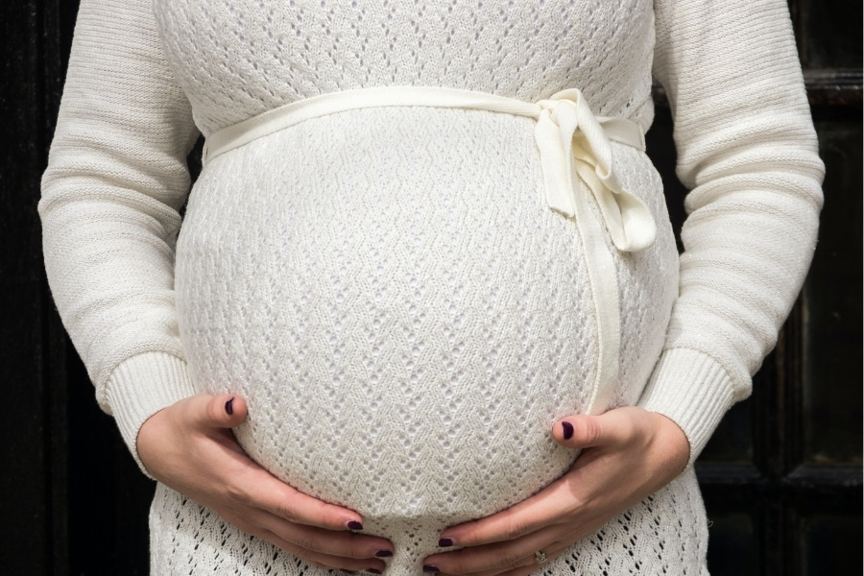Photo: Andrew Seaman

# Immersion on the eve of Tisha B'Av and the eve of Yom Kippur

Days of introspection typically urge us to seek cleanliness and purity. Although immersion at these times is irrelevant to the purity required for marital life, they pertain to a state of mind. Many men have the custom of immersing on the eve of Yom Kippur, and there is no reason for this custom to be limited to men only.

In truth, there is an old custom in some parts of the Hasidic world where women—young, mature, and elderly family members—come to immerse together on the night or day before Yom Kippur, when the men’s *mikvehs* are open for this customary immersion. Whether women today seek to continue such a family tradition or wish to adopt it anew, immersion in the *mikveh* before Yom Kippur is available to both women and men and is generally part of the religious services in cities and towns across Israel. (Not all *mikvehs* are open for this purpose; sometimes, a few are selected to serve the public in the morning hours before the pre-fast meal.)

For many, immersion on the eve of Yom Kippur symbolizes a process of forgiveness and atonement, and therefore, some have the custom of reciting a confession before entering the water. The imagery surrounding immersion and Yom Kippur is profound, hinting also at the process of conversion, where a person is reborn pure and free from sin and transgression. Additionally, it also references the work of the High Priest and the Temple service on Yom Kippur, which was performed in purity, and the desire for a person’s purity as they stand before God on the Day of Judgment.

Photo: Miss Mushroom

# Immersion after an emotionally difficult event

*The feeling of purity and transcendence that accompanies immersion, when done according to a woman’s wishes and vision, can also serve as a source of comfort*. Thus, when a woman experiences a persistent crisis or difficulty, the inward reflection, the time invested in preparing and nurturing the body, and the spiritual and emotional benefits associated with it, can somewhat alleviate the burden on the soul.

# Immersion after visiting a cemetery

A visit to the cemetery holds a somewhat unique status. Even though today we do not observe the laws concerning the impurity of the dead, some men and women experience the transition from the land of the dead to the land of the living more distinctly than others. In addition, there are those who wish to observe some sign or hint of these ancient laws, even though they are no longer part of our current reality.

Just as we customarily wash our hands upon leaving a cemetery, immersion can sharpen this transition. If the woman immersing finds it appropriate, it can even be part of the end of a mourning period or after concluding a memorial event. Such an immersion is not limited to women; it may also be relevant for men who find meaning in this symbolism and in the sense of purity associated with regulation the liminal spaces between life and death.

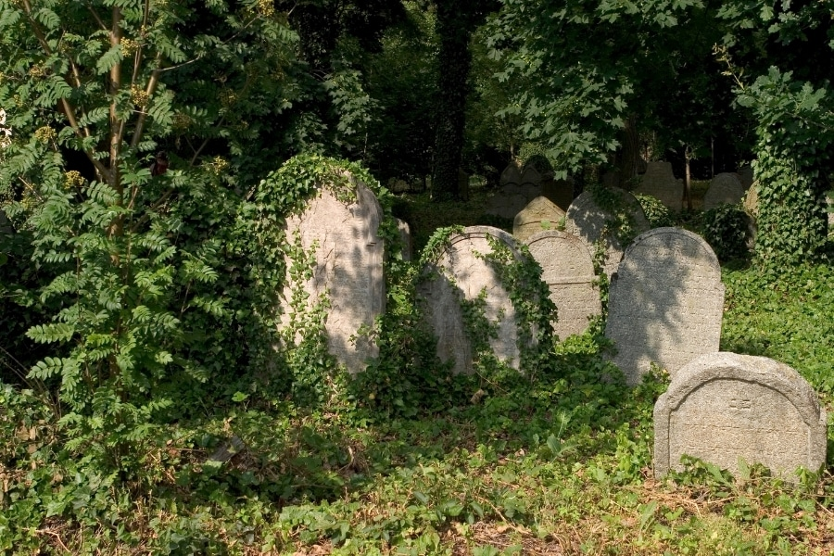

# Immersion after a miscarriage

Pregnancy loss is, above all, the loss of hopes and dreams, a fracture that wounds the trust in the body and soul of a future mother. The fact that society often struggles to acknowledge this loss, or may even be unaware of the woman’s experience of brokenness, only highlights the emptiness and void that is created, which we lack the language or tools to express. After a miscarriage and the associated bleeding, a woman will need to immerse in the *mikveh* in order to return to her husband. However, *this immersion, which the woman had only expected to take place after childbirth, serves as an opportunity to create a farewell ritual for the lost fetus*. Different women respond differently to miscarriage. Some find comfort in biological and rational explanations, while others struggle to find solace in this type of spiritual consolation and deeper emotional processing. All approaches are valid and worthy.

Immersion following a miscarriage has the potential to be triggering and may be particularly heartbreaking. It is also an opportunity to allow oneself to cry within the *mikveh*, to mourn for and endlessly love a child who will never exist. This is a sensitive space, and each woman will have her own way to cope with the situation. This immersion invites the woman who miscarried her child to acknowledge the event, not to ignore the emotional burden, and to choose whether she wants a ceremony that will address the lost pregnancy. Or does she prefer to view the immersion as the beginning of her journey toward a new and healthier pregnancy? As mentioned, all options are valid, appropriate, and important.

# Immersion after receiving a *get* (divorce document).

Beyond the rupture and loss of the marriage that once was and is no [more, the *get*](https://gluya.org/divorce-in-halachic-world/) often also signifies a departure from the cycle of purity and the routine of separation and closeness that was so dominant in the daily life of the individual woman and of the couple. Whether they separated on good terms or with immense heartbreak, immersing in the *mikveh* after receiving a get can be part of the process of rebirth and acceptance.

Such an immersion can also mark the conclusion of the divorce process itself, which can be lengthy or brief, but is almost always draining and intense even in its most efficient form. *Immersion can symbolize the shedding of accompanying residue, allowing the woman to start focusing on healing and self-rehabilitation.*

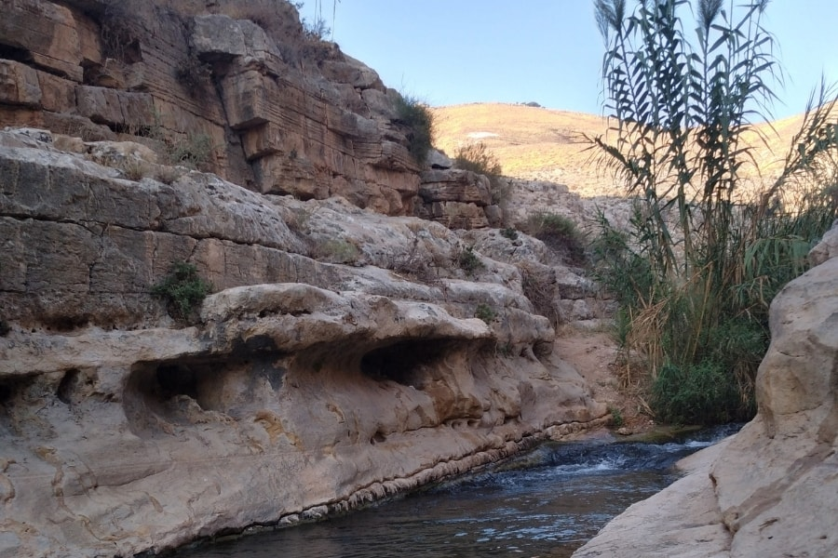Photo: Yael Israel

# Immersion as part of personal, professional, or other happy occasions

Alongside the ability to use the *mikveh* as a space for internal cleansing, immersion also presents an opportunity for deep self-celebration, where a woman places herself, her body, and her soul at the center of her celebration. The *mikveh* is a space where she can celebrate joyous occasions by traditional means, even if these celebrations are not traditional at all, such as receiving a promotion at work or any other achievement that fills her with pride and joy.

It is certainly possible to include friends in the celebration, to immerse together in a spring or the sea. This will incorporate the circle of female support into the event, so long as the companions participate with an open heart and not with envy. *The connection of joy to water, and the vitality within it, can provide an opportunity for deep conversations and even sharing with others moments of happiness or emotional experiences that they previously did not allow themselves to celebrate*.



# The last immersion

There is no clear and definitive moment when a woman realizes that her gynecological system has completed its function. Throughout the years of transition, she knows that every trip to the *mikveh* might be her last. Even when a woman has not visited the *mikveh* for many months, she cannot be certain whether she will no longer need to immerse or whether she will still come to immerse at very irregular intervals that are hard to predict.

A woman accustomed to visiting the *mikveh* develops a certain relationship with immersion, ranging from indifference to appreciation, from desiring her privacy to considering her personal and marital processes. Consciously or unconsciously, her arrival at the *mikveh* revealed information about her biological status, both related and unrelated to fertility. Therefore, *a woman’s cessation from going to immerse indicates a broader change that has occurred in her body*. Some women feel that they want to have a sort of farewell to the ritual itself, while others wish to combine this with a tangible farewell to the parts of her body that are no longer governed by the uterine cycle.

Photo: Tamar Herzberg-Shosiov

## Say: Water, water

*And only when we descended into the pit  
...*

*we suddenly heard*

*our lives, from the other side,*

*stirring gills.*

From *"Immersion" by Sarah Shekel*

This article suggested several occasions – be they celebrations or challenging events—that can be marked by immersion in a *mikveh*. Even though it may seem like a contradiction, this is not so surprising. Water can hold everything. Your *mikveh* experience will be whatever you wish it to be. You are the one who gives it the meaning and interpretation you desire. The ability to incorporate the living waters of the *mikveh* into our lives is also an opportunity to recognize the importance that fleeting moments hold for us. *Too often, women ignore or downplay significant moments, even important or distressing ones. This is an opportunity and an invitation to live according to a different schedule, where the internal rhythm matters*. The personal agency that women take for themselves is significant, allowing them to view life with an awareness of the stages they live through.