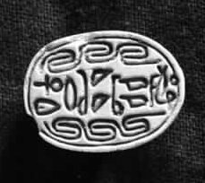
Scarab (Egyptian seal). The text reads: "Yaqub Har" - the name of the king of the Hyksos.
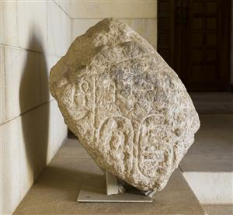
A fragment of Shishak's victory stela bearing his name.

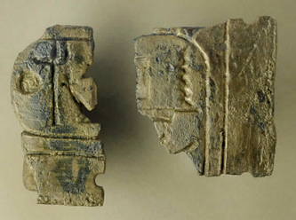
Fixture to a Canaanite temple door. One of Ramses III's titles is engraved on the fixture. Many Egyptian elements were incorporated into the temple in Canaan as part of Egypt's influence in the region. Bronze, Lakhish, Iron I, 1200-1000 BCE.
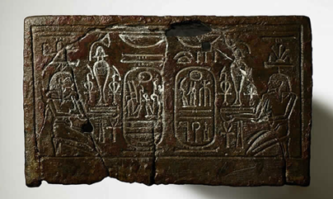
Base for sculpture. On the base stood a statue of Ramses VI.
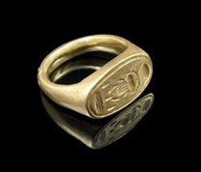
Seal ring bearing the name of "Tutankhamun" - one of the Pharaohs of Egypt.
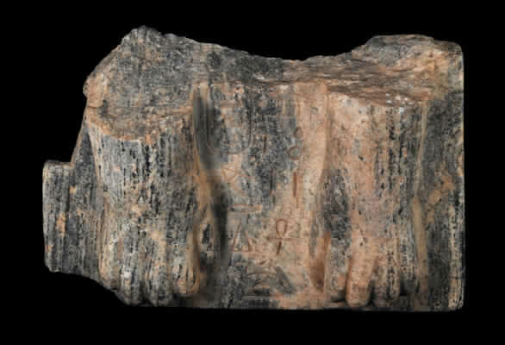
A fragment from a Sphinx sculpture. The Sphinx belonged to one of Egypt's earliest pharaohs (c. 3000 BCE), the owner of the small pyramid in Giza, and was probably sent as a gift to the ruler of Hazor by one of the later pharaohs of Egypt. Although the Egyptian pharaohs saw the Canaanite rulers as inferior to them, Hazor - the largest and most important of the Canaanite cities - was considered worthy of this gift.

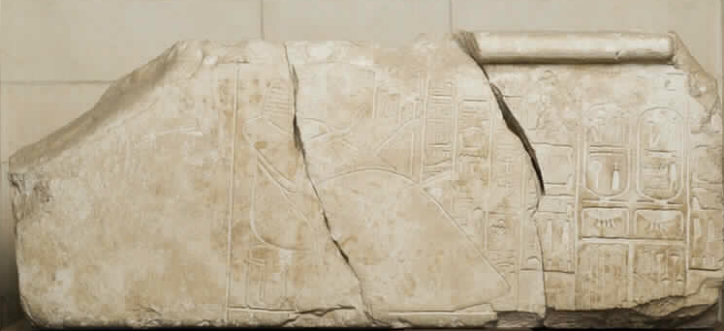
A lintel from the Egyptian governor's house in Beit Shean. The governor is depicted on the doorpost as admiring the name and titles of Ramses II. The governor is identified as the royal scribe and headmaster of Ramses's household.

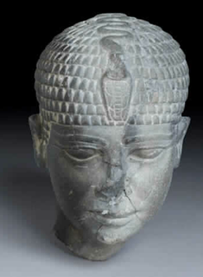
The head of a statue of Pharaoh (20th century BCE) was sent to the king of Hazor by later pharaohs (fourteenth century BCE) as part of a diplomatic process of gift exchanges.
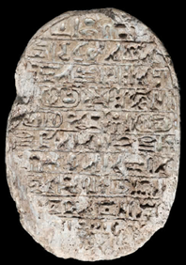
Commemorative scarab of Pharaoh Amenhotep III.
The scarab commemorates the arrival of the princess of the kingdom of Mitanni to Egypt for the purpose of a political marriage with Pharaoh. At the time of Amenhotep there was peace between Egypt and the kingdom of Mitanni. Commemorative scarabs served as a means of propaganda for the Egyptian court.
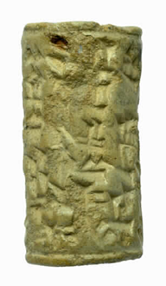
Letter written in cuneiform script on cylinder seal.
The text states: “Tell my lord Labaya: A message from Ta’agi:
To the King my Lord: I heard your message…”
Ta’agi was the king of the city of Gat Carmel and the ally of Labaya.
In the archives that were uncovered in Amarna, Egypt, letters were found from the kings of Canaan who accuse Labaya, King of Shechem (one of the three major cities in Canaan) of undermining Pharaoh and taking over the lands of other cities, including the lands of Pharaoh in the fertile Jezreel Valley. Following Pharaoh's demand, Labaya was captured by the ruler of Megiddo, then fled and was murdered by the inhabitants of the city of Gina (Jenin).

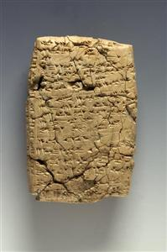
A cuneiform tablet from the city of Ugarit.
The governor of the city of Ugarit (Syria, the Hittite Kingdom), al-Hiya, was a senior Egyptian official. In the letter, the governor wishes to conclude a deal, mainly involving the sale of wheat originating from Canaan to the Hittites, transported through the ports of Acre and Jaffa. In the thirteenth century BCE, Ramses II made a covenant with the Hittites and supplied them with wheat from Canaan.

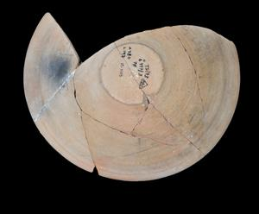
A bowl from an Egyptian stronghold at Tel Shera. The bowl bears an Egyptian inscription documenting a tax plan for religious institutions during the reign of Ramses III. Pottery, ink.

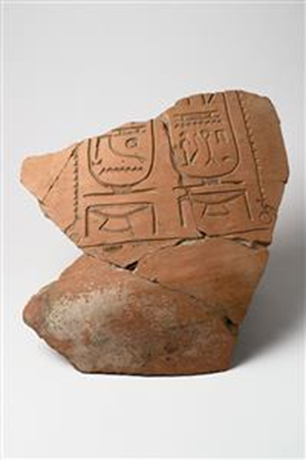
Fragment of a jar bearing an Egyptian inscription. The jar bears the name and description of Pharaoh Seti II. The fragment was found in the Egyptian governor's house and apparently came from the kingdom's warehouses in Egypt.

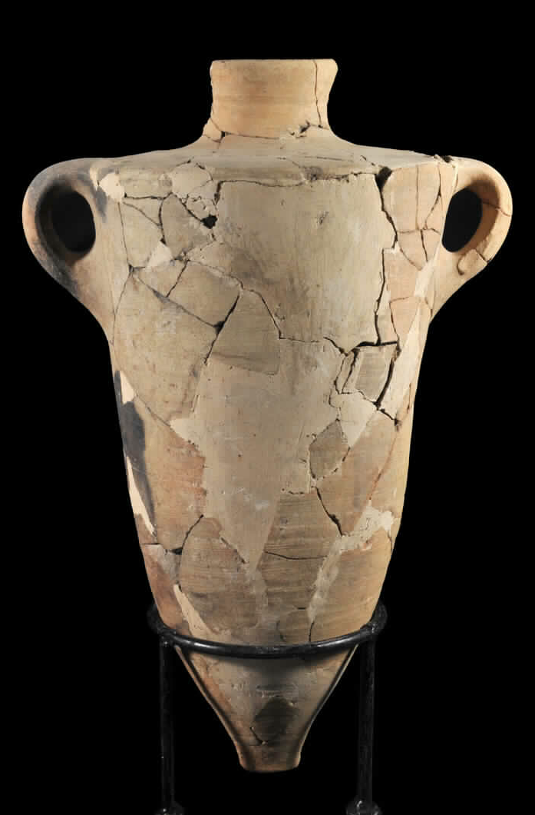
A Canaanite jar. Such jars, similar in size, were manufactured in Canaan to transport goods at sea. Because of their advantages, they were used to contain agricultural produce that was transported as a tax payment to Egypt.

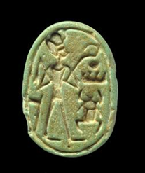
Scarab (Egyptian Seal)
The scarab depicts Pharaoh Thuthmose III holding symbols of rule.
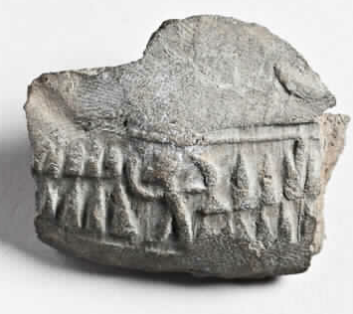
Bulla (seal). Bullae were used to seal small bags and containers. About 100 Egyptian bullae, apparently used to seal goods, were found at the site at Ein Ha-Besor, where an Egyptian merchants' colony was located.

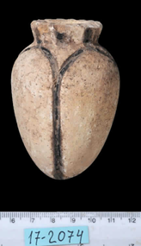
A flask shaped like the lotus blossom
Faience is an artificial material made by the Egyptians. Tools of this material were considered luxury vessels and were exported to neighboring countries.

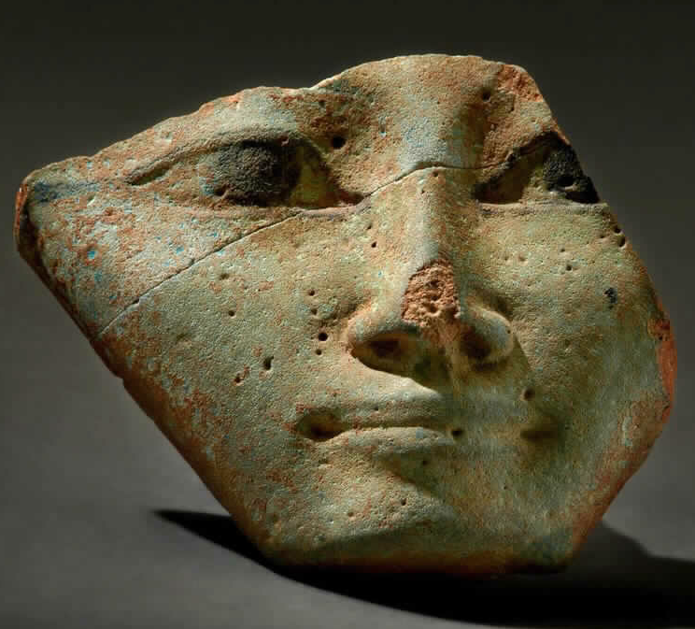
A mask in the shape of the goddess Hathor. One of the titles of the Egyptian goddess is 'Lady of the treasures of the foreign lands.' The goddess was patroness of the mines in Timna, where the Egyptians built a temple for her.

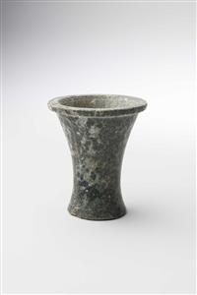
Egyptian Serpentine Cup. This type of stone is found in Egypt, but not in Canaan. Tools from this stone came from Egypt to Canaan.
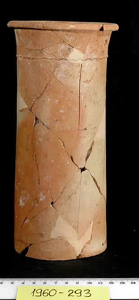
Cylindrical tool.
An Egyptian vessel from the merchant colony of Tel Erani.

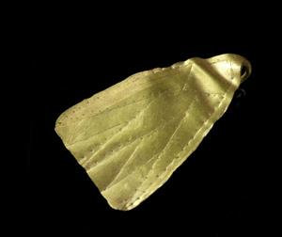
Pendant decorated with engraving, floral pattern, lotus flower.
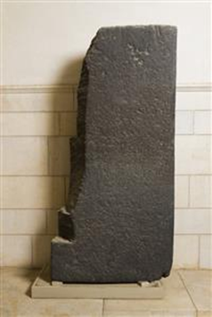
Victory stela. The stela commemorates the victory of an Egyptian unit (apparently from one of the strongholds) in the battle against nomads called '‘Apiru'. The latter attacked a tribe known as the 'Sons of Asia' (an unidentified group). The ‘Apiru are mentioned in the al-Amrana archive as rejected groups at the margins of society that harassed and robbed the townspeople.

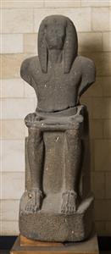
Statue of Ramses III.
In a temple in Medinet Habu in Egypt, Ramses notes that he defeated the sea nations (including the Philistines) who tried to invade Egypt. He placed the prisoners as mercenaries in fortresses on the Egyptian border. It is possible that the Egyptian fortresses in Canaan were also populated by seafaring nations and other mercenaries.

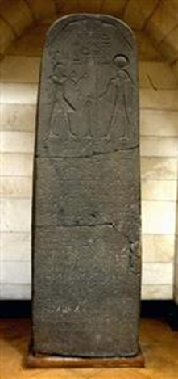

Victory stela. The stela commemorates a military campaign aimed at suppressing the revolt of Canaanite cities that took place during the reign of Pharaoh Seti I. In this account, Seti I stands before the god Ra and thanks him for the victory. The cities that formed an alliance to rebel against Egypt are mentioned in the text: Pella (Jordan), Hamat, Beit Shean, and Rahov and Yenoam.

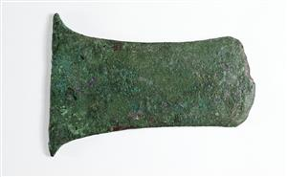
Egyptian axe

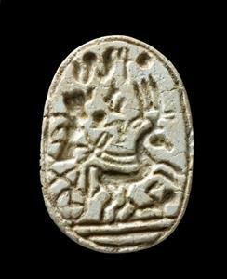
Scarab (Egyptian seal).
Pharaoh Ramses II stands on a chariot. His enemy lies beneath the horse. The chariot was brought to Egypt by the Hyksos.

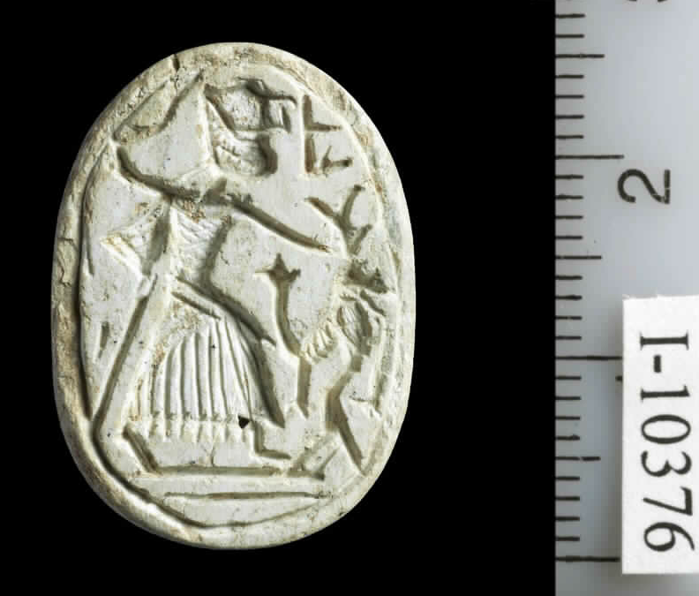

Pharaoh holds a sickle sword and strikes an enemy.

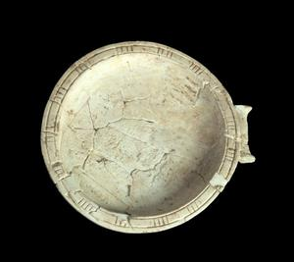
A cosmetics bowl

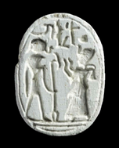
Ramses II worships the god Ra, one of the main gods in the Egyptian pantheon.

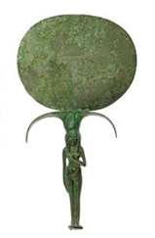
Hathor was considered the goddess of beauty and femininity. Mirrors were used in her ritual worship.

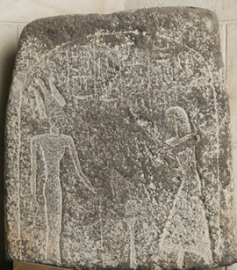

Burial stela. The owner of the stela stands in front of the goddess Anat. Between them stands a table of offerings with a lotus and jug. Anat was considered a Canaanite warrior and a protector of Pharaoh's troops.

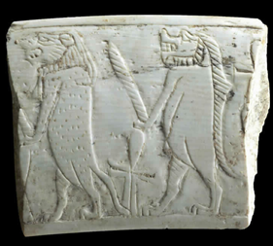
Broken magic wand. Magic wands were used in ceremonies to protect against demons.

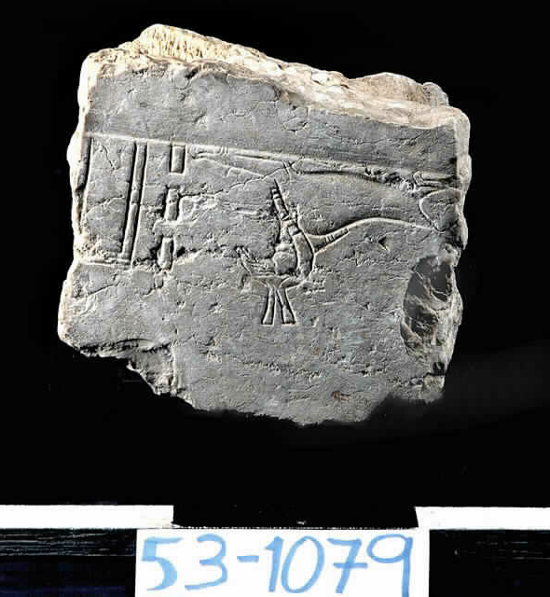
A stela fragment engraved with the figure of the god Seth.
The stela was found in Canaan in an Egyptian stronghold where Seth was worshiped. Ramses II transferred his capital to the Nile Delta, where the capital of the Hyksos was located 300 years earlier. Seth was the patron of the capital city Pi-Ramses.
Stone, al-Qubaybah, Late Bronze, 1550-1200 BCE.

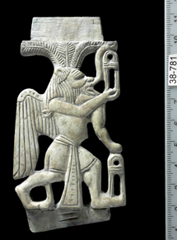

Inlay in the shape of the Egyptian god Bes.

-------------------------------------
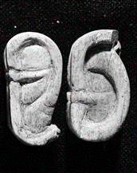

Ear of bone
Such ears were brought to the gods as a gift, so that they would listen to the believer and respond to his requests.

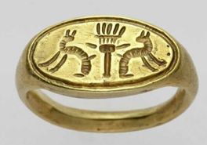

Ring decorated with musical instrument (sistrum) and cats.
Dance, music, and sexuality, as embodied in the cat, are aspects of the goddess Hathor.
Gold, Tell el-'Ajul, Late Bronze, 1550-1200 BCE

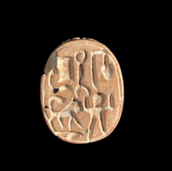
Scarab (Egyptian Seal)
The caption reads: "Ptah loves those who love him." Found in an Egyptian shrine to the god Ptah linked apparently to Ashkelon.
Steatite, Bet Shean, Late Bronze, 1550-1200 BCE

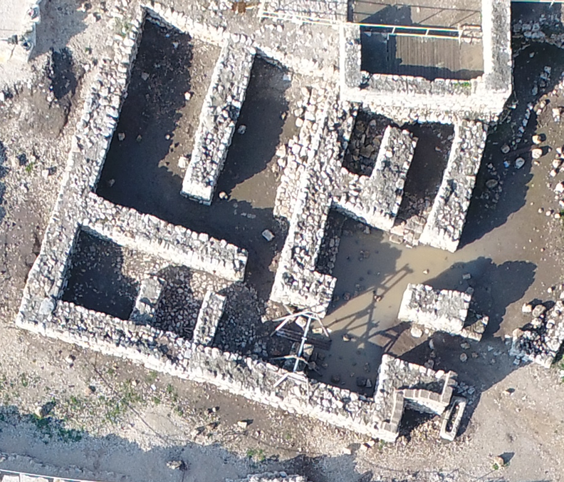

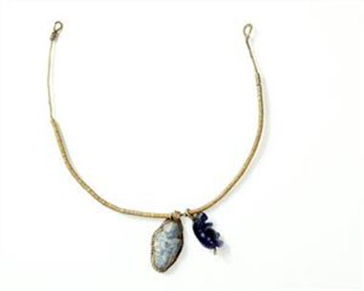
Beaded necklace with pendants. The goddess Taweret depicted as a hippopotamus - patroness of births. And the god Bes? patron of infants.

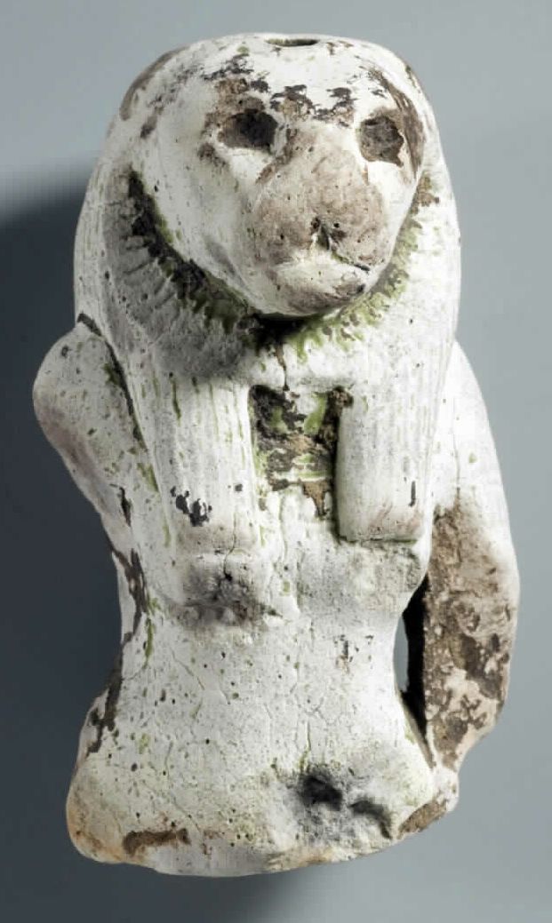
An amulet in the form of the goddess Sekhmet, depicted with a lioness head. This is the goddess of war, and it was believed that she also fought diseases. Her priests were considered healers.

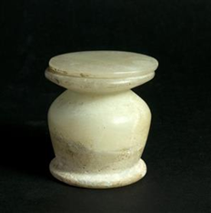
A vessel for ointments

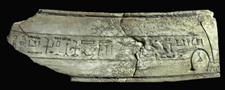
Inscribed ivory plaque depicting a singer of the temple of the god Ptah in Ashkelon, requesting the god to supply meat for her ka (soul). Such requests were part of the burial process to ensure food supplies for the dead.

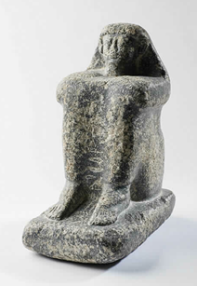
A figurine with inscription: Honored by the god Ptah-Soker, the supervisor of the workers, Huraba. The god Ptah-Soker was associated with burial ritual. Such statues were placed in the temples to bring the dead closer to the god and allow the deceased to share offerings. ‘The honored one’ is the title of the deceased. The statue is found in a Hyksos tomb and not in its original owner’s grave.

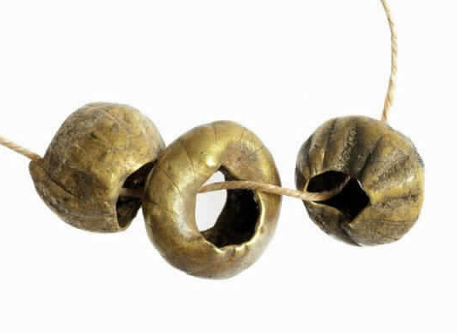
Gold beads. These beads were found in a tomb. Gold is considered the very flesh of the Egyptian gods. The fact that it is not biodegradable symbolized eternity to the Egyptians, hence its importance as part of the jewelry of the dead.

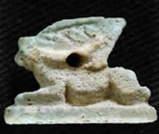

A rabbit amulet. The rabbit is characterized by speed, alertness, and fertility. Due to its qualities, rabbit charms were placed in the graves to provide the dead with regeneration power.
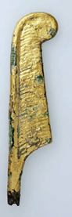
Fragment of a statue. The quill is the symbol of the goddess Maat, before whom the dead were brought to be judged.

