**Banners:**

1. Beresheet – a luxurious living experience in the Judean Hills
2. Beresheet – creating a community of the highest standard
3. Beresheet – assisted-living facility of the highest level
4. Beresheet – becoming a part of a new living experience
5. Beresheet – an innovative habitation concept for seniors
6. Beresheet – a luxurious residential community out in nature
7. Beresheet - a residential community of a standard you’ve never experienced
8. Beresheet – creating a new residential community together

**This is your time to live better**

Beresheet assisted living facility – a living experience for seniors located in the Judean Hills – a standard like you’ve never experienced

**Schedule an intro meeting before everyone else**

Full name:

Phone number:

**Send**

Or dial *2349

Beresheet, the place for new beginnings

For the first time in Israel, in the pastoral Motza neighborhood (on the outskirts of Jerusalem) a communal retirement experience for seniors who wish to become part of a community that allows each and every member to fulfill themselves, both as individuals and as a community. You are invited to make an influence and become active members in decision making, in choosing cultural activities and in participating in the household management. All of this while you are surrounded with interesting people of the highest quality in a luxurious complex, which would allow you to experience your best years in a warm, supportive and intimate place – unlike anything you have known before.



**This is your time to improve your quality of life**

An extensive amount of thought was put into the creation of Beresheet, in order to create a place full of experiences that would allow you a luxurious, advanced quality of life. A semi-Olympic swimming pool, an innovative gym, a splendid recreation hall, a wide variety of recreational activities, a prestigious synagogue – all these facilities and more are at your service so you could enjoy everything the good life has to offer, every single day. The green spaces, the friendly coffee shop, and the historic nature reserve, which is open to the public, would allow you to enjoy the open environment with friends, family, and the local community.



**This is your time to do what you really love**

After years of taking care of everyone around you, the time has come to put yourself at the center. This is your time to dare and fulfill your desires, discover hidden talents, expand your horizons, make new friends. Join us and become a part of a strong, engaged community, and discover a great variety of cultural and social activities, a house in which every tenant could take pleasure in habits of their personal preferences and the lifestyle that suits them best.

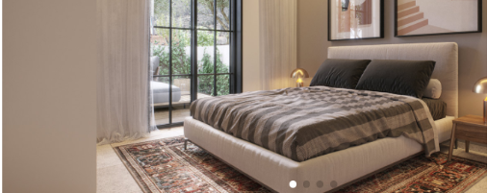

**This is your time to feel at home**

The house includes 300 apartments built in high quality building standard, with gardens or terraces overlooking a stunning view. Each apartment includes double bathroom and toilette, in the event a future caretaker may be needed in the unit. Each apartment is equipped with smart home technologies and designed with most consideration, to make you feel you live in a home that is made uniquely for you.

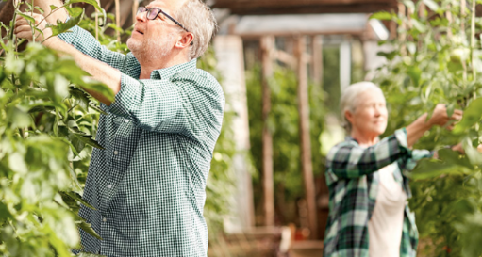

**This is your time to be a part of familial community**

Beresheet is the flagship project of the House of Lichak group, a group with 30 years of experience and professional reputation with senior living solutions. We are proud to be the first group in Israel to introduce a new, up-to-date way of living for senior citizens, by breaking the traditional structure of assisted living facilities, and creating a community living experience of a particularly high level. We consider the personal contact as the most important factor: we know each and every resident personally, and we do our best to listen to what you have to say and build a supportive community together, an environment you can call home.

**For the first time in years, a new retirement housing in Jerusalem**

100% personal care * 30 years of experience * A housing experience you’ve yet to live * 5 minutes’ drive from the city of Jerusalem * A community center * Breathtaking view * Endless possibilities to fulfill yourself

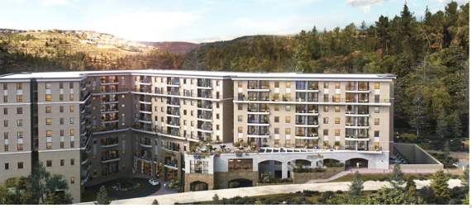

**This is your time to feel safe**

Knowing that a happy, secure and fascinating life must start with a healthy life, the house provides its tenants with a variety of medical services, including an innovative nursing department, close medical supervision around the clock, and a recovery unit, so you wouldn’t need to change your place of residence. The house has everything it takes to provide you security and peace, in order for you to achieve quality of life and longevity.

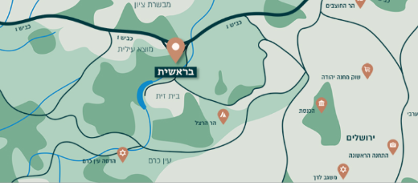

**This is your time to be close to everything**

Our house is located within 5 minutes’ drive from Jerusalem and 40 minutes’ drive from Tel Aviv, in the very heart of Motza – a community village, a provincial, long-established and affluent place surrounded with green, magical mountains. The state is nowadays in the process of paving Highway 16, a new road that will provide an additional entrance to Jerusalem, as well as direct access to the south and central sections of the city, and a direct exit to Tel Aviv.

**Schedule an intro meeting before everyone else**

Guarantee your place in the newest assisted-living facility in Israel

Fill your details and we will contact you as soon as possible

Full name:

Phone number:

E-mail address:

**Send**

* Motza, Jerusalem • call us now • [shirim@lichak.co.il](mailto:shirim@lichak.co.il) • follow us!