**Schedule of online lessons**

|  |  |  |  |  |  |  |  |  |
| --- | --- | --- | --- | --- | --- | --- | --- | --- |
| **8** | **7** | **6** | **5** | **4** | **3** | **2** | **1** | **Lesson No.** |
| Digestive System  group task)) | Digestive System | Respiratory system  (group task) | Respiratory system | States of Matter  (group task) | States of Matter | Animals  (group task) | Animals | **Subject** |
| Forex Horizon Website  Digital Content Unit  ((See screenshot No. 8) | Forex Horizon Website  Digital Content Unit  ((See screenshot No. 7) | Forex Horizon Website  Digital Content Unit  (See screenshot No. 6) | Forex Horizon Website  Digital Content Unit  ((See screenshot No. 5) | Forex Horizon Website  Digital Content Unit  ((See screenshot No. 4) | Forex Horizon Website  Digital Content Unit  ((See screenshot No. 3) | Forex Horizon Website  Digital Content Unit  ((See screenshot No. 2) | Forex Horizon Website  Digital Content Unit  (See screenshot No. 1) | **Learning materials** |
| Digitized task in a collaborative door to arrange digestive system components  (See exhibit) |  | Shared Word page for labeling an illustration  (See appendix) |  | Task panel for collaboratively collecting examples of materials in different states of matter  (See appendix) |  | Google Docs table for animal sorting  (See appendix) |  | **Cooperative task in the online lesson** |
| Appendix 4 | Appendix 4 | Appendix 3 | Appendix 3 | Appendix 2 | Appendix 2 | Appendix 1 | Appendix 1 | **Detailed lesson plan location** |

**Example lesson plan including communication skills**

**Online lesson plan for lessons No. 1 & 2**

|  |  |
| --- | --- |
| Lesson planning | **Component** |
| Fifth-grade students | **Target audience** |
| Two lessons of 90 min each | **Time frame (minutes)** |
| The lesson belongs to a learning sequence about the animal world.  The sequence includes lessons about animal habitats, characteristics, and subsistence needs.  Learning continuity is provided with the online lessons on the topic of animal matches and the invertebrates and invertebrates. | **Lesson-technological environment model in class** |
| Describe the animals’ adaptations to the environment in which they live.  Describe the common characteristics of insects and mollusks – the invertebrates.  Describe the common traits of fish, amphibians, reptiles, birds and mammals – the vertebrates.  Concepts:  Living environment, body structure, behavior.  Invertebrates: insects, molluscs.  Invertebrates: fish, amphibians, reptiles, birds, mammals. | **Content goals** |
| Using a variety of communication tools.  Media and information literacy: finding and assessing information, visualizing and illustrating, using multiple information formats (text, image, voice, copyright).  Communication skills: e-mail, collaborative editing.  Thinking and problem-solving: identifying a problem, defining the need for Information to solve the problem, displaying a solution space.  Interpersonal skills and collaborative work: collaborative editing, building common knowledge in a file, on a website, in a discussion group.  Independent learning while maintaining ethical and network-protected conduct during the internet tasks: independent learning, learning while receiving feedback, learning while building knowledge. | **21st-century skills** |
| Introducing the theme Environmentally Friendly for 5 minutes.  Intermediate summary of 5 minutes.  Frontal explanation of 10 minutes.  Viewing animal examples for 10 minutes.  Lesson 1 consists of individual work carried out by each student on the Horizon website http://ofek.co.il on a task in the digital content unit "Environmentally friendly animals," entering the Horizon website with to each student's personal password. Duration: 15 minutes.  Building on Lesson 1, Lesson 2 deals with the subject of animal taxonomy.  Lesson 2 includes two tasks related to vertebrates and invertebrates.  1. Task on the Horizon website <http://ofek.co.il> – 15 minutes  2. Collaborative assignment; at the end of the class students present their group product – 30 minutes. | **The structure of the lesson and the course and organization of the learners** |
| Thinking and problem-solving: identifying a problem, defining the need for Information to solve the problem, displaying a solution space.  Media and information literacy: finding and assessing information, visualizing and illustrating, using multiple information formats (text, image, voice, copyright). | **Prerequisites** |
| Online tasks prepared by the teacher:  1.Teacher sends students an assignment on the Horizon website: students submit solutions to the teacher individually at the end of the lesson to receive feedback.  2. The teacher instructs the student groups on a collaborative assignment; students submit solutions as a group.  Students receive group feedback on their product; the product evaluation reflects the attainment of lesson objectives regarding content and 21st century skills. | **Lesson product** |
| Incorporating multiple representations of the same information to address cognitive style variance.  Providing diverse and ranked tasks  Application for continued learning and permission tasks at the Ofek site. | **Addressing variance in the lesson** |
| Reference to learning outcomes and learning processes: remarks for teaching and return to teacher, reflective summary of the learner, peer assessment in the plenum, evaluation using the product. | **Assessment method (learning and product)** |

**Screenshot No. 1**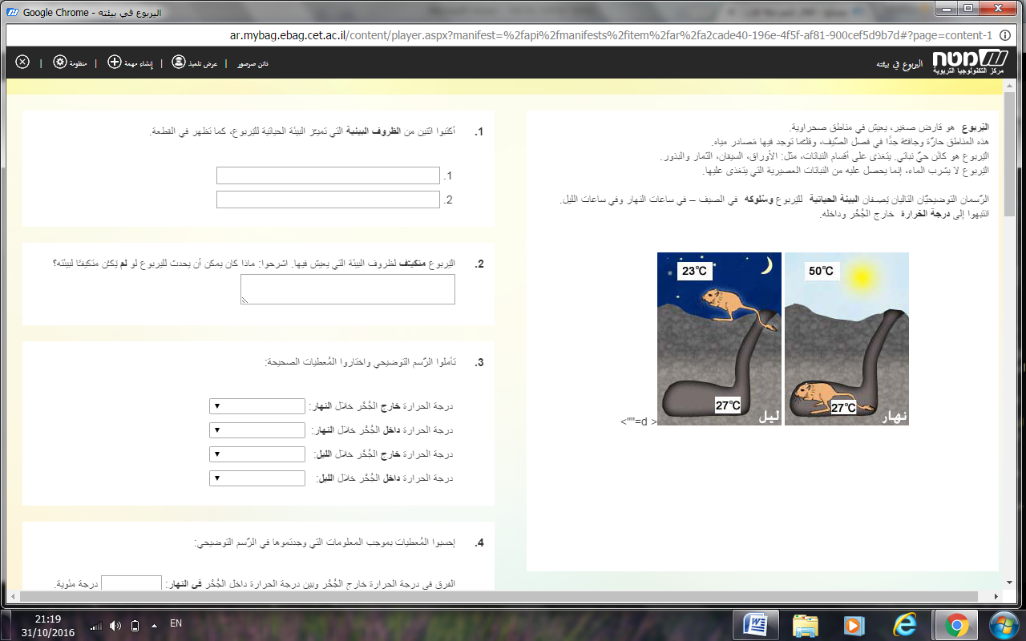

**Screenshot No. 2**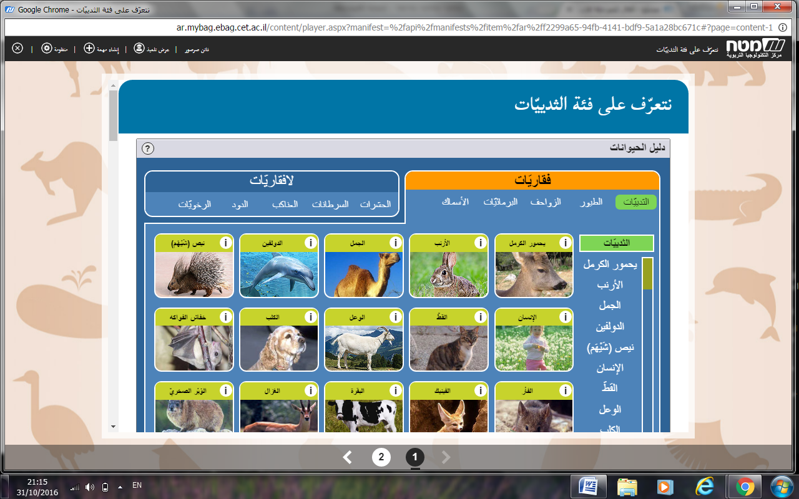

**Screenshot No. 3**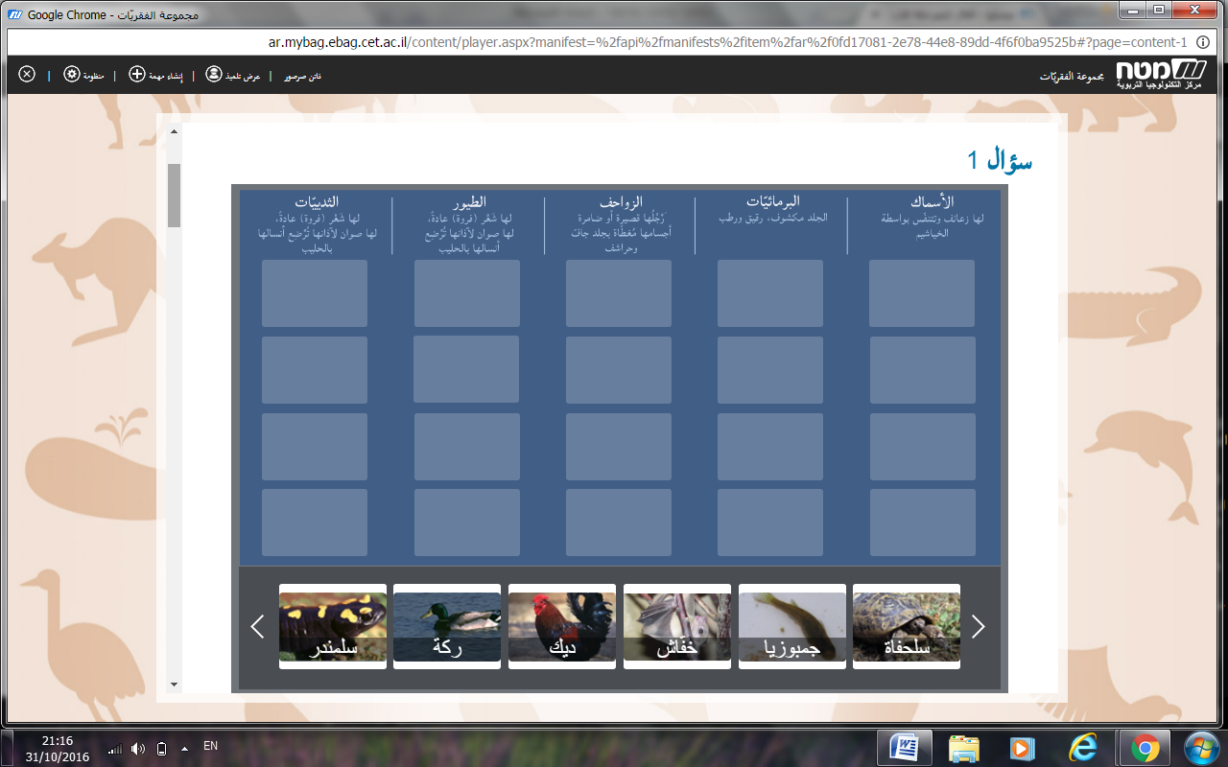

**Animals (vertebrates and invertebrates)**

Each group chooses one of the categories below and identifies the animals that belong to it.

**1.**

a) Assign the following animals to the appropriate categories:

**eagle, ant, snake, frog, comb, cat, bulb, salamander, crocodile, mullet, dog, lioness, turtle, dory, cockroach, gymnast, toad**

b) Add the names of the animals to your chosen category below.

|  |  |  |  |  |  |
| --- | --- | --- | --- | --- | --- |
| **Birds** | **Reptiles** | **Fish** | **Amphibians** | **Mammals** | **Insects** |
|  |  |  |  |  |  |
|  |  |  |  |  |  |
|  |  |  |  |  |  |
|  |  |  |  |  |  |

**Screenshot No. 4**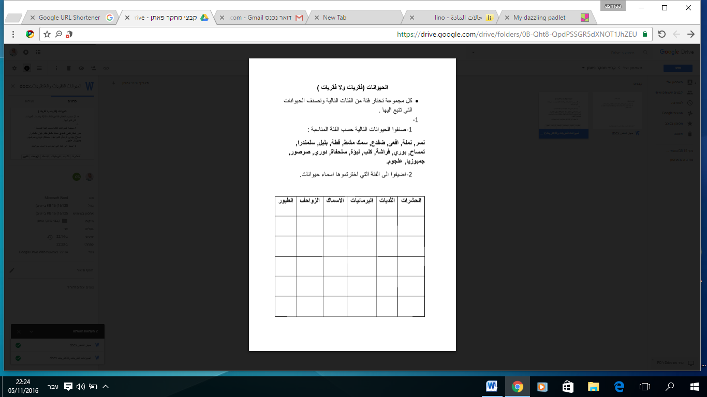

<https://drive.google.com/file/d/0B-Qht8-QpdPScklmZC1MWlFRM00/view?usp=sharing>

<https://goo.gl/DoBqwF>

**Exhibit**

**States of matter**

**Event Instructions:**

Each group gives examples of solid, liquid and gaseous substances on the shared board in the online environment.

**Screenshot No. 5**

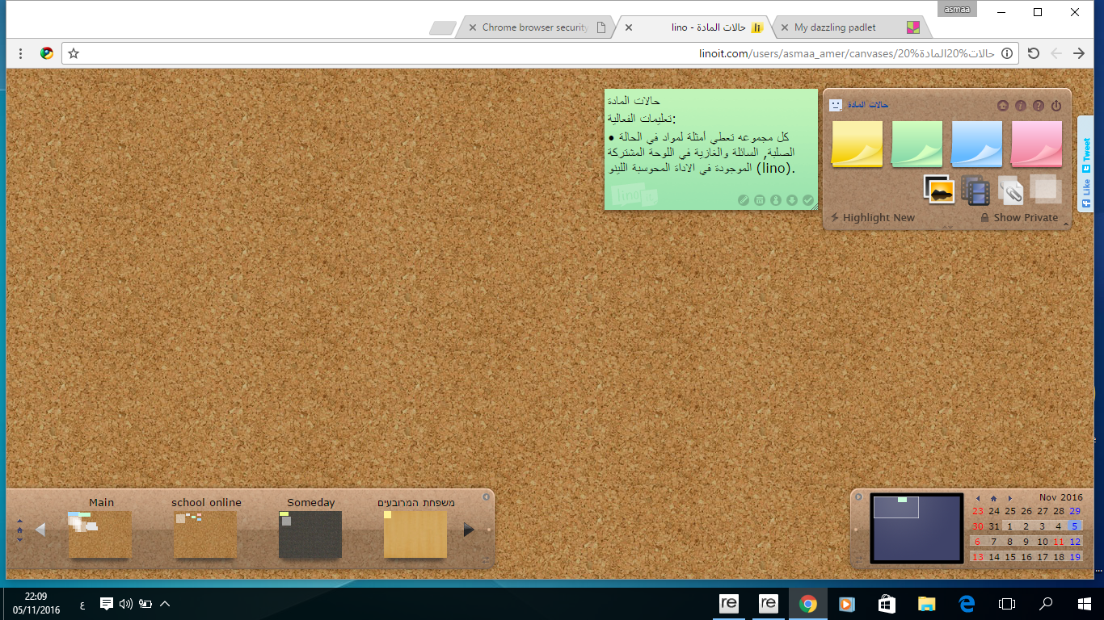

<https://goo.gl/k1rZBs>

**Respiratory system**

**Event Instructions:**

**1.** In front of you is a picture of the respiratory system. Write the following members into the appropriate square.*

**2.** Choose a member and search for information in the Google search engine to describe its structure and function.

**\*Image from Google Images showing arrows extending from empty squares to organs.**

|  |  |  |
| --- | --- | --- |
| **Occupation** | **Building** | **Member name** |
|  |  |  |

**Screenshot No. 6**

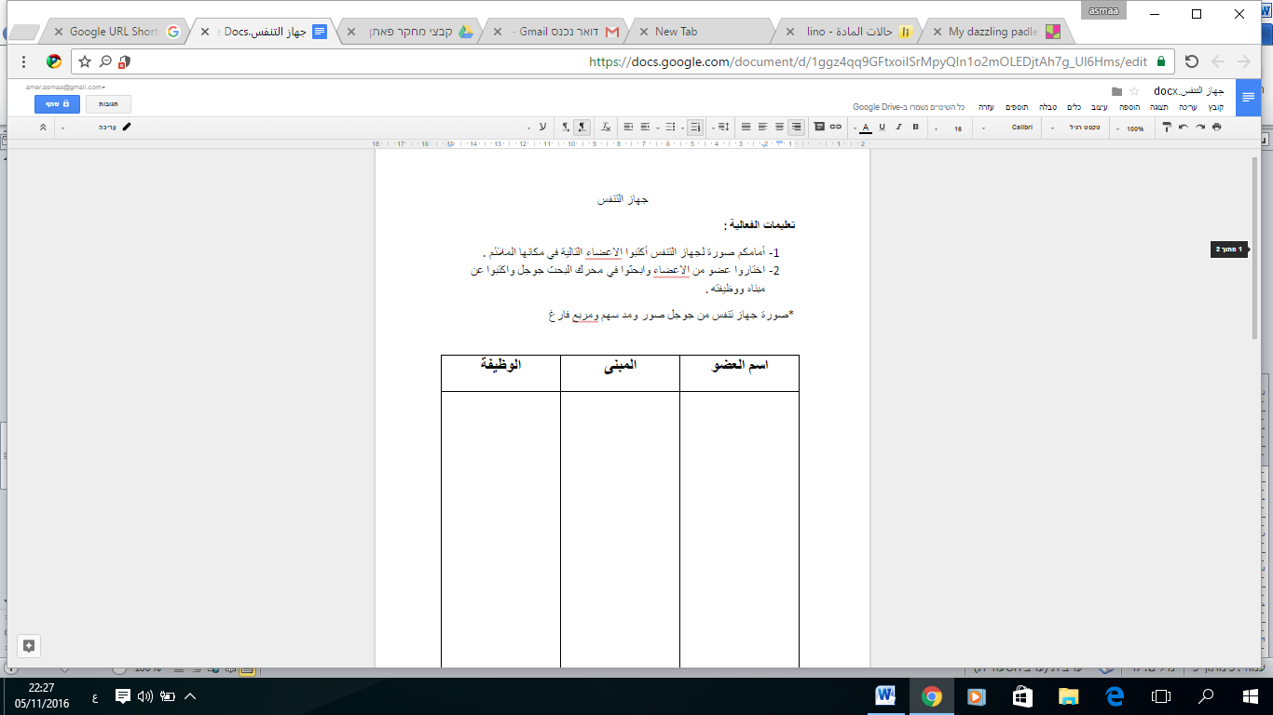

<https://goo.gl/II0JHC>

**Screenshot No. 7**

