**Banners:**

1. Beresheet – A New Senior Living Community in **the Jerusalem Mountains**
2. Beresheet – A New Senior Living Community of the Highest Standard
3. Beresheet – Renewal
4. Beresheet – Take Part in a New Experience of Living
5. Beresheet – A New Paradigm for Seniors
6. Beresheet – A Senior Living Community in the Heart of Nature
7. A Luxury Senior Living Community in the Jerusalem Mountains
8. Beresheet – Creating a New Senior Living Community, Together
9. A New Community for Those Looking for Continued Engagement and Belonging

Impact

Creating Continued Community Engagement in a New Senior Living Community

Think About Tomorrow

Landing Page:

**This is the Time to Plan Your Tomorrow**

Beresheet – A new Senior Living Community **in the Jerusalem Mountains,** in Israel

This is your opportunity to be part of a unique, involved, and active **senior** living community **in the Jerusalem Mountains**

A new senior living community is being established in the Jerusalem Mountains.  
Beresheet will offer a high standard of living and exceptional facilities in the perfect location, where you’ll be surrounded by friends committed to fulfilled living.  
Beresheet is the best place for residents who want to enjoy a breathtaking view, green meadows, and self-fulfillment in a warm and supportive community.

Beresheet – This is Your Time

**Move In - 2023**

**Contact us for more information**

NAME

PHONE

EMAIL

**Send**

Or dial *2349

Come enjoy a high standard of living and luxury facilities in the perfect location with a spectacular view, friends, and a sense of fulfillment.

For details

2349*

Beresheet, the place for new beginnings

For the first time in Israel, in the pastoral town of Motza in the Jerusalem Mountains, we are offering a retirement experience for seniors who wish to be part of a community, allowing each and every member to reach their full potential, as individuals and as a community. Our residents are invited to become active members in the community, taking part in decision-making, choosing cultural activities, and participating in the management of the senior living community. Beresheet offers a high standard of living and luxury facilities in the perfect location, surrounded by friends, allowing you to experience your best years in a warm and supportive community. This is truly a unique experience, unlike anything you’ve seen before.



**This Is Your Time to Enjoy a High Quality of Life**

An extensive amount of thought was put into the design of Beresheet, in order to create a place that allows you to lead the highest quality of life – a life of luxury and full of experiences. Our facilities include: a semi-Olympic swimming pool, a one-of-a-kind gym, a beautiful synagogue, a highly decorated recreation hall, and a wide range of leisure activities – soyou can enjoy these services and more, every single day. The green spaces, the friendly coffee shop, and the historic nature reserve, which is open to the public, will allow you to experience the open environment with friends, family, and the local community.



**This is Your Time to Do What You Really Love**

After years of taking care of everyone around you, it is time to focus on you. This is your time to be daring – to fulfill your desires, discover your hidden talents, expand your horizons, and make new friends. Join us, and become a part of a strong, engaging community. Discover a wide variety of cultural and social activities, in which everyone can enjoy their personal preferences and lead the lifestyle that suits them best.

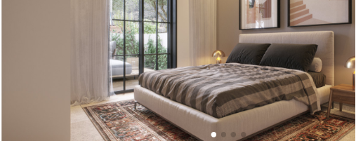

**This is Your Time to Feel at Home**

Luxurious garden apartments or apartments with balconies overlooking a spectacular Jerusalem view - all options are available. Every apartment includes fully equipped double bathrooms, to allow for a future caretaker if needed, as well as smart home technologies. The architectural design takes full advantage of the unique landscape of the Jerusalem Mountains, while creating intimate spaces and a sense of home. It’s your time to choose the apartment that is right for you.



**This is Your Time to be a Part of Community**

Beresheet is the flagship project of the Lilchak chain, a family-owned and operated company. Lilchak has 30 years of experience and a well-regarded professional reputation in the senior living sector. We are proud to be the first in Israel to introduce a new, state-of-the-art manner of senior living that replaces the traditional structure and creates a community living experience of the highest quality. We consider personal contact to be the most important element in our new living experience and make it a point to know each and every one of our members personally. We do our best to listen to what you have to say and to build a supportive community together, an environment you can call home.

It’s your time to get involved.

At Beresheet you determine how you want to live. Beresheet is intended for people who want to be part of a community that allows everyone to reach their potential together or separately, and for those who are interested in influencing and being active partners in decision-making, content selection, and lifestyle management. You have the opportunity to start over, enjoy life, and make an impact.

**For the First Time in Years, A New Senior Living Community** **in Jerusalem**

100% personal care * 30 years of experience * A new model * Five minute drive from Jerusalem * A community center * Breathtaking views * Unique, engaged, and active **senior** living

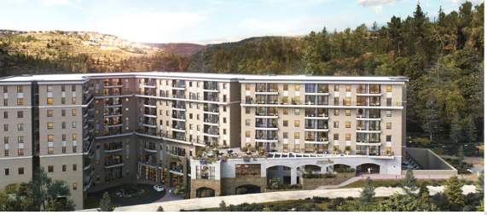

**This is Your Time to Feel Safe**

We know that an interesting, secure, and happy life begins with good health. For this reason, we provide personal care services and medical assistance, including a professional nursing department, round-the-clock personal medical supervision, and a rehabilitation unit, ensuring that you will not need to change your place of residence in the future. The community has everything you need to provide you with security and peace, so that you can enjoy your longevity and with the best quality of life.

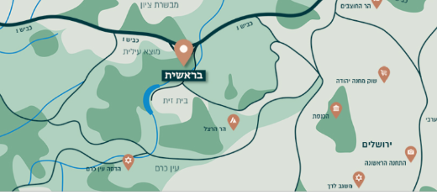

**This is Your Time to be Close to Everything**

Our location is a 5 minutes’ drive from Jerusalem, and 40 minutes’ drive from Tel Aviv, in the very heart of Motza – a long-established, idyllic, affluent neighborhood, surrounded by majestic green mountains. We are located near Highway 16, a new highway that is currently being built, which will provide an additional entrance to Jerusalem, direct access to the south and central sections of the city, and a direct exit to Tel Aviv.

It’s your time to be with family.

At Beresheet you can host your family perfectly. Together, you can go on family trips, eat in private rooms at the restaurant, and celebrate joint events, all while they enjoy their accommodations in designated guest apartments. The grandchildren will especially delight in the playground, activities, and summer camp at their disposal. It’s your time to host the ones you love.

**Take your first step towards fulfilling your dream of living in Jerusalem.**

**Contact us today to learn more about our** new senior living community

Full name:

Phone number:

E-mail address:

**Send**

* Motza, Jerusalem • Call us now • [shirim@lichak.co.il](mailto:shirim@lichak.co.il) • Follow us!