**Co-Teaching: From Theory to Practical Experience**

**Abstract**

This study focuses on co-teaching models, moving from the research literature to the practical experience of training processes in the 2016-2017 Academy-Class program at Ohalo College. We examine the experience models in terms of theory vs. practice from the perspectives of students, teachers, and pre-service kindergarten teachers. Specifically, we focus on the application of co-teaching practices within the Academy-Class program and examine the dominant patterns within them.

One-hundred and twenty-five subjects, both males and females, participated in the study. The main research questions were:

1. To what extent are the six main co-teaching models (as described in the research literature) expressed in practical and educational terms in the Academy-Class program?
2. How do the most common teaching practices, according to training teachers’ and students’ (who are participating in the program) reports, compare to the co-teaching models?

Our main findings show that the co-teaching models were more dominant than the traditional teaching models among all the sample groups. Specifically, the greatest difference was found in the reports of the training teachers (0.79) at the school, while the smallest difference was found among students in training to became teachers (0.13). A t-test found significant diversity in this intergroup difference: t(85)=2.56, p>0.05. On the other hand, the difference between the students (0.54) in the kindergarten and early childhood education programs was found to be higher than the difference between kindergarten teachers (0.42). Another t-test found non-significant diversity in the difference between low-level co-teaching and synergetic co-teaching, between the students and the kindergarten teachers: t(36)=1.81, p>0.05.

**Key words:** Academy-Class, co-teaching, experience models, teachers’ training.

**Introduction**

Schools around the world have tried to apply diverse methods of co-teaching in their classes. In the last decade, many educational researchers have explored and evaluated these co-teaching models, which have changed according to the dynamic needs and trends of 21st century education.

Several studies have spotlighted the significance of mutual relationships between teachers (Blank, 2013; Cleaveland, 2015; Petrick, 2015). In order to test this claim and shed more light on the subject, there is a need to expand the existing data. Accordingly, the current study aims to highlight and examine co-teaching models from a different angle within the framework of teacher training, by evaluating both theory and practice in a unique practical experience program at Ohalo College.

**Co-Teaching**

Bacharach, Heck, & Dank (2004) defined co-teaching as a situation where two teachers (a training teacher and a trainee teacher) work together in one classroom on planning, organization, and implementation. Cook and Friend (1995) expanded this definition to include two or more teachers teaching together in significantly different ways which are intended to reach a diverse group of students, all in one physical space. Wenzlaff et al. (2002) emphasized the benefits of this teaching method, in terms of teaching lessons that cannot be taught alone. One application of the co-teaching model refers to co-teaching between trainer teachers and trainee teachers. In such a case, the recommendation is to divert from a traditional practical experience, which would emphasize a hierarchy between trainer and trainee, to use a process where both partners share teaching and other responsibilities in the classroom (Roth & Tobin, 2005).

As shown in the literature, co-teaching offers several advantages. As one teacher receives significant assistance from another and shares the work with him or her, the students receive greater learning opportunities and significant mediation (Arbiv-Elyashiv, 2013; Forbes & Billet, 2012). In this way, the model provides additional assistance to weak students and enrichment to students who are above the class level. Studies on the influence of co-teaching on student achievement found an advantage in math achievement among students in co-teaching classrooms, compared to students in regular classrooms (Bacharach, Heck & Dahlberg, 2010; Forbes & Billet, 2010).

In addition, the trainer teachers reported authentic and significant professional development within co-teaching. Their daily interactions with trainees required constant discussion and reflection on teaching, revitalized their teaching methods, and encouraged the trainee teachers to expand their roles as leaders and potential trainers in the school (Gallo-Fox & Scantlebury, 2016). In addition, co-teaching within an environment of mutual respect, emotional support, and trust gives the added value of constructing the teacher’s identity, sharpening and deepening his or her knowledge of the teaching material, and raising the level of the actual teaching (Wehunt & Weatherford, 2015). Students who were exposed to co-teaching reported a gradual integration into the classroom, which focused on the connection between theory and practice. The students further reported that the experience enabled mutual learning and that co-teaching provides a supportive environment for professional and in-depth teaching (Arbiv-Elyashiv, 2013; Forbes & Billet, 2012; Rytivaara & Kershner, 2012).

Co-teaching’s success depends on several elements, notably shared work that includes planning, organization, and assessment. Shared planning is extremely important for co-teaching, so sufficient time and attention must be allocated for this stage (Kamens, Susko, & Elliott, 2013). At first, the planning will be very explicit, but over time the student will become responsible for a greater part in this process (Bacharach, Heck, & Dahlberg, 2010). Each of the co-teaching partners will contribute his or her personal talents and skills (Murawski & Lochner, 2011). Following the lesson, the teachers will assess and reflect on the process, and receive feedback from the students. Interpretation and analysis will clarify to the student what occurred and direct him or her to additional teaching strategies and techniques (Murawski & Lochner, 2011; Scantlebury, Gallo-Fox, & Wassell, 2008).

**Possible Models for Co-Teaching as Part of the Teaching Experience**

1. “One teacher teaches and the other observes”: the older and more experienced trainer leads the lesson, while the trainee integrates gradually, mainly by observing lessons and then experiencing private, group, and full-class teaching. The trainee learns by observing an experienced model, hearing the students’ responses, and analyzing the lesson (Bacharach et al., 2010; Cook & Friend, 1995; Graziano & Navarrete, 2012).
2. “Head teacher teaches and the other teacher supports”: the trainer takes the main responsibility for the lesson and teaches the material. The trainee floats among the students, helps them with their work, and explains and elaborates on the material as needed (Bacharach et al., 2010; Cook & Friend, 1995; Graziano & Navarrete, 2012; Walsh & Johns, 2004).
3. “Parallel Teaching”: in this model both teachers teach an identical lesson simultaneously, to two separate groups of students (Cook & Friend, 1995; Graziano & Navarrete, 2012; Villa, Navin, & Thousand, 2004).
4. “Teaching in Stations”: the trainer and trainee split up the students and the content that each of them will teach. They each teach their part of the material to one of the groups, and then they switch.
5. “Variable Teaching”: one teacher teaches the entire class, while the second teacher teaches one student or a small group of students at the same time.
6. “Group Teaching”: the teacher and the trainee share the responsibility to teach the same content simultaneously to the same group of students. According to this model the teachers use the same teaching methods, such as turns, role playing, examples, etc. (Bacharach et al., 2010; Cook & Friend, 2004).

**From Low-Level Co-Teaching to Synergetic Co-Teaching**

Among the abovementioned teaching methods, we find several models with a low level of collaboration: one teacher is dominant and leads the lesson, while the second is supportive but more passive. Tov-Li & Frisch (2008) stated that this is the traditional model of co-teaching, but it risks having no co-teaching at all, in contrast to the more complex models of parallel teaching or teaching in stations, where each teacher works separately from his or her colleague.

In this regard Sachs et al. (2011) introduced the value of Synergetic Collaboration. They claimed that such collaboration must include clear consent, mutual collaboration in growth processes, and a contribution to mutual development. Recent approaches define the term Synergetic Co-Teaching as teaching that is adapted to the educational needs of the 21st century. In an age where the skills required from workers emphasize teamwork, problem solving, and interpersonal relationships (De Fruyt, Wille, & John, 2015), high-level collaborative teaching, which involves in-depth cooperation between two teachers, strengthens an innovative teaching approach that prepares students to be independent and multidisciplinary, able to learn in diverse locations and styles (Amar & Ben-David, 2016; Brown, 2016).

**Methodology**

**Study Questions**

1. To what extent are the six co-teaching methods represented in a unique practical experience program, from the teachers’ and trainees’ perspectives?
2. How common is Synergetic Collaboration as a co-teaching method, in comparison to other low-level methods?

**The Study Population and Procedure**

At the end of the 2016/7 school year a questionnaire was sent via Google Drive to the participants— 140 students and 100 training teachers and kindergarten teachers— as part of their third-year practical experiment. Responses were anonymous. Subjects were requested to evaluate a series of 13 statements, using a Likert scale of 1-5. Of these recipients, 125 subjects completed the questionnaire, as detailed in Table 1: 36 students of education, 20 students of childhood education, 51 training teachers, and 18 kindergarten teachers. Average values were calculated for all responses, while t-tests were used to identify significance.

*Table 1: Respondents’ Fields of Specialization*

|  |  |  |
| --- | --- | --- |
| Field of Specialization | Students | Teachers/Kindergarten Teachers |
| Early Childhood | 20 | 18 |
| Judaism | 18 | 2 |
| English | 10 | 16 |
| Science | 4 | 19 |
| Mathematics | 2 | 5 |
| Biology | 2 |  |
| Physical Education |  | 1 |
| Israel Studies |  | 1 |
| Homeroom Education??? |  | 7 |

**Research Tools**

The research tool was a validated questionnaire that included a series of 13 statements based on a Likert scale (1-5). For all statements, the highest value (5) represents high incidence and the lowest value (1) represents low incidence. In the first stage, the 13 statements described the traditional model (that does not include co-teaching) as well as the seven co-teaching models detailed in the literature. The “variable teaching” model was divided into two models, in which one teacher teaches the entire class and the second teacher teaches either a small group or just one or two students.

*Table 2: Distribution of Statements into Content Categories*

|  |  |  |
| --- | --- | --- |
| **Model of Teaching Experience** | **Item** | **Content of Statement** |
| Traditional model of experience – one teacher teaching | 1 | The teacher teaches and I sit passively. |
| 2 | I teach and the teacher sits passively. |
| Model 1 – One teacher teaches and the other observes | 3 | The teacher teaches and I observe him/her and/or the other students. |
| 4 | I teach and the teacher observes me and/or the other students. |
| Model 2 – One teacher teaches and the other supports on the side | 5 | The teacher teaches and I support him/her on the side, helping the students. |
| 6 | I teach and the teacher supports me on the side, helping the students. |
| Model 3 – Two teachers teach the same material simultaneously in two separate groups (Parallel Teaching) | 7 | The teacher and I teach the same material simultaneously in two separate groups. |
| Model 4 – Two teachers teach different material to two groups in “stations” | 8 | The teacher and I teach different material in two groups in “stations.” |
| Model 5 – One teacher teaches most of the class while the other teaches a small group | 9 | The teacher teaches most of the class while I teach a small group. |
| 10 | I teach most of the class while the other teacher teaches a small group. |
| Model 6 – One teacher teaches the whole class while the other teacher works with one or two students | 11 | The teacher teaches the whole class while I work with one or two students. |
| 12 | I teach the whole class while the other teacher works with one or two students. |
| Model 7 – Two teachers teach the class together simultaneously (Group Teaching) | 13 | The other teacher and I teach the class together simultaneously. |

In the second stage, the models were mapped by their level of co-teaching and grouped into three categories, from lack of co-teaching to synergetic co-teaching, as detailed in Table 3.

*Table 3: Model Categories by Level of Co-Teaching*

|  |  |
| --- | --- |
| Category | Models |
| No co-teaching at all | Traditional experience model – one teacher only. |
| Low-level co-teaching (one teacher is more dominant than the other) | Model 1 – one teacher teaches and the other observes him/her  Model 2 – one teacher teaches and the other supports him/her on the side  Model 5 – one teacher teaches most of the class and the other teaches a small group  Model 6 – one teacher teaches the whole class and the other teaches one or two students |
| Synergetic co-teaching (two active teachers, equal partners, contributing equal values) | Model 3 – two teachers teach the same material simultaneously to two separate groups  Model 4 – two teachers teach the same material to two groups in “stations”  Model 7 – two teachers share teaching the class simultaneously |

**Findings**

The following tables present the subjects’ average responses to all statements, for each of the four groups.

*Table 4: Students of Education – Average Incidence of Co-Teaching*

|  |  |  |
| --- | --- | --- |
|  | Average | Standard Deviation |
| The teacher teaches and I sit passively. | 2.50 | 1.48 |
| I teach and the teacher sits passively. | 1.67 | .93 |
| The teacher teaches and I observe him/her and/or the students. | 3.36 | 1.25 |
| I teach and the teacher observes me and/or the students. | 2.58 | 1.13 |
| The teacher teaches and I support him/her on the side, helping the students. | 3.61 | 1.15 |
| I teach and the teacher supports me on the side, helping the students. | 2.67 | 1.43 |
| The teacher and I teach the same material simultaneously in two separate groups. | 1.89 | 1.33 |
| The teacher and I teach different material in two groups in “stations.” | 1.58 | 1.20 |
| The teacher teaches most of the class while I teach a small group. | 1.83 | 1.16 |
| I teach most of the class while the other teacher teaches a small group. | 1.25 | .60 |
| The teacher teaches the whole class while I work with one or two students. | 1.92 | 1.18 |
| I teach the whole class while the other teacher works with one or two students. | 1.39 | .96 |
| The other teacher and I teach the class together simultaneously. | 2.22 | 1.61 |

*Figure 1: Students of Education – Models of Experience in Co-Teaching*

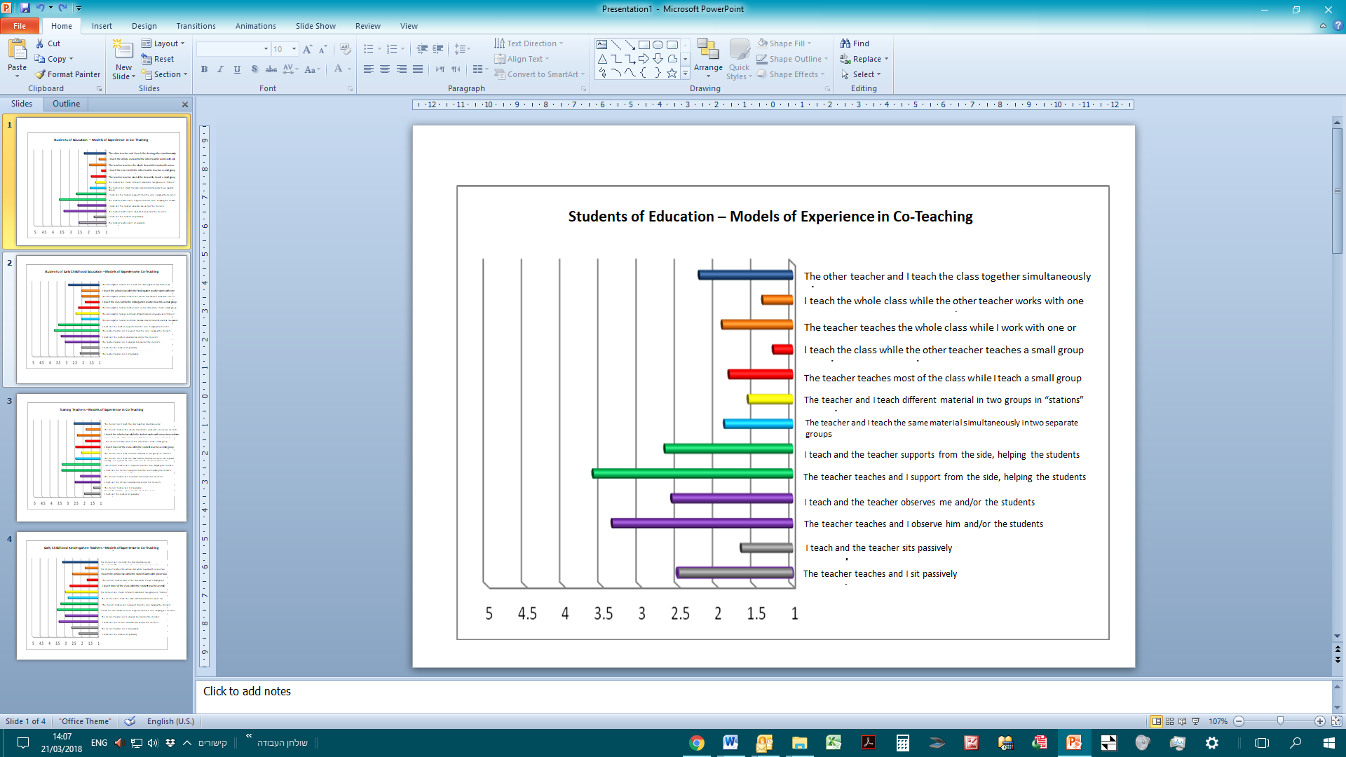

*Table 5: Students of Early Education — Average Incidence of Co-Teaching*

|  |  |  |
| --- | --- | --- |
|  | Average | Standard Deviation |
| The kindergarten teacher teaches and I sit passively. | 2.15 | 1.23 |
| I teach and the kindergarten teacher sits passively. | 2.05 | 1.15 |
| The kindergarten teacher teaches and I observe him/her and/or the other students. | 3.05 | 1.00 |
| I teach and the kindergarten teacher observes me and/or the other students. | 3.30 | 1.30 |
| The kindergarten teacher teaches and I support him/her on the side, helping the students. | 3.70 | 1.03 |
| I teach and the kindergarten teacher supports me on the side, helping the students. | 3.45 | 1.19 |
| The kindergarten teacher and I teach the same material simultaneously in two separate groups. | 2.05 | 1.32 |
| The kindergarten teacher and I teach different material to two groups in “stations.” | 2.40 | 1.35 |
| The kindergarten teacher teaches most of the class while I teach a small group. | 2.25 | 1.33 |
| I teach most of the class while the kindergarten teacher teaches a small group. | 1.85 | 1.18 |
| The kindergarten teacher teaches the whole class while I work with one or two students. | 2.05 | 1.19 |
| I teach the whole class while the kindergarten teacher works with one or two students. | 2.05 | 1.10 |
| The kindergarten teacher and I teach the class together simultaneously. | 2.85 | 1.69 |

*Figure 2: Students of Early Education — Average Incidence of Co-Teaching*



*Table 6: Training Teachers — Average Incidence of Co-Teaching*

|  |  |  |
| --- | --- | --- |
|  | Average | Standard Deviation |
| I teach and the student sits passively. | 1.96 | 1.13 |
| The student teaches and I sit passively. | 1.41 | .64 |
| I teach and the student observes me and/or the other students . | 2.53 | .92 |
| The student teaches and I observe him/her and/or the other students. | 2.20 | .83 |
| I teach and the student supports me on the side, helping the students. | 3.33 | .99 |
| The student teaches and I support him/her on the side, helping the students. | 3.31 | 1.29 |
| The student and I teach the same material simultaneously in two separate groups. | 2.49 | 1.19 |
| The student and I teach different material in two groups in “stations.” | 2.12 | 1.11 |
| I teach most of the class while the student teaches a small group. | 2.49 | .86 |
| The student teaches most of the class while I teach a small group. | 1.90 | .90 |
| I teach the whole class while the student works with one or two students. | 2.39 | .90 |
| The student teaches the whole class while I work with one or two students. | 1.86 | .92 |
| The student and I teach the class together simultaneously. | 2.59 | 1.08 |

*Figure 3: Training Teachers — Average Incidence of Co-Teaching*



*Table 7: Kindergarten Teachers & Training Teachers — Average Incidence of Co-Teaching*

|  |  |  |
| --- | --- | --- |
|  | Average | Standard Deviation |
| The student teaches and I sit passively. | 2.17 | 1.15 |
| I teach and the student sits passively. | 2.61 | 1.20 |
| I teach and the student observes me and/or the other students. | 3.39 | .85 |
| The student teaches and I observe him/her and/or the other students. | 3.00 | .84 |
| I teach and the student supports me on the side, helping the students. | 3.50 | 1.04 |
| The student teaches and I support him/her on the side, helping the students. | 3.28 | 1.13 |
| The student and I teach the same material simultaneously in two separate groups. | 2.83 | 1.42 |
| The student and I teach different material to two groups in “stations.” | 3.00 | 1.24 |
| I teach most of the class while the student teaches a small group. | 2.72 | 1.02 |
| The student teaches most of the class while I teach a small group. | 1.67 | .84 |
| I teach the whole class while the student works with one or two students. | 2.56 | 1.04 |
| The student teaches the whole class while I work with one or two students. | 1.78 | 1.00 |
| The student and I teach the class together simultaneously. | 3.17 | 1.20 |

Figure 4: Kindergarten Teachers — Average Incidence of Co-Teaching

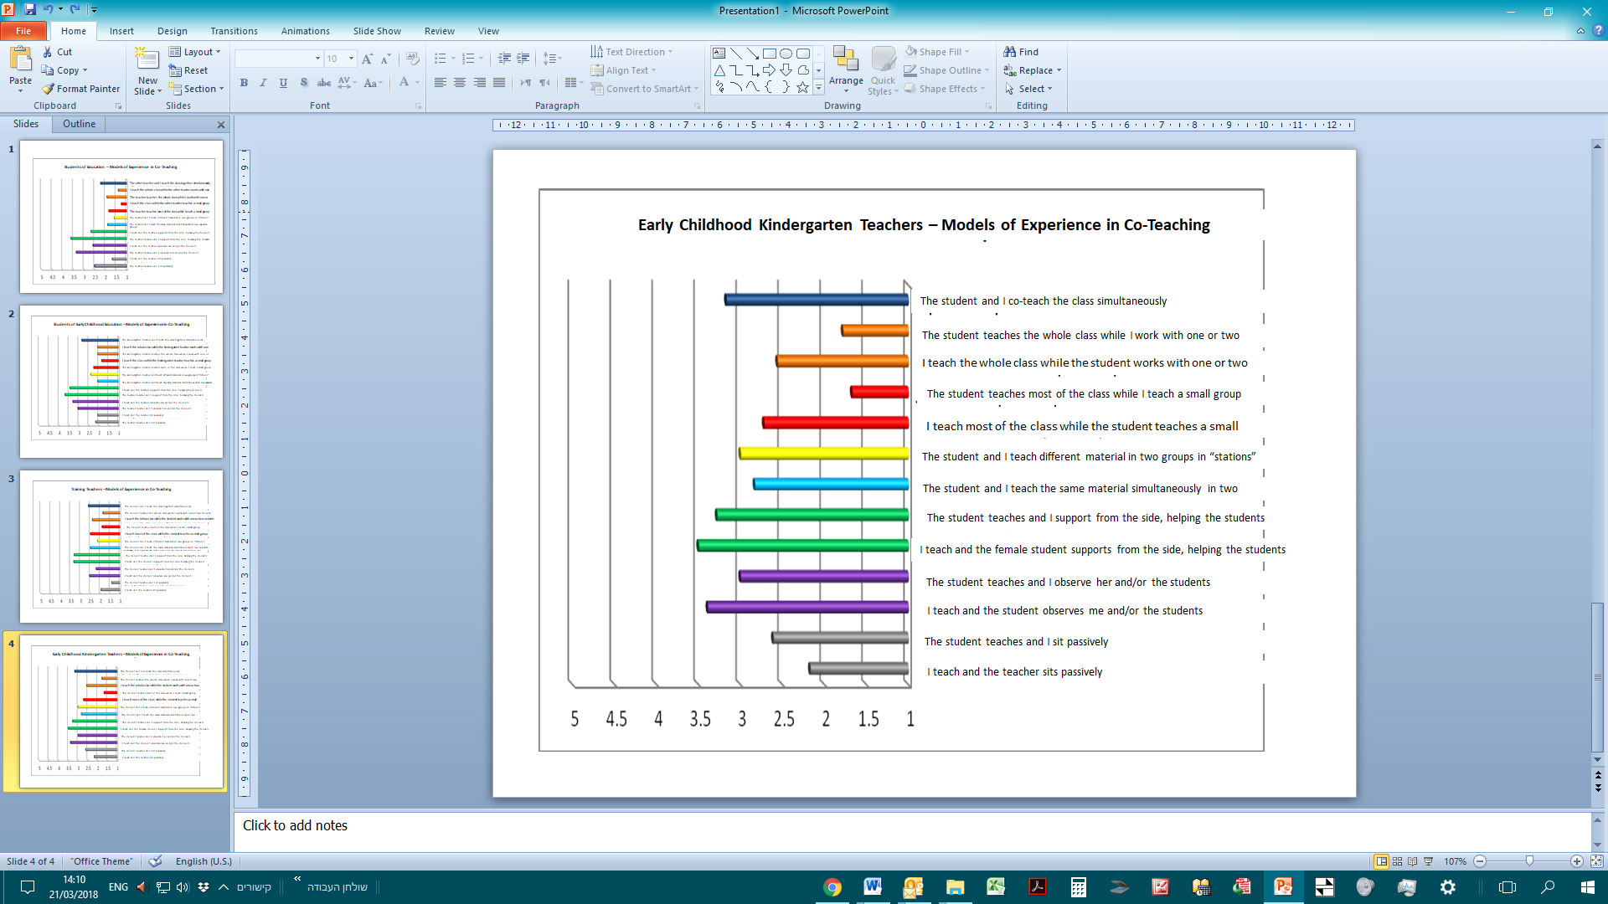

We will now present the averages of the traditional statements and the averages of the co-teaching statements. Statements 1-2, as they appear in the research questionnaire, indicate “traditional teaching” (a teaching model that does not include co-teaching at all), while the remaining statements (3–13) indicate co-teaching. Table 8 below displays the averages of these two indices among the four groups.

*Table 8: Traditional Teaching and Co-Teaching in the Four Groups*

|  |  |  |  |  |  |  |  |
| --- | --- | --- | --- | --- | --- | --- | --- |
|  | Traditional Teaching | | | Co-Teaching | | |  |
|  | N | Average | Standard Deviation | N | Average | Standard Deviation | Difference |
| Students of Education | 36 | 2.08 | 1.02 | 36 | 2.21 | .57 | .13 |
| Students of Early Education | 20 | 2.10 | 1.05 | 20 | 2.64 | .80 | .54 |
| Trainer Teachers | 51 | 1.69 | .73 | 51 | 2.47 | .52 | .79 |
| Kindergarten Teachers | 18 | 2.39 | .98 | 18 | 2.81 | .60 | .42 |

*Figure 5: Traditional Teaching and Co-Teaching*

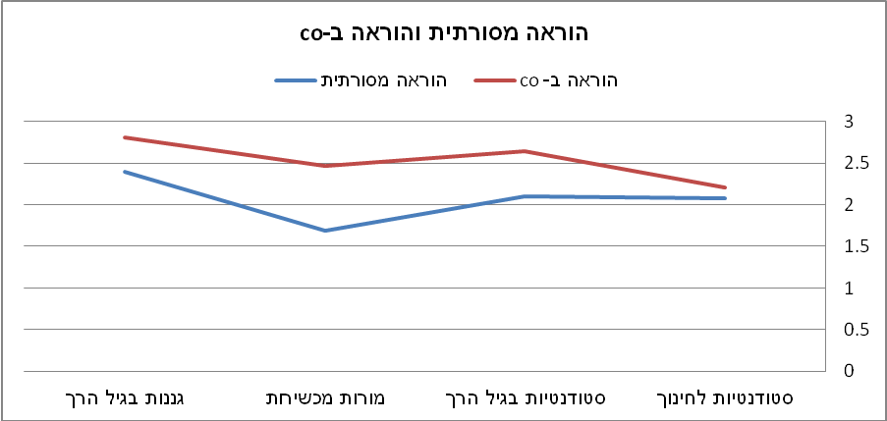

**Traditional Teaching and Co-Teaching**

Traditional Teaching

Co-Teaching

Early Childhood Kindergarten Teachers

Training Teachers

Early Childhood Students

Students of Education

A higher level of incidence was found for co-teaching than for traditional teaching in all groups. In particular, the highest difference in schools was among the trainer teachers (0.79), while the lowest difference was among students of education (0.13). The t-test found significant diversity in between the teachers’ group and the students’ group: t(85)=2.56, p<0.05.

On the other hand, in kindergartens the difference among the students (0.54) was higher than the difference among the kindergarten teachers (0.42). The t-test found non-significant diversity in the co-teaching vs. traditional teaching difference between the students and the kindergarten teachers: t(36)=0.29, p>0.05.

As stated above, the co-teaching statements, items 3–13 in the questionnaire, were divided into low-level co-teaching and synergetic co-teaching groups. Table 9 compares the averages of the low-level co-teaching statements with those of the synergetic co-teaching statements.

*Table 9: Low-Level Co-Teaching and Synergetic Co-Teaching in the Four Groups*

|  |  |  |  |  |  |  |  |
| --- | --- | --- | --- | --- | --- | --- | --- |
| . | Low-Level Co-Teaching | | | Synergetic Co-Teaching | | |  |
|  | N | Average | Standard Deviation | N | Average | Standard Deviation | Difference |
| Students of Education | 36 | 2.33 | .52 | 36 | 1.90 | 1.00 | .43 |
| Student of Early Childhood Education | 20 | 2.71 | .72 | 20 | 2.43 | 1.26 | .28 |
| Training Teachers | 51 | 2.50 | .49 | 51 | 2.40 | .92 | .10 |
| Kindergarten Teachers | 18 | 2.74 | .50 | 18 | 3.00 | 1.15 | -.26 |

*Figure 6: Low-Level Co-Teaching and Synergetic Co-Teaching in the Four Groups*

Low-Level Co-Teaching

Synergetic Co-Teaching

It was found that the incidence of low-level co-teaching was higher than that of synergetic co-teaching among students of education, among students of early childhood education and among trainer teachers, while among early childhood kindergarten teachers the incidence of synergetic co-teaching was higher than that of low-level co-teaching.

In particular, in schools the greatest difference was between students of education (0.43), while among training teachers the difference was small (0.10). The t-test found non-significant diversity in the low-level vs. synergetic co-teaching difference between the students and the kindergarten teachers that is not significant: t(36)=1.81, p>0.05.

Table 10 compares the results of the two school groups (students of education and training teachers) and of the two kindergarten groups (students of early childhood education and early childhood kindergarten teachers).

*Table 10: Traditional Teaching, Low-Level Co-Teaching, and Synergetic Co-Teaching in Schools and Kindergartens*

|  |  |  |  |  |  |  |  |  |  |
| --- | --- | --- | --- | --- | --- | --- | --- | --- | --- |
|  | Traditional Teaching | | | Low-Level Co-Teaching | | | Synergetic Co-Teaching | | |
|  | N | Average | Standard Deviation | N | Average | Standard Deviation | N | Average | Standard Deviation |
| School | 87 | 1.85 | 0.88 | 87 | 2.36 | 0.55 | 87 | 2.19 | .98 |
| Kindergarten | 38 | 2.24 | 1.01 | 38 | 2.72 | 0.71 | 38 | 2.70 | 1.22 |

Figure 7: Traditional Teaching, Low-Level Co-Teaching, and Synergetic Co-Teaching in Schools and Kindergartens

**Traditional Teaching and Co-Teaching**

Kindergarten

School

It is clear that the averages in the kindergartens were higher than the averages in schools in all three categories (traditional teaching, low-level co-teaching, and synergetic co-teaching). In particular, it was found that both in school (F(2,172)=9.51, p<0.01) and in kindergarten (F(2,74)=3.49, p<0.05) the incidence of shared teaching in low-level co-teaching was the highest, followed by the incidence of synergetic co-teaching. The incidence of traditional teaching was the lowest in comparison to co-teaching.

**Conclusions and Discussion**

An analysis of these findings shows that practical experience can be characterized in several models and that there exists a wide range of joint work — from the traditional model of practical experience, where the student is mainly passive, through an apprentice model of teaching, where the student is the teacher’s helper and participates in the teaching process, to a third and new model, which we emphasize here, of synergetic co-teaching.

Modern approaches and in-school programs emphasize innovativeness that is adapted to the 21st century, and invite a new, alternative model of co-teaching based on the theory of Connectivism (Siemens, 2008). This theory of learning is adapted to the modern, digital age, where co-teaching plays a central role. Studies of future-looking teaching approaches show that the need for and incidence of co-teaching are based on the fact that the individual is part of a group. The group learns together, individually or in smaller groups, and shares information resources with each member of the group. This method of learning is different than what existed in the past, when learning was paternalistic, centralized, and based on a personal-competitive dimension. Today, information is dispersed throughout social networks and in virtual realms (Siemens, 2004).

Such frequent changes and trends clarify the need for a widespread change of perspective, in order to best prepare today’s students for tomorrow. However, we must also bridge these differences in teacher training. The present research findings show that the incidence of shared work and co-teaching was higher than that of traditional teaching in all sampled groups. These findings support the goals of the unique practical experience program to make significant changes in the nature and essence of the training processes, in educational and teaching professions. In other words, the findings show the changeover of an educational cadet from a passive observer, sitting on the sidelines, to a significant partner (Lehavi, 2010). This change was made possible by an intensive three-day experience program, which enabled students and teachers to work together for many hours over several days a week, and to create a relationship featuring shared work, guidelines, and content. In addition, training teachers also learned from the seminars we held that emphasized the importance of co-teaching in training students (Ministry of Education Think Tank, 2014).

Despite the high reported levels of co-teaching compared to traditional patterns of teaching, an analysis of the various models that exist in co-teaching still shows that the level of shared work is within the low range. In other words, despite the fact that the experience models exemplify a new approach with greater shared work in the classroom, the training teacher still plays a more significant role in leading teaching processes. He or she is the one to direct the student’s role and at least for a time works mainly with the students, while the trainee student is his or her assistant. This finding is naturally clarified in light of the relationship between the training teacher and the trainee student — a more experienced veteran vs. a new teacher — but this can also be explained by the traditional pattern of training teachers, which was preserved among trainers who have more experience within the education system (Alian and Daniel-Sa'ad, 2013).

The complexity of the synergetic co-teaching approach, which expects the teacher to “release some responsibility and control” to the trainee teacher, could be another explanation of this pattern. Such a level of co-teaching is directed at using various pedagogical qualities, approaches, and methods that are totally different from the one-teacher-in-the-classroom style of teaching (Cook & Friend, 1995; Wenzlaff et al., 2002). This fact might also explain why training kindergarten teachers reported a higher level of synergetic co-teaching: the dynamic nature of their work, which generally includes a freer and more multidisciplinary work schedule, enables greater flexibility when working in a team (Ministry of Education, 2010).

Research findings also show that participants in the training program reported using several teaching models in various configurations, as also described in the literature (Bacharach et al., 2010; Cook & Friend, 1995; Graziano & Navarrete, 2012). No model was found to be significantly more dominant or apparent or to characterize the training process, as we found a wide range and various levels of shared work among the training teachers, the kindergarten teachers, and the students. This result correlates with the various models presented in the research literature and presents co-teaching within a structure of various models of experience. Some are more natural for a trainer–trainee relationship, depending on the trainer’s work in the past, and some exhibit the start of co-teaching, using the “two-teachers-in-the-classroom” model, on an increasingly synergetic level, as expected from the new program.

**Summary**

We have seen that experiencing a clinical model of teaching involves shared work between a trained teacher and of a trainee student of education. According to the common traditional model, it was accepted to have an apprentice in the classroom: the teacher would play a significant role in teaching, with the trainee student observing passively, supervised and controlled by the teacher but measured sparingly. Today, with the onset of the much-needed changes in training processes, we see the need to expand the theoretical approaches that describe a wide range of shared work. We recommend creating a language that characterizes events in the classroom and formulating an innovative theoretical framework that is adapted to the needs of the 21st century. Then we must anchor these theories in an innovative and diverse field, which is not based only on differential models of experience and teaching practice, but on a model that describes the wide range of synergetic co-teaching possible between the training teacher and the trainee student. This kind of experience has many advantages. The teacher and students share the responsibility for the classroom, and the students benefit from having two teachers; they enjoy widespread arbitration, enrichment, and in-depth learning. Moreover, the teachers themselves improve their professional skills and sharpen their thought processes and working methods, absorbing innovative skills from the younger students. The students, for their part, experience firsthand the great and diverse responsibilities that are part of the teacher’s role, while enjoying the protection, support, and advice of the training teacher.

This model is a suitable working model for students in the 21st century, as shared work, shared information, team efforts and normal working relationships will be demanded from citizens of the future. Therefore, we greatly recommend creating a support system, a full security network that will not leave the trainee teacher alone and out of the picture, but give him or her a significant field of experience where he or she is constantly active, learning, experiencing, feeling, teaching, correcting, improving, and receiving reflective feedback to realize his or her future roles. This method will encourage interdisciplinary and multidisciplinary teaching, where several teachers teach in large classes, using more creative and diverse methods of teaching.

**Study Limitations**

Despite the contributions discussed above, this study’s limitation is its focus on one specific research population. This convenient model was chosen in advance, in order to learn, observe, and come to conclusions regarding groundwork, the program’s didactic goals, and other administrative goals we set for ourselves as the program directors. Therefore, it seems fit to expand the study to future cohorts within this program, in order to examine the trends of co-teaching in a focused and longitudinal manner and identify the possible significance for this approach.

References

Alian, S., & Daniel-Sa'ad, A. (2013). Changing from the traditional model in practical experience to the co-teaching model – a slogan or current need? *Dapim – Journal in Educational Research*, *56*, 35–59.

Amar, S., & Ben-david, N. (2016). Realistic intelligence and 21st-century skills in adapted learning environment. In S. Amar., N. Bar David, & U. Carmi (Eds.), *Thoughts & Trends 2020-2025: Ohalo Education Conference Book* (pp. 23-41). Katzrin: Galilee Books PBH.

Arbiv-Elyashiv, R., & Zimmerman, V. (2013). *Dropping out from teaching in Israel: Who is the drop-out teacher? And how does the system deal with this phenomenon?* Tel Aviv: Ministry of Education, Mofet Institute.

Ariav, T. (2014). Practical Experience in Teachers Training: “Recalculating Destination.” *Mofet Institute Journal*, *53*, 13–19.

Ariav, T., & Smith, K. (2006). Creating partnerships between teachers training colleges and field work: International approach with a focus on a professional development school. In M. Zilberstein, M. Ben-Peretz, & N. Greefeld (Eds.), *New Trend in Teachers Training Programs: Partnerships between Colleges and Schools – The Israeli Story* (pp. 21-67). Tel Aviv: Mofet Institute.

Bacharach, N., Heck, T., & Dank, M. (2004). *Co-Teaching in student teaching: A case study.* Paper presented at the annual meeting of the Association of Teacher Educators, Dallas, Texas.

Bacharach, N., Heck, T., & Dahlberg, K. (2010). *Changing the face of student teaching through co-teaching*. St. Cloud, MN: Teacher Development Faculty Publications.

Blank, C. (2013). *General and special educators’ perceptions of co-teaching in inclusive middle schools*. (Unpublished master’s thesis).

Brown, B. A. (2016). *Understanding the flipped classroom: types, uses and reactions to a modern and evolving pedagogy*. Retrieved July 18, 2016 from<http://repository.stcloudstate.edu/cgi/viewcontent.cgi?article=1010&context=ed_etds>.

Cleaveland, P. (2015). *A multi-case study examining co-teaching approaches and practices in high school math and literature/composition classes*. Doctoral Dissertations and Projects. Paper 1001.

Cook. L., & Friend, M. (1995). Co-teaching: Guidelines for creating effective practices. *Focus on Exceptional Children, 28*(3), 1–17.

Cook, L., & Friend, M. (2004). *Co-teaching: Principles, practices and pragmatics*. Retrieved February 4, 2018 from <http://files.eric.ed.gov/fulltext/ED486454.pdf>.

De Fruyt, F., Wille, B., & John, O. (2015). Employability in the 21st century: Complex (interactive) problem solving and other essential skills. *Industrial and Organizational Psychology*, *8*(2), 276–281.

Forbes, L., & Billet, S. (2012). Successful co-teaching in the science classroom. *Science Scope, 36*(1), 61–64.

Gallo-Fox, J., & Scantlebury, K. (2016). Coteaching as professional development for cooperating teachers. *Teaching and Teacher Education, 60*, 191–202.

Graziano, K., & Navarrete, L. (2012). Co-teaching in the teacher education classroom:

Collaboration, compromise and creativity. *Issues in Teacher Education, 21*(1),

109–126.

Kamens, M. W., Susko, J. P., & Elliott, J. S. (2013). Evaluation and supervision of co-teaching: A study of administrator practices in New Jersey. *NASSP Bulletin, 97*(2), 166–190.

Kolb, D. A. (1983). *Experiential learning: Experience as the source of learning and development*. Englewood Cliffs, NJ: Prentice-Hall.

Lehavi, Y. (2010). *First and foremost hands–on practical experience in teachers training*. Masa, Mofet Institute. Retrieved May 7, 2017 from <http://portal.macam.ac.il/ArticlePage.aspx?id=2882>.

Maskit, D., & Mevarech, Z. (2013). It can be another way: Teachers training according to the colleagues’ co-teaching model in PDS. *Dapim – Journal in Educational Research*, *56*, 15–34.

Ministry of Education (2010). *Educational work in kindergartens: Guidelines for the educational staff*. Retrieved December 26, 2017 from http://meyda.education.gov.il/files/PreSchool/KavimManhim.pdf.

Ministry of Education Think Tank (2014). *A unique practical experience program – partnership in strengthening teaching: Think tank’s policy paper*. Ministry of Education. Retrieved May 5, 2017 from <http://academia-kita.macam.ac.il/Documents/%D7%A2%D7%99%D7%A7%D7%A8%D7%99-%D7%9E%D7%A1%D7%9E%D7%9A-%D7%9E%D7%93%D7%99%D7%A0%D7%99%D7%95%D7%AA-%D7%90%D7%97%D7%A8%D7%99-%D7%AA%D7%99%D7%A7%D7%95%D7%A0%D7%99%D7%9D.pdf>

Murawski, W. W., & Lochner, W. W. (2011). Observing co-teaching: What to ask for, look for and listen for. *Intervention in School and Clinic, 46*(3), 174–183.

Petrick Jr., D. L. (2015). *An investigation into co-teacher relationship collaboration factors: Co-teachers' perceptions*. Indiana, PA: Indiana University of Pennsylvania.‏

Roth, W. M., & Tobin, K. (2005). *Teaching together, learning together*. New York, NY: Peter Lang.

Rytivaara, A., & Kershner, R. (2012). Co-teaching as a context for professional learning and joint knowledge construction. *Teaching and Teacher Education, 28*, 999–1008.

Sachs, G. T., Fisher, T., & Canon, J. (2011). Collaboration, mentoring and co-teaching. *Journal of Teacher Education for Sustainability, 13*(2), 70–86.

Scantlebury, K., Gallo-Fox, J., & Wassell, B. A. (2008). Co-Teaching as a model for preservice science teacher education. *Teaching and Teacher Education, 24*(4), 967–981.

Siemens, G. (2008). Learning and knowing in networks: Changing roles for educators and designers. *ITFORUM for Discussion*.

Slotzker-Markowitz, G. (2015). *The protest of the sardines: Parents strike the educational system in protest against overcrowding*. Retrieved December 26, 2017 from <http://www.maariv.co.il/news/israel/Article-485242>.

Stith, I. & Roth, W. M. (2008). *Students in action: Cogenerative dialogue from secondary to elementary schools*. Rotterdam: Sense Publisher.

Tov Li, A., & Frisch, Y. (2008). Co-Teaching in a teachers’ training course. are we facing “more of the same” or “another way”? In the course: “Openness to Something Else – Nurturing Excellence in the Classroom.” *Shaanan College Yearbook*, *13*, 199–230.

Villa, R. A., Nevin, A. I., & Thousand, J. S. (2004). *A Guide to co-teaching*. New York, NY: Corwin Press.

Walsh, J. M., & Jones, B. (2004). New models of cooperative teaching. *Teaching Exceptional Children*, *36*(5), 14–20.‏

Wehunt, M. D., & Weatherford, J. S. (2014). Co-teaching for student engagement. *The Researcher, 26*(1), 45–48.

Wenzlaff, T., Berak, L., Wieseman, K., Monroe-Baillargeon, A., Bacharach, N., & BradfieldKreider, P. (2002). Walking our talk as educators: Teaming as a best practice. In E. Guyton & J. Ranier (Eds.), *Research on meeting and using standards in the preparation of teachers* (pp. 11-24). Dubuque, IA: Kendall-Hunt Publishing.

Whitford, E. V., & Barnett, B. E. (2016). The professional development school approach to teacher education: Identification of a model. In *Conference Proceedings. The Future of Education* (pp. 457-460).