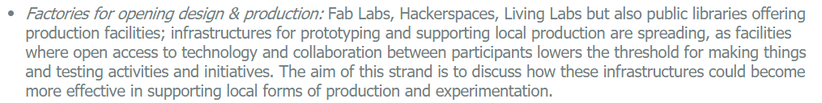

**Abstract**

Intensive manual labor enterprises in the developed world face challenges competing with products imported from countries where manufacturing costs are low. This reduces the volume of domestic production and leads to rapid loss of knowledge and experience in production processes and their accompanying arts.

This study focuses on the Israeli footwear industry as a case study. Qualitative methodologies were applied, including in-depth interviews and field observations. A literature review on previous research and contemporary trends was conducted.

The research examines challenges along the value chain in small factories. It finds that current work processes enable local designers to build brands and encourage market growth. However, mass production paradigms impose a decentralized process between designers and manufacturers and therefore do not leverage local potential into a sustainable competitive advantage for small factories.

The proposed solution is a digital and technological platform for small manufacturing plants. The platform mediates and designs the connections between production, technology, and design. It enables creation of a joint R&D system while overcoming the barriers of the global market and leveraging the advantages of personal contact with the consumer.

**Introduction**

I have worked professionally in the footwear industry in Israel for the last ten years. I have designed and produced shoes in the women's boutique niche, and teach this craft. Traditional production of shoes relies on manual labor.

Changes in global and local market conditions have led to a reduction in local footwear manufacturing. Today, there are only a few functioning industrial factories in Israel. There are also a few dozen micro-factories, reduced by market conditions to small-scale production and almost complete reliance on manual labor. They are on the cusp between factory and workshop. They maintain production relations with the local design industry and thus, in practice, enable organic growth in the industry. Mapping of the local footwear market indicates that products developed by small manufacturers for local designers are not competitive in the saturated domestic market. This threatens local knowledge and capabilities.

**Literature Review**

Local industry does not exist in a vacuum. It is influenced by and reacts to large and complex systems globally and locally, the characteristics of industry participants, and their interrelationships. The following is a list of the topics reviewed:

1. Recent changes in global market conditions. This includes how innovation has become a currency companies use to compete with countries with low manufacturing costs.
2. Innovation among low-tech footwear manufacturing industries.
3. Reciprocal relations in the fields of production and design. This includes relationships between participants in the Israeli footwear industry and the potential for innovation in design and production skills.
4. Changes in global production trends.
5. **Recent changes in global market conditions.**

Globalization and the information revolution affect the global production market.In recent decades, there has been a dramatic shift of production from places where production costs are high to places they are low. This was driven by the fall of trade barriers and the opening of previously closed markets. (Buciuni & Pisano, 2015). Globalization ended the advantage of many traditional industries in developed countries and created competition with developing economies having large and cheap labor forces. The communication revolution reduced communication costs between geographic regions to almost nothing and led to the creation of a knowledge society (Audretsch & Thurik, 2000). It is important to differentiate between "information" and "knowledge". "Information" refers to collected and processed data, while "knowledge" is a richer, more organized, and complex resource (Lor & Britz, 2007). For open markets in the global capitalist economy, access to information has become a social right and a condition for participation in social, economic, and political activities. In the “knowledge economy” the acquisition, creation, and utilization of knowledge provide a competitive advantage between companies (Hansen & Winther 2015). This had changed production clusters and the structure of companies’ supply chains. The surge in global production enables R&D to be carried out in one place and products manufactured elsewhere. This now-common practice creates value in sectors that deal primarily with intangible assets such as intellectual property. The textile, clothing, and leather production sectors were significantly affected by the opening of trade borders (Buciuni & Pisano 2015).

**2.** **Innovation in low-tech manufacturing industries**

Innovation has been defined as the effort invested by companies in research and development (R&D) (Bougrain & Haudeville 2002; Cardoso & Torkkeli, 2014; Drake et al. 2006). Indices for measuring innovation include the number of R&D studies and the number of people committed to R&D in a company.

Patents are a primary product of innovation and create opportunities. However, while patents are compatible with technology and science-oriented industries, they are not commercially viable for sectors characterized by rapid change (Marzal & Esperanza, 2007). Design, training, consulting, and practical knowledge are key resources for innovation, particularly in low-tech industries (Hirsch-Kreisen et al., 2003).

Hansen and Winther (2015) distinguish between two types of innovation: cumulative and radical. Cumulative innovation refers to ongoing improvement of a product or process ("to do what we already do better"). Radical innovation is a complete change of the product or marketing process ("to do something we did not do before").

Hansen and Winther further differentiate between analytical and synthetic bases of knowledge. In an analytical knowledge base, scientific data coding is the input and output of the knowledge creation process. In a synthetic knowledge base, existing and acquired knowledge are used in product development. A synthetic knowledge base can help companies shift from standard products towards customized products. Most low-tech companies rely on synthetic knowledge, which is globally available and context-specific. They innovate through collaboration, redesign, and tapping into knowledge repositories (Bender & Leastadius, 2005).

2.2 Radical innovation and cumulative innovation

Norman and Verganti (2012) note two major drivers of radical innovation: technological invention and changing the meanings of existing technology.

2.3 Creating competitive advantage and innovation in low tech industries

Innovation creates potential for growth, but involves risk (Bougrain & Haudeville, 2002). In small or medium-sized companies, it is difficult to allocate resources to high-risk projects. Several strategies have been proposed to address this. First, internal and extra-sectoral networks and co-operative structures can minimize risks to individual companies from the insecurities inherent in innovation (Boyana et al., 2001; Cardoso & Torkkeli, 2009). Second, inter-sector collaboration among craft industries can drive innovation and growth through evolution of techniques, discovery of new materials, and application of new tools, which can be applied to multiple industries (British Craft Council, 2016). Third, a case study of managerial innovation and collaboration in the footwear industry in northern Italy finds that a “Knowledge Integrator” enables sharing knowledge related to production, ideas, design, and global markets (Buciuni & Pisano, 2015). This led to an integrative supply chain, development of original knowledge, and a competitive advantage for all partners.

2.4 Sustainable innovation

Jesus Pacheco et al. (2016) systematically review critical factors of sustainable innovation among small and medium-sized manufacturers. Fussler and James (1996) coined the term "sustainable innovation", defined as "new products and processes that add to the consumer and business value and significantly reduce environmental impacts”. Foxen and Anderson (2008) emphasize the need to create and apply new knowledge, values, laws, and capabilities. Navas (2014) notes that small and medium enterprises need to invest in systemic innovation if they want to succeed or at least survive.

**3****. Reciprocal relations in the fields of production and design**

3.1 Production skills

Pye (1986) distinguishes between “the workmanship of certainty” - mechanized production, and “the workmanship of risk” - manual production. Manual production depends on manufacturers’ skill and familiarity with materials and processes. Risk and skillful manipulation of materials enable unplanned breakthroughs.

According to Sennet (2008), craftsmanship adds quality to the environment. The quality of work is embedded in an ethic to do a good job for its own sake. The development of skills becomes implicit knowledge, enabling discovery of new techniques and achievement of different results. Knowledge-building is a circular, operational process that transforms implicit knowledge into explicit knowledge. This process requires trial and error. Craftsmanship involves acquisition of knowledge and skills and a transformative dialogue between thought and action (Sennet, 2008). Niderer (2009) points out that craftwork can express values ​​that transcend time, space, and social boundaries. Its strength is based on an authenticity and intimacy with the object, which is absent from mass-produced products.

3.3 Design-production relations in the development of a new product

The combination of design, craft, and manufacturing has the potential to create innovation (Tomeltas, 2017; Wolley, 2011; Yair, Press, & Tones, 2001). Craftmanship enables selection of appropriate materials, structures, and technologies (Wolley, 2011). Integrating design in craft product development can challenge existing production methods and catalyze creativity and knowledge creation (Oberg et al., 2014; Press & Tomes 2001). Ongoing involvement of design throughout the product development process has a high potential for radical innovation (Roper et al., 2016). The designer's contribution to the production process may be expressed in various stages of knowledge creation (Temeltaş, 2017). In craft industries, product development tends to be cumulative rather than collaborative. Products are derived from predefined capabilities.

**4.** **Global trends in production**

 4.1 Changes in the production model

According to Hegel & Brown (2008), there are two models for resource mobilization: *Push*, created by the Industrial Revolution, and *Pull*, created by the Knowledge Revolution. The Push model focuses on concentrating resources, standardizing processes, and predicting consumer behavior. Production is characterized by: forecasting demand, high economic investment, production of surplus stock, and work with intermediaries that weaken consumer relations (Deloitte, 2015). The Push model is less competitive in contemporary changing market conditions (Hegel & Brown, 2008). The Pull model of on-demand production allows for reduced investment and inventory costs. It relies on technology enabling direct access to consumers (Deloitte, 2015). Future models of production will have to consider new market trends (Deloitte, 2015):

1. Increased consumer power. Unwillingness to compromise on standards of mass production. Growing desire for authenticity, customization, and niche markets.

2. "Smart" products with new technological capabilities. Transition from material products to those that enable access to services.

3. Technologies enabling rapid, small, and local production,.

4. Elimination of mediation between manufacturer and customer.

4.2 Business strategies in the PULL model

Koren et al. (2015), propose an advanced Pull model, an open platform enabling individualized mass production. The proposed sequence in their proposal is: manufacturer design of a platform with multiple interfaces > consumer selection of platform > consumer selection of modules that match the platform > designing the personalized product > sale > production. They suggest that using individually optimized production and open platform principles will lead to a sustainable industry and innovation. They note customized production is enabled by modular architecture and flexible production systems, such as Additive Manufacturing.

**Research questions**

The initial research question was: how can growth be sustained in a local manufacturing industry? This issue is examined through a case study of the footwear manufacturing industry in Israel. Local market conditions, skills, habits, perceptions, attitudes, barriers, needs, and challenges are mapped. The impact of market conditions on local production is examined to identify issues that could serve as a basis for creating opportunities for intervention. After analyzing the research data and mapping the industry, the research question was modified to: how can we preserve knowledge in the footwear manufacturing industry in Israel and leverage it to create new knowledge and sustainable economic practices that can compete in the global market?

**Research Methodology**

The research methodology included interviews with 11 informants from the industry and three experts. The interviews were recorded, analyzed, and categorized. A literature review was conducted on relevant issues in the field and global market trends. The study sought to deepen understanding of the various users and their relationships in the footwear industry in Israel.

The system is divided into five main axes corresponding to the stages of footwear production: market, design, technical development, production, and design training. These axes enable a broad perspective within the short research time. Informants represent different points of contact with various delegates in terms of enterprise size, place of production, and seniority.

Variables prior to field research

This short-term study (four months) did not enable representation of all participants in the field. The researcher’s professional experience in the field enabled access. However some informants might have viewed the researcher as a potential competitor. The proximity of the researcher to the field is liable to distort the data in the light of prior assumptions.

Approval was received for recording each interview. Factory managers granted prior approval for interviews with workers. The purpose of the study was explained prior to the interviews. There was a request not to disclose details of confidential business information.

**Research findings and insights**

Background: The effect of opening trade borders on the local ecosystem.

Until the 1980's, footwear factories in Israel were family enterprises based on professional knowledge brought from the owners’ countries of origin. They were protected from a competitive environment. In the 1980's, the Israeli government began to open the domestic market to foreign competition, in response to inflation. The local market was flooded with previously unavailable products, which varied in quality and price.

1. The footwear market in Israel: Background

High local production costs favor medium to high-grade niche products. At present, there are three medium-sized factories and 30-40 small-scale factories in Israel. Footwear production costs in Israel are four times higher than imported footwear. The average expenditure on footwear in Israel in the mass market is around $62 US. Footwear produced in small factories in Israel costs between $110-350 to the final consumer. Operating in a niche segment reduces the target audience. The local market is small, as Israel is country of 8.5 million inhabitants.

"It doesn't pay off to produce here, it is suicidal - unless you have something very special." (importer of leather and footwear in a leading company in the market)

"The biggest challenge in the local market is to get people to buy from me, there is a lot of competition and the market is small." (independent local designer)

2. Differences in strategy

Background: Large factories emphasize professional management. Small factories specialize in professional knowledge of footwear.

Since the 1980's, many factories closed due to competition with global markets. The remaining enterprises have taken various approaches to survive in the new conditions. Large factories introduced professional management and strategic knowledge external to the field of footwear. Their products are of a functional nature aimed at a niche market. In contrast, small factories specialize in professional knowledge of footwear and are service providers for local designers who design stylish boutique footwear.

2.1 The nature of the product affects planning, development, and production.

The findings show that large factories produce independent brands of functional character, which meet physiological needs (convenience and outdoor use) of customers in local and global niche markets. Small factories usually do not have an independent brand. They provide their services to local designers, and produce fashionable products. The Israeli fashionable footwear market has a diverse price range and has been flooded in recent years by global retailers.

The literature indicates different processes of design and development for functional versus fashionable products. Functional products remain relevant long-term. Their development is a process of improving existing products and streamlining production. Fashionable products have a short shelf life. The pace of their development process is high and most of the production line changes every season.

3. Disconnected manufacturers

Key insight: Service providers have lost the ability to respond appropriately to market conditions. Small-scale manufacturers and service providers are alienated from the distribution system and end users. They remain dependent on the marketing and distribution capabilities of local designers.

3.1 Secondary insight: The development process replicates manufacturers’ capabilities and does not encourage innovation.

Designers are in direct contact with consumers. They mediate knowledge about customers for the factory, in the form of product design. The literature suggests that collaboration between craft and design encourages innovation. A continuous, rather than collaborative, product development process tends to replicate known capabilities. The development process adjusts the design to the production line, but designers are not involved in the production process itself.

"People do not think creatively about the production process because they are not exposed to it ... If a designer understood how things were made he could make better designs and if he felt the system was limiting he could redesign the production process." (trend forecaster)

"When production and design were a single department, the designer brought a design that had a technological change in the performance and composition of the shoe. The approach to the shoe was completely different … and required a new production line and new equipment. This line became so successful that gradually most of the production changed to this method." (senior development expert)

The distance between producers and consumers prevents them from identifying needs and offering a new value proposition. Manufacturers lack tools that allow them to offer an independent identity to customers.

3.2 Secondary insight: Designers’ distribution challenges affect their ability to increase production. This prevents growth of small enterprises.

Most local designers use the same suppliers, distribution methods, and production methods, resulting in similar products. This congests the local market, preventing growth without additional resource investment.

Designers in Israel lack sufficient time and money to create efficient distribution networks and reach beyond the local market. Their distribution and marketing are often not based on professional business knowledge. Distribution depends on their ability to invest in development of an online shop, work with distributors, maintain a physical store, and sell at local fairs. Their distribution is mainly to local markets.

 "What designers need is help with advertising. '*Shuphuni* ' (the largest fair of Israeli shoes) gives them a big opportunity as a window display." (small manufacturer).

"The main obstacle to growth is lack of market. Going abroad is a much more complex operation" (entrepreneur of local shoe fair)

Inability to reach a wide market prevents designers from increasing production. The reliance of footwear manufacturers on the distribution capabilities of designers prevents them from influencing factories’ production quantities.

3.3 Secondary insight: Identifying commercial and market realities is necessary for cooperation and innovation. Managers lack business and professional knowledge, leading to nonprofitable investment decisions and preventing innovation.

Example 1: Manufacturer A invested in an advanced cutting machine and software. This increased product quality and improved the development process, but did not return the investment due to lack of sufficient production.

Example 2: Manufacturer B invested in creating a website for direct sale to customers, but the costs of digital marketing were higher than the website’s capabilities.

4. From a factory to a workshop

Key insight: The mass production model is not economically feasible for a workshop that produces in small series.

Most small factories were formerly medium-large family enterprises with independent brands and a mass production model.

"It's like producing just samples all the time. It does not permit for a flowing production line that can allow a sale or a production line to earn." (a senior development woman and a lecturer for footwear)

Manual production requires fewer employees, but each must have a broad skill set and take responsibility to make a high-quality product. Therefore, manual production is a "work of risk".

Small factories operate more like workshops than like industrial mass production plants. Their small series production line is not profitable, and traps them in survival mode. However, the literature indicates producing in small series presents an opportunity to move from a PUSH (build to stock) model to a PULL (made to order) model. To stimulate the innovative potential inherent in craft work, it must be combined with elements from other disciplines.

5. Survival mode

Key insight: Survival mode does not enable development of long-term strategies and differentiation from competitors. A long-term strategy requires investment of time and economic resources. When the owner is struggling to maintain the business, investment of resources constitutes an existential risk.

"It's hard to manage a factory when you manage the nuts and bolts." (senior developer in a medium-large scale factory, former manufacturer)

5.1. Secondary insight: Differentiation and competitive advantage result from new knowledge or a new value offered to the customer. In open markets in a competitive global capitalist economy, knowledge building is an indispensable resource enabling innovation.

"Traditional industry is defined as an industry whose knowledge is known. There is no change of knowledge here." (owner of a medium-large factory)

6. Creation as identity

Key Insights: Many factories in Israel were originally family enterprises, and the threat of losing their identity leads small manufacturers to perform radical changes in order to survive. Even when the enterprise is unprofitable, they try to maintain it.

"Whoever knows how to do, has to do. When I closed my factory, it was as if I was frozen. I was like a bird that someone cut her wings off." (a small manufacturer)

7. Sustainable awareness

Background insight: Craftwork promotes awareness for the environment, people, and materials.

In small factories, the small series production, broad responsibilities of workers, and manual labor suggest that manufacturers are craftsmen in its artisanal sense. They call their work "creation" rather than "production".

8. Decentralization versus union

Key insight: Creating partnerships in the footwear industry may reduce risk in development of knowledge and innovative products.

The reports of the Israeli Association of Craftsmen and the Israeli Association of Industry and Trade have not covered the footwear industry since 2007, due to its minimal contribution to the economy. This reflects the political attitude to the field.

Decentralization of the industry isolates each participant in their daily challenges and with limited resources. For small manufacturers, designers, and suppliers, unsafe investments endanger survival. Decentralization eliminates potential power and the ability to manage it systemically in current market conditions.

Risk of innovation can be minimized through internal and extra-sectoral cooperative networks, use of a knowledge coordinator (KI), and combining resources. This enables each network member to reach its potential and a competitive advantage.

**Summary of findings and insights**

This paper explores the possibility of growth in traditional manufacturing, using the case study of the Israeli footwear industry.

The synthesis between mapping the local footwear market, field interviews, a literature review, and examination of global consumer trends, identified challenges that prevent growth as well as opportunities to change the existing paradigm and shift it toward growth.

The high production costs in the domestic market directs the industry to a small niche market. The Israeli footwear industry has two types of factories: medium-large and micro-small. These differ in management, strategy, product character, distribution, product development, production quantities, nature of the work, and employees’ skill. Comparison of these systems highlights their respective strengths and weaknesses, and identifies opportunities for intervention among small producers.

The literature review enriches the field research on motivational factors among small producers, who are prepared to make radical changes to survive and preserve their identity. Value placed on craftsmanship, and awareness of the environment, people, and materials reflect a culture that can be the basis for creating a new paradigm in the industry.

Barriers to growth includes a disconnection between design and distribution, which discourages innovation. Small manufacturers’ reliance on the limited marketing and distribution capabilities of local designers distances them from consumers, limiting their influence on production quantity and profitability.

An unmediated connection between designer and craftsman can create new knowledge, essential in global and local market conditions. Cooperation and introduction of perspectives from different disciplines can serve as a basis for development of strategies, production methods, and innovative products.

The Israeli footwear industry does not provide significant profitable economic return, and therefore is not incorporated by government agencies. There is no independent industry association. This means that the industry is not assessed, has no systemic vision, and has no collective power.

Large factories have long-term management and strategic planning systems. Small factories and designers deal with daily challenges in a survival mode, inhibiting long-term strategies and competitive advantage in the global market.

"We will have innovation if we introduce it. We should be the initiators." (small manufacturer)

**Project Outputs**

Insights from the research on the case study of Israel footwear manufacturing, and principles of the proposition reviewed in this chapter indicate possible solutions for this and other industries. The preliminary research yielded two outcomes. One is the design of a product and its manufacturing process. The second, a derivative of the first, is a technological digital casing (platform) to be used by small manufacturers.

**Product design and manufacturing process**

First, a product and its production process were co-designed by a local manufacturer and the researcher, who served as a knowledge integrator (KI), mediating knowledge on market trends, consumers, and advanced production technologies. This allowed mapping and indicated issues for the proposed casing solution under three challenges identified in the preliminary research.

The research question was refined to the following: How can we preserve existing knowledge in the Israeli footwear industry, by leveraging it into a sustainable and competitive economic practice?

The following specify the terms for challenges in the research question:

1. "Preserve existing knowledge by leveraging" - a mixture of existing knowledge with new disciplines.

2. "Sustainable" - beneficial for the producer, consumer and the social and ecological environment.

3. "Competitive economic practice" - creation of knowledge enabling creation of a competitive advantage, differentiation, and added value to the consumer.

The synthesis of research on consumer, production, and distribution technology trends led to the selection of a triple bottom line business strategy for sustainable innovation.

Consumer trends - The rise of online consumption changed consumer expectations of service providers and products. Consumer power increased. Niche markets expanded. Consumers express a growing desire to be involved in product design and its adaptation to their lifestyle. An example of this trend in footwear is the steep drop in sales of tailored products and growth of a new segment, *Athleisure*, indicating a leisurely and sportive lifestyle.

Production and distribution trends – New technologies enable lean production, such as Additive Manufacturing, and enable small-scale, rapid, local production and personalized products. For example, smartphone applications assist in the collection, transfer, and analysis of consumer physiological data. These trends change the value chain of products, and the need to mediate between producer and customer. Inventory costs related to forecasting and purchasing are reduced.

Product Characterization: Focusing on one main product that offers personal value through 3D foot scanning and manufacture of a footbed and 3D printed soles. A lean and uniform production process is developed. Product development is from a “design for disassembly” perspective. Market segment is unisex, everyday wear, and leisure. Distribution and marketing are online.

Product Value Chain Mapping: Following the characterization of the product, a process of in-depth research was initiated. Meetings were held with experts[1] in fields related to the value chain of the product as a system. The experts helped map out the steps required for development.[2]

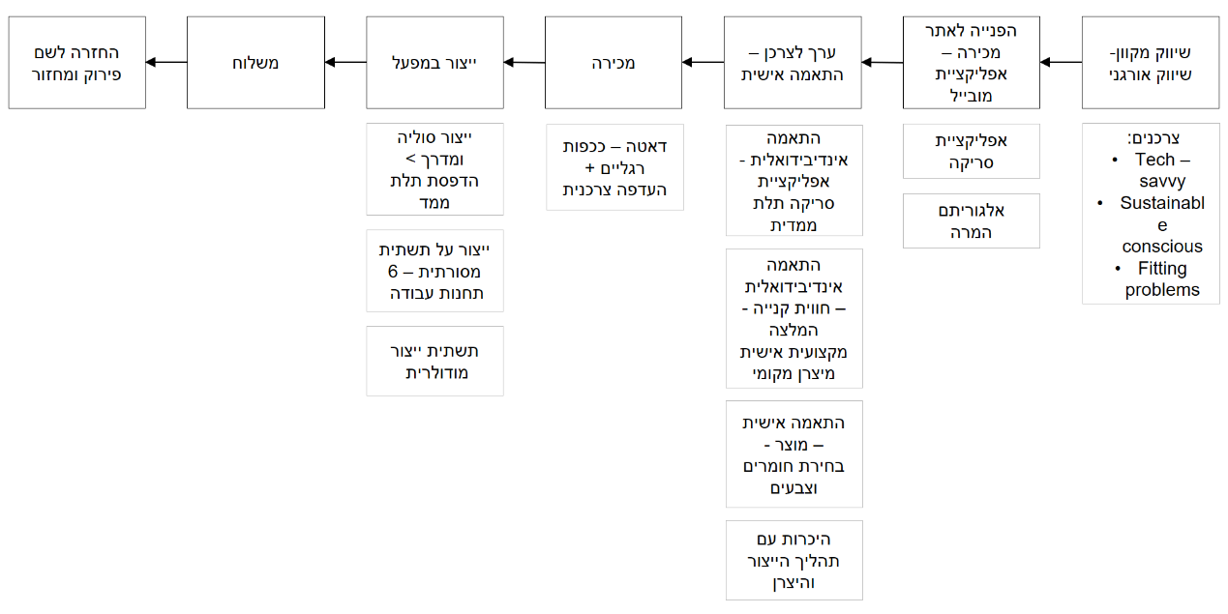

Sustainable product development: Recyclable materials are used. The shoe is connected by sewing, without adhesives. This allows for simple disassembly of the product at the end of its life cycle.

Development of the production process: Intervention in the existing production line with the assistance of the manufacturer has allowed for reduction of the number of workstations from 12 to 6. A manufacturing process allows for connecting shoe parts only by sewing.

3D scanning and printing technology enable employees to respond to new production capabilities and needs in planning the production line. This enables production of a single model with endless modes of expression adapted to the consumer’s foot structure, style, and values. This model can be executed within a single, uniform, and continuous assembly line. It therefore reduces the production cost of the shoe.

Consumer Value Proposition - Product: Durable footwear customized to physiological data.

Consumer value proposition - purchasing experience: Personal recommendation from a professional, personal acquaintance. An illustration of the product and the consumers’ shopping experience can be seen in the [Know- Me Video](https://youtu.be/YwVwDeEwhUk).

Emphasis on technological research: During the R&D process for this product, while searching for production technology that enables personal production with sustainable materials, contact was established with a Canadian start-up working on dynamic production technologies. Following set goals, a process of joint development of a single dynamic casting mold allowing personalized production of soles began. The expected result is rapid, low-cost production using a variety of possible materials. This development has the potential to serve as a disruptive technology in personalized footwear currently focused on 3D printing.

**Development of the Know-Me platform**

Cost calculations of the value chain of the product introduced in the prior chapter revealed an economic barrier to manufacturers. Gaps were found between the shoe production costs at the plant and the costs of operating the digital site, marketing, and data analysis. This led to a shift from a system serving a single enterprise to a one serving multiple enterprises and offering a variety of products to consumers.

The proposed solution Know-Me is a technological digital casing that designs:

1. Direct contact between manufacturer and consumer

2. Lean and modular production processes

3. A database that can be converted into business opportunities

The casing model is based on an open platform linking online shopping opportunities to strengthen the connection between manufacturer and consumer. Three design values ​​were defined as guiding principles for the casing value proposition to the end consumer: personalization, personal connection, and environmental impact (locally and globally).

**Value proposition to consumers: Artisanal approach to digital relations**

A review of the changes in production processes between pre-industrial craft production and global mass production identified values that could be leveraged as a new value proposition to consumers. These include the nature of the consumer-producer relationship, generic versus personalized products, and implications of the production process.

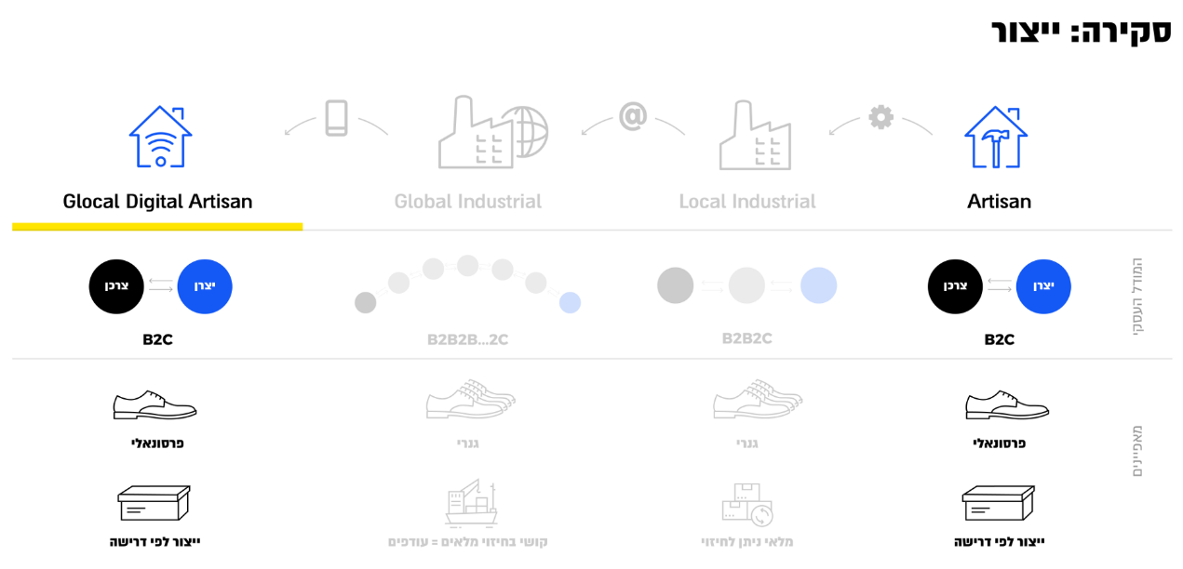

**Production Overview**

New technologies facilitate the return to artisanal production values (craft) in a new digital configuration in the glocal (global/local) system.

The primary value offered and marketed to the consumer - Personalized product and communication. The online selling site enables reception of physiological and other data from the consumer. In turn, the consumer receives personal and professional recommendations from the manufacturer.

The added value to the consumer - The possibility of buying a product with sustainable value and responsibility for the end of the product's life. During the buying process, consumers can select the material, reflecting their worldview. Also, they have an opportunity to get acquainted with the manufacturing process and the manufacturer.

The value of sustainability is expressed in a product designed for disassembly. It can be collected from the customer at the end of its use, easily disassembled, and the materials recycled and/or reused. This enables the following sequence of production on demand: designing modules and production infrastructure > customer personalizes & customizes the design > purchase > manufacture.

**Values ​​to manufacturers**

The casing offers the manufacturer accompaniment on three levels:

A. Product development process and production process

On-Boarding - The casing assists in co-developing a product and manufacturing process prior to the start of work. This is designed to adapt the product to a relevant target audience with a clear marketing value while maintaining an economically feasible production process and developing existing knowledge in the plant. The casing is used as a knowledge integrator.

Development of the production process - Development and design of the product takes place together with creation of a production infrastructure based on principles of minimal modules and workstations. This minimizes inventory of raw materials and eliminates excess stocks. It introduces technology to the plant that enables personal production on demand. This holistic process simultaneously considers product design, production, employee skills, and customer experience.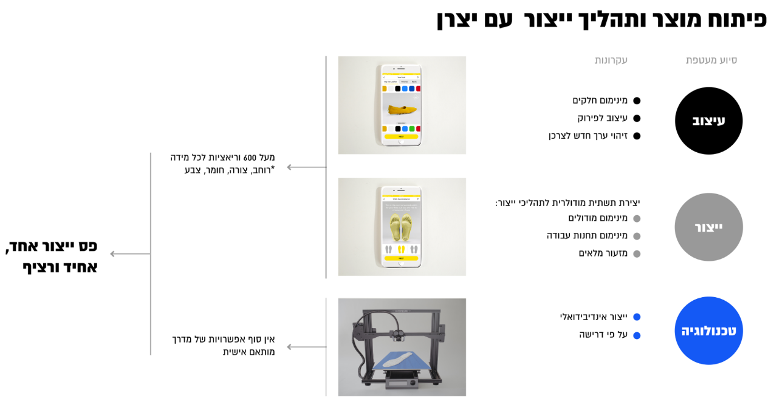

**Product development and manufacturing process with local manufacturer**

B. Support for ongoing activities

In daily operations, the casing manages the sale site, digital marketing, customer service, digital operation of the site and its applications, and transferring files needed for technological production (for instance 3D printing). The casing collects data and makes it accessible to the manufacturer. This is reflected in digital inventory management, production instructions for workstations, and communication with suppliers.

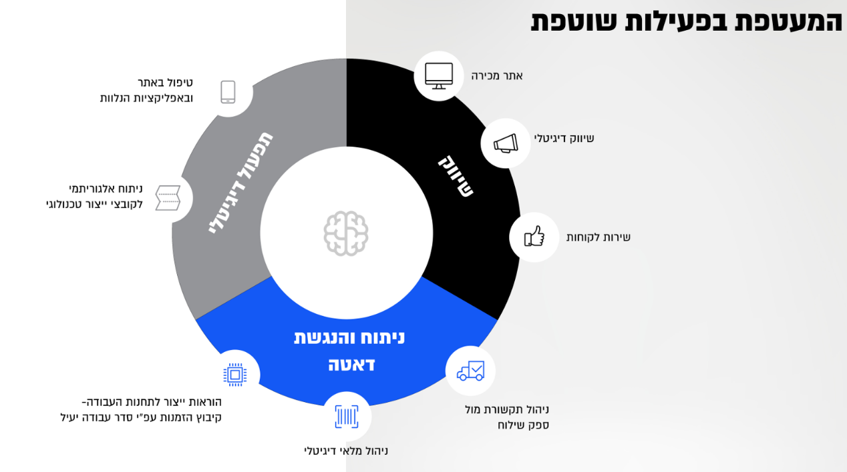 Casing support for ongoing activities

C. Database and future R&D processes

Digitization can revitalize local production. New technology in the production process enables development of manufacturing capabilities. Data on customers’ behavior and foot physiology will help identify opportunities for further development. This combination enables an interconnected and sustainable production process that can be continually updated and improved.

In the long term, the casing will enable creation of a unified network of an updatable and decentralized production process, which can be connected to additional workshops and industries to create new opportunities. The casing will unite plants in the collection and analysis of data, logistics, marketing, and distribution. It will allow for individualized production processes for different manufacturers, enabling a wide range of products for customers on the selling platform.

**Environmental and ecological values**

Short-term: Design for disassembly enables recycling or reusing materials. Eliminating final product inventory by producing on demand and reducing raw materials inventory.

Long term: Products will be offered to a local and global clientele. After identifying consumers outside the original production location, the casing will locate local producers in the new geographic location and initiate local production of the product near that customer.

**Summary**

The research presented in this paper finds that improving the connection between production and design within the footwear industry and with other industries enables creation of new knowledge regarding the product. This can lead to a competitive advantage for the Israeli footwear industry and serve as a potential growth engine for local production.

The proposed solution is a platform used as a digital and technological casing for micro-small manufacturing plants. The platform mediates and shapes the connection between production, technology, and design. It enables creation of a joint R&D system with the potential to develop strategies, production methods, and innovative products. It overcomes barriers of the global market and leverages the advantages of personal contact with the consumer.

The casing can serve as an infrastructure for developing a system that creates innovation. It could minimize the inherent risk of investing in innovative activity by creating a co-production and co-R&D network for manufacturers.

# BIBLIOGRAPHY

Hebrew sources:

El Or, T. (2014). *Sandals: The anthropology of local style*. Edited by E. Wolf. Tel Aviv: Am Oved.

El Or, T. & Revev, M. (2015). The establishment of the Israeli style: 1967-1973. In O. Shiff & A. Halamish (Eds.), *Studies in Israel’s revival* (pp. 308-333). Beer Sheva, Israel: Ben Gurion University Press.

El Or, T. (2014). Right where the body ends: The anthropology on and of the edges. In G. Ventura, O. Bartal, & E. Leeder (Eds.), *Thoughts about shoes* (pp. 224-241). Tel Aviv: Bezalel Academy (Department of History and Theory and Department of Jewelry and Fashion) and Resling.

Ventura, J. (2014). The movement from evolution to revolution: On shoes, teaching and design. In G. Ventura, O. Bartal, & E. Leeder (Eds.), *Thoughts about shoes* (pp.242-266). Tel Aviv: Bezalel Academy (Department of History and Theory and Department of Jewelry and Fashion) and Resling.

English sources:

Anderson, D. M. (2011). Mass Customization’s Missing Link. *Mechanical Engineering*, *133*(4), 32–35. Retrieved from https://search.ebscohost.com/login.aspx?direct=true&db=bth&AN=59861112&site=ehost-live

Audretsch, D. B., & Thurik, A. R. (2000). Capitalism and democracy in the 21st Century: from the managed to the entrepreneurial economy *. *Journal of Evolutionary Economics*, *10*(1–2), 17–34. <https://doi.org/10.1007/s001910050003>

Augusto, D., Pacheco, D. J., Carla, S., & Jung, C. F. (2017). Eco-innovation determinants in manufacturing SMEs: Systematic review and research directions Eco-innovation determinants in manufacturing SMEs: Systematic review and research directions, (November 2016). https://doi.org/10.1016/j.jclepro.2016.11.049

Brunoe, T. D., & Nielsen, K. (2016). Complexity Management in Mass Customization SMEs. *Procedia CIRP*, *51*, 38–43. https://doi.org/10.1016/j.procir.2016.05.099

Carvalho, L., Dong, A., & Maton, K. (2009). Legitimating design: a sociology of knowledge account of the field. *Design Studies*, *30*(5), 483–502. https://doi.org/10.1016/j.destud.2008.11.005

Dorst, K., & Cross, N. (2001). Creativity in the design process, *22*, 425–437. https://doi.org/10.1016/S0142-694X(01)00009-6

Eroglu, I., & Ceylan Esen, O. (2016). A Research on Designer Roles in Industries. *Systems & Design: Beyond Processes and Thinking (IFDP - SD2016)*, (June). https://doi.org/10.4995/IFDP.2016.3204

Filipa Soares Passos Cardoso, A., & Torkkeli, M. (2014). Innovation in footwear companies – does it pay off? *Journal of Engineering, Design and Technology*, *12*(1), 128–154. https://doi.org/10.1108/JEDT-09-2010-0063

Gandhi, A., Magar, C., & Roberts, R. (2014). How technology can drive the next wave of mass customization. *MC Kinsey & Company’s Business Technology Journal*, 1–8. Retrieved from http://www.mckinsey.com/insights/business_technology/how_technology_can_drive_the_next_wave_of_mass_customization

Gardetti, M. A., & Torres, A. L. (2013). Entrepreneurship, Innovation and Luxury. *The Journal of Corporate Citizenship*, (December), 55–76.

Hagel III, J., & Brown, J. S. (2011). From Push to Pull: Emerging Models for Mobilizing Resources. *Journal of Service Science (JSS)*, *1*(1), 93. https://doi.org/10.19030/jss.v1i1.4305

Hansen, T., & Winther, L. (2015). Manufacturing in the knowledge economy: innovation in low-tech industries. *Handbook of Manufacturing Industries in the World Economy*, 439–450. https://doi.org/10.4337/9781781003930.00040

Holmes, H. (2015). Transient craft: reclaiming the contemporary craft worker. *Work, Employment and Society*, *29*(3), 479–495. https://doi.org/10.1177/0950017014535834

John Hagel III, Brown, J. S., Kulasooriya, D., Gif, C., & Chen, M. (2015). The Future of Manufacturing, 1–20. https://doi.org/10.1049/tpe.1971.0034

Link, C. (2016). Can Marshall’s Clusters Survive Globalization

Lor, P. J., & Britz, J. J. (2007). Is a knowledge society possible without freedom of access to information? *Journal of Information Science*, *33*(4), 387–397. https://doi.org/10.1177/0165551506075327

Mozota, B. De. (2002). Design and competitive edge: A model for design. *Design Management Journal*, 88–103.

Mozota, B. B. de. (2010). The Four Powers of Design: A Value Model in Design Management. *Design Management Review*, *17*(2), 44–53. <https://doi.org/10.1111/j.1948-7169.2006.tb00038.x>

Niedderer, K. (2007). Sustainability of the Crafts as a Discipline, 1–10.

Niedderer, K., & Townsend, K. (2014). Craft, innovation and creativity. *Craft Research*, *5*(2), 149–153. <https://doi.org/10.1386/crre.5.2.149>

Norman, D. A., Verganti, R., Group, N. N., & Bio, D. A. N. (2012). Incremental and Radical Innovation: Design Research Versus Technology and Meaning Change, (2011), 1–19.

Koren, Y., Shpitalni, M., Gu, P., & Hu, S. J. (2015). Product Design for Mass-Individualization Product Design for Mass-Individualization, (December). https://doi.org/10.1016/j.procir.2015.03.050

Radicic, D., & Pugh, G. (2015). The impact of innovation support programmers on SME innovation in traditional manufacturing industries: an evaluation for seven EU regions. *Environment and Planning C: Government and Policy*, 1–28. https://doi.org/10.1177/0263774X15621759

Radicic, D., Pugh, G., Hollanders, H., Wintjes, R., & Fairburn, J. (2015). The impact of innovation support programs on small and medium enterprises innovation in traditional manufacturing industries: An evaluation for seven European Union regions. *Environment and Planning C: Government and Policy*, *34*(8), 1425–1452. https://doi.org/10.1177/0263774X15621759

Roper, S., & Love, J. (2016). The roles and effectiveness of design in new product development: a study of Irish manufacturers: The roles and effectiveness of design in new product development: a study of Irish manufacturers, *45*(41), 1–40.

Schwalbe, M. (2010). In search of craft. *Social Psychology Quarterly*, *73*(2), 107–111. https://doi.org/10.1177/0190272510369086

Strangleman, T. (2017). Deindustrialization and the Historical Sociological Imagination: Making Sense of Work and Industrial Change. *Sociology*, *51*(2), 466–482. https://doi.org/10.1177/0038038515622906

Temeltaş, H. (2017). Collaboration and exchange between “Craftsman” and “Designer”: Symbiosis towards Product Innovation. *The Design Journal*. https://doi.org/10.1080/14606925.2017.1352876

Tomlinson, P. R., & Branston, J. R. (2014). Turning the tide: prospects for an industrial renaissance in the North Staffordshire ceramics industrial district. *Cambridge Journal of Regions, Economy and Society*, *7*(3), 489–507. https://doi.org/10.1093/cjres/rsu016

Vale, M., & Caldeira, J. (2007). Proximity and knowledge governance in localized production systems: The footwear industry in the north region of Portugal. *European Planning Studies*, *15*(4), 531–548. https://doi.org/10.1080/09654310601134854

Weiss, Z. (2016). Innovation through craft: Opportunities for growth. *Kpmg*, (July). Retrieved from http://www.craftscouncil.org.uk/content/files/KPMG_CC_Innovation_Report.pdf

Woolley, M. (2011). Beyond control: Rethinking industry and craft dynamics. *Craft Research*, *2*(1), 11–36. <https://doi.org/10.1386/crre.2.11_1>

Yair, K., Press, M., & Tomes, A. (2001). Crafting competitive advantage: Crafts knowledge as a strategic resource. *Design Studies*, *22*(4), 377–394. https://doi.org/10.1016/S0142-694X(00)00043-0

Online presentations:

Richard Sennett: Craftsmanship, 2016 - presentation

Richard Sennett: "The Decline of the Skills Society “, 2011 - presentation

Designence Model 1 - Designers Knowledge (Brigitte Borja de Mozota).wmv. 2012 - [YouTube](https://www.youtube.com/watch?v=3yCBofccM20&list=PLGMdCW0AxCoEdqbwwfBfgz9a5VeQoA7P1&index=5)

model 3 - designence (Brigitte Borja de Mozota).wmv .2012 - [YouTube](https://www.youtube.com/watch?v=stYtO33ToEQ&index=4&list=PLGMdCW0AxCoEdqbwwfBfgz9a5VeQoA7P1)

TED - [Olivier Scalabre](https://www.ted.com/speakers/olivier_scalabre) - The next manufacturing revolution is here. 2016

TEDxEast - [Matt Crawford](https://www.youtube.com/watch?v=xdGky1JZovg) - Manual Competence. 2016

Reports and laws:

Central Bureau of Statistics, December

Overview of the Footwear Industry 2007: Israel Association of Work and Industry

Isracard Magazine, April 2017

Bank Leumi Report on Apparel, July 2017

The Makov Committee Report

The R & D Law

Innovation Report 2017, The Innovation Authority

Standard Industrial Classification of All Economic Activities

United States International Trade Commission 2017

Vend’ 2017 Retail Trends

[Footwear Consumer 2030 - Incorporating Global Trends to Foresight Footwear Market. Published 2.2015](https://issuu.com/joanavazteixeira/docs/footwear_consumer_2030)

Leading 10 footwear producers worldwide from 2013 to 2016, by country (in million pairs). STATISTA 2017

craft & innovation- UK craft council report 2016

craft council report 2016. UK

The future manufacturing – making things in changing a world - Deloitte 2015

<https://gearjunkie.com/keen-robot-builds-uneek-shoes>

<https://www.theverge.com/2017/4/7/15216724/adidas-3d-printed-sneaker-futurecraft>

<https://www.iconeye.com/design/news/item/12557-the-future-of-craft>

<https://inhabitat.com/ecouterre/grow-your-own-microbial-leather-in-your-kitchen-diy-tutorial/>

1. A senior development man in a large footwear factory, two entrepreneurs in the field of additive manufacturing, materials specialist, e-commerce, digital marketing, programmer of orthopedic software for three-dimensional.
2. Some of the meetings with experts were conducted with the manufacturer and at his initiative, and the researcher mediated some meetings.