**Computer Science and Mathematics**

**Why this track is unique:**

**This is a joint program towards a Bachelor of Science degree (BSc) in Computer Science and Mathematics.**

**The Faculty of** [**Computer Science**](http://www.cs.technion.ac.il/he/) **and the Faculty of** [**Mathematics**](https://web.math.technion.ac.il/site/) **offer a joint program designed for outstanding students (Excellence program). Upon the completion of their studies, graduates will receive a Bachelor of Science (BSc) in Computer Science and Mathematics.**

Detailed information regarding the Excellence program for both faculties can be viewed separately under the acceptance requirements of the main faculties; [Computer Science](https://admissions.technion.ac.il/academic-programs/students-experience/computer-science/) or [Mathematics](https://admissions.technion.ac.il/academic-programs/students-experience/mathematics/).

**Career Options and Job Opportunities**

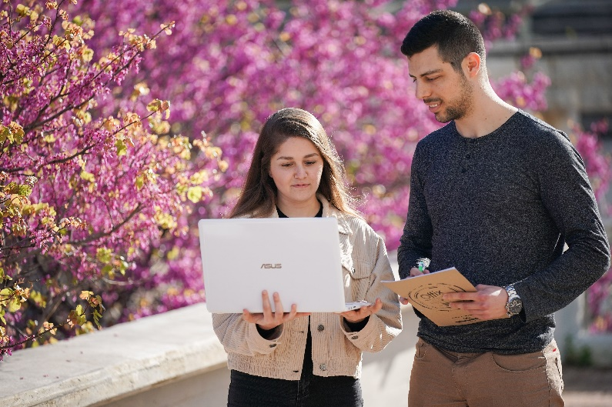

The goal of this track is for undergraduates to gain **a deep understanding of both computer science and mathematics**, allowing them to lead and participate in both research and industry in these fields. Participants in this track are excellent students, most of whom continue to graduate studies in either one of the two facultieschoice. Others are accepted into other leading universities, or find rewarding employment in the Hi-Tech industry.

**Study program**

This seven-semester program includes all the mandatory courses from both the Computer Science and Mathematics faculties, and the courses in this program are evenly distributed across both fields. **Students enjoy the benefits and services of both faculties of Computer Science and Mathematics;** they are granted access to the libraries, computer rooms, and laboratories of both faculties.

Graduates of this track may continue their studies towards a master’s degree (MSc) in either of the two faculties. **Graduates of this track will be considered as graduates of a four-year program when applying for the master’s program in either the Faculty of Computer Sciences or the Faculty of Mathematics.**

**Contact us:**

**Computer Sciences: Ortal Amsalem, Yael Saar, Miriam Shira Weiss**

[**ugoffice@cstechnion.ac.il**](mailto:ugoffice@cstechnion.ac.il)

**077-887-2206**

**077-887-4316**

**077-887-4344**

[**cs.technion.ac.il**](http://www.cs.technion.ac.il/he)

**Mathematics: Rachel Tubul**

[**mathstd@technion.ac.il**](mailto:mathstd@technion.ac.il)

**077-887-4279**

[**math.technion.ac.il**](http://phys.technion.ac.il/he/)