**Computer Science and Mathematics**

**Why this track is unique**

**This is a joint program towards the degree of Master of Science (MSc) in Computer Science and Mathematics.**

The Faculty of [Computer Science](http://www.cs.technion.ac.il/he/) and the Faculty of [Mathematics](https://web.math.technion.ac.il/site/) offer a joint program designed for outstanding students (excellence track). Upon the completion of their studies, graduates will receive the degree of **Master of Science (MSc) in Computer Science and Mathematics**.

Detailed information regarding the excellence programs in both faculties can be viewed separately under the acceptance track of the mother faculty, [Computer Science](https://admissions.technion.ac.il/academic-programs/students-experience/computer-science/) or [Mathematics](https://admissions.technion.ac.il/academic-programs/students-experience/mathematics/).

**Career Options and Job Opportunities**

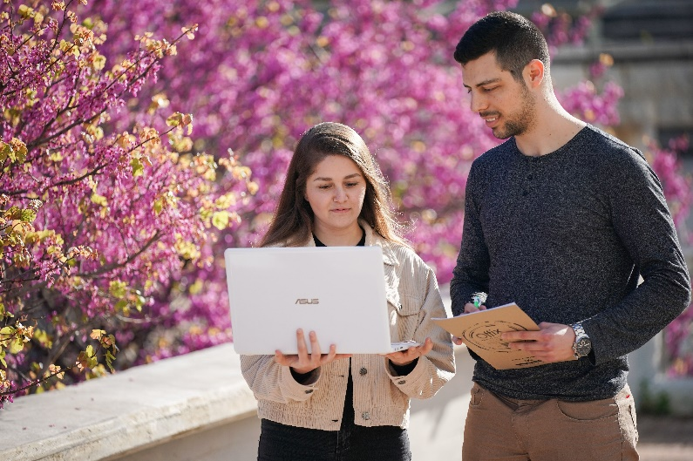

The goal of this track is to train graduates **in a deep understanding of both Computer Science and Mathematics**, who will later be able to participate in, and lead, the research and industry in these fields. Students in this track are excellent students, most of whom continue to graduate studies in one of the two faculties, according to their choice. The others are accepted to other leading universities or find rewarding employment in the Hi-Tech industry.

**Study program**

The seven-semester program includes all mandatory courses in both Computer Science and Mathematics. The courses in this program are evenly distributed between both fields. **Students enjoy the services of both faculties, Computer Science and Mathematics**. They are granted access to the libraries, computer farms, and laboratories of both faculties.

Graduates of this track may continue their studies towards a Masters’ degree in either of the two faculties. **Graduates of the track will be considered as graduates of a four-year track program when applying to the Master’s program in the Faculty of Computer Sciences or in the Faculty of Mathematics.**

**Contact us:**

**Computer Sciences: Ortal Amsalem, Yael Saar, Miriam Shira Weiss**

[**ugoffice@cstechnion.ac.il**](mailto:ugoffice@cstechnion.ac.il)

**077-887-2206**

**077-887-4316**

**077-887-4344**

[**cs.technion.ac.il**](http://www.cs.technion.ac.il/he)

**Mathematics: Rachel Tubul**

[**mathstd@technion.ac.il**](mailto:mathstd@technion.ac.il)

**077-887-4279**

[**math.technion.ac.il**](http://phys.technion.ac.il/he/)