Computer Science and Physics

**Why this track is unique**

**This is a joint program towards the degree of Master of Science (MSc) in Computer Science and Physics.**

The Faculty of [Computer Science](http://www.cs.technion.ac.il/he/) and the Faculty of [Physics](https://phys.technion.ac.il/he/) offer a joint program designed for outstanding students (excellence track). Upon the completion of their studies, graduates will receive the degree of **Master of Science (MSc) in Computer Science and Physics**.

Details regarding the faculties’ excellence programs can be viewed separately under the acceptance track of the mother faculty, [Computer Science](https://admissions.technion.ac.il/academic-programs/students-experience/computer-science/) or [Physics](https://admissions.technion.ac.il/academic-programs/students-experience/physics/).

Career Options and Job Opportunities

[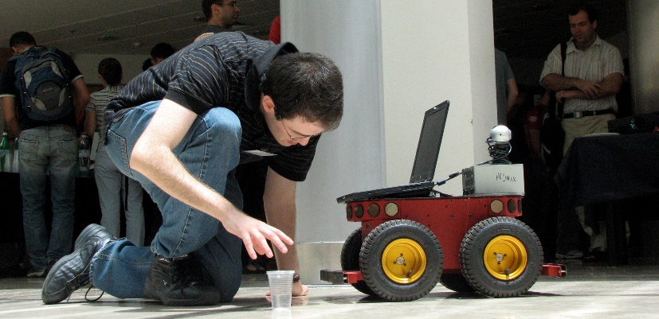](https://admissions.technion.ac.il/files/2014/05/%D7%9E%D7%93%D7%A2%D7%99-%D7%94%D7%9E%D7%97%D7%A9%D7%91-1.jpeg)

The goal of the track is to train graduates **with a deep understanding in both Computer Science and Physics**, who will be able to participate in, and lead, the research and industry in these fields. Students in this track are excellent students, most of whom continue to graduate studies in one of the faculties, according to their choice. The others are accepted to other leading universities, or find rewarding employment in the Hi-Tech industry. It is important to note that over the last few years, the Hi-Tech world has developed an increasing interest in quantum computers and in quantum coding communications.

**This track is especially suitable for students interested in specializing in interdisciplinary directions, such as: Quantum Computers | Quantum Communication and Coding | Physics of the Computer | Scientific Programming | Computational Physics | Intelligent Systems | Optics and Image Processing | Optical Communication | Dynamics | and more. In addition, graduates acquire broad knowledge which greatly benefit them in any scientific direction they choose to pursue, either in the industry or in academia.**

**Study program**

The eight-semester program includes all mandatory courses in both Computer Science and Physics. The courses in this program are evenly distributed between both fields. **Students enjoy the services of both faculties, the Faculty of Computer Science and the Faculty of Physics**. They are granted access to the libraries, computer farms, and laboratories of both faculties.

**Graduates of this track may continue their studies towards a Master’s degree (MSc) in either of the two faculties. Graduates of this track will be considered as graduates of a four-year track program when applying to the Masters’ program in the Faculty of Computer Sciences or in the Faculty of Physics.**

**Secondary Specialization Track in Quantum Computing**

This program is offered by the Faculty of Computer Science, and is especially suitable for outstanding students in the combined Computer Science and Physics track. Detailed information appears in the catalogue for undergraduate studies of the Faculty of Computer Science. Outstanding graduates of this track and program will have an advantage as prospective candidates for advanced degree programs specializing in quantum computing and technology, available today in several faculties at the Technion, including the Faculty of Physics.

Contact us:

**Computer Science: Ortal Amsalem, Yael Saar, Miriam Shira Weiss | 077-8874344/4316/2206 |** [**ugoffice@cstechnion.ac.il**](mailto:ugoffice@cstechnion.ac.il) **|** [**cs.technion.ac.il**](http://www.cs.technion.ac.il/he) **| Physics: Prof. Yariv Kafri |** [**kafri@physics.technion.ac.il**](mailto:bergman@physics.technion.ac.il) **| 077-8775936 | Etti Maman |** [**eti@physics.technion.ac.il**](mailto:eti@physics.technion.ac.il) **| 077-8875585 |** [**phys.technion.ac.il**](http://phys.technion.ac.il/he/)