**Overall Research Description**

The study comprises two phases: the first phase is an examination of the frequency of destructive leadership in Israel; the second phase is the core of the study that tests the model and its hypotheses among managers and their subordinates.

**Phase 1:**

There are two main objectives in Phase 1: a preliminary study to examine the prevalence of destructive leadership in Israel; and an examination of the disparity between the results of leadership prevalence among random subjects outside of the organizations (Phase 1) and random subjects within the organizations. (Phase 2 is a dyadic study that examines both the employee's perception concerning the destructive leadership of his current supervisor and the supervisor’s personal and behavioral characteristics, and the links between them.)

**Method:**

**Participants and procedure**

The study included 225 participants (after screening of 412 respondents, 54.6% response rate), all salaried employees who worked in at least three jobs.

Table 2: Descriptive Statistics Phase 1

|  |  |  |  |
| --- | --- | --- | --- |
| **Variable** | **Value** | **Frequency** | **Percent** |
| Gender | Male | 99 | 44 |
| Female | 126 | 56 |
| Education | High school graduate | 46 | 20.4 |
| Graduate non-academic studies | 63 | 28 |
| B.A. B.Sc. | 88 | 39.2 |
| M.A. M.Sc. | 21 | 9.3 |
| Ph.D. | 7 | 3.1 |
| Age | 20-30 | 58 | 25.8 |
| 31-40 | 124 | 55.1 |
| 41-50 | 43 | 19.1 |

**Research tools:**

Participants were asked to respond to a questionnaire on destructive leadership regarding their current manager. Destructive leadership was measured using the Abusive Supervision Questionnaire (Tepper, 2000), which includes 15 items (Cronbach’s alpha: 0.85; in this study: 0.95).The items were prefaced with the statement: "My boss.." Responses were on a five-point response scale: 1- "I cannot remember him/her ever using this behavior with me"; 2- "He/she very seldom uses this behavior with me"; 3- "He/she occasionally uses this behavior with me"; 4- "He/she uses this behavior moderately often with me"; 5- "He/she uses this behavior very often with me."

**Results:**

The frequency of the findings is presented in Table 2 and includes a comparison to the Ministry of Economy's 2015 Report on Bullying and Abuse in the Workplace. The comparison is applied only to averages from "occasional" up to "very frequent" (levels 3 and up).

The comparison to the Ministry of Economy's report shows that the results in Phase 1 in this study are higher. The average rate of bullying in Phase 1 is 15.3%, whereas the average rate of bullying in the study done in Israel is 10%. The average rate of those frequently experiencing phenomena of DL is 2.6%. The higher results in this study may be due to the fact that it was conducted online, whereas the Ministry of Economy research was conducted via telephone interviews.

The results in this phase are concurrent with international findings:

Hubert and Van Veldhoven (2001) reported a rate of about 11% in the Netherlands. Even higher rates are reported in a Norwegian study (Aasland et al., 2010), in which approximately a third of employees reported that they had been subject to some type of DL "frequently." In the U.S., abusive supervision was estimated to affect 13.6% of U.S. workers (Tepper, 2007).

**Phase 2:**

The purpose of the second phase is to examine whether there is a link between DL and traits of personality (narcissism and external locus of control) and behavior (mindlessness). In this phase, the study necessitates a connection between the manager and his/her subordinates.

**Method:**

**Participants and procedure**

Participants were recruited from companies in the finance industry in Israel. We contacted the companies' human resource managers to obtain their permission to conduct the study. The human resource managers provided us with the names and email addresses of supervisor-subordinate pairs who might be willing to take part in the study. The questionnaires were divided into two batches and participants completed them on a voluntary basis. The employees responded to the first batch. Each employee received an email containing information about the purpose and procedure of the study and a personal code. The employees' codes begin with E. They were asked about their direct supervisor and his/her destructive leadership. For the second batch, supervisors/managers' (codes start with M) were asked to respond to a questionnaire about their own personality traits and behavior: narcissism, locus of control and mindfulness /mindlessness.

Upon completion of the questionnaire, matching was done between the employee and the manager. Employees and managers without matches were eliminated from the study.

The sensitivity of the research topic and its data and the desire to prevent employees from feeling threatened as a result of filling out the questionnaires led to distribution of the questionnaires by _________ only, via personal email with a link to an online questionnaire. Human Resources and Organizational Development sent a preliminary email with a request to participate in the study. The participants were accorded full confidentiality.

In order to avoid reporting bias, we acted according to Podsakoff, MacKenzie, & Podsakoff (2012).

**Procedural remedies:**

1. Obtaineding the predictor measures from one person and the criterion measures from another:

This procedure can diminish or eliminate the effects of consistency motifs, idiosyncratic implicit theories, social desirability tendencies, dispositional mood states, and tendencies on the part of the subject to acquiesce or respond in a lenient, moderate, or extreme manner, because it renders impossible a predictor-criterion relationship bias in the mindset of the average subject.

In the present study, the dependent variable is destructive leadership as reported by the employees. The independent variables are narcissism, external locus of control, and mindlessness, as reported by the manager.

1. Temporal, proximal, or psychological separation between predictor and criterion:   
   In this study, employees received the link to the questionnaire at one point in time, and managers received the link to the questionnaire at a different point in time (one week apart). In the personal email that they received, the version was identical for both the employee and the manager in order to avoid creating tension around answering the questionnaires.
2. Increasing the motivation to respond accurately by developing a good cover story and instructions:  
   In the present study, an accompanying letter was attached requesting the participant’s cooperation in completing the questionnaire, and explaining that the answers will assist in investigating and understanding the subject. Anonymity and the fact that the data is collected for research purposes only were stressed. Sentences such as "There are no correct or incorrect answers, the answer you choose is correct" and "Thank you for your response and cooperation" were used. Contact details (email and mobile phone number) were attached in case questions would arise or if they would want to get the results of the study.

*Table 3: Descriptive Statistics Phase 2*

**Managers (n=41)** Sent to 90 managers. Response rate 45.5%**:**

|  |  |  |  |
| --- | --- | --- | --- |
| **Variable** | **Value** | **Frequency** | **Percent** |
| Gender | Male | 22 | 53.6 |
| Female | 19 | 46.4 |
| Seniority | Less than a year  1-3 years  More than 3 years | 1  5  35 | 2.4  12.2  85.4 |
| Education | B.A. | 15 | 36.6 |
| M.A. M.Sc. | 26 | 63.4 |
| Age | 20-30 | 2 | 4.9 |
| 31-40 | 25 | 61 |
| 41-50  50+ | 9  5 | 22  12.1 |

**Employees (n=105):**

|  |  |  |  |
| --- | --- | --- | --- |
| **Variable** | **Value** | **Frequency** | **Percent** |
| Gender | Male | 51 | 48.6 |
| Female | 54 | 51.4 |
| Seniority | Less than a year  1-3 years  More than 3 years | 20  43  42 | 19  41  40 |
| Age | 20-30 | 45 | 42.9 |
| 31-40 | 46 | 43.8 |
| 41-50  50+ | 9  5 | 8.6  4.7 |

**Employees:**

Destructive leadership (identical to Phase 1) was measured using the 15-item Abusive Supervision Questionnaire (Tepper, 2000), , (Cronbach's alpha: 0.85; in this study: 0.89).

**Managers:**

Mangers were surveyed using three scales: narcissism, locus of control and mindlessness.

**Narcissism (NAR)**

The most widespread index used by non-clinical researchers, the 40-item Narcissistic Personality Inventory – or NPI-40 – captures a range of different facets of the construct, but its length may be prohibitive to its use. NPI-16 has notable face, internal, discriminant, and predictive validity and may serve as an alternative measure of narcissism when the situation does not allow the use of longer inventories (Ames, Rose & Anderson, 2006).

We created a total of 16 binary items (Cronbach's alpha: 0.84-0.86; in this study: 0.72).

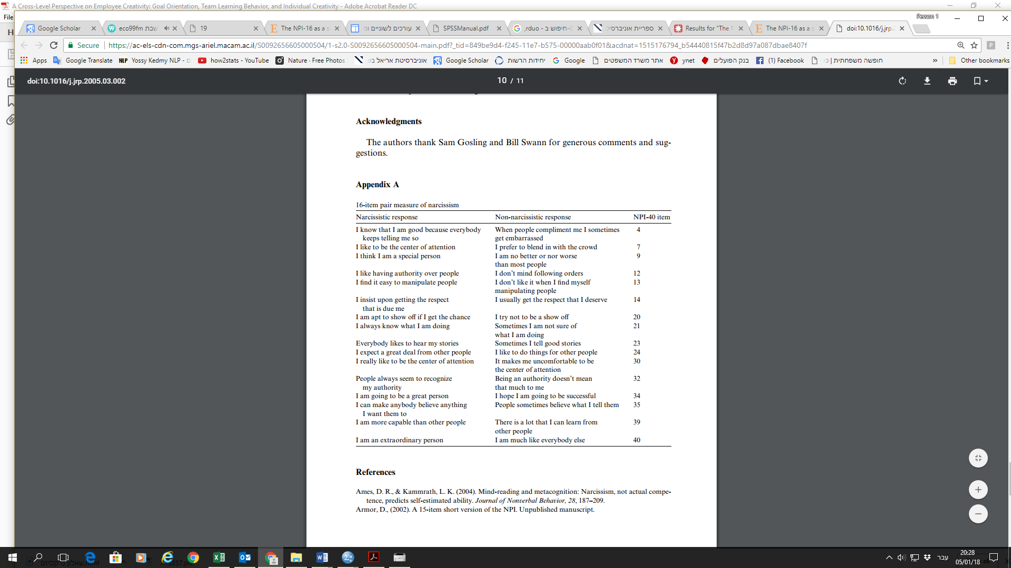*Table 4: 16-item pair measure of Narcissistic response and Non-narcissistic response*

**Locus of control (LOC)**

Locus of control was measured using the short Locus of Control Scale developed and extensively tested by Johnson and McGill (1988). It is a 15-item instrument using a Likert Scale response format. Only external LOC (ELoc) is relevant for our study and is represented by 7 items: numbers 1, 2, 6, 8, 9, 11 and 14.

**Mindlessness/Mindfulness (Mind)**

The scale wasdeveloped by Bonder & Langer (2001). In order to create an Israeli version of the original English instrument, we adopted the double blind back-translation procedure. Back-translation involves translating from the target language (i.e., Hebrew) back to the source language (i.e., English), such that the equivalence between source and target versions can be evaluated (Chapman & Carter, 1979).

We repeated the translation and back-translation processes until it made sense in both the original and target languages (Maneesriwongul & Dixon, 2004). This is necessary because if translation and back-translation are not done well it could result in false reporting of research findings.

In the 21-item survey instrument, Cronbach’s alpha is 0.85; in this study: 0.8.

We reversed items 1, 6, 10, 14, 16, 17, 19 and 21 and arrived at an average for all the items.

**Measures**

**Multilevel analysis**

The general concept is that the behavior of the individual is influenced by the social contexts in which they belong, and that the properties of a social group are influenced by the individuals who make up that group (Hox & Kreft, 1994). This general concept has led to a great deal of empirical research into the interaction between variables that describe properties of individuals and variables that describe properties of social groups (Blalock, 1984).

Multilevel models (also known as hierarchical linear models, nested data models, mixed models, random coefficient models, random-effects models, random parameter models, or split-plot designs), are statistical models of parameters that vary at more than one level. These models can be seen as generalizations of linear models (in particular, linear regression), although they can also extend to non-linear models.

The units of analysis are usually individuals (at a lower level) who are nested within contextual/aggregate units (at a higher level), such as a subordinate and his/her supervisor. Multilevel models can be used on data with many levels, although 2-level models are the most common. The dependent variable must be examined at the lowest (individual) level of analysis (Lazarsfeld & Menzel, 1961).

Multilevel models can be used as an alternative to ANCOVA, where scores on the dependent variable are adjusted for covariates (i.e., individual differences) before testing treatment differences. Multilevel models can be used to analyze these experiments without the assumption of homogeneity-of-regression slopes, required by ANCOVA.

**Cross-level interactions- להוסיף מקור**

Cross- level interactions are interactions between explanatory variables defined at different levels of the hierarchy. A single analysis of variance or multiple regression is performed, with one dependent variable at the lowest level and explanatory variables at all other levels of the hierarchy. The goal of the analysis is to determine the direct effect of individual level and group level explanatory variables, as well as to determine if characteristics of the context are moderating individual-level relationships (Cronbach & Webb, 1975). Analyzing cross-level interactions requires that variables defined at different levels of the hierarchy are combined in a single statistical model (Hox & Kreft, 1994). Disaggregating all higher level variables and preforming a single-level analysis implies unacceptable simplifications, leading to inefficient parameter estimates and downwardly biased precision of estimates. Multilevel models are designed to solve these problems.

In this study, we collected data from subordinates that are nested within their supervisors. The analyses were performed in R (Pinheiro, Bates, DebRoy, Sarkar & R Core Team, 2017). We did this in two stages because it is not possible to run a multilevel model with a mediator.

We performed two different analyses to validate the model structure:

Model 1: We ran a linear regression in which the dependent variable is MIND (the mediator in the general model). The independent variables included ELoc and NAR, as well as a binary variable indicating whether managers were in X (1) or in another company (0) given the large number of respondents from this company. This model is based solely on managers' data.

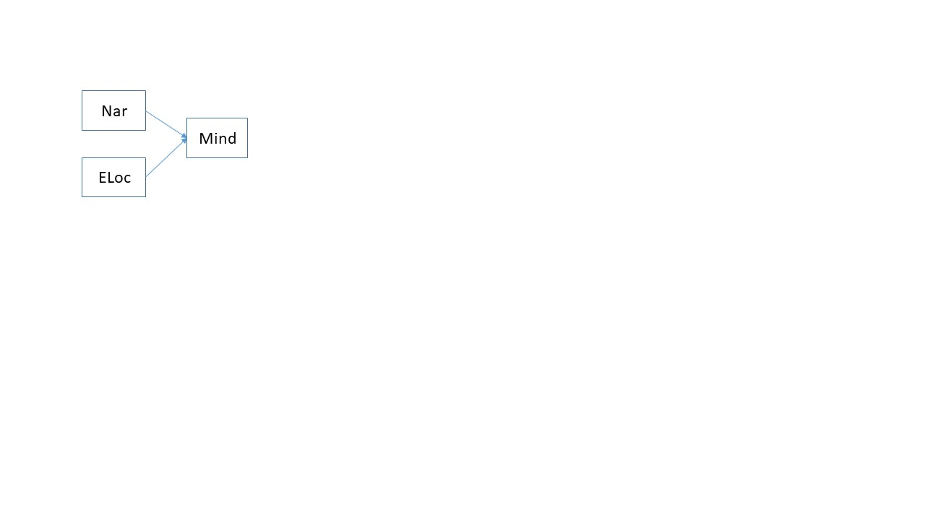Model 2: We ran a linear multilevel regression (employees nested within managers), in which the dependent variable is Destructive Leadership and the independent variables are MIND (the moderator), NAR, LOC, as well as the binary variable of company X.

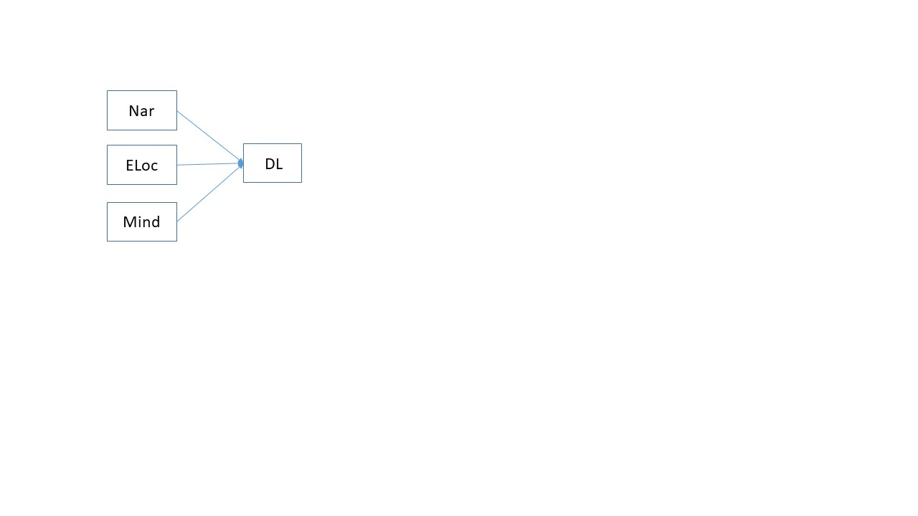

**Results:**

Model 1: The entire model is not significant [F(3,32)=2.59, p=.07) and explains 12% (R2=.12) of the variance in the dependent variable. Yet, it seems that narcissism has a positive effect on mindfulness/mindlessness. LOC and the control variable X have no effect. These results are presented in Table 5.

Table 5: Results of Linear Regression for Model 1   
Narcissism and External Locus of Control as Predictors of Mindfulness/Mindlessness

|  |  |  |  |  |  |
| --- | --- | --- | --- | --- | --- |
|  | B | SE | T | p | β |
| Nar | 0.05 | 0.02 | 2.34 | 0.026 | 0.38 |
| ELoc | 0.02- | 0.02 | 1.11- | 0.278 | 0.18- |
| Company X | 0.01- | 0.14 | 0.09- | 0.931 | 0.01 |
| קבוע | 3.77 | 0.38 | 10.02 | 0.000 | 0.00 |

Model 2: In this model, none of the variables had any effect on the dependent variable (and therefore there can be no mediation model in this case). See results in Table 6.

Table 6: Multilevel regression results for Model 2 – Narcissism, External locus of control and Mindfulness/mindlessness as predictors of destructive leadership

|  |  |  |  |  |  |
| --- | --- | --- | --- | --- | --- |
|  | B | SE | T | p | β |
| Nar | 0.02 | 0.02 | 0.86 | 0.395 | 0.13 |
| ELoc | 0.00 | 0.02 | 0.23 | 0.822 | 0.03 |
| Mind | 0.19- | 0.17 | 1.16- | 0.253 | 0.19- |
| Company X | 0.15- | 0.14 | 1.05- | 0.302 | 0.16- |
| קבוע | 1.92 | 0.73 | 2.62 | 0.012 | 0.04- |

**Discussion and Limitations**

As the results indicated, we were not able to confirm the hypotheses and the model, despite a solid theoretical background on the relationship between the variables. We did reveal that Narcissism has a positive and significant effect on Mindfulness/Mindlessness.

The prevalence of destructive leadership among employees in Phase A (outside organizations) is 15.3%, among employees as reported in the Ministry of Economy's Report on Bullying and Abuse in the Workplace (2015) is 10%, but among employees in Phase B is 4.5%.

In Phase B, the frequency is higher in items 6, 7 and 8: Reminds me of my past mistakes and failures (7.6%); Doesn't give me credit for jobs (12.3%); and Blames me to save himself/herself embarrassment (7.6%).

The explanation is the setup and structure of the research, including the research tools. This is a sensitive study in which the employee reports regarding his current manager. The fear that the information could reach the director (despite the promise of confidentiality) led to the employees feeling threatened and afraid, and the results of the destructive leadership questionnaire were not concurrent with the first phase of the study and with other studies in the field (e.g., the study done in Israel in 2015). See results in Table 7.

As I will show below, there is significance to an ‘in-organization’ study (employee-manager dyads) and an ‘out-of-organization’ study (random participants from various organizations that report regarding any manager during their career). The ability to gather reliable information will increase when there is a disruption to the dyadic relationship.

Studies that examined organizational dyads saw organizations as systems of negotiation with collaboration as the heart of the system (Graen & Scandura, 1987). In the process of negotiations, pairs are created, organizational dyads that mutually affect their partners positively- constructively or negatively- destructively. An example of an organizational dyad is a manager-employee dyad, which has been referred to in a large number of studies.

In the present study, we did not examine the mutual influence of the dyadic relationship, but rather only the worker's perception of his direct manager. It would be interesting to examine the manager's perception of the worker, which would complete the dyad.

Table 7: The prevalence of destructive leadership  
Comparison between Phase A and Phase B of the study and the Ministry of Economy's Report on Bullying and Abuse in the Workplace (2015)

|  |  |  |  |  |
| --- | --- | --- | --- | --- |
|  |  | "outside" organizations- phase 1 | "inside" organizations- phase 2 | Percent in Israel 2015 report |
| 1 | Ridicules me | 13.8 | 0.9 | 9.8 |
| 2 | Tells me my thoughts or feelings are stupid | 9.8 | 2.9 | 5 |
| 3 | Gives me the silent treatment | 17.3 | 3.8 | 9.8 |
| 4 | Puts me down in front of others | 11.1 | 1.9 | 7.4 |
| 5 | Invades my privacy | 10.7 | 2.9 | 6.6 |
| 6 | Reminds me of my past mistakes and failures | 18.7 | 7.6 | 12 |
| 7 | Doesn't give me credit for jobs requiring a lot of effort | 30.7 | 12.3 | 20.7 |
| 8 | Blames me to save himself/herself embarrassment | 15.6 | 7.6 | 15.2 |
| 9 | Breaks promises he/she makes | 20.4 | 5.7 | 15.7 |
| 10 | Expresses anger at me when he/she is mad for another reason | 22.7 | 5.7 | 16.2 |
| 11 | Makes negative comments about me to others | 13.3 | 6.7 | 9.1 |
| 12 | Is rude to me | 12.4 | 3.8 | 6.4 |
| 13 | Does not allow me to interact with my co-workers | 10.2 | 2.9 | 4.9 |
| 14 | Tells me I'm incompetent | 7.1 | 1.9 | 2.9 |
| 15 | Lies to me | 16.4 | 0.9 | 10.8 |

Similar results may be observed in the first empiric study that examined the differences between leaders who were collectively labelled as ‘destructive’. Erickson & Harvey (2011) found that most types of leaders identified via the cluster analysis could not be described as truly destructive. Rather, they tended to be destructive based on high scores on only a few negative behaviors. It seems that there are very specific behaviors that followers identify in their leaders that cause them to perceive their leaders as destructive.

Reed & Bullis (2009) investigated the Impact of Destructive Leadership on Senior Military Officers and Civilian Employees. They found that those in the reserve formations (National Guard and reserve) reported more experiences with destructive leadership than did those in active duty.

This is consistent with the results of the present study: When there is no severance of the dyadic relationship and when that employee is in the organization and feels that "he has something to lose" the tendency is not to share the real picture. Entering the organization, even if it is only for the purpose of distributing questionnaires, is an intervention that the employees treat with suspicion.

A review of leading studies (most cited in the last 10 years, according to Google Scholar) in the field of destructive leadership shows that most studies are theoretical, as shown in Table 8. Quantitative studies have not been conducted within organizations (while the dyadic relationship exists).

Table 8: A review of leading studies in the field of destructive leadership

הורדתי את הטבלה

An interesting point that arose during the study was a response from one of the participants: "The questionnaire made me want to write something good about my manager. I felt that I must defend him.” This relates to the article by Podsakoff et al. (2012) on the topic: Balancing positive and negative items. It, of course, has to do both with the questionnaire structure and the participant-style bias.

An unbalanced questionnaire is problematic because it inflates the estimates of the reliability of measures, may produce misleading factor analytic solutions, and may inflate or deflate correlation and regression coefficients, depending on the type of questions that are asked (Mirowsky & Ross, 1991). The procedural remedy to reduce this type of bias is to ‘balance’ the positively worded and negatively worded items. The advantage is that it is a proactive way to control for acquiescence biases.

One hypothesis that emerges is that an abusive leadership questionnaire is not suitable for in-organization research. A study that supports this hypothesis is that of Neubert, Kacmar, Carlson & Chonko (2008) on RFT-Regulatory Focus Theory. They claimed that the RTQ questionnaire is not suitable for the employment arena, and they developed a WRF-Work Regulatory Focus questionnaire.

The Regulatory Focus Questionnaire (RFQ) was developed as a questionnaire on reaction to events to “assess individual’s subjective histories of success or failure in promotion and prevention self-regulation” (Higgins, Friedman, Harlow, Idson, Ayduk & Taylor, 2001, p. 7). The WRF Scale was designed to be more contextual in nature, as it was developed to capture the degree of regulatory focus that is evoked in a work setting. All items focus on work-related situations and ask the respondents to consider their behavior at work. This makes the scale conceptually distinct from RFQ.

Our proposal for continuing research includes the development of a questionnaire adapted to the world of work – WDL – that includes situations from the domain of employment.

It is also important to mention the issue of organizational culture as an intervening variable in the study. About 80% of the results came from a large financial organization with a certain organizational culture that emphasizes individualism and is characterized by a relatively young, educated and informed population. It is possible that other results may have been obtained in the public sector, in the army or in the police, where the value of collectivism, the perception of power, and the exercise of authority are more significant.

Luthans, Peterson & Ibrayeva (1998) propose that ‘dark leaders”’ are likely to emerge in cultures that endorse the avoidance of uncertainty, collectivism (as opposed to individualism), and high power distance. Uncertainty avoidance involves the extent to which a society feels threatened by ambiguous situations; in such societies, people look to strong leaders to provide hope. Cultures that emphasize cooperation and group loyalty, as well as in-group/out-group distinctions, are defined as collective (Hofstede, 1991). Such cultures prefer strong leaders to bring people together, in part to absolve the citizens of working out conflicts directly and to provide solidarity and group identity.

In the present study, there is a significant link between narcissism and mindfulness: The more narcissistic the manager, the more mindful he is. Two possible explanations are: (1) biases in self-reporting, (2) issues related to the concept of healthy narcissism.

Healthy narcissism (Horwitz, 2000) involves a steady sense of one's worth based on genuine achievement, the capacity to recover from disappointment or failure, and the ability to find comfort and support in relationships.