**Inflation and Infection: Evidence from the G7 Countries**

*David Y. Aharon\**₰*, Mahmoud Qadan*§

**Abstract**

The purpose of this study is to examine the relationship between the ex-post inflation rates in the G7 countries, using a connectedness approach. Results obtained through both static and dynamic analyses confirm the US (Italy) as the main transmission (absorption) channel for inflation. Our dynamic analysis shows that the magnitude of inflation spillovers strengths during the outbreak of COVID-19 and earlier market crises such as the 2008 subprime crisis and the 2011 European debt crisis. The results may be important for policymakers at both the firm and country level, seeking for monitoring and mapping the evolution of Inflation.

*Keywords*: Inflation, Prices, Connectedness, TVP-VAR, COVID-19

*JEL classifications*: E31, E44

* Corresponding author.

₰David Y. Aharon, Faculty of Business Administration, Ono Academic College, Tzahal St 104, Kiryat Ono, Israel, [dudi.ah@ono.ac.il](mailto:dudi.ah@ono.ac.il).

₰Mahmoud Qadan, Department of Business Administration, Faculty of Management, University of Haifa E-mail: [Mqadan@univ.haifa.ac.il](mailto:Mqadan@univ.haifa.ac.il)

**Highlights**

* We explore the *ex-post* inflation connectedness between the G7 countries
* We employ TVP-VAR analysis for both static and dynamic evaluations
* The static analysis poses the US (Italy) as the main transmitter (receiver) of shocks
* The dynamic analysis shows that the magnitude and direction may change across time
* Connectedness increases during the 2008 and 2011 crises and the COVID-19 outbreak

**CRediT Author Statement**

**David Y. Aharon:** Conceptualization; Investigation; Data curation; Methodology; Resources; Formal analysis; Writing – original draft; Writing – review & editing.

**Mahmoud Qadan:** Conceptualization; Investigation; Data curation; Methodology; Resources; Formal analysis; Writing – original draft; Writing – review & editing.

**Declaration of Interests**

The authors declare that they have no known competing financial interests or personal relationships that could have appeared to influence the work reported in this paper.

The authors declare the following financial interests/personal relationships which may be considered as potential competing interests:

1. **Introduction**

One of the major economic consequences of the COVID-19 outbreak has been the leap in inflation. The annual inflation rate in the US, for example, accelerated through January 2022, hitting a 39-year high of 7.5%. The inflation rates in other developed and developing countries exhibited similar movements.

One of the questions that still concerns monetary policymakers is whether inflation rates are primarily driven by national or international factors (Bernanke, 2007; Draghi, 2016). While it is well established that inflation co-moves globally (e.g., Ciccarelli and Mojon, 2010; Mumtaz and Surico, 2012 Qadan and Yagil, 2015), the spillover of inflation between countries is not sufficiently understood. Although theory suggests that inflation rates could co-move between economies (e.g., Wand and Wen, 2007), empirically there seems no attempt to assess this connectedness and the direction of inflation spillovers globally. Hence, the objective of this paper is to fill this gap and extend the literature by analyzing the transmission of inflation across the G-7 economies, and to get an up-to-date picture of the interdependence of inflation between countries. The issue of interdependence is particularly important in light of the recent developments resulting from the outbreak of the COVID-19 pandemic. In addition, from the perspective of monetary policymakers, an understanding of whether inflation in other countries influences domestic inflation is vital for designing optimal monetary policy.

To accomplish this task, we use monthly CPI inflation rates for the period from 1990 to 2021 to explore the inflation dynamics between these countries, using the extension of Antonakakis et al. (2020) to the variance decomposition methodology suggested by Diebold and Yilmaz (2009, 2012, 2014). Understanding the extent to which inflation in foreign countries seeps into domestic inflation is key to assessing the vulnerability of domestic households to foreign price shocks.

Our results demonstrate that the *US*, *France*, and *Canada* function as net transmitters of inflation shocks, whereas *Italy*, the *UK*, *Japan*, and *Germany* are the net receivers of shocks. The *US* is the dominant transmitter while Italy is the main recipient of inflation shocks. In addition, the total inflation connectedness of the G7 countries peaks during financial crises such as the 2008 subprime crisis, the European debt crisis, and the COVID-19 pandemic.

This study adds to the literature on inflation and interest rate spillovers (e.g., Ciccarelli and García, 2021; Auer et al., 2019; Umar et al., 2022) by testing the connectedness of inflation across the G7 economies. This may also help in further understanding the behavior of interest rates. Moreover, an understanding of the dynamics of international inflation is important for currency unions, economic entities exposed to inflation risk, inflation forecasting, and the designing of monetary policy.

1. **Data**

Our data consist of the monthly consumer price index of the G7 countries. The sample covers the period from January 1990 to December 2021. The data come from the OECD website (<https://www.oecd.org/>) and is determined by availability. We focus on G7 countries as they share common economic features such as open economies, floating currency exchange rates, and flexible prices, and are similarly exposed to energy prices shocks. As there are periods during which inflation values are unchanged, we follow Antonakakis et al. (2018), and compute the first difference to the level series to ensure stationarity.[1] Table 1 presents descriptive statistics for monthly inflation rates in the G-7 countries. All variables are stationary as reported by the ERS unit root test (Elliott et al 1996).

1. **Methodology**

While the Diebold and Yılmaz (2009, 2012, 2014) connectedness approach is a well-common practice, it has limitations. Foremost among these is the random selection of the length of the rolling window. We follow Antonakakis et al. (2020) by utilizing a time-varying parameter vector autoregressive model (TVP-VAR). The approach proposed by Antonakakis et al. (2020) offers several advantages. The time-varying parameter prevents the possible loss of observations and has been shown to be more robust for outliers and small samples.

For brevity, we present below a shortened description of the TVP-VAR approach. The full development and definition of the TVP-VAR methodology are offered in Antonakakis et al. (2020).

The TVP-VAR(p) model can be outlined as follows:

$Z_{t}={Λ_{t}Y}_{t-1}+ε_{t}$, $ε_{t}|Ω_{t-1}\sim N\left[0,S_{t}\right]$, (1)

$vec(Λ_{t})={vec(Λ}_{t-1})+v_{t}$, $v_{t}|Ω_{t-1}\sim N[0,R_{t}]$, (2)

with

$Y_{t-1}= \left(\begin{matrix}Z_{t-1} \\ Z_{t-2} \\ ⋮ \\ Z_{t-p}\end{matrix}\right)$ and $Λ_{t}=\left(\begin{matrix}Λ_{1t} \\ Λ_{2t} \\ ⋮ \\ Λ_{pt}\end{matrix}\right)$.

where $Z_{t}$ and $Y_{t-1}$ are $N×1$ and $Np×1$ vectors, respectively, and $Ω_{t-1}$ represents all information in period $t-1$. $Λ_{t}$ and $Λ_{it}$ denote $N×Np$ and $N×N$ dimensional matrices, respectively. $ε_{t}$ and $v_{t}$ are $N×1$, and $N^{2}p×1$ vector, respectively.

The time varying variance-covariance $S_{t}$ and $R_{t}$ matrices are $N×N$ and $N^{2}p$ $×N^{2}p$ dimensional vectors, respectively. The vectorization of $Λ_{t}$ presented by $vec\left(Λ_{t}\right)$ is an $N^{2}p×1$ dimensional vector.

If $Z_{t}$ is covariance stationary, Eq. (1) can be transformed into a vector moving average (VMA) representation of the Wold representation theorem:

$Z_{t}=Π_{t}\left(L\right)ε_{t}$, (3)

where $Π_{t}\left(L\right)$ is an $N×N$ infinite lag polynomial matrix of coefficients, which feed into the calculation of the generalized forecast error variance decomposition (GFEVD) (Koop et al., 1996; Pesaran and Shin, 1998).

The GFEVD is given by ${ \tilde{ψ}}_{ij,t}^{g}\left(H\right)$, which determines the *pairwise directional connectedness* from variable $j$ to $i$ as follows:

${ \tilde{ψ}}_{ij,t}^{g}\left(H\right)=\frac{{ ψ}_{ij,t}^{g}\left(H\right)}{\sum_{j=1}^{N}{{ ψ}_{ij,t}^{g}\left(H\right)}}$, (4)

with ${ ψ}_{ij,t}^{g}\left(H\right)=\frac{S_{ii,t}^{-1}\sum_{h=0}^{H-1}{{\left(e_{i}^{'}Π_{h,t}S_{t}e_{j}\right)}^{2}}}{\sum_{h=0}^{H-1}{\left(e_{i}^{'}Π_{h,t}S_{t}{Π_{h,t}^{'}e}_{i}\right)}}$, $\sum_{j=1}^{N}{{\tilde{ψ}}_{ij,t}^{g}\left(H\right)=1}$, $\sum_{i,j=1}^{N}{{\tilde{ψ}}_{ij,t}^{g}\left(H\right)=N}$, where $H$ is the forecast horizon and $e_{i}$ is the selection vector, with unity in the $i$ th position and zeros everywhere else. Following former studies (e.g., Aharon, Umar and Vo 2021, Aharon and Demir, 2021 and Diebold and Yilmaz 2009, 2012, 2014) we define H=10. We utilize a Kalman filter approach, outlined in Antonakakis et al. (2020) and Chatziantoniou and Gabauer (2021) to obtain the measures of dynamic connectedness.

The *total connectedness index* (TCI), which measures the average share of one variable’s forecast error variance explained by all other variables:

$C_{t}^{g}\left(H\right)=\frac{\sum_{i,j=1,i≠j}^{N}{{\tilde{ψ}}_{ij,t}^{g}}\left(H\right)}{\sum_{i,j=1}^{N}{{\tilde{ψ}}_{ij,t}^{g}\left(H\right)}}.$ (5)

The *total directional connectedness* TO measures the percentage contribution of a shock in variable $i$ to the forecast error variance of all other variables $j$:

$C_{i→j,t}^{g}\left(H\right)=\frac{\sum_{j=1,i≠j}^{N}{{\tilde{ψ}}_{ji,t}^{g}}\left(H\right)}{\sum_{j=1}^{N}{{\tilde{ψ}}_{ji,t}^{g}\left(H\right)}}$. (6)

Next, the *total directional connectedness* FROM measures the percentage contribution to the forecast error variance of variable $i$ of shocks in all other variables $j$:

$C_{i←j,t}^{g}\left(H\right)=\frac{\sum_{j=1,i≠j}^{N}{{\tilde{φ}}_{ij,t}^{g}}\left(H\right)}{\sum_{i=1}^{N}{{\tilde{φ}}_{ij,t}^{g}\left(H\right)}}$. (7)

Finally, for the *net directional connectedness*, we subtract the total directional connectedness FROM others from total directional connectedness TO others:

$C_{i,t}^{g}\left(H\right)=C_{i→j,t}^{g}\left(H\right)-C_{i←j,t}^{g}\left(H\right).$ (8)

A positive (negative) value hints that variable $i$ is a transmitter (receiver).

1. **Results and Discussion**

We begin our discussion of results with a static connectedness framework, and then turn to analyze the connectedness in a dynamic fashion across time. **Table 2** presents the static analysis while the dynamic connectedness analysis will be discussed using **Figures 2-3**.

**4.1 Static connectedness analysis**

**Table 2** reports the full sample connectedness findings over the period from January 1990 to December 2021 for a 10-day-ahead forecast error variance decomposition. The TCI (total connectedness Index) suggests that a substantial portion of the variation of the inflation shocks is determined by cross-relationships within the system. On average, 40.51% of the total variance of forecast errors for G7 inflation variation is determined by the cross-countries innovations. The NET value is the result of subtracting connectedness FROM others from connectedness TO others for each G7 country, and determines its net role in the network. The results described in **Table 2** suggest that the *US*, *France*, and *Canada* function as net transmitters of inflation shocks, while *Italy*, the *UK*, *Japan*, and *Germany* are net receivers of shocks. Interestingly, the most influential transmitter appears to be the *US*, while *Italy* is the main receiver of inflation shocks. *Germany* and *Japan* also exhibit the highest diagonal elements (own variance percentage), which implies that they are mostly self-dependent. Nearly 71.85% (68.81%) of Japan’s (Germany’s) inflation variation is determined by internal shocks. **Figure 1** displays the static analysis results, which support to the interpretation above. It is clear from the size of nodes in the figure that the US is the main *transmitter*, whereas Italy is the main *receiver* of inflations shocks. That is, Italy tends to be influenced by other countries rather than affecting others.

To complete our investigation and to overcome the limitation of the static analysis, which considers only average values across time, we turn to a dynamic connectedness analysis, which can help us to gain a better perspective on the role that each country fulfills during the sample period.

**4.2 Dynamic spillover analysis**

**Figure 2** presents the total connectedness index and the Adjusted total connectedness index (Gabauer, 2021; Chatziantoniou and Gabauer (2021). Both indices confirm high inflation interconnectedness in different periods through the sample years, and show that inflation connectedness is far from being constant across time. Greater connectedness is mainly found around turbulent times such as the 2008 subprime crisis, the 2011 European debt crisis, and the 2013 debt ceiling crisis. A high level of connectedness was also observed during the COVID-19 outbreak.

**Figure 3** describes the dynamic NET spillover (TO minus FROM) for each variable.[2] As can be seen from this figure, the *US*, *France*, and *Canada* are clear transmitters of inflations shocks, although during COVID-19 *France* seems to turn into a receiver of shocks. *Italy*, the *UK*, *Japan*, and *Germany* are the main recipients of inflation shock spillovers. There are, however, certain exceptions in the case of Germany and Japan, where they act as net transmitters in some periods and as net receivers in others.

1. **Conclusions**

In this study, we investigated the static and dynamic connectedness of inflation in the G-7 countries during the years from 1990 to 2021. For this purpose, we followed the approach of Antonakakis et al. (2020) and utilized the TVP-VAR methodology for ex-post monthly inflation rates. Our findings reveal that the *US* dominates in driving inflation among the G-7 countries, whereas *France* appears to be the main recipient of inflation shocks. Interestingly, while *Japan* and *Germany* are net recipients of inflation shocks, it seems that much of their inflation variation is idiosyncratic. These results may be important for financial agents at both the firm and country level that seek to monitor and map the evolution of inflation. Monetary policymakers at the country level may find this information useful for designing better monetary policy, and firms operating internationally may find it useful for their business planning.

**References**

Aharon, D. Y., & Demir, E. (2021). NFTs and Asset Class Spillovers: Lessons from the Period around the COVID-19 Pandemic. *Finance Research Letters*, 102515.‏

Aharon, D. Y., Umar, Z., & Vo, X. V. (2021). Dynamic spillovers between the term structure of interest rates, bitcoin, and safe-haven currencies. *Financial Innovation*, *7*(1), 1-25.‏

Antonakakis, N., Chatziantoniou, I., & Gabauer, D. (2020). Refined measures of dynamic connectedness based on time-varying parameter vector autoregressions. *Journal of Risk and Financial Management*, 13(4), 84.

Antonakakis, N., Gabauer, D., Gupta, R., & Plakandaras, V. (2018). Dynamic connectedness of uncertainty across developed economies: A time-varying approach. *Economics Letters*, *166*, 63-75.

Auer, R. A., Levchenko, A. A., & Sauré, P. (2019). International inflation spillovers through input linkages. *Review of Economics and Statistics*, 101(3), 507-521.‏

Bernanke, Ben. (2007). Globalization and Monetary Policy. Speech at the Fourth Economic Summit, Stanford Institute for Economic Policy Research.

Chatziantoniou, I., & Gabauer, D. (2021). EMU risk-synchronisation and financial fragility through the prism of dynamic connectedness. *The Quarterly Review of Economics and Finance*, *79*, 1-14.

Ciccarelli, M., & Mojon, B. (2010). Global inflation. *Review of Economics and Statistics*, 92(3), 524-535.‏

Ciccarelli, M., & García, J. A. (2021). Expectation spillovers and the return of inflation. *Economics Letters*, 209, 110119.‏

Draghi, Mario. (2016). How Central Banks Meet the Challenge of Low Inflation. Marjolin lecture, Frankfurt.

Diebold, F. X., & Yılmaz, K. (2014). On the network topology of variance decompositions: Measuring the connectedness of financial firms. *Journal of Econometrics*, *182*(1), 119-134.‏

Diebold, F. X., & Yilmaz, K. (2009). Measuring financial asset return and volatility spillovers, with application to global equity markets. *Economic Journal*, *119*(534), 158-171.‏

Diebold, F. X., & Yilmaz, K. (2012). Better to give than to receive: Predictive directional measurement of volatility spillovers. *International Journal of Forecasting*, *28*(1), 57-66.

Elliott, G., Rothenberg, T. J., & Stock, J. H. (1996). Efficient tests for an autoregressive unit root.‏ *Econometrica*, 64 , pp. 813-836

Gabauer, D. (2021). Dynamic measures of asymmetric & pairwise connectedness within an optimal currency area: Evidence from the ERM I system. *Journal of Multinational Financial Management*, *60*, 100680.

Primiceri, G. E. (2005). Time varying structural vector autoregressions and monetary policy.  *Review of Economic Studies*, *72*(3), 821-852.‏

Mumtaz, H., & Surico, P. (2012). Evolving international inflation dynamics: world and country-specific factors. *Journal of the European Economic Association*, 10(4), 716-734.‏

Qadan, M., & Yagil, J. (2015). International co-movements of real and financial economic variables. *Applied Economics*, *47*(31), 3347-3366.

Umar, Z., Riaz, Y., & Aharon, D. Y. (2022). Network connectedness dynamics of the yield curve of G7 countries. *International Review of Economics & Finance*. Volume 79, 275-288.

Wang, P., & Wen, Y. (2007). Inflation dynamics: A cross-country investigation. *Journal of Monetary Economics*, 54(7), 2004-2031.‏ ‏

**Table 1: Descriptive Statistics**

Notes: The table reports the summary statistics for our key variables. The descriptive statistics reported here are monthly based. The reported descriptive statistics are: Mean, Median, Maximum, Minimum, Skewness, kurtosis (Kurt), Jarque-Bera test and its corresponding probability and finally, the total number of observations for the common sample is (N). All variables are stationary. Results are available upon request. ***, **denotes significance at the 1% and 5%, respectively.

|  |  |  |  |  |  |  |  |
| --- | --- | --- | --- | --- | --- | --- | --- |
|  | **CANADA** | **FRANCE** | **GERMANY** | **ITALY** | **JAPAN** | **UK** | **US** |
| **Mean** | 0.140 | 0.108 | 0.128 | 0.147 | 0.033 | 0.163 | 0.168 |
| **Median** | 0.158 | 0.110 | 0.093 | 0.172 | 0.000 | 0.200 | 0.169 |
| **Maximum** | 1.659 | 1.030 | 1.213 | 0.700 | 2.036 | 1.300 | 1.055 |
| **Minimum** | -0.948 | -1.000 | -1.026 | -0.700 | -0.916 | -0.700 | -1.750 |
| **Std. Dev.** | 0.312 | 0.261 | 0.316 | 0.186 | 0.334 | 0.266 | 0.296 |
| **Skewness** | 0.181 | -0.228 | -0.142 | -0.729 | 1.132 | -0.098 | -0.752 |
| **Kurtosis** | 4.817 | 4.548 | 4.245 | 5.037 | 8.566 | 4.692 | 8.332 |
| **Jarque-Bera** | 54.902 | 41.681 | 26.108 | 100.448 | 577.722 | 46.441 | 491.171 |
| **Probability** | 0.000 | 0.000 | 0.000 | 0.000 | 0.000 | 0.000 | 0.000 |
| **ERS Test** | -4.141*** | -8.424*** | -5.195*** | -2.301** | -3.143*** | -8.149*** | -3.893*** |
| **N** | 384 | 384 | 384 | 384 | 384 | 384 | 384 |
|  |  |  |  |  |  |  |  |
|  |  |  |  |  |  |  |  |

**Table 2: Static Connectedness Tables**

The table reports the connectedness measures between the system variables under a TVP-VAR (1) approach. The VAR order is determined by the Bayesian information criterion (BIC). The sample period is January 1990 - December 2021. The values “TO” (“FROM”) express the total spillovers transmitted (absorbed) by a single G7 country to (from) all remaining countries

|  |  |  |  |  |  |  |  |  |  |
| --- | --- | --- | --- | --- | --- | --- | --- | --- | --- |
|  | **Canada** | | **France** | **Germany** | **Italy** | **Japan** | **UK** | **US** | **FROM** |
| **Canada** | **59.75** | | 6.81 | 3.12 | 3.71 | 0.63 | 1.38 | 24.61 | 40.25 |
| **France** | 9.31 | | **47.75** | 7.98 | 7.79 | 3.5 | 13.19 | 10.47 | 52.25 |
| **Germany** | 4.87 | | 10.67 | **68.81** | 5.37 | 1.92 | 3.83 | 4.53 | 31.19 |
| **Italy** | 5.22 | | 12.61 | 8.44 | **59.24** | 1.55 | 2.98 | 9.95 | 40.76 |
| **Japan** | 2.48 | | 5.83 | 1.33 | 0.91 | **71.85** | 13.05 | 4.55 | 28.15 |
| **UK** | 5.23 | | 15.86 | 3.82 | 1.5 | 11.69 | **56.76** | 5.13 | 43.24 |
| **US** | 21.67 | | 10.34 | 4.79 | 7.15 | 2.01 | 1.8 | **52.23** | 47.77 |
| **TO** | | 48.77 | 62.12 | 29.49 | 26.44 | 21.31 | 36.23 | 59.24 | 283.6 |
| Inc. own | 108.52 | | 109.87 | 98.29 | 85.68 | 93.16 | 92.99 | 111.48 | **TCI=40.51** |
| **NET** | 8.52 | | 9.87 | -1.71 | -14.32 | -6.84 | -7.01 | 11.48 |  |
| NPDC | 1 | | 2 | 4 | 6 | 4 | 3 | 1 |  |

**Figure 1: Static Net Connectedness**

**Notes:** The above graphical descriptions illustrate the symbiosis network connectedness of the system variables. Blue (Brown) nodes illustrate net transmitter (receiver) of shocks. Vertices are weighted by averaged net pairwise directional connectedness measures. Size of nodes represent weighted average net total directional connectedness.

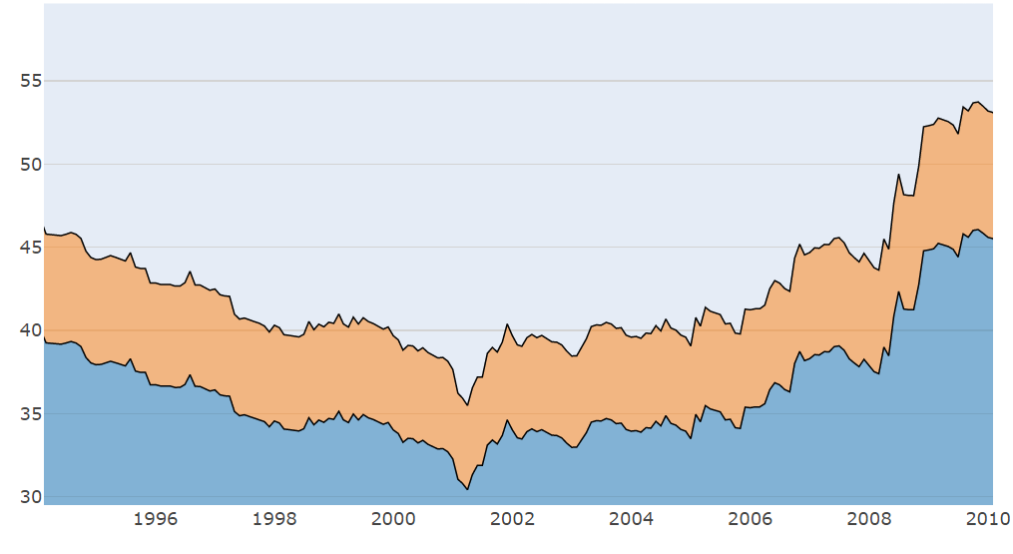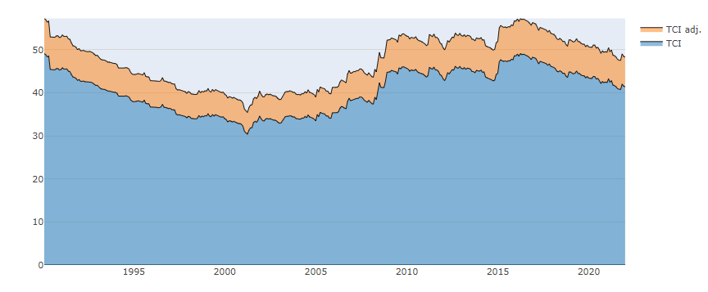**Figure 2: Total Connectedness Index**

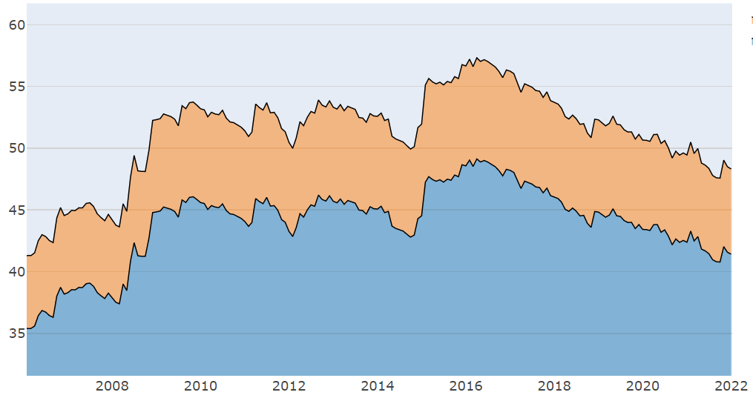

**Notes:** Total Connectedness Index. The figures above track the total connectedness index across time and the Adjusted total connectedness index (Gabauer, 2021 and Chatziantoniou and Gabauer 2021). The values in the vertical axis are the total connectedness index (%). That is, the average proportion of the variation which can be referred to the interaction between the network variables.

**Figure 3: Dynamic Net Connectedness Index**

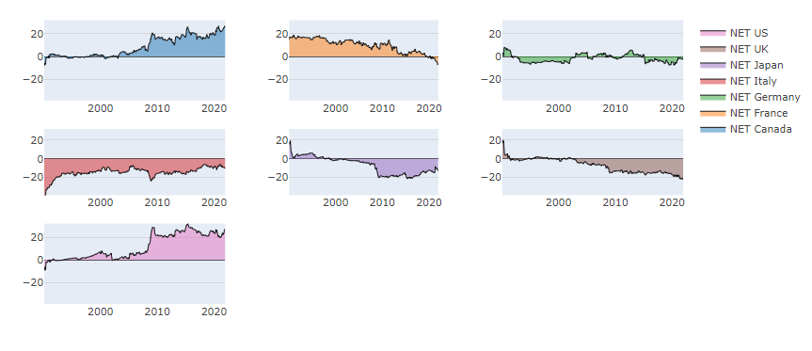

**Notes:** The above graphs depict the dynamic NET spillover (TO minus FROM) of each variable versus the rest of the system variables in terms of returns. The role is determined by the value of the connectedness. Positive (Negative) values imply transmission (absorption) mechanism of a certain system variable.

**Appendix A**

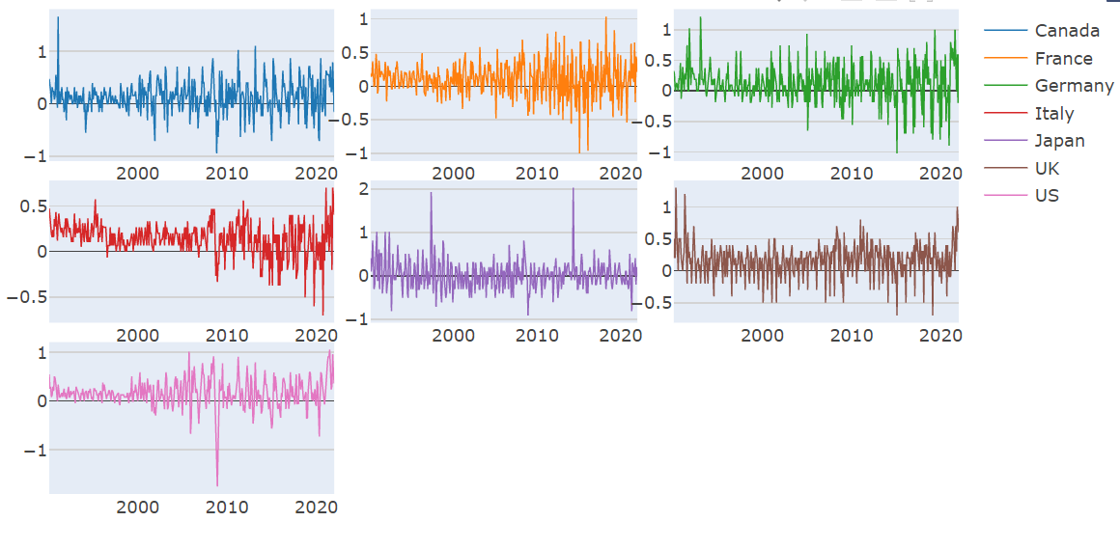

**First Difference for the Raw Series**

**Notes:** The above graphs depict the first difference for the consumer price index for each country thorough the sample period.

**Appendix B**

**Dynamic TO Connectedness Index**

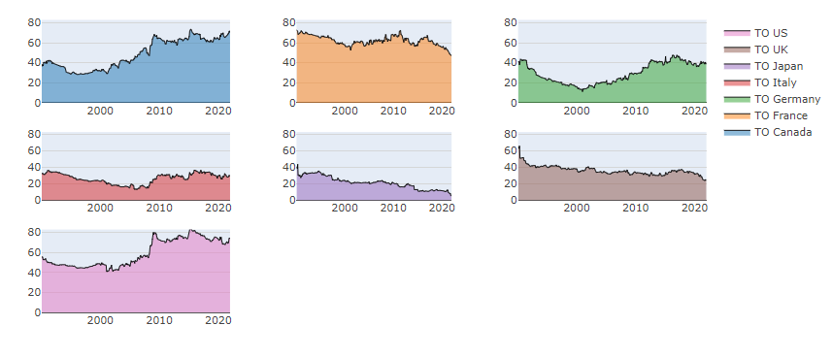

**Dynamic FROM Connectedness Index**

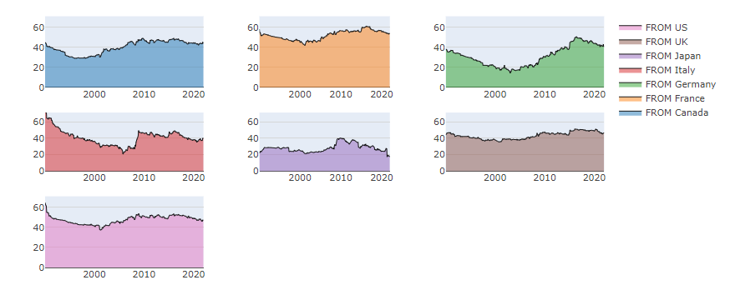

**Notes:** The upper graph depicts the dynamic contribution of each country TO the G-7 network, while the bottom graph describes the absorption of shocks of each country FROM the G-7 network.

1. Appendix A shows the first difference series across the sample period.
2. Appendix B presents the evolution of the FROM and TO series.