

INDEPENDENT EQUITY RESEARCH

Stock exchange

**TASE**

**BLENDER FINANCIAL TECHNOLOGIES LTD.**

INITIATION OF COVERAGE

XX.05.2021

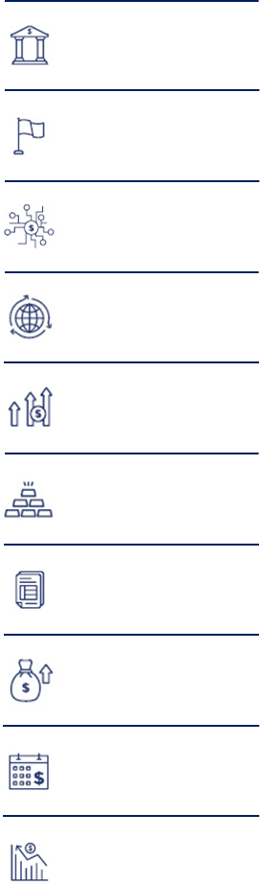

**Blender is a global e-lending company, providing innovative financing solutions in Europe and Israel. Blender’s platform facilitates the launch of online lending products and services while achieving operational efficiency, eliminating fraud, and minimizing risks. The company’s focus is on the fast-growing Buy Now Pay Later (BNPL) and Auto Loans markets. Using its propriety technology, Blender provides a better shopping experience for both e-Commerce and in-store purchases. The company plans to expand its digital banking services further, realizing its growth potential in the coming years.**

**Market**— The global fintech market is growing significantly due to the emergence of new digital banks and the adoption of digital banking methods by traditional banks. According to Frost & Sullivan, **the transaction volume on digital banking platforms is expected to grow from $6.84 trillion in 2020 to $13.92 trillion in 2025. We believe that neobanks with differentiated business models are likely to thrive in this environment. In our view, Blender's is well-placed to address the emerging needs of digital banking services.**

**Strategy**— Blender is looking to solidify its position as a global e-lending company by expanding into countries such as Poland and the Czech Republic, and expanding its financial services portfolio by introducing public deposits, which will drastically reduce its cost of capital in 2021 and 2022.

**Valuation— Based on market benchmarking for fintech firms and the multiples method, we value Blender's equity at NIS XX M, with a price target in the range of NIS XX to NIS XX, with a mean of NIS XX.**

Symbol

**BLND**

Sector

**Technology**

TBD

Stock performance (Since IPO)

**XX%**

Closing price

**xx NIS**

Market cap

**XX M NIS**

No. of shares

**7.3 M**

Average daily

trading volume

**XX stocks**

Sub-sector

**Internet & Software**

Stock price target

**xx NIS**



**Blender**

xx.05.2021

Contents

**Investment Thesis** 1-2

**1. Company overview** 3-11

**2. AI in Traffic Management Market Overview** 12-23

**3. Financial Analysis & Valuation** 24-29

**Appendix 1: Deals Sample** 30-40

**Appendix 2: About Frost & Sullivan** 41

**Disclaimers, disclosures, and insights for more responsible investment decisions** 42

# Investment Thesis

The financial world is undergoing a transformation, with more and more business transactions happening online. Both the general public and SMEs are looking for better financial products that enable more accessible and transparent payment solutions. Due to changes in consumer desires and needs, SMEs increasingly adopt financial technology or FinTech solutions to improve and automate the financial payment services they provide to their consumers. Specialized software and algorithms are utilized to manage financial operations better, and consumers increasingly use computers and smartphones to streamline interaction with their financial service providers. FinTech solutions do not require physical branches, and enable financial institutions to serve a broader clientele through their existing employee base. This enables them to provide specific and targeted financial products while reducing operational costs, becoming more cost-competitive than traditional market players.

Digitization of the financial world enables up-to-date user experiences, along with 24x7 customer support. Digitization also allows financial organizations to offer lower costs and charges without compromising their profitability. Consumer trust and regulatory hurdles form the primary obstacles to the adoption of innovative FinTech solutions in the financial world. This represents an ideal opportunity for Blender. The company develops innovative technology for providing consumer credit. It is currently in the process of becoming a fully-fledged cross-European digital bank, with deposit insurance under the European deposit insurance *scheme* (EDIS). The company aims to leverage respected sources of low-cost capital by raising deposits at a low rate, mainly from western European citizens. This is expected to reduce its cost base significantly. Moreover, a banking license would allow the company to operate seamlessly across the EEA as both a lender and as a deposit issuer, without the need to issue a new license to each country.

The company has received multiple industry awards and accolades, solidifying its integrity and enhancing consumer trust. The company utilizes machine learning and artificial intelligence-enabled tools to optimize financial operations such as portfolio development, risk assessment, and the profiling of lenders and borrowers. One of the primary outcomes is the near-elimination of fraud, allowing the platform to focus on the direct risk factors of each client.

Last but not least, the EU EMI license that the company holds allowed the company to empower its clientele to participate in crowdlending opportunities, funding large infrastructure projects like hydroelectric power plants.

|  |  |  |
| --- | --- | --- |
|  | **Key Focus Area:** | Underserved Credit Markets  (Primarily in developing, emerging, and western world countries) |
|  | **Key Function:** | Streamlined and low-risk cross-border lending services |

Blender has a very high employee-to-consumer ratio of 1:1,000, five times better than the EU banking average. In addition, the company's advanced technology platform enables it to reduce operational costs and offer attractive prices on its financial service offerings. The company provides various loans (with flexible repayment options and minimal charges) via two main channels, B2C and B2B2C. Blender acts as a balance sheet lender in Europe, and as a marketplace lender in Israel.

In Israel, Blender is considered a market leader in the BNPL segment, after signing agreements with hundreds of retailers. In addition, Blender is entering the highly profitable and centralized auto lending segment. The company is also raising additional institutional funds and bank credit lines to reduce its cost of funding and support growth.

In Europe, becoming a fully-fledged digital Bank for deposit and lending would increase Blender’s fund base, drastically reduce its cost of capital, and also facilitate its growth across the continent. To support this growth, the company is expanding its activity in Central Europe, as a balance sheet lender to new countries.

**We view Blender Financial Technologies Ltd. as a great opportunity for investors seeking to invest in an innovative FinTech company, specifically in one that provides services to an underserved and fast-growing market (the small-scale credits market). Furthermore, the company's plan of expanding into digital banking services also solidifies its potential growth value in the coming years.**

**Company Overview**

**Blender Financial Technologies Ltd.** (TLV: **BLND**), hereafter "the Company" and/or "**Blender**" is a publicly-traded financial technologies or **FinTech company**, providing a more accessible and flexible shopping and purchase experience to thousands of customers. The company is headquartered in **Israel** and has offices and activities in **Lithuania, Latvia, and Poland**. Blender is an e-Lender focusing on two main segments, Buy Now Pay Later (**BNPL**) and **Auto Loans**. The company has developed a propriety customer onboarding and credit rating system named **Rating2.0TM** for its **e-Lending** activity. The Rating2.0TM performance characteristics include **instant and accurate detection of identity fraud, data collection from various open data sources, data collection from multiple official data sources, higher rate of return for the amount lent, quick and hassle-free processing loans, advanced creditworthiness assessment process, and enhanced cybersecurity**. The company platform has been used to provide over NIS 730 million in loans so far. Using its platform, the company could quickly expand to additional countries and present significant growth.

**The company's digital banking activity is currently focused mainly on Europe. Blender is at an advanced stage of the application process for a specialized banking license in Europe.** Also, the company is expanding to new geographies - such as Poland (an office has already been opened) and the Czech Republic. **Upon obtaining the banking license, Blender would have access to serve all EU citizens, a market of over 500 million inhabitants.**

Blender has procured an EMI (Electronic Money Institution) license in European Union, allowing it to grant certain types of loans, transfer funds, and offer white label solutions throughout the European Union. Blender also holds a CCP (Consumer Credit Provider) authorization and is in the advanced stages of procuring a digital banking license.

For its Israeli marketplace lending activity, the technology suite developed by the company is called **DirectMatchTM**. The technology suite is essentially a portfolio builder designed for spreading out the lender's fund among a large pool of different loans. The DirectMatch portfolio builder excels in **increasing** the **investor's spread of risk, interest rate, and ease of use**. Further, DirectMatchTM also ensures that a borrower gets the best deal. The technology uses a proprietary **state-of-the-art matching algorithm** capable of assessing real-time market conditions and creating a unique loan portfolio optimized for those conditions.

The company's board of directors include prominent figures like **Dr.** **Gal Aviv** (Globes' - Israel's business and economic newspaper - list of **40 Under 40 Most Influential Figures**) as the Chief Executive Officer or **CEO** and **Boaz Aviv** (Forbes's List of **30 Under 30 Most Promising Young Entrepreneurs**) as the Chief Technology Officer or **CTO.** Further, other prominent **members on the board** are **Doron Aviv** (**Chairman - Aviv Group**), **Giora Ofer** (**Ex-CEO - Discount Bank**), owners of the **Lahav Investment Fund**, **Ronit Koren (Ex. VP - Battery Ventures, BOD Ayalon Insurance Company),** and a team of strategic advisors (mostly from **cybersecurity, taxation industry, and finance law fields**). We describe below the key milestones achieved by the company since its establishment:



* 2014: Blender Established
* 2016: Blender Lithuania and Blender Italy Established; Consumer Credit Provider (CCP) license received
* 2017: 1st Credit line from European institutions; Electronic Money Institution (EMI) license received
* 2018: Aided a hydropower project (Italy) via the crowdlending route
* 2019: 2nd Credit line from European institutions; Credit line from an Israeli institution
* 2020: Blender Latvia Established
* 2021: TASE IPO; 3rd Credit line from European institution; Blender Poland established

Blender's technology platform is expected to challenge the existing market monopoly in the loan market, where banks and credit card companies mainly control consumer loans. The technology **enables borrowers to get a loan quickly and simply without the need to visit** any branch mainly at a B2B2C model in channels like BNPL and Auto Loans. Blender differentiates itself by providing borrowers with the ability to repay at any time at zero cost along with a simple, user-friendly, and transparent loan processing and costing.Also, Blender has received **significant industry recognition**, which speaks volumes about its growth potential; for instance, the company has been **ranked among the top 100 startups in Asia and Europe** and was selected by the **London Stock Exchange** to participate in the ELITE program.

The below-given table provides a tabular representation of the company's awards and accolades.

|  |  |  |  |  |  |  |  |
| --- | --- | --- | --- | --- | --- | --- | --- |
| BLender | Loans Between People | LinkedIn | | | | **Industry Recognition: Awards & Accolades** | | | |
|  |  | |  | |  | |  |
| **2020**  selected to be part of the "**Efma-Capgemini Financial NewTech 2020 Watchlist** – category Wealth Management | **2020**  Award: **"Most Trusted Small Loan Provider, 2020 – Israel"** (CV Magazine) | | **2019**  **Red Herring 100 Awards** | | **2017**  Blender's CTO and board member recognized among **Forbe's list of 30 Under 30 Most Promising Young Entrepreneurs** | | **2016**  Selected to participate in the **Elite Program of the London Stock Exchange** |
|  | |  | |  | |  | |
| **2016**  Award: Red Herring 100 Awards | | **2015**  Award: **leading Israeli fintech company** | | **2015**  Shortlisted among **Top 100 Leading Global Fintech Innovators** | | **2015**  Blender's CEO and board member recognized among 40 Under 40 Most Influential Figures | |

**Key Attributes and Salient Features**

|  |  |  |
| --- | --- | --- |
| **Time required for fund transfers after a loan application is approved**  The same day, or within two days  Image result for time   icon |  | High-Interest Rate for Lender and Low-Interest Rate for Borrower |
|  | High Liquidity due to ReBlend |
|  | Ability to give microloans to individuals |
|  | A variety of Lending options |
|  | Transparent Visibility of all the associated charges |
| Computer Phone Icon Images, Stock Photos & Vectors | Shutterstock | Easy accessibility via computer and smartphone |
|  | Easy and quick funds withdrawal |

**Strategy and Business Model**

The unique selling proposition of Blender is that the company has no branches, minimum employees, and no overhead expenses, just a clear and predetermined management fee. Hence, the brokerage profits (often charged by competing banking institutions) and interest rates are saved from both the lenders and the borrowers. Further, the company's extremely low employee count to consumer count ratio enables it to save a lot on operational cost and time enabling a cost-effective business deal along with efficient transactions.

|  |  |
| --- | --- |
| **Blender's Performance in numbers** | |
| **40,000**  Paying Clients | **>ILS 730 million**  Cumulative Amount Lent amount till date |
| **33,000**  Approved Loan Applications to date | **430,000**  Registered Clients |
| **98.2%**  Of the surveyed customers (only those who have completed the loan process) said that they would highly likely recommend Blender to a friend or family member | **95.9%**  Of the surveyed customers (only those who have completed the loan process) said that the entire process was clear and simple |

One of the primary business geographies of the company is Israel. The loan market in Israel is estimated to be highly consolidated, with ~90% of the market controlled by legacy banking institutions and credit card companies. Further, due to the centralized situation in the Israeli loan market, the interest rate on deposits hover just slightly above 0%, whereas the interest rates for loans and overdraft situations may vary between 3.5 to 17% (annually). Blender has placed itself in a position that allows its customers to benefit from the differential present between loan and credit interest rates. Specifically, Blender acts as an interactive platform for connecting people seeking attractive interest rates on their funds and the people who need loans at a reasonable rate with easy-to-comply regulations (zero charges, early repayment option, and flexible loan tenure). Further, Blender offers a wide array of loans listed below, which cater to a wide range of needs of borrowers mainly via a wide BNPL partners' network:

|  |  |  |
| --- | --- | --- |
| **Types of Loans offered by Blender** | | |
| * Auto Loans | * Loan for vacation | * Loan for renovation |
| * eCommerce BNPL | * Sport Equipment | * Electronic goods |
| * An all-purpose Loan | * Loan for Housing / mortgage | * Student loans |
| * Debt Consolidation Loan | * Loan to buy a product |  |

The core principle behind the increasing attractiveness of the company's technology platform is that it allows borrowers a low interest rate and enables lenders to sell their loans to other investors for quick returns. Leveraging ReBlendTM, a lender can transfer his loan contract to another individual seeking to become a lender. In such a situation, the outgoing lender has to pay 15% tax as per the government norm, which is much lesser than the 25% tax levied on other investments such as stocks.

Interestingly, Eurozone as a region has witnessed a strong shift away from physical to digital banking; indicated by the fact that the number of physical branches of banks has dropped by 43% during 2008-18. The reduction in the number of physical banking locations has largely imitated the shift in customer preferences where digital banking has gained 15 Million customers during 2011-19, while retail banking has lost 2 million customers. As a digital banking solutions provider, Blender is looking to solidify its position in this growing market by expanding into new geographies such as Poland and the Czech Republic and expanding its financial services portfolio by introducing public deposits and other banking services in 2021.

**Products and Technology**

The rise in consumer spending and increased financial education globally have encouraged users to look beyond traditional banks to earn higher returns on their investments while incurring lower interest rates on loans. Along with higher returns and lower interest rates, customers are also looking for more flexibility, agility, and transparency from their financial partners, enabling alternative business models to gain a larger user base.

As a global provider of e-lending solutions, Blender has been providing e-lending solutions to users in Israel and across Europe to underserved credit markets, serving thousands of users. The P2P lending platform by Blender leverages proprietary automation technologies and anti-fraud systems to simplify and accelerate the lending process while reducing the risk of fraud. We describe below some of the services provided by the company:

* For borrowers:
  + A wide array of loans, such as car credit students' loans and more.
  + BlenderPay- Buy Now Pay Later (BNPL) solution instore and eCommerce.
  + BlenderCar- Auto Loans.
* For lenders:
  + The premium route- automatic allocation of loans. The auto lender program also regularly displays offers most suited to the consumer's requirement.
  + The constant lender- the option which allows a lender to get interest on money by creating a standing order from one's bank account.
  + Building a one-time portfolio, allowing users to choose from a variety of options to borrow or lend money as per their need
  + Manually selecting loans as per their individual characteristics such as interest rates and the loan repayment period. Further, the funds can be easily withdrawn and deposited from and to the bank via a single click (on Blender's platform from the website or the app).

Blender's lending platform serves as a facilitator between users seeking to earn returns in the form of interest rates by offering loans and loan seekers trying to minimize the cost and complexity of borrowing. Blender has derived its success primarily by offering lower interest rates for borrowers and higher interest rates for lenders. The company achieves this by minimizing overhead costs on physical infrastructure and by automating the credit process using AI and ML. The platform also automates the process of matching lenders with borrowers, maintaining security and privacy, ensuring the security of funds and creditworthiness assessment.

Lenders on the Blender platform enjoy unmatched funds security and higher rate of returns with significantly lower risk. Additionally, Blender also employs a robust method to ensure the security of lender's funds, under which the lender's investment is optimally dispersed amongst a large number of borrowers using DirectMatchTM, a lender-borrower matching system developed by Blender. Blender also maintains a security fund which ensures that the lender faces minimal impact on returns if a borrower is unable to repay their loan. In addition, Blender also launched an Insurance as a defence fund to allow lenders to recoup a part of their investment in extreme cases such as a capital market crunch.

One of the key differentiating aspects of Blender's loans is the flexibility enjoyed by lenders on the platform. Using Blender's ReBlend, lenders can pass on and sell their ongoing loans to other lenders on the platform and receive instant liquidity. Buyers buying an existing loan through ReBlend, in turn, get a shorter lending period.

Blender also employees a robust screening mechanism to determine the eligibility and creditworthiness of an individual before approving a loan for the applicant. For the screening, Blender uses automated processes that evaluate factors such as credit history and digital footprint to accelerate the vetting process without affecting the user experience. To enable fraud prevention and credit risk evaluation, Blender has developed a multidimensional approach.

Blender's system operates using methods and tools developed by the company, using, among other things, tools, methodologies, and ideas from the field of big data, data mining, machine learning, and statistics. The system considers several parameters, including social media interactions, classic financial parameters (credit history and income statements), customer knowledge, behavioral economics aspects, image/voice analysis (R&D stage), and psychological analysis combined with sociodemographic analysis. The information derived from an in-depth analysis of a variety of factors is pieced together to form a holistic picture of the customer's creditworthiness and financial stability that allows the system to make a customized underwriting decision for the customer while setting a competitive interest rate, which reflects the customer's probability of default. The result is a cutting-edge algorithm capable of evaluating credit risks and reduce them to a negligible rate in 30 seconds[1].

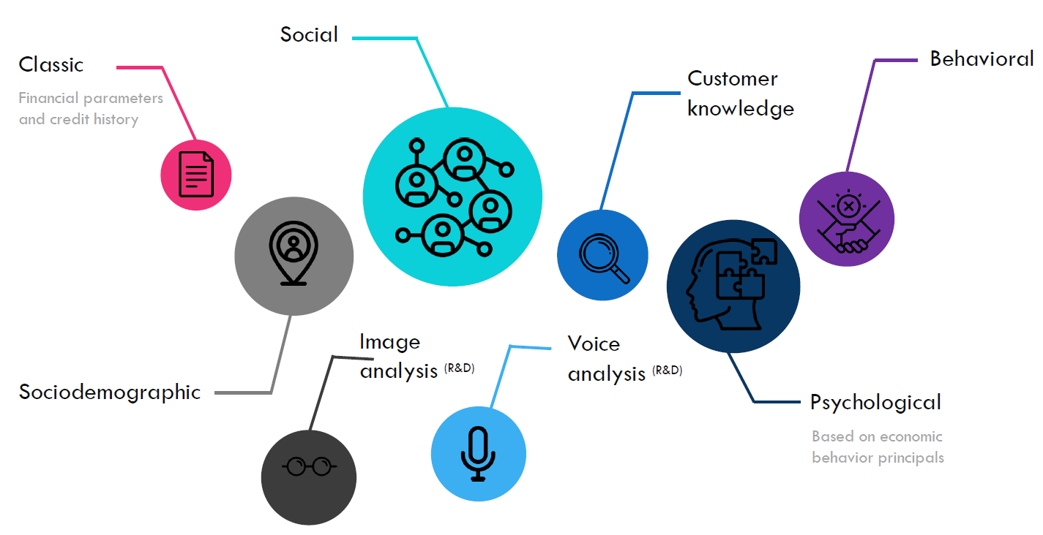A multidimensional fraud prevention and credit risk evaluation model

Source: Blender investors presentation

Blender's technological infrastructure was built specifically to support the company growth strategy:

* **Optimized architecture:** a unified management system powered by Salesforce, a modular system that can be adapted to new technologies and business needs.
* **Quick calibration, customization, and activation of the system in new geographic locations:** local database integration, regulatory compliance, customized customer interfaces in direct and indirect distribution channels.
* **Adheres to the strictest data protection regulations and standards:** ISO 27001, GDPR, NIST Cybersecurity Framework.

The system is based on a combination of modus operandi and an algorithm-based system, developed by the company over the years, and meets the requirements of the international standards ISO 27001, GDPR, and NIST Cybersecurity Framework. Based on the company's knowledge and experience, it can offer credit more accurately, matching risk and opportunity. In this way, the company can offer its customers loans in digital processes without a physical meeting, with careful risk management to reduce fraud. This technology is built to allow calibration, adjustment, and activation of the system in a short time when deployed in new geographies.

**Blender's operations Across Europe and Israel**

Blender has been running successful credit brokerage operations in Israel since 2014 and has maintained an average loan amount of 22 thousand ILS with an APR (Annual Percentage Rate) of 11% with a default rate of only 2.6-3.8%. Similarly, in Lithuania, Blender has been providing credit services since 2017 with an average loan amount of 6 thousand Euros with an APR of 19.4% and a credit loss of 2.6%.

*(Default Rate: Percentage of loans written off as bad debts, Credit Loss: Rate of credit related losses to the value of security, can be used to evaluate the risk profile of an bundled mortgage loan)*

**Digital Banking Market Overview**

**Market Overview:**

Digital banking has witnessed a swift adoption among users worldwide as smartphone and internet penetration has grown significantly. It is estimated that about three billion users worldwide will have access to retail banking services through smartphones and PCs across the globe. Digital banking has particularly been encouraged by regulatory bodies and governments due to its potential to reach unbanked populations across distant areas and communities where physical banking has not been able to reach. Lower operating costs behind digital banking businesses has made it possible for banking institutions to operate with lower margins while maximizing benefits for end customers. Mainly, digital banking has been a result of banking institutions trying to stay competitive by offering customers with more convenient and personalized channels of interaction.

Further the relaxation and amendments to banking regulations across Europe has made it possible for neo banks or digital only banks possible and number of startups has achieved significant growth in the space. The adoption of Neo banking has especially accelerated due to the increased volume of day-to-day online and cashless transactions, where digital banks have been able to provide ease of use and superior incentives to traditional banks while offering superior data security to facilitate online transactions. These banks have largely thrived in countries with a high smartphone and internet penetration combined with a progressive and developed regulatory framework. Some prominent banks in this space include Revolut (United Kingdom), N26 (Germany), Monzo (United Kingdom), Monese (United Kingdom), SoFi (United States), Chime (United States), and Robinhood (United States), Bunq (Netherlands), Kyash (Japan), Sterling Bank (United Kingdom) and Niyo (India) among others.

**Global FinTech Markets:**

The global market for FinTech is growing at a significant rate owing to the emergence of new digital banks and adoption of digital banking methods by traditional banks. The transaction volume on digital banking platforms is expected to grow from US $6.84 Trillion in 2020 to 13.92 Trillion in 2025. While digital payments is the largest segment and is expect to account for the majority of market even in the future, personal finance is also expected to witness a noteworthy growth in the forecasted period.

CAGR  
13.9%  
22.8%  
6.6%  
10.2%

|  |  |
| --- | --- |
| The digital payments segment is expected to account for more than 3/4th of the revenues of the global fintech market during the forecast period.  **European FinTech Market:**  The European market for FinTech shows signs of impressive growth after recovery from Covid induced lockdowns which resulted in negative growth for online banking service providers. The transaction volume in the region is expected to reach 2.36 Trillion in 2025 from 1.07 Trillion in 2020.  CAGR 16.3% 22.0% 4.3% 10.6%  The user base of FinTech applications in Europe is growing at a staggering pace as more and more individuals gravitate towards contactless banking and personalized banking services along with increased ecommerce transactions. The combined user base of FinTech applications is expected to grow from 505.64 Million to 617.32 Million users in 2025. |  |

CAGR  
3.5%  
14.4%  
3.1%  
N/A

Banking Reforms allowing Neo Banks to challenge Industry Incumbents. The current banking landscape in Europe and Israel is dominated by traditional banks such as HSBC, BNP Paribas, Bank Hapolim and Leumi, all under pressure to build strong digital offerings and cut legacy costs improve profitability to match the preferences of a younger customer base. Europe has seen a drop in the entry barriers for new banking institutions with introduction of directives such as PSD2 (Payment Service Directive 2) and grating of banking licenses to Neo Banks. At the same time, Israel has been taking strong actions to modernize and transform its banking system to spark greater innovation and enhance customer experience. In 2020, the Ministry of Finance in Israel contracted TCS to build a banking service bureau that would serve as a shared, plug-and-play digital banking platform to help new banks set up operations in Israel quickly in compliance with the regional regulations. This platform is expected to heavily benefit digital banks in setting up their operations. The Bank of Israel has also taken concrete steps to advance competition in the banking system and support the adoption of digital banking. The Bank of Israel has also concluded implementing the EMV (Europay Mastercard Visa) framework for payments processing and has moved all business transactions to the EMV framework from 31st July 2021. This step is expected to bring the Israeli payments framework in line with the world's advanced economies, in turn encouraging more global FinTech companies to enter the Israel market. As such, around 89% of Israelis use online payments, which present digital banks with a large addressable market in the country. Aside from establishing The First Digital Bank, even Bank Hapolim has expressed interest in establishing a digital bank in Israel. Higher levels of digital literacy, combined with high smartphone and internet penetration, have provided Neo Banks with an inviting user base of customers that they have acquired by competing on lower costs. Although traditional banks have made strong attempts to adopt digital practices, their pace of cost-cutting has been too slow to compete effectively. However, the only challenge for Neo Banks has been to establish trust with an already banked population with strong loyalty towards institutionalized banks, compelling Neo banks to look towards Eastern Europe, which still has a considerable underbanked population.

Although Neo banks have faced challenges in the past year due to Covid induced economic downturn, they are expected to witness an impressive growth owning to the geographic expansion of most of the digital banks. A number of European Neo banks have also applied or are planning to apply for a banking license in United States.

**Fintech Market Growth Drivers:**

|  |  |  |  |
| --- | --- | --- | --- |
| **Market Growth Drivers** | **Market Impact** | | |
| **Short Term**  **(<2 Years)** | **Medium Term**  **(2-5 Years)** | **Long Term**  **(>5 Years)** |
| **Need for Updated User Experience:**  As the volume of cashless transactions grows, customers are looking for higher levels of convince and user-friendliness from their digital banking services prompting them to opt for digital banking platforms in place of physical banks. Features such as 24*7 support, self-serve tools and integrations with multiple services pull more users towards digital banks. |  |  |  |
| **Cost & Charges:**  Traditional banks, by design have a very high overhead costs due to the presence of a number of physical banking locations and a large workforce to serve these locations. As these costs rise, the benefit to customers diminishes, which is why customers are looking at alternate options that can provide them with a higher return. |  |  |  |
| **Growth of Online Economy:**  The adoption of ecommerce and smartphone-based services has been growing at steadily, bringing a surge in cashless payments. This surge has been further fuelled by the disruptions caused to physical business by the Covid pandemic which has encouraged more and more users to adopt and prefer digital business methods. |  |  |  |
| **The emergence of Integrated Business Models:**  More and more services such as insurance, loyalty programs and online ticketing are using digital banking as a platform to interact with their end customers, which is incentivising banking service providers to develop a digital presence to open up new revenue streams and offer a more attractive feature set to their customer. |  |  |  |

**FinTech Markets Restrains:**

|  |  |  |  |
| --- | --- | --- | --- |
| **Market Restraints** | **Short Term**  **(<2 Years)** | **Medium Term**  **(2-5 Years)** | **Long Term**  **(>5 Years)** |
| **Customer Trust:**  It is generally challenging for new entrants in the banking industry to gain customers' trust, primarily governments of the respective countries inherently protect funds deposited with legacy banking institutions. In such scenarios neo banks have struggled to raise and maintain customer deposits. |  |  |  |
| **Regulatory Hurdles:**  Banking is a heavily regulated industry and is bound by strict laws that pose an entry barrier for digital-only banks. Many countries have had to amend their laws to allow digital banks to exist while many others still prohibit such banks. Even for countries that allow digital banks, approvals are hard to come by. |  |  |  |
| **Lack of Strong Monetization Models:**  Several successful Neo banks in Europe have achieved scale by acquiring new customers at the cost of profitability, by leveraging investor funds. However, once the customers are acquired, the business model behind retaining them and converting them into net revenue-generating customers has not been cemented. |  |  |  |
| **Challenges from Incumbents:**  With their personalized, 24/7 and low-cost banking services, Neo banks could gain customers very quickly at the initial stage. But overtime, industry incumbents have managed to develop their digital offerings. They are slowly catching up to Neo banks' service offerings, which is again tipping the customers in the favour of traditional banks. |  |  |  |

**Digital Banking: Competitive Landscape**

|  |  |  |
| --- | --- | --- |
| **Company** | **Key Products & Services** | **Competitiveness** |
| **Monzo:**  Monzo is a London-based digital bank serving over 4 million customers in UK and is currently working on launching in US. Monzo has acquired a UK banking license in 2017 and is regulated by FCA and PRA. The bank has also applied for a US banking license and has about 1500 employees. | * Current Accounts * Savings Accounts * Credit/Debit Cards * Loans/Overdrafts |  |
| **Revolut:**  Revolut is a London-based digital bank with a European banking license and is offering banking services to more than 12 million users worldwide. | * Savings Account * Credit/Debit Cards * Wealth Management * Payments Management |  |
| **N26:**  N26 is a digital bank based in Berlin and has a European and Brazilian banking license. The bank has more than 5 Million users. The bank also operates in the United States under a partnership with Axos Bank. | * Savings Account * Credit/Debit Card * Payments Management |  |
| **Chime:**  Chime, is a San Francisco-based digital bank operating in United States under a partnership with Bancorp bank. Chime has over 12 Million users on it platform. | * Spending/Savings Accounts * Debit/Credit Card * Payments Management |  |
| **Robinhood:**  Robinhood is an investment management platform that allows users to perform the trading of stocks and cryptocurrencies without commissions. Robinhood currently has over 13 million users. | * Stocks Trading * Crypto Trading |  |
| **SoFi:**  San Francisco-based SoFi is a student and personal loan-focused digital financing platform that offers financial services such as insurance, credit score management and investment management and crypto management. | * Personal Loans * Student Loans * Insurance * Credit Cards |  |
| **Bunq:**  Based in Amsterdam, Bunq is a digital bank operating under a Dutch banking license and serving over 30 countries. Apart from the usual banking services, Bunq differentiates itself by offering customers with a focus on user experience and transparency and control over the bank's investment decisions. | * Savings Account * Credit Card |  |
| **Niyo:**  Niyo Bank operates on India as a digital bank in partnership with Yes Bank and DCB bank among others. The bank has over 2 Million customers and has recently acquired Goalwise, a mutual funds investment platform. | * Savings Account * Debit Card * Investment Management |  |
| **Starling Bank:**  Starling bank, based in London has over 2 million users on its platform and operates under a UK banking license. The company is also working on acquiring an Irish banking license in order to serve a larger user base in Europe. | * Current Account * Personal Loans/Overdraft * Debit Cards |  |
| **Klarna**  **I would add Klarna instead of the two that were here since: B2B is SME lending, and Tarya is Realestate backed loans. <https://en.wikipedia.org/wiki/Klarna> https://www.klarna.com/international/about-us/** |  |  |

|  |  |  |  |
| --- | --- | --- | --- |
| **Legend** | *High* | *Medium* | *Low* |

**Recent Developments in Digital Banking:**

* In early 2021 SoFi agreed to an acquisition by a special purpose acquisition company that would allow it to go public. The company is currently valued at $8.65 Billion. The company also recently launched an auto loan refinancing service in partnership with Lantern.
* N26 is in the process of partnering with Simplesurance to enter the insurance business. The company plans to start smartphone insurance coverage and launch services in Germany first with other insurance plans and countries to follow.
* Revolut is planning to raise funds in the near future at a $10-15 Billion valuation. The company is planning to expand heavily by entering markets including India, Indonesia, Philippines, South Korea, China, Brazil and Mexico. The company has also applied for a banking license in the United States.
* Bunq in Dec 2020 announced that its mortgage portfolio had grown fourfold in six months after partnering with NN IP in July to offer mortgages in July 2020. The company also announced a growth of €200 Million in deposits which brought the total deposits to €633 Million.
* Linked Finance, a P2P lending services provider based in Ireland announced that it had facilitated over €150 Million in loans in 2,700 separate loans to SMEs with over €9.6 Million issued in Q1 2021.

# Financial analysis & valuation

**Valuation method & approach**

Valuation of a startup company in its early stages can be challenging due to limited cash flow (if any) and uncertainty regarding the future. As part of a Discounted Cash Flow (DCF), the accepted method used in financial valuations, there are several modifications to a startup company's valuation. In general, there are four primary methods within the DCF method:

1. Real options – this valuation method is designated for pre-clinical and early-stage clinical programs/companies where the assessment is binary during the initial phases and based upon scientific-regulatory assessment only (binomial model with certain adjustments).
2. Pipeline assessment – a valuation method used for early-stage companies before the market stage where time-to-market may be a few years for full operations. The company's value is the total discounted cash flow for its products/signed agreements plus unallocated costs and its technology platform assessment.
3. DCF valuation - this method applies to companies with products that have a positive cash flow from operations.
4. Market benchmark – this method is based on recent deals (M&A and/or fundraising) within the company's domain and on market multiples.

Blender is a fintech company in a growth stage with a solid technological base. The optimal way to evaluate its operations is market benchmarking that will reflect its core technology and potential development.

**Financial Overview - Fintech**

Since the global financial crisis (GFC), fintech has been one of the most well-funded and fastest-growing emerging technology areas. This growth was essentially a technological response to the flaws of the traditional financial services industry. Extensive regulations and financial reforms were enacted since the GFC, such as the creation of oversight committees, ongoing stress testing, and capital requirements. Thus, it appears that the traditional financial sector and newer fintech startups are well-prepared to withstand the current crisis caused by the COVID-19 pandemic. [2]

In addition, federal efforts aided to shore up liquidity in the financial system, including stimulus and loan programs that have helped borrowers meet loan obligations amid record-high unemployment. Furthermore, accommodative measures (early access to stimulus checks, payment forgiveness, loan modifications, deferrals, and insurance rebates) have helped fintech companies and financial institutions build stronger relationships with their customers.

The financial industry is broad, and the long-term impact of the pandemic would affect different industry segments differently. Decreased in-person spending and shuttered storefronts have hurt payment services providers focused on impacted verticals, but increased e-commerce will benefit online payments providers. Reduced net interest margins will negatively affect traditional banks as we remain in a zero-percent interest rate setting for the foreseeable future. **Neobanks with differentiated business models will likely thrive.**

Despite these mixed headwinds and the industry's pandemic-related challenges, we believe the long-term opportunity to provide innovative digital financial services remains unharmed. Still, much of the world's financial services are offered by a relatively small group of legacy providers, and we view this as a long-term disruption opportunity.

In 2020, VC, PE, and M&A cumulative global investment activity, for fintech companies was approx. $124 billion, much lower compared with $201 billion in 2019. Although 2020 saw a withdrawal in total deal activity and a shakeout among some of the less capitalized startups, we expect continued VC focus on long-term opportunities.

**FinTech – Venture Capital (VC) Activity[3]**

**Venture investments in fintech continued to increase in 2020, driven by consumer finance and payments companies. In 2020, fintech companies raised $44.4 billion in VC** across 2,581 deals, up 7.9% YoY in deal value. $12.3 billion in VC was invested in Q4, a 13.8% increase from the previous quarter. Late-stage companies secured 74.2% of the capital as investors favour more established players with more significant market share. The top three late-stage deals of the quarter include Loanpal ($800.0M), Robinhood ($668.3M), and Chime ($533.8M).

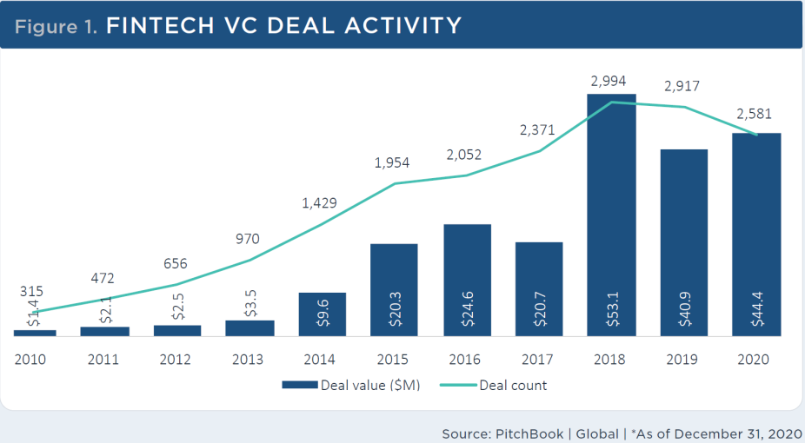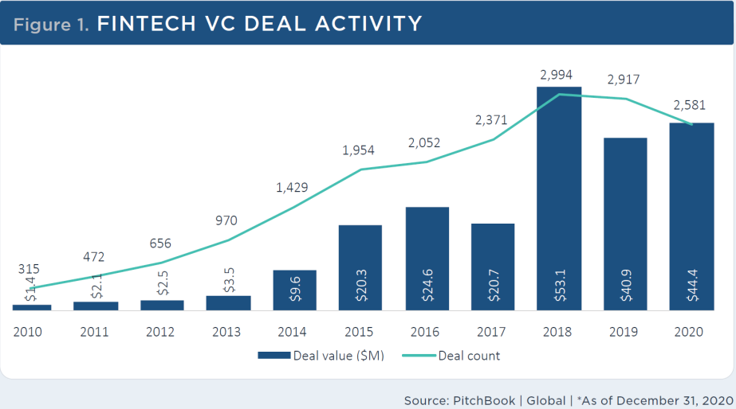

**The median pre-money valuation for VC-backed, late-stage fintech companies jumped considerably (66.5%) to $135.5 million in 2020, a new record high.** In 2019, the median valuation was $81.4 million. Early-stage median valuations also set new highs at $24.7 million, up 39.2% from $17.7 million in 2019. **Valuation multiples have also continued to climb, reaching 13.5x revenue in 2020** from 12.2x in 2019. However, this is still lower than the decade high of 16.3x set in 2015.

**VC exits for fintech companies reached a record high in 2020 with a cumulative value of $30.8 billion**. Some of the top exits via M&A include the $7.1 billion acquisition of Credit Karma by Intuit (NASDAQ: INTU), the $4.0 billion Honey deal by PayPal, the $1.2 billion Galileo deal by SoFi, and Personal Capital's $1.0 billion acquisition by Empower Retirement. While there were few public exits of fintech companies in recent years, market sentiment for IPOs appeared to turn positive in 2020 despite pandemic-related public market volatility. Lemonade (NYSE: LMND), nCino (NASDAQ: NCNO), and Upstart (NASDAQ: UPST) all had strong IPOs in 2020**. We expect 2021 to be an even stronger year for fintech exits via the public markets (including SPACs), particularly those in the consumer fintech sector.** We have already seen strong public offerings from Affirm (NASDAQ: AFRM), with expected SPAC mergers from SoFi, MoneyLion, Bakkt, Payoneer, and Hippo Insurance. For 2021, we also expect public offerings from Stripe, Ant Group, Robinhood, Toast, and Marqeta.

Below we further elaborate on 'consumer finance' and 'alternative lending,' two segments of the fintech industry that we deem highly relevant to Blender.

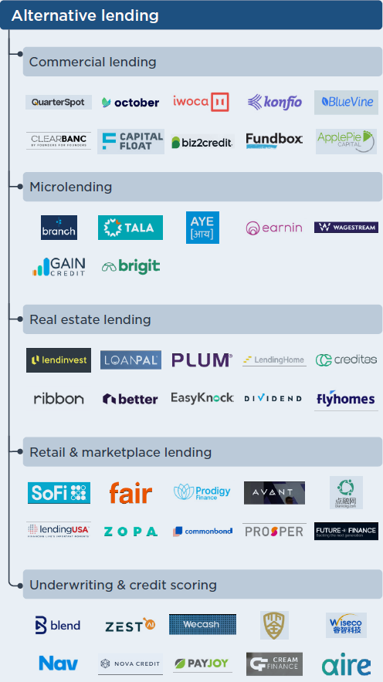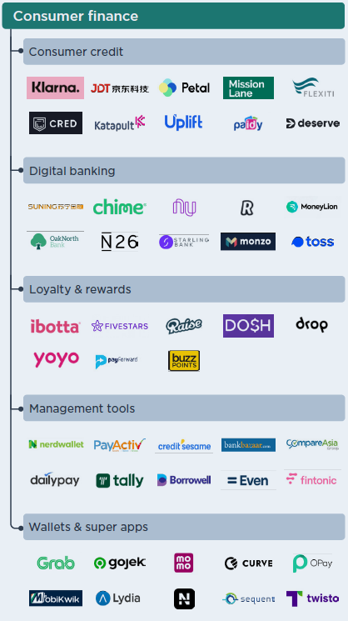

**Consumer** **Finance[4]**

**Overview**

The consumer finance industry includes everyday consumer financial services such as checking and savings accounts, debit cards, credit cards, and other point-of-sale (POS) credit products. Startups in this space provide services similar to traditional retail banking and personal financial management (PFM) tools. PFM tools are designed to help users manage, spend and budget their expenses. Some companies also may provide other revolving credit accounts or loyalty and rewards services. Companies in this segment differentiate primarily by focusing on distinct customer demographics and by providing personalized offerings.

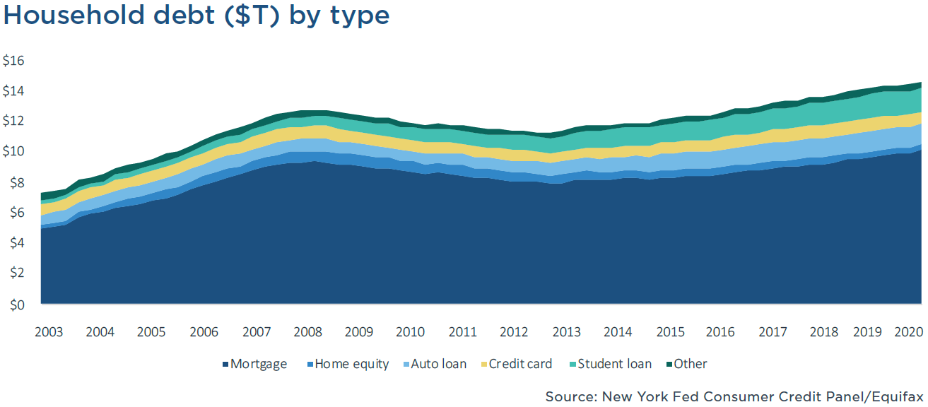

Startups in this space are focused on providing specialized financial services tailored to the needs of individual consumers; this differs from the traditional approach of incumbent retail banks, which generally offer one-size-fits-all products. Today's consumers are more discerning when choosing financial products and value the ability to compare them easily on different aspects such as savings account interest rates, credit card offers, mortgage rates, and more.

**Challenger banks and neobanks** are significant players in this space and have gained millions of customers in recent years. We estimate that in 2020, there will be almost 60 million customers in North America and Europe that have an account with a non-traditional financial service provider. We expect this growth to continue at a CAGR of 25% through 2024 to surpass 145 million customers.

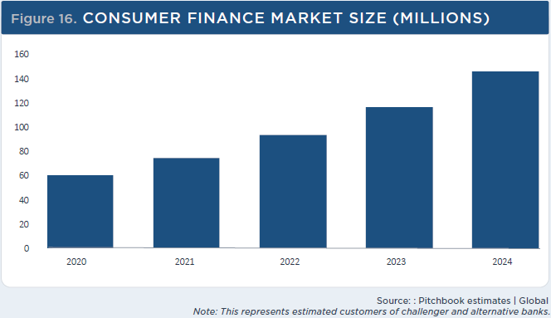

**VC Activity**

**VC investment into consumer finance companies has risen significantly over the past few years, reaching $13.7 billion across 355 deals in 2020.** **Over the past three years, companies in this segment have raised a staggering $51.0 billion.** Two trends have driven this investment capital: nonfinancial companies moving into consumer finance and the proliferation of neobanks. Two nonfinancial companies, Gojek and Grab, both raised massive venture rounds at $3.0 billion and $886.0 million, respectively, in 2020. **Many neobanks across the globe also had significant funding rounds in 2020, including Revolut ($727.0 million), Chime ($700.0 and $533.0 million), N26 ($570.0 million), and Neon ($300.0 million). POS financers (buy-now, pay-later) such as Klarna and Affirm also raised VC mega-rounds during the year.** We anticipate investor appetite in consumer finance companies to remain strong with potentially large venture raises in 2021 from Tally, Mission Lane, Tide, Dosh, and Ibotta. We also expect to see numerous exits in this space this year, especially to the public markets.

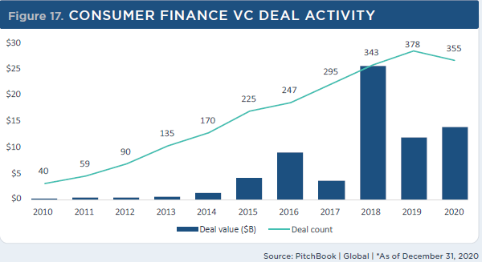

**Alternative Lending[5]**

**Overview**

Alternative lending primarily consists of nonbank companies or platforms that provide a range of consumer loans, business loans, and related underwriting services; this does not include companies that offer POS financing services, which we included in our consumer finance segment. Alternative lending providers often utilize AI & ML, data mining, and predictive modeling technologies for loan underwriting and incorporate alternative data (such as education history and phone records) into credit risk models. Also, limited regulations for these lenders (such as capital reserve requirements) and the lack of legacy infrastructure (such as physical branches) provide significant competitive advantages over legacy banks. These advantages beget the ability to offer lower fees and competitively priced interest rates. Distribution channels and service delivery (for example, fast application processes and instant funding) were early differentiators for alternative lenders. We believe that primary differentiators include pricing, customer demographic, and ancillary product offerings in today's market.

**Based on our original estimates, the US lending market, measured by combined personal and SME outstanding loan balances, was projected to reach $862 billion in 2020. However, we now expect these loans to contract this year due to defaults and tighter credit requirements, reaching around $700 billion.[6]** Our new forecasts expect loan balances to surpass the original 2020 projections by 2023.

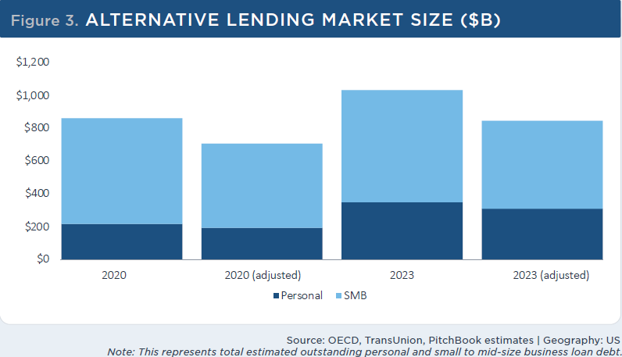

**VC Activity**

**Alternative lending continues its three-year slide in invested capital, drawing $8.9 billion of VC in 2020 compared to $9.3 billion in 2019.** We believe some of the alternative lending market has been clawed away by the burgeoning buy-now, pay-later (BNPL) space. Furthermore, despite increased appetite for relatively high-yield loan securitizations, available credit for consumers and SMBs has tightened as the COVID-19 crisis continues.

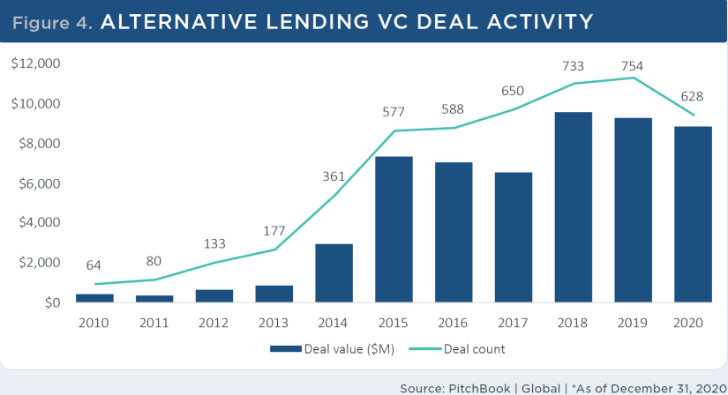We expect investment in alternative lending companies to continue to decrease in the foreseeable future as consumers shift to other credit products (such as BNPL). Alternative lending is a very mature segment, and many of the early movers have already exited via the public markets (for example, LendingClub (NYSE: LC), OnDeck (NYSE: ONDK), and Funding Circle (LON: FCH)), while others have expanded their focus to other areas of financial services (such as SoFi). However, we believe exit opportunities still exist for some of the VC-backed alternative lenders in this space and expect near-term exits from SoFi, Better.com, Zopa (the first P2P lending company), and LendInvest (a P2P mortgage lender).

**Valuation by comparable methods**

***Valuation by EV/Revenue multiple***

A revenue multiple measures the value of the equity of a business relative to its revenue. We examined Blender's industry, the FinTech industry, using data on 236 firms (as of Dec. 31, 2020[7]). We found that the median EV/Revenue was 13.5.

In 2020, Blender's revenue was about NIS 14.7 million; however, we deem this income, not representative.

We segmented the company revenue stream as followed:

1. Credit brokerage – In Israel, Blender is yet to receive a credit provider license, meaning that the company acts solely as a credit broker for the time being. Thus, according to accounting standards, only fees from brokerage operations are recognized as revenues, while interest income from loans to customers isn't.
2. Digital banking – In Europe, Blender prepares to act as a digital bank. In 2020, most of the company revenue steaming from the digital banking sector was derived from the company activity in Lithuania. The company initiated its activity in Latvia at the end of 2020. In 2021, the company plans to further establish its presence in Lithuania and Latvia, with an expected entrance to the Polish market.

According to accounting standards, both fees from credit operators and interest income from loans to customers are recognized as revenues.

We believe that in the foreseeable future, Blender will receive a fully-fledged digital bank license in Europe. It's important to mention that as a digital bank, one can raise credit for more favorable conditions than a credit broker. In other words, Blender could raise funds for lower interest, resulting in a more significant margin for the company.

In Israel we believe that Blender will convert from p2p lending into direct lending channels, by raising additional institutional funds, banks credit lines and public bonds.

Considering the above, for the comparison of Blender to other Digital banks and FinTech companies, we reckon that we should use the revenue that genuinely represents the company's potential. Hence, we added the income from loans to customers to the company's overall revenue (see appendix 1 – company financial statement 2020, Note 4).

According to our method, the company revenue was NIS 32.2 million (=14.74+17.49) in 2020. Thus, applying the mentioned EV/Revenue multiple of TBC

***Similar deals***

Based on the same data-set used to calculate the EV/Revenue median multiple, we found that the median pre-money valuation for late-stage fintech companies was $135.5M.

**Median pre-money valuation ($M) by stage**

**Price Forecast Risks**

**Regulation**

In the UK and EU, proactive regulation has made it easier for these digital banks to obtain banking licenses, though the process can still take up to a couple of years.

**Customer acquisition and retention are challenging**

The need to educate customers about the various benefits of digital financial services, coupled with the fact that financial habits take time to change, poses a unique challenge to fintech providers.

**Competition from incumbents and new entrants**

Growing consumer demand for personal financial management has attracted much new mobile banking, online revolving credit, and money management platform providers. We believe this sector is highly competitive and crowded with relatively low barriers to entry and a high risk of product commoditization. Further, prominent incumbent banks have considerable advantages given generally larger technology investment budgets and extensive client bases.

**Credit cycles and rising interest rates can hamper growth**

As alternative lending heavily relies on equity and debt investors (instead of traditional consumer deposits), we believe less capital will be available during an economic downturn.

**Supply-demand imbalance could lead to higher risk-taking**

We believe that the growth of P2P lenders' activity is constrained by borrower demand. Although there is plenty of capital available to lend to borrowers (especially from institutional investors), there aren't enough

credit-worthy borrowers to take in the capital surplus. Therefore, alternative lenders may seek new ways to incent prospective borrowers, which could lead to an increase in customer acquisition costs (CAC) or relaxation in underwriting standards as companies pursue higher-risk customers.

**Valuation summary**

TBC

**We conducted Blender's valuation using market benchmarks from recent deals and analysis of VC's activity; Given the assessments and findings mentioned above, we value the company's stock price target to be in the range of NIS XXX to NIS XXX, with a mean of NIS XXX.**

**Appendix #.1: Company Financial Statement 2020, Note 4**

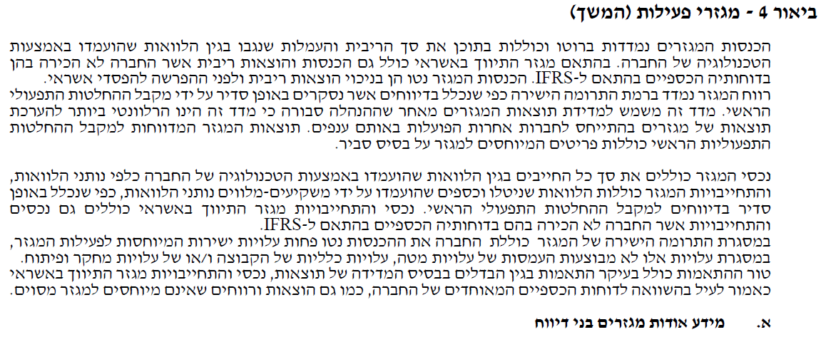

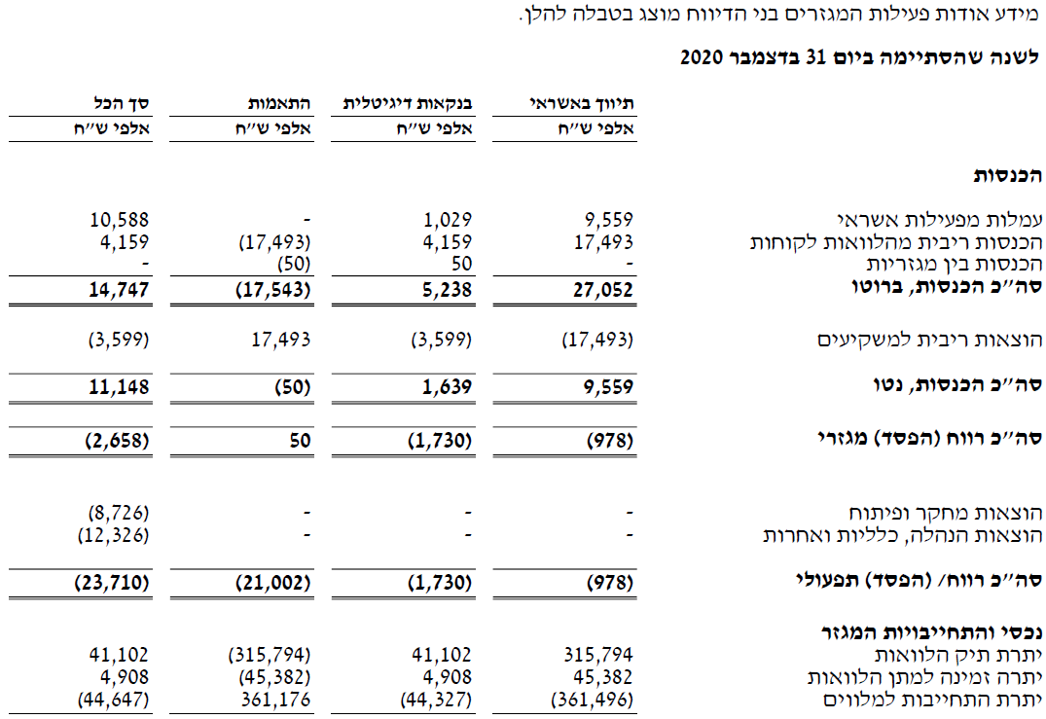

**Appendix #.2: About Frost & Sullivan**

Frost & Sullivan* is a leading global consulting, and market & technology research firm that employs staff of 1,800, which includes analysts, experts, and growth strategy consultants at approximately 50 branches across 6 continents, including in Herzliya Pituach, Israel. Frost & Sullivan's equity research utilizes the experience and know-how accumulated over the course of 55 years in medical technologies, life sciences, technology, energy, and other industrial fields, including the publication of tens of thousands of market and technology research reports, economic analyses and valuations. For additional information on Frost & Sullivan's capabilities, visit: www.frost.com. For access to our reports and further information on our Independent Equity Research program visit: www.frost.com/equityresearch.

*Frost & Sullivan Research and Consulting Ltd., a wholly owned subsidiary of Frost & Sullivan, is registered and licensed in Israel to practice as an investment adviser.

**What is Independent Equity Research?**

Nearly all equity research is nowadays performed by stock brokers, investment banks, and other entities which have a financial interest in the stock being analyzed. On the other hand, Independent Equity Research is a boutique service offered by only a few firms worldwide. The aim of such research is to provide an unbiased opinion on the state of the company and potential forthcoming changes, including in their share price. The analysis does not constitute investment advice, and analysts are prohibited from trading any securities being analyzed. Furthermore, a company like Frost & Sullivan conducting Independent Equity Research services is reimbursed by a third party entity and not the company directly. Compensation is received up front to further secure the independence of the coverage.

**Analysis Program with the Tel Aviv Stock Exchange (TASE)**

Frost & Sullivan is delighted to have been selected to participate in the Analysis Program initiated by the Tel Aviv Stock Exchange Analysis (TASE). Within the framework of the program, Frost & Sullivan produces equity research reports on Technology and Biomed (Healthcare) companies that are listed on the TASE, and disseminates them on exchange message boards and through leading business media channels. Key goals of the program are to enhance global awareness of these companies and to enable more informed investment decisions by investors that are interested in "hot" Israeli Hi-Tech and Healthcare companies. The terms of the program are governed by the agreement that we signed with the TASE and the Israel Securities Authority (ISA) regulations.

**For further inquiries, please contact our lead analyst:**

Dr. Tiran Rothman **T:** +972 (0) 9 950 2888 **E:** equity.research@frost.com

**Appendix #.3: Team Biographies**

**Dr. Tiran Rothman** is the head of Frost & Sullivan Research & Consulting Ltd., a subsidiary of Frost & Sullivan in Israel. He has over 10 years of experience in research and economic analysis of capital and private markets, obtained through positions at a boutique office for economic valuations, as chief economist at the AMPAL group, and as co-founder and analyst at Bioassociate Biotech Consulting. Dr. Rothman also serves as the Economics & Management School Head at Wizo Academic College (Haifa). Tiran holds a PhD (Economics), MBA (Finance), and was a visiting scholar at Stern Business School, NYU.

**Almog Josef Sokolik** is an Analyst and Consultant at Frost & Sullivan Research & Consulting Ltd., a subsidiary of Frost & Sullivan in Israel. He has experience in valuation of public and private firms, research and market analysis obtained through positions at the Ministry of Finance - Department of the Chief Economist, and Ben-Gurion University - Laboratory for Judgment & Decision Making as research analyst. Almog holds a BA in Economics and Psychology.

#### Disclaimers, disclosures, and insights for more responsible investment decisions

Definitions: "Frost & Sullivan" – A company registered in California, USA with branches and subsidiaries in other regions, including in Israel, and including any other relevant Frost & Sullivan entities, such as Frost & Sullivan Research & Consulting Ltd. ("FSRC"), a wholly owned subsidiary of Frost & Sullivan that is registered in Israel – as applicable. "The Company" or "Participant" – The company that is analyzed in a report and participates in the TASE Scheme; "Report", "Research Note" or "Analysis" – The content, or any part thereof where applicable, contained in a document such as a Research Note and/or any other previous or later document authored by "Frost & Sullivan", regardless if it has been authored in the frame of the "Analysis Program", if included in the database at www.frost.com and regardless of the Analysis format-online, a digital file or hard copy; "Invest", "Investment" or "Investment decision" – Any decision and/or a recommendation to Buy, Hold or Sell any security of The Company. The purpose of the Report is to enable a more informed investment decision. Yet, nothing in a Report shall constitute a recommendation or solicitation to make any Investment Decision, so Frost & Sullivan takes no responsibility and shall not be deemed responsible for any specific decision, including an Investment Decision, and will not be liable for any actual, consequential, or punitive damages directly or indirectly related to The Report. Without derogating from the generality of the above, you shall consider the following clarifications, disclosure recommendations, and disclaimers. The Report does not include any personal or personalized advice as it cannot consider the particular investment criteria, needs, preferences, priorities, limitations, financial situation, risk aversion, and any other particular circumstances and factors that shall impact an investment decision. Nevertheless, according to the Israeli law, this report can serve as a raison d'etre off which an individual/entity may make an investment decision.

Frost & Sullivan makes no warranty nor representation, expressed or implied, as to the completeness and accuracy of the Report at the time of any investment decision, and no liability shall attach thereto, considering the following among other reasons: The Report may not include the most updated and relevant information from all relevant sources, including later Reports, if any, at the time of the investment decision, so any investment decision shall consider these; The Analysis considers data, information and assessments provided by the company and from sources that were published by third parties (however, even reliable sources contain unknown errors from time to time); the methodology focused on major known products, activities and target markets of the Company that may have a significant impact on its performance as per our discretion, but it may ignore other elements; the Company was not allowed to share any insider information; any investment decision must be based on a clear understanding of the technologies, products, business environments, and any other drivers and restraints of the company's performance, regardless if such information is mentioned in the Report or not; an investment decision shall consider any relevant updated information, such as the company's website and reports on Magna; information and assessments contained in the Report are obtained from sources believed by us to be reliable (however, any source may contain unknown errors. All expressions of opinions, forecasts or estimates reflect the judgment at the time of writing, based on the Company's latest financial report, and some additional information (they are subject to change without any notice). You shall consider the entire analysis contained in the Reports. No specific part of a Report, including any summary that is provided for convenience only, shall serve per se as a basis for any investment decision. In case you perceive a contradiction between any parts of the Report, you shall avoid any investment decision before such contradiction is resolved. Frost and Sullivan only produces research that falls under the non-monetary minor benefit group in MiFID II. As we do not seek payment from the asset management community and do not have any execution function, you are able to continue receiving our research under the new MiFiD II regime. This applies to all forms of transmission, including email, website and financial platforms such as Bloomberg and Thomson.

Risks, valuation, and projections: Any stock price or equity value referred to in The Report may fluctuate. Past performance is not indicative of future performance, future returns are not guaranteed, and a loss of original capital may occur. Nothing contained in the Report is or should be relied on as, a promise or representation as to the future. The projected financial information is prepared expressly for use herein and is based upon the stated assumptions and Frost & Sullivan's analysis of information available at the time that this Report was prepared. There is no representation, warranty, or other assurance that any of the projections will be realized. The Report contains forward-looking statements, such as "anticipate", "continue", "estimate", "expect", "may", "will", "project", "should", "believe" and similar expressions. Undue reliance should not be placed on the forward-looking statements because there is no assurance that they will prove to be correct. Since forward-looking statements address future events and conditions, they involve inherent risks and uncertainties. Forward-looking information or statements contain information that is based on assumptions, forecasts of future results, estimates of amounts not yet determinable, and therefore involve known and unknown risks, uncertainties and other factors which may cause the actual results to be materially different from current projections. Macro level factors that are not directly analyzed in the Report, such as interest rates and exchange rates, any events related to the eco-system, clients, suppliers, competitors, regulators, and others may fluctuate at any time. An investment decision must consider the Risks described in the Report and any other relevant Reports, if any, including the latest financial reports of the company. R&D activities shall be considered as high risk, even if such risks are not specifically discussed in the Report. Any investment decision shall consider the impact of negative and even worst case scenarios. Any relevant forward-looking statements as defined in Section 27A of the Securities Act of 1933 and Section 21E the Securities Exchange Act of 1934 (as amended) are made pursuant to the safe harbor provisions of the Private Securities Litigation Reform Act of 1995.

TASE Analysis Scheme: The Report is authored by Frost & Sullivan Research & Consulting Ltd. within the framework of the Analysis Scheme of the Tel Aviv Stock Exchange ("TASE") regarding the provision of analysis services on companies that participate in the analysis scheme (see details: www.tase.co.il/LPages/TechAnalysis/Tase_Analysis_Site/index.html, www.tase.co.il/LPages/InvestorRelations/english/tase-analysis-program.html), an agreement that the company has signed with TASE ("The Agreement") and the regulation and supervision of the Israel Security Authority (ISA). FSRC and its lead analyst are licensed by the ISA as investment advisors. Accordingly, the following implications and disclosure requirements shall apply. The agreement with the Tel-Aviv Stock Exchange Ltd. regarding participation in the scheme for research analysis of public companies does not and shall not constitute an agreement on the part of the Tel-Aviv Stock Exchange Ltd. or the Israel Securities Authority to the content of the Equity Research Notes or to the recommendations contained therein. As per the Agreement and/or ISA regulations: A summary of the Report shall also be published in Hebrew. In the event of any contradiction, inconsistency, discrepancy, ambiguity or variance between the English Report and the Hebrew summary of said Report, the English version shall prevail. The Report shall include a description of the Participant and its business activities, which shall inter alia relate to matters such as: shareholders; management; products; relevant intellectual property; the business environment in which the Participant operates; the Participant's standing in such an environment including current and forecasted trends; a description of past and current financial positions of the Participant; and a forecast regarding future developments and any other matter which in the professional view of Frost & Sullivan (as defined below) should be addressed in a research Report (of the nature published) and which may affect the decision of a reasonable investor contemplating an investment in the Participant's securities. An equity research abstract shall accompany each Equity Research Report, describing the main points addressed. A thorough analysis and discussion will be included in Reports where the investment case has materially changed. Short update notes, in which the investment case has not materially changed, will include a summary valuation discussion. Subject to the agreement, Frost & Sullivan Research & Consulting Ltd. is entitled to an annual fee to be paid directly by the TASE. Each participant shall pay fees for its participation in the Scheme directly to the TASE. The named lead analyst and analysts responsible for this Report certify that the views expressed in the Report accurately reflect their personal views about the Company and its securities and that no part of their compensation was, is, or will be directly or indirectly related to the specific recommendation or view contained in the Report. Neither said analysts nor Frost & Sullivan trade or directly own any securities in the company. The lead analyst has a limited investment advisor license for analysis only.

© 2021 All rights reserved to Frost & Sullivan and Frost & Sullivan Research & Consulting Ltd. Any content, including any documents, may not be published, lent, reproduced, quoted or resold without the written permission of the companies.

1. A minimum period of time - only in indirect distribution channels (B2B2C), in Israel and Lithuania
2. <https://pitchbook.com/>
3. <https://pitchbook.com/>
4. <https://pitchbook.com/>
5. <https://pitchbook.com/>
6. This estimate does not include SBA-backed loans offered via the Paycheck Protection Program (PPP).
7. Pithcbook: <https://pitchbook.com/>