The Effects of Oil Price Shocks on Economics Activities in the G7 Countries

Abstract. This study examines the effects of three types of oil price shocks on inflation in the G7 countries, using Killian’s (2009) method of isolating oil price shocks into distinct demand and supply shocks. Based on monthly data from January 1974 to April 2022, we split the analysis into two periods: before and during the COVID-19 pandemic. The results show that aggregate demand shocks and oil-specific demand shocks have a significant impact on inflation among the G7 countries. This impact increased in magnitude during the COVID-19 outbreak. Our empirical findings have significant implications for policymakers at both the country and firm levels, as they seek to better understand the dynamics and causes of oil price fluctuations and their potential impact on inflation pressures.

Keywords: G7, ASEAN+3, COVID-19, SVAR, Oil Shocks, Inflation.

Introduction

The nexus between oil prices and inflation has been widely debated in recent years, though the precise relationship remains largely unclear. There is no doubt that both oil and inflation are expected to continue to arouse great public interest. Due to the central roles that oil prices and inflation fulfill in economic activity, both play integral parts in the design of government monetary policy and the financial decisions of firms, investors, and households.
During the last two decades, the world energy industry has undergone far-reaching changes. Global oil prices have plunged from a record level of around $140 per barrel in 2008 to extremely low levels during the COVID-19 pandemic, with volatility and market uncertainty both increasing. Recently, oil and energy prices have surged again as a direct consequence of the Russia-Ukraine conflict. Meanwhile, inflation has raised great concerns due to its status as a key macroeconomic indicator, movements of which can have a direct impact on the overall economic system (Arawatari et al. 2018; Mensi et al. 2020; Tang et al. 2021; Wei, 2019).
In June 2022, the World Bank estimated that yearly inflation in advanced economies increased from 1.9% to 6.95% while inflation in emerging and developing economies rose from 4.23% to 9.37% (World Bank, 2022). The high inflation rate indicates growing demand as economies adjust to the COVID-19 pandemic, as well as a recovery in energy prices after pandemic lows (Killian and Zhou, 2022). Concerns have emerged among policymakers that the high inflation rate may be persistent rather than temporary, as the price of West Texas Intermediate (WTI) has remained above 80 dollars per barrel since October 2021, briefly exceeding 120 dollars per barrel following Russia's invasion of Ukraine in early 2022. Today, policymakers designing monetary policy in each country face a double-edged sword: high inflation rates and global economic contraction driven by high and volatile prices of commodities and oil. This makes it vital to comprehend the oil-inflation relationship.
Oil price shocks can impact inflation both directly and indirectly. The direct effect is felt through the demand side due to increases in the prices of oil products in consumer baskets. The indirect effect operates via the supply side. A rise in the price of oil raises firm production costs, which in turn raises commodity prices, impacting overall inflation. This effect increases upward pressure on nominal wages, which pushes inflation higher (Wen et al., 2021). Conversely, rising oil prices may also have a moderate deflationary effect due to the decrease in consumption and investment that results from a decline in real income (Edelstein and Kilian 2007, 2009). As a result, high oil prices may reduce inflation by lowering domestic demand. Therefore, oil prices may, hypothetically, have both a positive and negative effect on inflation.
This study adds to the existing body of knowledge in several ways. First, our sample period extends beyond that of recent related studies (e.g., Elsayed et al., 2021; Wen et al., 2021) and covers more than two years of the COVID-19 pandemic as well as the outbreak of the Russia-Ukraine war, both of which have had a significant influence on the oil market and the macroeconomy. Even though several researchers have investigated inflation among G7 countries (e.g., Aharon and Qadan, 2022; Istiak et al. 2021) and the effects of oil price shocks on inflation in these countries, this is the first study to look at how decomposed oil price shocks affect inflation in the G7 countries, before and during the COVID-19 outbreak based the structural VAR approach. By splitting the analysis into two distinct sub-samples, we determine the impact of COVID-19 and recent geopolitical events on oil prices and inflation.
Second, we investigate whether distinct oil shocks affect inflation asymmetrically by separating positive and negative shocks. Third, in contrast to the typical approach of evaluating the situation in formal trading blocs with similar borders (e.g., NAFTA, EEA), we analyze a unique sample of countries with significant intra-regional trade, comprising major oil consumers and producers.
Given the microeconomic and macroeconomic importance of oil and its central role among the inflationary pressures that pose a threat to the sustainability of economies, we attempt to identify the different channels through which oil price shocks are transmitted and test their impact on inflation in the G7 countries. We also take advantage of the COVID-19 pandemic to test the following additional questions: Do oil price shocks have a different impact on inflation before and during the COVID-19 outbreak? Are the effects of oil shocks on inflation asymmetric?
Following Kilian (2009), we use a two-stage methodology to evaluate the response of inflation in G7 countries to oil shocks. First, we utilize a Cholesky decomposition to extract three separate structural shocks from an estimated structural VAR model based on Kilian’s (2009) identification approach: oil supply shock, global aggregate demand shock, and oil-specific demand shock. Next, we use cumulative impulse response functions to estimate the impact of structural crude oil price shocks on inflation for G7 countries from January 1974 to April 2022. To capture the impact of oil shocks on inflation during the COVID-19 outbreak, we split the analysis into two sub-sample periods; before COVID-19, which covers the sample period from January 1974 to February 2020, and during COVID-19, which spans the full sample period from January 1974 to April 2022.
Results show that demand shocks and oil-specific demand shocks have a significant effect on inflation, while the impact of supply shocks is rather limited. We document a positive but statistically insignificant impact of oil price shocks on inflation among G7 countries before COVID-19. However, we document a positive and significant impact of demand shocks and oil-specific demand shocks on inflation during the COVID-19 pandemic for all G7 countries.
Our findings have important policy implications for monetary authorities. Understanding the relative significance of positive and negative oil price shocks may help policymakers develop more effective responses to oil price and inflation dynamics. In addition, our findings may also be useful for investors making investment decisions concerning portfolio construction, asset allocation and hedging.
The remainder of this paper is organized as follows: In Section 2, we review the relevant literature; in Section 3, we explain our data sources and main methodology; in Section 4, we discuss our main findings; and in Section 5, we summarize and present conclusions.

- Literature Review

The relationship between oil prices and inflation has been studied for decades, but findings that quantify this relationship have been inconsistent and frequently contradictory (Kilic and Cankaya, 2020). Although there is considerable debate as to whether shocks in crude oil prices are largely responsible for recessions (see, for example, Kilian, 2014), it is generally accepted that oil shocks affect inflation, at least partially (Conflitti & Luciani, 2019; Edelstein and Kilian, 2009).
The literature is inconclusive on the question of why macroeconomic variables react differently to changes in oil prices. An examination of price transmission asymmetry suggests that increases in oil prices appear to engender a quicker reaction in terms of inflationary rates and outputs than decreases in oil prices. This irregular and asymmetrical nexus between oil price movements and inflation is also observed by Hammoudeh and Reboredo (2018).
Lòpez-Villavicencio and Pourroy (2019) indicate that oil price transmission is greater during oil price decreases than during oil price increases, among inflation-targeted nations. Choi et al. (2018) confirm the asymmetrical effects of oil price shocks for 72 developed and developing countries, with positive shocks having a larger impact than negative shocks. Evidence of asymmetry in the effect of oil prices on inflation among Asian countries is also documented by Chow and Lin (2013), Farzanegan and Markwardt (2009), and Ghosh and Kanjilal (2014). These studies generally find positive and negative oil price shocks significantly affect inflation, but the magnitude depends on the size of the shock. There are, however, counterarguments (e.g., Kilian, 2008; Kilian and Lewis, 2011) that downplay the possibility of a significant inflationary effect from rising crude oil prices. LeBlanc and Chinn (2004) draw similar conclusions, arguing that crude oil price fluctuations had less of an impact on headline CPI inflation for developed economies in the early 2000s. Sari and Soytas (2006) similarly find that oil price shocks have a small effect on inflation in Turkey. In addition, Álvarez (2011) analyses the spillover effect of fluctuating crude oil prices on inflation in Spain, finding that such fluctuations have a limited impact. Tiwari et al. (2019) implement a wavelet coherency analysis and discover that the impact of crude oil prices on inflation diminishes over time.
Kilian (2009) demonstrates in his seminal paper that the sources of oil price shocks determine how rising oil prices affect the U.S. macroeconomy. For example, the COVID-19 pandemic is a classic illustration of an unexpected shock from which oil prices plunge to an unprecedented low level, whereas the cuts in oil production induced by the Russia-Ukraine conflict are an example of an impact that originates from the supply channel. Kilian’s approach has been used by scholars to examine how shocks in oil prices affect other economic and financial variables (Alsalman & Karaki, 2019; Basher, Haug, & Sadorsky, 2016; Hu, Liu, Pan, Chen, & Xia, 2018; Wang, Wu, & Yang, 2014).
Our paper joins and extends the works dealing with the oil-inflation nexus across the G7 countries, to include data from the COVID-19 pandemic and the outbreak of the Russia-Ukraine conflict (e.g., Wen et al. 2021; Cologni and Manera 2008; Gómez-Loscos et al 2012(.
We aim to provide further empirical evidence related to the oil-inflation nexus in G7 countries, using Killian’s (2009) approach with one modification based on Atems et al. (2015) to account for the asymmetric effects of oil shocks. Our study seeks to shed light on this issue, which is currently threatening economic growth.

- Data and method

Our study utilizes monthly data from January 1974 to April 2022, consisting of inflation, crude oil prices, world oil supply, and a measure of global real economic activity. For inflation, we use the annual inflation rate for U.S, the United Kingdom, Germany, Italy, France, Japan, and Canada. Data for inflation are sourced from the IMF IFS database (https://data.imf.org). Real oil prices per barrel are calculated using the U.S. refiner acquisition cost of crude oil deflated by the U.S. consumer price index (CPI) (https://www.eia.gov). Data for the world oil supply (in millions of barrels per day) are obtained from the U.S. Energy Information Administration (https://www.eia.gov/international/data/world). Data on real global economic activity are downloaded from the Federal Reserve Bank of Dallas (https://www.dallasfed.org/research/igrea). This business-cycle index is derived from a panel of dollar-denominated worldwide bulk dry cargo shipping rates and can be used as a proxy for the quantity of shipping in global manufacturing equity markets. The data are different from what Kilian (2009) and Kilian and Park (2007) used, and are amended in accordance with the discussion in Killian (2019).

Method

Structural VAR for decomposed Oil Price Shocks

We define the structural VAR (SVAR) as follows

(1)

where $y_{t}$ denotes (i) world oil supply, (ii) index of global real economic activity, and (iii) the real oil price in US dollars; $ε_{t}$ is a vector of structural innovations with an economic interpretation, which are serially and mutually uncorrelated. Exclusionary restrictions are imposed on $A_{0}^{-1}$ in $e_{t}=A_{0}^{-1}ε_{t}$, where $e_{t}$ is a vector of errors in a VAR (see Kilian, 2009):

$y_{t}=A_{0}^{-1}A(L)y_{t-1}+A_{0}^{-1}ε_{t}$ (2)

The following are the three structural shocks: The oil supply shock, $ε_{st}$, denotes shocks to global crude oil supply, $ε_{yt}$ denotes global demand shocks for all industrial goods due to global real economic activity (hereafter "aggregate demand shock”) and $ε_{ot}$ denotes an oil-market-specific demand shock and is referred to as the oil-specific demand shock. In Eq. (2), the identification of $A_{0}^{-1}$ is obtained by imposing the following exclusion restrictions:

et=esteyteot=a1100a21a220a31a32a33ε1toil supply shock ε2tagregate demand shock ε3toill-specific demand shock (3)

Eq. (3) implies that (a) oil supply shock is independent of the innovations to the aggregate demand shock or oil-specific demand shocks. An oil supply shock is an external disturbance of the supply curve induced by geopolitical turbulence, such as armed wars or changes in OPEC members’ output restrictions. Oil producers are hesitant to modify their output promptly following changes in demand, owing to the high costs of changing production in the short term (i.e., one month). (b) There is a lag of at least a month before we see the effects of a change in aggregate demand due to an oil supply shock. An unexpected surge in economic activity accompanies a demand shock caused by global economic activity. A rise in global demand increases the demand for oil, resulting in increased oil prices and production. However, not all increases in oil prices are associated with an ongoing expansion of economic activity. Rather, some are prompted by more significant concerns about the future availability of oil. (c) Lastly, crude oil prices can be expected to react to changes in the oil supply and global real economic activity within the same month. This is referred to as an “oil-specific demand shock,” and it is important to note that even though oil production and prices are expected to increase, this shock will have no positive effect on global economic activity. Additional details on these identification systems can be found in Kilian (2009, pp. 1059–1060). Figure 1 depicts a decomposition of structural oil shocks derived from Eq (3). Following the 2008 GFC, we see a substantial negative oil demand shock in the late 2000s. The decrease in oil prices in 2008 was driven by a combination of a negative aggregate demand shock and a negative oil-specific shock. Hamilton (2009) argues that the oil price had already risen above its "fundamental" value by the time it reached 140 dollars per barrel in June 2008. The outbreak of COVID-19 is largely responsible for the significant negative supply-and oil-specific demand shocks in early 2020. The COVID-19 pandemic appears to have had a serious impact on crude oil supply because of dramatic declines in output and demand (Sharif et al., 2020).

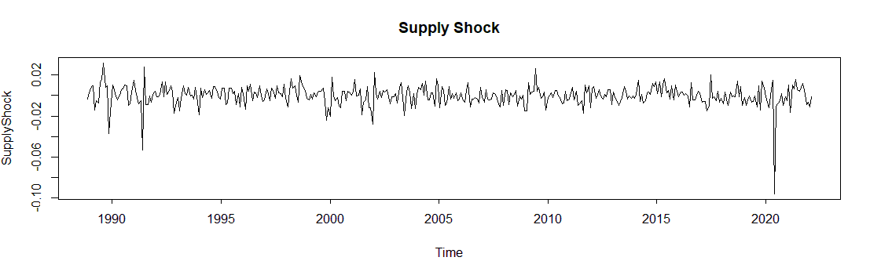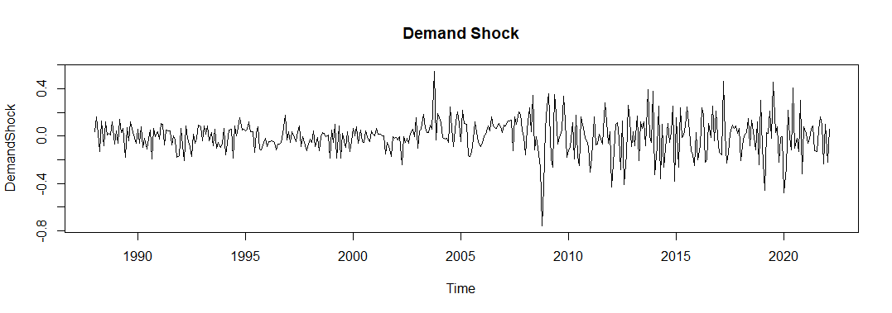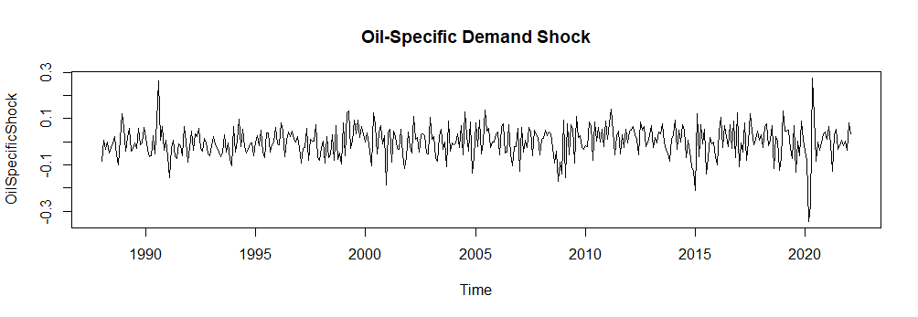Figure 1: Decomposed oil shocks

Descriptive Statistics

Kilian (2009) serves as the main inspiration for this paper (how do we justify Killian’s approach rather than Ready’s (2018) approach). Kilian (2009) characterizes the three types of structural oil shocks from the structural VAR model based on the log return of world oil supply, the detrended index of real global economic activity, and the log level of real oil price. Specifically, we use the same constructs of variables, similar to those used by Basher et al. (2016). For inflation, the first differences are used for all series to ensure the data are stationary. Table 1 summarizes the descriptive statistics for raw data on oil price shocks and inflation indices for G7 countries. We discover that the mean inflation is highest for Italy, at 5.9 percent, followed by the UK, with a mean inflation of 5.1 percent. The lowest mean inflation of 2.04 percent is recorded for Japan. All the series have skewness values that are not zero and kurtosis values that are typically more than 3, providing further evidence of asymmetry and fat tails in the distribution of the variables. All the variables follow nonnormal distributions, as indicated by the results of the Jarque-Bera test, which show significance at the 1% level.

Table 1. Descriptive statistics of variables.
 | Mean | Max | Min | SD | Skew | Kurt | JB | PP
Economic activity index
Real oil price
Oil supply
Inflation US
Inflation UK
Inflation Canada
Inflation Italy
Inflation Germany
Inflation France
Inflation Japan
Note: Max, Min, SD, Skew, Kurt, JB, and PP. are abbreviations for maximum, minimum, standard deviation, skewness, kurtosis, Jarque–Bera test of normality, Phillips-Perron tests of stationarity statistics, respectively. * Indicates the rejection of the null hypotheses of normality at a 1% significance level and the unit root at a 1% significance level. The optimal lag length for the tests was determined using the Schwarz Information Criterion (SIC).

- Empirical Findings

The effects of oil price shocks on inflation

To determine the impact of the three decomposed oil price shocks on inflation, we calculate the impulse response functions (IRFs) for all inflation rates for G7 economies. Based on Eq. (4), we plot the cumulative impulse response functions with a one-standard-deviation shock for 12 months ahead, along with their 95 percent confidence intervals. The (upper and lower) confidence intervals for the impulse response are shown by the dotted lines, while the solid line represents the actual response. We reject the null hypothesis of no significant impact from oil shocks on inflation when both the upper and lower confidence intervals cross above or below the horizontal (zero) line. Eq. (4) is formulated as follows:

${CPI}_{t}=β_{0}+\sum_{i=0}^{12}{ }β_{1i}ε_{s,t-i}+\sum_{i=0}^{12}{ }β_{2i}ε_{y,t-i}+\sum_{i=0}^{12}{ }β_{3i}ε_{o,t-i}+e_{t}$ (4)

where ${CPI}_{t}$ denotes the percentage change in the inflation series and $ε_{st},ε_{yt}$, and εot, denote the structural oil supply shock (SS), aggregate demand shock (DD), and oil-specific demand shock (OIL), respectively. Using the cumulative impulse functions derived from the structural VAR model, we estimate the response of inflation to identified oil price shocks using a dynamic OLS technique. Notable works that employ this methodology include Kilian (2009) and Basher et al (2016). Figure 2 depicts the responses of inflation to oil supply shocks, aggregate demand shocks, and oil-specific demand shocks derived from Eq. (4). Panel A of Figure 2 depicts the responses before the COVID-19 outbreak (January 1974 to February 2020) and Panel B of Figure 2 depicts the responses during the COVID-19 pandemic and the outbreak of the Russia-Ukraine conflict (January 1974 to April 2022).
In general, we find that all three types of structural oil price shock have no significant impact on inflation in G7 countries before the COVID-19 outbreak. However, we find that the impact of oil price shocks on inflation is statistically significant in G7 countries during the COVID-19 pandemic, for oil-specific demand shocks in particular. Our findings on the insignificant impact of oil price shocks on inflation before COVID-19 pandemic are consistent with Kilian and Lewis (2011) Álvarez (2011) and Tiwari et al. (2019). Apart from the considerable variation in crude oil prices, our findings corroborate evidence of declining inflation among advanced and emerging market and developing economies (EMDEs) in the 50 years preceding the pandemic. This decline has been attributed to a combination of factors, including a rise in globalization, the liberalization of financial, labor, and product markets, as well as a greater emphasis on price stability by monetary authorities (Ha et al., 2019a). In fact, inflation dropped so sharply in the 1990s and 2000s (during what was known as “The Great Moderation”) that by the early 2000s, deflation had become a significant concern in some industrialized economies. To illustrate, inflation in industrialized countries dropped from 15.3 percent to 1.3 percent between 1974 and 2019, with EMDEs recording the largest drop, from 17.5 percent to 2.6 percent during the same period (World Bank, 2022b). The World Bank (2022b) also reports that from 2012 to 2019, advanced economies with an inflation-targeting regime saw low inflation, while more than half of inflation-targeting EMDEs were able to keep inflation rates within target ranges.
On the contrary, our results during the COVID-19 pandemic are consistent with recent global economic developments. Figure 2 shows aggregate demand shocks and oil-specific demand shocks are associated with inflation increases, and the impacts are statistically significant for all G7 economies. While demand shocks are associated with inflation increases after the second or third month, oil-specific demand shocks generate positive inflation responses from the first month; and their effects last indefinitely. Our results are consistent with World Bank (2022b). The World Bank (2022b) opines that the current juncture is comparable to the oil price shocks of 1973 and 1979-1980. Russia's invasion of Ukraine, new pandemic outbreaks, and movement restrictions in China are contributing to higher crude oil prices, which drive inflation and CPI in many countries.
In fact, the World Bank (2022a) projects that the global inflation rate will remain above its 2019 average, despite a forecasted decline to about 3 percent in mid-2023. In addition, Ha et al. (2019b) show that a 50% increase in crude oil prices (approximately the same as the increase in 2021) is correlated with a statistically significant increase in inflation of around 4.4 percentage points after two years. In short, the inflationary effects originating from oil-specific demand shocks are consistent with Baumeister and Peersman (2013) and Kilian and Murphy (2014), who suggest that oil-specific demand shocks are ‘speculative shocks’ that represent a reaction to traders’ perceptions, which are often not related to fundamentals but rather to oil market uncertainty (Cuñado et al., 2015).
Figure 2 also shows that oil supply shocks have no statistically significant impact on inflation in G7 countries, before and during the COVID-19 outbreak. Our results support Killian (2009) but contradict with Wen et al. (2021). Using Ready’s (2018) methodology, Wen et al. (2021) discover a strong effect of supply shocks on inflation in the G7. However, the measured effect of supply shocks on inflation weakens when the supply shock is measured using Killian’s (2009) method. In addition, our results are consistent with the work of Umar et al. (2022), showing that oil supply shocks have a negligible impact on exchange rates across the ASEAN+3 countries.

Figure 2 further reveals that the responses of inflation to oil-specific demand shocks in each of the G7 countries during the spread of COVID-19 are identical. Oil-specific demand shocks have especially significant inflationary effects, and these effects becomes permanent after the initial shock. This result is also consistent with research showing that during COVID-19 the total connectedness of inflation across the G7 countries has increased (e.g., Aharon and Qadan, 2022).

A) Before COVID-19 (Jan. 1974 to Feb. 2020) B) Including COVID-19 (Jan. 1974 to Apr. 2022)
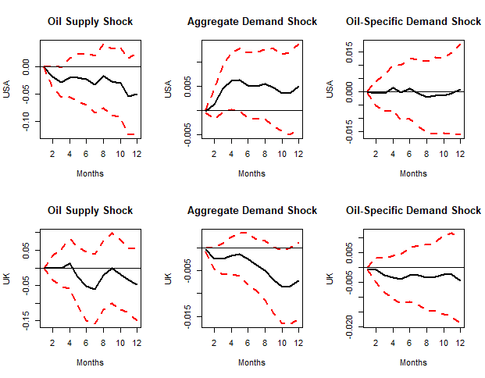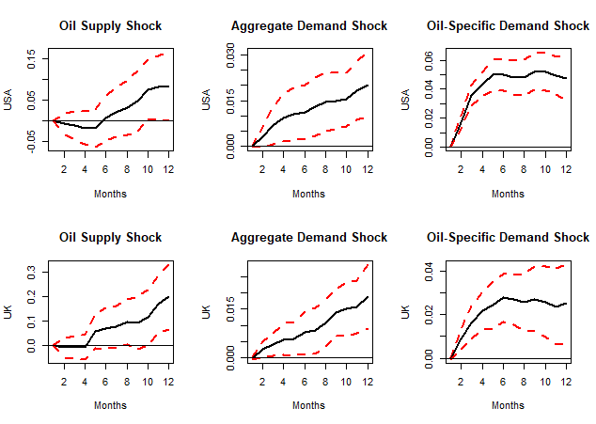
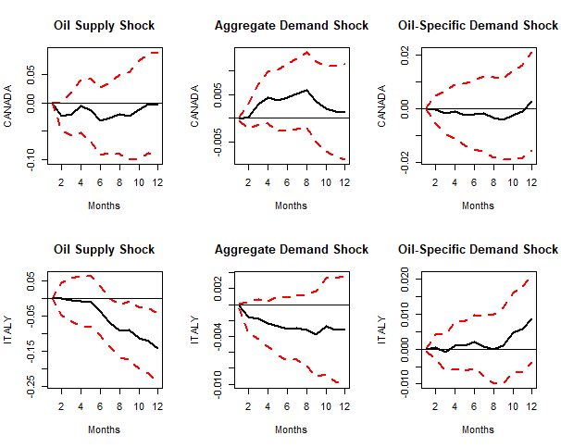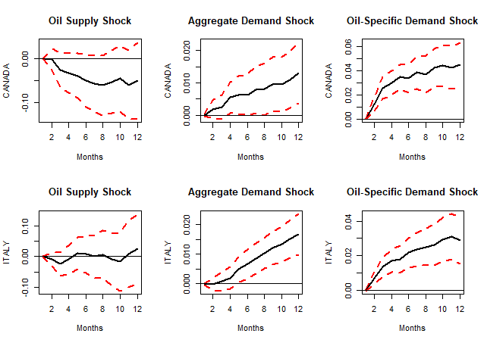
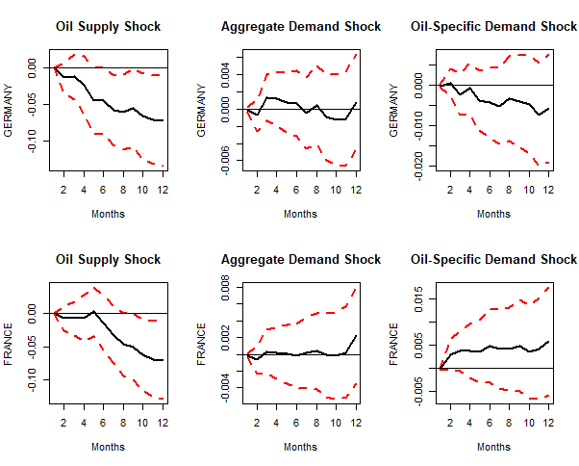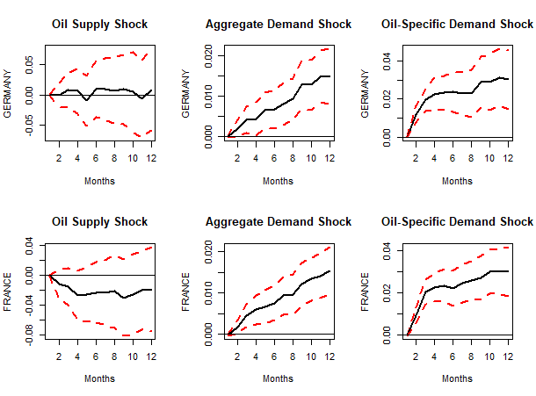
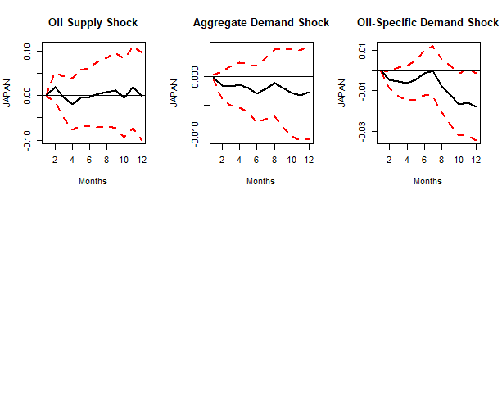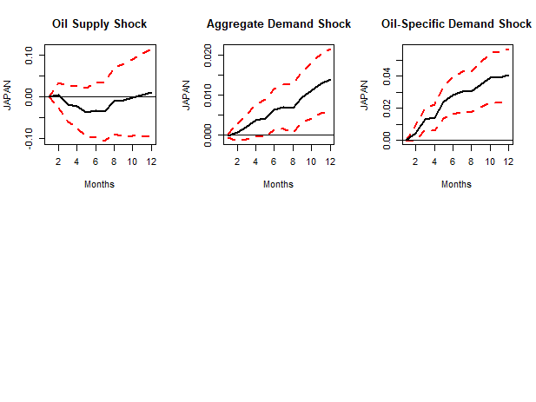

Figure 2: Response of inflation to each type of structural shock.

Analysis of the effects of oil price shocks on inflation using asymmetric specification
After demonstrating that inflation reacts differently to oil price shocks before and during the outbreak of COVID-19, in this section we explore whether it reacts differently to positive and negative shocks. According to Hamilton (2003), scholarly debates over the effect of oil shocks stem in part from employing the incorrect functional form. According to Mork (1989), increases in oil prices have a varying effect on U.S GDP than decreases in oil prices. Lee et al. (1995) show that real oil price shocks have asymmetric impacts on real GNP and unemployment, and that these impacts are significant for oil price increases but not for oil price decreases. Li and Guo (2022) find a strong asymmetry between oil prices and inflation in China, highlighting that the inflationary effect is more pronounced when the oil price decreases than when it increases, especially in the short term. In a same vein, Lòpez-villavicencio and Pourroy (2019) find that the pass-through from oil price to inflation is substantially larger in inflation-targeting countries when the oil price falls. Based on the innovative MTNARDL model, Pal and Mitra (2019) show that oil price changes have an asymmetric short-term impact on US inflation, suggesting that the magnitude of the impact is greater during oil price increases than oil price decreases. Since there is evidence that oil shocks affect inflation asymmetrically, especially during turbulent market environments, it seemed likely that inflation in G7 countries would exhibit a similar asymmetric response during the outbreak of COVID-19.
To test the asymmetric impact of oil shocks on inflation, we define the following function based on Atems et al. (2015):
$$\begin{matrix}{ CPI}_{t}= & β_{0}+\sum_{i=0}^{12}{ } β_{1i}ε_{s,t-i}^{+}+\sum_{i=0}^{12}{ } β_{2i}ε_{s,t-i}^{-}+\sum_{i=0}^{12}{ } β_{3i}ε_{y,t-i}^{+}+\sum_{i=0}^{12}{ } β_{4i}ε_{y,t-i}^{-} \\ & +\sum_{i=0}^{12}{ } β_{5i}ε_{o,t-i}^{+}+\sum_{i=0}^{12}{ } β_{6i}ε_{o,t-i}^{-}+e_{t}\end{matrix} (5)$$
where $ε_{st}^{+},ε_{yt}^{+}$, and $ε_{ot}^{+}$ are the shock values when the shocks are positive and 0 otherwise, and $ε_{st}^{-},ε_{yt}^{-}$, and $ε_{ot}^{-}$ are the shock values when the shocks are negative and 0 otherwise. Figure 3 depicts the impulse response functions estimated from Eq. (5) with a one-standard-deviation shock.
The asymmetry described above is supported by the results shown in Figure 3. First, there is limited evidence that global oil supply shocks had any (asymmetric) effect on inflation over any time horizon, either before or during the COVID-19 pandemic.
Second, during the COVID-19 pandemic, the majority of G7 countries recorded positive (albeit delayed) inflationary impacts from positive shocks to the global aggregate demand, whereas negative demand shocks had no statistically significant impact on inflation in any country, with the exception of France. Specifically, we can find the impact of positive demand shocks on inflation in the US, UK, Italy, Germany, and France start to increase only after the eighth or ninth month and remain positive afterward. This conclusion supports Killian and Zhou (2022a) who demonstrate the diminishing cumulative effect of gasoline price increases on US core inflation by late 2021.

Third, for all G7 countries, positive and negative oil-specific demand shocks lead to higher inflation during the COVID-19 outbreak. Oil-specific demand shocks (also known as speculative demand shocks) are inextricably linked with oil market uncertainty (Cuñado et al., 2015). The impact of the Russia-Ukraine war, which has elevated geopolitical risk in financial and commodities markets (Umar et al., 2022), may have increased concerns about the future availability of oil due to the embargo placed on Russian oil by Europe and the US, leading to an increase in the oil price and, consequently, inflation. In fact, the increased geopolitical risk from this war, which has held crude oil prices above $100 since March 2022, may have a limited deflationary effect on price levels in the event of a negative oil-specific demand shock. According to Friedman (1977), uncertainty about inflation may cause a rise in the natural rate of unemployment due to decreasing allocative efficiency, and this may result in a loss in output. Friedman’s viewpoint leads to a significant conclusion: if uncertainty about inflation is to blame for falling output, then uncertainty about oil prices might also be to blame for both the price level and decreasing output.

A) Before COVID-19 (Jan. 1974 to Feb. 2020) B) Including COVID-19 (Jan. 1974to Apr. 2022)

US: Before COVID-19 US: During COVID-19

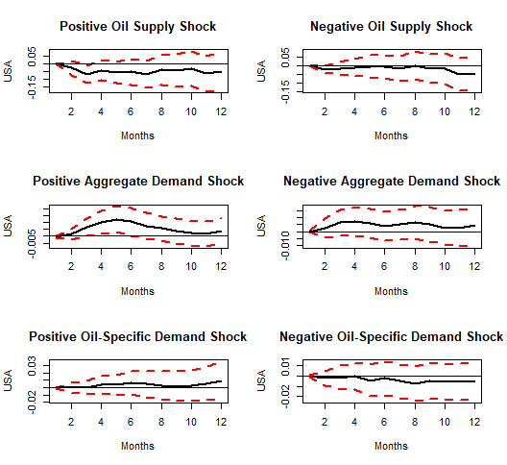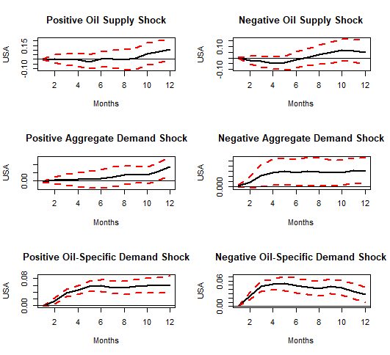

Figure 3: Response of inflation to asymmetric structural shocks.

UK: Before COVID-19 UK: During COVID-19
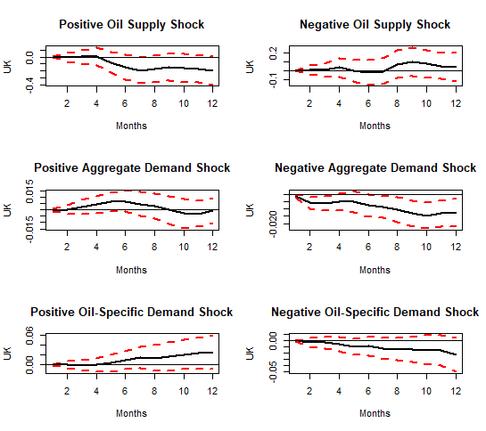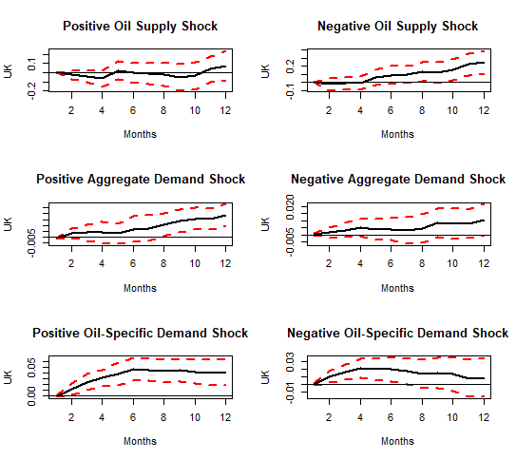

Canada: Before COVID-19 Canada: During COVID-19
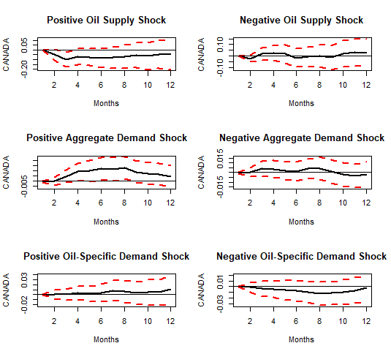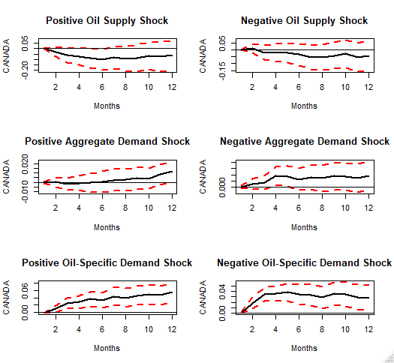

Italy: Before COVID-19 Italy: During COVID-19
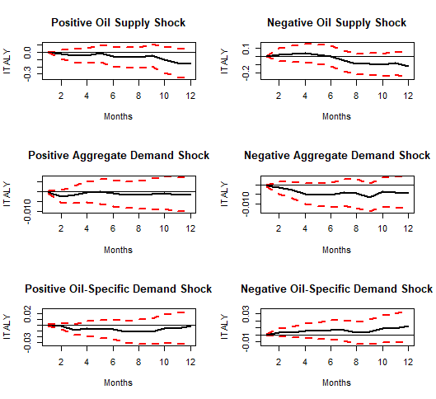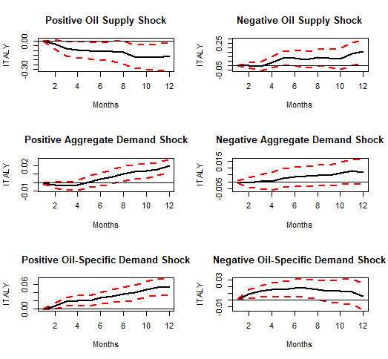

Figure 3: Response of inflation to asymmetric structural shocks (cont’d)

Gemany: Before COVID-19 Gemany: During COVID-19

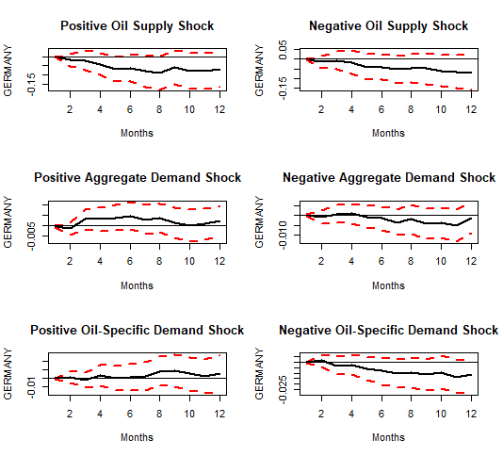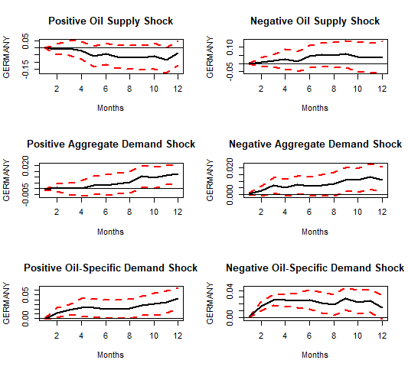

France: Before COVID-19 France: During COVID-19

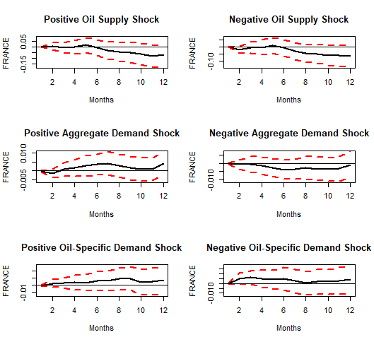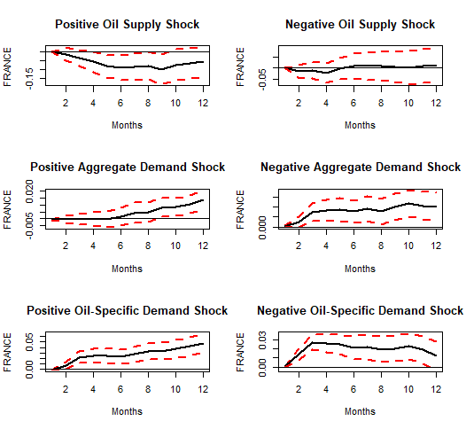

Figure 3: Response of inflation to asymmetric structural shocks (cont’d)

Japan: Before COVID-19 Japan: During COVID-19

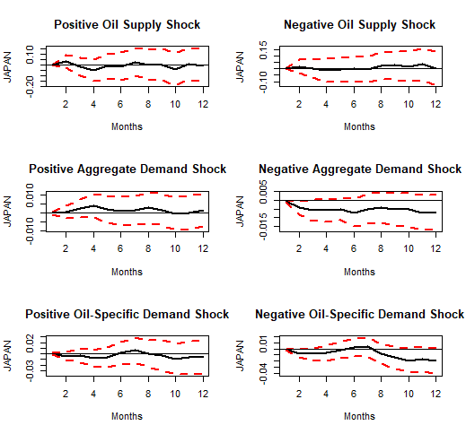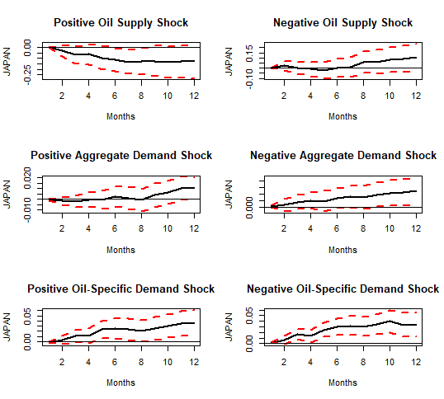

Figure 3: Response of inflation to asymmetric structural shocks.

Large versus small shocks
Hamilton (2003, 2009) and Bachmeier (2008), among others, provide a rationale for exploring whether large and small shocks impact inflation differentially. A unique threshold approach, commonly known as the “net oil price increase model,” was proposed by Hamilton (2003, 2009). According to Hamilton’s model, it is not increases in oil prices per se that have an effect on the economy, but rather increases in oil prices that are large relative to recent economic events.
We used the following model to examine how inflation responds to large and small oil price shocks:

$$\begin{matrix}{CPI}_{t}= & β_{0}+\sum_{i=0}^{12}{ } β_{1i}ε_{s,t-i}^{L}+\sum_{i=0}^{12}{ } β_{2i}ε_{s,t-i}^{S}+\sum_{i=0}^{12}{ } β_{3i}ε_{y,t-i}^{L}+\sum_{i=0}^{12}{ } β_{4i}ε_{y,t-i}^{S} \\ & +\sum_{i=0}^{12}{ } β_{5i}ε_{o,t-i}^{L}+\sum_{i=0}^{12}{ } β_{6i}ε_{o,t-i}^{S}+e_{t}\end{matrix}$$
where εstL, εytL and $ε_{ot}^{L}$ correspond to large oil shocks, and are 0 otherwise, and $ε_{st}^{S},ε_{yt}^{S}$ and $sε_{\text{ot }}^{S}$ correspond to small oil shocks, and are 0 otherwise. Since there is no consensus in economic theory over what constitutes a “large” or “small” shock, we utilise the threshold estimation procedure of Hansen (1996, 2000) based on Atem et al. (2015) to determine the appropriate threshold.
Figure 4

A) Before COVID-19 (Jan. 1974 to Feb. 2020) B) Including COVID-19 (Jan. 1974 to Apr. 2022)

US: Before COVID-19 US: During COVID-19
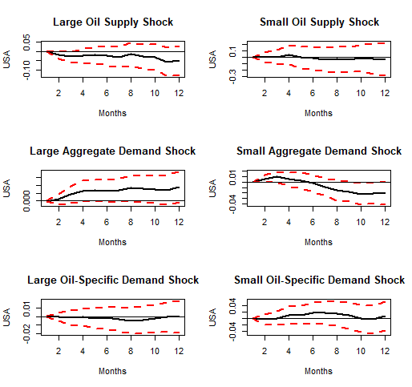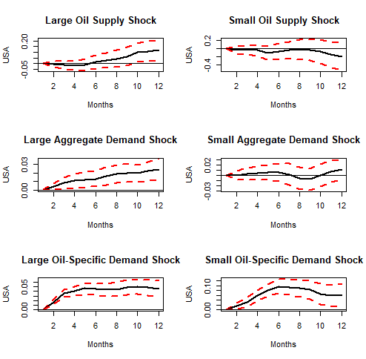

UK: Before COVID-19 UK: During COVID-19
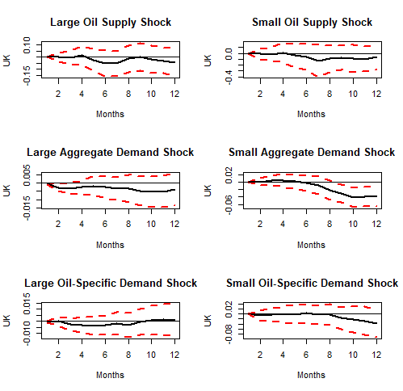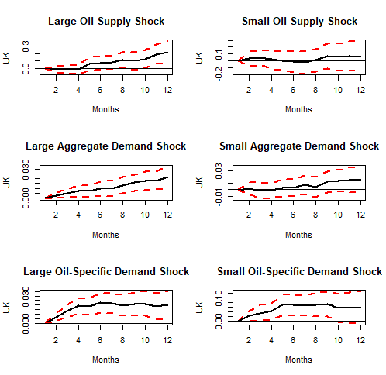
Fig. 4. Impulse responses of inflation to large and small shocks.

Canada: Before COVID-19 Canada: During COVID-19
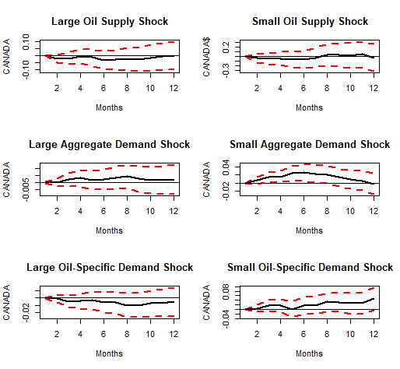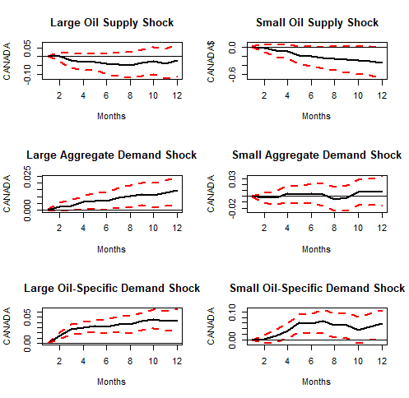

Italy: Before COVID-19 Italy: During COVID-19
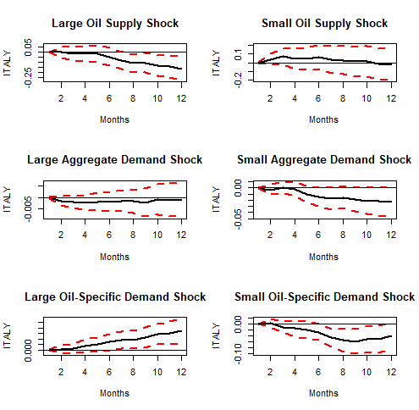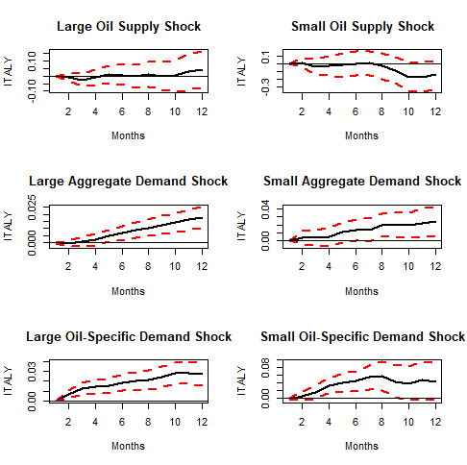
Fig. 4. Impulse responses of inflation to large and small shocks (Cont’d)

Germany: Before COVID-19 Germany: During COVID-19
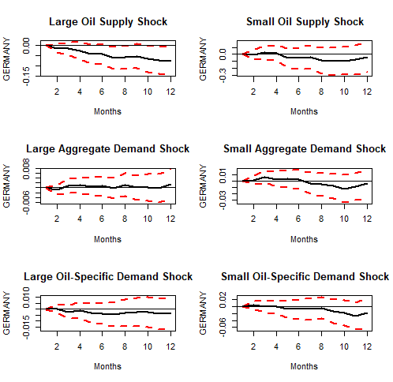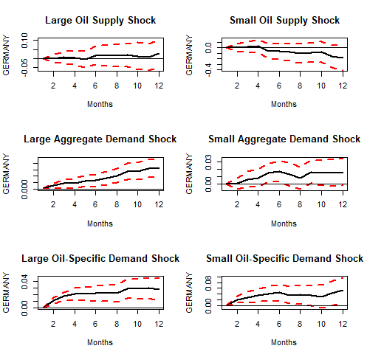

France: Before COVID-19 France: During COVID-19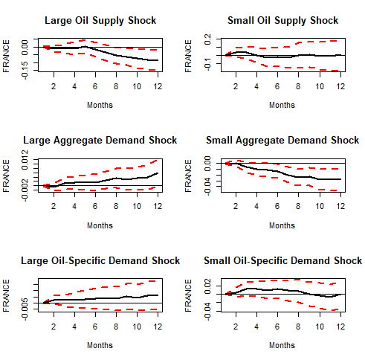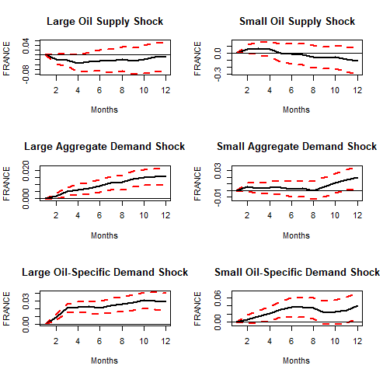
Fig. 4. Impulse responses of inflation to large and small shocks (Cont’d)

Japan: Before COVID-19 Japan: During COVID-19
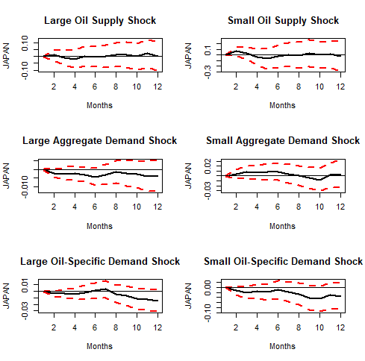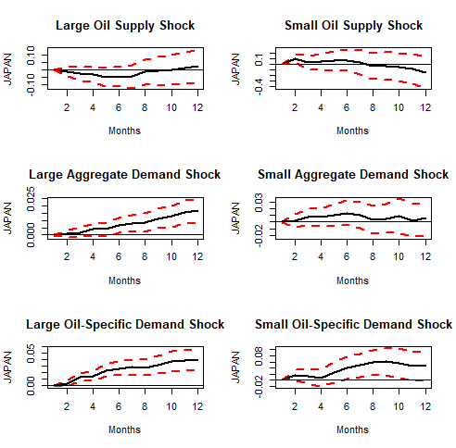
Fig. 4. Impulse responses of inflation to large and small shocks.
- Conclusion

This study adds to the current literature by employing Killian’s (2009) oil shock decomposition to investigate the effects of oil price shocks on inflation in the G7 countries before and during the COVID-19 pandemic and the outbreak of the Russia-Ukraine conflict. Using monthly data from January 1974 to April 2022, we find that during the COVID-19, the effect of aggregate demand shocks and oil-specific demand shocks on inflation are significant for all G7 countries, while the effect of supply shocks is rather limited. The impulse responses for all G7 countries show that the impact of aggregate demand shocks and oil-specific demand shocks on inflation are positive and statistically significant during the COVID-19 pandemic and the Russia-Ukraine conflict. We also find that supply shocks have little or no effect on inflation for the majority of G7 economies. By contrast, oil-specific demand shocks are an important factor in influencing inflation, particularly during the COVID-19 pandemic. Future research should incorporate an economic uncertainty index to better capture the impact of geopolitical events on the oil market.

References

Aharon, D. Y., & Qadan, M. (2022). Infection, invasion, and inflation: Recent lessons. Finance Research Letters, 50, 103307.‏
Alsalman, Z. N., & Karaki, M. B. (2019). Oil prices and personal consumption expenditures: does the source of the shock matter?. Oxford Bulletin of Economics and Statistics, 81(2), 250-270.

Al-Qudsi, S., & Ali, M. (2016). Economic Growth Implications of Oil Prices Fluctuations: The GCC Context. Doha Institute.
Álvarez, L. J., Hurtado, S., Sánchez, I., & Thomas, C. (2011). The impact of oil price changes on Spanish and euro area consumer price inflation. Economic modelling, 28(1-2), 422-431.
Apergis, N., & Miller, S. M. (2009). Do structural oil-market shocks affect stock prices? Energy economics, 31(4), 569-575.
Arawatari, R., Hori, T., & Mino, K. (2018). On the nonlinear relationship between inflation and growth: A theoretical exposition. Journal of Monetary Economics, 94, 79-93.‏
Arezki, R. J., Laxton, Z., Matsumoto, D., Nurbekyan, A., & Wang, A. H. and Yao, J.(2017). Oil Prices and Global Economy. IMF Working Paper. WO/17/15.
Arora, V., & Shi, S. (2016). Energy consumption and economic growth in the United States. Applied Economics, 48(39), 3763-3773.
ASEAN. Overview of ASEAN Plus Three Cooperation, ASEAN Secretariat Information
Paper. April 2020. Available online: https://asean.org/storage/2016/01/APT-Overview-Paper-24-Apr-2020.pdf (accessed on 31 December 2020)
Atems, B., Kapper, D., & Lam, E. (2015). Do exchange rates respond asymmetrically to shocks in the crude oil market?. Energy Economics, 49, 227-238.
Aziz, M. I. A., Azhari, A., & Mobin, M. A. (2022). Detecting asset price bubbles during the covid-19 crisis and its implications: evidence from the stock and oil market. International Journal of Banking and Finance, 17(2), 91-114.
Banikhalid, H. (2017). The impact of Oil price on the G7's inflation rate: an econometric study for the period (1986-2016). International Journal of Economics and Finance, 9(6), 1916-9728.
Basher, S. A., Haug, A. A., & Sadorsky, P. (2016). The impact of oil shocks on exchange rates: A Markov-switching approach. Energy Economics, 54, 11-23.
Basnet, H. C., & Upadhyaya, K. P. (2015). Impact of oil price shocks on output, inflation and the real exchange rate: evidence from selected ASEAN countries. Applied Economics, 47(29), 3078-3091.
Baumeister, C., & Peersman, G. (2013). The role of time‐varying price elasticities in accounting for volatility changes in the crude oil market. Journal of Applied Econometrics, 28(7), 1087-1109.
Chen, J., Zhu, X., & Li, H. (2020). The pass-through effects of oil price shocks on China's inflation: A time-varying analysis. Energy Economics, 86, 104695.
Choi, S., Furceri, D., Loungani, P., Mishra, S., Poplawski-Ribeiro, M., 2018. Oil price and
inflation dynamics: evidence from advanced and developing economies. J. Int. Money Finance 82, 71–96.
Chou, K. W., & Lin, P. C. (2013). Oil price shocks and producer prices in Taiwan: an application of non-linear error-correction models. Journal of Chinese Economic and Business Studies, 11(1), 59-72.
Cologni, A., & Manera, M. (2008). Oil prices, inflation and interest rates in a structural cointegrated VAR model for the G-7 countries. Energy economics, 30(3), 856-888.‏

Conflitti, C., & Luciani, M. (2019). Oil price pass-through into core inflation. The Energy Journal, 40(6).‏
Cuñado, Juncal, Jo, Soojin and Pérez de Gracia, Fernando, (2015), Macroeconomic impacts of oil price shocks in Asian economies, Energy Policy, 86, issue C, p. 867-879.
Eichengreen, B., Park, Y. C., & Wyplosz, C. (Eds.). (2008). China, Asia, and the new world economy. OUP Oxford.
Edelstein, P., & Kilian, L. (2007). The response of business fixed investment to changes in energy prices: a test of some hypotheses about the transmission of energy price shocks. The BE Journal of Macroeconomics, 7(1).
Edelstein, P., & Kilian, L. (2009). How sensitive are consumer expenditures to retail energy prices?. Journal of Monetary Economics, 56(6), 766-779.
Elsayed, A. H., Hammoudeh, S., & Sousa, R. M. (2021). Inflation synchronization among the G7 and China: The important role of oil inflation. Energy Economics, 100, 105332.
Farzanegan, M. R., & Markwardt, G. (2009). The effects of oil price shocks on the Iranian economy. Energy economics, 31(1), 134-151.
Friedman, J. W., 1977. Oligopoly and the Theory of Games. NorthHolland, Amsterdam
Ghosh, S., & Kanjilal, K. (2014). Oil price shocks on Indian economy: evidence from Toda Yamamoto and Markov regime-switching VAR. Macroeconomics and Finance in Emerging Market Economies, 7(1), 122-139.
Guesmi, K., Kaabia, O., & Abid, I. (2017). ASEAN plus three stock markets integration. Journal of Quantitative Economics, 15(3), 565-581.
Ha, J., Ivanova, A., Ohnsorge, F., & Unsal, D. F. (2019a). Inflation: Concepts, evolution, and correlates. World Bank Policy Research Working Paper, (8738).
Ha, J., Kose, M. A., Ohnsorge, F., & Yilmazkuday, H. (2019b). Sources of inflation: Global and domestic drivers. Inflation in Emerging and Developing Economies: Evolution, Drivers, and Policies, 143-199.
Hamilton, J. D. (2009). Causes and Consequences of the Oil Shock of 2007-08 (No. w15002). National Bureau of Economic Research.
Hu, C., Liu, X., Pan, B., Chen, B., & Xia, X. (2018). Asymmetric impact of oil price shock on stock market in China: A combination analysis based on SVAR model and NARDL model. Emerging Markets Finance and Trade, 54(8), 1693-1705.
Istiak, K., Tiwari, A. K., Husain, H., & Sohag, K. (2021). The Spillover of Inflation among the G7 Countries. Journal of Risk and Financial Management, 14(8), 392.
Kilian, L. (2008). A Comparison of the Effects of Exogenous Oil Supply Shocks on Output and Inflation in the G7 Countries. Journal of the European Economic Association, 6(1), 78-121.

Kilian, L. 2009. "Not All Oil Price Shocks Are Alike: Disentangling Demand and Supply
Shocks in the Crude Oil Market." American Economic Review, 99 (3): 1053-69.
Kilian, L., & Lewis, L. T. (2011). Does the Fed respond to oil price shocks?. The Economic Journal, 121(555), 1047-1072.
Kilian, L. (2014). Oil Price Shocks: Causes and Consequences. Annual Review of Resource Economics, 6(1), 133-154.
Kilian, L., & Murphy, D. P. (2014). The role of inventories and speculative trading in the global market for crude oil. Journal of Applied econometrics, 29(3), 454-478.
Kilian, L., & Zhou, X. (2022). The impact of rising oil prices on US inflation and inflation expectations in 2020–23. Energy Economics, 113, 106228.
Kilic, E., & Cankaya, S. (2020). Oil prices and economic activity in BRICS and G7 countries. Central European Journal of Operations Research, 28(4), 1315-1342.
LeBlanc, M., & Chinn, M. D. (2004). Do high oil prices presage inflation? The evidence from G-5 countries. UC Santa Cruz Economics Working Paper, (561), 04-04.
Li, Y., & Guo, J. (2022). The asymmetric impacts of oil price and shocks on inflation in BRICS: a multiple threshold nonlinear ARDL model. Applied Economics, 54(12), 1377-1395.
Li, P., Li, J., & Zhang, Z. (2021). The Dynamic Impact of Structural Oil Price Shocks on the Macroeconomy. Journal of Systems Science and Information, 9(5), 469-497.
Lòpez-Villavicencio, A., & Pourroy, M. (2019). Inflation target and (a) symmetries in the oil price pass-through to inflation. Energy Economics, 80, 860-875.
Majuca, R. P. (2020). Assessing the Impact of Oil Prices on the Malaysian Economy. https://www.amro-asia.org/wp-content/uploads/2020/04/Impact-of-Oil-Prices-on-Malaysia_final.pdf

Maojun, P. A., & Ghani, N. A. A. (2020). COVID-19: Impact on Inflation. https://www.bnm.gov.my/documents/20124/1067369/p3ba1.pdf
Mensi, W., Beljid, M., & Managi, S. (2014). Structural breaks and the time-varying levels of weak-form efficiency in crude oil markets: Evidence from the Hurst exponent and Shannon entropy methods. International economics, 140, 89-106.
Mensi, W., Rehman, M. U., & Al-Yahyaee, K. H. (2020). Time-frequency co-movements
between oil prices and interest rates: evidence from a wavelet-based approach. The North American Journal of Economics and Finance, 51, 100836.
Pal, D., & Mitra, S. K. (2019). Asymmetric oil price transmission to the purchasing power of the US dollar: A multiple threshold NARDL modelling approach. Resources Policy, 64, 101508.
Peersman, G., & Van Robays, I. (2009). Oil and the Euro area economy. Economic Policy, 24(60), 603-651.
Razmi, F., Azali, M., Chin, L., & Habibullah, M. S. (2016). The role of monetary transmission channels in transmitting oil price shocks to prices in ASEAN-4 countries during pre-and post-global financial crisis. Energy, 101, 581-591.
Sari, R., & Soytas, U. (2006). The relationship between stock returns, crude oil prices, interest rates, and output: evidence from a developing economy. The Empirical Economics Letters, 5(4), 205-220.
Sharif, A., Aloui, C., & Yarovaya, L. (2020). COVID-19 pandemic, oil prices, stock market, geopolitical risk and policy uncertainty nexus in the US economy: Fresh evidence from the wavelet-based approach. International Review of Financial Analysis, 70, 101496.
Shi, S., Hurn, S., & Phillips, P. C. (2020). Causal change detection in possibly integrated systems: Revisiting the money–income relationship. Journal of Financial Econometrics, 18(1), 158-180.
Shi, S., Phillips, P. C., & Hurn, S. (2018). Change detection and the causal impact of the yield curve. Journal of Time Series Analysis, 39(6), 966-987.
Shi, S., Hurn, S., & Phillips, P. C. (2020). Causal change detection in possibly integrated systems: Revisiting the money–income relationship. Journal of Financial Econometrics, 18(1), 158-180.
Stock, J. H., & Watson, M. W. (2001). Vector autoregressions. Journal of Economic perspectives, 15(4), 101-115.
Swanson, N. R. (1998). Money and output viewed through a rolling window. Journal of monetary Economics, 41(3), 455-474.
Tan, G. L., & Diaz, J. F. (2020). Real GDP growth rates of the ASEAN region: Evidence of spillovers and asymmetric volatility effects. Labuan Bulletin of International Business and Finance (LBIBF), 39-61.
Tang, Y., Xiao, X., Wahab, M. I. M., & Ma, F. (2021). The role of oil futures intraday information on predicting US stock market volatility. Journal of Management Science and Engineering, 6(1), 64-74.
Tiwari, A. K., Cunado, J., Hatemi-J, A., & Gupta, R. (2019). Oil price-inflation pass-through in the United States over 1871 to 2018: a wavelet coherency analysis. Structural Change and Economic Dynamics, 50, 51-55.
Thoma, M. A. (1994). Subsample instability and asymmetries in money-income causality. Journal of econometrics, 64(1-2), 279-306.
Umar, Z., Polat, O., Choi, S. Y., & Teplova, T. (2022). The impact of the Russia-Ukraine conflict on the connectedness of financial markets. Finance Research Letters, 102976.
Umar, Z., Aziz, M. I. A., Zaremba, A., & Tran, D. K. (2022). Modelling dynamic connectedness between oil price shocks and exchange rates in ASEAN+ 3 economies. Applied Economics, 1-18.
Wang, Y., Wu, C., & Yang, L. (2014). Oil price shocks and agricultural commodity prices. Energy Economics, 44, 22-35.
Wei, Y. (2019). Oil price shocks, economic policy uncertainty and China’s trade: A quantitative structural analysis. The North American Journal of Economics and Finance, 48, 20-31.
Wen, F., Zhang, K., & Gong, X. (2021). The effects of oil price shocks on inflation in the G7 countries. The North American Journal of Economics and Finance, 57, 101391.
World Bank. (2022a). Commodity Markets Outlook: The Impact of the War in Ukraine on Commodity Markets, April 2022.
World Bank. (2022b). Global economic prospects, June 2022. The World Bank.
Yin, L., & Feng, J. (2019). Can investors’ attention on oil markets predict stock returns? The
North Amer

Zhao, L., Zhang, X., Wang, S., & Xu, S. (2016). The effects of oil price shocks on output and inflation in China. Energy Economics, 53, 101-110.

NAFTA (The North American Free Trade Agreement), EEA (European Economic Area)
World Health Organization declared that COVID-19 is a pandemic on 11 March 2020. Therefore, we split the sub-sample period before the pandemic ending February 2020.
Different studies use different names for the three structural shocks. Baumeister and Peersman (2013) and Kilian and Murphy (2014) refer to the third shock, the oil-specific demand shock, as the “other demand shock” or the “speculative demand shock,” respectively. The idea here is to consider them independently of the prevailing economic demand. More accurately, these shocks result from shifts in economic sentiment (i.e., actors’ forward-looking behaviour), which leads to higher demand for oil. Furthermore, the sign constraints used by most studies are practically identical.
Between January 2015 to February 2020, crude oil price averaged at $52 per barrel. In contrast, between January 2021 to February 2022, oil was traded at around $70, before crossing the $100 mark in March 2022 following Russia’s invasion on Ukraine.
From their pandemic low in April 2020 to April 2022, crude oil prices have soared by 350 percent (in nominal terms), the largest increase for any two-year period since the 1973 oil crisis (World Bank, 2022b).

