**Addendum**

**Discussion: Are Loyalty Points Japan’s Corporate Pseudo-Currency?**

How close have loyalty points come to being a form of currency? Retail outlets in Japan, such as cake stores, give out loyalty points in the form of paper stamps. Once customers have collected enough points, they present them to the store to receive a discount on their next cake purchase. This does not imply however, that the paper stamps themselves constitute a means of payment. Platform provider-style companies however, issue loyalty points as if they are creating credit in their own private currency. These points can be used at member stores, and have begun to gain general acceptance. Loyalty points are stored as digital data, together with a customer’s purchase history, on point cards, electronic money, credit cards and other media. Customers perceive the points they receive as identical to a cash rebate, and the points are eventually converted to yen and treated as a discount on the price of a subsequent purchase .

In reality, loyalty points function as a means of digital payment for a range of goods and services at member stores. As already indicated, recently, new participants in the electronic money arena are competing to grant more points to consumers, and this approach is expected to become widespread in the future. It appears as if loyalty points will gain an increasing presence as a means of electronic payment in the future. Nonetheless, loyalty points have many characteristics that distinguish them from cash (bank notes), or legal currency. They perform a function similar to that of money, but do not seem to be in competition with legal currency. Here, I would like to deepen the discussion on the features of Japan’s characteristic systems of loyalty point as currencies, and examine several issues that should be considered in the future.

1. **The scale of loyalty point systems as a means of payment is still small compared to other payment methods**

The value of points issued must be viewed in broad terms, but is estimated by the Nomura Research Institute (NRI) to amount to approximately one trillion yen annually. Based on this assumption, I would like to consider the scale of loyalty points as a payment method.

Excluding points issued by individual companies, such as electronics retail stores, airlines, and gas stations, the value of points issued by platform provider-style companies is around 700 billion yen, and these have gained significant acceptance as a pseudo-currency. In the survey by NRI mentioned above, 95% of respondents used loyalty points, and 50% used them frequently. Assuming, therefore, that only 70% of the points are used, it seems that the equivalent of around 500 billion yen in points are used as a means of payment for goods and services in a variety of stores annually. The balance of points outstanding depends on expiry dates. Consequently, the total value of outstanding points is not certain, but it is unlikely to be significantly greater than the amount issued. Addendum Figure 1 shows the scale of point usage, assumed to be 500 billion yen, compared to other payment methods.

Assuming the value of loyalty points used as a generally accepted payment method is around 500 billion yen per annum, then it is certainly quite small compared to the value of bank deposits or payments using bank deposits, yet somewhat significant compared to the overall value of electronic money (297.5 billion yen). In reality, however, the scale of annual loyalty point usage it is quite small when compared to the amount of payments for retail transactions, and is equivalent to only one tenth of annual payments using electronic money, or one third of payments using debit cards.

Addendum Figure 1: Reference material on the scale of payment methods

Average balance of money stock, and balance of electronic money

　Deposited currency (M1 based checkable deposits): 699 trillion yen

　Cash currency in circulation: 102 trillion yen

　Electronic money: 297.5 billion yen

Payments associated with deposits (for May 2019)

Average business day payments over one year for the Zengin System (interbank payments system):*1

13,009.2 billion yen (1.87 million yen per transaction)

Average business day payments for the Core Time System (interbank payments system):*2

　3,789.7 billion yen (0.59 million yen per transaction)

Average business day payments for the Average week-day payments for the More Time System (interbank payments system):*3

　　79.8 billion yen (0.16 million yen per transaction)

　Payments through methods other than deposits (fiscal year 2018)

　Electronic money payments (annual): 5,479.0 billion yen (936 yen per transaction)

　Debit card payments (annual): 1,413.1 billion yen (5,368 yen per transaction)

　Credit card payments (2018): 56,711.5 billion yen

Source: Bank of Japan Payment and Settlement Statistics, and Japan Consumer Credit Association statistics

Notes: 1. Of which, large-scale internal currency transactions: 9,379.5 billion yen.

　　　2. System for small-scale currency transactions, operating from 8:30 a.m. to 3:30 p.m. on weekdays

　　　3. System for small-scale currency transactions, operating when the Core Time System is closed, such as at night, in the early morning, and on weekends

1. **The incomplete function of loyalty points as currency**

Next, I would like to deepen the examination of the qualitative aspects of loyalty points, focusing on their function as a means of payment and exchange. Loyalty points are used as a means of payment when purchasing goods or services, and are often exchanged for other points. It is clear that points issued by platform provider-style companies in particular are gaining general acceptance, and some have begun to take on a currency-like aspect. The currency-like characteristics of loyalty points are described below from the perspective of supply, with reference to points issued by platform provider-style companies.

- Issued by companies rather than a central bank (thus representing liabilities for the issuing business)

- Electronic (digital) in many cases

- Token-based rather than deposit-style (account-based) in many cases

- Consumers can use the points within a broad point economy comprising the issuing business’s network

of member stores

Where, then, do these loyalty point fit within the “money flower” taxonomy of money described in the Bank for International Settlements (BIS) Annual Report and Carstens (2018)? The “money flower” is a taxonomy of money created by economists at BIS. It classifies various kinds of money using four supply-side criteria: issuer (central bank or other); electronic (digital) or not; widely used or not; and whether it is a token-type or account-type. According to this classification, loyalty points are supplied by companies, are mostly electronic (digital), are widely used, and are token-type money. In the figure below, private digital tokens (general-purpose) and points that are not widely accepted in general could be classified as private tokens (wholesale only).

Addendum Figure 2

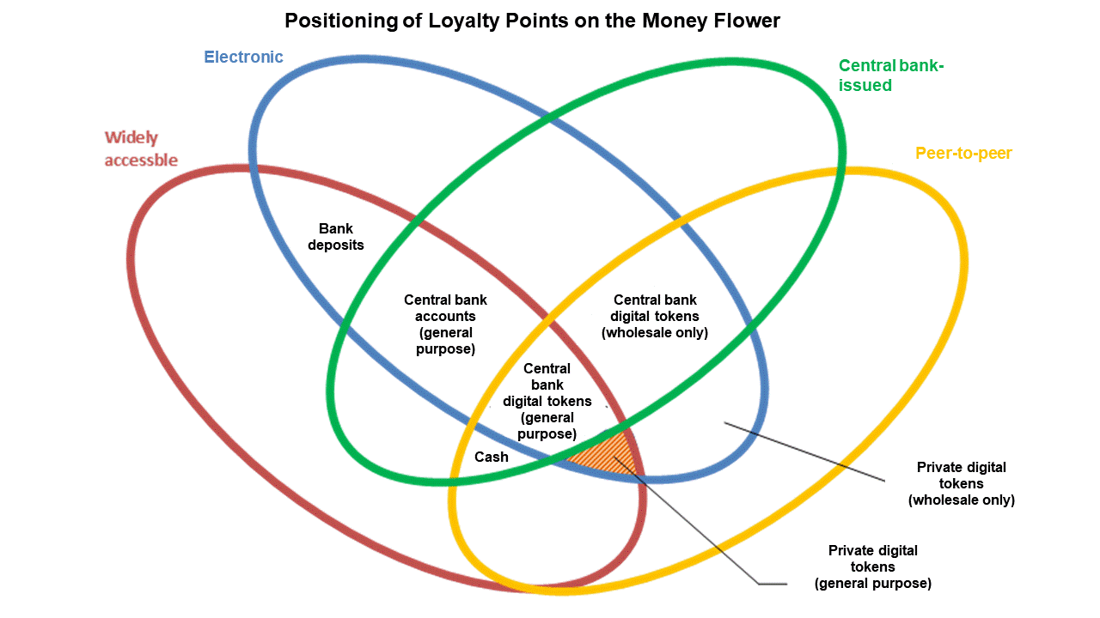

　　　　　　Reference: From Carstens (2018), revised by me

From the perspective of consumers however, loyalty points exhibit characteristics that distinguish them from other forms of money and electronic money.

- The value per unit and terms of exchange vary widely (one point cannot usually be exchanged for one yen, points are worth more for purchases at the issuing company, or terms of exchange differ depending on where they are exchanged).

- They can be used for payment only within the issuer’s platform, and can be exchanged only between a limited number of companies. As a rule, they cannot be exchanged between individuals (P-to-P). Points with an exchange-like function, however, can be exchanged with a relatively wide range of other points.

- With some exceptions, most have an expiry date, and become void after expiry These may be converted to cash, in order to avoid losing all value, but at unfavorable terms of exchange.

- Balances held by consumers do not tend to increase, as most points are used up in the consumption of goods and services, do not recirculate, and become void upon expiry. Even assuming that points remain valid for one to two years, balances do not accumulate rapidly, and the stock of outstanding points does not exceed the annual amount issued.

- Points can be “saved-up” by making payments (by purchasing products, or using cashless payment methods). However, any saved points do not attract interest.

In summary, loyalty points differ to currency (legal currency: cash and deposited currency), with its three functions as a store of value, a unit of account, and a medium of exchange. As shown in the table below, loyalty points do not fulfill the three requirements of currency, and are lacking in terms of each function.

Addendum Figure 3: Comparison between loyalty points and legal currency

|  |  |  |  |
| --- | --- | --- | --- |
| Three functions of currency | Characteristics of  loyalty points | Bank  deposits | Cash  (bank notes) |
| Unit of account | Value is variable within a range, as terms of exchange differ depending where points are exchanged | Fixed | Fixed |
| Medium of exchange | Only exchangeable with specified companies | Exchangeable between bank accounts | Exchangeable between individuals |
| Store of value | Can be accumulated but have expiry date, and lose validity after expiry | Can be used as a store of value | Can be used as a store of value |

1. **Why platform provider-style companies have turned loyalty points into a pseudo-currency**

Considering the origin of loyalty point services as a way for company groups to capture (lock-in) customers from competitors, the ability to exchange points represents a reduction in consumers’ switching costs. In principle, exchanges thereby diminish the economic effectiveness of loyalty points for the issuing company, and therefore should be limited only use with those companies that are not competitors of the issuer. In this sense, the networks that allow points exchanges are thus necessarily asymmetrical and unidirectional. Consequently, it is hard to conceive of most loyalty points issued by individual companies, in particular, ever spreading enough to become an instrument like a common or legal currency that can be used to pay for goods and services at any company. Points can only be exchanged within somewhat closed networks that exclude competitors.

By contrast, PayPal bonuses, LINE points, credit card points and other points issued by platform provider-style companies create their own point-based economies through collaboration with member stores and partners, including rival companies. Therefore, networks spread, the points gain increasing general acceptance, are used as a means of payment within the company’s own ecosystem, and become a kind of pseudo-currency. In addition, common or universal points purely for the purpose of exchange, issued by companies without their own products or services, although still small-scale, are gaining general acceptance, and function quite much like currency. These points are also convertible into cash, and can be used for investment. They are being utilized in ways that increasingly resemble bank deposits and other similar financial instruments.

In this way, at present, while the loyalty points issued by individual companies work as a tool to increase switching costs, and capture and lock-in customers, those issued by platform provider-style companies are aimed at gaining greater general acceptance and enhancing convenience, and are consequently gaining a greater presence in the context of economic activities. The issuance of loyalty points is expected to continue to increase in the future. Points issued by platform provider-style companies in particular are anticipated to strengthen their currency-like characteristics.

What factors should be borne in mind if these points become frequently used within each point economy? If the platform provider-style company that issues the points goes bankrupt, then problems may arise in terms of user protection. It is even possible that, if the scale is large enough, such an event could affect the stability of financial systems. Should a form of points become widely used within an economy, it may become necessary to prepare for the possibility of such a bankruptcy by considering some form of preservative measures similar to those in place for electronic money and the like. Whichever way, it will be necessary to monitor future trends in loyalty points as a means of payment.

1. **The fun features of points that differ from “money”**

Examining consumer attitudes and usage of loyalty point services based on the results of the survey by NIRA (2018), mentioned above, reveals that consumers save up points to purchase specific products and services at a discount, that they like to exchange points, and that, unlike money, points provide a measure of “fun” for consumers. This seems to be something like the attraction of digital tokens described by Hatogai (2019), which cannot be experienced with conventional money. Examining the NIRA survey by attribute reveals that more than 50% of respondents in each age group, with the exception of those in their 60s, like loyalty point services. There is no gender difference between respondents who like loyalty point services, but in terms of attitudes, female respondents had a 10% higher positive response to survey questions including savings awareness, effective utilization, enjoyment from saving up points, and enjoyment from exchanging points. These results indicate the high degree of interest in points among women. An average of 37.4% of respondents across all age groups enjoy saving up points, but this proportion is higher, 41.3%, among respondents in their 20s, whose income is still low. The younger generation, in particular, finds the act of accumulating points itself enjoyable. A survey of the ways of using points shows that an overwhelming proportion of respondents, 82.7%, use them for discounts on purchases, while 53.2% of respondents exchange points for cash or vouchers, 27.7% exchange them for promotional gifts and the like, and 6.5% use them for donations or other social contributions.

Seen in this way, consumers appear to regard loyalty points not so much as a form of currency, but rather as tokens, resembling money, yet attractive in a different way, incorporating the fun, reverse logic of “saving up by purchasing,” and enabling small contributions to society that consumers would not otherwise consider if using money.

Even if loyalty points are increasingly resembling currency, they are predicated on the profitability of private companies, and the trust placed in them must be considered in comparison to the credit worthiness of the bodies that issue currencies: central banks and nations, as well as other banks, etc. The growth of loyalty points necessitates some degree of monitoring, as described above. However, they do seem to surpass legal currency in terms of convenience and “fun.” With attractive features that money lacks, loyalty points do not rely on existing currency value systems, and can open new paths for diversity in currency.

Addendum Figure 4: Attitudes to loyalty points (by gender)

Male (1,509)

Female (1,491)