1. **Results and Discussion**

We speculate that the cyanoacetylene cluster growth process begins with a gradual buildup of neutral van der Waals clusters, and thus begin by discussing the relevant structures.

1. **Cyanoacetylene dimer and cluster structures**

Figure 1 displays the neutral structures of the pure cyanoacetylene dimers and different orientations of the molecules with respect to one another. The least stable structure, D1, is T-shaped, with the nitrogen atom of one molecule pointing toward the other molecule’s nitrogen-bound carbon atom. A more stable structure is D2, where the two molecules are positioned on top of each other, and each nitrogen atom is closest to its paired molecule’s hydrogen atom. The linear D3 structure is the most stable, with the hydrogen atom in one molecule pointing towards the nitrogen atom of the other molecule. The binding energy (BE) is similar in magnitude to the BE of the hydrogen cyanide (HCN) dimer, which is -4.97 kcal/mol for the linear orientation [44]. Due to the large dipole moment of cyanoacetylene (calculates 3.84 D), the dimer structures exhibit large BE’s with respect to acetylene dimers, which lack dipole moments and have a BE of -1.4 or -1.6 kcal/mol, depending on the molecular orientation [45].

Figures 2 and 3 present the structures of larger pure cyanoacetylene clusters. The trends exhibited by the larger clusters follow the patterns of the dimer clusters. Clusters are generally stabilized by intermolecular hydrogen-nitrogen interactions.

Upon ionization, the structures possess excess energy and are no longer at equilibrium or stable on the neutral surface. This leads to relaxation processes, as demonstrated schematically in Figure 4. We re-optimize the structures to determine the optimal structures on the ionic surface.

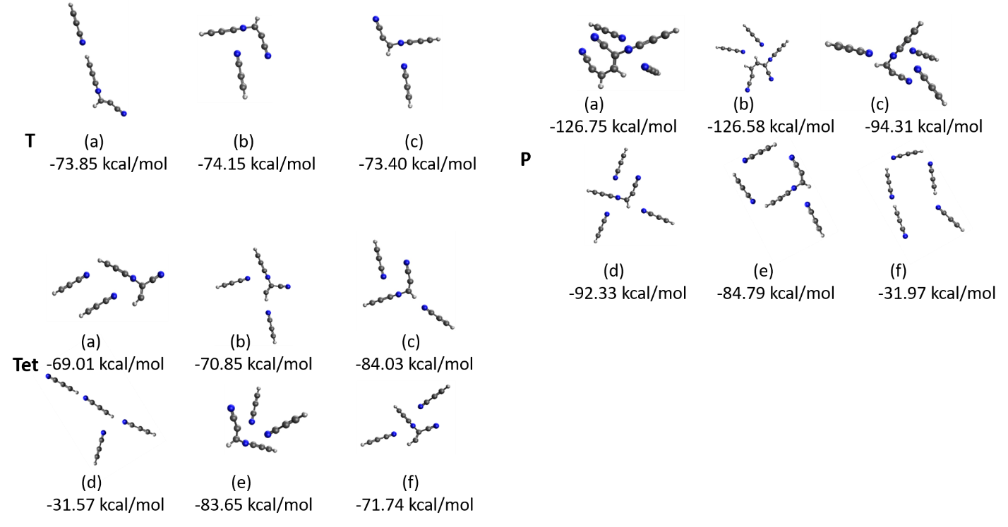

Figure 4: Optimized structures obtained from the starting geometries of the structures shown in Figures 2 and 3, presented on a cationic surface. T, Tet and P represent trimer, tetramer and pentamer clusters, respectively. BE’s are presented in kcal/mol.

The resulting structures reveal aspects of cyanoacetylene cluster formation. Firstly, we do not observe any proton transfer after optimization. This is in contrast to pure HCN clusters, discussed later in this article [44]. Secondly, in most clusters, we observe the formation of a bond after ionization. In the trimer and tetramer clusters, bonds form between two cyanoacetylene units. In the pentamer clusters, we observe bond formation between three cyanoacetylene units as well (Figure 4, P(a) and P(b)). Since the structures were identified via optimization, we conclude there is no formation barrier, but the energy from ionization can be utilized to form additional structures. To study the evolution of the systems over time, we perform ab-initio molecular dynamics (AIMD) simulations, presented in the subsequent section.