Avi Yalou  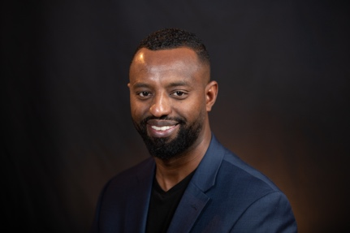 | Avi Yalou is a social activist and entrepreneur. He serves as chairman of the Israeli political party Tzedek (Justice). Previously, he managed networking for the organization Olim (Immigrants) Together. Prior to that, he served as the director general of the Israeli nonprofit organization Hila - The Public Committee for Equality in Education. In this role, he was entrusted with the daily management and development of the organization, including managing the team and its tasks, fundraising, creating content, planning and executing the organization’s plans.  He serves as a board member of the North American Conference on for Ethiopian Jewry (NACOEJ). He is a member of Sphere of Influence, a framework for directors of social organizations to be active leaders of social influence in their shared social fields. Avi is a member of the Joint Think Tank for Combating Racism and several other voluntary social organizations that aim to eradicate racism and to promote real change and improvement in Israeli society.
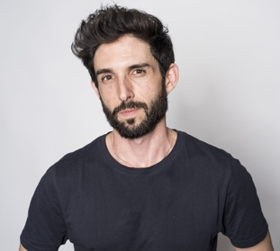  Ohad Hizki | Ohad Hizki, 36, lives in Tel Aviv, and holds a bachelor's degree in education and political science from Tel Aviv University. He has ten years of experience in non-formal education and has been trained as a group facilitator from the Tzipori Institute. For the past five years, Ohad has led the LGBT Association, the first organization in Israel to promote the struggle for pride, equality, and freedom for the LGBT community. For the past year, Ohad has served as a director of a municipal company in Ramat Gan.
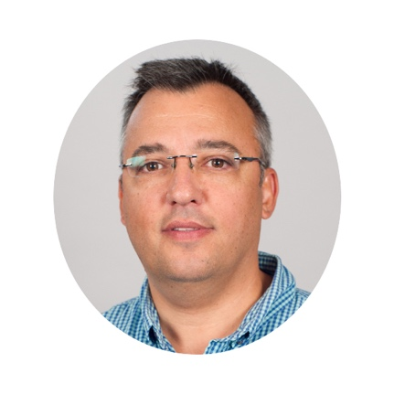  Uri Cohen | Uri Cohen, 51 years old, was born in Tel Aviv and now lives in Moshav Mevo Betar. He is married to Talia and father of four children. He holds a bachelor's degree from Bar-Ilan University in psychology and history of the Jewish People and a master's degree in administration and public policy from Ben Gurion University. He is a graduate of the Mandel Institute Program for Educational Leadership in Jewish Culture.  Uri has been active for 27 years in social, educational, Jewish and Zionist activities in the State of Israel and the Diaspora. He is a past director of the meetings department of the Gesher organization for the promotion of dialogue and discourse between religious and secular communities in Israeli society. He was the educational director for the Jewish Agency's Department of Education for the Commonwealth of Independent States (former Soviet Union).  In 2005, he founded Masa Israeli (I Belong Israel) and served as its CEO from that time until today. Masa Israeli is a program for youth, IDF commanders, companies and organizations from Israel and the Diaspora to journey in the landscapes and historical sites of the country, while clarifying the values, ideas and experiences of their personal, Jewish, Zionist and Israeli identities.  Masa Israeli was launched in collaboration with Beit Hanasi and led by the Tikva Israeli campaign for students in twelfth grade - a groundbreaking educational program to create a deep and unmediated acquaintance among students from the four streams of education and sectors of contemporary Israeli society: secular, religious, ultra-Orthodox, and Arab. For this work, Uri won the Jerusalem Prize for Zionist Education in 2015. In 2018 he won the Knesset Speaker Award for promoting quality of life, rule of law, and values of democracy and human rights. On the 72nd Independence Day of the State of Israel (2020), Masa Israeli was selected as an advisory organization to the UN on education and identity issues.
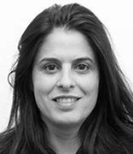  Orli Nitzan | Orli Nitzan, a resident of Hod Hasharon, was formerly an attorney at the State Attorney's Office and a Hod Hasharon municipal prosecutor. She then changed direction in her professional life and specialized in building and developing communities in Israel and around the world. Orli served as chairperson of Shacharit, an association for the promotion of common causes in Israeli society. She managed the fellowship program for the Memizrah Shemesh (Center for Jewish Social Activism and Leadership in Israel) and established and managed their Jewish Social Leadership Program.  Between 2011 and 2013, Orli served as the director of Neve Shechter, the Center for Jewish Art and Culture Education in Tel Aviv. From 2013-2017 she served as a senior emissary to the Jewish community in Brooklyn. Subsequently she served as the General Manager of the Jewish Federation and Agency in New York. She is currently the CEO of the Society for the Advancement of Education and Culture in Hod Hasharon.
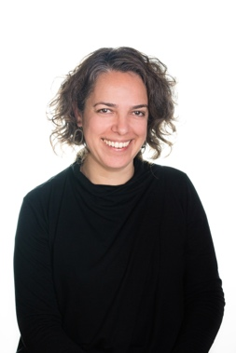  Ayala Hendin | Ayala Hendin was raised and lives in Jerusalem. She is active in promoting policies based on equality, fairness and partnership, and conducting research and teaching in this area. Recently, she was on the founding team of Israeli Hope in Academia, a program that works to promote partnership between the various sectors in Israeli society within the higher education system. Under her leadership, Israeli Hope in Academia has become a national program jointly supported by the President's House, the Planning and Budgeting Committee of the Council for Higher Education, and the Edmond de Rothschild Partnership. She is active in promoting policies of diversity, supervising academic institutions on issues of diversity, and accelerating partnership-promoting initiatives.  Ayala completed her doctoral studies in the Department of Politics and Government at Ben Gurion University of the Negev. She plans to begin her post-doctoral studies at the Minerva Center for Human Rights at the Hebrew University of Jerusalem. Her research addresses the policy of diversity of the composition of those studying in higher education from a socio-economic and civic-national perspective.  Previously, she worked as a researcher at the Myers-JDC-Brookdale Institute, where she designed programs to promote social leadership, including a multi-year program to make higher education more accessible to the Arab population. Ayala teaches "Educational Activism and Policy" at Ben Gurion University for students specializing in civil society organizations. She is a member of the board of directors of Crossroads, an association that promotes social tourism among the Arab communities in Israel.
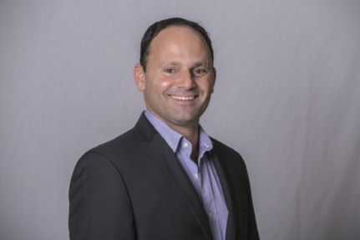  Eli Boch | Eli Boch is Director of Philanthropy at the Edmond de Rothschild Foundation. Since 2009, Eli has been responsible for the philanthropic management of the foundation and development of its strategy and implementation, with an emphasis on entrepreneurship, leadership, higher education, and academic excellence. He led the foundation’s transition from a traditional model of giving to a policy of strategic philanthropy through a variety of outcome-oriented programs and partnership building. He chaired the Israel Fund Forum, is a member of the Israeli branch of the Global Steering Group for Impact Investment (GSG) and a member of the board of directors of the Jewish Funders Network (JFN).  For over two decades, Eli has been involved in the development and leadership of innovative solutions to social challenges. He established social and educational programs in Israel and the United States. He was the founder and CEO of the nonprofit organization Kav Hazinuk (The Starting Line) for the development of leadership and entrepreneurship among young people.  Eli has a bachelor's degree in psychology from Bar-Ilan University and a master's degree with honors in public policy from Tel Aviv University. Eli is married to Meirav and is a father of three - Maya, Jordan and Gilad.
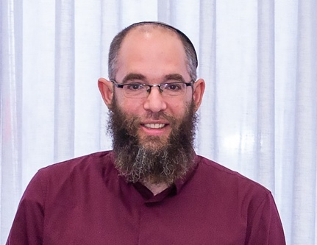  Elkana Sherlow | Elkana Sherlow is 43 years old, married to Maya and has eight children, including a daughter serving in the Israeli Defense Forces. Following the assassination of Rabin when he was in 12th grade, he moved to Yeruham, where he has lived for 25 years. He is a graduate of a Hesder Yeshiva and holds a master's degree in teaching. He teaches in more than 20 groups and institutions throughout the southern region of Israel. Out of a belief in the necessity of dialogue, he participates in various discussion groups about Israeli society, including leading the Israeli Rabbinate Movement and an interfaith dialogue group in the Negev. He especially enjoys playing the saxophone at bar mitzvah ceremonies and weddings.
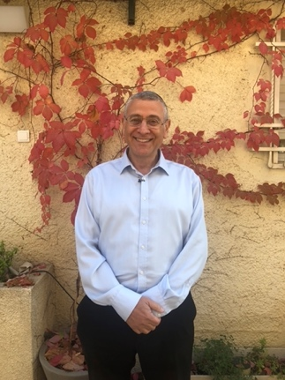  Benny Lau | Benny Lau was raised in a Zionist and nationalist-religious family. He was an active member of the Bnei Akiva movement as a youth, and joined the Gush Emunim movement in the 1970s. In the 1980s, he shifted toward the political center with the Memad political movement. He married Noa, from the religious kibbutz movement, and found himself deeply involved with this movement, which he says “seeks to heal the internal rift in the Jewish community between religious and secular.” For seven years he was a rabbi of Kibbutz Sa'ad and for 18 years a rabbi of the Ramban Synagogue in Jerusalem. He was the rabbi for schools in religious kibbutz and Jerusalem. He has established several educational frameworks: a Beit Midrash (study hall) for women, a Beit Midrash for social justice, and over the past seven years he has initiated and established the 929 Tanakh B'yachad project for Bible studies.  Benny was recently appointed chairman of Akim Israel, an organization that, in his words, “allows me to see the image of God in the face of every person, without paying attention to their limitations.”  He is married to Noa, father of six and grandfather of ten.
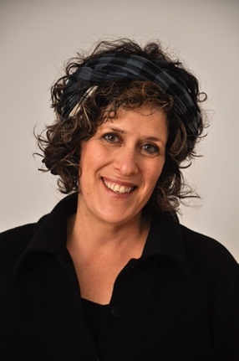  Batya Kahana-Dror | Batya Kahana-Dror is a lawyer and social activist. Since 2009, she has headed Mavoi Satum (Opening Closed Doors) for agnunot, women who are being refused a divorce. The organization represents hundreds of women who are trapped in marriages and divorced women, and fights for their civil and halakhic rights. This has led to breakthroughs and promoted change processes within the religious establishment.  She currently serves as a legal advisor to the organization Ne’emanei Torah Va’Avodah and has a private law office. She is a member of the Yisrael Beiteinu political party. As part of the struggle against the rabbinical monopoly on marriage in Israel, Batya founded the Private Halakhic Marriage project advocating marriage outside the rabbinate and establishment of private courts for the release of agunot.  In the Israel Supreme Court case HCJ 8213/14 Batya Kahana-Dror et al. v. Minister of Religious Services et al., Batya petitioned for the right of women to be appointed to the position of director of rabbinical courts. Following this petition, the Supreme Court set criteria that allow the appointment of women to senior positions in the religious establishment, including the director general of the courts. In practice, a deputy director was appointed.  Batya initiated amendments to legislation passed by various Knesset members, including an amendment to the Rabbinical Courts (Enforcement of Divorce Judgments) Law, which was passed in the twelfth Knesset.  In 2014, the newspaper Maariv-Makor Rishon listed Batya as one of the ten most influential Israelis in the field of Judaism, and one of the ten most influential jurists in the religious sector. In 2018, she was listed as one of the 50 most socially influential Israelis by the Yedioth Ahronoth newspaper. A documentary about her activities is currently being shown in cinemas around Israel.  She lectures and publishes opinion columns on political issues, religion and state, and women's rights.
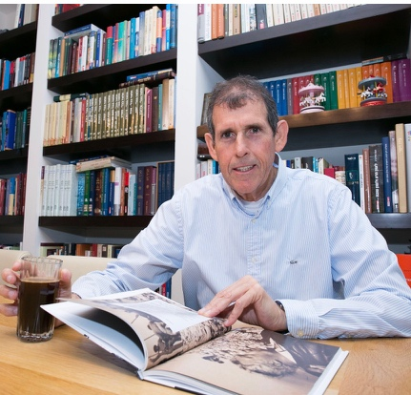  Dovi Eichnold | Dovi Eichnold is CEO, publisher, and editor-in-chief of Yedioth Books. Eichnold lived the world of books from a young age. His father (who survived Auschwitz) founded the publishing house Sefri Hemed. His mother Sarah (née Haltowski) is a native of Jerusalem. Dovi grew up in Bnei Brak, attended Haroeh High School in Ramat Gan. As a teenager he helped in the family business and joined the management of the business when he reached adulthood.  He served in the IDF as an officer in the investigative military police forces. After finishing his military service, he began studying for a bachelor's degree at Bar-Ilan University, which he did not complete due to a serious injury he sustained in the first of the Tyre headquarters bombings during his service as a reserve commander in the First Lebanon War. He was trapped under the rubble for nine hours, and was in critical condition when he was rescued.  In 1994, Sefri Hemed partnered with Yedioth Ahronoth and established Mishkel Publishing, better known as Yediot Seforim. Dovi Eichnold has been the CEO of the publishing house since that time. Dovi is married (his second marriage) to Dr. Tali Eichnold-Dvir (Dean of Executive Training and Foreign Studies at IDC Herzliya). They live in Givat Shmuel. Dovi has eight children.
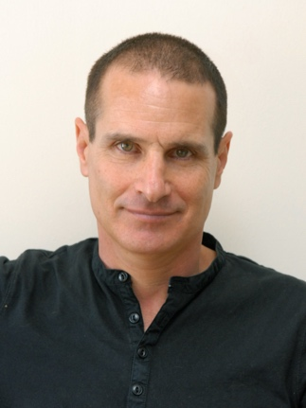  Jon Feder | Jon Feder has worked as editor-in-chief, a journalist, and content manager of various media and publishing entities. He was the editor-in-chief of Ynet from its founding until about a year ago. Prior to that, he was editor-in-chief of major publishing houses, Keter and Yedioth Ahronoth Books. As editor-in-chief he is responsible for setting program policy and outlining the editorial line for the media outlet. He is professionally and ethically responsible for its contents and the final arbiter regarding everything published in it on a regular basis. He determines the system’s work processes, manages the content teams, characterizes the media channels and sections, initiates, establishes and operates projects.  Jon holds a bachelor's and master's degree in communication and psychology from The Hebrew University of Jerusalem. He served in the IDF as a soldier and officer in the Egoz patrol and reached the rank of lieutenant colonel (in the reserves).  Jon is married to Prof. Edna Lomsky-Feder (a lecturer in the Department of Sociology at The Hebrew University of Jerusalem), and is a father of two children.
  Joseph Speiser | Joseph Speiser, 38, is married and father of two daughters. He is the eighth generation of his family in Jerusalem. He is a member of the Jerusalem City Council. He is a PhD student in the Department of Palestine Studies and Archeology at Bar-Ilan University and a lecturer in the field. He is an entrepreneur, the owner of a tourism company and works as a tour guide. He is a member of the public council of the right-wing party Habayit HaYehudi (Jewish Home). He is head of The Digital Forum: Keeping Children Safe Online.  He has traveled extensively, in Israel and around the world, “but something always brought me back to Jerusalem. Complex Jerusalem.” He says he became aware of Jerusalem’s complexity from a young age, “a secular boy who went on Shabbat to visit a grandmother of Oriental descent in Mea Shearim, with neighbors who spoke only Yiddish, and from there through the Jewish and Muslim quarter for a Shabbat tour.”  Today, he says, “I wear a kippah and feel I belong to the Zionist-religious stream. I have always lived between worlds, which is also why I am drawn to the angle of the conflict. I believe that familiarity can lead to new ideas and insights.”
Yotam Pulitzer   | Yotam Pulitzer is the CEO of IsraAid - the leading Israeli organization for international humanitarian aid. Today, the organization operates in 14 countries with a staff of 250 employees and 6,000 volunteers.  For the past 12 years Yotam has led short- and long-term aid missions for example to Japan after the tsunami, to South Korea to help North Korean refugees, to Sierra Leone following the Ebola epidemic, to Nepal following the earthquake, and to Greece and Germany following the Syrian refugee crisis. Yotam is a regular lecturer at major international conferences at the UN, AIPAC, the British Parliament and more.
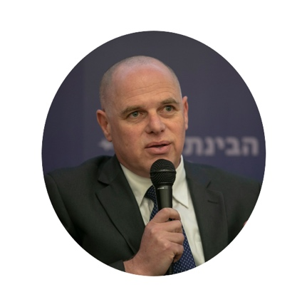  Yizhar Hess | Yitzhar Hess was born in Jerusalem. He holds a bachelor's degree in Hebrew literature and political science from The Hebrew University of Jerusalem, a law degree from the Interdisciplinary Center in Herzliya, a master's degree in Jewish studies from the Schechter Institute in Jerusalem, and a PhD in sociology from the University of Sussex in Brighton, UK.  Yitzhar served as executive director of the Masorti (Conservative) movement until 2020. He was the Jewish Agency's envoy to Arizona, USA. He served as director of partnerships between Jewish communities in South Africa, Washington and Rochester, NY and communities in Israel. He served as vice president of the Roots Institute and organized the Jewish Studies Festival in Kfar Blum, Israel. Hess is one of the leading voices in the discourse of Jewish renewal in Israel. His articles on religion and state are frequently published in the Israeli and the Diaspora. He was a co-editor of the bestseller Questions about God (1998). He lives in Maccabim, is married to Yael and father of Ahiad and Mika.
Yisrael Fry  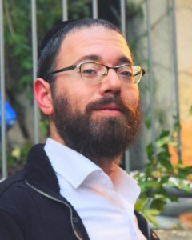 | Yisrael Fry, 34 years old, grew up in a Hasidic community in Tel Aviv. He is a yeshiva graduate who works in the field of journalism, first in the ultra-Orthodox media, now as a freelance journalist.
Meir Krauss  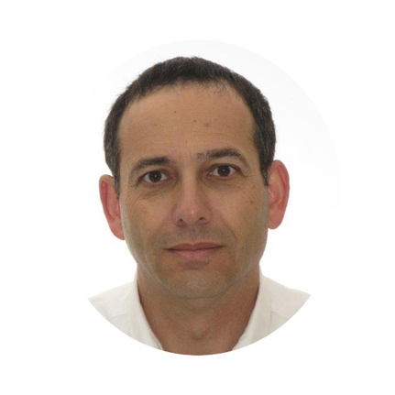 | Meir Krauss, born in Jerusalem, is married and the father of six and grandfather of eighteen. Currently he is a research fellow at the Hartman Institute. A major theme in his work is the renewed Jewish awareness of the Temple. Formerly the director of the Jerusalem Institute for Policy Studies, he led a research team on future solutions for Jerusalem and published Introduction to Negotiating on Jerusalem. Prior to that, he worked for many years in the education system in various positions, including the Director of Education in Jerusalem. He established and managed the high school yeshiva in Efrat.  He is a graduate of The Hebrew University of Jerusalem with a degree in Jewish Thought. He was a lieutenant colonel in the IDF reserves and a former commander of a paratroop battalion.
Michal Barak  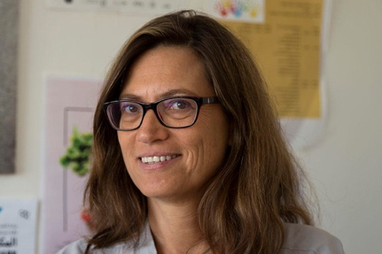 | Michael Barak has a master's degree in linguistics and public policy. “By common sense, I am a lawyer.” She has been involved for many years in promoting education for citizenship and democracy. She has written textbooks and study materials and has been involved in training citizenship teachers and mentoring teachers and principals. For the past seven years, she has been a leader in the field of diversity at The Hebrew University of Jerusalem. Her work addresses many aspects of diversity: university policy, students, lecturers, employees, physical and academic space, and diversity in the context of Arab society, East Jerusalem, ultra-Orthodox society, the periphery, and immigrants. She is active in organizations that deal with education, a common society and the promotion of equality for Arab society. She is 52 years old and a mother of three children.
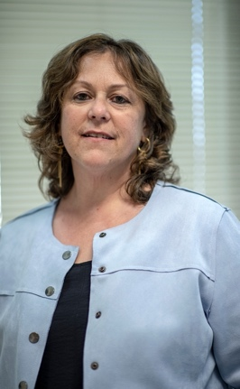  Mirit Stern | Mirit Stern is a resident of Hoshea in the Jezreel Valley. She is an attorney and a certified mediator and coach. She retired from the Ministry of Justice two years ago after completing an eight-year term as Northern District Attorney, where she dealt with a variety of criminal cases. She volunteers in the negotiation unit of the Israel Police, and is a member of the management committee of the Mitzpe Hoshaya settlement.
Mishy Herman  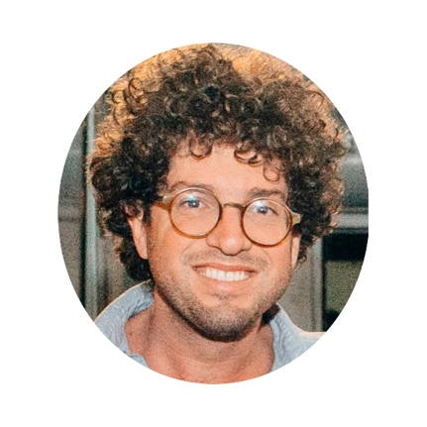 | Mishy Herman describes himself as “a 38-year-old curly-haired Jerusalemite…” who grew up in a “close and loving family,” with his parents, sister, older brother older and with grandparents across the street. He was involved in the traditional youth movement Noam as an apprentice, instructor and eventually as national chairperson. Since childhood, he has been interested in archeology, history, politics and Jerusalem.  In the military, he served in an elite unit that conducted "targeted" explosions of terrorists’ homes, which shaped his political identity: “I would spend most of my Saturdays at home protesting against house bombings in front of Arik Sharon's house.” After the army, he earned a bachelor's degree at Harvard University in the Department of History, with a thesis on the Jewish identity of the Falash Mura in Ethiopia. He was awarded a scholarship to do a master's degree at Cambridge University “where I studied archeology and wrote about pig bones.” He co-founded a start-up company in Boston (“a good idea but with unsuccessful execution”) and taught courses at Harvard. In 2011, he returned to do a doctorate at The Hebrew University of Jerusalem, completed in 2015 with a thesis on Samuel Govat, the first Protestant missionary in Ethiopia and the Protestant bishop of Jerusalem in the second half of the 19th century. He co-founded An Israeli Story, one of the first major podcasts in Israel, which he continues to lead. Today the program is broadcast in Hebrew on the Galatz radio station and its English version on American public radio. It has 15 employees, and hundreds of thousands of listeners around the world.  He is married to Federica, who is Italian, Catholic and a journalist (“but more importantly, a lovely and kind woman”), and with a daughter, Hillel Miriam and two dogs, Naomi and Golda.
Nir Lahav  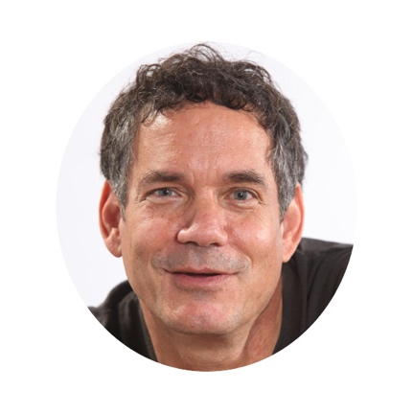 | Nir Lahav was born in Kibbutz Gazit and has lived in Tel Aviv most of his life. He is married to Dalit and a father to a daughter and two grown sons. For the past twenty years he held various positions in civil society (third sector organizations). At the beginning of his career, he worked with the JDC to promote national programs related to youth who dropped out of school and business ventures. Later, he worked with the Jewish Agency in various positions, most recently as director of the Social Activism Unit, which supports Jewish Agency activities in Israel in the areas of at-risk youth, students, pre-military and post-military preparatory courses, youth villages and more. For three years, he traveled with my family to Rwanda to establish a youth village for genocide survivors. Currently, he is a co-founder of an organization of evangelical Christians working to strengthen Israeli society. “I am driven by a sense of responsibility and a desire to promote a better and more egalitarian society in which people have greater opportunities to lead meaningful lives for themselves, their families and their community.” In recent years, he has been involved in establishing projects linking Jewish society with Arab and Bedouin. “It's a drop in the ocean but I believe that a deeper acquaintance between the various societies will teach us all that no one is a demon with horns, as too many people seem to think.”
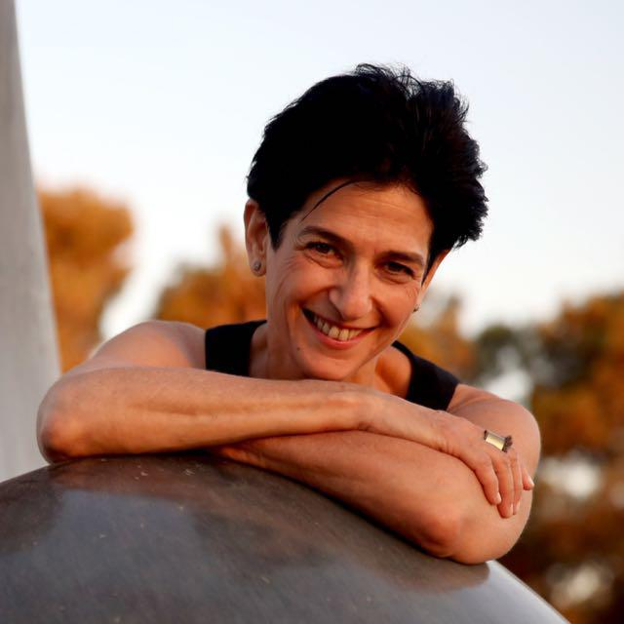  Naomi Bloch-Fortis | Naomi Bloch-Fortis was in the Bat Sheva dance ensemble for almost twenty years and co-artistic director and general manager for the second decade of that time. “Somewhere in the past - I was a dancer.” About a decade ago, she established Jerusalem Season of Culture/Mekudeshet “…with a wonderful group of dreamers and artists. I'm still there - creating realities through the power of creativity and art.” She is a consultant for festivals and organizations, teaches cultural and art management, and is a member of the board of directors of several organizations. “In general, I’m trying not to stop moving - in body, spirit, and consciousness.”
Inbal Ron   | Inbal Ron is a member of Dror Israel and CEO of Dror Schools. She is one of the founders of Kibbutz Eshbal, a partner in the establishment and management of a boarding school for at-risk youth. She taught in the Beit Midrash for Teachers of the Nation for graduates of the Arab branch of Working and Studying Youth at Beit Berl College. She founded and managed the Mitzpe Ramon Youth Society - a boarding school for leadership and social action. She founded and coordinated the Colleges for Professional Leadership and Community Care for the Elderly.
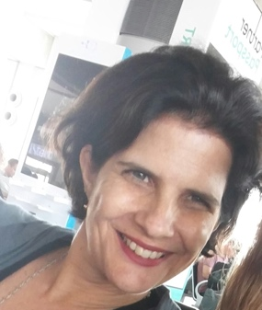  Inbar Horowitz | Inbar Horowitz was born in Kibbutz Dan and grew up in Be'er Sheva. “The geography of my life largely tells the biography. Each chapter and place left marks and shaped my identity and the various choices in my professional life.” From 1991-1997 studied for a bachelor's degree in political science and East Asian studies and a master's degree in political science) at The Hebrew University of Jerusalem. Upon graduation she and her partner Shahar moved to Berkeley, California, where they lived for nine years. She worked for the Jewish Federation of San Francisco and studied for a master's degree in public policy at the University of Berkeley. After graduation she worked for consulting firms for social change organizations and philanthropic foundations in California. During this period, her children Itamar and Ella were born. The family returned to Israel in 2007, settled in Haifa, where her third child, Abigail was born. She began a professional journey in civil society in Israel, leading change processes in a number of roles. Between 2008-2012 she served as CEO of the Tirat Carmel Community Foundation, an association that developed and operated innovative models of social entrepreneurship that rely on collaborations between the local authority, the local business sector and the community. In 2013, she joined Shitufim (Partners) and organization that creates dialogue and promotes participatory policies between government ministries, businesses and third-sector organizations, using a collective impact approach to systemic change. She served as the vice president of Shitufim. In January 2021, she joined the founding team of Bridging Insights, an initiative addressing the stalemate in employment and dealing with the Israeli-Palestinian conflict by bringing new knowledge to the field.
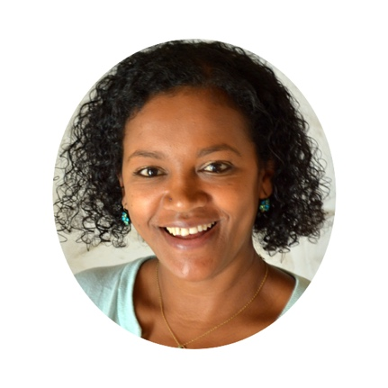  Pnina Agenyahu | Pnina Agenyahu manages the Jewish Agency's joint partnership network, which unites 44 partnerships of communities in Israel with communities around the world. She carried out a long senior mission of the Jewish Agency in the Greater Washington Federation. Upon her return in 2017, she joined the Strategic Planning and Content Unit of the Jewish Agency in Israel, in the role of Director of Synergy and Interfaces. As part of this role, she led a strategic mapping process connecting Israel with Jewish communities around the world. She led global projects connecting Jewish communities to Israel through the Hebrew language, thematic connections and education for Jewish people in Israel.  Previously, she managed the Hillel Center at Tel Aviv University and promoted a broad and diverse discourse of Jewish-Israeli social culture. She has been active in numerous initiatives in Israeli society, including founding the Wake Up movement. She is a board member of Afterwards, a member of the New York Federation's Jewish Initiative Task Force and the Nadav Foundation, a board member of the Ethiopian Jewish Association in Israel activities for the Sigd holiday, and more.  Pnina is a guest lecturer at Jewish organizations and educational institutions around the world on the issue of Jewish identity in Israel and Ethiopian Jews in Israel. In 2012 she was appointed as a public representative on the Council for Higher Education. In 2014, on the 66th anniversary of Israel's independence, Pnina was chosen by the Haaretz newspaper as one of 66 influential Israeli women. In 2016, Pnina received the Ted B. Farber Professional Excellence Award for developing a special program for youth in Washington about Israel and its complexity as a state and society.  Pnina holds a bachelor's degree in sociology and the history of the Jewish people, a master's degree in the program for managers of public political leadership, and a is a graduate of the Mandel Program for Excellence from the Mandel Institute and the Jewish Agency. Pnina immigrated to Israel from Ethiopia at the age of three, is married to Avi, and has three children, Eitan, Erez and Ella.
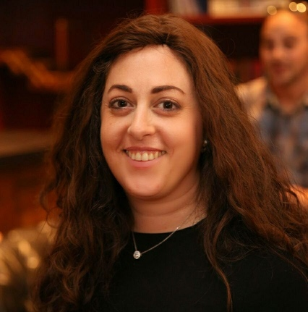  Pnina Piper | Pnina Piper, 42, from Jerusalem, is Director General of Hatzibor Haharedi Hamamlachti (The New Haredim). She is a social and political activist. She has two children, Adi and Avital. She works in the field of state ultra-Orthodox education (core studies), on issues of equality for ultra-Orthodox women and promoting a social-democratic worldview.  She works in the fields of state ultra-Orthodox education (core studies), equality for ultra-Orthodox women and a social democratic worldview. She is a member of the board of directors at 0202 — Points of View from Jerusalem. She is responsible for the Mizrahi project at the nonprofit Ir Amim (City of Nations).
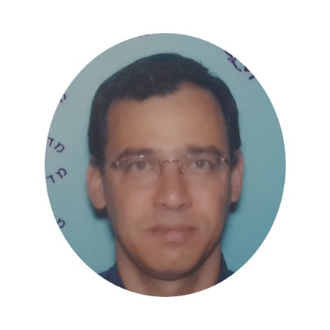  Shai Nitzan | Shai Nitzan was born in Jerusalem and lived there all his life. He is married to Tamar (a teacher of Arabic and Orientalism). He is the father of five. He graduated from the Netiv Meir Yeshiva. He was a paratrooper in the IDF. He is a graduate of The Hebrew University of Jerusalem with two degrees, one in law and one in the history of the Jewish people. He has a master’s degree in political science from the University of Haifa. He is a graduate of the College of National Security. He served for 30 years in a variety of positions in the State Attorney's office and from 2013-2019 served as the State Attorney. He is fond of traveling in Israel and abroad. His hobbies include dance, theater, and swimming.
Shir Nosatzki   | Shir Nosatzki is the founder and CEO of Have You Seen the Horizon Lately? an initiative that offers perspectives for resolving the Israeli-Palestinian conflict through lectures and events. Over 10,000 young people have participated in Horizon events across Israel. She is a social entrepreneur who has led a variety of struggles and projects for social justice and democracy, and was one of the initiators of the 2011 social protests. She was awarded the Dror Prize for Social Change, and was chosen by De Marker as one of the most influential Israelis on social media and by Maariv as one of the most promising young leaders in Israel. She was a journalist for various media outlets, including: Yedioth Ahronoth, TimeOut, and Walla!
Sara Shadmi-Wortman  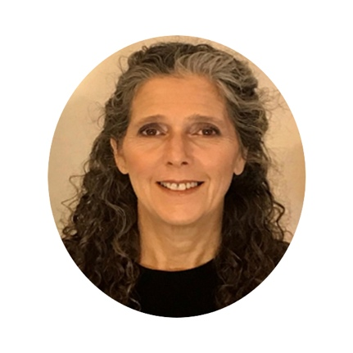 | Sara Shadmi-Wortman is an international expert in the field of building resilient communities. Through over 20 years of fieldwork and research, she developed a model for community building and a culture of belonging through networks among significant community factors and the creation of social capital. At the heart of the model is the connection between identity, shared values and a unifying collective story that emphasizes the role of local leadership, and community youth as a lever for community renewal. The principles, concepts, and tools of this model have a universal infrastructure that has been assimilated in broad processes around the world: Africa, Nepal, Europe and America, in ways Application of the model has affected the lives of hundreds and thousands of people in urban and rural areas in Africa, Nepal, Europe and the Americas. Community building has been used as a rehabilitative tool in the aftermath of earthquakes, civil wars and inter-tribal conflicts, to prevent the loss of future generations in Jewish settings, and assisting the poor in urban areas. Sara has published articles and a book describing the tools and principles of community building.  Sara is the founder and director of the International Center for Community Building at the Association of Community Centers (Matnasim). She was the co-founder and first director of several units at Oranim College in Israel. She was a co-academic director of the Khotam program for training educators in schools in the social and geographic periphery. She was head of the Community Social Change of the master's degree in education program at Oranim College’s K.A.M.A. Center. She was the first to serve as the sole leader responsible for community social change, innovation and entrepreneurship at Oranim College. She was in charge of Shdemot, a community leadership center that works with municipalities, organizations and government agencies to develop community leadership. She ran Hamidrasha, a center for Jewish education that works for the renewal of Jewish life in Israel.  Sara is a graduate of the fourth cycle of the Mandel School of Educational Leadership, and of the seventh cycle of Maoz. She has a bachelor's degree in sociology and education, a master's degree in political communication from the University of Haifa, and a PhD in education and community building from Tel Aviv University.
Elad Kaplan  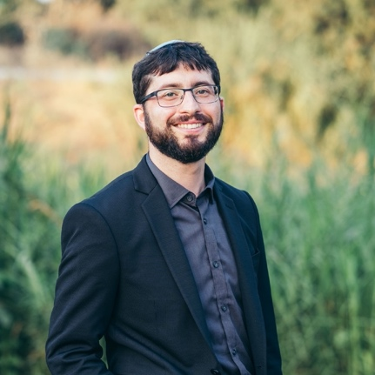 | Elad Kaplan is a lawyer and social entrepreneur. He is director of the Menomadin Center for Jewish and Democratic Law and works to create an infrastructure for connecting the components of Israeli identity. He has extensive experience in social organizations and led a series of petitions and public struggles promoting transparency, fairness and equality in the public system. Elad feels “driven by a desire to find creative solutions to social challenges.” He has rich experience in managing diverse teams, building work interfaces with private and public entities, strategic planning and developing work plans.  Previously, he managed the Atim organization working on behalf of the rights of immigrants, converts, and women encountering difficulties with the religious establishment. He was a co-founder of the independent court Halakhic Conversion, to enable attentive and inclusive conversion procedures. He is one of the founders of the Tag Meir Forum promoting mutual respect and the eradication of hate crimes and racism.  He holds a bachelor's degree in law and political science and a master's degree in science, technology and society from Bar-Ilan University, and a certificate in management and innovation from Cambridge University. He is currently a doctoral student in law, technology and society at Bar-Ilan University. Elad lives in Rehovot with his wife, Inbar, and his three sons, Kedem, Amiel and Yinon.
Gila Rockman  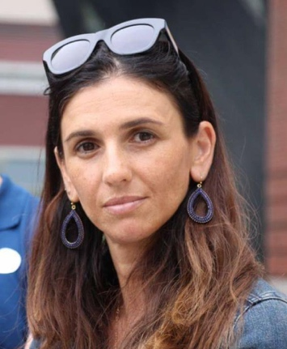 | Gila Rockman is the director of the Society and Community Department at the Shalem Academic Center, through which she developed the one-year experiential course Challenges in Israeli Society introduces crucial and central issues in Israeli society; the course is mandatory for all first-year students at the Shalem Center. She developed and leads the Shalem Center’s Peoplehood Project and the Koret Fund in San Francisco, CA. Gila directs all projects and programs on activism and volunteering outside the academic curriculum, including eight Shalem Center projects developed in collaboration with Jerusalem organizations and 15 student groups. Among the projects are a studio for service and maintenance workers at the Shalem Center (most of whom are Arabs), an economic activism group, and a debate group.  Gila served for eight years as Yeshiva University's Director of Educational Programs in Israel and worked in many development towns in Israel. Gila is an active member of the board of her community in Jerusalem, and is involved in other local organizations, including Afikim, an organization that helps at-risk youth and their families, and is a co-founder of the Afikim Race project, an annual fundraising event that begins in Jerusalem and ends in Eilat. Gila is married to Justin and they have four children.
Michal Kahana  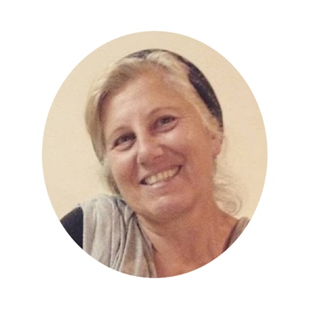 | Rebbetzin Michal Kahana is a graduate of the Maharat Yeshiva (Rabbinate for Orthodox Women), holds a PhD in Organizational Psychology, a bachelor’s degree in Israel Studies and Education, and a master’s degree in Jewish Education and Clinical Psychology. For many years she has been involved in Jewish education and leadership in the United States. She teaches Talmud and Judaism and conducts advanced training with spiritual guidance. She is a dedicated writer: her book The Circle was published in 2016 and she writes a weekly blog posted at www.miko284c.com
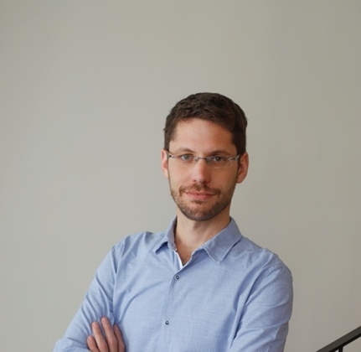  Noy Mordkovitz | Noy Mordkovitz is CEO of 0202 – Points of View from Jerusalem, which makes the perspectives of the various communities in Jerusalem accessible through Facebook pages and various projects.  Previously, Noy oversaw the budget of the five-year plan for East Jerusalem at the Ministry of Education. Noy holds a bachelor's degree in history from The Hebrew University of Jerusalem and a master's degree from Fry University in Berlin. He is currently completing a second master's degree in Jerusalem Studies at al-Quds University, Abu Dis.  Noy runs a family investment and real estate company. He has extensive experience in leading dialogue groups and concentrating projects related to Jewish-Arab relations.
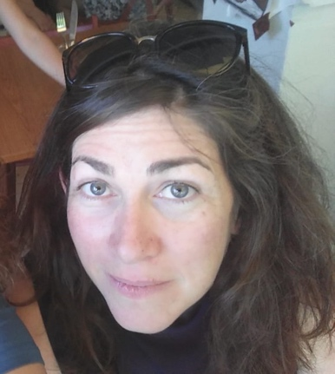  Ronit Sela | Ronit Sela is currently the manager of projects and impact at N-Drip, an Israeli start-up company that deals with economical irrigation of agricultural fields in the developing and developed world.  For many years she was a member of the Association for Civil Rights in promoting the human rights of Palestinians. Previously she was a news editor. She has been involved in guidance and instruction on social and political issues, including the conflict and climate crisis. Ronit lives in Jerusalem.

