**Research plan**

1. **Brief description of the subject and of the scientific and technological background**
   1. **Mating and aggression in *Drosophila melanogaster***

Mating behavior in *Drosophila melanogaster* has been the subject of intense research since it was first described more than a century ago [(Sturtevant 1915)](https://paperpile.com/c/WKDvYv/UMNR). Much of the circuitry underlying this mating behavior has been dissected in recent decades [(Auer and Benton 2016)](https://paperpile.com/c/WKDvYv/e2ZG). Mating behavior in *Drosophila melanogaster* relies on multisensory communication [(Dickson 2008)](https://paperpile.com/c/WKDvYv/hA5L). During courtship, males and females display their qualities while analyzing the value of a potential mate. **The male** **initiates courtship and the female decides whether she wishes to mate** [(Aranha and Vasconcelos 2018)](https://paperpile.com/c/WKDvYv/9aPv). Upon encountering a potential courtship partner, based on visual and chemosensory cues, the male taps the female’s abdomen to assess her desirability [(Bastock and Manning 1955; Spieth 1974)](https://paperpile.com/c/WKDvYv/nuEK+KDTY). The male then follows the female, extending a wing and vibrating it to generate the courtship song [(von Philipsborn et al. 2011)](https://paperpile.com/c/WKDvYv/smku). Next, the male taps and licks the female before attempting copulation [(Bastock and Manning 1955; Hall 1994)](https://paperpile.com/c/WKDvYv/nuEK+iZRG).

A female’s mating behavior is dependent on her sexual maturity and mating state. A female responds to a male’s courtship song by exhibiting changes in her locomotion [(Clemens et al. 2015)](https://paperpile.com/c/WKDvYv/bRC7) and ovipositor extrusion [(Mezzera et al. 2020)](https://paperpile.com/c/WKDvYv/6S7Y), as well by performing a range of rejection behaviors [(Aranha and Vasconcelos 2018; Connolly and Cook 1973; Lasbleiz, Ferveur, and Everaerts 2006)](https://paperpile.com/c/WKDvYv/9aPv+SPo6+ZMto) that include decamping, wing flicking, and shoving/fencing.

Most studies that have focused on the neurobiology of *Drosophila* mating behavior have involved a single virgin male and a single virgin female [(e.g., Zhou et al. 2014; Deutsch et al. 2020; Coen et al. 2014; Feng et al. 2014)](https://paperpile.com/c/WKDvYv/UfIg+xaZz+w6xd+bfPZ). However, it has been shown that in field settings, *Drosophila melanogaster* females store sperm from multiple males [(Singh, Singh, and Hoenigsberg 2002)](https://paperpile.com/c/WKDvYv/ZjmD). **Males encounter and court previously mated females much more often than they encounter virgins** [(Boulétreau 1978; Partridge, Hoffmann, and Jones 1987)](https://paperpile.com/c/WKDvYv/LniF+j12j) **and are capable of consecutive copulation with multiple females** [(S. X. Zhang, Rogulja, and Crickmore 2016)](https://paperpile.com/c/WKDvYv/gkCZ).

Therefore, the commonly used laboratory settings for studying the neurobiology of fly mating do not accurately reflect the settings in the wild.

The aggressive behavior of flies has mainly been studied in the context of fighting over food resources. While some aggressive phenotypes are sex-specific, others are not [(Nilsen et al. 2004; Chen et al. 2002; Lim et al. 2014)](https://paperpile.com/c/WKDvYv/1zO5+n2wm+ehn9). For example, while hierarchical relationships were seen to form between losing and winning males, no similar clear hierarchical relationship was observed in females [(Nilsen et al. 2004)](https://paperpile.com/c/WKDvYv/1zO5). Aggressive behaviors were also documented in the context of mating: males fight other males when competing over a female [(Sturtevant 1915)](https://paperpile.com/c/WKDvYv/UMNR), while unreceptive females show aggressive rejection behaviors toward courting males [(Aranha and Vasconcelos 2018; Connolly and Cook 1973)](https://paperpile.com/c/WKDvYv/9aPv+SPo6). The neural basis of aggressive behavior in males has been the target of intense research [(Hoopfer et al. 2015; Asahina et al. 2014; Certel et al. 2010)](https://paperpile.com/c/WKDvYv/4PJT+wRfC+Y7Hy) and recently also in females [(Deutsch et al. 2020; Palavicino-Maggio et al. 2019; Schretter et al. 2020)](https://paperpile.com/c/WKDvYv/xaZz+fDYC+0qiz). As with studies of mating behavior, laboratory studies of aggressive behavior have tended to focus on single, isolated pairs of flies, whether male or female.

How is aggressive communication affected by fly density and the male:female ratio? How do mating and aggressive behaviors interact? For example, do starved males fight for food or to court a female when both are available [(Rezával et al. 2014)](https://paperpile.com/c/WKDvYv/Synr)? How does a recent aggressive encounter modulate social communication in males and females [(Filice and Dukas 2019)](https://paperpile.com/c/WKDvYv/AJ2J)? We aim to answer these questions by monitoring mating and aggression among multiple flies, in a complex environment (that includes a food patch) and over an extended period of time.

**1.4 Group behaviors in *Drosophila melanogaster***

Studies of social interaction in *Drosophila melanogaster* have mainly focused on understanding the neuronal basis of innate and recognizable behaviors such as male–male aggression and male–female courtship encounters.

Studies that have investigated group behaviors in *Drosophila* have demonstrated that flies possess the neuronal ability to recognize different individuals in a group [(Schneider et al. 2018)](https://paperpile.com/c/WKDvYv/no0I); that groups of flies exhibit non-random group structures, which depend on certain sensory systems [(Ramdya et al. 2015; Schneider, Dickinson, and Levine 2012)](https://paperpile.com/c/WKDvYv/YCRA+ZxSu), group size [(Rooke et al. 2020)](https://paperpile.com/c/WKDvYv/UD4o), and social experience [(Bentzur et al. 2021)](https://paperpile.com/c/WKDvYv/53Q0); and that group interactions facilitate collective responses to threats [(Ramdya et al. 2015; Gibson et al. 2015)](https://paperpile.com/c/WKDvYv/YCRA+tV1q). Interestingly, some studies have indicated that the presence of multiple interacting flies also modulates mating behavior. For example, male courtship is modulated by the presence of rivals [(Setoguchi et al. 2015)](https://paperpile.com/c/WKDvYv/VNNa). These findings, together with evidence for the presence of social aggregates in wild flies [(Markow 2015; Soto-Yéber et al. 2018; Schneider, Atallah, and Levine 2012)](https://paperpile.com/c/WKDvYv/DWBR+dL79+JNlP), support the notion that group living is a fundamental component of *Drosophila* behavior.

Recently, machine learning tools for the automatic detection of social behaviors have been adapted for the study of group behaviors in *Drosophila* (Table 1), facilitating our understanding of collective behavior [(Ramdya et al. 2015)](https://paperpile.com/c/WKDvYv/YCRA) and social networks [(Schneider, Dickinson, and Levine 2012; Bentzur et al. 2021)](https://paperpile.com/c/WKDvYv/ZxSu+53Q0). However, little is known about how social context modulates individual, moment-to-moment social decisions. Specifically, how do the immediate social environment and fluctuating collective behavior modulate male–female, male–male, and female–female communication?

To address this knowledge gap, **we will track individual body parts of individual flies, in a mixed group of males and females, for an extended period of time (Table 1), using future development of SLEAP [(Pereira et al. 2020)](https://paperpile.com/c/WKDvYv/rVbt) for pose estimation (Fig. 1) and particularly for inferring male singing (Fig. 2).**

|  |  |  |  |  |  |  |
| --- | --- | --- | --- | --- | --- | --- |
| No. of individuals | Duration | Mixed sex | Food patch | Wings/legs tracked | Year | Reference |
| 12 | 30 min | NO | NO | NO | 2012 | [(Schneider, Dickinson, and Levine 2012)](https://paperpile.com/c/WKDvYv/ZxSu) |
| Up to 24 | 2–5 min | NO | NO* | NO | 2015 | [(Ramdya et al. 2015)](https://paperpile.com/c/WKDvYv/YCRA) |
| Up to 100 | Various | YES? | NO | NO | 2019 | [(Romero-Ferrero et al. 2019)](https://paperpile.com/c/WKDvYv/027F) |
| 7, 16 | 3, 5 h | YES? | NO | NO | 2020 | [(Gal, Saragosti, and Kronauer 2020)](https://paperpile.com/c/WKDvYv/XNs2) |
| 10 | 15 min | NO | NO | NO | 2021 | [(Bentzur et al. 2021)](https://paperpile.com/c/WKDvYv/53Q0) |
| **16** | **4 h** | **YES** | **YES** | **YES** | This proposal | |

**Table 1. Recent studies that have used machine learning tools for the quantification of group interactions in *Drosophila melanogaster***

**\*** No food patch, except for measuring aggregation density

**1.4 Using deep-learning methods for pose estimation and identity tracking**

Motion capture technology enables the precise quantification of complex phenotypes from high-resolution videography of freely behaving animals [(Pereira, Shaevitz, and Murthy 2020)](https://paperpile.com/c/WKDvYv/jmHk). Leveraging deep learning, the investigators’ previous work in developing these methods has recently been demonstrated to be feasible for tracking the motion of individual body parts of socially interacting animals, implemented using the SLEAP software framework [(Pereira et al. 2020)](https://paperpile.com/c/WKDvYv/rVbt). SLEAP works by using deep neural networks that take video frames as an input and then predict the location of body parts, group them into animals, and link them across time to generate continuous trajectories of poses for each animal. SLEAP has been found to be successful in tracking the poses of small groups of animals (2) for short periods of time (<1 h), with up to 99.9995% identity tracking accuracy (62 out of 11.7 million frames). Despite this good performance, in the more challenging setting involving larger groups of flies (16) recorded over longer sessions (4 h), we expect to encounter exponentially more frequent errors, as the potential for identity swaps increases combinatorially with the number of interacting animals and session duration. To address this, while also relieving the burden of manual proofreading on the experimenter, we will improve the robustness of SLEAP in identifying errors by leveraging state-of-the-art techniques for appearance and trajectory modeling employed in the multi-object tracking field. Specifically, we propose to leverage Transformers, a recently developed neural network architecture that employs a mechanism termed “attention”, to capture the relationship between complex data streams; Transformers has been found to be extremely successful for modeling sequence structure across data domains [(Lin et al. 2021)](https://paperpile.com/c/WKDvYv/h0hZ). This approach has recently been shown to outperform all existing methods for multiple object tracking [(Chu et al. 2021)](https://paperpile.com/c/WKDvYv/LYSW), and we propose to adapt this approach to capture the relationship between the relative positioning of body parts, static and dynamic appearance features, and postural trajectories in *Drosophila melanogaster*. To achieve this, we will represent each of these features and their relationships via a spatiotemporal graphical representation that will serve as an input to a deep neural network trained to associate animal poses across frames. Unlike all previously described methods for multi-animal tracking, this approach is ideally suited for our project as it enables context integration across multiple modalities of information (visual appearance, pose, dynamics) to achieve highly robust tracking, even in the presence of challenging occlusions that occur during complex multi-individual social interactions. As detailed below, in the first part of this project we will validate the quality of identity tracking using a large group of flies (specifically, eight males and eight females), using a complementary approach for color-based identity tracking [(Gal, Saragosti, and Kronauer 2020)](https://paperpile.com/c/WKDvYv/XNs2). This new approach for improved identity tracking will be made available as part of a future version of SLEAP.

**1.5 Supervised and unsupervised quantification of mating and aggressive behaviors in insects**

Both supervised and unsupervised learning methods have been developed for the automatic quantification of mating and fighting in *Drosophila* [(Kabra et al. 2013; Berman 2018; Anderson and Perona 2014)](https://paperpile.com/c/WKDvYv/TsWI+IBJ5+oPIz). While supervised methods allow the experimentalist to focus on specific behaviors (e.g., male chasing or female, female kicking), unsupervised approaches allow unbiased characterization of the behavioral space. A prerequisite for high-quality behavioral analysis, whether supervised or unsupervised, is precise tracking of an animal’s pose. As mentioned above, we will use SLEAP for pose estimation. SLEAP also allows the tracking of wing angle, which is a good proxy for male singing (Fig. 2; using a simple classifier we obtained 91% correct classification as to whether frames included part of a singing epoch), an important part of the male courtship ritual. The measurement of wing extension is also important for scoring aggressive behaviors, such as same-sex fights in males and females [(Nilsen et al. 2004)](https://paperpile.com/c/WKDvYv/1zO5) and rejection behaviors in unreceptive females [(Aranha and Vasconcelos 2018; Connolly and Cook 1973)](https://paperpile.com/c/WKDvYv/9aPv+SPo6).

**We will apply both supervised and unsupervised approaches to measure the behavior of individual flies and the interactions among individuals**.

1. **Objectives and significance of the research**

Our overall objective for this research is to determine how social communication in *Drosophila* is modulated by the environment. Specifically, we plan to reveal how male courtship and female responses are modulated by the immediate environment (other flies, a food resource) and by recent history (previous social encounters and recent feeding).

We will develop a behavioral setup and an analysis pipeline for automated offline tracking of the pose and identity of each individual fly in each frame for long periods of time (Aim 1; Figs. 1, 2). We will use this setup and analysis pipeline to describe mating behavior in wild-type flies in a complex environment (Aim 2; Fig. 3). We will also quantify the effect of activating specific, sexually dimorphic neurons in the central brains of males and females on their social communication in a complex environment (Aim 3, Fig. 4).

***Aim 1. Build a behavioral setup and validate the tracking pipeline (Haifa University and Salk Institute)***

We aim to develop an experimental setup and computational framework that will allow the monitoring and analysis of social communication (during mating and aggression) in the context of a complex environment. The complex environment includes 16 flies (8 males and 8 females) and a food patch.  
  
To this end, the Haifa group will build a circular arena with a small food patch in the center; this will be observed via a top-view, high-resolution camera and IR illumination (Fig. 1). A pilot dataset will be collected for identity validation, using colored flies and AnTrax [(Gal, Saragosti, and Kronauer 2020)](https://paperpile.com/c/WKDvYv/XNs2). The Salk group will track the flies using a future development of SLEAP (Aim 1) [(Pereira et al. 2020)](https://paperpile.com/c/WKDvYv/rVbt) and will use AnTrax to confirm that the fly identities are correct. Once this goal is achieved, the Haifa group will collect a second pilot dataset, using unmarked flies, for the Salk group to test.

***Aim 2: Determine how mating behavior is modulated by environmental cues and recent history***

The Haifa group will collect eight datasets, based on eight groups each comprising eight adult males and eight adult females, 4 hours per group, using wild-type NM91 flies. The Haifa group will track fly pose and identity (Fig. 1) and infer male singing (Fig. 2) using tools built by the Salk group as part of Aim 1. Then, the Haifa and Salk groups will work in collaboration to analyze the behavioral data, using both supervised and unsupervised learning approaches to extract fly behavior, particularly mating and aggressive behavior, as well as computational tools for analyzing group behaviors. Finally, conclusions will be drawn in relation to the spatial and temporal effects of the complex environment on social communication.

***Aim 3: Reveal how sexually dimorphic neurons control social communication in a complex environment***

Sexually dimorphic neurons that express the sex determination genes *doublesex* (*dsx*) and *fruitless* (*fru*) control social behaviors (e.g., mating and fighting) in *Drosophila*. After creating a pipeline for collecting and analyzing the detailed behavior of multiple flies over periods of several hours and establishing a detailed description of how wild-type flies communicate in a complex environment, we will perturb a specific subset of *dsx+* neurons in a single fly in each cohort and measure the effect this has on the social interactions of the manipulated fly.

1. **Comprehensive description of the methodology and plan of operation**

The proposed behavioral studies will be conducted at Haifa University. Tracking and pose estimation will be carried out using computational tools that will be developed at the Salk Institute. The two research groups will jointly design the experiments, coordinate the data analysis, and work collaboratively to implement state-of-the-art tools for analyzing behavioral data at multiple spatial and temporal scales. This close cooperation will be achieved via personal meetings, both online and through in-person student exchanges (see **Mode of cooperation**, below). Critically, neither the experimental group at Haifa University nor the computational group at the Salk Institute would be in a position to complete the project on its own.

***3.1 Rationale and general design***

We aim to set the stage to determine the effect of a complex environment on social communication in *Drosophila*. We will start by developing a new setup and analysis pipeline that allows the tracking of social encounters at high spatiotemporal resolution, in a socially complex and enriched environment. A first major challenge will be to extend the existing computational tools, particularly SLEAP, a deep-learning based framework for estimating the positions of animal body-parts that was originally developed by the Salk Institute partner, so that it is able keep track of 16 flies (8 males and 8 females) for an extended period of time (4 hours). We aim to reduce the proofreading requirement to a minimum, with the software highlighting only a small number of frames containing a potential event that requires human intervention (typically an identity flip). Once the data collection and tracking pipeline is ready, we will collect two datasets. The first will include wild-type flies, with the aim of describing how social communication is affected by complex environmental cues and recent social history. The complex environment includes a food patch and a large number of flies (eight males, eight females). All flies will be starved prior to the experiment, to encourage conflicts over feeding and mating. Based on previous experiments, we anticipate that both males and females will fight over the limited food resource. We will reveal how males and females manage the feeding–mating conflict over time, and we will decipher how social communication is modulated by food availability and by previous encounters, on or off the food patch. In the final part of the project, after establishing a “baseline” description of the wild-type behavior, we will explore how tonic activation of specific, sexually dimorphic cells modulates the social behavior of males and females in a complex environment (Fig. 4). Numerous studies have shown the male-only P1 group to be associated with male courtship and aggressive behaviors [(Hoopfer et al. 2015; Koganezawa, Kimura, and Yamamoto 2016; Inagaki et al. 2014)](https://paperpile.com/c/WKDvYv/4PJT+jjV4+K1DS). The same neuronal cluster was also associated with feeding [(Cheriyamkunnel et al. 2021)](https://paperpile.com/c/WKDvYv/xvXO) and sleep [(W. Zhang et al. 2018)](https://paperpile.com/c/WKDvYv/Oxsy). The female-only pC1d/e neurons have been shown to be associated with female receptivity [(Wu, Bidaye, and Mahringer 2019)](https://paperpile.com/c/WKDvYv/5kml) and with a persistent state of female–male aggression [(Deutsch et al. 2020)](https://paperpile.com/c/WKDvYv/xaZz). Here, we aim to characterize the breadth of the role that male-P1 and female-pC1d/e play in social communication.

*Drosophila* represents a unique system that allows focused manipulation of specific cell types throughout the brain. Using advanced computational tools, we will take advantage of this system to reveal how moment-by-moment social communication is modulated by social and non-social cues in a complex environment.

***3.2 Experimental procedures***

***Aim 1.1 Build a novel setup for measuring social communication in a complex environment***

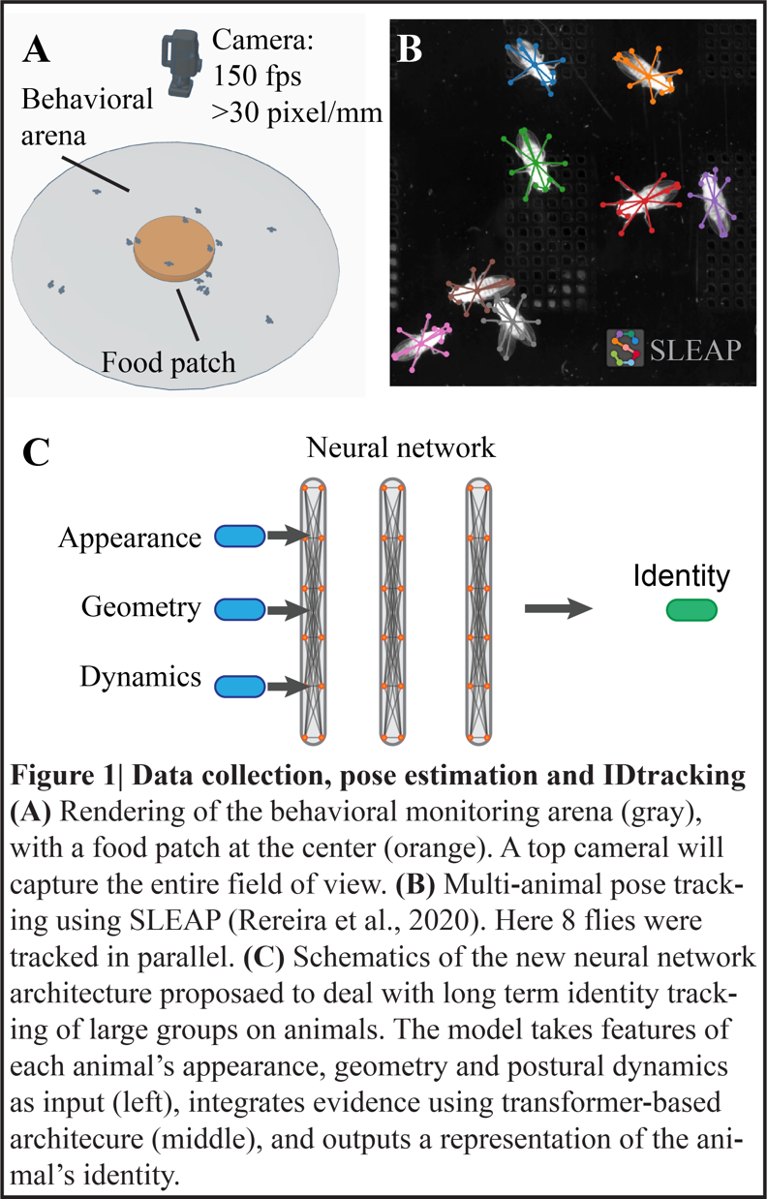We will build a circular arena with a food patch in the center. Under laboratory conditions, flies were shown to aggregate on lower, we choose to design our circular arena to have a fly density of 0.5 flies/cm2, therefore an arena diameter of ~64 mm (but see also Risk analysis and alternative plans, below). With modern cameras (e.g., Emergent CMOS HZ-21000-G), we can achieve a temporal resolution of 150 frames per second (this frame rate is important for capturing the wing motion dynamics) and 4096 pixels per axis. This equates to 4096/64 = 64 pixels/mm, which is twice the minimum that is necessary for reliable leg tracking [(Pereira et al. 2020)](https://paperpile.com/c/WKDvYv/rVbt). We will use a height of 3 mm, as was used previously [(Bentzur et al. 2021; Simon and Dickinson 2010; Kabra et al. 2013)](https://paperpile.com/c/WKDvYv/53Q0+bpDU+TsWI). To minimize the occurrences of flies walking on the walls and ceiling we will use Sigma coat [(Coen et al. 2014; Pereira et al. 2020)](https://paperpile.com/c/WKDvYv/w6xd+rVbt). A food patch will be placed in the center of the arena (15 mm in diameter, as previously described [(Dierick 2007)](https://paperpile.com/c/WKDvYv/BjYZ)). The food patch will therefore occupy approximately 5.5% of the arena size. We will adjust the illumination to ensure that we can detect and track fly pose both on and off the food patch.

We will use real-time, hardware-accelerated video compression (~100×) for the high resolution and framerate. With 8-bits per pixel and 4096×4096 pixels per frame, this would result in ~90 GB per hour of compressed data.

***Aim 1.2 Collect data for tracking validation***

We will collect a dataset comprising eight adult male and eight adult female flies, recorded over a period of 4 hours. All flies will be starved for 13 hours prior to the experiment. The flies will be colored the night before the experiments. The flies will then be transferred to vials containing moisture but no food, just prior to the beginning of the night cycle. Flies will be tracked using an existing method [(Gal, Saragosti, and Kronauer 2020)](https://paperpile.com/c/WKDvYv/XNs2), to obtain a reliable estimate for each fly’s identity. We will then track the same videos using an improved version of SLEAP (Fig. 1), aiming to track the pose and the identity of each individual fly throughout the course of the experiments. We will develop an algorithm for detecting all possible identity flips and an appropriate user interface for manual proofreading of these rare events. A satisfactory result will be up to a 1:1 ratio between human proofreading and total experimental time, such that for a 4-hour data collection period (with eight males and eight females, under our experimental conditions), the maximum proofreading time (that guarantees zero identity flips) will be up to 4 hours. This will allow us to perform data collection using the unmarked flies to address Aims 2 and 3. We will use machine learning tools to automatically detect fighting events, along with the winner and loser of each fight (based on who remained behind on the food patch). We will also use these tools to infer male singing from their wing angle, based on a previous comparison with recorded song (Fig. 2).

***Aim 2.1 Collect wild-type data***

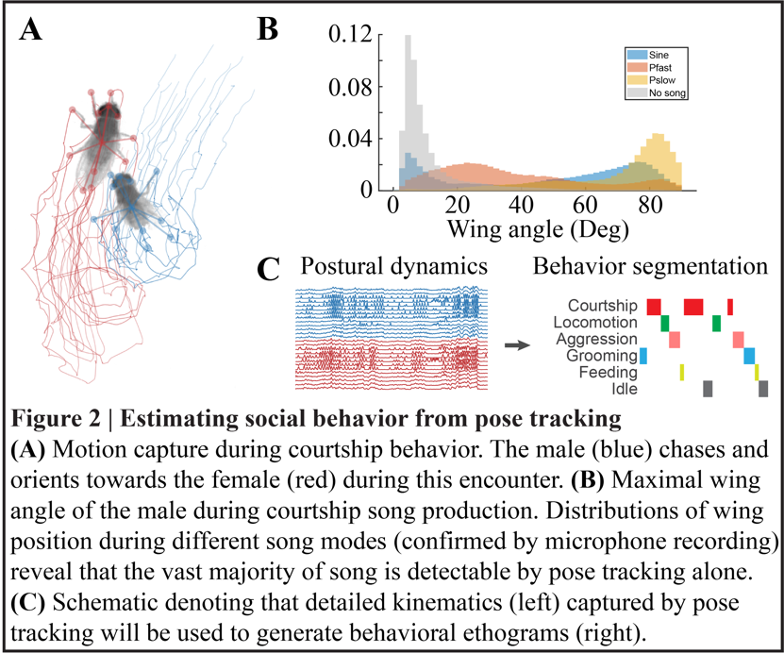Using a similar protocol to the one tested in Aim 1, we will collect 16 datasets, each comprising 8 virgin males and 8 virgin females videographed for a period of 4 hours. The flies will be collected 3 to 5 hours after emerging and maintained in a humidity- and temperature-controlled incubator, under a 12/12 h day/night cycle. Males and females will be individually housed to minimize their social experience. Flies will be removed from the incubator at the age of 4 days, 30 minutes after the behavioral incubator lights switch on to let the flights accommodate to the behavioral room and will then be inserted to the behavioral arena 60 minutes after the incubator lights switch on to optimize for peak fly activity. Flies will be individually loaded into the chamber using a custom-built aspirator. We will collect a single dataset each day, and we will clean the arena thoroughly the night before each experiment. Data will be tracked and proofread offline, based on the pipeline developed in Aim 1.

***Aim 2.2 Quantify individual and group fly behaviors using machine learning***

Based on the tracking of fly body-parts, we will extract kinematic variables for each individual fly (e.g., forward and turning velocities, position relative to the food patch), as well as other detectable behaviors such as singing (Fig. 2), ovipositor extrusion [(Wang et al. 2020)](https://paperpile.com/c/WKDvYv/QQr6), and locomotion [(DeAngelis, Zavatone-Veth, and Clark 2019)](https://paperpile.com/c/WKDvYv/towd). Based on these parameters, we will detect specific behaviors that involve a single fly (e.g., grooming) and behaviors that involve multiple flies (e.g., chasing or fighting).

We will employ state-of-the-art machine learning (ML) tools with improved accuracy and recall for the classification of pose-based social behavior at scale [(Nilsson et al. 2020)](https://paperpile.com/c/WKDvYv/oQW1). We will make our data annotations freely available and design an a priori labeling/classification protocol per behavioral class to minimize bias [(Leng et al. 2020)](https://paperpile.com/c/WKDvYv/7X9U). We will also apply unsupervised classification approaches, as previously carried out for flies [(Berman et al. 2014; Overman et al. 2021; Hernández et al. 2021)](https://paperpile.com/c/WKDvYv/PObP+Roka+HYQm), but under a more naturalistic setting.

In parallel to identifying the behaviors of individual flies or pairs of flies, we will analyze collective behaviors and social networks throughout the data [(Bentzur et al. 2021; Farine and Whitehead 2015)](https://paperpile.com/c/WKDvYv/53Q0+LYNl). Again, we will use state-of-the-art ML approaches that are designed to extract both common and rare behavioral events that may be unique to this complex environment [(Graving and Couzin 2020; Luxem et al. 2020)](https://paperpile.com/c/WKDvYv/jWWP+QxpI).

***Aim 2.3 Quantify social communication in complex environments***

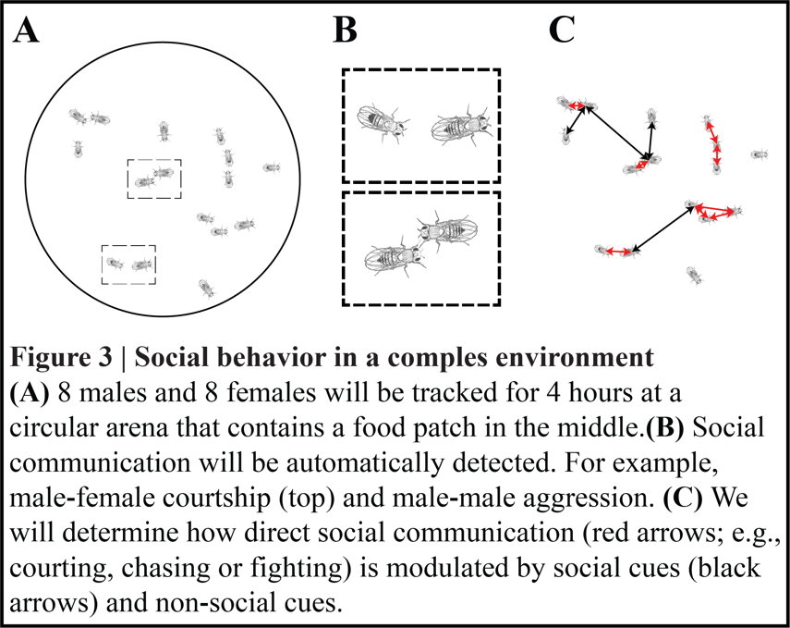Based on capturing the behavior of individual flies or pairs, as well as the group dynamics, we will quantify how the local environment of each fly and its recent history correlate with specific behavioral decisions.

Examples of questions relating to environmental effects will include: what is the effect of other flies (males, females) in the surroundings on the mating decisions of males and females? How do social networks (Fig. 3) affect courtship dynamics? How does the presence of a food source or flies that fight/aggregate over the food source affect nearby mating decisions? Examples of questions relating to the effects of recent history will include: does a previous defeat in a fight or an unsuccessful courtship attempt affect a male’s decision to court or not to court or the courtship pattern?

These correlations will inform us about the characteristics of individual fly behavior in a complex environment and will inform future studies that aim to demonstrate a causal link between a behavior and the activation or inactivation of specific cells, as investigated in Aim 3.

We will make the analysis pipeline fully open access via a shared repository, for use in future experiments. The use of this setup will allow researchers to ask questions relating to a range of fields, from genetics to ecology to neuroscience.

***Aim 3.1 Reveal the role central neurons play in mating decisions in both sexes***

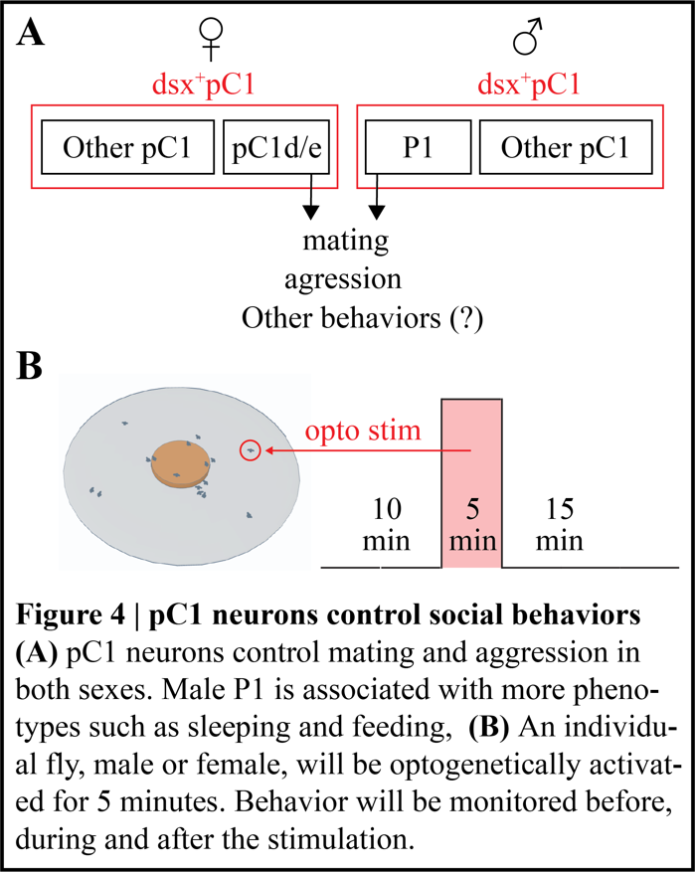Previous studies have indicated the role of the sexually dimorphic group of pC1 cells in controlling persistent mating motivation in both sexes [(Jung et al. 2020; Deutsch et al. 2020; S. X. Zhang, Rogulja, and Crickmore 2016)](https://paperpile.com/c/WKDvYv/iH7v+xaZz+gkCZ). However, pC1 neurons (including the male-only subgroup P1) have also been implicated in controlling sleep, feeding [(W. Zhang et al. 2018; Cheriyamkunnel et al. 2021)](https://paperpile.com/c/WKDvYv/Oxsy+xvXO), and aggression [(Deutsch et al. 2020; Hoopfer et al. 2015; Koganezawa, Kimura, and Yamamoto 2016)](https://paperpile.com/c/WKDvYv/xaZz+4PJT+jjV4). Here, we will measure the effect of low tonic activation of pC1 neurons on mating, fighting, social clustering, and general activity in both sexes (Fig. 4). We will activate (in separate experiments) pC1d/e neurons [(Deutsch et al. 2020; Schretter et al. 2020)](https://paperpile.com/c/WKDvYv/xaZz+0qiz) in females and P1 in males [(Koganezawa, Kimura, and Yamamoto 2016)](https://paperpile.com/c/WKDvYv/jjV4).

Each experiment will include eight males and eight females, as before, but will last just 30 minutes: 10 minutes of baseline, 5 minutes of pC1 activation (using red light), and 15 minutes after light offset (Fig. 4). In each experiment, only one individual fly – male or female – will express channelrhodopsin in the pC1 subset (pC1d/e or P1). We will collect 80 groups for each condition, i.e., a total of 240 groups (pC1d/e in females, P1 in males and controls). In total, we will collect 120 hours of data for Aim 3.

**4. Risk analysis and alternative paths**

***4.1 Identity tracking.*** In addressing Aim 1, we will develop SLEAP to keep the identity of 16 flies in a complex environment (that includes some heterogeneity due to the food patch), such that the time required for manual proofreading will not exceed the time required for the actual experiment. As detailed above, we will also track flies using a complementary approach that is based on marking the flies [(Gal, Saragosti, and Kronauer 2020)](https://paperpile.com/c/WKDvYv/XNs2) to validate the identity tracking. If we succeed in tracking and maintaining the identity of flies using SLEAP, we will then collect a second dataset to confirm that SLEAP identity tracking also works with unmarked flies. We will then perform the remaining experiments (Aims 2, 3) using unmarked flies. If we fail to achieve this goal, we will use markless flies for Aims 2 and 3 and, if necessary, we will adopt a hybrid approach, where fly pose is tracked using SLEAP and fly identity is tracked using AnTraX [(Gal, Saragosti, and Kronauer 2020)](https://paperpile.com/c/WKDvYv/XNs2).

***4.2 Arena dimensions.*** The sizes of the arena and the food patch were chosen based on the results of previous experiments. However, it might turn out to be the case that these dimensions are either too large, such that complex social interactions are rare, or too small, such that flies overlap with each other in a way that significantly differs from their natural dynamics [(Soto-Yéber et al. 2018)](https://paperpile.com/c/WKDvYv/dL79) and makes it impossible to track a fly’s pose in many frames, due to obstruction by other flies. If one of these turns out to be the case, we may need to modify the dimensions of the arena.

**4.3 Duration of starvation.** We plan to starve males and females for 13 hours prior to the experiments; this does not exceed the times that have been used in previous experiments. However, it is unclear how this will affect the optogenetic activation of males and females when ATR-containing food was not consumed by the flies for this duration. As we wish to maintain similar experimental conditions for both Aims 2 and 3, we will check, prior to collecting the data for Aim 2, whether P1-activated males sing upon P1 activation. If not, we will reduce the duration of starvation.

**References**

[Anderson, David J., and Pietro Perona. 2014. “Toward a Science of Computational Ethology.” *Neuron* 84 (1): 18–31.](http://paperpile.com/b/WKDvYv/oPIz)

[Aranha, Márcia M., and Maria Luísa Vasconcelos. 2018. “Deciphering Drosophila Female Innate Behaviors.” *Current Opinion in Neurobiology* 52 (October): 139–48.](http://paperpile.com/b/WKDvYv/9aPv)

[Asahina, Kenta, Kiichi Watanabe, Brian J. Duistermars, Eric Hoopfer, Carlos Roberto González, Eyrún Arna Eyjólfsdóttir, Pietro Perona, and David J. Anderson. 2014. “Tachykinin-Expressing Neurons Control Male-Specific Aggressive Arousal in Drosophila.” *Cell* 156 (1-2): 221–35.](http://paperpile.com/b/WKDvYv/wRfC)

[Auer, Thomas O., and Richard Benton. 2016. “Sexual Circuitry in Drosophila.” *Current Opinion in Neurobiology* 38 (June): 18–26.](http://paperpile.com/b/WKDvYv/e2ZG)

[Bastock, Margaret, and Aubrey Manning. 1955. “The Courtship of Drosophila Melanogaster.” *Behaviour* 8 (2/3): 85–111.](http://paperpile.com/b/WKDvYv/nuEK)

[Bentzur, Assa, Shir Ben-Shaanan, Jennifer I. C. Benichou, Eliezer Costi, Mali Levi, Amiyaal Ilany, and Galit Shohat-Ophir. 2021. “Early Life Experience Shapes Male Behavior and Social Networks in Drosophila.” *Current Biology: CB* 31 (3): 670.](http://paperpile.com/b/WKDvYv/53Q0)

[Berman, Gordon J. 2018. “Measuring Behavior across Scales.” *BMC Biology* 16 (1): 23.](http://paperpile.com/b/WKDvYv/IBJ5)

[Berman, Gordon J., Daniel M. Choi, William Bialek, and Joshua W. Shaevitz. 2014. “Mapping the Stereotyped Behaviour of Freely Moving Fruit Flies.” *Journal of the Royal Society, Interface / the Royal Society* 11 (99). https://doi.org/](http://paperpile.com/b/WKDvYv/PObP)[10.1098/rsif.2014.0672](http://dx.doi.org/10.1098/rsif.2014.0672)[.](http://paperpile.com/b/WKDvYv/PObP)

[Boulétreau, Josselyne. 1978. “Ovarian Activity and Reproductive Potential in a Natural Population of Drosophila Melanogaster.” *Oecologia* 35 (3): 319–42.](http://paperpile.com/b/WKDvYv/LniF)

[Calhoun, Adam J., Jonathan W. Pillow, and Mala Murthy. 2019. “Unsupervised Identification of the Internal States That Shape Natural Behavior.” *Nature Neuroscience* 22 (12): 2040–49.](http://paperpile.com/b/WKDvYv/KKHa)

[Certel, Sarah J., Adelaine Leung, Chih-Yung Lin, Philip Perez, Ann-Shyn Chiang, and Edward A. Kravitz. 2010. “Octopamine Neuromodulatory Effects on a Social Behavior Decision-Making Network in Drosophila Males.” *PLoS ONE*. https://doi.org/](http://paperpile.com/b/WKDvYv/Y7Hy)[10.1371/journal.pone.0013248](http://dx.doi.org/10.1371/journal.pone.0013248)[.](http://paperpile.com/b/WKDvYv/Y7Hy)

[Chen, Selby, Ann Yeelin Lee, Nina M. Bowens, Robert Huber, and Edward A. Kravitz. 2002. “Fighting Fruit Flies: A Model System for the Study of Aggression.” *Proceedings of the National Academy of Sciences of the United States of America* 99 (8): 5664–68.](http://paperpile.com/b/WKDvYv/n2wm)

[Cheriyamkunnel, Sherry J., Saloni Rose, Pedro F. Jacob, Lauren A. Blackburn, Shaleen Glasgow, Jacob Moorse, Mike Winstanley, Patrick J. Moynihan, Scott Waddell, and Carolina Rezaval. 2021. “A Neuronal Mechanism Controlling the Choice between Feeding and Sexual Behaviors in Drosophila.” *Current Biology: CB*, August. https://doi.org/](http://paperpile.com/b/WKDvYv/xvXO)[10.1016/j.cub.2021.07.029](http://dx.doi.org/10.1016/j.cub.2021.07.029)[.](http://paperpile.com/b/WKDvYv/xvXO)

[Chu, Peng, Jiang Wang, Quanzeng You, Haibin Ling, and Zicheng Liu. 2021. “TransMOT: Spatial-Temporal Graph Transformer for Multiple Object Tracking.” *arXiv [cs.CV]*. arXiv.](http://paperpile.com/b/WKDvYv/LYSW) <http://arxiv.org/abs/2104.00194>[.](http://paperpile.com/b/WKDvYv/LYSW)

[Clemens, Jan, Cyrille C. Girardin, Pip Coen, Xiao-Juan Guan, Barry J. Dickson, and Mala Murthy. 2015. “Connecting Neural Codes with Behavior in the Auditory System of Drosophila.” *Neuron* 87 (6): 1332–43.](http://paperpile.com/b/WKDvYv/bRC7)

[Coen, Philip, Jan Clemens, Andrew J. Weinstein, Diego A. Pacheco, Yi Deng, and Mala Murthy. 2014. “Dynamic Sensory Cues Shape Song Structure in Drosophila.” *Nature* 507 (7491): 233–37.](http://paperpile.com/b/WKDvYv/w6xd)

[Connolly, Kevin, and Robert Cook. 1973. “Rejection Responses by Female Drosophila Melanogaster: Their Ontogeny, Causality and Effects upon the Behaviour of the Courting Male.” *Behaviour* 44 (1/2): 142–66.](http://paperpile.com/b/WKDvYv/SPo6)

[DeAngelis, Brian D., Jacob A. Zavatone-Veth, and Damon A. Clark. 2019. “The Manifold Structure of Limb Coordination in Walking Drosophila.” *eLife* 8 (June). https://doi.org/](http://paperpile.com/b/WKDvYv/towd)[10.7554/eLife.46409](http://dx.doi.org/10.7554/eLife.46409)[.](http://paperpile.com/b/WKDvYv/towd)

[Deutsch, David, Diego Pacheco, Lucas Encarnacion-Rivera, Talmo Pereira, Ramie Fathy, Jan Clemens, Cyrille Girardin, et al. 2020. “The Neural Basis for a Persistent Internal State in Drosophila Females.” *eLife*. https://doi.org/](http://paperpile.com/b/WKDvYv/xaZz)[10.7554/elife.59502](http://dx.doi.org/10.7554/elife.59502)[.](http://paperpile.com/b/WKDvYv/xaZz)

[Dickson, Barry J. 2008. “Wired for Sex: The Neurobiology of Drosophila Mating Decisions.” *Science* 322 (5903): 904–9.](http://paperpile.com/b/WKDvYv/hA5L)

[Dierick, Herman A. 2007. “A Method for Quantifying Aggression in Male Drosophila Melanogaster.” *Nature Protocols* 2 (11): 2712–18.](http://paperpile.com/b/WKDvYv/BjYZ)

[Farine, Damien R., and Hal Whitehead. 2015. “Constructing, Conducting and Interpreting Animal Social Network Analysis.” *The Journal of Animal Ecology* 84 (5): 1144–63.](http://paperpile.com/b/WKDvYv/LYNl)

[Feng, Kai, Mark T. Palfreyman, Martin Häsemeyer, Aaron Talsma, and Barry J. Dickson. 2014. “Ascending SAG Neurons Control Sexual Receptivity of Drosophila Females.” *Neuron* 83 (1): 135–48.](http://paperpile.com/b/WKDvYv/bfPZ)

[Filice, David C. S., and Reuven Dukas. 2019. “Winners Have Higher Pre-Copulatory Mating Success but Losers Have Better Post-Copulatory Outcomes.” *Proceedings. Biological Sciences / The Royal Society* 286 (1900): 20182838.](http://paperpile.com/b/WKDvYv/AJ2J)

[Gal, Asaf, Jonathan Saragosti, and Daniel Jc Kronauer. 2020. “anTraX, a Software Package for High-Throughput Video Tracking of Color-Tagged Insects.” *eLife* 9 (November). https://doi.org/](http://paperpile.com/b/WKDvYv/XNs2)[10.7554/eLife.58145](http://dx.doi.org/10.7554/eLife.58145)[.](http://paperpile.com/b/WKDvYv/XNs2)

[Gibson, William T., Carlos R. Gonzalez, Conchi Fernandez, Lakshminarayanan Ramasamy, Tanya Tabachnik, Rebecca R. Du, Panna D. Felsen, Michael R. Maire, Pietro Perona, and David J. Anderson. 2015. “Behavioral Responses to a Repetitive Visual Threat Stimulus Express a Persistent State of Defensive Arousal in Drosophila.” *Current Biology: CB* 25 (11): 1401–15.](http://paperpile.com/b/WKDvYv/tV1q)

[Gorter, Jenke A., Samyukta Jagadeesh, Christoph Gahr, Jelle J. Boonekamp, Joel D. Levine, and Jean-Christophe Billeter. 2016. “The Nutritional and Hedonic Value of Food Modulate Sexual Receptivity in Drosophila Melanogaster Females.” *Scientific Reports* 6 (January): 19441.](http://paperpile.com/b/WKDvYv/9B5W)

[Graving, Jacob M., and Iain D. Couzin. 2020. “VAE-SNE: A Deep Generative Model for Simultaneous Dimensionality Reduction and Clustering.” *bioRxiv*. https://doi.org/](http://paperpile.com/b/WKDvYv/jWWP)[10.1101/2020.07.17.207993](http://dx.doi.org/10.1101/2020.07.17.207993)[.](http://paperpile.com/b/WKDvYv/jWWP)

[Grosjean, Yael, Raphael Rytz, Jean-Pierre Farine, Liliane Abuin, Jérôme Cortot, Gregory S. X. E. Jefferis, and Richard Benton. 2011. “An Olfactory Receptor for Food-Derived Odours Promotes Male Courtship in Drosophila.” *Nature* 478 (7368): 236–40.](http://paperpile.com/b/WKDvYv/CNJU)

[Hall, J. C. 1994. “The Mating of a Fly.” *Science* 264 (5166): 1702–14.](http://paperpile.com/b/WKDvYv/iZRG)

[Hernández, Damián G., Catalina Rivera, Jessica Cande, Baohua Zhou, David L. Stern, and Gordon J. Berman. 2021. “A Framework for Studying Behavioral Evolution by Reconstructing Ancestral Repertoires.” *eLife* 10 (September). https://doi.org/](http://paperpile.com/b/WKDvYv/HYQm)[10.7554/eLife.61806](http://dx.doi.org/10.7554/eLife.61806)[.](http://paperpile.com/b/WKDvYv/HYQm)

[Hoopfer, Eric D., Yonil Jung, Hidehiko K. Inagaki, Gerald M. Rubin, and David J. Anderson. 2015. “P1 Interneurons Promote a Persistent Internal State That Enhances Inter-Male Aggression in Drosophila.” *eLife* 4 (December). https://doi.org/](http://paperpile.com/b/WKDvYv/4PJT)[10.7554/eLife.11346](http://dx.doi.org/10.7554/eLife.11346)[.](http://paperpile.com/b/WKDvYv/4PJT)

[Inagaki, Hidehiko K., Yonil Jung, Eric D. Hoopfer, Allan M. Wong, Neeli Mishra, John Y. Lin, Roger Y. Tsien, and David J. Anderson. 2014. “Optogenetic Control of Drosophila Using a Red-Shifted Channelrhodopsin Reveals Experience-Dependent Influences on Courtship.” *Nature Methods* 11 (3): 325–32.](http://paperpile.com/b/WKDvYv/K1DS)

[Jung, Yonil, Ann Kennedy, Hui Chiu, Farhan Mohammad, Adam Claridge-Chang, and David J. Anderson. 2020. “Neurons That Function within an Integrator to Promote a Persistent Behavioral State in Drosophila.” *Neuron* 105 (2): 322–33.e5.](http://paperpile.com/b/WKDvYv/iH7v)

[Kabra, Mayank, Alice A. Robie, Marta Rivera-Alba, Steven Branson, and Kristin Branson. 2013. “JAABA: Interactive Machine Learning for Automatic Annotation of Animal Behavior.” *Nature Methods* 10 (1): 64–67.](http://paperpile.com/b/WKDvYv/TsWI)

[Koganezawa, Masayuki, Ken-Ichi Kimura, and Daisuke Yamamoto. 2016. “The Neural Circuitry That Functions as a Switch for Courtship versus Aggression in Drosophila Males.” *Current Biology: CB* 26 (11): 1395–1403.](http://paperpile.com/b/WKDvYv/jjV4)

[Lasbleiz, Christelle, Jean-François Ferveur, and Claude Everaerts. 2006. “Courtship Behaviour of Drosophila Melanogaster Revisited.” *Animal Behaviour* 72 (5): 1001–12.](http://paperpile.com/b/WKDvYv/ZMto)

[Leng, Xubo, Margot Wohl, Kenichi Ishii, Pavan Nayak, and Kenta Asahina. 2020. “Quantitative Comparison of Drosophila Behavior Annotations by Human Observers and a Machine Learning Algorithm.” *bioRxiv*. https://doi.org/](http://paperpile.com/b/WKDvYv/7X9U)[10.1101/2020.06.16.153130](http://dx.doi.org/10.1101/2020.06.16.153130)[.](http://paperpile.com/b/WKDvYv/7X9U)

[Lim, Rod S., Eyrún Eyjólfsdóttir, Euncheol Shin, Pietro Perona, and David J. Anderson. 2014. “How Food Controls Aggression in Drosophila.” *PloS One* 9 (8): e105626.](http://paperpile.com/b/WKDvYv/ehn9)

[Lin, Tianyang, Yuxin Wang, Xiangyang Liu, and Xipeng Qiu. 2021. “A Survey of Transformers.” *arXiv [cs.LG]*. arXiv.](http://paperpile.com/b/WKDvYv/h0hZ) <http://arxiv.org/abs/2106.04554>[.](http://paperpile.com/b/WKDvYv/h0hZ)

[Luxem, Kevin, Falko Fuhrmann, Johannes Kürsch, Stefan Remy, and Pavol Bauer. 2020. “Identifying Behavioral Structure from Deep Variational Embeddings of Animal Motion.” *bioRxiv*. https://doi.org/](http://paperpile.com/b/WKDvYv/QxpI)[10.1101/2020.05.14.095430](http://dx.doi.org/10.1101/2020.05.14.095430)[.](http://paperpile.com/b/WKDvYv/QxpI)

[Markow, Therese Ann. 2015. “The Natural History of Model Organisms: The Secret Lives of Drosophila Flies.” *eLife* 4: e06793.](http://paperpile.com/b/WKDvYv/DWBR)

[Mezzera, Cecilia, Margarida Brotas, Miguel Gaspar, Hania J. Pavlou, Stephen F. Goodwin, and Maria Luísa Vasconcelos. 2020. “Ovipositor Extrusion Promotes the Transition from Courtship to Copulation and Signals Female Acceptance in Drosophila Melanogaster.” *Current Biology: CB* 30 (19): 3736–48.e5.](http://paperpile.com/b/WKDvYv/6S7Y)

[Nilsen, Steven P., Yick-Bun Chan, Robert Huber, and Edward A. Kravitz. 2004. “Gender-Selective Patterns of Aggressive Behavior in Drosophila Melanogaster.” *Proceedings of the National Academy of Sciences of the United States of America* 101 (33): 12342–47.](http://paperpile.com/b/WKDvYv/1zO5)

[Nilsson, Simon R. O., Nastacia L. Goodwin, Jia Jie Choong, Sophia Hwang, Hayden R. Wright, Zane C. Norville, Xiaoyu Tong, et al. 2020. “Simple Behavioral Analysis (SimBA) – an Open Source Toolkit for Computer Classification of Complex Social Behaviors in Experimental Animals.” *bioRxiv*. https://doi.org/](http://paperpile.com/b/WKDvYv/oQW1)[10.1101/2020.04.19.049452](http://dx.doi.org/10.1101/2020.04.19.049452)[.](http://paperpile.com/b/WKDvYv/oQW1)

[Overman, Katherine E., Daniel M. Choi, Kawai Leung, Joshua W. Shaevitz, and Gordon J. Berman. 2021. “Measuring the Repertoire of Age-Related Behavioral Changes in Drosophila Melanogaster.” *bioRxiv*. https://doi.org/](http://paperpile.com/b/WKDvYv/Roka)[10.1101/2021.06.13.448265](http://dx.doi.org/10.1101/2021.06.13.448265)[.](http://paperpile.com/b/WKDvYv/Roka)

[Palavicino-Maggio, Caroline B., Yick-Bun Chan, Claire McKellar, and Edward A. Kravitz. 2019. “A Small Number of Cholinergic Neurons Mediate Hyperaggression in Female Drosophila.” *Proceedings of the National Academy of Sciences of the United States of America* 116 (34): 17029–38.](http://paperpile.com/b/WKDvYv/fDYC)

[Partridge, Linda, Ary Hoffmann, and J. S. Jones. 1987. “Male Size and Mating Success in Drosophila Melanogaster and D. Pseudoobscura under Field Conditions.” *Animal Behaviour* 35 (2): 468–76.](http://paperpile.com/b/WKDvYv/j12j)

[Pereira, Talmo D., Joshua W. Shaevitz, and Mala Murthy. 2020. “Quantifying Behavior to Understand the Brain.” *Nature Neuroscience*, November, 1–13.](http://paperpile.com/b/WKDvYv/jmHk)

[Pereira, T. D., N. Tabris, J. Li, and S. Ravindranath. 2020. “SLEAP: Multi-Animal Pose Tracking.” *bioRxiv*.](http://paperpile.com/b/WKDvYv/rVbt) <https://www.biorxiv.org/content/10.1101/2020.08.31.276246v1.abstract>[.](http://paperpile.com/b/WKDvYv/rVbt)

[Philipsborn, Anne C. von, Tianxiao Liu, Jai Y. Yu, Christopher Masser, Salil S. Bidaye, and Barry J. Dickson. 2011. “Neuronal Control of Drosophila Courtship Song.” *Neuron* 69 (3): 509–22.](http://paperpile.com/b/WKDvYv/smku)

[Ramdya, Pavan, Pawel Lichocki, Steeve Cruchet, Lukas Frisch, Winnie Tse, Dario Floreano, and Richard Benton. 2015. “Mechanosensory Interactions Drive Collective Behaviour in Drosophila.” *Nature* 519 (7542): 233–36.](http://paperpile.com/b/WKDvYv/YCRA)

[Rezával, Carolina, Tetsuya Nojima, Megan C. Neville, Andrew C. Lin, and Stephen F. Goodwin. 2014. “Sexually Dimorphic Octopaminergic Neurons Modulate Female Postmating Behaviors in Drosophila.” *Current Biology: CB* 24 (7): 725–30.](http://paperpile.com/b/WKDvYv/Synr)

[Romero-Ferrero, Francisco, Mattia G. Bergomi, Robert C. Hinz, Francisco J. H. Heras, and Gonzalo G. de Polavieja. 2019. “Idtracker.ai: Tracking All Individuals in Small or Large Collectives of Unmarked Animals.” *Nature Methods*. https://doi.org/](http://paperpile.com/b/WKDvYv/027F)[10.1038/s41592-018-0295-5](http://dx.doi.org/10.1038/s41592-018-0295-5)[.](http://paperpile.com/b/WKDvYv/027F)

[Rooke, Rebecca, Amara Rasool, Jonathan Schneider, and Joel D. Levine. 2020. “Drosophila Melanogaster Behaviour Changes in Different Social Environments Based on Group Size and Density.” *Communications Biology* 3 (1): 304.](http://paperpile.com/b/WKDvYv/UD4o)

[Schneider, Jonathan, Jade Atallah, and Joel D. Levine. 2012. “Chapter 3 - One, Two, and Many—A Perspective on What Groups of Drosophila Melanogaster Can Tell Us About Social Dynamics.” In *Advances in Genetics*, edited by Marla B. Sokolowski and Stephen F. Goodwin, 77:59–78. Academic Press.](http://paperpile.com/b/WKDvYv/JNlP)

[Schneider, Jonathan, Michael H. Dickinson, and Joel D. Levine. 2012. “Social Structures Depend on Innate Determinants and Chemosensory Processing in Drosophila.” *Proceedings of the National Academy of Sciences of the United States of America* 109 Suppl 2 (October): 17174–79.](http://paperpile.com/b/WKDvYv/ZxSu)

[Schneider, Jonathan, Nihal Murali, Graham W. Taylor, and Joel D. Levine. 2018. “Can Drosophila Melanogaster Tell Who’s Who?” *PloS One* 13 (10): e0205043.](http://paperpile.com/b/WKDvYv/no0I)

[Schretter, Catherine E., Yoshinori Aso, Alice A. Robie, Marisa Dreher, Michael-John Dolan, Nan Chen, Masayoshi Ito, et al. 2020. “Cell Types and Neuronal Circuitry Underlying Female Aggression in Drosophila.” *eLife* 9 (November). https://doi.org/](http://paperpile.com/b/WKDvYv/0qiz)[10.7554/eLife.58942](http://dx.doi.org/10.7554/eLife.58942)[.](http://paperpile.com/b/WKDvYv/0qiz)

[Setoguchi, Shiori, Ayumi Kudo, Takuma Takanashi, Yukio Ishikawa, and Takashi Matsuo. 2015. “Social Context-Dependent Modification of Courtship Behaviour in Drosophila Prolongata.” *Proceedings. Biological Sciences / The Royal Society* 282 (1818): 20151377.](http://paperpile.com/b/WKDvYv/VNNa)

[Simon, Jasper C., and Michael H. Dickinson. 2010. “A New Chamber for Studying the Behavior of Drosophila.” *PloS One* 5 (1): e8793.](http://paperpile.com/b/WKDvYv/bpDU)

[Singh, Shree Ram, Bashisth N. Singh, and Hugo F. Hoenigsberg. 2002. “Female Remating, Sperm Competition and Sexual Selection in Drosophila.” *Genetics and Molecular Research: GMR* 1 (3): 178–215.](http://paperpile.com/b/WKDvYv/ZjmD)

[Soto-Yéber, Luis, José Soto-Ortiz, Pablo Godoy, and Raúl Godoy-Herrera. 2018. “The Behavior of Adult Drosophila in the Wild.” *PloS One* 13 (12): e0209917.](http://paperpile.com/b/WKDvYv/dL79)

[Spieth, H. T. 1974. “Courtship Behavior in Drosophila.” *Annual Review of Entomology* 19: 385–405.](http://paperpile.com/b/WKDvYv/KDTY)

[Sturtevant, A. H. 1915. “Experiments on Sex Recognition and the Problem of Sexual Selection in Drosoophilia.” *Journal of Experimental Psychology. Animal Behavior Processes* 5 (5): 351.](http://paperpile.com/b/WKDvYv/UMNR)

[Wang, Fei, Kaiyu Wang, Nora Forknall, Ruchi Parekh, and Barry J. Dickson. 2020. “Circuit and Behavioral Mechanisms of Sexual Rejection by Drosophila Females.” *Current Biology: CB* 30 (19): 3749–60.e3.](http://paperpile.com/b/WKDvYv/QQr6)

[Wu, Y., S. S. Bidaye, and D. Mahringer. 2019. “Drosophila Female-Specific Brain Neuron Elicits Persistent Position-and Direction-Selective Male-like Social Behaviors.” *bioRxiv*.](http://paperpile.com/b/WKDvYv/5kml) <https://www.biorxiv.org/content/10.1101/594960v1.abstract>[.](http://paperpile.com/b/WKDvYv/5kml)

[Zhang, Stephen X., Dragana Rogulja, and Michael A. Crickmore. 2016. “Dopaminergic Circuitry Underlying Mating Drive.” *Neuron* 91 (1): 168–81.](http://paperpile.com/b/WKDvYv/gkCZ)

[Zhang, Wenxuan, Chao Guo, Dandan Chen, Qionglin Peng, and Yufeng Pan. 2018. “Hierarchical Control of Drosophila Sleep, Courtship, and Feeding Behaviors by Male-Specific P1 Neurons.” *Neuroscience Bulletin* 34 (6): 1105–10.](http://paperpile.com/b/WKDvYv/Oxsy)

[Zhou, Chuan, Yufeng Pan, Carmen C. Robinett, Geoffrey W. Meissner, and Bruce S. Baker. 2014. “Central Brain Neurons Expressing Doublesex Regulate Female Receptivity in Drosophila.” *Neuron* 83 (1): 149–63.](http://paperpile.com/b/WKDvYv/UfIg)