**Self-efficacy before and after an academic writing program and its relation to students’ language skill — an action research study**

# Abstract

Writing self-efficacy has been found to be associated with writing achievement and can even be improved with the help of an intervention program. However, with regards to writers who are college students, there is still ambiguity or partial information. First, unlike the case with school students, findings on the relationship between self-efficacy and achievement in college students are inconsistent, and second, findings from intervention programs designed to improve self-efficacy for the most part do not refer to differences in improvement between students with varying levels of language proficiency. Thus, the aim of the present study is to offer a possible explanation for the inconsistency in the findings and also to analyze the differences between more and less skilled writers following an intervention program. Eighty-one female college students participated in the study during a compulsory course in language skills. Self-efficacy was measured before and after the writing program by having the students fill out a questionnaire. The first major finding was that only in the measurement after the program was there a correlation between self-efficacy and achievement, and this correlation seemed to depend on the students knowing what writing requirements they were expected to meet. In writing courses in college, unlike in schools, there are no standardized tests and therefore expectations tend to be unclear. Reports about correlation are then inconsistent. However, by the second measurement of the program, the expectations were clear and therefore a correlation was shown. The second key finding concerns the intervention program and the improvement in self-efficacy. It was found that most of the change was among the more skilled writers, both in the ability to create ideas and in self-regulation, whereas those less skilled reported a moderate improvement only in self-regulation.

keywords: writing, self-efficacy, academic writing, writing program

# Introduction

Many studies point to the contribution of self-efficacy to writing achievement (Zimmerman and Bandura, 1994; Pajares, 2003; Schunk, 2003; Bruning & Horn, 2000; Perin, 2019; Pajares & Valiante, 2006), but not all findings are consistent. Findings from studies focusing on schools appear consistent and indicate a correlation (e.g., Pajares & Johnson, 1996; Villalón et al., 2015). In contrast, when it comes to college students, the findings are not unequivocal. Some studies have pointed to a correlation (Pajares & Johnson, 1994), but some have shown that the relationship is limited or non-existent (MacArthur et al., 2016). One of the aims of this study is to try to explain when such a correlation will exist and when it will not. Another matter to be examined is how self-efficacy contributes in writers with varying levels of language proficiency. Writers with different skill levels are known to differ in a variety of aspects (McNamara et al., 2010; Saddler & Graham, 2007), and here we seek to examine whether the contribution of self-efficacy varies between these groups. In general, self-efficacy studies in adult learners are not numerous (Perin, 2019; Hood, 2019), and the present study offers an expansion of knowledge in this area.

## Writing self-efficacy and its components

Bandura (1997) describes self-efficacy as individuals’ self-perception of their ability to learn and perform tasks as required. One of the most complex literate tasks is writing, and self-efficacy may contribute to writing performance (Pajares, 2003; Perin, 2019; Pajares & Valiante, 2006).

Writing self-efficacy can be divided into several categories. Initial studies conducted a few decades ago primarily measured self-efficacy regarding the mechanics of writing, such as spelling accuracy, the correct use of words, and the ability to formulate a sentence (McCarthy et al., 1985; Shell et al., 1989). Later studies (Pajares & Valiante, 1999) relied on research tools that measured these as well, but examined additional categories of self-efficacy using other external questionnaires that measured perceptions of writing and the degree of apprehension about writing. At the same time, a questionnaire examining the category of self-regulation was developed (Zimmerman and Bandura, 1994), and self-regulation was found to contribute to writing achievement. Another tool for measuring self-regulation was developed in a study by MacArthur et al. (2015). They included this tool as a sub-questionnaire within a general questionnaire on motivation. The two tools mentioned only address regulation in writing and do not address the self-efficacy associated with writing mechanics. A complete questionnaire that addresses both the mechanics of writing and regulation was constructed by Bruning et al. (2013) and is the basis for measurement in the present study. This questionnaire contains 16 items, which include three categories of self-efficacy: ideation, conventions, and self-regulation. The ideation dimension refers to self-belief in the ability to generate ideas for writing and develop them through the use of appropriate words (Zumbrunn, 2020; Bruning et al., 2013). Accuracy refers to self-belief in the ability to properly use grammatical elements and accepted linguistic characteristics to produce appropriate and clear wording (Bruning et al., 2013). The self-regulation component refers to self-belief in the ability to steer the various tasks involved in writing, to manage different emotions during task performance, and to avoid distraction (Zimmerman and Bandura, 1994; Bruning et al., 2013).

## Correlation between self-efficacy and writing achievement

Studies of school students tend to consistently show that there is a correlation between self-efficacy and writing achievement. For example, Pajares & Valiante (1997) and Pajares et al. (1999) examined elementary school students using a series of self-efficacy and writing apprehension questionnaires and measured writing achievement on a holistic scale between 1 and 5. The findings showed that students’ assessments of their ability were in accordance with their achievement. In another study using standardized writing tests, a similar correlation was found among elementary students (Shell et al., 1995).

Correlations were also found in post-primary schools. Pajares & Valiante (1999) examined the annual writing achievement of middle school students and found a correlation between achievement and self-efficacy. This was also the case with Pajares & Johnson (1996). Among high school students, the data from a variety of types of writing tests showed similar correlations. Villalón et al. (2015) measured achievement by having students write a synthetic text, examining each gender separately, and found a correlation, with gender having no effect on the correlation. Shell et al. (1995) found that the correlation holds when achievement was measured by standardized tests. Alongside this, there are a few findings of correlation in some of the components of self-efficacy. Zumbrunn (2020) found a correlation in only one factor (conventions) and not in the other two.

However, for college students, the findings are inconsistent. Shell et al. (1989) and Pajares & Johnson (1994) found that a correlation exists. In these two studies, the textual product was a writing task given during a course, and the text was assessed on a holistic scale from 1 to 5. Achievement, as stated, was in line with the self-efficacy in writing. By contrast, in a study by MacArthur et al. (2016), no correlation was reported. Also, the correlation reported in a study by Zimmerman & Bandura (1994) was not comprehensive, and the self-regulation factor was found to be unrelated to the level of writing achievement. Chea & Shumow (2017) found that there is a correlation, but it is extremely low (0.14). It can be seen, then, that there is a distinction between the stable findings obtained in schools and the findings arising from studies in colleges. In the present study, an attempt will be made to give a possible explanation.

## Writing intervention programs and self-efficacy

Little research has been done on writing self-efficacy among college students (Hood, 2019). Even fewer are the studies that included an intervention program with measurement before and after the intervention.

A study by Hood (2019) implemented an intervention program to strengthen writing self-efficacy among 40 students. The intervention group received an augmented program that included deepening students’ academic writing skills and strengthening their self-belief in their writing abilities. The study showed that there was an improvement in self-efficacy, and there was a correlation between self-efficacy and academic aspirations, but there was no correlation between self-efficacy and writing achievement. This study did not include groups at different language skill levels and therefore provided no information on possible differences in self-efficacy resulting from such differences.

Van Blankenstein et al. (2019) implemented a program to increase motivation for research and academic writing among 147 college students. The intervention program focused on promoting collaboration in groups of learners. Progress was measured at the beginning, middle, and end of the program. Among the metrics with which progress was recorded was writing self-efficacy. However, no achievement in writing was measured. Nor was there any reference to differences in students’ skill levels.

Another intervention study, in which 17 teachers participated, was conducted by Mascle (2011). The focus of the study was writing apprehensions and the impact they have on writing. The intervention program included a workshop on educational leadership, alongside the cultivation of writing and research skills. Measurements, both quantitative and qualitative, were taken at the beginning, middle, and end of the program. The results indicated a decrease in writing apprehensions and showed that an open workshop contributes to improved self-efficacy. In this study, writing achievement was not measured and no reference was made to differences in students' skill levels.

Compressed writing intervention programs have also improved self-efficacy. In a study done in a nursing department (Miller et al., 2015), the students learned remotely and practiced writing, and the findings showed an improvement in ability in the experimental group compared to the control group, who received the regular program. Similarly, Campillo & Pool (1999) reported that in an intensive (four days a week) course that included learning writing for several weeks, the students reflected their initial state on a graph, and throughout the program used the graph to monitor their progress. The results showed a significant improvement from the beginning to the end of the course. However, here too, the analysis was done on the whole group without distinguishing between different levels of language proficiency.

## Language skill

In the intervention studies presented so far, the findings were for all participants, with no distinctions made according to participants’ language skill levels. Numerous studies that examined academic writing while distinguishing between learners with different language proficiency have indicated significant differences between more and less skilled writers. A study that followed the writing of several drafts of a text found that during writing, more skilled writers focus on high-order thinking (such as text organization and message planning) compared to less skilled writers, who focus on low-order thinking (such as grammatical errors) (Tsai, 2009). A similar study of draft writing (Raviv, 2019) examined the types of changes and corrections that students make from draft to draft and found that more skilled writers formulate their ideas and content right away in the first draft and utilize the next draft for spot corrections. In contrast, less-skilled writers tend to continue to correct the content for two to three drafts. Highly skilled writers have also been found to use more complex language (McNamara, Crossley, & McCarthy, 2010), show greater flexibility in achieving cohesion within the text (Varner, Snow, & McNamara, 2014), and even have a higher ability to recognize errors and correct them, both in a text written by someone else and in a text written by themselves (Hull, 1987). How are these differences reflected in the writing self-efficacy of each group? The aim of the present study is to examine an intervention program designed to improve writing and to include an analysis of the changes in self-efficacy in each of the language proficiency groups.

## Research objectives and questions

The aim of this study is to examine the changes in self-efficacy during an intervention program, distinguishing between writers who are more skilled and those who are less skilled. To this end, the following questions are examined:

1. Does writing self-efficacy change during a writing program, and are there differences between the changes in more skilled and less skilled writers?

2. To what extent will there be a correlation between achievement in an academic writing course and self-efficacy, both before and after the intervention program?

# Method

## Participants

The participants consisted of 101 undergraduate students enrolled in public education colleges. All were females. Eighty-one participated in two measurements (before and after the intervention program), and 20 took part only in the first measurement (the reliability calculation was based on 101 participants). The socioeconomic status of the students at these colleges was middle class. The students’ age averaged 21, ranging from 20 to 25. The study took place during the first semester of the academic year.

## Measures

Self-efficacy questionnaire (Bruning et al., 2013): Self-efficacy was measured using a questionnaire created by Bruning and colleagues (2013). This questionnaire includes 16 statements relating to self-esteem regarding various components of writing. Responses are given on a 7-grade Likert scale from 1 (low) to 7 (high). There are no reverse questions in this questionnaire. A measurement of writing ability is obtained by averaging all statements. This questionnaire includes questions about three factors that make up writing skills, and below is their breakdown, with the level of reliability (Cronbach's alpha) in the original study (and in the current study, based on 101 participants, in parentheses): (1) Ideation — five statements with a reliability of 0.92 (0.77). Example: “I can think of many ideas for my writing.” (2) Conventions — five statements with a reliability of 0.85 (0.78). Example: “I can spell my words correctly.” (3) Self-regulation — six statements with a reliability of 0.87 (0.88). Example: “I can focus on my writing for at least one hour.” Another study that used this questionnaire on higher education students found a high overall reliability of 0.88 (Ekholm et al., 2015), while in the current study the overall reliability was 0.92.

Writing achievement: Similar to other studies (Shell et al., 1989, 1995; Pajares, 1997), this study measured writing achievement using a 30-minute assignment in which students wrote a persuasive text. The texts were scored according to a key of 40% for content and 60% for conventions.

## Procedures

In the present action research study, two measurements were taken, one at the beginning and one at the end of the writing program. The intervention program, given to several groups, was part of a mandatory academic course in writing and comprehension skills. All groups were pre-classified by achievement level using matriculation criteria or psychometrically. The present study included a medium-low and a high-level group. The first seven weeks of the semester were devoted to writing skills. The groups experienced the same program components, which included experience in writing in the argumentative genre (persuasive article). Students practiced paragraph structure, cohesion, and connectivity, completed exercises, and received feedback. At the end of the program, a writing test was conducted and scored according to a key of 40% for content and 60% for conventions. At the beginning of the program, 101 responses were collected. At the end of the program, 81 students filled out the questionnaire once again.

# Results

## Changes in self-efficacy according to language skill

To examine whether there was a change in self-efficacy between the measurements at the beginning and the end of the program, a two-way RM ANOVA was performed. The within-subject independent variable was the measurement time (beginning and end of the program), and the between-subject independent variable was language skill level (more versus less skilled). The dependent variable was the degree of self-efficacy. There was a significant main effect with the measurement time, F(1,79) = 20.65, *p*= 0.000, ηp2 = 0.21, which means that there was an increase in self-efficacy as the writing program progressed.

However, there was a significant interaction between the improvement in self-efficacy and language skill, F(1,79) = 11.53, *p*= 0.001, ηp2 = 0.12, which indicates that the extent of improvement in self-efficacy depends on language skill level. To find the source of the interaction, a dependent T test was performed on each skill level group separately. There was a significant improvement in the more skilled group, t(18) = 4.13, *p* = 0.001, while in the less skilled group there was no significant improvement, t(61) = 1.22, *p* = 0.22. These findings indicate that only the more skilled group reported an overall increase in self-efficacy. See Table 1 for averages and standard deviations. See also Figure 1.

Table 1

Means and standard deviations of self-efficacy before and after writing program.

|  |  |  |  |  |  |
| --- | --- | --- | --- | --- | --- |
|  | N | Before | | After | |
|  |  | M | SD | M | SD |
| more skilled students | 19 | 4.84 | 0.66 | 5.41 | 0.61 |
| less skilled students | 62 | 4.43 | 1.04 | 4.51 | 0.93 |
| Total | 81 | 4.53 | 0.98 | 4.72 | 0.94 |

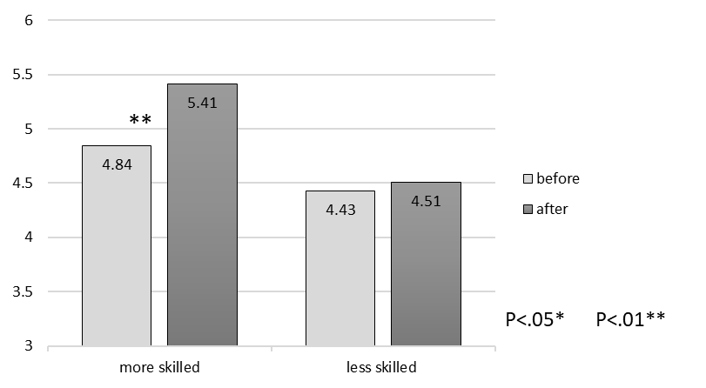

Figure 1. Changes in self-efficacy before and after writing program.

## Changes in factors within self-efficacy according to language skill

To deepen understanding of the changes in self-efficacy between the beginning and the end of the intervention program, a separate two-way RM ANOVA was performed for each of the questionnaire factors: ideation, conventions, and self-regulation. The within-subject independent variable was the measurement time (beginning and end of the program), and the between-subject independent variable was language skill level (more versus less skilled). The dependent variable was the degree of self-efficacy regarding each factor. (1) Ideation — There was significant interaction between the improvement in self-efficacy and language skill, F(1,79) = 10.10, *p*= 0.002, ηp2 = 0.11, indicating that the extent of improvement in self-efficacy depends on language skill level. To find the source of the interaction, a dependent T test was performed on each skill level group separately. There was a significant improvement in the more skilled group, t(18) = 3.07, *p* = 0.007, while in the less skilled group there was no significant improvement, t(61) = 0.93, *p* = 0.35. These findings reveal that only the more skilled group reported an overall increase in ideation. (2) Conventions — No main effect was found, F(1,79) = 0.21, *p*= 0.64, ηp2 = 0.003, and no interaction effect was found, F(1,79) = 1.84, *p*= 0.17, ηp2 = 0.023. This means that there was no change in this factor in either group. (3) Self-regulation — There was a significant interaction between the improvement in self-efficacy and language skill, F(1,79) = 8.90, *p*= 0.004, ηp2 = 0.10, which indicates that the extent of improvement in self-efficacy depends on language skill level. To find the source of the interaction, a dependent T test was performed on each skill level group separately. There was a significant improvement in both the more skilled group, t(18) = 4.74, *p* = 0.000, and the less skilled group, t(61) = 2.25, *p* = 0.028, although the improvement among the latter group was more moderate. This series of separate analyses shows that all participants improved in self-regulation, and no one improved in the use of conventions. On the other hand, when it came to ideation, there was improvement only in the more skilled group. See Table 2 for averages and standard deviations. See also Figure 2.

Table 2

Means and standard deviations of factors of self-efficacy before and after writing program (N=81).

|  |  |  |  |  |  |  |  |
| --- | --- | --- | --- | --- | --- | --- | --- |
|  |  |  | Before | | | After | |
|  |  | N | M | SD | M | | SD |
| Ideation | more skilled | 19 | 4.66 | 0.85 | 5.18 | | 0.70 |
|  | less skilled | 62 | 4.36 | 0.70 | 4.44 | | 1.05 |
| Conventions | more skilled | 19 | 5.49 | 0.82 | 5.71 | | 0.77 |
|  | less skilled | 62 | 4.86 | 1.13 | 4.75 | | 1.16 |
| Self- | more skilled | 19 | 4.45 | 0.82 | 5.36 | | 0.82 |
| regulation | less skilled | 62 | 4.12 | 1.40 | 4.37 | | 1.18 |

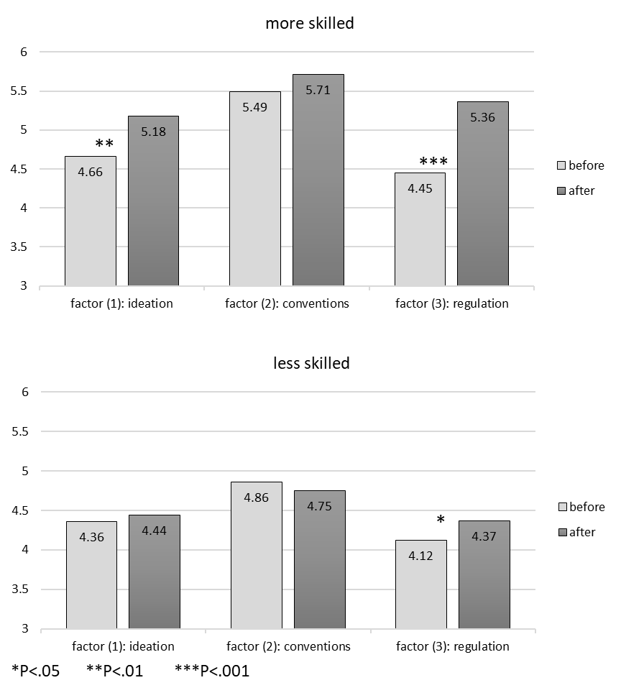

Figure 2. Changes in factors of self-efficacy before and after writing program.

## Correlation between self-efficacy and writing achievement

A Pearson correlation coefficient was computed to assess the relationship between the two measurements of writing self-efficacy (before and after intervention program) and writing achievement. The correlations are listed in Table 3. There was no correlation between the first measurement of self-efficacy and achievement, r=0.11 *p*>0.05, indicating that the students did not reasonably evaluate their writing abilities. In contrast, there was a positive correlation between post-program self-efficacy and achievement, r=0.29 *p*<0.05, so that the greater the self-efficacy, the higher the achievement. Of the three factors, only ideation and conventions correlated with achievement.

Table 3

Correlations among study variables: Grade (academic writing achievements), Self-efficacy (writing self-efficacy), Ideation, Conventions, Self-regulation (factors of self-efficacy) (N=81).

|  |  |  |  |  |  |  |  |  |  |  |
| --- | --- | --- | --- | --- | --- | --- | --- | --- | --- | --- |
|  |  | Before writing program (1) | | | |  | After writing program (2) | | | |
|  | Grade | Self-efficacy (1) | Ideation (1) | Conventions (1) | Regulation  (1) |  | Self-efficacy (2) | Ideation (2) | Conventions (2) | Regulation  (2) |
| Grade | 1 |  |  |  |  |  |  |  |  |  |
| Self-efficacy (1) | 0.11 | 1 |  |  |  |  |  |  |  |  |
| Ideation (1) | 0.04 | 0.85** | 1 |  |  |  |  |  |  |  |
| Conventions (1) | 0.20* | 0.78** | 0.56** | 1 |  |  |  |  |  |  |
| Regulation (1) | 0.04 | 0.88** | 0.64** | 0.50** | 1 |  |  |  |  |  |
| **Self-efficacy (2)** | **0.27\*\*** | 0.81** | 0.70** | 0.64** | 0.73** |  | 1 |  |  |  |
| **Ideation (2)** | **0.21\*** | 0.69** | 0.73** | 0.47** | 0.58** |  | 0.84** | 1 |  |  |
| **Conventions (2)** | **0.29\*\*** | 0.61** | 0.46** | 0.64** | 0.47** |  | 0.81** | 0.58** | 1 |  |
| **Regulation (2)** | **0.17** | 0.73** | 0.59** | 0.49** | 0.74** |  | 0.86** | 0.60** | 0.49** | 1 |

\**p* < .05; \*\**p* < .01

# Discussion

Concerning the first research question, a significant interaction between skill level and the degree of improvement was found, so that only the more skilled writers experienced a significant general improvement in self-efficacy, while the less skilled did not. Other intervention studies (Hood 2019; Van Blankenstein et al., 2019; Mascle, 2011; Miller et al., 2015) reported an overall improvement among participants. The present study also found a main effect of all participants as a whole improving in self-efficacy, but the addition of variables (skill levels) enabled the study to distinguish between groups of writers and showed that in fact only the skilled group reported improvement. From previous studies on writing skills among college students at various levels, we know that while writing, the less skilled are characterized by behaviors such as focusing on low-level thinking (such as correcting grammatical errors) (Tsai, 2009) and formulating content in small, multiple steps (Raviv, 2019). Hence, a seven-week intervention program does not seem to be enough for them, and they should be given programs that provide broader writing experiences. It is also possible that the short intervention plan implemented in the present study, compared to the full and annual plans implemented in the studies mentioned, did not allow less skilled writers to progress sufficiently, whereas in a long plan they also showed an improvement.

A more in-depth examination of the interaction was done by targeted analyses of each of the self-efficacy factors. Again there was an interaction for the ideation factor, indicating that only the more skilled reported improvement. This report could join a finding from a previous study (Raviv, 2019) on the content component among college students with different skill levels. In that study, students wrote three drafts of a text (in each draft, the complete text was resubmitted), and it was found that the more skilled students formulated the content right away in the first draft, while the less skilled needed two to three drafts to formulate the content. The current finding broadens the picture and shows that even in relation to improving self-efficacy regarding developing content and raising ideas, there are differences between these groups.

Another notable difference between the groups was in the interaction found in the self-regulatory factor. Both skill groups reported improvement in the level of regulation following the intervention program, but the degree of improvement among the more skilled was significantly higher than in the less skilled. The general improvement findings are consistent with previous studies on self-regulation (Schunk & Ertmer, 2000), but here there is additional information distinguishing the intensity of improvement between the two skill groups.

Concerning the second research question, the findings showed that only the second measurement, at the end of the intervention program, was correlated with achievement. In the first measurement, the students did not properly assess their ability, so there was no correlation with achievement. That is, some students rated themselves highly on achievement, and some underestimated, and this was not systematic. The difference between the two measurements can be attributed to how well the students understood what was expected of them and how their writing achievement would be measured. At the beginning of the course, the students did not know how the assessment would be done, and they assessed their ability according to previous writing experiences. By the end of the course, however, they had undergone some writing experiences, and the structure of the final test was clear to them. This helped them know what was expected of them, and they reported ability levels that were significantly correlated with their achievement. This can help explain the inconsistency in the findings on the relationship between writing self-efficacy and writing achievement. On the one hand, studies on school students indicate a stable relationship (Pajares & Johnson, 1996; Villalón et al., 2015; Pajares, 2003; Schunk, 2003; Bruning & Horn, 2000; Perin, 2019; Pajares & Valiante, 2006), but on the other hand when it comes to students in colleges, the findings are not unequivocal. Some findings have pointed to a connection (Pajares & Johnson, 1994), but some have shown that the connection is limited or non-existent (MacArthur et al., 2016). Students in schools have frequent standardized tests, and they know what is expected of them when they are asked to write, so their self-efficacy reports are stably consistent with achievement. In contrast, writing courses in academia do not use standardized tests, and each lecturer determines the structure of the test. In such a situation, students’ reports of their capabilities are limited in accuracy, and the findings about them are inconsistent. Accordingly, in the present study, it appears that when students did not know what to expect (first measurement of self-efficacy), their reports did not match their achievement, and only at the end of the course, after expectations were clarified (second measurement), was there a correlation.

# References

Bandura, A. (1997). *Self-efficacy: The exercise of control*. New York: Freeman.

Bruning, R., & Horn, C. (2000). Developing motivation to write. *Educational psychologist*, *35*(1), 25-37.‏ <https://doi.org/10.1207/s15326985ep3501_4>

Bruning, R., Dempsey, M., Kauffman, D. F., McKim, C., & Zumbrunn, S. (2013). Examining dimensions of self-efficacy for writing. *Journal of educational psychology*, *105*(1), 25.‏ <https://doi.org/10.1037/a0029692>

Campillo, M., & Pool, S. (1999). Improving Writing Proficiency through Self-Efficacy Training.‏

Chea, S., & Shumow, L. (2017). The relationships among writing self-efficacy, writing goal orientation, and writing achievement. *Asian-focused ELT research and practice: Voices from the far edge*, *12*(1), 169.‏ <https://doi.org/10.5746/leia/14/v5/i2/a07/chea_shumow>

Hood, S. (2019). *I believe I can write: exploring the impact of writing workshops on self-efficacy beliefs of Foundation degree students* (Doctoral dissertation, University of Reading).‏

Hull, G. (1987). The editing process in writing: A performance study of more skilled and less skilled college writers. *Research in the Teaching of English*, 8-29.‏

MacArthur, C. A., Philippakos, Z. A., & Graham, S. (2016). A multicomponent measure of writing motivation with basic college writers. *Learning Disability Quarterly*, *39*(1), 31-43.‏ <https://doi.org/10.1177/0731948715583115>

MacArthur, C. A., Philippakos, Z. A., & Ianetta, M. (2015). Self-regulated strategy instruction in college developmental writing. *Journal of Educational Psychology*, *107*(3), 855.‏ <https://doi.org/10.1037/edu0000011>

McCarthy, P., Meier, S., & Rinderer, R. (1985). Self-efficacy and writing: A different view of self-evaluation. College Composition and Communication, 36, 465–471. <https://doi.org/10.2307/357865>

McNamara, D. S., Crossley, S. A., & McCarthy, P. M. (2010). Linguistic features of writing quality. *Written communication*, *27*(1), 57-86.‏ <https://doi.org/10.1177/0741088309351547>

Miller, L. C., Russell, C. L., Cheng, A. L., & Skarbek, A. J. (2015). Evaluating undergraduate nursing students' self-efficacy and competence in writing: Effects of a writing intensive intervention. *Nurse education in practice*, *15*(3), 174-180.‏ <https://doi.org/10.1016/j.nepr.2014.12.002>

Pajares, F. (2003). Self-efficacy beliefs, motivation, and achievement in writing: A review of the literature. *Reading &Writing Quarterly*, *19*(2), 139-158.‏ <https://doi.org/10.1080/10573560308222>

Pajares, F., & Johnson, M. J. (1994). Confidence and competence in writing: The role of self-efficacy, outcome expectancy, and apprehension. *Research in the Teaching of English*, 313-331.‏

Pajares, F., & Johnson, M. J. (1996). Self‐efficacy beliefs and the writing performance of entering high school students. *Psychology in the Schools*, *33*(2), 163-175.‏ [https://doi.org/10.1002/(sici)1520-6807(199604)33:2<163::aid-pits10>3.0.co;2-c](https://doi.org/10.1002/(sici)1520-6807(199604)33:2%3C163::aid-pits10%3E3.0.co;2-c)

Pajares, F., & Valiante, G. (1997). Influence of self-efficacy on elementary students' writing. *The Journal of Educational Research*, *90*(6), 353-360.‏ <https://doi.org/10.1080/00220671.1997.10544593>

Pajares, F., & Valiante, G. (1999). Grade level and gender differences in the writing self-beliefs of middle school students. *Contemporary educational psychology*, *24*(4), 390-405.‏ <https://doi.org/10.1006/ceps.1998.0995>

Pajares, F., & Valiante, G. (2006). Self-efficacy beliefs and motivation in writing development. *Handbook of writing research*, 158-170.‏

Pajares, F., Miller, M. D., & Johnson, M. J. (1999). Gender differences in writing self-beliefs of elementary school students. *Journal of educational Psychology*, *91*(1), 50.‏ <https://doi.org/10.1037/0022-0663.91.1.50>

Perin, D. (2019). Reading, Writing, and Self‐Efficacy of Low‐Skilled Postsecondary Students. *The Wiley Handbook of Adult Literacy*, 237-260.‏ <https://doi.org/10.1002/9781119261407.ch11>

Raviv, H. (2019). From Reactive to Proactive Writing: Teaching Writing Through Sequential Drafts, and Its Differential Effect on College Students. *Helkat Lashon, 52*, 194-213. (In Hebrew) <https://www.academia.edu/38352767/From_reactive_to_proactive_writing_Teaching_writing_through_sequential_drafts_and_its_differential_effect_on_college_students>

Saddler, B., & Graham, S. (2007). The relationship between writing knowledge and writing performance among more and less skilled writers. *Reading & Writing Quarterly*, *23*(3), 231-247.‏ <https://doi.org/10.1080/10573560701277575>

Schunk, D. H. (2003). Self-efficacy for reading and writing: Influence of modeling, goal setting, and self-evaluation. *Reading &Writing Quarterly*, *19*(2), 159-172.‏ <https://doi.org/10.1080/10573560308219>

Schunk, D. H., & Ertmer, P. A. (2000). Self-regulation and academic learning: Self-efficacy enhancing interventions. In *Handbook of self-regulation* (pp. 631-649). Academic Press.‏ <https://doi.org/10.1016/b978-012109890-2/50048-2>

Shell, D. F., Colvin, C., & Bruning, R. H. (1995). Self-efficacy, attribution, and outcome expectancy mechanisms in reading and writing achievement: Grade-level and achievement-level differences. *Journal of Educational Psychology*, *87*(3), 386.‏ <https://doi.org/10.1037/0022-0663.87.3.386>

Shell, D. F., Murphy, C. C., & Bruning, R. H. (1989). Self-efficacy and outcome expectancy mechanisms in reading and writing achievement. *Journal of Educational Psychology*, *81*(1), 91.‏ <https://doi.org/10.1037/0022-0663.81.1.91>

Tsai, H. M. (2009). Examining metacognitive performance between skilled and unskilled writers in an integrated EFL writing class. In *Proceedings of the 26th International Conference on English Teaching and Learning in the* (pp. 678-689).‏

Van Blankenstein, F. M., Saab, N., Van der Rijst, R. M., Danel, M. S., Bakker-van den Berg, A. S., & Van den Broek, P. W. (2019). How do self-efficacy beliefs for academic writing and collaboration and intrinsic motivation for academic writing and research develop during an undergraduate research project?. *Educational Studies*, *45*(2), 209-225.‏ <https://doi.org/10.1080/03055698.2018.1446326>

Varner, L., Snow, E., & McNamara, D. (2014, July). The long and winding road: Investigating the differential writing patterns of high and low skilled writers. In *Educational Data Mining 2014*.‏

Villalón, R., Mateos, M., & Cuevas, I. (2015). High school boys’ and girls’ writing conceptions and writing self-efficacy beliefs: What is their role in writing performance?. *Educational Psychology*, *35*(6), 653-674.‏ <https://doi.org/10.1080/01443410.2013.836157>

Zimmerman, B. J., & Bandura, A. (1994). Impact of self-regulatory influences on writing course attainment. *American educational research journal*, *31*(4), 845-862.‏ <https://doi.org/10.3102/00028312031004845>

Zumbrunn, S., Broda, M., Varier, D., & Conklin, S. (2020). Examining the multidimensional role of self‐efficacy for writing on student writing self‐regulation and grades in elementary and high school. *British Journal of Educational Psychology*, *90*(3), 580-603.‏ <https://doi.org/10.1111/bjep.12315>