Wasserfall-Workflow

|  |  |
| --- | --- |
| Projektzeitskala |  |
| Planen |  |
| Erstellen |  |
| Prüfen |  |
| Freigeben |  |

TPM-Workflow

|  |  |
| --- | --- |
| Prozessgruppen |  |
| Initiierung |  |
| Planung |  |
| Ausführung |  |
| Abschluss |  |
| Überwachung |  |

PRINCE2-Struktur

|  |  |
| --- | --- |
| PRINCE2-Prozesse |  |
| Business Case |  |
| Organisation |  |
| Qualität |  |
| Plan |  |
| Risiken |  |
| Änderung |  |
| Status |  |
| PRINCE2-Themen |  |
| PRINCE2-Prinzipien |  |

Workflow im agilen Prozess

|  |  |
| --- | --- |
| Sprint |  |
| Anforderungsanalyse |  |
| Design |  |
| Entwickelung |  |
| Test |  |
| Prüfung |  |
| Lieferung |  |

Kanban-Struktur

|  |  |
| --- | --- |
| Fertigung |  |
| Verteilung |  |
| Verbrauch |  |
| Kanban-Karte/-Etikett zurück zur Tafel |  |
| Kanban-Tafel |  |
| Rote Zone |  |
| Rote Zone löst Fertigung aus (z.B. Verbrauch wieder herstellen) |  |

Online Kanban-Board

|  |  |
| --- | --- |
| Online Kanban-Board |  |
| Offen |  |
| In Arbeit |  |
| Erledigt |  |
| Team A |  |
| Design T1 |  |
| Präsentation T2 |  |
| Validierung T3 |  |
| Datensammlung T1 |  |
| Design T3 |  |
| Validierung T2 |  |
| Datensammlung T3 |  |
| Funktionserstellung T3 |  |
| Team B |  |
| Validierung T4 |  |
| A/B-Test T4 |  |
| Modell 1 Test T4 |  |
| Modell 2 Test T4 |  |
| Modell 3 Test T4 |  |
| Datensammlung T4 |  |
| Analyse T4 |  |

Kanban-Prinzipien

|  |  |
| --- | --- |
| Kanban-Prinzipien |  |
| 1. Keine Änderung am Anfang |  |
| 2. Verbesserung durch inkrementelle und evolutionäre Änderungen |  |
| 3. Führungsverantwortung auf allen Ebenen |  |
| 4. Einhaltung der bestehenden Regeln und Verantwortlichkeiten |  |

Kanban-Praktiken

|  |  |
| --- | --- |
| Kanban-Praktiken |  |
| Visualisierung |  |
| Minimierung laufender Arbeiten |  |
| Flussmanagement |  |
| Bewertung und Verbesserung |  |
| Verdeutlichung der Regeln |  |
| Feedback-Loops |  |

Gedränge (engl. Scrum) beim Rugby

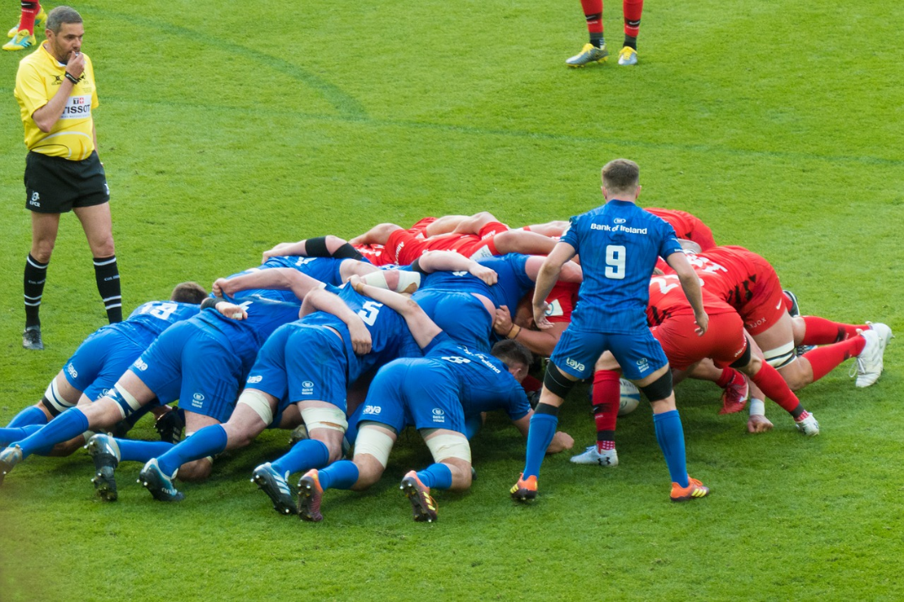

Agile Scrum Framework

|  |  |
| --- | --- |
| Stakeholderkontakt |  |
| Produktinhaber |  |
| Backlogartikel |  |
| Produktbacklog |  |
| Entwicklungsteam |  |
| Arbeitsprognose durch das Team zur Erreichung des Sprintziels |  |
| Sprintplanung |  |
| Thema 1: Backlogartikel prognostizieren |  |
| Thema 2: Arbeit (z.B. Aufgaben) planen |  |
| Sprintbacklog |  |
| Produktbacklog anpassen |  |
| Daily Scrum |  |
| Sprint (max. 1 Monat) |  |
| Scrum Master |  |
| Iterative, inkrementelle Entwicklung und Lieferung |  |
| Potentiell freigebbares Inkrement |  |
| Sprintprüfung |  |
| Sprint-Retrospektive |  |

Agile Scrum-Ereignisse

|  |  |
| --- | --- |
| Ereignisse |  |
| Sprintplanung |  |
| Daily Scrum |  |
| Sprintprüfung |  |
| Sprint-Retrospektive |  |
| Produktbacklog |  |
| Sprintbacklog |  |
| Inkrement |  |
| Sprint |  |

Extreme Programming

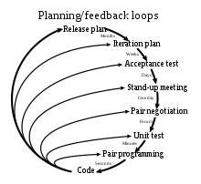

|  |  |
| --- | --- |
| Planung/Feedback-Loop |  |
| Release-Plan |  |
| Monate |  |
| Iterationsplan |  |
| Wochen |  |
| Akzeptanztest |  |
| Tage |  |
| Stand-Up-Meeting |  |
| Ein Tag |  |
| Verhandlung im Programmiererpaar |  |
| Stunden |  |
| Modultest |  |
| Minuten |  |
| Paarprogrammierung |  |
| Sekunden |  |
| Code |  |

Prinzipien des Lean Management

|  |  |
| --- | --- |
| Kundenbedürfnisse |  |
| Wert ermitteln |  |
| Wertstrom abbilden |  |
| Workflow entwerfen |  |
| Pull-System einführen |  |
| Prozess verbessern |  |

Vergleich der Methoden des agilen und des klassischen Projektmanagements

|  |  |
| --- | --- |
| Anforderungen |  |
| Kunde |  |
| Dokumentation |  |
| Größenordnung des Projekts |  |
| Organisationsstruktur |  |
| Modellpräferenzen |  |
| Klassisches Projektmanagement |  |
| Klare Anforderungen und wenig Änderungen |  |
| Nehmen nicht am Prozess teil |  |
| Formale Dokumentation |  |
| Groß |  |
| Linear |  |
| Anpassung an Änderungen |  |
| Agiles Projektmanagement |  |
| Klare Anforderungen und viele Änderungen |  |
| Enge Zusammenarbeit |  |
| Implizites Wissen |  |
| Klein bzw. mittelgroß |  |
| Iterativ |  |
| Änderungen im Voraus bedenken |  |

DevOps-Pipeline

|  |  |
| --- | --- |
| Planen |  |
| Entwickeln |  |
| Build |  |
| Testen |  |
| Release |  |
| Bereitstellen |  |
| Ausführen |  |
| Überwachen |  |

DevOps mit kontinuierlicher Integration und Bereitstellung

|  |  |
| --- | --- |
| Planen |  |
| Entwickeln |  |
| Build |  |
| Testen |  |
| Release |  |
| Bereitstellen |  |
| Aufrühren |  |
| Überwachen |  |
| Kontinuierliche Integration |  |
| Kontinuierliche Lieferung |  |
| Kontinuierliche Software-Verteilung |  |

Monolithische Architektur im Vergleich zur Microservice-Architektur

|  |  |
| --- | --- |
| Monolithische Architektur |  |
| Benutzeroberfläche |  |
| Geschäftsebene |  |
| Datenschnittstelle |  |
| DB |  |
| Microservice-Architektur |  |
| Microservice-Benutzeroberfläche |  |
| Microservice |  |

Kontinuierliche Integration und Bereitstellung anhand von Git, Jenkins, Docker und Kubernetes

|  |  |
| --- | --- |
| Quellen committen |  |
| Git |  |
| Erstellen und testen |  |
| Jenkins |  |
| Bereitstellen |  |
| Image pushen |  |
| Docker |  |
| Image pullen |  |
| Kubernetes |  |

Docker-Komponenten

|  |  |
| --- | --- |
| Client-Docker-CLI |  |
| REST-API |  |
| Server-Docker-Daemon |  |
| Docker |  |
| Managt |  |
| Netz |  |
| Container |  |
| Image |  |
| Datenvolumen |  |

Docker-Image im Vergleich zu Docker-Container

|  |  |
| --- | --- |
| Docker-Image |  |
| Docker-Images |  |
| Image-Registrierung |  |
| Docker ausführen |  |
| Ist eine Instanz von |  |
| Docker-Container |  |
| Docker ps -a |  |
| Host-Betriebssystem |  |

Übersicht des Docker-Lebenszyklus

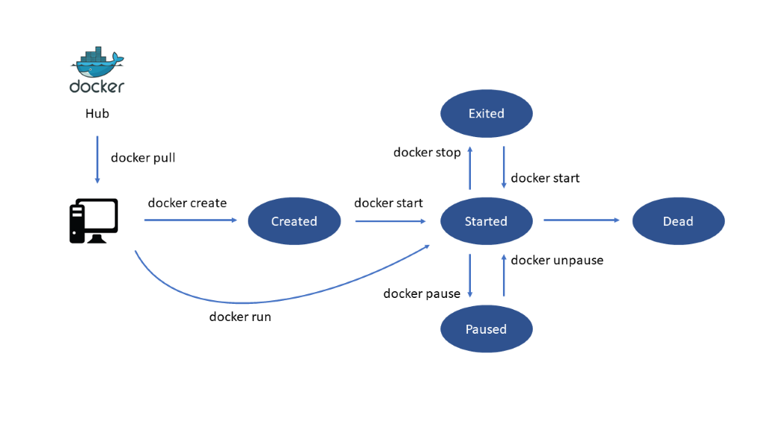

|  |  |
| --- | --- |
| Docker |  |
| Hub |  |
| Docker-Pull |  |
| Docker erstellen |  |
| Docker ausführen |  |
| Erstellt |  |
| Docker starten |  |
| Beendet |  |
| Gestartet |  |
| Angehalten |  |
| Docker stoppen |  |
| Docker erneut starten |  |
| Docker anhalten |  |
| Ende |  |

Kontinuierliche Integration und Bereitstellung anhand von Git, Jenkins, Ansible, Docker und Kubernetes

|  |  |
| --- | --- |
| Quellen committen |  |
| Git |  |
| Erstellen und testen |  |
| Jenkins |  |
| Liefern |  |
| Ansible |  |
| Image pushen |  |
| Bereitstellen |  |
| Docker |  |
| Image pullen |  |
| Kubernetes |  |

Kubernetes-Cluster

|  |  |
| --- | --- |
| Kubelet |  |
| Docker |  |
| Knoten |  |
| Master |  |
| Kubernetes-Cluster |  |

Kubernetes-Pods

|  |  |
| --- | --- |
| Kubelet |  |
| Docker |  |
| Pod |  |
| Knoten |  |

API-zentrische Ansicht

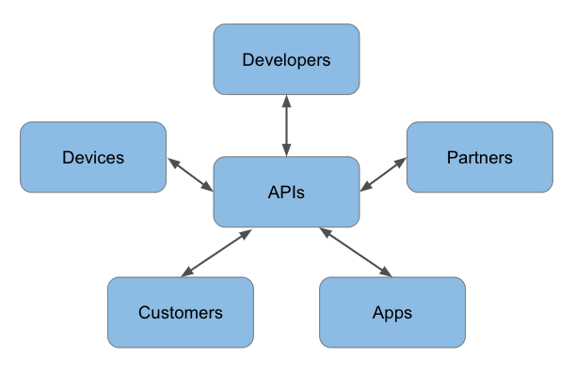

|  |  |
| --- | --- |
| APIs |  |
| Entwickler |  |
| Partner |  |
| Apps |  |
| Kunden |  |
| Geräte |  |

Marick’s Test Quadrant

Technology Facing

Business Facing

Development Support Facing

Product Critique

|  |  |
| --- | --- |
| Business facing |  |
| Technology facing |  |
| Development support |  |
| Product critique |  |
| Q2 |  |
| Funktionale Akzeptanztests |  |
| (Automatisiert) |  |
| Q3 |  |
| Usability-Tests |  |
| Explorative Tests |  |
| Vorzeigeprojekt |  |
| (Manuell) |  |
| Q1 |  |
| Modultests |  |
| Integrationstests |  |
| Systemtests |  |
| Q4 |  |
| Nicht-funktionale Akzeptanztests |  |
| (Manuell/Automatisiert) |  |

Testautomationspyramide

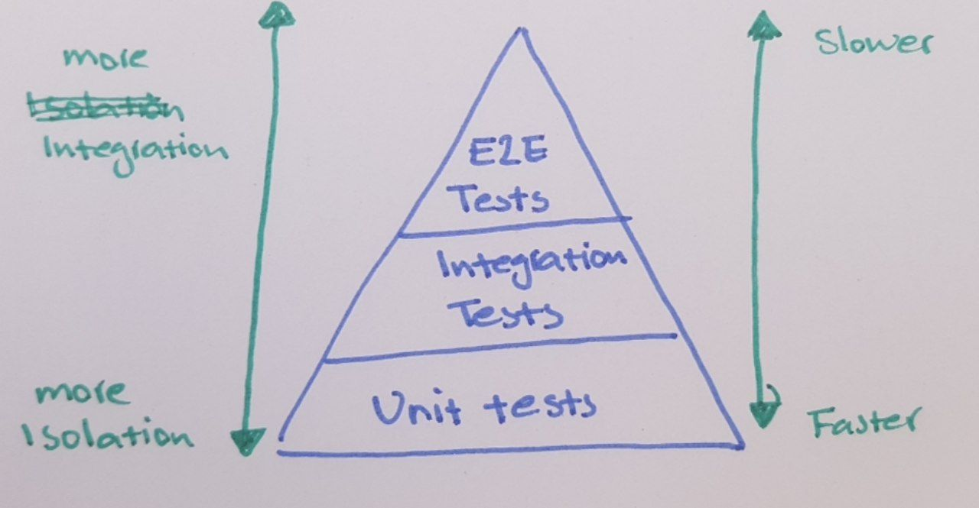

|  |  |
| --- | --- |
| Integrierter |  |
| Weniger integriert |  |
| E2E tests |  |
| Integrationstests |  |
| Modultests |  |
| Schneller |  |
| Langsamer |  |

Components Involved in the ML Model Building

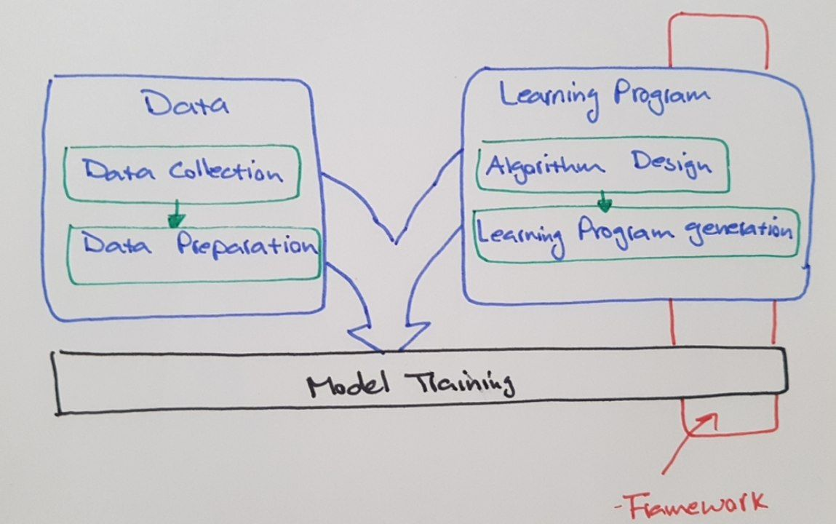

|  |  |
| --- | --- |
| Daten |  |
| Datensammlung |  |
| Datenaufbereitung |  |
| Modelltraining |  |
| Learning program |  |
| Algorithm design |  |
| Learning program generation |  |
| Framework |  |

Lebenszyklus der testgetriebenen Entwicklung

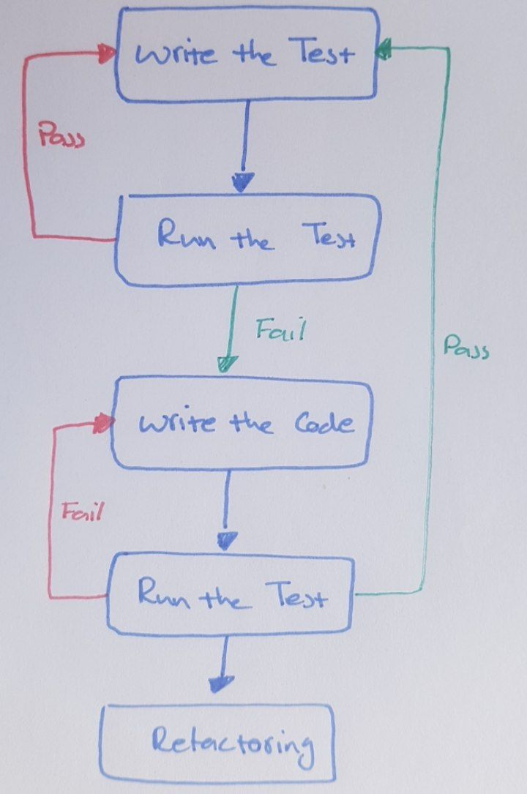

|  |  |
| --- | --- |
| Test schreiben |  |
| Test ausführen |  |
| Code schreiben |  |
| Refactoring |  |
| Pass |  |
| Fail |  |

TDD Cycle

|  |  |
| --- | --- |
| Write a failing test |  |
| Make the test pass |  |
| Refactor |  |

TDD versus BDD versus ATDD

|  |  |  |  |
| --- | --- | --- | --- |
|  | **TDD** | **BDD** | **ATDD** |
| **Definition** | Is a development approach to implement a feature | Is a development approach based on the system behavior | Is a development approach for capturing the requirements (similar to BDD) by writing acceptance tests before implementing the relevant functionality. |
| **Main focus** | Modultests | Understanding requirements based on system behavior | Writing acceptance tests |
| **Participants** | Developers | Developers, customers, quality assurance engineers | Developers, customers, quality assurance engineers |
| **Language** | Similar to the main code | Plain English | Plain English |

|  |  |  |  |
| --- | --- | --- | --- |
|  |  |  |  |
|  |  |  |  |
|  |  |  |  |
|  |  |  |  |
|  |  |  |  |

Continuous Delivery (CD) Pipeline

|  |  |
| --- | --- |
| Code commit |  |
| Build |  |
| Akzeptanztest |  |
| Performanztest |  |
| Produktion |  |

Orchestrated Experiment

|  |  |
| --- | --- |
| Datenvalidierung |  |
| Datenaufbereitung |  |
| Modelltraining |  |
| Modellbewertung |  |
| Modellvalidierung |  |

CI/CD for an ML Model

|  |  |
| --- | --- |
| Development & experiment |  |
| Pipeline CI |  |
| Pipeline CD |  |
| Kontinuierliches Training |  |
| Kontinuierliche Lieferung |  |
| Überwachung |  |

Lokales Versionsverwaltungssystem

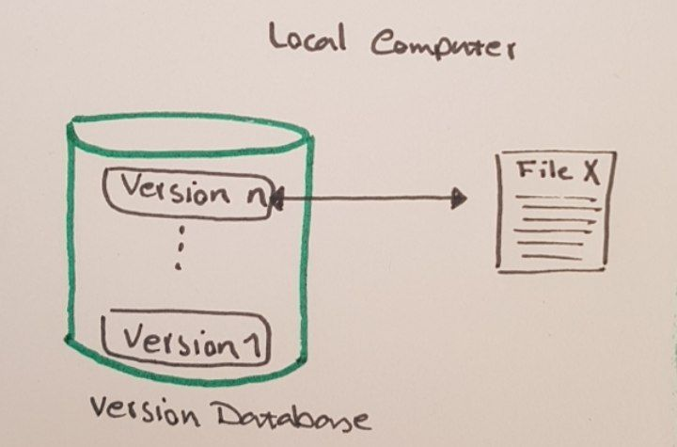

|  |  |
| --- | --- |
| Lokaler Computer |  |
| Version N |  |
| Version 1 |  |
| Versionsdatenbank |  |
| Datei X |  |

Zentrales Versionsverwaltungssystem

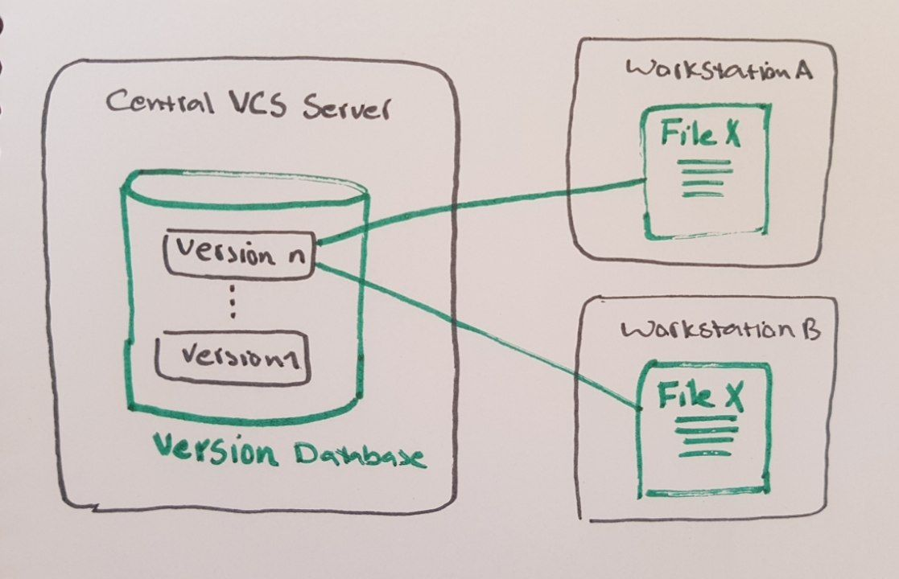

|  |  |
| --- | --- |
| Zentraler Server |  |
| Version N |  |
| Version 1 |  |
| Versionsdatenbank |  |
| Workstation A |  |
| Datei X |  |
| Workstation B |  |

Verteiltes Versionsverwaltungssystem

|  |  |
| --- | --- |
| Server |  |
| Workstation A |  |
| Workstation B |  |
| Datei X |  |
| Version N |  |
| Version 1 |  |
| Versionsdatenbank |  |

|  |  |
| --- | --- |
| Version 1 |  |
| Version 2 |  |
| Version 3 |  |
| Version 4 |  |
| Datei A |  |
| Datei B |  |

Sections in a Git Project

|  |  |
| --- | --- |
| Working directory |  |
| Staging area |  |
| .git directory |  |
| (Repository) |  |
| Checkout the project |  |
| Stage fixes |  |
| Commit |  |

Git Local Repository Trees

|  |  |
| --- | --- |
| Add |  |
| Commit |  |
| Working directory |  |
| Index |  |
| (Stage) |  |
| Head |  |

Branching in GitHub

|  |  |
| --- | --- |
| ‘Master’ branch |  |
| Create ‘side’ branch |  |
| Commit changes |  |
| Pull in request |  |
| Discuss changes |  |
| Merge ‘side’ to the ‘master’ |  |

IDE Syntax Highlighting

|  |  |
| --- | --- |
| import pandas as pd |  |
| import matplotlib.pyploy as plt |  |
| import datetime |  |
| from datetime import datetime |  |
| import plotly as pltly |  |
| import plotly.express as px |  |
| import plotly.graph_objs as go |  |
| import plotly.io as pio |  |
| from PIL import Image |  |

Eclipse IDE Components

Jupyter Notebook Landing Page

A Jupyter Notebook (.jpynb File)

Using Jupyter Notebook to Run a Simple Python Code

Using Markdown to Document the Code in Plain Text in a Jupyter Notebook

In-line Visualization in Jupyter Notebook

API-zentrische Ansicht

|  |  |
| --- | --- |
| Entwickler |  |
| APIs |  |
| Partner |  |
| Apps |  |
| Kunden |  |
| Geräte |  |

First Lines of a Dataset With .head()

|  |  |
| --- | --- |
| Out[15]: |  |
| SepalLengthCm |  |
| SepalWidthCm |  |
| PetalLengthCm |  |
| PetalWidthCm |  |
| Species |  |
| Iris-setosa |  |

Summary Statistics of a Dataset With .describe()

|  |  |
| --- | --- |
| In [16]: 1 iris_df.describe( ) |  |
| Out[16]: |  |
| SepalLengthCm |  |
| SepalWidthCm |  |
| PetalLengthCm |  |
| PetalWidthCm |  |
| Count |  |
| Mean |  |
| Std |  |
| Min |  |
| Max |  |

Example of a Scatterplot to Visualize Relationships Between Features

|  |  |
| --- | --- |
| Relationship between sepal length and width |  |
| Sepal width |  |
| Sepal length |  |
| Setosa |  |
| Versicolor |  |

Modellentwicklung und Produktionslebenszyklus (I)

|  |  |
| --- | --- |
| Problem understanding |  |
| Datensammlung |  |
| Cleaning wrangling |  |
| Exploratory data analysis |  |
| Experimentation, feature, and model selection |  |
| Hyperparameters tuning |  |
| Training, final selection |  |
| Initial deployment and integration |  |
| Deployment in production |  |

Modellentwicklung und Produktionslebenszyklus (II)

|  |  |
| --- | --- |
| Experimental phase |  |
| Identify problem and collect and analyze data |  |
| Choose an ML algorithm and code your model |  |
| Experiment with data and model training |  |
| Tune the model hyperparameters |  |
| Iterate tuning and training |  |
| Production phase |  |
| Transform data |  |
| Train model |  |
| Serve the model for online/batch prediction |  |
| Monitor the model’s performance |  |

Modellentwicklung und Produktion mit Kubeflow

|  |  |
| --- | --- |
| Experimental phase with Kubeflow |  |
| Identify problem and collect and analyze data |  |
| Choose an ML algorithm and code your model |  |
| Experiment with data and model training |  |
| Tune the model hyperparameters |  |
| Iterate tuning and training |  |
| PyTorch |  |
| scikit-learn |  |
| TensorFlow |  |
| XGBoost |  |
| Jupyter Notebook |  |
| Fairing |  |
| Pipelines |  |
| Katib |  |
| Produktionsphase mit Kubeflow |  |
| Transform data |  |
| Train model |  |
| Serve the model for online/batch prediction |  |
| Monitor the model’s performance |  |
| Chainer |  |
| MPI MXNet |  |
| TFJob |  |
| KFServing |  |
| NVIDIA TensorRT |  |
| PyTorch |  |
| TFServing |  |
| Seldon |  |
| Metadata |  |
| TensorBoard |  |
| Pipelines |  |

Umgang mit diesen Werkzeugen

|  |  |
| --- | --- |
| Vorsicht! |  |
| Diese Maschine hat kein Gehirn. Bitte das eigene verwenden. |  |

SageMaker Administrative Console

Granting Access to IAM Roles

