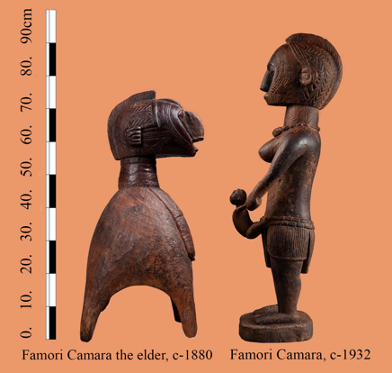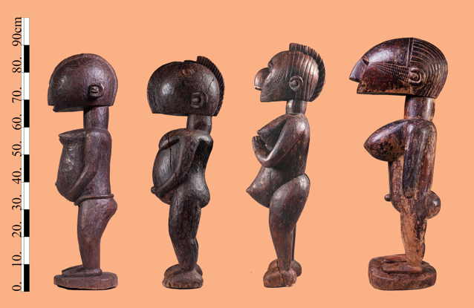**Amani Famori Camara**

**Amadi Famori Camara, born in Faraba Guinea in 1885.**

Four statues with outstanding abstract characteristics, once part of the the Katako hoard. These were later joined by two additional exceptional pieces from Henriette Conté’s estate. Close examination reveals that all six display characteristics of a unique master hand, a mature artist with a personal vocabulary who commanded a technique to match. Five have been dated with infrared spectrography to circa 1930–1950, while an older small Nimba of extremely condensed wood has been dated to 1880.

All are carved out of dense and heavy African teak, and nearly all measure nearly the same height range of 80–90 cm. All were immediately recognized by the Baga elders and by master Bangoura as works of the master Famori Camara, a renowned Baga sculptor who was part of the creative hub in Faraba prior to Guinean independence. Master Bangoura proudly aligned himself and his work with that of Camara, and even claimed to be one of his descendants.

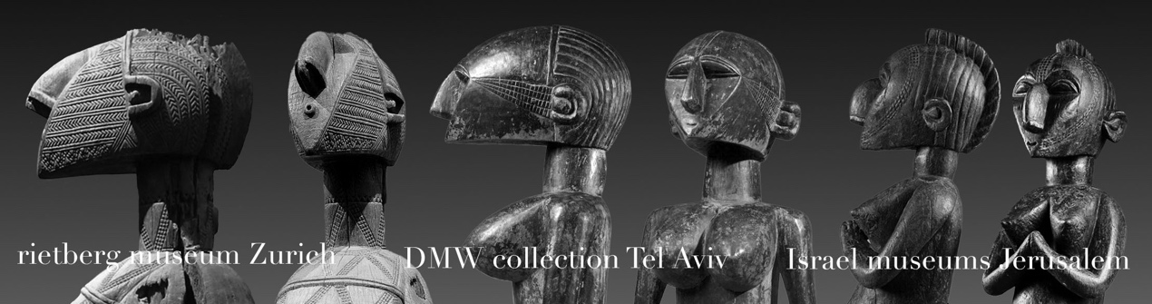An analysis of Camara’s work clearly reveals his language. He possessed the ability to reinterpret and modernize the traditional Baga canon, while using semi-abstract shapes and myriad geometric patterns to depict old age.

Camara developed a language in which the traditional ornate vocabulary was gradually reduced to a collage of primary shapes. He constructed the orthodox Nimba’s “Fulani” facial ornament from straight and rigorous geometric lines. Camara also reduced the ear to a circle surrounded by a concave half moon. All the Baga elders described this feature as “Famori’s personal mark,” an observation further supported by a comparison of it to the ears of works similar to Camara’s that are currently in Western museums, such as those in the Rietberg Museum, the Yale African Art Gallery and the museum of Berg en dal Netherlands—all works that might therefore be claimed as belonging to Famori Camara’s 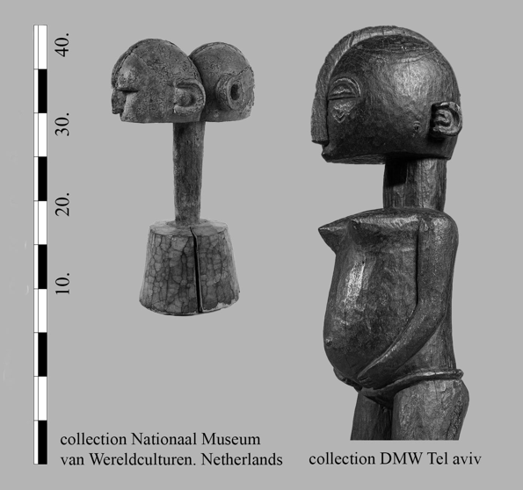oeuvre.

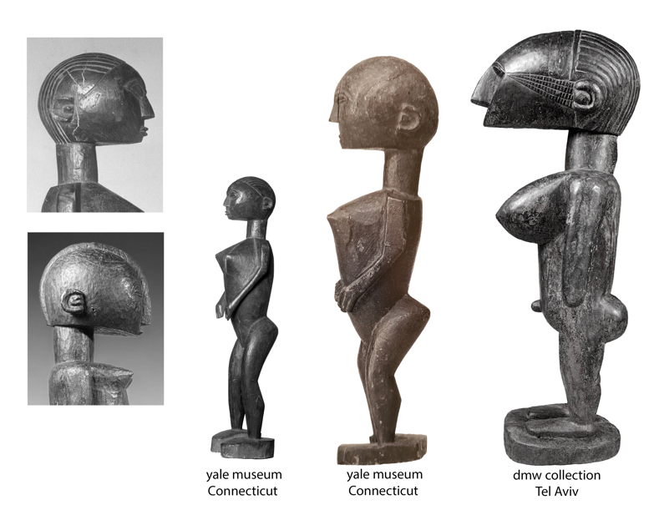This wonderful small nineteenth-century Nimba, whose right face has been leveled by countless loving strokes of hands during its long years of service, is attributed to Camara’s father (an artist considered by everyone as a forebear of the Katako sculptors ) and has a slightly different ear mark.

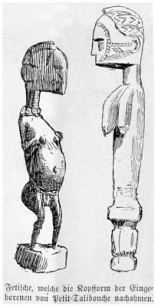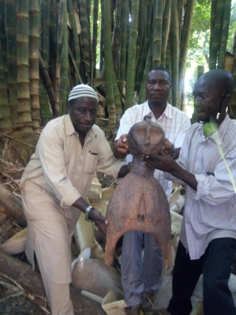A drawing of additional works resembling those made by this hand was published in 1886 by G. Caspar Felix in his account of his trip down the River Nunez, a trip embarked upon again only half a century later by Fred Bowald.

Master Famori Camara worked in the the 1930s and 1940s, a time when the colonial regime and its representatives in Katako, the French catholic mission, were at the zenith of their power and Christianity was slowly being integrated into Baga life. A glimpse of how Camara’s art could have evolved had the jihad and the subsequent destruction of Baga culture not occurred can be gleaned by comparing this singular interpretation of a standing Nimba, her hands clasped in a classic Christian gesture of prayer, with eyes turned upwards and her lips smiling, to the traditional Nimba, whose hands are clasped beneath her chin in a vow of silence, her eyes downcast, and her mouth closed to signify secrecy. One is a figure denoting power to whom worship is due, while the other is a mediator between God and her community.

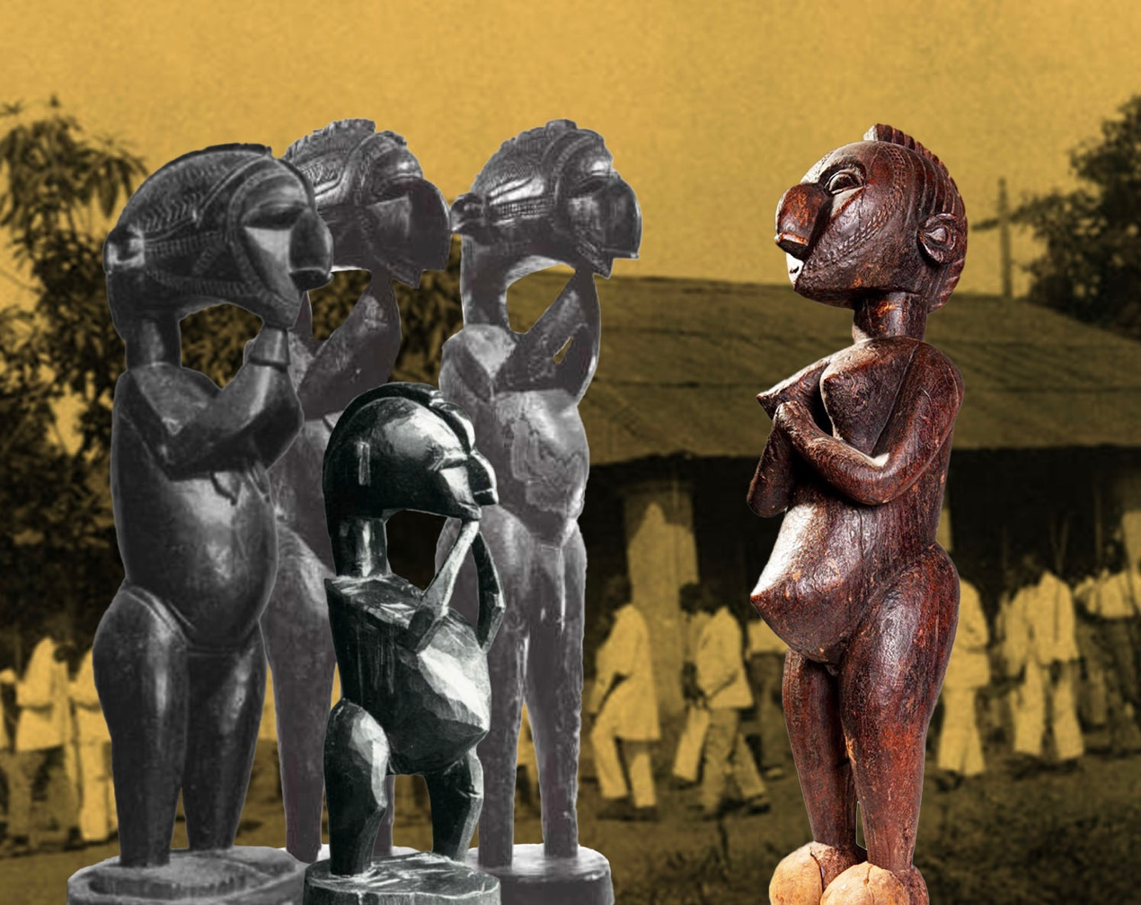

Camara’s work clearly shows that he was preoccupied with formalist and conceptual problems similar in nature to those of fellow Western European modern artists.

His oeuvre challenges the last century’s boundaries between and definitions of traditional versus modern art, White and Black, Western and African.