**Foté Camara**

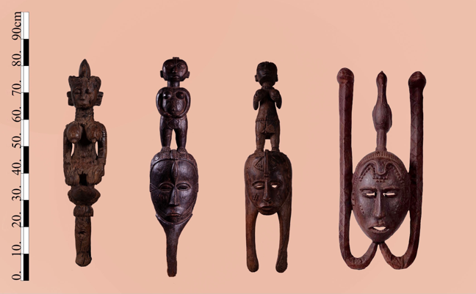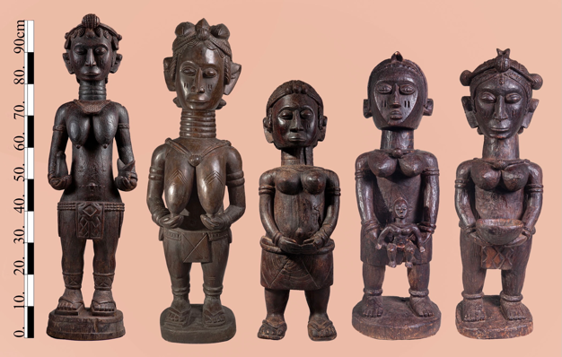

**Barbady Foté Camara, born in Tolkotch-Taigbé Falaba 1885**

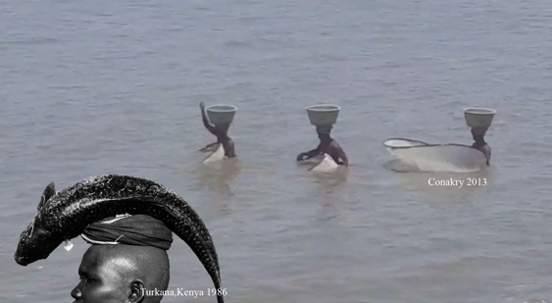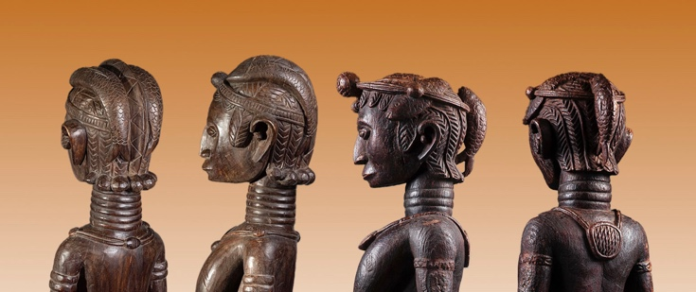Master Foté Camara was one of the most prolific and renowned Baga artists of the first half of the twentieth century. His fame spread widely throughout the Bagaland. Camara’s distinctive figurative style became extremely popular with the women’s secret associations, which, acting as the artist’s patrons, commissioned him to create numerous works for their ritual paraphernalia. Possession of a piece of such caliber and its presentation to new initiates during ceremonies was considered a sign of great status and a symbol of power for the entire secret society.

Many of Camara’s surviving works depict fish interlocked in elaborate female coiffeurs. Such figures have elongated ringed necks symbolizing beauty, downcast eyes, and a closed mouth denoting secrecy and unity. Their braided hair represent self-care and cultivation, and images of fish refer to an abundance of game and fertility (fishing was one of the women’s societies’ duties). Camara’s ability to combine all these symbols in a unified 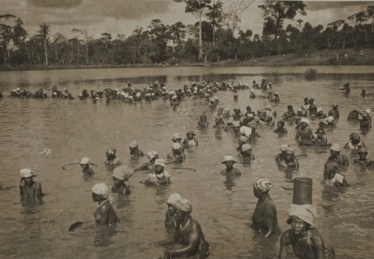sculptural figure is indeed unique.

*George Labitte , Nezekore, Guinea, 1940*

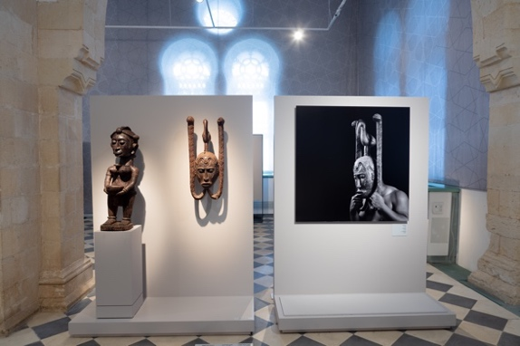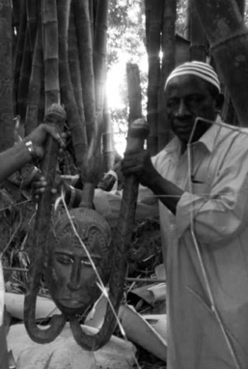Most of the masks of the men’s associations were destroyed in the 1958 jihad since they were regarded as armaments. Targeted by rebellious youth, their destruction was one of the first actions by the revolution. The importance of those that survive (Mask Museum, Scotland ) has never been realized. Three such masks by Camara were uncovered from the Katako hoard. Two of them are featured in the Israel Museum Jerusalem exhibit, *Nimba, Baga Art and the Great Mother.* A third one is now in the Be’er Sheva Islamic Art Museum’s *Gold Road Encounters* exhibit.

Camara’s hand and manner are easily recognizable. His compositions are static, frontal, and lavishly decorated, recalling classic European portraits. His beautifully rendered creations embody archaic monolithic omnipotent beings.

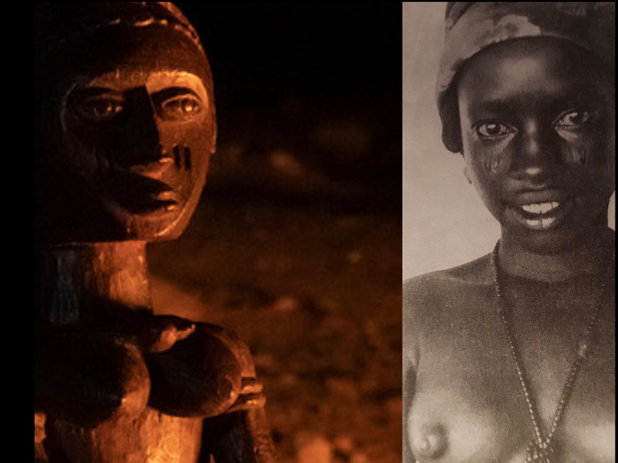Camara’s talent was so unique that his art was recognized by everyone without the help of any distinctive mark as signature. One is always drawn to his naturalistic all-consuming eyes, which, when illuminated by a red cascade of flickering flames (unlike the even, monochrome lighting in the museum), as they were in the women’s sacred forest, immediately spring to life.

Foté Camara’s greatness is evident in his archetypical portraits of Baga females, each representing a specific age group—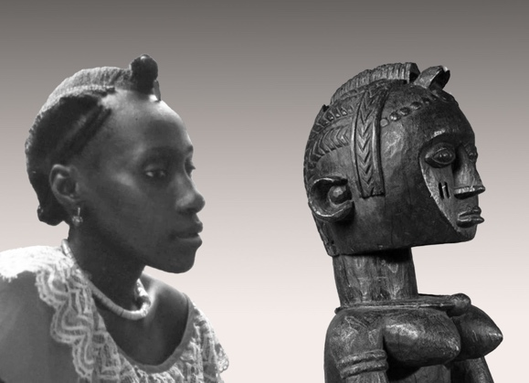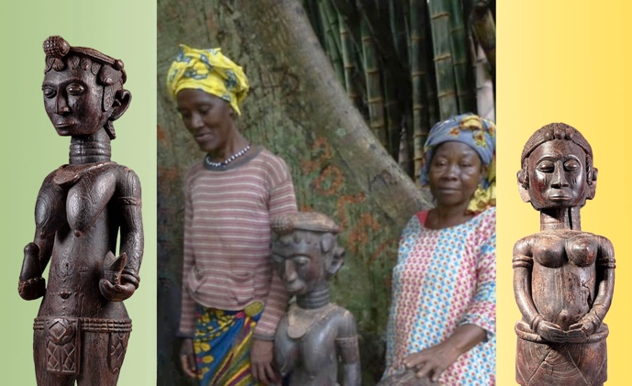young initiates, members, and elders—each typical of the group rather than a portrait of a specific individual.

When the idealized images are set alongside actual photos of Baga members taken years apart ( the statues were made in the 1930s, years before the older and younger members posing with them in Katako’s forest were ever born), Camara’s ability to capture the essence of his Baga patrons becomes apparent.

The works demonstrate incredible eidetic ability, especially bearing in mind that all the statues were carved from extremely hard wood with a single hand equipped with a traditional adze and no preparatory sketches. Camara’s figurative aspirations marked a clear break from tradition, which was usually strictly observed. So, for instance, the sound of the modern flute was banned from all festivities due to its similarly to the sound of a spirit. Nevertheless, Foté Comara’s art was praised by his peers and achieved immense popularity.

Post independence, his art was carefully guarded, kept away from the sight of the uninitiated for more then half a century, and made public only upon Henriette Conté’s death.

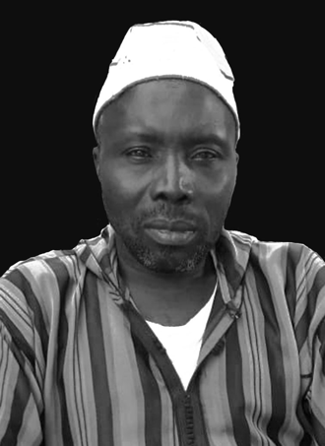Master Camara was succeeded by a son, born in 1930, with whom the practice ended. His grandson, Andre Foté Camara, was happy to recall that his illustrious grandfather had been a devout Muslim who made his living by fishing in the River Nunez Delta leading to the ocean.

*Andre Foté Camara, Faraba, Guinea , 2020.*