**El Hadje Ali Manigué Bangoura, born in Tolkoch 1895.**

El Hadje Ali Manigué Bangoura, born in Tolkotch, Taigbe Kamala, 1895.

George Bangoura, born in Tolkotch, Taigbe Kamala, 1930

Abou Bacar Petro Bangoura, the last heir, born in 1953

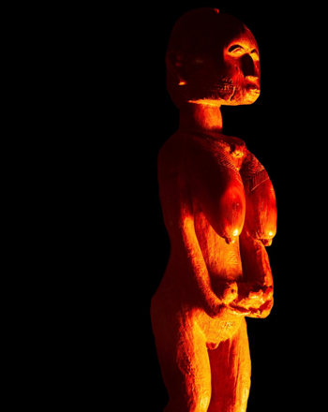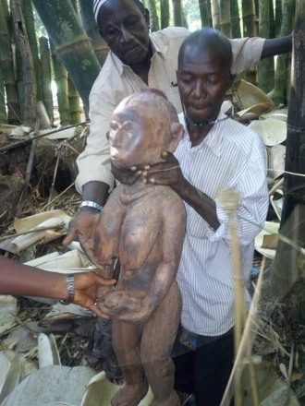

One of the most striking sculptures to emerge from the Katako hoard is that of an elderly female baga, 102 cm tall. The statue, whose face is a blend of human and Nimba, and whose exaggerated breasts and genitalia proclaim age and maturity, depicts the Baga ideal of the great mother; one who has given birth to many and is now an elder nourishing her community.

The figure’s face and breasts have been polished by countless caressing hands, whose ritual repetitive movements from top to bottom, from the cheeks down to the breasts, can be easily traced. When illuminated as intended by the flickering light of natural flames, the true nature and power of the statue becomes apparent: a mother solemnly holding a dead child’s body in her outstretched hands in a gesture of compliance, dignity, and grief.

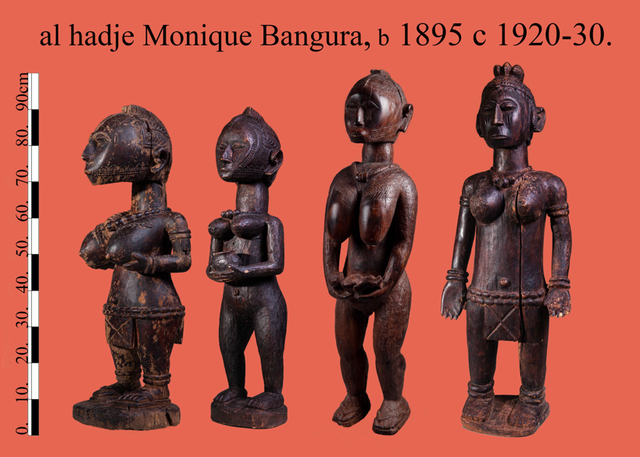This work was later joined by three additional pieces from the estate of Guinea’s First Lady Henriette Conté to form a group of four major works, all clearly crafted by the same hand.

As was common, the unique rendering of a human ear served as the artist’s personal mark, thereby expressing authorship without compromising the work’s liturgical powers. Among the other characteristics portrayed in the sculptures is the quest for human emotion, as evident in the powerful figure of the elder demanding total obedience, or the young disciple solemnly offering a tribute.

The community elders who were consulted identified the artist as Manigué Bangoura, a renowned artist from Faraba, (the River Nunez Delta) who later converted to Islam and made the pilgrimage to Mecca.

On a trip to El Hadje Bangoura’s birthplace, we were fortunate to meet his grandson, Abou Bachar Petro Bangoura, born in 1953, who continues with his grandfather’s profession and supplies local communities with the objects needed to maintain their community traditions.

Petro Bangoura is the son of George Bangoura (El Hadje Bangura’s son), also a known Baga sculptor. Petro Bangoura proudly sees himself as heir to his grandfather’s legacy and takes special pride in using his ancestor’s cherished handcrafted chair.

