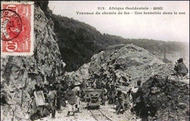The first half of the twentieth century was a time of prosperity for most of deep rural Baga. Its centuries-old arch enemy, the Fulani Muslim cavalry, had by now been subdued by French forces, and slave hunting expeditions had come to an end. The Baga’s safe haven amid the mangrove swamps of the River Nunez was too secluded to be of any interest to the central French colonial administration, which by then had ceased mandatory recruitment, and desisted from direct rule. Apart from the few who joined rare expeditions, westerners could not tolerate the Guinean climate or health hazards involved in visiting the Bagaland.

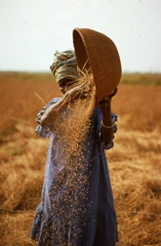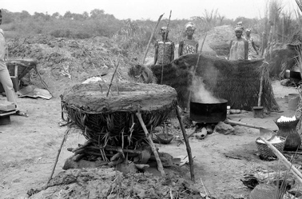The Baga community was thus able to thirve. Its highly developed subsistence rice farming enabled the elders to meet the French colonials tax quotas with no difficulty. It maintained

contact with the central French regime, a responsibility entrusted to the Bangoura family in Katako and the French missionaries.

The Baga credo, “*We Baga rice and salt,”* encompassing all aspects of Baga life, was literally put into practice by this proud rural agriculture community that devoted itself to intensive collective subsistence rice farming and that was organized according to age-old social structures based on gender and age.

In order to function and meet the challenges of communal farming, the society had to maintain a strict semi-voluntary rule that included all its members.

Even today, when neighboring groups are interviewed about the Baga, they often use the phrase: “They love their village too much.”

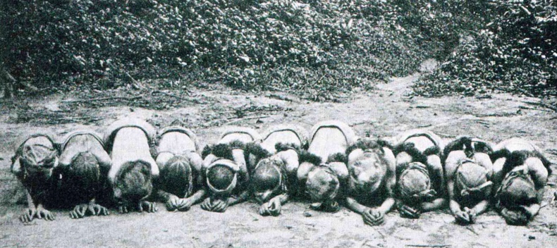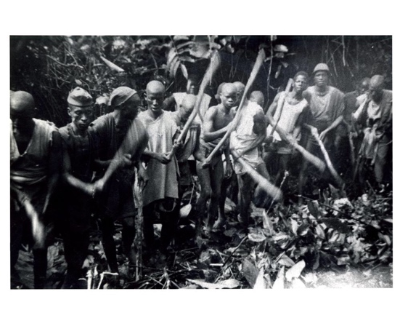Until the 1950s, all youth were sent to the “bush school,” attendance at which was a prerequisite for attaining adult status.

Male youth spent up to three years secluded in the bush, instructed by the elders on all the skills—social and professional—deemed necessary for leading an adult life. Upon returning to the village, they were expected to fulfill the traditional role established by their peers.

The bush school for girls lasted much less time and was held on the premises of the women’s society, an off-boundary secluded hut located at the village’s eastern perimeter. The girls spent several months in seclusion mastering their expected role as wives and mothers, and, most importantly, cultivating interdependence, secrecy, and loyalty to their fellow women. In this way, they came to serve as the backbone of Baga rural society and to maintain their power over village commerce and social well-being as a unified, coherent labor force and political group, responsible for the village commerce and social well-being.

The various women’s secret societies maintained their power and secrecy throughout the twentieth century, notwithstanding the onslaught of Sekou Touré’s Marxist regime. They ceased to operate only at the dawn of the twenty-first century, when the collapse of subsistence farming and the rise of mass Chinese rice imports opened Guinea to global international trade.

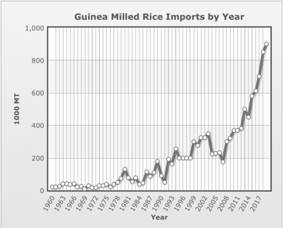

After Guinean independence in 1958, all male bush schools were strictly outlawed.

Unlike other groups that sent their children to bush schools or related groups in Liberia, the Baga were completely surrounded by the Muslim Susu population. For Baga men, this rupture in their highly structured life-cycle was a key moment in their descent,eloquently summarized in their adage: “*Once we were Baga, now we are Susu.”*

As in most acephalic West African societies, the Baga’s position in life was predetermined by birthright—offspring of first wife, second wife, etc.—as well as by the prominence of ancestors or family line. This highly deterministic social structure was balanced by a parallel structure based on age, membership in secret societies, and specific tutelage.

Such an elaborate double structure enabled each member to find his voice while

maintaining the equilibrium on which communal Baga society depended.

The Baga was a society with no concept of personal material accumulation;

wealth and status were measured in people (dependents), needed for political influence.

The society was a verbal one, with language and conversation held in high regard. Thoughts and ideas were implied rather than stated directly. Proverbs and elaborate stories were used to make a point. Decisions were reached by elders following lengthy meetings at which all adult members were expected to express their views in a delicate fashion, each in accordance with his position and rank. The overlapping sentences were shared and understood only by those of the same rank in 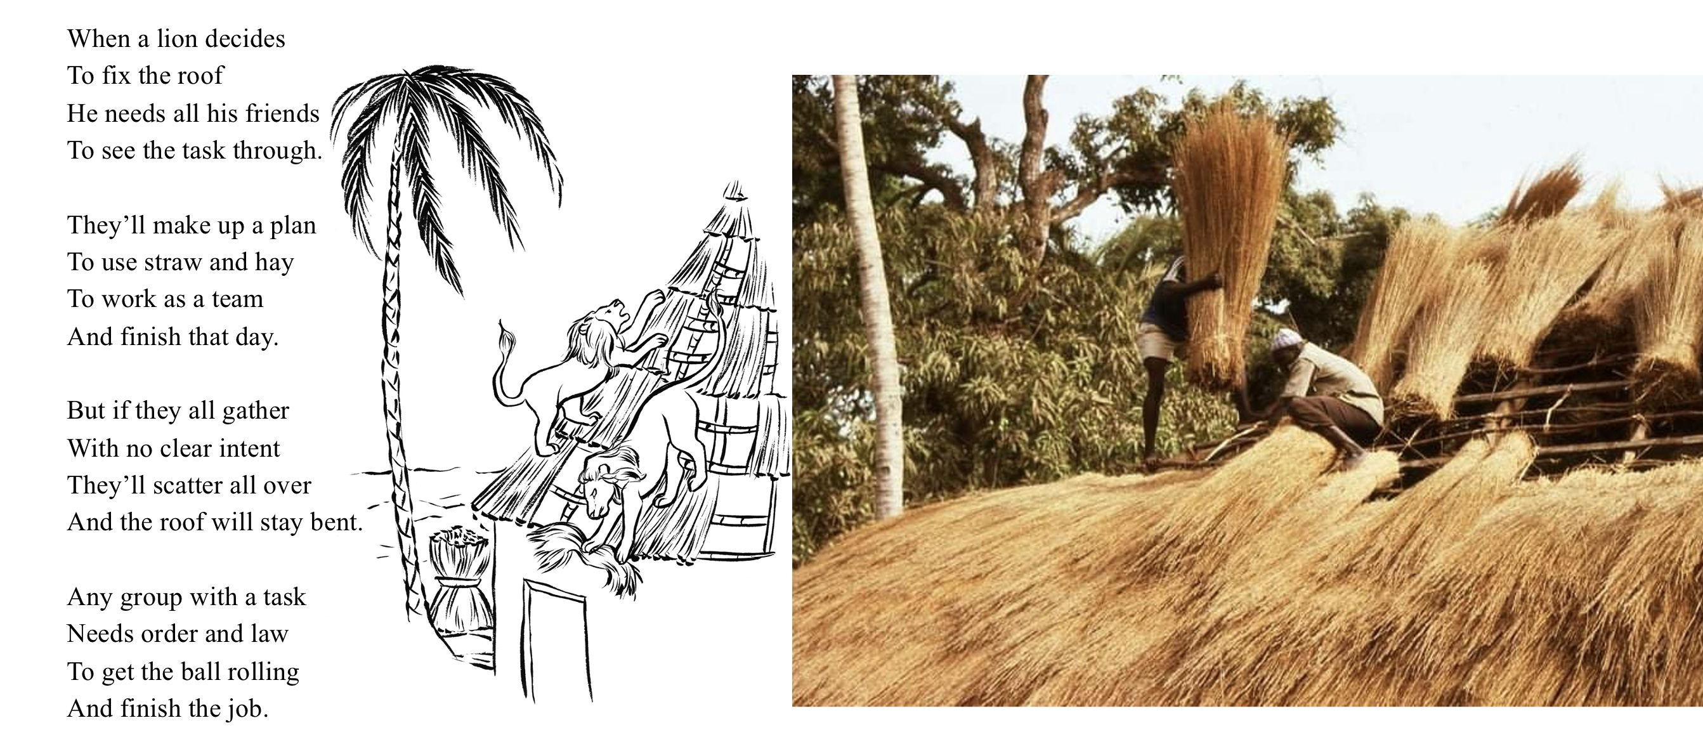parallel secret societies.

For a verbal, non-materialistic society such as this, the need for a written text was less acute. This was a society in which ancestors were present, involved in everyday life, and treated with great respect, while people were merely transient. Bagas venerated the all-encompassing forest, nature, and forces of sub-Saharan equatorial Africa, and the only physical manifestations of culture, knowledge, and memory were the three-dimensional objects produced by members of the society with the skills taught primarily at the bush school: wood carvings in the case of boys, and pottery in that of girls. Further study under a known master was pursued only by those so inclined.

After the rupture caused by the closure of the male bush school, each proclaimed master was generally succeeded by members of his direct family.

Nearly all material objects used in life were produced by members of the group.

Imported objects brought from afar, exchanged at crossroads markets set up by traveling Mandingo merchants, were of a mundane nature: jewelry, garments, medicines, or functional novelties. Everyday utilitarian objects and the customary paraphernalia, in contrast, were created by the Baga themselves with skills taught in the bush school,

For the Baga, life and art were totally interwoven. Religious objects accompanied all aspects of life and the celebrations conducted at everyday village gatherings: the setting of the bush school, graduation ceremonies, personal and extended family milestones, weddings and funerals, secret society gatherings, and religious conclaves deep in the woods.

To meet this demand, members produced an abundance of objects adhering to the conventional canon. Religious paraphernalia intended for the village masquerades were usually commissioned from local artisans, while important secret society commissions, such as power objects that proclaimed their members’ stature or the society’s power and needed to impress new recruits, were commissioned from known masters whose fame as artists extended beyond their village. At the heights of their powers, some of these artists even managed to replace farming as a living altogether with their carving . Only a few, however, elevated their practice to high art. Instead, they aspired after the profound while maintaining a dialogue with tradition and the canon.

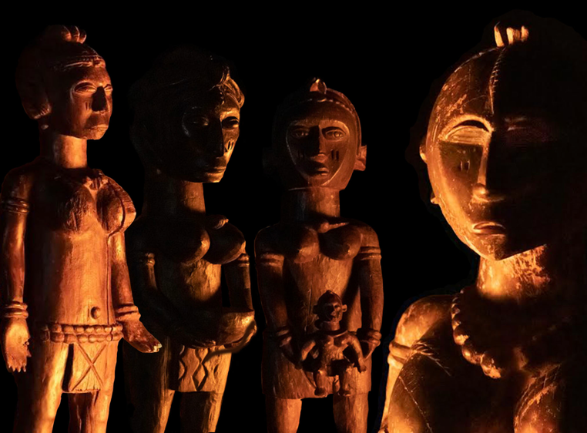The artists were known figures, recognized and appreciated by their peers. Like any artist, they were conscious of their vocation and not devoid of ego. As such, they were eager to leave their personal mark on posterity. Apart from their distinctive style and manner, they—all illiterate—developed a characteristic mark, usually a rendering of an ear or eye, in order to express their authorship.

They were also conscious of the fact that once their art was accepted, ordained by the clergy, and consecrated for ritual usage, it would be elevated to divine status. As such, it would be disassociated from its worldly creator. Most pieces were made for use in the women’s associations. The Sande *bundu* masks of the hinterlands, for example, were known to appear deep in the woods, usually near running water, and were supposed to proclaim their presence to association members in dreams without ever mentioning their male artists.

The wish to attain the divine ruled out the creation of representational portraits. However,

emblematic portraiture that relied on symbolic devices to evoke images was, as a rule, desirable. A more generalized anthropomorphic approach, however, was the norm.

One can only marvel at the eidetic capability demonstrated by these masters, who thrived by creating highly complex compositions, knowing as they did, the importance and religious status of their art within their community, and the amount of love, respect, and care that would be bestowed on their works once they were completed.

These masters were able to transform a mentally constructed visual image directly into a block of wood, and to develop the final image with no preparatory stages while carving. (Sketches have never been part of traditional West African art.)

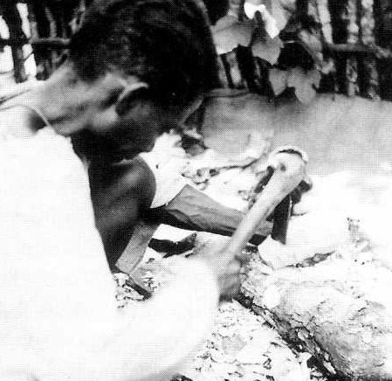Usually the artist would go and fell a tree only after having decided what he was looking for. The actual image materialized during the process of carving. When commissioning a work from these masters, members of the society usually took into account expected delays and the time required by the artist to contemplate and find his vision before producing the piece (in terms of reimbursement).

These monumental works of art were carved with a variety of sub-Saharan adzes.

Sitting or crouching on the ground, the artist carved with one hand while using his other hand, lap, thighs, and knees to hold the object in place. The production of such elaborate, precisely made sculptures with a simple adze required great concentration and technical skill. Although the Baga had a long history of trade with the West, they never resorted to industrial tools. (It takes two hands to manipulate Western carving tools.)

The artists worked within their tradition, all in close geographical proximity, each aware of the other’s accomplishments. All enjoyed full artistic license from their community. Their visual language developed from their memory of their masters’ works.

The moment a piece was delivered to the client (women’s association, etc.),

the artist never saw it again. A man could never venture into a women’s sacred grove, where these idols resided.

The Western concept of a studio that contained multiple works in process and enabled contemplation was totally alien to these artists. Each new commission had to be drawn from memory and made from scratch. Each work was unique. The artists respected the artistic heritage of their ancestors and considered it sacred.

The artists produced bodies of work that were organically bound to their community and faithful to their tradition, yet never marred by atavistic rigidity or soulless formalism.

Their creations, in fact, are wonderful examples of artistic license and tradition working in tandem to portray the divine.