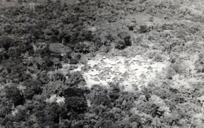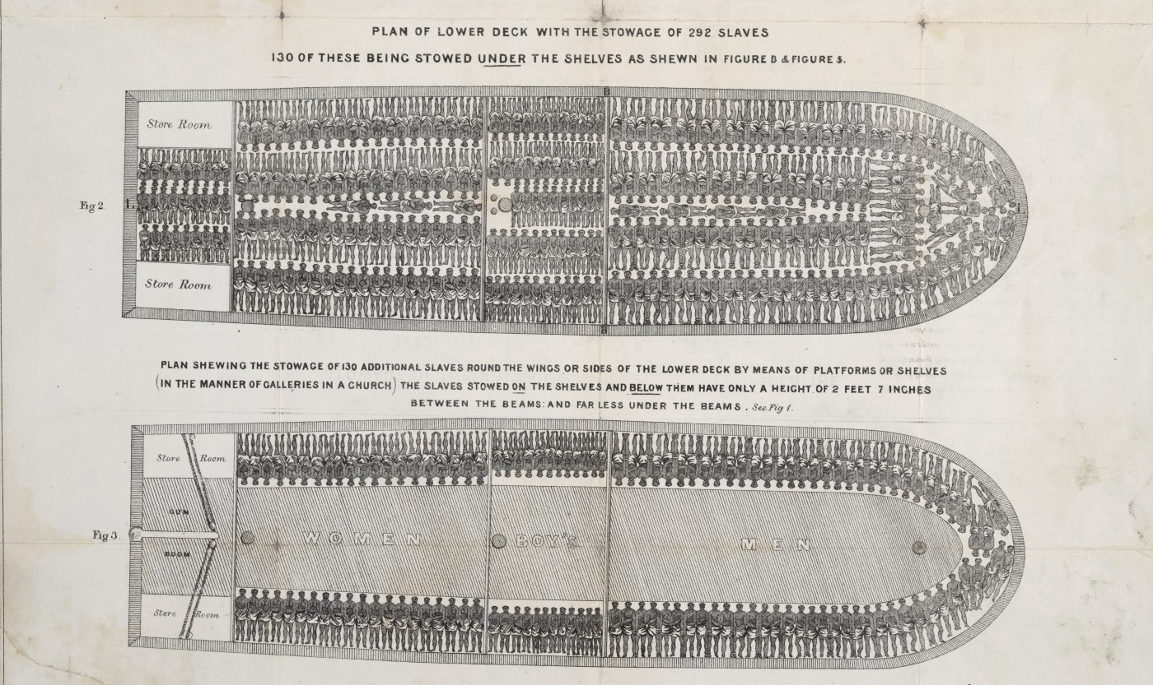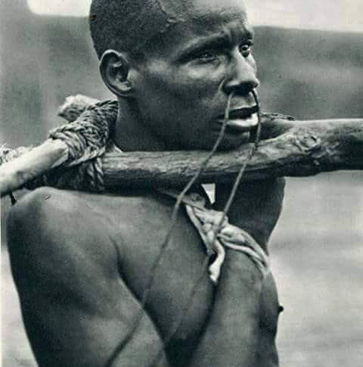From 1700 to 1900, Africa’s population remained steady at 140 million. Mass enslavement and the hunting of youths by industrialists reduced Africa’s percentage of world population from 20 to 8% within 200 years. This 12% drop reflects the terror and hardship experienced on a daily basis by natives of the Guinean coast for those 200 years.

In order to survive, most groups of the sub-Saharan rain forest lived in small, isolated hamlets, each perched strategically on a secluded mountain top. Warfare and violence were constant threats, as was the possibility of being hunted down or sold into slavery. The peaceful, non-materialistic agrarian cultures that had flourished before the slave trade had by then been relegated to a distant past. West African societies, as well as the women’s Sande initiation society, with the tortoise its totemic animal, were were ill prepared for the arrival of the notorious three C’s: Christianity, capitalism, and colonialism.



Massive migration from the savanna to the inhospitable forest in search of refuge from Muslim hunting cavalry had led to two hundred years of violence during which hunger, warfare, blood feuds, bride-kidnapping, and reciprocal raids were part of the daily routine. Colorful descriptions fueled the colonialist “pacification” agenda that enabled colonialism and mass subjugation at the dawn of the industrial area.

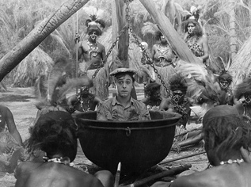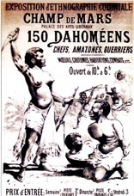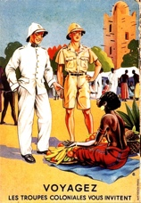

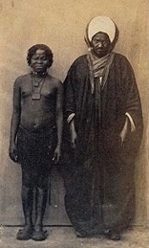The Baga, who were indigenous to the inaccessible River Nunez delta, where no domestic animal could survive, were always short of working hands and thus gladly incorporated into their ranks larger and more politically structured groups, such as Sierra Leone’s Sapi, or the Baga groups fleeing the Fouta Djallon mountains in fear of the Fulbe jihad.

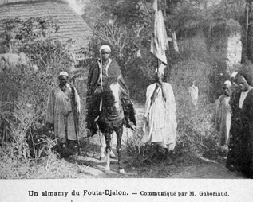

The mangrove swamps, inaccessible to the cavaliers, offered relative security, thereby enabling the development of far larger regional corporations, in which every extended household had a corresponding host family in an adjacent village. This made political alliances possible and mobilized the large work force needed to build and maintain the infrastructure required by the Baga’s intensive rice farming.

The magnitude and sheer complexity of the social structures and visual language that developed from this can be glimpsed in G. Labitte’s photo of a coming-out ceremony in the 1940s, as well as a photo of a Timba drum taken in Katako in the 1930s. The ceremony is highly structured, with an abundance of religious paraphernalia. 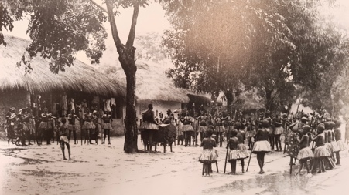The participants are all clad in identical “forest” dress uniforms while the spectators or “city folk” look on from the

surrounding verandah.

The importance of the Baga being the only Guinea forest group able to maintain and develop its distinctive culture without drawing any attention to themselves until the late 1950s cannot be overstated. This is particularly significant given that all that splendor was lost in the late 1950s, especially in the wake of the 1958 revolt from French rule and the ensuing twenty-five years of a totalitarian Marxist regime and cultural revolution.

