Dear Ladies and Gentlemen, dear colleagues:

I would like to thank the organizers very much for this invitation to speak, especially Matteo Ieva, who contacted me several weeks ago. “Ripensare la morfologia urbana” is the title of the current issue of the U+D *Urban Form and Design* journal, which is more of a book on urban morphology than simply a journal issue. The most important names in Italian architecture in Italy are all here. With scientific exactitude and great expertise, the essays investigate the topic of urban morphology and the morphogenesis of the city. The essays are very topical in addition to providing great historical and theoretical depth. The contributions are sure to attract international attention due to the fact that they are published in both Italian and English.

The presentation of the current issue, no. 15 of the journal, provides an opportunity, as Giuseppe Strappa writes in the editorial, for “moments of reflection and regeneration.” One can assess the situation but not yet draw a final conclusion yet: “one takes a look at the work done and takes stock, looking at the future with new eyes, and makes plans.”

It is a great pleasure for me to take part in this process and to contribute to it. I would like to take up some points that are mentioned in the editorial and that seem to me to be of great importance for the topic of urban morphology and morphogenesis under the current conditions, including social, technological, and climatic issues.

There is one sentence from the editorial in particular that I would like to focus on. It claims, among other things, that research into urban design “has its distant origins in the Lombard Enlightenment.” The fact that the author singles out the Lombard Enlightenment as opposed to the Enlightenment in general is significant. The Enlightenment and, as we shall see later, humanism feature in different variations depending on the context.

A little later, Giuseppe Strappa delves into a discussion of the long tradition of research into the morphology of the Italian city. He writes that “it is true that the research on the form of the city is characterized with us by a humanistic and historical background that has always prevented determinisms and taxonomies.” (Strappa 2021, 9) “With us” means something along the lines of “in the Italian tradition of morphological studies” going back to the 1950s.

We agree wholeheartedly. Especially when you think of the city’s long history of development, you realize that it is one of those cultural artifacts in which the respective basic humanistic attitude is extensively hypostatized, i.e., in shape and form, depending on how it is conceived. The humanistic idea is only realized in everyday life when it is given form and only when it is conveyed through a morphological shape. The city is an important place for transforming the pure idea so that it can achieve realization in everyday life. This can be seen in the fact that the concept of *appropriateness* or *adeguatezza* became central to architectural theory with the rise of Renaissance humanism. And when we say appropriateness, we mean with reference to people. Of course, who else would it be?

However, the idea is not as simple as it may appear. That is because it is always about people and “their place in the world” (Gehlen), which is in constant flux. The changes in society and in cities, but also the changes in the concept of humanism and the morphology of the city, are in a reciprocal relationship with one another. They mirror one another.

**Historical index** I would like to elaborate on the idea that since our thinking is grounded in humanism and history, we are able to avoid a narrowly deterministic and functionalist focus. This is especially important in light of the current frenzied attacks against our place of origin as well as humanism and the Enlightenment in general in the name of post-colonialism and post-racism, i.e., it provides a way of getting past the “cancel culture” of our own history.

As Susan Neiman, the director of the Einstein Forum in Potsdam, wrote some time ago, it is now fashionable to portray the Enlightenment in a twisted way, “attacking it for leaving a legacy of devastating consequences, where such arguments rely on a mixture of caricatures and distortions” (Neiman). The fact that all knowledge is grounded in history is completely ignored. Following Edmund Husserl, we must admit that we not only have a spiritual legacy, but are “through and through nothing other than the products of historical-spiritual processes” (Husserl 76). All knowledge comes with a “historical index” that it is tied to. Research into urban morphology, in particular, is being pursued with a view to the future, and it is informed by the idea that all knowledge is a product of spiritual processes and of the historical index. These are the conditions that determine the future viability of the city.

So what does it mean to hold on to humanism today, especially in a cultural environment that is changing as a result of artificial intelligence, digitization, climate change, and sustainability? The research into the morphogenesis of cities is based on the understanding that cities have their own developmental logic, their own self-will. And people have realized this long before *space syntax* or *actor-network theory* became fashionable in sociology and political ecology.

Humanism, as I understand it, is not rooted in the assertion that the human being somehow forms the center of the world. Rather, it consists in the awareness of self-will and the resistance of things. Humanism means being able to recognize the difference between things and people. This is a fruitful distinction, because it provokes the kind of reflection and critical thinking through which people become aware of “their nature and their position in the world” (Gehlen).

The term “organic,” in particular, echoes the resistance inherent in things. We need to realize that the term “organic” means something like the “structure and developmental logic of things” that Frank Lloyd Wright (1867–1959) once conceived of. For Wright, architectural thinking reveals itself in the organic “integrity of architecture.” The term “organic” is understood to mean the development of things following their own logic or the “beauty of thinking” that arises from the architectural task (Wright 105). What is organic is what is logical and thus develops following its own law while interacting with its context. Another word for this is morphogenesis or morphology, not unlike Goethe’s plant morphology.

**Eccentricity** I would first like to make a few comments on the concept of appropriateness, which is at the center of humanism and especially architecture. Analogous to the concept of humanism, the concept of appropriateness has also undergone various stages of transformation or metamorphosis. It is fascinating to see how appropriateness already assumes its modern form in the fifteenth century. This is a result of the transition from the mechanistic ancient worldview, as embodied in Vitruvius’s work *De architectura libri decem* [*Ten Books on Architecture*], to the Christian worldview as articulated, for example, by Giovanni Pico della Mirandola (1463–96) in his *De hominis dignitate* [*On Human Dignity*].

Christof Thoenes has written that the *Ten Books on Architecture* represent a “powerful vein of ancient superstition” (84). The degree to which everyday life and social institutions were permeated by pagan religious ideas and rituals in antiquity is described by Numa Denis Fustel de Coulanges (1830–89) in his book *La Cité antique* [*The Ancient City*](1864). Incidentally, Aldo Rossi referred to Fustel de Coulanges and the ancient worldview when, in the course of the discussion of form in his book *L’architettura della città* [*The Architecture of the City*], he conjured up the unity of “monument, rite, and myth” (Rossi 16) or of building structure, everyday ritual, and sentimental value.

But also note: It is interesting to see how Rossi reached past Renaissance humanism all the way back to antiquity and the ancient worldview in order to renew the concept of architecture in the 1960s.

The difference from the mechanistic worldview of antiquity can be clearly seen in the writing of Pico della Mirandola. In *De hominis dignitate* [*On Human Dignity*], he lets God speak to Adam: “I have placed you in the middle of the world to afford you with a more comfortable vantage point from which to see everything there is in the world” (Pico della Mirandola 9). Pico della Mirandola therefore espouses an anthropocentric worldview. At the same time, the human being forms part of an organic creation story that evolves under its own logic and is no longer determined by the mechanics of the ancient world.

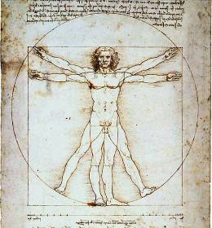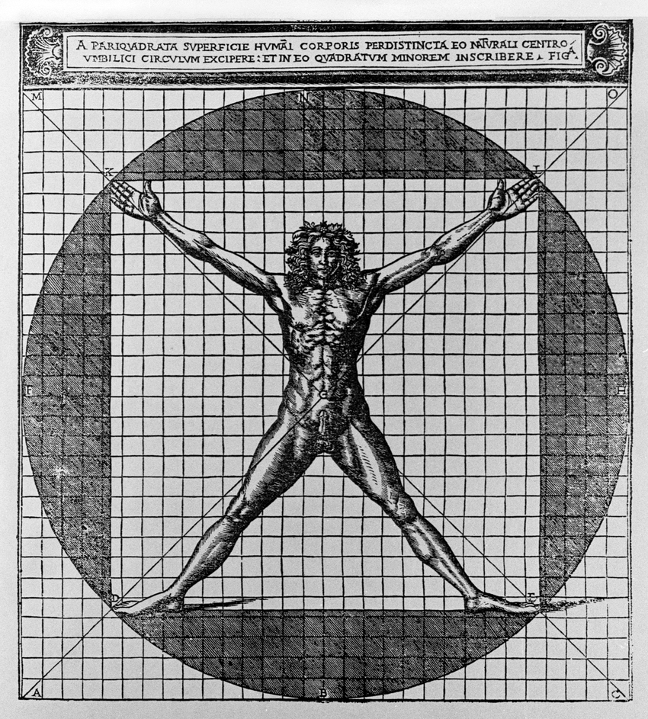

Leonardo da Vinci (1452–1519) portrayed the humanistic worldview in his drawing of the Vitruvian man. Leonardo deviates from Vitruvius’ description in one seemingly insignificant detail. In contrast to Vitruvius’s description, in Leonardo’s famous representation, the circle, the square, and the person are not centered on the same point. Cesare Cesariano (1475–1543) had followed the Vitruvian description literally, thus following the ancient mechanical world order. This is in contrast to Da Vinci, for whom the human being is part of a decentralized, dynamic order.

To use a term from Helmuth Plessner’s philosophical anthropology: The relationship between man and the world is reflected in the act of decentering or “eccentricity.” Humanism is characterized by the fact that the person stands eccentrically with reference to the center, so that even the question of the center can no longer be answered. Man is in a fraught relationship with the world, that is, with things. Or as Plessner wrote: Man “is not only situated in his environment, but is also set in opposition to it. He lives in a dynamic relationship in which he is both drawn to and repelled by it, the living thing” (Plessner 9).

It is only through this distinction between the material world and the human being that the process of reflection is able to enter the world, and this could be the topic of a separate paper. The human being only becomes aware of himself through this eccentricity. And as I quoted from Plessner, man is not just situated in his environment, “but is also set in opposition to it.” (9). This applies not only to nature, but also to the objects created from it. Man also finds himself in an eccentric position with regard to artifacts, devices, houses, and cities. So we can say that humanism is not so much shaped by the idea of the center, but by the awareness of this eccentricity.

Arnold Gehlen, one of the founders of philosophical anthropology, spoke in this regard of the “material resistance” (*Sachwiderstand*) of things. He understood this material resistance to be the trigger for critical thought, reflection, and the self-awareness of people in general. Gehlen pointed out the role of language here, because it represents “an intermediate world that lies between consciousness and the world [of things], which both connects and divides at the same time” (Gehlen 290). What is special is that language is both directed towards things and also encounters resistance from them. “When the word-thought finds resistance in matter, it falls back on itself (producing reflection)” (Gehlen 290). The word is “thrown back on itself or reflected” (Gehlen 290).

But where language encounters resistance and is reflected by things, something from these things sticks to the language. This, according to Gehlen, is the reason for people’s ability to reflect. The things force themselves upon language, and change both language and the world of ideas that is imagined using language. But that is also what is meant by theoretical reflection. It should not be unconcerned, indifferent, or neutral towards things. Rather, it should be tinged or colored by them.

Therefore, man encounters the resistance of things. Is this not the central concern of studies in urban morphology? Do they not fundamentally show that the city, meaning every city, has its own dynamic, that it is not only conducive to people’s lives, but that it also contributes to life by providing a point of friction?

The city never loses this resistant quality. It is because of this resistance that it can influence people at all. That is its cultural function: to “educate,” “civilize,” and “cultivate” through resistance. According to the German architect and painter Karl Friedrich Schinkel, architecture as an institution existing in the public space should have an educational mandate. Similarly, it is also possible to speak of the educational mandate of cities. People shape cities, but then cities also shape people.

The humanistic core of cities consists in embodying difference or resistance. This is part of their morphological structure and the historical indices that are attached to them. The city, which is charged with historical indices, offers resistance to ignorance, consumerism, the automatic behaviors of everyday life, and self-forgetfulness.

**Environments** I understand the task of the discipline of urban morphology (research in urban morphology) as reinforcing the self-will of the city and its humanistic basis against the ignorance of people, making it visible and giving it agency. Resistance is the humanistic mission of the city as well as its stimulating impetus. Appropriateness reveals itself in resistance.

But is not the humanistic function of architecture a fundamental product of material resistance? Is it not the case that every wall must fundamentally stand in the way of people, blocking their way in an act of resistance? Then, by opening a door and providing a way to the other side of the wall or to the inside of the house, people can come together and take part in various socialization processes.

Whether the city is appropriate to the people that live in it can be measured in its resistance or its material resistance. That is, it can be felt in its difference, in its eccentricity, in the “eccentric positionality” (Plessner 9, 1027) of people and cities or people and their surroundings. But I think that researchers could currently do much more to expand our understanding of the resistance of the world of things and of the city. With Giorgio Agamben’s “The Opening” and Jacob von Uexküll’s theses from *Streifzüge durch die Umwelten von Tieren und Menschen* [*Wanderings through the worlds of animals and humans*] (1956), the concept of appropriateness must be freed from its anthropocentric constraints, and the morphology of the city must be expanded into a morphology of environments.

Jacob von Uexküll was able to show through his studies with animals how humans live in their environment, and that it is not the only one. He demonstrates how every animal lives in its own environment using its sensory skills. The human environment, however, dominates the other environments by threatening and in certain cases destroying them.

When we speak of protecting the environment today, that means recognizing the material resistance of other environments. Resistant environments also include those belonging to various organisms, animals, and plants, but today we should remember that resistant environments are also material ones, involving elements like climate and artificial intelligence; and the environments of things, including especially cities, but also machines, houses, and institutions. Morphological research today should be expanded beyond the city to encompass the city as a hybrid of different environments, each with its own material resistance and humanistic mission. To accommodate an expanded concept of humanism, the morphology of the city currently needs to be expanded into a morphology of environments.

Berlin, October 4, 2021 Jörg H. Gleiter

**Bibliography**

de Coulanges, Numa Denis Fustel. *Der antike Staat* [*La Cité antique*; *The Ancient City*][1864]. Graz, 1961.

della Mirandola, Giovanni Pico. *De hominis dignitate. Über die Würde des Menschen* [*De hominis dignitate; On Human Dignity*]. 1486*.* Ditzingen, Philipp Reclam, 2009.

Gehlen, Arnold. *Der Mensch. Seine Natur und seine Stellung in der Welt [Man. His nature and place in the world*]. 1940*.* Frankfurt am M., Vittorio Klastermann, 2016.

Husserl, Edmund. *Die Krisis der europäischen Wissenschaften und die transzendentale Phänomenologie* [*The Crisis of European Sciences and Transcendental Phenomenology*]. Hamburg, Felix Meiner, 2019.

Neiman, Susan. “Wo die Gerechtigkeit bedroht ist” [“Where justice is under threat”]. *Frankfurter Allgemeine Zeitung,* 31 May 2021.

Plessner, Helmuth. *Mit anderen Augen. Aspekte einer philosophischen Anthropologie* [*Through other eyes. Aspects of a philosophical anthropology*]. Ditzingen, Philipp Reclam, 2017.

Rossi, Aldo. *Architektur der Stadt* [*L’architettura della città; The Architecture of the City*]. Basel and Berlin, Birkhäuser, 2015.

Uexküll, Jakob von, and Georg Kriszat. *Streifzüge durch die Umwelten von Tieren und Menschen* [*Wanderings through the worlds of animals and humans*]. Hamburg, Rowohlt, 1956.