Date: 8/2019

Observation no. 106

**Commercial observation: The effectiveness of the Bio T Plus preparation in controlling carob moth in almond, Kfar Menachem, August 2019**

**By David Sarid, Eran Shilo—BioYome Company**

**Introduction**: This commercial observation was conducted as part of an initiative to develop an environmentally friendly pest management strategy in almond orchards, focusing on the carob moth. This is a joint initiative with the Ministry of Agriculture and Rural Development’s Extension Service directed by Dr Shaul Ben Yehuda.

**Aim:**

To test the effectiveness of the Bio T Plus preparation in controlling carob moth in almond.

**Methods and materials:**

**The crop:** The observation was conducted in an orchard of the Umm el-Fahm almond variety, planted in Kfar Menachem in 2006.

Drip irrigation. Medium soil.

**Phenological stage**: fruit

**Application method and spraying volume:** Spraying was carried out using a standard commercial sprayer.

**Evaluation method:** Evaluation of damaged kernels and counting of live larvae. Approximately 400 fruit/treatment.

**Preparations:**

* Bio T Plus, SC containing Bacillus thuringiensis subsp. Kurstaki at 16,000 international units (ITU)/mg per litre
* Carob moth Splat, ointment, containing 2% (Z,E)-7-9-11-Dodecatrienyl formate

**The treatments:**

|  |  |  |
| --- | --- | --- |
| **No.** | **Treatment** | **cm3/ dunam (1000 m2) or %** |
| 1 | Mating disruption 50 | - |
| 2 | Mating disruption 50 + Bio T Plus | 0.4% |
| 3 | Mating disruption 65 | - |
| 4 | Mating disruption 65 + Bio T Plus | 0.4% |
| 5 | Standard commercial treatment |  |

**Results:**

Bio T Plus substantially improved the effectiveness of eliminating carob moth compared with the standard commercial treatment. Carob moth infestation was more than 50% lower in almond treated with Bio T Plus than in almond treated by standard commercial treatment.

No signs of phytotoxicity were observed with any of the treatments.

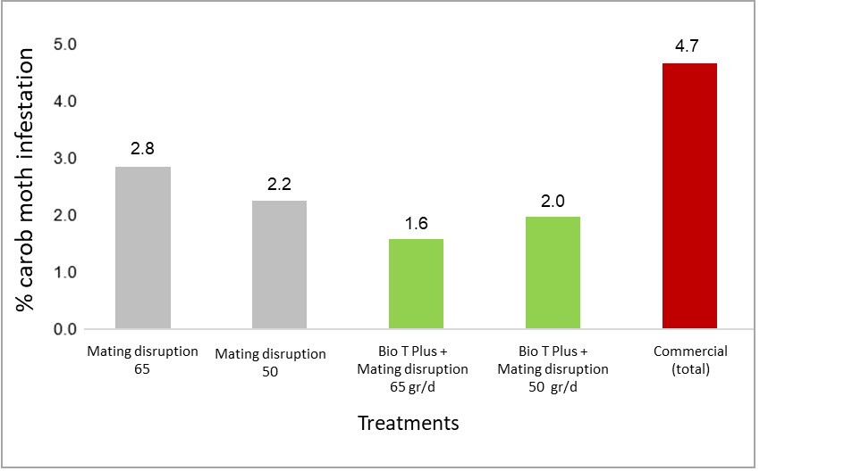**Graph 1. Carob moth infestations under different management strategies (%)**

**Graph 2. Carob moth captured in pheromone traps**

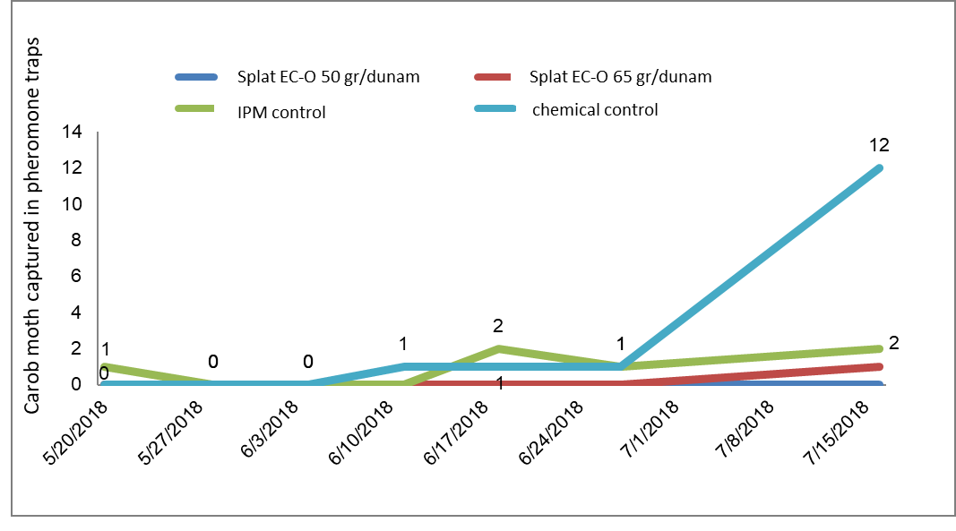

**Discussion and conclusions:**

Bio T Plus (0.4%) effectively eliminates carob moth larvae in almond and reduces infestation in the fruit.

No phytotoxicity was observed in the crop. No effects on foliage were observed during crop growth.

**Acknowledgements:**

We thank Dr Shaul Ben Yehuda for his professional advice and for supporting the observation.

We thank Nir Kilman from Zabar Kama for allocating the plot and helping with the observation.