**Thyroglobulin is a poor predictor of differentiated thyroid cancer in patients who undergo surgery for thyroid nodular diseases**

**Thyroglobulin for DTC prediction**

Shoham Rigbi1*, Ben-Zion Joshua3*, Lior Baraf2*, Uri Yoel2*¥, Merav Fraenkel2*€¥

1 Goldman School of Medicine, Ben-Gurion University of the Negev, P.O. Box 151, Beer Sheva, Israel

2 Endocrine Unit, Soroka University Medical Center, Beer Sheva, Israel

3 Department of Otolaryngology Head and Neck Surgery, Barzilai Medical Center, Ashkelon, Israel

*Faculty of Health Sciences, Ben-Gurion University of the Negev, P.O. Box 151, Beer Sheva, Israel

¥ Equal contribution as last co-authors

€ **Corresponding author**

Address for correspondence:

Merav Fraenkel, MD

Endocrine Unit

Soroka Medical Center

Yitzchak Rager

Beer Sheva

Israel

meravfra@gmail.com

**Keywords:** thyroglobulin, differentiated thyroid cancer, multinodular goiter, indeterminate cytology, Bethesda System

**Abstract**

**Objective**: Thyroglobulin, produced exclusively by thyroid follicular cells, serves as a specific tumor marker for the follow-up of differentiated thyroid cancer (DTC) patients after thyroidectomy. However, its role as a predictor of malignancy in patients with thyroid nodules is controversial. We assessed the potential ability of the preoperative serum thyroglobulin concentration to predict DTC in patients without a preoperative diagnosis of malignancy who underwent partial or total thyroidectomy.

**Methods**: This retrospective study included patients with a preoperative diagnosis of benign multinodular goiter (MNG) or a thyroid nodule with indeterminate cytology (INC) (Bethesda system categories III/IV) who underwent partial or total thyroidectomy between January 2014 and May 2019. We compared the patients’ demographic, clinical, imaging, and biochemical data according to their final diagnosis: DTC or benign thyroid nodular disease. Further statistical analysis included odds ratio calculation and receiver operating characteristic (ROC) curve analysis.

**Results**: Of 131 patients who met inclusion and exclusion criteria, the indication for surgery was benign MNG in 69 and thyroid nodule with INC in 62. A final diagnosis of DTC was reported in 18 of the 69 benign MNG patients (26%) and in 30 of the 62 thyroid nodule with INC patients (48%). The preoperative measurements of nodule diameter and serum thyroid-stimulating hormone and thyroglobulin concentrations did not differ between patients with a final diagnosis of DTC and those with benign histology.

**Conclusion**: Preoperative serum thyroglobulin alone is insufficient to preoperatively differentiate between malignant and benign thyroid nodular disease.

**Introduction**

Thyroid nodules (TNs) are a common finding on neck imaging and physical examination (1). Solitary TNs or those identified in a multinodular goiter (MNG) are usually benign and their prevalence depends on the detection method used, varying from 2%–6% for palpitation to 19%–68% for ultrasonography and 8%–65% for autopsy (2). Between 7% and 15% of all TNs correspond to differentiated thyroid cancer (DTC) (3).

TN evaluation begins with neck ultrasound (US) and the measurement of serum thyroid-stimulating hormone (TSH) levels. According to their diameter and specific ultrasonographic features (e.g., a hypoechoic region or the presence of microcalcifications), TNs should be further investigated using fine-needle aspiration (FNA) biopsy for cytological assessment (3,4). The Bethesda System for Reporting Thyroid Cytopathology is the standard way to interpret FNA specimens: category II signifies benign nodules while categories V and VI have very high malignancy rates (75% and > 95%, respectively). The malignancy risk for Bethesda category III (defined as atypia of undetermined significance/follicular lesion of undetermined significance) is 10%–30% while the risk for Bethesda category IV (follicular neoplasm/suspicious for follicular neoplasm) is 25%–40%. These two categories are commonly defined as indeterminate cytology (INC) (5,6).

The evaluation of malignancy risk in INC nodules includes consideration of worrisome clinical and sonographic features and repeat FNA with or without molecular testing. Surgery is a valid option when repeat FNA for cytology and/or molecular testing is inconclusive or omitted (6). The surgical intervention indications in cases of MNG are not as clear-cut. Surgery may be considered in patients with a large MNG causing airway or swallowing compromise or in those with an esthetic deformation (3,4).

Thyroglobulin (Tg), a storage protein crucial for thyroid hormone biogenesis, is synthesized exclusively by thyroid follicular cells and released into the circulation along with thyroid hormones. It serves as a specific tumor marker in patients who have undergone thyroidectomy for DTC (7). However, an elevated serum Tg concentration can be caused by several thyroid pathologies other than DTC, including Grave’s disease, toxic adenoma, thyroiditis, and benign nodular thyroid disease (3,4,8). Importantly, anti-Tg antibodies (Tg-Abs) may interfere with Tg measurement and falsely suggest a low Tg concentration (9).

Controversy surrounds the potential use of the serum Tg concentration as a predictor of DTC in patients evaluated for a TN or MNG. Different cutoff values of Tg for discriminating malignant and benign nodules have been offered by various research groups. However, the suggested cutoff values have ranged widely, from 75 to 1000 ng/mL (10–13). A systematic review by Trimboli et al. that specifically addressed this question included 13 studies, 9 with data on TNs with INC. The pooled analysis revealed that the preoperative serum Tg concentration had suboptimal accuracy in discriminating malignant from benign nodules, with a significant overlap of values between these groups. However, the authors noted that most studies showed a significantly higher preoperative serum Tg concentration in patients with DTC than in those whose final histology reported benign TN. Accordingly, they concluded that Tg is an independent preoperative predictor of DTC in patients with INC (8). Nevertheless, the 2015 American Thyroid Association (ATA) guidelines on DTC, published shortly thereafter, strongly recommended against the routine measurement of serum Tg for the initial evaluation of TN (with moderate-quality evidence), stating that “serum Tg levels can be elevated in most thyroid diseases and are an insensitive and nonspecific test for thyroid cancer” (3). However, this recommendation addresses TNs as a whole and does not discuss specific clinical scenarios in which preoperative Tg measurement may play a role.

Regarding this controversy and in the absence of “high-quality” evidence, we assessed the association between the preoperative serum Tg concentration and final histology of DTC in two distinct groups of patients who underwent thyroid lobectomy or total thyroidectomy: first, patients with MNG who underwent surgery for an indication other than suspected DTC and, second, patients with TNs who had an FNA result classified as INC.

**Methods**

*Study population*

This retrospective cohort study included patients who were admitted to the Otolaryngology Department of Soroka University Medical Center (SUMC), a tertiary referral center, for total thyroidectomy or thyroid lobectomy between January 2014 and May 2019 with a preoperative diagnosis of benign MNG (group 1) or TN with INC (group 2). Patients with both MNG and INC were included in group 2 only. Each group was divided according to the final histological diagnosis of DTC or benign thyroid nodular disease. Inclusion criteria were at least one preoperative serum measurement of Tg and TSH, dated up to 1 year prior to surgery, and available preoperative neck US. Patients with known DTC prior to the operation and those with positive Tg-Abs were excluded.

*Data collection*

Data were collected from the patients’ electronic medical records and included age, sex, type of surgery, pathology reports, and preoperative measurements of Tg, TSH, and Tg-Abs. If more than one Tg measurement was available in the year prior to surgery, the most recent was recorded. Tg-Abs were classified as either positive or negative, based on the laboratory reference ranges. FNA cytology, based on the Bethesda System for Reporting Thyroid Cytopathology (6), was recorded from the pathology report following the FNA procedure. Histological results were recorded from the final pathology reports and classified as malignant or benign. For malignant results, the histological type of DTC was also recorded, classified as papillary thyroid carcinoma (PTC) or follicular thyroid carcinoma (FTC).

All laboratory tests were performed in authorized laboratories. Most laboratory results were obtained from the endocrinology laboratory in SUMU as follows: TSH, using a third-generation, two-site sandwich chemiluminescent immunoassay (TSH3-UL assay, Advia CENTAUR XP, Siemens); Tg, using a two-site sandwich solid-phase immunometric assay (IMMULITE Xpi, Siemens); and Tg-Abs, using a solid-phase chemiluminescent enzyme sequential immunometric assay (IMMULITE Xpi, Siemens).

*Thyroid nodule US reports*

The maximum diameters of the dominant nodule of the MNG (group 1) and of the nodule on which the FNA was performed (group 2) were recorded based on the formal US report. The US examinations were conducted in SUMC or in other medical imaging centers and interpreted by authorized clinical radiologists.

*Statistical analysis*

The baseline characteristics of the study population were summarized using descriptive statistics. Continuous variables were compared using *t* test for normally distributed variables and Mann-Whitney *U* test for non-normally distributed variables. Chi-square test was used for categorical variables. Results are presented as means±standard deviations (SDs) for normally distributed continuous variables and as medians and quartiles 1 (Q1) and 3 (Q3) for non-normally distributed variables. Odds ratios (ORs) were calculated using logistic regression and are presented with 95% confidence intervals (CIs). The receiver operating characteristic (ROC) curve was used to evaluate the performance of preoperative serum Tg concentration as a diagnostic test to differentiate between malignant and benign nodules. For all analyses, a two-sided *p* value < 0.05 was considered statistically significant. Statistical analyses were conducted using SPSS software (ver. 26.0 for Windows; SPSS Inc., Chicago, IL, USA).

The study was approved by the Institutional Review Board of SUMC (authorization number 0352-15-SOR).

**Results**

Between September 2014 and May 2019, 177 patients underwent thyroidectomy or lobectomy for MNG or TN with INC at the Otolaryngology Department of SUMC. Of these, 131 met the inclusion criteria without any exclusion criteria and comprised the final study cohort. Sixty-nine patients underwent surgery for benign MNGs (group 1) and 62 patients underwent surgery for TNs with INC (group 2). Pathology reports confirmed the presence of DTC in 18 patients (26%) in group 1 and in 30 patients (48%) in group 2 (Figure 1). In the entire cohort, 41 (31.3%), 7 (5.3%), and 83 (63.4%) patients had postoperative diagnoses of PTC, FTC, and benign thyroid nodular disease, respectively (Table 1). ROC curve analysis of the entire cohort showed an area under the curve (AUC) of 0.5 (*p*=0.89), demonstrating that preoperative Tg did not distinguish between malignant and benign TNs when the patients of both study groups were included in the analysis (Figure 1A).

*Group 1: MNG without a preoperative diagnosis of DTC*

Table 2 summarizes the characteristics of the 69 patients who underwent surgery for apparently benign MNG, stratified by whether the postoperative diagnosis was DTC (18 patients, 26%) or benign MNG (51 patients, 74%). Mean age (49±15.69 versus 41.5±14.27 years, *p*=0.06) and female sex (94.4% versus 82.4%, *p*=0.27) did not differ between the two groups. The maximum TN diameter, as reported by the preoperative US, was 4.03±1.77 cm in patients with a postoperative diagnosis of DTC versus 4.63±1.59 cm in those with a postoperative diagnosis of benign MNG (*p*=0.28). The preoperative serum Tg concentration did not differ between patients with a final diagnosis of malignant or benign MNG (median (Q1,Q3)): 148.5 ng/mL (67.8,1158.5) and 190 ng/mL (62.4,574), respectively (*p*=0.97). Similarly, preoperative serum TSH concentrations were comparable between the two subgroups: 1.5±0.84 mIU/L and 1.98±1.38 mIU/L, respectively (*p*=0.30). ROC analysis for Tg as a potential predictor of DTC in patients who underwent surgery for apparently benign MNG determined an AUC of 0.49 (*p*=0.97), demonstrating that preoperative Tg did not distinguish between patients with postoperative diagnoses of DTC and benign MNG (Figure 2B). In addition, the ORs of group 1 patients for a final diagnosis of DTC were not significant for any of the assessed parameters, including preoperative serum Tg and TSH concentrations or maximum nodule diameter (Table 4).

*Group 2: indeterminate cytology*

Table 3 summarizes the characteristics of the 62 patients who underwent surgery for TNs with INC, stratified by a postoperative pathology diagnosis of DTC (30 patients, 48%) or benign TN (32 patients, 52%). Mean age (46.80±12.83 versus 48.93±13.93 years, *p*=0.56) and female sex (63.3% versus 71.9%, *p*=0.47) did not differ between patients with a final diagnosis of DTC or benign TN. Maximum TN diameter, as determined using preoperative US, was comparable between the two subgroups: 3.36±1.92 cm for postoperative DTC diagnosis versus 3.64±1.75 cm for benign TN (*p*=0.50). The last preoperative serum Tg concentration was nonsignificantly lower in patients with a postoperative DTC diagnosis than in those diagnosed with benign TN (median (Q1,Q3)): 160.5 ng/mL (82.2,536.7) and 205.5 ng/mL (65.2,821.5) (*p*=0.93). ROC analysis for Tg as a potential predictor of DTC in patients who underwent surgery for TN with INC determined an AUC of 0.49 (*p*=0.93), demonstrating that preoperative Tg did not distinguish between patients with postoperative diagnoses of DTC and benign TN (Figure 2C). Among patients with INC results, the ORs of the TN in question being malignant were not significant for any of the assessed parameters, including preoperative Tg level, TSH level, or nodule diameter (Table 4).

We further compared the preoperative serum Tg concentration among patients in group 2 according to their Bethesda system subcategory (Table 1). Of 62 patients, 33 and 29 patients had a cytology report of Bethesda III and IV, respectively. Among the 33 patients with Bethesda III cytology, 13 (39%) and 20 (61%) had final diagnoses of DTC and benign TN, respectively. Preoperative Tg did not discriminate between patients with a final diagnosis of DTC or benign TN (mean±SD, 694.7±1584.35 ng/mL versus 1012.75±1874.61 ng/mL, respectively; *p*=0.61). The same result was found among the 29 patients with Bethesda IV cytology. Of these, 17 patients (59%) with a final diagnosis of DTC had a mean preoperative Tg of 523.77±587.04 ng/mL while 12 patients (41%) with a final diagnosis of benign TN had a mean preoperative Tg of 563.77±1427.71 ng/mL (*p*=0.91).

In addition, we analyzed the potential ability of preoperative Tg to predict a postoperative diagnosis of DTC within the INC group (62 patients) according to the histological subtype of DTC (PTC and FTC) and compared with benign TN. PTC was diagnosed in 24 patients (38.7%), FTC in 6 (9.7%), and benign TN in 32 (51.6%) (Table 1). The preoperative serum Tg concentrations of patients with PTC or of those with FTC did not differ from the preoperative serum Tg concentration of patients with final histology of benign TN (405.38±478.7 ng/mL [PTC] and 1367.81±2286.2 ng/mL [FTC] versus 844.38±1710.53 ng/mL [benign TN]; *p*=0.17 and 0.51, respectively).

**Discussion**

In the current retrospective study, we evaluated the potential ability of the preoperative serum Tg concentration to predict a final DTC diagnosis in patients who underwent a partial or complete thyroidectomy for apparently benign MNG (group 1) or for a TN with INC (group 2). In general, the preoperative Tg concentration was significantly elevated in both groups. This may suggest that an elevated serum Tg concentration is a consideration in people who are referred for thyroid surgery. In our surgical cohort, with malignancy rates of 18% in group 1 and 48% in group 2, neither the preoperative serum Tg or TSH concentrations nor the TN diameter could discriminate benign from malignant thyroid nodular disease. Furthermore, these findings were consistent when we separately analyzed Bethesda categories III and IV within group 2 and when we grouped and investigated patients who were diagnosed with FTC or PTC against those with benign final histology. Importantly, to the best of our knowledge, there is the first study to investigate preoperative Tg as a predictor of DTC in patients who undergo surgery for MNG. Our results support the notion that, in this group of patients, thyroid mass is the main component determining Tg concentration and not the presence of DTC within a large MNG (7).

Several studies have investigated the potential role of the preoperative Tg concentration in patients with TN resembling INC, mainly of Bethesda category IV. The results of those studies were conflicting, and few supported our results. An investigation by Suh et al., which included 39 TNs that were classified by cytology as follicular or Hürthle cell neoplasms (Bethesda IV), found no correlation between the preoperative serum Tg concentration and postoperative DTC diagnosis (14). Kihara et al. also investigated the preoperative serum Tg concentration in 137 patients with INC nodules who underwent surgery (15). The included patients had a serum Tg concentration that was comparable to that observed in our cohort. There was no significant difference in the serum Tg concentration between patients with final histology of DTC and benign TN. In contrast to our results, Lee et al., in a study of 164 Korean patients with INC who underwent thyroidectomy, found that the preoperative Tg concentration had a significant predictive role for FTC and suggested additional risk factors for DTC, such as younger age and male sex and specific sonographic features, including larger TNs (10). None of these parameters were found to be valuable predictors of DTC in our cohort. Interestingly, the mean serum Tg concentration in that study was lower than in most similar studies, including ours. This may be explained by the performance of surgical interventions for relatively small TNs in Korea, where that study was conducted (16,17).

Two other studies that specifically addressed TNs with reported cytology of follicular or Hürthle cell neoplasms supported the ability of a higher preoperative serum Tg concentration to predict DTC. Petric et al. suggested three independent predictors of DTC in a cohort of 388 patients: age younger than 45 years, solitary tumor, and a preoperative serum Tg concentration greater than 400 ng/mL (13). Besic et al. evaluated the preoperative serum Tg concentration in a cohort of 244 patients with follicular or Hürthle cell neoplasms < 2 cm. They suggested a much lower cutoff—80 ng/mL—as a discriminator for DTC diagnosis, with somewhat low sensitivity (54.8%) and specificity (31.1%) (12). A recent prospective study by Hulikal et al. included 92 patients who were evaluated and underwent surgery for TNs. The authors used ROC analysis to assess the value of a preoperative serum Tg concentration as a potential predictor of DTC. They found that a Tg cutoff value of 53 ng/mL predicted malignancy risk with sensitivity and specificity of 72% and 73%, respectively (*p*<0.001). That study included only 33 patients with INC. In that subgroup, 13 of the 17 patients (76%) with a preoperative serum Tg concentration greater than 53 ng/mL had final histology of DTC compared with 20 of the 33 patients (60%) with a Tg concentration below this cutoff. However, the authors did not calculate the sensitivity and specificity of the preoperative serum Tg concentration for this subgroup (11).

The conflicting results between our study and those of most other cohorts may be explained by different inclusion criteria and time periods. For example, the largest reported cohort by Petric et al. (15) included patients with Bethesda subcategory IV only, whereas we included patients with Bethesda categories III and IV. Moreover, their study reported on data from as early as 1988. Thus, the patients who were included may differ from the current patients undergoing thyroidectomy because imaging modalities and cytopathology reporting systems have changed considerably. In addition, with the tendency to report on “positive” results more frequently than on “negative” ones, a publication bias cannot be excluded (18). Considering the large range of reported Tg cutoffs, a major question is the reproducibility of these values from one cohort to another. To address this question, we applied the cutoff of 400 ng/mL, suggested by the largest cohort reported by Petric et al. (15), to our 29 Bethesda subcategory IV patients. Using a 2×2 table (Supplementary Table 1), we found that this cutoff had positive and negative predictive values of 75% and 47%, respectively. Hence, this cutoff missed approximately 50% of patients in our cohort with a preoperative serum thyroglobulin less than 400 ng/mg, classifying them as having benign TNs when they actually had DTC.

Our study has several limitations, the most important being its retrospective nature and relatively small sample size. In addition, this study is a surgical series, which introduces a selection bias. It can be assumed that the size of the TN, suspicious US features, and possibly preoperative Tg levels were a consideration for surgical treatment. The current study did not include patients with TNs with INC or MNG who did not undergo an operation, and these patients’ serum Tg concentrations may have been significantly lower than that seen in our study cohort. We did not consider the number of nodules that each patient had or the thyroid and nodule volume prior to Tg measurement, rather we focused on the suspicious nodule that underwent the FNA. It is important to note that most of the studies discussed here did not mention whether the dominant nodule was solitary or part of a MNG.

Despite its limitations, this study has some major strengths. First, this is a real-life study that reflects the management of patients with MNG or TNs with INC in a single institution. This allowed for uniform blood testing and suggests that the study population was relatively homogenous. In addition, we excluded patients with positive anti-Tg-Abs, thereby eliminating the possibility of falsely low Tg levels. To increase the credibility of our results, larger prospective studies, preferably multicenter studies, incorporating the preoperative serum Tg concentration in the diagnostic algorithm of patients evaluated for nodular thyroid diseases may be warranted.

In conclusion, consistent with the current ATA guidelines (3), our results demonstrate that the preoperative serum Tg concentration alone is insufficient to differentiate preoperatively malignant from benign nodular thyroid disease. Thus, the presurgical measurement of Tg cannot currently be recommended for this purpose.

**Acknowledgements**

This study was conducted as part of the requirements for graduation from the Medical School of the Faculty of Health Sciences, Ben-Gurion University of the Negev, Israel.

**Conflict of interest**

The authors declare that they do not have any conflicts of interest.

**Funding**

This research did not receive any grant from funding agencies in the public, commercial, or not-for-profit sectors.

**Figures and tables**

177 patients underwent surgery for the following indications:

1. A preoperative diagnosis of benign MNG
2. A thyroid nodule with INC

**Final study cohort: 131 patients**

Excluded: 46 patients

32 with missing preoperative Tg

4 with missing preoperative cytology

10 with missing preoperative imaging

Final histology: DTC in 30 (48%)

Final histology: benign TN in 32 (52%)

Group 1: 69 patients

Preoperative diagnosis of benign MNG

Group 2: 62 patients

Preoperative diagnosis of TN with INC

Final histology: DTC in 18 (26%)

Final histology: benign MNG in 51 (74%)

**Abbreviations**: MNG, multinodular goiter; INC, indeterminate cytology; Tg, thyroglobulin, TN, thyroid nodule; DTC, differentiated thyroid carcinoma.

**Figure 1.** Flowchart summarizing the study design and population selection and exclusion.

|  |  |  |  |  |  |
| --- | --- | --- | --- | --- | --- |
| **Table 1.** Postoperative diagnoses of patients with a preoperative diagnosis of benign MNG or thyroid nodule with INC | | | | | |
| **Preoperative diagnosis** | | **Postoperative diagnosis** | | | **Overall** (category) |
| **PTC** | **FTC** | **Benign** |
| **Benign MNG** | | **17** | **1** | **51** | **69** |
| **Thyroid nodule with INC** | **Bethesda III** | **12** | **1** | **20** | **33** |
| **Bethesda IV** | **12** | **5** | **12** | **29** |
| **Overall** (final histology) | | **41** | **7** | **83** | **131** |
| **Abbreviations:** MNG, multinodular goiter; INC, indeterminate cytology; PTC, papillary thyroid carcinoma; FTC, follicular thyroid carcinoma; TN, thyroid nodule. | | | | | |

|  |  |  |  |  |
| --- | --- | --- | --- | --- |
| **Table 2**. Baseline characteristics of patients with a preoperative diagnosis of benign multinodular goiter (MNG) (group 1) according to the final diagnosis of DTC or benign MNG | | | | |
|  | **All** | **DTC** | **Benign MNG** | *p* value |
| (N=69) | (N=18) | (N=51) |
|  | |
| **Demographics** | | | | |  |
| Age, years Mean±SD (n)  Median  Min,Max | 43.46±14.91 42 10,76 | 49±15.69 50 17,69 | 41.5±14.27 39 10,76 | 0.06 |  | |
| Female sex, % (n/N) (n=% within sex, N=% within category) | 59 (100%. 85.5%) | 17 (28.8%, 94.4%) | 42 (71.2%, 82.4%) | 0.274 |  | |
| **Preoperative parameters** | | | | |  |
| Maximum thyroid nodule size on US, cm (mean±SD) | 4.48±1.64 (n=64) | 4.03±1.77 (n=16) | 4.63±1.59 (n=48) | 0.28 |  | |
| Last preoperative serum Tg value, ng/mL  Mean±SD (n)  Median  Min,Max | 925.25±1975.08 (n=69)  171  7.68,12842 | 904.01±1569.88 (n=18)  148.5  14.9,5272 | 932.75±2113.56 (n=51)  190  7.68,12842 | 0.97 |  | |
| Last preoperative serum TSH value, mIU/L (mean±SD) | 1.85±1.27 (n=69) | 1.5±0.84 (n=18) | 1.98±1.38 (n=51) | 0.30 |  | |
| **Abbreviations:** DTC, differentiated thyroid carcinoma; MNG, multinodular goiter; US, ultrasound; Tg, thyroglobulin; TSH, thyroid-stimulating hormone. | | | | |  | |

|  |  |  |  |  |
| --- | --- | --- | --- | --- |
| **Table 3**. Baseline characteristics of patients with a preoperative diagnosis of thyroid nodule with INC (group 2) according to the final diagnosis of DTC or benign thyroid nodule | | | | |
|  | **All** | **DTC** | **Benign TN** | *p* value |
| (N=62) | (N=30) | (N=32) |
|  |
| **Demographics** | | | | |  |
| Age, years Mean±SD (n)  Median  Min,Max | 47.74±13.33 45 21,78 | 46.80±12.83 44 28,73 | 48.93±13.93 45.5 21,78 | 0.56 |  |
| Female sex, % (n/N) (n=% within sex, N=% within category) | 42 (100%, 67.7%) | 19 (45.2%, 63.3%) | 23 (54.8%, 71.9%) | 0.47 |  |
| **Preoperative parameters** | | | | |  |
| Maximum thyroid nodule size on US, cm (mean±SD) | 3.51±1.82 (n=60) | 3.36±1.92 (n=29) | 3.64±1.75 (n=31) | 0.50 |  |
| Last preoperative serum Tg, ng/mL  Mean±SD (n)  Median  Min,Max | 725.1±1445.71 (n=62)  179  0.45,7838 | 597.87±1111.87 (n=30)  205.5  0.45,5895 | 844.38±1710.53 (n=32)  160.5  35.8,7838 | 0.93 |  |
| Last preoperative serum TSH, mIU/L (mean±SD) | 1.65±0.97 (n=62) | 1.72±1.17 (n=30) | 1.59±0.75 (n=32) | 0.73 |  |
| **Abbreviations:** DTC, differentiated thyroid carcinoma; MNG, multinodular goiter; INC, indeterminate cytology; US, ultrasound; Tg, thyroglobulin; TSH, thyroid-stimulating hormone; TN, thyroid nodule. | | | | |  |

|  |  |  |  |  |  |  |
| --- | --- | --- | --- | --- | --- | --- |
| **Table 4**. Odds ratio for a postoperative diagnosis of DTC among patients with a preoperative diagnosis of benign MNG or thyroid nodule with INC | | | | | | |
| Preoperative diagnosis | | **Demographic characteristics** | | **Selected preoperative sonographic and biochemical features** | | |
| Age | Female sex | Maximum nodule size | Last preoperative serum Tg | Last preoperative serum TSH |
| **Benign MNG** | Odds ratio; 95% CI | 1.03; 0.99–1.07 | 3.64; 0.42–31 | 0.79; 0.56–1.13 | 1; 0.99–1 | 0.71; 0.43–1.17 |
| **INC** | Odds ratio; 95% CI | 0.99; 0.95–1.02 | 0.67; 0.23–1.97 | 0.91; 0.69–1.21 | 1; 0.99–1 | 1.14; 0.68–1.92 |
| **Abbreviations:** DTC, differentiated thyroid carcinoma; MNG, multinodular goiter; INC, indeterminate cytology; Tg, thyroglobulin; TSH, thyroid-stimulating hormone. | | | | | | |

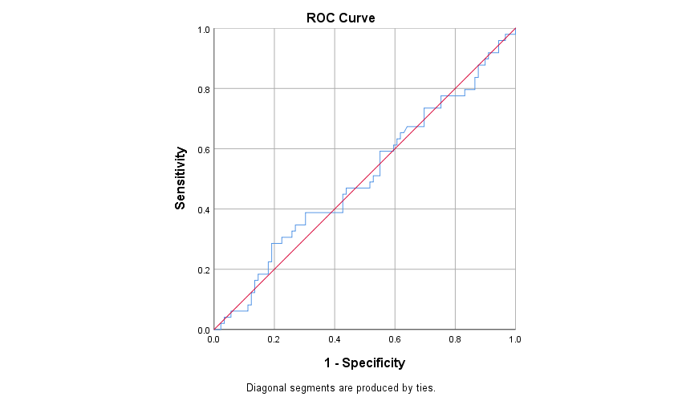

Entire cohort

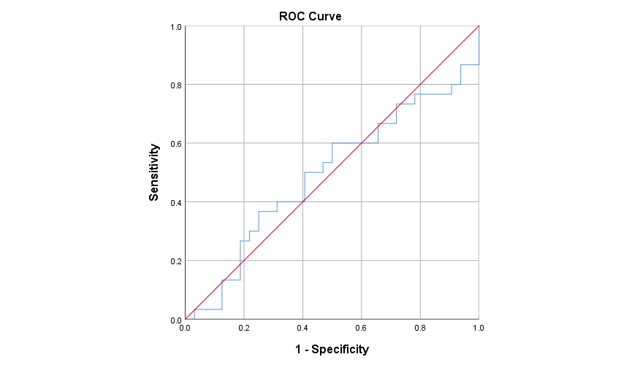

B

**Figure 2**. ROC curve of the preoperative Tg concentration as a predictor of a final diagnosis of differentiated thyroid cancer (DTC). A. Entire cohort. B. Patients with a preoperative diagnosis of benign multinodular goiter (MNG). C. Patients with indeterminate cytology (Bethesda III and IV).

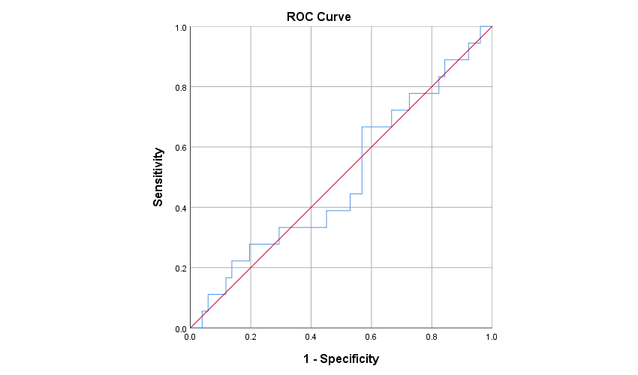

benign MNG

C

Benign MNG

Indeterminate cytology

**Supplementary Material**

|  |  |  |  |
| --- | --- | --- | --- |
| **Table S1**. Evaluation of the reproducibility of the cutoff value suggested by Petric et al. of Bethesda IV patients in our cohort | | | |
|  | **Postoperative malignant diagnosis** | **Postoperative benign diagnosis** |  |
| **Tg > 400 ng/mL** | 6 | 2 | PPV 75% |
| **Tg < 400 ng/mL** | 11 | 10 | NPV 47.62% |
|  | Sensitivity 35.29% | Specificity 83.33% |  |
| **Abbreviations**: Tg, thyroglobulin; PPV, positive predictive value; NPV, negative predictive value. | | | |

**References**

1. Meltzer CJ, Irish J, Angelos P, Busaidy NL, Davies L, Dwojak S, et al. American Head and Neck Society Endocrine Section clinical consensus statement: North American quality statements and evidence‐based multidisciplinary workflow algorithms for the evaluation and management of thyroid nodules. Head Neck [Internet]. 2019 Apr 18 [cited 2019 Jun 9];41(4):843–56. Available from: https://onlinelibrary.wiley.com/doi/abs/10.1002/hed.25526

2. Dean DS, Gharib H. Epidemiology of thyroid nodules. Best Pract Res Clin Endocrinol Metab [Internet]. 2008;22(6):901–11. Available from: http://dx.doi.org/10.1016/j.beem.2008.09.019

3. Haugen BR, Alexander EK, Bible KC, Doherty GM, Mandel SJ, Nikiforov YE, Pacini F, Randolph GW, Sawka AM, Schlumberger M, Schuff KG, Sherman SI, Sosa JA, Steward DL, Tuttle RM, Wartofsky L. 2015 American Thyroid Association Management Guidelines for Adult Patients with Thyroid Nodules and Differentiated Thyroid Cancer: The American Thyroid Association Guidelines Task Force on Thyroid Nodules and Differentiated Thyroid Cancer. Thyroid. 2016 Jan;26(1):1-133. doi: 10.1089/thy.2015.0020. PMID: 26462967; PMCID: PMC4739132.

4. Durante C, Grani G, Lamartina L, Filetti S, Mandel SJ, Cooper DS. The Diagnosis and Management of Thyroid Nodules: A Review. JAMA. 2018 Mar 6;319(9):914-924. doi: 10.1001/jama.2018.0898. Erratum in: JAMA. 2018 Apr 17;319(15):1622. PMID: 295098715.

5. Wu H, Swadley M. The Bethesda system for reporting thyroid cytopathology: into the clinic. Pathol Lab Med Int [Internet]. 2015 Jul 31 [cited 2019 May 24];7:47. Available from: http://www.dovepress.com/the-bethesda-system-for-reporting-thyroid-cytopathology-into-the-clini-peer-reviewed-article-PLMI

6. Edmund S. Cibas and Syed Z. Ali. The 2017 Bethesda System for Reporting Thyroid Cytopathology. 2017;27(11):1341–6.

7. Indrasena BSH. Use of thyroglobulin as a tumour marker. World J Biol Chem. 2017;8(1):81.

8. Trimboli P, Treglia G, Giovanella L. Preoperative Measurement of Serum Thyroglobulin to Predict Malignancy in Thyroid Nodules: A Systematic Review. Horm Metab Res [Internet]. 2014 Nov 10 [cited 2019 Mar 12];47(04):247–52. Available from: http://www.thieme-connect.de/DOI/DOI?10.1055/s-0034-1395517

9. Jo K, Lim DJ. Clinical implications of anti-thyroglobulin antibody measurement before surgery in thyroid cancer. Korean J Intern Med. 2018;33(6):1050–7.

10. Lee EK, Chung K-W, Min HS, Kim TS, Kim TH, Ryu JS, et al. Preoperative serum thyroglobulin as a useful predictive marker to differentiate follicular thyroid cancer from benign nodules in indeterminate nodules. J Korean Med Sci [Internet]. 2012 Sep [cited 2019 Feb 26];27(9):1014–8. Available from: http://www.ncbi.nlm.nih.gov/pubmed/22969246

11. Hulikal N, Azhagamuthu RE, Banoth M, Chowhan AK, Yutla M, Sachan A. Can preoperative serum thyroglobulin levels predict the risk of malignancy? Results from prospective analysis of biochemical predictors of malignancy in thyroid nodules. Acta Otorhinolaryngol Ital. 2020;40(1):33–7.

12. Petric R, Besic H, Besic N. Preoperative serum thyroglobulin concentration as a predictive factor of malignancy in small follicular and Hürthle cell neoplasms of the thyroid gland. World J Surg Oncol. 2014;12(1):1–7.

13. Petric R, Perhavec A, Gazic B, Besic N. Preoperative serum thyroglobulin concentration is an independent predictive factor of malignancy in follicular neoplasms of the thyroid gland. J Surg Oncol. 2012;105(4):351–6.

14. Suh I, Vriens MR, Guerrero MA, Griffin A, Shen WT, Duh Q-Y, et al. Serum thyroglobulin is a poor diagnostic biomarker of malignancy in follicular and Ḧurthle-cell neoplasms of the thyroid. Am J Surg [Internet]. 2010 Jul [cited 2019 Mar 21];200(1):41–6. Available from: https://linkinghub.elsevier.com/retrieve/pii/S0002961009007107

15. Kihara M, Ito Y, Hirokawa M, Masuoka H, Yabuta T, Tomoda C, et al. Role of ultrasonography in patients with cytologically follicular thyroid tumor. Auris Nasus Larynx [Internet]. 2011 Aug [cited 2019 May 24];38(4):508–11. Available from: http://www.ncbi.nlm.nih.gov/pubmed/21269788

16. Korea’s Thyroid-Cancer “Epidemic” — Screening and Overdiagnosis. Hyeong Sik Ahn, M.D., Ph.D., Hyun Jung Kim, M.P.H., Ph.D., and H. Gilbert Welch, M.D., M.P.H. T. N Engl J Med. 2014;371(19):1763–5. N Engl J Med. 2014;371(19):1763–5.

17. Miranda-Filho A, Lortet-Tieulent J, Bray F, Cao B, Franceschi S, Vaccarella S, et al. Thyroid cancer incidence trends by histology in 25 countries: a population-based study. Lancet Diabetes Endocrinol [Internet]. 2021 Apr 1 [cited 2021 Dec 23];9(4):225–34. Available from: http://www.thelancet.com/article/S2213858721000279/fulltext

18. Mlinarić A, Horvat M, Smolčić VŠ. Dealing with the positive publication bias: Why you should really publish your negative results. Biochem medica [Internet]. 2017 Oct 1 [cited 2022 Apr 9];27(3). Available from: https://pubmed.ncbi.nlm.nih.gov/29180912/