**Just talk to them! The importance of teacher-pupil communication in addressing child sexual abuse and assault**

**INTRODUCTION**

Child sexual abuse (CSA) is a worldwide health problem with long-term negative effects on survivors’ mental, psychological, physical, and sexual health. According to the World Health Organization (WHO, 1999), “Child sexual abuse is the involvement of a child in sexual activity that he or she does not fully comprehend, is unable to give informed consent to, or for which the child is not developmentally prepared and cannot give consent, or that violates the laws or social taboos of society. Child sexual abuse is evidenced by this activity between a child and an adult or another child who by age or development is in a relationship of responsibility, trust or power, the activity being intended to gratify or satisfy the needs of the other person.” For the purposes of this study, CSA includes offenses carried out by juvenile/peer offenders, and thus the word “assault” is added to the term: CSAA.

To date, researchers have focused extensively on estimating the prevalence of CSA (Barth et al., 2013; Singh et al., 2014; Stoltenborgh et al., 2011; Vogeltanz et al., 1999). Estimates of CSA prevalence worldwide range from 8% to 31% for girls and from 3% to 17% for boys (Barth et al., 2013). Pereda et al.’s meta-analysis of the worldwide prevalence of CSA (covering 22 countries) revealed that 7.9% of men and 19.7% of women had suffered sexual abuse before the age of eighteen (Pereda et al., 2009). In Israel, one out of four adults reports having been sexually abused as a child (Schein et al., 2000). In the Jewish population, no gender differences have been found in CSA rates (17.6% for boys and 17.7% for girls), whereas among the Arab population, these rates are significantly higher among boys (28.4%) than among girls (18.7%) (Lev-Wiesel et al., 2018). In a recent national study on child maltreatment in Israel, 18.7% of Israeli children aged between 12 and 17 reported having been sexually abused (Lev-Wiesel et al., 2018). Prior research has indicated that CSA has significant negative effects in both the short and long term, including post-traumatic stress disorder (PTSD), various psychiatric disorders, such as depression, anxiety, suicide and suicide attempts, substance use, neurobiological effects, poor physical health, eating disorders, and psychosomatic physical complaints and conditions (Briere & Runtz, 1993; Putnam, 2003).

Teachers play a key role in preventing and disclosing CSAA. In fact, in a recent study, Goldschmidt-Gjerløw highlights the importance of children’s rights and teachers’ responsibilities in addressing the topic of CSAA in schools (Goldschmidt-Gjerløw, 2019). As teachers spend several hours a day with their pupils, it is important that they discuss CSAA with them in appropriate and adequate ways. Such discussions help to prevent this type of abuse, as pupils become informed about CSAA, what relationships are characteristic between the abuser and the victim, and what victims can do to break out of this pattern. Conversations about CSAA between teachers and pupils can equip pupils with greater protection and safety, and by openly discussing CSAA, teachers can become more alert to signs indicating that a pupil is being subjected to violence or abuse, and this helps to promote (and facilitate) victims’ disclosure of CSAA.

A timely disclosure of CSAA, combined with an appropriate response, can potentially reduce the risk of subsequent sexual exploitation/revictimization, and put an end to the suffering inflicted by offenders. It is therefore imperative that responsible and trusted adults in children’s lives learn how to encourage genuine disclosure of CSAA. Previous research shows that children do not often disclose their CSAA experience to teachers. In a national study conducted in the United States, it was found that 66.3% of youths aged between ten and 17 years did not report cases of sexual abuse to a parent or any other adult. However, of those who did disclose offenses, 31% disclosed to their parents, 19.1% to the police, and 21.8% to a teacher (Gewirtz-Meydan & Finkelhor, 2019). Similarly, in another study involving CSAA survivors, 75% of respondents did not disclose abuse during their childhood. Of the 25% of survivors who reported having told someone about the abuse, only 7% disclosed episodes to their teacher (Wager, 2015). Findings from Alaggia’s (2010) study on adult survivors suggest that there is an expectation that teachers should recognize distress in their pupils, along with the assumption directly asking students about the cause would help provoke a disclosure.

It is regrettable that children do not feel comfortable discussing CSAA with their teachers or disclosing cases of abuse to them (Schönbucher et al., 2012). Children and adolescents need adults from all spheres of their life – including parents, teachers, police, magistrates, and treatment-providing workers – to openly discuss and sensitively respond to CSAA. The current study sought to examine the factors that facilitate this kind of open discussion between teachers and pupils. While previous research in this area has focused mainly on the perspective of either pupils (Schönbucher et al., 2012) or teachers (Goldman & Bradley, 2011; Tener & Sigad, 2019), there is a growing need for studies that integrate the perceptions of both pupils and teachers to examine the gap between them. This research addresses this gap by examining the perceptions of both pupils and their homeroom teachers in the discussion on CSAA.

The study examines teachers’ mediation strategies regarding CSAA and how they correlate with pupils’ perceptions of teacher support and acceptance. It is based on three core strategies of mediation: restrictive, negative active, and positive active (Boniel-Nissim et al., 2020; Efrati & Boniel-Nissim, 2021; Nathanson, 2016). Restrictive mediation focuses on rules and boundaries and is not really a forum for open discussion, but rather, is intended to convey a clear message that sexual harassment is illegal and against the law. Discussions on CSAA from a negative active mediation approach focus on the negative aspects of CSAA (i.e., explaining why such behaviors are dangerous and harmful). Finally, a positive active approach emphasizes on healthy and beneficial sexual behaviors (e.g., discussing sex as something potentially wonderful and joyful, and advising children and young people to contact an adult if anybody ever touches them without their consent, or if sex ever feels unpleasant).

Research examining mediation strategies focuses mostly on parents (Chen & Chng, 2016; Shin & Li, 2017) and on media usage and risk behaviors online (Livingstone & Helsper, 2008). Findings on different mediation styles are mixed, with some studies suggesting that the positive active approach is associated with the most positive outcomes (Nathanson, 2001) and others indicating that a combination of different mediation strategies is most beneficial (Chen & Chng, 2016).

**The current study**

The importance and benefits of open discussion between teachers and their pupils on the subject of CSAA have been widely acknowledged (Goldschmidt-Gjerløw, 2019; Goldschmidt-Gjerløw & Trysnes, 2020), yet the available data indicate limited disclosure of CSAA to teachers (e.g., Gewirtz-Meydan and Finkelhor, 2019; Wager, 2015). Given this background, the current study sought to identify the factors that predict open, effective, and supportive conversations about CSAA between middle- and high-school pupils and their teachers, from the perspectives of both groups. Specifically, we examine the perceptions of all participants on the teachers’ use of mediation strategies regarding CSAA (restrictive, negative active, and positive active). We then explore the views expressed by both pupils and teachers in their answers to the following questions: How severe is the teacher’s attitude toward CSAA? What is the teacher’s perceived sensitivity to CSAA? How is the quality of teacher-pupil communication rated in general, and with regard to CSAA specifically? To what extent does the teacher offer support in cases of CSAA? Pupils were also asked to appraise their teachers in terms of whether or not they provide a secure base.

**METHOD**

**Participants**

**Pupils**

The study population comprised 756 pupils (341 boys and 415 girls), aged 11-18 years (M = 15.32, SD = 1.82), all enrolled in the sixth (n= 28), seventh (n= 32), eighth (n= 135), ninth (n= 148), tenth (n = 79), eleventh (n = 108), or twelfth (n = 226) grades. Most (94%) were native-born Israelis. Socioeconomically, 6.1% reported being below average, 58% average, and 36% above average. The sample consisted of 299 (30%) self-defined religious individuals and 457 (70%) secular ones.

**Teachers**

The sample of teachers contained 66 individuals (21 men and 45 women), between the ages of 25 and 64 (*M* = 41.88, *SD* = 8.93). Each of the participants provided informed consent, and the study was approved by the ethical committee. Among the participants, two (3%) reported that they were single, 62 (94%) married, and two (3%) divorced. Most of the participants (95%) were native-born Israelis. Financially, 17 (26%) reported being in a “very good” condition, 47 (72%) described their financial condition as “good”, and two (2%) classified themselves as “poor.” The sample comprised 40 (60%) self-defined religious individuals and 26 (40%) secular ones. Participants’ years of education ranged from 12 to 26; the mean number of years of education was 17.09 (*SD =* 2.58). Finally, participants’ experience of teaching ranged from 2 to 34 years; the mean number of years of teaching experience was 15.34 (*SD =* 8.86).

**Measures**

*Teachers’ measures*

***Teacher’s Mediation of CSAA***(using the PMP scale, based on Boniel-Nissim et al., 2020): To assess teachers’ mediation strategies regarding sexual protection (restrictive, negative active, and positive active) we used the PMP scale, adapted to teachers for this research. *Restrictive mediation* was measured using two items (α = 0.81) (e.g., “I set clear rules for my pupils regarding sexual harassment”); *negative active mediation* was measured using three items (α = 0.79) (e.g., “I try to explain to my pupils why sexual harassment is a bad and dangerous thing”). *Positive active mediation* was measured using two items (α = 0.83) (e.g., “I try to explain to my pupils the need to tell and not keep ‘secrets,’ with an emphasis on healthy and beneficial sexual behavior”). We omitted co-use mediation in this study because it is not relevant to the research topic. Teachers were asked to report on their level of agreement with each item on a 5-point scale ranging from 1 (“not at all”) to 5 (“very much”). For each teacher, we obtained three scores for mediation strategies regarding sexual harassment by calculating the average score for the answers to the relevant items.

***Teacher-perceived Severity of CSAA*** (adapted from previous research conducted by Hwang et al., 2017; Kim et al., 2012): To evaluate threat appraisal, perceived severity was measured using two items (α = 0.81). Adjustments were made to adapt the items to the subject matter of sexual harassment. Sample items included “Sexual harassment is a serious problem” and “Sexual harassment can lead to severe consequences.” The items were rated on a 5-point Likert scale ranging from 1 (“Strongly disagree”) to 5 (“Strongly agree”).

***Teacher-perceived Susceptibility of Pupils to CSAA*** (adapted from previous research conducted by Hwang et al., 2017; Kim et al., 2012): Threat appraisal also includes perceived susceptibility. This was measured using two items (α = 0.83) . Adjustments were made to the items to adapt them to the subject matter of sexual harassment. Sample items included “My pupils were susceptible to sexual harassment” and “My pupils were at risk of sexual harassment and sexual assault”, rated on a 5-point Likert scale ranging from 1 (“Strongly disagree”) to 5 (“Strongly agree”).

***The Teacher-Pupil CSAA Communication Scale***(using the PCS scale, based on Jaccard et al., 2000): To assess the quality of teacher-pupil communication about sexual harassment, we administered the Hebrew version of the PCS scale. The scale comprises 16 items (e.g., “My pupils would not want to answer my questions about sexual harassment”) and pupils were asked to specify their level of (dis)agreement with each item on a 5-point Likert scale ranging from 1 (“Strongly disagree”)to5 (“Strongly agree”), which, according to Jaccard et al. (2000), is highly reliable. It was translated into Hebrew by Efrati and Gola (2019). For the purposes of the current study, we adapted the questionnaire to teachers and focused on sexual harassment. Accordingly, a score of communication about sexual harassment was calculated for each teacher by calculating the average for each of their answers. Cronbach’s alpha of the PCS in this sample was 0.87.

***The Teacher-Pupil Communication Scale*** (based on Barnes & Olson, 1982): This is constructed from two 10-item subscales – the degree of openness in communication between teachers and their pupils, and the extent of problems in family communication. The Open Teacher Communication (OTC) subscale reflects feelings of free expression and understanding in teacher-pupil interactions (e.g., “When I ask questions, I get honest answers from my pupils”). The Problems in Teacher Communication (PTC) subscale measures negative interaction patterns and hesitancy to disclose concerns (e.g., “My pupils are careful about what they tell me”). Respondents rated their answers on a 5-point Likert scale ranging from 1 (“Strongly disagree”)to 5 (“Strongly agree”) to indicate their level of agreement with each item. Scores ranged from 10 to 50 for both subscales. For the OTC subscale, a higher score indicated a higher degree of openness in teacher-pupil communication. The scores for items on the PTC subscale are reversed, so that a high score is indicative of communication problems, and a low score reflects a lack of perceived problems in teacher-pupil communication. For the present study, we adapted the questionnaire to teachers and focused on sexual harassment. Cronbach’s alpha of the scale in this sample was 0.83.

***Teacher Support*** (using a questionnaire adapted from the Multidimensional Scale of Perceived Social Support [MPSS] based on Zimet et al., 1988): The scale of Perceived Teacher Support is a 10-item self-report scale measuring how teachers perceive the support they provide (e.g., “My pupil trusts me when things go wrong” and “My pupils receive the help and emotional support they need from me”). Participants were asked to rate their answers on a 6-point Likert scale ranging from 1 (“Strongly disagree*”)*to 6 (“Very strongly agree*”*). A total *Teacher Support* score was obtained by calculating the average of the ten items (Cronbach’s alpha =.96).

***Teacher CSAA Support*** (using a questionnaire adapted from the Multidimensional Scale of Perceived Social Support [MPSS] based on Zimet et al., 1988): The scale of Perceived Teacher Sexual Assault Support is a 10-item self-report scale measuring perceived sexual assault support from teachers’ perspective (e.g., “I am always around when pupils need to talk to me about harassment and sexual assault” and “My pupils talk about their problems with me when it comes to harassment and sexual assault”). Participants were asked to rate their answers on a 6-point Likert ranging from 1(“Strongly disagree”)to 6 (“Very strongly agree”). A total *Teacher CSAA* *Support* score was given by calculating the average of the ten items (Cronbach’s alpha =.94).

*Pupils’ measures*

***Teacher Mediation of CSAA*** (using the PMP scale, based on Boniel-Nissim et al., 2020): The same questionnaire that was given to teachers was adapted to the perspective of pupils. Cronbach’s alpha of the PMP scale in this sample was 0.78 for restrictive mediation, 0.81 for negative active mediation, and 0.80 for positive active mediation.

*T****he Teacher-Pupil CSAA Communication Scale***(using PCS, based on Jaccard et al., 2000):The same questionnaire that was given to teachers was adapted to reflect the perspective of pupils. Cronbach’s alpha of the PCS in this sample was 0.90.

***The Teacher-Pupil Communication Scale*** (based on Barnes & Olson, 1982): The same questionnaire that was given to teachers was adapted to reflect the perspective of pupils. Cronbach’s alpha of the DASS-T in this sample was 0.84.

***Teacher Support*** (using MPTS, based on Zimet et al., 1988): The same questionnaire that was given to teachers was adapted to reflect the perspective of pupils. Cronbach’s alpha of the MPSS-T in this sample was 0.93.

***Teacher CSAA Support*** (using MPTS, based on Zimet et al., 1988): The same questionnaire that was given to teachers was adapted to reflect the perspective of pupils. Cronbach’s alpha of the MPSS-T in this sample was 0.94.

**Pupils’ Appraisal of Teacher as Offering a Secure Base (CATSB**, based on Al-yagon & Mikulincer, 2006): This 25-item scale assessed adolescents’ perceptions of their homeroom teacher as an attachment figure along a 7-point scale ranging from 1 (“Does not apply at all”) to 7 (“Applies very much”). Previous findings have demonstrated the validity and reliability of this scale (Al-yagon & Mikulincer, 2006; Barnes & Olson, 1982). The availability and acceptance subscale comprised 17 items assessing the teacher as caring and available in times of need (e.g., “My teacher is always there to help me when I need her/him”). Reliability was high α = .95. The rejection subscale comprised 8 items assessing the extent to which the adolescent perceived the teacher as unaccepting (e.g., “My teacher makes me feel unwanted”). Reliability for this scale was also good (α = .90).

**Procedure**

The study was presented as a research project on sexual harassment communication and mediation between teachers and their 11–18-year-old pupils. The participants constituted a convenience sample recruited from a variety of sources (postings on bulletin boards and in online forums). Questionnaires were uploaded onto Qualtrics – an online platform for questionnaires – and distributed by several research assistants via the class WhatsApp group (for pupils and parents) or personal communication (for the class teacher). Parents of pupils who agreed to participate in the study were contacted via email and/or phone and asked to review the questionnaires and sign an informed parental consent form, which was sent back to the research assistants by email. Upon agreement, a link for the online survey was sent to the pupils who were assured anonymity. Participants were then asked to complete the survey in private, in a quiet room at home (i.e., not in the presence of others). Following the completion of an informed consent form, questionnaires were presented in random order. All questionnaires were in Hebrew – Israel’s official language. Lastly, there was an online debriefing and participants were thanked for their participation. The procedure was approved by the Institutional Review Board of [masked for review].

**Data analysis**

Overall, the data comprised 757 pupils and 66 teachers (the number of pupils in each class ranged from 1 to 28, *M* = 11.45, *SD* = 7.38). ICC(1) coefficients (i.e., proportion of the total variance explained by the grouping structure) of the main outcome measures, i.e., pupils’ perceived mediation of sexual harassment (restrictive, active negative and active positive) indicated that between 9.44% and 14.37% of the variance in the outcome measures was accounted for by teacher-level data. Accordingly, multilevel analyses were selected as the main analytical approach. First, to examine the pattern of associations between the main variables, we used Pearson’s correlation coefficient formula. Next, to examine whether pupils’ perceived mediation of sexual harassment was different from their teachers’ reported level of mediation, we conducted a series of nested t-tests using *Ime4* (Bates et al., 2015) and the *ImerTest* (Kuznetsova et al., 2017) package in R. Finally, we conducted a series of hierarchical mixed-effect models to examine the predictors of pupils’ perceived mediation of sexual harassment. In the first step of the models, we included the sociodemographic measures of pupils: biological sex (male, female); age; religious affiliation (religious/secular); and economic status. For teachers: biological sex (male, female); age; religious affiliation (religious/secular); economic status; years of education; and teaching experience in years. Each measure had its own level of analysis. In each model, we retained the significant sociodemographic measures for the second step in which we added the measures of pupils’ and teachers’ quality of communication, quality of communication on sexual harassment, general support, and sexual-harassment-related support, each with its own level of analysis. In addition, we included teachers’ perceived severity of sexual harassment among pupils and susceptibility of pupils to sexual harassment. We also included the measures of pupils’ sense of acceptance and rejection by teachers as predictors. Models were performed by *Ime4* and *ImerTest* packages. In all models, random effects were entered only if they significantly improved the respective model’s fit, which was based on ANOVA-like likelihood ratio tests (via the *ranova* function).

**RESULTS**

Patterns of associations between the main study measures are reported in Figure 1.

**Do teachers’ reports on the level of sexual harassment mediation differ from pupils’ perceptions of sexual harassment mediation?**

Descriptive statistics of mediation measures are presented in Table 1. The nested t-tests indicated that teachers reported significantly higher levels of perceived mediation of sexual harassment (via all strategies) than pupils: *t*(51.17) = 3.83, *p* = .0004 for restrictive mediation, *t*(54.75) = 3.56, *p* = .0008 for active negative mediation, and *t*(53.82) = 6.16, *p* = 9.68-8 for active positive mediation.

**What predicts pupils’ perceptions of sexual harassment mediation?**

Results of the hierarchical mixed-effect models are presented in Tables 2a–c. The models indicated that when pupils perceived better quality of sexual-harassment-related support from teachers, the more they perceived sexual-harassment-related mediation, via all strategies – restrictive, active negative and active positive (see Figure 2). Teachers’ own reports of better sexual-harassment-related support were linked with more perceived active negative mediation but not with the other types of mediation. In addition, a greater sense of acceptance from teachers was related to more active types of mediation, both positive and negative. It was only nominally related to more restrictive sexual-harassment-related mediation (see Figure 3). Finally, in the sample of pupils, boys perceived the restrictive type of mediation to be higher than girls. Other results were not significant.

**DISCUSSION**

The current study highlights the mediation of teachers in the discussion on CSAA as a key factor that could contribute to prevention and disclosure of CSAA. In this research, we focused on two questions: (a) Do teachers’ reports on the level of CSAA mediation differ from pupils’ perceptions of CSAA mediation? (b) What predicts pupils’ perceptions of CSAA mediation? To this end, we conducted a study involving two sample populations: 756 pupils and their homeroom teachers (66 in total). We were thus able to examine the perceptions of CSAA mediation from the perspectives of both pupils and teachers separately. We also examined which of the following factors predict pupils’ perceptions of CSAA mediation: teachers’ perceived susceptibility of CSAA, quality of teacher-pupil communication in general and specifically about CSAA, teachers’ support in general and specifically about CSAA, and acceptance or rejection (measure of attachment) exhibited by teachers.

Unsurprisingly, and in keeping with predictions, teachers reported significantly higher levels of CSAA mediation (via all strategies) than did pupils. In other words, teachers believe they mediate and discuss CSAA with their pupils much more than their pupils say they do. However, when these conversations do occur, the quality of sexual-harassment-related support perceived by pupils is higher. Also, surprisingly, and contrary to the hypothesis, there was not a significant difference between the mediation strategies used by teachers (restrictive, active positive or negative mediation) in their scores for predicting pupils’ perceived quality of sexual-harassment-related support. Thus, as long as teachers discuss CSAA-related issues, regardless of how they do so, these discussions have a positive effect on pupils. This finding corresponds with earlier studies that found both active and restrictive mediation to be positively predictive of online self-regulation and emotion regulation among children and young people, and negatively predictive of impulsivity levels in a longitudinal study (Chen & Chng, 2016). This was also shown in a study examining the mediation of teachers with regard to risks and opportunities presented by the media (Berger, 2020) – suggesting that different mediation strategies do not compete with each other in teachers’ practices.

These findings correspond with previous studies indicating the importance and positive effects of discussions between teachers and pupils on CSAA (REF). It is important to note that while these interactions are highly meaningful, they are rarely initiated by pupils. Previous research shows that pupils do not approach their teachers to talk about CSAA issues, in part because they believe that their teachers tolerate such behavior (Doty et al., 2017) or because CSAA is a taboo subject (REF). It is also possible that teachers who feel anxious about CSAA may convey a sense of nervousness to their young students as well as lack experience referring to child welfare authorities should the need arise (Scholes et al., 2012). Teachers’ own reports of better CSAA-related support were linked with more perceived active-negative mediation. That is, when teachers describe the risks of CSAA, they perceive themselves as being more supportive. Perhaps the taboo around sexuality, and the embarrassment teachers feel about these issues, leads them to discuss CSAA by placing it in the context of laws and guidelines rather than feelings.

Finally, we found that when the teacher is perceived as accepting and available (and therefore approachable) in the pupil’s eyes, the mediation of CSAA is perceived as active (positive or negative) and not restrictive. While this association can be bidirectional, a clear picture arises from the association between active mediation and a higher level of perceived teacher acceptance and availability from the pupil’s viewpoint. Restrictive mediation in which the teacher focuses only on rules and laws can seem formal, impersonal, and emotionless. Thus, it makes sense that when the teacher is seen as offering a “safe place” and emotionally available to the student, the mediation perceived will also seem active.

Overall, the findings from the current study are encouraging. While we assumed that only a specific type of discussion between teachers and pupils in relation to CSAA would be beneficial, our findings show that any type of discussion is beneficial to pupils and predicts feelings of being supported and accepted among pupils. Perhaps pupils are eager to discuss CSAA with their teachers, and the discussion itself, no matter what type of mediation is employed, and whatever the focus, gives the pupil a sense of security and visibility.

Finally, boys perceived the restrictive type of mediation more highly than girls. This is perhaps because of gender constructs in which boys are perceived as “perpetrators” more often than they are seen as “victims.” IDEA FOR REFERENCEE? Thus, it could be said that it makes more sense for teachers to approach male pupils from within a more restrictive mediation framework in relation to CSAA. This finding corresponds with other studies examining parents’ communication with adolescent children about sex, which found gender differences: parents communicate more about sexual risks than positive sexual topics and the largest discrepancy in discussing these different types of topics was found in mother-daughter communication and the least discrepancy in father-son communication.

**Limitations and future studies**

The results of the current study should be considered in light of its limitations. The study was based on self-report measures, which may have been subject to response bias. This is especially relevant for items that address intimate subjects, such as sex-related discussions and CSAA. The design was cross-sectional. Hence, causal relations between the study variables could not be inferred. Longitudinal studies are necessary to determine the directionality of the associations between teacher mediation of CSAA, teachers’ perceived susceptibility of CSAA, quality of teacher-pupil communication in general and specifically about CSAA, teachers’ support in general and specifically about CSAA, and acceptance or rejection (attachment) exhibited by teachers as perceived by adolescents. Finally, the research population was comprised of pupils from Jewish Israeli schools. Future studies should examine other schools and diverse ethnic and cultural populations to ascertain the replicability and generalizability of the findings.

**Clinical implications**

Teachers have been recognized as being among the most important adults to interact with pupils in their daily social environment (Farmer et al. 2011) and may therefore be in a unique position to identify pupils at risk of CSAA and to operate appropriate mediation.

,

**REFERENCES**

Al-yagon, M., & Mikulincer, M. (2006). Adjustment in middle childhood. *Research in Education*, *75*, 1–18.

Alaggia, R. (2010). An ecological analysis of child sexual abuse disclosure: Considerations for child and adolescent mental health. *Journal of the Canadian Academy of Child and Adolescent Psychiatry*, *19*(1), 32–39. https://www.ncbi.nlm.nih.gov/pmc/articles/PMC2809444/pdf/ccap19_1p0032.pdf

Barnes, H., & Olson, D. H. (1982). *Parent-adolescent communication, family inventories. ‏*. Family social science, University of Minnesota.

Barth, J., Bermetz, L., Heim, E., Trelle, S., & Tonia, T. (2013). The current prevalence of child sexual abuse worldwide: A systematic review and meta-analysis. *International Journal of Public Health*, *58*(3), 469–483. https://doi.org/10.1007/s00038-012-0426-1

Bates, D., Maechler, M., Bolker, B., Walker, S., Christensen, R. H. B., Singmann, H., & Dai, B. (2015). Fitting Linear Mixed-Effects Models Using lme4. *Journal of Statistical Software*, *67*(1), 1–48. https://doi.org/https://doi.org/10.18637/jss.v067.i01

Berger, P. (2020). Teachers’ mediation practice: Opportunities and risks for youth media behavior. *Comunicar*, 47–56. www.revistacomunicar.com%7Cwww.comunicarjournal.com

Boniel-Nissim, M., Efrati, Y., & Dolev-Cohen, M. (2020). Parental Mediation Regarding Children’s Pornography Exposure: The Role of Parenting Style, Protection Motivation and Gender. *Journal of Sex Research*, *57*(1), 42–51. https://doi.org/10.1080/00224499.2019.1590795

Briere, J., & Runtz, M. (1993). Childhood sexual abuse: Long-term sequelae and implications for psychological assessment. *Journal of Interpersonal Violence*, *8*(3), 312–330.

Chen, V. H. H., & Chng, G. S. (2016). Active and restrictive parental mediation over time: Effects on youths’ self-regulatory competencies and impulsivity. *Computers and Education*, *98*, 206–212. https://doi.org/10.1016/j.compedu.2016.03.012

Efrati, Y., & Boniel-Nissim, M. (2021). Parents’ Psychopathology Promotes the Adoption of Ineffective Pornography-Related Parenting Mediation Strategies. *Journal of Sex and Marital Therapy*, *47*(2), 117–129. https://doi.org/10.1080/0092623X.2020.1835759

Efrati, Y., & Gola, M. (2019). Adolescents’ compulsive sexual behavior: The role of parental competence, parents’ psychopathology, and quality of parent–child communication about sex. *Journal of Behavioral Addictions*, *8*(3), 420–431. https://doi.org/10.1556/2006.8.2019.33

Gewirtz-Meydan, A., & Finkelhor, D. (2019). Sexal abuse and assault in a large national sample of children and adolescents. *Child Maltreatment*. https://doi.org/10.1177/1077559519873975

Goldman, J. D. G., & Bradley, G. L. (2011). Assessing primary school student-teachers’ pedagogic implementations in child sexual abuse protection education. *European Journal of Psychology of Education*, *26*(4), 479–493. https://doi.org/10.1007/s10212-011-0059-4

Goldschmidt-Gjerløw, B. (2019). Children’s rights and teachers’ responsibilities: reproducing or transforming the cultural taboo on child sexual abuse? *Human Rights Education Review*, *2*(1), 25–46. https://doi.org/10.7577/hrer.3079

Goldschmidt-Gjerløw, B., & Trysnes, I. (2020). #MeToo in school: teachers’ and young learners’ lived experience of verbal sexual harassment as a pedagogical opportunity. *Human Rights Education Review*, *3*(2), 27–48. https://doi.org/10.7577/hrer.3720

Jaccard, J., Dittus, P. J., & Gordon, V. V. (2000). Parent-teen communication about premarital sex: Factors associated with the extent of communication. *Journal of Adolescent Research*, *15*(2), 187–208. https://doi.org/10.1177/0743558400152001

Kuznetsova, A., Brockhoff, P. B., & Christensen, R. H. (2017). lmerTest package: tests in linear mixed effects models. *Journal of Statistical Software*, *82*(1), 1–26.

Lev-Wiesel, R., Eisikovits, Z., First, M., Gottfried, R., & Mehlhausen, D. (2018). Prevalence of Child Maltreatment in Israel: A National Epidemiological Study. *Journal of Child and Adolescent Trauma*, *11*(2), 141–150. https://doi.org/10.1007/s40653-016-0118-8

Livingstone, S., & Helsper, E. J. (2008). Parental mediation of children’s internet use. *Journal of Broadcasting and Electronic Media*, *52*(4), 581–599. https://doi.org/10.1080/08838150802437396

Nathanson, A. I. (2001). Parent and child perspectives on the presence and meaning of parental television mediation. *Journal of Broadcasting and Electronic Media*, *45*(2), 201–220. https://doi.org/10.1207/s15506878jobem4502_1

Nathanson, A. I. (2016). Identifying and Explaining the Relationship Between Parental Mediation and Children’s Aggression: *Http://Dx.Doi.Org/10.1177/009365099026002002*, *26*(2), 124–143. https://doi.org/10.1177/009365099026002002

Pereda, N., Guilera, G., Forns, M., & Gómez-Benito, J. (2009). The international epidemiology of child sexual abuse: A continuation of Finkelhor (1994). *Child Abuse & Neglect*, *33*(6), 331–342. https://doi.org/10.1016/J.CHIABU.2008.07.007

Putnam, F. W. (2003). Ten-year research update review: Child sexual abuse. *Journal of the American Academy of Child and Adolescent Psychiatry*, *42*(3), 269–278. https://doi.org/10.1097/01.CHI.0000037029.04952.72

Schein, M., Biderman, A., Baras, M., Bennett, L., Bisharat, B., Borkan, J., Fogelman, Y., Gordon, L., Steinmetz, D., & Kitai, E. (2000). The prevalence of a history of child sexual abuse among adults visiting family practitioners in Israel. *Child Abuse & Neglect*, *24*(5), 667–675. https://doi.org/10.1016/S0145-2134(00)00128-9

Scholes, L., Jones, C., Stieler-Hunt, C., Rolfe, B., & Pozzebon, K. (2012). The teachers’ role in child sexual abuse prevention programs: Implications for teacher education. *Australian Journal of Teacher Education*, *37*(11), 104–131. https://doi.org/10.14221/ajte.2012v37n11.5

Schönbucher, V., Maier, T., Mohler-Kuo, M., Schnyder, U., & Landolt, M. A. (2012). Disclosure of child sexual abuse by adolescents: A qualitative in-depth study. *Journal of Interpersonal Violence*, *27*(17), 3486–3513. https://doi.org/10.1177/0886260512445380

Shin, W., & Li, B. (2017). Parental mediation of children’s digital technology use in Singapore. *Journal of Children and Media*, *11*(1), 1–19. https://doi.org/10.1080/17482798.2016.1203807

Singh, M. M., Parsekar, S. S., & Nair, S. N. (2014). An epidemiological overview of child sexual abuse. *Journal of Family Medicine and Primary Care*, *3*(4), 430–435. https://doi.org/10.4103/2249-4863.148139

Stoltenborgh, M., Van Ijzendoorn, M. H., Euser, E. M., & Bakermans-Kranenburg, M. J. (2011). A global perspective on child sexual abuse: Meta-analysis of prevalence around the world. *Child Maltreatment*, *16*(2), 79–101. https://doi.org/10.1177/1077559511403920

Tener, D., & Sigad, L. (2019). “I felt like I was thrown into a deep well”: Educators coping with child sexual abuse disclosure. *Children and Youth Services Review*, *106*(April), 104465. https://doi.org/10.1016/j.childyouth.2019.104465

Vogeltanz, N. D., Wilsnack, S. C., Harris, T. R., Wilsnack, R. W., Wonderlich, S. A., & Kristjanson, A. F. (1999). Prevalence and risk factors for childhood sexual abuse in women: National survey findings. *Child Abuse and Neglect*, *23*(6), 579–592. https://doi.org/10.1016/S0145-2134(99)00026-5

Wager, N. M. (2015). Understanding children’s non-disclosure of child sexual assault: Implications for assisting parents and teachers to become effective guardians. *Safer Communities*, *14*(1), 16–26. https://doi.org/10.1108/SC-03-2015-0009

Zimet, G. D., Dahlem, N. W., Zimet, S. G., & Farley, G. K. (1988). The Multidimensional Scale of Perceived Social Support. *Journal of Personality Assessment*, *52*(1), 30–41. https://doi.org/10.1207/s15327752jpa5201_2

Table 1

Means, standard mediations, medians, and inter-quartile ranges of pupils’ and teachers’ sexual-harassment mediation measures

| Measure | Mean (SD)/Median (IQR) |
| --- | --- |
| Pupils’ perceived restrictive mediation | 2.92 (1.11)/3.00 (2.00-4.00) |
| Teachers’ reported restrictive mediation | 3.48 (0.88)/4.00 (3.00-4.00) |
| Pupils’ perceived active negative mediation | 3.11 (1.01)/3.00 (3.00-4.00) |
| Teachers’ reported active negative mediation | 3.54 (0.96)/4.00 (3.00-4.00) |
| Pupils’ perceived active positive mediation | 3.22 (1.10)/3.00 (3.00-4.00) |
| Teachers’ reported active positive mediation | 3.80 (0.79)/4.00 (4.00-4.00) |
|  | |

Table 2a

Mixed-effects model predicting pupils’ perceptions of restrictive sexual-harassment-related mediation

|  |  |  |  |
| --- | --- | --- | --- |
|  | **Restrictive Mediation** | | |
| *Predictors* | *Estimates* | *Beta* | *95% CI for Beta* |
| Intercept | 2.19 * | 0.16 | 0.03 – 0.28 |
| Student’s sex | -0.32 *** | -0.29 | -0.45 – -0.13 |
| Student’s SES | -0.01 | -0.00 | -0.07 – 0.07 |
| Teacher’s age | -0.00 | -0.01 | -0.10 – 0.09 |
| Teacher’s communication | -0.17 | -0.05 | -0.18 – 0.07 |
| Teacher’s sexual communication | 0.04 | 0.02 | -0.08 – 0.11 |
| Teacher’s severity | -0.08 | -0.04 | -0.13 – 0.06 |
| Teacher’s susceptibility | -0.01 | -0.01 | -0.10 – 0.09 |
| Teacher’s support | -0.04 | -0.03 | -0.17 – 0.11 |
| Teacher’s sexual support | 0.11 | 0.11 | -0.02 – 0.24 |
| Communication | -0.07 | -0.04 | -0.15 – 0.07 |
| Sexual communication | 0.01 | 0.00 | -0.09 – 0.10 |
| Support | -0.02 | -0.03 | -0.16 – 0.11 |
| Sexual support | 0.31 *** | 0.43 | 0.33 – 0.54 |
| Acceptance | 0.11 | 0.12 | -0.01 – 0.26 |
| Rejection | 0.03 | 0.03 | -0.06 – 0.12 |
| **Random Effects** | | | |
| σ2 | 0.87 | | |
| τ00 id | 0.05 | | |
| ICC | 0.05 | | |
| Marginal R2/Conditional R2 | 0.246 / 0.285 | | |
| *\* p<0.05   ** p<0.01   *** p<0.001* | | | |

Table 2b

Mixed-effects model predicting pupils’ perceptions of active negative sexual-harassment-related mediation

|  |  |  |  |
| --- | --- | --- | --- |
|  | **Active Negative Mediation** | | |
| *Predictors* | *Estimates* | *Beta* | *95% CI for Beta* |
| Intercept | 1.77 * | -0.01 | -0.09 – 0.07 |
| Student’s SES | -0.08 | -0.05 | -0.11 – 0.02 |
| Teacher’s age | -0.01 | -0.07 | -0.17 – 0.04 |
| Teacher’s education | 0.04 | 0.11 | -0.01 – 0.23 |
| Teacher’s communication | -0.22 | -0.08 | -0.20 – 0.05 |
| Teacher’s sexual communication | -0.00 | -0.00 | -0.10 – 0.09 |
| Teacher’s severity | 0.00 | 0.00 | -0.08 – 0.09 |
| Teacher’s susceptibility | -0.08 | -0.06 | -0.15 – 0.03 |
| Teacher’s support | -0.05 | -0.05 | -0.19 – 0.09 |
| Teacher’s sexual support | 0.13 * | 0.14 | 0.01 – 0.27 |
| Communication | -0.12 | -0.07 | -0.17 – 0.03 |
| Sexual communication | 0.08 | 0.06 | -0.02 – 0.14 |
| Support | -0.05 | -0.07 | -0.20 – 0.05 |
| Sexual support | 0.35 *** | 0.53 | 0.43 – 0.63 |
| Acceptance | 0.16 ** | 0.19 | 0.07 – 0.32 |
| Rejection | 0.05 | 0.06 | -0.03 – 0.14 |
| **Random Effects** | | | |
| σ2 | 0.58 | | |
| τ00 id | 0.03 | | |
| ICC | 0.05 | | |
| Marginal R2/Conditional R2 | 0.390 / 0.423 | | |
| *\* p<0.05   ** p<0.01   *** p<0.001* | | | |

Table 2c

Mixed-effects model predicting pupils’ perceptions of active positive sexual-harassment-related mediation

|  |  |  |  |
| --- | --- | --- | --- |
|  | **Active Positive Mediation** | | |
| *Predictors* | *Estimates* | *Beta* | *95% CI for Beta* |
| Intercept | 1.83 * | 0.00 | -0.07 – 0.08 |
| Student’s SES | -0.08 | -0.04 | -0.10 – 0.02 |
| Teacher’s age | -0.01 | -0.06 | -0.15 – 0.02 |
| Teacher’s communication | 0.11 | 0.04 | -0.08 – 0.15 |
| Teacher’s sexual communication | -0.01 | -0.01 | -0.09 – 0.08 |
| Teacher’s severity | 0.00 | 0.00 | -0.08 – 0.08 |
| Teacher’s susceptibility | -0.02 | -0.02 | -0.10 – 0.06 |
| Teacher’s support | -0.06 | -0.05 | -0.17 – 0.08 |
| Teacher’s sexual support | 0.05 | 0.05 | -0.06 – 0.16 |
| Communication | 0.03 | 0.02 | -0.08 – 0.11 |
| Sexual communication | -0.06 | -0.04 | -0.14 – 0.06 |
| Support | -0.08 | -0.11 | -0.23 – 0.01 |
| Sexual support | 0.40 *** | 0.57 | 0.48 – 0.67 |
| Acceptance | 0.13 * | 0.15 | 0.03 – 0.26 |
| Rejection | -0.04 | -0.05 | -0.13 – 0.03 |
| **Random Effects** | | | |
| σ2 | 0.60 | | |
| τ00 id | 1.20 | | |
| τ11 id.pupils’ sexual-harassment communication | 0.10 | | |
| ρ01 id | -0.99 | | |
| ICC | 0.13 | | |
| Marginal R2/Conditional R2 | 0.396 / 0.471 | | |
| *\* p<0.05   ** p<0.01   *** p<0.001* | | | |

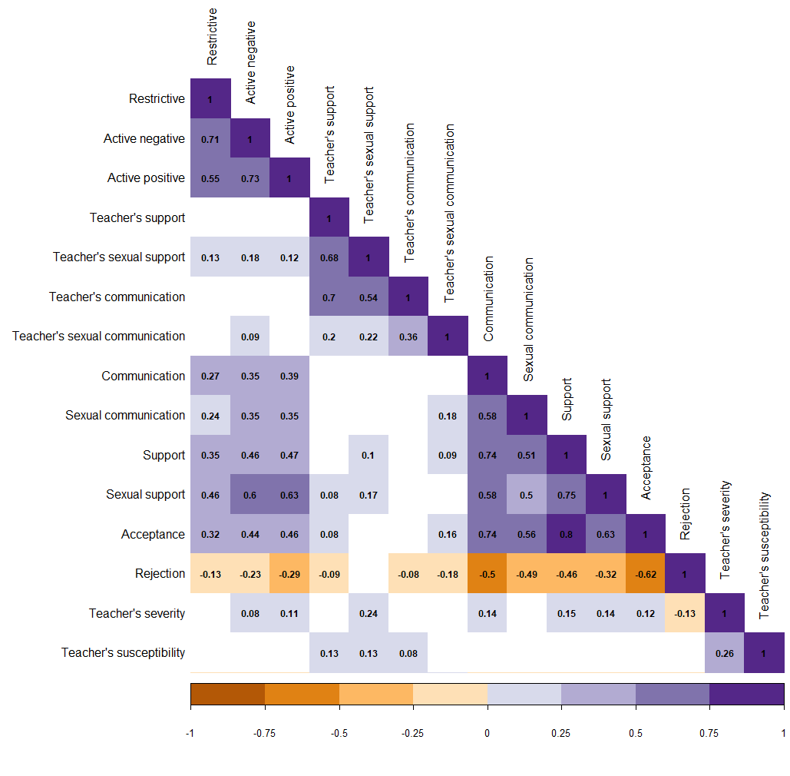

Figure 1. Pattern of associations between main study measures.

Figure 2. Pattern of associations between pupils’ perceived quality of sexual-harassment-related support from teachers and mediation strategies.

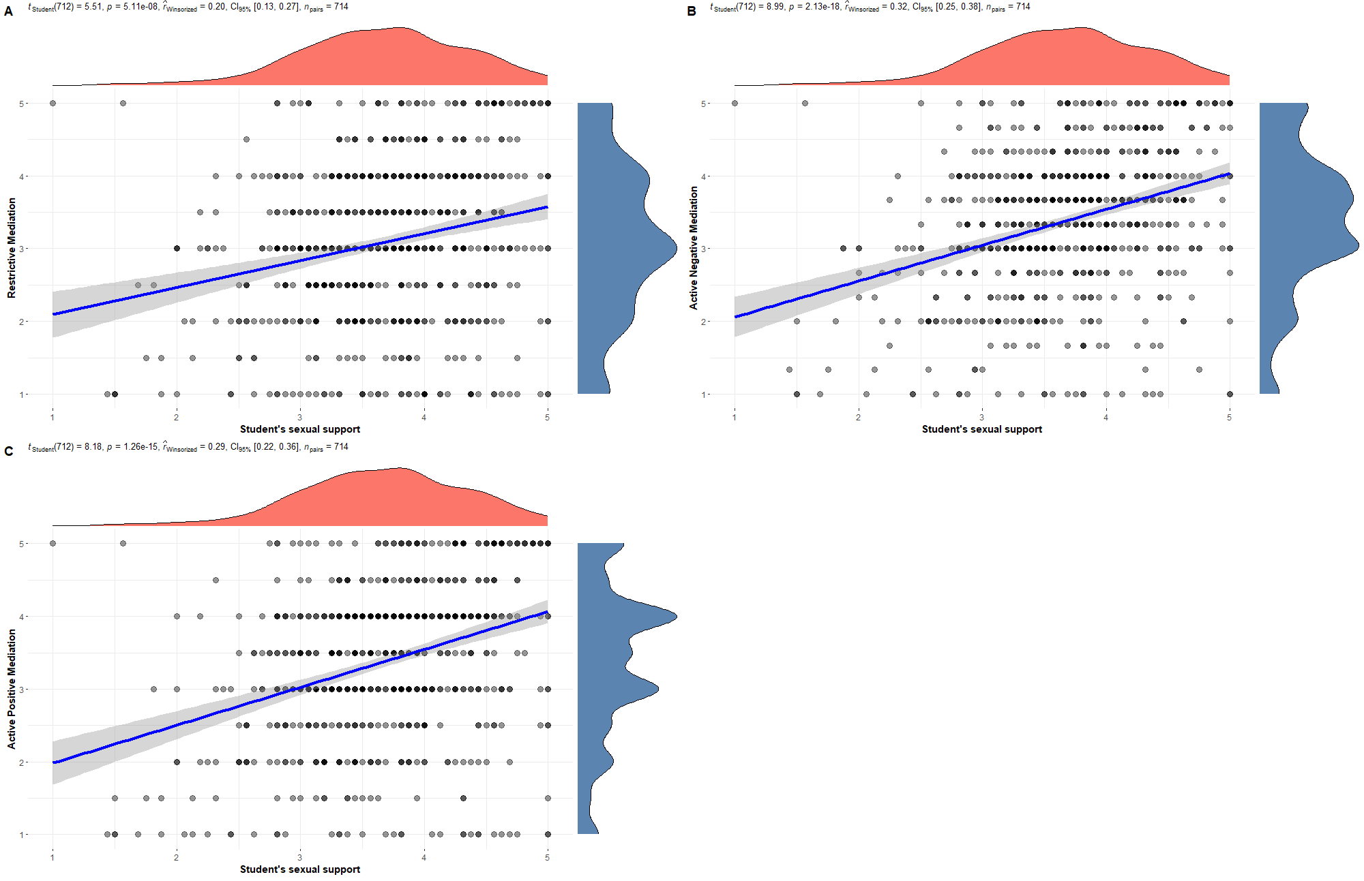

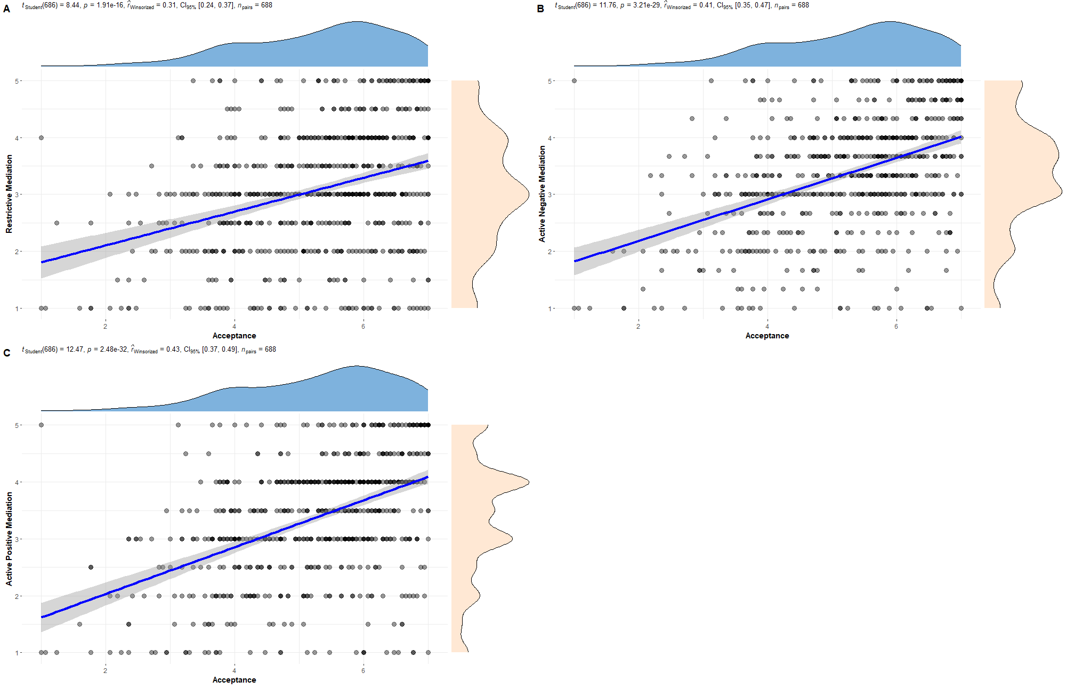Figure 3. Pattern of associations between pupils’ sense of acceptance from teachers and mediation strategies.