COURSEBOOK



Tools for Organizational Analysis

DLMWPWOAE01



Main Learning Objectives

##### Introduction 9



The course Tools for Organizational Analysis provides an understanding of what is meant by ‘organizations’, as well as what dynamics and structures form their backbone. You will learn about the basic principles of organizations, their set-up, which criteria are decisive for the form of the organization, how goals and strategies work within an organization, as well as what role people play in organizations. You will develop a scientific basis to apply different theoretical and empirical approaches to organizational research. Finally, you will also find out what contents the different branches of organizational research are concerned with, before you turn to organizational diagnostics.

While studying the topic of organizational diagnostics, a branch of organizational psychology, you will learn which organizational aspects are considered important by this discipline, and how these aspects can be analyzed using diagnostic tools. You will also gain an insight into three concrete instruments of team-based and organizational diagnostics.

The course further imparts the necessary knowledge to set up and carry out organizational analysis. For this purpose, the timing and content planning of organizational analysis will be discussed, and the reasons that lead to organizational analysis explained. These reasons, in turn, affect the concept of organizational analysis and the interest in recognizing its importance. Fundamental empirical methods of organizational analysis (surveys, observation and content analysis) are also presented, along with applied examples thereof.

Organizational analyses often focus on very specific topics such as change processes, careers, networks within organizations, or they can be part of due diligence processes. The course introduces these four application areas of organizational analysis, and explains how the analysis of these topics can be approached methodically.

[www.iubh.de](http://www.iubh.de/)



# Lesson 1

## The Organization

#### LEARNING OUTCOMES

After completing this lesson you will know …

…what is meant by organization and organizational structure.

... how goals and strategies are related to organizational structure.

... what is the function of organizations and what services they provide.

... what role people (employees) play within an organization.

... which different types of organizations exist.

DL-D-DLMWPWOAE01-L01

1. The Organization

### Case study

Mr. Mayer is head of an operational department in a company that sells building materials wholesale. Over the past few years, he has noticed serious changes in customer behavior. Existing customers are increasingly using the internet as a source of information and goods. This has a negative impact on his sales. In order to better understand how his department, or organizational unit, handles customer contact, Mr. Mayer carries out an organizational analysis. Using this, he would like to determine future approaches to better align his organizational unit to the customers’ new needs.

For this purpose, he gains a deeper understanding of how his organizational unit works, which goals the employees of the organizational unit pursue, how cooperation works and how the relevant organizational environment affects the organizational unit.

Mr. Mayer first considers the purpose and the basic functioning of organizations. After working out which elements are important for him in the analysis of his organization, he selects instruments and methods to assess them:

* + He analyzes the transformation processes within the organization that were already triggered by online commerce and changed customer behavior.
  + He analyzes the network of owners, neighboring departments, customers, public authorities etc., within which his operative unit is active.
  + He also analyzes the careers of the individual employees in his department to understand where they individually come from, and what skills they bring with them.

Through these analytical approaches, he creates a picture of the ins and outs of his organizational unit. With the results of the analysis, Mr. Mayer now possesse a lot of helpful information, which he can use to realign the processes and structures of his organizational unit, thus better adapting them to his customers’ changing needs.

The tools of organizational analysis are therefore essential instruments, on the basis of which strategic decisions can be made, specific areas of change may be isolated, and new approaches can be implemented within the organization. Before these are applied, however, it should be clear what is meant by “organizations” and what their components are.

Organization

### The concept of organization

What is the definition of the term “organization?” It is difficult to find a consistently accepted definition because the term can and often is used differently depending on the adopted approach. In business administration, for instance, work processes are at the core of its definition. Therefore, in this approach, the main focus is on the **organizational chart***,* i.e., the hierarchy of positions and functions, as well as the organization of the processes or **workflow**, which – in simple terms – is the sequence of activities within a working group. This perspective is based on a positivistic, normative understanding of companies as mechanisms to achieve specific goals. The organizational structure and its workflows are, in this sense, the means to fulfill corporate goals (Schreyögg, 2016).

In sociology, on the other hand, the term “organization” has a different meaning. In this field, the concept of organization describes a type of social system that occupies a level between the individual and society as a whole. Organizations, then, are social systems of decision-making communication (Luhmann, 2000). They are distinguished one another by their underlying distictive formal and informal features. In this sense, an organization is understood as a dynamic and interactive social system. This perspective is based on a constructivist understanding that focuses on the dynamics and interaction of the players in a specific field. This sociological perspective has increasingly asserted itself in organizational analysis and in the description of organizations in recent decades (Titscher et al., 2008).

###### The origin of organizations and the differences in related terms

Prior to the Industrial Revolution, business and family were, for the most part, inextricably linked. Agricultural products or handicrafts were produced by family groups. The Industrial Revolution finally led to a differentiation between the areas of business and family, and business-oriented organizations began to gain in importance. As a manufacturing unit, families were simply no longer competitive compared with industrially organized units. People of different backgrounds and abilities came together under the umbrella of a common entrepreneurial goal. They organized themselves, or they and their activities were organized around that entrepreneurial goal. Entrepreneurial organizations were formed, as well as receiving their own legal status, allowing them to exist as a separate entity, independently from their members.

In business administration, one usually speaks of *companies* when one is, in fact, referring to *organizations*. However, the term “organization” is more meaningful in comparison to that of “company,” “business,” or “enterprise” for the analysis and understanding of organizational processes and joint entrepreneurial action, since it better reflects the social-systemic character of these processes. The company (as a legal entity) and its business operation (as a location) are part of the environment when viewed as an organization, i.e., part of the organization system (Titscher et at., 2008).

Organizational chart This is the hierarchical structure of roles and units an organization gives itself in order to carry out its work activities.

Organizational processes/workflow

This describes the sequence of activities (workflows) within the organization.

Social system

This is comprised of the communicative space of decision-making among the actors in a group and their environment.

Constructivism

The several related theories of which constructivism is comprised, in simple terms, state that A does not necessarily have to be followed by B, but it could be followed instead by C, S, or Z. In short, there are no linear causal relations within systems.

###### Cornerstones of an Organisation

What organizations have in common is that they aspire to certain goals (or goal systems). However, the goal system is by no means rigid, and the goals communicated to the outside do not always coincide with those experienced inside the organization itself. The goal system of an organization is deﬁned more or less precisely by a process of negotiation between the agents within the organization. This is what is often called the subtle process of decision-making within a social system, which is based on the recognition of individual agents in the organization, and the distribution of power among its members.

Informal structure

The informal structure includes all those structural factors that are not documented. This includes norms and values of the organizational culture.

Furthermore, all organizations have a formal structure. Their form varies greatly depending on the organization and its organizational goal. For example, armies and start-ups have very different formal structures. Each part of an army has a very narrowly defined area of responsibility and strict hierarchies, while in modern start-ups categories such as boss, department and associated areas of responsibility often no longer exist. What both have in common, however, is that each individual member of the respective organization has a precise place in the (more or less pronounced) formal structure of the respective organization, and this is how their membership is deﬁned (Luhmann, 1964). In the example of a corporate organization, membership is usually recorded in an employment contract, which usually also regulates the tasks and responsibilities of the members in the organization (Titscher et. al., 2008). In addition, however, a large number of rules and standards for the members of the organization are not contractually ﬁxed. This is where we enter the area of **informal structure**. This refers to communication and decision-making paths established apart from the chain of command of formal hierarchies, but also to the organizational culture factor, which regulates desired and undesired behavior in groups and organizations, and holds the organization together as a social system (Schreyögg, 2016).

But what is an organization, then? Is it the assemblage of formal and informal structures, or does an organization consist of the sum of its members? The answer is neither. Every action of an organization, whether internal or external, is based on decisions made within the organization’s social system. To do this, the organization uses its formal and informal structures. The members use these to make decisions about organizational goals and the organizational purpose, or how the organization differentiates itself from its environment. However, neither the number nor the characteristics of individual members of an organization are decisive, but rather their social interaction.

In short, organizations do not consist of their members, as is commonly assumed, but rather of the decisions made by their members. Niklas Luhmann – one of the most influential organizational theorists of recent decades – places communication at the center of social systems. According to him, communication creates **reality**. Social systems, as represented by organizations, are based on their intrinsic communications and the decisions that result from them (Luhmann, 1981; 1984; 2000).

Organization

###### Radical Changes in Previously Established Forms of Organization

Luhmann’s perspective is all the more important to understand organizations now that the mainstream organizational forms, based on traditional ideas about formal structures, are in a state of upheaval. Forms of organization that have been well-established up to now are based on clear departmental and area boundaries that allow them to process tasks as much as possible within one unit. This property proves, however, to be a stumbling block in times of rapid change in business models and sales markets. Previous efforts by many organizations to develop strong formal structures have resulted in the establishment of so-called “silos” within companies, i.e., areas delimited by hierarchies that only pursue their own departmental/divisional goals; silos are characterized by a high concentration of power and rigid communication and decision-making patterns. The dynamic and efﬁcient decision-making that is necessary within large organizations was severely hampered by this structural problem, which has often led to economic imbalances and even bankruptcy.

On the other hand, new doctrines of organizational design such as sociocracy, holacracy, and other **agile organizational structures** have understood the central importance of Luhmann’s insights. Agile teams and forms of work in organizations are now increasingly developing around dynamic forms of communication and decision-making processes, in order to be able to react more quickly to changing sales markets, technologies, and customer needs. In short, rigid formal divisions in companies are loosening up, taking advantage instead of the dynamics of social systems.

This calls into question certain parts of previous organizational theory. However, many aspects of it are still retained, such as goals and strategies, which continue to shape the actions of organizations.

### Goals and Strategies of an Organziation

Every organization has goals, and so does every company. These can be represented very differently. Thus, for example, wellness hotels want to offer their guests the most relaxing stay possible, manufacturers of sports cars aim to build the fastest and most powerful cars, and NGOs endeavor to make world trade fair or politics corruption-free.

In order to achieve their respective organizational goals, organizations put together strategies. Strategies are “higher level” action plans that outline a way in which the organization’s goals can be achieved. This includes, for example, product design considerations in order to stand out compared to the competition (e.g., construction of the most powerful car), considerations about customer segmentation (e.g., focus on high-income sections of the population in a specific country), or the structure of the organization (e.g., exclusive distribution of the product from a specific country, or development of a distribution network with independent country organizations in several countries).

Reality

A shared reality is created through communication among members of a group. For companies, this means creating clarity about who counts as a customer, how service is deﬁned, etc.

Agile organizational structures

The speed of decision-making processes increases when organizational structures are agile, for example by reducing hierarchies and departmental boundaries. Thus, organizations are increasingly understood as social systems, instead of as mere fulfillment mechanisms to achieve goals.

The goal of an organization dictates its activities. The strategy defines priorities and the means by which the goal is to be achieved. The organizational structure forms the framework for the daily (collaborative) work of the people in the organization.

###### Organizational Goals

The goals of an organization can be further divided into organizational, formal and substantive goals or objectives. Organizational goals are those that describe the purpose of the organization. They state the benefits that the organization provides for its environment. These include the examples mentioned above (relaxing stay for hotel guests, construction of the most powerful car, creation of fair world trade, etc.).

Substan-tive goals

The substantive goals of an organization are based on quantifiable criteria, such as scope, quantity, quality, etc.

Formal goals

The formal goals of an organization are based on qualitative criteria, such as image, sustainability, market position, employee orientation, etc.

The substantive goals of an organization are goals with clearly quantifiable criteria such as scope of its work, its quantity, product quality, etc.; this also includes profitability, liquidity, or the turnover of a company. Formal goals are topics such as image, sustainability, market position, employee orientation, and other similar ones, i.e., goals that are defined by qualitative criteria. Examples of these are a company name that is publicly associated with the sustainable use of environmental resources, or an organization that is recognized by governmental institutions as a key advocate for human rights.

Nevertheless, those goals that an organization sets itself, and those which it actually pursues cannot always be recognized at first glance by an organizational analysis. This applies to the external view of the organization, as well as to the internal view by members of the organization itself. Many organizations have target documents such as mission statements, vision, and strategy documents, some of which can also be viewed publicly. However, these are usually formulated very vaguely; actual goals are communicated transparently only in the rarest of cases. The reasons for this lie, for example, in maintaining their competitiveness vis-á-vis other competitors, to whom organizations do not want to openly disclose their goals.

###### Explicit and Implicit Goals

Organizations operate on two levels of public disclosure for their goals. A distinction is thus made between explicit and implicit goals. **Explicit goals** are those that are documented and accessible to all relevant groups of people in an organization (and sometimes further afield). Their implementation is ofﬁcially and consciously pursued in the organization. To this end, they are clearly deﬁned and communicated within the organization. In publicly listed companies, for instance, these are the sales targets that must be communicated ofﬁcially even to the outside world.

Organization

In contrast to these, **implicit goals** are those not ofﬁcially documented and communicated by the organization, but which characterize its work nonetheless. In many cases, they are not consciously promoted within the organization, but rather implicitly adopted. For example, company owners pursue profits and liquidity as goals, while departments and teams that are in contact with customers pursue quality and customer satisfaction; the product developers in the same company pursue the goal of a perfectly designed and technically sophisticated product. The fact that these individual area and team goals are aligned with a common goal of the organization is due to the implicit coordination between the different areas.

On the other hand, if the coordination process between the goals of different organizational areas takes place consciously, i.e., explicitly, this creates a common goal system for the whole organization. In order to achieve this, the goals from different areas of the organization are arranged into a hierarchical structure and linked with one another. Through this conscious and documented process, previously implicit goals of the organization turn into explicit ones.

###### How are Organizational Goals Created?

How does an organization achieve its organizational, substantive, and formal goals? On the one hand, there is an interaction between organizations/companies and their environment. The environment of an organization refers to both society in general and the company’s immediate environment, consisting of customers, suppliers, authorities, etc. The organizational goal and the associated purpose of the organization deﬁne the raison d'être of the organization in relation to its environment.

If organizations do not provide any significant service that creates benefits for their environment, they will not survive in the long term. In this sense, non-profit organizations (NPOs), for example, pursue political or charitable goals that are intended to benefit the general public. Examples of this are the commitment to employee rights or environmental standards, but also the work of the local football club, whose goal is to strengthen the community and support sports activities.

However, business organizations such as companies primarily strive for objective goals such as profitability, liquidity and turnover. In this context, any benefit for the organizational environment is rather small. Therefore, in the ofﬁcial presentation of their organizational goals, all organizations usually orient themselves to their environment and the dominant discourse within it. As a consequence, many ofﬁcially communicated organizational goals are worded in a correspondingly vague way, so as not to antagonize people, or even to obscure the true goals (an example from Google: “Organize our world’s information and make it generally accessible and usable;” and from Deutsche Bank: “We exist to enable economic growth and social progress”). Only rarely do organizations communicate the goal of wanting to generate the highest possible profits at any cost (possibly even through bypassing social, civic, or legal restrictions).

Explicit/implicit goals

Explicit goals are documented and all interested parties are aware of them. Implicit goals are, on the other hand, those that are usually not documented. They shape the actions of organizational actors on a subconscious level.

The environmental factor thus shapes the formulation of the organizational goal and the associated organizational purpose on the one hand, and the ofﬁcial presentation of the goals of an organization that are communicated to the outside world on the other. In addition to this first factor – the orientation towards the organizational environment – a second, internal factor is decisive for the creation of goals.

Here, it is necessary to distinguish once again between the emergence of implicit and explicit goals. The explicit substantive and formal goals of an organization are created in an internal negotiation process between stakeholders of individual organizational areas (organization management, production, sales, etc.). The basis for defining these goals are economic considerations, how sales and earnings of the organization can be increased and costs kept low. The result of the internal negotiation process is a target system that includes both the substantive and formal goals of individual areas. The goals thus linked are brought into a target hierarchy, ideally in such a way that the individual goals of the area support the achievement of the entire organization.

Stake-holders

People that can influence a decision are defined as stakeholders. As such, they enjoy relative power.

Scaling of the target hierarchy

The purpose of scaling the target hierarchy is to compare increasing and decreasing measured quantities with one another.

Goals are thus defined for each area. For production, these are, for example, the number of product units produced, for sales the number of products sold or the profit margin achieved, for purchasing the purchase prices for raw materials or the storage period of the required raw materials, etc. The qualitative development of the organization is then guided by its deﬁned formal goals. For example, in manufacturing a product that is as inexpensive as possible or, conversely, one that is as highly developed as possible because the company wants to continue to cultivate its image as a leader in technology. Another example would be strengthening the image of the organization as particularly environmentally friendly or employee-oriented.

The goals obtained in this way are subsequently interpreted and further operationalized for day-to-day business. At the objective level, using the example of a manufacturing company, this means that production quantities per runtime are broken down into individual production machines or that maximum downtimes for production machines are clearly deﬁned. The result is a **scaling of the target hierarchy**, which makes the substantive goals of the individual areas measurable and comparable.

In addition to an organization's explicit hierarchy of goals, its implicit goals also shape the behavior of the organization’s members. Said goals can be reflected anywhere within the organization: in the organizational structure, in documents, in strategies, in the content of discussions, and in the organization’s culture (cf. Meyer & Höllerer, 2010).

The implicit goals of an organization arise from social norms and the habitus within the organization. These two factors shape the desired behavior and thinking of people within the organization. For instance, technicians usually deal with fine technical processes over many years of training; they tinker to design and build products that are as trouble-free and as sophisticated as possible. This behavior is widely recognized among technicians. Their habitus can, therefore, be commonly described as that of detail-oriented technophiles. Business managers, on the other hand, are conditioned through their training to be able to record processes in numerical terms and quickly assess their profitability. Everything centers around topics such as profitability, value increase, sales, etc.

Organization

Their habitus can be described as having a marked affinity for numbers. In many cases, technicians in companies will therefore implicitly pursue goals related to products or production processes, while business managers will pay attention to goals related to revenue generation or cost reduction, etc. Which of the implicit goals are predominant in an organization, gets decided by which group sets the overall tone within the organization – in this example, it could be the technicians or the business managers.

Both types of goals, implicit and explicit, are therefore present in the organization. The more conscious the goal negotiation process is, the easier it is to coordinate implicit and explicit goals within the organization. A well-functioning organization requires the elaboration of an explicit goal system in order to use the organization's energies and resources in the best possible way. The strategy of the organization is then based on the resulting goal system.

###### Strategies of the Organization

An organization's strategy is very closely linked to the organization's goal system. A strategy is a plan of action for procedures, means/resources, and key content areas of the organization that are designed to support the achievement of the organization's goals. The organization’s environnment serves as a benchmark for strategic considerations. Strategic considerations aim at creating an advantage for the organization in its environment/area of activities.

When setting up the organization’s strategy, a distinction is made between three areas, on which strategies are based (cf. Porter, 1980/1985):

* Customer leadership: The organization's resources serve to align the organization/company fully with the needs of its customer. Possible considerations here would be: Are there services that competitors do not yet offer? How can you gain more information about existing customers in order to better tailor services/products to them?
* Cost leadership: The organization's resources are geared towards keeping the organization’s internal costs (e.g., production costs) as low as possible. The resulting cost advantage is passed on to the customer or used for expansion. Possible considerations here would be: Where are the cost drivers in the production process? Where are there unused resources? How can costs be reduced in order to achieve a better profit margin on the one hand, and to offer the customer the most cost-effective services/products on the other?
* Knowledge or technology leadership: The organization’s resources should support the organization’s products/services, so that these are based on the highest level of technology and cutting-edge knowledge. This allows the organization to set itself apart from its competitors. Considerations in this regard could be: How can a product achieve certain features that competitors cannot implement (e.g., highest degree of hardness of steel; an algorithm that tailors advertising precisely to the needs of customers, etc.)? How can the organization strengthen innovation to maintain technology leadership?

Strategies emerge through a strategy planning process in the organization. The result of strategic planning is the organization's intended strategy. It includes one or more of the three areas mentioned above, as well as means of implementing the strategy. The latter include operational guidelines for the organization, techniques and implementation plans on topics such as marketing, products, production, customer service, organizational structure, expansion, etc.

However, there is usually a difference between the intended strategy and its actual implementation. Think of it as a car trip. At the beginning of the journey, the driver sets his destination and his arrival-time with defined costs for fuel, meals, accommodation, etc. His strategy is to travel as cheaply as possible. To accomplish this, he has rented a fuel-efficient car and researched the shortest route in advance. However, unexpected incidents occur along the journey: a traffic jam, or the tunnel being closed for several hours. As a result, the driver does not reach the first stage of his destination in time, and must look for new accommodation. Additional costs arise. As the journey continues, the route changes because the navigation system used has not received an update about blocked sections along the way. Thus, unforeseen events take place that the strategy planner cannot directly influence, but to which he can only react.

Emergent Strategy An emergent strategy is one that is implemented as a result of unexpected influences from outside and inside the organization.

The fact that planning and implementation differ, leads to the **emergent strategy**, i.e., the strategy form that is actually implemented. The implementation of the organizational strategy is influenced both by internal factors such as the number and qualifications of the organization’s employees, communication and work structures, and the habitus of the organization, as well as by external factors from the organizational environment, such as amendments to laws, changes in the competitors’ market behavior, the customers’ consumer behavior, or even the prices of the raw material.

Strategies are usually formulated as a long-term plan – with a timeframe of between two and five years. In this timeframe, unforeseen developments that have an impact on the implementation of the intended strategy are very likely to occur. Nevertheless, organizational strategies provide the orientation as to how the organization’s resources should be used in order to achieve the set goals. Increasingly faster upheavals in business models such as the automotive or financial industry, brought about by technological developments (keywords: digitization or battery technologies), and customer requests (key term: environmental compatibility of products), mean that strategies are not reviewed and reformulated every few years, but rather on an annual basis. Long-term strategies (two to five years) are still developed, but supplemented by short-term strategies (one year).

Organization

###### How are Strategies Created?

Organizational strategies arise from considerations of the current situation of the organization in relation to its environment. Specifically, the management of an organization obtains information on medium and long-term developments on the sales market, potential customer base, technologies, etc., and derives possible consequences for their own organization from this information.

An example of this is the topic of digitization. This is currently changing business models and leading to a new orientation in terms of content. Using the example of a manufacturer of industrial welding equipment, this means that digital data acquisition via built-in sensors in its equipment can be used to identify what the customer is using it for, which parameters are set on the equipment, and how long they it is in use. This information can ultimately be used by the manufacturer, on the one hand to improve the technology of the devices themselves, but also to align their sales structure even better with the customers and their needs. The manufacturer's previous strategy then shifts from cost and technology leadership to technology and customer leadership. For this purpose, the newly acquired knowledge of customers and product use can inform research and product development, but also how the sales department promotes its activities.

The great challenge for the management of an organization (i.e., identifying the right strategic approaches) is supported by methods of strategy development. The most commonly used methods in recent years are industry structure analysis, competitor analysis, environmental analysis, value chain analysis, SWOT (Strength/Weakness/Opportunity/Threat), and portfolio analysis (cf. Porter, 1980/1985). Exploring these in detail would fill another coursebook: at this point it should only be mentioned that these methods aim to identify the developments in the organization’s environment, to be able to better assess the strengths and weaknesses of the organization in its environment.

Concrete intentional strategies emerge in the course of **strategy workshops**, which offer a space for the development of the organization’s strategy. Analyzing the developments in the organizational environment and the strengths of the organization in terms of technology, customer orientation and internal cost structures can all provide approaches to reform the content of the organizational strategy.

However, who takes part in the strategy-finding process within an organization, and which approaches ultimately prevail in the strategy-finding process often depends on two factors. On the one hand, these are patterns of human thinking that influence the development of the content of strategic considerations; on the other hand, political processes within the organization play a decisive role in the question of who takes part in strategy workshops and what weight is given to the input of individual participants.

People usually make decisions in strategy-finding processes according to three patterns. These patterns significantly shape their thinking (Schreyögg, 2016):

Strategy workshop

A strategy workshop is a moderated form of work in which selected participants develop strategies and make decisions on the organization’s strategic approach.

Path dependency

Path dependency is understood as the tendency to maintain a previously taken direction.

Political processes

The concept of political processes defines the manners in which influence is exerted within an organization. These are based on the power and clout of different individuals or groups.

* Previously known thought patterns that have proven expedient for past successes are applied to new situations. This, however, results in the increased perception of previously known risks from the organizational environment (strong competitors, competition to attract skilled workers, etc.), while unknown risks are ignored. Tried and true solutions for familiar risks are copied without first checking whether they fit the new challenges.
* The organization as such forms a core competence that is reflected in its strategy and structures. For example, an Austrian manufacturer of production machines has its core competence in electronic and mechanical product development. It has large technical development departments and large production structures. The IT and sales structures, on the other hand, are kept relatively small, since the product has so far sold itself due to its technical superiority on the sales market. Challenges, such as digitization, are countered by strengthening the core competence - i.e., producing even better developed products.
* The strategies of an organization arise in a **path dependency** from existing thought patterns (cognitive patterns) and their core competences, comparable to a cycle or a closed system that strives for confirmation and internal continuity. Radical changes in the strategy of an organization can therefore only rarely be observed.

The second factor, the political processes within the organization, determines who participates in the strategy development process and what weight is given to the input of individual participants. The key factors here are recognition within the organization and being well connected at the same time. Recognition is given to individuals who have speciﬁc knowledge, skills, and economic success, which in turn is also prized within the organization.

For example, an innovative programmer in an IT company gets considerable recognition for his/her knowledge and his/her competences within the organization, having mastered a new programming language, implemented it in a developed product (e.g., applications for mobile phones), and finally brought about good sales for the company. If this programmer is also able to network well with sales staff, management, and employees from other areas within the company, and maintains good relationships with them, social recognition is also assured. With this combination, the programmer would most likely possess a great deal of influence in his organization's strategy-finding process.

How a company’s strategies emerge and are formulated depends both on the information available about the organizational environment, and on dominant thought patterns and social interdependencies within the organization.

For organizational analysis, the distinction between intended and emerging strategy is, therefore, of great importance. The former can be analyzed through the various strategy papers, annual reports, webpages, etc., since in most cases it is sufficiently documented and communicated by the organization. The strategy development process is also documented in most cases via workshop documents, and its contents are therefore largely comprehensible. Furthermore, decisions made through informal communication between members of the organization can be obtained through interviews with them.

Organization

When analyzing the emergent strategy of the organization – i.e., the actual strategy implementation – it is hardly possible to fall back on records/documents. The sources of information in this case are mostly interviews, the analysis of communication content (interview evaluations, meeting minutes, etc.), as well as observations of work processes, meetings, informal talks and the like, which can be used to identify which topics and focal points from the intended organizational strategy are actually being implemented.

One of the essential aspects through which the implementation of strategies can be recognized is the organizational structure. This factor should therefore be explained separately.

###### Strategy and its Effect on Organizational Structure

The issues of strategy and of organizational structure are closely related. In this sense, it is important to consider how formal structures, and operational, information, or communication processes are designed so as to support the implementation of the organizational strategy and the achievement of the organizational goals. Formal structures refer to departments, hierarchies, divisions, etc., that break up the work processes of an organization into different areas (such as departments).

In this context, a statement that is very well known in organizational research suggests that the chosen organizational structure follows the organizational strategy (“structure follows strategy”, cf. Chandler, 1962). Based on this, Schreyögg (2016) formulates categories based on Chandler & Rumelt (1974), which provide a rough overview of common organizational structures within companies. In doing so, he orients himself towards the product strategy of companies, which he sees as a decisive factor for the choice of organizational structure.

For this purpose, Schreyögg subdivides companies according to the number of products they produce:

* + Single-product companies are companies whose main product line accounts for more than 95% of the company's output, such as a plastic film manufacturer that “only” produces plastic film.
  + Core product companies are companies whose core product line accounts for between 70% and 95% of company output, e.g., a plastic film manufacturer who, in addition to the main product (plastic films), also produces plastic bottles and various other plastic containers.
  + Related Diversiﬁcation refers to companies that are made up of multiple divisions and whose main product line accounts for less than 70% of the company's output. This means that several divisions produce a large variety of products. Example: The plastic film manufacturer is part of a plastics processing company group, which produces other plastic products for speciﬁc applications, for instance in the automotive industry. The production of plastic films contributes less than 70% to the company’s performance.

Product strategy

The product strategy determines whether a company relies on one or more products/product categories for a competitive advantage.

* + - Conglomerate diversification refers to companies whose main product line represents less than 70% of the company’s output and which consist of several companies with different main product lines. Example: The plastics processing group, which manufactures films, bottles and containers as well as products for the automotive industry through two different companies, is itself part of a large conglomerate that also includes other companies such as, for instance, oil refineries or transport companies.

Functional organi-

zation A functional organization is considered to be such when, starting from the second hierarchical level, it is subdivided according to substantive functions.

Divisional organi-

zation An organization is considered as being divisional when a separate organizational unit is formed for each product or product group.

Depending on the degree of diversification of the product/offer range, different organizational structures are set up within companies. For example, organizations in the categories of single and main product companies are usually characterized by **functional organizational** forms in order to pool the organization's skills and competencies as far as possible according to organizational activities, e.g., production or sales.

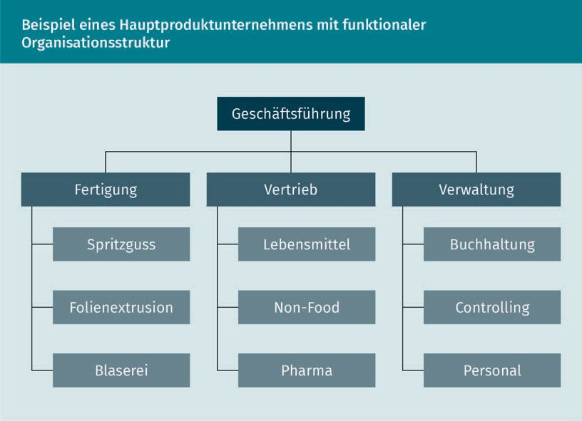More highly diversified companies (i.e., cases of related and conglomerate diversification), on the other hand, tend to choose **divisional forms of organization**, and subdivide themselves based on product groups. The individual divisions have largely independent decision-making authority and responsibility for their results. Below are two examples to illustrate these organizational forms.

Organisation

The company presented here is a main products company specializing in the production of plastic containers (by means of the injection molding production process). In addition to this main product, it also produces plastic films (via the film extrusion production process), and plastic bottles (via the blow molding production process). Production is structured according to production processes. The main sales market for plastic containers is in the non-food sector. Other sales markets are pharmaceutical companies that purchase films and packaging made of plastic, and beverage manufacturers that fill plastic bottles with their products. The sales department is structured according to the sales markets. Other areas of the company, such as accounting, auditing and human resources, are organized in one unit, that of the administration. In this example, the company has a functional organizational structure, since its units are subdivided according to its functional areas (production processes, sales markets, and subfields of administrative activity) after the second hierarchical level.

Highly differentiated companies are usually divided into divisional organizational structures. The company shown below consists of a holding, which in turn consists of three joint-stock companies. These, in turn, are divided into numerous limited liability companies. The latter are independent companies. Each of them has its own sales, purchasing, and administration structures, as well as an independent management. For example, the limited liability companies of the hardware stores are broken down by country in order to be able to react better to the developments and changing legal framework of local markets.

The companies in the real estate division, on the other hand, are structured in terms of procurement and development, and are more geared towards functional areas.

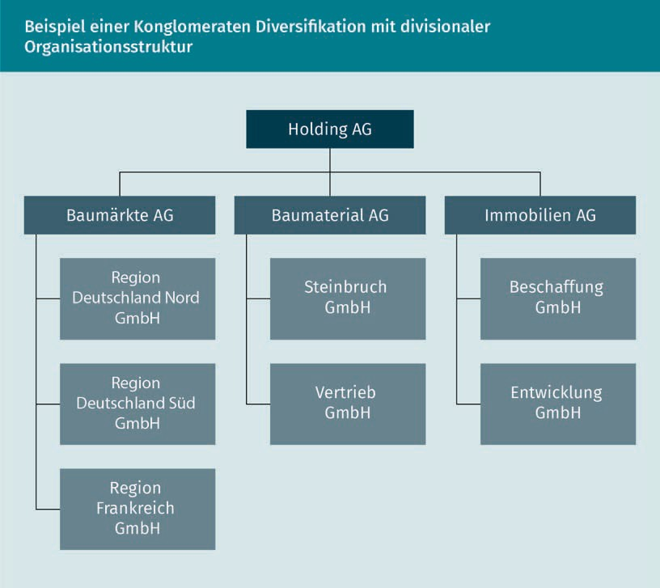

Which structure companies choose for themselves often depends on which strategic advantages the organization wishes to achieve through that structure. Changing competitive environments have led to greater internationalization of organizational structures in corporations. In multinational organizations, for example, rather than setting up country divisions with their own functional structures, cross-country organizational units have been created instead, which are based on functional areas (production, administration, sales, etc.). This is done with the aim of using synergies – such as keeping costs low – and better pooling of specialist knowledge within the company. As a result, corporations have instead set up international sales structures, international administrative structures, etc..

Many international organizations build on the structures of a matrix organization, in which there are regional units (e.g., in sales), but which are functionally managed by central units of the group (group management for sales). For the development of new products or services, project structures are often created in which people with different functions (such as technicians, auditors or sales staff) form their own organizational

Organization

unit for the duration of a project.

### Functions and Services of Organizations

Regardless of whether they are companies, NGOs or associations, organizations fulfill a social function by providing services that benefit the general public or parts thereof. Their range of services covers tasks from birth to death. Organizations accompany people from birth (hospitals or birthing centers), through to extra-family socialization (kindergarten, school, clubs), then later as employers (companies, NGOs, clubs), and food providers (food production and trade), and finally until death (hospice services) and beyond (burial grounds). Even the representation of interests for persons (or groups) vis-à-vis other organizations takes place via organizations such as parties, clubs, associations, trade unions, or work councils.

Organizations are thus active in almost all areas of society (economy, politics, religion, education, etc.). Firstly, with their services they ensure that the needs of individuals and of society as a whole are satisfied. Secondly, their organizational form means that their services are permanently available. This is the case because organizations exist independently of single individuals. These three factors – satisfaction of needs, consistent performance, and independence from individuals – contribute significantly to the importance of organizations for the functioning of our society.

In order to be able to provide their services permanently and independently of single individuals, organizations have their own legal forms. Examples of this are associations, limited liability companies (G. GmbH, i.e., Inc./Ltd.) or stock corporations (G. AG, i.e., plc.). These special legal forms allow them to act as a legal entity vis-à-vis other organizations and individuals. In this way, on the one hand, the liability of individual members can be limited to their contribution within the organization and, on the other hand, the organization can also sign stand-alone and long-term contracts – completely independently of its individual members. For example, even if the managing director of company A leaves his company before the conclusion of a contract with company B, the contract between the two companies still exists. From a legal standpoint, the directors did not sign the contract with each other as individuals, but rather on behalf of the organizations they were representing.

This advantage over individuals, whose contracts in most cases lose their validity upon their death, is likely to have led to organizations being able to establish themselves as powerful and constant actors in our social order from the early days of industrialization (Titscher et al., 2008; Coleman, 1974). Organizations have therefore taken on an important social function due to their performance and the services they have provided. However, if the scope of the services they provide is very wide, their inner organizational structure must also reflect that versatility (Parson, 1956). But what do all organizations have in common to assert themselves so incisively in our society?

Organizations themselves have very individual structures that enable them to provide their services. Factors such as their goal system, strategy, and organizational environment have a significant impact on the internal structure of the organization. However, all organizations share the **functional principles** that give them a significant advantage in the processing of their services. Titscherat al. (2008, p. 33) list them as follows:

Functional principles

The functional principles of an organization are the bases upon which the organization is set up, and which determine the operational functioning of an organization.

.

* Division of labor and specialization of task fulfillment: In organizations, a large number of people work together to achieve organizational goals (e.g., the manufacture of a product). Through the division of labor and specialization of task fulfillment (e.g.: manufacturing areas, sales, accounting), it is possible for an organization to achieve much higher productivity compared to the same number of individual entrepreneurs, and thus create more individual products at the same time.
* Coordination of tasks and functions: In every organization, tasks and functions are coordinated between the individual members/employees. This can be done through clear work specifications or the bundling of individual tasks in departments, but also – as is common in agile organizations – solely for the duration of a specific project.
* Conﬁguration and management system of the organizational structure: Organizational structures – be they permanent or temporary – create clarity about the areas of responsibility of individual members or teams. The manager-to-staff ratios, i.e., the number of employees to be managed per manager, are defined and clarified via the management system as to whether work is to be carried out in departmental or project form.
* Delegating decisions and distributing competences between the functions: Organizations are clearly regulated regarding who can make decisions about what, and how decision-making and implementation competences are distributed. Not every member can sign contracts with other organizations or deﬁne product features.
* Formalization of information ﬂows and task completion: Formalizations (that is, stipulations) of communication channels and tasks regulate the amount and type of information received by different members of the organization. This means that the flood of information is harnessed, and not every member has to be responsible for everything. Ideally, members/employees (only) receive precisely the information they need to fulfil their assigned tasks.

Irrespective of whether one considers traditional forms of organization – such as functional or divisional organizations with their departments and divisions – or agile forms of organization, in which subdivisions into departments or divisions become less important, the functional principles mentioned above still seem to be valid. They give organizations an advantage in their performance that family associations or sole proprietorships lack as entrepreneurial units. However, considering their functions also makes it clear that organizations cannot exist without their members.

Organization

### The Role of People within Organizations

Organizations are independent entities that can have the status of a legal entity. Nevertheless, they cannot be thought of without people, because they are primarily social systems. As such, they are characterized by rules and norms, as well as strongly held beliefs or **dogmas**, that regulate the interaction of several people within the system. This gives rise to structures embodying the differential distribution of power, which is expressed in the form of hierarchies, as well as communication patterns that regulate who in the organization talks to whom about what topics. In addition, ways of thinking and patterns of action are created, which determine how actions are to be carried out within the organization.

In some organizations, for example, there is a strong hierarchical thinking that runs through all areas and hierarchical levels of the organization. Thus, departmental structures that reflect these hierarchical thought patterns are likely to develop. The original form of hierarchical thinking often goes back to the founder of the organization. As a formative person in their social system, s/he had a great inﬂuence on their norms and rules as an individual. However, social systems such as organizations are not made up of individuals, but of a group of people. Therefore, other members of the organization and the organizational environment such as employees, authorities and customers naturally also influence the system’s norms and regulations. This affects, among other things, the time, the know-how, activities, perspectives and social skills that each individual member brings to the social system of the organization (Titscher et al., 2008).

In order to understand what role people play in organizations, it is important to consider their contribution to the organization on the one hand, and what framework the organization offers for them to get involved in, on the other.

###### From Basic Human Image to Organizational Understanding

People provide the organization with the performance that they are motivated to provide. How that interaction between organization and individual foments the motivation for the performance in benefit of the organization can be explained using a somewhat older but

Dogmas

Dogmas are (often unconsciously) held beliefs or principles that shape our world view, i.e., how we see ourselves and other people.

Theory X and Theory Y

The X-/Y-Theory describes different views about the basic attitude of humans to their behavior within organizations.

still informative theory:

Theory X and Theory Y

Using his X/Y theory, Douglas McGregor (1960), an early management and organization researcher, draws two action theories that ideally represent two opposing standpoints for the understanding of people and organizations. The anchor point of this explanatory approach is the human image, which underlies the understanding of how organizations function.

On the one side of the spectrum, X-Theory assumes that people shy away from responsibility and work, and can only be driven to a certain level of performance by coercion. Accordingly, coercive and control mechanisms, as well as specific power structures develop in the organization in order to “motivate” employees to carry out those activities that support the goals of the organization. The roles of individuals within the organization are accordingly divided into two groups: On the one hand, the organization consists of a group of people (the management) who exercise coercion through hierarchies, work specifications, disciplinary means, instructions, etc. On the other hand, the second group of people (employees) – the vast majority – submit to this structural coercion by following the management's guidelines and instructions, as they fear the imposition of sanctions. The most common example of this is an army. In this organization, officers direct the actions of hundreds of people. Clear hierarchies and the threat of punitive measures guarantee that the majority of subordinate members of the organization follows given instructions. Slightly modified, similar structures can also be found in some companies (e.g., in manufacturing companies, where workflows on processing equipment are closely defined in terms of time and content).

On the opposite side of the spectrum is the Y theory, which assumes a fundamentally different image of man. According to this theory, human beings strive to fulfill their basic needs, which specifically include the achievement of goals, meaningful work, acceptance of responsibility, self-control, and self-discipline. According to the Y theory, these are innate characteristics, which people and strive to realize. In this way, organizations that provide their members/employees with opportunities to display these qualities are able to function without tight control and coercion mechanisms. The role of the manager in this type of organization is also formulated in such a way as to ideally enable the employees within the organizational structures themselves to make the decisions that affect them (McGregor, 1960). For example, a start-up builds on the strong intrinsic motivation and commitment of both its founding members and its employees. Many start-ups specifically rely on their employees to act independently and creatively. The decision-making structures within the organization are designed in a similar way, characterized by unbureaucratic communication channels for thematic coordination between the

Organization

employees, and by ﬂat or non-existent hierarchies.

|  |  |
| --- | --- |
| McGregor‘s Theory X and Theory Y | |
| Theory X | Theory Y |
| People don't like to work. This attitude changes for the better as the hierarchical level increases. | People generally like to work. There is no differentiation between employees at different hierarchical levels. |
| Controlling people and their work by the management of an organization is necessary. | People value self-control and self-actualization in their work. |
| People refuse to take responsibility. | People strive to take on responsibility. |
| Certainty and clarity regarding the tasks and responsibilities are necessary. Achieving and maintaining this is the priority. Not following instructions leads to problems. | People like to use their intellectual, imaginative, and creative abilities to solve problems. |
| A centralized authority and coercion are essential for the functioning of organizations. | Employees of an organization need freedom and structures, in which personal responsibility and independent problem solving is possible within the framework of the organizational goals. Creating these structures is the task of management. |
| Organizations are driven by external motivators and sanctions | Organizations are kept running by allowing people to follow their drive for personal responsibility and creative action. |

These two opposing points of view of the X/Y theory illustrate how the basic concept of mankind can affect the structural design of organizations. The following table provides a more detailed overview of the diverging beliefs of the two theoretical strands.Intrinsic motivation

Intrinsic motivation is promoted by factors such as self-actualization, increasing self-esteem, etc., factors which arise within the people themselves.

Objective

side The objective side designates the given structures of the organization, such as work specifications, time, and space.

Subjective side The subjective side includes the individual's ability to work as well as their interest, which is expressed through performance and motivation.

The Interaction of Structures and Actions in Organizations

Titscher et al. (2008) contribute another aspect to the understanding of the interaction between people and organizations. In their approach, they focus on structures and actions, and thus less on the beliefs that underlie the X/Y theory. They also see two sides of the organization: on the one hand, the objective side, which provides the framework for the actions of the employees through the organizational structure, work processes, and technical necessities (e.g., machine-bound work). On the other hand, the interaction is also characterized by the subjective side of the organization. On this side, human beings are seen as employees, whose actions are shaped by their own performance, their experience, and their motivation (ibid.).

Which role a person takes on in an organization and how they contribute to it therefore depends on the one hand on the objective possibilities of the organizational structure, and on the other hand on subjective skills and motivation. An ideal interaction occurs when the objective and the subjective side have the greatest possible overlap, i.e., a person’s beliefs, abilities, and needs correspond to the structural possibilities and framework conditions of the organization (Rosenstiel et al., 2009). This can be the case, for example, when a very free-thinking, creative person works in an innovative and low-hierarchy start-up – or when a very structured, detail-oriented person works in narrowly deﬁned production processes. In both cases, the objective and subjective sides fit together perfectly.

As a rule, however, organizations buy the performance of their employees by providing them with certain compensations, such as salary and employment. This aims to fulfill the extrinsic motivation of employees. Intrinsic motivators are also part of this barter between the organization and employees, for example by giving them the opportunity to carry out meaningful activities or gaining opportunities to influence decision making, and the space for social integration in a group. In both cases, the organization earns the time, ideas, loyalty, and individual potential of its members in return.

The interaction between people and organization is therefore characterized by a reciprocal relationship. Theories that aim to explain this relationship in detail are not entirely in agreement. Nevertheless, each of these theories has its justification. It is therefore worth examining four of these key theoretical approaches in detail.

Four Approaches that Explain How Organizations Work:

The first approach – job satisfaction and organizational commitment research – points to the close connection between performance and consideration. It places this connection at the center of the interaction between people and organizations.

This approach is essentially based on American psychologist Abraham Maslow’s research on the hierarchy of needs, which differentiates them into five universal classes. According to this theory, human beings are constantly striving to satisfy their needs.

Organization

Basic needs – survival and security – are tackled first, before there are any incentives to meet other needs such as social belonging, self-esteem, or self-actualization. People strive to remedy a deficiency until they feel the need is permanently satisfied (Schreyögg, 2016).

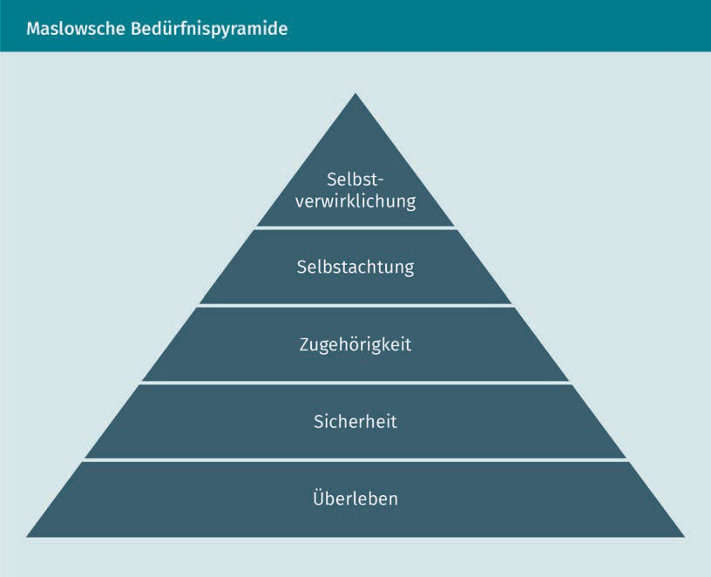

Organizations play a key role within today’s society, their relevance lies especially in their function as employers and, thus, wage providers. Accordingly, in many organizations, dependencies between the individuals and organizations exist, consequently establishing differently weighted power relations in favor of the organization. If, however, the basic needs of the employees (e.g., income and affordable housing) are satisfied, they then start being motivated by the desire for social affiliation (to the team structure of their department, for instance), as well as increased personal responsibility and decision-making power in the organization. This can currently be observed among younger generations entering the professional world. Social prosperity and safety seem to be secured through their parents’ generation, in addition to a high standard of living in our part of the world. Not more salary, but opportunities for self-realization are, then, one of the essential needs that an employer should offer to them.

The second approach to be described here does not focus on the principle of performance and consideration, but rather on social cooperation: The Coalition Fomation Theory describes organizations as coalitions of members who occupy different positions and roles (e.g., owners, management, area groups, customer, etc.).

Coalition Formation Theory According to this theory, members of an organization strive for cooperation and the formation of internal interest networks.

Agency theory In this theory, roles are divided between principals and agents. Principals set the direction. Agents use their freedom to work creatively.

Powerplay Theory The playful nature of human beings is paramount in powerplay theory as the base-assumption of how members of organizations treat each other.

In order to achieve organizational goals, interest groups are formed within the organization and resources shared between them. According to this approach, people tend to form groups, and organizations then function as a platform on which existing conﬂicts between interest groups are resolved, an exchange of interests takes place, and a common consensus is worked out in order to achieve the intended goals.

The third approach described here sees organizations as systems that are characterized by clear hierarchical structures in which people seek spaces to exercise their freedom of agency. The agency theory describes two core roles of members in organizations. It divides people into principals (owners, management) and agents (employees). The principals pursue their (corporate, departmental, area) goals by assigning work orders to the agents and influencing them in their compliance, for example by deﬁning information flows regarding the orders, rules of conduct, and opportunities for profit sharing for the agents. This means, for example, specifying the work steps in a production process in great detail, so that the employee has hardly any room for personal decision-making.

However, the principal’s system of control is always patchy. This means that the agents can retain some freedom in the organization of work, and endeavor to use this for their own benefit by making their own decisions in these control lapses. Very similar to this approach is the fourth approach described below, i.e., the Powerplay Theory.

Power and game theory shape how members of an organization work together. Tasks are coordinated via regulations (power) and the search for and use of free space (game). The organization, in which certain structures are a given, shapes the framework for the game, and these structures are in turn interpreted in their favor by the players (the members of the organization). The focus is on maintaining a constant balance between rules and freedom (Titscher, et al., 2008). Rules that describe work processes, for example, can be formulated in great detail in organizations. However, this does not describe all possible behaviors for employees, so that additional spaces to exert their freedom of agency can also be found.

Each of these four approaches considers the interaction between organization and individuals from a different perspective. By doing so, they convey an idea of the role that people can play in organizations and the framework organizations offer their employees and members to fulfill their tasks. Each of these approaches has its justification in explaining the interaction of people and organizations, since structural as well as social and psychological explanatory approaches help to shed light on this complex topic.

Organisation

###### An Illustrative Example

How does the interaction between people and organizations work in practice? Let’s take a company as an example, where different actors influence the organization. The actors in this organization are the owners, managers and employees, followed also by customers and suppliers, as well as other organizations such as the authorities.

Example Company A produces plastic bottles. The owners are the **principal shareholders**, they provide capital and in return expect annual returns, and the continued existence of the company. Furthermore, they are not involved in the operational business; the company is management-led. The management is supported by a supervisory board that formulates annual goals for the operation of the company. The management consists of several people, and in turn ensures the implementation of measures to achieve the company’s goals. To this end, it has established an organizational structure, defined work processes and provided them with goals/specifications. The actual production work, as well as activities in purchasing, sales and administration, are carried out by specialized employees. Some of the work processes are documented and specified. A large part is informally regulated. Although management carries out regular audits and similar random checks (such as product quality controls), most actions are carried out without the management’s control. Depending on their knowledge, ability and scope for action, members of the organization decide their activities on their own, which in turn means that they make decisions and carry out these actions for the organization.

Achieving the goals set by the owners depends on the performance of the employees. Management must now decide what means they can use (structures, work instructions, freedom, etc.) to motivate the company's employees to help achieve those goals. Depending on management’s understanding of how motivation and goal-oriented work can be promoted among employees, it will look for suitable means and implement them.

The complexity within this – simplified – example shows how members of the organization affect it, and how the organization inﬂuences its members and their actions. The different competencies and spheres of influence of the various members are also recognizable. However, this short description only depicts a fraction of the internal processes of an organization, and says nothing about the motivation or social ties of the members of the organization.

For the organizational analysis, it is therefore clear that the focus on a single phenomenon – such as the organizational structure or motivational factors – does not provide insight into the interaction between the organization and the individual, but that several perspectives must be analyzed in order to find explanations for how organizations and individuals inﬂuence each other.

Principal shareholders/majo-rity owners:

A principal shareholder or majority owner is a party that holds more than 50% of the share capital of a jointly held property (e.g., a company).

People take on different roles in organizations. With their beliefs, their skills and their worldview, they shape how cooperation works within organizations. To do this, they inﬂuence the structures, social ties, and ultimately the properties of the organization itself. This circumstance is one factor that explains differences between organizations, but it is not the only factor that contributes to the different forms of organization that exist.

### Differences between Organizations

Since the start of organizational research, there have been numerous attempts to establish categories of organizations. However, this is not very helpful for the understanding of organizations. In order to be able to recognize and record differences, it is useful to look at individual distinguishing features and their interaction. Initial attempts in this direction from the 1960s focused on the then dominant features of formal organizational structures – such as formalization, standardization or centralization. Although this perspective seems outdated today, a brief glance at it would prove beneficial.

Formal, inward-looking factors were especially important in the 1960s, but the criticism of this approach led in the following decades to a further analysis of factors that inﬂuence the creation of organizations. As a result, in recent years the focus of research has pivoted to those distinguishing features, which consider the quality of organizations as a dynamic system, and assess organizations also on the basis of their environmental relationships. These factors will be considered towards the end of the lesson.

###### Focus on Formal Organizational Structures

A British group of organizational researchers in the 1960s, called the Aston Group, categorized organizations according to classic factors of organizational research, which considered organizations mainly as formal entities. The focus of interest was clarifying the formal functioning of organizations.

The Aston Group developed five criteria by which organizations can be distinguished. Building on this, the group formulated ideal types of organizations that can be explained by the differences in the way the five criteria are formed. These five differentiating criteria are:

* Specialization: this refers to the division of labor between different roles in the organization;
* Standardization: this designates the degree of uniform regulation of workflows;

Organisation

* + Formalization: this describes the writing of rules on topics such as work processes, communication, or the behavior of the members of the organization;
  + Centralization: this describes how decision-making structures are developed, i.e., whether simple employees can make decisions, or whether the decision-making power is limited to individual managers.

Conﬁguration: the formation of the hierarchical levels, such as the numerical relationship between employees and managers (management-to-staff ratio).

Based on these criteria, the Aston Group distinguishes seven types of organizations:

1. Workflow bureaucracy: characterized by a strong focus on work processes and supporting means of control such as work plans, checklists, confirmation forms. Examples of this type of organization are mostly found in manufacturing companies.
2. Personnel bureaucracy: characterized, on the one hand, by strongly developed centralized hierarchies and, on the other, by hardly any structured work processes. Decisions are made here by central authorities. Public administration offices are examples of this type of organization.
3. Implicitly structured organization: characterized by weak hierarchies, as well as hardly any workflow specifications. Examples of this can be found among small or medium-sized companies with only a few employees.
4. Full bureaucracy: characterized by clearly defined work specifications, standardized decision-making processes and strict hierarchies with clear authorities. The function of the organization is controlled by a depersonalized set of rules.
5. Nascent workflow bureaucracy: this is a weakened form of workflow bureaucracy that occurs within smaller companies.
6. Nascent full bureaucracy: this is a weakened form of total bureaucracy, in which activities are less structured.
7. Pre-workflow bureaucracy: these are organizations that have hardly any controlled workflow with decentralized decision-making bodies. Work is therefore more likely to happen on a random basis.

These organizational types provide an idea of how organizations differ from each other. They relate first and foremost to formal criteria of work organization (workflow and organizational structures), and also include the aspect of development, for example from a nascent to a complete full bureaucracy.

The principle that was overlooked in the Aston Group's research is known as emergence. This “denotes the occurrence of characteristics at higher organizational levels that could not have been predicted on the basis of known components at lower levels” (Titscher at al., 2008, p. 48). This means that there are no mono-causal relationships that would allow the weak hierarchies in an organization (as in the category of implicitly structured organizations) to be explained causally by the standardization of workflows. The need for standardization could arise, for example, from the legal framework, while the absence of strong hierarchies could be due to modern

management principles.

Emer-gence

Emer-gence designates the fundamental feature of organizations as stemming from the fact that they cannot be explained exclusively through the sum of their individual parts, since they also develop further individual characteristics that only come about through the complex interaction of their parts.

Monocausal The term “monocausal” describes the fact that results can be traced back to a clear cause. However, this is not the case in complex systems such as organizations.

The principle that was overlooked in the Aston Group's research is called emergence. This "denotes the occurrence of characteristics at higher organizational levels that could not have been predicted on the basis of known components at lower levels" (Titscher at al., 2008, p. 48). This means that there are no mono-causal relationships that would allow the weak hierarchies in an organization (as in the category of implicitly structured organizations) to be explained causally by the standardization of workflows. The need for standardization could arise, for example, from the legal framework, while the absence of strong hierarchies could be due to modern management principles.

These insights informed later research on the topic, from which further distinguishing features were developed, without formulating causal chains or typologies of organizations.

###### Organisations as Systems

In order to take the complexity of the organizational landscape better into account, and the emergence and creation of organizations, more recent approaches rely on the consideration of holistic factors. For a few decades, organizations have been understood as a dynamic social system. Accordingly, the research focus shifted to factors that allow for an improved description of the relevant differences between organizations. These factors are subsumed under the concept of

“classic factors.”

Classic Factors:

Classic factors build on the insights and categories of the 1960s, and focus on distinctive features of the formal organizational structure, but without – as in the case of the Aston Group – assuming monocausal connections between them:

* Size: Among other considerations, the size of the organization is decisive for its complexity and reaction speed. Size usually means that hierarchical levels are expanded in order to keep management-to-staff-ratio as small as possible, and to promote the specialization of areas and functions/roles in order to be able to carry out activities more efﬁciently. Larger organizations attempt to put their sluggishness into perspective. Newer approaches such as holacracy are based on the dynamics in decision-making processes and organizational structures, in order to prevent organizations from becoming too slow in their reaction speed, regardless of their size.

Organization

* + Technology: Depending on the degree of manufacturing specialization, higher level of technology may make sense. By simplifying the formalization of activities and results, it also enables the implementation of stronger control mechanisms within the company. The example of assembly line work shows that high levels of technology in the manufacturing process and formalized specifications promote consistent quality and high output. But new technologies that are not yet fully developed, such as 3D printing, also have an impact on work processes and organizational structures. Rigidly formalized work steps that do not allow rapid adaptation of the production process make less sense here, since 3D printing technology can be used to produce individual pieces “as on an assembly line.”
  + Dynamics of the environment: Depending on the volatility of the environment, more or less flexibility will be required. Rigid structures, which may bring a cost advantage, can become a stumbling block in VUCA times. Nevertheless, in stable environments (e.g., with stable demand for the organization’s product, or a very mature product with few competing products), rigid, highly efﬁcient structures can thrive.
  + Needs of Organization Members: Certain groups of employees have different needs. Technical developers or IT people who need creative freedom for their work need other structures compared to auditors, who are used to working within strict specifications.

In this context, other distinguishing features for organizations are used compared to those of the Aston Group in order to be able to better understand the differences between organizations. Hard criteria such as the size of the organization (number of employees, number of divisions, etc.) and technologization (complexity of the products and technologization of production processes, etc.) are at the forefront, but soft factors are also taken into account, such as the dynamics in the organizational environment and that within the social system of the organization. Moreover, changes in the environment, whether in terms of customer demand or technical innovations, can lead to changes in the internal organizational structure, which was also taken into account.

###### Organizations as Systems with Environmental Relationships

A number of factors related to the environment enable a further differentiated view of organizations. For example, a business management perspective can take competition, internationalization, resource dependency, or the expansion of the range of services into account. Other variables whose analysis provides different organizational perspectives are an organization’s age, its ownership structure, and the industry or sector to which it belongs. Views that consider the preceding factors all reject the concept of organizations as closed systems, but focus rather on their interaction with their environment (including competition, internationalization, their industry/economic sector, ownership structure, etc.).

VUCA

The abbreviation VUCA (for vulnerability/un-certainty/complexity/

ambiguity) describes today’s fast-paced environment, in which customer requirements, technical possibilities, the labor market situation, etc. change very quickly.

Conditions and new developments in an organization's environment have a significant inﬂuence on the shape of the organization. This is due to the fact that organizations have to create benefits *for* their environment in order to survive, while they also have to react to the influences *from* their environment (demand for services/products, legal situation, resource availability, etc.) through internal adjustment (organizational structure, process organization, resource allocation, etc.).

A look at the individual factors clarifies the relationships between environment and organizations. For example, the range of services/products they offer (with the connection to the customer), internationalization (with the merging of different “cultures”), resource dependency (in the sense of raw materials, but also of investors), and the competitive situation (with a focus on competitors) form a clear external relationship between organizations and their environment.

Matrix organization

In addition to the disciplinary hierarchy, such as a division of a company, there is also a technical hierarchy via the head office of the parent company – the matrix organization – which is authorized to give instructions.

* Range of products: The breadth of product range affects diversification, divisional structures, and the differentiation of the organizational structure. A wide range of products tends to lead to divisional structures – that is, to structuring the organization according to products/services to handle production and other processes related to a specific product within the same organizational unit.
* Internationalization: International structures provide numerous challenges, such as different cultures or legal situations, as well as cooperation over long distances and different time zones. These have an impact on the organization and its form: matrix organizations are created, for example, in order to retain regional units on the one hand, and to be able to organize them as autonomously as possible on the other hand, but without having the matrix completely relinquish its control over technical management. Other tendencies point in the direction of greater standardization of work processes and organizational culture within international, centrally managed organizations.
* Resource dependency: A company that primarily consumes rare raw materials, or is dependent on external ﬁnancing from international financial markets will presumably develop other management and control mechanisms compared to those found in companies that are ﬁnanced by the public purse. On the other hand, an organization dependent on young, creative professionals who need the freedom to be creative, will develop very open and low-hierarchy structures.
* Competitive strategy: Does an organization focus on price leadership, on cost, or technology leadership? Does the organization assert itself against competitors with a niche or a diversification strategy? Depending on the competitive environment, the organization will look for suitable structures and forms.

The ownership structure of an organization regulates ownership and, thus, also exerts inﬂuence on internal power structures, whereas the time frame provided by the age of an organization offers space for development, growth and other changes.

Organization

* + Owner: Who the owner is, whether s/he is involved in the operative business or is a silent partner, whether the ownership structure is in **free float** or is owned by a family, are all factors that inﬂuence the design of the organizational structure, and the distribution of power in the organization. For example, cooperatives work with decision-making bodies that include many owners, while silent majority owners in a family business, for instance, appoint a managing director who has the central decision-making power. The type of ownership can therefore have an impact on the organizational structure (hierarchy, centralization).
  + Age: The organization will have different structures if it is a young start-up compared to a family business with a long tradition. The development phase of the organization also plays a role; young organizations are in a pioneering phase, in which a lot of dynamism is permitted or even desired. The larger and more differentiated companies become over time, the more likely their structures are to change towards standardized set-up and operational processes.

Organizations can also be organized according to branches and economic sectors. These are also part of the immediate environment of an organization: for example, branch cultures can inﬂuence the norms and ways of thinking of the organization.

* + Line of business: Different lines of business are shaped by different industry cultures. Classic factors such as technology, the needs of employees, or the dynamics of the environment play a role, in this case, simply as a framework. Each group has its own habitus and its own self-image of its line of business and its work.
  + Sector: It makes a difference how organizations structure themselves, depending on whether they belong to the market economy, the public sector or the third sector. Public organizations do not have owners in the traditional sense. They also usually do not strive for profits, but only for cost recovery. As a result, there is less need to work highly efficiently. Hierarchies are less pronounced, and tasks less differentiated.

All of these factors are fundamental when it comes to recognizing and analyzing differences between organizations. They can be used to analyze possible causes for the speciﬁc shape of an organization. In contrast to the formation of categories, as in the case of the Aston Group, this results in the flexibility to consider organizations in their individual form. However, the list of factors given here is certainly not exhaustive, and other ones may cause relevant differences in organizations (Titscher et al., 2008).

Best practices in organizational analysis require starting with well-known, tried and tested categories to obtain initial indications about organizational forms, such as possible reasons for internal structural design, or for the degree of formalization of work processes. However, if these initial steps are non-conclusive, other factors can be included to broaden the analytical perspective, and get a better substantiated picture of the organizational structure.

Free float

If the owners hold roughly the same ownership rights/shares in a company, this is referred to as free float. This is the case, for example, in cooperatives.

Summary

There are different perspectives on the concept of organization, all of which understand organizational analysis, organization, and organizational structure in different ways. Business administration focuses on the formal structures of the organization, while sociological approaches consider the organization as a social system. In recent years, this approach has increasingly gained acceptance beyond the boundaries of sociology.

Furthermore, we considered how goals and strategies are related to organizational structures, how they arise, and how they affect organizations. For example, the strategy of cost saving and internationalization in many corporations leads to divisional organizational structures. This is often based on objective goals such as cost reduction, increase in sales, etc. The strategy of making the organization more dynamic, in order to react more quickly to changes in customer needs or its competitive environment, has recently led to the dismantling of hierarchical structures and departmental boundaries in organizations.

Organizations play an important role in our society, taking on tasks for individuals and the general public from birth to death, and beyond. This includes providing education, salaried jobs, and even funerals. Due to their legal form, organizations are long term service providers that enable the functioning of our social order.

The view of people’s role in organizations has changed significantly in recent decades, and with it the understanding of organizations. People are no longer simply means to achieve the organizational goals, but rather members of the organization who actively influence the achievement of those goals. Basic concepts of human nature, for instance, when applied to the analysis of organizations or their management, suggest that opening decision-making spaces within organizational processes also has a significant inﬂuence on the creation of organizational structures and processes.

.



# Lesson 2

## Organizational Research

#### LEARNING OUTCOMES

After completing this lesson you will know …

... which scientific-theoretical perspectives inform organizational research.

... which fields are the focus of organizational research.

... which empirical approaches and methods are applied to organizational research.

... how a research concept is created and what elements it contains.

DL-D-DLMWPWOAE01-L02

1. Organizational Research

### Case Study

Mr. Mayer, the manager of an operational department of a construction materials wholesale company, realizes that his employees are dissatisfied. He decides to conduct an employee survey using a questionnaire to find out why. The standardized questions are open-ended and revolve around how employees feel, and how satisfied they are.

The survey yields the following results: Employee A reports on her reservations about the quality of her colleague B's work. Her doubts lead to constant follow-up work for her. Employee C complains about the job specifications, which are too strict. Employee B, on the other hand, is completely satisfied and does not wish to change anything, and so forth.

After reviewing the answers, Mr. Mayer has an overview of the individual condition of all employees, but their statements are not interconnected. In the course of the survey, Mr. Mayer did not specifically ask about working conditions, resources and workflows, or communication structures within the team and with neighboring departments. This means that there is no information on connections in the organization that could contribute to the well-being of the employees, and ultimately to the quality of their work. Processing employee statements in this form will therefore not allow any conclusions to be drawn about organizational causes of employee dissatisfaction, since the question was not designed in the context of the organizational structure.

Organizational research theories form the basis for asking meaningful questions and interpreting the information obtained in an organizational context. They offer the analysis a stable basis for understanding the organization, based on hypotheses tested to gain insights within the specific organizational context. This is the only way to enable substantial organizational analysis, as well as the subsequent organizational development.

### Perspectives from Organizational Research

The aim of organizational research is to understand organizations including their structure and functioning. To this end, it offers different approaches and a perspective of the type provided by scientific theories. Knowledge of their limits and possibilities is important in order to understand the organizational diagnostics and the analytical approaches based on them. Analytical practice without a theoretical basis would run the risk of getting lost in the complexity of organizational relationships, thus leading to vague and less goal-oriented results.

Organizational Research

The theoretical foundations of organizational research provide tools that enable the development of research questions, the limitation and selection of research objects and perspectives, the choice of survey methods, and finally the evaluation and interpretation of the collected data. The theory provides the framework for all of these distinct phases.

These perspectives cover a wide spectrum, ranging from a mechanical, scientific understanding of organizations that arose at the beginning of the 20th century, to approaches that focus on the individuals and their needs, to a sociological understanding of organizations as social systems. The most important approaches of organizational research are the following:

* Taylorism / Scientific Management Theory,
* Bureaucratic Management Theory,
* Human Relations Management Theory,
* Poststructuralism, and
* Systems Theory.

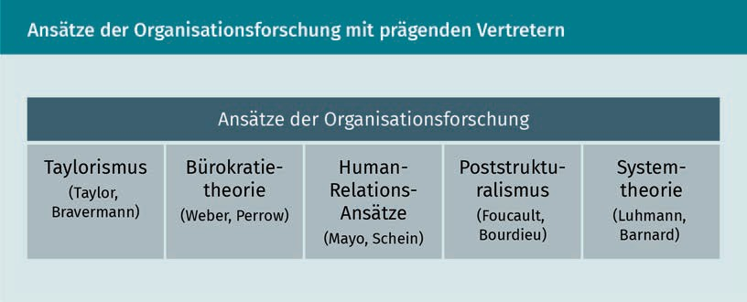

Some of these approaches differ significantly from one another, and yet they are also built on one another. Their details are discussed below.

###### Taylorism – Organizational Objectification and Measurability

Frederick Winslow Taylor, who gave his name to Taylorism, is one of the founding fathers of organizational research. With his work *The Principles of Scientific Management* (Taylor, 1911) he created the basis for understanding organizations at that time.

His theory arose in an era of increased industrialization/mechanization of production processes. Until then, the most important aspect of production process was the know-how of the workforce on the one hand, and a wage system linked to production quantities on the other. These aspects are decisive for companies to perform efficiently.

Organizational diagnostics

Organizational diagnostics analyzes the development of motivation and performance in organizations. It is based on approaches from organizational psychology.

Taylorism This term points to a scientific approach to organizational research, based on the objectification and measurement of the production processes within organizations, in order to increase productivity.

Burocratic Management Theory

The bureaucratic approach assumes that organizations function well when all processes and tasks are clearly and unequivocally laid out, and there are fixed responsibilities (competences, a decision-making authority).

Taylor, however, assumed that the interaction between production machines and people could achieve a significant increase in efﬁciency, if the work processes involved were designed and carried out according to scientific criteria. Thus, he sought to further increase the productivity of manufacturing companies by using quantitative scientific methods.

The methods of Taylorism aim to make work processes objectively measurable and representable in order to finally be able to identify and quantify unused resources (time or material), or cumbersome procedures in the production process. Based on the measurement results, production processes are designed, in which work stages are improved, and resources used more efﬁciently (e.g., selecting the optimal type of shovel for excavation work). This should ultimately increase production speed and enable higher productivity. The improvements achieved in the production process are then standardized by creating detailed process descriptions, containing records even of individual movements on the workpiece, including the associated processing times. In order to persuade workers in production to implement and comply with the standardized processes, management uses the argument of *scientificity* (e.g., scientific planning methods), but also disciplinary measures.

In Taylor's understanding of organization, the analysis and planning of a company's work resources and tasks are the responsibility of management, which itself works independently of the actual production process. Taylor, thus, also marked an increased separation of tasks and responsibilities along a hierarchical chain, which led to specializations and the creation of departments in organizations that had not previously existed (Taylor, 1911; Kühl, 2015, p. 694ff.). As a result of Taylor's approach, areas in companies developed separately: executive production departments, which had to follow instructions and specifications, as well as administrative departments such as accounting and management, which created specifications and monitored their implementation.

###### Bureaucratic Management Theory – Clear and Detailed Regulations

The Bureaucratic Management Theory takes a similar approach to Taylor’s. It builds on the findings of Max Weber, one of the most important sociologists who primarily devoted himself to economic questions. In his comprehensive work “Economy and Society” (1922) he assumes that the success of the Western economic and social order is largely based on the “legal-bureaucratic rules” in organizations. By this, he means a clear set of rules that is as complete as possible, and ensures consistency and success in organizations. It is, however, also characterized by official authority, formalization, and control.

Following the bureaucratic approach, responsibilities (distribution of tasks to roles/functions, rigid boundaries of competence), and organizational processes are regulated and structured in a highly detailed procedural sequence. The fulfillment of tasks is thus depersonalized, decoupled from the process and specialist knowledge of individual people, since the clear standards and rules guarantee total predictability and verifiability.

Organizational Research

The quality and output of organizational processes no longer depend on individual workers’ skills, but are rather bound to a set of rules (Kühl, 2015, p. 718ff.; Weber, 1922).

Organizational researchers were still building on Weber's theories in the 1970s. For instance, the US sociologist Charles Perrow continues to emphasize the need for a clear set of rules, supplemented by strong leadership, for the functioning of organizations (Perrow, 2014).

###### Poststructuralism – Emergence of Power and Informal Mechanisms

The poststructuralist approach to organizational research overcomes the rigid focus that organizational functioning solely relies on formal structures and their corresponding functions/roles, such as management. Michel Foucault, through his book “Discipline and Punish. The Birth of the Prison” (1994), made a significant contribution to the fact that organizational research no longer focuses solely on structural power relations and their maintenance. Instead, he was interested in the effect of power on human actions within the social fabric, and on the formation of social structures in organizations. He recognized that it is not primarily formal structures (departments, hierarchies, fixed work processes) that lead to functional organizations, but rather interpersonal relationships (Kühl, 2015, p. 278ff.; Foucault, 1994). These are shaped by social structures of power, which he understands “as a network of relationships between the subject [i.e., the individual], knowledge, practices, and things” (Kuhl, 2015, p. 280). In doing so, he focuses in particular on the leadership relationship between employees and managers.

In practice, this means that the fulfillment of management tasks – such as the distribution of tasks, control and management of the organization – does not primarily work on the basis of their formal position, but because of their knowledge, their actions, and the associated recognition in the social fabric of the organization.

The French sociologist and anthropologist Pierre Bourdieu explains how this recognition and the associated power that goes with it arise within an organization. According to him, an organization develops in isolation from its environment as its own social unit, where its own habitus also develops – i.e., its own understanding of behavioral norms, what is thinkable and feasible. As the organizational rules (habitus) are developed, the negotiating power is distributed differently between the members of the organization. For example, there are knowledge holders in organizations who have specialist knowledge that is constantly required, or networkers and motivators who lead interest groups within the organization and can then promote their motivation, as well as investors who provide money and can decide on the use of resources. Individuals that combine several of these roles exert more inﬂuence in the organization than those who “only” take on one, or none of these roles. A person’s inﬂuence within a group is based on the recognition of his or her individual knowledge and actions that generate benefits for the social group.

Poststructuralism Poststructuralism sees the network of relationships within organizations as a focal point of organizational analysis.

Forms of capital

In social systems, power does not arise from structural functions, but rather from the attribution of power and its social recognition.

Human Relations Management Theory:

When looking at organizations, the human relations approaches focus on the individuals, their motivation and well-being, as well as on a respectful and employee-oriented management relationship.

Poststructuralists analyze the different forms of capital (power) that work within social groups. Bourdieu names four types of capital that are relevant in social systems. Economic capital is comprised of money, possessions, and includes objects; cultural capital consists of (both theoretical and practical) knowledge or education; social capital is created through relationships, networks, or behavioral practices that benefit the social group. Finally, symbolic capital is relevant for individuals, who have several forms of capital that are particularly recognized in their respective organizations (social unit) (Bourdieu, 1989; 1990; 1998; Lebitsch 2019). People with strong symbolic capital are often decision-makers in an organization: they shape opinions and make directional decisions.

For example, an IT technician with strong programming skills (cultural capital), who is well networked in his organization (social capital) and whose work also contributes to the ﬁnancial success of the organization (economic capital), has high symbolic capital. This is reflected in the high level of recognition in their organization and the associated opportunities to motivate colleagues, and to help shape the organization, regardless of whether they hold a management function in the formal organizational structure.

Through the research of the post-structuralists, the understanding of organizations as social systems is greatly enhanced, and the focus shifts away from formal structures towards informal ones. As a result, the understanding of the ways in which organizations operate is thereby significantly expanded.

###### Human-Relations Management Theory – Human Needs as Main Focus

Human relations approaches have essentially developed from the criticism of Taylorism and the bureaucratic management theory approaches, which equate people and machines with production resources, and want to clock their interaction to the second in order to increase efﬁciency (Kühl, 2015, p. 543). The human relations approach is based on the work of Elton Mayo, a psychologist and organizational researcher in the 1930s and 1940s. In contrast to Taylorism and the bureaucratic approach, Mayo sees human needs and social relationships in the work context as essential factors for the efficient functioning of organizations. Using empirical studies in manufacturing companies, he makes it clear that the work performance of the employees is not only determined by “objectifiable factors,” such as work time and break cycles ,or by individual features of the work environment such as conditions in the workplace (light, temperature, space), but rather by functioning and appreciative

Organizational Research

social relationships within the closer working group. The type of leadership demanded of the executives is characterized by respect, appreciation of the employees, and contact with them. Shared contact and intensive communication with employees lead to increased performance.

According to Mayo's studies, employee output can be increased through social aspects such as a cooperative group structure, the involvement of employees in decision-making processes, coupled with appreciative interactions when achieving performance and quality goals. According to Mayo's human relations approach, the management’s function is to ensure a pleasant work environment (Kühl, 2015, p. 453ff.; Mayo, 2003) and not, as in Taylorism, to create work directives and possibly enforce them with disciplinary measures.

Later proponents of this group of theories, such as the psychologist and management professor Edgar Schein, see organizations as “programs for shaping human activity” (Schein, 1980, p. 20), which are regulated by a “psychological contract” between the individual and the organization. This unwritten “contract” describes social components of organizational cooperation that go beyond the formal employment contract. These are implicit expectations between the two contracting parties, for instance regarding the possibilities of co-decision and self-realization, or space for creativity within the organization (Kühl, 2015, S. 591ff.; Schein, 1980).

The human relations approach makes it clear that performance in organizations is not achieved purely through quantifiable processes and decision-making structures designed as efﬁciently as possible. It is achieved, instead, through components that take into account the employees’ social needs of belonging, recognition, and self-realization. Employee satisfaction, therefore, also has a performance-enhancing effect on the workforce.

###### Systems Theory – Organization as the Social System of Decision-making

Systems Theory is considered to be the most up-to-date theoretical school of organizational research. Its main representative and creator is Niklas Luhmann. His sociological view of organizations sees the processes of decision-making and the communication on which they are based within the social system of an organization as a central factor in understanding organizations, as well as their structure and functioning.

According to systems theory, organizational operations are brought about through decision-making: “by generating decisions from decisions, and linking them inside a network of other decisions derived from the first ones” (Kühl, 2015, p. 426f.).

This means that organizations are responsible for their actions - i.e., for every action they take – and for the decisions about the content and manner of action, using the environment (the network) of the organization as a frame of reference that plays an Systems theory

Systems theory revolves around the question of how organizations make decisions as social systems.

important role in this decision-making process.

This could mean, for example, that an organization decides whether to develop new products or services, or adapt existing ones, in response to changing customer demand. To do this, the organization includes its own skills, core competencies and previous developments, but also environmental factors such as the reactions of competitors and customer needs in the decision-making process.

The starting point for organizational decision-making processes is usually the use of incentive and reaction systems from one of the organizational environments (customers, competitors, authorities). In order to understand individual actions or incentives within the system, they are always considered within the system’s specific context. There is a difference in complexity here. This describes the “principle that a single action cannot do justice to its system, or, in reverse formulation, that systems are not suitable as a criterion for the choice or assessment of individual actions” (Kühl, 2015, p. 422). Put simply, this means that an organization is not the sum of its members or their individual decisions, but follows its own rules and logic, resulting from the multitude of actions and decisions of the organization. This means that both the actions of individuals and those of organizations are shaped by numerous factors in a complex system, characterized by different inﬂuences. Clearly predictable and monocausally derivable structures and processes, therefore, do not exist in complex systems such as those represented by organizations.

For example: If employees in department A follow the work specifications set by management, it cannot automatically be deduced from this that the employees in department B will also do so, even though they work in the same company. The reasons for this can be very diverse and, in turn, cannot be clearly traced back to individual factors such as the manager's recognition, the logic of the work processes, or the dynamics of the work environment.

Luhmann's systems theory also differentiates his understanding of organizations into formal and informal decision-making structures. With regard to membership and hierarchy in organizations, this means that they are determined by formal specifications (e.g., employment contract or work process description), but only become relevant for implementation through the recognition process, i.e., the decision of the members of the organization to follow these formal specifications. For example, it is not the management's specifications for work processes that are primarily decisive for compliance with them, but rather the decision of the social system/organization to follow

Organizational Research

the management's specifications.

Systems theory shows the complexity and multifaceted nature of organizations as social systems, for which the analysis and further development of an understanding of organizations as the sum of monocausal relationships, as presented in Taylorism and in the human relations approaches, is insufficient (Luhmann, 1964; 1973; 2000; Parson, 1956).

### Areas of Research

Understanding theory-based fundamentals is necessary in order to create coherent research concepts. Both the focus of the analysis, the selected analysis tools, and the topics in focus for organizational analysis must be consistent in order to be able to produce reliable findings.

Should you wish to optimize individual processes in an organization's production process (removing interfaces, reducing waiting times, etc.), it is logical to limit the analytical consideration to this one process and to select tools such as time measurements, path diagrams or Muda workshops, which can be used to quantify current and future processes. A clearly deﬁned research field – a production process – makes it possible to choose clearly deﬁned and relatively pointed analysis methods (i.e., focused on one aspect such as time, route, etc.) in order to support future organizational decision-making with actual data. Taylorian approaches provide the theoretical framework for this.

If, on the other hand, the process of change of an organization is the focus of interest, a more comprehensive conceptual and methodological approach must be chosen. Said approach must be able, in fact, to depict the complexity of the main analysis questions (e.g., how and with the participation of which actors are decisions on organizational change made?). For this purpose, observations are made, documents analyzed, individual or group interviews conducted, and career and network analyses prepared in order to be able to quantify and qualify the decision-making processes and the current form of the organizational system. System-theoretical approaches form the appropriate framework for this type of analysis.

Several scientific theories give rise to these different approaches located on a continuum, whose extremes are represented by positivism and constructivism.

Positivist approaches to organizational research (Taylorism, bureaucratic approach) focus on formal processes and structures. Quantitative measurability and objectivity are thus in the foreground. To analyze individual elements, especially mechanical production processes (e.g., increasing machine capacities through improved preparation for production processes), research approaches, and analytical tools from this group of theories can be helpful. However, the claim to measurable empirical results and thus to absolute objectivity must be viewed critically, when applied to the analysis of social systems.

Muda

The term "muda" comes from the Japanese lean management concept, and designates types of waste in processes, such as waiting times, interfaces between departments, unnecessary journeys, etc.

Positivism

At the heart of a positivist world view are quantifiability, measurability and normative specifications. Positivist principles can be compared to empiricism.

Constructivism Nuancing, the representation of different perspectives (because perception is shaped by one’s subjective consciousness), descriptive procedures, and an understanding of the system are at the center of this worldview.

For instance, in issues of leadership between employees and management, objectivity is a question of perspective – the quality of leadership cannot be measured objectively and depends on the perception of the employees, which arises from extensive negotiation and decision-making processes within the social system.

The focus of interest for human relations approaches is the motivation and well-being of the individual within an organization. The analytical focus would mostly be, in this case, on the working conditions and their effects on the performance of the employees of an organization.

Constructivist approaches place communication and interaction in organizations at the center of organizational research. The central question here is how decisions are made within organizations. In addition, the environment-organization interaction is also considered. This means that organizations are not seen as an isolated unit, but as a dynamic system in a lively exchange with its environment. Central to constructivist approaches is also the view that the analyst's perspectives and insights can serve as the basis for decision-making in the organization. Constructivist approaches to organizational research therefore refuse to interpret their findings as objective truth. They stand in contrast to positivist approaches in organizational research.

###### Major Research Areas

Which research areas result from this spectrum of approaches for organizational research? Areas that are currently influential in organizational research range from the goals/strategies of an organization and leadership behavior, to workflows and processes of change, as well as the analysis of careers within organizations. All revolve around the question of how organizations function. The list below also gives some reasons why each field is relevant for organizational analysis.

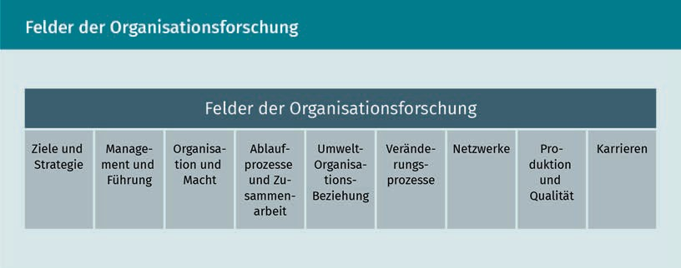

Organizational Research

Goals and strategies provide orientation for an organization and its members. What added value the organization generates for its environment, what output it delivers and what formal structures it wants to use to achieve its goals are all areas of interest for research. Above all, research now focuses on the underlying decision-making processes within an organization.

Management and leadership in organizations tell us much about how cooperation and goal achievement work in organizations. Different forms of cooperation can develop in an organization (more or less hierarchically), when decisions are made in the group or made exclusively by management. In many current work environments, for example, decentralized teams are purposefully created non-homogeneously, and have sole decision-making authority over their areas of responsibility. On the one hand, different management styles and different views on management’s tasks characterize actual cooperation within an organization, and have an inﬂuence on the motivation of its members.

Organizational structures shaped as formal hierarchies reflect formal reporting and area structures (departments, divisions, etc.). The results are organizational charts showing the hierarchies and tasks, or functions. Power plays an essential role here, both in the formal and informal structures of the organization. The distribution and attribution of power within the social system has an impact on the functioning of the organization, and is therefore of interest for the analysis of decision-making structures. Thus, it makes a difference whether power is linked to hierarchical functions or recognition from the group. Decision-making power within organizations – think of the forms of capital according to Bourdieu – often lies apart from management functions, which are often only endowed with formal power.

Formal workflows outline what work needs to be done, in which order, and where there are handover points to other employees and departments. Depending on the degree of formalization/standardization, workflows allow the employees to have a more or less independent decision-making space for the execution of their work, and for the forms of cooperation in the organization.

The degree of formalization of processes and cooperation can also provide information about the management’s understanding of corporate governance, the prevailing view of people in the organization or how complex the work is that needs to be carried out. For example, assembling an industrial PC with a million variants requires clear, narrowly defined instructions, while simply selling a PC can be based on broadly formulated sales principles.

An organization’s environment – customers, authorities, competitors, technological developments, etc. – determines its existence or nonexistence. The environment supplies the organization with resources and utilizes its services (in the form of products or services). A key question in this field of research is – in addition to the environment’s inﬂuence on the organization – how does the organization deﬁne itself, i.e., how does it distinguish itself from its environment? For example, silent owners are part of the organization even though they are not involved in its operations. Authorities – in the catering sector, for example, health authorities – can also be understood as part of the organization, since they exert significant influence on processes (hygiene checklists, cleaning work, etc.).

Change in and of organizations in general has become an important topic in organizational research in recent decades. The focus is on how changes affect organizations, but also how change in organizations is initiated, guided, implemented and reflected on. Change affects familiar processes and structures in the organization. As a consequence, collaboration and functioning in the organization often have to be rethought and rebuilt.

Work in organizations involves a large number of people, often in cooperation with other organizations – networks are formed between them that function according to common social norms and values (e.g., collegiality or competition). Network analysis offers the possibility of connecting the micro level of a network’s individual members with the macro level, inter-organizational and intra-organizational structures (i.e., networks between different organizations). For instance, looking at the behavior of individual people (or groups) in the network lets the analyst infer what the organizational rules for cooperation are. Network analysis considers, on the one hand, how individual organizations of the network function, and, on the other hand, how cooperation within the network takes place. What rules for cooperation emerge, for example, in a network within an organization, or which organizational culture prevails?

The production process of an organization, and the final quality of a manufacturing process (products or services) are at the center of organizational performance. The improvement of these processes (production and quality) requires data on decision-making structures, work processes, forms of cooperation in the organization in order for them to be reorganized and optimized. Quality in services or products results from a functioning interaction of many actors and factors in organizations. This requires good quality raw materials, as well as error-free processes, and well-functioning communication and decision-making processes within the organization. Organizational research provides insights into all these aspects.

Career means the professional change of people in the organizational structure, and not necessarily just a hierarchical change. Duration of affiliation, entry department, number and quality of department changes, as well as training paths are of particular interest for the analysis of careers.

Organizations are interested in the pattern (time period, department of origin, target department, etc.) that operative employees use to move to administrative areas or vice versa. Such career paths create networked knowledge within the organization, which can be of great value in the event of a strategic realignment. The analysis of recognizable career patterns and organizational career logic also says a lot about the process and framework of organizational renewal processes (competence development, fluctuation, generational change, knowledge transfer, etc.), existing skills and competencies as well as strategic flexibility of an organization (Mayerhofer et al., 2010).

Organizational Research

The range of research areas in organizational research is quite broad. What all areas have in common, however, is that they aim to explore how the organization works. In many cases, they are already linked to one another. For example, management and leadership in organizations cannot be analyzed without considering the organizational processes and structures (both formal and informal). The systemic character of organizations is, thus, important in all fields of research.

### Empiricism of Organizational Research

Every science and research area has their preferred theory and way of gathering data (empiricism). We speak of empiricism when findings do not come from theoretical considerations, but from observed and perceived actions in a defined research field. This means going into the field one is researching to collect information on defined research questions through a systematic approach. The scientific principle must be followed. For the analysis of social systems, this can be described as follows: “The collection of social data must be intersubjectively comprehensible. Regardless of the inclinations and abilities of individual researchers, the individual steps of researching social facts, and their interpretation by third parties must be designed in a way that is controllable [i.e., comprehensible]” (Atteslander, 2010, p. 6).

This means that, first of all, the researcher's decisions about which data to collect, with which analysis tools, how they are evaluated and ultimately interpreted must be comprehensible to outsiders. Secondly, guidelines should be followed that ensure the quality and consistency of empirical research. What these are and what needs to be considered is discussed below.

Scientific theories such as Taylorism or systems theory offer the advantage of providing a tested, **coherent**, and systematic concept for how organizations function. These theories emerge through hypothesis-based data collection and systematic concentration of empirical data, which are subsequently spun into a coherent theory. Through multiple scientific reviews and further development, theories provide an understanding of organizational functional patterns that is relatively consistent and reliable. If a current empirical research project is based on an existing theory, individual questions of current research on the connections between organizational structures and modes of operation can be addressed through the findings of the selected theory already during the design phase of the research project.

Coherence

The coherence and replicability of the research concept, including the selected methods and thematic priorities, form the basis for successful analyses.

Hypothesis A hypothesis is a non-contradictory assumption that has to be proved or disproved by empirical surveys.

For example, if a manager wants to analyze why errors in the production process frequently occur in a specific department, on the basis of systems theory, they could not only consider the production process itself, but especially examine decision-making and management processes in the affected department. Hypothesis-led research work (clarification of the question, data collection, etc.) means here that the manager starts from the assumption (**hypothesis**) that errors occur due to cooperation. This assumption is based both on previous observations, and on the knowledge of organizational theories. Without this theoretical understanding, the manager would possibly only analyze the production process, but without considering its “organizational environment.” The appropriate organizational theory for this is provided by Luhmann's systems theory – on the other hand, if the manager wants to look exclusively at the individual production phases, Taylor's organizational theory provides suitable concepts and tools for analysis.

Theory-based empiricism can already provide a general overview of the organization to be analyzed, because organizational theories offer adaptable concepts for the analysis of the functions and connections between the individual elements of organizations, which can in turn be used to create the guidelines for research and analysis.

Clear Formulation of Questions:

In organizations, questions for analysis first arise from the everyday life of the organization, for instance, due to a frequenty occuring a problem in the cooperation between two departments. Questions for analysis then arise, on the one hand, from this problem, but on the other hand also from organizational theories, which provide the general theoretical framework for forms of cooperation in organizations. For example, in order to investigate the problem of non-functioning cooperation, it is possible to ask how the cooperation takes place (technically), or how the cooperation is perceived (socially); a combination of the two aspects (technical and social) can also make sense to ascertain what causes the breakdown in cooperation.

Questions that are too narrowly formulated, or a sample that is too small, often lead to a blurred frame of reference for the object of the analysis. For example, the questioning of individual persons about their sensibilities in the workplace does not lead to an understanding of the quality of the cooperation in the organizational structure. If you want to explore how cooperation works in an organization, you first have to work out which aspects of cooperation you would like to explore, in order to be able to carry out a targeted analysis. Is it a matter of analyzing the situation of individual employees, or rather a matter of communication patterns between departments (regarding both quality and quantity)? Only if the question to be investigated is clear can a research concept be set up. It also helps to consider the research question within an organizational context.

Clarity of Organizational Relationships

Theories of organizational research help to place the research question in the organizational context. Links between the research object and related factors in the

Organizational research

organization's system must be established before the preparation of the research concept, in order to be able to design and perform the analysis precisely. For example, if the research object is “Cooperation between two organizational areas” and the central research question is “How does cooperation between area A and area B work?”, it is obvious - from the findings of previous research on cooperation in organizations – that factors such as “forms of cooperation,” “employee feelings about cooperation,” or "networks within and between different departments,” must be included in the analysis.

Since organizations are complex social systems, actions of members of the organization are always to be understood within the context of the organization itself. It is therefore useful to get an overview of the (temporal, spatial, social) context, in which actions are carried out. For example, surveying the situation of the employees does not provide any information about cooperation in the organization. If, on the other hand, not only the actions of employees, but also their causes and context, are analyzed in order to determine the motives that gave rise to them, then we can gain useful insights into cooperation in the organization.

Only when the research question is clear, can the preparations to set up the research concept be started.

Clear Research Concept

A clear research concept first and foremost includes considerations regarding the assumption/hypothesis, on which the research question is based (Scientific work 2016). If one wants to analyze a certain topic - for example, cooperation within the organization – one already makes the assumption that this does not work as it should. Researchers already have a certain picture in their mind of how cooperation should work, and what it needs to function. The hypothesis arises from the intensive engagement with the research question and subject. This is done, on the one hand, through preliminary surveys (interviews, observations), on the other hand, by engaging with organizational theories. The clearer the researchers’ assumptions, the easier it will be for them to create a concept for the analysis of the research question, which includes data collection, evaluation and interpretation.

Research concepts also include a kind of correction loop, in which the initial hypothesis is checked and the research concept is adjusted if necessary.

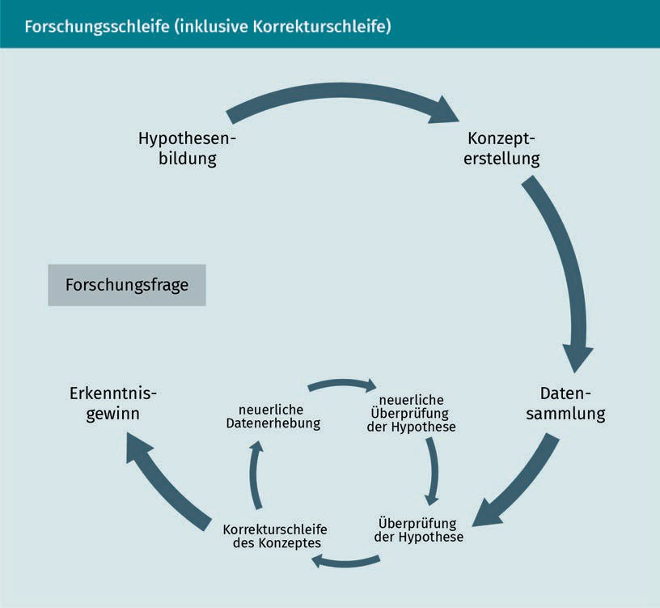

Combination of observation, survey and content analysis (method triangulation)

The most important methods of empirical social research are observation, surveys, and content analysis. Each of the methods can be used individually or in combination. Method triangulation occurs when all three methods are used together to answer the research question, combining the advantages of all three.

Once the research question and possible sources of information (persons, processes or data) have been clarified, the appropriate method, or combination of methods, for data collection must be selected:

* Observations provide data on people’s actions. In addition, actual processes can be recorded in different work contexts. "Observational studies can investigate visible, audible, and olfactible phenomena. [...] Using observation, complex fields of research can be developed, and comprehensive

Organizational Research

interaction patterns and group formation processes can be understood” (Atteslander, 2010, p. 78). This rather neutral method does not capture contexts or opinions.

* Surveys provide data on people’s opinions and ratings. They take place in certain set-up contexts, be it in interview situations between interviewer and interviewee, but also through written methods such as employee surveys. In general, interviews provide insights into verbal behavior. In contrast to purely observational methods, here objective circumstances, as well as opinions and attitudes can be recorded.
* The content analysis of text documents provides data on the type and content of communication between sender and receiver. For example, texts provide insights into the context of origin (when which information is communicated, by whom, to whom, and for what purpose), the content (which information is communicated, and which is not), as well as the transmitter and receiver (who passes on information and to whom) of a written information source. Content analysis is a neutral analysis, which is particularly suitable for detecting issues and events that have already occurred; the analyzed material does not change as a result of the analysis.

Organizations, as social systems, are complex in the expression of their characteristics. Therefore, it is important to collect data not only from one perspective, but rather to use a variety of methods to answer the question on the basis of adequate data.

Focus on Actions

One supposedly convenient empirical method, often chosen for analysis, is data collection by means of surveys. In this way, data from many people can be quickly collected, which are subsequently usually analyzed and interpreted purely quantitatively. However, the possible knowledge gain from these data is limited, since statements made verbally or in writing are opinions and assessments of the persons interviewed. Actual behavior in social interactions may differ drastically from the described statements of surveyed persons (cf. LaPiere, 1934).

In order to gather data on actual behavior in the social context of the organization, one must therefore observe behavior of persons in the actual field (the place of interaction). It's the only way to see how interaction actually happens in organizations. As a method, empirical observations are recommended, which may be structured differently as close, open, concealed or participatory respectively (cf. Atteslander, 2010). A separate publication would be required in order to describe these in detail.

The table below, however, illustrates the difference between the knowledge gain from surveys and observations. Thus, the results show that interviews tend to give answers that reflect the expected behavior, while they do not coincide to the same extent with the actual behavior of the interviewees (especially extreme in the discrepancy regarding giving thanks when one has been omitted). Surveys allow, therefore, to gather insights

Expectation context The interviewees have certain ideas about what the interviewer wants to know from them.

Answers are therefore not unfiltered information!

Quantitative analysis Quantitative analysis compresses data on numbers and charts.

Relationships in organizations cannot be unlocked.

into the opinions and perspectives of the persons interviewed. Information on actual behavior, on the other hand, is obtained via the observation method.

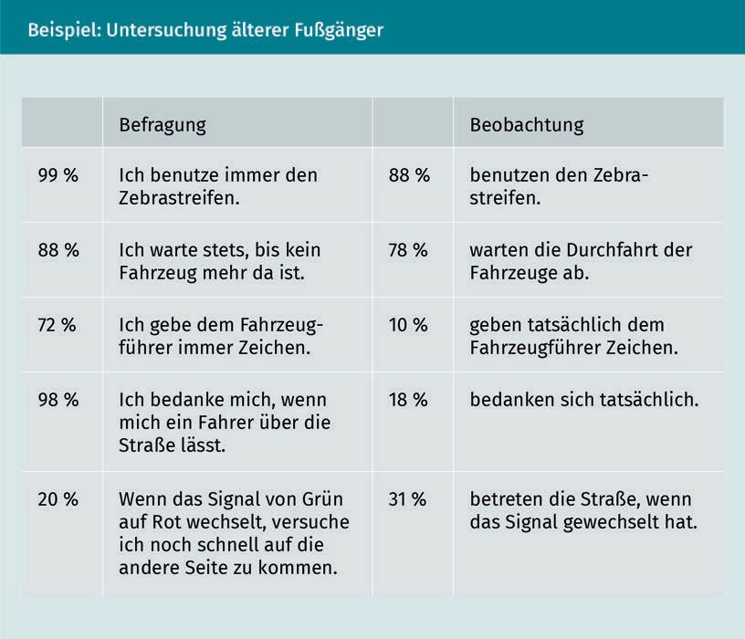

The steps taken so far towards empirical organizational research – formulation of the research question, conception of the analysis, data collection, etc. – are important aspects to arrive at reliable findings in organizational analysis. However, one essential aspect characterizes all these elements: that of the researchers’ role in the analysis of the organization, as well as their understanding of self and one’s findings in the field of research.

Clarity about Researchers’ Role

Both the definition of the question and the choice of the method of inquiry, as well as the interpretation of the data with subsequent knowledge gain are closely connected with the researcher.

The analysis project arises from the context in which the researcher is located and from how this person sees him/herself in the structure of the same organizations that are being researched. If, for example, a manager claims that s/he is the only one that can

Organizational Research

detect the problems of the organization, and solve them, the horizon of problem detection will be narrower than for a manager, who involves the employees in problem detection and resolution.

In addition, the researcher usually has a role in the organization (manager, consultant, owner, colleague, etc.) that cannot be set aside for the duration of the analysis. In this way, s/he is not perceived by her/his counterparts as an "objective researcher," but rather as a boss, colleague, consultant, etc. Information passed on is thereby pre-filtered (subjectively) by the informants.

The more the researchers are aware of their own role in the organization, and the more they incorporate that awareness into their research, the sooner it will be possible to correctly classify the information obtained into the context of the organization. It is worth considering this aspect in depth, because this self-reflection is often underestimated.

The image of organizational analyst/researcher already characterizes the entire research project and every analytical activity. Likewise, the perception of the function of an organization, the perception of one's own role in the analysis and the assessment of the importance of one's own results have a great influence on the entire research process.

The table below illustrates how the image of organizations, the perception of the function of organizational analysis, the perception of one's own role and the attitude towards the importance of one's own analytical results causes researchers to differ from one another on the basis of two opposing standpoints - a positivist one in the left column, and a constructivist one in the right column.

|  |  |
| --- | --- |
| Conflict of personal views affecting the analysis | |
| Tne image one has about organizations | |
| In particular companies, organizations are planned entities which are intended to achieve predetermined objectives by means of predetermined processes. The behaviors of the actors must follow the given structures and processes. If they act differently, this deviation has a disrupting effect. That is why it is necessary to describe first of all the official side of the organization and what is impeding its performance. | Organizations are socially constructed systems that exist independently of individual actions. They have their own dynamics, which are shown, for example, in the interplay between formal and informal patterns. If one wants to understand the functioning of an organization, one must find out the interplay between the (formally) constructed order and events caused by interactions. An analysis must compare the given structure with the interpretations of the affected persons. |

|  |  |
| --- | --- |
| Conflict of personal views affecting the analysis | |
| Concept of the function of an organizational analysis | |
| An analysis is there to determine why the actual state deviates from the desired state. What counts are facts.  An analysis should capture and present this as objectively as possible. In the most favorable case, it enables researchers to suggest improvements. | An analysis should be able to explain how the given state is maintained, and give meaning to possible deviations from the formal order. What matters are results that lead to discussion. An analysis is intended to expand perspectives. |
| Perception of one's own role | |
| With the analysis I must prove my competence. The report is intended to show how useful knowledge is. I'm curious to see how my results will be received. | I can learn a lot from the analysis, especially if I listen well and observe closely. I am curious about what happens in this organization and how you can understand it. |
| Value of own results | |
| The analysis creates a more or less realistic picture of the organization or the examined sections. This is a solid foundation for further measures. | The result of an analysis shows one of several possible points of views. How close to reality it is will be shown by the subsequent action of the participants. |

The more a researcher is aware of their position in the analysis project, the easier it will be for them to produce a consistent research/analysis concept and to produce results that help the organization.

###### Case Study

Mr. Mayer notes that there is some dissatisfaction among the staff in his department. He has already carried out an employee survey – with the result that each employee has given different reasons for his or her own dissatisfaction. Mr. Mayer will therefore not make any progress on the basis of the survey already carried out. What he lacked was a concept for the analysis of his organization. His employees and he are themselves part of the organization and thus not stand-alone elements. They are to be understood in connection with the organization. Mr. Mayer therefore decides to reassess his problem,

Organizational Research

while directly observing activities first, then explaining relationships, and finally evaluating the findings. He proceeds step by step:

Mr. Mayer defines his department as the primary field of research. However, since it operates in the structure of a larger operation, and also maintains contacts with customers, he defines the research field as a department plus subsidiary departments with which its department works, plus customers.

As a research question, Mr. Mayer keeps his earlier assumption that job satisfaction among employees of his department is low. He would like to find out what the reasons are based on the organizational structure. His research question is as follows: “What factors contribute to employee satisfaction in working with subsidiary departments and customers?”

Mr. Mayer selects two types of data collection methods. On the one hand, he wants to use interviews. To this end, he formulates a guide for the interview, which contains questions about roles, tasks and the organizational integration of the tasks of individual employees. On the other hand, he really wants to see how cooperation and customer contact between his employees takes place. After informing the employees about his plans, he goes to the customer area and observes, as a passive observer, contacts between employees and customers. Informing employees in advance about the purpose and course of the observation is particularly important, in order not to give them the feeling of being monitored. For the observational study, Mr. Mayer chooses, first, an open observation that is intended to provide information and aspects, of which he was not aware until now, and, secondly, he decides on a targeted observation of the work processes, with a focus on interfaces between employees, departments and then between these and customers. In doing so, he would like to know how the organization actually works together, and how the distribution of tasks in the organization works.

Before he starts the entire process of analysis, he clarifies his role in the organization. As a long-standing executive in the organization, he has played a decisive role in the organizational structure in recent years. His department is one of the largest within the organization, he has a corresponding weight in the management of the organization, and enjoys a corresponding reputation among the employees. He is aware that due to his management position, not all employees will provide him with very open information and will not act completely freely in observed situations. Accordingly, he opts to draw on the support of the human resources department, which can be more neutral towards employees in this situation. On the other hand, he informs the employees of his departments and those of neighboring departments about his project and thus creates transparency. This helps him, even after the analysis, to discuss and interpret his findings as openly as possible with representatives of his employees.

Summary

The lesson provided an overview of the formative scientific-theoretical perspectives of organizational research. It has presented the two dominant trends in organizational research, the positivist and the constructivist approach: Positivist approaches explain correlations in organizations as objective and universally valid if-then correlations, while constructivist approaches assume that correlations are more complex and are constructed through social negotiations (communication/interaction) in organizations. Scientific approaches such as Taylorism, the human relations approach, post-structuralism and systems theory can be assigned to these two currents.

Knowledge of theories of organizational research forms the basis for assessing the possibilities and limits of the individual theories and their methods for research projects. Individual theories have focused on different fields of research. The lesson provided an introduction to the main research areas of organizational research and corresponding survey methods, giving an overview of current research fields, which range from the research of an organization's goals/strategies, to the environment-organization relationship and change processes, to careers within organizations.

Organizational research, thus, deals with numerous aspects of organizations, be it the design and shaping of internal structure and structural processes, or external influences, as they are the focus of the research interest in the area of the relationship between an organization and its environment.

The lesson also provides an insight into the empiricism of organizational research. The role of empirical research in the development of organizational structures was discussed here, in particular: which steps are necessary for the conception of an empirical research project. Thus, empirical research – usually the purview of experimental science - makes it clear how organizations actually structure themselves, and whether they align with theoretical organizational concepts.

This overview has underlined what is to be taken into account when developing research questions, selecting the survey methods, and considering the influence of the researcher him/herself on the conduct of an empirical research (whether they want to provide an additional perspective on the research topic, or a solution to be implemented for a problem of the organization). This knowledge makes it possible to create robust research concepts.

Through further study of empirical approaches and methods of organizational research after this lesson, it will be possible to assess how a research/analysis concept is worked out, and which factors should be considered.



# Lesson 3

## Organizational Diagnostics

#### LEARNING OUTCOMES

After completing this lesson you will know ...

... what is meant by organizational diagnostics.

... which applications exist for organizational diagnostics.

... how useful organizational diagnostics are for the management of an organization.

... which considerations are helpful when designing tools for team and organizational diagnosis.

DL-D-DLMWPWOAE01-L03

1. Organizational Diagnostics

### Case Study

Mr. Huber was promoted from Head of Division to Head of Operations for three locations of a manufacturing company. He knows the company quite well, as he has been part of the organization for more than ten years. The improvement of processes in the company was always a great concern of his during this time, which was also a major reason for his promotion. Mr. Huber has always had to deal with smaller units of the organization. However, the locations of which he is now in charge include several hundred employees and numerous different areas, from administration to production, and sales. The size of his area of responsibility no longer allows him to personally identify potential for improvement in the locations through observations and individual interviews. However, he must find these problem areas in order to further increase the efficiency of the locations he is now responsible for.

Mr. Huber chooses a method from organizational diagnostics. He builds on the opinions and experiences of his employees. Over the course of a comprehensive employee survey, he would like to ask them for their perspective on the internal improvement potential. Together with his HR department, he is preparing a staff survey for a diagnosis of the collaboration between the departments, availability of necessary work equipment, reshaping of the organizational structures (processes and hierarchies), as well as the organizational climate and management culture in the company's locations. He would like to incorporate these findings into organizational, personnel and management development measures, thus making the organizational units more competitive.

### Definition and Objectives of Organizational Diagnostics

Organizational diagnostics is derived from organizational psychology. This, in turn, has arisen from the concern to describe and explain the effect of organizational workflows, working conditions, and forms of cooperation on individuals.

Organizational diagnostics is a complex process that aims at "recording, analyzing and interpreting human experience and behavior in relation to organizations" (Werner & Elbe, 2013, p. 11). In organizational diagnostics, it is therefore first of all a question of learning how members of an organization experience organizational modes of operation (such as workflows or forms of cooperation), and structures (such as hierarchies or possibilities for co-decision by employees). Secondly, organizational diagnostics aims to discover how this experience affects the behavior of people within an organization. From this basis, suitable measures for organizational development can be derived in order to improve efficiency or to solve problems.

Organizational Diagnostics

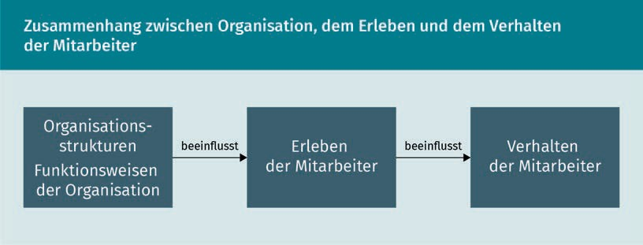

The word “diagnostics” designates the **methodology** for the diagnosis of organizations. Diagnostics is primarily also the process of analysis and data acquisition, which provides the basis for the interpretation and evaluation of organizational functions and structures. The diagnosis itself contains the description, analysis, explanation and evaluation of the findings gained from the analysis carried out by an organization (Spörrle, 2013).

Organizational diagnostics is distinguished from organizational research and organizational analysis by its focus on the experience and behavior of employees in organizations on the one hand, and by its fields of application on the other. Methods and basic approaches for the creation and execution of an analysis (key phrase: research concept) are very similar to organizational research and analysis. Similarly, organizational diagnostics places great importance on the informed, scientific application of quantitative and qualitative methods, as is also the case in organizational research and analysis.

###### Goals of Organizational Diagnostics

According to Franke & Kühlmann (1995, p. 350), the objectives of organizational diagnostics are:

1. “The provision of data for questions of comparative organizational research;
2. the analysis of hidden weaknesses of an organization;
3. the evaluation of organizational development measures;
4. Awareness-raising of managers about the objective and subjective situation of employees;
5. The consideration of employee interests.”

This means that organizational diagnostic analyses are carried out, firstly, in order to compare the characteristics of the structures, processes, hierarchies, and communication patterns of different organizations with one another; secondly, to identify weaknesses within the structures and functions of an organization that have a negative impact on the experience and behavior of the employees. This is done, on the one hand, by carrying out cross-sectional studies - i.e., broad analyses over several areas of the organization – and, on the other hand, by conducting longitudinal studies,

Methodology

Methodology is the study of scientific methods used for specific purposes.

Employee Participation

By involving the affected employees in the analytical process, diagnostic results and newly developed solutions can be better accepted by the employee.

which analyze the impact of organizational development measures through comparative studies over longer periods (Dietz 2006); thirdly, to improve the work environment for employees in organizations. In particular, this happen especially if there is a high degree of employee participation in the analyses carried out. Employee participation is ensured by the chosen diagnostic methods (interviews, workshops, surveys), which offer space for the participation of the employees in the analytical process. This creates pressure for change in the organization, which should lead to the implementation of measures, and eventually to improvements in the situation of employees. By publicly airing topics important to the employees, organizational diagnostics can achieve the goal of sensitizing managers to the situation of their employees. In turn, this should highlight issues important to the employees, so that they are addressed during organizational change processes (Felfe & Liepmann, 2008). The main goal of organizational diagnosis is thus to understand the current mode of operation of an organization, since it provides the necessary information for designing improvement measures derived from it (Kauffeld et al.,2013).

### Fields of Application for Organizational Diagnostics

The specific fields of application for organizational diagnostics are derived from four thematic areas (cf. Rosenstiel, 2007, p. 394f.): measures to improve organizational structures, organizational climate, organizational culture, and human assets. These four factors of an organization affect the experience and behavior of an organization’s employees.

###### Organizational Structure

Organizational structure refers to all those formal structures imposed on workflow and processes that regulate the work in organizations. They include hierarchies, tasks, and work phases. Organizational structures effectively nfluence the cooperation within the organization and form the framework for the employees’ work-related “free spaces,” i.e., their possibility to work more or less independently.

###### Organizational Climate

The quality of an organization’s internal environment is called the organizational climate. This environment includes the design of process and workflow superstructures, the definition of the operational understanding of performance, the relationship of colleagues to one another and to their superiors, the creation of information and communication patterns, as well as cooperation within the organization (Rosenstiel & Bögel, 1992). “Organizational climate” here, means the daily perception

organizational diagnostics

of the organization by its members, and is also measured by individual perception. For example, there can be a climate for change, for quality, or for innovation within an organization.

###### Human Resources

In the field of business administration and psychology, human assets are understood as being the value “of the skills and attitudes of the employees, and their social coordination for the company” (Rosenstiel, 2007, p. 395). This means how the skills of the employees, and their attitude to the work performed, can be developed in order to generate value for the company/organization.

###### Organizational Culture

**Organizational culture** refers to visible elements (hierarchies, areas/departments, working clothes, office space design), and hidden elements (ways of thinking, habitus) of the organization. It has a great influence on the experience and behavior of the employees, as it co-defines how thought and action are shaped, which structures are formed, and how employees experience management. Culture forms the common denominator for thinking and acting in an organization, thus, also the shared system of values and norms, by which one organization differs from others (cf. Schein, 2010; Schreyögg, 2016; Lebitsch, 2019).

###### Specific Areas of Application of Organizational Diagnostics

Specific areas of application for organizational diagnostics have developed within this broader subdivision of topics (cf. Felfe & Liepmann, 2008). These range from organizational development to quality management, and questions about the promotion of corporate health. The focus is always on understanding the relationship between structures and functions of the organization, and the experience and behavior of people. Knowledge is incorporated into improving organizational structures, organizational climate, organizational culture, and the human resources of the organization.

Organizational culture Organizational culture is the vehicle and motor of the organization, and sets up the framework for common ways of thinking and acting.

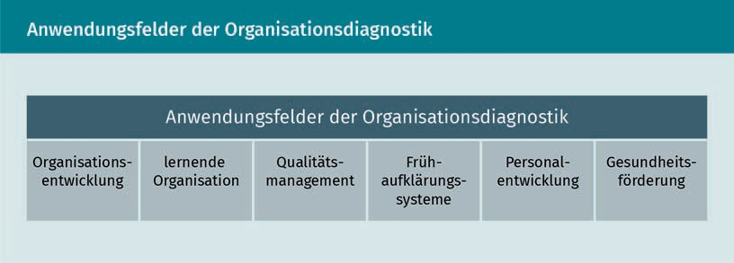

Bottom-up Processes that originate from employees of an organization are called

“bottom-up,” in contrast to “top-down,” i.e., management-driven measures, which are imposed from above onto the employees.

Organizational Development

Organizational diagnostics supports measures of organizational development, such as changes to the structure and sequence organization by longitudinal and cross-sectional studies. Organizational diagnostics support **bottom-up** participation of the members of the organization in development measures (cf. Grote et al., 2013) through the methodical focus on qualitative forms of employee surveys. The latter, in turn, deal with issues of flexibility, innovation climate, the openness/unity of the organization, questions of the division of competencies in teams, and effects of organizational development measures on individuals (see the following figure).

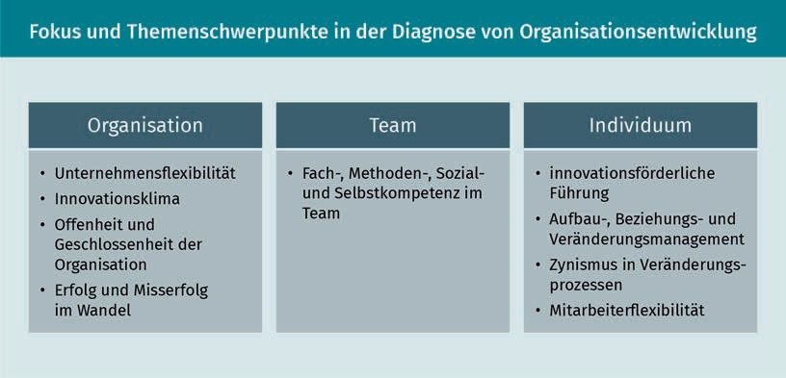

Learning organization

Increasing environmental complexity, in part due to globalization or rapid technological developments (digitization, e-mobility, 3-D printing, among others) requires increased flexibility in the control and structuring of organizations. In order to cope with this increasing complexity, organizations rely on the diverse competence landscape of their members and their environment. They use it as a source for organizational learning, which can be defined as follows: Changes in the knowledge base of an organization ...

Organizational Diagnostics

* ... take place in the interplay between individual and organization,
* … provide an interaction between internal and external environments of the organization,
* … are constructively based on existing action theories of the organization,
* … contribute to system adaptations and increased problem-solving capabilities of the organization (Felfe & Liepmann, 2008).

Learning is understood here as a change in organizational behavior. This means that an organization learns about the activation and use of external and internal knowledge through changed behavior to deal with new challenges (agility instead of hierarchies; holacracy instead of department silos). Organizational diagnostics show what interaction patterns exist in the organization, i.e., how exchange and learning work and can finally be promoted.

Quality Management

Quality management in the organizational diagnostic sense means the interplay of individual and collective behavior and thinking of the organizational members who influence the quality of organizational outputs (products, services, etc.). The analysis focuses on the expression and quality of the following factors:

* Governance and communication culture: Are errors dealt with openly and constructively, or are they covered up, and are culprits looked for? How does the organization develop continuously and systematically to avoid errors?
* Error culture: How are the detected errors used? Are fault analyses oriented towards learning and improvement, and how do errors influence the competence development of the organization?
* Management system: What about systematic and proactive quality management and priority-driven action management?
* Improvement system: On what factors/facts is the operational improvement system based? Is this systematically extended, and do proposals lead to improvement measures?
* Competence management: How are the competences of the employees and the organization developed, and what are the upstream requirements in the organization?

Early warning systems

In organizational diagnostics, early warning systems are understood as ways of recognizing changes (opportunities or threats) that are both internal and external to the system at an early stage, thus increasing the speed of the organization’s response. The aim is to transform these into options and opportunities for action within the organization. Organizational diagnostics uses systematic analysis methods to support the ...

Landscape of competences

The diversity of the competences of employees and actors in the organizational world, for example the professional, methodological, social, and personal competences.

Holacracy

A method of decentralized management in organizational areas, which is based on autonomous responsibility in the team.

* + ... location and recording of change signals (e.g., technical developments, customer requirements, growing competitors, generational changes, shortages of skilled workers, etc.) with the help of the organizational members (360-degree analysis, benchmarking),
  + Dissemination of detected change signals among organizational members (analysis of: degree of distribution, behavioral patterns),
  + Assessment of the relevance of the change signals (via: prioritization, concern of the organization), and the
  + Development of strategies to cope with different change scenarios (cf. Felfe & Liepmann, 2008).

However, this field of application of organizational diagnostics is still in its infancy, and further theoretical and practical work is necessary to create a stronger diagnostic basis.

Personnel Development

With regard to the collection and presentation of organizational qualification and upstream training requirements, organizational diagnostics can help members of the organization to be able to meet the needs of the organization now and in the future. The early warning system works by comparing the existing and future necessary competences. This takes place at three levels of the organization:

* + individual/personal level: Desired qualifications of employees and supervisors, target agreements between the two, as well as career planning are compared.
  + organizational level: Leadership principles (such as personnel or task organization) that have an impact on the development of existing employees, as well as requirements for competences for strategic realignment are considered.
  + functional level: Requirement profiles, job descriptions, and responsibility profiles are compared.

In the sense of cost-benefit control, organizational diagnostic methods of data collection are used to create transparency regarding missing qualifications and associated costs; after successful qualification measures, the organization strives to make those benefits diagnosable and measurable.

Health Promotion

Organizational diagnostics deals very centrally with the question of the employees’ experience and impression of organizational processes and structures. In recent years, topics such as participation, self-determination, and cooperative leadership have been the focus in surveying organizational experience for organizational diagnostics. In recent years, the health aspect has increasingly become part of organizational diagnosis.

Organizational Diagnostics

Health promotion includes measures aimed at improving the safety and health protection of the employees of an organization. In addition to the individual, personal-related factors of physical health, these also include organizational structures and processes that affect participation and self-determination, and thus influence the physical and mental health of employees.

Organizational Diagnostics as Part of Health Promotion ...

* + 1. ... by means of risk analysis (interviews of employees to identify hazards),
    2. by regularly reviewing the health status of employees; and
    3. the preparation of health reports for the management team of an organization ...

... which help to identify factors that are burdensome in the medium and long term, and which have a negative impact on job and life satisfaction, health statistics, and ultimately on productivity. For this purpose, physical, psychological, performance, and behavioral stresses are analyzed, the causes of which is to be found in the functioning and structure of the organization (Felfe & Liepmann, 2008).

The central question in all the fields of application of organizational diagnostics mentioned here is how employees experience organizational structures, the atmosphere at work, the organizational culture, and how these influence human assets, and ultimately the behavior of an organization’s employees.

### Organizational Diagnosis as a Management Tool

Organizational diagnostics offers suitable means for the management of an organization to identify starting points for development measures via a broadly applied (cross-sectional) analysis. It also seeks to obtain additional perspectives on change through the participation of employees in the analysis process. After completion of the change process, the degree of implementation and success of the change process can also be measured by means of an organization-diagnostic longitudinal analysis. Thus, organizational diagnostic analysis is also a suitable evaluation tool for management because recommendations and measures can be derived from it.

Change and development processes in organizations lead to adaptations, further development, or completely new developments on several levels:

* + 1. the conditions at work, such as an employee’s the room to maneuver or the diversity of work processes,
    2. the patterns of interaction in the organization, such as collaboration or communication, i.e., group interactions (e.g., the design of service plans); and
    3. of the entire organization with its functions, structures, and organizational culture.

However, employees’ behavior is decisive for the actual further development in organizational activity. For this, organizational diagnostics considers working conditions in organizations taking into account a wide range of factors such as workplace, interaction, and organization. These factors influence the experience of the employees, which ultimately influences their behavior (see figure below). If, for example, hierarchies are very pronounced in a company, employees experience the work as being externally determinted. Their behavior will therefore tend to be characterized by a sense of duty, and less by personal responsibility. In contrast, agile organizations are characterized by decentralized or self-controlled structures that promote, indeed almost require, employee ownership.

If the management of an organization therefore wishes to bring about changes in the organization and behavior of its members, general working conditions and their effects on the experience of the employees must be analyzed in order to finally bring about changed behavior.

Organizational Diagnostics

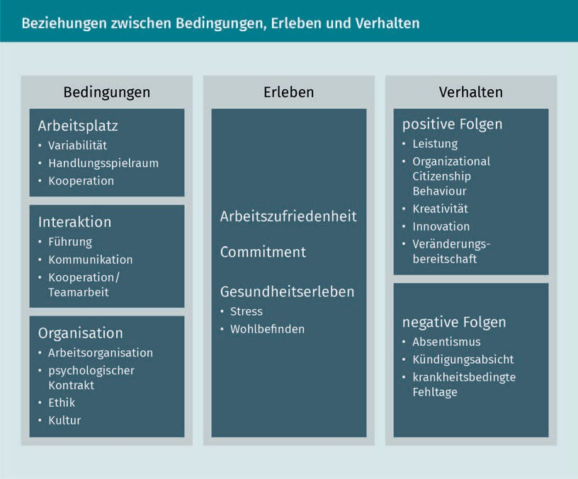

In the following, the three levels “conditions,” “experience,” and “behavior” of the employees are discussed in detail, in order to better understand them and the relationships between them.

###### Conditions of Organizational Work

The following are decisive conditions in organizational diagnostics: the workplace, the quality and forms of interaction, and the form of the organization (Felfe & Liepmann, 2008).

The Workplace

Requirements for the employees arise, on the one hand, from their work, on the other hand, from their working conditions (room for maneuver, autonomy, etc.), and the work environment. These factors influence employees’ experiences and behavior. Organizational diagnostics provide approaches to identify those factors that affect people's lives and health in the workplace, and ultimately help strengthen the resources available to employees, and to enable them to meet requirements and cope with their tasks.

Here, resources are means which allow one to cope with demands and stresses in the workplace, for example, alternation in activity, room to maneuver, and having the space to make one's own decisions, as well as cooperation possibilities within the team.

From a management perspective, findings from diagnostic analyses of work conditions can promote measures to increase work performance, and reduce health risks (stress, overstrain, physical risks, etc.). The following list provides an overview of factors affecting workplace conditions:

* Variability and variety of requirements: Work that is perceived as monotonous and short-cycle (such as assembly line work) can lead to physical and psychological strain on the worker. On the other hand, motorically, cognitively and socially varied tasks (such as project work) are experienced as interesting and motivating, which promote the growth of employee competencies. Surveys of affected employees enable the management to gain insights into their experience of the work situation, as well as on the associated reasons for low efficiency, and effectiveness of the services provided.
* Scope, control, autonomy, and regulatory requirements: If the employees experience their work situation as too narrowly defined, without space for their own decisions and own objectives, and without room to maneuver, their intrinsic motivation to perform decreases. On the other hand, the highest possible degree of autonomy and regulatory requirements create the possibility for employees to learn and expand their skills. Division of labor also plays a role here – the more complete the fulfillment of a task in the hands of a person, the higher the degree of decision-making and implementation autonomy. In conjunction with the fulfillment of more complex tasks, this has a personal and health-promoting effect on the employees of the organization. The organization itself benefits from this. However, not every employee desires the same room to maneuver. Here, it is up to the manager to recognize this, and to design the right framework for each employee.
* Possibilities for cooperation: The possibility for cooperation, in the sense of an exchange between colleagues, creates space in organizations for mutual social support. This is regarded as an essential resource for the management of challenging activities, which a person cannot handle entirely on their own, for example because of their complexity. Findings about whether and in what form cooperation between employees takes place, and which factors promote cooperation should therefore be of interest for the management of an organization.

Burdens and ultimately stress arises in organizations when the resources of the employees (knowledge, competencies, networks, etc.) do not meet the requirements of the work over the long term, or to a very large extent. If individual factors, such as faulty material, waiting times for information, missing information or frequent interruptions in work, are perceived as a burden by several employees of an organization, these are usually organizational stressors, whose cause is to be found in the functioning and structure of the organization.

Organizational Diagnostics

These stressors are perceived by employees as regulatory obstacles. They are distinguished by the fact that they hinder the independent regulation of the actions without the employees being able to effectively influence these obstructing factors themselves (Leitner et al., 1987). In general, obstacles are understood to be all those factors that permanently act against a physical or psychological achievement. This includes, among others, missing information/feedback, processes with motor difficulties, interruptions of work for various reasons, noise, ambient climate, inadequate lighting, etc.

In addition to regulation impediments, there are regulation overloads. Regulatory overload is defined as factors that reduce the effective execution of work due to overloading. These include time pressure, monotony and high dependence on cooperation. The reasons for time pressure may be, for example, clocking of work sequences, but also high customer frequency, and continuous interruptions. However, overloading may also result from the lack of a target or from an unclear one, and from role specifications by the manager.

In addition to the conditions of work processes and workplaces, the quality of the interaction between members of the organization counts as another essential factor that influences the employees’ working conditions.

Interaction

Interaction takes place in organizations on a horizontal, as well as on a vertical level - that is, between hierarchies, and at the same hierarchy level. As a social exchange, interaction promotes the mental health of employees, leads to clarity about the tasks in the form of target communication and feedback - as part of leadership - and ensures social cohesion in the organization. Leadership, quality and quantity of team communication and interaction are therefore important diagnostic fields for the management of an organization.

* Leadership: **Leadership** is the direct interaction (communication and behavior) between the supervisor and the employee, which is aimed at getting employees to act in accordance with the organization's goals. The employees’ exposure to leadership influences their behavior and experience. Interviews with subordinate employees provide information about the executive’s behavior, and the characteristics of their management style. For example, is the behavior more task-oriented or more employee-oriented? Does management’s behavior show that it is invested in providing friendly attention, co-decision, participation, and open room for employees to maneuver? Orientation towards the workforce leads to motivation and satisfaction among the members of an organization. This also includes formulating clear goals and allowing employees room for maneuver to determine needs and requirements. If the management style is more task-oriented, this often results in the curtailment of the employees’ acting competencies, while focusing mostly on their performance.
* Communication: The quality of the communication flows between employees and colleagues, as well as from and to the manager, is an essential factor for finding the right way to collaborate. The diagnosis of problems and bottlenecks in organizational information flows is therefore an important lever for management

Leadership

Management’s leadership qualities influence employees' experiences and behavior in the workplace.

to make organizations more effective. The focus of the diagnosis is on quality (availability and comprehensibility) and quantity (frequency and scope) of information, as well as the design of the information paths themselves (for example via communication rooms or intranet). Missing, incorrect or misleading information leads to errors and inefficiencies in the workflow, and consequently to stress in the employee's work experience.

* + Team Diagnostics: Working in groups and teams is increasingly encouraged. It is therefore important for the management of an organization to understand this form of cooperation in order to promote it in targeted team development measures. By means of an employee survey, it can be clarified whether existing teams are more task-oriented or more person-oriented. Task orientation means that the team is oriented towards a common goal and the division of tasks, while person orientation means that the climate/the interaction within the team is in the foreground and tasks are solved jointly. As a rule, both orientations are arranged side by side. Team diagnostics provide information on which aspects are more pronounced, and which are still to be developed.

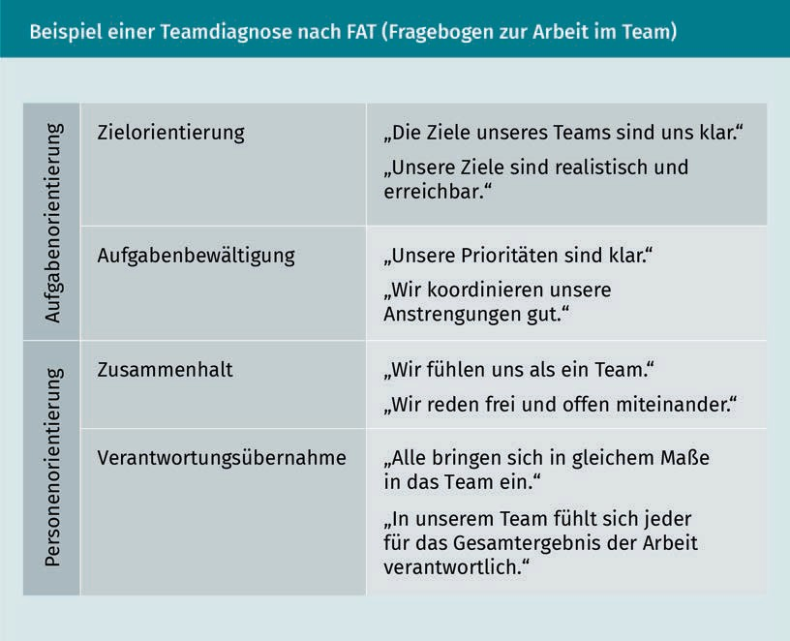

Interaction and its form, thus, strongly influence the experience of the employees in the team. Organizational diagnostic analyses on the topics described above provide clarity to shape interaction patterns. They are therefore an important management tool.

Organizational Diagnostics

Task-oriented teams are geared towards achieving a common goal (such as opening several branches of a trading company). The project team dedicated to this task has been assembled from experts from various areas of the company (e.g., purchasing, service processes, finance, etc.). However, the management of the company recognizes, during the project work to open the first branch, that the team does not work well together (tasks are not processed in time; the team is despirited). A team analysis makes it clear that although the common goal (opening of branches) is clear to all, and that the distribution of tasks also essentially works, there is no team identity in the project team. As a result, basically every project employee works out his/her tasks, without seeking support from his/her project colleagues when difficulties arise. Through a team diagnosis, the management of the company recognizes this shortcoming and can counteract with team development measures (building trust among project staff members, creating space for small talk also during project communications, etc.).

In addition to working conditions in the workplace and interaction, the organization itself is also an important factor that has an influence on employee experience.

The Organization

From an organizational diagnostic point of view, an organization is a multidimensional system characterized by the degree of differentiation or specialization of its structures, the degree of centralization of task coordination, its dominant ethics and culture, and, finally, by the psychological contract (expectations of the employees and the organization) between the organization and its members (employees). Organizational diagnostic analyses and measurements help to make the state of implementation and the design of these multidimensional qualities of the organization easier to recognize, and ultimately also to change. This can be used for industry comparisons, historical and strengths/weaknesses analysis of the organization, and it can be used in change processes.

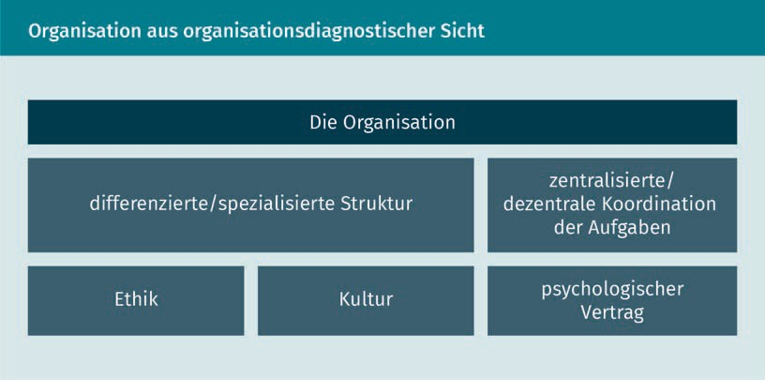

From an organizational diagnostic point of view, what are the important aspects of an organization and how can these be analyzed?

Centralization of work coordination, as well as of the organizational structure can be determined by means of document analysis (documented guidelines stipulating goals etc.), an analysis of the organizational chart (number of job designations/hierarchy levels/areas), and interviews with key persons of the organization. Interesting questions include: Which areas/departments are there? How do departments or persons in their work processes differ/specialize? Is there a large number of specialized, small departments, or are there large specialist areas? Do you even have agile teams that are built up to meet specific tasks?

The coordination of tasks often depends on the distribution of power, and on the decision-making powers within the organization. Structured interviews with key persons such as department heads or staff associations can be used to capture and represent the area of influence employees have on their room to maneuver in the organization. In this context, the key questions are: How standardized, routinized and formalized are workflows? To what extent are these requirements controlled by managers and followed by employees?

If we think of cooperation beyond the personal level, the question arises as to the coordination of interdepartmental work. The focus here is on questions according to the degree of control of coordination/communication: How often and in what context do exchanges on interdepartmental work topics take place? Which contact patterns (frequency, contact medium, contact persons, etc.) are there? These questions must be answered within the framework of differentiated/specialized structures, and the work organization in general, in order to derive suitable measures for organizational development, and to achieve efficiency gains in the organization.

Formal work structures and coordination of tasks form one side of the organization. On the other hand - but closely linked to the formal side - there are informal topics such as ethics, culture and the “psychological contract,” which significantly influences the work in organizations.

The field of organizational diagnostics knows about the informal bonds between people in organizations that influence the experience and behavior of their members. Thus, in addition to the contractually secured conditions for work in organizations (working hours, approximate areas of responsibility, and responsibilities of individual employees, etc.), there is a large number of non-written agreements, which characterizes the relationship between organization and employees. In concrete terms, this means that in the psychological contract, the organization offers, for example, a salary, additional services, social contacts, tasks and giving their life a meaning (through work itself), while the employees offer their performance at work, creativity, skills, knowledge, talent, energy, time, and health. If this psychological contract is balanced, the employee is bound to the company. Contracts not fixed in writing can be distinguished into transactional and relational contracts, the former being based on economic exchange, and the latter on social obligations.

Organizational Diagnostics

**Transactional contracts** are based on the promise of “performance for money.” There is little emotional connection between the organization and the employees; what matters are purely economic considerations. **Relational contracts**, on the other hand, are based on the emotional bond between employee and organization. What employees or the organization understand as “binders,” whether it is money or emotions, can be of importance for the organization’s management design. This is particularly true, for example, if challenging times are ahead (reorganization of the organization; strategic realignment, etc.), and management needs to retain and motivate existing employees for the upcoming change.

In addition to “psychological contracts,” the ethics and culture of the organization play an increasingly important role as factors in the experience of the organization, especially in companies. Ethics and its specific understanding by the organization has an influence on how decision-making spaces for employees are shaped, or how the company appears to the outside world, and becomes aware of its social responsibility (corporate responsibility). The culture of an organization, on the other hand, characterizes the entire action and thinking, as well as the cohesion of the organization. In both categories – ethics and culture – the question arises of the identification of the employees with the values experienced in the company and carried to the outside. Are there overlaps, a common view on ethics and culture, or are there serious differences?

The sum of the aforementioned working conditions determines whether employees experience work in a positive or negative way. This information is relevant for the management of an organization, in order to improve working conditions, or the handling of employees by managers. The next chapter section deals with how employees experience these working conditions.

###### The Experience of Working Conditions

Diagnosing the employees’ experience of their working conditions in an organization enables the management to assess their emotional and cognitive reaction to said conditions. This results in possible modification requirements. Satisfaction, commitment, and health issues, such as stress and irritation, are all assessed, since they all influence the quality of employee performance. Topics such as burn-out or **bore-out**, but also identity crises in the work environment are discussed more and more. Therefore, diagnoses for how one’s work reality is experienced are becoming increasingly central. What is meant by job satisfaction, commitment and health, and how these are analyzed are highlighted in the following paragraphs:

* Job satisfaction: Work satisfaction describes a state that arises from positive emotional satisfaction because of the work one has personally carried out. This mainly depends on the attitude towards different facets of the work, such as the respective task, working conditions, decision-making areas, variability, as well as social aspects such as relationship with colleagues and superiors. In this case, an internal comparison of the mental representation and the reality of the facets mentioned takes place with each person. Diagnostic surveys can start

Transactional and Relational Contracts Transactional and relational contracts are not in writing, yet are binding to members of an organization in different ways.

Bore-out

Bore-out refers to a condition that results from systematic under-demands on employees.

from a single question “How satisfied are you with your working conditions?”, to a detailed survey of job satisfaction taking all facets into account.

* + Commitment: Commitment refers to the employee's commitment to the organization. On the positive side, this is characterized by high loyalty, on the negative side, indifference to rejection prevail instead. Commitment can be further divided into three levels (Allen & Meyer, 1990): affective commitment based on desires and ideas, predictive commitment based on rational and economic considerations, and normative commitment based on social values, such as staying with a company for many years, or loyalty to an organization. Employees with a high affective commitment are characterized by a strong and lasting commitment to the organization, since the conditions of the organization (ethics, culture, working conditions, etc.) correspond to the employees’ ideas. On the other hand, the so-called continuance commitment, i.e., a purely gains vs. losses commitment is associated with a high risk of employee turnover, since in difficult times employees tend to search for better alternatives out of (economic) safety considerations. Commitment can also be analyzed via employee surveys.
  + Health: Stressors and lasting stress lead to health impairments. However, if an employee is healthy, he or she is physically and psychologically capable, and there are no impairments from their condition. Otherwise, these lead to irritation and stress resistance. These, in turn, lead to increasing error rates, as well as social impairments in dealing with their immediate work environment. As a result, permanent stress means that employees can no longer switch off and recover during their free time, and thus can slide more easily into burn-out and long-term illnesses. The promotion of mental well-being aims at meaningful measures, and the extension of the range of effectiveness of the employees, so that they feel pride and joy, and can show increased commitment in their work.

Extra-role Behavior

Be-havior of the employees outside of fixed job descriptions, since behavior along fixed roles nowadays often no longer fits the requirements well.

Positive experience has a positive effect on employees. In all respects, however, the quality of the experience of the working conditions has an influence on the employees’ behavior. Organizational diagnosis analyzes mainly the **extra-role performance behavior** of employees, i.e., whether and in what quality employees perform tasks that are not related to their structurally defined roles.

###### Impact on performance and behavior

The performance and behavior of an organization’s employees increasingly depend on factors that are outside the organization’s defined structures. It is therefore not primarily processes and tasks that are defined as narrowly as possible that promote employee performance. This happens particulary when, at a time of high pressure for change, organizations are compelled to refrain from enforcing rigid internal structures. In this context, organizational diagnostics focus on understanding role behavior that manifests itself outside defined structures (Felfe & Liepmann, 2008). Extra-role behavior is strongly based on emotional and motivational conditions.

Organizational Diagnostics

* Organizational Citizenship Behavior (OCB): OCB refers to a very strong relationship between organization and employees, which promotes extra-role behavior. Based on the concept by management professor Dennis Organ (1988), people with a high OCB exhibit pronounced altruism, conscientiousness, tolerance, consideration, participation, and commitment. A high degree of these factors can also be observed among employees with increased job satisfaction and high levels of affective commitments. OCB analysis assesses the qualities mentioned (altruism, etc.) through instruments for external and self-assessment.
* Innovative behavior, creativity, and willingness to change: The ability to react to changing environmental factors is a key factor that contributes to the long-term inventory of companies and organizations. Creativity (the radical discovery of new ideas) and innovation (the ongoing/planned improvement of existing themes) simultaneously entail a certain willingness to change, as tasks and processes change, right up to the radical restructuring of organizations. In order for creativity and innovation to emerge, two factors are required: the willingness of the employees to work in this form, and a positive innovation climate in the organization. The role of the management of an organization is decisive in creating learning areas for members of the organization, in which experiments and learning from mistakes are allowed. After innovation has been achieved and new solutions have been found, the readiness must be created in the organization to implement the newly created innovations. Here again, the managers and executives of an organization need to promote the willingness to change and to accompany change processes to completion (Felfe & Liepmann, 2008).

The characteristics of both fields - the OCB and the topics of innovation, creativity, and willingness to change - depend primarily on how employees experience their work conditions. From an organizational diagnostic point of view, this in turn depends on the design of the work conditions. Organizational diagnostic analysis provides insights into the shaping of work conditions, their effect on employee experience, and finally into how the experience affects the employees’ behavior.

### Target Groups of Diagnostic Findings

The main target group of organizational diagnostic surveys are the management and the leadership of the organization. They receive essential information about the experience, and ultimately also the behavior of the members of the organization, through organizational diagnostic methods. Organizational diagnostics, thus, provide the basis for the further interpretation and evaluation of the collected data.

Findings from the collected data are important for the control of an organization, whether in the area of human resources, conflict resolution, and group work, or in terms of strategic topics such as innovation, employee retention and change

management. The organization diagnostics provide a foundation for further development measures, and the long-term existence of the organization through the sound diagnosis of the state of the organization, and focusing on employee experience and behavior.

TEQ

The TEQ (team effectiveness questionnaire) is a questionnaire based on organizational and psychological

findings.

Especially for managers, organizational diagnostics provides approaches to better deal with the challenges of today's work environments. For example, team diagnostics can be used to specifically analyze which aspects (task or person orientation) are to be strengthened, in order to support agile teams in their further development. Here, organizational diagnostic analysis tools, such as **TEQ**, allow a manager to fulfill his or her task in organizational and team development by showing the team’s potential for further development (for example, by strengthening team spirit). In turn, the manager will support the team in its further development (for example, by doing activities for team building). Leaders take advantage of the potential of the employees and their ideas, and, as is characteristic of a modern management style, make sure to create structures that promote employee satisfaction and the effectiveness of the workflows in equal measure.

The organizational diagnostic approach of improving working conditions with the participation of employees also enables managers to create a participatory management culture in the organization. This is achieved, for example, by regular employee surveys in order to obtain suggestions for improvement (for example, for workflow processes in the organization, or the reduction of interfaces in the workflow), which can then be developed and implemented together with the employees.

Organizational diagnostics also provides managers with an understanding of the framework conditions (such as task coordination, psychological contract, or ethics and culture) in their own organization that contribute to employees being effectively and permanently active for the organization. For example, executives can build agile forms of cooperation based on insights to define the aforementioned framework conditions in their own organization. For example, if there already is a strong relational behavior (via emotional attachment to the organization) among members of the organization, and employment relationships are already built up on the widest possible decision-making spaces for employees, this can serve as a basis for the creation of agile teams – that is to say, largely self-directed teams. However, if such framework conditions are hardly pronounced, the first step should be to create them, before attempting to install agile teams. Organizational diagnostic analyses, thus, provide clarity about the status of the organizational development, and are the starting point for further development measures, which are recognized and initiated by executive management.

Organizational Diagnostics

### Selected Tools for the Team and Organization Diagnostics

Organizational diagnostics does not have a separate set of methods that distinguish this discipline from organizational research or analysis. Instead, they implement a series of quantitative and qualitative methods of survey and evaluation borrowed from the sociological approaches to organizational research. This includes interviews, observations, and content analysis. However, one method stands out because it is very well-suited to study the members of an organization’s health, and how they experience working within it: The employee survey (ES) questionnaire is the central instrument of organizational diagnostics.

###### Employee Surveys in Organizations

In practice, the employee survey is the central method of organizational diagnostics. Traditional employee surveys have in the past aimed primarily at inquiring about the two aspects of employee satisfaction and commitment. However, from an organizational diagnostic point of view, this does not seem deep enough. Considering the potential for perspectives on the organization that employees can provide (e.g., modes of cooperation between departments, corporate governance, workflow processes that have potential for improvement, etc.), their suggestions for improvement and references to organizational problems are at the center of the survey. If one considers employees less as an object to be investigated, and more as co-designers of the organization, an employee survey can actually succeed in improving organizational development. The concept and implementation of modern employee surveys take this awareness into account.

The completion of an employee survey requires time and resources, as does the evaluation of the data, and its subsequent interpretation by members of the organization. In order to derive a corresponding benefit from the employee survey, it is therefore necessary as a first step, to thoroughly research and design the survey.

Key characteristics of the employee survey

An employee survey asks ...

* ... employees from specific or all levels/areas of an organization,
* by using social science data collection methodology (questionnaires or interviews),
* [employees] systematically about their opinions and attitudes to certain topics,
* [questions] relevant to the achievement of the organization’s goals.
* This is done with the intention of gaining a complete picture of the organization, and thus
* identify areas of activity that support the achievement of said organizational goals.

Employee Survey Variants

Employee surveys are conducted for a wide variety of reasons. However, they fit quite well in a few main categories, depending on the approach according to which they were designed:

* + Benchmark: Organizations may be interested in how they position themselves as employers compared to other organizations. Comparative studies can also be carried out within the organization, between departments or locations. Results can be used internally to derive measures for improvement, on the one hand, and externally to support, for example, the representation of the organization as a good employer.
  + Organizational climate: The question of the organizational climate is primarily used by the top management of an organization to obtain a comprehensive picture of the mood within the organization, and of structural and organizational strengths, and weaknesses.
  + Leadership: This aims to ask about the management skills of individual managers in order to achieve improvements. These employee surveys are also used to formulate management goals, which are linked to the achievement of management bonuses.
  + Employees: In order to give the management of an organization a good picture of the employees’ values, attitudes, expectations, and fears, appropriately designed employee surveys are implemented.
  + Marketing activity: By means of employee surveys, topics can be brought to the attention of the organization. Employee surveys are, therefore, also internal marketing tools to keep topics in focus with employees, and to accelerate their implementation.
  + Evaluation of measures: Employee surveys are also quite suitable as a tool for evaluating the implementation of measures (longitudinal analyses). The focus is once again on the employees’ experience and perception regarding measures already implemented, in order to receive further suggestions for improvement in the design of the work conditions (see Borg, 2015).

Once the issues of the case in question are in focus, the employee survey can begin.

Content Design

At the center of the conceptual design is the question of which research question should be answered. What should be analyzed: the form and quality of the cooperation, the decision-making powers of the employees, or management behavior? Reflections on the research question also include thoughts on who should be interviewed, which areas of the organization should participate in the employee survey, which specific topics are part of the employee survey, and also who should benefit from the findings obtained from the employee survey.

Conditions such as available time and resources, but also expected participation or resistance in the organization due to the choice of topics, may subsequently influence the design of the employee survey. In the case of the question of the addressees, a distinction can be made, for example, between random and full surveys.

Organizational Diagnostics

This has an impact on the size of the employee survey. The former requires less effort in the implementation, but only gives hints of areas where action is needed in the organization, and may lead to feelings of unequal treatment, because not all employees can give their opinion. Full surveys are more complex, but offer the opportunity to get a full picture of the opinions and attitudes of the employees of an organization, and thus to be able to access more precise information about action requirements.

Which areas of interest are polled depends significantly on the core question of the employee survey, as well as on the complexity of the question. Using the example of employee job satisfaction, this requires not only to simply ask the question “How satisfied are you with your work?”, but also looking at job satisfaction from several angles by asking about work equipment and conditions, the employee’s knowledge necessary for task fulfillment, and the employee’s motivation. A scientific theory that explains organizational relationships usually lies at the basis of sound survey concepts (cf. inter alia, Rosenstiel et al., 2009).

In order to design the content block of the employee survey, and later to obtain a comprehensive and reliable opinion on the organization by the employees, several sources are available:

* Organizational theories: These provide a scientifically verified foundation that makes relationships in organizations understandable, and need to be considered in the preparation of the questionnaire.
* Staff survey literature: Numerous already tested questionnaires exist, which have been scientifically developed, and are used in practice (see Borg, 2015).
* Workshops with key persons: Using a workshop with key persons of the organization to develop appropriate topics for the questionnaire will undoubtedly lead to numerous references to topics that are important in the organization.
* Preliminary interviews: These are comparable to workshops, in which selecting the subject areas is subsequently the responsibility of the creator of the employee survey.

After the selection of topics has been completed, it is necessary to design the individual questions and answer options (named items).

Creation of Items

Items can be asked as an open or closed question, but also as a declarative statement (so-called Likert-scale question). There are also several variants to design the answer options. For example, scales of 0-10 or 1-5 with corresponding response options are common. Response options and scales may differ from question to question, or – and this is the great benefit of Likert scales – may be identical for all questions.

Items

An item is the combination of question-and-answer response.

|  |  |
| --- | --- |
| Question Forms and Response Scales in an Employee Survey (Example) | |
| Open Question | Scale |
| How satisfied are you with your work? | 0 – completely dissatisfied / 1 - moderately dissatisfied / 2 - dissatisfied / 3 - satisfied / 4 - very satisfied / 5 - completely satisfied |
| Closed Question | Scale |
| Are you satisfied with your work? | 1 - yes/ 2 - no |
| Likert Scale Question | Scale |
| I am satisfied with my work. | 0 - not true at all / 1 – quite untrue / 2 - hardly true / 3 - true / 4 – moderately true / 5 – completely true |

Likert Items Statements that you can agree with, to increase the response speed.

The great advantage of the Likert items is that statements can often be formulated more compactly than questions, and the respondent does not have to understand response scales that are different for every question. Both have a positive effect on response time and accuracy.

At the beginning of the design of the specific questionnaire, demographic data are usually collected (gender, age, company, department, or area affiliation, etc.). This serves to create internal comparisons, and to be able to assign fields of action to certain areas and employee segments. Please note that confidentiality or anonymity must be guaranteed for the respondents. After all, the goal of the employee survey is not to analyze the opinions of individual employees, but to recognize the need for action within the organization.

The main part of the employee survey consists of a series of items that are logically arranged by topic. This is useful in order to make it easier for the addressee to answer the questions by being able to concentrate on respectively similar question topics. At the beginning of this block, it is advisable to ask so-called warm-up questions in order to emotionally prepare the addressee for the topic.

Organizational Diagnostics

|  |  |
| --- | --- |
| Example of a Warm-Up Question | |
| Question | Scale |
| There are topics in my work area that need to be improved. | 0 – not true at all / 1 - hardly true |
|  | / 2 a little true - / 3 - true / 4 - |
|  | quite true / 5 – completely true |
|  |  |

In order to give employees room for open feedback on topics that were not taken into account in the questionnaire, an open part (text box for open-ended feedback) is part of most employee surveys.

Accompanying Measures

As preparation for the employee survey, this is usually preceded by an explanation of the process, and handling of the results. On the one hand, this serves to inform the parties about how the information obtained is further processed. On the other hand, it is also intended to increase their willingness to answer the questions. In this context, an accompanying communication strategy is also recommended for the organization (see also Borg, 2015).

After completion of the survey, the interpretation of the data and the set-up of related measures usually follow, in order to process areas of action identified from employee feedback. This is done by means of projects, and is in many cases accompanied by a final, if not cyclic, employee survey in order to prove the progress, and/or the success of the implementation of the measures (longitudinal analysis).

###### Case Study: A Survey on Coordination and Communication in Organizations

A specific form of the employee survey, which is devoted to the analysis of organizational communication patterns, is the survey on coordination and communication in organizations. In the following, a questionnaire is presented which was developed by Andrew H. Van de Ven and Diane L. Ferry, and published in 1980 (p. 499ff.). It aims to assess the current status, and the current characteristics of the two factors of communication and cooperation in an organization, and to identify the positives and problems in those areas.

The questionnaire is divided into three parts. Initially, biographical data (department affiliation, position, duration of affiliation to the organization, etc.) about the interviewed person are requested. This is followed by a short quantitative part which queries contacts of one unit to other specific units within a defined time period (see the figure “Question about the frequency of contacts with other

Communication Strategy

A communication strategy provides the employees of an organization with information about the reasons, process, and results of the employee survey.

company units”). In addition, information on contact persons in other areas is requested (see figure below: “Mention of contact persons and contact frequency over the last six months”).

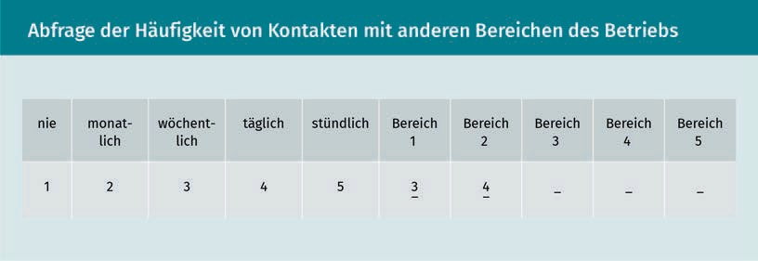

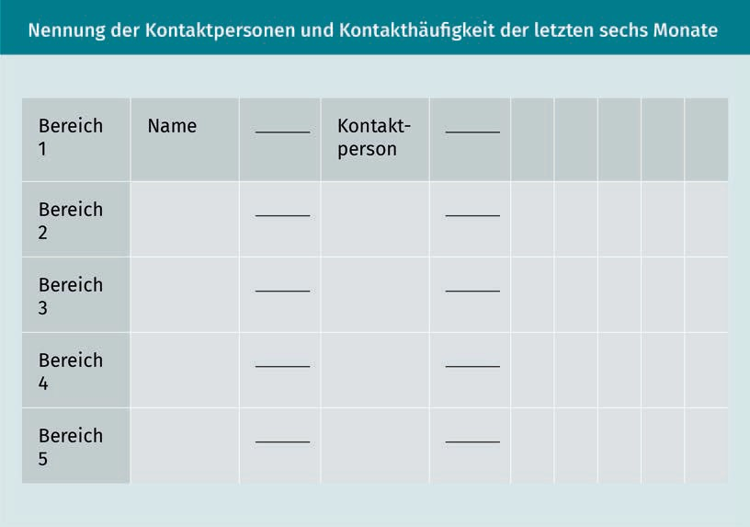

In the main part of the questionnaire, the questions center around the quality of the interaction.

Organizational Diagnostics

|  |  |  |  |  |  |
| --- | --- | --- | --- | --- | --- |
| Main part of the questionnaire | | | | | |
| Question | unit 1 | unit 2 | unit 3 | unit 4 | unit 5 |
| 1) How well do you know your contact person in the relevant unit?  not at all (1)/not very well (2)/well (3)/quite well (4)/very well (5) |  |  |  |  |  |
| 1. How much do you and your contact agree?    1. ... with the target priorities of your unit?    2. ... with the specific way your unit handles work and offers services?    3. ... with the special characteristics of the relationship with that unit?   do not know (0)/no agreement (1)/hardly any agreement (2)/little agreement (3)/considerable agreement (4)/total agreement (5) |  |  |  |  |  |
| 3) How well are you informed about the specific goals of the other unit?  Not at all (1)/a little (2)/well (3)/quite well (4)/ very well (5) |  |  |  |  |  |
| 4) How intense was the concrete working relationship between your units before the last six months?  non-existent (0)/hardly existent (1)/some relationship (2)/close relationship (3)/quite close relationship (4)/very close relationship (5) |  |  |  |  |  |

|  |  |  |  |  |  |
| --- | --- | --- | --- | --- | --- |
| Question | unit 1 | unit 2 | unit 3 | unit 4 | unit 5 |
| 1. How much contact was there between the respective units within the last six months ...    1. ... for the purpose of customer or work exchange?    2. ... for the purpose of resource exchange?    3. ... for technical support purposes?    4. ... for the purpose of information exchange (controlling/planning/evaluation)?   Not at all (1)/rare (2)/common (3)/regular (4)/very common (5) |  |  |  |  |  |
| 6) Now consider the balance of the relationship of give and take between the departments. How do you feel about the relationship between your unit and the other unit?  We receive far too little. (1)/We receive too little. (2)/It is balanced. (3)/We receive more than we should. (4)/We receive much more than we should. (5) |  |  |  |  |  |
| 7) How often does the other unit need services, resources or support from your unit?  Not at all (1)/rarely (2)/ frequently (3)/regularly (4)/very frequently (5) |  |  |  |  |  |
| 8) How often does your unit need services, resources or support from the other unit?  Not at all (1)/rarely (2)/ frequently (3)/regularly (4)/very frequently (5) |  |  |  |  |  |

Organizational Diagnostics

|  |  |  |  |  |  |
| --- | --- | --- | --- | --- | --- |
| Question | unit 1 | unit 2 | unit 3 | unit 4 | unit 5 |
| 9) How much influence does the other unit have on the internal processes of your unit?  Not at all (1)/very little (2)/some (3)/a lot (4)/ too much (5) |  |  |  |  |  |
| 10) How much influence does your unit have on internal processes of the respective other unit?  Not at all (1)/very little (2)/some (3)/a lot (4)/ too much (5) |  |  |  |  |  |
| 1. To what extent are the conditions of cooperation with the other unit...    1. ... exactly formulated and discussed?    2. ... recorded in detail in writing?   Not at all (1)/very little (2)/somewhat (3)/a lot (4)/ too much (5) |  |  |  |  |  |
| 12) To what percentage have you done work directly related to each other's activities in the last six months? | % | % | % | % | % |
| 13) How many times have colleagues in your unit been in direct contact (in person, by phone, or e-mail) with people in the other unit?  Not at all (0)/once (1)/monthly (2)/every two weeks (3)/weekly (4)/daily (5)/several times daily (6) |  |  |  |  |  |

|  |  |  |  |  |  |
| --- | --- | --- | --- | --- | --- |
| Question | unit 1 | unit 2 | unit 3 | unit 4 | unit 5 |
| 14) How difficult was it to make contact with people in the other unit?  Impossible (0)/not difficult (1)/rarely difficult (2)/difficult (3)/hardly possible (4)/ very difficult (5) |  |  |  |  |  |
| 15) How difficult do you find it to communicate your ideas clearly to people from other units, if you have already made contact?  Impossible (0)/not difficult (1)/rarely difficult (2)/difficult (3)/hardly possible (4)/ very difficult (5) |  |  |  |  |  |
| 16) How often did disputes with persons from the other unit occur?  Never (0)/once (1)/monthly (2)/every two weeks (3)/weekly (4)/several times weekly (5)/daily (6) |  |  |  |  |  |
| 17) To what extent has the last six weeks seen active work disruption in your unit by the other one?  do not know (0)/not at all (1)/ hardly (2)/a little (3)/a lot (4)/very much (5) |  |  |  |  |  |
| 18) How successfully are difficulties between your and the other unit resolved at the moment?  Not at all (1)/somewhat (2)/sufficiently well (3)/ well (4)/very well (5) |  |  |  |  |  |

Organizational Diagnostics

|  |  |  |  |  |  |
| --- | --- | --- | --- | --- | --- |
| Question | unit 1 | unit 2 | unit 3 | unit 4 | unit 5 |
| 19) How decisive was the other unit for the achievements of your unit?  Not at all (1)/not very decisive (2)/somewhat decisive (3)/decisive (4)/extremely decisive (5) |  |  |  |  |  |
| 20) To what extent has the other unit fulfilled its responsibilities and commitments to yours in the last six months?  Not at all (1)/a little (2)/somewhat (3)/a lot (4)/ very much (5) |  |  |  |  |  |
| 21) To what extent has your unit respected its responsibilities and commitments to the other one in the last six months?  Not at all (1)/a little (2)/somewhat (3)/a lot (4)/ very much (5) |  |  |  |  |  |
| 22) How productive do you feel about the relationship between your unit and the other unit?  Not at all (1)/a little (2)/somewhat (3)/a lot (4)/ very much (5) |  |  |  |  |  |
| 23) How much do you find the time and effort involved in maintaining relations between your unit and the other unit fruitful?  Not at all (1)/a little (2)/somewhat (3)/a lot (4)/ very much (5) |  |  |  |  |  |

|  |  |  |  |  |  |
| --- | --- | --- | --- | --- | --- |
| Question | unit 1 | unit 2 | unit 3 | unit 4 | unit 5 |
| 24) How satisfied are you with the relationship between your department and the other one in the last six months?  Not at all (1)/a little (2)/somewhat (3)/a lot (4)/ very much (5) |  |  |  |  |  |
| 25) To what extent has your department changed or affected services or processes of the other department within the last six months?  Not at all (1)/a little (2)/somewhat (3)/a lot (4)/ very much (5) |  |  |  |  |  |
| 26) To what extent has the other department changed or affected services or processes in your department within the last six months?  Not at all (1)/a little (2)/somewhat (3)/a lot (4)/ very much (5) |  |  |  |  |  |

If the questionnaire is filled out by a large number of employees in all departments, a diagram of the frequency and quality of the interaction between the units/departments can be created. From this, direct fields of action (e.g., measures to improve communication and information flow between units) can be derived, as well as areas for further analysis for cooperation between the units.

In addition to carrying out such employee surveys, rapid analyses of the frequency of communication by evaluating e-mail traffic or chat contacts between employees in different units/departments are also possible today. This enables a rapid initial overview of communication networks and frequency between areas in organizations. From this and from analyses of ERP data, further information on the workflow between units, such as throughput speed, waiting times or dependencies between units, can be analyzed. Bringing both analyses together provides an effective picture for cooperation and interaction within an organization.

Organizational Diagnostics

###### Team Diagnostics Methods - Teamwork Effectiveness Questionnaire (TEQ)

Another well-known instrument of organizational diagnostics is the Teamwork Effectiveness Questionnaire (TEQ). This was developed in 2004 by Simone Kauffeld in order to be able to diagnose structure orientation and person orientation in the team structure. Structural orientation means goal orientation and task management in the team; Personality orientation involves taking responsibility and keeping the team together. The questionnaire is based on four dimensions, which concern cooperation and social structure within the team.

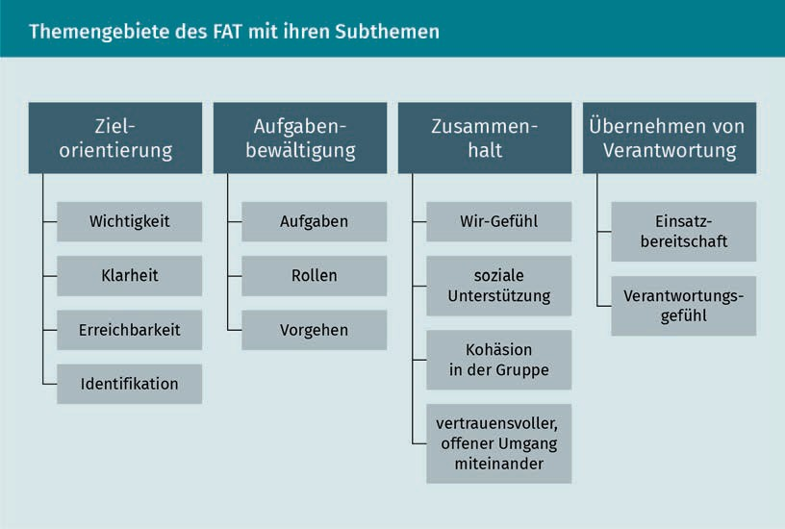

These four dimensions are:

* Target orientation: Questions include how goals are formulated in the team, how clearly they are formulated, and how comprehensible they are to team members.
* Task management: Questions aim to capture how effectively priorities are set in the team, how tasks are assigned and coordinated, and how information that is necessary for task management is shared.
* Cohesion: Questions inquire as to the extent to which task coordination in the team takes place to everyone’s satisfaction, and how strongly mutual support, respect, and trust are evident.
* Taking responsibility: Questions deal with topics of cooperation, exchange of information in the team, as well as mutual/common assistance, and the opportunities to take responsibility for one’s own work area.

Enterprise Resource Planning (ERP)

The concept of Enterprise Resource Planning is used for (mostly IT) systems, with the help of which workflows are planned and carried out. SAP is probably the best-known example of this.

Through response scales of 1-6 and the categorization of the questions in 24 items, it becomes possible to analyze structure and person-related topics for the entire team, and to present corresponding results. This also allows analysis results from different teams or team levels to be compared (Kauffeld et al., 2013).

The TEQ example shows how questionnaires can be broken down to organize topics. This subdivision helps, on the one hand, with the design of the questionnaire, as individual questions can be gathered together according to subject area. On the other hand, it helps in answering the questions, as the participants can concentrate on a single topic at a time. Finally, the clear structuring of the questions across several dimensions and items facilitates the evaluation of the data.

Summary

To recapitulate, an organizational diagnosis provides a systematic understanding of organizations, in order to deduce appropriate organizational development measures. This improves the effectiveness of organizations, and can solve concrete problems.

Organizational diagnostic analyses are primarily applicable when it is important to analyze the relationships between organizational functions and structures, as well as employee experience and behavior.

The lesson provided an overview of the essential areas of application of organizational diagnostic analyses. These range from organizational development to learning organizations, and from early warning systems to health promotion in organizations. The main areas of concern of these fields of application are organizational culture, organizational climate, organizational structure, and human assets.

In addition, organizational diagnostic analyses are mainly performed as a management tool, since they can provide insights into the interrelationship of structures and functions of the organization, as well as into the experience and behavior of the organization’s employees. In order to understand these interrelationships in this specific approach, the topics of work conditions, and of the experiences and behavior of the organizational members were discussed.

Organizational diagnostic findings also provide executives with suitable approaches for identifying organizational needs, and consequently initiating development within the organization (in its structures, teams, and work conditions).

The employee survey is the central method used in organizational diagnostics. It aims to gather opinions and perspectives of employees, and, thus, to provide the management of an organization with the right approaches

Organizational Diagnostics

to improve organizational structures and cooperation. The contents of the survey are based on the research question. For example, one can survey team structures and management’s leadership (as in the example of the TEQ – the Teamwork Effectiveness Questionnaire), but also the cooperation between several departments/units of an organization (as in the example of the questionnaire reproduced above by Van de Ven/Ferry).

Any type of survey also requires a well-thought-out communication strategy that conveys to the interviewed employees both the meaning and purpose of the survey. It is also important to share its outcomes, the management’s interpretation, and the application of the resulting measures to be implemented.

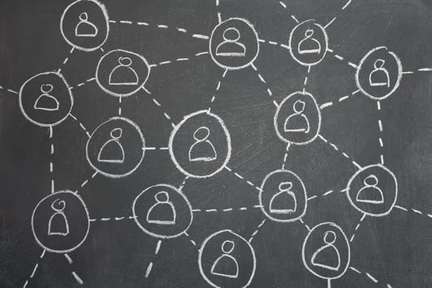

# Lesson 4

## Organizational Analysis

#### LEARNING OUTCOMES

After completing this lesson you will know ...

... what the subject of an organizational analysis is.

... what approaches and research interests support organizational analysis.

... which preliminary considerations must be made when setting up the analytical process.

... which considerations are relevant for the design and operationalization of an analysis.

... which collection methods are available.

... what to consider when carrying out and evaluating the analysis.

... which principles inform the presentation of results and the reflection on them.

DL-D-DLMWPWOAE01-L04

1. Organizational Analysis

### Case Study

A food retailer with over 70 sales locations and a total of around 2,500 employees is struggling to cope with the fact that only 10% of candidates internal to the company are promoted to management (for instance, as site managers or the area managers at headquarters). As a result, and through high turnover rates of up to 20% per year, the company loses a lot of internal process knowledge.

The management has recognized the problem and now wants to find out why. For this purpose, the human resources department is instructed to carry out an internal organizational analysis. The key analysis question is defined as follows: What (procedural, cultural, structural) reasons are there for the fact that only 10% of the leadership is recruited internally? In order to answer this question, employees of the HR department analyze the career paths of internal candidates, who have been promoted to management as part of an organizational analysis. They analyze decision structures and criteria for replacements for management positions, and conduct interviews with internal candidates who have made the career leap. This gives them an idea of the structural, cultural, and process criteria of the organization that are conducive to or stop internal employees from filling management positions.

### Organizational Analysis

The aim of the organizational analysis is to recognize, capture and describe facts, perceptions, opinions, interpretations and relationships in organizations, as well as organizational structures and processes. The focus is not on individual elements of the organization, but on the interaction of all the factors that make up an organization. Thus, it is not about the analysis of a single process with its concrete process steps, but rather about the question of how a process within the organization is defined, implemented and changed; which actors are involved in the process, as well as which actors from the organization and its environment get to influence the process.

The results of an analysis serve to supplement the perspective on organizational contexts of the members of the organization, and to give them the opportunity to reflect on their own decision-making regarding the examined process. Organizational analysis, thus, also forms the basis for measures to implement change in organizations.

What does an organizational analysis entail, and how can it be defined? According to Titscher et al. (2008, p. 55), an organizational analysis takes place “when the characteristics, conditions, structures and processes in organizations are the subject of systematic investigation and description.” Moreover, it should be added that

Organizational Analysis

one refers to an organizational analysis when it is not individual elements that are examined, but organizational relationships. The basis for this is the principle of emergence, according to which features on the organizational level, such as decision-making, process design, functioning of structures, organizational thinking and action, cannot be explained causally from their individual parts (cf. Titscher et al., 2008), but represent a separate level of analysis.

An organizational analysis is also characterized by the fact that it uses a theoretical basis (theories of organizational research), and scientific and empirical methods. Scientific theories provide explanatory approaches for the functioning of organizations, which are the basis to interpret empirical findings. Organizational analysis thus represents a method that checks the realities of an organization, and can lead to drastic changes. Therefore, an organizational analysis can also be considered as a political process.

###### Object of Organizational Analysis

Organizational analysis has as its main focus the organization as a social system, and aims to explain organizational action (cf. Küng, 2015, p. 3ff.), and organizational relationships. According to systems theory, the predominant theory in this field, it is first and foremost *decisions* that are a prerequisite for the existence and design of an organization. Decisions taken within the organization form the basis, first of all, for the organization's demarcation from its environment, secondly, for the design of internal structures and processes, and thirdly, for the organization-specific creation of the organizational culture and climate.

In the predominant sociological view of organizations, an organizational analysis first of all requires a delimitation of the organization on the inside and on the outside. An organization is defined at three levels:

* Members: How is membership of the organization defined?
  + formal membership through employment contracts and structure (for instance a role/function in the organizational hierarchy)
  + Informal membership through the adherence to certain standards, rules, common habitus (e.g., work clothes, hands-on mentality, understanding of customer service)
* Environment: How does the organization distinguish itself from its environment?
  + formal agreements (legal form of the company [GmbH/Inc., AG/plc., etc.]), interactions between the organization and its environment (partner organizations, with close cooperation or, for example, subcontracting agreements)
  + informally, through its location (company headquarters), and the company’s fields of activity (sector, product range, etc.)
* social structures: How do structures in the organization define themselves?

Systems Theory

Systems Theory is a theory of knowledge of organizational research. It states that organizations exist in an interaction with their environment as a system of communication and decision-making.

* + Regularities, formalities, commonalities in actions and interactions (such as centralization of decision-making processes or agile structures)
  + Standards and values (e.g., open leadership culture or success orientation)

The observation of these three levels makes it possible, in particular for external organizational analysts, to recognize organizations as an internally coherent and externally delimited social system. If, for example, there is very close cooperation and interaction between an organization (trading company), and a partner organization (exclusive supplier company), it may be useful for an analysis of the internal networks and communication patterns to consider both organizations – legally separated from one another – as a unit of analysis, since a common social structure can exist across both organizations.

Through these three levels (members, environment, social structure), an organization can be determined as an independent object of analysis. However, more explicit factors of the organization can also be defined as objects of analysis: its structures, processes of action or decision-making processes – which in turn shape patterns of interaction, forms of cooperation or spaces of action within the organization. Internal organizational analyses, such as personnel from the human resources department or management personnel who perform an organizational analysis, are usually more aware of the boundaries of the organization. For them, this type of demarcation work is usually not necessary before an analysis.

However, organizational analysis does not just aim to describe the objects to be examined, but also to know more about them, and to find the reasons for action patterns or manifestations of organizational structures. Sociological organizational analysis claims to understand the foundations of underlying organizational decisions and decision-making processes on the one hand, and to provide the foundations for these decision-making processes on the other, while adhering to scientific standards.

Analysis depth and focus are influenced in the real field of analysis by two factors, both of which are swayed/predetermined by the client. On the one hand, there is the specific interest in the knowledge provided by the analysis (i.e., the question of why an organizational analysis is carried out at all, for example, to optimize the organization of hierarchical structures into more agile network structures), and on the other hand, there is the approach chosen for the analysis.

###### Knowledge Gain

Organization analyses are requested and carried out for a wide variety of reasons. It mostly depends on the interests pursued by the clients, and how this is used in the “political structure” – i.e., in the decision-making processes – of the organization.

Organizational Analysis

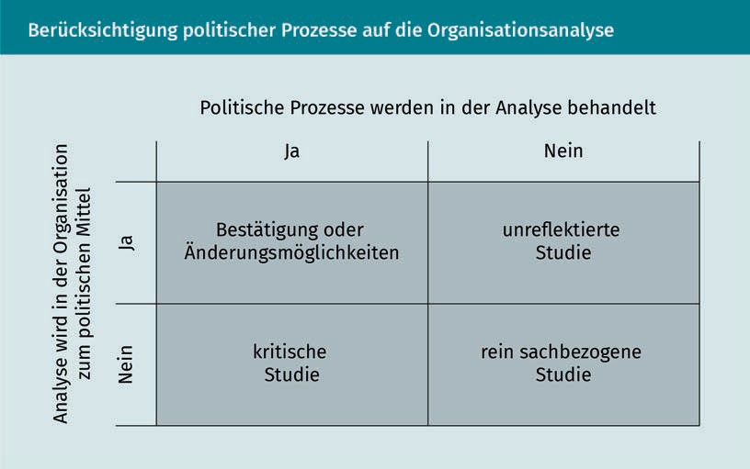

In essence, three levels of knowledge may be distinguished. Some organizational analyses are satisfied with the description of the current state, further analyses provide explanations for its forms, and some analyses are carried out to provide forecasts for the future development of the organization.

Purely descriptive analyses are intended to represent facts, processes, or structures of the organization without, however, explaining their impact on the organization, or the reasons for their development. This type of analysis offers the possibility of representing the current state of an organization in order to determine the starting point for further organizational development projects, such as the establishment of new departments/units or improvement initiatives (for example regarding the communication between the individual areas by means of the introduction of a company’s wiki).

The real claim of an organizational analysis lies, however, in explaining the reasons for the creation of the organization, its structures and processes, as well as its relationships and decisions. Explanations lead to answers to the question of why a certain aspect of the organization arose (such as the definition of processes, development of departments and units, etc.). The organizational analysis, thus, shows which characteristic is determined by which factors (environment: competitors, customers; organizational culture; ways of thinking, among others), and highlights the connections between them. The basis for explanatory analyses is the data collection, and the subsequent explanation and interpretation of the data, taking into account underlying assumptions/hypotheses. These are formed by dealing with a specific research topic (in this case the organization), and already characterize the formulation of the question.

Boundary Conditions

To prepare a forecast, it must be clear which conditions must remain the same (Latin: ceteris-paribus - under the same conditions). These are called boundary

conditions.

Organizational analyses are typically used to determine change requirements, to develop approaches for areas of change, or to develop forecasts of how influencing factors from within or outside might affect the organization. Forecasts are to predict the future (desired) state of the organization, in order to be able to take appropriate change measures already in the present. These measures are based on the forecast state of the organization (strategically considered, for example: change of customer needs, or lack of skilled personnel). For this purpose, it is necessary for the forecast to take into account and define the current degree of the organization, and its **boundary conditions**. This means that, on the one hand, the current state of the analyzed unit must be known exactly, and on the other hand, the internal and external conditions, which have an influence or no influence on the predicted development must also be known.

Regardless of whether analyses are purely descriptive, explanatory or predictive, all three approaches to the acquisition of knowledge share the common factor of having to consider both known and unknown elements of the organization. Descriptive studies bring to light previously unknown facts, explanatory analyses reveal hidden perspectives in order to be able to re-interpret relationships, and forecasts attempt to make unknown developments usable for the organization. All three approaches use the known starting position (actual state), and above all a systematic approach to knowledge gain that is comprehensible to outsiders (cf. Titscher et al., 2008).

###### Different Reasons

Every request for an organizational analysis usually stems from one of the client’s concrete reasons to have it done (for example the preparation of a structural change of the organization, or the establishment of new decision-making processes). Clients often are part of the management of the company, on its board, or in personnel departments. If they come from outside the organization, they are often banks, competitors intending to take over the company, or similar entities.

In order to prepare and carry out an analysis, it is important to recognize the interests behind the reason for the contract, since this reason already has an impact on the form and execution of the analysis. As already mentioned, organizational analyses take place in a social system that is characterized by organizational politics. The question therefore arises as to what the client wants to achieve with the analysis and its findings, and how explosive or fraught the topic to be analyzed is in the organization. If, for example, an organizational analysis prepares for far-reaching structural changes, which are associated with job cuts, resistance from the organization will already be apparent during the analysis. If, on the other hand, hierarchical decision-making processes within the organization are to be reduced, then this is a project in which, as a rule, lower resistance from the employees, but increased resistance from some managers can be expected even during the preceding analysis process. Both factors (purpose of the analysis and sensitivity to the analysis topic) are decisive for the design (analysis design), and for the implementation planning (analysis strategy).

Organizational Analysis

Organizational analyses can be roughly divided to four types according to two factors – the first one is the reason for the analysis, and the second the interest in knowledge gain:

1. research and benchmarks to gain orientation (external cause, knowledge gain as main interest);
2. control studies, such as **due diligence** of banks, authorities etc. (external cause, to control the behavior of others as main interest);
3. status quo studies to capture the actual state of the organization (internal cause, knowledge gain as main interest);
4. Commissioned studies and in-house analyses in order to develop approaches for changes (internal motivation, controlling the behavior of others as main interest).

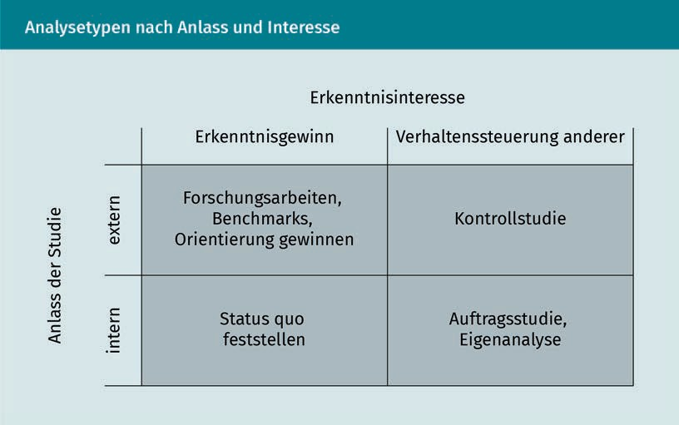

So how do we progress from the reason and the interest in knowledge gain to the design and implementation of the analysis?

### Preliminary Considerations for the Process of Analysis

Before the design of the analysis can be started, certain preliminary considerations have to be clarified.

###### Reason and Interest

Prompting organizational analyses are the reasons and interests of individual persons or groups of persons in the organization. These reasons and interests form the essential framework for organizational analysis, i.e., they decide who is able and allowed

Due diligence

Due diligence is the comprehensive examination of a company for sale by the potential buyer, which, in addition to the operational and economic examination, also analyzes functional methods and structures.

to carry out the organizational analysis. In general all organizational analyses are mostly used for the implementation of development measures in the organization. These aim, for example, to achieve improvements in the cooperation of various areas of the organization, to make decision-making processes less hierarchical in order to increase the reaction speed of the organization, or to bring about improvements in the attitude of its members. In order to establish which variables are relevant, factors such as leadership culture, autonomy in the workplace, career patterns, and so on, need to be analyzed.

###### The Analyst

The analysts are often members of the organization (e.g., management, human resources, or internal consulting departments), who are, thus, themselves part of the social system of the organization. They are, in fact, subject to the social norms of the organization, which characterize desirable and undesirable behavior in the group, or harbor hidden beliefs, which define their perspective on the functioning of the organization from within the organization (for example: Defining frameworks for co-design vs. simply implementing structures for management instructions). Both factors have a regulatory effect on which aspects of the organization are analyzed, which questions are asked during the analysis, and which information is passed on by the participants (members of the organization).

###### The Participant

In addition, for example, the passing on of information by the participants is usually associated with expectations. After all, participants invest time in answering the questions. They expect a benefit from this, be it direct or indirect recognition by the organization, or an even more direct benefit through the findings from the analysis. However, carrying out an organizational analysis can also trigger fears and concerns among potential participants about what happens to the forwarded information, and for what it will be used in subsequent organizational development measures, and thus can cause resistance. This is especially important in the case where expectations are raised that cannot be met, or participants are not sufficiently involved in the analysis and subsequent development measures.

###### The Target Audience

Another important aspect is the question of the target audience for the findings from the analysis. Are they made available only to a specific group (e.g., top management) and only this group benefits from the findings (e.g., via the payment of bonuses through demonstrated potential for cost reduction), or are all members of the organization beneficiaries of the results of the analysis (e.g., via an improvement of information flows or an extension of ownership)?

Organizational Analysis

These four factors (reason and interest, analysts, participants, and target audience) have an influence on which questions are asked, and how information is collected and processed. Under certain circumstances, for example, in a phase of strategic reorientation of an organization, data on the actual state are collected by an external organizational consultancy with the broad participation of the employees. The results of the survey are then interpreted in the course of workshops with the participation of recognized employee representatives, in order to define measures for strategic reorientation. In this case, a critical event is defused by the broad participation of the organizational members, and critical analyses are carried out by external analysts. The result will be different if the analysis is part of the due diligence of a bank, which sends external auditors to analyze figures in an inaccessible office, and who, in a covert manner, equipped with notepads and cameras, capture an image of the business, within the audited and possibly insolvent organization. This will likely lead to obstructionist postures, or very limited information transfer. Accordingly, hardly any open workshop formats will be used in this case as methods of analysis, but rather standardized interviews and content analysis of documents.

###### A Structural Plan for the Analytical Process

A structural plan divides the analysis into a chronological sequence, supplemented by the required resources (literature/internet searches, persons, analytical tools, data of the organization, etc.). The analytical process is divided into analysis phases and associated work packages by means of a structural plan. Typical analysis phases are: Preliminary considerations, design, survey, evaluation, presentation, and reflection.

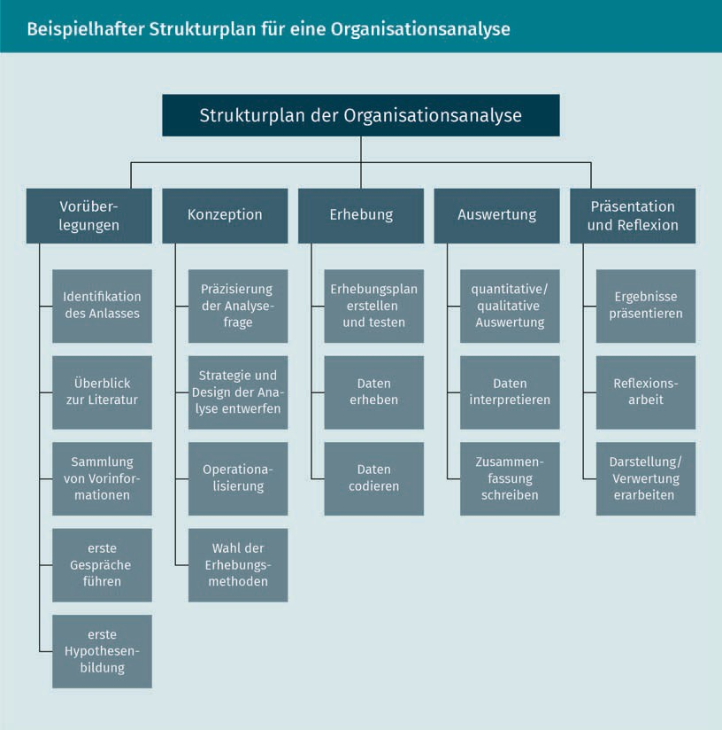

The structural plan supports, firstly, the definition of the logical sequence of the analytical phases, so that the knowledge gain takes place systematically. Secondly, the structural plan, as in conventional project management, determines the start and the end time points for work packages, and evaluates the necessary resources, in order to be able to estimate the overall burden for the organization and for the unit to be analyzed, as well as the approximate duration of the analytical process. Thirdly, at any stage of the analysis, the structural plan provides clarity on the current state of the analysis and next steps, which is particularly important when carrying out highly complex, lengthy or controversial analyses.

###### Creation of a Work Plan

Preliminary considerations for the analysis serve primarily to ...

Organizational Analysis

1. ... get to know the organization to be analyzed through initial discussions with representatives of the organization,
2. to recognize the different perspectives of the members of the organization on the topics to be analyzed,
3. to be able to assess the interests of certain persons or groups of persons that gave rise to the topics of analysis, and the analysis requirement, in the first place;
4. to know the target audience and the stakeholders of the analytical results and their concerns regarding the analysis, in order to understand the political component behind the organizational analysis, and
5. the boundary conditions of the forthcoming organizational analysis in order to prepare for its subsequent phases.

The result of the preliminary reflections is a work plan for the upcoming organizational analysis, which is sufficiently robust so as not to collapse at the first encountered difficulty (whether temporal, social, or thematic).

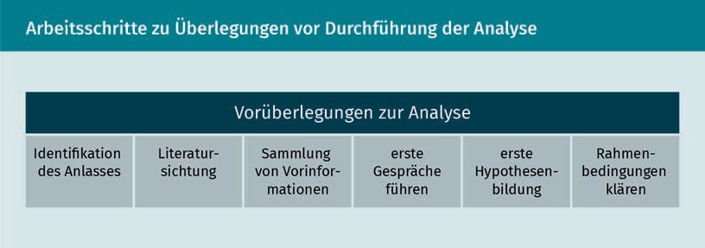

During the preliminary reflection phase, the following work packages will be developed:

The Reason for Organizational Analysis

The key question to be answered is this: What is the reason for the analysis and who in the organization is the reason for the analysis?

Review of Relevant Literature

The review of the relevant literature on the topic of the analysis helps to clarify the question(s) for the analysis, and the creation of a first hypothesis. It also provides standards of analysis for the respective topic, and to keep the benchmarks on the topic of analysis as a reference. For example, there are countless articles on organizational cooperation (contributions from consultants, dissertations, etc.) from which you can obtain information on the methods (causes and knowledge gain), reports from past analyses or simply on the topic itself (e.g., communication, forms of cooperation, management culture, etc.). A targeted Internet search in the run-up to the analysis expands the perspectives on the analysis topic, deepens your own knowledge for implementation, and thereby creates security regarding the orientation of the analysis (method choice, communication strategy, possible influencing factors, etc.).

Collection of Preliminary Information

The actual analysis does not take place in an office, but in the middle of the organizational structure. Therefore, it is important to contact the organization in advance in order to be able to better evaluate it: the more different perspectives and opinions from members of the organization, as well as from the organizational environment are known about the analysis topic and the functioning of the organization itself, the easier it is to form a sustainable working hypothesis later on. Information from informal discussions with employees, but also from the organization’s website (for self-presentation, industry sector, and structure) are easily accessible sources. In many cases, newspaper articles and reports are also available, and provide additional perspectives.

Initial Thematic Discussions

All this information is used to be well prepared in the first thematic conversations. Regardless of whether you are part of the organization or have been hired from outside to carry out the analysis, it is always necessary to win over the counterpart for the analysis. The usefulness of the analysis must be clearly communicated to the interlocutors, as well as the division of roles in the analysis, which includes the rights and obligations of the analyst (such as access to data and documents on the one hand, and confidentiality on the other), as well as those of the participants.

Circular Questions

The term "circular questions" stands for a questioning technique that aims for the interviewee to change their perspective. (For example:

“What do you think the management has in mind by requesting this

analysis?”)

In terms of content, it is important to collect the information (temporal, social, thematic) that is needed for the further conceptual preparation of the analysis, i.e., for example, who are the possible interviewees, in view of when the analysis topic first appeared in the organization, or which topics the organization deals with that are connected with the analysis topic. Open and **circular questioning** are useful here, in order to learn further aspects about the analysis topic.

In addition, first assumptions are already available after the collection of preliminary information, the study of previous literature, and the knowledge of the reason for the study. Said assumptions can be examined in these first discussions. These provide additional information on organizational behavior, such as how easy/difficult it is for analysts to find meeting dates and partners, how conversation partners react to the topic of the analysis, or who is recommended as another conversation partner. Further assumptions on the analysis topic can be made about reactions of the interlocutors of the organization (openness, skepticism, obstructionist attitude, etc.). Thus, a complete picture emerges of how the organization sees the analysis topic, and which aspects appear relevant to the topic from its viewpoint.

Creating a First Hypothesis

The steps taken so far, from the reason for the analysis to the selection of first interlocutors, were based on assumptions made by the client and the analysts. These hypotheses have an influence on which questions are asked, which content aspects of the analysis topic are followed, and which people are involved in the initial discussions. Any action and thought of the analyst must be guided by hypothesis – realizing this fact

Organizational Analysis

is already an important step in the implementation of the analysis (Titscher et al., 2008). Next, one needs to become aware of these hypotheses, and put them on paper.

From the preliminary considerations phase of the analysis, assumptions have already been made which have led to establishing contact with first interlocutors, first questions for clarification of the topics of analysis, and first conceptual considerations. From these it is now necessary to define a hypothesis for further work (working hypothesis). This means the process of identifying key aspects/variables regarding the research question, which are considered in the subsequent analysis.

The analyst asks him/herself about these two questions: What preliminary assumptions have been made by the clients? Which assumptions were confirmed during the preliminary analysis and which were rejected? For example, when commissioning the analysis, the assumption was: Upstream departments provide incorrect information for the production process. In the course of the preliminary analysis, the following differentiated picture emerged: information is available; their quality will be assessed differently depending on the sector; Cross-cutting cooperation is often mentioned as an issue; cooperation in the course of projects works well; cross-cutting collaboration in the workflow is not likely; inaccurately defined transfer times lead to conflicts and errors; Information transfer points are not properly defined; The managers and employees of individual areas hardly talk to each other.

From the above findings, a working hypothesis can now be formulated, for example:

“Cooperation in terms of the flow of information between the areas of planning, material purchasing, logistics, and production is not functioning sufficiently well. Specifically, it is emphasized that the quality and timing of the information transfer is perceived as inadequate. Organizational factors such as department/area thinking and leadership culture seem to be a significant factor influencing this.”

This working hypothesis will play a central role in the development of the analytical question.

Clarifying Boundary Conditions

However, the organizational framework must be clarified before the content work can begin. This is primarily about the time, thematic and social framework, in which the analysis should and can be carried out.

The time frame is determined by seasonality, for example in the case of manufacturing companies -say- for machines for the hay harvest: If the main production time is in summer and autumn, the organization (and potential informants, such as production managers, purchasing managers, etc.) will have little time for detailed interviews during these months. Thematic issues are mainly: the relevance and the underlying usefulness of the topic. For example, all department managers perceive the topic “Interdisciplinary cooperation with a focus on information exchange with regard to improving production processes” as relevant.

On the other hand, the topic “Cooperation in development projects” is regarded as irrelevant by the powerful production manager, so for thematic and social reasons (power) the focus of the first analysis will prevail.

It is therefore necessary to clarify in which time frame the organizational analysis is carried out, who from the organization is needed and when, and for how long can they be used for data collection, as well as which topics are in the foreground of the analysis. Of course, no detailed scheduling with informants is possible at this point of the analysis, but a first concrete overview should be created for the resource planning of the analysis team, on the one hand, and for the organization’s expenditure estimation, on the other.

### Design and Operationalization

The next step is the precise design and operationalization of the analysis. The basis for this is the information, which was collected during the first preliminary considerations for analysis. The separation of both steps (preliminary reflections and design) is mainly useful if one is not yet so experienced as an analyst in the execution of organizational analyses, or if one carries out an analysis as an external consultant in an as yet unknown organization.

The design involves, roughly speaking, the precise planning of analytical contents and resources. Operationalization means considering how information/data can be collected for analysis, i.e., from the abstract term to the measurable variable.

|  |  |  |
| --- | --- | --- |
| Steps for creating the analytical design | | |
| Preparation of the analytical design | | |
| Precision of the analytical question | Analysis strategy and design | Operationalization |

###### Clarification of the Analytical Question

The analytical question is the central element of the analysis. It identifies the topic or problem to be investigated. Some considerations help to clarify this, so that the client, the participants, and the analysts themselves are aware of what is to be analyzed.

Organizational Analysis

In advance, a clarification of the analytical question is required from the client: Which analysis question has emerged, which aspects and topics have been rejected? Was the original analysis question something like: “What are the reasons for non-functioning cooperation between organizational units with regard to the production process?”, now - on the basis of the working hypothesis and the boundary conditions for the analysis - a revised analytical question arises, which must be formulated cleanly and comprehensibly, for example: “Which factors (leadership style, hierarchies, culture, processes, etc.) influence the interdisciplinary cooperation with regard to production processes in the organization?” As a second step, it is then important to define terms clearly in order to further limit the variables of the analysis, i.e., a definition of what is meant by “units/areas of the organization” – in this case, for example, planning, material purchasing, logistics, production; what is meant by “cooperation” - in this case, for example, communication/information exchange via files, ERP programs, telephone, etc.

This working hypothesis is now used to create the analytical strategy and the analytical design.

###### Analytical Strategy and Design

At this stage, it is advisable to differentiate between strategic considerations regarding the form, depth, or perspective of the empirical surveys, and considerations regarding the design of the analysis, which defines the form and means of the data collection.

The **analytical strategy** includes the clarification of the function of the analysis (for example as a political analysis, commissioned by the production manager, with the aim of confirming the assumption that the information flows do not work, or as an analysis for the collection of improvement potentials in order to reduce costs due to production errors, commissioned by the company management), and which areas of the organization are to be analyzed. In the case of the research question “Which factors (leadership style, hierarchies, culture, processes, etc.) influence the interdisciplinary cooperation with respect to production processes in the organization?”, the company divisions planning, material purchasing, logistics, and production are part of the analysis, as well as information processes, company culture, and management culture. In addition, the analysis strategy includes considerations on the relevant interlocutors, i.e., who the informants are and who should also be involved in the analysis for political reasons (e.g., stakeholders of the organization).

The analytical design refers to the way in which analytical instruments are used. Depending on the subject matter of the analysis, field access and complexity of the working hypothesis, instruments are selected which correspond to the requirements. For instance, for opinion research a relatively simple analysis design is needed (opinion collection by means of standardized interviews). On the other hand, analyses of organizational interactions, as in the case of cooperation and information flows between areas of

Analytical strategy

The analytical strategy defines the procedure during the analysis; i.e., the areas for analysis and, at least roughly, the topics for analysis.

Field Access

In research, the term field access refers to access to informants and information of the organization. Thus, it may be that certain data may not be entered (e.g., planning data on production quantities), since they are kept secret within the company.

the Organization require a multi-dimensional design, dependent on different methods of data acquisition (interviews, observations, workshops, data analyses, etc.).

**Field access** is reflected in the availability of informants and information. If the organization is open to analysis, wide-ranging interviews of employees can be used by means of questionnaires and observations (such as process observations and records of information flows). If the organization, or parts of it, have a negative stance towards the analysis, because they fear negative consequences (sanctions, loss of status, job cuts etc.), then the analytical method should be comprised of data/content analyses and individual interviews with informants willing to communicate.

At this point in the design, fundamental considerations on the methods of analysis are made. However, a further step is required for designing the survey methods, that of operationalization. This implies that the analytical question is broken down into analyzable variables to such an extent that individual questions for interviews, questionnaires or observations, as well as data analyses, can subsequently be created.

###### Operationalization

Operationalization involves making key concepts from the analytical question available for data collection. This requires dividing the analytical question into individual aspects that can be measured or detected, and corresponds approximately to the reverse logic of abstraction. Subsequently, appropriate methods can be chosen and questions formulated in order to collect the data corresponding to the concept that gave rise to the analytical question (e.g., collaboration, management culture, area/department, etc.).

As a first step, the central concepts of the analytical question are precisely defined. These terms are then fitted with relevant variables and features that enable measurability. These steps are often unconscious, since most of the terms we use in everyday life are already associated with a social meaning (e.g., “cooperation” as the positive fulfillment of a task by several persons working together). It is, nonetheless advantageous to design this process consciously over the course of an analysis, in order to create traceability and clarity for clients, informants and analysts.

###### An Example

Question for analysis: “Which factors (leadership style, hierarchies, culture, processes, etc.) influence the interdisciplinary cooperation with respect to production processes in the organization?”

Organizational Analysis

For this purpose, concepts such as “leadership style” and “cooperation” must now be defined:

* Management style is the extent of employee-oriented and/or task-oriented behavior of the supervisor.
* Collaboration is the work of two or more persons/units, performed at a certain time and with a certain quality, which leads to a visible result.

These terms are now made measurable in a further step, i.e., provided with features that can be detected by means of survey methods.

* Leadership style:
  + Employee orientation: friendly assistance; respect for other views of employees; promoting staff skills; co-determination of employees; control Vs. laissez-faire, etc.
  + Task orientation: clear procurement; clear areas of responsibility; role of the task; monitoring of deadlines;
* Cooperation:
  + the form of cooperation (frequency and quality – cooperative or competitive cooperation; sequential or parallel);
  + Goal/vision (common objective, common vision for cooperation);
  + the result of the cooperation (time required for the amount accomplished; quality of work).

Based on these qualities, which can now be measured, a suitable survey method is selected to make the collected data actually quantifiable, as well analyzable by qualitative research. For this purpose, the qualities (e.g., cooperation in team work, or control of the fulfillment of tasks, etc.) must be defined to such an extent that they are clearly recognizable. It must therefore be clear how cooperation is expressed in team work. This is a very subjective feeling, i.e., an assessment or perception by a single person. Perceptions cannot be observed, they can only be asked about, which is why a survey is a valid method in this context .

|  |  |  |
| --- | --- | --- |
| The most common methods of data collection in organizational analysis | | |
| Methods for Organizational Analysis | | |
| questionnaires /  interviews | observation | content analysis |

What do the individual methods consist of, and what should be taken into account when applying them?

###### Questionnaires and Interviews

An interview is a form of communication between the person asking and the person that is being asked the questions. The communication is characterized by expectations and assumptions. Communicative messages (both questions and answers) are pre-filtered before they are asked or given. Answers represent opinions and assessments of events that have been experienced and remembered.

This means that interviews can capture verbal behavior rather than actual behavior. Respondents reflect on their perspectives, opinions, and assessments of a situation, about which they are being questioned. This fact is important for organizational analysis, as interviews ...

* + 1. ... are used to gather the opinions and views of the respondents, but
    2. cannot be used to establish facts;
    3. the setting of the interview (e.g., open and personal interview, or anonymous questionnaire on the internet) influences the respondents’ answers; and
    4. the given answers must always be understood from the respondant’s perspective.

For organizational analysis, it should additionally be noted that interviews should not focus on the individual, but on their role/function in the organization. Furthermore, one cannot directly conclude anything about the forms of the organization from the results of these surveys. These, however, do give indications for the development of topics such as cooperation, organizational culture, etc.

One advantage of the survey - provided that it has been prepared methodically and its content is precise – is, among others, that information from a large number of persons can be collected quickly, for example through standardized and electronically supported surveys. This can be used in organizational analysis to obtain information on the perceived cooperation in organizations, or on the management culture of the company.

Organizational Analysis

Surveys can be designed differently. For example, they can be carried out by means of interviews or through questionnaires.

Interviews are carried out in person. This means that the interviewer and the interviewee communicate with each other directly. Interviews may be conducted as individual or group interviews. Their exact content (design of the survey) depends on the formulation of the main question. If, in a group interview, one wishes to find out which opinion is dominant in a group, one would choose a moderated open questioning model that offers the opinion leaders room for expression. If, on the other hand, one wishes to ask the opinion of each individual group member, then individual interviews are more appropriate in order to give each person space to express their opinion. By means of interviews, further information can be collected about the respondent, in addition to verbal information, which allows for conclusions about their state of mind. By state of mind we mean, for example, acoustic expressions (laughter, snorting, etc.), as well as facial expressions and gestures, which the person shows in the course of answering the questions.

Questionnaires are a form of questioning, in which the interviewer and the interviewee communicate only indirectly. This means that the situation in which the interviewee passes on information can be influenced or reflected on in retrospect only with difficulty by the interviewer. However, a reflection on the situation of the survey is important in order to understand the expectations accompanying the respondents’ opinion. For example, in group interviews, a social interaction that influences the expression of opinions takes place; dominant group members will shape the opinion of the entire group in this setting, more than “fellow runners”. This is also done by the group reacting to the social role of the questioner (e.g., if this person is the manager, or an employee of the HR department). Whether a respondent fills out a questionnaire unobserved or under the direct/indirect influence of other persons also makes a difference. So does how the respondent feels about the subject of the survey, about the client ordering the analysis, or the person carrying out the survey, but these feelings cannot be detected or reflected on through a written questionnaire. This must be taken into account when deciding on the method to use.

In principle, interviews can be arranged orally or in writing, standardized (same questions for all participants), or open (open question), as well as closed (questions with predefined answer options). Surveys can also be carried out as group or individual surveys, anonymously or by providing personal data. Which form you choose for the analysis crucially depends on the research question, and the setting within the organization.

###### Observation

Observations, in the organizational analytical sense, are systematic perception processes to record the behavior of members of an organization within the organizational setting. In the course of an organizational analysis, a systematic record is made of the situations and behaviors displayed by one or more members of an organization.

However, the aim is not to analyze the behavior of an individual, but rather the behavior of function and role-holders of an organization in a specific situation (interaction in meetings, workflow processes, decision-making processes, etc.). This includes who is interacting and for what purpose, and the quality of this interaction. The quality and quantity of the interaction, as well as actual interaction patterns, i.e., who interacts with whom, are meaningful for the analysis of organizational functions and structures.

Systematic observation takes place in compliance with some basic principles:

1. A selection process for the field of observation and the aspects to be observed is carried out in advance of the observation. This selection of social and spatial contents is deduced from the analytical question.
2. Observation represents a social interaction in the field of analysis, since the analyst must be on site for the performance of the observation. This can also trigger behavior in the observed persons that would not otherwise be shown. For the evaluation of the obtained data, it is important to reflect on the effect and the role of the analyst in the social structure of the organization.
3. Records are meant to reflect the behavior of the observed party, not the observer’s interpretation. For this purpose, for example, an observation sheet must be designed in such a way that the necessary aspects to answer the research question can be filtered out of the complexity of human behavior during observation.
4. Observation always occurs right in the place of the event.

The clear advantage of the observation method is that actual behavior can be detected by persons in definable situations. In contrast to the survey, actual interaction and current behavior can be recorded. If the findings are later supplemented with data from surveys, the meaning of the behavior/interaction in organizations can be easily determined.

Observations can be designed in different ways. Atteslander (2010) divides them according to three categories - structuring, openness and participation. Structuring refers to the degree of definition of an observation scheme. If, on the basis of the research question, one wants to analyze precise aspects of the interaction that occurs in meetings, a highly structured observation schema is helpful. In such a schema, one can record the number and length of spoken messages, as well as the reactions of individual meeting participants to them. This is a so-called structured observation.

The principle of openness, on the other hand, relates to visibility in the field of observation. Does the analyst enter the field of observation for everyone, with an analysis sheet and a pencil in his hand, or does the observation take place in a concealed way, so that the observed persons do not register that they are being observed? This may be the case, for example, if an observer intentionally causes a certain situation in order to observe it, without making himself recognizable as an observer/analyst. For example, the observer disguised as a customer starts a complaint process in a hardware store

Organizational Analysis

to observe the extent to which employees comply with the stipulated escalation stages set by their supervisors, and usually bound to a certain commodity value.

Participation, as the third category, refers to the degree of participation in the observation field. There is no non-participation in this sense, since the observer is always part of the social interaction he observes. In this respect, it is better to consider it passive or active participation.

The degree of structure, openness and participation can be varied, as required for the creation and collection of the observations. This is based on the consideration of how to gather information about human behavior. If the question of analysis is very narrowly defined, a structured observation sheet is recommended in order to focus on its essential aspects. If you want to minimize the distance to the observed persons, because you are part of the organization, an open, participating observation model is clearly better. This also enables to gain detailed knowledge of actual/natural behavior and the standards and behavioral patterns that cause it, within the observed organizational unit (Atteslander, 2010).

###### Content Analysis

The third major category for data collection methods in organizational analysis is content analysis, by means of which linguistic and pictorial communication contents of texts, films and images can be analyzed. The focus is mostly on the analysis of textual content such as work instructions, strategy papers, executive guides, communication via the intranet and similar material.

The method of content analysis is based on a simple sociological communication model, according to which communication “is described as an exchange of symbols between the sender and the receiver, in which a certain content is transmitted, the generation and decryption of which are determined by a multiplicity of conditions (social situation)” (Atteslander, 2010, p. 202f.). The content analysis of documents, images and films can, therefore, be used to determine who the sender and the recipient of the information are, for what purpose and in what social situation the information was created, what was communicated and what was not communicated, or also how the recipient accepts and uses the contents of the communication.

A systematic procedure is recommended for carrying out content analysis, which includes the selection of suitable documents to answer the research question. As a first step, this usually takes place via research on the intranet, or on the organization's website, as well as via discussions with the organization's knowledge carriers, in order to find out which documents are, in fact, available. Subsequently, the documents that have now been read are again filtered according to relevance for the research question, validity and content quality (comprehensibility, substance). Then, the filtered documents will be checked for authenticity, traceability (date, authorship, etc.) and content

(description, interpretation, instructions, etc.) before the start of the content analysis. Content analysis consists first of viewing the document to find out which aspects of the content communication can answer which aspects of the research question. In a second phase, the actual content of the document is then analyzed.

How the content analysis proceeds in detail then depends on the research question and the focus of the analysis. If you want to filter out which transmitters communicate with which receivers, it is sufficient to collect this information. If, on the other hand, one wishes to work out which social norms are communicated through the documents, then it is necessary to go deeper in terms of content by forming categories from the hypothesis, which are then searched for in the communication contents. We have no time or space for an exact description of this method, some information in the next section will have to suffice.

The content analysis of communication content is a good supplement to the other two methods, observation and surveying. The reason for this is that, in many larger organizations, a significant part of the communication takes place in written form. For example, corporations are typically advised to provide vision statements, strategies, work instructions, management guidelines, further training content, etc. from the organization alongside the often-sparse personal communication that exists in writing.

### Collection and evaluation

Coding The (en)coding of the data is used to prepare for the evaluation. Data is abstracted and categorized in order to be easier to find and order during the evaluation.

The data collection includes, first, the preparation of a collection plan and the collection instruments, including a preliminary test of the instruments (in the case of a questionnaire, for instance, to check how coherent it is); secondly, the actual collection of data, and, thirdly, the coding of the data. The qualitative and quantitative evaluation, the interpretation of the data and the summary of the findings are then carried out.

###### The collection of data

|  |  |  |  |
| --- | --- | --- | --- |
| Steps for data collection | | | |
| Data collection steps | | | |
| Design a survey plan | Perform a pretest | Collect data | Encode Data |

Organizational Analysis

The first step of data collection is the preparation of a survey plan. This includes time-scheduled tasks during data collection. It is also useful for smaller analysis projects in order to structure the procedure. The second aspect of the survey plan is the consideration of which methods are used, as well as in which order and form.

If the analytical question is formulated very unclearly (for example: “How do employees of departments A and X perceive the cooperation of their departments?”), it may however be clarified by the application of, for example, an employee survey and subsequent observations. In such a case, it would be advisable to start the analysis by surveying the employees and collecting specific observations first. The observations function as a supplement to the survey, in order to get a more objective picture: after all, organizational analysis not only strives to describe, but also to ascertain why, in this case, cooperation works as it does between the analyzed organizational units. The survey provides opinions and hints on how cooperation is perceived. Observations then provide insights into the social context in which cooperation takes place, as well as the social behavior of unit members.

For example: In addition to the selection of methods, a survey plan includes, first of all, the preparation of the questionnaire with subsequent **pretest**. Secondly, the scheduling of the execution of the survey, whereby in addition to the analysis team’s resources, also the time frame of the organization must be considered. Thirdly, the data collection should be designed in such a way that the output (time, addressee), and return of the questionnaires (time, sender) are traceable in order to have control over the completeness of the data. Fourthly, the survey plan shall include a review of initial results followed by a review of the main hypothesis of the analysis. If that hypothesis is confirmed, considerations for further data collection by means of observation are derived from the first (preliminary) results of the survey. This may mean that individual aspects of the cooperation (e.g., meetings between departments, or communication patterns via electronic media) may turn out to be particularly interesting for further analysis. Fifthly, the observation sheet is drawn up and, sixthly, applied.

Once the data collection (via questionnaires and observation sheets) has been completed, all the data will be reviewed for completeness and usability. Incomplete or incorrectly completed questionnaires and forms are discarded because they can falsify the data analysis. Viewing the instruments directly is also useful to evaluate whether sufficiently meaningful data are available in order to arrive at a reliable statement at the end of the analysis. If this is not the case, missing data must be added – if this is no longer possible, the data collection must, entirely or in part, be carried out anew.

Significant data are encoded in the last step of the survey. The reason for coding is mainly the fact that data are often processed via statistical programs in order to be able to create graphs, diagrams, and other similar objects. Textual encoding is also used to categorize communication content.

Pretest

In the pretest, the consistency of the questions and the expected results is tested before the actual survey is carried out.

Using this learning cycle as an example, the following categories could be set up: Paragraph 1 - A summary of the content; Paragraph 2 - Example of method choice; Paragraph 3 - Content of the survey plan, etc. These categories could be used for the entire text and its chapters, in order to evaluate it quantitatively and qualitatively.

Encoding the data plays a decisive role in analyzing large amounts of text. As a result, not every single word of an interview or document is subsequently used for the evaluation work, but rather more abstract category levels will be used, based on the hypothesis of the analysis. This returns us to the analytical question.

###### The Evaluation

|  |  |  |
| --- | --- | --- |
| Steps for evaluating data | | |
| Data Evaluation Steps | | |
| Quantitative analysis | Qualitative analysis | Interpretation of data |

In the course of the evaluation, collected and filtered data are analyzed using quantitative and qualitative evaluation methods. Quantitative analysis provides both a *descriptive* evaluation of the data, by visualizing their statistical frequencies (number of entries, distribution of the scales of values, number of variables), and an *analytical* evaluation, by revealing possible links between those individual data categories. For example, the question “How many employees are satisfied with their management?” may show the following result: 95% (55% of them female, 45% of them male) are satisfied, as their manager acts in a person-oriented manner; At the same time, 50% (70% of them male, 30% of them female) are satisfied because their manager is task oriented. Here, the category “satisfaction” is linked to the categories “person orientation” and “task orientation,” and differentiated according to the gender of the respondent.

Qualitative evaluation mainly uses the creation of categories based on the hypothesis of the analysis. The qualitative content analysis (e.g., contents of transcribed interviews or documents) provides categories whose features were defined by the organization being analyzed. Qualitative analysis, therefore, aims to understand how the analyzed organization defines categories (e.g., cooperation or successful communication) and how these affect the social structure of the organization.

For qualitative analysis of written communication content, Mayring (2008) distinguishes three forms. Two of them are particularly helpful for organizational analysis: both for the summary of content analysis, in which statements from the data collection are first paraphrased; then going through a further step to

Organizational Analysis

filter by category, and finally distinguish/qualify key categories. For example: During an interview with the analyst, the production manager makes the following statements regarding the category “information flows” from the planning unit:

|  |  |  |  |
| --- | --- | --- | --- |
| Mayring’s Summary of Content Analysis | | | |
| Testimony from the interviews | Paraphrase | Generalization | Category qualification |
| “You’ve always | Information | Information | Information sharing: it  is perceived as tedious, not actively shared by the planning unit. Area culture: Passive communication; starting from the unit manager |
| got to request | must always be | request |
| information from | requested. |  |
| them”. |  |  |
| “You cannot | Information is | Information |
| expect to get | not willingly | is not |
| any useful | shared | actively forwarded |
| information from the | from the |  |
| [planning unit | planning unit |  |
| manager].” |  |  |
|  |  |  |
|  |  |  |
| “Everyone does it | Information from | The entire planning |
| that way | the planning unit | unit does not |
| [in planning] | is not actively | actively provide |
| I don’t think that | shared. | information. |
| they know how to | This occurs in the | Communication |
| do it in any other way. | entire planning | culture |
| No one there is | unit. |  |
| willing to share |  |  |
| information of their |  |  |
| own initiative.” |  |  |

Through these steps, it becomes clear that information flows between planning and production are perceived as tedious and passive, and that this passive communication culture starts from the unit manager (leadership culture as topic?), and affects the entire unit.

The second procedure is called explicative content analysis, in which a central aspect or part of a text is expanded by additional perspectives by means of other text sections. This is done in order to be able to view the central aspect of the question from several points of view, which can ultimately contribute to understand it better. Figuratively speaking,

throughout the content to be analyzed (such as an interview), one searches for clues as to the central aspect (for example, leadership culture, which was recognized as a possible cause of the dysfunctional cooperation), and brings them together to understand how they contribute to it.

|  |  |  |  |
| --- | --- | --- | --- |
| Explanatory content analysis according to Mayring | | | |
| Testimony from the interviews | Paraphrase | Generalization | Category qualification |
| “If he [the | Communication | Impersonal | Leadership culture: |
| production manager] | to employees | communication | impersonal |
| gives his staff | via e-mail. |  | (a) locked door |
| instructions, |  |  | shows little |
| he does so |  |  | readiness |
| most frequently |  |  | to interact/ |
| by e-mail.” |  |  | openness; this |
|  |  |  | affects the entire |
|  |  |  |
| “The door [of his | Director’s closed | Separation from | department. |
| office] is in any case | office door | employees |  |
| always closed” |  |  |  |
|  |  |  |  |
| “That's what's going on there | Information | The entire unit |  |
| [in planning]. | from planning | does not actively |  |
| Everyone is like that. I don’t | unit not actively | provide |  |
| believe that they | shared. | information |  |
| can do it in any other way. | This is true of the | communication |  |
| No one there | entire planning | culture |  |
| takes the initiative | unit. |  |  |
| and actively |  |  |  |
| shares information.” |  |  |  |
|  |  |  |  |

The processed data serve as a basis for further interpretation. The data are now interpreted in order to be able to correlate with or falsify the hypothesis. In other words, the recovered, processed data is used to check whether the assumption from the beginning of the analysis is actually true. Using the example of cooperation between departments A and X, which the commissioner of the analysis assumed did not work well, it can now be seen whether this is the case and why. For this purpose, some principles for data interpretation must be followed:

Organizational Analysis

1. Interpretation of the data is not a fact, but a conclusion. How the analyst comes to this conclusion must be transparent, i.e., well-founded.
2. Nothing, no concept and no conclusion, is self-explanatory. These must therefore be explained to the target audience of the analysis (the organization and the client).
3. All deductions must be represented in such a way as to be comprehensible and traceable.

In interpreting the data, existing concepts from scientific research or other organizational analyses can be used to establish links between the factors that have an established influence on the topic of analysis. This has the advantage that even when interpreting the data, it is possible to use already tested concepts for cooperation in organizations, and thus use the basic work of earlier analyses as a basis for one’s own analysis.

For example, if one wants to interpret the results of one’s own analyses of team cooperation through the concepts of trust and leadership in one’s organization, the work by Kim, Kim & Ali (2015) and McAllister (1995) provide the basis for linking the effects of trust on cooperation and performance in teams. Kim, Kim & Ali (ibid.) provide three specific measures of trust (mutual ability trustworthiness; mutual benevolence trustworthiness; mutual integrity trustworthiness). McAllister (1995) complements this perspective with the impact of trust on the behavior and performance of an organization’s employees. One’s own results are thereby classified into already verified patterns of organizational behavior, as a result of which connections can now be recognized that may not have been immediately apparent from one’s own data before. This is often due to the number of datapoints collected (for example, Kim, Kim & Ali have 1353 data points, while one’s own surveys may have 100).

### Presentation of Analysis and Reflection

There is no uniform, generally applicable procedure regarding the form of the final report and the presentation of the analysis results. Differences exist here, depending on whether the results are recorded in a report, shown to an audience in a presentation, or to members of the organization for further discussion during a workshop. The first consideration must therefore be: who the target group for the results of the analysis is, and for what purpose the results are presented. The differences between the report and presentation will be explained below.

###### The Final Report

A final report of an organizational analysis typically rests on four cornerstones: a description of the problem, the procedure for the analysis, a description of the results of the analysis, and finally the interpretation/conclusion based on the findings from the analysis.

In the part of the problem description, the question of the analysis and the starting point, i.e., the reason for carrying out the analysis, are again examined. The theoretical frame of reference is also discussed here. With regard to the procedure and research method, the following are presented: which methods were chosen for data acquisition, which sources were used, who was part of the study group, and how the data were evaluated. The results of the analysis shall be presented through the most relevant empirical data. One then proceeds to the interpretation of these data, and their relation to the original analytical question in the last part of the report, i.e., the conclusions.

Depending on the target group, reports differ in their form and focus. As a rule, companies/managers expect very concrete results and associated approaches, such as how the results can be used for the concrete improvement of operational structures and functions. The main goal of a final report from a managerial point of view is, therefore, to receive concrete implementation advice that can be applied in the short term, and most importantly that leads to success. If, on the other hand, the analysis is oriented as a research project, and if the target group is the scientific community, the final report will be more strongly oriented towards explaining all steps of the analysis in detail, and making them comprehensible. This will be done by communicating rather general explanatory patterns oriented towards scientific theories, rather than concretely applicable solutions. The ultimate goal, in this case, is to write an insightful article for a specialized journal.

A similar differentiation can be applied to the preparation of a presentation of the results for the client, specifically for the analyzed organization.

Presentation of the Results

Once the analysis and the final report have been completed, the results must be made available to the client, the informants (i.e., all persons or groups of persons who provided data/information for the analysis), and the analyzed organization. However, the presentation and its goals differ depending on the audience.

The client that requested the analysis in the first place is presented with results, conclusions, and often recommendations for next steps of implementation. Clients (often individuals from an organization’s management) usually expect a short and very precise presentation, which, depending on the reason for the analysis (control study, self-analysis, confirmation of previous procedures, critical study, etc.), will meet their expectations and show concrete recommendations for action.

Organizational Analysis

The presentation for informants is somewhat different. They have made the time and effort available for the analysis, and have provided insights into their personal decision-making and work spaces. This is usually also done because they hope to benefit from the participation and/or the results of the analysis, for example obtaining an improvement of their work situation. Therefore, it is fair and respectful to present the results to the informants as well, in part also to be able to count on their cooperation for future analyses.

The organization itself has great interest in the results of the analysis. How the results are presented depends on how they are to be used. Here, two basic directions are to be distinguished, which are related to the self-image of the researcher:

* The results of the analysis represent the perspective of the analysts/researchers: Even if analysts worked according to scientific criteria, the result is not an absolute fact, but rather emerged from the analyst’s interpretation. Organizational analyses carried out with this awareness provide the results of the analysis as a basis for discussion for the organization. In terms of content, this means, for example, that recognized patterns of action, or reasons for organizational modes of operation, are presented in order to initiate the discussion by the organization.
* The results of the analysis are actual facts: The result of the analysis is therefore absolute, and the researchers/analysts explain to the organization why organizational patterns and functions have been shaped in those specific ways. Part of the presentation is also the approach to a solution, how any malfunctions can be cleaned up, or efficiency increased. The organization simply needs to implement these approaches.

Regardless of the analyst/researcher’s self-image, fundamental consideration must be devoted to preparing a presentation of results that is appropriate for the target audience:

* Selection of content by target group of information: If, for example, the management is the target group for the presentation, there is usually little time available to present complex content in a concrete and understandable manner. In addition, managers usually expect feasible solutions. If, on the other hand, a mixed group of persons from the organization is the target audience, more emphasis should be placed on the traceability of the analysis steps, without however overloading the participants with information. In this setting, the results of the analysis are often presented as part of a workshop, to be used for the development of solutions.
* Understandability: In all cases, the steps of the analysis and the steps of the conclusions are to be made comprehensible - irrespective of the presentation’s target group.
* Ensuring anonymity of statements: Statements used to present the results may not be based on informants. This is important not only because in most cases informants were assured anonymity

when providing information, but also because – in case of any unpleasant results – informants should not be penalized for participating in the study!

When carrying out the presentation of the results, the researchers often also receive feedback on individual aspects, such as the procedure during their analysis, and on the results. These flow into the last step of the analysis, namely the reflection after the analytical process.

Whether as a report or a presentation, both forms have in common that they should justify whether the analytical question was answered (i.e., was the goal of the organizational analysis achieved?), or to what extent the analytical question was answered. The reflection then assesses why the analysis target was not reached at all, or only partially, and what is still missing in order to achieve it.

Reflection on the Analysis Process

Reflection on one's own actions helps to make one’s own abilities, knowledge and patterns of action conscious, and to learn for future analyses. This learning process is based on feedback from the environment of the analysis. In the case of an organizational analysis, the environment is usually comprised of some members of the organization, the clients who requested the analysis, and the informants. They receive space for feedback during the analysis process itself, and during the presentation of the results. Feedback can be obtained directly – in some cases – or indirectly via questions, comments, etc.

In terms of content, members of the organization provide information on the implementation of the analysis (time planning, method selection, questions, etc.), on the form and design of the data collection, and on their own appearance during the analysis and during the presentation. Of course, they also provide feedback on the value of the findings from the analysis for the organization itself. What is particularly important for the organization is usually already clear when the analysis is first ordered - whether the client’s goal is a critical analysis or an acknowledgement of the organization's functional modes of operation. Reflection, in this case, means clarifying once again with the clients whether this goal has been achieved and, if not, why they think it has not been achieved.

Reflection on the basis of one's own perception, and on the basis of feedback from others, thus, forms the basis for improving future organizational analyses.

Summary

Organizational analysis deals with organizational contexts and modes of operation.

For this purpose, it considers organizations as independent units of analysis, which

define themselves through membership, social structure and environment.

Organizational Analysis

Organizational analysis sheds light on different areas of knowledge, which are also determined by the reason for the analysis. Thus, organizational analysis can be used to describe the existing circumstances of the organization, to explain relationships, or to create forecasts.

Knowing why the client is requesting the analysis, and what they are interested in, is an essential factor for the design of the analysis. Thus, reasons may be politically motivated, in order to support a certain line of reasoning by the client. This, in turn, has an effect on what the client wishes to find out, since a specific result is expected. The object of analysis, the reasons why the analysis has been requested, and the client’s interests, therefore, shape the possible analytical concepts from the start.

The data collection depends on the question, the reason for the analysis, and the client’s interest in the potential knowledge gain. This is where it is decided who is to be interviewed, which processes are to be observed, and which written data (for example documents) are available for analysis. The evaluation of the data, and above all, the presentation of the results is strongly influenced by the party that commissioned the analysis, and by the primary target audience for the results. If the target audience is the managers of the organization, then quantifiable data and facts are more likely to be presented. If, on the other hand, the target audience is the staff of the organization, and the results are to serve as a basis for further improvement, then it is more likely that the analytical results will be presented in such a way that can be further developed in the work groups within the organization.

To carry out an organizational analysis, it is important to read up on existing research in order to learn the concepts and methods that will be useful to frame the analytical question and carry out the analysis. However, informal discussions with members of the organization before the beginning of the analysis are just as important as the preparation for the analytical design and the structural plan, which arranges the tasks of the analysis in a chronological sequence.

The central point here is once again to carefully consider the hypothesis driving the analytical question, since it influences the entire analysis (who is interviewed, which topics are analyzed, which survey methods are used). The hypothesis forms the basis for how the analyst understands the object of analysis (for example certain social relationships of an organization), and the variables/elements that are assumed to be relevant to explain it.



# Lesson 5

## Practical Application in Specific Areas

#### LEARNING OUTCOMES

After completing this lesson you will know ...

... which approaches for the analysis of change processes exist.

... what is meant by network analysis, and how it works.

... what organizational analysis understands as career, and how to analyze this concept.

... what is meant by due diligence, and how it relates to organizational analysis.

DL-D-DLMWPWOAE01-L05

1. Practical Application in Specific Areas

### Case Study

Organizational analysis uses sociological analysis methods and research approaches. The area of application, the reason for the analysis, and the expected knowledge gain can be combined in different ways, and tailored to the relevant question and the specific field of research or analysis.

For example, when change processes in organizations are analyzed, the focus is on social dynamics and interaction patterns that occur in the course of said processes in an organization. This requires interactive data collection methods, such as interviews or workshops, which allow for both surveys and observations.

The analysis of organizational networks focuses on the emergence and effect of networks in organizations, as well as on underlying factors such as power, ranking, autonomy and their specific characteristics. Complex structures are compacted into quantifiable data that are then mathematically evaluated and analyzed.

If careers within an organization are analyzed, questions of individual change arise, but the focus is mostly on changes in certain groups of people within an organization. The aim is then to obtain an image of which variables (such as organizational structures and processes, or changing framework conditions) have an impact on career progression. Quantitative data analysis serves as a basis for the acquisition of knowledge, supplemented by qualitative data from interviews.

Due diligence in turn represents a very special form of organizational analysis. It is used in cases of divestment, or when a company is sold. The aim of the analysis is to highlight the essential parameters/variables concerning the state of a company (in this case, especially organizational structures and corporate culture), make them measurable and, thus, assessable for the buyer. This is a challenge to overcome under additional time pressure. It has an influence on the choice of the data collection and evaluation methods, and on the analysis strategy, i.e., the planning of the analysis both in terms of time and personnel (which interlocutors are most likely to provide the necessary information; how you can gain interlocutors as informants in the time available).

### Analysis of Change Processes

Change processes are always happening in organizations. This is done in part through a conscious effort, when changes are initiated by the management or the members of an organization, but partly also unconsciously through developments in the day-to-day business.

Practical Application in Specific Areas

Subconscious processes of change take place, for example, when a team adjusts to a new colleague and thereby shifts (professional and informal) tasks in the team, or even when new technologies (such as online meetings in addition to physical meetings) slowly become part of the everyday life of a company. Conscious processes of change can be attributed to changes in strategy, or the introduction of a new service or a new product. This often has a great impact on the structures and functions of an organization because it can create new departments, and dissolve old ones.

This form of conscious changes in organizations has increased sharply in the last decades because of globalization, the associated reduction of trade barriers, rapid technological developments in the IT and digital sector, and in many European industrialized countries, as well as because of demographic change.

The approach of change management – that is, the management of change processes – has emerged from the need for organizations to deal with major change processes. **Change Management** means the conscious design of the change process and related measures and tasks that lead to changes in the structures, processes, and behavior in an organization. In addition, it includes measures to win over the organization and its members to accept the upcoming change, i.e., to create willingness for change and to involve the employees in the design of the change measures.

###### Analytical Thinking in Change Processes

Organizational analysis creates an excellent basis for the preparation of change processes, for the monitoring of their implementation, and for their evaluation, thanks to its various steps of knowledge gain (description of the starting position → explanation of the connections → prognosis of possible effects of change measures). The aim of any change process is to derive action measures or solutions for organizational development or improvement of processes, behaviors, and structures in an organization.

For the analysis of change processes, a first step is to clarify how change can be defined. To this end, a distinction is made between **continuous** and **episodic change** (Weick & Quinn, 1999):

* If change is constantly happening within organizations, then it also represents the constant search for balance in the organization. Change is here understood as a normal state, in order for the organization to adapt to the conditions around it (changing environment, changing organizational structures, changing state of knowledge, etc.). Change skews here towards the positive pole, as it takes place in forms that enable the organization to try and reflect on new things, such as projects, small tests on new developments, as well as

Change management Change management provides for the conscious planning, realization, and stabilization of changes (strategies, processes, structures, behaviors, etc.) in the organization. This involves overcoming the employees’ fears and concerns caused by change.

Episodic change

Episodic change takes place irregularly and consciously, in order to realign an organization that has become misaligned

and stabilize it again (to establish an equilibrium).

Disruptive

In this context, the term disruptive refers to a radical change that results in the partial or total restructuring of the organizational processes and modes of operation.

The Three-Stage Model by

Lewin The three stages of change

by Lewin are

“Unfreeze” (create readiness for change), “Change” (bring about change) and “Refreeze” (consolidate achieved results).

through networks of communication and learning involving customers, suppliers or partner organizations, in which new ideas are developed, discussed and tried out. Change is seen here in the context of a learning organization that develops continuously.

* From the perspective of **episodic change**, change is a deviation from the normal state of equilibrium. According to this point of view, the pressure for change comes from outside of the organization, because of a changing market situation or changing customer wishes etc. Change is **disruptive** (i.e., destructive and with far-reaching consequences for the company), and takes place consciously in order to escape from crisis-related situations (economic imbalances, strategic crises, etc.). Accordingly, change measures for affected members of the organization are associated with fear of loss of income and status, and often lead to obstructionism by members of the organization.

For the analysis of disruptive change, the analytical focus is on the answer to the question of how change is influenced by management, employees, structures, etc., and what consequences it has for the company.

Organizations are seen as planned and moldable structures that can and must be rebuilt by management according to the respective requirements. Models with a strong theoretical foundation, such as the eight-step model based on Kotter and Lewin's three-stage approach, are suitable for explaining and analyzing change processes. These phase models are used in the analysis as a "checklist" for the examination of change processes in organizations, and provide a comparison of change processes in different organizations (Kasper & Müller, 2010).

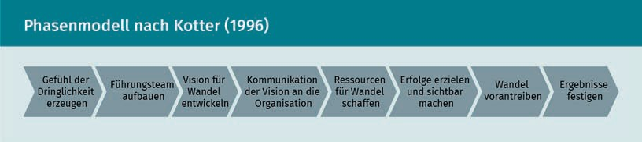

###### Performing an Analysis of Change Processes

Kotter's phase model is a good basis for analyzing change processes. For example, the management of a drugstore products company would like to extend its existing distribution channels (bricks-and-mortar stores) to online distribution (online shop). To this end, management has already recruited and begun recruiting people from outside the company, and has set up a corresponding “online shop” department. After some time, however, the management realizes that the new department has to contend with massive internal resistance, which manifests itself in the lack of cooperation, lack of information transfer, boycotted meetings, etc. by employees of the “old” departments. What happened here? The existing

Practical Application in Specific Areas

organization felt threatened by the new department and the new sales channel (online shop). Fears and anxiety over a loss of job or significance among employees of the existing organization have led to obstructionism towards the new department. In addition, the creation of the new structures has resulted in a significant increase in the overall burden on the organization, and the organizational members of the existing departments, owing to insufficient capacity to develop new structures and processes. In order to find out how this situation arose and how it can be resolved, the previous change process is analyzed by a management consultancy based on Kotter's model.

Phase 1 - Creating a Sense of Urgency

People and organizations are prepared to change if they recognize the need for it, i.e., a previous business model no longer generates enough revenue and jobs are threatened. Through interviews with some of the stakeholders (department heads and opinion leaders of the “old” organization), as well as the company’s management, the measures previously taken by management in the previous change process are analyzed, and whether this has created a sense of necessity for change among the employees.

Phase 2 - Building a Leadership Team

A comprehensive process of change requires the support of a strong team, which is able to structurally support the process of change in the organization, and especially absorb it emotionally. Here, it is necessary to have recognized personalities from the existing organization, who also have structural management and leadership skills, in order to be able to inspire the employees affected by the upcoming changes to embrace them willingly. In our case study, it is important to find out in the analysis, whether such a team had been set up in the drugstore products company during the change process, and what status the individual members of this team have in the organization.

Phase 3 - Develop a Vision for Change/Phase 4 - Communicate the Vision to the Organization

In order to generate a willingness to change, this team must work with management to develop an attractive vision that can appeal to members of the organization, so that they will actually support it. As for our example company, this would mean working out what the future of the company looks like after the introduction of an online shop. Does this result in more sales and guarantee the company's continued existence? Do the new structures provide attractive development opportunities for employees of the company? Are salaries and jobs of existing employees secured?

The vision that has been developed must then be communicated to the organization. For this, a convenient form should be chosen: one that enables the members of the organization to grapple with the new vision, for example through workshops, discussion platforms, or in other ways. Once again, in this case, it is necessary to analyze through interviews and company documents, whether relevant events have already taken place, and how these were designed. The example company is characterized by a hierarchical corporate culture.

Employees are accustomed to following the management's instructions, provided they are well explained. The analysis therefore questions whether there was an event for the communication of the vision, and whether it was designed in such a way that the employees of the organization were recruited to attend. Was the vision understandable and attractive? Has a “project plan” for implementing the vision been communicated, showing the employees that management knows what to do? Were employees able to gain confidence in the management plan?

Phase 5 - Creating Resources for Change

Changes are always accompanied by an increased need for time, labor and performance in a company. In most cases, projects that support the implementation of change processes are carried out alongside the day-to-day business of the employees. For the employees, this means extra work, time pressure and stress. The readiness to support necessary change measures (project work or conversion of previous routines etc.) increases within the organization if sufficient resources (time, money, know-how) are provided for the purposes of compensating work time and labor. In this case, it is therefore necessary to check whether time for project work has been set aside for existing employees, or whether additional staff has been hired (if necessary), and whether short-term training and the further training measures required for the new tasks have been offered. The establishment of a new sales channel means much more than the establishment of a new “online shop” department, since all areas of the company have to change their processes and structures, which were previously oriented towards brick-and-mortar stores. For example, marketing, which has hitherto advertised location of stores and sales service, now has to advertise topics such as “availability of goods 24/7” on new advertising channels (YouTube, Instagram, etc.).

Phase 6 - Achieving Results and Making Them Visible/Phase 7 - Driving Change

The positive dynamics after the communication of the vision must be taken advantage of by making the first results visible as quickly as possible (e.g., the establishment of the offices for the online shop employees, or the adaptations of the older processes to the new structures, such as marketing processes for brick-and-mortar stores, as well as online channels). By highlighting these first concrete results of the change process, the organization is made aware that the change efforts are to be taken really seriously.

In phase 7, the change/change process must be advanced by adding the new component of the online shop to all the necessary projects (additions to ongoing processes; development of marketing activities on the digital distribution channel - online shop, social media; organizing shipping processes of goods ordered from the online shop, etc.). Again, it is important to ensure visibility and to support the employees from an emotional standpoint, by giving them the opportunity to actively shape the change through project work, or workshops on the new processes.

The analysis also applies here, on the one hand, through the structural planning (project plans; project teams, etc.), and to clarify whether a realistic and comfortable timeline has been planned and implemented for the change process. On the other hand – and this has enormous significance for the success of change processes – it is important to

Practical Application in Specific Areas

assess whether the employees of the company were able to play an active role in the change processes, and whether the process (project) team and the company’s management responded to the employees’ fears and concerns.

Phase 8 - Consolidate Results

New structures and processes are generally unstable at the beginning. This means that measures must be taken to integrate the new processes, communication patterns, forms, IT programs, etc. into the employees’ work routine. Difficulties that prevent this are often small errors in the processes, novel situations (such as customer inquiries, which are now sent to central employees via e-mail or online form, instead of being processed by sales staff in the actual stores as before), or even unconsolidated knowledge about the application of new IT systems, and similar issues. If these difficulties are not taken seriously and resolved by management, frustration quickly arises among the employees, and the laboriously developed new structures do not thrive. The analysis must find out whether regular reviews or audits are used by the management to record problems systematically, and later whether they collect employees’ suggestions, and implement improvement measures.

If the example company wants to analyze why the first attempt to set up an online shop failed, then it is possible to systematically determine by means of Kotter's phase model, which accompanying measures were implemented. The company can draw conclusions from this, about which elements have already been implemented well, and which ones must be taken up again from scratch (for example, communication of the vision, or providing sufficient resources for the change process).

### Network Analysis

Networks exist both within and between organizations. They are characterized by different features in the connections between actors (such as cooperation or competition), and offer advantages to individual actors by extending their sphere of influence, and the associated scope of action. This is done, on the one hand, by knowledge that becomes available via network contacts, and on the other, by the ability to influence other actors in the network.

An Example

In the industrial group “X”, with 50 locations distributed over several countries, management is working on a new strategy, namely the introduction of the so-called *lean management* in the production areas of the company. The well-connected manager of production location “G” finds out early from his contacts

about this new strategy. He has learned over many years of company affiliation that it is advantageous for his personal career, and the continued existence of the units he leads, to be one of the first to participate in new strategy initiatives. He therefore decides to take early action.

He is himself well connected to site managers in his vicinity (four other production plants are located within a 200-kilometer radius). He is now using these contacts to convince his colleagues to use his and the four “neighboring plants” as a test region for the new strategy. The Executive Board of the company knows that site manager "G" is a reliable and successful implementation manager, who is able to inspire further site managers to adopt change measures willingly. However, since the new strategy initiative is a crucial development for the company from the perspective of the Executive Board, they decide to carry out a network analysis among all site managers and central areas, in order to identify the best option for a pilot region (made up of several sites) for the first phase of strategy implementation.

###### What Are Networks?

On the one hand, the network is comprised of the interconnection of relationships between actors (persons or organizations), and on the other hand, of the opportunities for interaction (events to enable communication, or communication hubs in organizations, for example, those between interface departments, cf. Jansen 2010). Networks may exist between organizations, between organizations and their environment (customers, recruiters, etc.), and between persons/groups within the organization. Network contacts often take place at an informal level and are characterized by the “social capital” variable (cf. Bourdieu, 1992). Social capital is the ability to derive the maximum benefit from existing network contacts with minimum effort, for instance by obtaining recognition by the company (Burt, 1992).

Actors in networks differ in the degree and type of their centrality. Names for various actors are:

* + Hub: The hubs are understood as central actors in the network, as they have a large number of direct connections. They receive information and distribute it on their network.
  + Broker: Brokers are a link to actors and groups that have few relationships in the network. These promote communication and cooperation, but also exercise control over them.
  + Gray Eminence: Gray eminences have good contacts with well-connected actors. In this indirect way, they have a large number of indirect contacts and thus the possibility to reach and influence actors far beyond their own sphere of influence (Thiel, 2016).

Practical Application in Specific Areas

Each of these roles has a different task in the entire network. This can be visualized by means of sociograms (see figure).

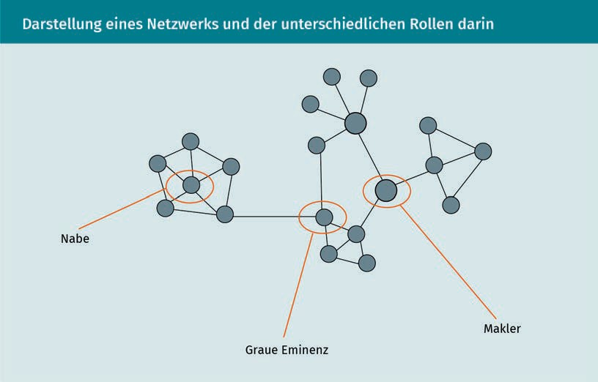

What Is a Network Analysis?

Organizations consist of formal and informal structures. Informal structures are often described with the term “organizational culture” from a business-management viewpoint (cf. Kotter & Heskett, 1992; Schein, 2010; Schreyögg, 2016). Networks are expressed at the informal level of organizations, so at first glance they are often not recognizable to the actors of a network itself. Network analysis makes it possible to present these informal structures in concrete terms by measuring and making visible connections and interactions in their quantity (frequency, extent, distribution of network contacts across different areas of the company, etc.), and quality (form, type of relationship, power relations, depth of the connection, etc.).

A network analysis can be used specifically for the ...

* ... preparation of change projects to identify influential actors in the organization (e.g., gray eminences in the company), and
* in the merger of companies, in order to find out how the communication networks of the respective subcompanies work, and who are the central contact partners (hubs or gray eminences) in the respective companies.

How Does Network Analysis Work?

Network analysis makes connections between actors visible. In order to collect the data, it is useful to have in advance a finite set of actors involved, i.e., for example, an organizational unit, or an organization and certain competitors. In our example,

industrial company "X" now wants to analyze the company's internal network (production sites and company headquarters) of the 50 site managers, in order to find out who is best suited as a “multiplier” for the implementation of the company strategy. The set of actors is thus delimited, and limited to the company-internal contacts of the site managers.

How is the data collected? Mutual communication data from all 50 site managers are collected, and sent to the area managers at headquarters. Questionnaires are used as an essential data source to collect data on contacts, contact frequency, perceived relevance of the contacts, intensity of the contact events (for example short call vs. long meeting), and perceived quality of the cooperation.

The Executive Board now has Human Resources design a questionnaire, which queries the above-mentioned features for all 50 site and area managers of the relevant units.

After the return of all questionnaires, the data obtained provides information on how intense cooperation and solidarity potentials (cohesion, proximity, etc.) between the site managers and the area managers are, which structural position (e.g., hub, broker, gray eminence) individual actors occupy in the network, how access to information in the network is organized, and how opportunities for the exercise of social influence are distributed in the network. This is done by quantifying the data, detailed data analysis, and presentation of the results on the basis of sociograms/network visualization (see figure above), as well as through matrices.

To do this, the number of direct relationships in the network is measured (for example, by answering these questions: “Which site managers do you have a direct relationship with?” and “How often are you in contact with the respective site manager?”). A distinction is made between these as “indegree” (in the case of a communication received by the site manager interviewed), or as “outdegree” (one that is initiated by the site manager interviewed), but communications can also simply be “reciprocal.”

Matrix algebra

Matrix algebra consists of computational forms which provide information on the connection types between different actors, such as network density, clustering; hierarchization, etc.

In order to obtain a meaningful result in the evaluation of the data, it is useful to collect them in matrices (grids organized along an X- and a Y-axis), which allow a multi-layered analysis, and the representation of networks. For this purpose, **matrix algebra** is used, which makes it possible to identify networks of individual actors (e.g., the number of contact points, or indegree and outdegree connections), the network density, and individual groups within networks (for more details see Jansen, 2006).

Matrices arrange contact points along two axes. The vertical axis (columns) designates the transmitters of a contact (for example, G receives information from A, C, D and E; but not B and F), while the horizontal axis (rows) lists the receivers (G passes information to A, B, C, E; but not to D and F).

Practical Application in Specific Areas

The cells will have information on the quality of the contact, such as "1" for contact; "0" for no contact; "-" if the contact is not possible (e.g., with oneself).

n

n · n − 1

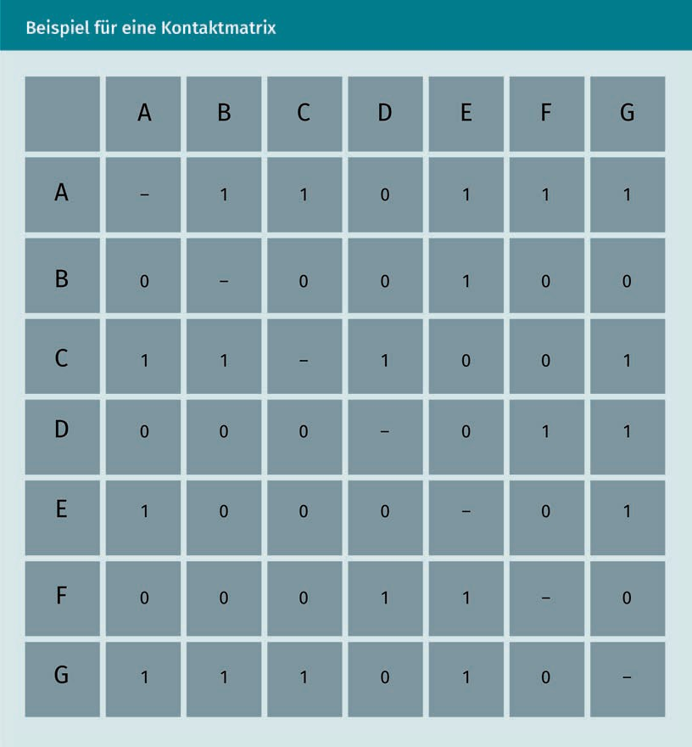

This forms the basis for the calculation of individual “key figures” on the basis of which networks are analyzed. For example, the “key figure for network density” is obtained from the sum of the realized contact points divided by the product of “all contact

points” and “all contact points minus 1” expressed mathematically as

.

The maximum number that can be reached is 1.

This would mean that all actors of a network maintain contacts with one another. The above-mentioned matrix yields the following results:

20

7· 7 − 1

48

Score:

= 20 = 0,417; this value certifies that this network section

(the site managers A-G) has a high interaction density.

If the interaction patterns of the site managers A-G are considered in detail here, the site managers A, C and G show themselves as strong transmitters of information, and actors E and G as recipients of the information flows within the network. Actor B, on the other hand, hardly appears as a transmitter, and just as an average receiver in the network. Qualitatively, one can establish here that actor G is very central for the network, and that the contacts that are mostly sought out from the network are mainly actors E (who assumes the role of a broker) and G.

After the evaluation of the entire information on all the actors from the network analysis, it becomes apparent that in company X, site manager G has a particularly strong communication network, characterized by both incoming (indegree) and outgoing (outdegree) communication. He maintains particularly good contacts with site managers of geographically close production sites, but also with actors at the Group’s headquarters (division managers and board assistants). This qualifies him as a "Gray Eminence" in the company's internal network, able to reach a large number of people in the company via his network, and influence their actions. From the point of view of the Executive Board of Company X, G is therefore suitable as a supporter for the implementation of the *lean management* strategy, by being able to promote the implementation of said strategy through his central communication role in the company.

Network analysis provides insight into the structure of the interaction between actors of a defined field via the representation matrices and sociograms. Network analysis, thus, makes informal structures visible, and contributes to organizational analysis as a tool to qualify and quantify the corporate culture variable (informal structures of the organization).

### Career Assessment in Organizations

Human capital

The skills and competences of the staff of an organization responsible for providing services to the organization.

Employees and organizations are closely connected. Employees shape the success of an organization through their abilities, their personality, and even their networks. At the same time, organizations offer their members/employees the opportunity and space to apply, and develop their skills. There is thus a close interconnection between the organization, which benefits from the abilities of its members, and the individuals, to whom an organization offers development opportunities for their competences, status, salary, etc. The assessment of careers as part of organizational research aims to describe these relationships, and, thus, provide explanatory approaches for the development of the human capital of an organization.

###### What Is a Career?

A career can be described as "forms of movement of a person through a social space and the individual experiences contained therein" (Hughes, 1958 quoted in Mayrhofer, 2010). In terms of organizations/companies, this is the

Practical Application in Specific Areas

change of position within the organization over a certain period (for example, the duration of the affiliation to the organization). This definition includes three variables:

* Time: Change within a certain period, such as from joining an organization until leaving it.
* Individual: Persons with their individual abilities, competences, training, career/experience, points of reference/networks within a social framework.
* Organization (social space): Organizational structures and processes, as well as organizational culture, norms, values and organizational environments (such as industry, networks, etc.).

From the perspective of organizational analysis, the above definition and the three above-mentioned factors that affect careers form the framework for career assessment. What does this mean in detail?

###### What Does Career Assessment Entail from the Perspective of Organizational Analysis?

Organizational analysis deals on the one hand with individuals, on the other with organizations as an analytical object *made* of careers. Individual factors, such as position changes, membership duration, and many others are analyzed, and – importantly – also how organizational structures and processes influence careers.

On the individual level, the assessment mainly analyzes the horizontal (i.e., at the same hierarchy level), and the vertical change of position, as well as the increase in income, status and subjective satisfaction with one’s own career development (Mayrhofer, 2010).

The organization focuses on analyzing the impact of organizational structures and processes on career development (how the entry phase proceeds; promotion within the organization; duration of affiliation) of individuals and groups of persons (trainees, lateral entrants, employees of certain career levels or areas of the organization, etc.). However, the analysis also focuses on which career patterns develop within the organizational structures and processes, and how these patterns affect turnover, the duration and quality of the employee's commitment to the organization, and the availability of human capital (presence of sufficient employees with the necessary skills).

To identify such patterns, qualitative exit interviews are useful, i.e., interviews with people who are leaving the company, followed by follow-up interviews, which are conducted sometime after their having left the company. This form of interviews is carried out with the aim of identifying reasons for employee resignation, and patterns causing the resignations (for example, too few opportunities for further development, management philosophy within the company, particularly in one’s own area, etc.). A study by the German Association for Personnel Management from 2014 shows that both survey forms

make sense, since if some time has elapsed from the severance, the employee can easily give other reasons than the actual ones. This form of interviews can also be carried out entirely by an independent body (such as an external service provider), which ensures absolute anonymity, in order to obtain the most authentic answers possible (DGFP 2014).

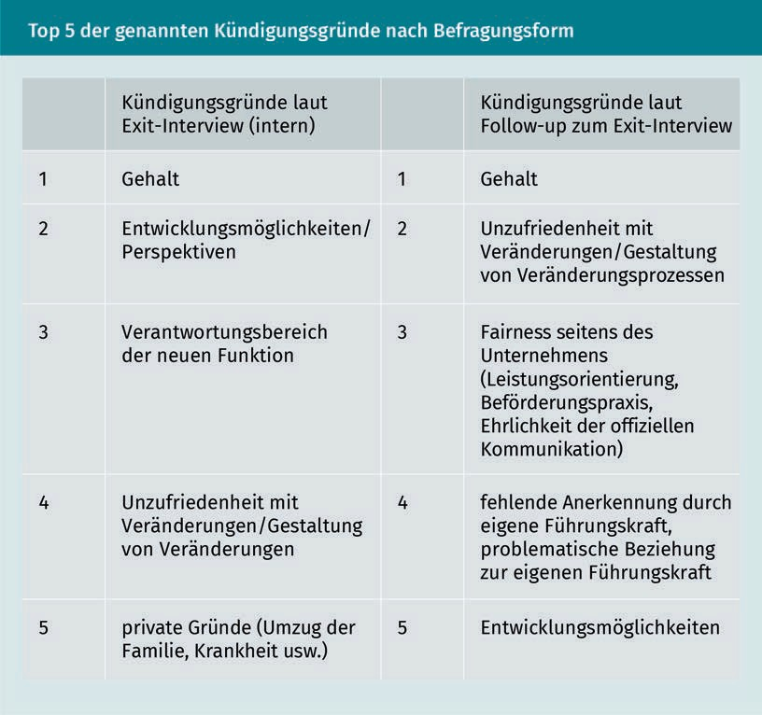

Thus, from a structural/cultural point of view, the above-mentioned results show that, in addition to the topic of salary, a number of other factors are named as important, once some distance has passed from the moment they left the company. These can be the existing change processes and management culture, besides the transparency in promotion, and the availability of career opportunities. From these analysis results, the analyzed company can obtain new insights for further assessment of change processes, and the management culture in the company, so as to reduce the problems mentioned, and thus reduce future turnover related to them.

The quantitative analysis of organizational career patterns provides further information on organizational structures and their effects on career development. The course of a career is defined as the time spent in the company/department, the number of position changes within the organization, or the availability of potential

Practical Application in Specific Areas

employees/managers per specific tasks/positions for any future promotion. Organizational structures that affect career progress can be subdivided as follows: on the one hand, explicit requirements, such as official career planning or official change options in organizations, on the other hand in implicit structures, such as **opportunity structures** (in the sense of White, 1970), proximity to decision-makers, values/culture of the organization, etc.

Organizational factors influencing careers can be the demographics of the organization (age and gender structure), its size (number of posts), as well as forms of cooperation (team, team structures, hierarchies, etc.), and the existence of official mentoring programs, or career planning that includes training opportunities.

Findings from career assessment enable organizations to design career systems or career planning (e.g., career planning for talents, trainees, etc.), general personnel development measures, such as junior staff training, on-the-job training, as well as in a rather banal way as a decision basis for upcoming promotions. Looking ahead, findings from career assessment are also used for long-term planning of available human capital for the organization, in order to retain sufficient staff with the necessary skills (Mayrhofer, 2010).

###### How Does the Assessment of Careers Work?

Career assessment is based on scientific concepts, on the one hand, and on the collection and evaluation of quantitative personnel data, on the other. Careers can nowadays also be analyzed using **succession planning**. These methods are based on the concept that companies want to fill key positions with suitable persons. They focus on corporate culture, and on how people fit into it, as well as on the period of time during which employees can rise to which position, and which development measures they need during this period (Welsh 2019).

Conceptually, the analysis of career patterns in organizations is based on two approaches. One is the concept of “sponsored mobility” (as proposed by Turner, 1960), and the other is the concept of “contest mobility” (as in Rosenbaum, 1979/1984). How do they work?

* Sponsored Mobility: The concept assumes that factors such as the proximity to the decision makers of the organization, similar views/values systems, as well as the social origin of individuals and decision makers are decisive for one’s career. These factors are used to create well-established career paths for selected individuals/groups. Examples of this may include: trainees, talent

Opportunity structures Opportunities for career changes, which arise due to the size of the organization, turnover, growth of the organization, hierarchy structures, etc., are described as

“Opportunity structures”.

Succession planning Succession planning is based on the consideration of which persons in the best-performing company can contribute to the corporate and management culture, and occupy decisive positions in the future.

programs, or simply attending specific schools and universities, which serve as starting points for lifelong careers by ascribing to a certain system of values.

* + Contest Mobility: This concept assumes that it is crucial for careers to stand out from competitors for individual positions at the right moment. When the going gets tough, social skills and individual networks are decisive, in addition to professional skills. If a person succeeds in prevailing over others in the competition for higher positions, this opens up subsequent options for them; If they don’t succeed, further career paths often remain blocked too. Positively completed career moves, in turn, have a positive effect on future career options. Examples of this are career systems in consulting companies, which range from junior to senior consultant to partner. Unsuccessful candidates are mostly eliminated from the system, leaving them unable to participate in promotions at a later stage (see Mayrhofer, 2010).

Along these two career concepts, hypotheses arise for carrying out an analysis, which are examined in the course of data collection and evaluation. Examples of hypotheses from the point of view of contest mobility can be as follows:

* + There are typical career paths within the organization.
  + Early career steps within the organization have an impact on further career development.
  + Newcomers have better career opportunities to achieve a higher management position.

Examples of hypotheses from the point of view of sponsored mobility can be as follows:

Internal labor markets

The “internal labor market" is a labor market exclusively for the members of an organization, in order to provide them with career options, thus strengthening employee connections, and the human capital of the organization.

* proximity to decision-makers (having the same mindset; similar cultural characteristics, etc.) has a positive effect on career paths.
* Ascendants to middle management come from individual areas of the company.
* **Internal labor markets** work on the basis of proximity/distance to decision-making bodies, or also on the basis of long service membership/lateral entry into the organization.

The data used for the analysis are primarily personal data (which are highly sensitive because they are confidential) in different categories. The following are usually of interest:

* length of service, division and area (current and past);
* entry position, current position and all previous position changes; and
* the duration of the time spent in each position (current and past).

However, more personal data, such as the following, may be equally important:

Practical Application in Specific Areas

* + ... age and sex,
  + salary increases,
  + training(s) and qualifications;
  + management experience and manager-to-staff ratio; and
  + performance assessments, among others.

For the (statistical) evaluation of the data, it is advisable to form categories into which one can distribute employees (for example according to the time of entry, and entry position). On the basis of this distribution, the change can then be traced over a longer period of time. Additional data categories (age, department, training, participation in career programs, etc.) provide further information on organizational structures and patterns that are either conducive to or detrimental for career development.

Findings are used to examine and adapt personnel development and career programs, or set up lists of official criteria for promotion, etc. In practice, these data are also frequently used by talent management to tie high performers to the company by enticing them with attractive career opportunities.

### Organizational Analysis and Due Diligence

Due diligence is a form of analysis that is usually applied to companies in order to examine them carefully. Financial, legal and economically relevant issues that contribute to the assessment of the company will be examined as a matter of priority. How do organizational analysis, which is devoted to organizational processes, structures, modes of operation and culture, on the one hand and due diligence on the other, fit together? Where are the overlaps, and what characterizes due diligence specifically?

###### What is Due Diligence?

Due diligence can be understood as “a process of systematic investigation and analysis, as well as the examination and evaluation of an object, which is at the center of a planned business transaction” (Baumgartner 2010, p. 345). The aim of due diligence is thus to assess quantitatively and qualitatively the economic potential and possible risks of an organizational unit/organization that is to be taken over/bought/integrated. In the classical sense, due diligence explores topics such as:

* + enterprise strategy (for example: customer, service/product, technology orientation),
  + market position (including sector structure),
  + technical and human resources (state of machinery, age, quality and salary structure of employees),
  + organizational infrastructure (state and location of buildings and land),
    - financial situation (insights from account books, balance sheet, cash flow, etc.); and
    - legal framework (e.g., legal form of the organization).

The major challenges for due diligence are usually the time factor, and the access to information about the company to be acquired.

###### Due Diligence and Organizational Analysis: How Do They Fit Together?

Organizational analysis is mainly devoted to the analysis of the formal (organizational structure, process organization) and informal structures of an organization (organizational culture, forms of real cooperation, communication patterns). When two companies are integrated in the course of a merger, what takes place is typically an encounter of different corporate and management cultures, as well as of different formal structures (hierarchies, organization of departments, etc.). Consider, for example, a group that wants to integrate an innovative start-up. Here, the group must be aware that the innovative culture of the start-up could be quickly destroyed by hierarchical group structures. Ideally, however, a new corporate culture emerges from the mixing of the hierarchical corporate culture and the innovative start-up culture. The implementation of an organizational analysis of the innovative start-up as part of the due diligence can provide information on who are the carriers of the innovative corporate culture, and which structures (such as communication patterns, or improvement processes with broad participation of the employees, etc.) contribute to the innovative power of the start-up. Accordingly, after the takeover of the start-up, the Group can take care to ensure that its decision-making structures (such as short-cycle communication and broad employee participation in the innovation processes, etc.) remain in place. This can be done, for example, by only very carefully integrating said structures into the reporting lines of the group, or even by testing forms of employee participation in innovation processes taken from the start-up into the Group’s existing structures.

The aim of both forms of analysis (due diligence and organizational analysis) is to make known and unknown aspects of the organization visible. By doing so, those aspects that are relevant for the purchase/sale of the company can thus be assessed by the buyer (but also by the seller). The challenge for due diligence is that the access to information is strongly influenced by the time factor – the duration of a due diligence is usually between a few days to a few weeks – and by the framework of the acquisition process, i.e., whether it is a friendly or a hostile takeover. Both factors affect access to information (openness or obstruction by the audited entity).

Practical Application in Specific Areas

###### What Are the Relevant Factors for an Organizational Analysis Performed in the Course of Due Diligence?

Three factors – framework conditions, purpose of analysis, and procedure of analysis – shape the analysis strategy (order of analysis elements, and depth of analysis) and the analysis design (choice and design of methods).

Due diligence is usually performed under difficult circumstances and restrictions (strict time limitations; reasons and findings are limited to economic topics). However, it takes time to carry out an organizational analysis for even the friendly takeover of a company. For example, for the analysis of the communication culture of two companies, a more extensive examination of communicative behavior is necessary.

The purchasing company K – an established wholesale company with hierarchical communication structures – wants to acquire a location of trading company S, in the third generation of family ownership, with rather flat hierarchies and open communication culture. In order to analyze the communication culture of S, it is advisable to perform qualitative interviews with executives and employees of the S company, as well as the participation of organizational analysts in team meetings at the premises of company S. As a result, the purchasing company K can experience and understand the values that inspire communication in company S.

This is relevant both for an assessment of the acquisition, and for the assessment of the subsequent costs of enterprise integration. If two completely contradictory corporate cultures meet, the companies’ merger can lead to considerable additional costs, for example, because external consultants need to be engaged to accompany the development of new structures, or of a new communal corporate culture.

Due diligence usually takes place in the run-up to a company takeover, when this happens…

1. ... as a friendly takeover or joint venture (i.e., strengthening of the company's own portfolio by merging two companies),
2. as a hostile takeover (the integration of a competitor), or
3. in the event of a company’s insolvency.

Organizational analysis in the run-up to a company purchase takes place mainly in the course of the friendly takeover of a company. In the course of a hostile takeover, it takes place in the follow-up instead, as a preparatory measure for the integration of processes and structures. It cannot happen earlier, since hardly any information can be gathered from the company taken over due to of the expected obstructionism towards the purchasing company.

In addition to the framework conditions in which a due diligence takes place, and the purpose of the organizational analysis (i.e., an analysis of the organizational culture and structures, as well as of the management and communication culture), the course of the analysis also influences its strategy and design. For example, the preliminary analysis looks at publicly available material, such as the company's website (corporate strategy, history, structure, key figures, etc.), prospectuses, and annual reports, in order to obtain information on the company's culture and structure. For example, on many corporate pages, the corporate vision, or even the self-image of the corporate culture can be seen.

This also serves to further plan the focus of the analysis (leadership culture or organizational structure). Depending on the type of takeover, there are differences in the choice of collection methods. Here, a distinction can be made between:

Multi-moment recording

A multi-moment recording is an analytical method

in which impressions of operational processes of one unit (such as the production facility) are gathered over multiple visits of said location.

* Merging/enterprise integration among partner enterprises: The willingness to support the merger is rather high, and methods such as interviews, observations of workflow processes are feasible, even desirable as a confidence-building measure. For example, before taking over, employees and managers of the company location S are shown that there is interest and respect for their corporate culture, in that managers of the purchasing company K want to know how to work together at S.
* Buying a company as a friendly takeover: the analyzed company is expected to provide substantial support. Interviews are possible, as well as joint audits (standardized evaluations), and **multi-moment recordings**. If, for example, work processes (formal processes) and structures of the company (divisions/departments) are to be analyzed, it would be possible to carry out a mixture of observation studies and interviews with managers of the company for sale. Audits and multi-moment recordings enable a rapid recording of existing structures based on a comparison model (e.g., the structures of the purchasing company). In this case, for example, company K can ask via an audit whether customer complaints are received and processed at company S in accordance with a comparable pattern, or whether sales areas in the sales department are internally structured in a similar way.
* Hostile takeover: In this case, strong resistance from the company can be expected as soon as it becomes aware of the buyer's intention to take over. Information for the analysis is therefore obtained mainly on the basis of annual reports and external sources, such as internet searches, magazines, etc. The essential evaluation method will be a content analysis. Under these conditions, it is very difficult or even impossible to carry out a substantial organizational analysis.

In the pre-signature phase - i.e., before a possible sale contract is concluded – one finds that analyses of possible risks and burdens for the purchasing company are typically carried out because they may influence the purchase price. On the other hand, pre-analyses are also carried out, in this context, to support the later integration/merger of the companies. These analyses focus on organizational

Practical Application in Specific Areas

workflow and structure, as well as organizational culture and networks within the purchasing company. For this purpose, surveys (broad analysis among employees) and interviews (personal interviews with key persons) are carried out.

Organizational analytical methods and analytical processes, as can be seen from these observations, tend to be used for the preparation of a corporate integration/merger (also called M&A, from the English term "mergers and acquisitions"). In order to examine formal and informal aspects of the organization, organizational analysis mainly builds on interactive methods, such as surveys and observations. These require the willingness of the interviewed persons/organizational members to provide information. However, a content analysis, which is also regarded as an essential method of organizational analysis, can be applied already in the preliminary analysis. This can even be done under conditions, in which the website or the official messages of a company (e.g., advertising and PR texts) are the only documents able to be accessed.

Organizational analysis therefore provides due diligence with methods and procedures to expand its original analytical focus (finance and law), in order to examine the formal and informal aspects of the organization being analyzed.

Summary

The lesson provides an overview of four specific areas of application of organizational analysis: change processes, networks, career assessment, and due diligence. The first area is the analysis of change processes, where the purpose and sequence of change processes can be divided into two categories: continuous and episodic change. Continuous change offers a concept of change that is organic and positive within the organization: organizational change, in fact, occurs as a response to changing conditions in the organization’s environment. The view provided by the concept of episodic change, on the other hand, is that organizational change is a state of emergency that is consciously initiated and controlled. Kotter’s and Lewin’s phase models are two explanatory models applicable to the contexts of organizational change. They can be used both for the initiation/implementation of change, and for the analysis of change processes.

The second area of analysis is that of networks.

Networks are made up of people with different roles and tasks. These include hubs (which maintain close relationships with other actors), brokers (which compensate for information deficits in networks), and gray eminences (which have a large number of contacts connecting them to many different networks). Networks offer benefits to all these actors by strengthening information gains and related influences. Network analysis uses sociograms and matrices to analyze and represent the quantity and quality of connections in networks.

The third area is career assessment. When analyzing careers, organizational analysis again offers two central concepts to describe their development. On the one hand there is “sponsored mobility,” which explains careers as a result of similar values and proximity to decision-makers; on the other, there is "contest mobility," which assumes that the ability to compete for a position/post against others has a positive effect on future career advancement. Career assessment shows organizational career patterns/logics, and explains how corporate culture and corporate structures influence careers in organizations. Simple exit interviews are a suitable means to gain insights into career patterns (for instance the turnover factor). Further sources are the company’s personnel data, which are processed quantitatively and tested on the basis of hypotheses.

As a fourth example of an area of application of organizational analysis, it was shown how organizational analysis and due diligence are interrelated. For this purpose, the lesson focused on objectives, purpose and boundary conditions for a due diligence, which decisively define the analytical question, and the possibilities of data collection. For example, due diligence often has to reckon with a tight deadline for the analysis, and the resistance to providing data by the analyzed organization. Organizational analysis can therefore make the greatest contribution with friendly takeovers, where the whole of the analytical and methodological spectrum of organizational analysis can be used to examine organizational culture, management culture, and corporate structures. Organizational analysis, thus, provides insights into the organization’s formal and informal structures, and supplements the core areas of due diligence (finance and law) with the essential component of how an organization is structured, and how it functions.



# Appendix 1

## Bibliography

Bibliography

Allen, N. & Meyer, J. (1990): *Organizational Socialization Tactics: A Longitude Analysis of Links to Newcomer’s Commitment and Role Orientation.* In: Academy of Management Journal, 33rd Jg., issue 4, pp. 847-858.

Atteslander, P. (2010): *Methoden empirischer Sozialforschung* [Methods of empirical social research]*.* 13th edition, Erich Schmidt, Berlin.

Baumgartner, P. (2010): *„Due Diligence“ – Eine Organisationsanalyse der besonderen Form ...?.* ["Due Diligence" - An organizational analysis of the special form ...?*.*]In: Mayrhofer, W., Meyer, M. & Titscher, S. (eds.): Organizational Analysis practice

- Application fields and methods. Facultas, Vienna, pp. 345-363.

Borg, I. (2015): *Mitarbeiterbefragung in der Praxis* [Employee surveys in practice]. Hogrefe, Göttingen.

Bourdieu, P. (1989): *Social Space and Symbolic Power*. In: Sociological Theory, 7th Jg., issue 11, pp. 14-25.

Bourdieu, P. (1990): *The logic of practice.* Stanford University Press, Stanford/CA.

Bourdieu, P. (1992): *Ökonomisches, kulturelles und soziales Kapital.* [translated into English with the title *Forms of Capital*]In: Bourdieu, P.: Die verborgenen Mechanismen der Macht. Schriften zu Politik & Kultur 1. VSA, Hamburg, S. 49–75.

Bourdieu, P. (1998): *Practical reason. On the theory of action.* Polity Press, Cambridge/MA.

Burt, R. S. (1992): *Structural Holes. The Social Structure of Competition.* Harvard University Press, Cambridge/MA.

Chandler, A. D. (1962): *Strategy and structure: Chapters in the history of the American industrial enterprise.* Cambridge, London.

Coleman, J. (1974): *Power and the Structure of Society.* Norton & Company, New York.

DGFP - Deutsche Gesellschaft für Personalführung e. V. (2014): *Retentionmanagement für die Praxis – Erfolgsentscheidende Mitarbeiter ﬁnden und binden*. [Retention Management for Practice - Find and retain employees who are critical to success.] DGFP Praxisedition Band 108, serial editor DGFP e. V., Düsseldorf.

Dietz, F. (2006): *Psychologie 1: Methodische Grundlagen biopsychologische Modelle* [Psychology 1:The methodological basis of biopsychological models]*.*

Medi-Learn Verlag, Marburg/Lahn.

Felfe, J. & Liepmann, D. (2008): *Organisationsdiagnostik* [Organizational diagnostics]. Hogrefe, Göttingen.

Foucault, M. (1994): *Überwachung und Strafen. Die Geburt des Gefängnisses* [translated into English as *Discipline and Punish. The Birth of the Prison*]. Suhrkamp, Frankfurt am Main.

Bibliography

Franke, J. & Kühlmann, T. (1995): *Organisationsdiagnostik.* In: Grieff, S./Holling, H./Nichol- son, N. (Hrsg.): Arbeits- und Organisationspsychologie: Internationales Handbuch in Schlüsselbegriffen. [Organizational diagnostics. In: Grieff, S./Holling, H./Nichol-son, N. (eds.): Work and organizational psychology: International manual of key terms]. Beltz, Weinheim, pp. 350-353.

Fritz, W. et al. (1988): *Unternehmensziele und strategische Unternehmensführung,* [Corporate goals and strategic corporate governance], In: Die Betriebswirtschaft [Business administration], 48. Jg., issue 5, pp. 567-586.

Goffman, E. (2007): *Wir alle spielen Theater. Die Selbstdarstellung im Alltag.* 5. Auﬂage[We all play theater. Self-expression in everyday life. 5th edition], Piper, Munich/Zurich.

Gouldner, A. (1954): *Patterns of Industrial Bureaus.* Free Press, New York.

Grote, S., Kauffeld, S. & Berhöfer, F. (2013): *Wandel und Innovation.* In: Werner, C./Elbe, M. (Hrsg.): Handbuch Organisationsentwicklung. [Change and innovation. In: Werner, C./Elbe, M. (eds.): Organizational Development Manual]. Herbert Utz, Munich, pp. 219-238.

Hürlimann, F. W. & Hebenstreit, B. v. (1987): *Verkehrssicherheit in der Praxis* [Road safety in practice]. Hogrefe, Bern.

Jansen, D. (2006): *Einführung in die Netzwerkanalyse. Grundlagen, Methoden, For- schungsbeispiele*. 3. Auﬂage[Introduction to network analysis. Basics, methods, research examples. 3rd edition], Springer, Wiesbaden.

Jansen, D. (2010): *Netzwerkanalyse als Instrument der Organisationsforschung* [Network analysis as an instrument of organizational research].In: Mayrhofer, W./Meyer, M./Titscher, S. (eds.): Praxis der Organisationsanalyse – Anwen- dungsfelder und Methoden. [Practice of organizational analysis - fields of application and methods]. Facultas, Vienna, pp. 208-226.

Kasper, H. & Müller, B. (2010): *Analyse von Veränderungsprozessen* [Analysis of change processes]. In: Mayrhofer, W./ Meyer, M./Titscher, S. (Hrsg.): Praxis der Organisationsanalyse – Anwendungsfelder und Methoden. In: Mayrhofer, W./ Meyer, M./Titscher, S. (eds.): [Practice of organizational analysis - fields of application and methods]. Facultas, Vienna, pp. 182-207.

Kauffeld, S. & Frieling, E. (2001): *Die beruﬂiche Handlungskompetenz bei der Bewältigung von Optimierungsaufgaben in betrieblichen Gruppen* [The professional competence to act in the management of optimization tasks in company groups].In: Frisch, R., Beck, D. & English, B. (ed.): Projektgruppen in Organisationen [Project groups in organizations]. Hogrefe, Göttingen, pp. 74-89.

Kauffeld, S., Grote, S. & Lauer, L. (2013): *Gruppendiagnostik* [Group diagnostics]. In: Werner, C./Elbe, M. (eds.): Handbuch Organisationsentwicklung [Organizational Development Manual]. Herbert Utz, Munich, pp. 105-124.

Kim, Y./Kim, D./Ali, M. (2015): *The Effects of Mutual Trustworthiness between Labor and Management in Adopting High Performance Work Systems*. In: Relations Industrie- lles/Industrial Relations, 70. Jg., Vol. 1, pp. 36-61.

Kotter, J. P. & Heskett, J. L. (1992): *Corporate culture and performance*. Free Press, New York.

Kühl, P. (2015): *Schlüsselwerke der Organisationsforschung* [Fundamental

works of organizational research]. Wiesbaden, Springer.

Küng, Z. (2015): *Praktische Organisationsanalyse: Strategien verstehen und gestalten – erkennen, was gespielt wird* [*Practical organizational analysis: Understanding and designing strategies - recognizing what is at stake*]*.* 2nd edition, Springer, Heidelberg.

LaPiere, R. T. (1934): *Attitudes vs. Actions.* In: Social Forces, 13th Jg., issue 2, pp. 230-237.

Lebitsch, J. (2019): *Digitalisierung ist mehr als ein IT Projekt* [Digitalization is more than just an IT project]. In: Austrian Management Review, 9th Jg., pp. 78-88.

Leitner, K. et al. (1987): *Analyse psychischer Belastung in der Arbeit – Das RHIA-Verfah- ren.* [Analysis of psychological stress at work - The RHIA procedure].Verlag TÜV Rheinland GmbH, Cologne.

Luhmann, N. (1964): *Funktion und Folgen formaler Organisation* [Function and consequences of formal organization]. Duncker & Humbold, Berlin.

Luhmann, N. (1973): *Zweckbegriff und Systemrationalität. Über die Funktion von Zweck in sozialen Systemen* [Purpose and system rationality. The function of purpose in social systems]. Suhrkamp, Frankfurt am Main.

Luhmann, N. (1981): *Organisation und Entscheidung* [Organization and decision]. In: Luhmann, N.: Soziologische Aufklärung 3. Soziales System, Gesellschaft, Organisation. [Sociological education 3. Social system, society, organization]. Westdeutscher Verlag, Opla- den, pp. 335-389.

Luhmann, N. (1984): *Soziale Systeme. Grundriss einer allgemeinen Theorie* [Social systems. Outline of a general theory]. Suhrkamp, Frankfurt am Main.

Luhmann, N. (2000): *Organisation und Entscheidung* [Organization and decision]. Westdeutscher Verlag, Wiesbaden.

Maslow, A. H. (2010): *Motivation und Persönlichkeit* [Motivation and personality]*.* 12th edition, Rowohlt, Reinbek.

Mayo, E. (2003): *The Human Problems of an Industrial Civilization.* In: Thomsom, K. (eds.): The Early Sociology of Management and Organizations (Volume 6). Routledge, London.

Mayrhofer, W. (2010): *Die Analyse von Karrieren in Organisationen* [The analysis of careers in organizations]. In: Mayrhofer, W./ Meyer, M./Titscher, S. (eds.): Praxis der Organisationsanalyse – Anwendungsfelder und Methoden [Practice of organizational analysis - fields of application and methods]. Facultas, Vienna, pp. 279-301.

Mayrhofer, W., Meyer, M. & Titscher, S. (2010): *Praxis der Organisationsanalyse – Anwendungsfelder und Methoden* [Practice of organizational analysis - fields of application and methods]. Facultas, Vienna.

Mayring, P. (2008): *Qualitative Inhaltsanalyse. Grundlagen und Techniken* [Qualitative content analysis. Basic concepts and techniques]*.* 10th edition, Beltz, Weinheim.

Bibliography

McAllister, D. J. (1995): *Affect- and Cognition-Based Trust as Foundations for Interpersonal Cooperation in Organizations.* In: The Academy of Management Journal, 38th Jg., issue 1, pp. 24-59.

McGregor, D. (1960): *The human side of enterprise.* McGraw-Hill, New York.

Meyer R. & Höllerer, M. (2010): *Ziele und Strategien von Organisationen* [Goals and strategies of organizations]. In: Mayrhofer, W., Meyer, M. & Titscher, S. (eds.): *Praxis der Organisationsanalyse – Anwendungsfelder und Methoden* [Practice of organizational analysis - fields of application and methods]. Facultas, Vienna, pp. 47-62.

Organ, D. W. (1988): *Organizational citizenship behavior: The good soldier syndrome.*

Lexington Press, Lexington/MA.

Parson, T. (1956): *Suggestions for a Sociological Approach to the Theory of Organizations.* In: Administrative Science Quarterly, 1st Jg., pp. 63-85 and pp. 225-239.

Perrow, C. (2014): *Complex organizations. A critical essay.* 4th edition, Echo Point Books & Media, Brattleboro/VT.

Porter, M. E. (1980): *Competitive strategy: Techniques for analyzing industries and commentators*. Free Press, New York.

Porter, M. E. (1985): *Competitive advantage: Für die Verfügung stellen und systaining überseperfere.* Free Press, New York.

Rosenbaum, J. E. (1979): *Organizational career mobility: promotion changes in a corporation during periods of growth an contraction.* In: American Journal of Sociology, 85. Jg., issue 1, pp. 21-48.

Rosenbaum, J. E. (1984): *Career mobility in a corporate hierarchy*. Academic Press, New York.

Rosenstiel, L. v. (2007): *Grundlagen der Organisationspsychologie* [Basic concepts in organizational psychology]*.* 6th edition, Schaeffer-Poeschel, Stuttgart.

Rosenstiel, L. v. & Bögel, R. (1992): *Betriebsklima geht jeden an* [The work environment affects everyone]. Bayerisches Staatsminis terium für Arbeit, Familie und Sozialordnung [Bavarian Ministry of Labor, Family and Social Affairs], Munich.

Rosenstiel, L. v., Regent, E. & Domsch, M. E. (2009): *Führung von Mitarbeitern.* *Handbuch für erfolgreiches Personalmanagement.* [Leadership and employees. *A manual for successful personnel management*]*.* Schaeffer-Poeschel, Stuttgart.

Rumelt, R. P. (1974): *Strategy, structure and economic performance.* Harvard Business Press, Boston.

Schein, E. H. (1980): *Organizational psychology.* 3rd edition, Prentice-Hall, Englewood Cliffs/NJ.

Schein, E. H. (2010): *Organizational Culture and Leadership.* 4th edition, Wiley & Sons, San Francisco.

Schreyögg, G. (2016): *Grundlagen der Organisation* [Fundamentals of organization]*.* 2nd edition, Springer Gabler, Wiesbaden.

Spörrle, M. (2013): *Methoden der Organisationsdiagnostik* [Organizational diagnostic methods]*.* In: Werner, C./Elbe, M. (eds.): Handbuch Organisationsdiagnose [Organizational Diagnostics Manual]. Herbert Utz, Munich, pp. 271-284.

Taylor, F. W. (1911): *The Principles of Scientific Management.* Harper & Brothers, New York.

Thiel, M. (2016): *Was leistet die soziale Netzwerkanalyse?* [What does social network analysis do?] (URL: https://www.business- wissen.de/artikel/organisationsentwicklung-was-leistet-die-soziale-netzwerkanalyse/ [last access: 04.01.2020]).

Titscher, S./Meyer, M./Mayrhofer, W. (2008): *Organisationsanalyse – Konzept und Methoden* [Organizational analysis - concept and methods]*.* Facultas, Vienna.

Turner, R. (1960): *Modes of social ascent through education. Sponsored and contest mobility.* In: American Sociological Review, 25 Jg., pp. 855-867.

Van de Ven, A. H./Ferry, D. L. (1980): *Measuring and assessing organizations.* Wiley & Sons, New York.

Weber, M. (1922): *Wirtschaft und Gesellschaft. Grundrisse der verstehenden Soziologie* [translated into English as *Economy and Society*].J. C. B. Mohr (Siebeck), Tübingen.

Weick, K. E./Quinn, R. E. (1999): *Organizational Change and Development*. In: Annual Review of Psychology, 50th Jg., pp. 361-386.

Welsh, J. (2019): *7 steps to successful succession planning.* In: Forbes Magazine, Jan 14, 2019. (URL: https://[www.forbes.com/sites/johnwelsheurope/2019/01/14/7-steps-](http://www.forbes.com/sites/johnwelsheurope/2019/01/14/7-steps-) to-successful-succession-planning/#eaf95cc45fbd [last access 01/04/2020]).

Werner, C./Elbe, M. (2013): *Handbuch Organisationsdiagnose* [Organizational Diagnostics Manual]. Herbert Utz, Munich.

White, H. C. (1970): *Chains of Opportunity, System Models of Mobility in Organizations.*

Harvard University Press, Cambridge/MA.

Wissenschaftliches Arbeiten (2016): *Hypothesen formulieren* [How to formulate hypotheses]. (URL: https:// [www.youtube.com/watch?v=o7HGeeOVt7g](http://www.youtube.com/watch?v=o7HGeeOVt7g) [last access: 24.01.2020]).