**Figure 1:  Screen shot of the anatomy and virtual dissection of the foot.**

The lecture was delivered by Zoom application. The main screen presents the TA board with a picture of a dissection. As demonstrated in the screenshot, the TA can draw and mark on the board. In the upper right corner of the screen students can see the TA in real time, and the TA can see the students upon choice.

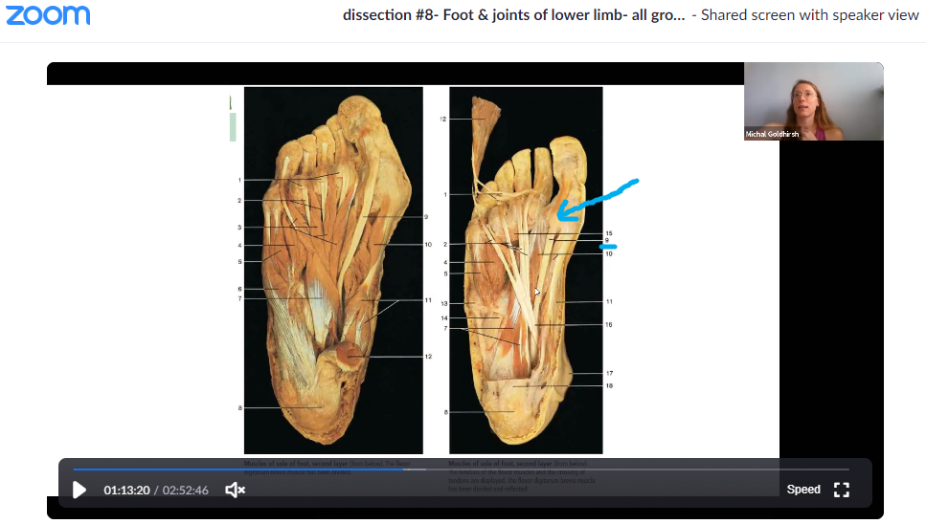

**Figure 2: An example of one test station from the online practical test.**

Each arrowhead indicates an anatomical structure that students were requires to identify and write the full anatomical name. The test contained 25 stations in this manner.

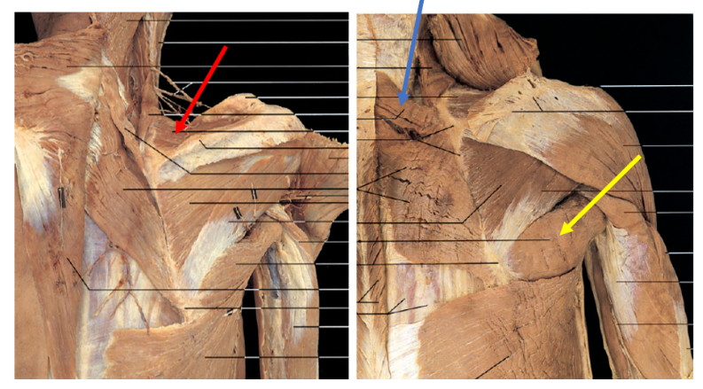

**Figure 3: Means and SDs of course evaluations (measured by seven items): A comparison of** **online (one module) and traditional methods (three prior modules) within academic year 2019-2020.**

Note: The bars displaying mean ± SD of the course evaluation. Paired-sample t-tests showed significant differences in all items. Specifically, for questions 1, 2, 4, 5, and 7 p<.01 and for items 3 and 6 p<.02. N=24.

**Figure 4: Percentages of student preferences between the online module and three prior traditionally taught modules on five aspects of learning for academic year 2019-2020.**



Note: N=24.

**Figure 5: Grades in the theoretical and practical limbs exams versus the mean grades in the other anatomical exams (abdomen & pelvis, head & neck, and thorax) throughout the years of 2018, 2019, and 2020.**

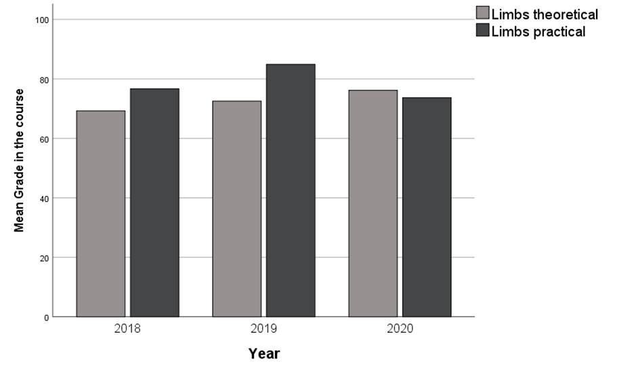

Note: The limbs module was taught online in 2019-2020 whereas it was taught traditionally in the other years. N=29 in 2020; N=33 in 2019; N=26 in 2018.