**Optimization of the Secretion and Isolation of *Frateuria defendens*-DerivedMetabolites with Inhibitory Activity Against Phytopathogenic Mollicutes**

Naama-Amar Alaa1,2, Gerchman Yoram2, Iasur-Kruh Lilach*1, Naor Vered3

1Department of Biotechnology Engineering, ORT Braude College of Engineering, Karmiel, Israel

2Department of Evolutionary and Environmental Biology, Haifa University, Haifa, Israel

3Shamir Research Institute, Katsrin, Israel

*corresponding author

**ABSTRACT**

*Frateuria defendens* is a candidate biocontrol agent that has been shown to reduce phytoplasma-related disease symptoms in grapevines and periwinkle plants. While a crude filtrate prepared from *F. defendens* can inhibit mollicute growth, the specific growth parameters for this bacterium necessary to enhance this protective inhibitory response remain unknown. Moreover, the separation of filtrate preparations from bacterial cells via centrifugation and filtration is laborious and time-consuming. As such, the present study was conducted to define the optimal growth conditions associated with maximal inhibitory activity of *F. defendens* and to establish a better approach to separating these bacterial cells from their secreted metabolites. To conduct these analyses, *F. defendens* was cultured in a range of media types, while associated inhibitory effects were tested using *Spiroplasma melliferum* as a model mollicute bacterium with phytoplasma-infected periwinkle plantlets. These analyses revealed *F. defendens* growth patterns change based upon media composition, with filtrates prepared from S-medium exhibiting beneficial activities, including the inhibition of *S. melliferum* and enhanced plant growth. When *F. defendens* cells were grown within semi-permeable, membrane-coated Small Bioreactor Platform (SBP) capsules, they could be more readily separated from the secreted metabolite fraction, obviating the need for filtration and/or centrifugation. This study is the first to have reported the use of SBP capsules to separate bacterial cells from their secreted metabolites under sterile conditions while retaining the ability of these metabolites to inhibit *S. melliferum* growth.

**INTRODUCTION**

Yellows disease in grapevine causes substantial damage to this high-value crop and yet remains difficult to control. The causative agents of yellows-type diseases are a range of phloem-inhabiting phytopathogenic mollicute bacteria, referred to as phytoplasma, that are vectored by insects of the Hemiptera order [1]. Bois noir, which is caused by *Candidatus* Phytoplasma solani, is the only form of yellows disease known to affect grapevines in Israeli vineyards[2]. Efforts to control this disease via uprooting infected grapevines or deploying insecticides against the planthopper *Hyalsthes oboletus,* which is known to vector this disease, have proven ineffective methods of disease control. *Frateuria defendens* is a novel endophytic bacterium isolated from *H. obsoletus* [3]. *F.* *defendens* has been shown to penetrate plants via roots or leaf stomata, whereupon it can inhabit the xylem and phloem of grapevines and many other plants without apparent phytotoxicity [4]. *F. defendens* application has been reported to reduce the symptoms of phytoplasma-induced yellows disease in potted grapevine and periwinkle plants, and in grapevines under field conditions, suggesting the potential for the application of *F. defendens* as a bacterial biocontrol agent (bBCA) [5-6]. However, the inhibitory effects of *F. defendens* on infected grapevines and its survival period under field conditions are lower than those observed during laboratory testing [6]. The utilization of *F. defendens-*derived secreted metabolites has thus been proposed as a potential means of overcoming this issue, with *F. defendens* filtrates having been shown to significantly inhibit the growth of the cultivable Mollicutes *Spiroplasma melliferum*, which is used as a surrogate for phytoplasma under laboratory conditions [3]. *F. defendens* filtrates have further been shown to reduce mortality in periwinkle plantlets infected by yellows disease [7], further affirming the potential utility of these filtrates as a surrogate bBCA.

Efforts to identify the inhibitory substances present within *F. defendens* filtrates led to the identification of 4-quinolincarboxyaldehyde and 5-hydroxymethylfuraldehyde within the filtrate active fraction [7]. However, these compounds exhibited reduced inhibitory activity relative to that observed for the crude filtrate, suggesting other compounds to also be involved in the inhibitory process [7]. Indeed, bacteria-derived filtrates often contain a wide variety of compounds with antibiotic activity, as in the case of *Trichoderma* spp., which secrete an estimated 100 antibiotic substances [8]. Moreover, filtrates prepared from *Pseudomonas fluorescens* FF48 cultures have been reported to inhibit *Flavobacterium psychrophilum* biofilm formation [9], while *Bacillus subtilis* CW14 culture-derived filtrates inhibited *Aspergillus ochraceus* growth [10]. In some instances, the use of bacteria-free filtrates has been reported to be more effective than the application of the bBCA species from which these filtrates are prepared [11]. For example, *Pseudomonas fluorescence* AS15 exhibits a lower inhibition rate (35.5%) against *Rhizoctonia solani,* the causal pathogen of banded leaf and sheath blight disease, when grown under a dual plate assay, as compared to that observed when applying the cell-free filtrate (86.6%) [12-13]. As such, bacteria-derived filtrates are complex, rich solutions with the potential to inhibit microbial growth more effectively than individual purified compounds or bacteria species, necessitating effective and reliable approaches to their preparation and purification.

In an effort to build upon the above observations, the present study was developed with the goal of optimizing the growth conditions for *F. defendens* so as to maximize its inhibitory activity against *S. melliferum*, and to establish the most effective approach to separating *F. defendens* cells from metabolite-rich filtrates produced therefrom. The results of these analyses highlight promising new approaches to the effective biocontrol of phytoplasma-driven diseases in grapevines and other economically important plant species.

**MATERIALS AND METHODS**

**Bacterial strains**

*S. melliferum* and *F. defendens* culture stocks from the laboratories of Zchori-Fein (Newe Yaar, Agricultural Research Organization, Israel) and Naor (Shamir Research Institute, Israel) were used for allexperiments [3]. Both of these bacteria were routinely grown in S-medium (see below), and were stored in100-200 μl aliquots in 50% glycerol at -80°C. Starter cultures were prepared by adding one aliquot to15 ml of medium, and cells were grown at 28°C to log phase (5 days for *S. melliferum*; 2 days for *F. defendens*), reaching approximately 3x107 CFU/mL.

**Phenotypic characterization of *F. defendens***

The 96-well panelGEN׀׀׀ MicroPlate (Biolog, USA) was used for *F. defendens* characterization. This assay utilized a 96-well plate in which each well contained a different carbon source, distinct growth conditions (pH/ salinity), or inhibitors, together with tetrazolium redox dyes. *F. defendens* growth in a given well could thereby be detected by tetrazolium reduction, yielding a purple color. A pure *F. defendens* culture was prepared by centrifuging a starter culture for 5 min at 4000 rpm, after which the pellet was resuspended in the provided buffer (Biolog, USA). Then, 100 µl of the resultant pure *F. defendens* suspension (2.9x107 CFU/mL) was added per well, and plates were sealed with parafilm and incubated for 48 hours at 28°C. The assay was conducted in triplicate, with *F. defendens* phenotypic fingerprints being established based upon the composition of the growth medium in wells in which a color change was visible at the end of the 48 hour culture period.

**Growth media preparation and growth conditions**

To determine whether *F. defendens* inhibitory efficacy was influenced by culture conditions, *F. defendens* growth was assessed in four different types of medium under identical incubation conditions: (1) *Spiroplasma* medium (S-medium) containing 20 g/L lysogeny broth powder (LB miller, Sigma, USA), 2.5 g/L heart infusion broth powder (Sigma, USA), 1 g/L fructose, 1 g/L glucose, 10 g/L sucrose, 70 g/L sorbitol, 4.5 g/L NaCl 4.5 [3,7]; (2) nutrient broth containing 1 g/L beef extract, 2 g/L yeast extract, 5 g/L peptone, and 5 g/L NaCl; (3) LB containing 10 g/L tryptone, 5 g/L yeast extract, and 10 g/L NaCl (LB miller) or 0.5 g/L (LB-Luria) (Neogen, Lancashire, UK); (4) K9 minimal medium containing K2HPO4*3H2O 54.5 g/L, KH2PO4 15 g/L, KCl 3.2 g/L, NH4Cl 5 g/L, MgSO4*7H2O 0.5 g/L, and CaCl2*2H2O 7.35 g/L. As a carbon source, 5 g/L of either glucose, galactose, or myoinositol were added to the K9 medium, with or without 50 g/L of peptone (Sigma, USA) as a nitrogen source.

**Growth curves**

*F. defendens* growth curves were established by adding 5 µl of bacterial culture starter cultures to each well of 96-well polystyrene microplates (Corning, USA) containing 200 µl of the tested medium in five replicates. Plates were then sealed with parafilm and incubated for 10 days at 28°C. Optical density at 595 nm (OD595) was measured daily using a Biochrom EZ Read 400 plate reader. Live cell counts (CFU/ml) were determined at 0, 4, and 10 days via 10-fold serial dilution and plating on 0.1 ml of Nutrient Agar, with the final count being established by multiplying the number of colonies by the corresponding dilution and volume factors. Growth rates were calculated as follows:

$$K=\left[\left(logN2-logN1\right)2.303\right]/∆t$$

In the above formula, K corresponds to the growth rate, N1 corresponds to the total bacterial count at the first time point, N2 corresponds to the total bacteria count at the second time point, and $∆t$ corresponds to the difference between the two time points. Both time points were selected from the logarithmic phase of the growth curve.

For inhibition experiments, 20 ml of each designated medium was added to a 100 ml Erlenmeyer flask and mixed with 900 µl of bacterial culture starter grown in the same media, followed by incubation at 28°C with constant shaking at 120 rpm. After 4 and 10 days, filtrate samples were collected from each Erlenmeyer flask for downstream use in inhibition assays. These experiments were conducted using five replicate samples per condition in three independent experiments.

**Assessment of filtrate-mediated inhibition of S. melliferum growth**

The inhibitory effects of the secreted metabolites prepared from *F. defendens* were assessed *in vitro* using the cultivatable Mollicutes S. melliferumas a phytoplasma surrogate, as detailed in previous studies [3]. Briefly, 0.5 ml of filtrate was mixed with 0.5 ml of fresh S-medium in a 1.5 ml Eppendorf tube to which 10 μlof *S. melliferum* (~8x105 cells) was added, followed by incubation for 5 days at 28°C. As a positive control, *S. melliferum* was cultured in fresh S-medium, while cell-free S-medium served as a negative control. Each treatment was conducted in triplicate. Inhibitory effects were assessed by adding 5 µl from each tube to 200 µl of S-medium containing phenol red in a polystyrene 96-well microplate, followed by incubation for 3-5 days. The OD595 values for each well were then measured as a correlate for cell growth, with higher (red) and lower (yellow) values corresponding to an absence of growth and growth, respectively. The minimum inhibitory concentration (MIC) of prepared filtrates was assessed by preparing serial two-fold filtrate dilutions in polystyrene 96-well microplates and testing the inhibitory activity for each well as detailed above.

**Assessment of *F. defendens* crude filtrate effects on phytoplasma-infected periwinkle plantlet growth**

To test the *in planta* inhibitory effects of the prepared filtrates, we utilized the crude filtrate prepared in S-medium given that it was the only filtrate to exhibit *in vitro* inhibitory activity. The effects of the secreted metabolites contained within this filtrate on the growth of periwinkle plantlets infected with alfalfa witch’s broom phytoplasma were assessed. Plantlets were grown under controlled conditions (25°C, 14 h/10 h, day/night photoperiod) for 2 months in plant agar (MS media [Sigma M5524] supplemented with vitamins and solidified with 0.65% [w/v] agar) prior to experimental use. Plantlet roots were separated dipped in 1 mL of *F. defendens* filtrate or sterile S-medium in a covered tube for 24 hours under sterile conditions. Each plantlet was then replanted in a glass tube containing 20 ml of fresh medium and grown under controlled conditions for 21 days. In total, 9 replicates were included per treatment, and the growth and viability of these plants were assessed every seven days. At the end of this 21-day period, plantlets were removed from these tubes, and their biomass was measured.

**Separation of *F. defendens* cells from secreted metabolites**

Filtration and small bioreactor platform (SBP)-based approaches were tested to separate *F. defendens* cells from secreted metabolites. For the filtration-based separation strategy, cells were cultured in a flask for 10 days, after which cell suspensions were centrifuged for 10 min at 5000 rpm at room temperature. Supernatants were then filtered througha 0.22 µm filter (FPV, JET BIOFIL, Spain). Two rounds of centrifugation and filtration were performed to obtain 20 ml of clear filtrate.

For the SBP approach, SBP capsules with semi-permeable membranes that retain microorganisms within the capsule while allowing their secreted metabolites to pass through were utilized. *F. defendens* cultures were grown within sealed SBP capsules (AC-20, BioCastel) by injecting 1 ml of *F. defendens* starter culture in S-medium into the capsule using a 25-G needle. Capsules were then sealed three times with a sealant and dried for ten minutes at room temperature according to provided instructions. Three different methods were then tested to achieve SBP capsule surface sterilization, as described below. After sterilization, each SBP capsule was submerged in 20 ml of sterile S-medium in a 50 ml tube and grown on a shaker at 120 rpm for 10 days at 28°C. Cell counts per SBP capsule were determined after removing the capsule from the growth medium and extracting the cultured bacteria from within using a syringe. The culture was then subjected to 10-fold serial dilutions, with 0.1 ml of the 10-6-10-3 dilutions then being plated on Nutrient Agar. Filtrates containing secreted metabolites were collected by removing the SBP with sterilized tweezers.

These experiments were conducted using five replicate samples per condition in three independent experiments, with the inhibitory effects of prepared filtrates on *S. melliferum* growth being assessed as detailed above.

**SBP capsule surface sterilization**

Three different techniques were tested to establish the optimal approach to SBP capsule surface sterilization. Briefly, capsules containing *F. defendens* cells were (1) dipped in 70% ethanol and then rinsed with sterile saline; (2) irradiated for 30 minutes per side with an ultraviolet (UV) illuminator; or (3) dipped in 70% ethanol and then subjected to UV irradiation (30 min/side). After sterilization, individual capsules were placed in 20 ml of S-medium in a 50 ml tube and incubated for 10 days, with medium clarity being assessed on a daily basis. Tubes were considered to be contaminated if the media therein turned opaque during the observation period.

**Statistical analysis**

Data are reported as means with standard error. Descriptive statistics were calculated using Microsoft Excel. One-way analyses of variance (ANOVAs) with significance post hoc comparison tests were performed using SPSS (IBM, USA) to compare *F. defendens* growth rates and inhibitory activity levels.

**RESULTS AND DISCUSSION**

***F. defendens* biochemical characterization**

Initially, a GEN׀׀׀ MicroPlate test kit was used to characterize *F. defendens* growth characteristics by modulating multiple variables (Fig. S1). Following a two-day incubation period, this analysis revealed that *F. defendens* was able to utilize D-galactose, D-glucose, myoinositol, D-fucose, and N-acetyl-glucosamine. These bacteria were unable to grow at a pH below 6 or at NaCl concentrations above 1% (Fig. S1). *F. defendens* also appeared to be resistant to lincomycin, vancomycin, troleandomycin, and rifamycin.

**Assessment of *F. defendens* growth in different media**

In light of the above results, we prepared different formulations of growth media in an effort to optimize *F. defendens* growth and metabolite secretion. Specifically, two types of media were assessed—defined salt media and rich, non-defined media. For defined salt media, a variation on classic M9 media was used in which salts were K+-based rather thanNa+-based (K9 media) owing to the observed sensitivity of *F. defendens* to NaCl. The growth of *F. defendens* in K9 media supplemented with various sugars as the sole carbon source (galactose, glucose, or myoinositol) with or without peptone supplementation was assessed. The tested rich, non-defined media types included S-medium, NB, LB-Miller, and LB-Luria media. Distinct patterns of *F. defendens* growth, as measured based on absorbance (OD595), were observed for each tested media type (Fig. 1). With the exception of S-medium, cell growth was similar in each tested type of rich media, with similar results for K9-based media (Fig. 1A and B). The primary difference observed among media types was the time required to reach the stationary phase, which was reached in all K9-based media other than K9+mioinositol within 7 days (Fig. 1A), while cultures grown in LB, NB, and K9+mioinositol reached the stationary phase after just three days (Fig. 1B). When grown in minimal medium containing myoinositol, *F. defendens* cultures exhibited a two-day lag phase, followed by a two-day logarithmic growth phase, after which they reached stationary phase. A prolonged four-day lag phase was observed when cultures were grown in S-medium. No correlations were observed between growth rate and the maximal CFU counts in a given media type (Table 1). Overall, lower growth rates were observed on average when cells were cultured in either minimal medium or rich media containing high Na+ concentrations.

The above results suggest that *F. defendens* is a prototrophic bacterium capable of growing in minimal media containing different types of sugars included as the sole carbon source. However, as with many other bacteria, its growth was better in complex media containing amino acids and other nutrients as evidenced by the significant improvements in *F. defendens* growth in K9 medium containing glucose and galactose when media was supplemented with peptone (Table 1). Interestingly, *F. defendens* growth in the S-medium (S) exhibited a unique pattern characterized by a late and abrupt increase in OD595 during the log phase, whereas the population size (measured in CFU/mL) remained constant from days 4-10 at ~1x107 CFU/mL (Table 1). This suggests that the increase in OD595 was attributable to a change in media color, which turned brown, rather than a result of an increase in the number of live bacterial cells. We speculate that this darker media coloration was the result of secreted and/or degraded metabolites released by *F. defendens.*

**Assessment of the inhibitory activity of *F. defendens* filtrates on *S. melliferum* growth**

Cultures of the phytoplasma surrogate S. melliferum cultures were next grown in the presence *F. defendens* filtrates prepared in the different media formulations discussed above. Only the filtrate prepared from *F. defendens* grown inS-medium significantly inhibited *S. melliferum* growth (Fig. 2). These results are consistent with prior evidence that growth medium can influence bBCA antibiotic activity, with *Pseudomonas fluorescens* strains AS15 and UTPF61 exhibiting distinct patterns of growth, metabolite secretion, and inhibitory activity against *Rhizoctonia solani* and *Sclerotinia sclerotiorum*, respectively, when grown in different types of media [13, 14].

The inhibitory activity of *F. defendens* filtrates was increased following a 10-day culture period (Fig. 2), suggesting that inhibitory metabolite secretion likely occurs primarily during the stationary phase, indicating that these inhibitory substances are probably secondary metabolites. Similarly, secondary metabolites of the endophytic bacterial strains *Bacillus* *megaterium NBRC* and *Pseudomonas protegens* MP12 inhibit the growth of phytopathogenic bacteria and phytopathogenic fungi, respectively [15-16].

***In planta* examination of the inhibitory activity of *F. defendens* filtrates**

To test the *in planta* relevance of the above *in vitro* data*,* the roots of phytoplasma-infected periwinkle plants were dipped in filtrates collected from *F. defendens* after culture for 10 days in S-medium. Following a 21-day growth period, the leaf biomass of treated plantlets was doubled compared to control plantlets (Fig. 3A). This difference was the result of the growth of both mature and newly emergent leaves (Fig. 3A), suggesting that, following filtrate treatment, both leaf developmental stages exhibited decreased symptoms of yellows disease. In general, a higher number of leaves were observed in treated plantlets, and the leaves were greener and more prominent, while in the control group, plantlets were characterized by fewer leaves, many of which had turned yellow-brown (Fig. 3B and C). These results emphasize the beneficial effect of the secreted metabolites derived from *F. defendens* on phytoplasma-infected plants, consistent with previously published results (Iasur Kruh et al., 2018).

**SBP capsules enable the effective separation of *F. defendens-*derived metabolites**

Given that *F. defendens* cells are relatively small, separating them from secreted substances is challenging as not all bacteria can be readily pelleted during centrifugation, resulting in the filtration of the collected supernatants being slow and often leading to the clogging of the filter. As such, we sought to resolve this problem by enabling *F. defendens* cells to grow within a separate, spatially confined area such that their secreted metabolites could be rapidly and reliably collected. Consequently, we tested the use of the Small Bioreactor Platform (SBP; AC-20, BioCastel) under the hypothesis that *F. defendens* would be able to grow within SBP capsules, while the metabolites secreted from these cells would be able to pass into the sterile growth media in which the SBP was submerged.

SBP capsules have previously been evaluated for their ability to encapsulate bacteria including *Pseudomonas putida* [17], *Rhodococcus zopfii* and *Pseudomonas putida* [18], and *Delftia* EROSY [19] in an effort to achieve the efficient degradation of a range of pollutants by maintaining high bacterial concentrations and viability within these capsules. However, this report is the first to our knowledge in which SBP capsules have been evaluated under sterile conditions as tools for readily and rapidly separating cells from their secreted metabolites. To achieve this goal, specific sterilization strategies including capsule sealing and surface sterilization were required. Following injection of the bacterial culture into the capsules, the most effective surface sterilization strategy was found to involve immersing the SBP capsule in 70% ethanol, followed by UV irradiation for 30 min (Table 2).

Following the 10-day incubation period, the external media surrounding SBP capsules remained cell-free, while the number of viable *F. defendens* cells present in liquid media (CFU/mL) was similar to the number present within SBP capsules (Fig. 4). These results confirmed that bacterial viability was maintained within the SBP. In addition, the MIC for the filtrate prepared from these SBP capsules was a 1:4 dilution, and the prepared filtrate exhibited inhibitory activity to that prepared via the conventional method (Fig. 4), suggesting that SBP capsules do not limit the secretion or diffusion of inhibitory metabolites.

**Conclusions**

In summary, the results of this study indicate that *F. defendens* requires very rich media with specific characteristics in order to secrete high concentrations of secondary metabolites capable of inhibiting *S. melliferum* growth and the symptoms of phytoplasma infection in plantlets. Moreover, we found that SBP capsules were able to effectively confine *F. defendens* cells such that their secreted secondary metabolites could be readily collected, providing an efficient and reliable approach to the preparation of filtrates with inhibitory activity.

**Declaration of interest statement**

**Funding**

This research was funded by the Israeli Ministry of Science, Technology, and Space.

**REFERENCES**

1. Lee IM, Davis RE, Gundersen-Rindal DE. Phytoplasma: phytopathogenic mollicutes. Annual reviews in microbiology. 2000; 54:221-55.
2. Weintraub PG, Wilson MR, Jones P. Control of phytoplasma diseases and vectors. Phytoplasmas: genomes, plant hosts and vectors. 2010; 233-49.
3. Iasur-Kruh L, Naor V, Zahavi T, Ballinger MJ, Sharon R, Robinson WE, Perlman SJ, Zchori-Fein E. Bacterial associates of *Hyalesthes obsoletus* (Hemiptera: Cixiidae), the insect vector of bois noir disease, with a focus on cultivable bacteria. Research in microbiology. 2017; 168:94-101.
4. Lidor O, Dror O, Hamershlak D, Shoshana N, Belausov E, Zahavi T, Mozes‐Daube N, Naor V, Zchori‐Fein E, Iasur‐Kruh L, Bahar O. Introduction of a putative biocontrol agent into a range of phytoplasma‐and liberibacter‐susceptible crop plants. Pest management science. 2018; 74:811-9.
5. Iasur-Kruh L, Zahavi T, Barkai R, Freilich S, Zchori-Fein E, Naor V. *Dyella*-like bacterium isolated from an insect as a potential biocontrol agent against grapevine yellows. Phytopathology. 2018; 108:336-41.
6. Naor V, Zahavi T, Barkai R, Weiss N, Mozes-Daube N, Dror O, Finkelstein C, Ahron S, Bahar O, Zchori-Fein E, Iasur-Kruh L. *Frateuria defendens* reduces yellows disease symptoms in grapevine under field conditions. Vitis. 2021; 60:109-117.
7. Naama-Amar A, Gitman S, Shoshana N, Bahar O, Naor V, Zchori-Fein E, Iasur-Kruh L. Antimicrobial activity of metabolites secreted by the endophytic bacterium *Frateuria defendens*. Plants. 2020; 9:72.
8. Schuster A, Schmoll M. Biology and biotechnology of *Trichoderma*. Applied microbiology and biotechnology. 2010; 87:787-99.
9. De la Fuente M, Vidal JM, Miranda CD, González G, Urrutia H. Inhibition of *Flavobacterium psychrophilum* biofilm formation using a biofilm of the antagonist *Pseudomonas fluorescen* s FF48. SpringerPlus. 2013; 2:1-9.
10. Shi L, Liang Z, Li J, Hao J, Xu Y, Huang K, Tian J, He X, Xu W. Ochratoxin A biocontrol and biodegradation by *Bacillus subtilis* CW 14. Journal of the science of food and agriculture. 2014; 94:1879-85.
11. Vinale F, Nicoletti R, Borrelli F, Mangoni A, Parisi OA, Marra R, Lombardi N, Lacatena F, Grauso L, Finizio S, Lorito M. Co-culture of plant beneficial microbes as source of bioactive metabolites. Scientific reports. 2017; 7:1-2.
12. Rana A, Sahgal M, Kumar P. Biocontrol Prospects of *Pseudomonas fluorescens* AS15 against banded leaf and sheath blight disease of maize under field condition in conducive soil. National academy science letters. 2019; 42:425-8.
13. Rana A, Sahgal M. Evaluation of Bio Control Efficacy *of Pseudomonas fluorescens* AS15 against banded leaf and sheath blight disease pathogen (*Rhizoctonia solani*) in different carbon and nitrogen sources. International journal of current microbiology application science. 2017; 6:1347-53.
14. Heidari-Tajabadi F, Ahmadzadeh M, Moinzadeh A, Khezri M. Influence of some culture media on antifungal activity of *Pseudomonas fluorescens* UTPF61 against the *Sclerotinia sclerotiorum*. African journal of agricultural research. 2011; 6:6340-7.
15. Liu JM, Wang SS, Zheng X, Jin N, Lu J, Huang YT, Fan B, Wang FZ. Antimicrobial activity against phytopathogens and inhibitory activity on solanine in potatoes of the endophytic bacteria isolated from potato tubers. Frontiers in microbiology. 2020; 11.
16. Andreolli M, Zapparoli G, Angelini E, Lucchetta G, Lampis S, Vallini G. *Pseudomonas protegens* MP12: A plant growth-promoting endophytic bacterium with broad-spectrum antifungal activity against grapevine phytopathogens. Microbiological research. 2019; 1:123-31.
17. Kurzbaum E, Raizner Y, Cohen O, Suckeveriene RY, Kulikov A, Hakimi B, Kruh LI, Armon R, Farber Y, Menashe O. Encapsulated *Pseudomonas putida* for phenol biodegradation: Use of a structural membrane for construction of a well-organized confined particle. Water research. 2017 121; 37-45.
18. Menashe O, Raizner Y, Kuc ME, Cohen-Yaniv V, Kaplan A, Mamane H, Avisar D, Kurzbaum E. Biodegradation of the endocrine-disrupting chemical 17α-ethynylestradiol (EE2) by *Rhodococcus zopfii* and *Pseudomonas putida* encapsulated in small bioreactor platform (SBP) capsules. Applied sciences. 2020; 10:336.
19. Oz YB, Mamane H, Menashe O, Cohen-Yaniv V, Kumar R, Kruh LI, Kurzbaum E. Treatment of olive mill wastewater using ozonation followed by an encapsulated acclimated biomass. Journal of environmental chemical engineering. 2018; 6:5014-23.

**APPENDIX**

**Figures and tables**

Table 1: The effects of different growth media on *F. defendens* total cell counts (OD595nm) and live cell counts (CFU/ml)

|  |  |  |  |  |  |  |  |
| --- | --- | --- | --- | --- | --- | --- | --- |
| Media/day | 0 | | 4 | | 10 | | Growth rate K ± S.D (1/hr)* |
|  | OD595nm | CFU/ml | OD595nm | CFU/ml | OD595nm | CFU/ml |  |
| NB | 0.010 | 1.06E+07 | 0.453 | 7.30E+08 | 0.296 | 1.91E+09 | 0.040±0.009 a** |
| LB Luria | 0.006 | 5.00E+06 | 0.325 | 1.10E+09 | 0.232 | 5.00E+08 | 0.036±0.001 a |
| LB Miller | 0.007 | 5.60E+06 | 0.742 | 1.04E+09 | 0.633 | 1.20E+08 | 0.023±0.004 b |
| S-medium | 0.010 | 7.70E+06 | 0.212 | 1.00E+07 | 1.370 | 1.00E+07 | 0.035±0.018 a |
| K9-Glucose | 0.007 | 1.30E+07 | 0.276 | 1.90E+08 | 0.360 | 3.50E+08 | 0.024±0.004 b |
| K9- Glucose Peptone | 0.007 | 1.33E+07 | 0.677 | ND | 0.797 | 1.20E+09 | 0.033±0.006 a |
| K9-Galactose | 0.005 | 1.44E+07 | 0.086 | 1.60E+08 | 0.128 | 1.70E+08 | 0.030±0.006 ab |
| K9- Galactose Peptone | 0.009 | 1.47E+07 | 0.439 | 9.00E+06 | 0.589 | 1.04E+09 | 0.046±0.001 c |
| K9-myoinositol | 0.008 | 8.00E+06 | 0.172 | 3.00E+06 | 0.254 | 7.00E+06 | 0.034±0.02 ab |
| K9- myoinositol Peptone | 0.045 | 5.00E+06 | 0.379 | 3.00E+07 | 0.658 | ND | 0.027±0.003 b |

* data calculated from OD595nm at log phase; **different letters represent significant differences in growth rates (*P-value* < 0.05); ND- not detected

Table 2: Sterilization methods used for SBP.

*F. defendens* cells were injected into the capsules, which were then sealed according to the manufacturer’s instructions and placed in S-medium for 10 days. Success was tested daily based upon the clarity of the medium, with opaque medium being considered to be contaminated.

|  |  |
| --- | --- |
| Sterilization method | Contaminated tubes (number/total tube number) |
| 70% Ethanol | 2/4 |
| UV | 3/4 |
| 70% Ethanol and UV | 0/8 |

Fig. 1

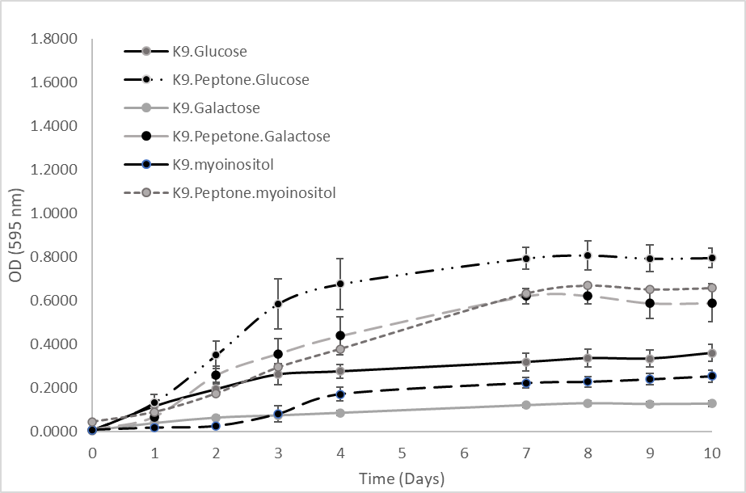

B

A

Fig. 2

**\*\*\***

Fig. 3

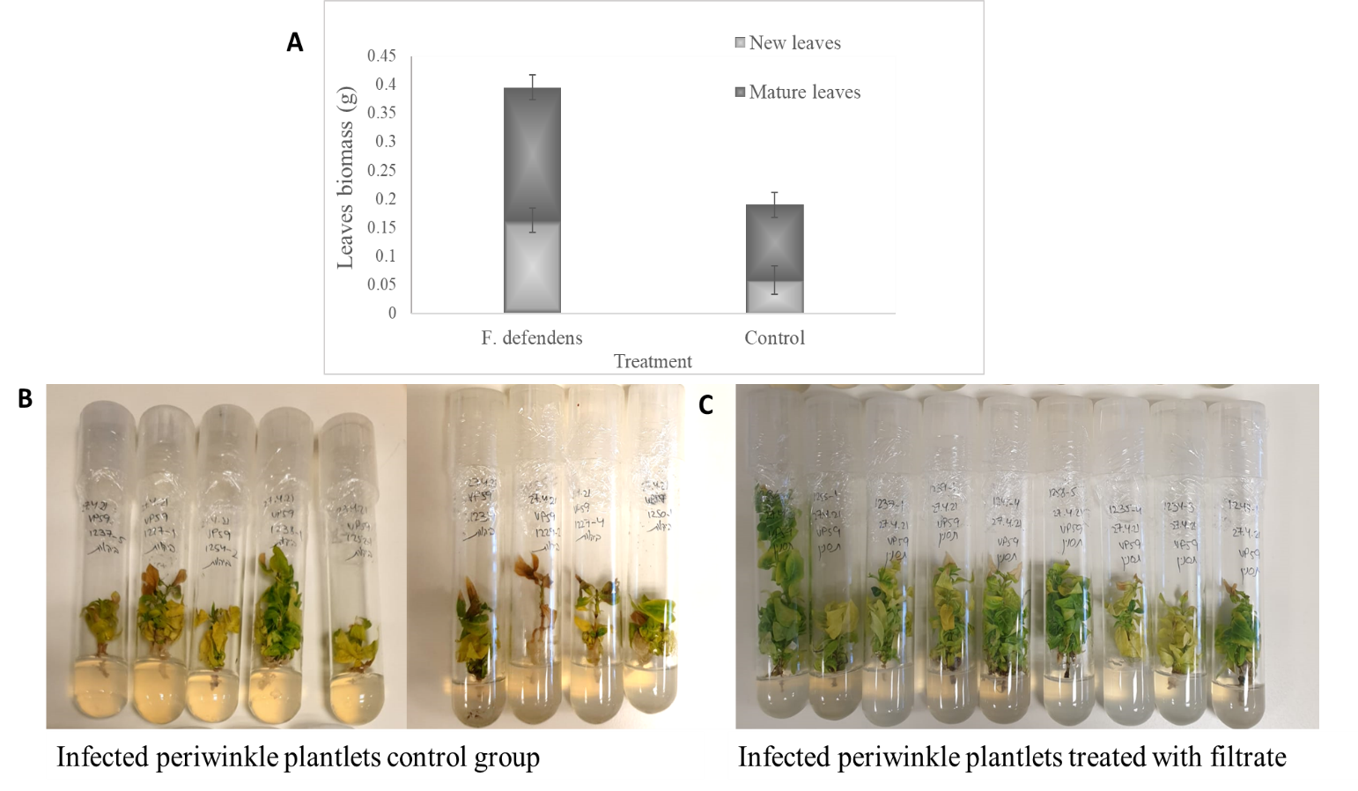

Fig. 4

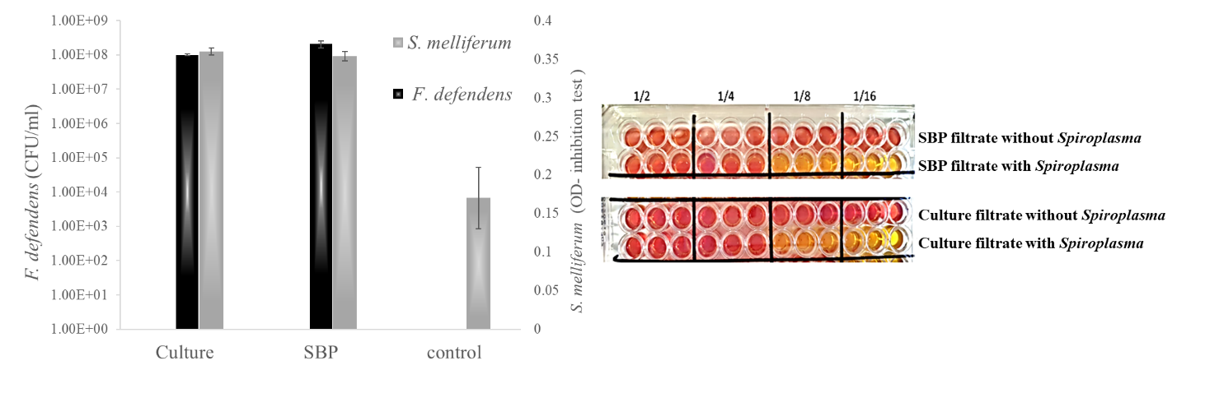

**Figure Legends**

Fig. 1: *F. defendens* bacterial growth curves in different media. A. Rich non-defined media: S-medium, NB, LB (LB Miller and LB Luria). B. Defined media based on K9 minimal salt medium, supplemented with a carbon source (glucose, galactose, or myoinositol), with or without peptone. Five replicates samples were assessed for each media formulation in three replicate experiments.

Fig. 2: The inhibitory effects of different *F. defendens* filtrates on *S. melliferum* growth in culture at two time points. Filtrates were tested after 4 and 10 days of *F. defendens* growth prior to filtration. Higher OD values correspond to lower growth. Sterile medium served as a negative control (NEG), and *S. melliferum* (approx. 107 CFU/ml) was cultured in S-medium as a positive control (POS). Data are given as means with standard deviations from triplicate samples, with results being representative of three replicate experiments. ***P < 0.01

Fig. 3: The effects of *F. defendens* filtrate treatment on the growth of phytoplasma-infected periwinkle plantlets at 21 days post-treatment. A. Plant biomass of mature and new leaves. B. Control filtrate-treated periwinkle plantlets treated with 1 mL of filtrate prepared from sterile S-medium. C. Filtrate-treated periwinkle plantlets treated with 1 mL of prepared *F. defendens* filtrate. Each plantlet was dipped in filtrate for 24 h before being replanted in plant agar.

Fig. 4: *F. defendens* growth in SBP versus liquid culture, and the inhibitory effect of secreted metabolites on *S. melliferum* growth. A. *F. defendens* culture growth and its effect on the growth of *S.melliferum*. The dark gray column corresponds to the live *F. defendens* cell count for each culture method, while the light gray column corresponds to the OD value as a readout for *S. melliferum* growth, with higher and lower OD values respectively corresponding to lower and higher levels of growth. *S. melliferum* in sterile S-medium served as a control. Each analysis was conducted with 8 replicates. B. Minimum Inhibitory Concentration (MIC) values for filtrates prepared from SBP or liquid culture. Different filtrates were subjected to serial two-fold dilution and mixed with S-medium containing phenol red. Yellow and red colors respectively correspond to *S. melliferum* growth and the absence of growth. *S. melliferum-*free medium served as a negative control.

**Supplementary Figures**

|  |  |  |  |  |  |  |  |  |  |  |  |  |
| --- | --- | --- | --- | --- | --- | --- | --- | --- | --- | --- | --- | --- |
| 12 | 11 | 10 | 9 | 8 | 7 | 6 | 5 | 4 | 3 | 2 | 1 |  |
| pH5 | pH6 | Positive Control | Stachyose | D-Turanose | Sucrose | Gentibiose | D-Cellobiose | D-Trehalose | D-Maltose | Dextrin | Negative control | A |
| 8% NaCl | 4% NaCl | 1% NaCl | N-Acetyl Neuraminic Acid | N-Acetyl-D-Galactosamine | N-Acetyl-β-D-Mannosamine | N-Acetyl-D-Glucosamine | D-Salicin | β-Methyl-D-Glucose | D-melibiose | α-D-Lactose | D-Raffinose | B |
| D-Serine | Fusidic Acid | 1% Sodium Lactate | Inosine | L-Rhamnose | L-Fucose | D-Fucose | 3-Methyl Glucose | D-Galactose | D-Fructose | D-Mannose | α-D-Glucose | C |
| Minocycline | Rifamysin SV | Troleandomycin | D-Serine | D-Aspartic Acid | D-Fructose-6-PO4 | D-Glucose-6-PO4 | Glycerol | myo-Inositol | D-Arabitol | D-Mannitol | D-Sorbitol | D |
| Niaproof 4 | Guanidine HCl | Lincomycin | L-Serine | L-Pyroglutamic Acid | L-Histidine | L-Glutamic Acid | L-Aspartic Acid | L-Arginine | L-Alanine | Glycyl-L-Proline | Gelatin | E |
| Tetrazolium Blue | Tetrazolium Violet | Vancomycin | D-Saccharic Acid | Quinic Acid | Mucic Acid | Glucuronamide | D-Glucuronic Acid | D-Gluconic Acid | L-Galactonic Acid Lactone | D-Galacturonic Acid | Pectin | F |
| Potassium Tellurite | Lithium Chloride | Nalidixic Acid | Bromo-Succinic Acid | L-Malic Acid | D-Malic Acid | α-Keto-Glutaric Acid | Citric Acid | L-Lactic Acid | D-Lactic Acid Methyl Ester | Methyl Pyruvate | p-Hydroxy-Phenylacetic Acid | G |
| Sodium Bromate | Sodium Butyrate | Aztreonam | Formic Acid | Acetic Acid | Propionic Acid | Acetoacetic Acid | α-Keto-Butyric Acid | β-Hydroxy-D,L-Butyric Acid | α-Hydroxy-Butyric Acid | γ-Amino-Butryric Acid | Tween 40 | H |

Fig. S1 BIOLOG results