**Survey of Graduate Students at Feinberg College: Main Findings**

**December 2021**

**Research Director:** Dr. Meytal Eran-Jona

Research Team:

Dr. Meytal Eran-Jona

Dr. Roni Orr

Sharon Diamant-Pick

**Main Findings: Abstract**

The student population of the Feinberg Graduate School (FGS) at the Weizmann Institute of Science is relatively homogenous. Most of the MSc and PhD students were born in Israel, come from a background of high socioeconomic status, and have parents who also received higher education. Three-quarters of the students have at least one parent of Ashkenazi background. One-third of the students receive economic support.

There is an under-representation of students from minority and marginalized groups in Israeli society: Arabs, Ultra-orthodox Jews, students from low socioeconomic backgrounds, and students who are the first generation in their families to receive higher education.

Students reported an extremely high level of satisfaction regarding the quality of education at FGS. They said they were highly satisfied with their relationship with their advisor and with campus services.

Most students indicated that they chose to study at the Weizmann Institute because of its prestige and excellence in the sciences, and also sought a positive learning environment.

The students reported a significantly lower level of satisfaction with the lecturers’ teaching abilities and with the content of the courses, in comparison to other aspects of the college.

The scholarships that students receive are perceived as non-competitive and are mainly for students studying mathematics, computer science, and physics.

Students reported low rates of bullying and sexual harassment (as compared to other institutes of higher education in Israel); however, there is a need to eliminate any kind of abuse of power.

Female students were significantly more likely say that they suffer from psychological difficulties, discrimination, bullying, and sexual harassment.

The survey was conducted during the Covid-19 pandemic, a context that created multiple challenges for all students, including: stress, social isolation, academic hardships, lack of mentor support, economic difficulties, and additional caregiving responsibilities.

Intersectionality of marginalized positions is challenging for FGS students. Students from minority group were more likely to report that they suffer from discrimination, psychological difficulties, and financial hardships.

**Introduction**

Feinberg Graduate School (FGS) is the educational arm of the Weizmann Institute of Science. Students can earn postgraduate degrees (master's, doctoral, and postdoctoral) in one of four faculties: physical sciences, mathematics & computer science, chemical sciences, or life sciences. FGS also has a department specializing in science education that prepares graduates to teach in these fields.

Dedicated to academic excellence, this educational institute is based on some 250 research groups that are at the forefront of a wide range of scientific fields. Academic studies take place in small groups, enabling students to receive individual attention. Students are integrated into the institute's research laboratories from an early stage of their studies. They receive an annual stipend for living expenses and a full exemption from tuition.

In the 2020-2021 academic year, the FGS administration conducted its first survey of its students. The survey covered a wide range of topics relating to the school’s agenda. The survey was conducted between December 2020 and January 2021, and was open to all FGS students. A high level of response was received; over 1,000 students responded, constituting 72% of the college.

This report presents the main findings pertaining to the topics covered in the survey: students’ socio-economic background, students’ opinions regarding their course of study, satisfaction with the academic and research tracks, rotation track schedules in the life sciences and chemical sciences faculties, difficulties and challenges faced during the Covid-19 pandemic, students’ relationships with their supervisors and the academic staff, the atmosphere and cultural aspect of the institute, and students’ perceptions of equality, discrimination, and experiences of abuse or sexual harassment.

The survey findings shed light on the institution’s strengths as well as on areas in need of improvement. Additionally, the survey enables an in-depth assessment of the challenges and difficulties that students face, and potential responses to students’ needs from various partners: the academic staff, lecturers, and the various institutions that provide services to students. The survey findings provided a basis for the administration’s decision-making processes. In the wake of these findings, a series of changes were implemented in areas such as: lecturers’ training, scholarships, a diversity and inclusivity program, and more.

This document presents a summary of the main findings of the survey, as a foundation for learning, decision-making, and future assessments.

**Methodology**

The survey was conducted in December 2020 and January 2021. It was designed to encompass the entire population of graduate and postgraduate students at FGS. A very high response rate (72%) was achieved by taking certain steps to ensure the largest possible number of respondents, including: a personal request from the dean that was distributed along with the survey, sending a number of personal reminders, and entering all respondents in a raffle with cash prizes. The details of the survey tool and the characteristics of the methodology are briefly presented below.

Graph 1 shows the number of students in the total college population compared to the number of respondents, by degree type.

**Graph 1**

*Total Student Population and Respondents, by Degree Level (in numbers)*

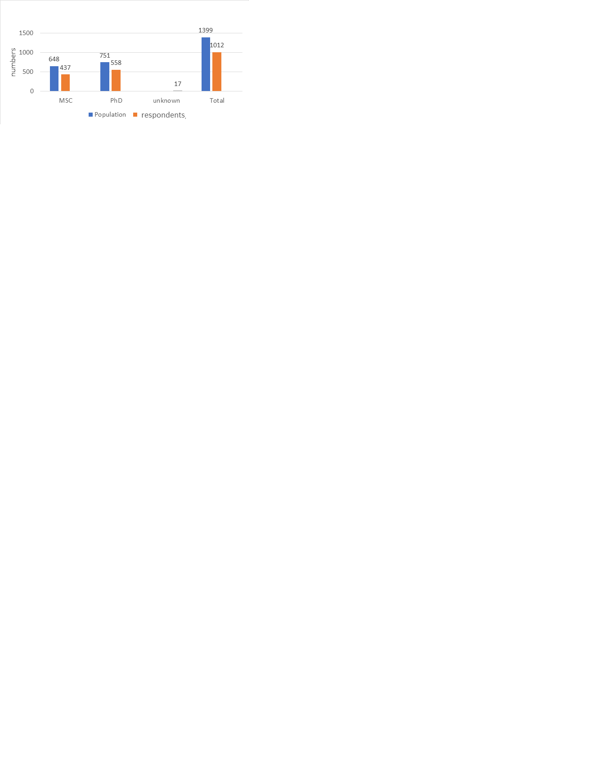

* Method: Self-completed questionnaire, sent by e-mail.
* Topics covered: socio-demographic traits of student population, satisfaction with the study program and services at FGS, satisfaction with academics and courses, attitudes towards the rotation track (chemistry and life sciences only), relationship with research supervisor, scholarships, dealing with the Covid-19 pandemic, personal difficulties, aspects of institutional atmosphere, equality and discrimination, and adverse experiences (bullying, sexual harassment, or other abuse of power).
* Response rate: Out of the total student population (N = 1,399) survey responses were received from 72% (N = 1,011). Among the master’s degree students, the response rate was 67% (N = 436 out of a total of 648). Among doctoral students, the response rate was 74% (N = 559 out of a total of 751).
* Maximum sampling error: for the general population ± 1.7%; for graduate students ± 2.7%, for doctoral students ± 2.1%.
* Survey implementation period: The questionnaire was sent to students for completion between December 2020 to January 2021, during the time of the Covid-19 pandemic. Studies were being conducted remotely, not on campus, and work in the research laboratories was intermittent, depending on the situational health regulations in response to the pandemic.

**Main Findings**

***Socio-demographic Traits of Students***

This first section examines the traits of the students and their socio-demographic background. The aim was to identify which population groups are represented and under-represented at the institute, as a basis for formulating a collaborative work plan to promote equal opportunities and diversity amongst the student population.

The survey results indicate that about half of the students at FGS are either married or in a long-term relationship. Approximately one-quarter of them have young children. One-fifth of the students are the first generation of their family to receive higher education. Over one-third of all students are financially supported by their parents.

Although there are student from around the world at FGS, most students were born in Israel (71%). Among Israeli-born students, there is very little representation of the Arab population and the ultra-Orthodox Jewish population minorities; approximately 1% of the student population is of each of these groups. It was also found that most Israeli-born students come from a relatively well-established socio-economic background; 80% of FGS students are from localities in the upper 7-10 socio-economic deciles (according to Israel Central Bureau of Statistics [CBS] definitions), compared to about 40% of the general public.

A summary of the main findings on this topic is presented below:

* **Average age of all students:** 29.4 years
* **Marital status:** 51% are married/in a relationship, 39% are single, 1% are divorced or separated, 9% unknown. The marriage rate is higher among doctoral students (57%) compared to graduate students (41%).
* **Children:** 23% of the students have children. The representation on students with children is much higher among doctoral students (35%) than among graduate students (9%).
* **Country of birth:** 71% were born in Israel, 8% are from Asia, 7% from Europe, 7% from former USSR countries, and 5% from North America.
* **Self-defined religious identity:** 79% identified themselves as Jews, 6% as Christians, 3.4% as Hindus, 1.2% as Muslims, and approximately 10% defined themselves as atheists or agnostics.
* **Ethnicity among Jewish students:** 55% of the Jewish students identified themselves as Ashkenazi, 15% as Mizrahi, 27% mixed, and 1% as other.
* **Religiosity among Jewish students:** The vast majority (72%) of the Jewish students said they are secular, 14% defined themselves as traditional, 8% as religious, and 1% as ultra-Orthodox.
* **Financial situation:** Approximately 25% of all students said they work alongside their studies. 38% said they received financial support from their parents during their studies (amongst them, 24% said they received minimal financial support from their parents and 14% said they received significant financial support).
* **Parents’ higher education:** 20% of the students are the first generation in their family to receive higher education, and 45% have at least one parent with a master's degree or doctoral degree.
* **Socio-economic status:** The majority of Israeli-born students come from localities in deciles 7-10, according to the CBS index of socio-economic index of localities. 82% of master’s degree students and 79% of doctoral students come from localities in decile 7-10, as compared to about 40% of the general public in Israel.

|  |  |  |  |  |
| --- | --- | --- | --- | --- |
| **Decile of home localities’ socioeconomic status according to the CBS scale** | **MSc students**  **(N = 277)** | **PhD students**  **(N = 297)** | **Total**  **(N = 573)** | **Israeli population** |
| **1-4 (Low SES)** | 3% | 5% | 4% | 36.8% |
| **5-6** | 12% | 14% | 13% | 23% |
| **7-8** | 78% | 74% | 76% | 39% |
| **9-10 (High SES)** | 4% | 5% | 5% | 1.3% |
| **Born abroad** | 3% | 2% | 2% | -- |