**Computer Science and Physics**

**Why this track is unique:**

**This is a joint program towards a Bachelor of Science degree (BSc) in Computer Science and Physics.**

The Faculty of Computer Science and the Faculty of Physics offer a joint program designed for outstanding students (excellence program). Upon the completion of their studies, graduates will receive a **Bachelor of Science (BSc) in Computer Science and Physics**.

Detailed information regarding the excellence program for both faculties can be viewed separately under the acceptance requirements of the main faculties (Computer Science or Mathematics).

**Career Options and Job Opportunities**

[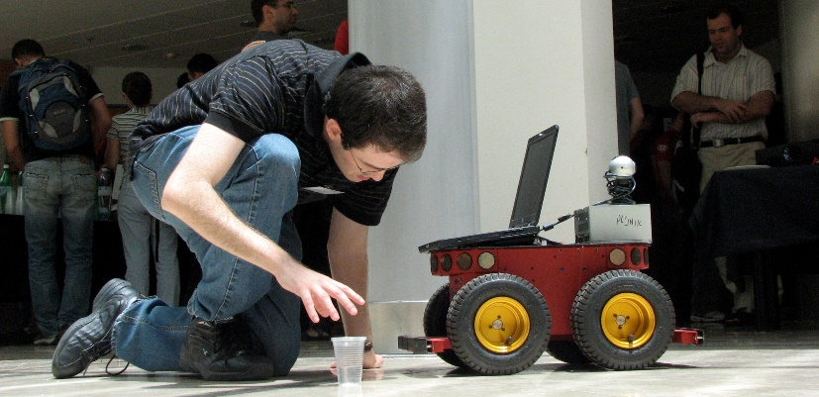](https://admissions.technion.ac.il/files/2014/05/%D7%9E%D7%93%D7%A2%D7%99-%D7%94%D7%9E%D7%97%D7%A9%D7%91-1.jpeg)

The goal of the track is for undergraduates to gain **a deep understanding of both computer science and physics**, allowing them to lead and participate in both research and industry in these fields. Participants in this track are excellent students, most of whom continue to graduate studies in either of the two faculties. Others are accepted into other leading universities, or find rewarding employment in the hi-tech industry. It is important to note that over the last few years, the hi-tech world has developed an increasing interest in quantum computers, quantum communication, and quantum cryptography.

**This track is especially suitable for students interested in specializing in interdisciplinary fields, such as: Quantum Computing | Quantum Communications and Cryptography | Computer Physics | Scientific Computing | Computational Physics | Intelligent Systems | Optics and Image Processing | Optical Communication | Dynamics | and more. Moreover, graduates acquire broad and extensive knowledge which greatly benefits them in any direction they choose to pursue, either in the industry or in academia.**

**Study Program**

This eight-semester program includes all the mandatory courses from both the Computer Science and Physics faculties, and the courses in this program are evenly distributed across both fields. **Students enjoy the benefits and services of both faculties, Computer Science and Physics;** they are granted access to both faculties' libraries, computer rooms, and laboratories.

**Graduates of this track may continue their studies towards a master’s degree (MSc) in either of the two faculties. Graduates of this track will be considered as graduates of a four-year program when applying for the masters’ program in either the Faculty of Computer Sciences or the Faculty of Physics.**

**Secondary Specialization Track in Quantum Computing**

This program is offered by the Faculty of Computer Science and is especially suitable for outstanding students in the combined Computer Science and Physics track. Detailed information can be found in the catalog for undergraduate studies of the Faculty of Computer Science. Graduates both of this track and the excellence program have an advantage as prospective candidates for graduate degree programs specializing in quantum computing and technology in several faculties at the Technion, including the Faculty of Physics.

**Contact Us:**

**Computer Science: Ortal Amsalem, Yael Saar, Miriam Shira Weiss | 077-8874344/4316/2206 |** [**ugoffice@cstechnion.ac.il**](mailto:ugoffice@cstechnion.ac.il) **|** [**cs.technion.ac.il**](http://www.cs.technion.ac.il/he) **| Physics: Prof. Yariv Kafri |** [**kafri@physics.technion.ac.il**](mailto:bergman@physics.technion.ac.il) **| 077-8775936 | Etti Maman |** [**eti@physics.technion.ac.il**](mailto:eti@physics.technion.ac.il) **| 077-8875585 |** [**phys.technion.ac.il**](http://phys.technion.ac.il/he/)