**Computer Science — The Best of All Worlds**

**Study Tracks**

**The list of degrees and years of study are detailed in the Undergraduate Studies Catalogue**

|  |
| --- |
| **Computer Science (a three-year program)**   * **General track** * **Learning and Data Analysis program** |
| **Computer Science (four-year program)**   * **General track** * **Cyber and Computer Systems Security** * **Computer Science with a specialization in Bioinformatics** |
| **Software Engineering** |
| **Computer Engineering** |

**Secondary Specialization in All Tracks**

|  |
| --- |
| **Quantum Computing** |

**Computer Science — Sparking a Revolution**

Computer Science has changed the world exponentially, and more than anything has defined the 21st century through several technological advances. These enabled the progress from early computers—with their cogs and switches—to today’s Internet, and gave us the ability to quickly and efficiently process information in a way that continues to change our world.

Computers are everywhere today—from smartphones to the computers and servers which transfer money at the click of a button or fly airplanes. Many of us spend long hours at work in front of a computer, followed by media consumption and entertainment on our devices. The progress does not stop and computers continue to create new paradigms, from automated cars to quantum computing. So, what does the future hold in store for us? That depends on you.

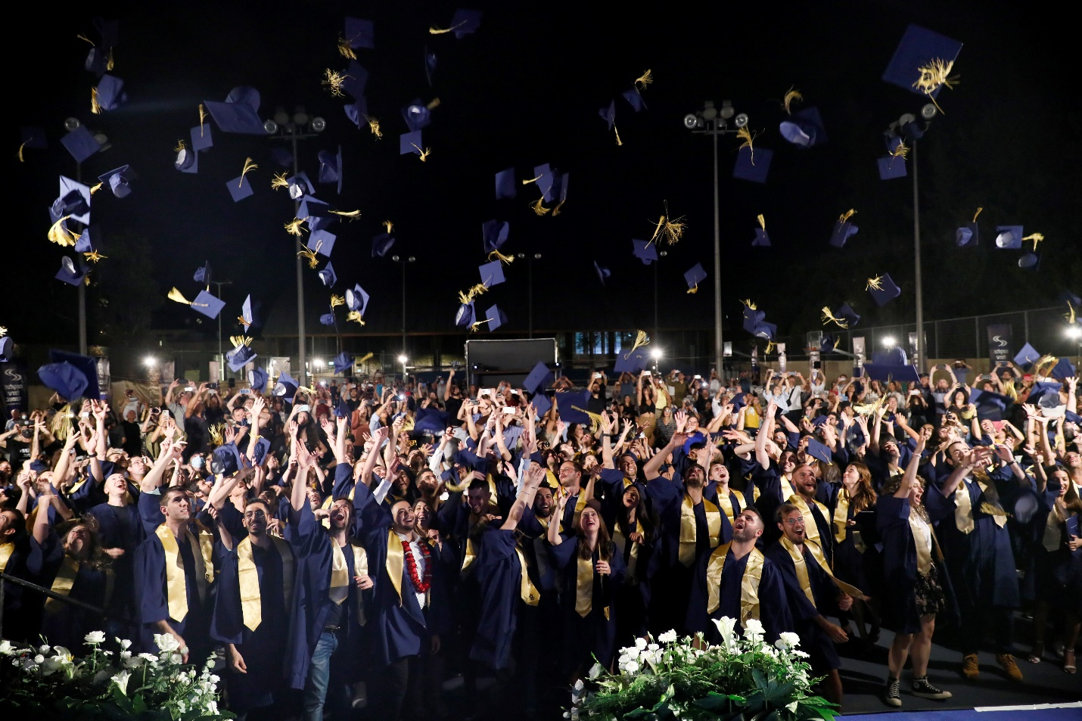

**Computer Science at the Technion**

The Henry and Marilyn Taub Faculty of Computer Science at the Technion is a world leader in the field and facilitates a unique intersection between science and technology. It is the largest faculty of its kind in Israel, with over 2,000 undergraduate students and another 300 students in graduate programs (MSc and PhD). Over 55 faculty members teach in the program, each of them scholars of international reputation, who educate and train the next generation of global hi-tech industry leaders and the scientists of the future.

The CS Ranking (2018) of most quoted institutions for computer science ranked the Technion 18th in the field of computer science, worldwide. In addition, an international evaluation committee that carried out a detailed survey of the faculty in May 2018 determined according to international standards, that the faculty has consistently been a leader in computer science for the past 25 years.

The Faculty of Computer Science provides students with tools for analytical thinking in addition to practical experience in the design and construction of programming systems. Indeed, many graduates are leaders in the hi-tech industry, fill key positions in prominent companies, and are integrated into the world’s leading research facilities.

The Faculty of Computer Science offers unique study tracks, some in collaboration with other faculties at the Technion, and has a variety of designated excellence programs. This enables students to design their study programs to best suit their ambitions and fields of interest. In an era where everything is computerized, the research subjects offered in the faculty cover a wide range of topics. Within the clusters which comprise the study fields, you will find dozens of courses in which you can deepen your knowledge and specialization. Alongside the theoretical studies, from the fourth semester onwards you will also experience practical work in the faculty laboratories. Developing projects in your fields of interest will further allow you to acquire new skills, adding to the resource of practical experience that you amass.

**Our Unique DNA**

The faculty places great importance on developing an optimal and inviting learning environment; providing an advanced learning environment in cooperation with the students and attention to their needs.

The Computer Science Students’ Committee offers a social and academic platform for students with a variety of events and activities: round tables for making acquaintances during the first semesters, semester parties, movie screenings, gaming and tabletop game tournaments, an “open stage” evening with live performances and artists, hackathons, and competitive challenges.

The infrastructure at the Faculty of Computer Science supports a unique learning experience on campus—the faculty building is a “smart building” that includes a unique and well-designed learning space. This allows for an alternative learning environment, including auditoriums and classrooms which are equipped with advanced multi-media devices for hybrid learning, a spacious balcony with lush seating arrangements, and a library with designated conference rooms for students. The faculty also has state-of-the-art teaching laboratories that students can use for their workshops and projects.

With us, you will find everything you need and more—to deepen your knowledge, flourish, research, and breakthrough boundaries.

Facebook: <https://www.facebook.com/technioncs/>

Instagram: <https://www.instagram.com/cs.technion/>

YouTube: <https://www.youtube.com/channel/UCwdJtbLuOU-lf--BXICWHgg>

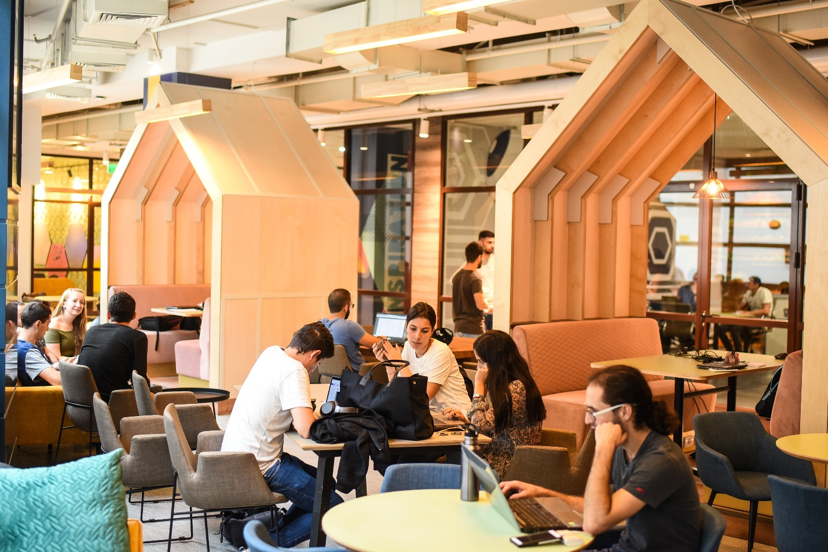

**Endless Opportunities**

The Faculty of Computer Science places special emphasis on cultivating student relationships with the industry, hence, our graduates are among the most sought-after and well-paid employees in the job market. During their studies, students are exposed to the hi-tech industry through projects led by engineers, career and hiring days, summer internships, scholarships, and enriching bonus lectures. In addition, there is mentoring by entrepreneurs, CEOs, engineers, and hiring teams, who offer advice throughout the process of entering the workforce and with career development. Many of the faculty’s graduates are at the forefront of the global STEM industry, have keystone positions in prominent hi-tech industries, and promote entrepreneurship.

**Among our Graduates**

#### Karin Eibschitz-Segal

###### Vice President & General Manager of Intel Israel Development Center and Intel Validation Engineering in the Design Engineering Group, Intel Corporation

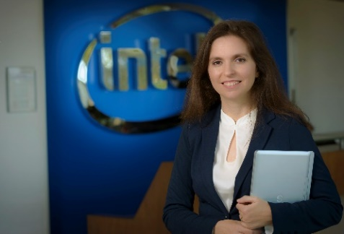

*Dr. Kira Radinsky*

# Entrepreneur. Founder & CEO, Diagnostic Robotics

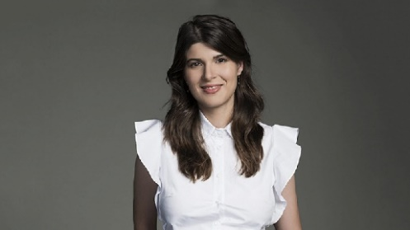

# *Johny Srouji*

## Senior Vice President Hardware Technologies, Apple

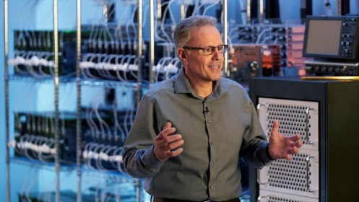

**The Sky is the Limit — Excellence Programs**

**The “Lapidim” Excellence Program**

“Lapidim” is an excellence program that identifies and trains outstanding students who have the potential to become leaders in the hi-tech industry and academia. The acceptance process is very selective and is based on both academic excellence and strong interpersonal skills. This program identifies outstanding academic students who possess leadership qualities and exceptional skills and offers them an inspiring study and work environment. In addition, the program exposes them to the worlds of academia, industry, and technology, through contact with seniors, entrepreneurs, venture capitalists, incubators, and others.

The Lapidim program offers a unique and supportive learning environment that includes a designated study area for program participants, mentoring by a faculty member, exemption from tuition fees, a monthly living stipend, and more.

The program website: <https://lapidim.cs.technion.ac.il/he/about/overview/>

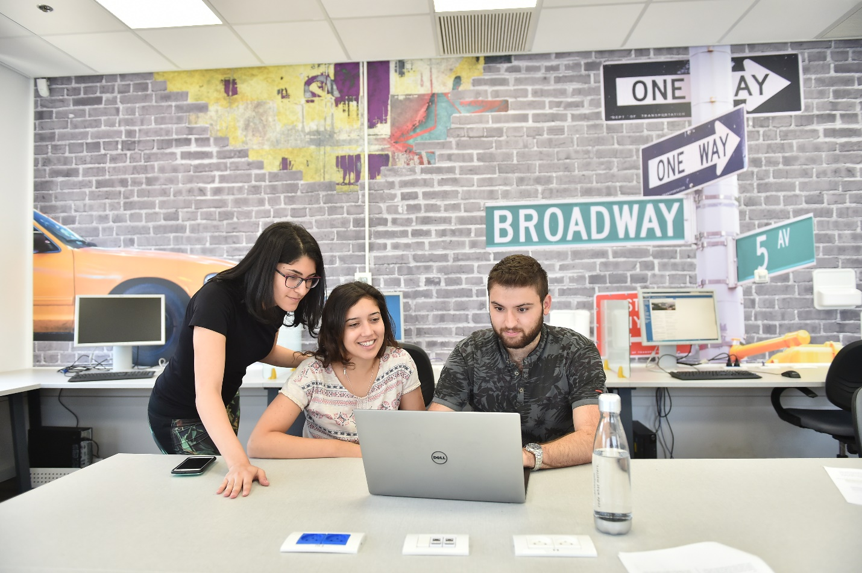

**The “Academic Leadership” Excellence Program**

This is a new excellence program within the faculty, which preps students who have the potential to pursue an academic career as future university faculty members. The selection process emphasizes qualities important for success as faculty members: academic excellence, a passion for science and research, and the ability to motivate a research team. Participants in this program are entitled to benefits including mentoring by a faculty member, exemption from tuition fees, and a monthly stipend.

**“Samba” — Excellent Students in Computer Science**

As part of the objective to encourage excellence, the faculty offers one-off scholarships for outstanding undergraduate students. This program is open to all students enrolled in the faculty, in all tracks, including tracks that are jointly run with other faculties. Acceptance to this program is based on criteria that are updated periodically.

**Excellence Program in Enhanced Software Engineering and the “Psagot” Program for Outstanding Academic Reserve Students**

This is an excellence program in software engineering aimed at training future R&D leaders in hi-tech industries and Israel’s security forces. Participants in this program complete all academic requirements for a BSc in Software Engineering, as well as most courses necessary for an MSc, during four years of study. Enrollment and acceptance processes are carried out by the IDF, which approaches the suitable candidates personally. The faculty is not responsible for the enrollment process and acceptance to this program.

**Female Students in the Faculty**

The faculty finds extreme importance in expanding the presence and influence of women in hi-tech. Female students in the faculty lead a community called SHE-S, whose goal is to strengthen the networking between female students and to create a fruitful and enriching environment in the field of technology and careers. In addition, hi-tech companies offer a variety of scholarships to encourage and promote women in the field of computer science.

SHE-S group: <https://www.facebook.com/groups/1010542439460278>

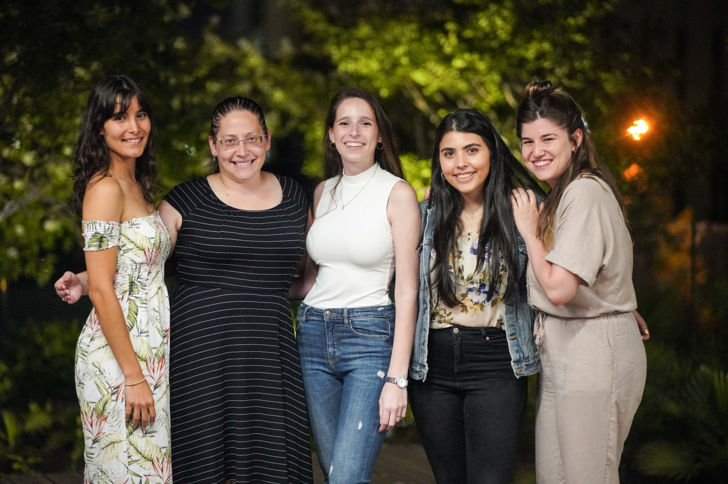

**Study Tracks**

**Computer science is a broad topic. Therefore, the faculty offers several study tracks and specialized programs.**

**Three-year Track**

**A three-year track** toward a Bachelor of Science degree (BSc) in Computer Science.

**General Three-Year Track**

This track is geared towards students interested in a wide range of subjects within computer science: **Software and Hardware studies, Computer Engineering and Applications, Artificial Intelligence, Computer Science Theory, and more.**

**Machine Learning and Data Analysis Specialization Program**

This program trains future engineers who will specialize in data collection, signal and data processing and analysis, and the study of methods and algorithms in these fields. The program focuses on the principles of data processing and the extraction of content through the use of signal processing tools, statistical reasoning, and machine learning. This program provides graduates with a broad background in computer science, in addition to mathematical enrichment and courses specializing in the compilation, processing, and learning from data. Graduates will receive a Bachelor of Science degree (BSc) in Computer Science. The name of the program will appear in a certificate appended to the graduation diploma and transcript.

**Participants in the four-year General Computer Science Track and the Software Engineering Track** will also be eligible to receive the Machine Learning and Data Analysis certificate in addition to the four-year degree, on condition that they fulfill the requirements and the number of credits necessary for the completion of the degree in the main track in which they are enrolled, as well as completing the specific (mandatory and core) requirements of the Machine Learning and Data Analysis program.

**Four-Year Track**

**A four-year learning track** toward a Bachelor of Science degree (BSc) in Computer Science.

**General Four-Year Track**

This track is geared towards students interested in a wide range of topics within computer science: **Software and Hardware studies, Computer Engineering and Applications, Artificial Intelligence, Computer Science Theory, and more.**

**Cyber and Computer Systems Security Specialization Program**

**Participants in the four-year track can choose the Cyber and Computer Systems Security specialization program.** The goal of this program is to train undergraduates who will specialize in cyber security. Graduates of this program will have a broad background in computer science with an emphasis on the theory and practice of security in the digital world.

Graduates receive a Bachelor of Science degree (BSc) in Computer Science. The name of the program will appear in a certificate appended to the graduation diploma and transcript.

**Computer Science with a focus on Bioinformatics Specialization Program**

This specialization program is jointly run by **the Faculty of Computer Science and the Faculty of Biology.**

The goal of this program is to train undergraduates to enter and lead the bioinformatics industries or advance into graduate studies that combine an understanding of both life sciences and computer science. The curriculum provides students with broad knowledge in a variety of fields in computer science, as well as fundamental molecular and cellular biology, focusing on computational biology and the software tools and systems of bioinformatics.

Graduates will receive a Bachelor of Science degree (BSc) in Computer Science. The name of the program will appear in a certificate appended to the graduation diploma and transcript.

**Software Engineering Track**

This is a four-year track toward a Bachelor of Science degree (BSc) in Software Engineering. **The Software Engineering Track trains engineers who will specialize in large software systems.** Participants in this track learn a variety of programming methods, such as analysis, design, application, testing, verification, maintenance, evaluation, and software conversion. This track provides students with a broad background in applied computer science and thorough experience with creating software and the use of advanced tools for software engineering.

**Computer Engineering Track**

This is a four-year track toward a Bachelor of Science (BSc) in Computer Engineering. **This track is jointly run with the Faculty of Electrical Engineering and Computers.** This program provides students with a broad background in both software and hardware and trains them as engineers who specialize in the design, construction, and programming of computers and computer-based electronic systems.

**Secondary Specialization Programs for all Tracks**

**Quantum Computing**

The Faculty of Computer Science also offers a specialization program in Quantum Computing and Information. This secondary specialization can be added to any study program in the faculty, including the tracks joint with other faculties. Students who complete this specialization will receive a certificate that confirms that they have successfully completed this secondary program.

**Joint Tracks**

The faculty offers **three** study tracks in cooperation with other faculties.

1. **Computer Science and Mathematics** **—** This track is run jointly by the Faculty of Computer Science and the Faculty of Mathematics, for students with exceptionally high grades. **This is a direct admission track that requires a separate application process.**
2. **Computer Science and Physics —** This track is run jointly by the Faculty of Computer Science and the Faculty of Physics, for students with exceptionally high grades. **This is a direct admission track that requires a separate application process**.
3. **Medicine and Computer Science (double degree)** **—** This track is run jointly by the Faculty of Medicine and the Faculty of Computer Science, for exceptional students with especially high grades. **This program awards a double degree: a Bachelor of Science (BSc) in Medicine Science and a Bachelor of Science (BSc) in Computer Science.** The goal of this track is for undergraduates to gain a deep understanding of both computer science and medicine, enabling them to lead in each of these fields separately; in research, development, and industry that requires knowledge of both. **This is a five-year program. After successfully completing all the requirements for a double degree, students may continue to the clinical division (according to application guidelines for medicine) for three additional years plus a year of residency, toward a Medical Doctor degree (MD).** This program is intended for students who were accepted to medical school and wish, in addition, to pursue a degree in computer science. **Completing only one of the two degrees will require the fulfillment of all the requirements of that degree.**

The Technion has additional programs which provide partial knowledge in computer science and software, which are headed by other faculties and not in conjunction with the Faculty of Computer Science. **Those tracks are under the sole responsibility of the faculties offering those courses.**

**Study Program**

**Students enrolled in the Computer Science track can choose between the following programs: Three-Year Computer Science | Four-Year Computer Science | Software Engineering | Computer Engineering | Machine Learning and Data Analysis | Cyber and Computer Systems Security | Computer Science with a focus on Bioinformatics**

**(See also the Joint Programs detailed above)**

**These study programs include a wide range of topics:**

**Computability Theory | Algorithms and their Complexity | Coding and Cryptography | Machine Learning | Artificial Intelligence | Natural Language Processing | Computerized Vision | Image Processing | Computerized Graphics | Computational Geometry | Robotics and Automation | Software Engineering | Compilation | Formal Verification of Software and Hardware Systems | Programming Languages | Data Processing and Operating Systems | Computer Architecture | Computer and Internet Networks | Parallel and Distributed Algorithms | Logic for Computer Science | Neural Networks | Computational Biology | Quantum Computation and Cryptography | Databases | Parallel and Distributed Programming | Interconnection and Sorting Networks | Geometric Design | Applied Mathematics | Numerical Algorithms | Optimization and Applied Engineering and Scientific Specializations**

**The curriculum consists of three sections:**

**The first section**, taught during the first three semesters, provides **fundamental information in core subjects**: Mathematics, Physics, Fundamentals of Programming, and more.

**The second section** includes mandatory courses from The Faculty of **Computer Science**. In the joint engineering program, the curriculum also includes courses from the Electrical Engineering program.

The **Computer Science with a focus on Bioinformatics** program includes mandatory courses from the Faculty of Biology.

The **joint Computer Science and Mathematics** program includes mandatory advanced courses in **mathematics.**

The **joint Computer Science and Physics program** includes mandatory advanced courses in **physics.**

This section provides students with fundamental knowledge in each of the faculties’ fields of specialization, ensuring that all faculty graduates will have a broad background and won’t be limited to a narrow field of specialization.

**The third section** of the curriculum includes **faculty elective courses**, where students specialize in topics of their choice. In addition, students carry out projects in campus laboratories as part of their study requirements, gaining practical experience in their field of interest.

**Graduates’ Experience**

**Nofar, a graduate of BSc, MSc, and PhD in the Faculty of Computer Science.**

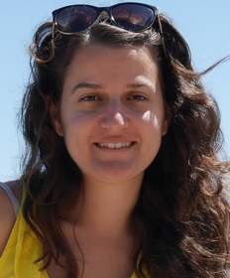I have always been interested in many subjects, and deciding what to study wasn’t easy. I tried to think of fields that I found interesting, and I started comparing them to one another to try and imagine which I would enjoy working in more. **I decided that I want to study a profession where I can create something. I chose computer science because it appeared to be a broad subject area where I can find interesting employment in the future.** In fact, today I enjoy doing theoretical research in computer science, despite not having considered this an option when I began studying. To be honest, at first, I didn’t fully understand what computer science was, asides from programming. We deal with problem-solving, and computers are only a tool. “Computational Engineering” is perhaps a term that better describes what I do here. **The Technion was a natural choice for me since I grew up in the North—I knew of the Technion’s good reputation and its impressive curriculum.**

**The first semester was difficult, and my enjoyment increased over time.** Throughout the semesters, I adopted successful and calm study habits and created a social environment that suited me. I utilized the Technion’s student exchange program with the University of Toronto to spend an exciting semester abroad. There I tried “Improv” (theater improvisation) for the first time. When I returned to Israel, we started our own “Technion Improv” where I found a funny and liberating social circle with which I am still connected.

In the faculty’s excellence program, “**Lapidim”**, I got to know people whom I really like. Thanks to them, I enrolled in a competitive programming course, in which teams solve problems using theoretical methods studied in the faculty’s core courses. This was the most enjoyable class I took during my undergraduate studies, not even to mention the fact that I went to Portugal with my team to represent the Technion in an international competition.

**At the end of my undergraduate studies, I felt good here—both personally and professionally—and decided to continue here for my graduate studies, later pursuing a doctorate as well.**

**My tip: Set consistent times for activities you enjoy—it is impossible to work all the time anyway (not effectively, at least). This will help you work better during studying time, and you will gain quality time as well.**

**Contact Us:**

Ortal Amsalem | Yael Saar | Miriam Shira Weiss

077-8872206 | 077-8874344 | 077-8874316

[**cs.technion.ac.il**](http://www.cs.technion.ac.il/he/index.html) | [**ugoffice@cs.technion.ac.il**](mailto:ugoffice@cs.technion.ac.il)

### [Back to the list of Study Tracks](https://admissions.web.technion.ac.il/study-tracks/)