

Author Questionnaire (Book Proposal)

1. The main title should be less than 57 characters, which will show up as 19 characters / line x 3 lines. Make sure it specifically conveys the topic of your book. Avoid phrasing your title in the form of a question.

***“Japanese Enterprise and German Enterprise: Comparison of Industrial Concentration and Business Management”***

1. Indicate whether your book is a single-authored volume, a co-authored volume or an edited volume.

■Single-Authored Volume

□Co-Authored Volume (maximum of three co-author names on the cover)

□Edited Volume (maximum of three the volume editor names on the cover) (edited volumes typically

include more than five chapters by chapter contributors

C. Indicate the Name(s) of the Author(s) or Editor(s) in the order that they should appear on the front cover of the book. Also indicate one main title(s), one main institution(s), e-mail and postal address (es). The name(s), title(s) and institution(s) will also appear inside the book.

|  |  |
| --- | --- |
| Name of volume author/editor 1 (**main corresponding author/editor**): Toshio Yamazaki | |
| Institution (One main institution): | Ritsumeikan University |
| Faculty/Department: | College of Business Administration |
| Title (Professor/Associate Professor/Etc.): | Professor |
| e-mail address: | tyt01363@ba.ritsumei.ac.jp |
| Complete postal address: | 567-8570 |
| Building Name, Floor & Room Number | Building A, 9th floor, Room Number 9414 |
| Telephone number: | +81-72-665-2440 (072^665-2440) |
| [ORCID id](https://www.springer.com/gp/authors-editors/orcid) (if you have one)*: |  |

* If you do not have an ORCID id, register for free here: <https://orcid.org/>

* To ensure secure postal delivery, please indicate details of the building name, floor, room number, and telephone number.

1. Please provide us a brief summary for marketing your book within 1,000 to 1,900 characters (including spaces and punctuation marks) (Approximately 150 - 200 words). Please see Appendix 1 of this document for details on how to write the description. Springer’s online SEO copy-editor will later copy-edit your summary.

The purpose of this book is to analyze and compare characteristics of corporate expansion in postwar Japan and Germany. It explores how distinctive Japanese and German business management styles were created and evolved according to both exogenous and endogenous factors, drawing for the first time on many fields related to business administration, such as the concentration of enterprise, management systems, production systems, management education, marketing, organizational structure, business strategy, and corporate governance. The book examines commonalities and differences of business management and how development of business management determined the regionalization in each country, notably Germany’s “Europeanization” and Japan’s “Asianization.” This book provides a unique understanding of business management and capitalism in both nations. These arguments reframe how we understand the mechanisms of corporate expansion. Demonstrating business management and the resulting logic of development of enterprise in Japan and Germany, this book will prove invaluable to readers interested in business management, business history, and economic history and international comparative study.

**To be included (suggestion: after sentence 3):** from the perspective of the author’s original framework “Re-framing.”

1. Please write a short SEO Metadata description within 130-150 characters (characters, including spaces and punctuation marks – not words). Springer will later copy-edit your metadata description.

This book analyzes/compares business management in postwar Japan and Germany, arguing that processes of regionalization shaped each country’s corporate expansion.

1. Please tell us three unique selling points (USPs) of your book (under 60 – 110 characters (including spaces and punctuation marks) each). USP’s should show why a customer wants to buy your book and they will show up front and center on springer.com. Springer will later edit these USPs.

|  |  |
| --- | --- |
| 1. | Argues that the industrial concentration determined the competition structure and corporate expansion in postwar Japan and Germany |
| 2. | Compares the Americanization of business management in Japan and Germany from the author’s original framework of “Re-framing” |
| 3. | Examines how business management in Japan and Germany after the war determined the trend toward regionalization |

1. Please provide more than 6 keywords that are applicable to your book. These key words will be used for Search Engine Optimization. Keywords should be single words or two-word phrases, not multi-word phrases, that potential readers are likely to use on search engines to find the content. They should be concrete and specific, yet concise. Each keyword should be no longer than 64 characters (including spaces and punctuation marks).

|  |  |
| --- | --- |
| 1. | Americanization |
| 2. | Business management |
| 3. | German enterprise |
| 4. | Industrial concentration |
| 5. | Japanese enterprise |
| 6. | Regionalization |

1. Please provide us the table of contents. It does not matter if it is only a tentative one.

**Preface**

**Chapter 1 Introduction: Research Topics and Analytical Framework**

1.1 Awareness of the Issues of this Book

1.2 Research Topics

1.3 Prior Research and Issues Thereafter

1.4 Analytical Framework

***Part 1 Total System of Business Management and Characteristics of Management in Japan and Germany***

**Chapter 2 Overview of the Total System of Business Management in Postwar Japan and Germany**

2.1 Overview of the Total System of Business Management in Japan after World War II

2.2 Overview of the Total System of Business Management in Germany after World War II

**Chapter 3 Characteristics of Business Management in Japan and Germany**

3.1 Commonalities of Business Management among Major Countries

3.2 Characteristics of Japanese Business Management

3.3 Characteristics of German Business Management

***Part 2 System of Postwar Industrial Concentration***

**Chapter 4 Structures and Functions of Large Corporate Groups**

4.1 Influence of the US De-concentration Policy on Monopolies in Japan and Germany

4.2 New Developments in the System of Large Corporate Groups in Japan

4.3 New Developments in the System of Large Corporate Groups in Germany

4.4 Japanese and German Characteristics regarding the System of Large Corporate Groups

**Chapter 5 New Developments of the Industrial System Based on Industry****–Bank Relationships**

5.1 New Development of Industrial Concentration Based on Industry–Bank Relationships in Japan

5.2 New Development of Industrial Concentration Based on Industry–Bank Relationships in Germany

5.3 Japanese and German Characteristics of Industrial System Based on Industry–Bank Relationships

***Part 3 Americanization of Business Management and “Re-framing” in the Postwar Boom Years***

**Chapter 6 Deployment of American Management Education**

6.1 Deployment of American Management Education in Japan

6.2 Deployment of American Management Education in Germany

6.3 The Characteristics of Japanese and German Deployment of American Management Education

6.4 Re-framing in the Deployment of American Management Education in Japan and Germany

**Chapter 7 Deployment of Human Relations**

7.1 Deployment of Human Relations in Japan

7.2 Deployment of Human Relations in Germany

7.3 The Characteristics of Japanese and German Deployment of Human Relations

7.4 Re-framing in the Deployment of Human Relations in Japan and Germany

**Chapter 8 Deployment of Industrial Engineering**

8.1 Deployment of Industrial Engineering in Japan

8.2 Deployment of Industrial Engineering in Germany

8.3 The Characteristics of Japanese and German Deployment of Industrial Engineering

8.4 Re-framing in the Deployment of Industrial Engineering in Japan and Germany

**Chapter 9 Deployment of the Ford System**

9.1 Deployment of the Ford system in Japan

9.2 Deployment of the Ford system in Germany

9.3 Re-framing in the Deployment of the Ford system in Japan and Germany

9.4 The Rollout of Mass-Production Systems and Japanese and German Manufacturing

**Chapter 10 Deployment of Marketing Methods**

10.1 Deployment of Marketing Methods in Japan

10.2 Deployment of Marketing Methods in Germany

10.3 The Characteristics of Japanese and German Deployment of American Marketing Methods

10.4 Re-framing in the Deployment of American Marketing Methods in Japan and Germany

**Chapter 11 Deployment of a Divisional Structure**

11.1 Transformation of Business Strategy and Deployment of Divisional Structure in Japan

11.2 Transformation of Business Strategy and Deployment of Divisional Structure in Germany

11.3 The Characteristics of Japanese and German Deployment of the Divisional Structure

11.4 Re-framing in the Deployment of Divisional Structure in Japan and Germany

**Chapter 12 “Re-framing” in the Americanization Process and Japanese-Style Management and German-Style Management during the Postwar Boom Years**

12.1 Japanese- and German-Style Adaptation in the “Americanization” of Business Management

12.2 “Re-framing” in the Americanization Process and Japanese-Style Management

12.3 “Re-framing” in the Americanization Process and German-Style Management

***Part 4 Business Management in the Periods from the 1970s to the 1980s and after the 1990s***

**Chapter 13 Development of Mass Production Systems in Japan and Germany from the 1970s to the 1980s and Its Significance**

13.1 Social and Economic Background Regarding the Reforms of the Mass Production System

13.2 Production System Reforms in Japan

13.3 Production System Reforms in Germany

13.4 Significances of the Reforms of the Mass Production System in Japan and Germany

**Chapter 14 Transformation toward Shareholder Value-Oriented Management and Corporate Governance in Japan and Germany after the 1990s: Resurgence of the Americanization of Business Management**

14.1 Influence of US-led Financialization in Japan and Germany

14.2 Transformation toward the Shareholder Value-Oriented Management Model in Japan

14.3 Transformation toward the Shareholder Value-Oriented Management Model in Germany

14.4 “Re-framing” in the “Americanization” of Business Management in Japan and Germany

14.5 Changes of Characteristic in the “Americanization” of Business Management after the 1990s and Their Significance

**Chapter 15 Conclusion: Significance of Comparative Study of Business Management in Japan and Germany**

15.1 Pursuit of Economic Rationality in Each Country: Comparison of the US, Japan, and Germany

15.2 The Postwar Reforms and Democratization of Economy and Their Influences on Business Management and Corporate Expansion in Japan and Germany

15.3 Industrial Development and Industrial Structure and Their Influences on Business Management and Corporate Expansion in Japan and Germany

15.4 Inter-firm Relationships and Their Influences on Business Management and Corporate Expansion in Japan and Germany

15.5 Regional Conditions and Their Influences on Business Management and Corporate Expansion: Different Paths toward the Global-Regionalization in Japan and Germany

1. Is this book originally written in English, or translated from another language? If it is a translation, please provide its original title, publisher’s name and publishing year.

This book is translated from Japanese.

Original title:

Publisher:

Publishing year:

1. Product category (Please select only one option from the list below.)

　　　□ Handbook

　　　■ Monograph (Edited Volume)

　　　□ Proceedings

　　　□ Textbook (for undergraduates)

　　　□ Textbook (for graduates/advanced undergraduates)

　　　□ Springer Briefs

　　　□ / Other ( )

1. Please select 3-6 sub-disciplines that cover your book’s topic from Column F Subject Name in the separately supplied spreadsheet.

Business and Management

Corporate History

Economic History

Management Education

Marketing

Modern History

**(in alphabetical order)**

1. Please point out at least one title that is most similar to your title in terms of its purpose and its target readers that is offered by a publisher other than Springer.

|  |  |
| --- | --- |
| Title: | German and Japanese Business in the Boom Years. Transforming American Management and Technology Models |
| Author(s)/Editor(s): | Akira Kudo, Matthias Kipping, Harm G. Schröter (eds.) |
| Publisher: | Routledge |
| Print ISBN (ISBN-13): | 9781138864023 |
| Publication year: | 2015 (First publishing: 1st Edition 2004) |
| Hardback or Paperback: | Hardback |
| Pages: | pp.1-304 |
| Price: | 42.39￡ |
| How is your book different: | 1. My book directly compares Japan and Germany rather than deals with each country in separate chapters. It points out the unique factors in Japan and Germany and demonstrates the development of Business Management in both countries from a unified, comparative framework.  2. Based on the author’s original framework — “Re-framing” — my book analyzes business management with regard to the adaptation, modification, and adjustment of American management methods, which made them compatible with the structural pecularities of Japanese and German capitalism. By applying the author’s original framework, a unique understanding of business management and capitalism in Japan and Germany is made possible.  3. My book traces the development of Japan and German enterprises chronologically, starting with the 1950s and 1960s. It also pays attention to each country’s significant embeddedness in regional economic structures (?) in Europe and Asia, as well the deep connections they had with the United States. It explores the significance of the German business management model that developed in the European environment by comparing Germany’s situation in Europe with that of Japan’s in Asia. The corporate expansion in postwar Japan and Germany was shaped by processes of regionalization in each country. |

|  |  |
| --- | --- |
| Title: | Americanization and Its Limits: Reworking US Technology and Management in Post-war Europe and Japan |
| Author(s)/Editor(s): | Jonathan Zeitlin, Gary Herrigel |
| Publisher: | Oxford University Press |
| Print ISBN (ISBN-13): | 9780199269044 |
| Publication year: | 2004 (First publishing: 2000) |
| Hardback or Paperback: | Hardback |
| That | pp.1-410+xvi |
| Price: | ＄74 |
| How is your book different: | 1. The book does not directly compare common topics between Japan and Germany. Therefore, they miss both similarities and differences between the two countries. In my book, I study the characteristics of business management and corporate expansion by highlighting the importance of business management and industrial concentration.  2. The edited book only considers specific issues of business management for each country in separate chapters. My book compares business management in various important fields that concern corporate expansion in postwar Japan and Germany. Through a comparative analysis, I highlight the importance of industrial concentration and business management in Japan and Germany.  3. Based on the author’s original framework – the “Total System of Business Management”, my book analyzes business management in relation to the structure of German capitalism and the cooperative, interdependent structures that arose from the concentration of industry. Overall, the book attempts to explain this fundamental transformation in business management. |

|  |  |
| --- | --- |
| Title: | Der produktive Blick. Wahrnehmung amerikanischer und japanischer Management- und Produktionsmethoden durch deutsche Unternehmen |
| Author(s)/Editor(s): | Christian Kleinschmidt |
| Publisher: | Akademie Verlag |
| Print ISBN (ISBN-13): | 3-05-003657-5 |
| Publication year: | 2002 |
| Hardback or Paperback: | Hardback |
| Pages: | pp.1-453 |
| Price: | €64.8 |
| How is your book different: | 1. By comparing Germany in Europe and Japan in Asia, my book analyzes the significance of Japanese business management, which developed depending on the US markets, and German Business Management, which evolved within regional structures in Europe.   2. Based on the author’s own framework ― the “Total System of Business Management”, my book considers business management with regard to the structure of German capitalism and the cooperative, interdependent structures that arose from the concentration of industry. The book attempts to explain the stages of transformation in business management.  3. In my book, I consider the implementation of American-style management from the author’s original framework―(1) “Re-framing” that management style, and (2) Germany’s and Japan’s contrasting methods of implementing it. |

1. 本書に関係する本で，Springer社から出ている本を1冊以上教えてください．Springer社の本は，[www.springer.com](http://www.springer.com)から選んでください．

Please point out at least one title which is related to your book and offered by Springer. You can search for our books on [www.springer.com](http://www.springer.com)

|  |  |
| --- | --- |
| Title: | Americanization of the European Economy |
| Author(s)/Editor(s): | Harm G. Schröter |
| Print ISBN (ISBN-13): | 978-1-4020-2884-7 |
| Publication year: | 2005 |
| Hardback or Paperback: | Hardback |
| Pages: | pp.1-268+xii |
| Price: | €117.69 |
| How is your book different:  How is this title related: | 1. In my book, I examine the implementation of American-style management within the author’s original framework― (1) “Re-framing” that management style, and (2) Germany’s and Japan’s contrasting methods of implementing it.  2. Based on the author’s original framework – the “Total System of Business Management”, my book explores the development of management in regard to the structure of German capitalism and the cooperative, interdependent structures that arose from concentration of industry. Overall, the book attempts to explain the transformation in business management.  3. My book traces the development of Japan and German enterprises chronologically from the 1950s and 1960s. It also pays attention to each country’s embeddedness in significant regional economic pecularities in Europe and Asia, as well the deep connections they had with the United States. It explores the significance of the German business management model that developed in the European environment by comparing Germany’s situation in Europe with that of Japan’s in Asia. Indeed, the corporate expansion in postwar Japan and Germany was shaped by processes of regionalization in each country. |

N. What kind of people do you think will read your book? (Please select only one option from the list below.)

(1) Popular/General

(2) Lower undergraduates

(3) Higher undergraduates

(4) Graduates

■(5) Researchers

(6) Other:

O. If you selected (2), (3) or (4) in quesiton N above, please inform us of the names of the courses and universities which will adopt your textbook.

P. Please provide, if any, the name of a book series in which you would like your book to be published.

Q. Expected number of pages after type-setting: 　　　 pages(A type-set page includes 504 words on average.)

　　　340 pages

R. Expected number of tables and figures: Color tables and figures: 　　　 Black & white tables and figures: 　　.

Tables: 12

Figures: 2

S. By when can you send your sample chapters or writing sample (30 - 50 pages). (Writing sample means a paper/article with a similar topic that you have published in the past.)

Month__March__ 　Date__3__ Year_2021__

T. By when can you send us your final manuscript (complete with all figures and after English copy-editing, conducted by a native speaker of English, and roughly formatted in Springer style)?

Month_　April___ Date__14__ Year 2021__

U. 略暦（最大4000文字）

Please provide details of your area of work, honors, etc. which underline the usefulness of your work to the reader. This information will be used in marketing materials. Note: Please repeat the above information for all authors and editors of the work. Short bio (max.4000 characters).

**Toshio Yamazaki**

**University**: Ritsumeikan University, Japan

**Department**: College of Business Administration

**Title/Position**: Professor

**Other affiliations**: Graduate School of Business Administration, Ritsumeikan University

**Academic background**: 1. Doctor of Business Administration (March 1999)

2. 1981-1985 Faculty of Commerce, Doshisha University, Japan

3. 1985-1987 Doctoral Program (1st Semester), Graduate School, Division of Commerce, Doshisha University (Master of Commerce)

4. 1987-1990 Doctoral Program (2nd Semester), Graduate School, Division of Commerce, Doshisha University, Japan

**Research activities**: 1. Japan Academy of Business Management

2. Japan Association for the Comparative Studies of Management

3. Japan Association of Business History

**Subject of research**: International comparative study of business administration

**Research summary**: Comparative Study on business management in Japan, Germany, and the United States

The target is to develop a corporate theory based on management studies, made through comparative studies on the process of development of corporate management and management systems in Japan, Germany, and the United States

**Present specialized field**: Management (keyword: Business administration)

Business History (Keyword: Comparative business history)

**Receiving a prize**: Academic Award of the Japanese association for the Comparative Study of Management, 2015 (Receiving a reward: Mai 2015)

*“German Business Management: A Japanese Perspective on Regional Development Factors”* Springer, 2013

V. Please submit the full English CVs of the volume author(s)/volume editor(s). The CV(s) should include a list of the author’s publications(journals/books), any experience as a journal editor, and awards/honors, in addition to professional/educational experiences. For multi-author volumes, please provide a short bio for chapter authors as well.

**Curriculum vitae (CV)**

**Name**: Toshio Yamazaki

**Date of birth**: 22. 3. 1962

**University:** Ritsumeikan University, Japan

**Department/ Course**: College of Business Administration (Department of Business Administration)

**Title/Position**: Professor

**Academic degree**: Doctor of Business Administration (March 1999)

**Academic background**

1981-1985 Commerce, Faculty of Commerce, Doshisha University

1985-1987 Doctoral program (1st Semester), Commerce, Graduate School, Division of Commerce, Doshisha University

1987-1990 Doctoral program (2nd Semester), Commerce, Graduate School, Division of Commerce, Doshisha University

**Business career**

1989-1990 Assistant professor, Faculty of Humanity, Koch University

1990-1992 Lecturer, Faculty of Humanity, Koch University

1992-1994 Associate professor, Faculty of Humanity, Koch University

1994-2001 Associate professor, College of Business Administration, Ritsumeikan University

2001- Professor, College of Business Administration, Ritsumeikan University

**Research activities**

Japan Academy of Business Management

Japan Association for the Comparative Studies of Management

Japan Association of Business History

**Subject of research**

International comparative study of Business Management

**Research achievement**

**Books**: 1. *Inter-firm Relationships in Germany: Structures and Functions of Personnel Connection between Enterprises* (Language: Japanese), Moriyama shoten, 2019, pp.1-544.

2.*Comparison of Business Management in Japan and Germany* (Language: Japanese), Moriyama

shoten, 2007 pp.1-612.

3. *German Business Histrory* *before World War II* (Language: Japanese), Moriyama shoten, 2015, pp.1-362.

4. *German Business Management: A Japanese Perspective on Regional Development Factors*

(Language: English), Springer, 2013, pp.1-247.

5. *Contemporary German Enterprise* (Language: Japanese), Moriyama shoten, 2013, pp.1-602.

6. *German Capitalism after World War II* *and Business Administration* (Language: Japanese), Moriyama shoten, 2009, pp.1-562.

7. *Reconstruction of Modern Business Management Study* (Language: Japanese), Mpriyama shoten, 2005, pp.1-502.

8. *The Rationalization Movement in Germany during National Socialism* (Language: Japanese), Moriyama shoten, 2001, pp.1-459.

9. *The Rationalization Movement in Germany during the Weimar Republic* (Language: Japanese), Moriyama shoten, 2001, pp.1-462.

10. *History of Business Management System in Germany* (Language: Japanese), Moriyama shoten, 1997, pp.1-378.

**Receiving a prize**: Academic Award of the Japanese association for the Comparative Study of Management, 2015 (Day of receiving a reward: 5.2015)

*“German Business Management: A Japanese Perspective on Regional Development Factors”* Springer, 2013

W. Please list up four to five names and e-mail address of professors (or researchers with equivalent expertise), if any, by whom you would like to have your manuscript reviewed. We will use this list as a guide to find referees for your manuscript. However, please note that the actual referee(s) may not be the ones in your list, and we will not be able to disclose their names to you.

|  |  |
| --- | --- |
| Name 1: | Christian Kleinschmidt |
| Title: | Professor |
| Institution: | Philipps Universität Marburg, Germany |
| e-mail address: | Christian.kleinschmidt@staff.uni-marburg.de |
| Name 2: | Masaru Yoshimori |
| Title: | Emeritus Professor |
| Institution: | Yokohama National University, Japan |
| e-mail address: | Yoshimori-masaru-dj@ynu.ac.jp |
| Name 3: |  |
| Title: |  |
| Institution: |  |
| e-mail address: |  |
| Name 4: |  |
| Title: |  |
| Institution: |  |
| e-mail address: |  |
| Name 5: |  |
| Title: |  |
| Institution: |  |
| e-mail address: |  |

X. If you are interested in publishing your book as an Open Access book, please let us know. For further details about our Open Access books, please see https://www.springer.com/gp/open-access/books

Y. If there is anything else you would like to mention about this book, please let us know.

Springer Japan

Editorial department: Economics, Business

Administration, Statistics, and Law

Appendix 1: Instructions for Writing a Book Description

The Description (Question D of this Author Questionnaire) will be printed on the back cover of the printed book as well as on the home page for your book on Springer.com and the product page on Amazon. Please follow the instructions below in writing the description.

* Length: 1,000 to 1,900 characters (including spaces and punctuation marks) (This is roughly 200 - 350 words.)
* Do not use the title of your book in the first two sentences.

* Begin with what is new about this book (compared to other similar books in the field).
* Articulate in the first or second sentence on what is specific to this book and how it is different from others.  
  (e.g. This is the first book to …..)
* Start your paragraph with one of the following openers:
* This (edited) book/volume/work/anthology/study/collection…
* The research and its outcomes presented here…
* is about…
* is devoted to….
* contains…
* focuses on…
* …. & …. form the cornerstone of this work (by international/world-renowned experts/authors).
* At the heart of this book is the matter of…

Other examples

* This is the second edition of a well-received book that reflects the state of the art in… This comprehensive reference text examines the current state of… which encompasses…
* A major objective of this monograph is to identify the key determinants of …
* This book covers many aspects of …
* The main focus of this monograph is …
* The idea of this monograph is to present the latest results related to…
* The purpose of this book is to thoroughly prepare the reader for research in string theory, at an intermediate level.
* This book shows how scientists, water managers, and policy makers approach drought and water scarcity in arid and semi-arid regions.
* How can anthropology and demography be used in conjunction in the field of population and development? This work addresses that question in 3 parts…
* Focus on the benefits of the book (how it solves problems in the field; latest insights and latest analyses), the scope of your project, the core themes, arguments, issues and/or topics of the work.
* Do not tell what your product IS but rather tell what your product DOES.
* Do not list up summaries of each chapter.
* Avoid describing the field your title is about or beginning your description with back-ground information or context. Expected readers are already familiar with the field. That's why they want your book. If you must provide context, please make sure to keep it to a minimum.
* Your description will be copy-edited by a native English speaker.

・ Example of a good book description:

**Monetary Economics in Globalised Financial Markets**

Belke, Ansgar, Polleit, Thorsten　(Springer, 2011)

<http://www.springer.com/978-3-540-71002-8>

This book integrates the fundamentals of monetary theory, monetary policy theory and financial market theory, providing an accessible and comprehensive introduction to the many-sided interrelations between these fields of research. It provides the reader with the intellectual groundwork indispensable for understanding the workings and interactions of today’s globalised financial markets. The topics addressed in this book include, inter alia, alternative money supply regimes, money demand functions, monetary policy transmission, monetary policy effectiveness and the natural rate of unemployment, monetary political business cycles, and monetary policy strategies. Basic valuation models for stocks, and bonds and asset price linkages across currency areas are covered as well. Illustrated by carefully chosen examples and supported by extensive data analyses, this book is highly recommended to readers who seek an in-depth and up-to-date integrated overview about the ever-expanding theoretical and quantitative fields of monetary and financial economics. (1,062 Characters / 142 Words)

***Description on Springer.com***

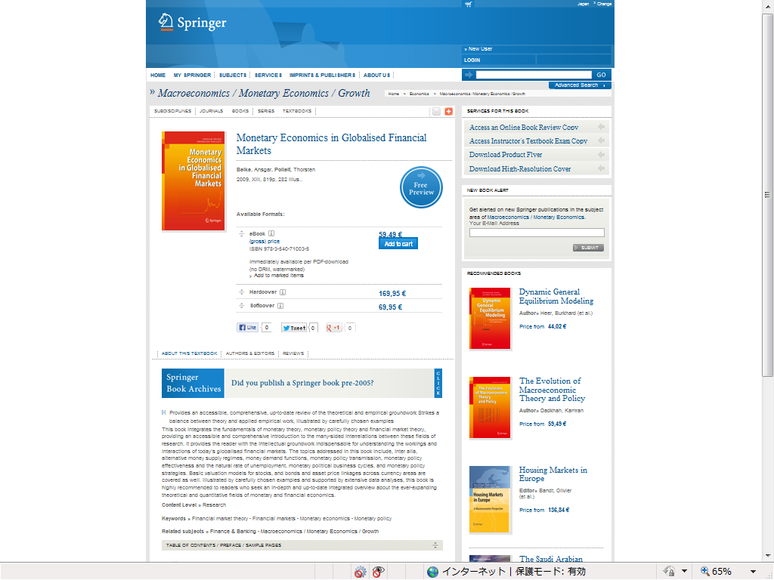

***Description on Amazon***

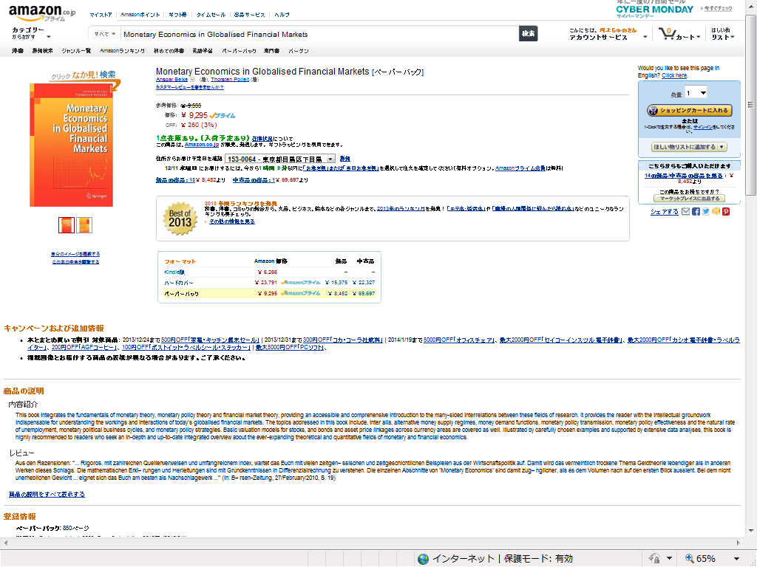

***Back cover text***



**The comments could not be saved in the specific column: the comments below are for category K, first book.**

1. My book directly compares Japan and Germany rather than deals with each country in separate chapters. It points out the unique factors in Japan and Germany and demonstrates the development of Business Management in both countries from a unified, comparative framework.

2. Based on the author’s original framework — “Re-framing” — my book analyzes business management with regard to the adaptation, modification, and adjustment of American management methods, which made them compatible with the structures of Japanese and German capitalism. By applying the author’s original framework, a unique understanding of business management and capitalism in Japan and Germany is made possible.

3. My book traces the development of Japan and German enterprises chronologically, starting with the 1950s and 1960s. It also pays attention to each country’s significant embeddedness in regional economic structures (?) in Europe and Asia, as well the deep connections they had with the United States. It explores the significance of the German business management model that developed in the European environment by comparing Germany’s situation in Europe with that of Japan’s in Asia. The corporate expansion in postwar Japan and Germany was shaped by processes of regionalization in each country.