**A digital workflow for regenerative zero-carbon urban design in a changing climate: A scalable and robust cross-climatic application**

**Research Plan**

**Summary**

Even though the global race toward carbon neutrality in the built environment is in full swing, few tools and methods are available for designers to gain reliable indications of the carbon performance of their building in the course of the design process. At the urban level, in particular, delivering zero carbon should be considered holistically in conjunction with other environmental performance indicators and tested against predicted changes in climate and urban conditions to produce an outcome that is robust and achievable. This project aims to bridge the current tools gap through the synergy of two complementary disciplines – Life Cycle Assessment (LCA) and urban environmental analytics – from two distinct climatic and urban contexts – Sweden and Israel – to create a robust workflow for regenerative zero-carbon urban design.

1. **Research Background** 
   1. **Toward zero carbon in a changing climate**

In recent decades, the challenge of urban decarbonization has become a major topic in the global discourse and revolves around two main intertwined strands: on the one hand, the global urbanization increase that, according to forecasts, is expected to reach 70% by 2050 [1], and on the other hand, the recognition of the central role of cities in both energy consumption and greenhouse gas (GHG) emissions (75% and 70%, respectively [2]). By way of response, and in parallel with the traditional pursuit of better energy performance for individual buildings, we are witnessing a variety of international initiatives and standards – using a variety of metrics – that attempt to integrate carbon and environmental performance considerations into the process of overall urban design. Prominent among these is the pursuit of zero carbon, which can be seen as an extension of its predecessor, the EU’s ‘Nearly Zero Energy Building’ (NZEB) directive of 2010 [3]. However, while the NZEB concept focused on operational energy demand and its offset by renewable energy supply, zero carbon or carbon neutrality signifies a more holistic approach, in which GHG emissions from the entire life cycle of a building are accounted for and, in turn, balanced by the integration of on-site or off-site renewable energy [4].

Since the Paris Climate Agreement of 2015, in which the target of reducing GHG emissions to net zero by 2050 was introduced and widely adopted, several studies of tools and methods, most including Life Cycle Assessment (LCA), have been carried out to bridge the gap between the zero-carbon ambition and the reality of common practice. Thus, Lobaccaro et al. [5] developed a parametric multi-objective optimization model to minimize embodied carbon and maximize solar irradiation for a NZEB by varying building geometry and orientation; Kiss and Szalay [6] developed a similar approach to minimize the environmental impacts of different building systems, including envelope, heating, and energy systems; Płoszaj-Mazurek et al. [7] built a machine-learning model to predict carbon footprint using basic design parameters such as wall area, roof area and height.

Despite such recent advances and the increasing availability of digital tools for LCA, most studies have been focused at building level. A few studies have applied LCA at the urban level (e.g., Cremer et al. [8]) but do not explore the interrelations between urban form and carbon performance. Moreover, most studies have focused on cold climates, with hot climates remaining underrepresented in the state of the art, despite the considerable demographic and urban challenges they present. Furthermore, the consideration of urban LCA in the face of unprecedented rates of climatic change, which is critical for the robustness of the calculations and for the resilience of future cities, requires urgent further research.

* 1. **Regenerative design using digital tools**

Given the similar need to promote the enhancement of positive interactions between natural, human and built systems, it is not surprising that the multi-objective approach required to support the emerging concepts around *regenerative* design and development is reflective of the wide spectrum of the UN’s 17 Sustainable Development Goals (SDGs) for 2030, albeit with additional key performance indicators (KPIs) [9]. To address such levels of complexity, specifically in the challenging urban environment, recent studies have harnessed digital workflows to quantitatively explore a range of environmental performance criteria. For example, Ratti et al. [10] explored the impact of urban morphology on environmental performance in a hot arid climate by applying a Digital Evaluation Model (DEM) technique that was used to calculate several geometrical indicators, which in turn were used as performance metrics at the urban block scale. Cheng et al. [11] combined DEMs with solar simulations to explore the daylight, photovoltaic (PV) potential and ground-level sky views of a theoretical urban district in several different configurations of morphology and density. Kanters and Wall [12] used detailed energy simulations to compare the environmental performance of different urban typologies in Sweden, and a study by Zhang et al. [13] performed a parametric study of 30 different urban block combinations based on six typologies to study the energy supply and demand patterns of urban blocks in the tropical context of Singapore. Driven by the 2050 carbon-neutral initiatives, more recent studies have used embodied carbon as a performative criterion in urban-scale environmental studies; for example, on the life-cycle building impact of a residential neighborhood in the Middle East (Kuwait) [14], and in computational methods to quantify the most cost-effective energy-retrofitting policies for carbon-neutral neighborhoods in Europe [15].

However, despite the more holistic approach adopted by some of these studies, the consideration of urban-scale GHG emissions over the whole life cycle, together with other environmental KPIs such as daylight availability or outdoor thermal comfort, have yet to be explored. In addition, despite the rapid development of new tools, environmental KPIs are typically evaluated separately, that is, the interdependencies and trade-offs between such metrics are either rarely explored or neglected altogether. Moreover, despite their potential, the application of these tools to practice is still very rare, and further studies are needed to create a reliable bridge between theory and real-world application.

* 1. **Zero-carbon urban design: Two diverse national perspectives**
* **Sweden** In 2019, Sweden’s construction and real-estate sector accounted for 21% of Sweden's total GHG emissions, and the sector also contributes to large overseas GHG emissions through its import of goods. With Sweden aspiring to be climate-neutral by 2045, a climate declaration based on a simplified LCA calculation for all new buildings was introduced in January 2022. However, this has three very significant gaps, which the current project seeks to address: 1) reporting the GHG emissions does not, in and of itself, lower them; 2) only considering buildings in isolation ignores the impact of interactions between them; 3) the focus on carbon alone is not sufficient and additional KPIs need to be incorporated into an holistic assessment.
* **Israel** Demographic projections for 2050 suggest that the urban built-up area of Israel will double over the next 30 years. Although the Israeli government has recently reinforced its commitment to zero carbon by 2050, urban design practice has been slow to respond, and previous advances in regenerative design workflows are far from being even being partially implemented. Given this gap and the unprecedented construction rates expected to occur in Israel, there is a massive and pressing opportunity to rethink the design of urban typologies in Israel in pursuit of a zero-carbon future based on the application of new digital tools.

**1.4 Preliminary work by the PIs**

The two PIs who will collaborate on this project focus on the integration of environmental intelligence into the design process using digital tools from two complementary perspectives:

* **Dr Alexander Hollberg** His PhD work aimed to integrate LCA into the early stages of building design to support better environmental decision-making. His development of a novel, parametric approach to LCA [16] laid the foundation for a variety of related studies with differing research objectives, such as consideration of the influences of geometry [17] and renovation [16]. In many cases, multi-criteria optimization was used to identify trade-offs. A study with students using a prototype of the parametric LCA tool showed that, on average, their building designs performed 30% better in relation to GHG emissions than a reference group working without the tool [18]. Besides the development of methods and tools, he has worked on the definition of benchmarks for building components [19] and their inclusion into the design process. More recently, his work has involved the modeling of uncertainty in input parameters to ensure more robust solutions for cost-efficient and low-carbon building renovation [20].
* **Dr Jonathan Natanian** His studies are dedicated to exploring holistic urban-scale environmental performance by employing computational methods to balance urban form, energy supply, energy demand and environmental quality. Several aspects of urban-scale environmental performance evaluation have been covered, including exploration of the trade-off between energy balance and urban form [21], the environmental trade-off between energy and outdoor thermal comfort [22], and urban-scale trade-offs in the context of ongoing climate change [23]. Recent developments of his urban analytical workflows include the integration of artificial intelligence (AI) methods [24], and the development of the Urban Solar Block generator [25], a generative solar-driven approach for urban design.

1. **Research Objectives**

**This project aims to combine the expertise of PIs from Israel and Sweden to bridge the gaps in urban zero-carbon design by developing a robust and climate-proof computational workflow that will allow designers to use a set of environmental performance indicators to deliver regenerative zero-carbon design at the urban block scale.**

**2.1 Specific objectives**

1. Establish a digital workflow to holistically evaluate **urban-scale carbon performance**.
2. Identify and evaluate metrics to be used as **environmental performance indicators for holistic urban analysis**.
3. Evaluate the efficiency of **optimization workflows** and algorithms to screen best-performing solutions from a broad range of design variants.
4. Explore the **applicability and robustness** of the approach by accounting for diverse climates (spatially, i.e., different climatic zones, and temporally, i.e., current and future climates), different scales (from block to district), and diverse urban contexts (Israel and Sweden).
5. **Methodology**

Fig.1 illustrates the research design sequence, which is divided into four high-level tasks (broadly corresponding to the objectives listed above) and distributed between the Israeli and Swedish partners. The majority of the project will be conducted by two PhD candidates – one from Sweden (Chalmers) and one from Israel (Technion) – with complementary (Tasks 1 and 2) and combined (Tasks 3 and 4) research segments. Tasks 3 and 4 will be supplemented by an additional postdoctoral researcher in Israel, focused on the optimization and robustness aspects of the project. The tasks are described in more detail in the following subsections.

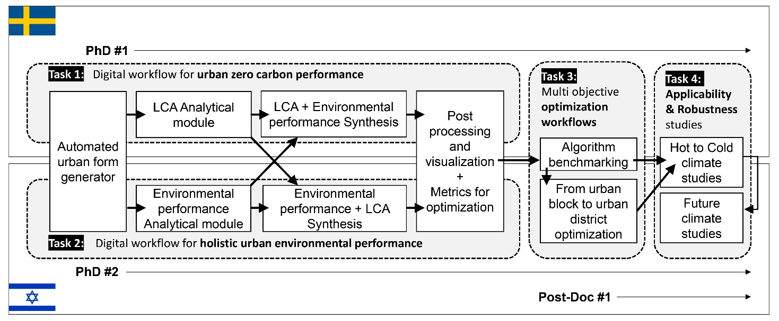

**Fig. 1:** Research plan; four high-level tasks distributed between the Israeli and Swedish partners

**3.1 Tasks 1 and 2: Digital workflow for high performance and zero-carbon urban design**

Tasks 1 and 2 will focus on establishing the computational foundation of the project, to include a geometrical urban-form generator, two analytical modules, and a post-processing and visualization module. These components, described in more detail below, will be developed in Grasshopper, a parametric interface for the three-dimensional computer-aided design program *Rhinoceros 3D* (‘Rhino’; Robert McNeel & Associates, Seattle, WA).

**3.1.1 Geometrical urban-form generator** This willbe developed aspart of both Tasks 1 and 2 and will serve as the basis for the morphological inputs of both building and city in accordance with both the Israeli and the Swedish contexts and the needs of the analytical modules. The Grasshopper-based workflows developed as part of this module will allow for fast and automated prototyping of various design configurations at different scales, and the combination of control parameters for the building scale (e.g., window-to-wall ratios) and the urban scale (e.g., distance between buildings).

**3.1.2 Analytical modules** Development of these in relation to LCA and environmental performance will be divided between Dr Hollberg and Dr Natanian according to their specific areas of expertise and then synthesized into a combined workflow (see below) and explored in both Swedish and Israeli contexts.

* **LCA analytical module** (Task1) Development will be conducted in Chalmers under the supervision of Dr Hollberg and will focus on establishing the link between the geometrical properties acquired from the geometrical module, estimations for the operational energy demands identified by the environmental performance analytical module, and embodied carbon coefficients, combining them in support of LCA calculations. Previously developed tools such as *Bombyx* will be extended to the urban scale and to multiple embodied carbon-coefficient databases (based on both Swedish and Israeli LCA databases) and Environmental Product Declarations (EPDs). In addition, a specific link in support of the coefficients generated using the *OpenLCA* tool and the *ecoinvent* database will be established to allow for the assessment of additional environmental indicators alongside Global Warming Potential (GWP).
* **Environmental performance analytical module** (Task 2)Development will focus onestablishing areliable andeffectiveinterchange between the geometrical data gathered for each iteration, the sampling of the relevant numerical and geometrical inputs, and the relevant environmental simulation engines. The aim of the module will be the integration of a wide variety of environmental KPIs into the decision-making process throughout the design of urban blocks and districts. It will be conducted using several components of the *Ladybug Tools* plugin (https://www.ladybug.tools/) for Grasshopper, via which different environmental metrics will be calculated by using validated environmental performance simulation tools (e.g., *Radiance*, *EnergyPlus* and *OpenFOAM* modeling engines). The computational module developed here will set the stage for the integration of LCA (from Task1) in support of a fully harmonized workflow.

**3.1.3 Synthesis** Once developed, the two analytical modules will be synthesized into a single computational workflow in which both environmental performance (i.e., thermal comfort, daylight availability, and solar performance) and LCA calculations will be accounted for and seamlessly integrated for each iteration. This synthesis will be developed together by the Israeli and Swedish PIs through reciprocal research sojourns at their respective institutions. It will conclude with the identification of a set of environmental metrics and their corresponding simulation workflows that can be combined to account for both carbon and other aspects of environmental performance in the context of both countries. In addition, the synthesized module will highlight simplified and faster-to-calculate metrics that can be used for optimization studies at larger scales (for Tasks 3 and 4). The analytical process will start with a sensitivity analysis to test the individual impact of each morphological input on the different environmental KPIs, which will be followed by a wide parametric study for both contexts. The robustness of the developed workflow will be established by refining the analysis via two distinct case studies, one in Sweden and one in Israel:

* **Landvetter Södra case study, Sweden** The vision for the Landvetter Södra development is to build a sustainable city from scratch for at least 25,000 inhabitants. The site lies within an area of protected nature, close to an international airport and next to a busy highway, yet has high sustainability ambitions (https://landvettersodra.se/agenda-2030/), providing many interesting design challenges with respect to environmental criteria such as noise, air pollution, and GHG emissions. This timeline fits our project perfectly, because the preparations for a master plan will start this year and gradually evolve ahead of the start of individual building design in 2025. As such, the project results can support the design process.
* **Sde Dov case study, Tel Aviv, Israel** Sde Dov is the name of a former airport site in Tel Aviv and is one of the largest redevelopment projects in Israel; by 2030, the district is to become host to 16,000 housing units, 35 high-rise office towers, and 250,000 m2 of hotel floor area. The city of Tel Aviv is part of several global initiatives associated with climate change and has directed significant resources into embedding sustainability in the design of this district regeneration. However, carbon-impact considerations, together with their trade-offs against other environmental aspects (e.g., solar availability, thermal comfort, etc.) in both current and future climatic conditions have not been accounted for. Thus, the workflows developed in our project will generate new insights as to the environmental performance and carbon-impact trade-offs of Sde Dov under both current and future climatic conditions.

**3.1.4 Post-processing and visualization** This will be dedicated to exploring the results of the synthesis and its case studies and developing further insights for the application of holistic zero-carbon workflows in both contexts. Given the practical focus of our project, this module will focus on the exploration and visualization of the data, and the interfaces to enable different users to analyze, stream, and communicate the data. In this part of the project, researchers from Israel and Sweden will continue to work in full collaboration to develop communal interfaces for data transactions using computational tools (e.g., dedicated Grasshopper components for data streaming and visualization,such as*Colibri* and the *DesignExplorer* platform) and the outputs of other ongoing research projects, such as *Twinable* (https://dtcc.chalmers.se/twinable/). The cross-contextual nature of the results obtained from the different case studies, as well as the holistic synthesis of the LCA and environmental performance modules, will serve as the framework here for defining the analytical methods of the final two tasks of the project.

**3.2 Task 3: Multi-objective optimization workflows for urban zero-carbon design**

When upscaling performance evaluation from one building to a series of buildings (i.e., to a district), the numerous possible iterations require an optimization module to be integrated into the evaluation workflow to automate the screening of the results according to the environmental objectives selected. Because an holistic approach is central to this project, we incorporate a multi-objective optimization (MOO) that involves at least two objectives. Task 3 is thus dedicated to exploring optimization methods for district-scale zero-carbon design in both Israeli and Swedish contexts, and starts by setting up the optimization of the computational workflow in Grasshopper through the *Opossum* plugin. The components of this plugin are connected to the performance evaluation workflow assembled in the previous tasks to allow a seamless data flow between the generation, analysis and visualization modules and the MOO. Selection of the objectives for the MOO will be based on the outputs of Tasks 1 and 2, and a series of sensitivity optimization studies will test different algorithms and explore their performance in the context of our optimization challenges. This part of the research is critical in upscaling from the block to the district scale and will unlock the exploration of a larger variety of possibilities; for example, the environmental performance of larger districts in higher-density scenarios or in mixed-use configurations.

**3.3 Task 4: Applicability, robustness and future climate studies**

This task is dedicated to experimenting with the workflow in different climatic conditions (regional climates and future climates) and at different scales, and should enable the finalization of the project with: (i) observations as to the feasibility of urban zero-carbon design in Israel and Sweden; (ii) integration of digital tools and optimization methods into the zero-carbon design process; (iii) much greater robustness in zero-carbon urban design for different urban and climatic settings. As such, the task will have two main focuses:

* **Climatic diversity** Given that, for example, the solar trade-off manifests differently in different climatic regions, an additional module will utilize the same morphological and analytical configuration to test four different climatic contexts in Israel and Sweden. This will serve to highlight insights regarding the robustness of the methodology, and the metrics and/or their weightings that require contextual adaptation. In addition, a supplemental analytical climate module will be dedicated to future climate calculations by using climate files for 2050 as forecast by the *Meteonorm* (https://meteonorm.com) weather-generator software. This approach should add the important perspective of climatic adaptation of the urban zero-carbon perspective and further the discussion of environmental performance, carbon neutrality and architectural form in a changing and increasingly unstable climate.
* **Applicability** Because this project aims to help bridge some of the current gaps around achieving zero carbon in practice, its applicability potential will provide an important reference point throughout. To ensure a high impact on local design practices and building sectors in both Israel and Sweden, the project will include several interfaces with local practitioners, policymakers, and urban planning agencies. Thus, in Tasks 1 and 2, both the geometrical and analytical modules will be developed in accordance with local codes and practices, and in strong coordination with selected design firms, municipality leaders and local environmental experts. The use of case studies will also help deliver specific solutions for real-world challenges, as well as providing practical insights that can be used in other local projects. The studies will also help to inform/address the upscaling challenge in both contexts (in Task 3) in a practical fashion. In Task 4, the applicability of the workflow will serve as a focal point in itself, and the interface that the project will develop will be tested with local designers and policymakers in its different phases. This will be achieved both by establishing close individual engagement between the researchers and specific local stakeholders, and through the use of several workshops that will be held throughout the project and made open to local architecture, engineering and construction (AEC) professionals (see Section 4 below). These workshops, along with the project’s other dissemination activities (see the accompanying strategic impact statement), will encourage discussion of zero-carbon urban design and offer practical methods with which to pursue it for both countries. Another crucial aspect of applicability concerns the education of future designers and researchers, and both PIs will integrate and test the workflows of the project in design studios, courses, and seminars at their respective faculties at both graduate and undergraduate levels.

1. **Work Plan and Main Milestones**

The work plan shown in Fig. 2 sets out the timescale for the five-year project and its evolution between the two partners (Sweden in **yellow** and Israel in **blue**). On the basis of the methodological logic and the task distribution, some research segments are conducted separately in Sweden or Israel, and others are carried out in full collaboration (yellow/blue dotted lines).

Besides the research activities, another important aspect of the project are the joint events, secondments, and dissemination activities. Thus, Fig. 2 shows the series of annual workshops that will support the project, starting with a kickoff seminar (month 6), followed by a set of workshops dedicated to different analytical themes, and ending in a final conference that will conclude the project. The workshops will be held in Sweden and Israel and will focus on testing and disseminating the findings and analytical segments of the research. Two reciprocal research sojourns during Tasks 1 and 2 (shaded in green in Fig. 2) will ensure the appropriate synergy between the analytical modules.

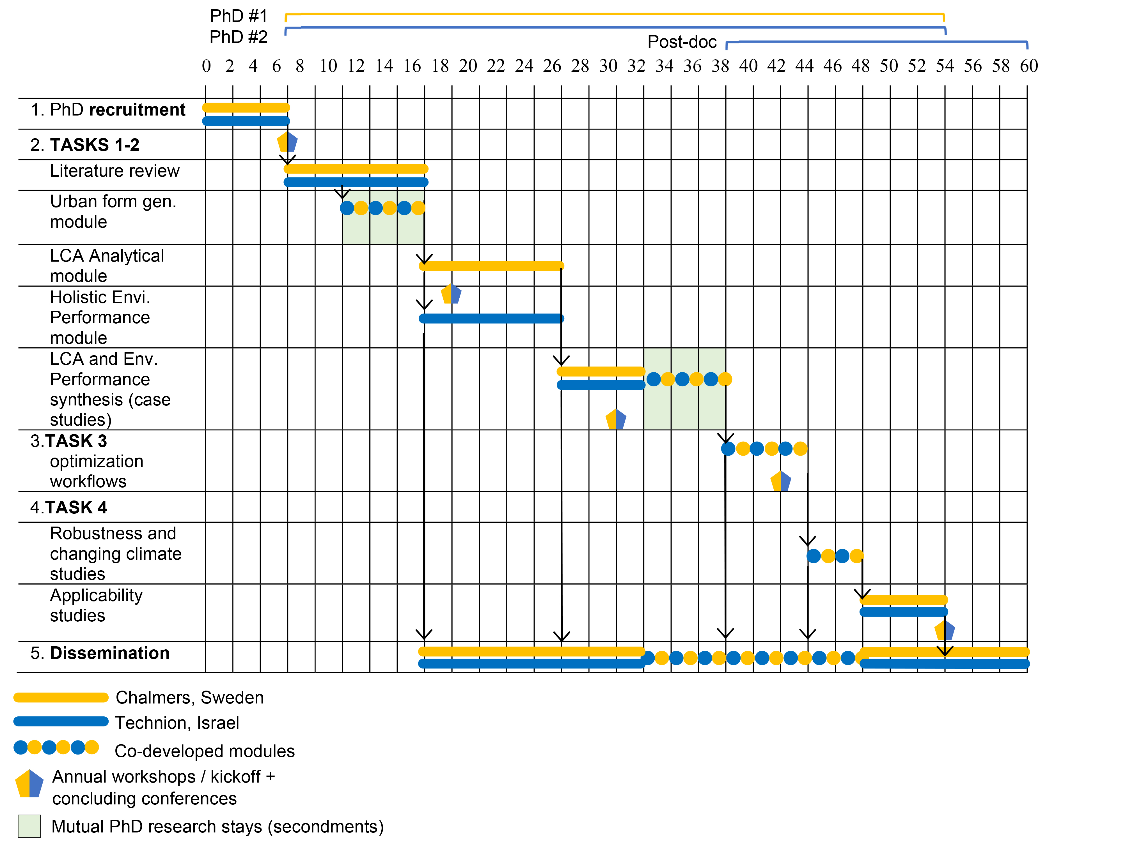

**Fig. 2:** Research plan highlighting interactions between the Israeli and Swedish partners during the 5-year project

1. **Constellation**

This project brings together two very different climates, two different urban contexts, and two PIs with complementary expertise from the leading academic institutions in respect of these contexts to pursue one mutual target: decarbonizing our cities by 2050. Based on an understanding of the holistic perspective needed to address this daunting task, this constellation offers the cross-climatic and cross-contextual framework necessary to the development of a new computational approach. Both the expertise and resources and the synergy and task division described below demonstrate the complementary nature of the collaboration and the different facets that must come together to achieve a robust and reliable approach to zero-carbon urban design.

* 1. **Collaborating research groups – Expertise and resources**
* **Assist. Prof. Dr Alexander Hollberg (Chalmers)** Alexanderjoined Chalmers University of Technology as a tenure-track assistant professor for Computational Sustainable Design in 2019. He holds a PhD (summa cum laude) from Bauhaus University Weimar, where he developed the parametric LCA method. He is cofounder of the software company CAALA and spent two years as a postdoc at ETH Zürich. Currently, he supervises a team of three PhD students and two postdocs within the Sustainable Building research group in the Department of Architecture and Civil Engineering (ACE). Alexander also leads *Twinable*, a long-term interdisciplinary project within the Digital Twin City Center (DTCC), and participates in Future City Lab Global (ETH Zürich), which provides an excellent platform for international exchange and dissemination. He also has well-established networks through participation, among others, in the International Energy Agency EBC Annex 72, the Swedish Life Cycle Centre, Sustainable Building Councils (SGBC, DGNB), and the CIB young researcher network, which will support the PhD students in this project. The grant would allow further establishment of his research group, would support Chalmers’ vision of a sustainable future, and contribute to establishing Sweden as a front runner in sustainability and digitalization.
* **Assist. Prof. Dr Jonathan Natanian (Technion)** Jonathan is an assistant professor at the Faculty of Architecture and Town Planning at the Technion. He holds a PhD (summa cum laude) from the Technical University of Munich (TUM), where he developed computational workflows to explore the correlation between dense urban morphology and environmental performance in hot climates. The Environmental Performance and Design Lab (EPDL) that Jonathan leads at Technion is dedicated to exploring the boundary between environmental engineering and architectural design in a cross-contextual, multiscale, and cross-disciplinary way. The lab’s equipment allows it to operate in three main clusters, which together form a triangle of knowledge: data acquisition (cutting-edge sensors, remote sensing devices), computational analysis (strong analytical and data servers and cloud-computing capabilities), and interface design (interactive screens combined with augmented- and mixed-reality devices).
  1. **Collaboration synergy and research task division**

As previous sections have described, the aim of the project is to combine urban environmental analytics with LCA in a symmetric way to create a new, highly applicable computational workflow for zero-carbon design. Our proposal is based on the premise that without intertwining these two elements, a reliable and robust approach for zero-carbon design cannot be achieved. The task distribution (see Fig. 1) and research plan (see Fig. 2) clearly reflect this approach in the symmetrical allocation of activities between Sweden and Israel. Thus will we gradually evolve the analytical workflow between the PIs in a way that LCA and other environmental performance KPIs are intertwined and synthesized into a single workflow (Tasks 1 & 2). The subsequent research tasks (3 & 4) will be co-developed between the universities, with postdoc support from the Israeli side focused on AI integration. The project’s synergies will also echo through its outcomes, which will generate insights in relation to the reduction of GHG emissions in urban realms across a diversity of contexts and climates. The shared workshops and reciprocal research stays will reinforce the collaboration and ensure constant transfer and maximum synergy of data and resources between the PIs and researchers involved.

1. **Expected Results and Scientific Outcomes**

We expect that the application of the proposed regenerative zero-carbon urban computational workflow will **increase the integration of environmental performance indicators into architectural design and urban planning** by establishing a generative approach in which performative insights directly influence the architectural form-finding process. We anticipate that the proposed approach will mark a new chapter in zero-carbon design whereby the use of parametric tools powered by machine-learning algorithms will open new possibilities to explore large design spaces, analyze multiple KPIs, and efficiently screen and transmit the best-fit results to the designer. This brings new features to existing environmental analysis methodologies and offers a new horizon for the interaction between environmental engineering and architectural design, enriching design outcomes in terms of architectural form and the environmental performance of buildings and districts. In light of the 21st-century challenge to decarbonize urban environments in the face of climatic uncertainty, this project will provide fresh opportunities for designers and analysts to both improve and realize the full environmental potential, and not just the carbon performance, of their designs, and generate buildings and districts driven by a robust and holistic environmental approach.

Further scientific significance of the project stems from several other novelties that it offers to the wider field of urban environmental performance, in the form of the following: a holistic analytical approach that combines several environmental performance criteria; generative methods to create new solar-driven typologies through a bottom-up approach; an optimization module that introduces new insights in relation to selection criteria for multi-objective environmental optimization.

**References**

[1] United Nations. (2019). *World population prospects 2019*.

[2] IRENA. (2021). *World Energy Transitions Outlook: 1.5°C Pathway*. Abu Dhabi, UAE: International Renewable Energy Agency.

[3] EPBD. (2010). Directive 2010/31/EU of the European Parliament and of the Council of 19 May 2010 on the energy performance of buildings (recast). *Official Journal of the European Union*, *18*(06), 2010.

[4] Pan, W., & Pan, M. (2018). A dialectical system framework of zero carbon emission building policy for high-rise high-density cities: Perspectives from Hong Kong. *Journal of Cleaner Production*, *205*, 1–13.

[5] Lobaccaro, G., Houlihan Wiberg, A., Ceci, G., Manni, M., Lolli, N., & Berardi, U. (2018). Parametric design to minimize the embodied GHG emissions in a ZEB. *Energy and Buildings*, *167*(February), 106–123. https://doi.org/10.1016/j.enbuild.2018.02.025

[6] Kiss, B. & Szalay, Z. (2020). Modular approach to multi-objective environmental optimization of buildings. *Automation in Construction*, *111*(July 2019), 103044.

[7] Płoszaj-Mazurek, M., Ryńska, E., & Grochulska-Salak, M. (2020). Methods to optimize carbon footprint of buildings in regenerative architectural design with the use of machine learning, convolutional neural network, and parametric design. *Energies*, *13*(20), 5289.

[8] Cremer, A., Berger, M., Müller, K., & Finkbeiner, M. (2021). The first city organizational LCA case study: Feasibility and lessons learned from Vienna. *Sustainability (Switzerland)*, *13*(9), 1–15.

[9] Cole, R. J., Busby, P., Guenther, R., Briney, L., Blaviesciunaite, A., & Alencar, T. (2012). A regenerative design framework: Setting new aspirations and initiating new discussions. *Building Research & Information*, *40*(1), 95–111.

[10] Ratti, C., Raydan, D., & Steemers, K. (2003). Building form and environmental performance: Archetypes, analysis and an arid climate. *Energy and Buildings*, *35*(1), 49–59.

[11] Cheng, V., Steemers, K., Montavon, M., & Compagnon, R. (2006). *Urban form, density and solar potential.* Paper presented at PLEA 2006, 23rd International Conference on Passive and Low Energy Architecture, Geneva, Switzerland.

[12] Kanters, J., & Wall, M. (2014). The impact of urban design decisions on net zero energy solar buildings in Sweden. *Urban, Planning and Transport Research*, *2*(1), 312–332.

[13] Zhang, J., Xu, L., Shabunko, V., Tay, S. E. R., Sun, H., Lau, S. S. Y., & Reindl, T. (2019). Impact of urban block typology on building solar potential and energy use efficiency in tropical high-density city. *Applied Energy*, *240*,513–533.

[14] De Wolf, C., Cerezo, C., Murtadhawi, Z., Hajiah, A., Al Mumin, A., Ochsendorf, J., & Reinhart, C. (2017). Life cycle building impact of a Middle Eastern residential neighborhood. *Energy*, *134*, 336–348.

[15] Buckley, N., Mills, G., Reinhart, C., & Berzolla, Z. M. (2021). Using urban building energy modelling (UBEM) to support the new European Union’s Green Deal: Case study of Dublin Ireland. *Energy and Buildings*, *247*, 111115.

[16] Hollberg, A., & Ruth, J. (2016). LCA in architectural design—A parametric approach. *The International Journal of Life Cycle Assessment*, *21*(7), 943–960.

[17] Hollberg, A., Klüber, N., Götz, M., Lichtenheld, T., & Hollberg, P. (2019). Improving the collaboration between architects and energy consultants through design-integrated early BIM-tools. In V. Corrado, E. Fabrizio, A. Gasparella & F. Patuzzi (Eds.), *Building Simulation* (p. 7).

[18] Hollberg, A., Ebert, M., Schütz, S., Cicek, B., Gumpp, R., & Ruth, J. (2016). Application of a parametric real-time LCA tool in students’ design projects. *Sustainable Built Environment*, 72–81.

[19] Hollberg, A., Lützkendorf, T., & Habert, G. (2019). Top-down or bottom-up?–How environmental benchmarks can support the design process. *Building and Environment*, *153*, 148–157.

[20] Galimshina, A., Moustapha, M., Hollberg, A., Padey, P., Lasvaux, S., Sudret, B., & Habert, G. (2020). Statistical method to identify robust building renovation choices for environmental and economic performance. *Building and Environment*, *183*, 107143.

[21] Natanian, J., Aleksandrowicz, O., & Auer, T. (2019). A parametric approach to optimizing urban form, energy balance and environmental quality: The case of Mediterranean districts. *Applied Energy*, *254*, 113637*.*

[22] Natanian, J., & Auer, T. (2020). Beyond nearly zero energy urban design: A holistic microclimatic energy and environmental quality evaluation workflow. *Sustainable Cities and Society*, *56*, 102094.

[23] Naboni, E., Natanian, J., Brizzi, G., Florio, P., Chokhachian, A., Galanos, T., & Rastogi, P. (2019). A digital workflow to quantify regenerative urban design in the context of a changing climate. *Renewable and Sustainable Energy Reviews*, *113*, 109255.‏

[24] Natanian, J., & Wortmann, T. (2021). Simplified evaluation metrics for generative energy-driven urban design: A morphological study of residential blocks in Tel Aviv. *Energy and Buildings*, *240*, 110916.‏

[25] Natanian, J., De Luca F., Wortmann, T., & Capeluto, G. (2021). The Solar Block Generator: An additive parametric method for solar driven urban block design. *Journal of Physics: Conference Series*, 2042.