**Prinzip der Privilege Escalation**

*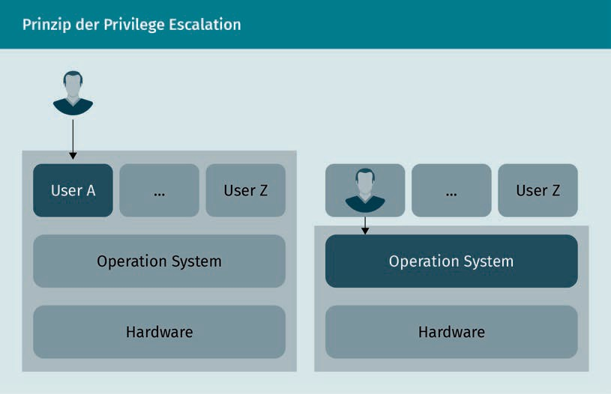****Privilege escalation principle***

|  |  |
| --- | --- |
| Prinzip der Privilege Escalation | Privilege escalation principle |
| User A | User A |
| User Z | User Z |
| Operation System | Operation system |
| Hardware | Hardware |
| User Z | User Z |
| Operation System | Operation system |
| Hardware | Hardware |

**Änderung einer MAC-Adresse in Windows**

***Changing a MAC address in Windows***

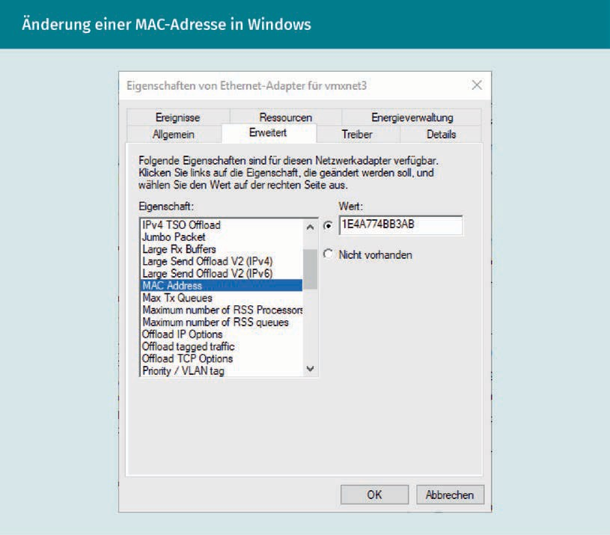

**Binäre Darstellung einer Bitmap-Datei**

***Binary representation of a bitmap file***

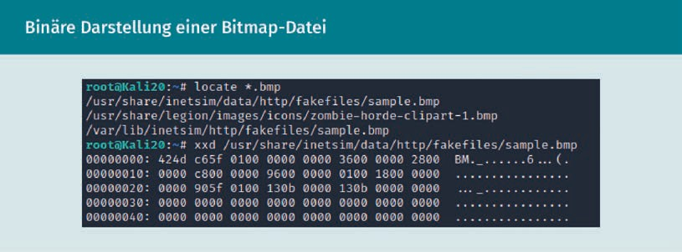

**Ein TPM von ASUS  
*An ASUS TPM***

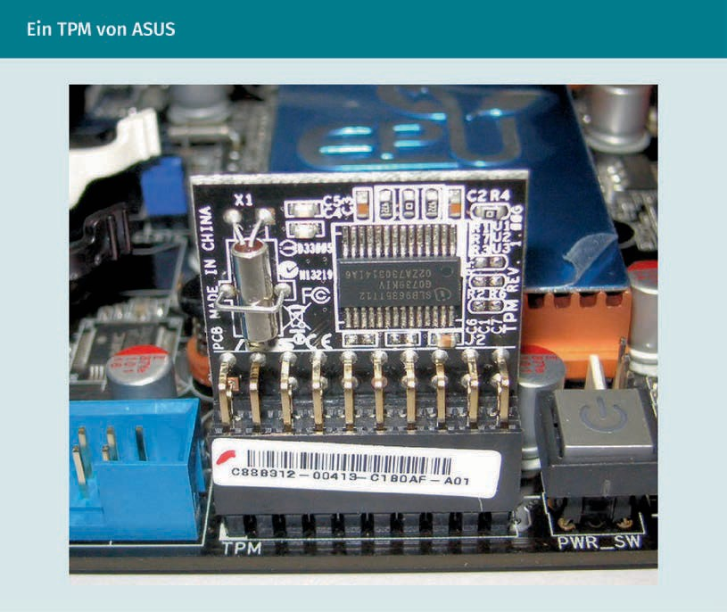

|  |  |
| --- | --- |
| Ein TPM von ASUS | An ASUS TPM |