בְּסִיַּעְתָּא דִשְׁמַיָּא
"…and write down this Song…"
Literally calling itself the “Song”, the book of books, the most popular work of all time, the Torah, or the Old Testament Bible as Christians around the world call it, commands mankind to copy and multiply the holy volume with each new generation. It consists of what was written down from its source, the words of the prophet Moses, or rather, as the “hidden” Jewish liturgy informs us, from the song of its Creator. At the same time, the Book has strictly exhorted mankind to pass down everything across the centuries all while maintaining absolute accuracy and without changing the spelling of words even slightly. Clear rules governing the pronunciation of all the laws making up the harmony of life, which the Holy Composer of this song of the universe teaches us, have also been passed down from mouth to mouth.
The diligence with which religious Jews observe the commandments of the Creator, even during the many years of their exile, is evidenced not only by the extensive Jewish liturgy, which has been passed down even to the present day, and the clear picture of the life and religious service of the people at all times, but also by the findings of science, and in particular archeology. The latter has confirmed the identity of numerous canonical scrolls and books of Holy Scripture that have been discovered so far, which are greatly dispersed across time and space. With only minor ethnic differences that manifest themselves in how the letter decorations are written, the cherished lines have come down to us exactly word-for-word. However, something of great significant has been lost and forgotten along the way. It is something so characteristic of the Jewish people that we must recognize the history of its disappearance and consignment to oblivion as a kind of sad miracle. Of course, the fact that it is once again becoming known and obvious, and amazing, like Peace itself, is also miraculous. You, dear reader, must be particularly sensitive to peace and its absolutely perfect harmony either thanks to a professional or personal interest that you have taken in the subject. Or perhaps you are simply interested in the peace that comes from observing the harmony of art. The music of the holy song was lost for centuries before it was unexpectedly discovered once again! We are now starting to decipher the musical score, which is not only hidden in the lines of the Holy Testament. Rather, apparently in compensation for many years of silence, we have been able to open the curtains to reveal a large-scale opera taking place across the centuries, and its music is composed of the sounds from many unexpected works of art. These include the artistic fruits of familiar kings and sages, who have turned out to be poets, composers, and playwrights, though we never previously suspected it. And leading this concert transcending the centuries is a work familiar to everyone, the poem and composition of the Creator Himself: the Torah.
***
A historic discovery in the art of poetics and music
A new study of the texts of the Holy Scriptures using semiotic analysis has allowed us to decipher the musical meanings of the traditional Teamei Mikrá system of articulation marks. They reveal that the book of books, the Holy Torah, is a completely rhymed musical and poetic work that is striking for its progressive composition and imaginative power. Furthermore, we have also discovered many other sources of the sacred canon that are fully aligned with the rhymed songs and produce melodies of various styles that are familiar to us. These exactly match the deciphered meanings of the original notation.
This unexpected discovery has required us to completely revisit our understanding of the level of achievement of ancient musical and poetic techniques as well as key figures, dates, and, in general, the story of how art evolved in this direction. This new decoding of the traditional marks demonstrates that they contain indications of melody and musical rhythm, which reveal to us the compositional component of the original works precisely and consistency. Using the rhythm created from the deciphered values of note durations, biblical texts can be built into rhymed pieces of music that satisfy all the rules of poetic and rhythmic composition, many of which are familiar to us. An analysis of the musical motifs demonstrates that the melodies found in the sources include forerunners of styles that are popular today, including opera, Latin American music, jazz, and even rock and rap, and their compositional structure often follows all the laws of modern musical and poetic technique.
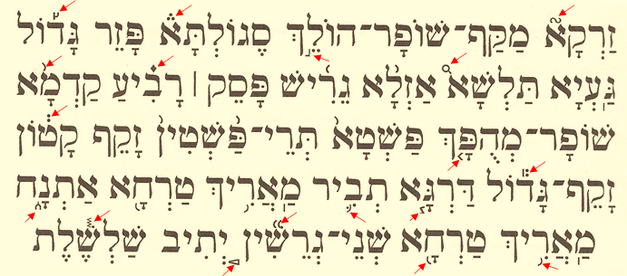
Teamei Mikrá marks
The Teamei Mikrá marks in the ancient Jewish liturgy are small signs of various shapes that accompany the words and letters of the source texts in addition to the traditional Hebrew language vowel and punctuation marks. They can be placed on various sides of the letter, and they are indicated using various graphic devices, such as short lines, arcs, arrows, etc. According to tradition as we currently understand it, Teamei Mikrá indicate how words and phrases should be pronounced. There are several traditional schools of how to "read" texts with Teamei Mikrá marks. With only minor disagreements, members of one school argue that they essentially perform the function of punctuation marks. They do not convey semantic, but rather only phonetic information by determining the boundaries of individual words and phrases. This tradition claim approximately 25 Teamei Mikrá marks (with some difference in opinions between traditional schools). According to traditional sources, originally only specially sanctified groups of clergymen determined the rules for the writing of holy texts, and they were passed down orally from generation to generation and never written down. These marks were introduced into Scriptural texts by the Men of the Great Assembly in the era following the destruction of the first Temple in Jerusalem. Like vowel symbols, they were added only to special editions of the sources, the canonical scrolls of Scripture, and they do not appear today.

***
*** The discovered notes of the Testament ***
It is a miracle that we have now uncovered the original musical score! Or, to put it more precisely, we have uncovered the basic principles of how to recreate it from the sources. In this article, which is mainly directed to the professional community of readers in musical theory, I will try to describe this discovery precisely and lay out the technical musical details. But let me start, nevertheless, by explaining why this discovery can truly be called a miracle. I do not know if the respected reader has had a chance to read my story about how I made my discovery (“Testament Rhapsody”). It describes the causes and events that accompanied this unexpected discovery, and it also gives a lot of individual general details regarding this topic that I discovered in the process of reviewing various sources of the Jewish liturgy. Thanks to how I have combined the evidence, I have created a picture of the completely underestimated enormous significance and scale of influence of the musical and poetic art of Judaism that one might say is still unknown. And I discovered that this not only concerns the texts that make up almost all of the canonical scriptures, but the very manner in which students were educated in the texts as well as the daily rituals, life, everyday religious practices of the people, especially in the land of Israel and in the capital and the center of its intellectual development: Jerusalem. Most of all, it affected the laws of ritual practice and almost all types of services held in the Jerusalem Temple itself.

