COURSE BOOK



Manufacturing Processes Industry 4.0

DLBINGFVI01



Overall Learning Objectives

##### Introduction 9

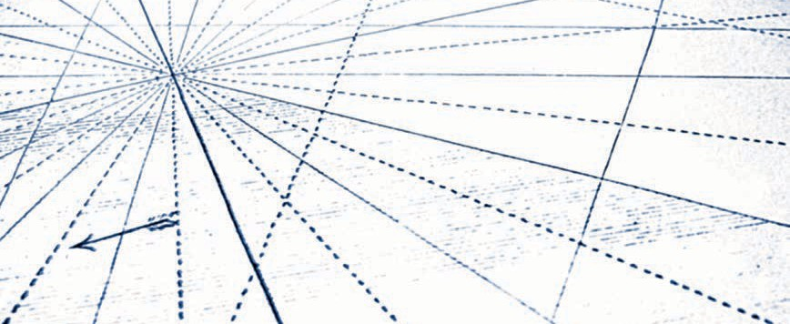

The Manufacturing Processes Industry 4.0 course objective is to provide students with an overview of manufacturing engineering. Conventional manufacturing engineering (also referred to as subtractive processes) as well as novel additive methods are examined. Today's global production is predominantly carried out using conventional manufacturing processes. The novel “additive processes” (also known as “generative processes”), particularly the additive processes of rapid manufacturing, currently only account for an insignificant share of less than 1% of global production, but are showing an increasing trend in application. These processes are a development from recent decades since around 1985. Rapid prototyping is generally implemented within the field of product development while rapid tooling is also used in a variety of applications within the field.

In the scope of this presentation, the primary focus of manufacturing engineering is on conventional manufacturing processes according to their significance within the field as a whole. However, a complete overview of the additive processes will also be provided. Innovative manufacturing technologies such as rapid prototyping, rapid tooling, and rapid manufacturing have already successfully proven the initial capabilities and economic benefits of their processes in many areas of industry and research. In particular, rapid manufacturing processes can be quite economical alternatives in production if specific framework conditions and requirements are met. For example, in individual manufacturing or in the production of very small series, these requirements can be whether the component is suitable in terms of its required properties, materials, and geometry. It is precisely these processes that will continue to influence production in the future and will be used in suitable processes to an even greater extent. Nevertheless, the substantive results of these production processes such as production times and quantity performance, quality, and costs for the respective production task must still meet the criteria at acceptable levels. The course also addresses the consequences of the digitalization and networking of production and production systems as well as their elements in terms of the cyber-physical system of the current of Industry 4.0 philosophy.

[www.iubh.de](http://www.iubh.de/)

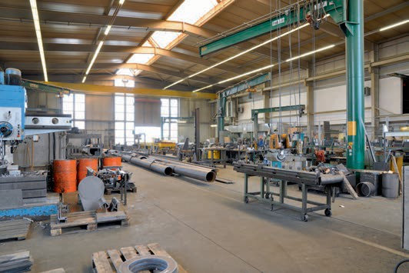

Unit 1

Introduction to Manufacturing Engineering

STUDY GOALS

After completing this unit, students will know ...

… the meaning of the terms production, manufacturing engineering, and process engineering.

... the classification of manufacturing processes with their respective main groups and subgroups.

... the framework conditions and relationships within production.

... the importance of the degree of automation and flexibility.

… the meaning of long tail within production.

DL-D-DLBINGFVI01-L01

1. Introduction to Manufacturing Engineering

Introduction

Carl Martin Dolezalek (Professor of Manufacturing Engineering at the University of Stuttgart, 1899–1984) defined the term *production engineering* and the distinction between it and the terms *manufacturing engineering* and *process engineering* in greater detail. Based on this, the term production engineering was defined for the first time along with the classification of process engineering, manufacturing engineering, energy engineering, and information technology (see Figure 1.1).

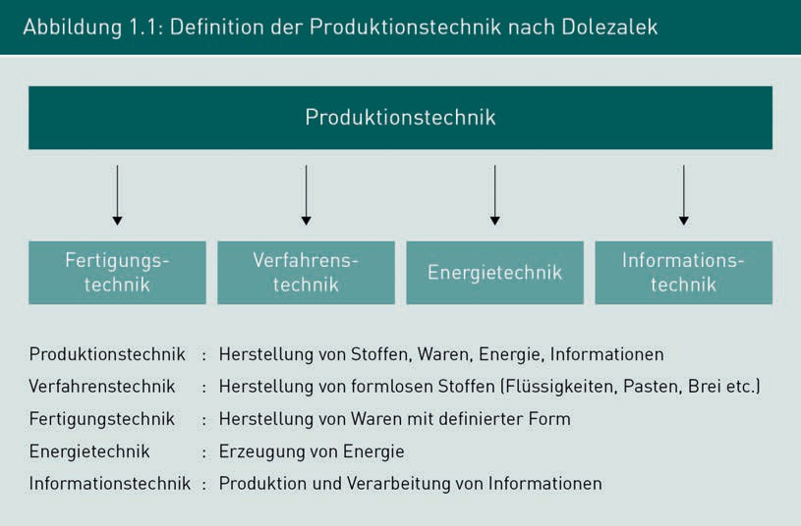

According to this, manufacturing engineering involves the production of components with defined characteristics, e.g., geometry, dimensions, and material properties as well as the joining of components to form products. In contrast, process engineering involves the production of formless materials (solid, liquid, gaseous), but with deﬁned properties, such as with lubricants, fuels, powders, granulates, etc. Dolezalek also places energy engineering and information technology within production engineering.

Introduction to Manufacturing Engineering

* 1. Basic Terms and Relationships in Manufacturing Engineering

**Manufacturing engineering** describes the science of the processes for forming and changing the properties of components. The German DIN 8580 Standard (o. V. 2003) describes the processes available for these purposes and classifies them according to the main groups of primary shaping, forming, cutting, joining, coating, and changing of material properties (see Figure 1.2).

These manufacturing processes are based on the concept of cohesion of materials. Cohesion is described by the processes of the **main groups**: creation, preservation, reduction and increase by applying the main groups (1 to 5) primary shaping, forming, cutting, joining, and coating. In addition, the German DIN 8580 Standard distinguishes the Main Group 6 as the changing of material properties.

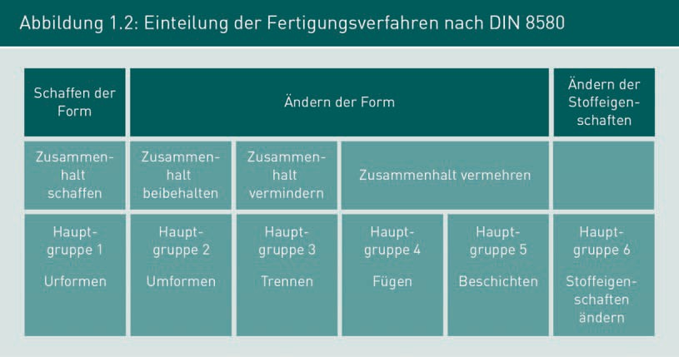

Overall, manufacturing engineering not only considers the technological and physical relationships, but also the economic aspects in which the topics of manufacturing costs and quality (accuracy and tolerances of dimensions and surfaces, properties) are a priority. Furthermore, manufacturing engineering has a close relationship with materials science since the properties of the components are determined by the materials, yet these properties can also be changed through the manufacturing processes.

Figure 1.3 shows the totality of the manufacturing processes with division into the main groups and subgroups according to the German DIN 8580 Standard.

Manufacturing engineering

This describes the science of the processes for shaping/forming and changing the properties of the components.

**Side Note:** **Main groups** The main groups of manufacturing technology are based on the concept of cohesion. All manufacturing processes are classified into the six main groups according to the German DIN 8580 Standard.

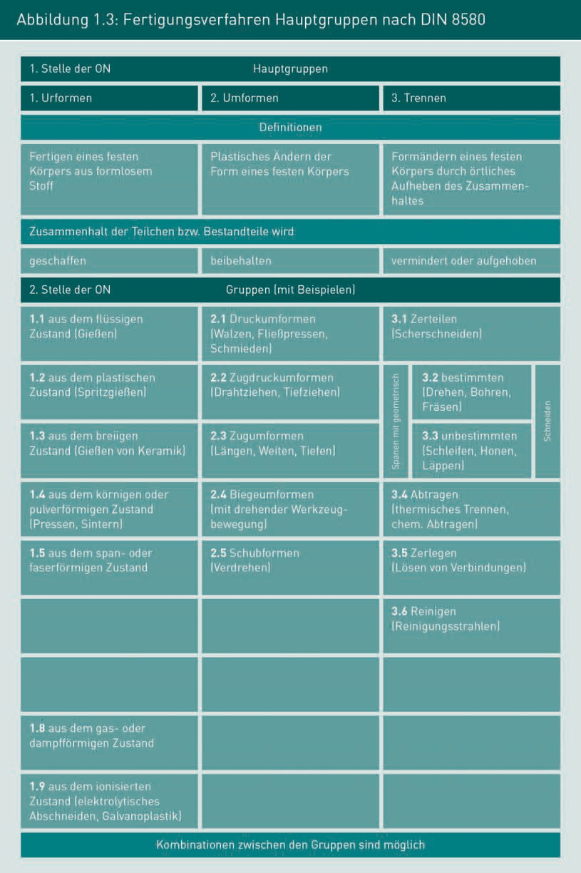

Introduction to Manufacturing Engineering

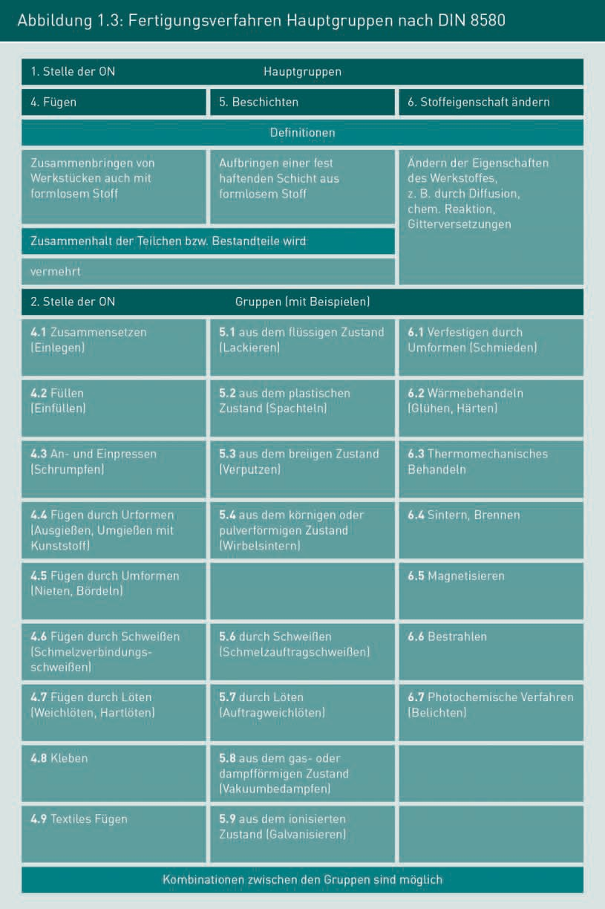

Overall, manufacturing engineering includes the production of components through forming or changing processes with specified measurements (geometry, surfaces, and tolerances) as well as the changing of the material properties. Alongside this, manufacturing engineering also includes the joining of components and structural parts to assemblies or finished products.

Manufacturing result

The essential manufacturing result and the criteria for assessing the manufacturing task are quantity performance, quality, and

costs.

Manufacturing engineering requires a holistic view of the aspects of manufacturing processes and materials and the **manufacturing result**, represented by quantity performance, quality (dimensional accuracy, as well as form and position accuracy, surfaces, properties) and costs (see Figure 1.4) (vgl. Westkämper/Warnecke 2010, pp. 1–9, 40–45).

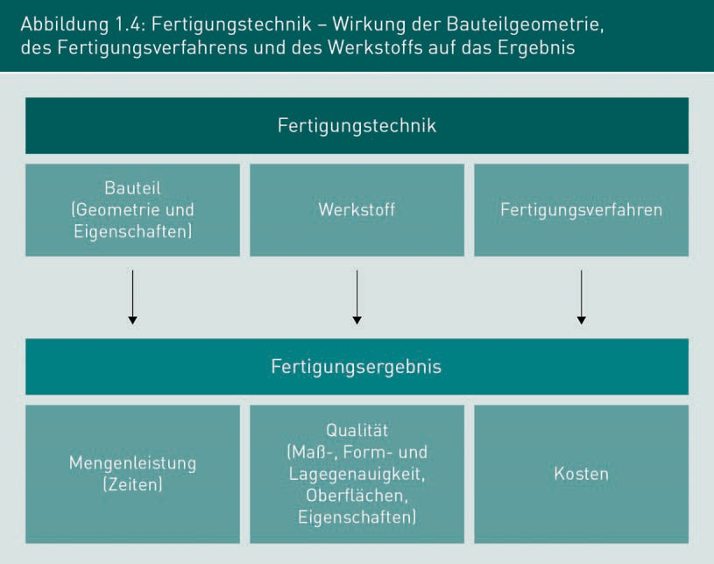

Next, the aspects of materials, quantity performance, quality, and costs as well as production management will be briefly discussed.

Materials in Machine, Automobile, and Aircraft Manufacturing

A large number of **materials** with a wide variety of properties are used within the machine, automobile, and aircraft manufacturing industries. These materials must be processed in manufacturing engineering in order to produce parts with defined shapes and defined properties as components or parts. Overall, steel materials are still the most frequently used construction material in the world today. In addition, light metals, plastics and

Introduction to Manufacturing Engineering

composites (combinations of matrix materials and reinforcing materials e.g., from metals and plastics as well as fibers, etc.) are used (vgl. Martin 2013, pp. 169–172).

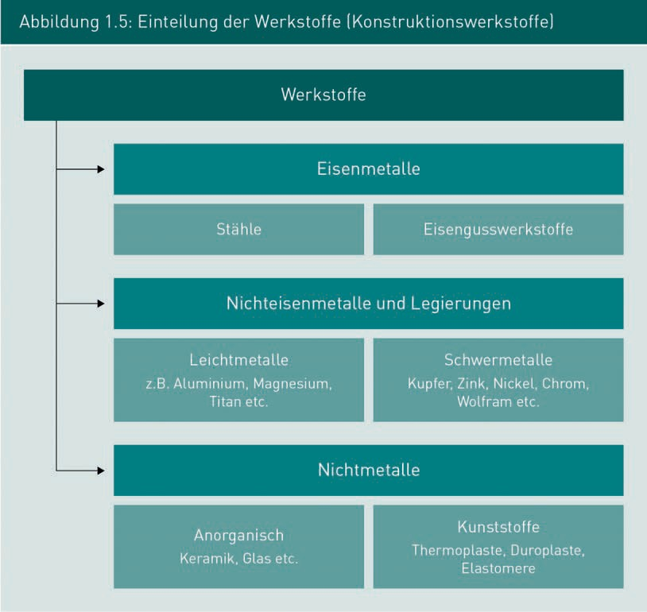

In general, depending on the load to be borne by the components, the materials must fulfill a large number of **properties**, e.g., strength (under static and dynamic load) and toughness as well as corrosion, heat, and wear resistance, etc. (vgl. Ruge/Wohlfahrt 2013, pp. 15–56). Other aspects such as processability (manufacturing), availability, and costs are equally important.

Lightweight construction is a design philosophy with the goal of maximum weight reduction. The aim of lightweight construction is to save fuel, raw materials, and costs during the manufacture and assembly of products as well as in the use of those products. Particularly in the case of masses that must be accelerated or decelerated on a regular basis or where the weight of the system has a decisive influence on operating costs (e.g., automobile and aerospace manufacturing), lightweight construction can significantly reduce operating costs or increase useful loads. For example, typical materials in lightweight construction are aluminum, titanium, and fiber-reinforced plastics.

Materials

A large number of materials are processed within the scope of manufacturing engineering. The most significant of these are ferrous materials, light metals (especially aluminum), and plastics.

Properties

Depending on the respective use and load, the materials must have a large number of properties.

As a result, a lower driving power is needed for the same drive or flight characteristics, particularly with automobiles, aircraft, and other dynamic systems. In addition, fuel consumption and thus CO2 and pollutant emissions are reduced and the weight ratio to the load of the means of transport is improved, allowing drives and fuel quantities to be designed more compactly.

Composites CFRP (carbon fiber-reinforced plastics) are a particularly ideal material for lightweight construction in terms of weight, processability, costs, etc.

.

The metallic lightweight materials used in automobile and aircraft manufacturing are essentially alloys of aluminum, magnesium, or titanium. Hybrid constructions from combinations of steel, aluminum, and plastic are also used in automobile manufacturing. In particular here, **composites** (see Figure 1.6) in which the properties of different materials, such as density, strength, corrosion resistance, etc., are combined are now used in many areas where the weight of the systems plays a crucial role. The advent of composite materials has allowed a wide variety of combinations of different materials to be realized (see Figure 1.6). Composite systems of this type, e.g., fiber-reinforced composites made of CFRP (carbon fiber-reinforced plastics) or layered composites (GLARE – glass fiber-reinforced aluminum), are generally accepted. This is particularly the case with demanding lightweight constructions, for example, in aircraft and manufacturing (vgl. Martin 2013, pp. 169–172).

The materials in composites are usually combined with one another, with each of these having particularly favorable property values such as strength, density, and corrosion resistance for meeting specific criteria that can also be combined with one another (see Figure 1.7).

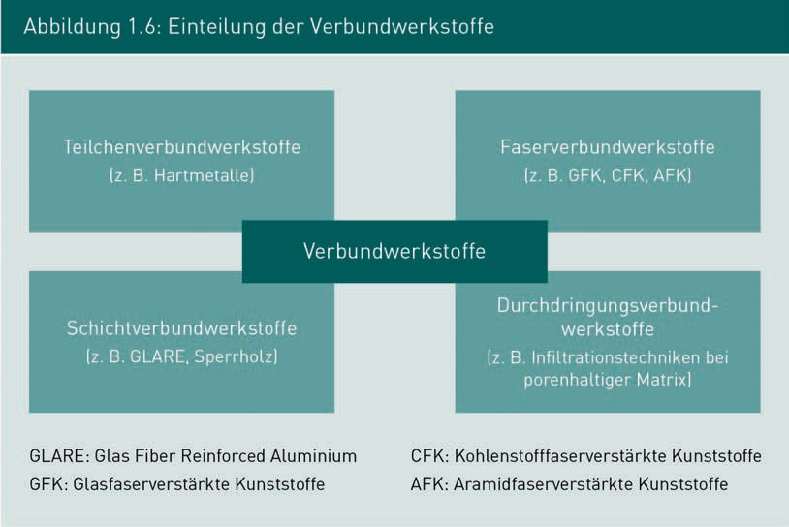

Introduction to Manufacturing Engineering

In addition, fiber-reinforced composites are now regarded as the traditional lightweight construction materials in upscale automobile and aircraft manufacturing. The demand for lightweight materials has increased exponentially in recent years.

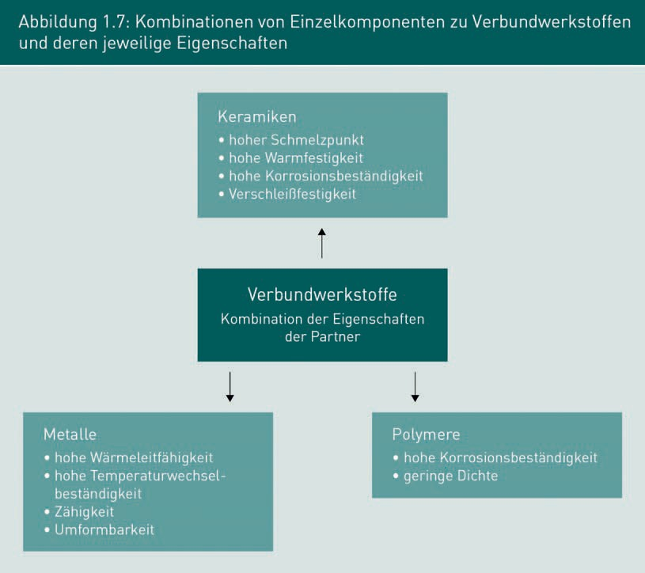

Plastics and fiber-reinforced composites (**CFRP** – carbon fiber-reinforced plastics) have considerably gained in prominence during the most recent years of lightweight construction (vgl. Fritsche et al. 2014). They are attractive lightweight materials due to their high specific rigidities (e.g., bending, elongation or torsional rigidities) and strengths. These composites also open up a multitude of new processing and design possibilities (vgl. Ruge/Wohlfahrt 2013, pp. 182–219).

Low weight combined with high strength and rigidity are the primary requirements for materials and design methods for lightweight construction in the automotive and aviation industries. The background to these requirements are primary assessment characteristics such as weight, performance, useful load ratio, purchase price, and operating costs for the various automobile models and aircraft. This is because materials of the primary structure (load-bearing main structure in aircraft, automobiles, etc.) have a decisive impact on total weight and fuel consumption.

CFRP

The manufacturing costs of a CFRP design are generally much higher than for conventional materials, e.g., steel, aluminum, etc.

Requirements for materials

Materials with deﬁned properties are used within the scope of manufacturing components and finished products. The construction materials used in the various industries of machine, automobile and aircraft manufacturing are predominantly metals (steel, aluminum alloys, titanium, etc.), plastics, and composite systems. The respective properties of the materials used depend on the requirements for the use of these components. The following requirements can be cited as an example (vgl. Martin 2013, pp. 169–172).

Machine manufacturing, automotive engineering, aircraft manufacturing

* high static and dynamic strength and rigidity
* low density, thus low weight, particularly for moving masses in dynamic processes
* low thermal expansion
* high corrosion and oxidation resistance
* low price and quick availability

Thermal machines and thermal processes

* high heat resistance
* low oxidation tendency and low diffusion tendency
* high operating temperature depending on the use, sometimes up to approx. 1,000° C for materials, e.g., in reactors, chemical plants, engines, gas turbines, aircraft engines, etc.)
* low creep behavior

Steel is typically the preferred material in machine manufacturing due to its suitability, price, and availability. As an alloy with a wide variety of alloying elements, steel is a material that can be used universally and adapted to specific uses. Its diverse properties, particularly its corrosion resistance and high thermal stability, are based on a large number of possible alloying elements (e.g., chromium, nickel, etc.).

Body construction

In modern body construction, various types of steel with different properties are used to design the occupant protection as well as crash deformation zones

Steels with a wide variety of properties are also used extensively in the area of **body construction** within automobile manufacturing. For example, high-strength steels are used for occupant protection and readily formable steels with energy absorption are used for crash protection. In addition, aluminum alloys are also used to a large extent in automobile manufacturing (e.g., engine housings, transmissions, chassis components, etc.). In aircraft manufacturing, the current standard material for use in the primary structure is still aluminum with its wide range of alloys. High-strength and corrosion-resistant aluminum alloys are typically used in this case. However, fiber-reinforced composites (e.g., CFRP) are also increasingly being used in automobile and aircraft manufacturing.

Introduction to Manufacturing Technology

Due to the various bending, tensile, compression, and torsion load conditions caused by dynamic loads, the forces and stresses to be borne by the material in dynamic systems are highly variable and generate strong oscillating loads that can quickly lead to the fatigue of the material. In the case of oscillating loads, the full load-bearing capacity of the tensile or compressive strength of the material cannot generally be utilized due to the required fatigue strength.

Plastics have long been used as composite materials in aircraft as well as automobile manufacturing. The most significant composites include glass fiber, carbon fiber, and aramid fiber-reinforced plastics (GFRP/CFRP/AFRP). The fibers are the load-bearing and stiffening components of this composite. They absorb the tensile forces acting on the material and the matrix material in the form a plastic (thermosets such as epoxy resins, for example) holds the fibers in their correct position relative to one another or transmits their shear strengths.

In machine manufacturing, the requirements for materials with regard to high strength and simultaneously low density are generally not very demanding. However, in automobile and aircraft manufacturing, there are extreme requirements for the materials in terms of the weight of the components and the strength as well as the service life of the components. Particularly in the new development of civil aircraft like the Airbus A380 and the A350 as well as the Boeing 787, innovative fiber-reinforced composites (**CFRP**) and advanced design methods are being considered with the aim of achieving further weight reductions. Alongside layered composites of aluminum and glass fiber, the novel materials also include carbon fiber-reinforced composites and metallic alloys of aluminum-lithium (5% higher strength, 10% lower weight than traditional Al alloys). GLARE is used in the stiffening of fuselage shells (aircraft outer skin) and aluminum-lithium is used in the self-supporting structures in the wings as well as within automobile manufacturing. Also, carbon fiber-reinforced composites have already proven their usefulness in automobile manufacturing and in secondary structure components. This refers to attachments to the primary structure, e.g., tail units, spoilers, flaps, doors, etc. In the case of the Airbus A320, the vertical stabilizer (vertical tail) has already been successfully manufactured from carbon fiber-reinforced composite materials as the primary structure since its market launch in recent decades (vgl. Martin 2013, pp. 169-172).

In comparison to modern aluminum alloys, a weight reduction of up to 25% can be achieved by using carbon fiber-reinforced composites. Likewise, a weight reduction of 10% can be achieved when using aluminum lithium material. In aircraft manufacturing, for example, fuel consumption could be reduced by about 10%. However, new materials and design methods only make sense if the associated additional costs for materials and production are acceptable. In addition, the maintenance of aircraft and automobiles must not be adversely effect during their service life.

For example, the Airbus A350 and the Boeing 787 increasingly use fiber-reinforced composites, which accounts for approximately 50% of the weight of the primary structure. The prerequisite for this is the development of innovative manufacturing concepts and design principles with significant differences from conventional processes in metal

CFRP

Carbon fiber-reinforced plastics can save considerable amounts of fuel when used in aircraft manufacturing.

structures. Today's metallic materials can only be replaced by modern materials once the hazards and risks of the new technologies have been comprehensively investigated and are therefore manageable (vgl. Martin 2013, p. 172).

Weight reduction This is the most important factor for the use of lightweight materials in

aircraft manufacturing.

Flexibility This is a production system characteristic that allows it to work with different geometries.

Degree of

automation

This is the extent to

which workers are still

involved in the manufacturing

process.

**Weight reduction** is one of the most important factors in automobile and aircraft manufacturing. The lighter the automobile or aircraft, the lower the fuel consumption. Carbon fiber-reinforced plastics are a particularly interesting alternative to metallic materials for next-generation automobiles and commercial aircraft. These new materials are already playing an important role in the new generation of commercial aircraft, such as the Airbus A350 and the Boeing 787. Current considerations assume that a weight reduction of up to 25% can be achieved with a fiber composite material percentage of more than 50% (vgl. Ruge/Wohlfahrt 2013, pp. 216–219).

Quantity Performance (flexibility and degree of automation)

A key requirement for the economic efficiency of production is a high degree of flexibility and the adequate degree of automation of a production system (vgl. Martin 2013, p. 172).

**Flexibility** is a characteristic that allows a production machine to process a large number of very different components (geometries) as well as produce a large scope of geometric form elements. When the flexibility of a production machine is low, only a few specific and very similar parts and geometries can be produced on the machine. In contrast, high flexibility allows for a large variety of geometries and components to be produced (vgl. Martin 2013 p. 173).

The **degree of automation** is the measure of proportionate manual activity. With a degree of automation of 0%, the worker must be continually present in order to advance the process. With a degree of automation of 100%, the running of a production machine is automatic, even without the presence of a worker.

It is well known that a high degree of automation and high flexibility are mutually exclusive. Highly flexible production systems are generally universal machines that can process a wide variety of components and geometries. Such universal machines are not automated or have only a low degree of automation. In contrast, highly automated production systems usually have very little flexibility. These systems are often designed only for a specific product, whereby fully automatic production is intended. This is the case, for example, with body welding systems in the automotive industry or with highly automated production systems in the production of brake discs (vgl. Westkämper/ Warnecke 2010, pp. 1–9, 40–45).

Figure 1.8 shows the requirements for the series size. Small series require universal machines with a high degree of flexibility since small series can rarely utilize the production machine by only producing one product or one order. Medium series require high flexibility, but also high levels of automation. This is precisely what CNC machines

Introduction to Manufacturing Technology

fulfill to a high degree. Large-scale series and mass production require highly automated systems, which usually only have very little flexibility. Here, the production machines are generally utilized for many years, sometimes even for just a single component (e.g., in the automotive industry).

As the degree of automation rises, **unit costs** fall, but flexibility decreases while investments increase. As a result, small series production requires universal machines since these are the only economical approach.

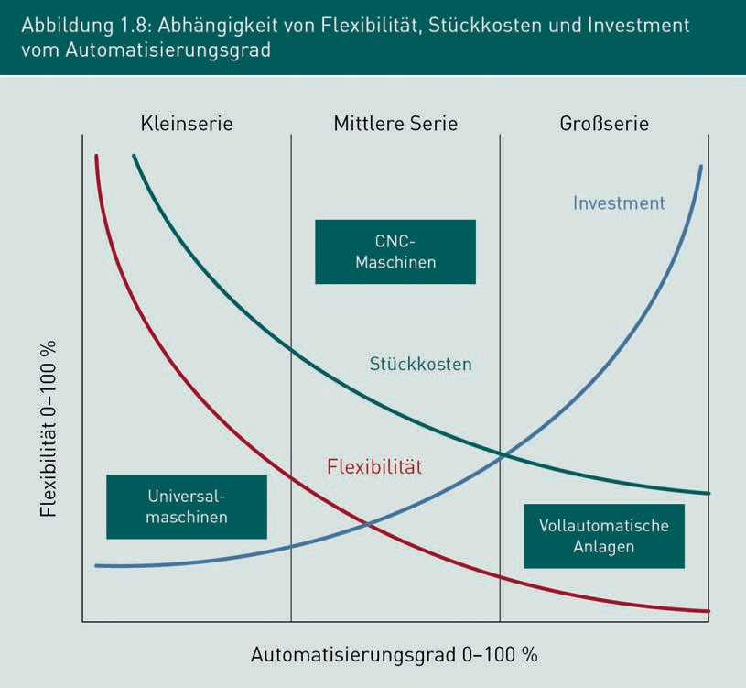

An important basis for assessing the quantity performance is a detailed knowledge of the production times. This detailed knowledge of production times is of essential importance for costing, payroll accounting, and production planning. To do this, a detailed time analysis is prepared for each component (unit) and the allowed times for each individual work step are then determined from this. There are various methods for the determination of these times and the **REFA** System (vgl. REFA 2016, pp. 61–75) is one of the most significant methods.

Unit costs

Flexibility decreases with a rising degree of automation. In contrast, unit costs fall considerably, while investment costs increase sharply.

REFA

This is an organization that provides a structure for time planning in manufacturing. According to REFA, times are determined in the work

process.

The determination of the allowed time (according to REFA) is an essential process in the specification of work processes in manufacturing. The allowed times represent the time load for the person in the work process (work order time, person-related) or of the manufacturing equipment (occupancy time, equipment-related). The time for the person working (allowed time) is determined separately from the equipment (occupancy time). The determination of the allowed time is carried out according to the rules of the REFA association by questioning the working persons, by self-recording, or by using time studies as ACTUAL times or by calculating, comparing, estimating, or planning times as TARGET times. In addition to the determination of the basic times, the determination of the allowance times as well as the recovery times (only for the working person) is also essential.

In the context of order processing, TARGET times (vgl. REFA 2016) are the times in the work process that are required by persons (work order time) and equipment (occupancy time) in order to conduct the work processes to be carried out. REFA assumes the normal performance (100%) of a working person. In the case of deviations in the work rate, the performance degree is estimated and the allowed time is corrected with the performance degree. The normal performance corresponds to the proper completion of a task at a normal pace in a given work system and with specified influence variables. The allowed times are essential data for production planning and the production order.

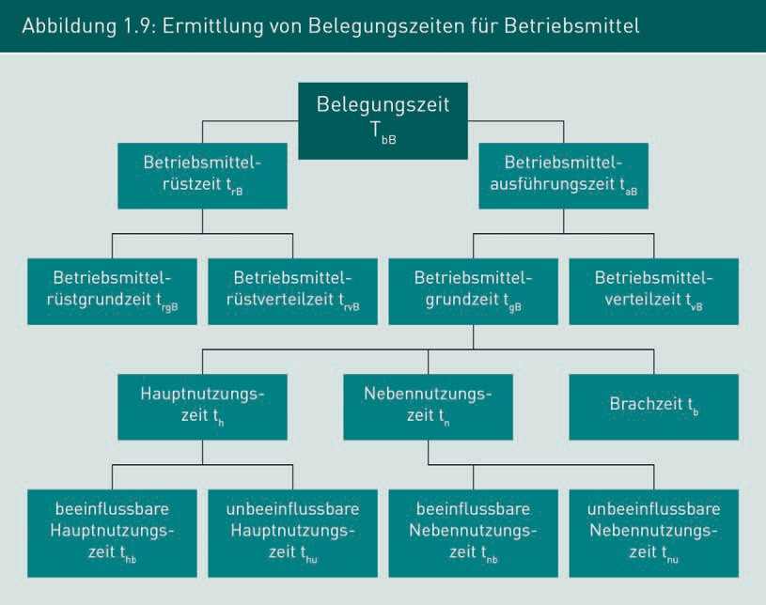

Introduction to Manufacturing Technology

Figure 1.9 shows the determination of occupancy times for the equipment and Figure 1.10 shows the determination of allowed times and work order times for manual activities according to REFA.

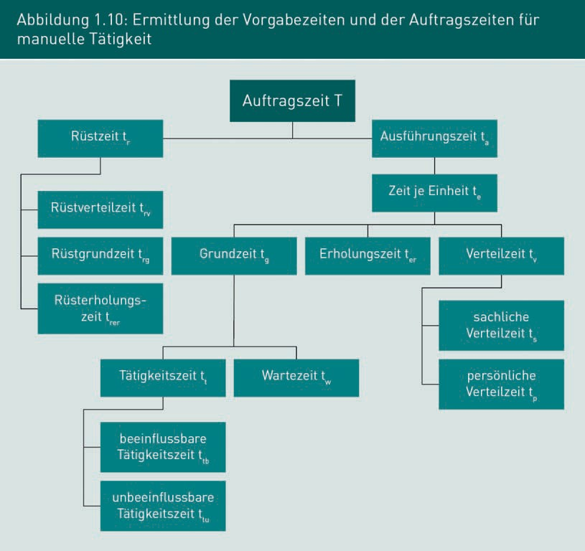

In addition to the REFA system for determining allowed times, there are other methods for determining the time load of work processes. One such is the Work Factor method (WF) system of predetermined times in which allowed times are determined by adding analyzed motion sequences in order to establish allowed times by totaling individual motion elements (from the WF motion element catalogue) with assigned standardized time units. Another method for determining allowed times is the MTM method (Methods Time Measurement), which is also a system of predetermined times. Likewise here, motion sequences are analyzed and broken down into individual motion elements. The times determined with the MTM method (with the TMU - Time Measurement Unit) correspond to the 100% performance of a skilled worker. The MTM method is also a system of predetermined times.

Quality

For the success of an industrial production, it is not only necessary that the suitable and economically optimal production processes are used, it is also necessary that the result of the production is defect-free and that the respective component meets the required quality. In order to achieve this, the processes and machines in the production must be installed as systems that are capable of avoiding defects, detecting defects, and compensating for them as automatically as possible. In particular, mass production requires a continual safeguarding of the processes and process capability that is in alignment with the respective quality standards.

DIN EN ISO 9001

This standard is the internationally applied guideline for quality management.

Quality improvement

This is an essential goal of the production task. Quality deviations involve considerable costs.

According to **DIN EN ISO 9001** (o. V. 2015), the following deﬁnition stands for the term quality: Quality is deﬁned as the degree of fulfillment of inherent (associated) characteristics to the requirement. Quality thus indicates the extent to which a product (or service) meets the requirements.

It widely accepted that the installation of quality management systems (QMS) leads to an increase in productivity and, at the same time, to improved operational results within the scope of cost considerations and thus also to higher customer approval. Figure 1.11 shows the positive results of **quality improvement**.

Introduction to Manufacturing Technology

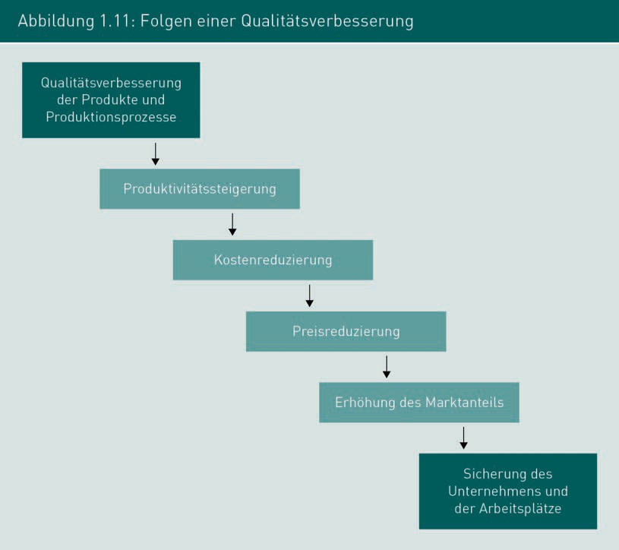

The elimination of defects is typically associated with considerable costs since the manufacturer must remedy defects and assure warranted characteristics or provide replacements as outlined in its warranty obligations. Avoiding defects is an important requirement for the economic success of a company. Based on the **Rule of 10 in quality management**, Figure 1.12 shows (in terms of one euro) how the costs of defects develop in later stages, depending on the stage at which they are discovered. The later defects are discovered, the higher the costs for their elimination (vgl. Schmid 2013, p. 354).

Rule of 10 in quality management

This states the costs of eliminating a defect depending on the stage of discovery.

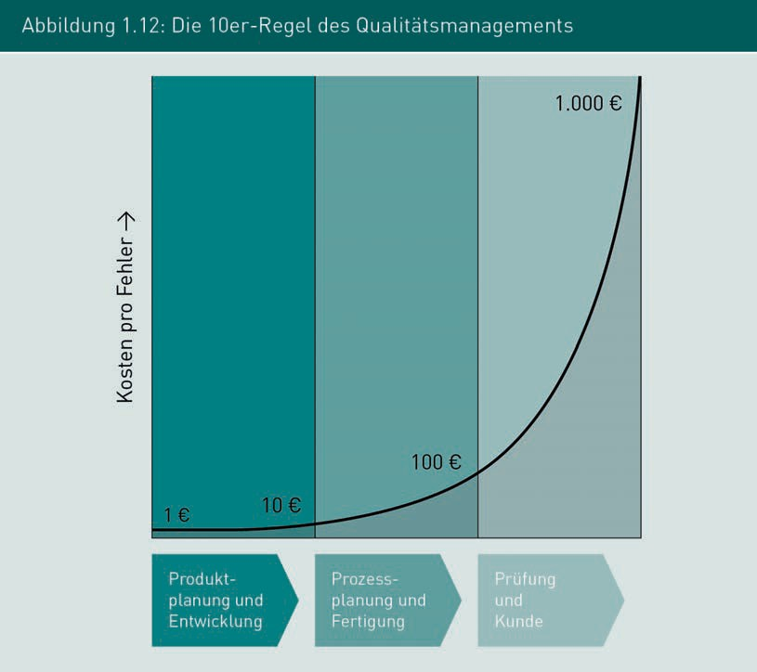

Therefore, it is absolutely essential for a company to maintain a quality management system, which ensures that a variety of quality assurance measures are taken and implemented in the early stages of development in order to avoid defects in the production processes or report defects automatically. According to Figure 1.12, it is necessary to ensure that defects are avoided at an early stage of product development. Methods such as FMEA (Failure Mode and Effects Analysis) are installed for this purpose. It is well known that the costs for rectification increase by a factor of 10 with each additional stage (vgl. Schmid 2013, p. 345). Expensive recalls are known from many areas of industry, particularly the automotive industry.

For these reasons, a company must have a functioning quality management system (QM), that provides all measures to ensure the quality of the products by monitoring both the production processes and the services. According to DIN ISO 9001, quality management is an essential core task of management. In many industries, regulations or laws require manufacturers of certain high-risk products to have a functioning quality management system, e.g., in the aerospace industry, the automotive industry, medical technology, and pharmaceutical industry, as well as food production.

Introduction to Manufacturing Technology

Another significant quality standard is **ISO/TS 16949:2016** (vgl. Association of the Automotive Industry 2016a). In recent years, this standard has become firmly established as a global quality standard for large-scale production in the automotive industry. This standard has been adapted even more intensively to the international standards for the automotive industry and has been given the designation IATF16949 (International Automotive Task Force). In the future, IATF16949 will take even greater account of the structure and requirements of ISO 9001:2015 for mass production and will also include the special additional requirements specifically for the automotive industry. This has largely replaced older prevalent automotive standards such as VDA 6.1 (1996), EAQF (Evaluation d'Aptitude sur la Qualité pour les Fournissseurs, France), AVSQ (Associazione Nazionale Fra Industrie Automobilistiche, Italian Automotive Industry Network, Italy), QS-9000, etc. In the future, the new quality standard VDA Volume 6 (Association of the Automotive Industry 2016b) will be the German regulatory guideline for the automotive industry and is particularly aimed toward the OEMs and suppliers of German automobile manufacturers.

Alongside the IATF 16949, the VDA Volume 6 has been the current VDA Guideline for the certification of quality management systems in the automotive industry since 1996. In addition to the automobile manufacturers for cars, trucks, buses, etc., this current VDA 6 Guideline also applies to the manufacturers of assemblies and production materials as well as the suppliers to the automotive industry.

Production Management

In addition to the quality management systems, various production, planning, and control systems have become established in the area of **production management systems** in recent years (vgl. Gummersbach 2017, pp. 223–246). This is where SAP's supporting software systems play a significant role in the major industries. Considering today's strong integration of suppliers and just-in-time production (delivery directly to the process without storage times) in the automotive industry and in aircraft manufacturing, production control systems are no longer conceivable without a complex data structure and integration of suppliers.

Furthermore, a change in thinking has also prevailed in industry in recent decades. This is particularly the case the automotive industry, in which the values of the groups involved, such as employees, suppliers and customers (see Figure 1.15), have been taken into account to a much greater extent than in the past. A part of this change was that the U.S. and Europe quickly recognized that Japanese managers had established the notably successful philosophy of the **Toyota Production System** and Lean Management (vgl. Gorecki/Pautsch 2018, pp. 17-25) in many areas of industry and services for their industries, particularly for the automotive industry and other mass production companies (see Figure 1.13). Today, both systems are also a component of modern production management systems in large and medium-sized industries in Asia, the USA and Europe.

ISO/TS 16949:2016

This is the most significant quality standard for mass production in the automotive industry. The standard has been redrafted and is now called IATF 16949.

Production management systems

These are necessary to control the complex production and integrate the multitude of suppliers for just-in-time production.

Toyota Production System

This places a much heavier emphasis on the involvement of the customer, employees, and quality in the production process.

Lean Management

This philosophy has the goal of doing only what the customer values.

The Toyota Production System (TPS) and the philosophy of **Lean Management** (lean production) were fundamentally applied in Japan with a consistent implementation and considerable economic success. In their basic precepts, the systems primarily take the high importance of the human factor of employees into account. Lean management is essentially based on the guiding principle that only those services that the customer is willing to value and also to pay for should be performed on a product. The concept of lean management encompasses diverse principles, methods, and processes for the more efﬁcient design of the entire value chain within the production of industrial goods and the provision of services.

The Toyota Production System is an integrated, social, and technical philosophy for production and production management in industrial companies. Particularly in the automotive industry, the TPS is an organizational system for production and logistics, but is now also being applied to many other industries. Taiichi Ohno and Eiji Toyoda, two Japanese production engineers, developed the system between 1948 and 1975. Toyota's founder, Sakichi Toyoda, and his son, Kiichiro Toyoda then further developed the system (vgl. Gorecki/Pautsch 2018, pp. 9-16). This particularly involved deﬁning the concept of waste in more detail and establishing rules for reducing the seven types of waste. Specifically, these are:

* overproduction,
* inventory,
* transport and walking routes,
* laborious processing,
* laborious motions,
* waiting times, and
* reworking.

An eighth type of waste is now also defined as the unused talent of employees. The Japanese initiators recognized that the success of a company and the improvement of its processes could only be realized through well-trained employees.

The reduction of waste types is also reflected in the principles of lean management, which is now established in many sectors of industry and services (Figure 1.13). Lean management emerged as an inspired result of the development of the Toyota Production System.

Introduction to Manufacturing Technology

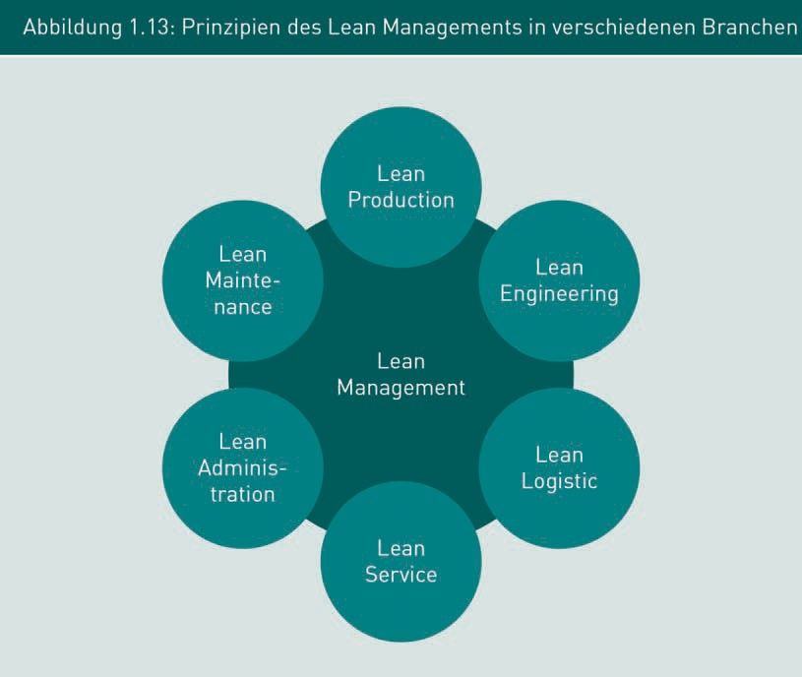

The following important principles are applied in lean management:

* + only improve what the customer values in the product,
  + focus on your own strengths,
  + involve employees in continuous improvement processes (CIP),
  + build personal responsibility, team spirit and teamwork,
  + autonomy and self-determination of employees,
  + build a leadership culture,
  + continued training of employees,
  + a clear and open information policy toward the workforce,
  + discussion and involvement of employees in change processes, and
  + cultural change to social structures in the company.

The main success of the Toyota Production System lies in the implementation of the principles mentioned in Figure 1.14. Alongside these principles, the areas below hold the greatest importance (see Figure 1.15):

* + customer orientation,
  + employee orientation,
  + process orientation,
  + orientation toward standards,
  + quality orientation,
    - competitive orientation, and
    - customer-supplier concepts.

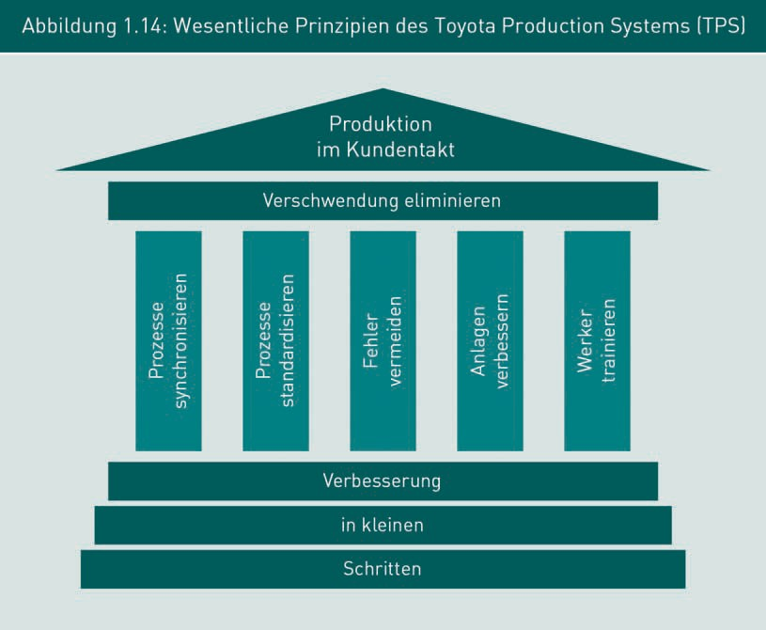

The Kaizen system (vgl. Gorecki/Pautsch 2018, pp. 30–42) aims at learning from mistakes. The Kaizen philosophy includes the statement: “Mistakes are an opportunity to improve.” The Kaizen process, as also presented previously, refers to the main objectives of the company's processes.

Introduction to Manufacturing Technology

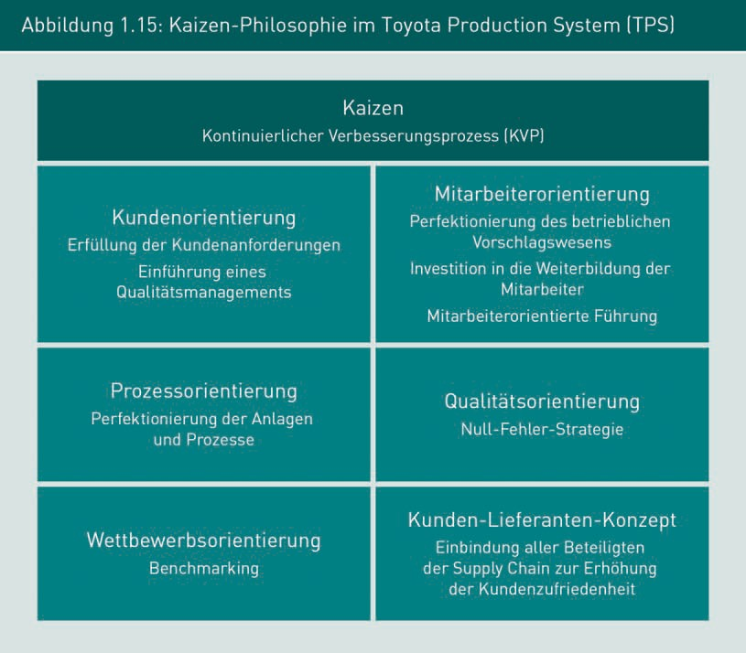

Production costs

To consider the competitiveness and determine the price of a product, it is essential to know the production costs for the materials and production of a product. The systematics of cost accounting include which ACTUAL costs (cost element) have been incurred on a product, where they have been incurred in the company (cost center) and for which product they have been incurred (cost unit).

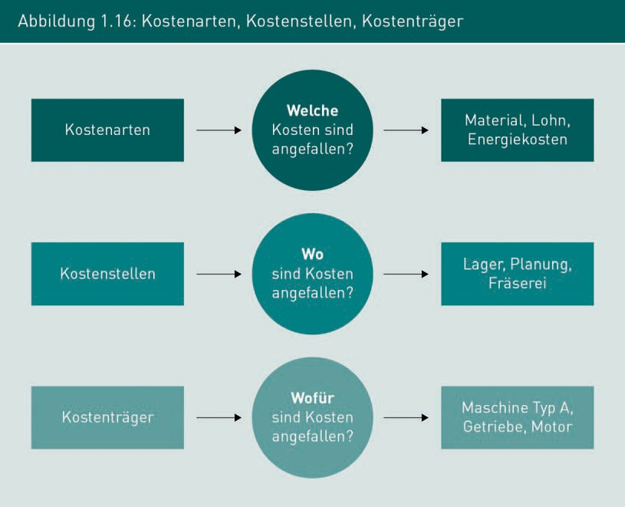

For this purpose, the planned costs are already considered with their cost element in the planning stage within the scope of a cost estimate. Next, the respective costs are distributed to the various cost centers and cost units (products, orders, etc.). The result (profit or loss) can be determined by comparing production costs with sales revenues for a product or service.

Cost and performance accounting are therefore an essential area of operational accounting. This makes it possible to record operational proceedings within the scope of production and compare them with the planned costs of the cost calculation. The most important tasks of cost and performance accounting are:

* + - recording costs and services of a billing period,
    - determining production costs and cost of goods sold for a component or unit of activity,
    - valuation of unfinished and finished goods for inventory purposes,
    - creating calculations (target costs),
    - preparing data for statistics and planning,
    - providing a basis for decision-making,
    - determining the economic efficiency of processes in production, and
    - controlling and monitoring costs.

Figure 1.17 shows the typical structure of a product calculation (vgl. Gummersbach 2017, pp. 397–398).

Introduction to Manufacturing Technology

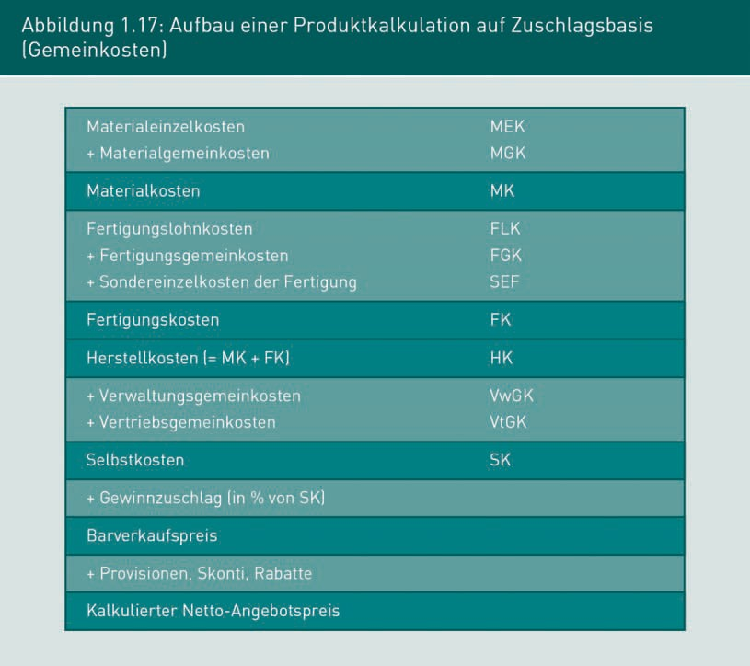

Overall, production costs are incurred through the processing of raw materials, operating consumables, and operating supplies, through the manual activity of a worker or through machine work on the basis of machinery sets. Production costs consist of direct production costs (e.g., production wages), flat-rate production overheads (e.g., operating consumables, energy costs, etc.) and specific direct production costs (fitments and devices, external processing, etc.).

The cost accounting of unfinished and finished products is a necessary and important process in times of strong international competition. It serves as information for the planning of costs and revenues in a company.