**HAMBURGER**

**MOR**

**GEN**

**POST**

www.mopo.de

Tuesday, July 16, 2002 | C1986

|  |
| --- |
| **Eliad Sharony**  A Crossover on the Piano: Compositions From the Walz to Pop and Famous Melodies  with Eliad Sharony. 8:00 p.m., Café Keese |

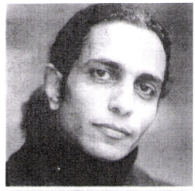

* Atmospheric piano music in Café Keese.

**Eliad Sharony** on the piano

delighted not just the invited guests, such as **Nikolas Graf von Bernstorff, Dariusz Michalczewski, Friedhelm Mönter** and **Jutta Heck**, but also everyone with an ear for soulful music. On the piano, Eliad Sharony’s offering was the finest of crossovers. His melancholic mix of waltzes, eastern pop, and famous melodies from throughout history carried listeners away and made the evening a very special experience. Many were reminded of concerts by the great Maestro, **Leonard Bernstein**. No wonder, considering that Bernstein took Sharony as a protege four years before his death, and formed and influenced him in his own image.