Article

Whole exome/genome sequencing joint analysis in a family with oligogenic familial hypercholesterolemia

1. Supplementary Figures

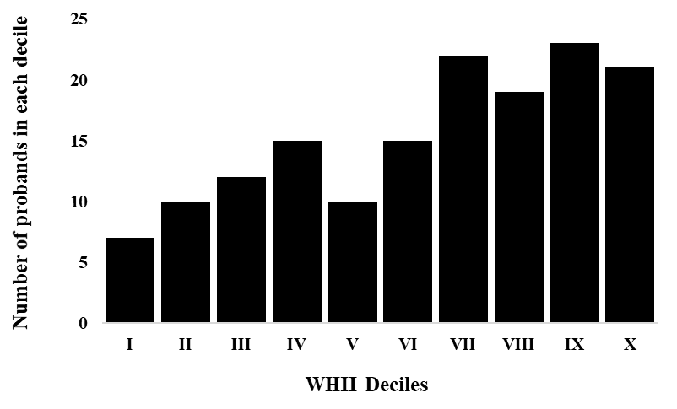

**Figure S1. Distribution of probands in the 10 deciles of the weighted Polygenic Risk Score in the UK Whitehall II (WHII) cohort study.**

**A B**

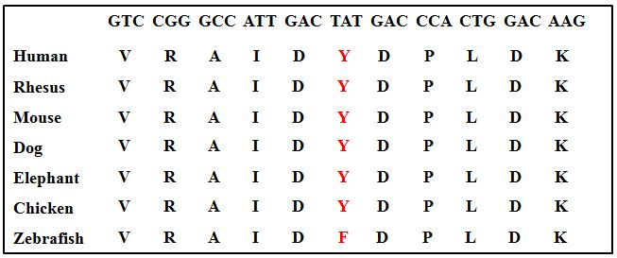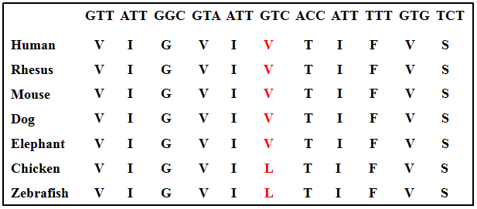

**C D**

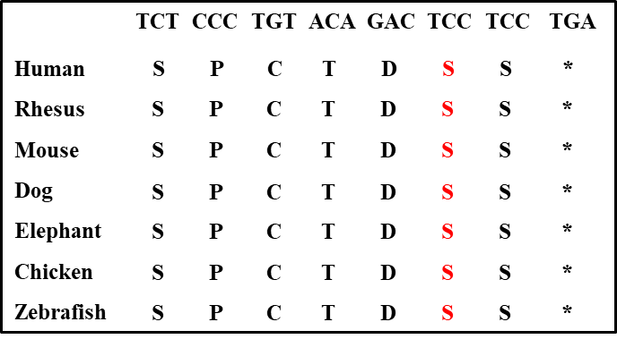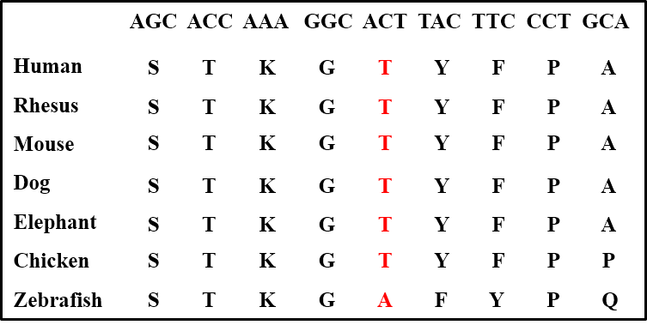

**Figure S2. Conservation of the mutated amino acid** **in *LRP6.*** The conservation of the mutated amino acid between species from human to zebrafish is represented for each variant. The position of the variant is indicated in red. (**A**) p.(Val1382Phe) variant. (**B**) p.(Tyr972Cys) variant. (**C**) p.(Thr1479Ile) variant. (**D**) p.(Ser1612Phe) variant.

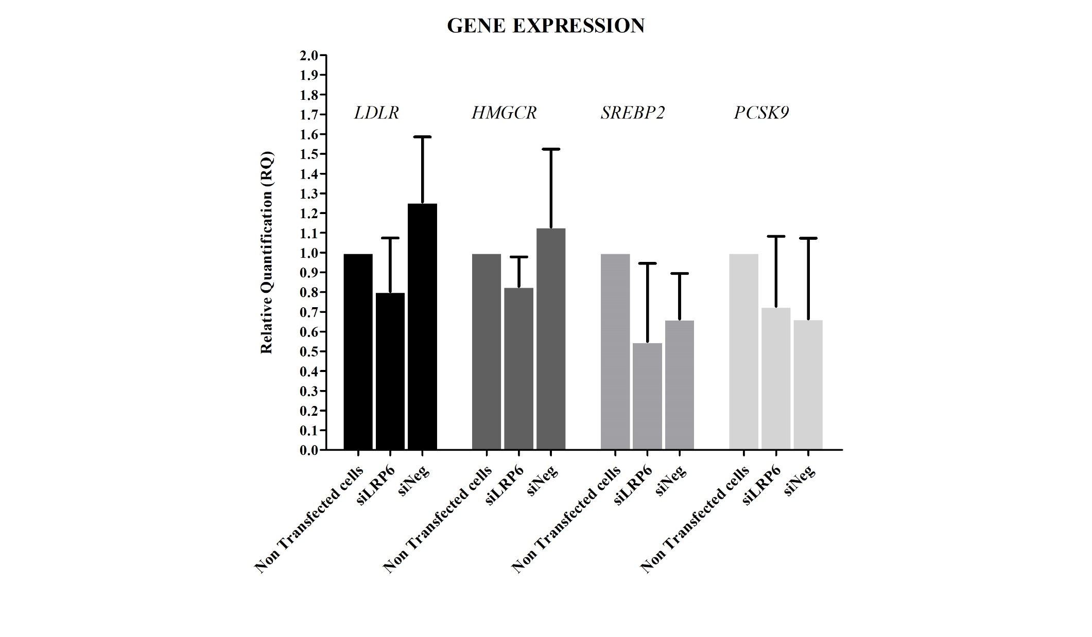

**Figure S3. Expression of genes implicated in cholesterol metabolism in HuH7 cells transfected with siLRP6.** Mean Relative Quantification (RQ) for *LDLR*, *HMGCR*, *SREBP2* and *PCSK9* in HuH7 cells transfected with siLRP6, siNeg and in non-transfected HuH7 cells. Reactions were run in triplicate for each cDNA. *POLR2A* was used as the reference gene. The relative quantification of gene expression was performed using the ∆∆CT method and the non-transfected cells were used as calibrator. Results are shown as mean ± standard deviation (SD).

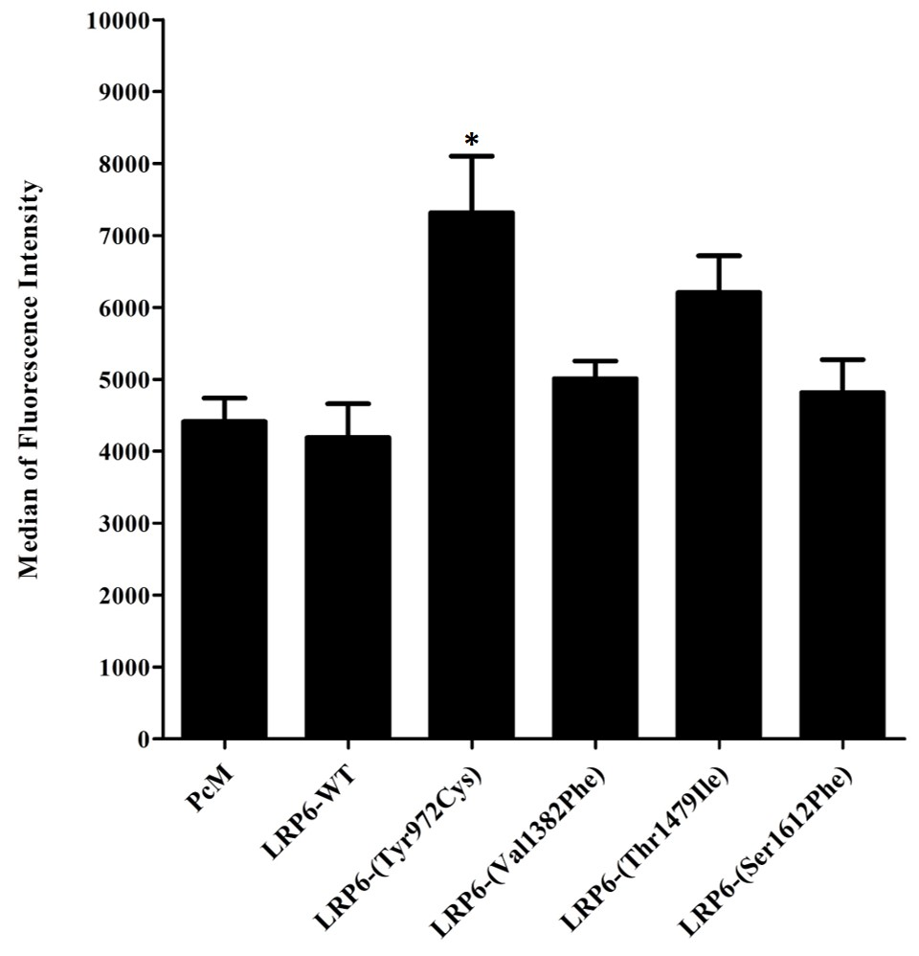

**Figure S4. LDL binding and uptake in HEK293T after transfection with empty vector, LRP6-WT or mutated plasmid (cells harvested without trypsin).** Median fluorescence intensity of 100000 events was acquired for each sample but only median fluorescence intensity of living cells is presented. Data represent four independent assays. In all experiments, the difference between two conditions was determined by non-parametric Mann-Whitney U test and p-values < 0.05 were considered as statistically significant. Error bars represent ± SD.

*: p < 0.05

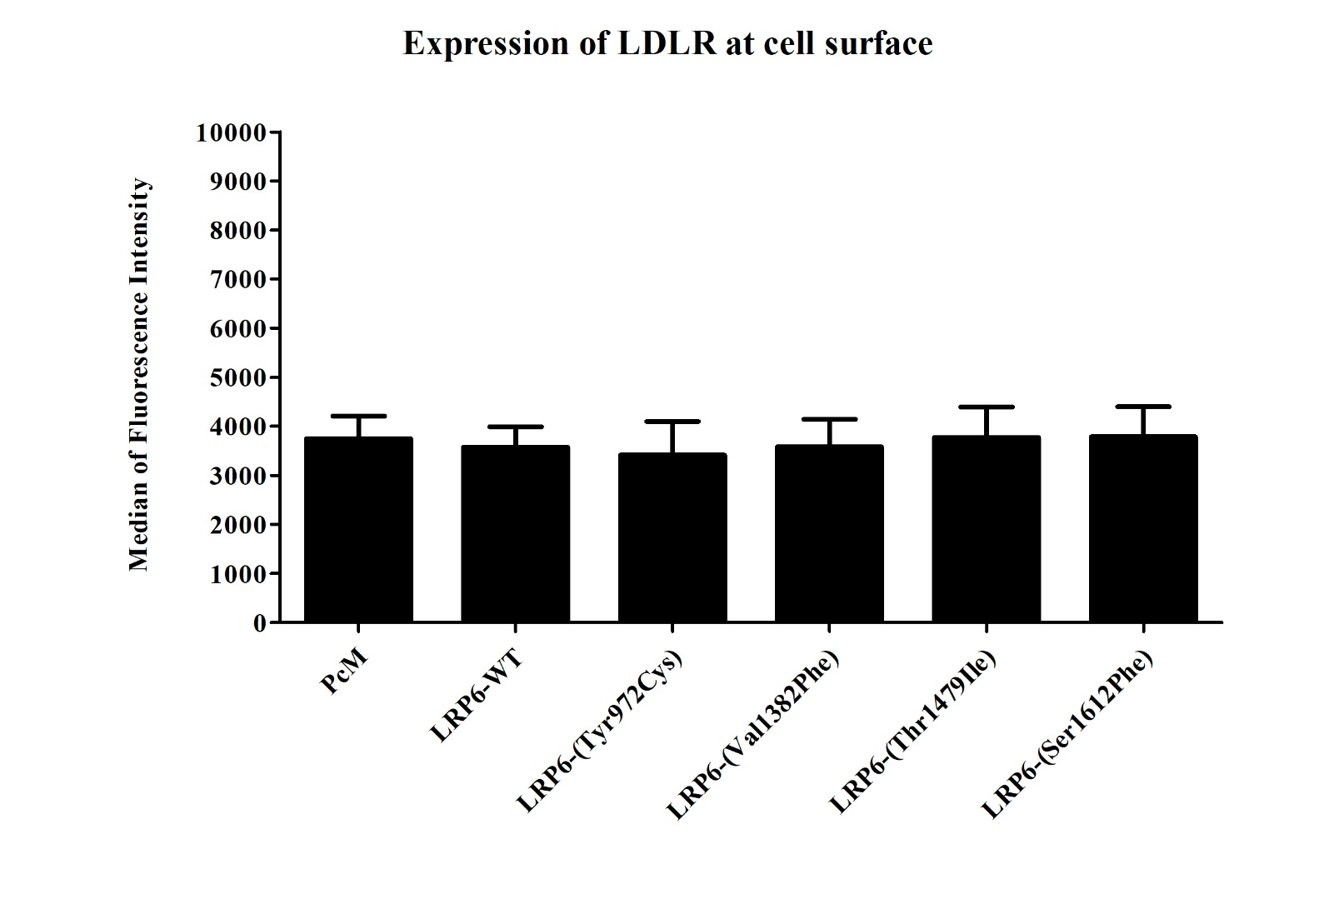

**Figure S5. Effects of transfection with WT or mutated LRP6 on membrane expression of LDL receptor.** Membrane expression of LDL receptor in HEK293T cells after transfection with empty vector, LRP6-WT or mutated plasmid. Cells were transfected with the corresponding plasmid for 48 hours, labeled with extracellular PE mouse anti-human LDLR antibody for 30 minutes at 4°C then analyzed by FACS. Median fluorescence intensity of 100000 events was acquired for each sample but we represent only media fluorescence intensity of living cells. Data represent four independently performed assays. The difference between cells transfected with empty vector, LRP6-WT or mutated plasmid was determined by non-parametric Mann-Whitney U test and p-values < 0.05 were considered as statistically significant. Error bars represent ± SD.

1. Supplementary Tables

**Table S1.** **Variants identified in HC438 family by WES and WGS.** The pathogenicity of the variants was evaluated using Varsome, PolyPhen2, Provean, ClinVar, CADD score, and Splice AI.

|  |  |  |  |  |  |  |  |  |  |  |  |  |  |
| --- | --- | --- | --- | --- | --- | --- | --- | --- | --- | --- | --- | --- | --- |
| **Gene** | **c.notation**  **p.notation** | **rs number** | **Pathway** | **GTEx-TPM_Liver #** | **gnomAD**  **(total)\*** | **gnomAD (ENF)\*** | **FREX\*\*** | **Varsome\*\*\*** | **PolyPhen2** | **Provean †** | **ClinVar** | **CADD Score ‡** | **Splice AI** |
| **Nonsynonymous Variants transmitted from I-2 to II-1, II-4 and II-7** | | | | | | | | | | | | | |
| *CYP7A1*  (NM_000780) | c.1192C>G  p.(Pro398Ala) | rs142708991 | Bile acid and bile salt metabolism | 2.612 | 0.336%  (951/282868) | 0.43%  (555/129184) | 0.0871% | LB | PD | D  (-7.559) | LB | 25.1 | No-consq  (0) |
| *KIFC2*  (NM_145754) | c.1399C>T  p.(Pro467Ser) | … | Vesicle-mediated transport | 11.75 | … | … | … | VUS | B | N  (-2.482) | … | 19.14 | No-consq (0) |
| *LRP6*  (NM_002336) | c.4144G>T  p.(Val1382Phe) | rs139480047 | Vesicle-mediated transport | 9.662 | 0.08379%  (237/282856) | 0.1061%  (137/129164) | 0.261% | B | B | N  (-1.246) | LB | 22.3 | Donor gain (0.02) |
| **Intronic Variant transmitted from I-2 to II-1, II-4 and II-7** | | | | | | | | | | | | | |
| *SLC39A4*  (NM_017767.3) | c.1074+10C>T | rs782654111 | Transport of small molecules | 2.835 | 0.0072%  (17/237238) | 0.000093%  (1/107736) | … | LB | … | … | B | 5.199 | Donor Loss (0.01) |
| **Nonsynonymous Variants transmitted from I-1 to II-1 and II-7** | | | | | | | | | | | | | |
| *LDLRAP1*  (NM_015627) | c.604_605delTCinsCA  p.(Ser202His) | rs386629678 | Clathrin-mediated endocytosis | 112.23 | … | … | … | LB | PD | N  (-2.072) | LB | … | … |
| *GOLGA4*  (NM_2078) | c.4481G>T  p.(Arg1516Ile) | rs201034947 | Vesicle-mediated transport | 17.45 | … | … | … | VUS | PD | D  (-2.826) | … | 14.84 | No-consq (0) |
| *AP2A1*  (NM_130787) | c.1927C>T  p.(Gly643Ser) | … | Vesicle-mediated transport | 26.45 | … | … | … | VUS | B | N  (0.111) | … | 19.11 | Donor Loss (0.01) |
| **Nonsynonymous Variant transmitted from I-2 to II-1 and II-7** | | | | | | | | | | | | | |
| *MOGAT2*  (NM_025098) | c.14C>T  p.(Ala5Val) | rs146774065 | Digestion and absorption | 57.92 | 0.0059%  (9/152220) | 0%  (0/68036) | … | LB | PD | D  (-2.916) | … | 19.18 | No-consq (0) |
| **Intronic Variants transmitted from I-2 to II-1 and II-7** | | | | | | | | | | | | | |
| *PEX19*  (NM_2857.4) | c.181-5C>T | rs199818690 | Transport of small molecules | 30.73 | 0.100% (154/152170) | 0.180% (122/68030) | 0.2 | VUS | … | … | LB/VUS | 1.094 | Acceptor Loss (0.02) |
| *TSC2*  (NM_0548.5) | c.2838-4A>G | rs45517272 | Vesicle-mediated transport | 17.91 | 0.085% (240/282284) | 0.12% (156/128748) | … | B | … | … | B | 12.26 | Acceptor Loss (0.08) |
| **5’UTR Variants transmitted from I-1 or I-2 to II-1, II-4 and II-7 ++** | | | | | | | | | | | | | |
| *AP3S1*  (NM_1284) | c.-114T>G | rs62371472 | Vesicle-mediated transport | 33.86 | … | … | … | VUS/B | … | … | … | 15.23 | No-consq (0) |
| *AP2A2*  (NM_012305) | c.-49G>C | … | Vesicle-mediated transport | 20.46 | … | … | … | VUS | … | … | … | 5.6 | No-consq (0) |
| **3’UTR Variants transmitted from I-1 or I-2 to II-1, II-4 and II-7 ++** | | | | | | | | | | | | | |
| *SMAP2*  (NM_022733) | c.*1073C>T | rs541351955 | Vesicle-mediated transport | 29.56 | 0.0032% (1/31392) | 0.000 (0/15424) | … | VUS | … | … | … | 9.1 | … |
| *SEC22B*  (NM_004892) | c.*425T>G | … | Vesicle-mediated transport | 9.244 | 0.00068% (1/146068) | 0.000 (0/65958) | … | VUS | … | … | … | 5.745 | No-consq (0) |
| *ACTR3*  (NM_005721) | c.*3247C>T | rs1322808539 | Vesicle-mediated transport | 12.07 | … | … | … | VUS | … | … | … | 3.857 | Acceptor Gain (0.01) |
| *SEC22C*  (NM_032970) | c.*2598A>G | … | Vesicle-mediated transport | 3.841 | … | … | … | VUS | … | … | … | 3.241 | Donor Gain (0.03) |
| *KIF13B*  (NM_015254) | c.*2477A>C | rs879249361 | Vesicle-mediated transport | 5.813 | … | … | … | VUS | … | … | … | 3.241 | No-consq (0) |
| *CD59*  (NM_001127223) | c.*3923A>G | … | Vesicle-mediated transport | 65.13 | … | … | … | VUS | … | … | … | 3.169 | No-consq (0) |
| *SLC2A3*  (NM_006931) | c.*1345dup | rs1335777343 | Transport of small molecules | 7.774 | 0.002% (3/152086) | 0.003% (2/68026) | … | VUS | … | … | … | … | … |
| *RAB27A*  (NM_004580) | c.*2253_*2256delTTTG | … | Vesicle-mediated transport | 12.7 | … | … | … | VUS | … | … | … | … | … |
| *AQP9*  (NM_020980) | c.*1766G>A | rs551728298 | Bile acid and bile salt metabolism | 110 | 0.0032% (1/31376) | 0.00 (0/15420 | … | VUS | … | … | … | 1.264 | Acceptor Loss (0.01) |
| *MED1*  (NM_004774) | c.*923T>G | rs988981826 | Regulation of cholesterol biosynthesis by SREBP | 3.617 | … | … | … | VUS/B | … | … | … | 15.96 | No-consq (0) |

# Gene expression in the liver, from the Genotype Tissue Expression database (GTEx). TPM: transcripts per million

**\*** Allele frequency, from the Genome Aggregation database (gnomAD): allele count/allele number in the general population and in the European non-Finnish

** Allele frequency from the French Exome Project database.

*** Varsome tool according to the ACMG guidelines [51]

**++** 3’UTR and 5’UTR variants were uncovered by the WES in subjects I-2 and II-1.

**†** Provean:Variant with a score ≤-2.5 is considered “deleterious” and with a score > -2.5 is considered “neutral”.

**‡** CADD score ≥ 20 indicates that the variant is predicted to be among the top 1% of the most deleterious substitutions in the human genome, and a score ≥ 30 indicates that the variant is predicted to be among the top 0.1% of the most deleterious substitutions in the human genome.

N: neutral, LB: likely benign, B: benign, VUS: variant of unknown significance, PD: probably damaging, D: deleterious

**Table S2.** **Linkage analysis of the variants identified in HC438 family by WES and WGS**

|  |  |  |  |  |  |
| --- | --- | --- | --- | --- | --- |
| **Chromosome** | **Gene** | **c.notation**  **p.notation** | **rs number** | **Multipoint LOD SCORE** | **Results** |
| ***Hypothesis 1: A paternal trait inherited by the three affected children. mean ELOD=0.72, max ELOD=1.84*** | | | | | |
| 1 | *SMAP2*  (NM_022733) | c.*1073C>T | rs541351955 | -1.417 | Probably excluded |
| 1 | *SEC22B*  (NM_4892) | c.*425T>G | … | -3.704 | Excluded |
| 2 | *ACTR3*  (NM_5721) | c.*3247C>T | rs1322808539 | 0.067 | … |
| 3 | *SEC22C*  (NM_032970) | c.*2598A>G | … | 0.418 | … |
| 5 | *AP3S1*  (NM_1284) | c.-114T>G | rs62371472 | -2.688 | Excluded |
| 8 | *KIF13B*  (NM_015254) | c.*2477A>C | rs879249361 | -0.951 | … |
| 11 | *AP2A2*  (NM_012305) | c.-49G>C | … | 0.519 | … |
| 11 | *CD59*  (NM_1127223) | c.*3923A>G | … | **0.914** | **Probably linked** |
| 12 | *SLC2A3*  (NM_6931) | c.*1345dup | rs1335777343 | -3.154 | Excluded |
| 15 | *AQP9*  (NM_020980) | c.*1766G>A | rs551728298 | 0.966 | … |
| 15 | *RAB27A*  (NM_4580) | c.*2253_*2256delCAAA | … | 0.862 | … |
| 17 | *MED1*  (NM_4774) | c.*923T>G | rs988981826 | 0.467 | … |
| ***Hypothesis 2: A paternal trait inherited by the two more severely affected children. mean ELOD=0.51, max ELOD=1.61*** | | | | | |
| 1 | *LDLRAP1*  (NM_015627) | c.604_605delTCinsCA  p.(Ser202His) | rs386629678 | **0.813** | **Probably linked** |
| 3 | *GOLGA4*  (NM_2078) | c.4481G>T  p.(Arg1494Ile) | rs201034947 | **1.198** | **Probably linked** |
| 19 | *AP2A1*  (NM_130787) | c.1927C>T  p.(Gly643Ser) | … | 0.417 | … |
| ***Hypothesis 3: A maternal trait inherited by the three affected children. mean ELOD=0.77, max ELOD=2.00*** | | | | | |
| 1 | *SMAP2*  (NM_022733) | c.*1073C>T | rs541351955 | -1.278 | Probably excluded |
| 1 | *SEC22B*  (NM_4892) | c.*425T>G | … | 0.150 | … |
| 2 | *ACTR3*  (NM_5721) | c.*3247C>T | rs1322808539 | -0.072 | … |
| 3 | *SEC22C*  (NM_032970) | c.*2598A>G | … | -3.171 | Excluded |
| 5 | *AP3S1*  (NM_1284) | c.-114T>G | rs62371472 | -3.259 | Excluded |
| 8 | *CYP7A1*  (NM_000780) | c.1192C>G  p.(Pro398Ala) | rs142708991 | **1.200** | **Probably linked** |
| 8 | *KIFC2*  (NM_145754) | c.1399C>T  p.(Pro467Ser) | … | 0.200 | … |
| 8 | *SLC39A4*  (NM_017767.3) | c.1074+10C>T | rs782654111 | 0.201 | … |
| 8 | *KIF13B*  (NM_015254) | c.*2477A>C | rs879249361 | -0.770 | … |
| 11 | *AP2A2*  (NM_012305) | c.-49G>C | … | -0.376 | … |
| 11 | *CD59*  (NM_1127223) | c.*3923A>G | … | -4.332 | Excluded |
| 12 | *LRP6*  (NM_002336) | c.4144G>T  p.(Val1382Phe) | rs139480047 | **1.369** | **Probably linked** |
| 12 | *SLC2A3*  (NM_6931) | c.*1345dup | rs1335777343 | **1.042** | **Probably linked** |
| 15 | *AQP9*  (NM_020980) | c.*1766G>A | rs551728298 | -3.820 | Excluded |
| 15 | *RAB27A*  (NM_4580) | c.*2253_*2256delCAAA | … | -2.796 | Excluded |
| 17 | *MED1*  (NM_4774) | c.*923T>G | rs988981826 | 0.467 | … |
| ***Hypothesis 4: A maternal trait inherited by the two more severely affected children. mean ELOD=0.54, max ELOD=1.61*** | | | | | |
| 1 | *PEX19*  (NM_2857.4) | c.181-5C>T | rs199818690 | 0.419 | … |
| 11 | *MOGAT2*  (NM_025098) | c.14C>T  p.(Ala5Val) | rs146774065 | -0.492 | … |
| 16 | *TSC2*  (NM_0548.5) | c.2838-4A>G | rs45517272 | **0.673** | **Probably linked** |

ELOD = expected LOD SCORE.