IU

Mechanics-Statics
DLBROMS_E

Learning Objectives
The equilibrium of material bodies is a natural and necessary state to which objects in the universe tend to converge. The motion of our planet itself is governed by the laws of equilibrium; the steady contact of people with the Earth also represents a type of equilibrium that prevents them from flying off the surface of Earth. One may add many standard examples of objects used in daily life that are in equilibrium, such as cars, buildings, bridges, and machines.
Statics belongs to the field of study called Solid Mechanics and is the science that studies the equilibrium of objects. Equilibrium is the result of a group of efforts that balance each other so that an object either stays at rest or moves at a constant speed in a straight line.
In this course, you will first learn the three axioms of Newton, the concept of force and moment, and the replacement of a system of forces by a single force and vice versa. We will then discuss the different types of efforts that might be applied to a solid and the different types of bearings and supports that can hold a solid, the representation of these efforts, and the calculation of reactions in supporting structures through the mathematical conditions of equilibrium known as static determinacy. Special attention will be given to planar trusses.
We will also discuss the difference between external and internal efforts and the importance of the latter in the equilibrium process as well as how to prevent fracture or instability. The location of the center of gravity of complex objects is another key topic to be covered in this course.
Friction force occupies a considerable part of this course because it involves key aspects in practical life such as adherence between car tires and the road, contact between two articulations, and power transmission through systems of pulleys and belts.
Equilibrium, which is the main topic of this course, thus becomes in essence a starting point or an initial state in the study of the future motion or kinematics of objects.

Unit 1 – Basic Physical Quantities

Study Goals

On completion of this unit, you will be able to …

… understand the concept of force.
… apply the three well-known theorems of Newton.
… distinguish between external and internal forces.
… execute all mathematical operations about vectors.

1. Basic Physical Quantities, Vectors

Introduction
Mechanics is a branch of physics that studies the state of objects either at rest or in motion. A given state is caused by a system of actions, known as forces and/or moments, applied to an object. Both solids and fluids constitute materials of interest in mechanics. Statics is a sub-branch of mechanics that deals with the equilibrium of rigid bodies: this equilibrium can be manifested by an object at rest or moving with constant velocity.
The essential quantities that create the state of any object are forces and moments. Consequently, the study of the equilibrium of a rigid body requires theoretical and mathematical knowledge of aspects dealing with these quantities. One may also cite “indirect” quantities that are used in mechanics, such as length, mass, weight, and time.
“Mechanics is based on only a few laws of nature which have an axiomatic character. These are statements based on numerous observations and regarded as being known from experience. The conclusions drawn from these laws are also confirmed by experience.” (Gross et al., 2013, p.1). Therefore, knowledge of Newton’s three laws of mechanics is crucial. In addition, the concepts of force, types of forces, resultant force, and the decomposition of forces will be discussed in detail. This discussion necessitates considerable knowledge about vectors and vector operations, which are discussed at the end of this unit.

1.1 Physical Quantities and Units
Many physical quantities are used in the field of mechanics. Although they may appear simple and obvious, it is important to recall their definitions, the concepts that they represent, and their units. The system of units used in physics is the International System of Units (SI), also known as the metric system.
International system of units:
This is the standard system of units used worldwide for scientifical measurements.
Length. A physical quantity that gives the location of an object measured with respect to a determined reference and/or the dimensions of this object. In SI units, length is expressed in meters (m) (Hibbeler, 2010).
Time. Quantification of a succession of events or of variable status events. When an action or a process remains unchanged it is said to be time independent. In SI units, time is expressed in seconds (s) (Hibbeler, 2010).
Temperature. Quantification of amount of thermal energy stored in an object. In SI units, it is expressed in kelvin (K) (Halliday et al., 2021).
Mass. Quantification of the amount of material contained in a substance. Mechanically, it also represents the resistance of a body against a change in velocity. In SI units, mass is expressed in kilograms (kg). (Hibbeler, 2010).
Force. A “push” or “pull” action applied to a body by its surrounding, either by direct contact or at a distance (Hibbeler, 2010). In SI units, force is expressed in newtons (N). Note that a newton is not a basic unit but is a compound unit involving mass, length, and time: N = kg m/s².
When any quantity evaluates to a very large or very small number, it is customary in SI to “reduce” the numerical value and “replace” the extra zeros in the number with a prefix before the unit symbol. For example, when the duration of an impact is 0.003 s, we write it as 3 × 10⁻³ s or 3 ms (milliseconds); the letter “m” (for milli) added to the main unit “s” (for seconds) is a prefix. Another example is a force of 5,000,000 N, which is written as 5 × 10⁶ N or 5 MN (meganewton); the letter “M” (for mega) added before the main unit “N” (for newtons) is a prefix. The first example above is a submultiple case (negative power of ten), while the second example is a multiple case (positive power of ten).
Table 1.1 summarizes all prefixes used for multiples and submultiples.
Table 1.1 Prefixes of SI Units
Multiple/Submultiple | Exponential notation | Nomenclature | Symbol
1,000,000,000 | 10⁹ | Giga | G
1,000,000 | 10⁶ | Mega | M
1,000 | 10³ | kilo | k
0.001 | 10⁻³ | milli | m
0.000001 | 10⁻⁶ | micro | μ
0.000000001 | 10⁻⁹ | nano | n
0.000000000001 | 10⁻¹² | pico | p

Self-Check Questions
- Specify whether the following statement is True or False and justify your answer
The volume of a body is a basic physical quantity. False: volume represents the product of three lengths. The units m³ are composed of three basic units of length (or the same basic unit of length repeated three times).
- Choose the correct answer
The equivalent prefix unit used for a 1 ton mass is
Gg Mg mg ng

1.2 Newton’s Basic Axioms
Before stating Newton’s three axioms, we clarify the difference between two terms used to “idealize” the representation of a body.
Particle. A “particle” is the representation of a solid having mass but negligible size with respect to the characteristic lengths in the system under study (Beer et al., 2012). For example, when considering a car or group of cars driving across a huge bridge, the cars are small with respect to the bridge, so only the effect of their weight applied to the bridge is considered. In the idealized model, each car is treated as a particle “pushing” down on the bridge via its weight. This is illustrated in Figure 1.1.
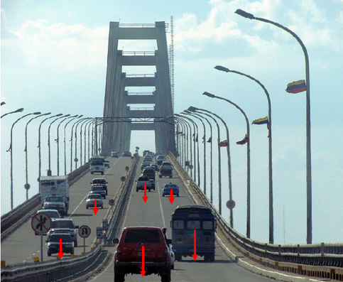
Figure 1.1 Cars crossing a bridge over Maracaibo lake (Venezuela).
Rigid Body. A rigid body is a solid having both mass and volume (Beer et al., 2012). It is treated as a group of particles located at known positions with respect to each other that remain unchanged by the application of a load on the body. In other words, within solids modeled as rigid bodies, any change in position of the particles with respect to each other is neglected.
As an example, consider the trailer of Figure 1.2, which is subjected to the following forces: its own weight, the normal reaction force from the road (exerted vertically upward at the wheels), the normal reaction force exerted vertically upward from the pickup’s trailer hitch, and the horizontal pulling force exerted by the trailer hitch to move the trailer forward. The deformations developed within the trailer due to these forces are negligible.
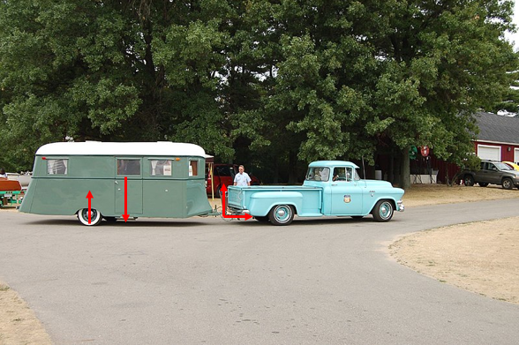
Axiom: An axiom is a statement accepted as true and used to develop further rationales.
Figure 1.2 Pickup truck pulling a trailer.
Note that the three axioms of Newton (Hibbeler, 2010) are applicable to an object in a fixed frame of reference or in a frame of reference moving at constant velocity.
Axiom 1. When a particle is originally at rest or moving in a straight line at constant speed and then is subjected to a balanced system of forces, it maintains its original motion before the application of the balanced forces.

This axiom is illustrated in Figure 1.3: consider that the forces $\vec{F_{1}}$, $\vec{F_{2}}$, …., $\vec{F_{n}}$ are balanced (i.e., they sum to zero) and are applied to the particle. If the particle was at rest (velocity v = 0) before the forces were applied, it remains in the same state (at rest) after the forces are applied. If the particle was in steady motion (velocity v = const.) before the forces were applied, it remains in the same state (in motion at constant velocity v) after the forces are applied.
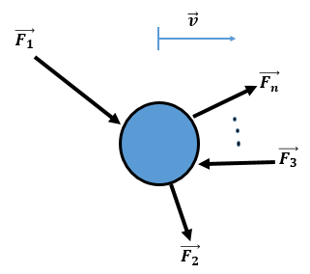
Figure 1.3 Particle subjected to a balanced-force system.
Acceleration: This is the rate of change in velocity per unit time.
Axiom 2. If a particle of mass m is subjected to an unbalanced system of forces of that sum to F (i.e., the resultant force is $\vec{F}$), it moves with acceleration $\vec{a}$ in the same direction as $\vec{F}$. The magnitude of this acceleration is proportional to the magnitude of $\vec{F}$ and inversely proportional to the mass m (a=Fm).
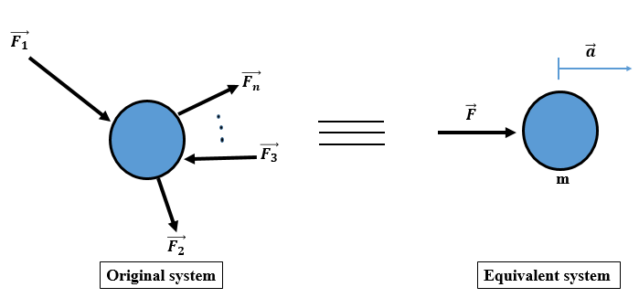
Figure 1.4 Particle accelerated due to the application of a resultant force.
This is illustrated schematically in Figure 1.4 and mathematically through Equation (1.1).
$\vec{ F}=m\vec{a}$ (1.1)
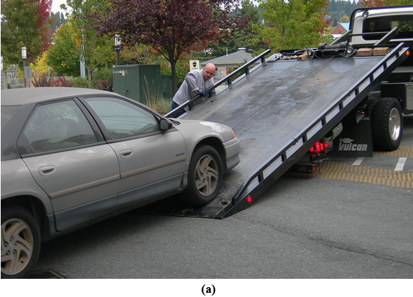
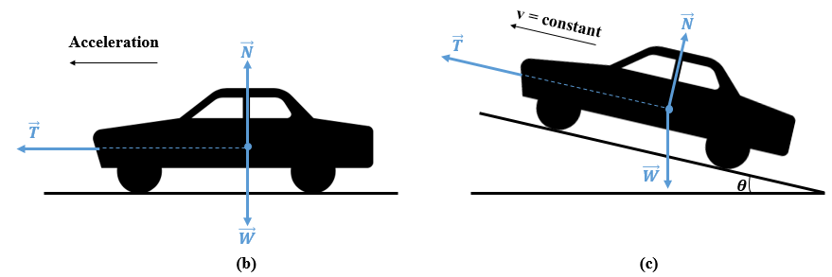
Figure 1.5 (a) Car pulled forward on a winch, (b) car accelerating before reaching the winch, (c) car moving forward at a constant velocity.
A practical example of the first two axioms is represented in Figure 1.5. Consider a car at rest that is to be mounted onto a flatbed truck by using a winch. A cable is attached to the car to pull it forward, as shown in Figure 1.5(a). When the cable starts to pull, the car is on the horizontal road and is subjected to the system of three forces shown in Figure 1.5(b). The weight $\vec{W}$ of the car and the normal reaction force $\vec{N}$ exerted by the road on the wheels balance each other, so the resultant force in this system is simply the tension $\vec{T}$ of the cable. As per axiom 2, the magnitude of the tension is equal to the mass of the car multiplied by its acceleration; which is the change in the velocity of the car from zero (i.e., at rest) to the final velocity at which the car moves forward toward the winch.
Figure 1.5(c) shows the system of forces exerted on the car when the car is on the inclined plane. In this case, the normal reaction force exerted by the inclined plane cancels a part of the car’s weight and the tension exerted by the cable cancels the remaining weight of the car, leading to a system of three balanced forces or zero resultant force. Since the car was already in steady motion, it will remain in that state as per axiom 1 until the pulling process is finished.
Axiom 3. When two particles interact, each exerts a force on the other; the forces are of the same magnitude but opposite in direction. This principle is known as the principle of action and reaction.
Figure 1.6 shows two particles A and B exerting mutual forces FA on /B=-FB on /A illustrating this third Newton’s axiom.
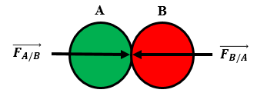
Figure 1.6 Principle of action and reaction.

Figure 1.7 A book resting on a table demonstrates the principle of action and reaction.
Figure 1.7 shows a practical example of the principle of action and reaction. Treat the book as particle A and the table supporting the book as particle B. The book applies its downward weight on the table and the table applies on the book an upward normal reaction force that is of the same magnitude but opposite in direction with respect to the weight of the book. The resultant force is zero so the book remains at rest on the table.

Self-Check Questions
- Assign to each of the following cases the appropriate axiom of Newton.
Case 1: Lift raised by a motor via a cable (Axiom 2)
Case 2: A mother carrying her baby in her arms (Axiom 3)
Case 3: A couch at rest before and after people sit on it (Axiom 1)
- Complete the following sentence:
An 800 N man is lying in the middle of a four-legged bed. Based on axiom 3 of Newton, each leg of the bed exerts a reaction force of 200 N.

1.3 Scalar, Position, and Force Vectors

Scalar and vector
Scalar. A scalar is a numerical quantity that can be positive or negative (Hibbeler, 2010). For example, the abscissa of a point is −2 m (−2 is a scalar). The duration of a motion is 30 s (30 is a scalar).
Vector. A vector is a geometric element representing a physical quantity and is represented by a line segment of a specific orientation (Hibbeler, 2010).
A vector is drawn as an arrow, as shown in Figure 1.8. Four elements are needed to draw a vector:
- Origin: Starting point of the vector.
- Direction: Inclination of the vector as determined by the angle formed between the horizontal and the vector line. This angle is positive if measured counterclockwise and negative if measured clockwise.
- Sense: Orientation of the vector. A vector has two options for a sense. For instance, if the direction is horizontal, a vector may have either a leftward sense or a rightward sense. If the direction is vertical the sense may be either downward or upward.
- Magnitude: Amount or value of the physical quantity that is represented by the vector. Geometrically, the magnitude is the distance from the vector’s origin and the tip of its arrow.
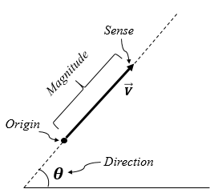
Figure 1.8 Representation of a vector.
A vector is denoted by a symbol with an over-arrow: $\vec{V}$. It may also be represented by a bold symbol with no over-arrow: V. The magnitude of a vector (i.e., its length) is denoted by the same letter with no over-arrow: V. Another way to denote vector magnitude is as follows: $\left|\vec{V}\right|$ or $\left\|\vec{V}\right\|$.

Position
Position is a physical quantity specifying the location of a point of interest with respect to a reference point. Mathematically, the position of a point in space is specified by a vector, known as a position vector, whose origin is the point of reference and whose tip is the target point or the point of interest. Figure 1.9 illustrates the position in space of a point P(x,y,z) with respect to the origin O of a direct Cartesian orthonormal reference frame (O,$\vec{i}$,$\vec{j},\vec{k}$); where $\vec{i}$,$\vec{j},\vec{k}$ are respectively unit vectors along the x, y, and z axes. The scalar components of a position vector along the three axes are calculated from the difference in coordinates between the tip and origin: OP=OPx=xP-xOOPy=yP-yOOPz=zP-zO=xP-xOyP-yOzP-zO while the magnitude is calculated by applying the Pythagorean Theorem: $OP=\sqrt{{{OP}_{x}}^{2}+{{OP}_{y}}^{2}+{{OP}_{z}}^{2}}$.
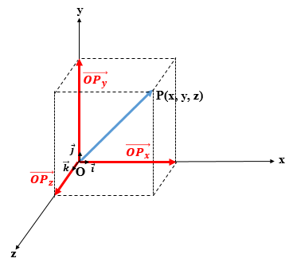
Figure 1.9 Representation of a position vector.

Force
Definition and concept
In mechanics, a force is defined as the action exerted by one body on another body (Beer et al., 2012). This action may be applied by direct contact or at a specified distance. Mathematically, a force is represented by a vector, which has a point of application, a direction, a sense, and a magnitude, so these four elements are needed to define a mechanical force. A force is typically denoted by the letter “F” with a rightward over-arrow:$\vec{F}$.
Figure 1.10a shows an example of a force: it is the action applied by the worker on the crate via the cable-pully system to raise the crate. Figure 1.10b shows the vector representation of this force $\vec{F}$ including its four elements:
- Point of application: the point of the cable at which the force is exerted. Mathematically, the point of application is the origin of the force vector. (Hibbeler, 2010).
- Direction: the angle between the force (i.e., along the cable) and a horizontal line; mathematically, the direction is described by the angle θ formed between a horizontal line and the force (Gross et al., 2013). The angle is positive when measured counterclockwise and negative when measured clockwise.
- Sense: the orientation of the vector force; in Figure 1.10b, the sense is downward.
- Magnitude: the amount of the applied force; measured in newtons (N) in the SI. Its symbol is the same as the vector force but without the over-arrow: F is the magnitude of F. One must not confuse a vector, which is a “geometric” representation, and its magnitude, which is a scalarF. F F
Numerous examples of forces may be categorized either as contact or distance forces: a person opening a door exerts a direct force or contact force on the door; a person trying to move a wardrobe from one place to another exerts a contact pushing force on the furniture. The force of attraction exerted by a magnet on a metallic key is a distance force, and the same applies to the force exerted between protons and electrons in an atom.
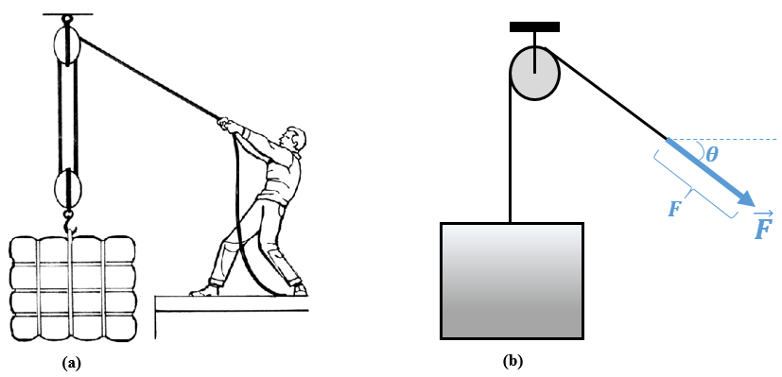
Figure 1.10 (a) Worker lifting a crate via a pulley and cables system, (b) representation of force exerted by the worker on the cable.
Special force: gravity
Gravity is a force of attraction between any two objects with mass. Earth is the largest mass by far in our immediate vicinity, so gravity is often taken to mean the force exerted by Earth on other objects. This force is called the “weight” of the object. It is a distance force because the objects need not touch the Earth to have weight. The weight vector $\vec{W}$ has its point of application at the center of gravity of the object and is exerted in a vertical direction with a descending sense and a magnitude proportional to the magnitude of the gravity acceleration vector $\vec{g}$. The coefficient of proportionality is none other than the mass m of the object:
$\vec{W}=m⋅\vec{g}$ (1.2)
Since $\vec{W}$ and $\vec{g}$ are exerted in the same direction (and in the same sense because mass is always positive), Equation (1.2) may be used to calculate the magnitude W of the weight. In SI units, weight is measured in newtons (N), mass in kilograms (kg), and the acceleration g in meters per second squared (m/s²).
The acceleration due to gravity is essentially constant on any given planet; on Earth, g has an average value of 9.81 m/s², whereas g on Mercury is estimated to be 3.73 m/s². However, since mass represents the amount of material in an object, it does not depend on the location of the object, so the weight of the object changes from one place to another because the acceleration due to gravity changes. For instance, an object of mass 10 kg has a weight of 98.1 N on Earth but of 37.3 N on Mercury.
Concentrated and distributed force
When a force is exerted on a part of a body that is much smaller than the body (i.e., region assimilated to a point), the force is said to be concentrated. Consider the case of Figure 1.10 as an example: the tension of the cable is exerted at a point on the crate where the cable is connected to the crate, so the tension is classified as a concentrated force (Gross et al., 2013). This force is clearly represented in Figure 1.11.
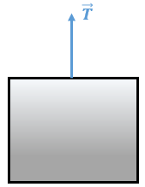
Figure 1.11 Tension of a cable as an example of concentrated force.
When a force is exerted over a considerable portion of a body (or even over the entire body) and not at a specific point or points, the force is said to be distributed. A force may be distributed either over a volume (N/m³), over a surface area (N/m²), or along a line (N/m). The most famous classical example of a distributed force is the weight of an object: in fact, the most common meaning of the weight $\vec{W}$ of an object is a concentrated vertical descending force exerted at the object’s center of gravity; however, this weight represents a resultant force or a force equivalent to a group of “sub-weights” that are the weights of all the points that constitute the object. These points “fill” the volume of the body and each of them has its own weight. Thus, the real weight of a body is a distributed force per unit volume of the body whereas the “conventional” total weight is the resulting, or sum, of all the per-unit-volume weights. Figure 1.12 illustrates this concept.
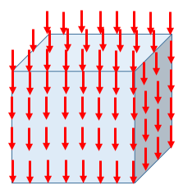
Figure 1.12 Weight of a body as an example of distributed load per unit volume.
External and internal forces
A system is said to be subjected to an external force when this force is applied by any object in the environment surrounding the structure. A system is said to be subjected to an internal force when this force is applied by any “neighboring” component belonging to the system itself.
We clarify this concept by an example: going back to Figure 1.7, if the system is the entire “set” (book + table), the environment surrounding the system is the floor on which this system rests and thus the external forces are the weight of the system (book +table) and the normal force exerted by the floor on the system to keep it at rest. In this case, the interaction forces developed between the book on one side and the table on the other side do not appear since they cancel each other according to Newton’s third axiom. However, when the book alone is considered as the system, the table is considered to be part of the surrounding environment, so the external forces applied to the book are its own weight (vertically downward) and the vertically upward normal reaction force exerted by the table on the book to keep it at rest on the surface of the table. For the book alone these become external forces but for the book + table system these constitute internal forces. The difference between both cases is illustrated in Figures 1.13a and 1.13b.
In conclusion, when the book + table system is considered, the interaction forces between two “components” of this system (book and table, Figure 1.13a) are internal and thus do not appear as external forces. When this system is “split” into separate systems and we consider the book alone as our system (Figure 1.13b); the internal forces from the larger system (i.e., the weight of book and the normal reaction force of the table) now become external forces exerted on the system (book).
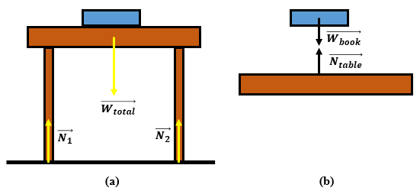
Figure 1.13 Table holding a book and resting on the floor showing (a) external forces and (b) internal forces.
Application 1.1. A child is pushing a trailer toy of mass 1.2 kg to accelerate it from rest to 0.8 m/s in 2 s. What is the magnitude of the force applied by the child on the trailer?
Solution 1.1. The initial velocity of the toy is zero (i.e., the toy starts at rest) whereas its final velocity is 0.8 m/s, which it reaches in 2 s. This results in an acceleration
$$a=\frac{0.8-0}{2}⇒a=0.4 m/s^{2}$$
Applying Newton’s second axiom gives
F=1.2 kg⋅(0.4 m/s2)⇒F=0.48 N=480 mN
Application 1.2. Calculate the scalar components and the length of the position vector that extends from the origin O of a Cartesian (x,y,z) coordinate system to a point P = (4.0, −2.0, 5.0) (m).
Solution 1.2. The scalar components of $\vec{OP}$ are
OP=4.0-0.0=4.0-2.0-0.0=-2.05.0-0.0=5.0 (m)
The length of this vector is OP=16+4.0+25 m=45 m=35 m=6.708 m.

Self-Check Questions
- Complete the following sentence:
The position of a point B = (−1, +2, +1) (m) is measured from a reference point A = (0, 3, −1) (m). The scalar components of the relevant position vector are −1 m, −1 m, and +2 m and the distance separating B from A is $\sqrt{6}$ m.
- Explain whether the reaction force exerted by the seat of a car on the body of its car driver is an external or internal force.
If the driver herself is isolated as the system, then the seat is part of the surrounding environment and thus this force is external. However, if the entire car with all objects inside it are included in the system, then both the driver and the seat are part of the system, in which case the normal reaction force exerted by the seat on the driver is an internal force.

1.4 Vector Operations

Multiplication by a scalar
Consider a vector $\vec{V}$ with well-defined components. When this vector is multiplied by a scalar k, the result is a new vector ${\vec{V}}^{'}=k⋅\vec{V}$ parallel or collinear to $\vec{V}$, having a magnitude V'=k⋅V and having the same sense as $\vec{V}$ if k >0 or an opposite sense to $\vec{V}$ if k <0. Figure 1.14 shows couple of examples.
Dividing a vector $\vec{V}$ by a scalar k is the same as multiplying it by a scalar 1/k.
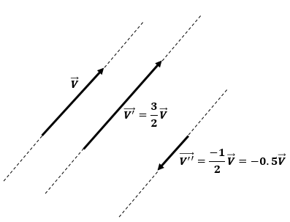
Figure 1.14 Geometric representation of multiplication and division of a vector by a scalar.

Dot product
The dot product of two vectors $\vec{V_{1}}$ and $\vec{V_{2}}$ gives a scalar number obtained by multiplying the magnitudes of both vectors by the cosine of the angle formed between them:
V1⋅V2=V1⋅V2⋅cos(V1,V2) . (1.3)
Another way to calculate the dot product is to sum the products of the individual scalar components of each vector:
V1⋅V2=V1x⋅⋅V2x+V1y⋅V2y+V1z⋅V2z. (1.4)

Cross product
The cross product of two vectors $\vec{V_{1}}$ and $\vec{V_{2}}$ gives a new vector $\vec{V_{3}}$ whose direction is perpendicular to the plane containing $\vec{V_{1}}$ and $\vec{V_{2}}$, whose sense is determined by the right-hand rule, and whose magnitude is the product of the magnitudes of $\vec{V_{1}}$ and $\vec{V_{2}}$ and the sine of the angle between $\vec{V_{1}}$ and $\vec{V_{2}}$. The Cartesian formulation is given by the following determinant:
V3=V1×V2=ijkV1xV1yV1zV2xV2yV2z, (1.5)
V3=V1⋅V2⋅sin(V1,V2). (1.6)
By expanding the determinant in Equation (1.5), the quantities multiplying the unit vectors $\vec{i}$, $\vec{j}$, and $\vec{k}$ are the scalar components of $\vec{V_{3}}$ along the x, y, and z axes, which are denoted V_{3x}, V_{3y}, and V_{3z}.
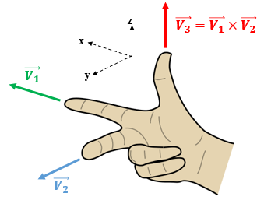
Figure 1.15 Right-hand rule applied to cross product of vectors.
Recall that one formulation of the right-hand rule consists in using the thumb, index finger, and middle finger to form three orthogonal axes in space. To find the sense of $\vec{V_{3}}$, the index is oriented along $\vec{V_{1}}$ and the middle finger along $\vec{V_{2}}$; the thumb then gives the sense of the cross product vector $\vec{V_{3}}$. This rule is illustrated in Figure 2.15.
Application 1.3. Consider two vectors: $\vec{V_{1}}=-3\vec{i}+\vec{k}$ and $\vec{V_{2}}=4\vec{i}-5\vec{j}+2\vec{k}$.
- Calculate the dot product of the two vectors.
- Determine the cross product $\vec{V}=\vec{V_{2}}×\vec{V_{1}}$.
- Evaluate, using two different methods, the magnitude V of the vector $\vec{V}$.
Solution 1.3. From the Cartesian notations given, the scalar components of the vectors are $\vec{V_{1}}=\left(\begin{aligned}-3 \\ 0 \\ 1\end{aligned}\right)$ and $\vec{V_{2}}=\left(\begin{aligned}4 \\ -5 \\ 2\end{aligned}\right)$.
- Apply Equation (1.4): $\vec{V_{1}}⋅\vec{V_{2}}=-12+0+2=-10$.
- Apply Equation (1.5): $\vec{V}=\vec{V_{2}}×\vec{V_{1}}=\left|\begin{matrix}\vec{i} & \vec{j} & \vec{k} \\ 4 & -5 & 2 \\ -3 & 0 & 1\end{matrix}\right|$
V=-5i-10j-15k.
- Method 1: Pythagorean formula
V=(-5)2+(-10)2+(-15)2⇒V=19.8.708
Method 2: Magnitude of cross product
Equation (1.6) requires the angle between $\vec{V_{1}}$ and $\vec{V_{2}}$.
This angle is found by combining Equations (1.3) and (1.4):
α=V1,V2=cos-1(V1⋅V2V1⋅V2)acosV1⋅V2V1⋅V2,
where
V1=(-3)2+(0)2+(1)2=3.162 ; V2=(4)2+(-5)2+(2)2=6.708.
This gives α=cos-1acos-1021.2132=cos-1acos(-0.4714)⇒α=118.13°.
Finally, V=3.162⋅6.708⋅sin118.13⇒V=19.8.705

Addition and subtraction of vectors
The addition of vectors can be done by using a graphical construction as opposed to a numerical calculation. To graphically add a series of vectors$\vec{V_{1}}$, $\vec{V_{2}}$, $…$, $\vec{V_{n}}$, start from an arbitrary point O in the plane and draw a vector parallel, with the same sense, and equal to $\vec{V_{1}}$. From the extremity of the vector $\vec{V_{1}}$ just drawn, draw a parallel vector, with the same sense, and equal to $\vec{V_{2}}$. From the extremity of $\vec{V_{2}}$, repeat the process until reaching $\vec{V_{n}}$. Finally, join the initial point O and the extremity of the last vector $\vec{V_{n}}$ by the vector $\vec{V_{R}}$. This “resultant” vector gives the vector sum: $\vec{V_{R}}=\vec{V_{1}}$+$\vec{V_{2}}$+⋯… +$\vec{V_{n}}$V1V2Vn. Figure 1.16 illustrates the graphical vector sum method.
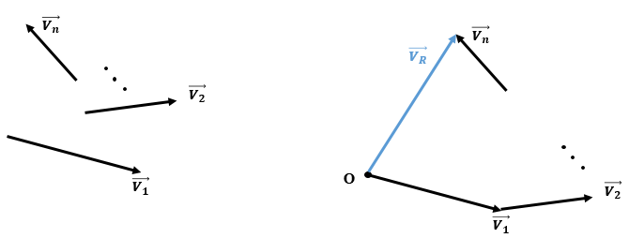
Figure 1.16 Graphical vector addition.
Note that vector addition is a geometrical operation; it does not consist of adding numbers or magnitudes and thus the magnitude of $\vec{V_{R}}$ is never equal to the sum of magnitudes of $\vec{V_{1}}$, $\vec{V_{2}}$, …, $\vec{V_{n}}$ except when the latter are collinear or parallel and all have the same sense.
Subtraction between vectors is an indirect sum of vectors. Although, for the sake of clarity and brevity, this operation is shown between two vectors, it may be expanded to multiple vectors.
Consider the vector subtraction $\vec{V_{R}}=\vec{V_{1}}-\vec{V_{2}}$ . This expression may be written as $\vec{V_{R}}=\vec{V_{1}}+(-\vec{V_{2}})$. In the graphical construction, once arriving at $-\vec{V_{2}}$, a vector parallel to V2 but of the opposite sense is drawn in the vector diagram, as illustrated in Figure 1.17. This process is applied each time a subtraction operation precedes any vector in the sum for multivector addition or subtraction.
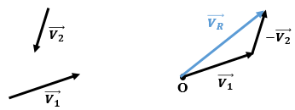
Figure 1.17 Graphical vector subtraction.

Application to force vectors
Composition of forces
Concurrent forces. Concurrent forces are forces that are exerted at a common point, so they have the same vector origin (Hibbeler, 2010). For a solid modeled as a particle, this common origin is the particle itself. Note that drawings of forces exerted on a body modeled as a particle may show the forces as having different origins, you can slide the forces along their lines of actions until they all have the same origin, which will not modify how the forces affect the particle.
Resultant force. A resultant force is a theoretical force that replaces a group of physical forces acting on a body and produces the same effect as the original group of forces (Hibbeler, 2010). Mathematically, the resultant force $\vec{R}$ is the vector sum of all forces to be replaced:
R=i=1nFi=R. (1.7)
One method to determine $\vec{R}$ is the graphical approach based on constructing a force-vector diagram.
Case of two concurrent forces. The simplest case to start with is two forces $\vec{F_{1}}$ and $\vec{F_{2}}$ that are concurrent at an origin O and rotated by an angle θ with respect to each other. The magnitudes F₁ and F₂ are known. The resultant force $\vec{R}= \vec{F_{1}}$ + $\vec{F_{2}}$ is constructed graphically as shown in Figure 1.18. The middle sketch illustrates the standard force-vector diagram to obtain $\vec{R}$, and the right-most sketch is an equivalent graphical method known as the parallelogram law, which consists in drawing from the tip of $\vec{F_{1}}$ a parallel line segment of magnitude F₂F2 and from the tip of $\vec{F_{2}}$ a parallel line segment of magnitude F₁F1, forming a parallelogram. The diagonal of the parallelogram drawn from the origin O is the resultant force vector $\vec{R}$. However, the graphical approach no longer suffices at this stage because the four elements of the vector $\vec{R}$ must be determined precisely.
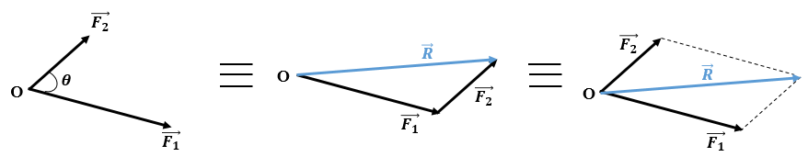
Figure 1.18 Resultant of two concurrent forces.
- The point of application is the origin O, which is the common origin of the forces $\vec{F_{1}}$ and $\vec{F_{2}}$.
- The direction is along the diagonal of the parallelogram, starting from the origin O. The law of sines in Equation (1.9) below gives the angles formed between $\vec{R}$ and $\vec{F_{1}}$ and $\vec{F_{2}}$ .
- The sense: $\vec{R}$ is oriented from the origin O to the vertex of the parallelogram opposite to O.
- The magnitude R is calculated by applying the generalized Pythagorean Theorem (1.8).
The generalized Pythagorean Theorem and the law of sines are applicable to any triangle ABC (Figure 1.19) and are given by Equations (1.8) and (1.9), respectively:
a=b2+c2-2⋅b⋅c⋅cosα , (1.8)
$\frac{a}{\sin{α}}=\frac{b}{\sin{β}}=\frac{c}{\sin{γ}}$. (1.9)
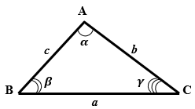
Figure 1.19 Triangle ABC showing notation used in Equations (1.8) and (1.9).
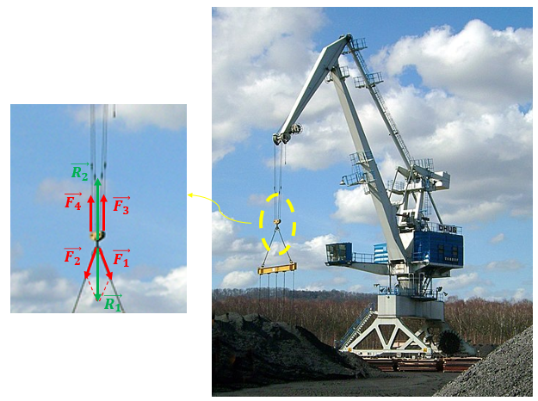
Figure 1.20 Resultant force due to tension in cables of a crane system.
A practical example is illustrated in Figure 1.20 where the hook of a crane is connected to a network of cables to lift the metallic yellow bar. The expanded view of the hook and its environment shows the forces more clearly. The forces $\vec{F_{1}}$ and $\vec{F_{2}}$ are concurrent, so they may be replaced by the resultant force $\vec{R_{1}}$. The forces $\vec{F_{3}}$ and $\vec{F_{4}}$ are parallel and having same sense; so the resultant force $\vec{R_{2}}$ has the same direction and sense as $\vec{F_{3}}$ and $\vec{F_{4}}$ and a magnitude equal to F₃ + F₄. Finally, given the static equilibrium of the hook, $\vec{R_{1}}$ and $\vec{R_{2}}$ must balance each other, so they must be collinear, have the opposite sense, and have the same magnitude.
Case of multiple concurrent forces. More complicated systems can have many more than two concurrent forces. However, the construction of the vector diagram follows the same procedure as for two forces.
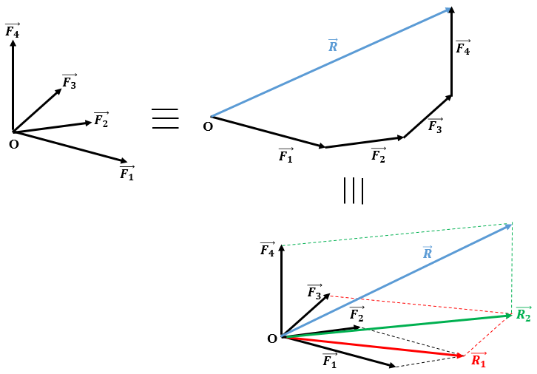
Figure 1.21 Construction of resultant force equivalent to multiple concurrent forces.

Consider n concurrent forces $\vec{F_{1}}$, $\vec{F_{2}}$, $\vec{F_{3}}$, …,$\vec{F_{n}}$. In this case, the parallelogram law is applied sequentially to each force. The first parallelogram of $\vec{F_{1}}$ and $\vec{F_{2}}$ produces $\vec{R_{1}}$ as the resultant force. The second parallelogram is then constructed from $\vec{R_{1}}$ and $\vec{F_{3}}$ to give the resultant force $\vec{R_{2}}$. This procedure is repeated to construct the parallelogram from $\vec{R_{2}}$ and $\vec{F_{4}}$ to obtain the final resultant force R3R. R
All “intermediate” resultants $\vec{R_{1}}$, $\vec{R_{2}}$R3, etc. up to the final resultant $\vec{R}$ are calculated from Equations (1.8) and (1.9), each in its relevant parallelogram. Figure 1.21 illustrates the resultant force of four concurrent forces.
Decomposition of forces
Decomposition of forces is the inverse procedure of constructing the resultant force and consists in replacing a single force with two forces in the two-dimensional case (2D) or with three forces in the three-dimensional case (3D). These new forces are known as components of the original force. The decomposition of a force is done along two (for the 2D case) or three (for the 3D case) predefined directions.
Decomposition into two components. For the 2D case or a planar force, two directions are selected (conventionally named x and y) and oriented to form a direct reference with an origin O and a unit vector in each direction or axis. $\vec{i}$ is the unit vector for the x axis and $\vec{j}$ is the unit vector for the y axis. The x axis is normally chosen to be horizontal and increasing from left to right and the y axis may form any angle with the x axis and is oriented upward. For the special case when the y axis is perpendicular to the x axis, the frame of reference is said to be a Cartesian orthonormal frame of reference; this type of frame will be used by default unless otherwise instructed. The force to be resolved is applied at the origin O of the reference (xy), which is denoted also by (O,$\vec{i}$ ,$\vec{j}$) and the angle θ of orientation is measured from the x axis and is considered positive when measured counterclockwise and negative when measured clockwise (Gross et al., 2013).
The vector components are drawn by using the inverse parallelogram law: from the tip of $\vec{F}$, a line parallel to the y axis is drawn until it intersects the x axis and then a vector is drawn from O to this point of intersection. This vector is denoted $\vec{F_{x}}$ and is called the vector component of $\vec{F}$ or vector projection of $\vec{F}$ along x. F_{x} is the scalar component of $\vec{F}$ or the scalar projection of $\vec{F}$ along x. F_{x} is an algebraic quantity and is positive if $\vec{F_{x}}$ has the same sense as the x axis or as $\vec{i}$ and is negative in the opposite case. The Cartesian notation for $\vec{F_{x}}$ is written as the product of the scalar component F_{x} and the corresponding unit vector: $\vec{F_{x}}=F_{x}⋅\vec{i}$ .
This same principle applies to the vector component $\vec{F_{y}}$ and the scalar component F_{y} along the y axis. The vector relation between the force vector and its components may be written either as a standard vector sum [Equation (1.10)] or as a Cartesian vector [Equation (1.11)]:
F=Fx +Fy , (1.10)
F=Fxi +Fyj. (1.11)
Figure 1.22a shows the decomposition of a force in an arbitrary reference (O,$\vec{i}$ ,$\vec{j}$) and Figure 1.22b shows the decomposition in an orthonormal reference (O,$\vec{i}$ ,$\vec{j}$); this latter frame of reference will be used from now on as the default frame of reference.
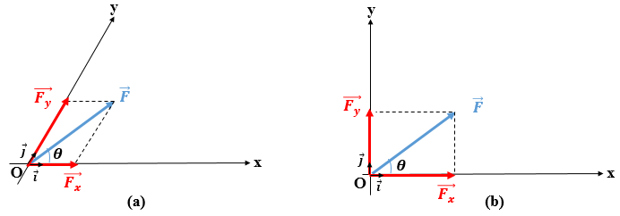
Trigonmetric laws: mathematical relationships involving a right triangle and that relate the lengths of the sides to the trigonometric functions of the acute angles.
Figure 1.22 2D decomposition of a force in (a) an arbitrary frame of reference and (b) an orthonormal frame of reference.
In an orthonormal frame of reference, the scalar projections of the force $\vec{F}$ are deduced through the trigonometric laws:
Fx=F⋅cosθ , (1.12)
Fy=F⋅sinθ. (1.13)
Inversely, the composition of a force from two known perpendicular components may be calculated as follows from the standard Pythagorean formula (to get the magnitude) and from the trigonometry in a right-angle triangle (to get the direction):
F=Fx2+Fy2 , (1.14)
tanθ= FyFx. (1.15)
A vector could thus be defined by just stating its scalar components such as $\vec{F}=\left(\begin{aligned}F_{x} \\ F_{y}\end{aligned}\right)$ This notation involves indirectly the direction, sense, and magnitude through Equations (1.14) and (1.15).
Decomposition in three components. For the 3D case (i.e., a spatial force), the Cartesian reference frame (Oxyz) is always orthonormal and direct such that (xy) coincides with the plane of the page (same as the 2D case), and the z axis is perpendicular to the plane of the page and oriented outward from the page. The unit vectors $\vec{i}$, $\vec{j}$, and $\vec{k}$ are assigned respectively to the axes (Ox), (Oy), and (Oz). In a direct reference frame, the thumb of the right hand is oriented along (Ox), the index finger along (Oy), and the middle finger along (Oz). The force $\vec{F}$ applied at the point O has its direction in space defined by three direction angles α = ($\vec{i},\vec{F}$), β = ($\vec{j},\vec{F}$), and γ = ($\vec{k},\vec{F}$). The cosines of these angles are known as the cosine directions, which determine the three scalar components of the force through the following equations:
Fx=F⋅cosα , (1.16)
Fy=F⋅cosβ , (1.17)
Fz=F⋅cosγ., (1.18)
The same concept involving the vector and scalar projections of a force in the planar case can be extended to the 3D spatial case, in which case Equations (1.10) and (1.11) become
F=Fx +Fy+ Fz , (1.19)
F=Fxi +Fyj+ Fzk. (1.20)
The decomposition of a spatial force is illustrated in Figure 1.23a.
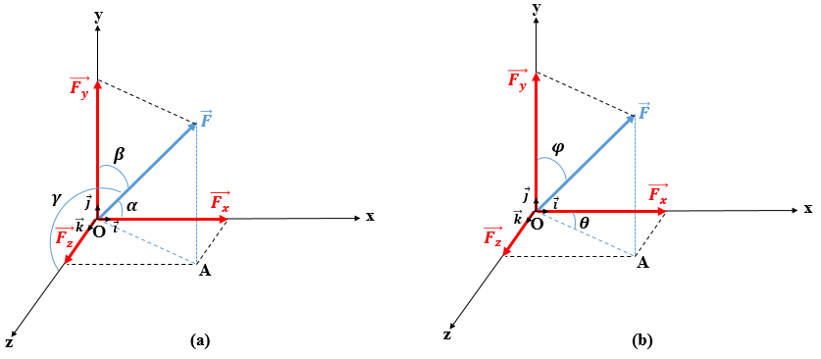
Figure 1.23 3D decomposition of a force using (a) the cosine directions and (b) the intermediate directions.
Inversely, if the three scalar components of a vector force are known, such as $\vec{F}=\left(\begin{aligned}F_{x} \\ F_{y} \\ F_{z}\end{aligned}\right)$, then the magnitude and the direction angles of the force can be determined by using
F=Fx2+Fy2+Fz2 , (1.21)
α=acoscos-1FxF, (1.22)
β= cos-1acosFyF, (1.23)
γ= cos-1acosFzF. (1.24)
Note that the three cosine directions are not completely independent; they are related by Equation (1.25), which means that only two directions need to be known, and the third direction is deduced from Equation 1.24. By squaring both sides of Equation (1.21) and dividing by F², we get
cos2α+ cos2β+ cos2γ=1. (1.25)
Figure 1.23b shows another approach to obtain the direction of a force in 3D space. The first step consists in projecting the force along the y axis and along the plane (xOz), which gives the scalar components F_{y} = Fcosφ and OA = Fsinφ. In the second step, the vector component $\vec{OA}$ is projected along the x and z axes to get F_{x} = OAcosθ and F_{z} = OAsinθ . This leads to the equations
Fx=F⋅sinθ⋅sinφ, (1.26)
Fy=F⋅cosφ, (1.27)
Fz=F⋅sinθ⋅cosφ . (1.28)
Application 1.4. Consider two forces concurrent at a point A such that F₁ = 20 kN and F₂ = 30 kN rotated through an angle of 45° with respect to F₁. Determine the resultant force by graphical construction.
Solution 1.4. Apply the parallelogram law to draw the resultant, which gives the diagram in Figure 1.24. Calculate the magnitude R and the direction by using Equations (1.8) and (1.9), respectively.
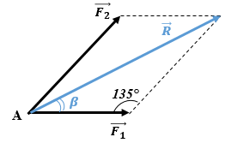
Figure 1.24 Parallelogram law for Solution 1.4.
R=202+302-2⋅20⋅30⋅cos135° $⇒R=46.352 kN$
30sinβ=46.352sin135° $⇒\sin{β}=0.4577⇒ β=27.24°$
Application 1.5. Repeat the previous application using Cartesian notation.
Solution 1.5. The system is in a Cartesian orthonormal reference frame (A,$\vec{i}$ ,$\vec{j}$), as illustrated in Figure 1.25.
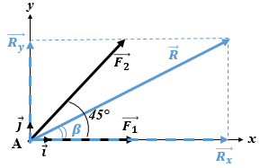
Figure 1.25 Two concurrent forces and the resultant force in a Cartesian reference frame.
The scalar components of $\vec{F_{1}}$ and $\vec{F_{2}}$ are calculated by using Equations (1.12) and (1.13):
F1x=20⋅cos0°⇒F1x= +20 kN
F1y=20⋅sin0°⇒F1y= 0 kN
F2x=30⋅cos45°⇒F2x= +21.213 kN
F2y=30⋅sin45°⇒F2y= +21.213 kN
Writing Equation (1.7) in Cartesian notation gives
Rx⋅i+Ry⋅j=(20i+0j)+(21.213i+21.213j)
By adding the $\vec{i}$ components together and the $\vec{j}$ components together on the right side and then identifying each component with the same component on the left side gives
$$\vec{R}=\left(\begin{aligned}+41.213 \\ +21.213\end{aligned}\right) kN$$
By tracing $\vec{R_{x}}$ and $\vec{R_{y}}$ and then completing the parallelogram (which is here a rectangle) one obtains the resultant force $\vec{R}$ shown in Figure 1.25.
Finally, by using Equations (1.14) and (1.15), we obtain the magnitude and the direction of R :
$$R=\sqrt{{41.213}^{2}+{21.213}^{2}}⇒R=46.352 kN$$
β=tan-1atan21.21341.213⇒β=27.24°
Note: The tangent function is π periodic. Depending on which of the four quadrants $\vec{R}$ lies, we add or subtract the suitable multiple of π. In the current application, $\vec{R}$ is in the first quadrant.
Application 1.6. Consider two concurrent forces applied at a particle at the origin O of a direct Cartesian 3D reference frame (O,$\vec{i}$,$\vec{j}$, $\vec{k}$) with F₁ = 20 kN and F₂ = 30 kN. $\vec{F_{1}}$ forms an angle of 150° with the x axis and 30° with the z axis and forms an angle of 45° with the y axis, as shown in Figure 1.26. Determine the resultant force.
Solution 1.6. The direction of the force $\vec{F_{1}}$ is given by α = 150° and γ = 30°, so β may be deduced from Equation (1.25):
cos2β=1--322-+322⇒cosβ=±22.
Considering the position of $\vec{F_{1}}$ in space (Figure 1.26), its scalar projection along the y axis is positive, so the positive solution of cosβ is retained.
Applying Equations (1.16)–(1.18), the scalar components of $\vec{F_{1}}$ are
$\vec{F_{1}}=\left(\begin{aligned}-17.32 \\ +14.142 \\ +17.32\end{aligned}\right)$.
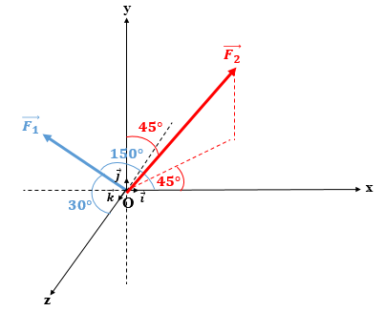
Figure 1.26 Resultant force from two concurrent forces in a 3D Cartesian reference frame.
According to Figure 1.26, the scalar projections of $\vec{F_{2}}$ is positive along the x and y axes and negative along the z axis. Equations (1.26)–(1.28) give the components of $\vec{F_{2}}$:
$\vec{F_{2}}=\left(\begin{aligned}+15 \\ +21.213 \\ -15\end{aligned}\right)$.
The components of the resultant force $\vec{R}$ are given by the vector sum of F1 and F2 (or by using Cartesian notation as done in application 1.5 but this time for the 3D case)F1F2:
$\vec{R}=\left(\begin{aligned}-17.32 \\ +14.142 \\ +17.32\end{aligned}\right)+\left(\begin{aligned}+15 \\ +21.213 \\ -15\end{aligned}\right)=\left(\begin{aligned}-2.32 \\ +35.355 \\ +2.32\end{aligned}\right)$.
Finally, Equations (1.21)–(1.24) serve to calculate the magnitude and direction angles of the resultant force:
$$R=\sqrt{{(-2.32)}^{2}+{35.355}^{2}+{2.32}^{2}}⇒R=35.507 kN$$
αR=cos-1acos-2.3235.507⇒αR=93.75°
βR=cos-1acos35.35535.507⇒βR=5.3°
γR=cos-1acos2.3235.507⇒γR=86.25°

Self-Check Questions
- Choose the correct answer:
If two concurrent forces $\vec{F_{1}}$ and $\vec{F_{2}}$ have equal magnitudes, their resultant has the same magnitude as F₁ and F₂ only when the angle between $\vec{F_{1}}$ and $\vec{F_{2}}$ is
0° 90° 120° 180°

- Complete the following sentence:
A force F=(-5i+10j+10k) (kN) forms an angle of 109.5° with the x axis, 48.2° with the y axis, and 48.2° with the z axis.
- Specify whether the following statement is True or False and justify your answer:
The cross product of two vectors having the same directions is a zero vector. True, since two vectors with the same directions form between them an angle of 0° or 180°, and the sine of either angle is zero so the resulting vector has zero magnitude.
Summary
Statics is the branch of mechanics that studies bodies that are either at rest or in steady motion.
A particle is an ideal representation of a solid with mass but negligible size relative to its spatial reference frame. A particle can only translate (it cannot rotate). A rigid body is an ideal representation of a solid with non-negligible mass and size. Any deformations within the solid are neglected. A rigid body can translate and rotate.
A force is an action exerted on a solid body by its surrounding environment. The force may be external and either active or reactive by an item supporting the body, or internal in which case it is within the body and does not affect the motion of the body except if a system is chosen such that the point of application of the force is at the system boundary. Schematically, a force is represented by a vector, which is determined by a point of application, a direction, a sense, and a magnitude. The weight of a body is a force exerted by Earth’s gravity on the body.
A system of forces can be replaced by an equivalent force that produces the same effect as the original system of forces. This equivalent force is the resultant force. Conversely, a single force may be resolved into two forces in a plane or into three forces in space by projecting the force along the relevant directions. These forces are known as components.
When a body is subjected to a system of balanced forces (i.e., with zero resultant force), the body either remains at rest or moves with constant velocity. The principle of action and reaction originates from this law: the forces that two particles exert on each other are opposite in direction, collinear, and equal in magnitude. If the resultant force is not zero, the particle on which the force is exerted undergoes an acceleration proportional to the force and inversely proportional to the mass of the particle.

Unit 2 – Static Equilibrium

Study Goals

On completion of this unit, you will be able to …

… establish the mathematical conditions of equilibrium of particles and rigid bodies.
… determine the moment of a couple and of a force about an axis.
… identify the bearing types and assign the relevant reaction components.
… distinguish between statically determinate and indeterminate systems.
… calculate the bearing reactions.

2. Static Equilibrium

Introduction
A particle or a rigid body is said to be in static equilibrium when they are permanently at rest despite possibly having forces exerted on them by other objects. In other words, in static equilibrium, a particle or a rigid body does not undergo translation and, in addition, a rigid body does not rotate. The effort that affects rotation is called a moment and comes from a force exerted on the rigid body at distance from the axis of rotation. Mathematically, a system of balanced forces has a zero resultant force. Since forces (and thus moments) are modeled as vectors and equilibrium requires a zero vector resultant, this implies that the mathematical conditions of equilibrium are of vector type and so deal with geometrical quantities. However, Cartesian notation involves scalar components that can be used to describe the vector conditions of equilibrium, thereby converting the problem from a vector to a scalar formulation.
In addition, the vector conditions of equilibrium involve all external forces, be they active or reactive. The active forces, which are known, depend on the application in which the subjected body is employed and on the user’s needs from this application. However, the reaction forces, which are unknown, depend on the type of bearing or support holding this body and preventing its motion once the active forces are applied. Nevertheless, identifying the type of bearing exclusively would not suffice; the configuration and location of these bearings along the body have a key influence on the equilibrium and, above all, on the stability of the solid as well as the sufficiency of the scalar equilibrium equations to calculate the reactive forces needed for equilibrium. This will play a role in determining whether the body is statically stable or unstable and whether it is determinate or indeterminate.

2.1 Equilibrium of particles
Steady motion is motion at a constant velocity (i.e., having zero acceleration).

Vector condition of equilibrium
A system of forces is said to be in equilibrium when the forces balance each other. This condition means that the object on which the forces are applied is a rest or undergoes steady motion, as per Newton’s first axiom. In particular, if the body is at rest (i.e., its velocity is zero), the body is in static equilibrium.
Mathematically, since each force is represented by a vector, the forces satisfy the equilibrium condition when the vector sum of these forces is equivalent to a zero vector:
i=1nFi=0. (2.1)
Although Equation (2.1) appears to involve summation, it does not consist of algebraic operations since vector addition is in practice a geometrical operation rather than a numerical operation. In this equation, no numbers or forces magnitudes are added; it is an addition of “geometrical elements” and is to be solved graphically in the scope of this subsection.
Applying the graphical construction of Equation (2.1), equilibrium is established when the resultant force is equivalent to a zero vector, which is graphically determined when the extremity of the last vector in the summation coincides with the starting point of the first vector in the summation.
However, prior to constructing the polygon of forces to get the resultant force, the original forces themselves must exist and be drawn on the body of interest. These forces are recognized by analyzing the effects of the surroundings on the body itself. This symbolic representation of the forces on the isolated body of interest is known in mechanics as a free body diagram (FBD).
The concept of equilibrium of forces and the relevant equation (2.1) are now clarified through two practical examples. Figure 2.1a shows the first example, which consists of an engine held in equilibrium by a system of chains. Figure 2.1b shows the FBD of the engine, which is subjected to its own weight $\vec{W}$ and two tensile forces $\vec{T_{1}}$ and $\vec{T_{2}}$. exerted by the chains. Figure 2.1c shows the vector diagram used to sum the force vectors: A is the starting point from which $\vec{T_{1}}$ is drawn. Next, the extremity B of $\vec{T_{1}}$ is the origin or starting point of $\vec{T_{2}}$, and finally the extremity C of $\vec{T_{2}}$ is the origin of the weight $\vec{W}$ that ends at D. The fact that D coincides with the starting point A means that the resultant force of this system of three forces is zero. Given that the engine is at rest, it is in static equilibrium.
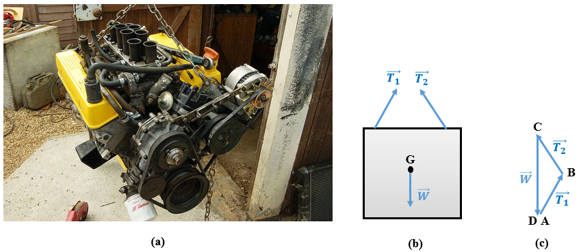
Figure 2.1 (a) Engine hanging from chains. (b) FBD of the engine. (c) Vector diagram of equilibrium.
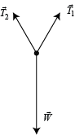
The second example of equilibrium is illustrated in Figure 2.2a, which shows a young girl sitting on a swing suspended from a scaffold by two ropes. The importance of this example is that there are two options for the system of interest and on which the FBD depends. The first case assumes that the girl is the system and thus the seat of the swing on which she sits is part of her environment. This means that the normal force $\vec{N}$ of reaction that must balances the weight of the girl completes the FBD, as shown is Figure 2.2b (we assume no forces are exerted on the girl’s hands). Figure 2.2c shows the FBD, which is quite particular because $\vec{N}$ and $\vec{W}$ are collinear and so, to ensure equilibrium, are drawn as two parallel vectors of equal magnitude but of opposite sense. The second case to consider is the girl and her seat as the system, in which case Newton’s third axiom imposes that the normal force $\vec{N}$ exerted by the seat on the girl is balanced by a parallel force of equal magnitude but opposite sense exerted by the girl on the seat. Another explanation of the “disappearance” of $\vec{N}$is that the seat is no longer part of the environment but is now considered part of the system whose environment includes the two ropes. This results in the FBD of Figure 2.2d, where the total weight of the system is balanced by the tension in the ropes. The equilibrium vector diagram is represented in Figure 2.2e.
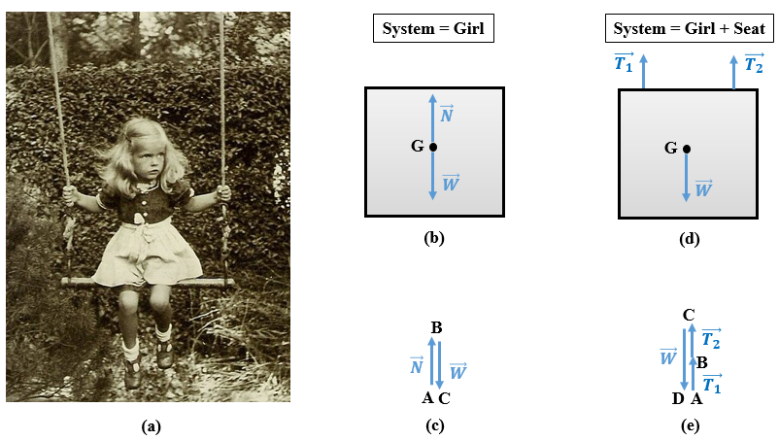
Figure 2.2 (a) Girl sitting on a swing in equilibrium. (b) FBD for the girl as the system. (c) Vector force diagram showing equilibrium of the girl. (d) FBD for the girl and her seat as the system. Vector force diagram showing equilibrium of the girl and the seat as the system.

Scalar conditions of equilibrium
All forces exerted on a particle are concurrent at the particle itself, which allows for the possibility of an “exclusive” translational motion if the resultant force is nonzero. However, the condition of static equilibrium of a particle means that it is undergoing translation, and a particle, by definition, cannot rotate.
The mathematical condition of equilibrium is stated in Equation (2.1), which is a vector condition. The transition to scalar equations is possible by expressing each vector in Cartesian notation, which involves the scalar components of each vector force.
Consider n forces $\vec{F_{1}}$, $\vec{F_{2}}$, $\vec{F_{3}}$,…..,$\vec{F_{n}}$ exerted on a particle in static equilibrium in a direct Cartesian reference frame (O, $\vec{i}, \vec{j}$, $\vec{k}$). In Cartesian notation, each force is
Fi=Fix⋅i+Fiy⋅j+Fiz⋅k ,; i=1, 2, 3,…,n.
Inserting these equations into Equation (1.8) gives
F1x+F2x+F3x+…+Fnxi+F1y+F2y+F3y+…+Fnyj+F1z+F2z+F3z+…+Fnzk=0⋅i+0⋅j+0⋅k.
Identifying the left and right coefficients multiplying$\vec{i}$, $\vec{j}$, and $\vec{k}$ gives the scalar equations fulfilling the equilibrium condition of a particle:
i=1nFix=0, (2.2)
i=1nFiy=0, (2.3)
i=1nFiz=0. (2.4)
The single vector equation for equilibrium thus produces the three scalar equations (2.2)–(2.4), which can be useful to calculate the unknown forces needed to establish the static equilibrium of a particle. Physically speaking, the zero magnitude of the three components of the resultant force means that the particle does not translate along any of the three directions x, y, or z.
The fact that there are three equations means that the spatial equilibrium equations allow us to calculate three unknown forces to establish equilibrium. Note that an unknown could be either a magnitude or an angle (i.e., vector orientation). Moreover, if the equilibrium is planar then the number of equations reduces to two [(2.2) and (2.3)], so only two unknowns may be calculated for 2D equilibrium.
Application 2.1. Particle A is subjected to the system of forces shown in Figure 2.3, where F₁ = 1000 N, F₂ = 800 N, and F₃ = 1200 N. Check whether the static equilibrium condition is satisfied.
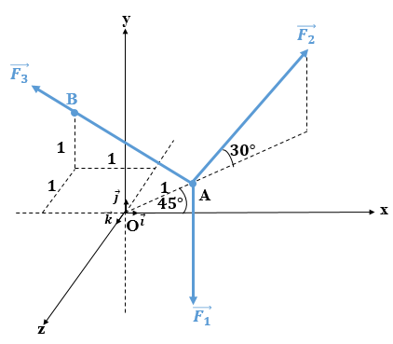
Figure 2.3 Particle in space subjected to three forces.
Solution 2.1. The equilibrium condition demands that the resultant force of the three forces be zero; in other words, the algebraic sum of the components of all forces along each of the three axes must vanish, as per Equations (2.2)–(2.4).
$\vec{F_{1}}$ is parallel and opposite to the y axis, so F1=0-10000 N.
The components of $\vec{F_{2}}$ are determined by applying the classical projection calculations:
F2=800⋅cos30°⋅cos45°=490800⋅sin30°=400-800⋅cos30°⋅sin45°=-490 N.
The scalar projections of F3 are not straightforward because the direction of its line of action is not given directly; instead, the coordinates of two points of its line of action are given
F3 are not straightforward since because the direction of its line of action is not given directly;, instead, the coordinates of two points of its line of action are given: A(22,0,-22) and $B(-1,1,-1). The direction vector of \vec{F_{3}}$ is AB=-1.70711-0.2929, which has having a magnitude of AB=(-1.7071)2+12+(-0.2929)2=2 m.
The cosine directions of the line of action of $\vec{F_{3}}$ are
cosα3=ABxAB=-1.70712=-0.85355,
cosβ3=AByAB=12=0.5,
cosγ3=ABzAB=-0.29292=-0.14645.
The components of $\vec{F_{3}}$ are found by applying the set of equations (1.16)–(1.18):
F3=1200⋅-0.85355=-1024.261200⋅(0.5)=6001200⋅-0.14645=-175.74 N=-1024.26600-175.74 N.
Finally, the components of the resultant force $\vec{R}$ are given by the algebraic sum of the components of each of the forces:
R=0+490-1024.26=-534.26-1000+400+600=00-490-175.74=-665.74 N=-534.260-665.74N.
Note that R_{x} and R_{z} are not zero, meaning that the particle is not in equilibrium.
Application 2.2. As shown in Figure 2.4, block B of mass 5.0 kg rests on a smooth incline forming an angle of 30° with the horizontal and held at rest by counterweight C through a rope passing over pulley P.
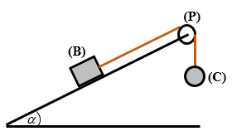
Figure 2.4 Block held motionless on an incline by a rope.
Draw the FBD of block B and determine the normal reaction force exerted by the incline on block B and the mass of the counterweight C.
Solution 3.2. Figure 2.5a shows a FBD of block B subjected to its weight $\vec{W}$, oriented vertically downward, the normal reaction force $\vec{N}$ exerted on the box by the incline upward and perpendicular to the incline, and the tension $\vec{T}$ of the rope parallel to the incline. To obtain the mass of the counterweight C, we draw the FBD of the pulley P and of the counterweight C. Figure 2.5b shows the isolated pulley P subjected to the tensions of the rope that are the same on each side of the pulley to prevent rotation of the pulley, and the normal force $\vec{N'}$ is the reaction force exerted by the pin on the pulley. Figure 2.5c shows the counterweight C subjected to its own weight $\vec{W'}$ and to the tension $\vec{T}$ of the rope.
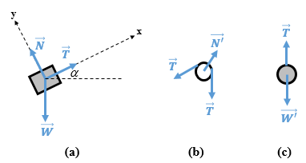
Figure 2.5 FBD of (a) block B, (b) the pulley P, and (c) the counterweight C.
The equilibrium of the particle B requires Equations (2.2) and (2.3) to be satisfied:
Fx=0⇒T-W⋅sinα=0⇒T=m⋅g⋅sin30°=5.0⋅9.81⋅(0.5)⇒T=254.525 N
Fy=0⇒N-W⋅cosα=0⇒N=5.0⋅9.81⋅32⇒N=42.48 N
The FDB of the counterweight C consists of two collinear forces that must balance each other, so they must be opposite in sense and have equal magnitudes:
$$W^{'}=T⇒m^{'}=\frac{24.525}{9.81}⇒m^{'}=2.5 kg$$
Note: The reference frame (xy) has been placed along and perpendicular to the incline to simplify the expansion of the equations. However, the conventional horizontal-vertical (xy) reference frame could have been used; the final results would not change.
Application 2.3. A particle of weight 100 N is held in equilibrium by two ropes AB and AC as shown in Figure 2.6. If each rope cannot withstand more than 200 N of tension, calculate the value of the angle α.
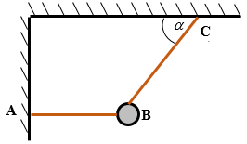
Figure 2.6 Particle held by two ropes in a plane.
Solution 3.3. The FBD of the particle is illustrated in Figure 2.7.
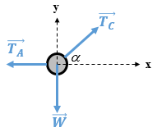
Figure 2.7 FBD of a particle held by two ropes in the plane.
Applying the equations of equilibrium (2.2) and (2.3) gives
Fx=0⇒-TA+TC⋅cosα=0⇒TA=TC⋅cosα,
Fy=0⇒-W+TC⋅sinα=0⇒W=TC⋅sinα.
The first equation indicates that T_{C} is greater than T_{A} since cosα < 1. The biggest tension possible is thus T_{C}, so T_{C} = 200 N.
From the second equation, $\sin{α}=\frac{W}{T_{C}}=\frac{100}{200}=0.5 ⇒α=30°$
Application 2.4. A particle O is holding a block D of weight 100 N through a cable OD. In addition, it is held by two cables OA and OB as well as by a spring OC of stiffness 3000 N/m as shown in Figure 2.8. The spring is mounted in a smooth slot so that it remains horizontal after elongation. Before mounting the whole system, the length of the spring was 0.15 m. Calculate the forces in each of the cables and the length OC.
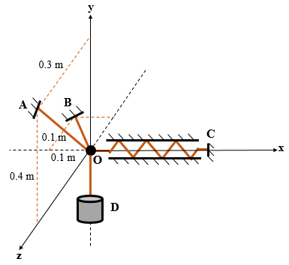
Figure 2.8 Particle O held in space by cables and spring.
Solution 2.4. The FBD of particle O is illustrated in Figure 2.9. Note that the cable OD transmits the weight of block D to particle O; in other words, T_{D} = W = 100 N.
Before applying the equilibrium equations (2.2)–(2.4), we find the scalar components of each force.
Force $\vec{T_{A}}$: The line of action of this force passes through O(0,0,0) and A(0, 0.4, 0.3) and thus the direction vector is $\vec{OA}=\left(\begin{aligned}0 \\ 0.4 \\ 0.3\end{aligned}\right) m$, whose magnitude is
$OA= \sqrt{0^{2}+{0.4}^{2}+{0.3}^{2}}=0.5 m$. The cosine directions of this vector (i.e., of the force $\vec{T_{A}}$ ) are cosαA=OAxOA=0 ; cosβA=OAyOA=45 ; cosγA=OAzOA=35 .
The scalar components of $\vec{T_{A}}$ are TA=TAx=0TAy=45TATAz=35TA.
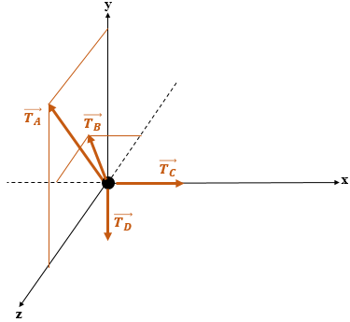
Figure 2.9 FBD of a particle held by cables and a spring in space.
Force $\vec{T_{B}}$: The line of action of this force passes through O(0,0,0) and B(−0.1, 0, −0.1) and thus the direction vector is $\vec{OB}=\left(\begin{aligned}-0.1 \\ 0 \\ -0.1\end{aligned}\right) m$, whose magnitude is
$OA= \sqrt{{0.1}^{2}+0^{2}+{0.1}^{2}}=0.1\sqrt{2} m$, so the cosine directions of this vector (i.e., of the force $\vec{T_{B}}$ ) are cosαB=OBxOB=-22 ; cosβB=0 ; cosγA=OBzOB=-22.
One can now write the scalar components of $\vec{T_{B}}$: TB=TBx=-22TBTBy=0TBz=-22TB.
Force $\vec{T_{C}}$: The line of action of this force is along the x axis and in the same sense as the x axis, so TC=TCx=TCTCy=0TCz=0.
Force $\vec{T_{D}}$: The line of action of this force is along the y axis and in the opposite sense, so TD=TDx=0TDy=-100TDz=0 N
Applying Equation (2.2) gives
TAx+TBx+TCx+TDx=0,
-22TB+TC=0⇒TC=22TB.
Applying Equation (2.3) gives
TAy+TBy+TCy+TDy=0,
45TA-100=0⇒TA=125 N.
Applying Equation (2.4) gives
$$T_{Az}+T_{Bz}+T_{Cz}+T_{Dz}=0$$
35⋅(125)-22TB=0⇒TB=752 N=106 N.
The first equation of equilibrium gives $T_{C}=75 N$.
Applying Hooke’s law, the elongation of the spring: ΔOC=TCk=753000=25 mm.
The final length of OC is OC=OCinitial+ΔOC=150+25 ⇒OC=175 mm.

Self-Check Questions
- Specify whether the following statement is True or False and justify your answer
A particle is subjected to two perpendicular forces F₁ = 4 kN and F₂ = 3 kN. To establish the equilibrium of this particle, a third force of magnitude 5 kN forming a clockwise angle of 143° with $\vec{F_{1}}$ should be added to the system. True, because, by applying the parallelogram law, the resultant force of $\vec{F_{1}}$ and $\vec{F_{2}}$ has a magnitude of 5 kN and is shifted from $\vec{F_{1}}$ by an angle of 37° counterclockwise. The equilibrium is established when a force equal in magnitude and opposite in sense is applied to this particle.

- Choose the correct answer.
A particle of mass 6 kg is sandwiched between two identical springs that are vertically collinear. The upper end of the upper spring is fixed to the ceiling and the lower end of the lower spring is fixed to the floor. The system deflects by 12 mm at equilibrium. The stiffness of each spring in N/m is
4905 2452.5 1226.25 9810

2.2 Moment

Moment of a couple
In mechanics, the term couple denotes a pair of parallel vector forces, opposite in sense, equal in magnitude, and separated by a distance d called the arm.
When a couple is applied to a solid object, it tends to produce rotation. When a driver rotates a steering wheel, she is in fact applying a couple at two points on the periphery of the steering wheel. Another example of a couple is the screwing and unscrewing of the nuts of a car wheel, as shown in Figure 2.10. The couple is applied at the extremities of the wheel wrench and the arm is the length separating the extremities.
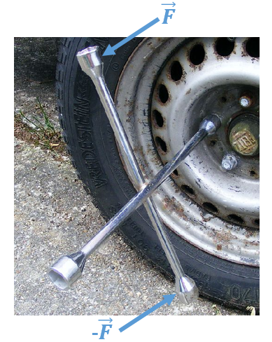
Figure 2.10 Application of a couple to unscrew tire nuts.
The moment of a couple is a physical quantity that determines the ability of a couple to produce rotation. Its units are newton meters (N m) in the SI system of units.
Mathematically, the moment of a couple, like the force, is also a vector. It is drawn as a double-tipped arrow and is determined by the cross product between the arm $\vec{d}$ (oriented from --F to $\vec{F}$ ) and the force $\vec{F}$ of the couple and as is expressed as
$\vec{M}=\vec{d }×\vec{F}$ (2.5)
The elements of the vector moment $\vec{M}$ are explained based on the example shown the Figure 2.11, which shows someone tightening a screw with a screwdriver. The effort applied by the hand of the worker at the periphery of the screwdriver’s handle is a couple where the forces are separated by an arm equal to the diameter of the handle. This develops a moment $\vec{M}$, also called a torque $\vec{T}$, as shown in Figure 2.11b. Note that a moment is a more general terminology whereas torque is specific to mechanical applications where torsion or twisting is applied. Figure 2.11c graphically analyzes Equation (2.5) and defines the elements of $\vec{M}$.
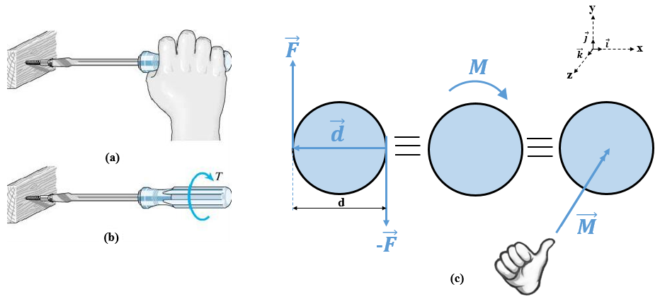
Figure 2.11 (a) Tightening a screw, (b) moment (or torque) exerted on screwdriver, (c) scheme of couple, sense of rotation, and vector moment.
The arm vector $\vec{d}$ oriented from $-\vec{F}$ to $\vec{F}$ and perpendicular to the couple forms with this couple (which is geometrically two parallel lines) a plane that is coincident with the plane of the page (xy). This constitutes the side-view plane of Figures 2.11a and 2.11b. According to Equation (2.5), we define the following elements of $\vec{M}$:
- Point of application: $\vec{M}$ is a free vector since it depends exclusively on the distance separating the pair of forces, which are not referred to any fixed position with respect to any frame of reference.
- Direction: $\vec{M}$ is perpendicular to the plane formed by ($\vec{d}$, $-\vec{F}$, $\vec{F}$) that is coincident with the (xy) plane. In the case of Figure 2.11c, the moment vector is perpendicular to the plane of the page (i.e., parallel to the z axis).
- Sense: Apply the right-hand rule where the index finger is oriented along $\vec{d}$ and the middle finger along $\vec{F}$; the thumb gives the sense of $\vec{M}$. For Figure 2.11c, the moment vector is oriented into the page (opposite to the sense of the z axis). By curling the fingers about the line of the vector moment one obtains the sense of rotation of the couple. This is shown in the middle sketch of Figure 2.11c: it is a clockwise sense of rotation.
The clockwise sense of rotation is similar the sense of rotation of a clock’s hand.
- Magnitude: Since the angle between $\vec{d}$ and $\vec{F}$ is 90° and the magnitude of the cross product is M = Fd sin($\vec{d,}\vec{F}$), we obtain that the magnitude of the moment is the product of the force and the arm. This is known as the scalar formulation of the moment of a couple and is expressed as
M=F⋅d. (2.6)
In the SI system of units, M is expressed in N m, F in N, and d in m.
The moment is considered positive when the rotation is counterclockwise (i.e., in the same sense as the coordinate axis) and negative when the rotation is clockwise (i.e., opposite to the sense of the coordinate axis).
When n couples act in a single plane, the vector moments are all parallel (all perpendicular to the plane of action of the couples), so the resultant moment is determined by the algebraic sum of the moments:
MR=i=1nMi. (2.7)
Application 2.5. A driver applies to a steering wheel of diameter 30 cm a couple of magnitude 10 N (Figure 2.12). Determine and draw the vector moment of this couple.
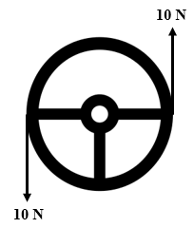
Figure 2.12 Rotation of a steering wheel by a couple.
Solution 2.5. First, we should not limit the answer to the determination of the magnitude of the moment. The determination of a vector requires finding all its elements.
According to Equation (2.5) and since the forces and the arm lie within the plane of the steering wheel, the vector moment acts along a line perpendicular to this plane, with no fixed point of application since a moment is a free vector.
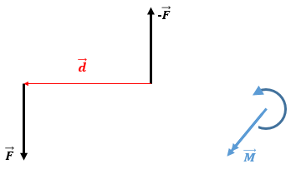
Figure 2.13 Determination of the vector moment exerted on the steering wheel.

Furthermore, applying the right-hand rule, one can deduce that the sense of rotation is counterclockwise, so the vector moment acts out of the plane and induces a positive moment, as calculated by Equation (2.6):
M = +10 × 0.3 = +3 N m.
The details are illustrated in Figure 2.13.
Application 2.6. The body shown in Figure 2.14 is subjected to a system of three couples. Determine the resulting equivalent moment applied to this body.
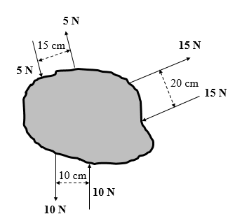
Figure 2.14 Body subjected to three couples.
Solution 2.6. Since all the couples act in the plane of the page, all the vector moments act perpendicular to this plane and so are parallel to each other. This allows us to add the magnitudes of those moments [see Equation (2.7)] to find the equivalent resulting moment M_{R}.
MR=-15)⋅(0.2+10)⋅(0.1+5)⋅(0.15⇒MR=-1.325 N .m.
The equivalent scheme is shown in Figure 2.15 below. Note that, despite the resulting moment being negative, only the absolute value is given on the equivalent scheme because the sense of rotation (clockwise) is indicated. This means, by convention, that the moment is negative. In other words, the sense of rotation and the absolute value stated simultaneously determine the sign of the moment.
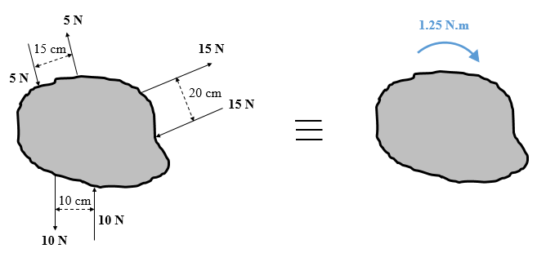
Figure 2.15 Original and equivalent couple applied to a solid.

Moment of a force
The moment of a force about a point that is not on the line of action of the force, or about an axis passing through this point and orthogonal to the plane formed by the force and the point, is defined as a physical quantity measuring the ability of this force to produce rotation about the point (i.e., the axis). Its units in the SI system are newton-meters (N m).
The distance separating the point of application of the force from the point of rotation O is the arm and is specified by the position vector $\vec{r}$. The distance d is measured from O to the line of action of the force. The vector formulation of the moment of a force about a point (i.e., an axis) is given by
MO=r ×F. (2.8)

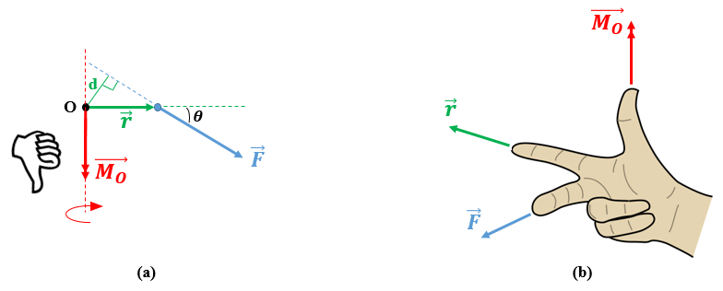
Figure 2.16 (a) Illustration of the moment of a force about a point. (b) Right-hand rule to find the sense of the moment.
Figure 2.16a illustrates graphically Equation (2.8). The position vector $\vec{r}$ is oriented from the axis O to the point of application of the force $\vec{F}$ forming an angle θ with the latter. The distance d separates O from the line of action of the force, so d = r sinθ . The force $\vec{F}$ is oriented outward where $\vec{r}$ lies in the plane of the page. The right-hand rule shown in Figure 2.16b aligns the index finger with $\vec{r}$ and the middle finger with $\vec{F}$, and the sense of the thumb gives the sense of the vector moment$\vec{M_{O}}$. This analysis allows us to determine the elements of $\vec{M_{O}}$:
- Point of application: Unlike the moment vector of a couple, the moment about a point is not a free vector since it depends on the position of the force with respect to the given point. Thus, the point of application of the moment is the point O about which the rotation occurs. Thus, the subscript “O” is added to the symbol “M” of the moment.
- Direction: Inspired by the cross product of Equation (2.8), the line of action of $\vec{M_{O}}$ is the axis perpendicular to the plane formed by $\vec{r}$ and $\vec{F}$ and passing through the point O.
- Sense: The right-hand rule illustrated in Figure 2.16b determines the sense of the vector moment. In Figure 2.16a, the moment $\vec{M_{O}}$ is oriented downward. By curling the remaining four fingers of the right hand about the axis of $\vec{M_{O}}$, the sense of rotation is determined.
- The magnitude: This is given by the magnitude of the cross product, which is calculated as
MO=F⋅r⋅sinθ. (2.9)
As stated earlier, the trigonometric constraint leads to another formula:
MO=F⋅d, (2.10)
which is known as the scalar formulation of the moment of a force.
In the International System of units, M is expressed in N m, F in N, and d in m.
The moment is considered positive when the rotation is counterclockwise (i.e., the same sense as the coordinate axis) and negative when the rotation is clockwise (i.e., the sense opposite to the coordinate axis).
Principle of transmissibility. A force sliding along its line of action maintains the same position with respect to a point of interest O, so the moment of this force about O remains unchanged by the sliding operation. As a result, the cross product between an arbitrary position vector from O to an arbitrary point of the line of action of the acting force also remains constant. This is known in mechanics as the principle of transmissibility of a force (Hibbeler, 2010), which is illustrated in Figure 2.17.
MO=r1 ×F= r2 ×F=r3 ×F=…=rn ×F. (2.11)
The deep concept of the moment of a force could be clarified using Figure 2.18. Consider a solid body subjected to a force $\vec{F}$ and a point O of this solid not belonging to the line of action of the force. $\vec{F}$ and O are both in the plane of the page. Let Δ′ be an axis passing through O and parallel to $\vec{F}$ and let Δ be another axis passing through O but perpendicular to the plane (O, F), which is non-other than the plane of the page. The distance separating $\vec{F}$ from O and thus from Δ is denoted d.

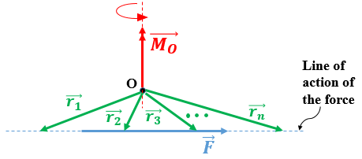
Figure 2.17 Principle of transmissibility keeping an unchanged moment about a point.
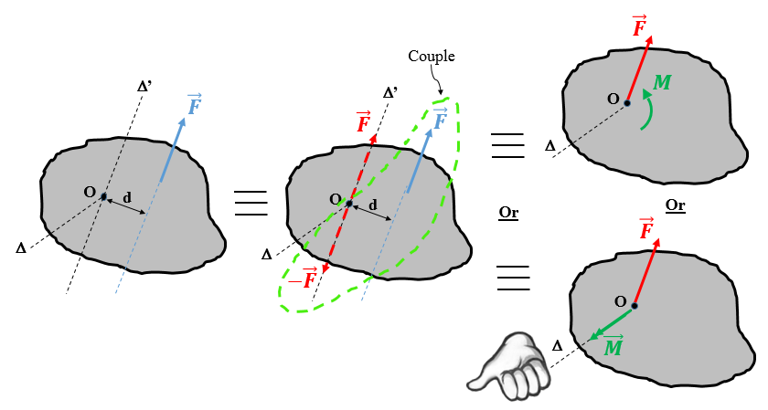
Figure 2.18 Equivalent schemes for constructing the moment of a force about a point.
Two forces are thus exerted on the solid: $-\vec{F}$ and $\vec{F}$ (marked in red in Figure 2.18). The forces are equal in magnitude, opposite in sense, collinear to Δ′ (i.e., parallel to the original applied force $\vec{F}$ marked in blue in Figure 2.18), and are applied at O. These two additional forces are balanced, or in other words, equivalent to a zero-force system, so they will not disturb the initial kinetic state of the solid. Consider now the pair of forces formed by the original applied force $\vec{F}$ and the force $-\vec{F}$, which is one of the two added forces: these forces are parallel, opposite, equal in magnitude, and separated by a distance d, meaning that they form the moment of couple M = Fd. This couple is equivalent to a vector moment acting along Δ and whose sense is determined by the right-hand rule (outward from the page in the case of Figure 2.18). The final system now consists of a force $\vec{F}$ applied at O and a couple moment vector $\vec{M}$.
By comparing the initial and final states of the system, we conclude that applying a force at a certain distance from a point is equivalent to translating this force parallel to its direction to the point of interest and adding the effect of the moment of this force about the point of interest.
Finally, we close the topic of the moment of a force by a practical application: opening and closing a door. Figure 2.19a shows a girl gripping the handle of a wooden door to open it—a very frequent operation that anyone may do many times per day. However, what is happening from a mechanical point of view is sketched in Figure 2.19b.
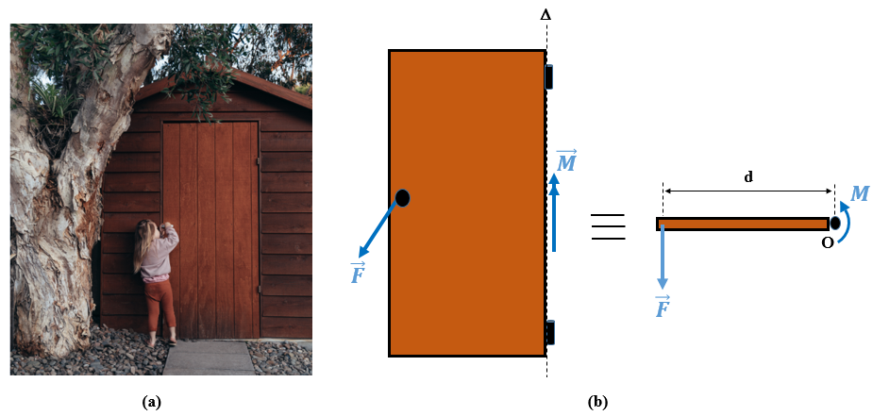
Figure 2.19 (a) Opening a door. (b) Mechanical scheme for opening the door.
The hinges of the door constitute the “pivot” or the point O used throughout the theory of the moment of a force. The line passing through the hinges is denoted Δ and is the axis of rotation; it is in the plane of the door, which coincides with the plane of the page. The action applied by the girl at the handle is the opening force and is perpendicular to the plane of the door and thus is oriented out of the plane of the paged. The horizontal vector from the point O (i.e., the axis of rotation or hinges) to the point of application of the force (i.e., the handle) is the position vector $\vec{r}$ whose magnitude is the width d of the door. This scheme is clarified in the top view of the door shown in Figure 2.19b. Since the force is distant from the hinge O by an arm equal to the door’s width, the opening (and closing) effect is quantified by the moment of this force about the axis Δ being the same as point O. The vector moment $\vec{M_{O}}$ acts along the line of the hinges and is applied at O; its magnitude is the product of the force’s magnitude and the width d of the door, according to Equation (2.10), and has a positive sign because the sense of rotation is counterclockwise. The moment required to close the door induces clockwise rotation and is negative.
Since the door is rigid, it requires constant moments to be opened and closed. Therefore, the magnitude F and the position at which it is applied with respect to the hinges can vary provided their product remains constant. Consequently, when the distance between the force and the hinges (axis of rotation) increases, the force decreases by the same factor and vice versa. This explains why, when you push or pull the door at points close to the hinges, it is difficult to rotate the door and requires a considerable amount of force to do so. In contrast, if the effort is applied far from the hinges, the door rotates more easily because the force required is small.
Application 2.7. Calculate the moment of a 50 N force about the pivot A in Figure 2.20
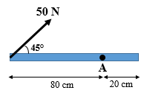
Figure 2.20 Application of a force to cause rotation about an axis.
Solution 2.7. Figure 2.21 shows the clockwise sense of the moment about A, the direction of the moment vector is perpendicular to the plane of the page. Given that counterclockwise rotation is positive by convention, the magnitude of the moment M_{A} is negative.
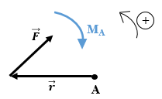
Figure 2.21 Vector diagram of solution of application 2.7.
MA=-50⋅0.8⋅sin45°⇒MA=-2.8284 N.mN m
Application 2.8. Determine the sense and the magnitude of the vertical force $\vec{P}$ that should be applied at the right and of the bar, as shown in Figure 2.22, to keep the bar horizontal.
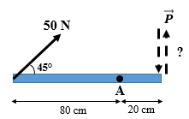
Figure 2.22 Bar prevented from rotating.
Solution 2.8. To keep the bar horizontal, it must not rotate about the pivot A. Mechanically, this condition is realized when the resulting moment of all the forces about A cancel each other. Since all the moments act along the same direction (perpendicular to the plane of the page), their magnitudes can be summed algebraically. Mathematically, we have
MR,A = MF,A + MP,A = 0.
This equation means that the moment of $\vec{P}$ must be opposite to that of $\vec{F}$, which we found was negative in application 2.7. This implies that the moment of $\vec{P}$ must be positive, striving for a counterclockwise rotation about A. Thus, $\vec{P}$ must be downward and have a magnitude of
-50⋅0.8⋅sin45°+P⋅(0.2)=0⇒P=14.142 N.

Components of the moment vector
To this point, we have seen that, in the 2D case, it suffices to consider a scalar formulation of the moment (either for a couple or for a force about an axis) since the vector moment has been directed perpendicular to the plane of the page (z axis) and could be oriented positively with respect to the z axis (corresponding to a counterclockwise sense of rotation) or negatively with respect to the z axis (corresponding to a clockwise sense of rotation).
However, in the 3D case, the vector formulation requires that we determine accurately the vector moment, which can be positioned anywhere in space depending on the force and the position vector (i.e., the arm). By applying the Cartesian formulation of Equation (2.8) [i.e., Equation (2.5)], we can determine the three scalar components of the moment vector:
MO=ijkrxryrzFxFyFz . (2.12)
Expanding the determinant of Equation (2.12) gives
MO=ry⋅Fz-rz⋅Fy⋅i+rz⋅Fx-rx⋅Fz⋅j+rx⋅Fy-ry⋅Fx⋅k.
This latter equation gives the scalar components M_{Ox}, M_{Oy}, and M_{Oz} of the moment vector $\vec{M_{O}}$:
MO=MOx=ry⋅Fz-rz⋅FyMOy=rz⋅Fx-rx⋅FzMOz=rx⋅Fy-ry⋅Fx=ryFz-rzFyrzFx-rxFzrxFy-ryFx . (2.13)
Given the scalar components, we now calculate the magnitude and the angular orientation of $\vec{M_{O}}$ by using Equations (2.14)–(2.17), which are similar to those used for force in Equations (1.21)–(1.24):
$M_{O}=\sqrt{M_{Ox}^{2}+M_{Oy}^{2}+M_{Oz}^{2}}$ (2.14)
α=acoscos-1MOxMO, (2.15)
β= cos-1acosMOyMO, (2.16)
γ= acoscos-1MOzMO. (2.17)
Recall that this whole approach is applicable for either a moment of a force about an axis or for a couple. In addition, Equation (2.14) is equivalent to the magnitude of the moment calculated by Equations (2.6) and (2.9).
MO
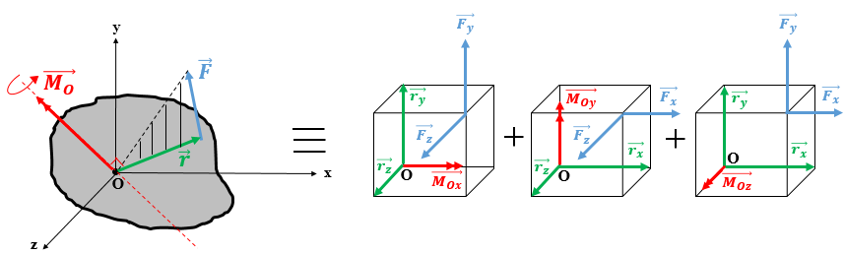
Figure 2.23 Visualization of the three components of the moment vector.
The vector components of MO are visualized in Figure 2.23, which consists of the original case where a solid body is subjected to a spatial force $\vec{F}$ tending to rotate it about a point O, considered as coincident with the origin of a direct Cartesian reference frame. The vector $\vec{r}$ is the position vector from O to the origin of the force. The vector moment $\vec{M_{O}}$ is determined by Equation (2.8), as shown also in the original state shown in Figure 2.23. This state is in fact the superposition of three vector moments, which are the vector components of $\vec{M_{O}}$ along the x, y, and z-axes. Each of these vector components is shown separately along with the components of $\vec{r}$ and $\vec{F}$ that contribute to creating this moment component.
For instance, M_{Ox} is composed of two “sub-moments:” the first in a positive sub-moment coming from the product of the force F_{y} and the arm r_{z}; these are orthogonal so the sine function is omitted since sin 90° is unity. Upon applying the right-hand rule to $\vec{r_{z}}$ and $\vec{F_{y}}$ on the first equivalent scheme in Figure 2.23, we deduce the positive sense. The second sub-moment is negative; it comes from the product of F_{z} and the arm r_{y}; these are orthogonal so the sine function is omitted since sin 90° is unity. Upon applying the right-hand rule to $\vec{r_{y}}$ and $\vec{F_{z}}$ in the first equivalent scheme in Figure 2.23, we deduce the negative sense. Finally, M_{Ox} is the algebraic sum of the two sub-moments, as appears in the first component of Equation (2.13). A similar analysis holds for M_{Oy} and M_{Oz}

Resultant of parallel forces
By definition, a system of forces is parallel when none of the lines of action of the forces intersect. A system of parallel forces may consist of either concentrated forces or distributed forces (volumetric, areal, or linear distribution). This is illustrated in Figures 2.24a and 2.24b.
Like concurrent forces, it is important to replace a system of parallel forces with a single force that produces the same effect as the original system: this is the resultant force.

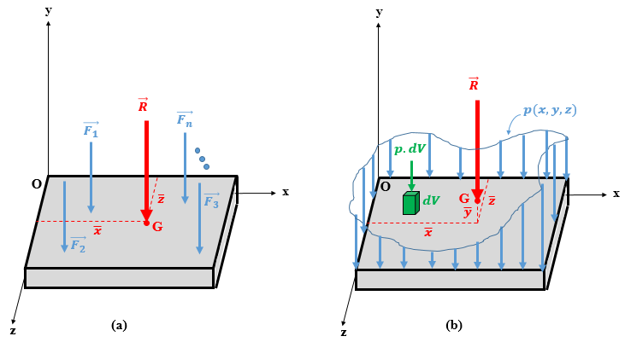
Figure 2.24 Resultant force for parallel forces: (a) concentrated, (b) distributed.
The concurrent case has shown that the point of application is the same as the point of intersection of the two initial forces, whereas the direction must be calculated. In the case of parallel forces, the situation is reversed: the location of the point of application of the resultant force (denoted G in Figure 2.24) needs to be calculated whereas the direction of the resultant is parallel to the forces that are replaced by the resultant.
Consider a direct reference (O,$\vec{i}$,$\vec{j}$, $\vec{k}$) where the forces are all parallel to the y axis (but the sense could be either the same or the opposite). In other cases, the forces might be parallel to another axis; however, the analysis remains the same. Since those forces are parallel to the y axis, they can create moments about the x and z axes. The resultant $\vec{R}$ must have a magnitude and a sense equivalent to those of the original system and it must be applied at a point G that produces the same moment about the x and z axes as the original system of forces.
For concentrated forces (Figure 2.24a), applying Equation (1.7) but in Cartesian notation gives
Rx⋅i+Ry⋅j+Rz⋅k=F1y⋅j+F2y⋅j+F3y⋅j+…+Fny⋅j.
Identifying the left and right members gives
$R_{x}=0$, (2.18)
$R_{y}=\sum_{i=1}^{n}{F_{iy}}$, (2.19)
$R_{z}=0$. (2.20)
In addition, the scalar components of the vector moment of the resultant force should be the same as the algebraic sum of those of the initial forces about the x and z axes:
Mx,R=Mx,F1+Mx,F2+Mx,F3+…+Mx,Fn.
Let $\overline{z}$ be the arm between $\vec{R}$ and (Ox), z₁ the arm between $\vec{F_{1}}$ and (Ox), z₂ the arm between $\vec{F_{2}}$ and (Ox), …, z_{n} the arm between $\vec{F_{n}}$ and (Ox). Replacing in the previous equation each moment by the product of the magnitude of the force and the corresponding magnitude of the arm (without forgetting the positive and negative signs due to the sense of rotation), one obtains the distance separating the resultant force from the x axis established in Equation (2.21):
$\overline{z}=\frac{\sum{F_{i}.z_{i}}}{R_{y}}$. (2.21)
Applying the same rationale for the equivalent moment about (Oz), the location of the resultant far from z axis is determined by
$\overline{x}=\frac{\sum{F_{i.}x_{i}}}{R_{y}}$ . (2.22)
Thus, G(x,z) is the point of application of the resultant force R of the system of parallel forces.
Note the following:
- Equations (2.18)–(2.20) imply automatically that the direction of the resultant force is parallel to the y axis (i.e., parallel to the initial system of forces) since the components along the x and z axes are zero.
- Equation (2.19) gives two pieces of information: the sign of the sum at the right indicates the sense of the resultant; if positive then R is oriented along the orientation of the unit vector j, and if negative R is oriented in the opposite sense. Moreover, the magnitude R is the absolute value of the quantity on the right.
- If the forces are parallel to another axis (the z axis for instance), the same equations are applicable just by swapping z with y in all Equations (2.19)–(2.22). If the forces are parallel to the x axis, then z is swapped with x.
Consider now the case of distributed force (Figure 2.24b): one may take inspiration from the concentrated case and make the suitable changes to establish the appropriate equations of the resultant. The mathematical function of distributed force is denoted by p(x,y,z). If a volumetric differential element dV is considered, the force applied at this element is simply p dV. One can imagine that the distributed function could be partitioned into an infinite number of differential elements, each of force p dV such that one may consider applying a group of concentrated forces each of magnitude p dV and parallel to the y axis. Since these are differential forces, we replace the discrete sums in Equations (2.19)–(2.22) with integrals:
Ry=px,y,z.dV, (2.23)
x=x.px,y,z.dVpx,y,z.dV, (2.24)
z=z.px,y,z.dVpx,y,z.dV. (2.25)
When the force is distributed over an area (line), the integral becomes a double (single) integral.
If the magnitude of the distributed force is the same over the entire space [mathematically p(x,y,z) = const.], the distributed load is said to be uniform.
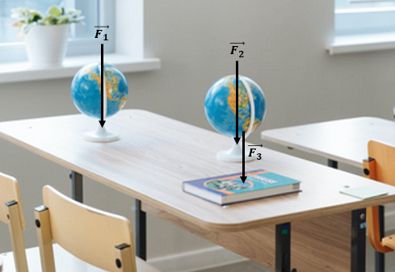
Figure 2.25 Table subjected to a system of parallel, concentrated forces.
This paragraph is closed by two examples about concentrated and distributed load faced in real life. The first example is depicted in Figure 2.25 and shows a table carrying a couple of objects. Each object has a size small compared to the size of the table itself and thus each object is modeled as a particle that exerts its vertical descending weight on the table. Thus the table is subjected to a system of three concentrated parallel forces.
Figure 2.26 illustrates an example of a distributed load: the roof of the house is covered by a thick layer of snow that applies its weight along a certain determined area from the roof. Each point of this area is sustaining an effect from the snow and thus this is an aerial distributed loading. In case the thickness of the snow is constant this means that the distributed weight at each point of the roof is the same, in that case only, it is a uniformly distributed load.
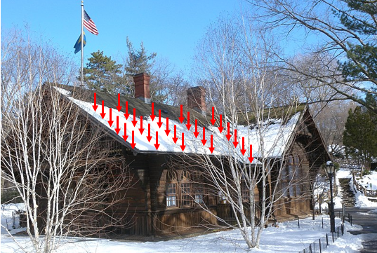
Figure 2.26 Roof subjected to distributed parallel load.
Application 2.9. Determine the vector moment of the force of 500 N about point A in Figure 2.27. All dimensions are in meters.
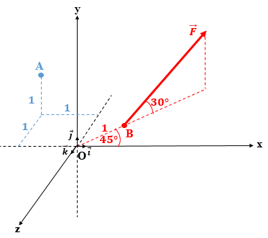
Figure 2.27 Application to components of moment vector.
Solution 2.9. The position vector $\vec{r}$ is the vector $\vec{AB}$. The coordinates of A are straightforward from Figure 2.27: A(−1,1,−1) while B, which is in the plane (xOz), has the coordinates:
xB=1×⋅cos45°=22 m; yB=0; zB= -1×⋅sin45°=-22 m
The scalar components of the position vector $\vec{r}$ are calculated as follows:
rx=xB-xA=22+1=1.7071 m,
ry=yB-yA=0-1=-1 m,
rz=zB-zA=-22+1=0.2929 m.
Moreover, the components of the force are calculated as follows:
Fx=500⋅cos30°⋅cos45°=306.19 N,
Fy=500⋅sin30°=250 N,
Fz=-500⋅cos30°⋅sin45°=-306.19 N.
The next step consists of using Equation (2.13) to calculate the scalar components of the moment vector:
MAx=-1⋅-306.19-0.2929⋅250=232.965 N. m,
MAy=0.2929⋅306.19-1.7071⋅-306.19=612.38 N m,N.m
MAz=1.7071⋅250--1⋅306.19=732.965 N m.N.m
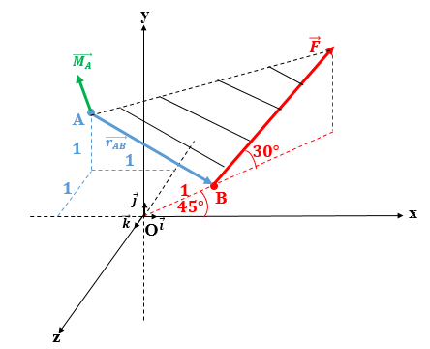
Figure 2.28 Vector representation of the moment about A.
Figure 2.28 shows a schematic drawing of the vector moment produced about A by the force F.
Finally, the magnitude and the direction angle of the moment may be determined by applying Equations (2.14)–(2.17):
MA=232.9652+612.382+732.9652⇒MA=983.117 N m,N.m
α=cos-1acos232.965983.117⇒α=76.3°,
β=cos-1acos612.38983.117⇒β=51.47°,
γ=cos-1acos732.965983.117⇒γ=41.8°.
Note: Another method could have been applied to find the magnitude M_{A} from Equation (2.9). To find the angle θ between $\vec{r}$ and $\vec{F}$ , the two formulations of the dot product should be equated.
The Cartesian formulation of the dot product gives
r⋅F=rx⋅Fx+ry⋅Fy+rz⋅Fz=1.7071)⋅(306.19+-1⋅250+0.2929⋅-306.19=183.014 N m.N.m
The definition of the dot product gives
r⋅F=r⋅F⋅cosθ=1.70712+-12+0.29292(⋅500)⋅cosθ=1000⋅cosθ.
Calculating the angle θ gives
θ=cos-1acos183.0141000=79.46°.
Finally, MA=r⋅F⋅sinθ=2⋅500⋅sin79.46°⇒MA=983.12 N m.N.m
Application 2.10. Determine the magnitude and the location of the system of forces shown in Figure 2.29.
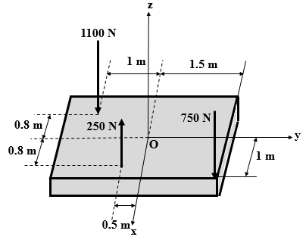
Figure 2.29 Application involving parallel concentrated forces.
Solution 2.10. Applying Equation (2.19) with y with z swapped gives the sense and the magnitude of the resultant:
Rz=-750+250-1100⇒Rz=-1600 N.
This result means that the resultant is parallel to the z axis but oriented downward due to the negative sign of the scalar component. The magnitude of the resultant is R = 1600 N.
Equations (2.21) and (2.22) can be used to calculate the location of the point of application:
x=750)⋅(1-250)⋅(0.8-1100⋅(0.8)-1600⇒x=-0.20625 m,
y=-750)⋅(1.5-250)⋅(0.5+1100⋅(1)-1600⇒y=+0.09375 m.
The result is shown in Figure 2.30.
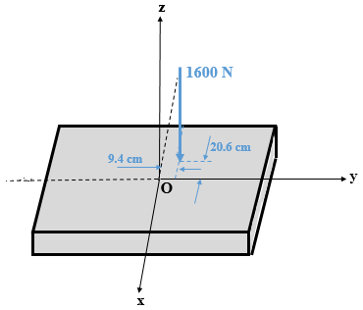
Figure 2.30 Resultant force produced by parallel concentrated forces of Figure 2.29.
Application 2.11. Determine the resultant of the parallel linearly distributed load shown in Figure 2.31.
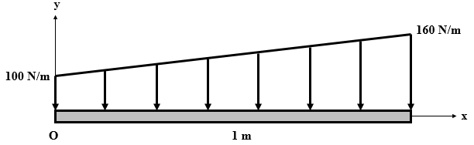
Figure 2.31 Linearly distributed parallel load.
Solution 2.11. The load is distributed along a length, so the function is p(x). The Equation for p(x) is a straight line according to Figure 2.31; it begins at 100 N/m at x = 0 and ends at 160 N/m at x = 1. This gives the following equation for p(x):
p(x) = 60x + 100.
Apply Equation (2.23) to find the magnitude and Equation (2.24) to find the location:
R=0160x+100dx⇒R=130 N.
x=0160x2+100xdx130⇒x=713 m=0.538 m.
The result is shown in Figure 2.32.
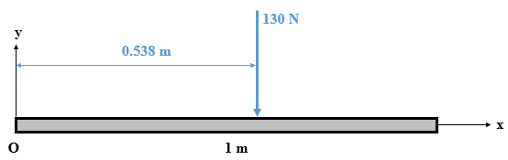
Figure 2.32 Resultant of the linearly distributed parallel load shown in Figure 2.31.

Self-Check Questions
- Name the two cases where the moment of a nonzero force about an axis is zero.
Case 1: The line of action of the force passes through the axis.
Case 2: The line of action of the force is parallel to the axis.

- Choose the correct answer.
A person applies a perpendicular force of 15 N at the handle of a door that is 85 cm from the hinges. The force exerted on the door if the person pushes mid-way between the hinges and the handle is
30 N 15 N 7.5 N 12.75 N

- Specify whether the following statement is True or False and justify your answer
Two parallel forces of equal magnitudes produce the same moment about the same point. False because two parallel forces may not be the same distance from the point of rotation.
- Complete the following sentence.
A uniformly distributed loading of 5 kN/m is applied along a bar AB of length 1.8 m. The magnitude of the moment (in absolute value) produced by this loading about the point A is 8.1 kN m.

2.3 Center of Gravity

Definition
The center of gravity (CG) of a body is the point of application of its weight (Beer et al., 2012). When a solid is modeled by a particle, this particle is no other than the center of gravity where the entire weight is concentrated. In a uniform field of gravity, the center of mass is coincident with the center of gravity (Hibbeler, 2010).
The location of the center of gravity of a rigid body is essential to draw the relevant FBD and study the equilibrium because the weight of a body is an external force applied by the gravity field produced by Earth on the body.
For a uniform rigid body, the location of the center of gravity is well known. For instance, a rectangular rigid body having a uniform thickness and density has its center of gravity at the geometric center of the rectangle. However, when it comes to non-uniform or compound rigid bodies, determining the center of gravity is less straightforward. Calculations are needed in this case to locate the center of gravity before drawing the FBD and then studying the static equilibrium.
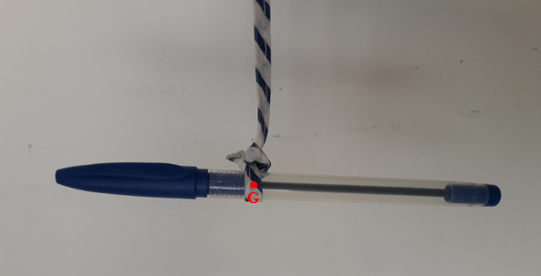
Figure 2.33 Pen held at its center of gravity by a strap.
Another interesting aspect of this point is that the center of gravity is the balance point at which a body could be held without tipping. Figure 2.33 shows a pen held by a strap at a point such that the pen remains horizontal. In fact, the strap is attached at the center of gravity of the pen. Since the mass of the pen is not uniformly distributed, the center of gravity is not at the midpoint of the pen but is shifted toward the cap.

Determination of the center of gravity by integration
Consider a rigid body in a direct Cartesian reference frame (Oxyz). Imagine dividing this body into an infinite number of differential elements, each of weight dW, as shown in Figure 2.34a.
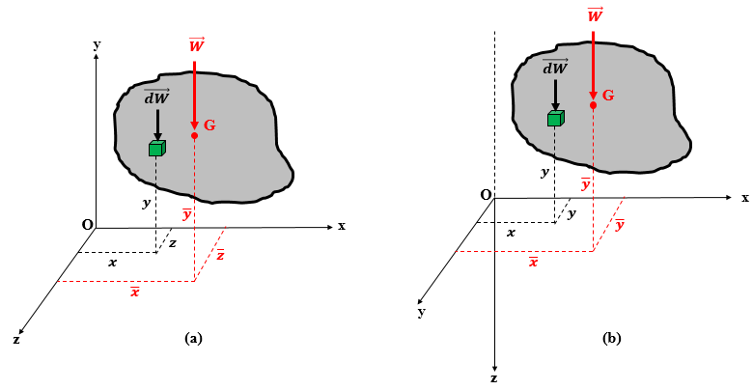
Figure 2.34 Center of gravity of a body (a) in a direct reference frame and (b) in a rotated reference frame.
Let x, y, and z be the coordinates of any differential element in the body. The weights of all the differential elements constitute a distributed parallel-force system; in the case of Figure 2.34a, they are parallel to the y axis. The total weight $\vec{W}$ of the body is exerted at the center of gravity of the body, which is denoted G and whose coordinates x, y , and $\overline{z}$ are to be determined.
Apply Equations (2.23)–(2.25) for Figure 2.34a and then rotate the plane (yz) by 90° about the x axis (Figure 2.34b). Apply again Equation (2.25) to get the three coordinates of G as follows:
x=x⋅dWdW, (2.26)
y=y⋅dWdW, (2.27)
z=z⋅dWdW. (2.28)
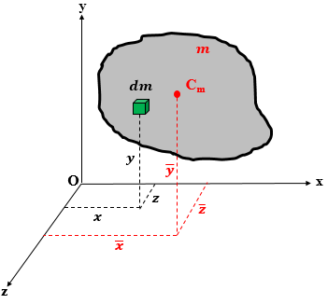
Figure 2.35 Center of mass of a body.
Figure 2.35 shows the center of mass C_{m} of a body. However, for a constant gravity and since dW = g dm, g simplifies in Equations (2.26)–(2.28) to give the following equations that show that G and C_{m} are coincident:
x=x⋅dmdm, (2.29)
y=y⋅dmdm, (2.30)
z=z⋅dmdm . (2.31)
Note that the denominator in Equations (2.26)–(2.28) is the total weight of the body. Similarly, it is the total mass in Equations (2.29)–(2.31).
For a planar body, Equations (2.28) and (2.31) are omitted.

Center of gravity of composite bodies
“A composite body consists of series of ‘simpler’ shaped bodies which may be rectangular, triangular, semicircular, etc.” (Hibbeler, 2010, p.470).
This composite body may be virtually divided into a finite number n of regular “sub-bodies,” each of known weight (i.e., mass) and location. We denote by W_{i} the weight (m_{i} is the mass) of sub-body i in the composite body and (x_{i}, y_{i}, z_{i}) are the coordinates of sub-body i. The coordinates of the center of gravity (i.e., the center of mass since gravity is assumed to be spatially uniform) of the composite body are deduced from Equations (2.26)–(2.28) [Equations (2.29)–(2.31) for the center of mass] by replacing the integral by a discrete sum for i = 1 to n:
x=i=1nxi⋅Wii=1nWi , (2.32)
y=i=1nyi⋅Wii=1nWi, (2.33)
z=i=1nzi⋅Wii=1nWi . (2.34)
Similar Equations hold for the center of mass C_{m}:
x=i=1nxi⋅mii=1nmi, (2.35)
y=i=1nyi⋅mii=1nmi, (2.36)
z=i=1nzi⋅mii=1nmi. (2.37)
For a planar composite body, Equations (2.34) and (2.37) can be omitted.
Application 2.12. Locate the center of gravity of the cone shown in Figure 2.36 given that its density increases with its height according to
$ρ=200\left(5y+1\right) kg/m^{3}$.
Solution 2.12. Since both planes (Oxy) and (Oyz) are planes of symmetry of the cone, the center of gravity must be on the y axis, so x=z=0.
The ordinate $\overline{y}$ is calculated by using Equation (2.30), but the challenge is to find the differential mass dm of the cone which is a disk at a height y, of thickness dy, and of radius r that varies with y. This is illustrated in Figure 2.37.

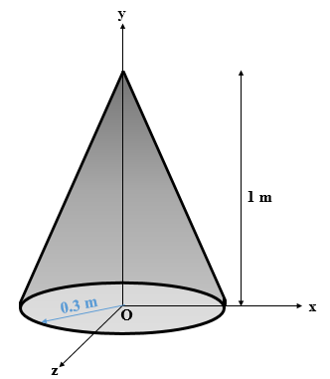
Figure 2.36 Cone with a variable density.
From Figure 2.37 and applying the Thalès Theorem, we obtain
r(y)0.3=y1⇒ry=0.3y.
The differential mass of the disk is
dm=ρ⋅dV=2005y+1⋅π⋅ry2⋅dy,
dm=18π5y3+y2⋅dy.
The center of gravity of the differential element (i.e., the disk) is the same as its height y.
All the elements needed to apply Equation (2.30) are now known, so
y=0118π(5y4+y3)dy0118π5y3+y2dy=1+1454+13⇒y=1519 m=0.79 m.
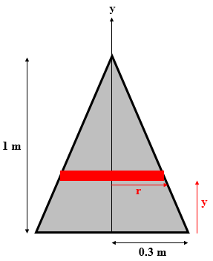
Figure 2.37 Differential element of a cone.
Application 2.13. Figure 2.38 shows a 2-mm-thick plate made from a material of density 2500 kg/m³ from which a small square is cut. Locate the center of mass of this plate.
Solution 2.13. This plate is a composite body that could be partitioned into three regular parts: a big rectangle denoted part 1 (with no rectangular hole), a small square denoted part 2 with a negative mass to cancel out the mass of part 1 in this region, and a right-triangle denoted part 3 (see Figure 2.39). Let G₁, G₂, and G₃ be their respective centers of gravity. This plate is in a planar Cartesian reference frame (Oxy), as shown in Figure 2.39. We will apply Equations (2.35) and (2.36) after finding the coordinates of G₁, G₂, and G₃ measured from O and the mass of each part. For the latter, we have
m1=2500⋅0.5⋅0.6⋅(0.002)=1.5 kg,
m2=-2500⋅0.15⋅0.15⋅(0.002)=-0.1125 kg,
m3=2500⋅12⋅0.3⋅0.6⋅(0.002)=0.45 kg.
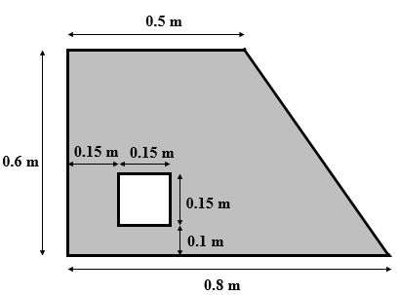
Figure 2.38 Composite plate with unknown center of gravity.
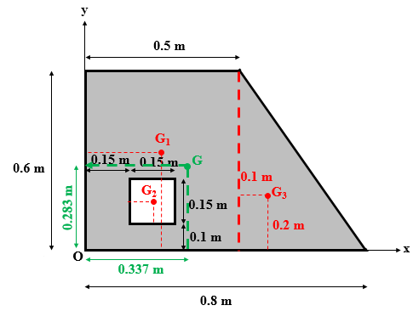
Figure 2.39 Partitioned composite plate from Figure 2.38.

x1=0.25 m ,; y1=0.3 m,
x2=0.15+0.152=0.225 m ;, y2=0.1+0.152=0.175 m,
x3=0.5+0.33=0.6 m ;, y2=0.63=0.2 m.
We summarize the results of the calculation in Table 2.1 to facilitate the application of Equations (2.35) and (2.36).
Table 2.1 Summary of results for composite plate of Figure 2.38.
Part | m_{i} (kg) | x_{i} (m) | y_{i} (m) | m_{i}x_{i} (kg m) | m_{i}y_{i}(kg m)
1 | 1.5 | 0.25 | 0.3 | 0.375 | 0.45
2 | −0.1125 | 0.225 | 0.175 | −0.0253125 | −0.0196875
3 | 0.45 | 0.6 | 0.2 | 0.27 | 0.09
Whole | 1.8375 |  |  | 0.6196875 | 0.5203125

x=miximi=0.61968751.8375⇒x=0.337 m,
y=miximi=0.52031251.8375⇒y=0.283 m.
The center of gravity of the composite plate is shown in Figure 2.39.

Self-Check Questions
- Choose the correct answer.
Two identical cubes each having a side of length 1 are placed on the floor one above the other, and the lower cube is 1.5 times heavier than the upper cube. The height above the floor of the center of gravity of the whole system is
0.5 0.65 0.75 0.9

2.4 Equilibrium of Rigid Bodies

Equilibrium equations
A rigid body can translate in any direction (like a particle) but also rotate about any point in the space. This means that the vector condition $\sum{\vec{F_{i}}=\vec{0}}$ no longer suffices as the sole condition for static equilibrium because it does not prevent the rigid body from rotating. To ensure that a rigid body does not rotate, the resultant vector moment produced by all the moments applied to the body must vanish. Mathematically, this condition gives rise to the vector equation Mi/-A=0, where A is an arbitrary point in the space through which may pass three directions parallel to the reference directions x, y, and z. By following the same rationale to develop the equations of a particle’s equilibrium (i.e., switching to Cartesian notation), we obtain the following six equilibrium equations that ensure the static equilibrium of a rigid body in the space:
$\sum_{i=1}^{n}{F_{ix}}=0$, (2.38)
$\sum_{i=1}^{n}{F_{iy}}=0$, (2.39)
$\sum_{i=1}^{n}{F_{iz}}=0$, (2.40)
i=1nMix-/A=0, (2.41)
i=1nMiy-/A=0, (2.42)
i=1nMiz-/A=0. (2.43)
Each of the two vector equations for equilibrium has produced three scalar equations: Equations (2.38)−(2.40) for the force conditions and Equations (2.41)−(2.43) for the moment conditions. These equations are useful algebraically to calculate the unknown forces and/or moments needed to establish the static equilibrium of a rigid body. Physically, the nullity of the three components of the resultant force means that the rigid body does not accelerate in any of the three directions x, y, or z, while the nullity of the three components of the resultant moment means that the rigid body does not change its rotational state about the three axes x, y, and z.
Given the six equilibrium equations, we can calculate six unknown forces and/or moments to establish equilibrium. Note that an unknown could be either a magnitude or an angle of orientation. Moreover, if the equilibrium is in a plane, then the number of equations reduces to three: (2.38), (2.39), and (2.43). Consequently, only three unknowns can be calculated for a situation involving 2D equilibrium.
Parallel forces. Consider the case where all forces applied on the rigid body are parallel to each other (e.g., parallel to one of the axes of a Cartesian reference frame, such as Oy). The resultant is directed exclusively along the y axis whereas it can rotate about the x and z axes. In this case, the six equations of equilibrium reduce only to three equations (quasi-planar problem). The useful equations in this case are Equations (2.39), (2.41), and (2.43).
Application 2.14. A cube of sides 10 cm each and that weighs 80 N is subjected to the system of forces shown in Figure 2.40. Determine the force and the moment couple to be applied at the origin O to maintain the cube in equilibrium.
Solution 2.14. First, assign a symbol to each of the applied forces to avoid any confusion. F₁ = 100 N, F₂ = 200 N, F₃ = 300 N, F₄ = 400 N, and the weight W = 80 N that is applied vertically downward at the center of the cube (not shown in Figure 2.2 for sake of clarity). The components of these forces are
F1=00-100 N, ; F2=02000 N,; F3=-30000 N;, F4=00400 N,;
W=0-800 N.
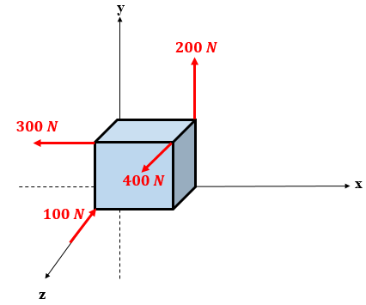
Figure 2.40 Cube to be kept in equilibrium.
The resultant force of this system is
R=-300120300 N.
The force $\vec{F_{b}}$ required to balance the resultant force and keep the body in equilibrium must be a vector opposite to $\vec{R}$ and of the same magnitude:
Fb=300-120-300 N,
Fb=3002+(-120)2+(-300)2=441 N.
The direction of this balancing force is determined by the three cosine directions:
αF=cos-1acos300441=47.14°,
βF=cos-1acos-120441=105.8°,
γF=cos-1acos-300441=132.86°.
The next step consists of calculating the scalar components of the moment vector about the point, with the three Cartesian axes passing through O since it is the point at which the balancing elements are requested to be applied.
Forces $\vec{F_{1}}$ and $\vec{F_{2}}$ pass through the x axis, whereas force $\vec{F_{3}}$ is parallel to the x axis, so these three forces do not produce a moment about (Ox). The remaining forces exert the following moment about (Ox):
Mx-/O=400)⋅(0.1+80)⋅(0.05=44 N ⋅m.
Forces $\vec{W}$ and $\vec{F_{2}}$ are parallel to the y axis, whereas force $\vec{F_{1}}$ passes through the x axis, so those three forces do not develop moment about (Oy), the remaining forces exert the following moment about (Oy):
My-/O=-300)⋅(0.1+-400)⋅(0.1=-70 N ⋅m.
Forces $\vec{F_{1}}$ and $\vec{F_{4}}$ are parallel to the z axis and so do not produce a moment about (Oz), the remaining forces exert the following moment about (Oz):
Mz-/O=200)⋅(0.1+300)⋅(0.1+-80⋅0.05=46 N ⋅m.
The balancing moment vector $\vec{M_{bO}}$ has scalar projections that are the opposite of those of the resulting moment:
MbO=-4470-46 N.mN m.
The magnitude of the balancing moment equals that of the resulting moment and is calculated as follows:
MO=(-44)2+702+(-46)2=94.615 N ⋅m.
The direction of this balancing moment is given by the three cosine directions:
αM=cos-1acos-4494.615=117.71°,
βM=cos-1acos7094.615=42.28°,
γM=cos-1acos-4694.615=119°.
Application 2.15. The square frame shown in Figure 2.41 is subjected to a system of forces parallel to the x axis. Determine the magnitude, sense, and position of the point of application A of the force needed to establish static equilibrium for this frame.
Solution 2.15. Let $\vec{F_{b}}$ the unknown force needed to complete the equilibrium. By default, we consider that it is oriented along the positive sense of the x axis. Since all forces are parallel to the x axis, F_{by} = F_{bz} = 0. The component F_{bx} is calculated from Equation (2.38):
Fbx+200-400+300+500=0⇒FbxFbx=-600 N.
This result gives the magnitude F_{b} = 200 N and a sense opposite to the positive sense of the x axis.
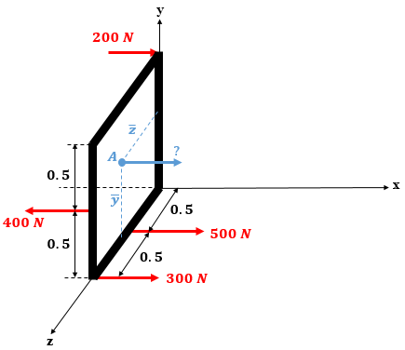
Figure 2.41 Frame in equilibrium while subjected to parallel forces.
To locate the point of application point A of $\vec{F_{b}}$, we apply Equations (2.42) and (2.43):
My-/O=0⇒-600⋅z-400)⋅(1+300)⋅(1+500)⋅(0.5=0,
⇒z=0.25 m.
Mz-/O=0⇒+600⋅y-200)⋅(1+400)⋅(0.5=0,
⇒y=0 m.

Alternative sets of planar equilibrium equations
Consider a rigid body located in a direct planar reference (Oxy) subjected to a system of forces $\vec{F_{i}}$, i = 1 to n in planar equilibrium. Figure 2.42 shows one force for the sake of clarity. Each force $\vec{F_{i}}$ can be resolved into two components $\vec{F_{ix}}$ and $\vec{F_{iy}}$ that may replace the original force. The scalar components F_{ix} are responsible for acceleration in the x direction, whereas F_{iy} is responsible for acceleration in the y direction. All components of the forces may cause rotation of the body about any point in the plane. These three motions are known as degrees of freedom.
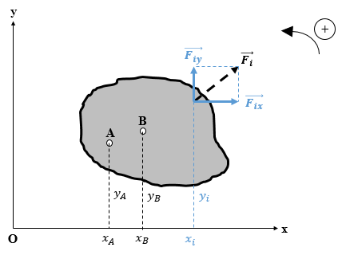
Figure 2.42 Planar equilibrium of a rigid body.
To prevent both translation and the rotation and thereby establish planar equilibrium, the resultant force components along the x and y axes and the resultant moment about an arbitrary point in the plane must vanish. We obtain the three equations (2.38), (2.39), and (2.43) from the set of six spatial equilibrium equations. These are
$\sum_{i=1}^{n}{F_{ix}}=0$, (2.38)
$\sum_{i=1}^{n}{F_{iy}}=0$, (2.39)
i=1nMi-/A=0. (2.43)
The next step consists of proving that the selection of the arbitrary point at which to apply Equation (2.43) does not affect the result of the calculation. Consider the point O as an arbitrary point in the plane and calculate the sum of the moments about this point:
Mi-/O=xi⋅Fiy-yi⋅Fix.
This equation does not change when zero is added and subtracted:
Mi-/O=xi⋅Fiy-yi⋅Fix+0-0.
By multiplying Equation (2.38) by y_{A} and Equation (2.39) by x_{A}, the right sides of these two equations remain zero:
yA.Fix=0 and xA.Fiy=0.
The first zero added to Mi-/O can be replaced by yA.Fix and the second zero can be replaced by xA.Fiy, which gives
Mi-/O=xi⋅Fiy-yi⋅Fix+yA⋅Fix-xA⋅Fiy
This latter equation can be rearranged as follows:
Mi-/O=(xi-xA)⋅Fiy-(yi-yA)⋅Fix.
The differences (x_{i} − x_{A}) are the arms of the forces $\vec{F_{iy}}$ about A and (y_{i} − y_{A}) are the arms of the forces $\vec{F_{ix}}$ about the same point, meaning that the right side of the latter equation is non-other than Mi-/A. Finally, according to Equation (2.43), the sum of moments about A is zero; so replacing it in the expression of the moments about O gives
Mi/-O=0.
This result shows that choosing either point O or A or any other arbitrary point does not change the equilibrium condition of rotation. However, depending on the loading and the geometry, the choice of a particular point might simplify the calculations.
In addition, this latter result was derived by using Equations (2.38) and (2.39) which mean physically a block of two translational motions along two perpendicular directions. Mathematically, one of those conditions might be replaced by Mi/-O=0. Mechanically, preventing two translations and one rotation is equivalent to preventing one translation and two rotations about two arbitrary, distinct points in the plane.
In conclusion, one may use alternative sets of equations of equilibrium as the original set (2.38), (2.39), and (2.43) without affecting the mechanical state of the body (equilibrium).
The first set consists of
i=1nFix=0, (2.44)
i=1nMi-/A=0, (2.45)
i=1nMi/-O=0, (2.46)
and the second set consists of
i=1nFiy=0, (2.47)
i=1nMi/-A=0, (2.48)
i=1nMi-/O=0. (2.49)
Notice that, for both previous sets of equilibrium equations, O and A are two arbitrary points in the plane that may be chosen under one strict condition: The two points must not be on a straight line perpendicular to the line of action along which forces are countering translational motion. In other words, for the first alternative set of equations of equilibrium, Equation (2.44) is constricting translation along the x direction, which is in the horizontal plane, so points O and A cannot lie on a vertical line (i.e., parallel to the y axis) because, in this case, the arm x_{A} − x_{O} = 0, which means that the two remaining equations in this set become dependent (i.e., the number of effective equations in the set decrease from three to two; so the condition $\sum{F_{iy}}=0$ is not replaced and thus not satisfied).
Applying the same rationale to the second set of equilibrium equations, points O and A cannot lie on a horizontal line (i.e., parallel to the x axis); otherwise, the equilibrium conditions would not be entirely satisfied.
Inspired by these two sets of equilibrium equations, a new set could also be generated based on constricting rotation about three distinct arbitrary points in the plane. This is mechanically equivalent to constricting two translational motions and one rotational motion (i.e., as satisfied in the original set of equations of equilibrium). Considering three arbitrary points O, A, and B in the plane, the new alternative set of equations is
i=1nMi-/A=0, (2.50)
i=1nMi-/O=0, (2.51)
i=1nMi-/B=0. (2.52)
This latter set is valid under the strict condition that the three points must be on a line.
To prove this condition, consider Figure 2.43, which shows the force Fi and the three points O, A , and B belonging to the same straight line and separated from the line of action of Fi by the arms d_{iO}, d_{iA}, and d_{iB}, respectively. All arms are perpendicular to the same direction (i.e., the line of action of the force) and originate from three points lying on a line, so they are all parallel to each other. Applying the Thalès Theorem of proportionality gives d_{iA} = K_{A}d_{iO} and d_{iB} = K_{B}d_{iO}, where
Thalès theorem says that a line parallel to a triangle’s side divides the two other sides by equal proportions.
$K_{A}=\frac{IA}{IO}$ and $K_{B}=\frac{IB}{IO}$ are coefficients of proportionality.
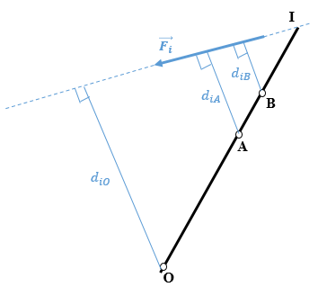
Figure 2.43 Moment of a force about three points lying on a straight line.
Expanding Equations (2.50)–(2.52) gives
Mi-/A=0⇒Fi⋅diA=0⇒KA⋅Fi⋅diO=0⇒Fi⋅diO=0,
Mi-/O=0⇒Fi⋅diO=0,
Mi-/B=0⇒Fi⋅diB=0⇒KB⋅Fi⋅diO=0⇒Fi⋅diO=0.
The three equations have produced a single equation, meaning that the three conditions are in fact a single condition, so not all motions are constricted. Thus, the equilibrium conditions are not all satisfied by the choice of three points on a line.
Finally, recall that, for all four sets of equations, the sense of scalar projections along the x and y axis is considered positive when the orientation is from left to right along the x axis and upward along the y axis. A moment is considered positive if it promotes counterclockwise rotation, as shown in Figure 3.1.
The equilibrium of a particle in a plane imposes a block of translations in the x and y directions, so only Equations (2.38) and (2.39) should be satisfied. These are indeed identical to Equations (2.2) and (2.3).

Self-Check Questions
- Choose the correct answer
When a rigid body is subjected exclusively to many force couples, the element(s) needed to establish static equilibrium is (are)
No elements are needed, the body is already in equilibrium.
Only a balancing force is needed.
Only a balancing moment is needed.
Both balancing force and moment are needed.
- Choose the correct answer.
When a rigid body is subjected to many collinear forces, the element(s) needed to establish its static equilibrium is (are)
No elements are needed, the body is already in equilibrium.
Only a balancing force is needed.
Only a balancing moment is needed.
Both balancing force and moment are needed.

Bearing Types, Static Determinacy

Definition of bearing
A bearing is a physical object connected to the rigid body under consideration to prevent the latter’s motion along one or several directions. A translational motion is reduced by applying a force in the direction opposite the translation, and a rotational motion is reduced by applying a couple moment about the axis in the direction opposite the rotation. To generalize, we introduce the concept of degree of freedom (DOF), which represents a direction along which a rigid body may move, either in translation or rotation. Depending on its type, a bearing may constrain one or multiple DOFs.
Bearings may be split into many categories:
- monovalent bearings that block one DOF;
- bivalent bearings that block two DOFs;
- trivalent bearings that block three DOFs;
- polyvalent bearings that block more than three DOFs in space.
Bearings exert one or more components of reactive forces that hold a rigid body in static equilibrium once the body is subjected to active forces. Both active and reactive forces are external forces. However, active forces are known since they are exerted by a user on the rigid body in a practical application, whereas reactive forces exerted by the supports are unknown and must be calculated to satisfy the equilibrium equations (i.e., either six conditions in space or three conditions in a plane).

Bearing types and reactions
Planar bearings
Planar bearings involve a rigid body, the applied forces, and the bearings supporting the body that all lie in a plane (Oxy).
The following are the most common supports:
Cable. A cable is a linear support connected to the main body to prevent its motion along the line defined by the cable. A cable can apply only a tensile force—it collapses under compression and thus cannot exert any reactive force in that sense. Figure 2.44a shows a cable acting on a member in 2D. The reaction of the cable produces a tensile force acting along the line of the cable, as shown in Figure 2.44b. Since the direction θ of the cable is already known from the system’s configuration, the lone unknown is the magnitude of the tensile force.
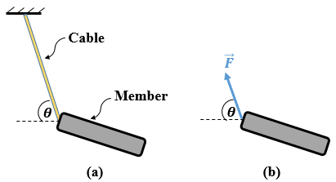
Figure 2.44 (a) Cable supporting a member in the plane. (b) Reactive force supplied by the cable.
Rigid link. A rigid link (see Figure 2.45a) is like a cable except that its rigidity allows it to exert a reaction force either in tension or compression. The reaction force is like that of a cable except that, for the rigid link, the reaction could have both senses: either tension or compression. The reaction force exerted by a weightless rigid link on a member is illustrated in Figure 2.45b.
Roller. A roller is a spherical or cylindrical item that rests on a surface and prevents translation in the direction perpendicular to the surface, so the only unknown is the magnitude of the reaction force. Figure 2.46a shows a roller connected to a rigid body, and Figure 2.46b shows the possible reaction forces.
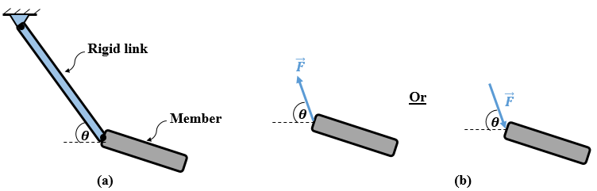
Figure 2.45 (a) Rigid link in the plane. (b) Reaction force exerted by rigid link on member.

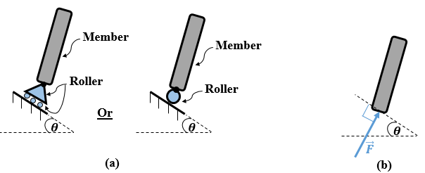
Figure 2.46 (a) Roller support in the plane. (b) Reaction force exerted by roller on member.
Rocker. A rocker is a pivot rounded on the bottom and resting on a surface; it prevents translation exclusively in the direction perpendicular to this surface, so the only unknown is the magnitude of the reaction force. Figure 2.47a shows a rocker connected to a rigid body and Figure 2.47b shows the reaction force.
Smooth supporting plane. This is a rigid polished solid surface on which a point or a partial area of the rigid body can rest. It prevents translational motion perpendicular to and toward the plane. The only unknown is the magnitude of this reaction force. This support is schematized in Figure 2.48a and Figure 2.48b shows the reaction force.
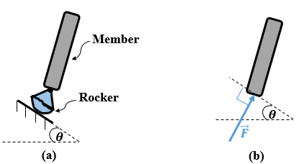
Figure 2.47 (a) Rocker support in the plane. (b) Reaction force exerted by rocker on member.
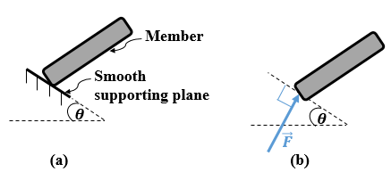
Figure 2.48 (a) Smooth surface support in the plane. (b) Reaction force exerted by smooth supporting.
Slotted roller or pin. A cylindrical device confined between two smooth rigid planes so it can translate parallel to planes but not perpendicularly, so the only unknown is the magnitude of the reaction force. This bearing is shown in Figure 2.49a, and its reaction force is shown in Figure 2.49b.
Sliding pinned collar. This is a cylindrical tube through which slides freely a smooth, concentric rod. A member is pinned to the cylindrical tube. This bearing prevents translation perpendicular to the smooth rod, so the only unknown is the magnitude of the reaction force. This type of bearing is shown in Figure 2.50a and its reaction force is shown in Figure 2.50b.
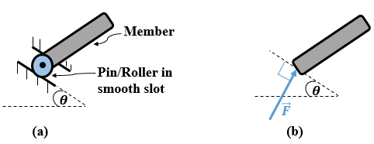
Figure 2.49 (a) Slotted roller support in the plane. (b) Slotted roller reaction force.
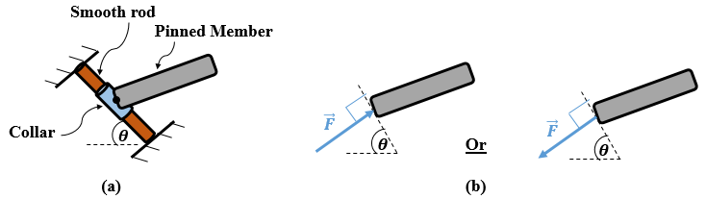
Figure 2.50 (a) Sliding pinned collar support in the plane. (b) Reaction force of sliding pinned collar.
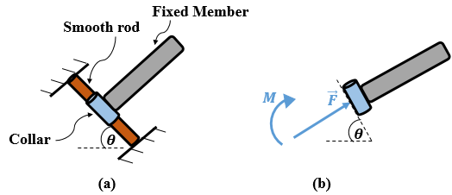
Figure 2.51 (a) Sliding fixed collar support in the plane, (b) sliding fixed collar reaction components.
Sliding fixed collar. This is a cylindrical tube through which passes freely a smooth, concentric rod. The tube is welded or otherwise adhered to a rigid body. It prevents translation perpendicular to the smooth rod and rotation within the plane. It allows only translation parallel to the smooth rod. This type of bearing is shown in Figure 2.51a and Figure 2.51b shows the corresponding reaction force and couple moment produced by a fixed collar.
Pin. A pin (also called a hinge) has two spaced flanks between which a rigid body with a hole is positioned. A screw fixed with a nut goes through a hole in the rigid body to connect it to the flanks. A pin has two leaves so that it can be fixed to the ground (Hibbeler, 2010). Figure 2.52a shows a pin. A pin prevents translation in the plane in all directions, which means that it exerted a reaction force directed along any inclination (with respect to the x axis) in the plane. However, one can replace this force (and its unknown angle) with two orthogonal components (i.e., a reaction force along the x axis preventing translation in this direction and another reaction force in the y direction preventing translation in this direction). Mechanically, when translation is prevented in two directions, it is blocked completely. Consequently, a pin bearing produces two unknown reaction-force components: one horizontal and one vertical force, or one unknown force magnitude and the corresponding direction θ (see Figure 2.52b). In most cases, the two orthogonal components are adopted.
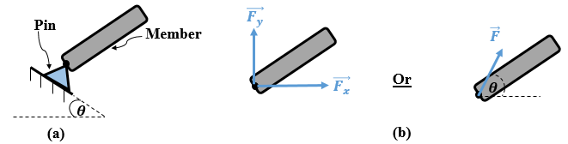
Figure 2.52 (a) Pin support in the plane. (b) Components of pin reaction force.
Fixed support. This is any device preventing a body from undergoing any motion—it blocks all translational and rotational motion. The end at which a fixed support is connected is said to be cantilevered. Figure 2.53a shows a fixed support. Because all DOFs are eliminated by a fixed support, this type of bearing exerts three reaction components: two orthogonal force components and a couple moment. This is illustrated in Figure 2.53b.
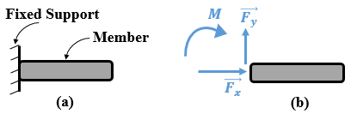
Figure 2.53 (a) Fixed support in the plane, (b) fixed support reaction components.
All these bearings and their characteristics are summarized in Table 2.2.
Table 2.2 Supports types and reactions for 2D rigid bodies.
Bearing Type | Bearing symbol | Number of prevented DOF | Reaction components
Cable |  | 1
Rigid massless link |  | 1
Roller |  | 1
Rocker |  | 1
Smooth supporting plane |  | 1
Roller in smooth slot |  | 1
Sliding pinned collar |  | 1
Sliding fixed collar |  | 2
Pin |  | 2
Fixed support |  | 3

Spatial bearings
Spatial bearings involve a rigid body, the applied forces, and the bearings supporting the body that all are in a 3D Cartesian frame of reference (Oxyz).
The following are the most used supports:
Cable. This is a linear tool used exclusively in tension and connected to the main body or member to prevent the motion of the latter along its axis. A cable collapses under compression and thus exerts no reaction in that sense. Figure 2.54a shows a cable acting on a member in 3D. For the reaction force developed, the same concept as a cable in a plane applies in 3D space. The reaction force is illustrated in Figure 2.54b. Note that the rigid link in 3D space is the same concept as a rigid link in a plane.
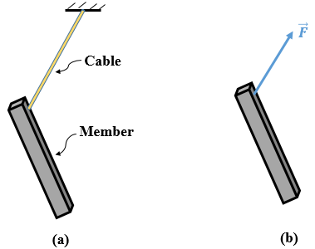
Figure 2.54 (a) Cable support in space, (b) cable reaction force.
Smooth supporting plane. This is a rigid polished solid surface on which a point or a partial area of the rigid body can rest. It blocks translational motion perpendicular to the plane and is schematized in Figure 2.55a. For the reaction force, the same concept applies in 3D space as in the plane. The reaction force is illustrated in Figure 2.55b.
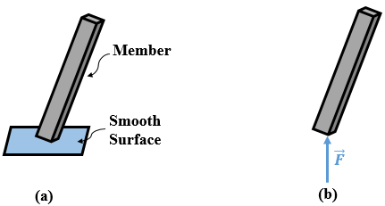
Figure 2.55 (a) Smooth plane support in 3D space, (b) smooth plane reaction force.
Roller. A roller is a spherical or cylindrical item resting on a surface and preventing translation perpendicular to this surface. Figure 2.56a shows a schematic of a roller connected to a rigid body. For the reaction force, the same concept applies in 3D space as in a plane. The reaction force is illustrated in Figure 2.56b. Note that the reaction may be oriented either upward or downward, depending on the loading.
Ball and socket. This is a spherical device connected to a point on a rigid body and confined within a rigid housing. Figure 2.57a shows its schematic illustration. This type of bearing allows rotation in all directions but blocks translation in all directions. This is represented by three reaction force components acting in three mutually perpendicular directions. Figure 2.57b shows these components.
Circular single journal bearing. This is a mechanical support of hollowed cylindrical shape consisting of lubricated internal rings and is used to support shafts. It is shown schematically in Figure 2.58a. It blocks both translation and rotation about the radial axes of the shaft; only longitudinal motions are allowed. This implies that the reaction consists of two rectangular force components acting along two mutually perpendicular radial directions and two rectangular moment components acting about the same axes. Figure 2.58b illustrates these components.
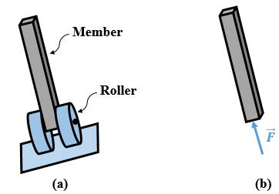
Figure 2.56 (a) Roller support in 3D space, (b) roller reaction force.
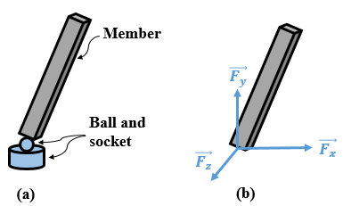
Figure 2.57 (a) Ball and socket support in 3D space, (b) ball and socket reaction components.
Square single journal bearing. This is a mechanical support of hollowed prismatic shape consisting of lubricated internal rings and used to support shafts. It is shown schematically in Figure 2.59a. It blocks both translation and rotation about the radial axes and rotation about the longitudinal axis of the shaft; only longitudinal translation is allowed. Figure 2.59b illustrates the five reaction components generated by this type of support.
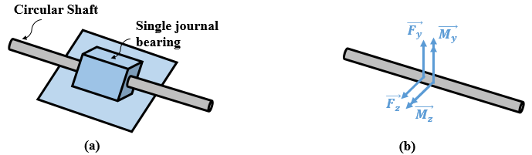
Figure 2.58 (a) Single circular journal bearing in 3D space, (b) single circular journal bearing reaction components.
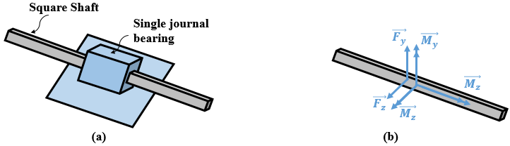
Figure 2.59 (a) Single square journal bearing in 3D space, (b) Single square journal bearing reaction components.
f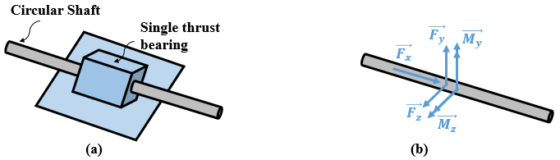
Figure 2.60 (a) Single thrust bearing in 3D space, (b) single thrust bearing reaction components.
Single thrust bearing. This is a mechanical support with a hollowed cylindrical shape consisting of lubricated internal rollers and/or balls. It is used to support shafts (see schematic illustration in Figure 2.60a). It blocks both translation and rotation about radial axes of the shaft and longitudinal translation. Only rotation about the longitudinal axis of the shaft is allowed. Figure 2.60b shows the five reaction components generated by this type of support.
Pin. A pin has two spaced flanks between which is the rigid body with a hole. A screw through the hole and a nut connect the flanks with the rigid body. A pin has two leaves that are fixed to the ground or other support (Hibbeler, 2010). A schematic drawing of a pin appears in Figure 2.61a. In addition to preventing translation in all directions (as it does in a plane), a pin bearing also prevents rotation in 3D space about any radial direction (coincident with the radial direction of the hole in the rigid body used to mount the pin). This results in five reaction components being exerted by the pin, as illustrated in Figure 2.61b.
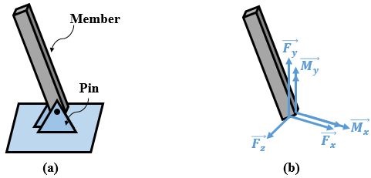
Figure 2.61 (a) Pin support in the space, (b) pin reaction components.
Hinge. A hinge consists of two thin plates with holes interlocked together through male and female cylinders to allow rotation about the cylinder axis, all other motions are blocked (see Figure 2.62a). A hinge may be used, for example, to mount a door on the frame such that the door rotates only about a vertical axis. The function of a hinge is very similar to that of a pin. It blocks thus five DOFs. The five reaction components are shown schematically in Figure 2.62b.

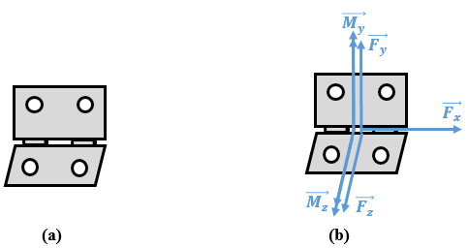
Figure 2.62 (a) Hinge support in 3D space, (b) hinge reaction components.
Fixed support. A fixed support is any device that blocks all translation and rotation of a body. The end at which the fixed support is connected is said to be cantilevered. Figure 2.63a shows schematically a fixed support. All DOFs in 3D space are blocked by the fixed support, so this type of bearing has six reaction components: three rectangular force components and three rectangular couple moment components. This is illustrated in Figure 2.63b.
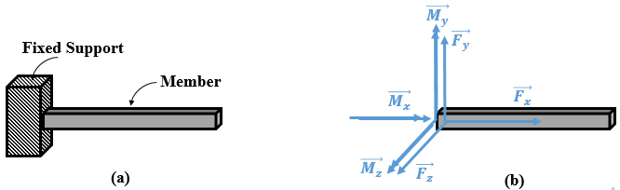
Figure 2.63 (a) Fixed support in 3D space, (b) fixed-support reaction components.
Note that, except for the cable and the supporting plane where the sense of the reaction forces is well known, the senses of the reaction components of all other types of bearings are positive or negative along a given direction. The correct sense is determined by the algebraic signs obtained upon calculating the components.
All these bearings and their characteristics are summarized in Table 2.3.
Table 2.3 Support types and reactions for 3D rigid bodies.
Bearing Type | Bearing symbol | Number of prevented DOF | Reaction components
Cable |  | 1
Smooth supporting plane |  | 1
Roller |  | 1
Ball and socket |  | 3
Circular single journal bearing |  | 4
Square single journal bearing |  | 5
Single thrust bearing |  | 5
Pin |  | 5
Hinge |  | 5
Fixed support |  | 6

We now illustrate several physical and practical examples to better understand the use of supports.
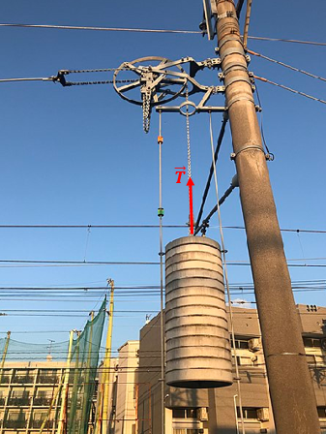
Figure 2.64 Reaction force (tensile) of a chain.
Figure 2.64 shows a heavy cylinder hung by a chain which is equivalent to a cable in terms of effect; the chain applies a tensile reaction force along the line of the chain, which is vertical in this example. This reaction force prevents the cylinder from undergoing free fall (motion) due to its own weight.
Figure 2.65 shows a door-groom link that is designed to resist the opening of the door by exerting a reactive force along the axis of the link.
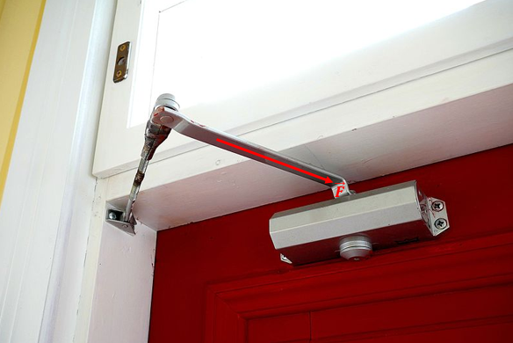
Figure 2.65 Reaction force exerted by door-groom link.
Figure 2.66 shows a prismatic bar tested in a laboratory under a bending load. This bar is supported by two rollers at its extremities that exert reaction forces $\vec{R_{1}}$ and $\vec{R_{2}}$ to counter the bending load.
Figures 2.67 and 2.68 illustrate two applications of pins. Figure 2.67 shows how metallic bars of a warehouse ceiling structure are pinned together while Figure 2.68 shows how the arms of a truck’s forklift are pinned to the frame of the truck.
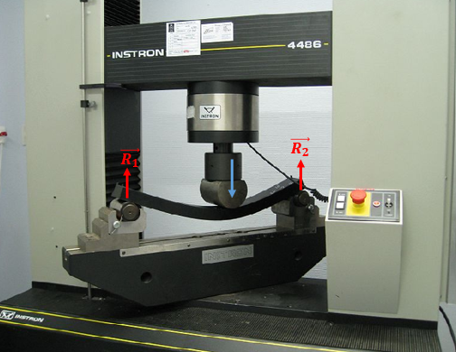
Figure 2.66 Reaction forces exerted by two rollers on a bar during bending test.
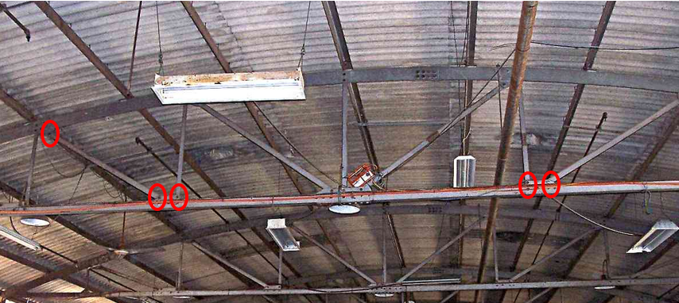
Figure 2.67 Metallic bars connected by pins.
Figure 2.69 shows a special thrust bearing where a ring of metallic balls are connected to a housing to allow rotation about the centerline but block translations in radial directions. Figure 2.70 shows a complete physical ball-and-socket device and a section where half of the housing is removed to display the spherical object inside.
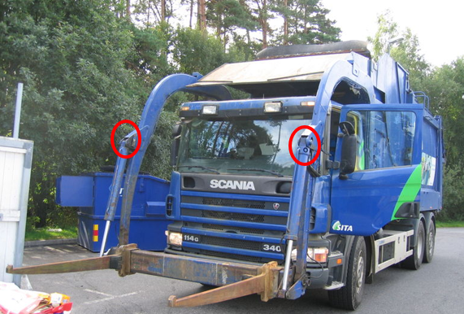
Figure 2.68 Application of pins for to articulate lift arms.
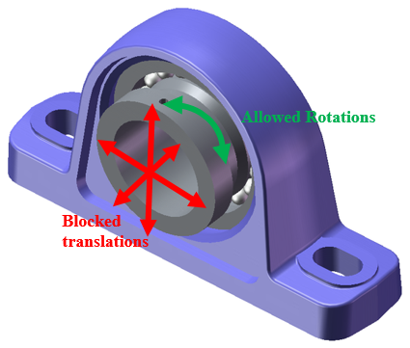
Figure 2.69 Special thrust bearing.
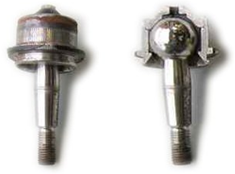
Figure 2.70 Special ball-and-socket bearing.
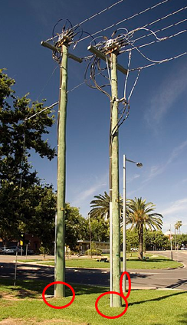
Figure 2.71 Poles cantilevered to the ground.
A final example is illustrated in Figure 2.71, which shows multiple poles supporting electrical equipment: wooden poles to hold cables and a metallic pole to hold lamps are fixed to the ground to prevent motion, either translation or rotation, in any direction. This is an application of a fixed support.
Application 2.16. Calculate the reaction forces at the fixed support A of the beam AB shown in Figure 2.72.
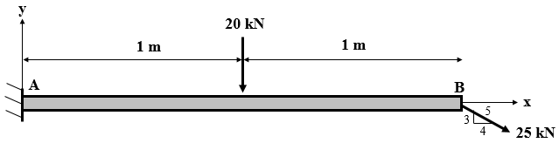
Figure 2.72 Fixed supported beam loaded in the plane.
Solution 2.16. The force at the free end be may be replaced by its rectangular components, as shown in the FBD of Figure 2.73.

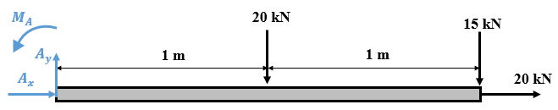
Figure 2.73 FBD of fixed supported beam under planar loading.
Applying the set (2.38), (2.39), and (2.43) of equilibrium equations gives
Fx=0⇒Ax+20=0⇒Ax=-20 kN,.
Fy=0⇒Ay-20-15=0⇒Ay=35 kN,.
M/A=0⇒MA-20)⋅(1-15)⋅(2=0⇒MA=50 kN .m.
Application 2.17. A rigid weightless bar AB is pinned at A and connected at B to the wall by a cable BC, as shown in Figure 2.74. The bar is subjected to two vertical forces. Calculate the reaction forces at A and B.
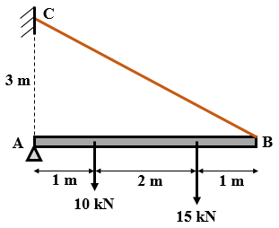
Figure 2.74 Loaded 2D bar supported by a pin and a cable.
Solution 2.4. First, we draw the FDB by isolating the main body (bar AB) and showing all external forces applied (see Figure 2.75).
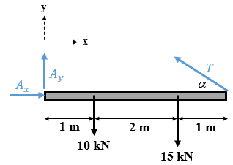
Figure 2.75 FBD of bar AB.
The pin at A generates two force components denoted A_{x} and A_{y} and the cable BC generates a tensile force of magnitude T along the line of the cable. The inclination α (i.e., direction) is known because the lengths AB and AC of the right-triangle ABC are known. The force in the cable can only be tensile and thus is oriented from B to C; however, the reaction forces at the pin may be in either sense; by default, we choose the same sense as the Cartesian axes x and y. Once calculated by using the equilibrium equations, a positive (negative) sign means that the chosen sense is correct (incorrect).
In the right-triangle ABC, AB = 4 m and BC = 3 m. Applying the Pythagorean theorem gives the length of the cable, BC = 5 m. Applying trigonometry determines the orientation α of the tension in the cable:
cosα=ABBC⇒cosα=45,
sinα=ACBC⇒sinα=35.
Applying the equilibrium equations (2.38), (2.39), and (2.43) gives
Fx=0⇒Ax-T⋅cosα=0⇒Ax=45⋅T,.
Fy=0⇒Ay+T⋅sinα-10-15=0⇒Ay+35⋅T=25,
M/A=0⇒+T⋅4T⋅sinα-10⋅1-15⋅(3)=0⇒T=23 kN.
Inserting T in the first two equations gives A_{x} = 18.4 kN and A_{y} = 11.2 kN.
Application 2.18. A square plate of weight 500 N is hinged at A and held by a cable BC connected to the plate by hook B, as shown in Figure 2.76. Determine the reactions of the hinge and the tension of the cable.
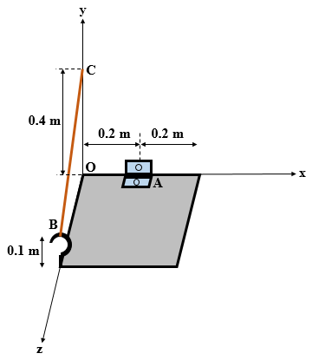
Figure 2.76 3D loaded plate supported by a hinge and a cable.
Solution 2.5. The FBD of the plate is shown in Figure 2.77. There are six unknown reaction components. If the system is in equilibrium, then it is a stable determinate system. By default, the senses of the components of the reaction forces and moments at the hinge are chosen in the positive sense of the Cartesian axes. The weight, vertical descending, is parallel and opposite to the y axis and is exerted at the geometric center of the plate.
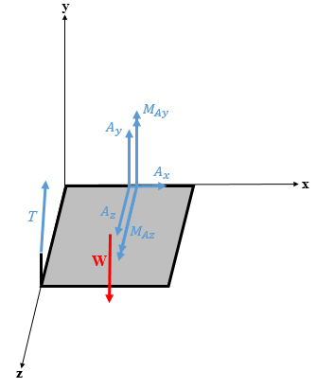
Figure 2.77 FBD of the square plate.
However, before applying the six equilibrium equations (2.4)–(2.9), note that the tension of the cable is neither parallel nor orthogonal to any of the three Cartesian axes, so its components and the components of its vector moment about A should be expressed in Cartesian coordinates.
The coordinates of A, B, and C are A(0.2, 0, 0); B(0, 0.1, 0.4); C(0, 0.4 ,0).
The components and the magnitudes of the direction vector $\vec{BC}$ and the position vector $\vec{AB}$ are
BC=00.3-0.4 m ,; BC=0.5 m,
AB=-0.20.10.4 m ,; AB=0.458 m.
From the components of the direction vector $\vec{BC}$ and its magnitude, the cosine directions of the cable’s tension $\vec{T}$ and its scalar components are found:
cosα=0,; cosβ=35,; cosγ=-45⇒T=Tx=0Ty=35TTz=-45T=035T-45T.
From the components of the position vector $\vec{BC}$and those of $\vec{T}$, the components of the moment of $\vec{T}$ about A become
MT-/A=ijk-0.20.10.4035T-45T⇒MT-/A=-1.65T-0.85T-0.65T.
Applying the six equilibrium equations gives
Fx=0⇒Ax+Tx=0⇒Ax=0,
Fy=0⇒Ay+Ty+Wy=0⇒Ay+35T=500 N,
Fz=0⇒Az+Tz=0⇒Az-45T=0,
Mx-/A=0⇒500⋅(0.2)-1.65T=0⇒T=312.5 N,
My-/A=0⇒MAy-0.85T=0⇒MAy=50 N .m,
Mz-/A=0⇒MAz-0.65T=0⇒MAz=37.5 N .m.
Now that T is known, A_{y} and A_{z} may be found from the second and third equations:
A_{y} = 312.5 N, A_{z} = 250 N.
The positive signs of the answers mean that the physical forces are exerted in the sense drawn in the FBD.

Stability and instability
External forces applied to a rigid body may be either active forces or reactive forces. The latter are applied by physical objects known as bearings or supports. Supports hold a solid that is subjected to active forces and prevent its motion. In other words, bearings or supports exert reactive forces, known as support reactions or bearing reactions to counter the effect of the applied active forces and thereby hold the solid body in static equilibrium. The entire system of external forces consisting of both active and reactive forces must satisfy the equilibrium equations (2.38)–(2.43) for equilibrium to hold in the space. This set of equations reduces to equations (2.38), (2.39), and (2.43) when it comes to a planar equilibrium. Globally, all active forces are known in terms of direction, sense, and magnitude whereas the reaction forces are unknown, so the equilibrium equations are applied to calculate the bearing reaction forces exerted on a solid body. Since the number of equilibrium equations is limited (i.e., six equations in 3D and three equations in 2D), one may calculate the six reaction forces only in space and three reaction forces only in a plane. However, this number of reaction forces in a physical state of a body may not match the mathematical requirements; in other words, the number of reactive forces may be less than six but may also exceed six. Nevertheless, it is not guaranteed that the reaction forces suffice to ensure the stability of the body; it all depends on the configuration of the bearings and how they are placed to hold the body.
The coming text contains a detailed discussion of the state of a rigid body supported by bearings and subjected to external active forces. for sake of clarity and simplicity, the discussion considers the planar case but an extension to the spatial case is possible.
Before starting the discussion, we give the definitions of several key terms that are essential for understanding the coming discussion.
Stability. A rigid body is said to be in stable equilibrium when it remains at rest under any possible type, direction, sense, and magnitude of external loading.
Instability. A rigid body is said to be in an unstable state if it moves as the result of at least one case of loading, regardless of its type, direction, sense, and magnitude.
Unstable Equilibrium. A rigid body is said to be in unstable equilibrium when it remains in equilibrium only under a particular loading, but this equilibrium is broken once the loading changes.
Statically determinate structure. A structure is said to be statically determinate when it is stable and the number of unknown reaction forces equals the number of equilibrium equations (i.e., six unknowns in 3D and three unknowns in 2D). In this case, all the reaction forces exerted by the supports may be determined by applying the equilibrium equations.
Statically indeterminate structure. A structure is said to be statically indeterminate when it is stable and when the number of unknown reaction forces exceeds the number of equilibrium equations (i.e., seven or more unknowns in 3D and four or more unknowns in 2D). In that case, the reaction forces exerted by the supports cannot be determined by applying the equilibrium equations alone; additional equations are needed to determine all the reaction forces, which are known as deformation compatibility equations. However, this is an advanced topic that goes beyond the scope of this textbook.

Statically determinate structure
Consider the structure shown in Figure 2.78. It is subjected to a known active force having a horizontal and vertical component P_{x} and P_{y}, respectively. It is supported by a pin-type bearing at point A and a roller-type bearing at point B. A pin reacts by producing a two-component reaction force (components are denoted A_{x} and A_{y}) whereas the reaction applied by a roller is a one-component force denoted B_{y}. This is a planar problem having three unknowns A_{x}, A_{y}, and B_{y}. Despite having three equilibrium equations (i.e., the same as the number of unknowns), one may not determine that the structure is determinate without ensuring its stability. Mathematically, the structure is stable when the three unknowns admit a unique solution for each. Otherwise, the structure is either totally unstable or in unstable equilibrium.
unique solution: in terms of linear algebra, this corresponds to a nonzero Cramer’s determinant
Applying equations (2.38), (2.39), and (2.43) gives
Fx=0⇒Ax-Px=0⇒Ax=Px,
Fy=0⇒Ay+By-Py=0⇒Ay+By=Py,
M-/A=0⇒By⋅d1+d2+Px⋅d3-Py.⋅d1=0⇒By=Py⋅d1-Px⋅d3d1+d2.
Going back to the second equation above, A_{y} can be determined as follows:
Ay=Py-By⇒Ay=Py⋅d2+Px⋅d3d1+d2.
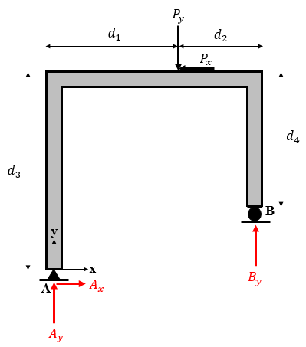
Figure 2.78 Statically determinate structure.
Since the three unknowns have unique solutions each, the structure is stable and thus statically determinate. Physically, the existence of those solutions means that the motion is prevented from undergoing a horizontal translation (i.e., along the x axis) due to $\vec{A_{x}}$, a vertical translation (i.e., along the y axis) due to $\vec{A_{y}}$ and $\vec{B_{y}}$, and a planar rotation (i.e., about the outward z axis) due to the combination of the three components together. Consequently, this structure is in static equilibrium.
In Equation (2.43), one may choose any point in the plane to calculate the moments’ equilibrium and the equation remains satisfied. However, it is preferable to choose a specific point that simplifies the calculations of moments. In the case of Figure 2.78, point A looks like the most convenient point because two unknown forces pass through it, so their corresponding moments are zero (since their arms have zero length) leading to the apparition of only one unknown B_{y} in the equation, which reduces considerably the calculations. The reader is invited, for sake of verification, to choose another point (e.g., B) and calculate the equilibrium of moments there.

Statically indeterminate structure
Consider now the same structure under the same loading conditions. However, in addition to the pin at A and the roller at B, the structure is also supported by another pin at C, as shown in Figure 2.79. The number of equilibrium equations being always three, the problem has five unknowns: A_{x}, A_{y}, B_{y}, C_{x}, and C_{y}. The number of unknowns is thus greater than the number of equations. To consider the structure indeterminate, it must also be stable; this applies in case each of the equations admits many possible solutions. Otherwise, the structure would be either totally unstable or in unstable equilibrium.
Applying Equations (2.38), (2.39), and (2.43) gives
Fx=0⇒Ax+Cx-Px=0⇒Ax+Cx=Px,
Fy=0⇒Ay+By+Cy-Py=0⇒Ay+By+Cy=Py,
M/-A=0⇒By⋅d1+d2-Cx⋅d3+Cy⋅d5=Py⋅d1-Px⋅d3.
The development of the three planar equilibrium equations has led to three equations that may admit an infinite number of solutions, so the structure is stable indeterminate. A part or even the totality of the bearing reactions cannot be calculated exclusively by using the equilibrium equations. Solving the indeterminate structure is now within the scope of Statics.

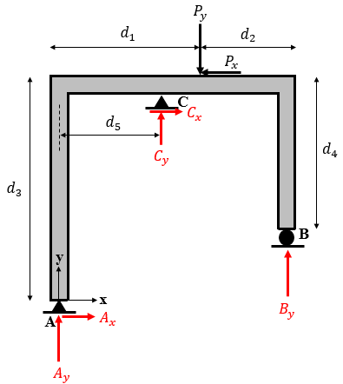
Figure 2.79 Statically indeterminate structure.

Unstable structure
Many case studies may involve completely unstable structures or structures in unstable equilibrium. Below, we illustrate several examples.
Figure 2.80 depicts the same structure but this time all three supports are roller types that induce reactions parallel between themselves (in this case, all are vertical). As a first case, consider that the external active loading consists only of P_{y} (P_{x} is shown as a dashed line since it will be applied in a later stage).
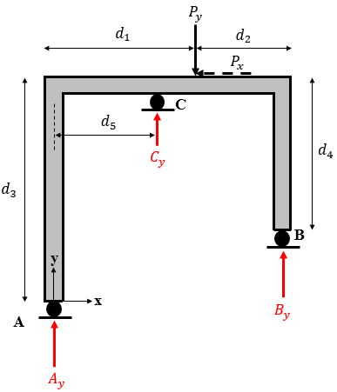
Figure 2.80 Unstable structure supported by three rollers.
Apparently, the number of unknowns equals the number of equations, so one would consider that the structure is determinate. However, it will be proven that this structure is unstable.
Applying the three equilibrium equations (2.38), (2.39), and (2.43) gives
Fx=0⇒0=0,
Fy=0⇒Ay+By+Cy-Py=0⇒Ay+By+Cy=Py,
M/-A=0⇒By⋅d1+d2+Cy⋅d5=Py⋅d1.
Mathematically, the first Equation (0 = 0) means that the structure is in unstable equilibrium: no external loading is applied along the x axis but also no bearing-type force or position induces a reaction along the x direction. However, in the absence of any horizontal reaction force, the application of any external active force on the structure (here denoted P_{x} in Figure 2.81) will break this unstable equilibrium and move the structure. Mathematically, Equation (2.38) gives 0 = P_{x}, which is not satisfied because P_{x} is an applied force and cannot be zero. In fact, the horizontal translation is not prevented by any bearing. The remaining two equations involve the three unknowns, which cannot be solved. Mechanically speaking, this structure is stable indeterminate along the y axis and completely unstable along the x axis, meaning that, overall, it is unstable since the stability condition imposes no motion in all directions simultaneously.
In conclusion, the equality between the number of equations and unknowns is a necessary but not sufficient condition to ensure the stability and determinacy of a structure. The location and distribution of the supports along the body play a key role in stability. In Figure 2.80, the three rollers exert three reaction forces but their distribution is not appropriate: they are all directed to balance y components and the rotation due to active loading, whereas the x-direction equilibrium is not satisfied. For instance, if the roller C is rotated in a way that applies either an inclined or a completely horizontal reaction, the stability would be permanently maintained.
Consider now another example inspired from the previous one but with an additional roller mounted at point D, as shown in Figure 2.81. Apparently, the number of unknowns is greater than the number of equations, so one may think that the structure is indeterminate. However, by repeating the same rationale as for the case of Figure 2.80 we find that the structure is in unstable equilibrium under the external loading P_{y} [i.e., Equation (2.38) results in 0 = 0] and is totally unstable when the external loading P_{x} is applied [i.e., Equation (2.38) results in 0 = P_{x}].
Although the bearings exert a greater reaction force than needed, this redundancy in reactions, if not well configured, might not ensure the equilibrium of the structure.
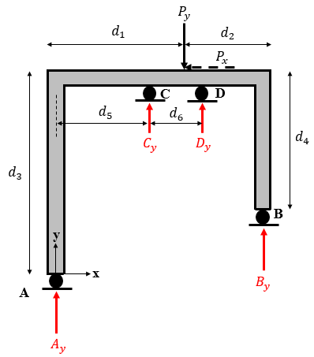
Figure 2.81 Unstable structure supported by four rollers.
Moving to Figure 2.82 to illustrate a new case study of instability, one now sees that roller B is located such that the line of action of its reaction force passes through point A. Although the number of unknowns and the types of bearings at A and B are like the case in Figure 2.78, the structure is not stable determinate as found in Figure 2.78. The change in position of one of the supports has indeed changed the stability status of the structure. Applying Equations (2.38), (2.39), and (2.43) gives
Fx=0⇒Ax-Px=0⇒Ax=Px,
Fy=0⇒Ay+By-Py=0⇒Ay+By=Py,
M/-A=0⇒+Px⋅d3-Py⋅d1=0.
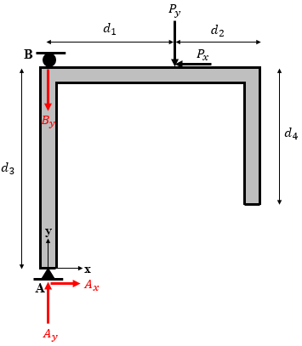
Figure 2.82 Unstable structure supported by a pin and a roller.
The first equation shows that the equilibrium along the x axis is established and determinate (A_{x} is calculated). The second equation shows that equilibrium is established along the y axis, but the case is indeterminate because the equations relate A_{y} and B_{y} and accept an infinite number of solutions. However, the third equation shows that the structure is unstable with respect to rotation because the moment created by the active external forces P_{x} and P_{y} is not balanced by any reaction force. All the lines of actions of the reaction forces are concurrent at one point, which implies that the moments are unbalanced, so the structure is unstable.
Finally, any structure supported by bearings that produce fewer reaction forces (i.e., unknowns) than the number of equilibrium equations (i.e., fewer than six in 3D and fewer than three in 2D), the structure is automatically unstable.
Application 2.19. The 90° arm shown in Figure 2.83 is supported by a ball and socket at O and held by a rigid weightless link AB. It is subjected to an external couple along the z axis and a concentrated force parallel to the y axis. Discuss the stability of this structure. If it is unstable, what solution would make it stable determinate? Calculate the reaction forces exerted by the bearings in the latter case.
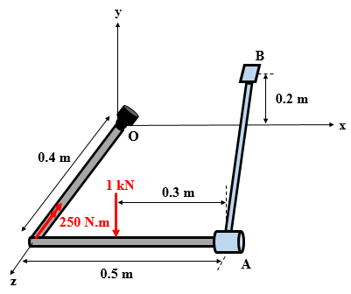
Figure 2.83 3D-loaded arm supported by a ball and socket and a link.
Solution 2.19. The FBD of the structure (Figure 2.84) shows that the bearings exert only four reaction-force components (three force components are exerted by the ball and socket and a single force component is exerted along the link). In the space, at least six reactions are needed (and properly arranged) to establish the stability of the structure. This means that this system requires two components to become stable. As is, the structure is unstable.
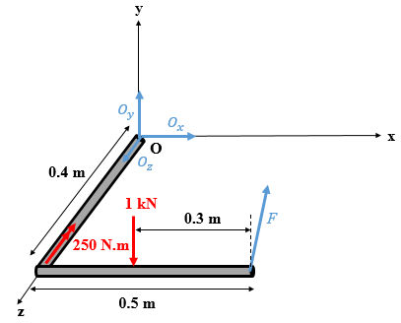
Figure 2.84 FBD of the 3D arm.
To render the structure statically determinate stable, one of the solutions is to replace the ball and socket by a pin that allows rotation only about the x axis. To the FBD of Figure 2.84, two couple moment components M_{Oy} and M_{Oz} are added.
Before applying the six equilibrium equations, we determine the components of $\vec{F}$ and the components of its moment about O since it is an inclined force in space.
The direction vector $\vec{AB}$ of $\vec{F}$ has the following components and magnitude:
AB=00.2-0.4 m ,; AB=25 m,
cosα=0,; cosβ=1105,; cosγ=-155⇒F=Fx=0Fy=1105FFz=-155F.
The position vector is OA=0.500.4 m, and which allows us to determine the scalar components of the vector moment as follows:
MF/-O=ijk0.500.401105F-155F⇒MF/-O=-1255F+1105F+1205F.
Applying the equilibrium equations (2.38)–(2.43) gives
Fx=0⇒Ox+Fx=0⇒Ox=0,
Fy=0⇒Oy+Fy-1000=0⇒Oy+1105F=1,
Fz=0⇒Oz+Fz=0⇒Oz-155F=0,
Mx-/O=0⇒1⋅(0.4)-1255F=0⇒F=105 kN,
My-/O=0⇒MOy+1105F=0⇒MOy=-1 kN ⋅m,
Mz-/O=0⇒MOz+1205F-0.25-1)⋅(0.2=0⇒MOz=-50 N ⋅m.
Finally, replacing F by its value in the second and third equilibrium equations, one gets O_{y} = 0 and O_{z} = 2 kN. The negative sign in M_{Oy} and M_{Oz} means that they act in the opposite sense to the right-hand rule.
Application 2.20. The arm AB pinned at A and supported by a fixed sliding collar at B is loaded as shown in Figure 2.85. Discuss the stability status of the arm and suggest suitable modification(s) to render it determinate in case it is not. Calculate the reactions in that case.
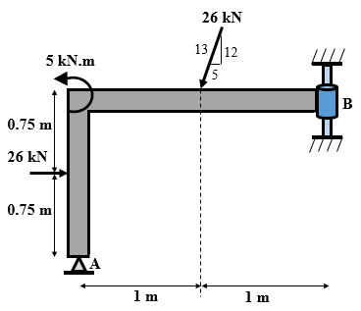
Figure 2.85 2D loaded arm supported by a pin and a fixed collar.
Solution 2.20. Figure 2.86 shows the free body diagram with the four reaction components. The four unknowns is greater than the number (three) of equilibrium equations. However, the structure is not stable indeterminate. An inappropriate arrangement of the bearings might lead to an instability. One must apply the three equilibrium equations reach a conclusion:
Fx=0⇒Ax+Bx+26-26.513=0⇒Ax+Bx=-16,
Fy=0⇒Ay-26⋅1213=0⇒Ay=24 kN,
M-/A=0⇒MB-1.5Bx-26)⋅(0.75+26⋅513⋅(1.5)-26⋅1213⋅(1)+5=0
⇒MB-1.5Bx=23.5.
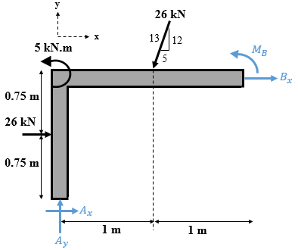
Figure 2.86 FBD of the 2D arm.
The second equation has led to the determination of A_{y}. The two other equations are satisfied for an infinity of options for A_{x}, B_{x}, and M_{B}. We thus conclude that the structure is stable and indeterminate. A modification of bearing(s) should lead to the removal of one of those three unknowns. The simplest solution is the replacement of the pin by a roller at A, which removes the components A_{x}. From the first equation one gets B_{x} = −16.5 kN (meaning that B_{x} acts from right to left). The third equation gives M_{B} = −1.25 kN m; similarly, the negative sign means that this couple acts in the clockwise sense of rotation.
Application 2.21. Beam AB is supported by a pin at A and a roller at B and is loaded in the plane, as shown in Figure 2.87. Verify that the alternative set of equilibrium equations based on the nullity of three resultant moments about three points lying on the beam does not lead to the determination of reaction forces.
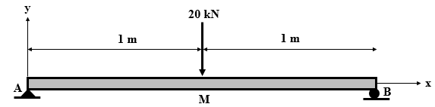
Figure 2.87 Loaded beam supported by a pin and a roller.
Solution 2.21. The FBD of the beam is shown in Figure 2.88, where the pin A exerts two reaction components A_{x} and A_{y} while the roller B exerts only one (B_{y}).
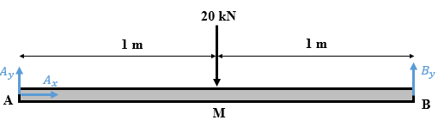
Figure 2.88 FBD of a loaded beam in the plane supported by a pin and a roller.
To find the three unknown reaction forces, apply the moment equilibrium about A, M, and B:
M-/A=0⇒-20)⋅(1+2⋅By=0⇒By=10 kN,
M-/M=0⇒(-1)⋅Ay+(1)⋅By=0⇒Ay=By,
M-/B=0⇒20)⋅(1-2⋅Ay=0⇒Ay=10 kN.
This set of equation is not helpful for determining A_{x}. In fact, the three chosen points fall all on a line. The second and third equations lead to the same result. However, by choosing any other point not on the beam (e.g., point C 0.5 m above point A) one calculates
M-/C=0⇒-20)⋅(1+2⋅By+(0.5)⋅Ax=0⇒Ax=0 kN.
The three components of the reaction forces are now fully determined. This latter component could have been found also by applying Equation (2.43).

Self-Check Questions
- Specify whether the following statement is True or False and justify your answer.
When a rectilinear bar is supported by two pins, it is automatically stable indeterminate. True, since two pins generate four reaction components, two vertical and two horizontal, that balance the three equilibrium conditions in the plane.

- Specify whether the following statement is True or False and justify your answer.
A rigid body supported by six cables in the space is certainly in static equilibrium because each cable exerts a reaction force, and six reaction components suffice to establish equilibrium. False because all the cables may be parallel between themselves or all of them intersecting at a single point, this will not prevent motion in all directions.

- Choose the correct answer
- A bulb hung vertically from the ceiling by its electrical cable has the following status:
Stable determinate
Stable indeterminate
Unstable equilibrium

Completely unstable

- The type of support that might be used alone to hold a body in static equilibrium is
Ball and socket
Hinge
Single thrust bearing
Fixed support

- Complete the following sentence
A shaft supported by two single-thrust bearings is supported by ten reaction components. Its equilibrium status is stable indeterminate.
Summary
A free-body diagram (FBD) is a schematic representation of an idealized solid showing all the forces exerted on it.
When a force is applied to a rigid body and separated from an axis point by a distance known as the arm, the force creates a moment about this axis. Also, a moment is created by two equal and parallel forces of the opposite sense separated by an arm; this is known as a couple. A moment is represented by a vector determined from the cross product between the position vector “axis of rotation–line of force” and the force itself.
The equilibrium conditions of a rigid body are expressed mathematically by a set of six equations for a rigid body in space:$\sum{F_{x}}=0$ , $\sum{F_{y}}=0$, $\sum{F_{z}}=0$, Mx-/A=0, My-/A=0, and Mz-/A=0. For a particle’s equilibrium, only the first three equations apply.
Externally, the active applied forces are balanced by another system of external forces named reactions, which are developed by bearings or supports mounted on the rigid body to hold it in equilibrium. A bearing may exert one to six components of reaction force in the space (i.e., one to three in the plane), depending on its type. To satisfy the six equilibrium equations, the total number of reaction-force components must be at least six, so appropriate bearings should hold the rigid body. In addition, they should be arranged in an appropriate manner such that their reactions prevent all motions. In that case, the structure is said to be stable. When a rigid body may move along any direction it is said to be unstable. A statically determinate structure is where all reaction forces exerted by its supports are determined exclusively from the equilibrium equations. A statically indeterminate structure is a stable structure with the number of reaction forces exceeding the number of equilibrium equations.

Unit 3 –Planar Trusses

Study Goals

On completion of this unit, you will be able to …

… identify a simple and compound truss.
… determine the internal forces in the bars of a truss using the method of joints.
… determine the internal forces in the bars of a truss using the method of sections.
… calculate the node displacements in a truss using the theorem of virtual work.

3. Planar Trusses

Introduction
After studying in detail the equilibrium of particles and rigid bodies, which are considered “single-component” solids, the next step deals with the equilibrium of structures. A structure is a solid body made of several components or parts connected together (Beer et al., 2012). A special type of structure known as a truss is the topic of the present unit. A truss is a solid structure “composed of straight slender members” (Gross et al., 2013, p.153). Each member is known as a bar and the points where bars are joined are known as nodes or joints. A bar is thus a segment joining two nodes. In an ideal truss, all joints are considered frictionless pins and all external forces are applied at the joints. In some real cases, when loads are applied on the bars, the problem could be mathematically converted to a joint-loaded truss. However, this latter case is beyond the scope of this unit.
A slender member is classified as slender when its length is much greater than its lateral dimensions.
Trusses are useful in many applications such as supporting the roof panels of warehouses or hangars, supporting bridge floors, or supporting ceilings in stadiums. Globally these are spatial trusses (3D trusses) that are composed of many 2D “sub-trusses” or planar trusses. Consequently, the study of an entire spatial truss consists in studying a series of planar trusses forming the whole spatial truss; for this reason, this unit considers only planar trusses.
One particular type of truss is studied herein, namely, the triangular truss. Besides determining the support reaction forces exerted on a loaded triangular truss, we will determine the internal forces generated within the bars of the truss by applying two different methods: the method of joints and the method of sections. Finally, the displacements of the nodes of a triangular truss are evaluated by applying the Theorem of Virtual Work.

Simple Triangular trusses

Concept
A truss is said to be triangular when the joint bars form between themselves a multitude of interconnected triangles. Figure 3.1 shows the upper structure of a metallic bridge across the Keya Paha River in Nebraska; the structure consists of a 3D truss that can be subdivided into numerous 2D trusses, such as the planar truss ABCDE composed of the two interconnected triangles ABC and CDE. Thus, ABCDE is a triangular truss.
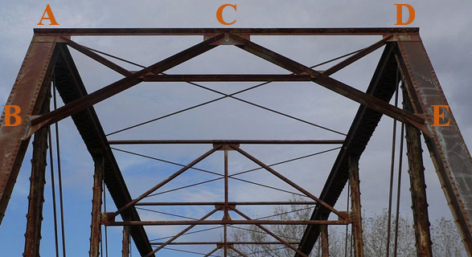
Figure 3.1 Triangular planar truss making up part of a spatial truss of a bridge.
Figure 3.2 shows a simplified spatial truss of a roof, which consists of many interconnected planar wooden trusses. The planar truss ABCDE is formed by connecting triangles ABE, BEF, BDF, and BCD. In consequence, the structure ABDCE is a planar triangular truss.
When an entire spatial truss is loaded (by persons or cars crossing the bridge, for instance, in the case of Figure 3.1, or by the weight of covering panels resting on the truss to complete the roof in the case of Figure 3.2), the load is transmitted through each of planar truss composing the whole truss and through the pins at the joints connecting the bars together.
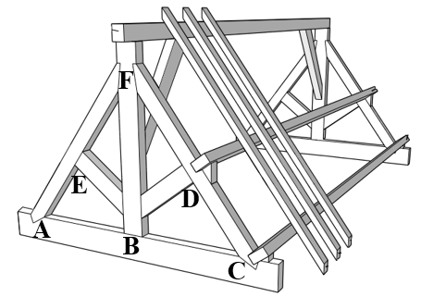
Figure 3.2 Triangular planar truss part of a whole spatial truss of a roof.
Two types of triangular trusses exist: a simple truss and a compound truss. We detail each below.

Simple truss
A simple truss is a particular triangular truss constructed as follows: the basic structure begins with a stable triangle denoted ABC, i.e., three bars and three nodes joined two by two. The second step consists in joining to the two nodes of this triangle, say B and C, two bars connected themselves by a common node D, say BD and CD. The next step consists in joining to the nodes of the entire structure ABCD, say B and D, two bars connected themselves by a common node E, say EB and ED. This step is repeated as many times as desired. The final structure constitutes a simple truss.
Figure 3.3 illustrates a simple truss constructed as explained above. Ten triangles are joined in the plane and connected via pins to form the entire simple truss ABCDEFGHIJKL. This truss involves 12 nodes and 21 bars.
Like any rigid body, a truss is supported by bearings, namely pins, rollers, and rockers, at some of the nodes. These bearings differ from internal pins that join the bars between themselves at the nodes. In Figure 3.3, the entire truss is supported by bearings at nodes A and L.
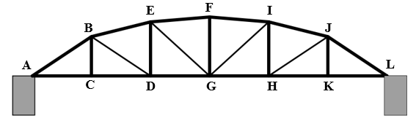
Figure 3.3 Simple truss.
We now establish a general relationship between the number n of nodes and the number b of bars in a simple truss. The idea is to count the nodes and bars involved in each step of the construction of the truss.
In step 1, the process starts with a triangle, which has three bars and three nodes.
In step 2, the process adds two bars and one node.
Step 2 is repeated (n − 3) times to obtain a total number n of nodes.
The total number of bars is b = 3 + 2(n − 3); by rearranging we get
$b=2n-3$ (3.1)
Equation (3.1) is a necessary but not sufficient condition for the truss to be a simple truss. This idea is emphasized by returning to the simple truss of Figure 3.3 which has b = 21 and n =12, which satisfies Equation (3.1). However, this result does not confirm that the truss is simple. To assure that a truss is simple, we must check if the construction process matches that of a simple truss. A counterexample is obtained in the truss of Figure 3.3 by removing the bar GI and adding a bar DF. This would not change the total number of nodes and bars, so Equation (3.1) remains satisfied but the truss is no longer a simple truss since its construction does not follow the rule of construction of a simple truss. Arriving at the stage ABCDEG, node F is connected to three bars instead of two: FE, FD, and FG.

Compound truss
A compound truss is a category of triangular trusses consisting of many simple trusses connected between themselves. Each pair of simple trusses involved in a compound truss may be connected in two ways:
Method 1: Consider two simple trusses ST₁ and ST₂. This method consists in putting in common a node of ST₁ with a node of ST₂ and then joining another node of ST₁ to another node of ST₂ by a bar that does not pass through the node that was put in common.
Method 2: Consider two simple trusses ST₁ and ST₂. This method consists in joining two by two the three distinct nodes from ST₁ to the three distinct nodes from ST₂ by three different bars that are neither parallel nor intersecting at a single point.
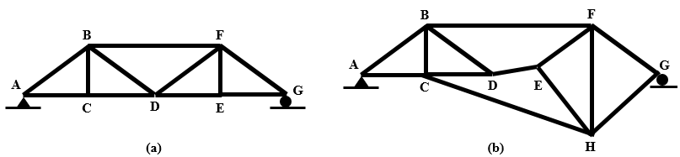
Figure 3.4 Compound trusses constructed with methods (a) 1 and (b) 2.
Figure 3.4(a) illustrates a compound triangular truss ABCDEFG supported by a pin at A and roller at G constructed using method 1. In fact, structures ABCD and DEFG are two simple trusses and are joined by the common node D and the bar BF joining node B from the first simple truss ABCD to node F from the second simple truss DEFG.
Figure 3.4(b) illustrates a compound triangular truss ABCDEFGH supported by a pin at A and a roller at G constructed using method 2. In fact, structures ABCD and EFGH are two simple trusses and are joined by (i) bar BF joining node B from the first simple truss ABCD to node F from the second simple truss DEFG, (ii) bar DE joining node D from the first simple truss ABCD to node E from the second simple truss DEFG, and (iii) bar CH joining node C from the first simple truss ABCD to node H from the second simple truss DEFG. These three bars are neither parallel between themselves nor intersect at a single point.
Now, a general relationship will be established between the number n of nodes and the number b of bars in a simple truss. The idea is to count the numbers n₁ and n₂ of nodes and the numbers b₁ and b₂ of bars involved in each of the two simple trusses ST₁ and ST₂, respectively, and add to them the number of items used for joining.
Applying Equation (3.1) to ST₁ and ST₂ gives b₁ = 2n₁ − 3 and b₂ = 2n₂ − 3
Method 1: n = n₁ + n₂ − 1 (since a node from each is brought in common) and
b = b₁ + b₂ + 1 = (2n₁ − 3) + (2n₂ − 3) + 1 = 2(n₁ + n₂ − 1) − 3 = 2n − 3.
Method 2: n = n₁ + n₂
b = b₁ + b₂ + 3 = (2n₁ − 3) + (2n₂ − 3) + 3 = 2(n₁ + n₂) − 3 = 2n − 3.
In conclusion, for a compound truss, and regardless of the method of construction,
b=2n-3. (3.2)
It is a similar condition as a simple truss and is also a necessary but not sufficient condition for a compound truss.

Two-force and zero-force members
A truss can be loaded at any of the nodes in the plane; the reactions of the supports would keep the truss in static equilibrium because, at this stage, one is dealing with external forces. The forces applied at the nodes will be transmitted to the bars of the truss, which are all components of the same structure, so the forces developed in the bars are internal forces. Those would not appear in any FBD unless a virtual section is applied and a portion of the truss is isolated and its FBD is plotted.
We now prove that the internal forces developed in a bar act along the line of the bar, meaning that the internal forces constitute an axial force (i.e., directed along the longitudinal axis of the bar). Since the whole truss is in static equilibrium, each component or portion of this truss is in equilibrium, namely, any selected and isolated bar.
Consider a bar AB chosen from a truss in equilibrium, so AB itself is in static equilibrium. Since a truss is loaded at its joining pins, the FBD of the rigid bar AB consists of forces applied at the nodes A and B, which are pins. It is known that pins generate a force of arbitrary direction in the plane. The forces applied by the pins A and B on the bar AB are denoted respectively by $\vec{F_{A}}$ and $\vec{F_{B}}$, with each having its own direction in the plane. This is illustrated in Figure 3.5.
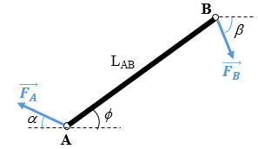
Figure 3.5 FBD of an isolated bar from a truss.
Applying equilibrium equations (2.38), (2.39), and (2.43) on the bar AB gives
Fx=0⇒FAcosα=FBcosβ,
Fy=0⇒FAsinα=FBsinβ,
M/-B=0⇒FAsinα+ϕ⋅LAB=0⇒FA=0.
This also means F_{B} = 0, which leads to zero forces, meaning that the truss is unloaded which is false since the problem starts with a loaded truss. To satisfy the latter equation for an existing force F_{A} (and thus F_{B}), the line of this force must pass through B and so F_{A} must act along the bar’s line AB. To satisfy the two other equilibrium equations, F_{B} must also act along the line of AB and be opposite in sense and equal in magnitude to F_{A}.
One can then conclude that any bar of a truss is subjected to two axial forces, acting along the direction of the bar, opposite in sense and equal in magnitude. Hence, each member of a truss is called a two-force member. The unified notation of a force along a bar consists of an index denoting the name of the bar: $\vec{F_{A}}=\vec{F_{B}}$ $= \vec{F_{AB}}$. This could either pull on the bar, applying a tensile effort, or push on the bar, applying a compressive effort. This is schematized in Figure 3.6.
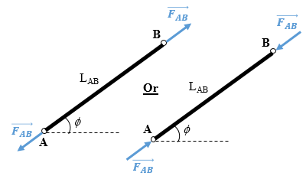
Figure 3.6 Two-force member under either tension or compression.
Note the following:
- An internal force acting within a bar is an algebraic quantity: a tensile force is positive whereas a compressive force is negative.
- Since the force acts along the bars and since the lengths and inclinations of all bars are known, the directions of all forces along all bars are known. Only their magnitudes are unknown. In other words, each bar generates one unknown that must satisfy the static equilibrium condition.
- By default, each force within a bar is considered a tensile force (outward from the member) in the FBD. Once calculated from the equilibrium equations, the sign of the result indicates the true sense: a positive result indicates that the force is tensile (as drawn by default in the FBD) whereas a negative result indicates that the force is compressive.
In some special cases, members might be free from any load, in which case they are known as zero-force members. However, these members are helpful in increasing the stability of the structure.
Case 1: When only two bars intersect at a given node and this node is free from any external force (either active or reactive), the two bars are zero-force members.
Case 2: When three bars intersect at a given node and two of them are collinear and the node is free from any external force (either active or reactive), the non-collinear bar is a zero-force member.
These two cases are illustrated in Figure 3.7. Figure 3.7a shows a simple truss ABCDEFG supported by a pin at A and a roller at E and subjected to external loading $\vec{P_{1}}$ and $\vec{P_{2}}$ at joints F and D, respectively. Node G satisfies the conditions of case 1 for the zero-force member while node C satisfies the conditions of case 2. Their respective FBDs are depicted in Figures 3.7b and 3.7c. The forces shown represent the action of each relevant bar on the node trying to “pull” on the node. Thus, as per Newton’s third axiom, the node also pulls on the bar. All forces are thus considered tensile by default.
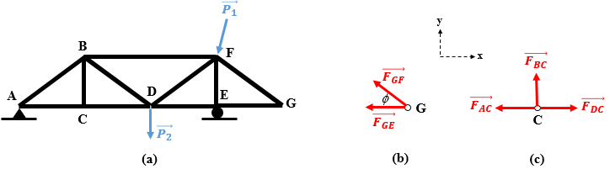
Figure 3.7 (a) Simple truss under external loading, (b) FBD of joint G, (c) FBD of joint C.
A joint is considered a particle, so two equilibrium equations preventing translation along x and y must be satisfied.
Joint G
Fy=0⇒FGF⋅sinϕ=0⇒FGF=0,
Fx=0⇒-FGF⋅cosϕ-FGE=0⇒FGE=0.
The latter results show that the forces in the bars GF and GE are zero; in other words, these bars are zero-force members.
Joint C
Fy=0⇒FBC=0,
Fx=0⇒FAC=FDC.
The latter results show that the force in bar BC is zero; in other words, this bar is a zero-force member.
Designing a truss involves determining the forces developed within the bars that compose this truss. However, these forces are internal and act between the joining pins and the different bars. To let those internal forces appear one should isolate each component, draw the relevant FBD, and then apply the equations of static equilibrium to determine the forces in the members.
There are two methods available to determine the unknowns in the members: the method of joints and the method of sections. These will be developed in the coming sections.

Self-Check Questions
- Specify whether the following statement is True or False and justify your answer.
A truss consisting of 11 nodes and 19 bars is a triangular truss. False; despite the relation b = 2n − 3 being satisfied, the bars may be arranged so that the truss is neither a simple nor a compound truss.
- Choose the correct answer.
A triangular truss ABC is pinned at A, supported by a roller at B and subjected to an external concentrated force at C.
AB is a zero-force member

BC is a zero-force member
AC is a zero-force member
No zero-force members

Analysis by method of joints
This method consists in isolating each joint of the entire truss in static equilibrium and drawing its FBD, which includes the active forces, reactive forces, and forces applied by the bars on the given node which are the forces generated in the bars (applied by the pin joints on the members according to the principle of action and reaction). A joint is modeled as a particle. In the plane, the following two equilibrium equations are applied to each particle (i.e., to each joint):
i=1nFix=0, (3.3)
i=1nFiy=0. (3.4)
For a truss with n joints, this set of equations is applied n times to determine all the unknowns whose number is the number b of bars. However, the types of trusses discussed herein are limited to simple and compound triangular trusses, where the relationship between b and n is given by Equations (3.1) and (3.2). In fact, Equations (3.3) and (3.4) applied to n joints generate 2n equations, which helps to solve b + 3 unknowns as per Equations (3.1) and (3.2). Given that the bars have b unknowns, the three remaining unknowns are the external reactions of the supports holding the truss in static equilibrium. Recall that, in the planar case, and to satisfy a globally statically determinate structure, the reaction components must total three and, to avoid instability, should be neither parallel between themselves nor intersecting at a single point. In other words, the 2n equations indirectly involve the three equilibrium equations of the whole truss counted as a rigid body and would be used to check the reaction forces that have already been determined by the 2n equilibrium equations for the joints. Generally, trusses are supported by pins, rollers, and rockers.
To simplify the calculations and because each set of equations (3.3) and (3.4) allows two unknowns to be calculated, one should start by selecting joints with two unknown forces in two bars to avoid dealing with unknown quantities when going from one joint to another.
Application 3.1. For the truss ABCDEFG of Figure 3.7a, consider P₁ = 20 kN and P₂ = 10 kN inclined by 30° from the vertical, AC = BC = CD = DE = EG = EF = 1 m. Determine the forces developed in the bars of the truss.
Solution 3.1. From Figures 3.7b and 3.7c, bars BC, GE, and GF are zero-force members. Since the joints A, B, D, E, and F have more than two unknowns (including the reaction forces at A and E), we determine the reaction forces at the supports A and E based on the equilibrium of the whole truss (Figure 3.8), and then use the method of joints. In this case, the equations that remain for the last joint are used for verification.
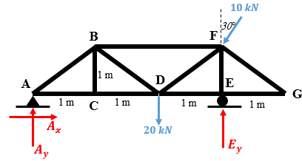
Figure 3.8 FBD of the whole truss ABCDEFG.
Equilibrium of the entire truss:
M-/A=0⇒3⋅Ey+10sin30°⋅1-10cos30°⋅3-20⋅(2)=0,
Ey=20.33 kN,
Fx=0⇒Ax-10sin30°⇒Ax=5 kN,
Fy=0⇒Ay+20.33-10cos30°-20=0⇒Ay=8.33 kN.
The next step consists of isolating each joint and then drawing the relevant FBD starting with joints exhibiting only two unknowns. Joint A is a good option to start with since A_{x} and A_{y} are now known, the only two unknowns that remain are the forces in members AB and AC. Moving then to joint C, we calculate the force in member CD. At this stage, joint B seems a suitable choice since the remaining unknown forces in bars passing through B are those in BD and BF. Joint E is tackled next to find the forces in members EF and ED. The final member is DF; any joint between D and F is suitable; the remaining equations are used to verify the results. Note that the inclined members are the hypotenuses of isosceles right-triangles, meaning that they are inclined by 45°. Tensile forces are denoted T and compressive forces are denoted C.
Joint A
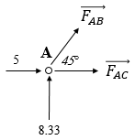
Figure 3.8a: FBD of joint A.
Fy=0⇒FAB⋅22+8.33=0⇒FAB=-11.78 kN (compressive),
Fx=0⇒FAB⋅22+5+FAC=0⇒FAC=+3.33 kN (tensile).
Joint C has been treated in Figure 3.7c which gives: $F_{CD}=+3.33 kN$(tensile)
Joint B
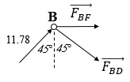
Figure 3.8b: FBD of joint B.
Fy=0⇒-FBD⋅22+(11.78)⋅22=0⇒FBD=+11.78 kN (tensile),
Fx=0⇒(11.78)⋅22+(11.78)⋅22+FBF=0⇒FBF=-16.66 kN (compressive).
Joint E
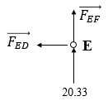
Figure 3.8c: FBD of joint E.
$\sum{F_{x}}=0⇒F_{ED}=0$,
$\sum{F_{y}}=0⇒F_{EF}=-20.33 kN$ (compressive).
Joint F
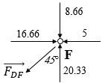
Figure 3.8d: FBD of joint F
Fx=0⇒-FDF⋅22-5+16.66=0⇒FDF=+16.49 kN (tensile).
All forces are now determined, and three equations remain to be checked: the second equation of equilibrium for joint F and two equations for joint D. As stated earlier, we could have applied the equilibrium condition to all seven joints to calculate the forces in all members and also the three reactions at the supports and then used the three equilibrium equations of the entire truss for verification; however, this choice in the present application would complicate the calculations.
The second equation of equilibrium applied at joint F gives
Fy=0⇒-(16.49)⋅22-8.66+20.33=0⇒0=0 (verified).
Joint D
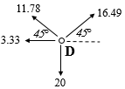
Figure 3.8e: FBD of joint D
Fx=0⇒+16.49⋅22-11.78⋅22-3.33=0⇒0=0 (verified),
Fy=0⇒+16.49⋅22+11.78⋅22-20=0⇒0=0 (verified).
Application 3.2. Use the method of joints to determine the forces in all members of the truss ABCDEF shown in Figure 3.9 supported by a pin at A and a roller at B.
Solution 3.2. The truss ABCDEF consists of two simple trusses ABF and CDE joined together by three distinct bars AD, EF, and BC joining three distinct nodes from ABF to three distinct nodes from CDE, and the bars are neither parallel between themselves nor intersect at a single point, so the entire truss is a compound truss. Given that the structure rests on supports with three reaction-force components that are neither parallel nor intersect at a common point, the structure is globally stable determinate.
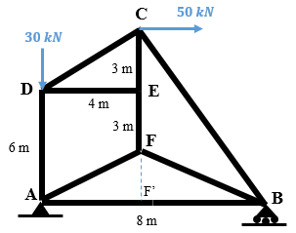
Figure 3.9 Planar compound triangular truss supported by a pin and a roller.
Joint E has no external loading and is a node of intersection of only three bars, with two among them being collinear (CE and EF), so the member DE is a zero-force member: $F_{DE}=0$ and $F_{CE}=F_{EF}$. In light of this result, joint D now has only two unknowns, namely, the forces in AD and CD.
Joint D:
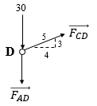
Figure 3.9a: FBD of joint D.
Fx=0⇒FCD⋅45=0⇒FCD=0,
$\sum{F_{y}}=0⇒F_{AD}=-30 kN$ (compressive).
Since AD = CF = 6 m and are parallel, AFCD is a parallelogram, so AF = CD = 5 m. In addition, the height FF′ of triangle AFB is AD – EF = 3 m and AF = 5 m, which gives AF′ = 4 m. Thus, F′ is the midpoint of AB. We conclude that F′B = 4 m. In addition, CF′ = 9 m, which means that the angle α between CF′ and BC is calculated from the trigonometric relationship in the right triangle BCF′:
α=tan-1atan49⇒α=24°.
Joint C
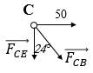
Figure 3.9b: FBD of joint C
Fx=0⇒FCB⋅sin24°+50=0⇒FCB=-123 kN (compressive),
Fy=0⇒123⋅cos24°-FCE=0⇒FCE=+112.5 kN (tensile),
$⇒F_{EF}=+112.5 kN$ (tensile).
Joint F
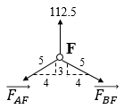
Figure 3.9c: FBD of joint F
Fx=0⇒FBF⋅45-FAF⋅45=0⇒FBF=FAF,
Fy=0⇒112.5-FAF⋅35-FBF⋅35=0⇒FAF=FBF=+93.75 kN (tensile).
Joint B
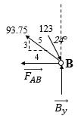
Figure 3.9d: FBD of joint B.
Fx=0⇒-FAB-93.75⋅45+123⋅sin24°=0⇒FAB=-25 kN (compressive),
Fy=0⇒By+93.75⋅35-123⋅cos24°=0⇒By=+56.25 kN.
Joint A
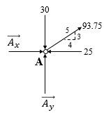
Figure 3.9e: FBD of joint A.
Fx=0⇒Ax+93.75⋅45-25=0⇒Ax=-50 kN,
Fy=0⇒Ay+93.75⋅35-30=0⇒By=-26.25 kN.
Now that all forces in all members and the reaction forces of the supports are determined, the three equilibrium equations of the entire truss are used to check the answers found for A_{x}, A_{y}, and B_{y}:
$\sum{F_{x}}=0⇒A_{x}+50=0⇒-50+50=0⇒0=0$ (verified),
M-/A=0⇒8By-50)⋅(9=0⇒8)⋅(56.25-450=0⇒0=0 (verified),
$\sum{F_{y}}=0⇒A_{y}+B_{y}-30=0⇒-26.25+56.25-30=0⇒0=0$ (verified).

Self-Check Questions
- Choose the correct answer
For a simple triangular truss ABCDEFGH loaded at nodes supported by one pin and one roller, the number of equations needed to determine and check all the unknowns is
11 13 16 19

- Complete the following sentence:
Consider an equilateral triangular truss ABC supported by a pin and a roller at A and B, respectively, and subjected at node C to a vertical downward force of 22.5 kN. The forces developed in members AB, BC, and AC are respectively +6.5 kN (tensile), −13 kN (C) and −13 kN (compressive).

Analysis using method of sections
This method consists in “splitting” the truss into two portions by applying a virtual cut at a region involving purpose members to be designed. Figure 3.10a illustrates section m-m passing through several members of a loaded truss.
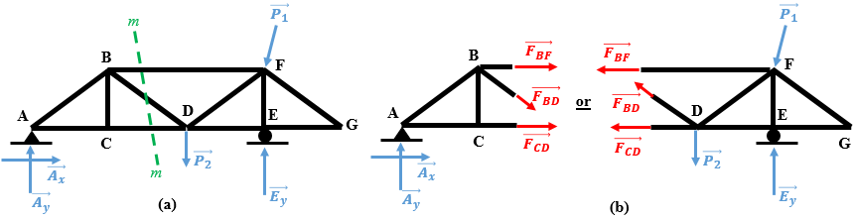
Figure 3.10 (a) Section m-m through truss in equilibrium, and (b) an isolated portions (either left or right).
By continuing to apply forces (i.e., active and reactive) to one of the two portions (either left or right) and removing the other portion, the forces generated in the sectioned bars appear in the FBD of the isolated portion, as shown in Figure 3.10b. These forces represent the action of the removed portion on the isolated portion retained, so the forces in the bars are responsible for balancing the remaining external forces applied to the isolated portion retained. In other words, the forces in the members are calculated by applying the equilibrium equations to the isolated portion. Given that a portion of a truss is modeled as a rigid body, three equilibrium equations are applied:
i=1nFix=0, (3.5)
i=1nFiy=0, (3.6)
i=1nMi-/A=0. (3.7)
In Equation (3.7), A could be any point in the plane, either a physical point belonging to the isolated portion or any other arbitrary point. This original set of equations (3.5)–(3.7) could be replaced by any other alternative set of equations, such as replacing equation (3.5) or (3.6) by a sum of moments about another point B such that line AB is not perpendicular to the direction x if Equation (3.5) is kept or to the direction y if Equation (3.6) is kept. In addition, both Equations (3.5) and (3.6) could be replaced by two sums of moments about two distinct points B and C in the plane such that A, B, and C do not lie on the same straight line. All in all, this method allows the three equations to be solved for each section, so one should select an appropriate section passing through three unknown bars to avoid keeping unknown values for the coming sections.
Note that, in the FBD of the isolated portion, the senses of the forces in the members are drawn by default as tensile (i.e., out of the member). If the calculations give a positive value, the force acts in the sense drawn on the FBD (i.e., a tensile force), whereas a negative value means that the force acts opposite to the sense drawn on the FBD (i.e., a compressive force).
Finally, depending on the geometry of the truss and the loading case, one might combine the methods of joints and sections to determine the forces in the members.
Application 3.3. The truss ABCDEFG pinned at A and supported by a rocker at G is loaded at its nodes C, D, and F as shown in Figure 3.11. Determine the forces in members BD, BF, and DF using the method of sections.
Solution 3.3. The truss in question is a simple triangular truss. Moreover, it is supported by three reaction components that are neither parallel nor concurrent at one point, so the structure is globally stable determinate. Figure 3.12 shows the FBD of the entire truss. First, the reaction forces at the pin and rocker are calculated by the three equilibrium equations in the plane:
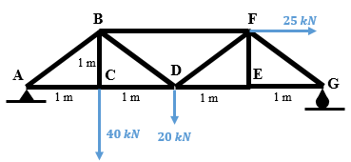
Figure 3.11 Simple truss ABCDEFG supported by a pin and rocker.
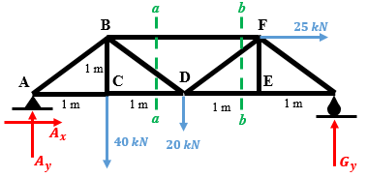
Figure 3.12 FBD of the entire truss with two sections a-a and b-b.

M-/A=0⇒4Gy-25)⋅(1-20)⋅(2-40)⋅(1=0⇒Gy=26.25 kN,
Fy=0⇒Ay+26.25-20-40=0⇒Ay=33.75 kN,
Fx=0⇒Ax+25=0⇒Ax=-25 kN.
Given that a unique section cannot pass through the three targeted members, we consider sections a-a passing through members BF, BD, and CD and b-b passing through members BF, DF, and DE.
Section a-a: The left portion is isolated. The relevant FBD is shown in Figure 3.13 and shows three unknown forces. However, we are asked to determine the forces in two members of the three (the force in CD is not requested), meaning that it is not necessary to apply all three equilibrium equations of the isolated left portion.
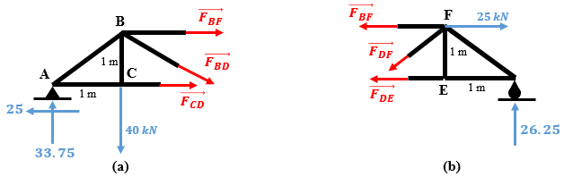
Figure 3.13 (a) Isolated left portion from cut a-a of Figure 3.12 and (b) isolated right portion from cut b-b of Figure 3.12.
Since the lines of action of $\vec{F_{BD}}$ and $\vec{F_{CD}}$ pass through point D, we could sum the moments of the forces about point D to determine $\vec{F_{BF}}$. Moreover, since $\vec{F_{BF}}$ and $\vec{F_{CD}}$ are horizontal (parallel to the x axis), we directly calculate F_{BD} by summing forces along the y axis:
M-/D=0⇒-1×⋅FBF-2)⋅(33.75+40)⋅(1=0⇒FBF=-27.5 kN (compressive),
Fy=0⇒-FBD⋅22-40+33.75=0⇒FBD=+8.84 kN (tensile).
Section b-b: The right portion is now isolated. The relevant FBD is shown in Figure 3.13b and shows three unknown forces. However, we must determine the forces in only one of the three members (the forces in DE are not requested, and we already know the force in BF), meaning that we need not apply all three equilibrium equations of the isolated right portion. Since $\vec{F_{BF}}$ and $\vec{F_{DE}}$ are horizontal (parallel to the x axis), we directly calculate F_{DF} by summing the forces along the y axis,
Fy=0⇒-FDF⋅22+26.25=0⇒FDF=+37.123 kN (tensile).

Self-Check Questions
- Specify whether the following statement is True or False and justify your answer.
A section passing through three parallel bars within a truss means that this truss is unstable by construction. True since the FBD of an isolated portion gives three unknowns that are all parallel. If the external loading on the isolated portion contains one nonparallel force to those three unknowns, this external force could not be balanced by any of the three internal parallel forces.
- Specify whether the following statement is True or False and justify your answer.
The method of joints is a particular case of the method of sections. True; instead of cutting within the entire structure and isolating rigid body portions, the method of joints means practically that the cut is around a node. The isolated part in this case is a node, which is a part of the entire truss.

The Principle of Virtual Work

Fundamental concept
The Theorem of Virtual Work was initially established to determine the displacements and the slopes developed at any point of a deformable body under any external loading (Hibbeler, 2011). A particular application of this principle to trusses consists in evaluating the displacements generated at any selected node with the truss subjected to an external load.
First, the principle of Virtual Work will be established for a general deformable solid, following which it will be applied to trusses.
Recall that, in Mechanics, any force that acts over a displacement performs work (denoted U) that equals the product of the force and the displacement (i.e., U=F⋅Δ). The unit of the work in SI units is joules (J) when the force is in newtons (N) and the displacement in meters (m).
Consider a deformable solid of arbitrary shape in static equilibrium, supported by a bearing, and subjected to a series of forces $\vec{P_{1}}$, $\vec{P_{2}}$,$\vec{P_{3}}$, …, $\vec{P_{n}}$, as shown in Figure 3.14a. An arbitrary point A is selected and we are interested in determining the displacement Δ of point A in the desired direction caused by the application of this series of forces. This displacement will appear in the calculations through the work developed at A. However, work involves both force and displacement (which is the unknown of the problem). Since no real force is applied at point A, the idea is to remove virtually the series of real applied forces and then apply at point A a virtual external force $\vec{P'}$ having the same desired direction of the displacement Δ and unit magnitude; its sense could be either inward or outward. The right sense is determined by the sign of Δ the results from the calculated. Since the virtual force $\vec{P'}$ has unit magnitude, it is called a unit force; the unit of this force is the same as the real forces $\vec{P_{1}}$, $\vec{P_{2}}$, $\vec{P_{3}}$, …, $\vec{P_{n}}$ (N; kN; MN; …). After applying $\vec{P'}$, the series of real forces will be applied again, inducing this time the displacement Δ at A but also at $\vec{P'}$ applied at A. The displacement Δ due to $\vec{P'}$ generates the virtual external work U_{ext} = P′Δ = 1Δ.
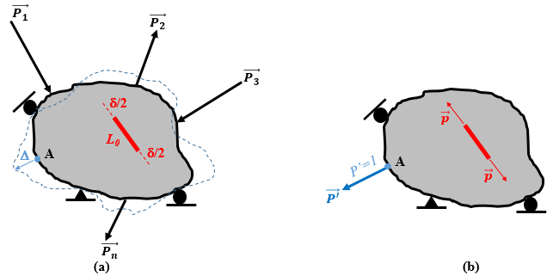
Figure 3.14 (a) Deformable body in equilibrium subjected to n external forces. (b) Virtual unit force applied at a point on the body.
Consider an internal fiber of initial length L₀ before the application of a real load. Once a series of forces is applied, like any point in the solid, this fiber will displace (either elongate or shorten) by an amount denoted δ. Once the real loading is removed and the external virtual unit force is applied at A, an internal virtual force $\vec{p}$ is generated in the internal fiber of the body, as shown in Figure 3.14b. To sum up, Figure 3.14a shows real displacements, either external (Δ) or internal (δ), created by the real external load $\vec{P_{1}}$, $\vec{P_{2}}$,$\vec{P_{3}}$, …, $\vec{P_{n}}$ and Figure 3.14b shows virtual forces; either the external unit force $\vec{P'}$ or the internal virtual force $\vec{p}$. After application of $\vec{P'}$, the real loading $\vec{P_{1}}$, $\vec{P_{2}}$,$\vec{P_{3}}$, …, $\vec{P_{n}}$ is applied, which generates the external virtual work U_{ext}. Internally, the virtual force $\vec{p}$ is displaced by δ due to the application of the real load, which develops internal virtual work denoted u_{i} = pδ. The total internal work U_{int} is the sum of all internal work in all internal fibers forming the solid, so Uiint=jpj⋅δj.
elastic solid: solid body that absorbs energy under a certain loading and then releases it back in totality without losses once the loading is removed.
Finally, for an ideal elastic solid where no loss of work occurs, one may apply the conservation of energy between internal and external work. By equating U_{ext} and U_{int}, one obtains the principle of virtual work as follows:
Δ=jpj⋅δj. (3.8)
In some references, the principle of Virtual Work is called the principle of Virtual Force, since, in practice, the virtual work involves virtual forces, whereas the displacements are real.
A positive (negative) sign of the calculated real displacement Δ indicates that it is in the same (opposite) sense as the applied virtual unit force.

Axial displacement of a rod
The internal fibers in the deformable solid represent a multitude of parts that form the entire solid. For a truss, these are the connected members or the bars. Consequently, the terms p_{i} in Equation (3.8) are the virtual axial forces generated in all the members of a truss under a unit force applied at the node in question; these are determined either by the method of joints or by the method of sections. Since Δ is the final unknown, the remaining step resides in determining the real internal displacements δ_{j} (i.e., the axial displacements generated in the members under the real loading applied to the truss). According to elastostatics theory, a uniform rod subjected to an axial force (either tensile or compressive) may be simulated as a linear spring of stiffness k subjected to the same force, as illustrated in Figure 3.15. According to Hooke’s law, the axial deflection ΔL of the extremity of a linear spring subjected to an axial force F is determined by
stiffness: physical property designating the amount of force needed to cause a unit of displacement along the line of action of the force.
$ΔL=\frac{F}{k}$.
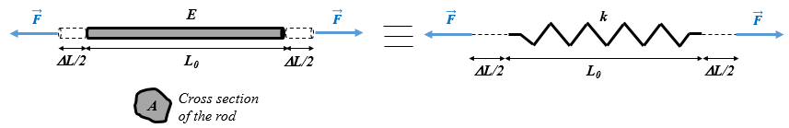
Figure 3.15 Uniform rod under axial force modeled by a linear spring.
The stiffness k of a uniform rod depends on the type of material from which the rod is made and on the geometry of the rod, as given by Equation (3.9). However, the proof of this equation is a topic of elastostatics, which goes beyond the scope of this textbook. The stiffness is given by
k=E⋅AL0, (3.9)
where
k (N/m) is the stiffness of a theoretical linear spring simulating the physical rod,
E is the modulus of elasticity characteristic of the material and gives the axial pressure that must be applied to reach (theoretically) a unit of relative displacement of the rod (i.e., to reach ΔL = L₀). E is also known as Young’s modulus (named after the British scientist Thomas Young) and is expressed in pascals (Pa). For example, the Young’s modulus of steel is 200 × 10⁹ Pa, and aluminum has a Young’s modulus of 70 × 10⁹ Pa.
A (m²) is the cross-sectional area of the uniform rod. The cross section is the 2D shape obtained when virtually cutting the rod perpendicular to its longitudinal axis. For example, the cross section of a cylindrical rod is a circle; the cross section of a prismatic rod is a rectangle. Finally,
L₀ (m) is the initial length of the rod before applying the axial force.

Application to trusses
Identifying each member of a truss as a uniform rod, ΔL is the displacement δ_{j} in Equation (3.8) and F is the axial force generated in the bar due to the real load applied to the truss. Combining Hooke’s law with Equation (3.9), the axial displacement δ_{j} for each bar j is
δj=Fj⋅L0jEj⋅Aj. (3.10)
Finally, using Equation (3.10) in Equation (3.8) gives the principle of Virtual Work applied to a truss and gives the displacement of any node along a desired direction:
Δ=j=1bfj⋅Fj⋅L0jEj⋅Aj, (3.11)
where
Δ (m) is the real displacement of the node in question along the desired direction under the real external load applied to the truss,
b is the total number of bars in the truss,
f_{j} is the virtual axial force (N) generated in bar j due to the virtual unit load applied at the node in question along the desired direction,
F_{j} is the real axial force generated in bar j (N) due to the real external load applied to the truss,
L_{0j} is the length of bar j (m),
E_{j} is Young’s modulus of the material forming bar j (Pa), and
A_{j} is the cross-sectional area of bar j (m²).
Application 3.4. Determine the vertical displacement of node D of the truss shown in Figure 3.11. All bars have a 12-mm-diameter circular cross section and are made from steel with a Young’s modulus of 200 GPa.
Solution 3.4. For the truss of Figure 3.11, many values have already been calculated in application 3.3 due to the real loading applied on the truss, namely,
A_{x} = −25 kN, A_{y} = 33.75 kN, G_{y} = 26.25 kN,
F_{BF} = −27.5 kN, F_{BD} = 8.84 kN, F_{DF} = 37.123 kN.
From Figure 3.13a, we calculate the remaining unknown F_{CD}:
M-/B=0⇒1⋅FCD-1)⋅(33.75-25)⋅(1=0⇒FCD=58.75 kN (tensile).
From Figure 3.13b, we calculate the remaining unknown F_{DE}:
M-/F=0⇒-1⋅FDE+1)⋅(26.25=0⇒FDE=26.25 kN (tensile).
Joint E is the intersection of three bars: DE, EF, and EG, where DE and EG are collinear. Moreover, joint E is free from any external force, which implies F_{EF} = 0 and F_{EG} = F_{DE} = 26.25 kN.
Joint C
$\sum{F_{x}}=0⇒-F_{AC}+58.75=0⇒F_{AC}=+58.75 kN$ (tensile),
$\sum{F_{y}}=0⇒F_{BC}-40=0⇒F_{BC}=+40 kN$ (tensile).
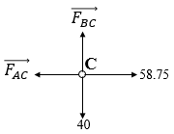
Figure 3.11a: FBD of joint C.
Joint A
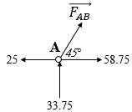
Figure 3.11b: FBD of joint A.
Fy=0⇒FAB⋅22+33.75=0⇒FAB=-47.73 kN (compressive),
Fx=0⇒-(47.73)⋅22+58.75-25=0⇒0=0 (verified).
Joint G
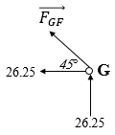
Figure 3.11c: FBD of joint G.
Fy=0⇒FGF⋅22+26.25=0⇒FGF=-37.123 kN (compressive),
Fx=0⇒-(37.123)⋅22+26.25=0⇒0=0 (verified).
Virtual unit force
This step consists in removing the external real loading from the truss and applying a virtual unit force at point D in the requested direction (vertical in this problem). The equilibrium equations of the whole truss allow us to calculate the reaction forces at the supports, following which we apply the method of joints to obtain the virtual forces generated in the members. Figure 3.16 illustrates the virtual loading.
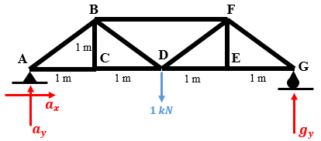
Figure 3.16 Virtual unit force applied to simple truss.
M-/A=0⇒4gy-2)⋅(1=0⇒gy=0.5 kN,
Fy=0⇒ay+0.5=1⇒ay=0.5 kN,
Fx=0⇒ax=0.
The truss is geometrically and mechanically (external forces applied) symmetric about the vertical axis passing through D. This allows us to calculate the forces in half of the truss and deduce the forces in the other half by symmetry.
At joint C, BC is a zero-force member, so f_{BC} = 0 and f_{AC} = f_{CD}.
Joint A
Fy=0⇒fAB⋅22+0.5=0⇒fAB=-0.707 kN (compressive),
Fx=0⇒-22⋅22+fAC=0⇒fAC=+0.5 kN (tensile)
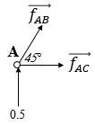
Figure 3.16a: FBD of joint A.
Joint B
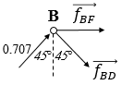
Figure 3.16b: FBD of joint B.
Fy=0⇒-fBD⋅22+0.707⋅22=0⇒fBD=+0.707 kN (tensile),
Fx=0⇒fBF+0.707⋅22⋅(2)=0⇒fBF=-1 kN (compressive).
By symmetry: f_{FD} = 0.707 kN, f_{DE} = f_{EG} = f_{AC} = f_{CD} =0.5 kN, f_{GF} = −0.707 kN.
The cross-sectional area of the bars is $A=π{(6)}^{2}=113.1 {mm}^{2}$.
We summarize all the data in Table 3.1 to simplify the application of Equation (3.11).
Table 3.1 Data summary of truss in Figure 3.11.
Bar | f_{j} (kN) | F_{j} (kN) | L_{0j} (mm) | E_{j}.A_{j} (kN) | f_{i}F_{j}L_{0j}/(E_{j}A_{j})
AB | −0.707 | −47.73 | 1414.2 | 22620 | 2.109741
AC | 0.5 | 58.75 | 1000 | 22620 | 1.29863
BC | 0 | 40 | 1000 | 22620 | 0
BD | 0.707 | 8.84 | 1414.2 | 22620 | 0.390742
BF | −1 | −27.5 | 2000 | 22620 | 2.431477
CD | 0.5 | 58.75 | 1000 | 22620 | 1.29863
DF | 0.707 | 37.123 | 1414.2 | 22620 | 1.640895
DE | 0.5 | 26.25 | 1000 | 22620 | 0.580239
EF | 0 | 0 | 1000 | 22620 | 0
EG | 0.5 | 26.25 | 1000 | 22620 | 0.580239
FG | −0.707 | −37.123 | 1414.2 | 22620 | 1.640895
Σ |  |  |  |  | Δ_{D}=11.97 mm

Application 3.5. Determine the horizontal displacement at node D of the truss ABCD pinned at A and supported by a roller at B as shown in Figure 3.17. The members AB, BC, CD, and AD each have a cross-sectional area of 200 mm² and the cross-sectional area of AC is 250 mm². All members are made from titanium with a modulus of elasticity of 110 GPa. The lengths of the members are given in millimeters.
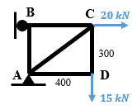
Figure 3.17 Simple truss ABCD supported by a pin and a roller.
Solution 3.5. Forces in all members should be determined for the real-loading case and then for a horizontal virtual unit force applied at D. The FBDs for both cases are shown in Figures 3.18a and 3.18b, respectively.
Real case: We find the forces in all members without considering the reactions of the supports. We combine the methods of joints with the method of sections to solve the problem.
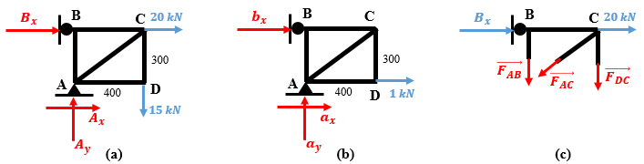
Figure 3.18 (a) FBD of entire truss under real load, (b) virtual force, and (c) section with upper portion kept.
At joint D, the external force in Figure 3.18a is collinear with bar CD, meaning that bar AD is a zero-force member, so F_{AD} = 0 and F_{DC} = 15 kN (tensile).
Consider the FBD and the equilibrium of joint C:
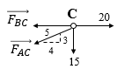
Figure 3.18a: FDB of joint C.
Fy=0⇒-FAC⋅35-15=0⇒FAC=-25 kN (compressive),
Fx=0⇒25⋅45-FBC+20=0⇒FBC=+40 kN (tensile).
To find the force in AB we use the FBD of the isolated section in Figure 3.18c and sum the moments about C:
M-/C=0⇒400⋅FAB=0⇒FAB=0.
Virtual case: We find the forces in all members without considering the reactions of the supports. We combine the methods of joints with the method of sections to solve the problem.
At joint D, the unit force in Figure 3.18b is collinear with bar AD, meaning that bar CD is a zero-force member, so f_{CD} = 0 and f_{AD} = 1 kN (tensile).
In this case, by removing the effect of CD, node C becomes the intersection of only two effective members, AB and AC. Since no external force is applied at C, both members are zero-force members: f_{AC} = f_{BC} = 0.
Moreover, by sectioning the truss in Figure 3.18b through AB, AC, and CD, the FBD is the same as in the real case shown in Figure 3.18c, except that the force of 20 kN at C does not exist. However, this does not affect the sum of moments about C, which remains the same as for the real case (i.e., f_{AB} = 0).
In conclusion, the virtual case produces only one nonzero-force member, which is AD. In the real-loading case, the force in AD is zero, so Equation (3.11) gives Δ_{D-horizontal} = 0.

Self-Check Questions
- Specify whether the following statement is True or False and justify your answer.
A node of a truss supported by a rocker automatically has zero displacement without needing to apply the principle of virtual work. False because a rocker blocks only one DOF perpendicular to its plane of support. In a direction parallel to the plane of support of the roller, the joint is free to move.
- Choose the correct answer:
A zero-force member must have
both nodes with zero displacement.

only one node with zero displacement.

both nodes that generally displace.

Summary
A truss is a solid structure composed of many slender members known as bars and which are connected at their extremities by frictionless pins known as joints or nodes. A simple truss is a triangular truss constructed by joining in a repetitive manner two bars issued from one node to an already-stable triangle, whereas a compound truss is formed by many simple trusses joined together either by one common node and one bar or by three non-concurrent bars. The numbers of bars (b) and nodes (n) in a triangular truss are related by b = 2n − 3. This is a necessary but not sufficient condition for a simple or compound truss.
Each member of a truss only sustains forces acting along the line of the bar, either in tension or in compression; these are known as two-force members.
To calculate the forces generated in truss members one may apply: (i) the method of joints, consisting of applying the equilibrium of a particle at each isolated node, (ii) the method of sections, consisting of cutting virtually a certain desired region throughout the truss and applying the three planar equilibrium equations of a rigid body on one of the generated portions.
Given a truss composed of b bars, the principle of Virtual Work allows us to calculate the displacement Δ of any node along any desired direction by determining the forces F_{j} in the bars under a real external loading. We can then remove the real loading and apply a unit virtual load on the node in question acting along the same desired direction and find the virtual forces f_{j} in the bars:
Δ=j=1bfj⋅Fj⋅L0jEj⋅Aj,
where L_{0j,} A_{j}, and E_{j} are the length, the area of the cross section, and the modulus of elasticity of the material of bar j, respectively.

Unit 4 –Internal Forces

Study Goals

On completion of this unit, you will be able to …

… locate the centroid of any geometrical shape.
… calculate the moment of inertia of a surface about any system of axes.
… establish the expressions of internal forces in beams.
… plot the diagrams of internal forces in beams.

4. Internal Forces

Introduction
After locating the center of gravity of a body and, in extension, its center of mass, we expand this aspect to locate the geometrical center of a body exhibiting either a volumetric, areal, or linear shape. This geometrical center is known as the centroid. For a homogeneous uniform body located in a constant-gravity field, the center of gravity, center of mass, and centroid are coincident. Furthermore, we develop the moment of inertia, which is another important geometrical aspect related particularly to surfaces. The moment of inertia represents a geometric resistance of a planar shape to bending about a given axis. This parameter depends on the shape, size, and position of the axis about which the moment of inertia is calculated.
In addition, a considerable part of this unit is devoted to the study of internal forces. A special type of body is considered: the beam element. Since beam elements are developed within the internal faces of a loaded body or within different parts composing a structure, virtual cuts are made at locations of interest where internal forces appear. These internal forces are of four types: axial force, shear force, bending moment, and torque. These are algebraic quantities with a determined sign convention. By changing the location of the section, the internal forces change. Consequently, a series of expressions for these internal forces along the beam will be established and plotted in terms of beam length to determine the evolution of these forces, which will be useful in future courses to design a loaded member.

4.1 Center of area, Moment of Inertia

Centroid of a volume
Inspired by the coordinates of the center of mass expressed in Equations (2.29)–(2.31) and for a homogenous volume body (i.e., constant density ρ), one may write a differential volumetric element dV as shown in Figure 4.1a, dm = ρdV. Thus, the coordinates of the centroid C of the volume become
x=x⋅dVdV, (4.1)
y=y⋅dVdV, (4.2)
z=z⋅dVdV. (4.3)
Recall that the centroid is a geometrical point whereas the center of gravity is a point of application of the weight. If the body is homogeneous (i.e., has constant density), both centers are coincident.

Centroid of an area
An area represents a geometrical shape within a plane, meaning that its centroid C lies within the same plane. Two coordinates are needed to locate the centroid of an area, as illustrated in Figure 4.1b. These are expressed as in Equations (4.1) and (4.2):
x=x⋅dAdA, (4.4)
y=y⋅dAdA. (4.5)

Centroid of a line
A line is a thin curve in a plane, as shown in Figure 4.1c. As is the case for an area, two coordinates are required to locate the centroid C of a line, and these are determined by
x=x⋅dLdL, (4.6)
y=y⋅dLdL. (4.7)
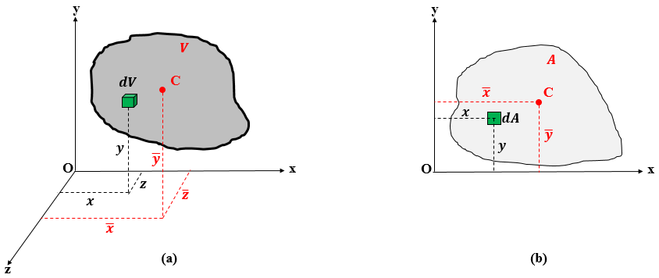
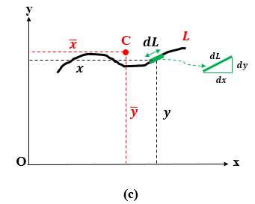
Figure 4.1 Centroid of a (a) volume, (b) area, and (c) line.
Based on Figure 4.1c, we can deduce the expression for dL by applying the Pythagorean theorem as follows:
dL=(dx)2+(dy)2.
One may reformulate this by either taking dx or dy out from the radical, which gives two options for dL:
dL=(1+y'2 )dx, (4.8)

dL=(1+x'2 )dy, (4.9)
where y′ is the derivative with respect to x of the line’s equation y = f(x) and x′ is the derivative with respect to y of the line’s equation x = g(y).

First moment of an area
Like the moment of a force about an axis, which is the product of the given force and the distance separating it from the given axis, one may define a moment of an area about a specific axis as the product of the area and the distance separating the centroid of the area from the specific axis. This quantity is known as the first moment of an area about an axis. Physically, this quantity is useful for calculating the transverse shear stress in a beam. However, this topic belongs to the field of Mechanics of Materials.
shear stress: force per unit area tending to deform a material by slippage of cross-sections one with respect to the other
Since an area is in a planar Cartesian reference (xOy), the first moment may be defined about the x and y axes and is denoted Q_{x} and Q_{y}, respectively. As per their definition, they are calculated as follows:
Qx=y⋅A, (4.10)
Qy=x⋅A. (4.11)
Identifying equations (4.10) and (4.11) with equations (4.4) and (4.5), respectively, and knowing that the total surface of an area is $A=\int{dA}$, one may write the following expressions for the first moment:
Qx=ydA, (4.12)
Qy=xdA. (4.13)
In the SI system, the units of the first moment are cubic meters (m³). The first moment about an axis passing through the centroid of an area is zero.

Centroid of composite shapes
Following the same rationale as used for the center of gravity of composite bodies (i.e., their center of mass), a composite volume, area, or line may be sectioned into many regular shapes with well-known centroids. The example in Figure 4.2 shows a composite area consisting of a semicircle, rectangle, and triangle. Another example of a metallic vessel composed of a cylindrical and truncated volumes is shown in Figure 4.3. For a composite shape, the integral expressions in Equations (4.1)–(4.7) are converted into discrete sums involving a finite number n of regular shapes composing the final body.
A vessel is a container for storing fluids.
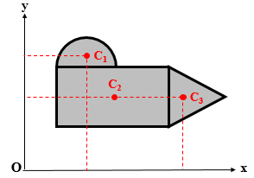
Figure 4.2 Example of a composite area.
For a composite volume, the coordinates of the centroid C are determined by:
x=i=1nxi⋅Vii=1nVi, (4.14)
y=i=1nyi⋅Vii=1nVi, (4.15)
z=i=1nzi⋅Vii=1nVi. (4.16)
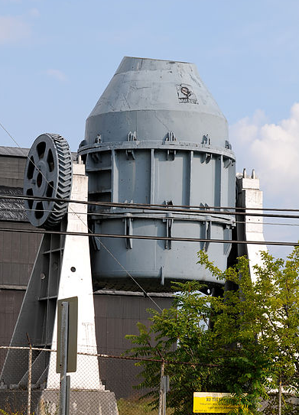
Figure 4.3 Metallic vessel as an example of a composite volume.
For a composite area, the coordinates of the centroid C are determined by
x=i=1nxi⋅Aii=1nAi, (4.17)
y=i=1nyi⋅Aii=1nAi. (4.18)
For a composite line, the coordinates of the centroid C are determined by
x=i=1nxi⋅Lii=1nLi, (4.19)
y=i=1nyi⋅Lii=1nLi, (4.20)

Application 4.1. Locate by integration the centroid of the solid homogeneous hemisphere of radius R shown in Figure 4.4.
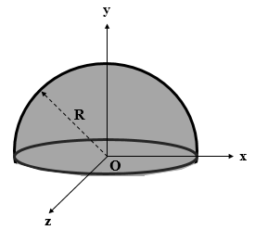
Figure 4.4 Solid hemisphere.
Solution 4.1. Since both planes (Oxy) and (Oyz) are planes of symmetry of the hemisphere, the centroid lies on the y axis, so $\overline{x}=\overline{z}=0$.
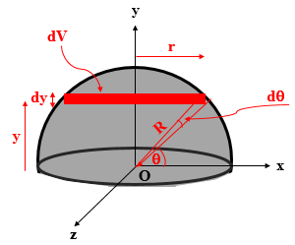
Figure 4.5 Differential volumetric element for a hemisphere.
The ordinate $\overline{y}$ is calculated from Equation (4.2), but the challenge is to find the differential volume dV of a differential element of the hemisphere, which is a disk at a height y, of thickness dy, and of radius r that varies with y. The extremity of this disk is located and the angle θ measured from the x axis. This is illustrated in Figure 4.5. Note that the hemisphere is homogeneous, meaning that the center of gravity and the centroid are coincident.
From trigonometric relationships in a right triangle:
y=R⋅sinθ⇒dy=R⋅cosθdθ,
r=R⋅cosθ.
The volume of a disk of radius r and thickness dy is
$$dV=πr^{2}dy=π{(R\cos{θ})}^{2}R\cos{θ}dθ$$
⇒dV=πR3cos3θdθ.
The denominator in Equation (4.2) is the total volume of the hemisphere:
V=dV=0π2πR3cos3θdθ=πR3[sinθ-sin3θ3]0π2,
V=23πR3.
Calculating the numerator N of Equation (4.2) gives
N=ydV=0π2πR4sinθcos3θdθ=πR4[-cos4θ4]0π2=πR44.
Finally, $\overline{y}=\frac{\frac{πR^{4}}{4}}{\frac{2πR^{3}}{3}}$ ⇒y=38R.
Application 4.2. Determine by integration the position of the centroid of the shaded area under the curve shown in Figure 4.6, and then deduce the first moments about the x and y axes.
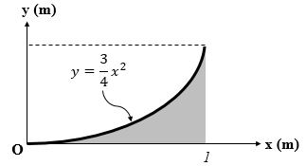
Figure 4.6 Nonuniform area delimited by a curve.
Solution 4.2. For an area, the set of Equations (4.4) and (4.5) should be applied. However, two options of differential element dA might be chosen. This is illustrated in Figures 4.7a and 4.7b. We will solve the problem using both approaches.
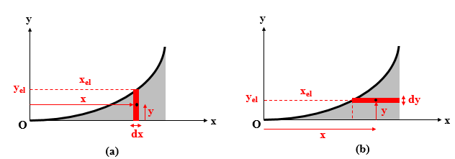
Figure 4.7 Differential thin element parallel to (a) y axis and (b) to x axis.
Option 1
The differential element in Figure 4.7a is a thin rectangle of thickness dx parallel to the y axis and of height extending from the x axis to the curve. The coordinates of its local centroid are
$x= x_{el}$ and y=yel2=12.34xel2⇒y=38x2.
The area of this element is dA=yel⋅dx⇒dA=34x2dx.
The total area under the curve is
A=0134x2dx=x3401[x34]01⇒A=14 m2.
The coordinates of the centroid are found from Equations (4.4) and (4.5):
x=0134x3dx14=[34x4]01⇒x=34 m,
y=01932x4dx14=[940x5]01⇒y=940 m.
Option 2
The differential element in Figure 4.7b is a thin rectangle of thickness dy parallel to the x axis and of width extending from the curve to the vertical line x = 1. The coordinates of its local centroid are
$x= \frac{{1+x}_{el}}{2}$ and y=yel=34xel2⇒dy=32xeldxel.
The area of this element is dA=1-xel⋅dy⇒dA=32(xel-xel2)dx.
The total area under the curve is found by integrating dA as follows:
A=0132(xel-xel2)dxel=32[xel22-xel33]01⇒A=14 m2.
The coordinates of the centroid are found from Equations (4.4) and (4.5):
x=0134(xel-xel3)dxel14=3[xel22-xel44]01⇒x=34 m,
y=0198(xel3-xel4)dxel14=92[xel44-xel55]01⇒x=940 m.
Calculation of the first moments from equations (4.10) and (4.11) gives
Qx=940⋅14⇒Qx=9160 m3,
Qy=34⋅14⇒Qy=316 m3.
Application 4.3. A metallic rod has the curved shape of a cubic polynomial, as shown in Figure 4.8. Locate the centroid of this rod.
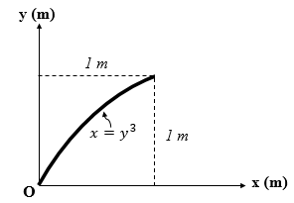
Figure 4.8 Bent metallic rod.
Solution 4.3. A differential element of length dL of the rod is shown in Figure 4.9.
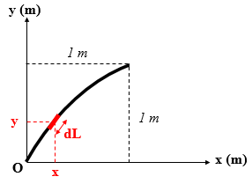
Figure 4.9 Linear differential element of a rod.
Since the given Equation of the rod is of the form x = g(y), one finds the derivative x′:
$x^{'}=\frac{dx}{dy}=3y^{2}$.
Applying Equation (4.9) gives
dL= 1+9y4dy.
The total length of the rod is
L=dL=011+9y4dy ⇒L=1.5479 m.
The coordinates of the centroid are found by applying equations (4.6) and (4.7):
x=01y31+9y4dy1.5479=0.5670881.5479⇒x=0.366 m,
y=01y1+9y4dy1.5479=0.94211.5479⇒y=0.609 m.
Note: The integrals in this application are calculated by numerical methods. The primitives of these functions are given in the appendix.
Application 4.4. A homogeneous rod is bent in the shape shown in Figure 4.10. Locate the coordinates of its centroid.
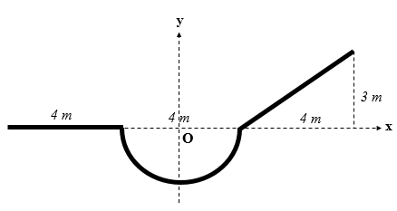
Figure 4.10 Compound bent rod.
Solution 4.4. It is straightforward to locate the centroid of each of the uniform straight lines at the midpoint of each. However, one should locate the centroid of the semicircle by integration and then go back to the composite-line case to locate the entire centroid using Equations (4.19) and (4.20).
Since (Oy) is an axis of symmetry of the semicircle, the centroid of this shape is located on this axis, so its abscissa is zero. The differential element of a semi-circular line is shown in Figure 4.11.
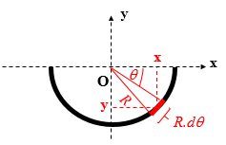
Figure 4.11 Differential linear element for a semicircular rod.
$x=R\cos{θ}$; $y=R\sin{θ}$; $dL=Rdθ$:
y=0-πR2sinθdθ0-πRdθ=Rπcosθ0-π=-2Rπ.
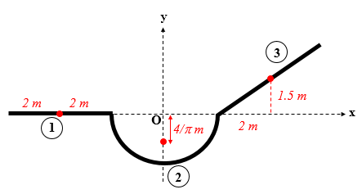
Figure 4.12 Centroids of different parts of a composite line.
The quantities for each portion of the whole line shown in Figure 4.12 are summarized in the Table 4.1.
Table 4.1 Data for composite line from Figure 4.10.
Part | L_{i} | x_{i} | y_{i} | L_{i}⋅ x_{i} | Li⋅ y_{i}
1 | 4 | −4 | 0 | −16 | 0
2 | 2π | 0 | −4/π | 0 | −8
3 | 5 | 4 | 1.5 | 20 | 7.5
Whole | 15.2832 |  |  | 4 | −0.5

x=415.2832⇒x=0.262 m,
y=-0.515.2832⇒y=-0.0327 m.
Application 4.5. A homogeneous solid consists of a cylinder that is blindly hollowed with a cone at its top, as shown in Figure 4.13. Calculate the position of the centroid.
Solution 4.5. Since both planes (Oxy) and (Oyz) are planes of symmetry of the body, the centroid lies on the y axis, so $\overline{x}=\overline{z}=0$.
The composite body consists of three shapes:
Cone: V1=π⋅(0.3)2⋅(1.23)=0.1131 m3; y1=1.24+1.6=1.9 m,
Hole cylinder: V2=-π⋅(0.1)2⋅(0.6)=-0.01885 m3; y2=-0.62+1.6=1.3 m,
Main cylinder: V3=π⋅(0.3)2⋅(1.6)=0.4524 m3; y3=1.62=0.8 m.
The centroids of each of the three shapes are shown in Figure 4.14, and the data are summarized in Table 4.2.

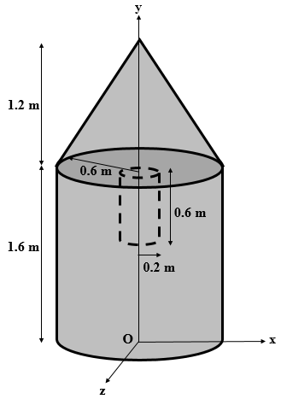
Figure 4.13 Compound volumetric homogeneous solid.
Table 4.2 Data summary for composite body of Figure 4.13.
Part | V_{i} | y_{i} | Vi⋅ y_{i}
1 | 0.1131 | 1.9 | 0.21489
2 | −0.01885 | 1.3 | −0.024505
3 | 0.4524 | 0.8 | 0.36192
Whole | 0.54665 |  | 0.552305

y=0.5523050.54665⇒y=1.01 m.
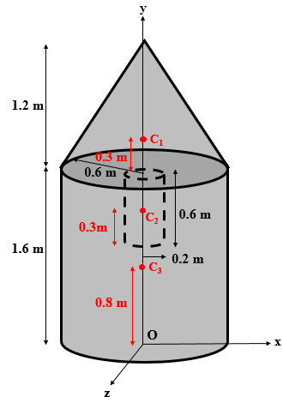
Figure 4.14 Centroids of parts forming the composite volume.
Application 4.6. A structure formed by three rigid bars each having a weight of 300 N, is supported by a pin at A and a roller in a smooth slot at B, as shown in Figure 4.15. Determine the bearing reactions.
Solution 4.6. Since all the weight is vertically downward wherever the whole center of gravity is located, and since all shapes are uniform rods, the centroid of each bar is located at the midpoint of the given bar. Thus, the weight of each bar is applied vertically downward at the center of the given bar, as illustrated in the FBD of the structure in Figure 4.16.

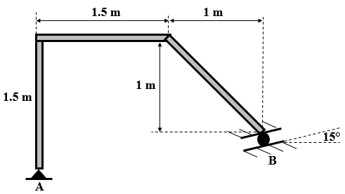
Figure 4.15 Structure made of three rigid bars supported by a pin and slotted roller.
The inclined bar forms the hypotenuse of an isosceles right triangle, so it forms an angle of 45° with the horizontal and vertical directions. In addition, the reaction of the roller is normal to the plane of the slot, which means that its line of action forms an angle of 15° with the vertical line.
Applying the equilibrium equations of a rigid body gives
M-/A=0⇒RBcos15°)⋅(2.5+(RBsin15°)⋅(0.5)-300)⋅(0.75-300)⋅(2=0⇒RB=324.26 N,
Fx=0⇒Ax-RBsin15°=0⇒Ax=84 N,
Fy=0⇒Ay+324.26⋅cos15°-300-300-300=0⇒Ay=586.8 N.

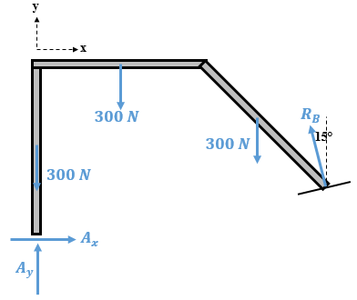
Figure 4.16 FBD of the three-bar structure subjected to its own weight.

Moment of inertia of an area
Preliminary examples
The concept of moment of inertia of an area, known also as the second moment, is introduced through two physical examples, where a distribution $Δ\vec{F}$ of forces acts on the area and its magnitude is proportional to the area ΔA of the elements forming the entire area. In addition, this magnitude varies linearly with the distance separating the elements from the axis of interest.
The first example, inspired from the field of mechanics of materials, is illustrated in Figure 4.17a, where the cross section of a straight member (i.e., beam) is subjected to a distributed loading $Δ\vec{F}$, which is compressive above the x axis and tensile below the x axis. The magnitude of $Δ\vec{F}$ is given by ΔF=k⋅y⋅ΔA. This distribution constitutes a couple that seeks to bend the cross section about the x axis passing through the centroid C.
The magnitude of the resultant $\vec{F}$ of the force distribution $Δ\vec{F}$ is given by
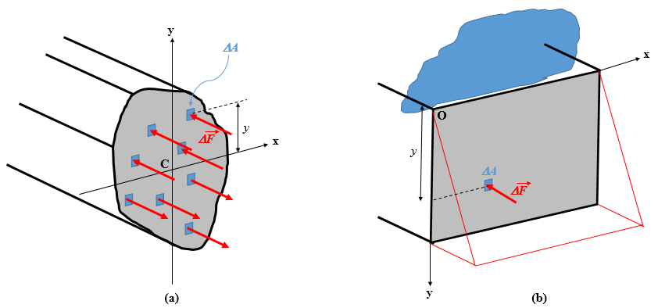
Figure 4.17 (a) Cross section of a beam under bending. (b) Wall under hydrostatic pressure.
F=dF=k⋅y⋅dA=k⋅y⋅dA.
This latter integral is no other than the first moment Q_{x} of the cross section about the x axis. Since this axis passes through the centroid C of the cross section, the first moment is zero, so the resultant force F = 0. This is an expected result because the distribution of forces forms a couple (equal and opposite forces).
The magnitude of the couple M is
M=dM=y⋅dF=k⋅y2⋅dA=k⋅y2⋅dA.
This integral gives the moment of inertia of the area or the second moment of the area about the x axis, which is denoted I_{x}. Physically, it represents a geometric resistance of the cross section against bending. As this quantity increases, the rotation of the cross section becomes more difficult. Mathematically, it is formed by the sum of the products of area elements and the square of the distance separating each element from the axis of bending. Consequently, a moment of inertia is always a positive quantity, expressed in m⁴ in SI units.
The second example, inspired from fluid mechanics, is illustrated in Figure 4.17b. In this example, the wall of a concrete structure is submerged under a column of fluid and subjected to a hydrostatic pressure P_{h}. The pressure of the fluid increases linearly with the depth, so the force generated on the area is proportional to the depth. The fluid thus generates a distributed hydrostatic force $Δ\vec{F}$ applied on the area elements ΔA of the wall as follows:
ΔF=Ph⋅ΔA=ρ⋅g⋅y⋅ΔA,
where ρ is the density of the fluid and g is the acceleration due to gravity.
The magnitude of the resultant force $\vec{F}$ produced by the force distribution $Δ\vec{F}$ is
F=dF=ρ⋅g⋅y⋅dA=ρ⋅g⋅y⋅dA.
This result is the first moment Q_{x} of the wall’s area about the x axis.
In addition, the magnitude of the couple M is
M=dM=y⋅dF=ρ⋅g⋅y2⋅dA=ρ⋅g⋅y2⋅dA.
This result is the moment of inertia of the area or the second moment of the wall about the x axis. It contributes to the resistance of the wall against bending due to hydrostatic pressure.
Mathematical expressions
The previous examples and calculations show that we can calculate the moments of inertia about the x and y axes, respectively, by using the following equations:
Ix=y2dA, (4.21)
Iy=x2dA. (4.22)
The differential element dA and the distances separating it from both axes as well as the direct distance r from the origin O are shown in Figure 4.18.
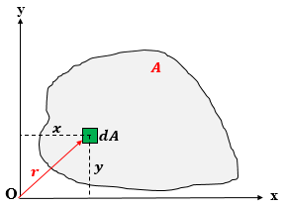
Figure 4.18 Differential element in an arbitrary area.
The differential element dA is chosen in practice as a rectangular strip of thin differential thickness (either dx or dy) with the width depending on the curves that delimit the area of interest. This is depicted in Figures 4.19a and 4.19b.
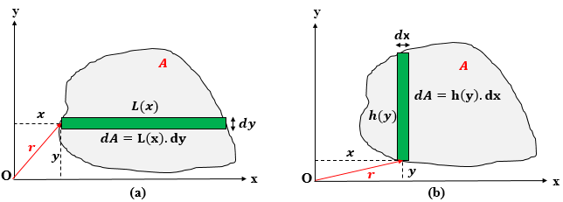
Figure 4.19 Differential rectangular strip element parallel to (a) x axis and to (b) y axis.
Polar moment of inertia
In Figure 4.18, considering the distance r separating the origin O from the element dA, we define the polar moment of inertia of an area with respect to the pole O as the amount J_{O}, which is given by

JO=r2dA. (4.23)
This is “an integral of great importance in problems concerning the torsion of cylindrical shafts and in problems dealing with the rotations of slabs” (Beer et al., 2012, p.475).
Using the Pythagorean Theorem $r^{2}=x^{2}+y^{2}$ in Equation (4.23)
JO=(y2+x2)dA=y2dA+x2dA.
Replacing Equations (4.21) and (4.22) in this latter expression gives the following relationship between the polar and second moments:
JO=Ix+Iy. (4.24)
Radius of gyration of an area
Imagine that a physical area having a total surface A like the one shown in Figure 4.18 is converted into a very thin but very long rectangular strip parallel either to the x axis or the y axis while conserving the area A of the surface (see Figures 4.20a and 4.20b). Consider this strip held parallel and to the x axis. The perpendicular distance k_{x} from the x axis required to reach the same moment of inertia I_{x} as the original real area in the radius of gyration of the area about the x axis. The same concept applies to the radius of gyration k_{y} about the y axis when the strip is held parallel to the y axis.
Applying Equation (4.21) to the strip in Figure 4.20a gives
Ix=kx2dA=kx2dA=kx2⋅A,
$k_{x}=\sqrt{\frac{I_{x}}{A}}$. (4.25)
Applying Equation (4.22) to the strip in Figure 4.20b gives
Iy=ky2dA=ky2dA=ky2⋅A,
ky=IyA. (4.26)
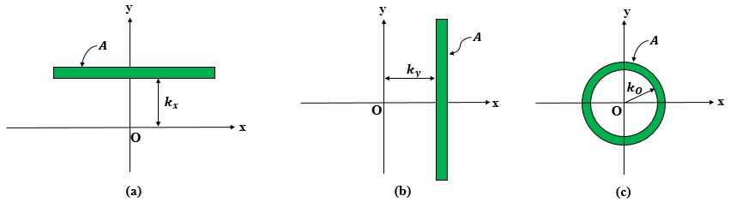
Figure 4.20 Radius of gyration about the (a) x axis, (b) y axis, and (c) pole O.
Additionally, this physical area having a total surface A could be converted into a very thin annular strip centered at the pole O while conserving the area A of the surface (see Figure 4.20c). The radial distance k_{O} at which this strip should be held parallel and away from pole O to reach the same value of the polar moment of inertia J_{O} as the original real area in the polar radius of gyration of the area about pole O.
Applying Equation (4.23) to the strip in Figure 4.20c gives
JO=kO2dA=kO2dA=kO2⋅A,
kO=JOA. (4.27)
Finally, squaring both Equations (4.25) and (4.26), adding member by member, and then identifying with Equations (4.24) and (4.27) gives the following relationship between the three radii of gyrations:
$k_{O}^{2}=k_{x}^{2}+k_{y}^{2}$. (4.28)
Product of inertia
Referring again to Figure 4.18, the product of inertia I_{xy} of an area with respect to the x and y axes is defined by
Ixy=x⋅ydA. (4.29)
This property “is required to determine the maximum and minimum moments of inertia for the area. These maximum and minimum values are important properties needed for designing structural and mechanical members such as beams, columns and shafts” (Hibbeler, 2010, p.530).
Unlike moments of inertia, a product of inertia can be positive if both coordinates of the element dA have the same sign or negative when those coordinates have opposite signs. Consequently, when one or both axes are axes of symmetry of the area, the product of inertia is zero. This is illustrated by the example in Figure 4.21, where a T-shape section has the y axis as an axis of symmetry. Any differential element dA of coordinates x and y corresponds to a symmetric element dA′ of coordinates −x and y. By summing all such pairs in Equation (4.29) with equal and opposite abscissas, the product of inertia vanishes.
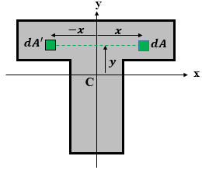
Figure 4.21 T-shape area with an axis of symmetry.

Moments of inertia of standard shapes
Rectangle. Consider a rectangular area of height h and width b located in a centroidal Cartesian reference (xy), as shown in Figure 4.22a. Two rectangular strips will be considered as differential elements dA: one parallel to the x axis and the other parallel to the y axis, as shown in Figures 4.22b and 4.22c, respectively.
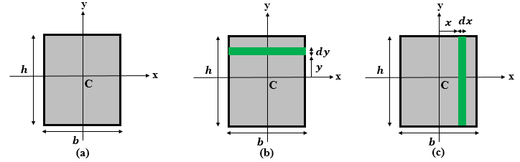
Figure 4.22 Rectangular area with (a) central axes, (b) differential element parallel to x axis, and (c) to y axis.
From Figure 4.22b, dA = bdy. Applying Equation (4.21) gives
Ix=-h2h2b⋅y2dy=b[y33]-h2h2⇒Ix=b⋅h312.
From Figure 4.22c, dA = h dx. Applying Equation (4.22) gives
Iy=-b2b2h⋅x2dx=h[x33]-b2b2⇒Iy=h⋅b312.
Circle. Consider a circular area of radius R in a centroidal Cartesian reference (xy), as shown in Figure 4.23a. The differential element dA is a rectangular strip parallel to the x axis, as shown in Figure 4.23b.
From trigonometry we have x=R⋅cosθ and y=R⋅sinθ ⇒dy=R⋅cosθdθ.
The area of the rectangular differential strip is $dA=2xdy=2R^{2}\cos^{2}{θ}dθ$.
Applying Equation (4.21) gives
Ix=-π2π22R4sin2θcos2θdθ=2R4[θ8-sin4θ32]-π2π2⇒Ix=πR44.
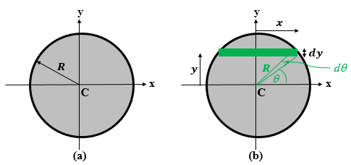
Figure 4.23 (a) Circular area with central axes and (b) differential element parallel to x axis.
To determine I_{y}, one might consider a differential strip parallel to the x axis. However, one may also use I_{y} established previously for a rectangle and apply it to the differential rectangle of dimensions 2x × dy, which gives a differential moment of inertia dI_{y}. By integrating along θ, we obtain the total moment of inertia of the circle:
dIy=(2x)312dy⇒Iy=2R33-π2π2cos4θdθ,
Iy=2R33[sin4θ+8sin2θ+12θ32]-π2π2⇒Iy=πR44.
The polar moment of inertia is determined by using Equation (4.24):
JO=πR44+πR44⇒JO=πR42.
For several standard shapes, Table 4.3 summarizes the expressions of their moments of inertia about their centroidal axes. These are useful in many applications.
Table 4.3 Moments of inertia of standard shapes.
Name | Shape | I_{x} | I_{y} | J_{O}
Rectangle |  | $$\frac{bh^{3}}{12}$$ | $$\frac{hb^{3}}{12}$$ | $$\frac{bh(h^{2}+b^{2})}{12}$$
Circle |  | $$\frac{πR^{4}}{4}$$ | $$\frac{πR^{4}}{4}$$ | $$\frac{πR^{4}}{2}$$
Isosceles triangle |  | $$\frac{bh^{3}}{36}$$ | $$\frac{hb^{3}}{48}$$ | $$\frac{bh(4h^{2}+3b^{2})}{144}$$
Right triangle |  | $$\frac{bh^{3}}{36}$$ | $$\frac{hb^{3}}{36}$$ | $$\frac{bh(h^{2}+b^{2})}{36}$$
Ellipse |  | $$\frac{π{ab}^{3}}{4}$$ | $$\frac{π{ba}^{3}}{4}$$ | $$\frac{πab(a^{2}+b^{2})}{4}$$

Parallel-Axis Theorem
This theorem establishes a relationship between the moment of inertia of an area about an axis passing through the centroid of this area and the moment of inertia about an axis parallel to the centroidal axis and separated from this centroidal axis by a known distance.
Figure 4.24 illustrates a shaded area with centroidal axes (CX) and (CY) with a differential element dA with coordinates X and Y measured in the centroidal reference. Another reference (xOy) having (Ox) parallel to (CX) and (Oy) parallel to (CY) is located such that the distance d_{x} separates (Ox) from (CX) and a distance d_{y} separates (Oy) from (CY).
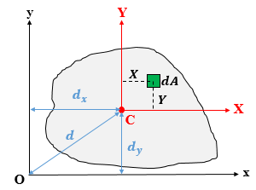
Figure 4.24 Area located in two parallel reference frames.
The moment of inertial about (Ox) is determined by
Ix=(Y+dy)2dA=Y2dA+2dyYdA+dy2dA.
The first integral is the moment of inertia about the centroidal axis (CX): $\overline{I_{X}}=\int{Y^{2}}dA$. The last integral is the total surface $A=\int{dA}$.
The integral in the middle is the first moment of the area about the centroidal axis (CX), which is zero: YdA=Y⋅A=0.
The final expression for I_{x} is
Ix=IX+dy2⋅A. (4.30)
Similarly, one finds for I_{y},
Iy=IY+dx2⋅A. (4.31)
Expressing the polar moment of inertia J_{O}:
JO=Ix+Iy=IX+IY+(dx2+dy2)A,
and since $\overline{J_{C}}=\overline{I_{X}}+\overline{I_{Y}}$ and $d^{2}=d_{x}^{2}+d_{y}^{2}$, the final expression for J_{O} is
JO=JC+d2⋅A. (4.32)
In conclusion, the Parallel-Axis Theorem (known also as Steiner’s Theorem) for any moment of inertia (either about an axis or polar) states that “the moment of inertia for an area about an axis is equal to its moment of inertia about a parallel axis passing through the area‘s centroid plus the product of the area and the square of the perpendicular distance between the axes” (Hibbeler, 2010, p.513).
The expression for the product of inertia is
Ixy=(X+dx)(Y+dy)dA=XYdA+dyXdA+dxYdA+dxdydA.
The first integral is the product of inertia about the centroidal axes (CX) and (CY): $\overline{I_{XY}}=\int{XY}dA$. The last integral is the total surface $A=\int{dA}$.
The two middle integrals are the first moments of the area about the centroidal axes (CY) and (CX), respectively, which are zero: XdA=X⋅A=0 and YdA=Y⋅A=0.
The final expression for I_{xy} is
Ixy=IXY+dx⋅dy⋅A. (4.33)
Moments of inertia of composite areas
A composite area is a planar shape composed of numerous regular shapes connected together, such as triangles, rectangles, and circles. Given the moment of inertia of each shape about a centroidal axis, we can use the Parallel-Axis Theorem to calculate the moment of inertia of each shape about another axis. The total moment of inertia of the entire composite area is the algebraic sum of the moments of inertia of the composing shapes.
Figure 4.25 shows a composite area sectioned into many regular “sub-areas” with their “local” centroidal axes (x₁y₁), (x₂y₂), and (x₃y₃). The moments of inertia and the product of inertia are determined by summing the moments of inertia (i.e., the product of inertia) of each part as given by the parallel axis theorem.
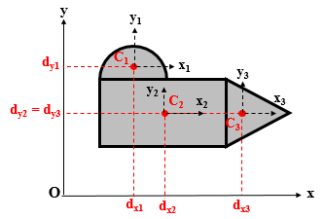
Figure 4.25 Composite area sectioned into regular parts.
Ix=Ix1+A1dy12+Ix2+A2dy22+Ix3+A3dy32,
Iy=Iy1+A1dx12+Iy2+A2dx22+Iy3+A3dx32,
Ixy=Ixy1+A1dx1dy1+Ixy2+A2dx2dy2+Ixy3+A3dx3dy3.
Moments of inertia about inclined axes
Given the loading case and the geometry of a structure, a mechanical designer may need the inertia properties of the cross section about inclined axes.
Figure 4.26 shows an arbitrary area of total surface A in an original reference (Oxy) and in another reference (OXY) obtained by rotating (Oxy) about O by an algebraic angle θ (considered positive for a counterclockwise rotation).
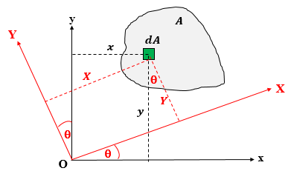
Figure 4.26 Arbitrary area in an inclined reference frame.
The coordinates (X, Y) in the new reference (XY) of a differential element dA are deduced from its original coordinates (x, y) by applying the following formulas of rotation:
X=xcosθ+ysinθ,
Y= -xsinθ+ycosθ.
The goal is to express the new inertias I_{X}, I_{Y}, and I_{XY} in terms of the original inertias Ix, Iy, Ixy, and θ:
IX=Y2dA=(-xsinθ+ycosθ)2dA,
IX=sin2θx2dA+cos2θy2dA-2sinθcosθxydA.
Notice that $I_{y}=\int{x^{2}}dA$, $I_{x}=\int{y^{2}}dA$, and $I_{xy}=\int{xy}dA$, so the inertia I_{x} becomes:
IX=Ixcos2θ+Iysin2θ-2Ixysinθcosθ. (4.34)
Similar calculations for I_{Y} and I_{XY} give
IY=Ixsin2θ+Iycos2θ+2Ixysinθcosθ, (4.35)
IXY=(Ix-Iy)sinθcosθ+Ixy(cos2θ-sin2θ). (4.36)
Equations (4.34)–(4.36) are called the transformation equations.
Another formulation of the transformation equations can be established by applying the trigonometric identities $\cos{2θ}=\cos^{2}{θ}-\sin^{2}{θ}$ and $\sin{2θ}=2\sin{θ}\cos{θ}$
to the original set and simplifying, which gives
$\cos{2θ}=\cos^{2}{θ}-\sin^{2}{θ}$
IX=(Ix+Iy)2+(Ix-Iy)2cos2θ-Ixysin2θ, (4.36)
IY=(Ix+Iy)2-Ix-Iy2cos2θ+Ixysin2θ, (4.37)
IXY=(Ix-Iy)2sin2θ+Ixycos2θ. (4.38)
By adding Equation (4.36) to Equation (4.37) we find that the polar moment of inertia J_{O} is independent of θ:
JO=IX+IY=Ix+Iy.
The angle of rotation of the axes θ₀ at which the moment of inertia is optimum corresponds to the value that makes the derivative of I_{X} vanish with respect to θ:
An optimum is either a maximum or a minimum.
dIXdθ=0⇒-Ix-Iysin2θ-2Ixycos2θ=0,
θ0=12tan-1(-2IxyIx-Iy)+kπ2 . (4.39)
Equation (4.39) shows that two angles θ₀′ and θ₀′′ satisfy the condition of optimum inertia I_{X}, this optimum being either a maximum or a minimum. These two angles correspond to k = 0 and k = 1 in Equation (4.39); higher values of k lead again to θ₀′ or θ₀′′, respectively, because the tangent function has a period of π. In addition, θ₀′ and θ₀′′ are shifted by 90°, as per Equation (4.39), meaning that the two directions that optimize the moments of inertia are perpendicular to each other These directions are called the Principal Directions of Inertia and denoted (Ox₀) and (Oy₀). One of them is the axis about which the moment of inertia is maximal and the other is the axis about which the moment of inertia is minimal. Given that the sum I_{X} + I_{Y} is constant and independent of θ, we can deduce that, when I_{X} is maximum, I_{Y} is minimum and vice versa. In this special case, they are denoted I_{x0} and I_{y0}, respectively.
To express the optimum moments of inertia, Equation (4.39) is used in Equations (4.36) and (4.37) to obtain
Imax=(Ix+Iy)2+(Ix-Iy2)2+Ixy2, (4.40)
Imin=(Ix+Iy)2-(Ix-Iy2)2+Ixy2. (4.41)
By using Equation (4.39) in Equation (4.38) to express the product of inertia in the principal reference of inertia, we obtain I_{x0y0} = 0. This means that, in a reference where the product of inertia is zero, the moments of inertia are optimal. Consequently, any axis of symmetry of an area is a principal axis of inertia because the product of inertia about such an axis is zero.
When the principal axes of inertia have the centroid of the area as their origin, they are called the central principal axes of inertia.
Application 4.7. Determine the moments of inertia of the area of Figure 2.38 about the centroidal axes parallel to the original axes (Ox) and (Oy).
Solution 4.7. Figure 4.27 shows the center of gravity G (coincident with the centroid) located as found in application 2.13. The local axes at the centers of gravity of each part are also shown.
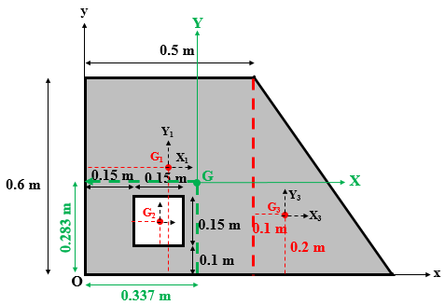
Figure 4.27 Composite area sectioned into three parts.
We now calculate the moments of inertia about the central axes (GX) and (GY). First, we find the coordinates of each center in the reference (GXY), which will be the distances separating (GX) and (GY) from the parallel axes passing through G₁, G₂, and G₃:
G₁(X₁ = 0.25 − 0.337 = −0.087 m, Y₁ = 0.3 − 0.283 = 0.017 m),
G₂(X₂ = 0.225 − 0.337 = −0.112 m, Y₂ = 0.175 − 0.283 = −0.108 m),
G₃(X₃ = 0.6 − 0.337 = 0.263 m, Y₃ = 0.2 − 0.283 = −0.0183 m).
The next step consists of calculating the moments of inertia of each shape about the “local central axes” passing through G₁, G₂, and G₃, respectively, and being parallel to (GX) and (GY):
IX1=0.5⋅(0.6)312⇒IX1=0.009 m4,
IY1=0.6⋅(0.5)312⇒IY1=0.00625 m4,
IX2=-0.15⋅(0.15)312⇒IX2=-4.21875×⋅10-5 m4=IY2,
IX3=0.3⋅(0.6)336⇒IX3=0.0018 m4,
IY3=0.6⋅(0.3)336⇒IY3=4.5×⋅10-4 m4.
Applying the parallel axis theorem to each of the three parts gives
IX1=0.009+0.5)⋅(0.6⋅(0.017)2⇒IX1=0.0090867 m4,
IY1=0.00625+0.5)⋅(0.6⋅(-0.087)2⇒IY1=0.0085207 m4,
IX2=-4.21875×⋅10-5-0.15)⋅(0.15⋅(-0.108)2⇒IX2=-3.046275×⋅10-4 m4,
IY2=-4.21875×⋅10-5-0.15)⋅(0.15⋅(-0.112)2⇒IY2=-3.244275×⋅10-4 m4,
IX3=0.0018+0.3)⋅(0.3⋅(-0.0183)2⇒IX3=0.00183 m4,
IY3=4.5×⋅10-4+0.3)⋅(0.3⋅(0.263)2⇒IY3=0.00667521 m4.
The total moments of inertia about (GX) and (GY) are
IX=0.0090867-3.046275×⋅10-4+0.00183⇒IX=0.010612 m4,
IY=0.0085207-3.244275×⋅10-4+0.00667521⇒IY=0.014871 m4.
Application 4.8. Calculate the moments of inertia, the product of inertia, and the radii of gyration with respect to the x and y axes of the shaded area shown in Figure 4.28.
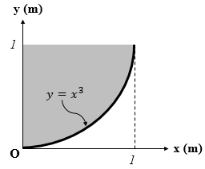
Figure 4.28 Nonregular area delimited by a cubic polynomial curve.
Solution 4.8. Two options are available for the differential rectangular strip dA: either parallel to the x axis or parallel to the y axis, as shown in Figures 4.29a and 4.29b, respectively.
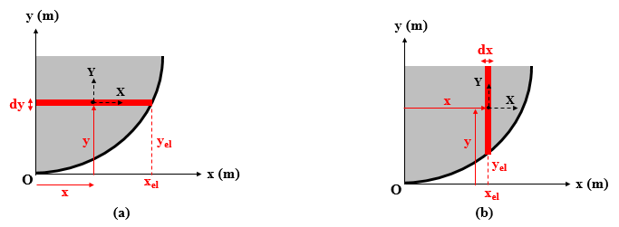
Figure 4.29 Differential rectangular strip parallel to (a) x axis and (b) to y axis.
Both options will lead to the same result. For both options, a local central reference (XY) passing through the centroid of the strip is shown.
Option 1
The differential element in Figure 4.29a is a thin rectangle of width dy parallel to the x axis and of length delimited by the y axis and the curve. The coordinates of its local centroid are
$x= \frac{x_{el}}{2}$ and y=yel=xel3⇒dy=3xel2dxel.
The area of this element is dA=xel⋅dy⇒dA=3xel3dxel.
The total surface of the shaded area is found by integrating dA:
A=013xel3dxel=34[xel4]01⇒A=34 m2.
To find I_{x}, apply the definition, which gives Ix=y2dA=013xel9dxel⇒Ix=310 m4.
To find I_{y}, consider the differential inertia of the rectangular strip along the centroidal axis Y (from Table 4.1) and then apply the parallel axis theorem to reach the y axis:
dIy=dIY+x2dA=xel312dy+34xel5dxel=xel5dxel,
Iy=dIy=01xel5dxel⇒Iy=16 m4.
A similar approach gives the product of inertia I_{xy}, with the only difference being that $d\overline{I_{XY}}=0$ since the X and Y axes are axes of symmetry of the differential rectangle.
dIxy=dIXY+x⋅ydA=0+xel2xel3⋅3xel3dxel=32xel7dxel,
Ixy=dIxy=0132xel7dxel⇒Ixy=316 m4.
Option 2
The differential element in Figure 4.29b is a thin rectangle of thickness dy parallel to the y axis of length delimited by the curve and the horizontal line y = 1. The coordinates of its local centroid are
$x= x_{el}$ and y=1+yel2=1+xel32=1+x32.
The area of this element is dA=(1-yel).dx⇒dA=1-x3dx.
The total surface of the shaded area is found by integrating dA:
A=01(1-x3)dx=[x-x44]01⇒A=34 m2.
To find I_{y}, apply the definition: Iy=x2dA=01(x2-x5)dx⇒Iy=16 m4.
To find I_{x}, consider the differential inertia of the rectangular strip along the centroidal axis X (from Table 4.1) and then apply the parallel axis theorem to reach the x axis:
dIx=dIX+y2dA=(1-x3)312dx+1+x3241-x3dx=1-x93dx,
Ix=dIx=011-x93dx=13[x-x1010]01⇒Ix=310 m4.
A similar approach gives the product of inertia I_{xy}, with the only difference being that $d\overline{I_{XY}}=0$ since the X and Y axes are axes of symmetry of the differential rectangle.
dIxy=dIXY+x.ydA=0+x1+x32⋅1-x3dx=x-x72dx,
Ixy=dIxy=01x-x72dx=12[x22-x88]01⇒Ixy=316 m4.
The polar moment of inertia is JO=310+16⇒JO=715 m4.
The three radii of gyrations are
kx=3/101/4⇒kx=305 m=1.095 m,
ky=1/61/4⇒kx=63 m=0.8165 m,
kO=7/151/4⇒kO=210515 m=1.3663 m.
One can check that kO2=kx2+ky2.
Application 4.9. Consider the right triangle in Figure 4.30. Its area is in a centroidal Cartesian reference frame. Calculate and draw the centroidal principal directions of inertia and the maximum and the minimum moments of inertia. Dimensions are in millimeters.
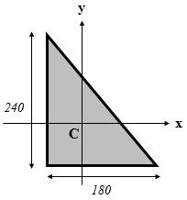
Figure 4.30 Right triangle in a Cartesian central reference frame.
Solution 4.9. According to Table 4.1, both moments of inertia about the centroidal axes (Cx) and (Cy) may be calculated as follows:
Ix=180⋅(240)336⇒Ix=69,120,000 mm4,
Iy=240⋅(180)336⇒Iy=38,880,000 mm4.
However, the product of inertia should be determined by integration. For the sake of simplicity, a general right triangle of any dimensions h and b will be considered in a Cartesian reference frame (OXY) coincident with the right-angle sides, as shown in Figure 4.31a. Consider a differential rectangular strip parallel to the X axis. A differential product of inertia dI_{XY} will be established by using the parallel axis theorem. The parallelism is between (OXY) and a local central reference for the differential rectangle, where the differential product of inertia is zero because this local reference consists of axes of symmetry for the differential rectangle. The hypotenuse is a straight inclined line whose equation is given in Figure 4.31a.
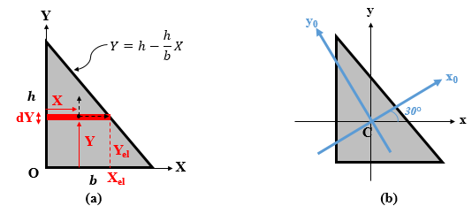
Figure 4.31 (a) Differential strip element in a right triangle. (b) Principal direction of inertia.

The local centroid of the differential strip has the coordinates
$X=\frac{X_{el}}{2}$, Y=Yel=h-hbXel⇒dY=-hbdXel.
The differential area of the strip is dA=Xel⋅dY=-hbXeldXel.
The parallel axis theorem gives
dIXY=0+XYdA=-hbXel22(h-hbXel)dXel,
IXY=-h22b2b0(bXel2-Xel3)dXel=h22b2[bXel33-Xel44]0b,
IXY=h2b224.
To find the product of inertia about the centroidal axes (Cx) and (Cy), apply the parallel axis theorem as follows:
IXY=Ixy+h3⋅b3⋅bh2⇒Ixy=h2b224-h2b218⇒Ixy=-h2b272,
Ixy=-(180)2⋅(240)272⇒Ixy=-25,920,000 mm4.
Apply Equation (4.39) to determine the principal directions of inertia:
θ'0=12atantan-1(2⋅(25920000)69120000-38880000)⇒θ'0=30°,
θ''0=90+30⇒θ''0=120°.
The central principle directions (Cx₀) and (Cy₀) are shown in Figure 4.31b.
Calculate I_{max} and I_{min} from Equations (4.40) and (4.41):
Imax=(69120000+38880000)2+69120000-3888000022+259200002,
Imax=84,007,679 mm4,
Imin=(69120000+38880000)2-69120000-3888000022+259200002,
$I_{min}=23,992,321 {mm}^{4}$.
Finally, one should associate each value of the optimal results to the corresponding direction; that is, if I_{max} is about (Cx₀) or (Cy₀). For this purpose, one can replace θ′₀ in Equation (4.36):
Ix0=(69120000+38880000)2+(69120000+38880000)2cos60°+25920000sin60°=84,007,679 mm4.
Thus, I_{x0} = I_{max}, which implies that I_{y0} = I_{min}.

Self-Check Questions
- Choose the correct answer.
A cone of radius R and height h is welded at the top of a cylinder made of the same material and having the same radius as the cone but a height h′. To get the center of gravity of the whole body at the cone-cylinder interface (i.e., at the base of the cone and at the top of the cylinder) the ratio h′/h must be
$\sqrt{6}/6$ $1/6$ 1 $\sqrt{6}$
- Complete the following sentence:
For a square of side length d located within its central principal reference of inertia, the three radii of gyration measure $\frac{\sqrt{3}}{6}d$ about the x axis, $\frac{\sqrt{3}}{6}d$ about the y axis, and $\frac{\sqrt{6}}{6}d$ about the pole C.
- Specify whether the following statement is True or False and justify your answer.
Any two perpendicular radial directions of a circle are centroidal principal directions of inertia. True because any radial line is an axis of symmetry, so the product of inertia in that reference is zero.

4.2 Internal Beam Loading

External and internal forces
A solid body is in equilibrium when the forces applied to the body balance each other, which results in an equivalent zero force. The forces applied to the body are divided into two categories: active forces, which “refer to the physically prescribed forces in a mechanical system” (Gross et al., 2013, p.11) such as weight, water pressure, and the traction of a motor; and reaction forces, which refer to constraints applied by the environment on the body to prevent its motion. Examples of reaction forces include the normal reaction of a planar support, the tension in a holding cable or chain, and the reactive force applied by a hinge. In a FBD, the main body is isolated from its surrounding supports and the active and reaction forces are then drawn.
An external force is a force that is exerted by an object exterior to the main body (Gross et al., 2013) and may be either an active or reaction force. Internal forces are forces exerted by the various components of the main body. When the FBD of the entire body is drawn, the internal forces do not appear because they all cancel because of the principle of action and reaction (Newton’s third axiom). Internal forces appear when the different components constituting the main system are “separated” from each other. In Mechanics, such separation to visualize internal forces is called cutting or sectioning and the use of this technique is called the method of sections. Sectioning consists of passing an imaginary line or plane of section to virtually cut the body at a place where the internal forces need to be visualized and calculated. When separated, the internal forces that appear in a component represent the action of the other component(s) that was (were) connected to it. The internal forces become external on this isolated component whereas they “disappear” when the component is “re-joined” with its neighboring components.
Figure 4.32 details this concept.
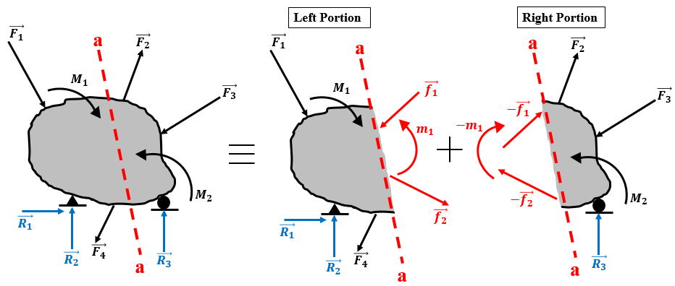
Figure 4.32 Visualization of external and internal forces.
In Figure 4.32, the original case consists of a body in static equilibrium subjected to an external loading involving active loads (in black) and reactive forces (in blue). Since the body is shown as one unit or as an entire body, the internal forces do not appear. At a location of interest within the body, a virtual cut a-a is applied to split the main body into two virtual portions. Since the entire body is in equilibrium, each portion of the body satisfies the conditions of equilibrium. However, only part of the external loading is applied to each portion. Therefore, to maintain equilibrium, the external loading must be compensated by internal forces that appear at the cut. Due to the principle of action and reaction, these forces applied to the two portions are equal in magnitude and opposite in sense. When re-assembling the left and the right portions, the internal forces balance each other and the main body is obtained in static equilibrium.
Note that the equilibrium equations are applicable to any portion produced by sectioning the body, which allows us to evaluate the internal forces that maintain equilibrium.

Beams
A rectilinear beam is a straight member whose length is much greater than its lateral dimensions (cross section). A beam is conceived to support mainly transverse loading for any practical application, such as concrete slabs in buildings, or metallic standard profiles for frames and chassis (Hibbeler, 2010). This loading may consist either of concentrated or distributed forces and/or moments or any combination thereof. A beam remains in static equilibrium because of the reaction forces exerted by the bearings that support this beam, such as pins, rollers, and fixed supports. Figures 4.33a–4.33d show different standard configurations of supported beams with the name of each configuration. Both applied loads and reaction forces exerted by the supports constitute an external loading system that acts on the beam. Furthermore, when a system satisfies the conditions of static equilibrium, any sub-system or part of the initial system must be in the state of equilibrium. This means that any portion of the beam must remain in equilibrium. Such a portion of a beam may be obtained from a virtual transverse cross section at any point along the beam, and either the left or right portion may be retained. For either portion (left or right), only a part of the total external load remains, so equilibrium of the portion requires that a system of forces be applied at the cut to balance the externally applied load.
This balancing of the load is known as internal loading because it appears within the beam only when the beam is “cut.” When considering the entire beam in equilibrium, internal loading does not appear because, in this case, the external loading is balanced by the reaction forces exerted by the supports. One may conclude that internal loadings applied at cuts are equal in magnitude and opposite in sense, which is the same conclusion reached by applying the classical principle of action and reaction, known as Newton’s first axiom. In fact, the internal loading applied at the cut on the left portion is the force applied by the right portion on the left portion and vice versa.
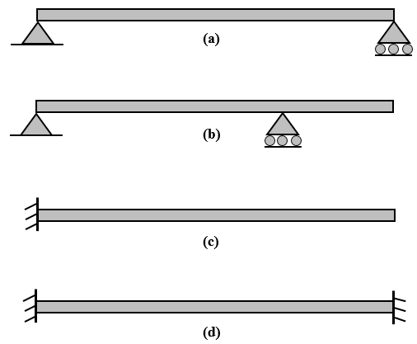
Figure 4.33 (a) Simply supported beam, (b) overhang beam, (c) fixed-free or cantilever beam, and (d) fixed-fixed or double cantilever beam.
Note that internal loadings produce stresses within the cross sections of a beam in equilibrium. Depending on the stress with respect to the strength of the beam’s material, the beam may or may not support the externally applied load. A beam that can support the load is said to be “safe,” whereas one that cannot support the load leads to failure of the beam.
We next discuss all aspects of internal loading developed within a rectilinear beam: FBDs, types, sign conventions, calculation of equations, variations, and relationships.

Internal forces and moments
Free body diagram
We begin with the most general case of a loaded beam, which is the 3D case or spatial case. Next, we analyze the 2D or planar case.
Consider a simply supported beam in equilibrium located in a 3D Cartesian direct reference (Oxyz) such that the origin O is coincident with the center of gravity of the cross section at the left end of the beam. The x axis is oriented to the right along the length of the beam and is called the longitudinal axis. The y and z axes are the transverse axes and are coplanar to the cross section of the left end of the beam. The y axis lies in the plane of the screen and the z axis points outward. This is illustrated in Figure 4.34.
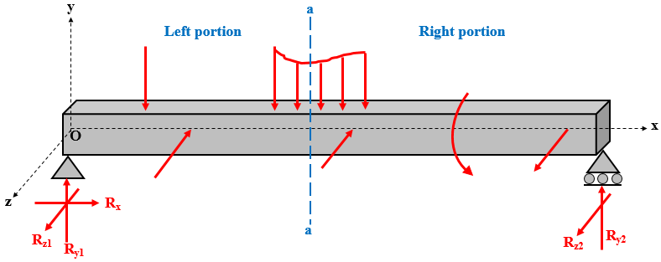
Figure 4.34 3D external loading for a beam in equilibrium.
As stated earlier, the internal loading appears within the beam after a virtual transverse cut at any cross section through the abscissa x. This cut is denoted a-a in Figure 4.34 and generates a left and right portion, each subjected to a part of the external load. At the center of gravity G of the cross-sectional cut, the internal loading must appear in the FBD shown in Figure 4.35 and compensate for the part of the external loading applied to the left portion.
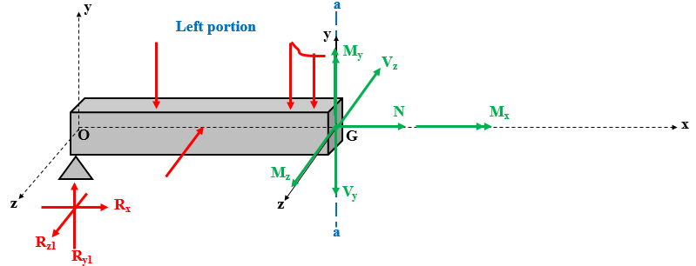
Figure 4.35 3D internal loading on a portion of a beam in equilibrium.
Types
To ensure the equilibrium of all portions, the internal loading system must balance the resultant forces and moments acting along each of the three axes x, y, and z. This means that in, 3D, one may distinguish six types of internal loadings (Hibbeler, 2011):
- The axial force N, which is an internal force acting along the longitudinal axis (x axis) of the portion of the beam and that compensates the resultant component of the external forces acting along the x axis of the same portion.
- The shear force V_{y}, which is an internal force acting along the transverse axis (y axis) of the portion of the beam and that compensates for the resultant component of the external forces acting along the y axis of the same portion.
- The shear force V_{z}, which is an internal force acting along the transverse axis (z axis) of the portion of the beam and that compensates the resultant component of the external forces acting along the z axis of the same portion.
- The torsional moment M_{x}, which is the internal moment acting about the longitudinal axis (x axis) of the portion of the beam and that compensates for the resultant component of the external moments acting along the x axis of the same portion.
- The bending moment M_{y}, which is the internal moment acting about the transverse axis (y axis) of the portion of the beam and which compensates the resultant component of the external moments acting along the y axis of the same portion.
- The bending moment M_{z}, which is an internal moment acting about the transverse axis (z axis) of the portion of the beam and which compensates the resultant component of the external moments acting along the z axis of the same portion.
Sign convention
The six types of internal loading described in the previous section are in fact algebraic quantities that may be either positive or negative. The assignment of algebraic signs obeys the following convention (Hibbeler, 2011):
- The axial force N is positive when it acts outward from the cross section or physically when the portion is under tension. This means that, for the left (right) portion, N is positive when it has the same (opposite) sense as the x axis.
- The shear force V_{y} is positive when it acts downward (opposite the sense of the y axis) in the left portion and positive when it acts upward (same as the sense of the y axis) in the right portion.
- The shear force V_{z} is positive when it acts inward (opposite the sense of the z axis) in the left portion and positive when it acts outward (same as the sense of the z axis) in the right portion.
- The torsional moment M_{x} is positive when it acts outward from the cross-section. This means that, for the left portion, M_{x} is positive when it rotates following the right-hand rule around the x axis whereas, for the right portion, M_{x} is positive when it rotates opposite to the right-hand rule around the x axis.
- The bending moment M_{y} is positive when it rotates following the right-hand rule around the y axis whereas, for the right portion, it is positive when it rotates opposite to the right-hand rule around the y axis.
- The bending moment M_{z} is positive when it rotates following the right-hand rule (trigonometric or counterclockwise) around the z axis whereas, for the right portion, it is positive when it rotates opposite to the right-hand rule (clockwise) around the z axis.
Calculation of internal forces
Since a system of internal loading ensures the equilibrium of any portion of a beam, the six components of the internal loading system may be calculated by applying the force and moment equilibrium equations along the three axes x, y, and z:
Axial force:
Fx=0. (4.42)
Shear force along y:
Fy=0. (4.43)
Shear force along z:
Fz=0. (4.44)
Torsional moment:
Mx-/G=0. (4.45)
Bending moment about y axis:
My-/G=0. (4.46)
Bending moment about z axis:
Mz/-G=0. (4.47)
The switch to the planar-beam case means that the external loading lies either in the plane (xOy) or in the plane (xOz), in which case only three components of internal loading remain: N, V_{y}, M_{x}, and M_{z} in plane (xOy) or N, V_{z}, M_{x}, and M_{y} in plane (xOz). In each case, the beam is said to be subjected to simple bending if N = 0 or to compound bending if N $≠$ 0.

Variation of internal forces and moments
The current analysis focuses on a very basic standard case of a beam consisting of a 2D loaded beam with simple bending under static equilibrium in a direct Cartesian reference (Oxy), as illustrated in Figure 4.36. Figure 4.37 shows the FBD of both the left and right portions of the beam. The purpose is to analyze how the shear force V_{y} and the bending moment M_{z} evolve along the beam’s length. Mathematically, the goal is to determine the expressions for V_{y}(x) and M_{z}(x) given the type of external loading. The graphs of the two latter functions are known as shear force and bending moment diagrams, respectively.
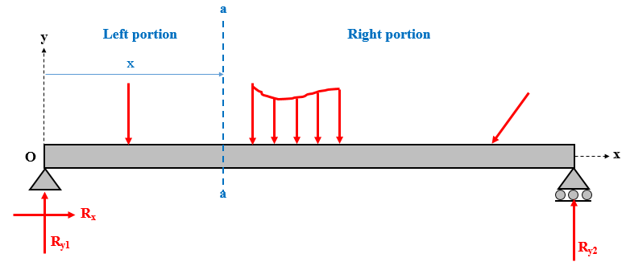
Figure 4.36 2D external loading of a beam in equilibrium.

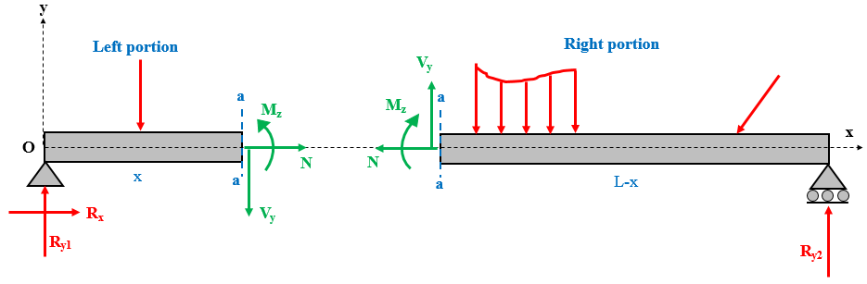
Figure 4.37 2D internal loading of a beam in equilibrium.
Distributed loading
Consider a differential element of length dx on the abscissa x picked up from a beam subjected to distributed loading of magnitude q. Figure 4.38 shows the FBD of the beam under equilibrium and following the sign convention of internal loadings.
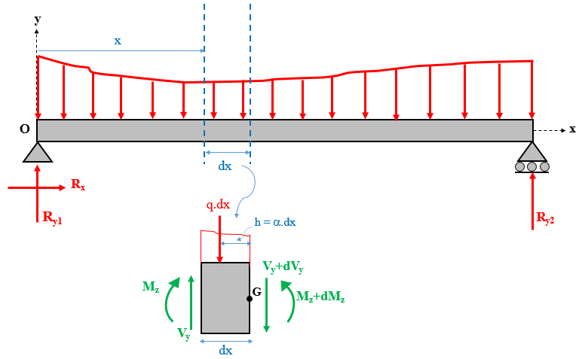
Figure 4.38 Differential element of a beam under distributed loading.
On this FBD, the resulting intensity of the portion of the distributed loading on dx is a concentrated force of magnitude qdx and located a distance h from the right section, which is the position of the center of gravity of this partial distributed loading. This distance h locates dx and thus represents mathematically a fraction of dx, which is denoted α.
Applying the equilibrium equations for the differential element dx and neglecting higher orders of dx (i.e., dx² << dx) gives
$\sum{F_{y}}=0$,
-q⋅dx+Vy-Vy+dVy=0,
$\frac{{dV}_{y}}{dx}=-q$, (4.48)
Mz-/G=0,
q⋅dx⋅h-Vy⋅dx-Mz+Mz+dMz=0,
dMzdx=Vy. (4.49)
Equation (4.48) shows that the shear force generated in a distributed-loaded beam is the integral of the magnitude of the distributed loading, and Equation (4.49) shows that the bending moment is the integral of the shear force. In other words, if the beam is subjected to a uniformly distributed loading (q = const.), the shear force varies linearly along the length of the beam while the bending moment is a parabolic function of x. If the beam is subjected to a linearly distributed loading (q = ax + b), the shear force varies parabolically along the length of the beam and the bending moment is a cubic polynomial function of x. If q = 0 (i.e., no distributed loading), the shear force becomes constant along the beam and the bending moment varies linearly.

Concentrated loading
Figure 4.39 shows the FBD of two differential elements dx around a concentrated force and a concentrated couple, respectively.
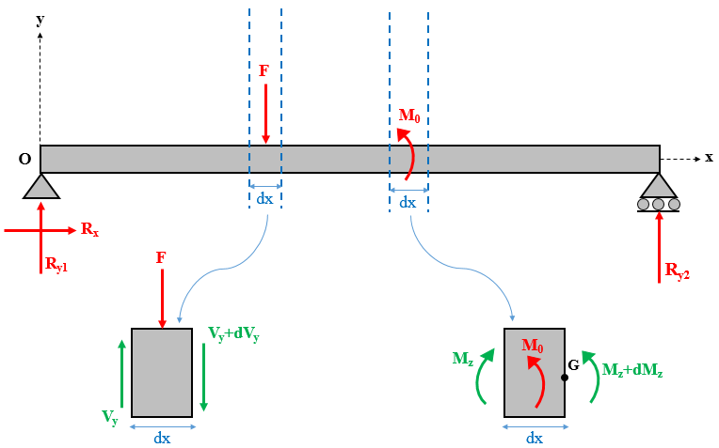
Figure 4.39 Differential elements of a beam under concentrated force and concentrated couple.
Applying the equilibrium equations to each case gives
Fy=0,
-F+Vy-Vy+dVy=0,
dVy=-F, (4.50)
Mz-/G=0,
M0-Mz+Mz+dMz=0,
dMz=-M0. (4.51)

Equation (4.50) shows that the shear force just after the concentrated force decreases when the external concentrated force is downward and increases when the concentrated force is upward. Each time, the decrease or increase equals the magnitude of the concentrated force.
Equation (4.51) shows that the bending moment just after the concentrated couple drops when the external concentrated couple acts counterclockwise and jumps when the concentrated couple acts clockwise. Each time, the magnitude of the discontinuity equals the magnitude of the concentrated couple.
Application 4.10. A 90° arm cantilevered at O and free at A is subjected at its free end to a force F=(-10i+30j+20k )kN kN as shown in Figure 4.40. Determine the internal efforts developed at cross section B, which is 1 m from O.
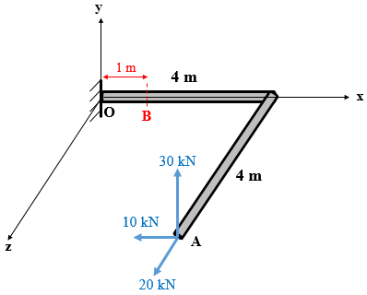
Figure 4.40 Fixed-free 90° arm loaded in space.

Solution 4.10. The external loading (i.e., active loading) should be completed by the reactions at the fixed support O. However, one may “shorten” the solution by cutting at B and keeping the right portion, which has no support. Figure 4.41 shows the FBD of this portion.
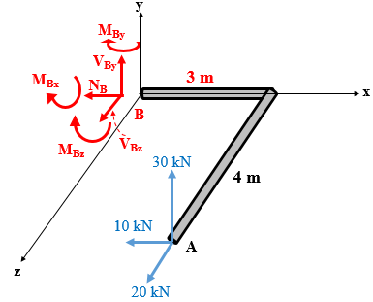
Figure 4.41 FBD of the right sectioned portion of a 90° arm.
The six components of internal efforts are calculated using Equations (4.42)–(4.47). However, before using this set of equations, it is convenient to find the components of the external moment generated by the external force $\vec{F}$ about point B. This requires the components of the position vector $\vec{BA}$:
B(1,0,0) and A(4,0,4) give $\vec{BA}=3\vec{i}+4\vec{k}$.
MB=ijk304-103020=(-120i-100j+90k) (kN⋅m) kN m.
The internal efforts at B are calculated as follows:
Fx=0⇒-NB-10=0⇒NB=-10 kN.
Fy=0⇒VBy+30=0⇒VBy=-30 kN,
Fz=0⇒VBz+20=0⇒VBz=-20 kN,
Mx-/B=0⇒-MBx-120=0⇒MBx=-120 kN .m,
My-/B=0⇒-MBy-100=0⇒MBy=-100 kN .m,
Mz-/B=0⇒-MBz+90=0⇒MBz=+90 kN .m.
Application 4.11. Draw the diagrams of the shear force and bending moment of the beam cantilevered at A and free at B shown in Figure 4.42.
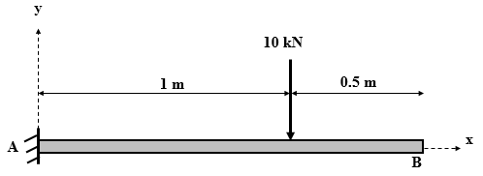
Figure 4.42 Fixed-free beam in planar equilibrium.
Solution 4.11. The three reaction components (A_{x}, A_{y}, and M_{A}) at the fixed support at A are determined by applying the equilibrium equations in the plane of the entire beam:
Fx=0⇒Ax=0,
Fy=0⇒Ay=10 kN,
Mz-/A=0⇒MA=10⋅1=10 kN ⋅m.
Since the external loading changes twice along the beam, first at the reactions at A and the next at the active concentrated force of 10 kN, two sections should be taken to account for the change in external forces and thus in internal forces. The loading case implies that retaining the right portion leads to easier calculations. Figure 4.43 shows the FBDs of the whole beam and of the two portions. The origin of the x axis is always coincident with point A.
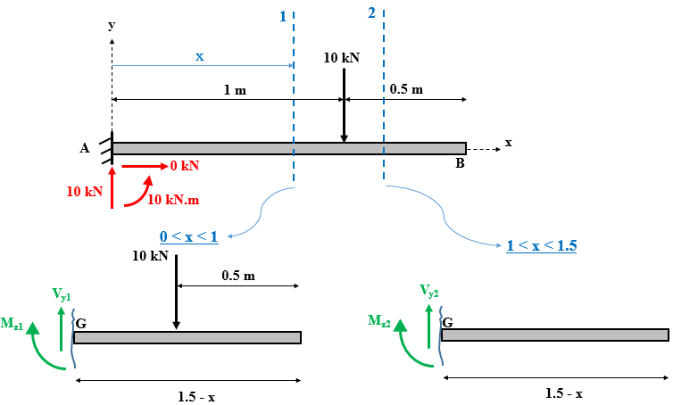
Figure 4.43 FBD of entire fixed-free beam and sectioned portions thereof.
The next step consists in calculating V_{y}(x) and M_{z}(x) using the equilibrium equations (4.43) and (4.47) for the two intervals of cuts.
Cut 1: 0 < x < 1
Fy=0⇒Vy1-10=0⇒Vy1=10 kN,
M-/G=0⇒-Mz1-101-x=0⇒Mz1=10x-10 kN .m.
Cut 2: 1 < x < 1.5
Fy=0⇒Vy2=0 kN,
M-/G=0⇒Mz2=0 kN .m.
For both cuts, the shear force equals the derivative of the bending moment, which emphasizes the validity of Equation (4.49). Moreover, calculating the difference of shear forces just after and before the concentrated force gives $V_{y2}\left(1^{+}\right)-V_{y1}\left(1^{-}\right)= -10 kN$, which verifies Equation (4.50).
Finally, Figure 4.44 shows the diagrams of the shear force and bending moment.
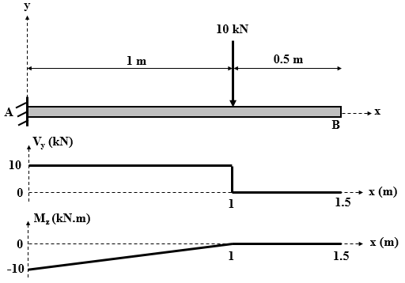
Figure 4.44 Diagrams of shear force and bending moment for a fixed-free beam under concentrated force.

Self-Check Questions
- Specify whether the following statement is True or False and justify your answer.
In a planar truss, two types of internal loadings are developed. False because all bars in a truss only sustain forces along the bars (i.e., axial forces).
- Choose the correct answer:
A simply supported beam of length L is subjected to a downward distributed load $q\left(x\right)=\frac{P}{L}\sin{(\frac{πx}{L})}$ where P is a known force. The bending moment at the middle of the beam is equal to
PL/2π −PL/2π PL/π² −PL/π²

4.3 Beams with different support conditions

Simply supported beam under uniformly distributed load
Figure 4.45 illustrates a simply supported beam subjected along its entire length L to a uniformly distributed load of intensity q and the relevant diagrams of the shear force and bending moment. The resultant force from this uniform distribution is equal to the area of the rectangle qL and is applied at the center of the rectangle, which coincides with the midpoint of the beam (i.e., x = L/2). Due to the symmetry of the case, the vertical reaction forces at the supports are upward with magnitudes qL/2.
Since the load remains constant along the entire beam, only one cut need be performed at any abscissa x, generating only one expression for V_{y} and one expression for M_{z}. These are normally established by isolating either the left or right portion of the cut, drawing its FBD, and applying the equilibrium equations. However, due to the particularity of the case, one can integrate Equations (4.48) and (4.49) as follows:
Boundary conditions are specific “already-known” values at the ends of intervals that allow us to establish general expressions for quantities within the interval.
Vyx=-qx⋅dx+C1=-q⋅x+C1,
Mzx=Vyx⋅dx+C2=-12q⋅x2+C1⋅x+C2.
The constants C₁ and C₂ are determined based on the boundary conditions of V_{y} and M_{z} at the pin (i.e., at x = 0), respectively, by writing the equilibrium equations of the cut portion at x = 0, as illustrated in Figure 4.45 and which gives $C_{1}=V_{y}\left(0\right)=\frac{qL}{2}$ and $C_{2}=M_{z}\left(0\right)=0$. The final expressions for the shear force and bending moments are
Vyx=-q⋅x+qL2,
Mzx=-12q⋅x2+qL2⋅x.
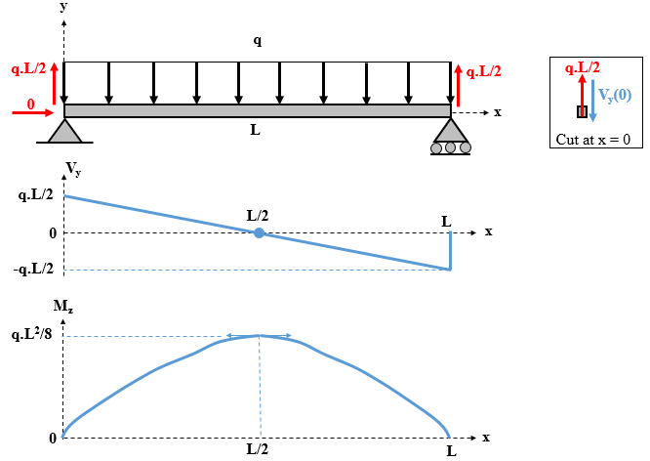
Figure 4.45 Diagrams of shear force and bending moment for a simply supported beam under a uniformly distributed load.
From the diagrams and because V_{y} is the derivative of M_{z}, we see that, when V_{y} is zero at the center of the beam, M_{z} goes through a maximum. Moreover, at the supports (i.e., x = 0 and x = L), the reactions consist of concentrated forces, so the shear force V_{y} jumps up and a drops, respectively, with the magnitude of each discontinuity equal to the magnitudes of the reaction forces. In addition, since the supports exert no coupling reaction, the bending moment M_{z} is zero.

Simply supported beam under concentrated force
Figure 4.46 shows a simply supported beam subjected to a concentrated force at a distance a from the pin (i.e., at the origin of the x axis). Applying M---/pin=0 and M--/roller=0 gives the vertical reactions. The horizontal component is zero because there is no external horizontal force.
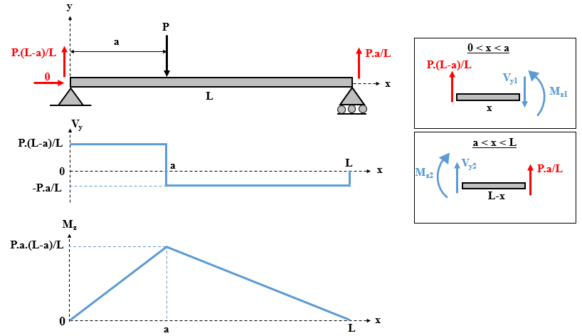
Figure 4.46 Diagrams of shear force and bending moment of a simply supported beam subjected to a concentrated force.
Since the external loading changes twice, two cuts are made. For sake of simplicity, the left portion is retained for the first cut, and the right portion is retained for the second cut. Figure 4.46 shows the relevant FBDs. Applying the equilibrium equations at each cut, one establishes the expressions of V_{y1}(x), V_{y2}(x), M_{z1}(x), and M_{z2}(x).
Cut 1: 0 < x < a
Fy=0⇒Vy1-P(L-a)L=0⇒Vy1=P(L-a)L,
M/--cut=0⇒Mz1-P(L-a)Lx=0⇒Mz1=P(L-a)Lx.
Cut 2: a < x < L
Fy=0⇒Vy2=-P⋅aL,
M/--cut=0⇒Mz2=-P⋅aLx+P⋅a.
From the diagrams and since V_{y} is the derivative of M_{z}, M_{z} increases linearly when V_{y} is positive and constant, whereas the opposite occurs when V_{y} is negative and constant. The drop in the shear force at x = a equals the magnitude P of the concentrated force. At that point, the slope of the bending moment changes, indicating that it passes by a maximum. Moreover, at the supports (i.e., x = 0 and x = L), the reaction forces are the only concentrated forces, so the shear force V_{y} jumps and drops each time, with the magnitude of the discontinuities equal to the magnitudes of the reaction forces. Finally, since the supports exert no coupling reaction, the bending moment M_{z} is zero.

Fixed-free beam under uniformly distributed load
Figure 4.47 shows a fixed-free beam subjected along its entire length L to a uniformly distributed load of intensity q and the relevant diagrams of the shear force and bending moment. The resultant force from this uniform distribution equals the area qL of the rectangle and is applied at the center of the rectangle, which coincides with the midpoint of the beam (i.e., x = L/2). Applying M/--support=0 and Fy=0, we get the vertical and couple reactions, whereas the horizontal component is zero due to the lack of external horizontal forces.
Since the load does not change along the entire beam, only one cut need be performed at any position x, which generates only one expression for V_{y} and one expression for M_{z}. We could have integrated Equations (4.48) and (4.49) but, to diversify the methods used, we consider the equilibrium of the isolated right portion shown in Figure 4.47:
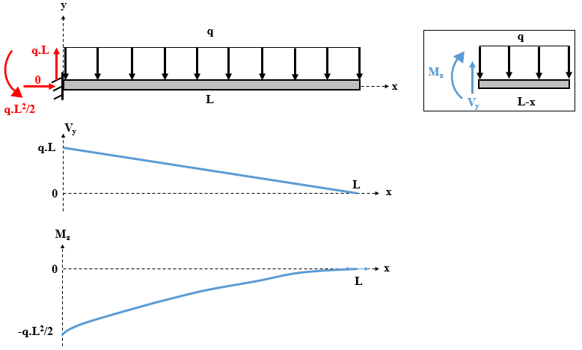
Figure 4.47 Diagrams of shear force and bending moment of fixed-free beam with applied uniformly distributed load.
Fy=0⇒Vy-q⋅L-x=0⇒Vy=q⋅(L-x),
M/-cut=0⇒-Mz-q⋅L-x⋅L-x2=0⇒Mz=-q⋅(L-x)22.
From the diagrams and since V_{y} is the derivative of M_{z}, the slope of the parabolic bending moment is upward but decreases continuously along x because V_{y} is positive but linearly decreasing. Both quantities reach zero at the free end (i.e., x = L), where no concentrated force or couple nor a support exists at the fixed support (i.e., at x = 0). Both V_{y} and M_{z} attain the magnitude of the relevant components of the reaction efforts.

Fixed-free beam under concentrated force
Figure 4.48 illustrates a fixed-free beam subjected to a concentrated force applied a distance a from the cantilever (i.e., at the origin of the x axis). Applying M--/support=0 and $\sum{F_{y}=0}$, we get the vertical and the couple reactions, whereas the horizontal component is due to the lack of external horizontal forces.
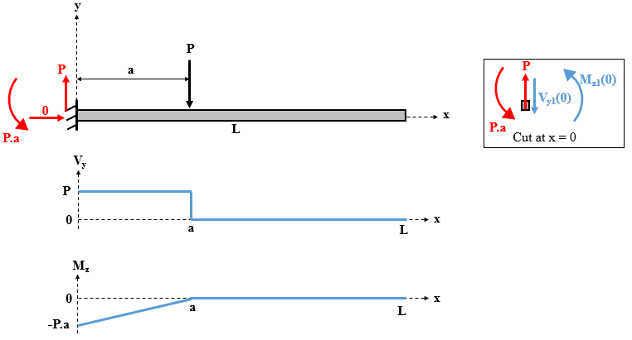
Figure 4.48 Diagrams of shear force and bending moment of fixed-free beam with applied concentrated force.
Given that the external loading changes twice, two cuts are made. To diversify the methods used, Equations (4.48) and (4.49) are integrated over each portion cut and the boundary and continuity conditions are used to determine the constants of integration.
Cut 1: 0 < x < a
Vy1x=-qx⋅dx+C1=0+C1=C1,
Mz1x=Vy1x⋅dx+C2=C1⋅x+C2
The constants C₁ and C₂ are determined from the boundary conditions for V_{y1} and M_{z1}, respectively, at the cantilever (i.e., at x = 0) by writing the equilibrium equations for the cut portion at x = 0, as illustrated in Figure 4.48 and which gives $C_{1}=V_{y1}\left(0\right)=P$ and C2=Mz20=-P⋅a. The final expressions for the shear force and bending moments are
Vy1x=P,
Mz1x=P⋅x-P⋅a.
Cut 2: a < x < L
Vy2x=-qx⋅dx+C3=0+C3=C3,
Mz2x=Vy2x⋅dx+C4=C3⋅x+C4.
The constants C₃ and C₄ are determined from the boundary conditions for V_{y2} and M_{z2} at the free end (i.e., x = L), which is free from any concentrated force or moment and also not supported by any bearing, which means that $C_{3}=V_{y2}\left(L\right)=0$ and $C_{4}=M_{z2}\left(L\right)=0$.
The final expressions for the shear force and bending moments are
Vy2x=0,
Mz2x=0.
From the diagrams and because V_{y} is the derivative of M_{z}, M_{z} increases linearly when V_{y} is zero, M_{z} is constant In the absence of any externally applied couple, this constant is zero when V_{y} is positive and constant. On the other side, the drop in shear force at x = a equals the magnitude P of the concentrated force. Both quantities reach zero at the free end (i.e., x = L) where no concentrated force or couple nor support exist at the fixed support (i.e., x = 0) both quantities attain a magnitude equal to the relevant components of the reaction.

Self-Check Questions
- Specify whether the following statement is True or False and justify your answer.
In an overhang beam, the bending moment at the intermediate support is zero. False because, if a cut is made just before and just after this isolated support, a bending moment will appear from the part of the beam before the cut and thus another bending moment must appear at the cut just after the support to maintain equilibrium.
- Choose the correct answer:
Consider two identical beams of length L. the first beam is fixed-free and the second beam is simply supported. Uniformly distributed loads of intensities q and q′ are applied on the first and second beams, respectively. What should be the ratio q′/q that generates the same maximum bending moment (in absolute value) in both beams?
1/4 1/2 2 4
Summary
To locate by integration the centroid of a shape of size S, which could be either a volume, an area, or a length, we consider a differential element dS measured the coordinates x, y, and z of its local centroid, and then apply the following equations:
x=x⋅dSdS ,; y=y⋅dSdSa, ; z=z⋅dSdS .
To locate the centroid of a composite body, one divides it into a finite number n of regular shapes of size S_{i}, measures the coordinates x_{i}, y_{i}, and z_{i} of its local centroid, then applies the following equations:
x=i=1nxiSii=1nSi, ; y=i=1nyiSii=1nSi, ; z=i=1nziSii=1nSi.
The moment of inertia of an area about an axis or a pole is the integral of the product of a differential element dA and the square of the distance D (i.e., abscissa, ordinate, or polar distance) separating the element from the axis or the pole: I=D2⋅dA.
The parallel axis theorem establishes a relationship between the moment of inertia of an area about an axis passing through the centroid $\overline{I}$ and the moment of inertia I about a parallel axis separated by a distance d from the centroidal one such that I= I+A⋅d2.
The principal directions of inertia represent a particular rotation of the original reference at which the moments of inertia are optimal.
Internal forces appear on the FBD when a portion of a sectioned beam is isolated with the external loading applied to this portion. Internal forces are calculated from equilibrium equations applied to the isolated portion.
On a beam, the internal forces change with length (i.e., abscissa x) each time the external load changes, so the number of cuts is the same as the number of external loading variations. Diagrams of the internal efforts may be plotted as functions of x.

Unit 5 –Solid-State Friction

Study Goals

On completion of this unit, you will be able to …

… analyze the aspect of dry friction and its influence on the equilibrium of bodies.
… investigate how dry friction affects bodies at rest or in sliding or rolling motion.
… explore the practical side of friction through pulley-and-belt applications.

5. Solid-State Friction

Introduction
Throughout this textbook, all contacts between different surfaces have been considered smooth (i.e., ideal). This assumption has led to further simplifications in the different laws applied to a solid. However, in reality, all surfaces exhibit a certain level of roughness, meaning that different faces of the solid are not perfectly smooth despite their smooth appearance on the macroscopic scale. A microscopic analysis of surfaces reveals some substructures in the surface profile and, as deviations from the ideal shape increase, the surface becomes qualified as rough and wavey. In consequence, a planar contact between faces of solids becomes contact at certain points, which are the peaks of the rough surfaces of the faces. Mechanically speaking, this results in nonperpendicular reaction force exerted by the planar face on the solid, so a component of this reaction force that is tangential to the surface appears. This tangential component is known as the friction force. It acts as a reaction force when the solid is at rest and as an action force against the motion when the solid moves.
The scope of the present unit is limited to dry friction or Coulomb friction (after the name of the French engineer Charles-Augustin de Coulomb) (Gross et al.,2013) where the friction force acts directly between two main surfaces of contact in the absence of any intermediate “softer” material such as a fluid or lubricant. Three different types of friction force and their influence are analyzed and calculated: friction force on a body at rest (static friction), friction force on a translating body (sliding friction), and friction force on a rotating body with a forward motion (rolling friction).

5.1 Static friction

Fundamental concept of Coulomb friction
Consider a rigid block of weight $\vec{W}$ resting on a rough deformable horizontal plane. This block is subjected to a horizontal force $\vec{P}$ trying to move this block horizontally along the plane, as illustrated in Figure 5.1a. Because of the irregular profile of both contact surfaces, the support exerts along its whole surface a nonuniform distribution of both normal forces $Δ\vec{N_{(i)}}$ and tangential or frictional forces ΔHs(i), as shown in Figure 5.1b.
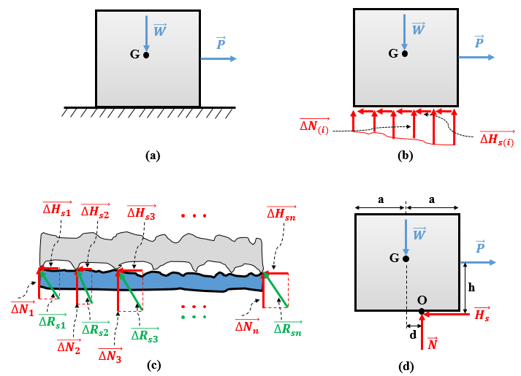
Figure 5.1 (a) Block resting on a rough surface, (b) nonuniform distribution of normal and friction forces, (c) expanded view of contacting surfaces, and (d) resultant reaction forces produced by the rough planar support.
A microscopic analysis of the contacting surfaces in Figure 5.1c reveals that contact is made at points instead of over the whole surface. At each point acts a “part” of this normal and tangential distribution of forces. Applying the law of parallelograms (here it is a rectangle), the resultant of the reaction at each contact point i is an inclined force $Δ\vec{R_{s(i)}}=Δ\vec{H_{s(i)}}+Δ\vec{N_{(i)}}$ .
Applying the equation of equilibrium in the x direction, the distribution of friction forces (i.e., their resultant $\vec{H_{s}}$), must be opposite to the horizontal pulling force $\vec{P}$ and their magnitudes must be equal: H_{s} = P. The equation of equilibrium along the y direction imposes that the distribution of normal forces (i.e., their resultant $\vec{N}$) must be opposite in sense to the vertical downward weight $\vec{W}$ while their magnitudes must be equal: N = W. If the block is modeled as a particle, the lines of all four forces of action must pass through the center of gravity G to satisfy the equilibrium conditions. However, for the rigid-body model, the resultant of the reaction force is applied at a certain point O that is a distance d from G, as illustrated in Figure 5.1d. By applying the third equation of equilibrium, M-/O=0 , we obtain d = (P/W)h.

Static equilibrium
Upon progressively increasing the intensity of the pulling force $\vec{P}$, the magnitude of the dry friction or Coulomb friction $\vec{H_{s}}$ increases in proportion to maintain the block in static equilibrium, thereby the role of a tangential support reaction. $\vec{H_{s}}$ is known as the static friction force.
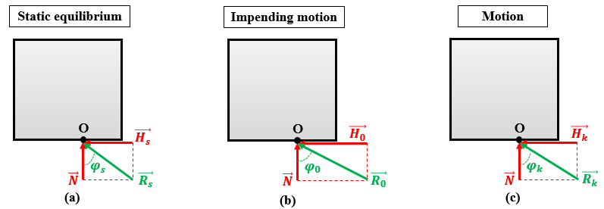
Figure 5.2 (a) Normal and friction force components at static equilibrium, (b) impending motion, (c) motion.
H_{s} increases as P increases and N remains constant, so the static resultant reaction $\vec{R_{s}}=\vec{H_{s}}+\vec{N}$ increases not only in magnitude but also in direction angle φs=tan-1(HsNHsN). This status is depicted in Figure 5.2a. Note that “the orientation of the friction force always opposes the direction of the motion that would occur in the absence of friction” (Gross et al., 2013, p. 264). However, depending on the complexity of the loading case, one may select an arbitrary sense for the friction force and then determine the sense of the friction force may by the algebraic sign at the end of calculations.

Impending motion
The magnitude of the static friction force H_{s} cannot increase indefinitely to maintain the balance with P. In fact, H_{s} has an upper limit denoted H₀ and known as the limiting static friction force beyond which static equilibrium is not conserved and the block moves. H₀ is the maximum value of H_{s} that retains static equilibrium; in other words, at H_{s} = H₀ the body is in impending motion, meaning that it is on the verge of translating horizontally (i.e., sliding on the support). According to the experiments of Coulomb, H₀ is proportional to the magnitude of the normal reaction N:
H0=μ0⋅N, (5.1)
where μ₀ is the coefficient of static friction. This coefficient depends mainly on the roughness of the contacting surfaces. For instance, for metal-ice contact, μ₀ ranges from 0.03 to 0.05 whereas for wood-wood contact, μ₀ ranges from 0.3 to 0.7 (Hibbeler, 2010). For steel-steel contact, μ₀ ranges from 0.15 to 0.5, and tires on snow have μ₀ = 0.7–0.9 (Gross et al., 2013).
Figure 5.2b shows the angle φ0 of static frictionφ0. Since $φ_{0}=\tan^{-1}{(\frac{H_{0}}{N})}$ and using Equation (5.1) gives
φ0=tan-1atanμ0. (5.2)
The condition of static equilibrium imposes $\left|H_{s}\right|<H_{0}$ (i.e., $φ_{s}<φ_{0}$)
For a 2D case, the limiting zone in which $\vec{R_{s}}$ retains static equilibrium under any external load is described by a static friction wedge constructed by two lines at angles ±φ0 from the surface normal, as illustrated in Figure 5.3a.
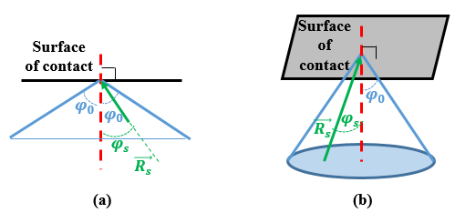
Figure 5.3 Limiting regions for the support reaction for static equilibrium: (a) static friction wedge in 2D and (b) static friction cone in 3D.
For the 3D case, the limiting zone in which $\vec{R_{s}}$ may lie and still maintain static equilibrium under any external load is the static friction cone, which is constructed by rotating a line inclined by $φ_{0}$ with respect to the surface normal. This case is depicted in Figure 5.3b.
We now present several practical examples involving the static friction force. Figure 5.4a shows an athlete pushing a cart full of weights. If the floor and the bottom of the cart were perfectly smooth, a slight effort from the athlete would suffice sufficient to produce motion. The roughness of the contact surfaces determines the coefficient of static friction, and the weight determines the normal reaction force, so the limiting static friction force H₀ increases as the weight increases. This explains why it is difficult to move furniture over rough floors.
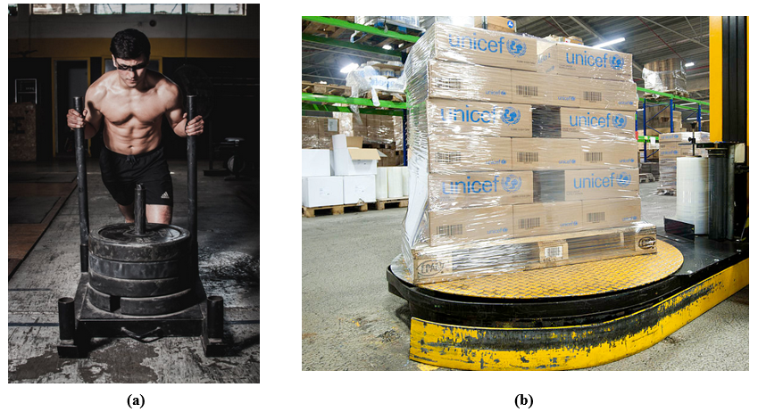
Figure 5.4 Example of static friction force: (a) steel cart on rough floor, (b) loaded wooden palette on rotating metallic platform.
Figure 5.4b shows a second example where a heavy wooden palette carrying many boxes rests on a rotating metallic platform. In absence of friction force, the pallet might slip off the platform.
The static friction force $\vec{H_{s}}$ plays a key role in maintaining the stability of solid bodies. It is responsible for the adherence between the body and its supporting surface. Provided H_{s} is less than H₀, contacting surfaces adhere permanently to each other. Another example is the adherence between car tires and the road, where acceleration is possible on icy roads or an undesired sliding motion may occur.

Sliding motion
Once P exceeds even slightly the limiting static friction force H₀, the friction force drops from H₀ to a lower value H_{k} known as the kinetic friction force or sliding friction force, which also opposes the motion of the block. In that case, the kinetic resultant reaction $\vec{R_{k}}=\vec{H_{k}}+\vec{N}$ forms an angle $φ_{k}$ with the normal to the surface. This angle $φ_{k}=\tan^{-1}{(\frac{H_{k}}{N})}$ is called the angle of kinetic friction
“Kinetic” is a term belonging to the field of kinetics, which analyzes the relationship between motion and its causes.
Figure 5.5 summarizes the theory of dry friction or Coulomb friction H_{s} by showing how the friction force evolves as the external pulling force P increases.
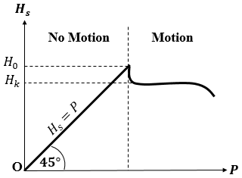
Figure 5.5 Friction force as a function of applied pulling force.

Self-Check Questions
- Specify whether the following statement is True or False and justify your answer.
It is easier to move a package of 60 kg on a horizontal floor with a coefficient of static friction of 0.1 than a package of 30 kg on a horizontal floor with a coefficient of static friction of 0.3. In both cases, N = W (equilibrium in the y direction); however, in the first case, H01=0.1⋅60⋅(9.81)=58.86 N whereas, in the second case, H02=0.3⋅30⋅(9.81)=88.29 N, so $H_{01}<H_{02}$.
- Complete the following sentence:
The resultant reaction at the impending motion of a crate of weight 800 N resting on a support of coefficient of static friction of 0.4 is inclined from the horizontal by 68.2° and has a magnitude of 861.63 N.

5.2 Sliding friction

Characteristics of kinetic-friction force
Referring to Figure 5.5, the kinetic friction force $\vec{H_{k}}$ appears after the impending motion point (i.e., when P goes slightly beyond the limiting static friction force H₀). In this case, the static resultant reaction $\vec{R_{s}}$ exits the static friction wedge in the plane of the static friction cone in space. Static equilibrium is thus broken, and sliding motion begins because the reaction becomes a kinetic reaction $\vec{R_{k}}$.
Unlike the static friction force, the kinetic friction force acts as an active force on the solid working to slow the sliding motion of the body, which tends to overcome the surface contact asperities and maintain the motion. In consequence, the sense of the kinetic friction force is opposite to the sense of the velocity vector $\vec{v}$. Denoting by $\vec{u_{v}}$ the unit vector indicating the direction of $\vec{v}$, one may write
Asperities are a group of discrete spots distributed along a surface due to a pronounced unevenness of the surface.
Hk=-Hkuv. (5.3)
In contrast with the static friction force, one may not assume at random the sense of action in the case of the kinetic friction force. This aspect is emphasized in Figures 5.6a–5.6d.
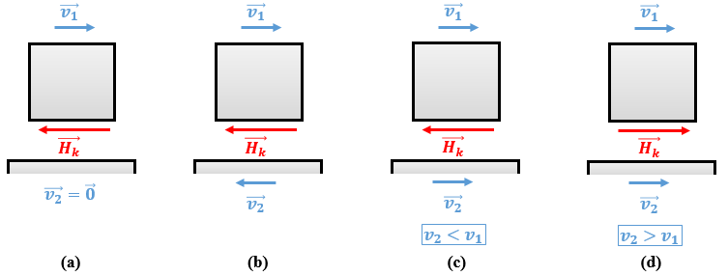
Figure 5.6 Sense of kinetic friction force with respect to relative velocity between contact surfaces: (a) support unmovable, (b) support moving opposite to the body, (c) support moving slower and in the same sense as the body, and (d) support moving faster and in the same sense as the body.
The case of Figure 5.6a is straightforward, but the sense of $\vec{H_{k}}$ in the remaining cases depends on the relative velocity between the support and the body. In each case, the kinetic friction force works to reduce the relative velocity.
The magnitude H_{k} is independent of the velocity of the body. The law of friction established by Coulomb is similar to the static friction force by assigning a proportionality between the kinetic friction H_{k} and the normal N of the support:
Hk=μk⋅N, (5.4)
where μ_{k} is denoted by the coefficient of kinetic friction, which is generally about 15% less than the corresponding coefficient of static friction (Hibbeler, 2010). As in Equation (5.2), the kinetic direction $φ_{k}$ is determined by
φk=atantan-1μk . (5.5)
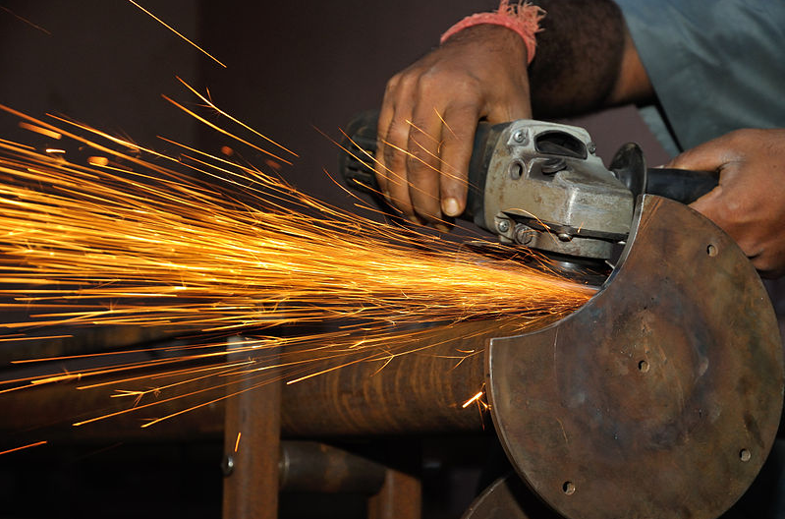
Figure 5.7 Generation of thermal energy in absence of lubricant due to dry kinetic friction force.
If static friction can be beneficial in most cases, “kinetic friction is often undesirable due to the resulting loss in energy. In the contact areas, mechanical energy is converted to thermal energy resulting in a temperature increase” (Gross et al., 2013, p.263). For this reason, lubricating fluids are often used between contact surfaces to decrease the effect of kinetic friction. Figure 5.7 shows the significant heat generated due to dry contact (i.e., when lubricant is completely absent between the polishing disk and the metallic shaft). In contrast, Figure 5.8 shows the effect of a lubricant when cutting metal.
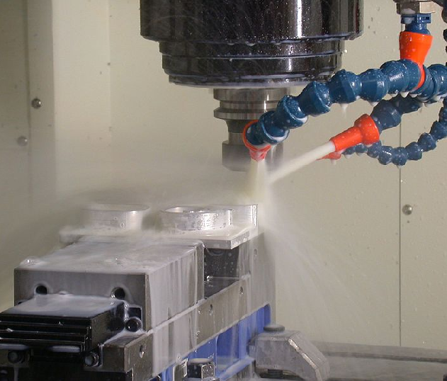
Figure 5.8 Lubrication reduces the thermal energy generated due to kinetic friction.

Application to friction: Contact pulley-belt
In the mechanical and industrial fields, one encounters cases where contact between components is used to generate motion. One such method to transmit power from a motor to an inertial body (such as a fan wheel or turbine) is the system of a pulley and a flat V-belt, as shown in Figure 5.9.
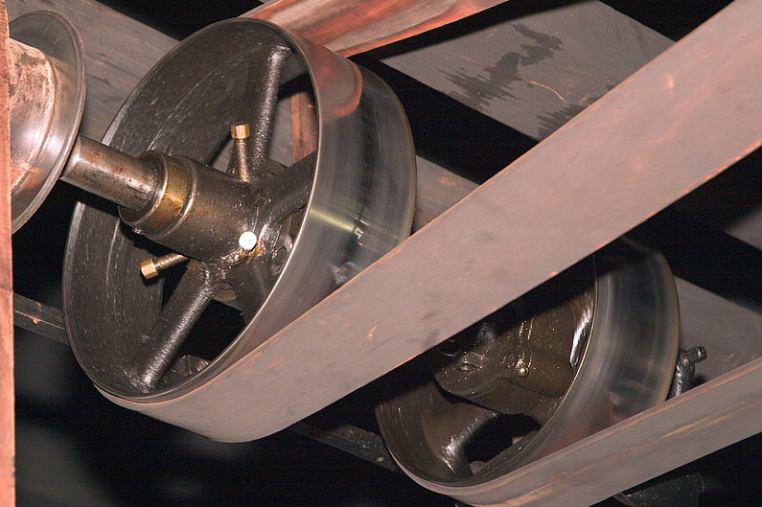
Figure 5.9 Pulley-flat-belt system.
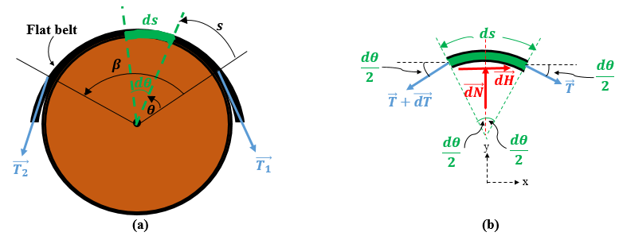
Figure 5.10 (a) Tensile forces acting on a flat belt over a pulley. (b) FBD of a differential belt element.
Figures 5.10a and 5.10b show a mathematical friction analysis of a flat belt stretched over a pulley with tension forces $\vec{T_{1}}$ and $\vec{T_{2}}$ and a FBD of a differential element of length ds of the flat belt (since the reaction distribution over the contact region is not known). $d\vec{N}$ denotes the differential normal force applied by the pulley on the differential element of the flat belt and $d\vec{H}$ denotes the friction force applied by the pulley on the belt element, working to oppose either the impending motion for the static case or the sliding motion for the kinetic case. Thus, dH= μ⋅dN where dH is either H₀ or H_{s} depending on whether the system is in the state of impending motion or sliding. The coefficient μ is μ₀ or μ_{k}, respectively. Applying to the differential element of the flat belt the two equilibrium equations for a particle, considering very small angles so that $\sin{(\frac{dθ}{2})≈\frac{dθ}{2}}$ and $\cos{(\frac{dθ}{2})≈1}$, and neglecting the product of two differential quantities (i.e., dT.dθ≈0), we obtain
Fx=0⇒-dF-Tcosdθ2+(T+dT)cosdθ2=0⇒dN=1μdT,
Fy=0⇒dN-Tsindθ2-(T+dT)sindθ2=0⇒dN=T⋅dθ.
Combining these equations gives
dTT=μdθ,
which shows that the tension in the flat belt is independent of the pulley’s diameter and depends solely on the angular contact surface. Integrating this latter equation requires the limits of the integrals. Referring to Figure 5.10a, the contact surface extends from θ = 0 to θ = β. At these boundaries, the tension force T is respectively T₁ and T₂, so
T1T2dTT=μ0βdθ⇒[lnT]T1T2=μ[θ]0β⇒lnT2T1=μ⋅β.
Exponentiating the left- and right-hand sides gives
T2=T1⋅eμβ, (5.6)
where
T₂ is the tension force in newtons (N) generated in the flat belt under impending motion or sliding motion and acting in the same sense as the relative motion;
T₁ is the tension force in newtons (N) generated in the flat belt under impending motion or sliding motion and acting against the relative motion: T₁ < T₂;
μ is the coefficient of static friction for impending motion or kinetic friction for sliding motion between the contact surfaces and the pulley flat belt;
β is the angular extension of the belt in contact with the pulley and is expressed in radians (rad).
Note. Considering Equation (5.5) under the particular case of impending motion, we deduce that static equilibrium is maintained for $T_{1}e^{-μ_{0}β}≤T_{2}≤T_{1}e^{μ_{0}β}$ while slipping occurs either when $T_{1}e^{-μ_{0}β}≥T_{2}$ or $T_{2}≥T_{1}e^{μ_{0}β}$.
Application 5.1. A wooden crate weighing 300 N rests on a horizontal floor with a coefficient of static friction of 0.2. If a pulling force of 65 N is applied through an inclined attached rope as shown in Figure 5.11, what is its equilibrium status?
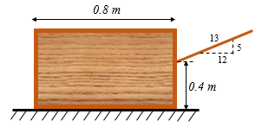
Figure 5.11 Crate pulled by a rope over a rough floor.
Solution 5.1. The FBD of the crate is illustrated in Figure 5.12 and includes the friction force $\vec{H}$ acting against the pulling force.
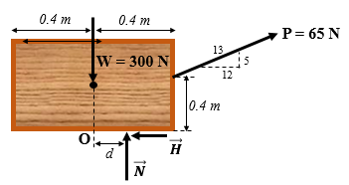
Figure 5.12 FBD of the crate resting on the rough floor under pulling force.
Applying the three equilibrium equations of a rigid body in the plane gives
Fx=0⇒-H+65⋅1213=0⇒H=60 N,
Fy=0⇒N+65⋅513-300=0⇒N=275 N,
M-/O=0⇒275d+65⋅513⋅(0.4)-65⋅1213⋅(0.4)=0⇒d=5.1 cm.
Since the sign of d is positive, the reaction of the floor acts to the right of the central vertical line. Moreover, since d < 40 cm, the reaction acts on a “physical” region of the crate and not outside. This result indicates that no tipping occurs.
The limiting static friction force H0=0.2⋅(275)=55 N. Since H > H₀, the crate does not remain in static equilibrium but slides over the floor.
Application 5.2. A block of mass 20.4 kg rests on a rough incline of coefficient of static friction μ₀ = 0.6 and is held by a cable parallel to the incline and connected to a counterweight of 10.2 kg through a pulley, as shown in Figure 5.13. Determine the interval of the angle α for which the block remains in static equilibrium.
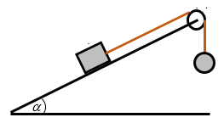
Figure 5.13 Block resting on a rough incline and held by a cable and counterweight.
Solution 5.2. Two possible scenarios may govern this system: Either the tension in the cable is large and overcomes the effect of the weight, in which case the static friction force $\vec{H_{s}}$ acts downward along the incline, or the tension is small and cannot overcome the effect of the weight, in which case the block slips down the incline. The latter case implies the development of a static friction force $\vec{H_{s}}$ acting up the incline to oppose slipping. The FBDs of the block for both scenarios are depicted in Figures 5.14a and 5.14b.
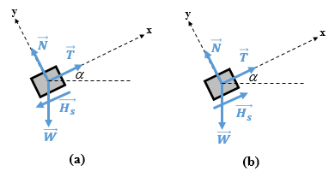
Figure 5.14 FBD of a block on a rough incline when (a) T is large and (b) T is small.
For both cases, the equilibrium along the y axis remains the same:
Fy=0⇒N-Wcosα=0⇒N=200cosα.
For the case of Figure 5.14a, the equilibrium along x axis leads to
Fy=0⇒T-Hs-Wsinα=0⇒Hs=100(1-2sinα).
To keep $H_{s}≥0$, the angle must satisfy: sinα≤12⇒α≤30°.
Static equilibrium persists when Hs≤H0=0.6⋅(200cosα)=120cosα.
Replacing H_{s} in the function of α leads to
$1-2\sin{α}≤1.2\cos{α}$,
1+tan2α≤1.44+4tan2α+4.8tanα,
$3\tan^{2}{α}+4.8\tan{α}+0.44≥0$.
This equation is satisfied for $\tan{α}≤-1.5023$ and $\tan{α}≥-0.0976$. T
he relevant result is satisfied when $α≤30°$.
For the case of Figure 5.b, equilibrium along the x axis leads to
Fy=0⇒T+Hs-Wsinα=0⇒Hs=100(2sinα-1).
To ensure $H_{s}≥0$, the angle must satisfy sinα≥12⇒α≥30°.
Replacing H_{s} in the function of α gives
2sinα-1≤1.2cosα,
$3\tan^{2}{α}-4.8\tan{α}+0.44≥0$.
This equation is satisfied for $\tan{α}≤0.0975$ and $\tan{α}≥1.5023$, which gives $α≤5.57°$ and $α≥56.35°$. Given the condition $α≥30°$, the second solution is retained.
Finally, since the angular interval over which static equilibrium is maintained is from 0° to 56.35°
Application 5.3. A disk of diameter 200 mm pivoted at its center C rotates under a couple of 40 N m. A brake consisting of a 90° arm pinned at O requires a minimum force P = 300 N at its handle to stop the rotation of the disk (see Figure 5.15). Calculate the coefficient of static friction between the disk and the arm. Evaluate also the reactions at the pin O of the brake’s arm.
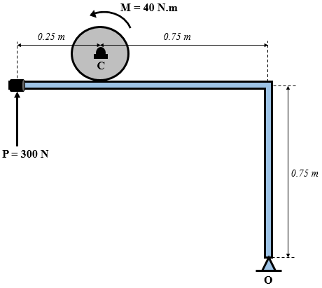
Figure 5.15 Braking system of a rotating disk.
Solution 5.3. Since the couple is moving the disk in a counterclockwise sense of rotation, the arm must apply a braking force that creates a clockwise moment about the center of the disk C with the same magnitude as the applied couple, which leads to a friction force oriented leftwards applied by the arm on the disk. The normal reaction is vertical upwards. Due to the principle of action and reaction, the disk exerts on the arm a force of equal magnitude but opposite in sense. Separating the disk from the arm and drawing the FBD of each give the schemes illustrated in Figure 5.16.

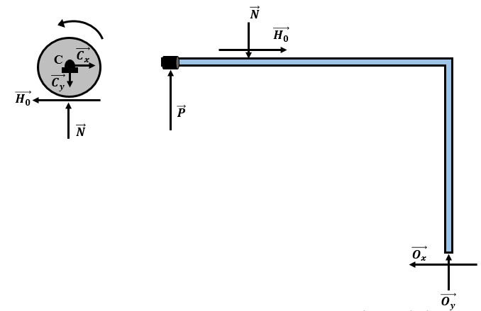
Figure 5.16 FBD of the isolated disk and arm.
Imposing the equilibrium of the disk with respect to rotation about C gives
M-/C=0⇒40-0.1H0=0⇒H0=400 N.
The law of friction gives H0=μ0⋅N⇒N=400μ0.
Using the FBD of the arm and applying the equation of equilibrium of moments about O give
M-/O=0⇒-1)⋅(300-0.75)⋅(400+0.75⋅400μ0=0⇒μ0=0.5,
Fx=0⇒Ox=400 N,
Fy=0⇒Oy+300-800=0⇒Oy=500 N.
Application 5.4. A block is to be lifted at a constant speed by sliding along a rough incline under the effect of a force $\vec{P}$ applied on a belt attached to the block and enrolled around two rough drums A and B, as shown in Figure 5.17. Knowing that the maximum tension sustained by the belt is 400 N and the coefficient of kinetic friction between all contacting surfaces is μ_{k} = 0.1, calculate the maximum mass of the block that could be pulled up the incline.
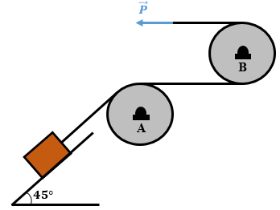
Figure 5.17 System of two drums and a belt to lift a block by sliding.
Solution 5.4. Since the motion is oriented upward, the kinetic friction forces at contact surfaces act downward, meaning that the tension in the belt is increasing from point to point starting from the block, passing by contact points at drum A and finally at drum B. One may then deduce that the highest tension developed in the belt is the lifting force P = 400 N.
Conversely, Figure 5.18 shows the FBD of the isolated block, drum A, and drum B.
At drum B, the contact angle is β_{B} = 180° = π rad, so
400= TBe0.1π⇒TB=4001.3691⇒TB=292.16 N.
At drum A, the contact angle is β_{A} = 45° = π/4 rad, so
292.16= TAe0.1π4⇒TA=292.161.0817⇒TA=270.1 N.

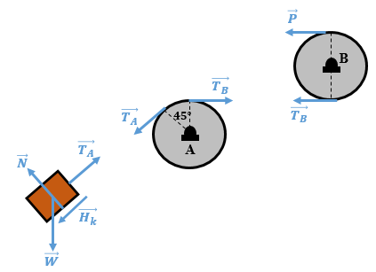
Figure 5.18 FBD of isolated block and drums.
Enforcing the equilibrium of the block with the x axis parallel to the incline and the y axis perpendicular to the incline gives
Fy=0⇒N-Wcos45°=0⇒N=22W,
Fx=0⇒TA-Hk-Wsin45°=0⇒Hk=270.1-22W.
Finally, using the Coulomb law of friction [Equation (5.4)] and replacing N and H_{k} by their expressions in terms of W give
Hk=0.1N⇒270.1-22W=0.1.22W⇒0.7778W=270.1 N,
⇒W=347.26 N.
The maximum mass is: m=347.269.81⇒m=35.4 kg.

Self-Check Questions
- Choose the correct answer.
The minimum horizontal tension in a rope to lift a vertical weight of 250 N around a drum for a coefficient of static friction 0.25 is about
141 N 169 N 183 N 212 N
- Specify whether the following statement is True or False and justify your answer.
A cubic crate of weight W resting on a rough horizontal floor is subjected to a horizontal tensile force of magnitude P exerted at the middle of its vertical side. It will tip if P > W. True, because the weight is exerted effectively at the center of gravity, so the line of action passes through the middle of the horizontal face when the crate is on the floor. Since both forces are half the length of the cube’s sides from each edge of the cube, the sum of moments about this edge vanishes when P = W. If P > W, the moment due to P becomes greater than the moment due to W, so the cube will tip.
- Complete the following sentence:
A particle of weight 120 N moves on a rough incline of 60°. Once the kinetic friction force measures one-third of the weight, the coefficient of kinetic friction between contact surfaces reaches a value of 2/3 while the pulling force, which is parallel to the incline, has a magnitude of 144 N.

5.3 Rolling friction
When an object such as a cylinder, disk, or drum rolls on a flat surface, the contact point changes continuously during the motion. When the materials of both objects and supports are very rigid, the planar support exerts a perpendicular reaction on the rolling solid. However, in practice, there are no indefinitely rigid materials. If the supporting plane is made from a material that is softer than the rolling object, it will deform under the action of the weight of the rolling object, meaning that this latter is “pushed” slightly by the instantaneously deformed shape of the supporting plane. This leads to an inclined reaction $\vec{N}$ exerted on the rolling object that reduces its velocity and, in consequence, a driving force $\vec{P}$ acting on the rolling object is required to overcome the effect of $\vec{N}$and maintain the motion. This phenomenon is depicted in Figure 5.19.
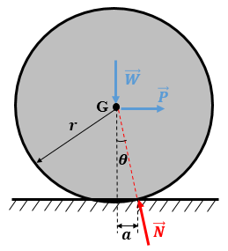
Figure 5.19 Resistance to rolling motion.
The main effect causing the rolling resistance force is thus the deformability of surfaces. The surface roughness and adherence level play a secondary role in this case, in contrast with sliding motion. The condition ensuring the dynamic equilibrium of a rolling object (i.e., constant-velocity motion) is the intersection of $\vec{N}$,$\vec{P}$, and $\vec{W}$ at the center of gravity G in Figure 5.19. Summing the moments of these forces about the point of intersection between $\vec{N}$and the horizontal supporting plane gives W⋅a=P⋅r⋅cosθ at equilibrium. Since the deformations are small, $\cos{θ}≈1$, so
P≈arW. (5.7)
The distance a (in millimeters) is the coefficient of rolling resistance. This coefficient decreases with increasing rigidity of the contacting materials. However, it depends also on the speed of rotation and the surface status. Equation (5.7) explains why, under the same conditions, heavy objects have higher rolling resistance than lighter objects, therefore requiring greater driving force. “Furthermore, since Wa/r is generally small compared to μ_{k}W, the force needed to roll a cylinder over the surface will be much less than that needed to slide it across the surface.” (Hibbeler, 2010, p.435).
Figure 5.20 shows an example of rolling resistance between a cement floor and the relatively soft rubbery wheels of a pallet truck; however, it remains easier to move the package by using the truck than by rolling it directly on the floor (without the wooden pallet) or sliding it with the wooden pallet.
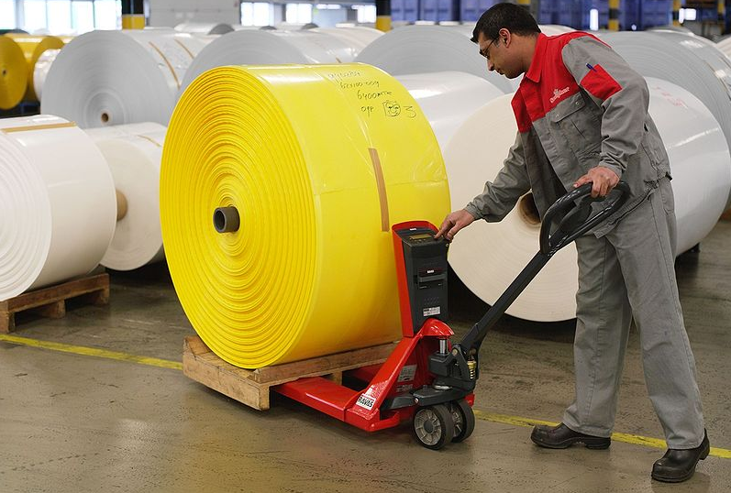
Figure 5.20 Example of rolling resistance between pallet truck wheels and floor.
Figure 5.21a shows a rigid bowling ball rolling on a relatively rigid floor (which explains the high speed of the ball), demonstrating its “easy” rolling motion along its path. Figure 5.21b shows schematically the rolling resistance of a deformable soccer ball over a grass field. The ball may stop after traveling a relatively limited distance.
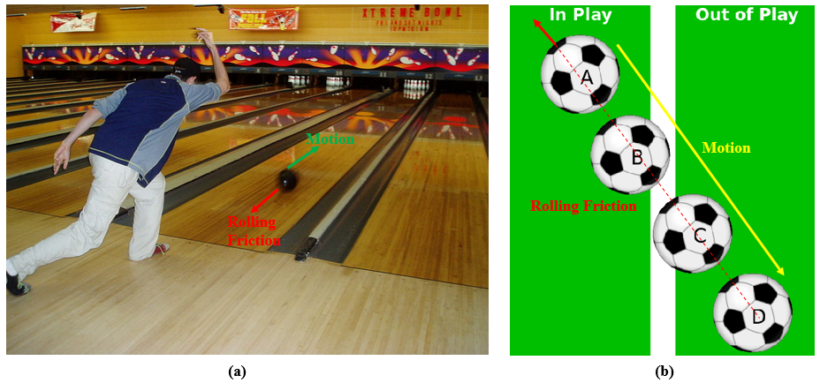
Figure 5.21 Rolling resistance force: (a) low on a bowling floor and (b) high on a grass field.
Finally, Table 5.1 summarizes the differences between sliding and rolling friction.
Table 5.1 Sliding friction vs rolling friction.
Sliding friction | Rolling friction
Two planar contact surfaces between the body and the support | Contact point between a curved rolling body and a flat supporting plane
Occurs due to roughness of contacting surfaces | Occurs due to the deformation of contacting surfaces
The coefficient of kinetic friction depends on (texture) of the surface | The coefficient of rolling friction depends on the hardness of the surface
Formula: Fk=μk⋅N | Formula: P=ar⋅W

Application 5.5. The grass of the lawn is compacted by a 65 kg cylinder rolling at constant velocity thanks to a force P = 90 N acting along the arm AC, as shown in Figure 5.22. Calculate the value of the coefficient of rolling friction.
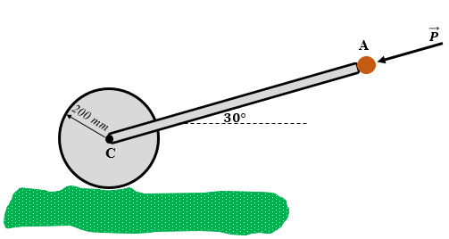
Figure 5.22 Lawn roller overcoming the resistance of grass.
Solution 5.5. The horizontal component $\vec{P_{h}}$ of $\vec{P}$ contributes to overcoming the rolling resistance and its vertical component $\vec{P_{v}}$ increases the effective weight of the roller. The FBD of the cylinder shows the resistance to rolling $\vec{N}$ in Figure 5.23.
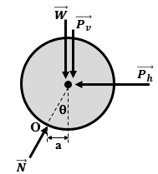
Figure 5.23 FBD of lawn-rolling cylinder.

Ph=P⋅cos30°=90⋅32=78 N,
Pv=P⋅sin30°=90⋅12=45 N,
M-/O=0⇒78⋅200=65)⋅(9.81+45⋅a⇒a=22.85 mm,
θ=asinsin-122.85200=asinsin-1(0.11425)⇒θ=6.56°.

Self-Check Questions
- Choose the correct answer.
A rolling cylinder having the coefficient of rolling resistance a/r = 0.12 may have a coefficient of kinetic friction of
0.09 0.12 0.21 none of the previous answers
2. Complete the following sentence:
A 100 N steel cylinder begins to roll on a wooden incline once the inclination angle reaches 3°. The driving force P = 5.233 N and the ratio a/r is 0.0523.
Summary
When a body rests on a rough surface, the reaction force exerted on the body is generally inclined (i.e., has a normal and a tangential component). This latter component is called the dry friction force or Coulomb friction force. Moreover, the static friction force is defined to have a sufficiently large magnitude to resist the driving force. Although the static friction force increases to maintain the static equilibrium of the body, it cannot increase indefinitely: the limiting static friction force is the maximum possible static friction force before sliding motion starts; a state known as impending motion. The magnitude of the limiting static friction force is proportional to the normal component of the reaction force and the coefficient of proportionality is called the coefficient of static friction, which depends on the roughness of the surfaces making contact. Once the limiting static friction is overcome, the frictional force decreases slightly to a value known as the kinetic friction force. Kinetic friction opposes the sliding motion generated by the driving active force and is also proportional to the normal component of the normal reaction, with the coefficient of proportionality being the coefficient of kinetic friction.
A flat belt passing over a rough pulley generates a tensile force on one side of the belt. This tensile force exceeds the friction with the pulley plus the tensile force on the opposite side of the pulley, with the tensile force depending exponentially on the coefficient of friction and depending on the angular contact between the pulley and the flat belt.
When a solid rolls on a relatively soft surface, the deformation of the latter produces an inclined reaction force known as the rolling resistance force. A driving force is thus required to overcome the rolling resistance and maintain the motion. The driving force is proportional to the weight of the roller and the horizontal distance separating the line of action of the weight from the point of application of the resistance force. This distance is called the coefficient of rolling resistance.

Appendix 1 – References
Alphabetical order
Ammodramus. (2011). Keya Paha river lowest bridge in Boyd Country, Nebraska [Illustration]. Wikimedia Commons. https://commons.wikimedia.org/wiki/File:Keya_Paha_River_lowest_bridge_upper_truss_1.JPG
Ardho, L. (2018). Man pushing cart with weight plates [Illustration]. Pexels. https://www.pexels.com/photo/man-pushing-cart-with-weight-plates-1552104/
Beer, F.P., Johnston, E.R.Jr., & Eisenberg, E.R. (2012). Vector Mechanics for Engineers. Statics. McGraw Hill.
Bidgee. (2010). Dead end riser poles [Illustration]. Wikimedia Commons. https://commons.wikimedia.org/wiki/File:Dead_end_riser_poles.jpg
Caronna Heinz, S. (2008). Kreuzschlüssel [Illustration]. Wikimedia Commons. https://commons.wikimedia.org/wiki/File:Kreuzschl%C3%BCssel.jpg
Cjp24. (2009). Three-point flexural test on a composite beam using Instron conventional machine [Illustration]. Wikimedia Commons. https://commons.wikimedia.org/wiki/File:Three_point_flexural_test.jpg
Collard, L. (2010). Rover V8 engine [Illustration]. Wikimedia Commons. https://commons.wikimedia.org/wiki/File:Rover_V8_engine.jpg
Does E. (2015). Steering wheel [Illustration]. Wikimedia Commons. https://commons.wikimedia.org/wiki/File:Steering_wheel.svg
Feola. (2008). Example of torque [Illustration]. Wikimedia Commons. https://commons.wikimedia.org/wiki/File:Aula_torcao.JPG
Fmiser. (2012). Diagram of a Parker truss as used in bridge construction [Illustration]. Wikimedia Commons. https://commons.wikimedia.org/wiki/File:Parker-truss.svg
Foresman, P.S. (2007). Block and tackle system [Illustration]. Wikimedia Commons. https://commons.wikimedia.org/wiki/File:Block_and_tackle_(PSF).png
Ganguly, B. (2012). Grinding sparks – Kolkata [Illustration]. Wikimedia Commons. https://commons.wikimedia.org/wiki/File:Grinding_Sparks_-_Kolkata_2011-11-26_7427.JPG
GreenMeansGo. (2018). Bow-string-truss [Illustration]. Wikimedia Commons. https://commons.wikimedia.org/wiki/File:Bow-string-truss.jpg
Griffen-Commons-Wiki. (2006). Scania front loader [Illustration]. Wikimedia Commons. https://commons.wikimedia.org/wiki/File:Scaniafrontloader.JPG
Gross, D., Hauger, W., Schröder, J., Wall, W.A., & Rajapakse, N. (2013). Engineering Mechanics I. Statics. Springer.
Halliday, D., Resnick, R., & Walker, J. (2021). Fundamentals of Physics. Wiley.
Heb. (2011). Pallet wrapper [Illustration]. Wikimedia Commons. https://commons.wikimedia.org/wiki/File:Pallet_wrapper.jpg
Henderson, J. (2010). Swedish cottage after snow [Illustration]. Wikimedia Commons. https://en.wikipedia.org/wiki/File:Swedish_cottage_CP_snow_jeh.JPG
Hibbeler, R.C. (2010). Engineering Mechanics. Statics. Prentice Hall.
Hibbeler, R.C. (2011). Mechanics of Materials. Prentice Hall.
Jelson 25. (2006). A car being loaded onto a flatbed tow truck [Illustration]. Wikimedia Commons. https://commons.wikimedia.org/wiki/File:Flat_Bed_Tow_Truck.jpg
Jmk7. (2012). Oxygen-Process Steel Making Vessel McLouth Steel Products Corporation [Illustration]. Wikimedia Commons. https://commons.wikimedia.org/wiki/File:Oxygen-Process_Steel-Making_Vessel.jpg
KdYpUvMgT. (2008). Illustration of the right-hand rule for the cross product [Illustration]. Wikimedia Commons. https://commons.wikimedia.org/wiki/File:Right_hand_rule_cross_product.svg
Lindecke, C. (2008). Pillow block bearing UCP [Illustration]. Wikimedia Commons. https://commons.wikimedia.org/wiki/File:Stehlager.png
Lokilech. (2007). Kran in Dillingen/Saar [Illustration]. Wikimedia Commons. https://commons.wikimedia.org/wiki/File:Dillingen_Kran.jpg
Mack, B. (2020). Girl opening door of wooden house near tree [Ilustration].Pexels. https://www.pexels.com/photo/girl-opening-door-of-wooden-house-near-tree-5707671/
Mckechnie, G. (2005). Milling Machine [Illustration]. Wikimedia Commons. https://commons.wikimedia.org/wiki/File:Makino-S33-MachiningCenter-example.jpg
Monstera. (2020). Book with white hard cover on table [Illustration]. Pexels. https://www.pexels.com/photo/book-with-white-hard-cover-on-table-6373305/
Mormegil. (2007). Ten-pin Bowler releasing the ball [Illustration]. Wikimedia Commons. https://commons.wikimedia.org/wiki/File:Bowlerbowling.JPG
MoSchle. (2013). Kleines Mädchen auf Gartenschaukel [Illustration]. Wikimedia Commons. https://commons.wikimedia.org/wiki/File:MoSchaukel.jpg
OgreBot. (2016). A ball joint and a cross-section of one [Illustration]. Wikimedia Commons. https://commons.wikimedia.org/wiki/File:Ball_joint_cross_section_(from_English_Wikipedia_to_be_used_in_other_languages).jpg
PeeJay2K3. (2012). Diagram demonstrating the ball in and out of play in football association [Illustration]. Wikimedia Commons. https://commons.wikimedia.org/wiki/File:Ball_in_and_out_of_play_2.svg
Perhelion. (2017). Thumb-up icon [Illustration]. Wikimedia Commons. https://fr.m.wikipedia.org/wiki/Fichier:Thumbs_up_icon.svg#
Ponderevo, G. (2012). Simplified schematic of a typical timber roof structure [Illustration]. Wikimedia Commons. https://commons.wikimedia.org/wiki/File:Roof_parts_simplified.svg
Pratheeps. (2006).Symbol thumbs down [Illustration]. Wikimedia Commons. https://commons.wikimedia.org/wiki/File:Symbol_thumbs_down.svg
Ross, J. (2007). "Red Barns Spectacular" car show at the Gilmore Car Museum, Hickory Corners, Michigan [Illustration]. Wikimedia Commons. https://commons.m.wikimedia.org/wiki/File:Mid_50%27s_GMC_pickup_pulling_1930%27s_house_trailer_(1144507758).jpg
Sonarpulse. (2009). Silhouette of a car [Illustration]. Wikimedia Commons. https://commons.wikimedia.org/wiki/File:Car.svg
Soramimi. (2020). Overhead line tensioner near Kyusandai-mae station [Illustration]. Wikimedia Commons. https://commons.wikimedia.org/wiki/File:Overhead_line_tensioner_near_Kyusandai-mae_Station.jpg
Thirdman. (2018). Two Globes and Book on Wooden Table [Illustration]. Pexels. https://www.pexels.com/photo/two-globes-and-book-on-wooden-table-8926540/
Ukexpat. (2009). Belt drive power delivery mechanism, machine shop, Hagley Museum [Illustration]. Wikimedia Commons. https://commons.wikimedia.org/wiki/File:HagleyBeltDrive01.jpg
Viinamäki, S. (2017). Door closer [Illustration]. Wikimedia Commons. https://commons.wikimedia.org/wiki/File:Door_closer_20170214.jpg
Wilfredor. (2011). Crossing the bridge over Maracaibo lake [Illustration]. Wikimedia Commons. https://commons.wikimedia.org/wiki/File:Crossing_the_bridge_over_Maracaibo_Lake.jpg
Wikiaanvullen. (2009). Wegende palletwagen of pallettruck bron [Illustration]. Wikimedia Commons. https://commons.wikimedia.org/wiki/File:Wegende_pallettruck.jpg

Appendix 2 – List of Tables and Figures
Table 1.1 Prefixes of SI Units
Source: Challita (2021).
--------------------------------------------------------------------------------------
Figure 1.1 Cars crossing bridge over Maracaibo lake (Venezuela).
Source: Wilfredor (2011). CC BY-SA 3.0.
--------------------------------------------------------------------------------------
Figure 1.2 Pickup truck pulling a house trailer
Source: Ross (2007). CC BY-SA 2.0.
--------------------------------------------------------------------------------------
Figure 1.3 Particle subjected to a balanced-force system.
Source: Challita (2021).
--------------------------------------------------------------------------------------
Figure 1.4 Particle accelerated due to the application of a resultant force.
Source: Challita (2021).
--------------------------------------------------------------------------------------
Figure 1.5 (a) Car pulled forward on a winch, (b) car accelerating before reaching the winch, (c) car moving forward at a constant velocity.
Source: Jelson25 (2006).Public Domain; Sonarpulse (2009). CC BY-SA 3.0.
--------------------------------------------------------------------------------------
Figure 1.6 Principle of action and reaction.
Source: Challita (2021).
--------------------------------------------------------------------------------------
Figure 1.7 A book resting on a table demonstrates the principle of action and reaction.
Source: Monstera (2020). CC0.
--------------------------------------------------------------------------------------
Figure 1.8 Representation of a vector.
Source: Challita (2021).
--------------------------------------------------------------------------------------
Figure 1.9 Representation of a position vector.
Source: Challita (2021).
--------------------------------------------------------------------------------------
Figure 1.10 (a) Worker lifting a crate via a pulley and cables system, (b) representation of force exerted by the worker on the cable.
Source: Foresman (2007).Public Domain; Challita (2021).
--------------------------------------------------------------------------------------
Figure 1.11 Tension of a cable as an example of concentrated force.
Source: Challita (2021).
--------------------------------------------------------------------------------------
Figure 1.12 Weight of a body as an example of distributed load per unit volume.
Source: Challita (2021).
--------------------------------------------------------------------------------------
Figure 1.13 Table holding a book and resting on the floor showing (a) external forces and (b) internal forces.
Source: Challita (2021).
--------------------------------------------------------------------------------------
Figure 1.14 Geometric representation of multiplication and division of a vector by a scalar.
Source: Challita (2021).
--------------------------------------------------------------------------------------
Figure 1.15 Right-hand rule applied to cross product of vectors.
Source: KdYpUvMgT (2008). CC BY-SA 3.0.
--------------------------------------------------------------------------------------
Figure 1.16 Graphical vector addition.
Source: Challita (2021).
--------------------------------------------------------------------------------------
Figure 1.17 Graphical vector subtraction.
Source: Challita (2021).
--------------------------------------------------------------------------------------
Figure 1.18 Resultant of two concurrent forces.
Source: Challita (2021).
--------------------------------------------------------------------------------------
Figure 1.19 Triangle ABC showing notation used in Equations (1.8) and (1.9).
Source: Challita (2021).
--------------------------------------------------------------------------------------
Figure 1.20 Resultant force due to tension in cables of a crane system.
Source: Lokilech (2007). CC BY-SA 3.0.
--------------------------------------------------------------------------------------
Figure 1.21 Construction of resultant force equivalent to multiple concurrent forces.
Source: Challita (2021).
--------------------------------------------------------------------------------------
Figure 1.22 2D decomposition of a force in (a) an arbitrary frame of reference and (b) an orthonormal frame of reference.
Source: Challita (2021).
--------------------------------------------------------------------------------------
Figure 1.23 3D decomposition of a force using (a) the cosine directions and (b) the intermediate directions
Source: Challita (2021).
--------------------------------------------------------------------------------------
Figure 1.24 Parallelogram law for Solution 1.4.
Source: Challita (2021).
--------------------------------------------------------------------------------------
Figure 1.25 Two concurrent forces and the resultant force in a Cartesian reference frame.
Source: Challita (2021).
--------------------------------------------------------------------------------------
Figure 1.26 Resultant force from two concurrent forces in a 3D Cartesian reference frame.
Source: Challita (2021).
--------------------------------------------------------------------------------------
Figure 2.1 (a) Engine hanging from chains. (b) FBD of the engine. (c) Vector diagram of equilibrium.
Source: Collard (2010).Public Domain; Challita (2021).
--------------------------------------------------------------------------------------
Figure 2.2 (a) Girl sitting on a swing in equilibrium. (b) FBD for the girl as the system. (c) Vector force diagram showing equilibrium of the girl. (d) FBD for the girl and her seat as the system. Vector force diagram showing equilibrium of the girl and the seat as the system.
Source: MoSchle (2013).Public Domain; Challita (2021).
--------------------------------------------------------------------------------------
Figure 2.3 Particle in space subjected to three forces.
Source: Challita (2021).
--------------------------------------------------------------------------------------
Figure 2.4 Block held motionless on an incline by a rope.
Source: Challita (2021).
--------------------------------------------------------------------------------------
Figure 2.5 FBD of (a) block B, (b) the pulley P, and (c) the counterweight C.
Source: Challita (2021).
--------------------------------------------------------------------------------------
Figure 2.6 Particle held by two ropes in a plane.
Source: Challita (2021).
--------------------------------------------------------------------------------------
Figure 2.7 FBD of a particle held by two ropes in the plane.
Source: Challita (2021).
--------------------------------------------------------------------------------------
Figure 2.8 Particle O held in space by cables and spring.
Source: Challita (2021).
--------------------------------------------------------------------------------------
Figure 2.9 FBD of a particle held by cables and a spring in space.
Source: Challita (2021).
--------------------------------------------------------------------------------------
Figure 2.10 Application of a couple to unscrew tire nuts.
Source: Caronna (2008). CC BY-SA 3.0.
--------------------------------------------------------------------------------------
Figure 2.11 11 (a) Tightening a screw, (b) moment (or torque) exerted on screwdriver, (c) scheme of couple, sense of rotation, and vector moment.
Source: Feola (2008).CC BY-SA 4.0 (Intl), 3.0 (Unp), 2.5, 2.0, 1.0 (Gen); Perhelion (2017). CC BY-SA 4.0; Challita (2021).
--------------------------------------------------------------------------------------
Figure 2.12 Rotation of a steering wheel by a couple.
Source: Does (2015). CC0 1.0.
--------------------------------------------------------------------------------------
Figure 2.13 Determination of the vector moment exerted on the steering wheel.
Source: Challita (2021).
--------------------------------------------------------------------------------------
Figure 2.14 Body subjected to three couples.
Source: Challita (2021).
--------------------------------------------------------------------------------------
Figure 2.15 Original and equivalent couple applied to a solid.
Source: Challita (2021).
--------------------------------------------------------------------------------------
Figure 2.16 (a) Illustration of the moment of a force about a point. (b) Right-hand rule to find the sense of the moment.
Source: Challita (2021); Pratheeps (2006). Public Domain; KdYpUvMgT (2008). CC BY-SA 3.0.
--------------------------------------------------------------------------------------
Figure 2.17 Principle of transmissibility keeping an unchanged moment about a point.
Source: Challita (2021).
--------------------------------------------------------------------------------------
Figure 2.18 Equivalent schemes for constructing the moment of a force about a point.
Source: Challita (2021).
--------------------------------------------------------------------------------------
Figure 2.19 (a) Opening a door. (b) Mechanical scheme for opening the door.
Source: Mack (2020).CC0; Challita (2021).
--------------------------------------------------------------------------------------
Figure 2.20 Application of a force to cause rotation about an axis.
Source: Challita (2021).
--------------------------------------------------------------------------------------
Figure 2.21 Vector diagram of solution of application 2.7.
Source: Challita (2021).
--------------------------------------------------------------------------------------
Figure 2.22 Bar prevented from rotating.
Source: Challita (2021).
--------------------------------------------------------------------------------------
Figure 2.23 Visualization of the three components of the moment vector.
Source: Challita (2021).
--------------------------------------------------------------------------------------
Figure 2.24 Resultant force for parallel forces: (a) concentrated, (b) distributed.
Source: Challita (2021).
--------------------------------------------------------------------------------------
Figure 2.25 Table subjected to a system of parallel, concentrated forces.
Source: Thirdman (2018). CC0.
--------------------------------------------------------------------------------------
Figure 2.26 Roof subjected to distributed parallel load.
Source: Henderson (2010). CC0 1.0.
--------------------------------------------------------------------------------------
Figure 2.27 Application to components of moment vector.
Source: Challita (2021).
--------------------------------------------------------------------------------------
Figure 2.28 Vector representation of the moment about A.
Source: Challita (2021).
--------------------------------------------------------------------------------------
Figure 2.29 Application involving parallel concentrated forces
Source: Challita (2021).
--------------------------------------------------------------------------------------
Figure 2.30 Resultant force produced by parallel concentrated forces of Figure 2.29.
Source: Challita (2021).
--------------------------------------------------------------------------------------
Figure 2.31 Linearly distributed parallel load.
Source: Challita (2021).
--------------------------------------------------------------------------------------
Figure 2.32 Resultant of the linearly distributed parallel load shown in Figure 2.31.
Source: Challita (2021).
--------------------------------------------------------------------------------------
Figure 2.33 Pen held at its center of gravity by a strap.
Source: Challita (2021).
--------------------------------------------------------------------------------------
Figure 2.34 Center of gravity of a body (a) in a direct reference frame and (b) in a rotated reference frame.
Source: Challita (2021).
--------------------------------------------------------------------------------------
Figure 2.35 Center of mass of a body.
Source: Challita (2021).
--------------------------------------------------------------------------------------
Figure 2.36 Cone with a variable density.
Source: Challita (2021).
--------------------------------------------------------------------------------------
Figure 2.37 Differential element from a cone.
Source: Challita (2021).
--------------------------------------------------------------------------------------
Figure 2.38 Composite plate with unknown center of gravity.
Source: Challita (2021).
--------------------------------------------------------------------------------------
Figure 2.39 Partitioned composite plate from Figure 2.38.
Source: Challita (2021).
--------------------------------------------------------------------------------------
Table 2.1 Summary of results for composite plate of Figure 2.38.
Source: Challita (2021).
--------------------------------------------------------------------------------------
Figure 2.40 Cube to be kept in equilibrium.
Source: Challita (2021).
--------------------------------------------------------------------------------------
Figure 2.41 Frame in equilibrium while subjected to parallel forces.
Source: Challita (2021).
--------------------------------------------------------------------------------------
Figure 2.42 Planar equilibrium of a rigid body.
Source: Challita (2021).
--------------------------------------------------------------------------------------
Figure 2.43 Moment of a force about three points lying on a straight line.
Source: Challita (2021).
--------------------------------------------------------------------------------------
Figure 2.44 (a) Cable supporting a member in the plane. (b) Reactive force supplied by the cable.
Source: Challita (2021).
--------------------------------------------------------------------------------------
Figure 2.45 a) Rigid link in the plane. (b) Reaction force exerted by rigid link on member.
Source: Challita (2021).
--------------------------------------------------------------------------------------
Figure 2.46 (a) Roller support in the plane. (b) Reaction force exerted by roller on member.
Source: Challita (2021).
--------------------------------------------------------------------------------------
Figure 2.47 (a) Rocker support in the plane. (b) Reaction force exerted by rocker on member.
Source: Challita (2021).
--------------------------------------------------------------------------------------
Figure 2.48 (a) Smooth surface support in the plane. (b) Reaction force exerted by smooth supporting.
Source: Challita (2021).
--------------------------------------------------------------------------------------
Figure 2.49 (a) Slotted roller support in the plane. (b) Slotted roller reaction force.
Source: Challita (2021).
--------------------------------------------------------------------------------------
Figure 2.50 (a) Sliding pinned collar support in the plane. (b) Reaction force of sliding pinned collar.
Source: Challita (2021).
--------------------------------------------------------------------------------------
Figure 2.51 (a) Sliding fixed collar support in the plane, (b) sliding fixed collar reaction components.
Source: Challita (2021).
--------------------------------------------------------------------------------------
Figure 2.52 (a) Pin support in the plane. (b) Components of pin reaction force.
Source: Challita (2021).
--------------------------------------------------------------------------------------
Figure 2.53 (a) Fixed support in the plane, (b) fixed support reaction components.
Source: Challita (2021).
--------------------------------------------------------------------------------------
Table 2.2 Supports types and reactions for 2D rigid bodies.
Source: Challita (2021).
--------------------------------------------------------------------------------------
Figure 2.54 (a) Cable support in space, (b) cable reaction force.
Source: Challita (2021).
--------------------------------------------------------------------------------------
Figure 2.55 (a) Smooth plane support in 3D space, (b) smooth plane reaction force.
Source: Challita (2021).
--------------------------------------------------------------------------------------
Figure 2.56 (a) Roller support in 3D space, (b) roller reaction force.
Source: Challita (2021).
--------------------------------------------------------------------------------------
Figure 2.57 (a) Ball and socket support in 3D space, (b) ball and socket reaction components.
Source: Challita (2021).
--------------------------------------------------------------------------------------
Figure 2.58 (a) Single circular journal bearing in 3D space, (b) single circular journal bearing reaction components.
Source: Challita (2021).
--------------------------------------------------------------------------------------
Figure 2.59 (a) Single square journal bearing in 3D space, (b) Single square journal bearing reaction components.
Source: Challita (2021).
--------------------------------------------------------------------------------------
Figure 2.60 (a) Single thrust bearing in 3D space, (b) single thrust bearing reaction components.
Source: Challita (2021).
--------------------------------------------------------------------------------------
Figure 2.61 (a) Pin support in the space, (b) pin reaction components.
Source: Challita (2021).
--------------------------------------------------------------------------------------
Figure 2.62 (a) Hinge support in 3D space, (b) hinge reaction components.
Source: Challita (2021).
--------------------------------------------------------------------------------------
Figure 2.63 (a) Fixed support in 3D space, (b) fixed-support reaction components.
Source: Challita (2021).
--------------------------------------------------------------------------------------
Table 2.3 Supports types and reactions for 3D rigid bodies.
Source: Challita (2021).
--------------------------------------------------------------------------------------
Figure 2.64 Reaction force (tensile) of a chain.
Source: Soramimi (2020). CC BY-SA 4.0.
--------------------------------------------------------------------------------------
Figure 2.65 Reaction force exerted by door-groom link.
Source: Viinamäki (2017). CC BY-SA 4.0.
--------------------------------------------------------------------------------------
Figure 2.66 Reaction forces exerted by two rollers on a bar during bending test.
Source: Cjp24 (2009).CC BY-SA 3.0 (Unp), 2.5, 2.0, 1.0 (Gen).
--------------------------------------------------------------------------------------
Figure 2.67 Metallic bars connected by pins.
Source: GreenMeansGo (20189).CC BY-SA 3.0 (Unp), 2.5 (Gen).
--------------------------------------------------------------------------------------
Figure 2.68 Application of pins for to articulate lift arms.
Source: Griffen-Commons-Wiki (2006). CC BY-SA 3.0.
--------------------------------------------------------------------------------------
Figure 2.69 Special thrust bearing.
Source: Lindecke (2008). CC BY-SA 3.0.
--------------------------------------------------------------------------------------
Figure 2.70 Special ball-and-socket bearing.
Source: OgreBot (2016). Public Domain.
--------------------------------------------------------------------------------------
Figure 2.71 Poles cantilevered to the ground.
Source: Bidgee (2010). CC BY-SA 2.5.
--------------------------------------------------------------------------------------
Figure 2.72 Fixed supported beam loaded in the plane.
Source: Challita (2021).
--------------------------------------------------------------------------------------
Figure 2.73 FBD of fixed supported beam under planar loading.
Source: Challita (2021).
--------------------------------------------------------------------------------------
Figure 2.74 Loaded 2D bar supported by a pin and a cable.
Source: Challita (2021).
--------------------------------------------------------------------------------------
Figure 2.75 FBD of bar AB.
Source: Challita (2021).
--------------------------------------------------------------------------------------
Figure 2.76 3D loaded plate supported by a hinge and a cable.
Source: Challita (2021).
--------------------------------------------------------------------------------------
Figure 2.77 FBD of the square plate.
Source: Challita (2021).
--------------------------------------------------------------------------------------
Figure 2.78 Statically determinate structure.
Source: Challita (2021).
--------------------------------------------------------------------------------------
Figure 2.79 Statically indeterminate structure.
Source: Challita (2021).
--------------------------------------------------------------------------------------
Figure 2.80 Unstable structure supported by three rollers.
Source: Challita (2021).
--------------------------------------------------------------------------------------
Figure 2.81 Unstable structure supported by four rollers.
Source: Challita (2021).
--------------------------------------------------------------------------------------
Figure 2.82 Unstable structure supported by a pin and a roller.
Source: Challita (2021).
--------------------------------------------------------------------------------------
Figure 2.83 3D-loaded arm supported by a ball and socket and a link.
Source: Challita (2021).
--------------------------------------------------------------------------------------
Figure 2.84 FBD of the 3D arm.
Source: Challita (2021).
--------------------------------------------------------------------------------------
Figure 2.85 2D loaded arm supported by a pin and a fixed collar.
Source: Challita (2021).
--------------------------------------------------------------------------------------
Figure 2.86 FBD of the 2D arm.
Source: Challita (2021).
--------------------------------------------------------------------------------------
Figure 2.87 Loaded beam supported by a pin and a roller.
Source: Challita (2021).
--------------------------------------------------------------------------------------
Figure 2.88 FBD of a loaded beam in the plane supported by a pin and a roller.
Source: Challita (2021).
--------------------------------------------------------------------------------------
Figure 3.1 Triangular planar truss making up part of a spatial truss of a bridge.
Source: Ammodramus (2010). CC0 1.0.
--------------------------------------------------------------------------------------
Figure 3.2 Triangular planar truss part of a whole spatial truss of a roof.
Source: Pondereva (2012). CC BY-SA 3.0.
--------------------------------------------------------------------------------------
Figure 3.3 Simple truss.
Source: Fmiser (2012). CC BY-SA 3.0.
--------------------------------------------------------------------------------------
Figure 3.4 Compound trusses constructed with method (a) 1 and (b) 2.
Source: Challita (2021).
--------------------------------------------------------------------------------------
Figure 3.5 FBD of an isolated bar from a truss.
Source: Challita (2021).
--------------------------------------------------------------------------------------
Figure 3.6 Two-force member under either tension or compression.
Source: Challita (2021).
--------------------------------------------------------------------------------------
Figure 3.7 (a) Simple truss under external loading, (b) FBD of joint G, (c) FBD of joint C.
Source: Challita (2021).
--------------------------------------------------------------------------------------
Figure 3.8 FBD of the whole truss ABCDEFG.
Source: Challita (2021).
--------------------------------------------------------------------------------------
Figure 3.8a: FBD of joint A.
Source: Challita (2021).
--------------------------------------------------------------------------------------
Figure 3.8b: FBD of joint B.
Source: Challita (2021).
--------------------------------------------------------------------------------------
Figure 3.8c: FBD of joint E.
Source: Challita (2021).
--------------------------------------------------------------------------------------
Figure 3.8d: FBD of joint F.
Source: Challita (2021).
--------------------------------------------------------------------------------------
Figure 3.8e: FBD of joint D.
Source: Challita (2021).
--------------------------------------------------------------------------------------
Figure 3.9 Planar compound triangular truss supported by a pin and a roller.
Source: Challita (2021).
--------------------------------------------------------------------------------------
Figure 3.9a: FBD of joint D.
Source: Challita (2021).
--------------------------------------------------------------------------------------
Figure 3.9b: FBD of joint C.
Source: Challita (2021).
--------------------------------------------------------------------------------------
Figure 3.9c: FBD of joint F.
Source: Challita (2021).
--------------------------------------------------------------------------------------
Figure 3.9d: FBD of joint B.
Source: Challita (2021).
--------------------------------------------------------------------------------------
Figure 3.9e: FBD of joint A.
Source: Challita (2021).
--------------------------------------------------------------------------------------
Figure 3.10 (a) Section m-m through truss in equilibrium, and (b) an isolated portions (either left or right).
Source: Challita (2021).
--------------------------------------------------------------------------------------
Figure 3.11 Simple truss ABCDEFG supported by a pin and rocker.
Source: Challita (2021).
--------------------------------------------------------------------------------------
Figure 3.12 FBD of the entire truss with two sections a-a and b-b.
Source: Challita (2021).
--------------------------------------------------------------------------------------
Figure 3.13 (a) Isolated left portion from cut a-a of Figure 3.12 and (b) isolated right portion from cut b-b of Figure 3.12.
Source: Challita (2021).
--------------------------------------------------------------------------------------
Figure 3.14 (a) Deformable body in equilibrium subjected to n external forces. (b) Virtual unit force applied at a point on the body.
Source: Challita (2021).
--------------------------------------------------------------------------------------
Figure 3.15 Uniform rod under axial force modeled by a linear spring.
Source: Challita (2021).
--------------------------------------------------------------------------------------
Figure 3.11a: FBD of joint C.
Source: Challita (2021).
--------------------------------------------------------------------------------------
Figure 3.11b: FBD of joint A.
Source: Challita (2021).
--------------------------------------------------------------------------------------
Figure 3.11c: FBD of joint G.
Source: Challita (2021).
--------------------------------------------------------------------------------------
Figure 3.16 Virtual unit force applied to simple truss.
Source: Challita (2021).
--------------------------------------------------------------------------------------
Figure 3.16a: FBD of joint A.
Source: Challita (2021).
--------------------------------------------------------------------------------------
Figure 3.16b: FBD of joint B.
Source: Challita (2021).
--------------------------------------------------------------------------------------
Table 3.1 Data summary of truss in Figure 3.11.
Source: Challita (2021).
--------------------------------------------------------------------------------------
Figure 3.17 Simple truss ABCD supported by a pin and a roller.
Source: Challita (2021).
--------------------------------------------------------------------------------------
Figure 3.18 (a) FBD of entire truss under real load, (b) virtual force, and (c) section with upper portion kept.
Source: Challita (2021).
--------------------------------------------------------------------------------------
Figure 3.18a: FDB of joint C.
Source: Challita (2021).
--------------------------------------------------------------------------------------
Figure 4.1 1 Centroid of a (a) volume, (b) area, and (c) line.
Source: Challita (2021).
--------------------------------------------------------------------------------------
Figure 4.2 Example of a composite area.
Source: Challita (2021).
--------------------------------------------------------------------------------------
Figure 4.3 Metallic vessel as an example of a composite volume.
Source: Jmk7 (2009). CC BY-SA 3.0.
--------------------------------------------------------------------------------------
Figure 4.4 Solid hemisphere.
Source: Challita (2021).
--------------------------------------------------------------------------------------
Figure 4.5 Differential volumetric element for a hemisphere.
Source: Challita (2021).
--------------------------------------------------------------------------------------
Figure 4.6 Nonuniform area delimited by a curve.
Source: Challita (2021).
--------------------------------------------------------------------------------------
Figure 4.7 Differential thin element parallel to (a) y axis and (b) to x axis.
Source: Challita (2021).
--------------------------------------------------------------------------------------
Figure 4.8 Bent metallic rod.
Source: Challita (2021).
--------------------------------------------------------------------------------------
Figure 4.9 Linear differential element of a rod.
Source: Challita (2021).
--------------------------------------------------------------------------------------
Figure 4.10 Compound bent rod.
Source: Challita (2021).
--------------------------------------------------------------------------------------
Figure 4.11 Differential linear element for a semicircular rod.
Source: Challita (2021).
--------------------------------------------------------------------------------------
Figure 4.12 Centroids of different parts of a composite line.
Source: Challita (2021).
--------------------------------------------------------------------------------------
Table 4.1 Data for composite line from Figure 4.10.
Source: Challita (2021).
--------------------------------------------------------------------------------------
Figure 4.13 Compound volumetric homogeneous solid.
Source: Challita (2021).
--------------------------------------------------------------------------------------
Table 4.2 Data summary for composite body of Figure 4.13.
Source: Challita (2021).
--------------------------------------------------------------------------------------
Figure 4.14 Centroids of parts forming the composite volume.
Source: Challita (2021).
--------------------------------------------------------------------------------------
Figure 4.15 Structure made of three rigid bars supported by a pin and slotted roller.
Source: Challita (2021).
--------------------------------------------------------------------------------------
Figure 4.16 FBD of the three-bar structure subjected to its own weight.
Source: Challita (2021).
--------------------------------------------------------------------------------------
Figure 4.17 (a) Cross section of a beam under bending. (b) Wall under hydrostatic pressure.
Source: Challita (2021).
--------------------------------------------------------------------------------------
Figure 4.18 Differential element in an arbitrary area.
Source: Challita (2021).
--------------------------------------------------------------------------------------
Figure 4.19 Differential rectangular strip element parallel to (a) x axis and to (b) y axis.
Source: Challita (2021).
--------------------------------------------------------------------------------------
Figure 4.20 Radius of gyration about the (a) x axis, (b) y axis, and (c) pole O.
Source: Challita (2021).
--------------------------------------------------------------------------------------
Figure 4.21 T-shape area with an axis of symmetry.
Source: Challita (2021).
--------------------------------------------------------------------------------------
Figure 4.22 Rectangular area with (a) central axes, (b) differential element parallel to x axis, and (c) to y axis.
Source: Challita (2021).
--------------------------------------------------------------------------------------
Figure 4.23 (a) Circular area with central axes and (b) differential element parallel to x axis.
Source: Challita (2021).
--------------------------------------------------------------------------------------
Table 4.3 Moment of inertia of standard shapes.
Source: Challita (2021).
--------------------------------------------------------------------------------------
Figure 4.24 Area located in two parallel reference frames.
Source: Challita (2021).
--------------------------------------------------------------------------------------
Figure 4.25 Composite area sectioned into regular parts.
Source: Challita (2021).
--------------------------------------------------------------------------------------
Figure 4.26 Arbitrary area in an inclined reference frame.
Source: Challita (2021).
--------------------------------------------------------------------------------------
Figure 4.27 Composite area sectioned into three parts.
Source: Challita (2021).
--------------------------------------------------------------------------------------
Figure 4.28 Nonregular area delimited by a cubic polynomial curve.
Source: Challita (2021).
--------------------------------------------------------------------------------------
Figure 4.29 Differential rectangular strip parallel to (a) x axis and (b) to y axis.
Source: Challita (2021).
--------------------------------------------------------------------------------------
Figure 4.30 Right triangle in a Cartesian central reference frame.
Source: Challita (2021).
--------------------------------------------------------------------------------------
Figure 4.31 (a) Differential strip element in a right triangle. (b) Principal direction of inertia.
Source: Challita (2021).
--------------------------------------------------------------------------------------
Figure 4.32 Visualization of external and internal forces.
Source: Challita (2021).
--------------------------------------------------------------------------------------
Figure 4.33 (a) Simply supported beam, (b) overhang beam, (c) fixed-free or cantilever beam, and (d) fixed-fixed or double cantilever beam.
Source: Challita (2021).
--------------------------------------------------------------------------------------
Figure 4.34 3D external loading for a beam in equilibrium.
Source: Challita (2021).
--------------------------------------------------------------------------------------
Figure 4.35 3D internal loading on a portion of a beam in equilibrium.
Source: Challita (2021).
--------------------------------------------------------------------------------------
Figure 4.36 2D external loading of a beam in equilibrium.
Source: Challita (2021).
--------------------------------------------------------------------------------------
Figure 4.37 2D internal loading of a beam in equilibrium.
Source: Challita (2021).
--------------------------------------------------------------------------------------
Figure 4.38 Differential element of a beam under distributed loading.
Source: Challita (2021).
--------------------------------------------------------------------------------------
Figure 4.39 Differential elements of a beam under concentrated force and concentrated couple.
Source: Challita (2021).
--------------------------------------------------------------------------------------
Figure 4.40 Fixed-free 90° arm loaded in space.
Source: Challita (2021).
--------------------------------------------------------------------------------------
Figure 4.41 FBD of the right sectioned portion of a 90° arm.
Source: Challita (2021).
--------------------------------------------------------------------------------------
Figure 4.42 Fixed-free beam in planar equilibrium.
Source: Challita (2021).
--------------------------------------------------------------------------------------
Figure 4.43 FBD of entire fixed-free beam and sectioned portions thereof.
Source: Challita (2021).
--------------------------------------------------------------------------------------
Figure 4.44 Diagrams of shear force and bending moment for a fixed-free beam under concentrated force.
Source: Challita (2021).
--------------------------------------------------------------------------------------
Figure 4.45 Diagrams of shear force and bending moment for a simply supported beam under a uniformly distributed load.
Source: Challita (2021).
--------------------------------------------------------------------------------------
Figure 4.46 Diagrams of shear force and bending moment of a simply supported beam subjected to a concentrated force.
Source: Challita (2021).
--------------------------------------------------------------------------------------
Figure 4.47 Diagrams of shear force and bending moment of fixed-free beam with applied uniformly distributed load.
Source: Challita (2021).
--------------------------------------------------------------------------------------
Figure 4.48 Diagrams of shear force and bending moment of fixed-free beam with applied concentrated force.
Source: Challita (2021).
--------------------------------------------------------------------------------------
Figure 5.1 (a) Block resting on a rough surface, (b) nonuniform distribution of normal and friction forces, (c) expanded view of contacting surfaces, and (d) resultant reaction forces produced by the rough planar support.
Source: Challita (2021).
--------------------------------------------------------------------------------------
Figure 5.2 (a) Normal and friction force components at static equilibrium, (b) impending motion, (c) motion.
Source: Challita (2021).
--------------------------------------------------------------------------------------
Figure 5.3 Limiting regions for the support reaction for static equilibrium: (a) static friction wedge in 2D and (b) static friction cone in 3D.
Source: Challita (2021).
--------------------------------------------------------------------------------------
Figure 5.4 Example of static friction force: (a) steel cart on rough floor, (b) loaded wooden palette on rotating metallic platform.
Source: Ardha (2018). CC0; Heb (2011). CC BY-SA 3.0.
--------------------------------------------------------------------------------------
Figure 5.5 Friction force as a function of applied pulling force.
Source: Challita (2021).
--------------------------------------------------------------------------------------
Figure 5.6 Figure 5.6 Sense of kinetic friction force with respect to relative velocity between contact surfaces: (a) support unmovable, (b) support moving opposite to the body, (c) support moving slower and in same sense as the body, and (d) support moving faster and in same sense as the body.
Source: Challita (2021).
--------------------------------------------------------------------------------------
Figure 5.7 Generation of thermal energy in absence of lubricant due to dry kinetic friction force.
Source: Ganguly (2012). CC BY-SA 3.0.
--------------------------------------------------------------------------------------
Figure 5.8 Lubrication reduces the thermal energy generated due to kinetic friction.
Source: Mckechnie (2005). CC BY-SA 2.0.
--------------------------------------------------------------------------------------
Figure 5.9 Pulley-flat-belt system.
Source: Ukexpat (2009). CC BY-SA 3.0.
--------------------------------------------------------------------------------------
Figure 5.10 (a) Tensile forces acting on a flat belt over a pulley. (b) FBD of a differential belt element.
Source: Challita (2021).
--------------------------------------------------------------------------------------
Figure 5.11 Crate pulled by a rope over a rough floor.
Source: Challita (2021).
--------------------------------------------------------------------------------------
Figure 5.12 FBD of the crate resting on the rough floor under pulling force.
Source: Challita (2021).
--------------------------------------------------------------------------------------
Figure 5.13 Block resting on a rough incline and held by a cable and counterweight.
Source: Challita (2021).
--------------------------------------------------------------------------------------

Figure 5.14 FBD of a block on a rough incline when (a) T is large and (b) T is small.
Source: Challita (2021).
--------------------------------------------------------------------------------------
Figure 5.15 Braking system of a rotating disk.
Source: Challita (2021).
--------------------------------------------------------------------------------------
Figure 5.16 FBD of the isolated disk and arm.
Source: Challita (2021).
--------------------------------------------------------------------------------------
Figure 5.17 System of two drums and a belt to lift a block by sliding.
Source: Challita (2021).
--------------------------------------------------------------------------------------
Figure 5.18 FBD of isolated block and drums.
Source: Challita (2021).
--------------------------------------------------------------------------------------
Figure 5.19 Resistance to rolling motion.
Source: Challita (2021).
--------------------------------------------------------------------------------------
Figure 5.20 Example of rolling resistance between pallet truck wheels and floor.
Source: Wikiaanvullen (2009).CC BY-SA 3.0 (Unp), 2.5, 2.0, 1.0 (Gen).
--------------------------------------------------------------------------------------
Figure 5.21 Rolling resistance force: (a) low on a bowling floor and (b) high on a grass field.
Source: Mormegil (2007).CC BY-SA 3.0 ; Jfd34 (2012). Public Domain
--------------------------------------------------------------------------------------
Table 5.1 Sliding friction vs rolling friction.
Source: Challita (2021).
--------------------------------------------------------------------------------------
Figure 5.22 Lawn roller overcoming the resistance of grass.
Source: Challita (2021).
--------------------------------------------------------------------------------------
Figure 5.23 FBD of lawn-rolling cylinder.
Source: Challita (2021).
--------------------------------------------------------------------------------------

