COURSE BOOK



## Leadership

MMAN02-02



Learning Objectives

##### Introduction 9



In today’s knowledge society, a company's employees are one of its most important resources. One of the basic competencies of leaders is to develop and promote the knowledge and skills of individuals in the organization through leadership. The professional and systematic leadership of employees is decisive to the success of a company in competition.

Against this background, this Leadership course addresses the necessary competencies of leaders in companies with modern, knowledge-based work organizations. Key issues as well as various approaches to modern leadership theory and practice are discussed. The focus is on the basics of professional leadership, leadership and motivational tools, aspects of situational leadership, and communication and interaction in the context of strategic leadership and change processes. Methodological-conceptual basics as well as empirical examples and discussions on leadership behavior in organizations are also presented to help prepare students for the challenges of leadership, handling change, team development, and conﬂict management in a company.

In this context, what constitutes good leadership is addressed while drawing on the most significant leadership theories and their empirical validation. Leadership is discussed as a balance of values between the requirements of organizations, people, and performance. Furthermore, current empirical findings on leadership, teams and work-life balance, communication, and assessment of employees will be explored. Following this course, students will be able to apply their acquired practical and problem-solving understanding of leadership and leadership behavior in business practice.

[www.iubh.de](http://www.iubh.de/)



# Unit 1

## Leadership Overview

#### STUDY GOALS

After completing this unit, students will know ...

... how three of the great management thinkers deﬁne leadership.

... on which levels of leadership success can be considered.

... to what extent leadership has an effect on a company's success.

... which efﬁciency and effectiveness criteria can be used to assess leadership success.

DL-D-MMAN02-02-L01

1. Leadership Overview

### Introduction

There are two marketing teams in Company A. One is led by Ms. Peters, the other by Mr. Schunk. Ms. Peters leads her team with great commitment, holds regular team meetings to coordinate among themselves, and has a very cordial relationship with each of her employees. She knows exactly what each individual is working on at any given time and how their private life is going.

Mr. Schunk leads in a somewhat different way. In his view, his employees are all experts in their respective fields who do their job very well and at their own pace. He ﬁnds it wrong to look over their shoulders and, as he perceives it, “interfere with their work”. When his employees have questions, they seek out Mr. Schunk and quickly and unbureaucratically clarify what needs to be clarified.

Is Mr. Schunk or Ms. Peters the better leader? Would you rather work on Ms. Peters' team or Mr. Schunk's? Can they both be equally effective?

### Significance of Good Leadership

“Leadership” is an area of great historic and contemporary significance. Associations with leadership often refer to powerful and dynamic personalities who fought important battles (e.g., Julius Caesar or Alexander the Great) or were responsible for large companies or nations while stationed in ostentatious buildings. Leadership has something mysterious about it because it is difficult to describe “how to lead properly” in one sentence. Different people in history have led their respective projects to success in very different ways. So, is there one right way to lead well?

Considering this complexity, there are different ways to identify and describe good leadership. Specifically, this means that there are many different measurement variables for leadership success and, accordingly, different success factors can be identiﬁed for the respective types of leadership success.

Leadership can be assigned to the role of a leader, yet it can also be viewed as a social influence process (Yukl 2012, S. 24). As an influence process, leadership has far-reaching consequences and a leader can influence many different aspects, for example (based on Yukl, 2012, S. 24):

* the goals and actions of an organizational unit,
* the motivation of employees to achieve these goals,
* the trust and cooperation among employees,

Leadership Overview

* the allocation of resources for goals and measure, and
* the arrangement of bureaucracies and systems.

Leadership has an indirect, but significant influence on the overall success of a company. As an example, there are two field sales managers, each of whom leads a few traveling salespersons. If one of the field sales managers succeeds in motivating their employees more strongly, they will presumably be able to record a greater product turnover, which ultimately leads to a higher sales volume, and therefore to greater earnings.

However, this is not only true in sales, it also includes other areas of a company. Imagine that a company has an increased error rate in production. A leader who sensitizes their employees to this problem, explains the significance of error rates, and offers solutions for error-free production can also contribute to a company's success through their leadership behavior.

The topic of leadership can be traced back to a long tradition of research that continues to this day. This is devoted to two questions in particular (Kals 2006, S. 97):

1. What personality traits characterize a successful leader (question of selection)?
2. Under what conditions should which strategies to lead successfully be used (question of modiﬁcation)?

The following sections provide an overview of the most significant answers to these two questions.

### Leadership: Conceptual Deﬁnitions

Leadership is a complex construct. In the broadest sense, however, it can be found wherever socially organized life is involved (Guldin/Gelléri 2014, S. 680). To begin, an overview of how the well-known management thinkers, Peter Drucker, Jack Welch, and John S. Kotter understand and define the term is presented in the following.

Peter Drucker, the developer of the “Management by Objectives” concept, outlines leadership in four aspects (Drucker 1996):

* Leadership requires employees who follow.
* Leadership is not about being popular or admired, but about doing the things that need to be done. It is not popularity that makes a leader, it is the results achieved.
* A leader must be visible and lead by example.
* It is not rank, privilege, title or money that makes a leader, it is the responsibility.

John S. Kotter, a professor at Harvard Business School, describes leadership as the deﬁnition of how the future should be shaped, as coordination of employees and goals, and as a force that inspires employees to achieve goals despite obstacles (Kotter 2011).

Jack Welch, long-standing CEO of General Electric, describes the process of assuming leadership in such a way that the first task in preparing for leadership is one's own growth. As soon as leadership responsibility is assumed, the focus must be on the growth of others (Welch/Welch 2005).

Rosenstiel's understanding of leadership is established in the German-speaking countries: He describes leadership as *goal-oriented influencing* that is intended to motivate the person being led to achieve specific goals, which are usually derived from the goals of a company (von Rosenstiel 2014, S. 3). Concrete goals can be those already addressed such as increasing sales, improving the work atmosphere, or emphasizing specific quality standards.

In principle, this influencing can occur in two different ways: via leadership through structures and via leadership through people. Structures are thought of in terms of organigrams, job descriptions, and procedural rules. They often have an effect, even without the direct intervention of a particular person.

No matter how rigid or ﬂexible these structures of an organization may be, leadership through people is of central importance. The behavior of a leader is crucial in clarifying their goals, coordinating tasks, motivating employees, and monitoring results.

Leadership of Employees

This is deﬁned as the process of influencing on the part of

supervisors.

In summarizing and clarifying these thoughts, the following deﬁnition of **leadership of employees** can be formulated(von Rosenstiel 2014, S. 4): “Leadership is the goal-oriented influencing of subordinates by supervisors with the aid of communication means.” Weibler (2012, S. 258) also adds that the success of leadership depends on acceptance by employees.

For historic reasons, speaking of a *Führer* in German is generally avoided; instead, the English word *leader* is frequently used. There is essentially no deﬁnitory difference between management and leadership, since *leadership* is simply the English term for *employee management*. However, it is now customary to refer to newer leadership concepts such as *transformational leadership* as *leadership*, whereas older leadership concepts are often still referred to by the German term *Führung*.

Leadership Overview

### Criteria of Leadership Success

There is no one true and correct approach to assessing leadership success. Rather, different authors and research groups have developed varying approaches to measuring or assessing *leadership success*. These are briefly presented below.

Three different levels can be considered when assessing leadership success. The first level is the **dyad**, i.e., the relationship level between each individual being led and the leader. The second level to be considered is the group or team, and the third level is the entire organization (Weibler 2012).

One indicator of leadership success can be the success of the entire organization. However, empirical findings on organizational success and leadership show a mixed picture. An early study (Lieberson/O'Connor 1972) of return on sales and annual net profit measured over 20 years and related to leadership showed that leadership makes only a very small contribution to organizational success. In another study, however, a leadership influence of 50% (in the person of the CEO) on the company's success was shown. These examples and many other studies reinforce the picture that it is very difficult to clearly determine what contribution *good* leadership makes to a company’s success. Pfeffer (1977) substantiates this with the high degree of similarity between top managers and business leaders in terms of their education and attitudes, with a limited scope for action due to predefined roles and norms, and with a large number of environmental factors such as the economy, technical progress, etc. that have a strong impact on company success.

Weibler (2012, S. 65) proposes three efﬁciency criteria for assessing leadership success: economic efﬁciency, performance process efﬁciency, and personal efﬁciency. Economic efﬁciency refers to typical company success figures such as earnings, profitability, or sales. In the case of performance process efﬁciency, success can be differentiated according to tangible performance processes (rejects, accidents, deviations from plan) and intangible performance processes (problem solving). Personal efﬁciency can also be differentiated in terms of work-related attitudes (satisfaction, morale, complaints) and individual attitudes (acceptance of influence, willingness to cooperate).

If, in contrast to efﬁciency, the effectiveness of leadership is considered, three types of effectiveness criteria can be distinguished in leadership (Weibler 2012, S. 72):

* performance (quality, time savings, creative performance),
* cohesion (team cohesion, frustration tolerance, group performance), and
* satisfaction (job satisfaction and commitment).

Dyad

A dyad is a relationship between two people. For example, a dyad exists between a leader and employee A, and another dyad exists between a leader and employee B.

In addition to the efﬁciency and effectiveness criteria described above, a broader stakeholder approach can also be used. Successful leadership can also be defined as leadership that achieves the highest possible level of satisfaction among as many stakeholders as possible (e.g., employees, suppliers, customers, lenders, society, etc.).

von Rosenstiel correctly points out that it is ultimately a decision of company policy as to which criteria are used to measure and assess supervisors – even if this is rarely made explicit in practice (von Rosenstiel 2014, S. 5).

Summary

Leadership is a complex construct and the question of what constitutes *good* leadership is therefore not easy to answer. Historically, leadership has been of considerable importance in politics and wars. Nevertheless, there are many different deﬁnitions of what exactly leadership means.

However, the core of the various deﬁnitions is that leadership is a communication process between the leader and the led, which in turn has the purpose of achieving a certain goal.

Leadership success can be measured or assessed in many different ways. In addition to the efﬁciency approach, the effectiveness approach can be deployed. Alternatively, a stakeholder approach can also be used to assess leadership success.

Ultimately, the decision on which criteria to use to measure and assess supervisors is up to the individual company.



# Unit 2

## Leadership Theories through Changing Times

#### STUDY GOALS

After completing this unit, students will know ...

... which different leadership models and approaches there are.

... how a respective situation can be included in leadership approaches.

... which approach is systemic leadership and which is symbolic leadership.

... how transactional and transformational leadership differ and complement each other.

DL-D-MMAN02-02-L02

1. Leadership Theories through Changing Times

### Introduction

Mr. Schmidt is a department manager in a bank. His department includes Mr. Zahn, Ms. Herbst, a trainee, Ms. Meier, Mr. Elmer, and Mr. Funke. Mr. Funke, Ms. Herbst, and Mr. Elmer have each worked at the bank for nearly 20 years, and Mr. Schmidt often includes them in his decisions or asks them for their professional opinion. Otherwise, he gives them great deal of freedom in doing their work because he knows they are doing a good job.

Mr. Schmidt's behavior toward Ms. Meier and Mr. Zahn, however, is completely different. He monitors the former at every turn; she must present him with interim results of her work several times a day and he gives her very clear guidelines that must be adhered to. Ms. Meier ﬁnds this unfair. Mr. Zahn, who has only recently moved to the bank and previously worked at the city administration, is also somewhat unnerved by the close-meshed monitoring to which Mr. Schmidt subjects him. Although he does not need to defend his work on a daily basis, he does have to do so several times a week in regular communication meetings. Mr. Schmidt always seems to find something wrong with it. Mr. Zahn wonders if Mr. Schmidt secretly favors the other three employees and has a personal dislike for Ms. Meier and himself?

How would you rate Mr. Schmidt's leadership style? Does he act inconsistently, genuinely, or unfairly?

The concept of what constitutes *good*, *right*, or *effective* leadership has changed considerably over the years. Many authors have developed approaches and models to provide guidelines for leadership. Even now, however, there is no consensus in management research as to what the best leadership approach should be.

### The Trait Theory

The trait theory is primarily concerned with the personality of the ideal leader. It is therefore based on the question: What traits and characteristics must a person have in order to be particularly qualiﬁed as a leader?

The trait theory, also known as the *great man theory*, developed in the second half of the 19th century – a time when social Darwinist elitism prevailed (Schirmer/Woydt 2016, S. 55ff.). Successful men such as Werner von Siemens, Gottlieb Daimler, or Alfred Krupp, were impressive with their successes, which were characterized by sole decision-making power. The approach resulted from ideals that were still shaped by feudal structures and were based on the idea that leadership talent was inherited by nobility, clergy, and heads of industry, which is why employee participation in decision-making was also categorically rejected (Schirmer/Woydt 2016, S. 55ff.). This approach is complementary to Taylorism, which assumes that workers can only act in a limited way at a respective time, resulting in a strong division of labor.

Leadership Theories through Changing Times

When employees are seen as mentally limited, participation is virtually excluded and strong leadership is required.

Between 1900 and 1950, management research was therefore heavily focused on the identiﬁcation of key traits in the personality of leaders. Initially, the focus was on external traits such as size, strength, and health. Later, these were supplemented by internal traits such as intelligence, willpower, and decisiveness (Schirmer/Woydt 2016, S. 55ff.). An early meta-analysis by Stogdill (1948) revealed the following traits as central to leadership success:

* ability (intelligence, judgment, eloquence, intelligence, etc.),
* achievement (knowledge, school success, athletic success, etc.),
* responsibility (reliability, initiative, self-confidence, etc.),
* participation (cooperation, adaptability, humor, etc.), and
* status (socioeconomic position, background, popularity, etc.).

Since the 1990’s, Stogdill's work has been continued by authors such as Timothy A. Judge, Joyce Bono, Fred Luthans, and Robert and Joyce Hogan. Most studies used the *big five* personality scale (extraversion, agreeableness, openness, conscientiousness, emotional stability) or the Hogan Development Survey to assess personality (Judge et al. 2002). In recent years, there has been increasing interest in what are known as *state-like* personality traits, i.e., personality traits that can be developed with training (e.g., **grit**) (Duckworth et al. 2007). This trait approach is described as a static approach, meaning that the leadership situation is not considered.

### Leadership Style and Leadership Person

###### One-dimensional Leadership Styles

What is known as the *Iowa Studies* (Lewin et al. 1939) were the first to test the effectiveness and consequences of different leadership styles. In randomized groups, ten-year-old boys were assigned to one of three group leaders, with whom they worked on various handicraft projects over several weeks. In each case, one leader behaved in an authoritarian, democratic or *laissez-faire* manner. In the authoritarian group, the expectations of the children were clearly communicated and how the crafts were to be made was clearly dictated. In the democratically led group, the leader integrated into the group, guided, and allowed feedback and input from the children. In the *laissez-faire* style group, the leader left the children to their own devices and offered little guidance.

Subsequently, the children's satisfaction with the respective group leader was surveyed and the children's *performance* in the craft projects was assessed. 19 out of 20 children were satisfied with democratic leadership and 14 out of 20 preferred the *laissez- faire*

Grit

This is understood to mean perseverance, resilience, and the pursuit of long-term goals.

leadership versus authoritarian leadership. The behavior of the children among themselves was particularly interesting: In the authoritarian group, the aggression of the children among themselves was the highest and it was the lowest in the democratic group. The democratic-led group was also the most productive while the *laissez-faire* group was the least productive.

Although this study laid the foundation for further empirical research on the effectiveness of different leadership styles, its limitations are obvious. The extent to which the behavior of ten-year-old children (exclusively boys) can be transferred to a highly qualiﬁed workforce of both sexes is extremely questionable. With the background of this study, the effectiveness of one-dimensional leadership styles must therefore, at minimum, be considered questionable.

Based on these constraints, Tannenbaum and Schmidt developed the “Leadership Style Continuum” in which the framework conditions of an individual situation during which leadership occurs are considered.

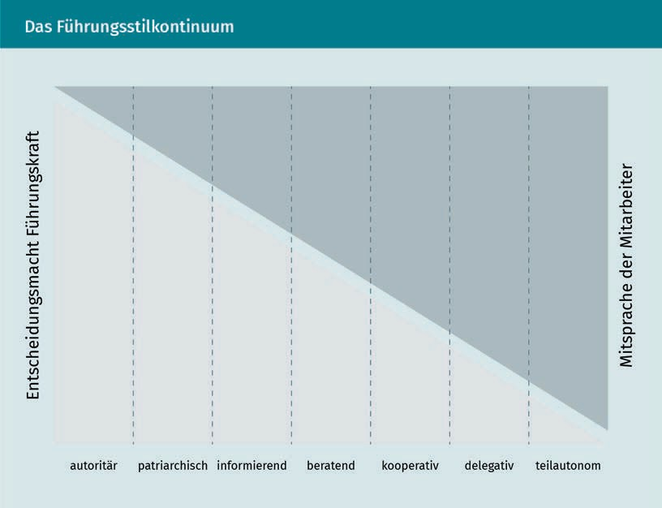

In an authoritarian leadership style, the supervisor orders and decides without consulting the employees. In a patriarchal leadership style, the supervisor decides alone, but strives to convince employees of the correctness of their decisions. In an informatory style, the supervisor makes decisions, but questions about correctness are allowed. In a consultive leadership style, the supervisor informs the employees of planned decisions and employees then have the opportunity to contribute their opinions before

Leadership Theories through Changing Times

a final decision is made by the supervisor.

In a cooperative leadership style, the team develops proposals. Then the leader identifies the proposal to be implemented from the pool of suggestions developed by the team. In a delegative leadership style, the freedom is so great that the group decides for itself based on the leader's specification of the problem and their established *guard rails*. Semi-autonomous groups decide completely on their own, and the supervisor acts more as an advisor. In principle, the question of when which leadership style is most effective cannot be answered. Rather, it is important to take the framework conditions into account, such as the personal characteristics of the leader, team size, industry and work content, the qualifications of the employees, and the acceptance of the leader in the team and to then exercise an appropriate leadership style based on this.

### Consideration of the Situation

Various models propose a consideration of the situation or framework conditions of leadership. Fiedler's contingency theory, Hersey and Blanchard's model, and Vroom and Yetton's decision model are closely examined in the following.

###### Contingency Theory according to Fiedler

The contingency theory addresses the question of which leadership style is most promising in which situation (Stock-Homburg 2013, S. 493). It takes its name from situational influences (contingency factors) that are considered to be of key importance to leadership success. Its central hypothesis is that group performance is a function of the relationship between leadership style and the extent to which the group situation allows the leader to exercise influence (Kals 2006, S. 100). The situation, which represents the sum of the framework conditions of a leadership situation, can be further defined by the following aspects (Fiedler 1967):

* + Leader-Employee relationship: led group employees tend to be more willing to accept stimuli from the leader if they value the leader or feel valued. The dyadic relationship is thus the most important situational variable.
  + Positional power: the influence of a leader based on their hierarchical position in the organization is also referred to as positional power. The greater the positional power, the more influence the leader has on the behavior of the employees being led.
  + Degree of task structuring: this refers to the number of recurring elements, their predictability, and the verifiability of performance results. The more clearly the tasks are structured, the easier it is to coordinate and control the employees being led.

Each of the aspects named above can be high or low, resulting in eight different *situations*. Depending on the situation, Fiedler recommends more employee-oriented or more performance-oriented leadership.

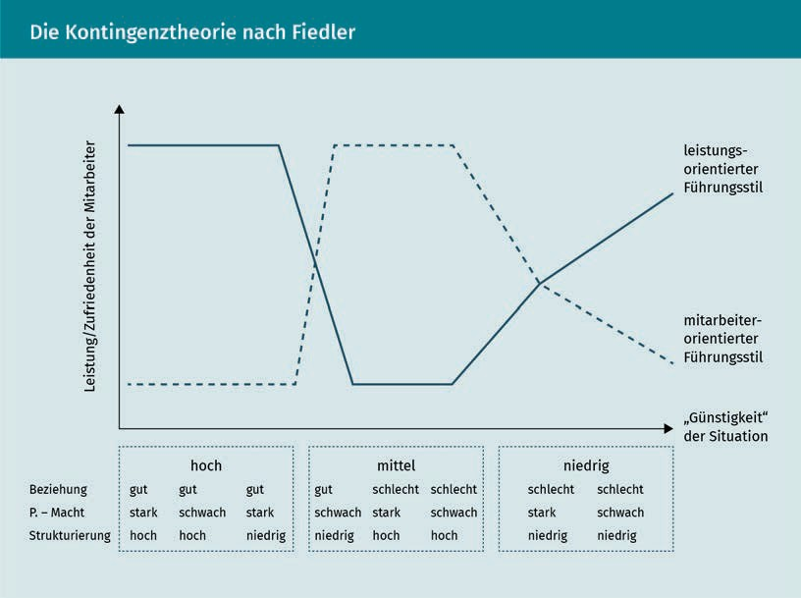

In empirical studies, Fiedler was able to show that different leadership styles are promising in different leadership situations. In both particularly favorable and particularly unfavorable situations, performance-oriented leadership proves to be more effective in terms of group employee performance and satisfaction. In contrast, a more employee-oriented leadership style should be applied in intermediate situations.

Leadership Theories through Changing Times

It must be added that Fiedler's results have been confirmed in a laboratory experiment, but not yet in field studies. Despite all the criticism, however, it should be noted that Fiedler was the first to take situational conditions into account in an empirically verifiable leadership model (Kals 2006, S. 101).

###### Maturity Model according to Hersey and Blanchard

The maturity model according to Hersey and Blanchard bears this name because it makes a recommendation for leadership behavior depending on the *maturity level* of the person being led. It is assumed here that employees with different levels of maturity are to be led differently (Stock-Homburg 2013, pp. 423-427). For the first time, Hersey and Blanchard advocated individualized leadership and were against the *watering can principle*. This means that despite authentic leadership by a supervisor, it is more effective and fairer if employees are led differently. This is not intended to lead to inconsistency in leadership, but rather to consider the theory that employees with lower maturity need more guidance and monitoring and employees with very high maturity deserve more freedom.

The authors distinguish between four different levels of maturity among employees (M1 to M4 ), which are based on the psychological and functional – work-related – maturity of the employees. It is important to note that this is not a matter of the employee's abstract personal maturity, but rather with a view of the respective task in question from their current area of responsibility: “The level of maturity depends on performance motivation, willingness to assume responsibility, and training or experience” (Kals 2006, S. 102).

* M1 is characterized by low psychological and low functional maturity.
* M2 is characterized by high psychological, but low functional maturity.
* M3 is characterized by low psychological, but high functional maturity.
* M4 is characterized by both high functional and psychological maturity.

In this respect, the new, 18-year-old trainee in a department could probably be assigned M1 , whereas the long-standing employee in accounting, who has already handled many difficult circumstances masterfully, could be assigned M4 . An employee who has a great deal of potential and enthusiasm, but has only recently moved from purchasing to sales, will correspond to M2 . At the same time, the question of maturity level arises anew when an employee starts a new job.

The figure below illustrates how leadership behaviors and employee maturity are to be correlated according to Hersey and Blanchard.

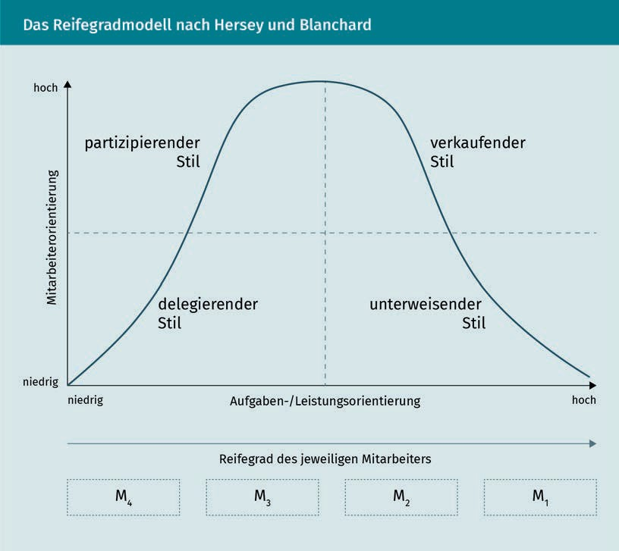

The maturity model differs from Fiedler's contingency theory on essential points. While the latter is based on the assumption that a leadership style can only be changed in the medium to long term, Hersey and Blanchard assume that each employee should be led according to their maturity. They additionally require that leaders always work to maximize the maturity level of their employees. In this respect, a leader must master all four leadership styles (participative, delegative, instructive, and selling) and use them as appropriate to the situation in order for the maturity model to be effectively implemented. An empirical study from Taiwan (Silverthorne/Wang 2001) tested the effectiveness of the maturity model. The results showed that the better the leader can respond to the maturity level of each employee, the higher the productivity. Nevertheless, the maturity model has also been criticized as lacking empirical evidence. Nevertheless, in view of its plausibility, it enjoys high popularity in the practice of leadership training (von Rosenstiel 2014, S. 17).

Leadership Theories through Changing Times

###### Vroom-Yetton Decision Model

The decision model by Vroom and Yetton is also frequently the basis of leadership training. Its validity is supported by empirical studies (Kals 2006, S. 102). As a situational leadership theory, it also addresses the question of when a leader should allow what degree of participation by those led. It considers autocratic decisions, decisions based on consultation with those led, and group decisions. With the help of a decision tree, the leader is guided through six situation diagnostic questions that they must answer yes or no (Kals 2006, S. 102):

1. Does the decision to take one action strategy or another make a difference?
2. Is the problem structured?
3. Does implementation require that employees accept the decision and its consequences?
4. Would they also accept it if the leader made the decision on their own?
5. Do employees share the organization's goals that the decision is intended to achieve?
6. Is the decision likely to lead to a conﬂict among employees?

Once the leader has answered these questions, they are advised on whether they should make their leadership decision alone, or after consultation with those led, or as part of a group decision-making process. Depending on how the questions are answered, one of the following five recommendations is provided at the end of the decision tree (Kals 2006, S. 102):

* authoritarian decision by the leader,
* authoritarian decision by the leader after gathering information from the employees,
* decision of the leader on their own, but after prior individual consultation with individual employees,
* sole decision by the leader after consultation with the working group, or
* group decision.

The first six questions above lead to a *better* leadership decision depending on the situation, whereby the (presumed or actual) improvement is determined by three hierarchical criteria (von Rosenstiel 2014, S. 17):

1. quality of the decision,
2. acceptance of the decision, and
3. economics of the decision behavior.

von Rosenstiel summarizes: “Although the model appears rationalistic and mechanistic, there is indeed evidence for its usefulness […]. The approach has also proven itself for training purposes. The learning objective here is to sensitively perceive one's own leadership situation in order to then be able to react ﬂexibly in terms of leadership behavior” (von Rosenstiel 2014, S. 18).

### Systemic Leadership

In the 1980’s, a paradigm shift in leadership occurred that was largely driven by the work of Niklas Luhmann (1984). This changed the prevailing opinion from an input/output-related, mechanistic, and monocausal view of leadership to a systemic perspective that seeks to consider reality in its entire, non-linear complexity. The core idea of systemic leadership is that leadership actions in a complex, networked social structure lead to a multitude of direct and indirect reactions.

Systems are understood as a number of different elements (e.g., people in a company) that are related to each other in different ways and interact with each other. For example, a gearbox is a fairly simple system in which various cogwheels engage with each other. A specific force occurs as input, the elements exist in different relations and interact, and a specific force results as output. Larger social systems such as companies are exponentially more complex, because if an input (for example, a competitive situation) changes, the company can anticipate a large number of potential conditions.

In general, systems theory is focused on synergetics. It describes regularities according to which new, self-organized structures and effective reactions can arise in complex systems (Schirmer/Woydt 2016, S. 201ff.). Self-organization can be understood as the adaptation of a system in the presence of new input. For example, self-organization would occur, in a *company* system when the *competitive situation* input changes. If a direct competitor lowers prices, the product management, finance department, and sales will coordinate whether a temporary lower price can be accepted and therefore result in accepting lower contribution margins from sales, or whether more economical product variants can be produced at short notice that have fewer features, but can be offered at a lower price.

According to Luhmann (1984), the basic element in social systems is not the human being, but communication itself. This is influenced by the subjective reality construction of the subjects in the system. Suitable structures are created based on this. According to Luhmann (1984), if a system is to be influenced, this is only possible by *inducing* a constructivist view of reality. The various subjects or employees involved exhibit different interpretation patterns that can lead to a variety of alternative outcomes.

Leadership Theories through Changing Times

In this respect, systemic leadership does not attempt to reduce complexity, rather it attempts to influence it by means of communication as a necessary component of the system. It is the task of a leader to understand complex and bilateral interactions between all participants (employees, customers, suppliers, etc.). Ultimately, a leader only has the task of acting as an initiator (Schirmer/Woydt 2016, S. 202ff.). The problem of leadership using the systemic view lies in the fact that the leader their self is a subject in the system and therefore dependent on a large number of uncontrollable, self-regulating influences.

### Symbolic Leadership

According to Nerdinger (2014) and Neuberger (2002), leadership not only depends on the intention of the leadership behavior, but also on the manner of leading. *Symbolic leadership* is spoken of when the leadership behavior symbolizes the values and beliefs of a company (Neuberger 2002, S. 194ff.). A symbol is understood to be a representation of something that cannot be tangibly perceived. In the sense of symbolic leadership, it is not only what happens objectively in a company that is important, but also how this event is perceived by the leader and employees (Rybnikova 2014, S. 234).

This is because many things that occur in a company – be it a written or personal announcement of a new strategy, an unwritten dress code, or the fact that the management is located on the top floor of the building – also have a symbolic character and thus indirectly say something about a company (Nerdinger 2014, S. 106). For example, a conservative dress code may represent conservative values of a company or the removal of a timekeeping system without a replacement may represent a company's trust in its employees. According to Nerdinger (2014, S. 106), leadership behavior is actually always symbolic, since led people will always interpret the behavior of leaders. An open door to a supervisor's office can signal responsiveness and, by implication, be interpreted by employees as their supervisor’s appreciation of the importance of their issues.

However, recommendations regarding symbols in leadership should be treated with caution, since *forced* symbolism is quickly perceived as inauthentic. If a company has followed a formal, conservative dress code with a strict hierarchy and a “Mr., Mrs., or Ms.” form of address for years, it may seem inauthentic if the dress code became more casual overnight and an informal “by first name” form of address is adopted.

Moreover, one and the same leadership action can be interpreted differently by different employees. For example, if leader frequently and thoroughly checks the work results of employees, this can be interpreted by one employee involved as conscientiousness, interest, and support, but can alternatively be perceived as control and mistrust.

The theory of symbolic leadership is still insufficiently researched empirically (Rybnikova 2014, S. 253). Regardless, its merit undeniably lies in the broadening of a narrow view of leadership as effective handling of human objects toward a more comprehensive view of leadership as a meaning-conveying process that involves all participants.

### Transactional and Transformational Leadership

The concept of transformational leadership has had a lasting influence on international leadership research over the past 30 years. While this approach was initially met with skepticism in Germany, it has stimulated numerous research activities there as well. This approach is also becoming more widespread in the practice of leadership development. Transformational leadership builds on transactional leadership, complementing and extending it by utilizing positive reinforcement, but placing even greater focus on the leader's role model function. Building on earlier research, Bernhard M. Bass was the first author to distinguish between the “transactional” and “transformational” approaches (Bass 1985). Both approaches will be explained in more detail and distinguished from each other in the following.

###### Transactional Leadership

Transactional leadership is based on the learning theory principle of reinforcement that stems from operant conditioning. This is based on the experiments of Burrhus Frederic Skinner (1963) and is often described in management jargon as *carrots and sticks leadership.* Positive work results are rewarded (*carrot*), while negative work results are punished (*stick*). The table below provides an overview of the different types of conditioned reinforcement.

|  |  |
| --- | --- |
| Reinforcement Types | |
| Apply a Stimulus | Remove a Stimulus |
| Positive Reinforcement (e.g., Praise, Bonus Payment) | Negative Reinforcement (e.g., Cancellation of an Employee Discount) |
| Punishment (e.g., Demotion, Warning) | Extinction (Ignoring the Undesirable Behavior) |

Leadership Theories through Changing Times

In transactional leadership, the leader controls both the way in which tasks are completed as well as the achievement of goals by employees (Nerdinger 2014, S. 90). The concept of transactional leadership corresponds with the idea of *management by exception*, which involves the leader not interfering until exceptions occur. Positive exceptions can arise through special performance that the leader should then positively reinforce and conversely, negative exceptions can arise that the leader should then either negatively reinforce or punish. In addition, there is the possibility of ignoring negative exceptions, but this contradicts the idea of *management by exception* (Nerdinger 2014, S. 90).

###### Transformational Leadership

Transformational leadership focuses on different leadership principles than transactional leadership. Whereas transactional leadership focuses on the *transaction*, i.e., the fair exchange between leader and employee and the leader is responsible for achieving and monitoring goals, transformational leaders motivate their employees by influencing their values and feelings on four levels (what is known as the *4 I’s*):

* by convincingly communicating attractive visions (*inspirational motivation*),
* by credible embodiment of a role model (*idealized inﬂuence*),
* by stimulating independent thinking and supporting change (*intellectual stimulation*), as well as
* by supporting employee development (*individualized consideration*).

In this way, long-term and overriding values and ideals can replace short-term material goals. Transactional leadership is thus supplemented, but there is certainly no room for the development of transformational leadership if there is no fair exchange of performance and consideration (work performance in return for pay and development opportunities) (Felfe 2014, S. 39).

Thus, it is primarily a matter of trust and of conveying meaning to employees at work (Nerdinger 2014, S. 90). Transformational leadership is thus manifested in the above-noted charismatic behavior, inspiration, intellectual stimulation, and individual appreciation of those led (Yammarino/Dubinsky 1994, cited in Stock-Homburg 2013, S. 463).

A large number of empirical studies have now shown that transformational leadership has a positive effect on various success factors, such as individual commitment and employees' self-efficacy expectations, as well as on the success of a company as an organization. Research has also shown that this correlation is particularly high in an environment that is considered to be unstable (Felfe 2014, S. 40).

With regard to individual success variables, numerous meta-analyses show the positive effects of transformational leadership on job performance, commitment, work engagement, job satisfaction, and employee well-being, among others. Furthermore, employees are less likely to quit if they are led according to transformational leadership principles, i.e., with charisma, inspiration, intellectual stimulation, and individual appreciation (Stock-Homburg 2013, S. 465).

With regard to organizational success variables, empirical studies reveal the positive effects of transformational leadership on the development of product and process innovations, the market launch of such innovations, and company performance (including market share and return on sales) (Stock-Homburg 2013, S. 466).

The table below provides an overview of the various role behaviors of a transactional or transformational leader (Stock-Homburg 2013, S. 464):

|  |  |  |
| --- | --- | --- |
| Role Behaviors of Leaders | | |
| Traits | Transactional Leadership | Transformational Leadership |
| Coordination Mechanisms of Leadership | Contracts, Rewards, Punishment | Enthusiasm, Cohesiveness, Trust, Creativity |
| Focus on Employee Motivation | External Incentives (Extrinsic) | Task in Itself (Intrinsic) |
| Focus on Goal Achievement | Rather Short-Term | Rather Long-Term |
| Goal Content | Material Goals | Idealistic Goals |
| Role of the Person Leading | Instructor | Teacher, Coach |

### Leadership Theories through Changing Times –Leadership in a Field of Tension

There is a multitude of leadership theories and approaches, as well as a wealth of empirical studies that have tested the effectiveness and efﬁciency of these approaches. Despite the abundance of empirical data, it has not been possible to identify *the* *one, right* leadership theory, since the matter is dependent upon too many contextual factors such as the specific industry, the economic situation, (company) culture, power

Leadership Theories through Changing Times

distance, leader personality, trust between a leader and their employees, and many other factors.

With the help of a wide range of leadership theories, a leader can expand their (theoretic) spectrum of action, but must then decide on a concrete option for action. Their task can therefore be understood as acting in a field of tension (Berkel 2007). As a result, leadership must ultimately be understood not only as a role, behavior, or leadership style choice, but also as finding a balance of values within this field of tension. For an understanding of what constitutes *values*, reference can be made to the philosophy of Friedrich Nietzsche and his aphoristic observations (Berkel 2007, S. 207):

* Values are perspectives or points of view, according to which people prefer or pursue things/relationships.
* Values are discovered or created.
* Values change because people change, and different values are a primary focus at different times.
* Values demand to be *ought*, but unlike laws, they cannot force their realization.

With regard to leadership, a distinction can then be made between managers and leaders on the basis of values. Management is understood as a profession that focuses on results and relies on measurable goals, while leaders use values to guide: Measurable goals represent important parameters that allow “landing with pinpoint accuracy and checking that landing with precision” (Berkel 2007, S. 209). However, much is lost if a company is exclusively reduced to measurable goals. Whether a management that works simplistically and strictly with quantitative goals is desirable is also questionable. Instead, goals need to be supplemented by values, since goals in themselves are derived from values. For example, if sales growth goals of 15% are set, this goal is derived from the *growth and expansion* value.

Nevertheless, unlike goals, values require an argumentative accommodation and intellectual debate. Organizations are always more than the monetary condensation of performance based on their values: fundamental values outline “the cosmos in which one moves and is understood [...]. They give employees indications of how to act in new situations not yet covered by goal planning in order to fulfill the company's mission” (Berkel 2007, S. 210). Values thus create a common ground and understanding between those involved.

In contrast to values, quantitative goals compel employees to act rationally and optimally. However, it is essential to consider people in all their complexity, because “they experience and act [...] not only as rationally programmable beings, they also have an abundance of feelings, standards, communication” (Berkel 2007, S. 210). If management is solely based only on quantitative goals, companies risk dissatisfaction and the loss of free, internal self-commitment, as well as the willingness to take risks and innovate on

the part of those employees that companies urgently need, particularly in competitive times, in order to be able to act ﬂexibly while simultaneously staying on course with their overall vision.

In this respect, companies’ exclusive orientation and incentive systems toward quantitative goals can be viewed very critically. Shareholder value can be seen as a value in the company, but can also be questioned as to whether it should be the only value pursued by the organization. In Germany, this is already the case for legal reasons, since the Basic Law succinctly states in Article 14: “Property entails obligations. Its use shall also serve the common good.” The principles of the social market economy, which include employee participation, are derived from this. For this reason alone, it is not possible in Germany for a company to be exclusively orientated toward the principles of shareholder value. The interests of other stakeholders, such as employees, must also be taken into account and this is considered to be a *de jure* value here. In other words, it is a value that abides by German law.

To depict leadership in a field of tension, Berkel proposes the graphic model below:

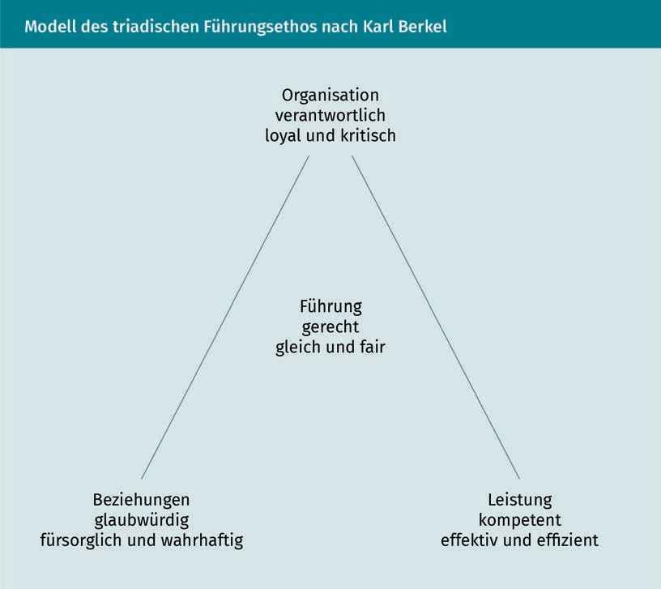

Leadership Theories through Changing Times

The model is based on the considerations of traditional anthropology. It distinguishes between three spheres of human reality: the material, the social and the spiritual side. In relation to a company or an organization, the material side refers to what the organization represents, such as products, processes, and services. The social side includes all relationships among members, as well as with the outside world, that are reflected in communication, cooperation, or customer orientation. The spiritual side refers to the global line of approach of an organization, its purpose, and reason for existence (*raison d'être*). It manifests itself in the guiding idea, principles, and structures of an organization (Berkel 2007, S. 211).

As it relates to the leadership model, responsible, loyal, and critical organization can be applied to the spiritual side of an organization; the relationships between people should be caring and truthful, and the performance (material side) should be competent as well as efﬁcient and effective.

Understood in this way, the goal of good leadership is to act *justly* (equally and fairly) in this field of tension among values (Berkel 2007, S. 219).

Summary

It is difficult to make a value judgment with regard to leadership. A large number of theoretical models have been developed over the past 50 to 100 years. Some of these models have undergone a variety of empirical tests (e.g., the transformational leadership approach), while others are difficult to test empirically due to their conceptual complexity (e.g., Berkel's Leadership Ethos model).

However, even empirical testing does not always yield the clear findings desired in practice. For example, the transformational leadership approach has been shown to be quite effective for certain variables. However, studies of the transactional approach have found even greater effect sizes (Shamir/House 1993, cited in Stock-Homburg 2013,

S. 465).

Many researchers address the topic of leadership every year, and a great deal of professional journals (e.g., Leadership Quarterly) annually publish numerous articles. The topic of leadership is alive, it is dynamic, new approaches are emerging, and ultimately, leadership is always contextual. It depends on the personality and experience of a leader, the maturity of individual employees, the workforce composition, the value structure of a company, and its incentive systems. In this respect, it is extremely difficult to derive generally applicable principles for *good leadership*. Rather, empirical studies allow for making limited, comparative correlative statements (*the …, the …* constructions). Theoretical works also provide normative principles on how leadership should be designed responsibly and ethically.



# Unit 3

## New Leadership Approaches

#### STUDY GOALS

After completing this unit, students will know ...

... what agile leadership means.

... how agile leaders can be developed.

... what the terms *VUCA* and *ﬂat world* mean.

... how leadership can empower and what consequences this has for employees.

... what the buzzword concepts of holacracy and sociocracy mean.

DL-D-MMAN02-02-L03

1. New Leadership Approaches

### Introduction

Concepts and claims such as *the world is ﬂat*, *new work*, and *agile leadership* dominate the headlines of many blogs on leadership topics and are increasingly penetrating professional literature. Although there is still a considerable lack of empirical studies testing the causal relationships and success of such new leadership approaches, they are quickly gaining acceptance in practice.

### VUCA and Leadership

*VUCA* is an acronym for environments and times characterized by “volatility, uncertainty, complexity, and ambiguity” (Lawrence 2013). The acronym originated in the U.S. military and was widely used after September 11, 2001 to describe the changing world in which we live. The financial crisis of 2008, which rendered many business models obsolete, also contributed to the acronym’s use, as did the explosive spread and growing significance of social media (Lawrence 2013, S. 3).

Thomas Friedman refers to this in his book “The World is Flat” and describes the development as the “rapid ﬂattening of the world” (Friedman 2005, S. 78). Significant changes are taking place and these are not only developing rapidly, but are also simultaneously affecting far more people than any change before. This challenges the management of all companies to adapt to the rapidly changing conditions. The greatest difficulty arises from the unpredictability of events and changes that require leaders to possess a high adaptability as well as the ability to make continual and rapid adjustments in the business model, processes, technology, and organization (Lawrence 2013, S. 3). A study by Boston Consulting Group confirms this and underscores the need for *adaptive companies* and an *adaptive advantage*, rather than a *competitive advantage* (Lawrence 2013, S. 3).

Johansen's VUCA Prime Model proposes qualiﬁcations for management to counter the threats posed by VUCA (Lawrence 2013):

* A strong vision can counter volatility. Managers with a strong vision are able to guide companies better if they have long-term goals and are able to withstand unforeseen events better.
* Uncertainty can be met with understanding, which can be paraphrased as the ability to look inward, look carefully, and listen.

New Leadership Approaches

* Complexity can be met with clarity by facing chaos with deliberative thinking.
* Ambiguity can be countered by agility, which is deﬁned as the ability to communicate throughout the entire organization and apply speed in implementing solutions.

In this context, vision, understanding, agility, and clarity are not understood as completely independent of each other, but rather as intertwined. Lawrence (2013, S. 6) suggests the following points as a recommendation for action in talent management:

* Hire agile leaders by taking agility and the ability to think through complex issues into account as early as the selection process.
* Develop the management to be agile leaders by promoting adaptivity, innovativeness, collaboration, communication, and openness to change, as well as critical thinking strategies. Scenario planning tools are ideal for this and aid in mentally implementing different scenarios in order to react to changing framework conditions. Virtual simulations are particularly suitable for this purpose. Job rotation is an example of enhancing adaptivity, since it promotes thinking *outside the box* and cross-functional thinking.
* Develop an organizational culture that fosters agile capabilities and retains agile leaders. To this end, Lawrence suggests creating incentives for innovation, agile behavior, and taking calculated risks while being ﬂexible in their design by offering leaders the stimuli that appeals to them, such vacation days, bonuses, and stock options, in order to communicate agility in the incentive design as well.

### Empowering Leadership

Leaders who have a strong focus on empowerment “share power with their employees by delegating authority to employees, holding employees accountable, involving employees in decision-making, encouraging self-management of work, and conveying conﬁdence in employees' capabilities to handle challenging work” (Chen et al. 2011, S. 541). If leaders show a low willingness to empower, they tend to micromanage and monitor (Chen et al. 2011, S. 541ff.).

The effect of leaders with a strong or weak empowerment conviction toward their teams is clearly different. If leaders allow empowerment, they promote motivation in the team and ensure that employees can contribute fully. They have more confidence in their teams and trust them more overall. They are also more open to involving their employees in decision-making and giving the team more autonomy and decision-making freedom (Chen et al. 2011, S. 541ff.). In turn, empowerment by a leader results in self-confidence, a sense of self-determination, and an awareness of creating value, autonomy, opportunities for development, and self-efficacy with regard to the required work results.

(Chen et al. 2011, S. 541ff.). Alongside this, commitment is strengthened, which further contributes to employee engagement and subsequently lowers the labor turnover rate.

### Sociocracy and Holacracy

Holacracy and sociocracy describe organizational structures that represent alternatives to the conventional hierarchy. The term *sociocracy* goes back to the French philosopher Auguste Comte (1798-1857), who was a proponent of sociologically driven politics. Sociocracy is based on four cornerstones:

* Consensus takes precedence: Decisions are made when there are no *serious reservations* in the decision-making body. Reservations and counter-arguments are highly valued and must be presented rationally.
* Organization in circles: The organization consists of semi-autonomous circles, each of which is responsible for the implementation, measurement, and monitoring of their respective processes. They are also responsible for the development of the circle and the members in the circle. The circle should ﬁnd its own knowledge gaps and close them autonomously.
* Double link: The operational leader of each circle is automatically a member of the next higher circle. In addition, each circle elects another representative who is also a member of the next higher circle. Thus, there are two “links” up (and down, if there are subordinate circles).
* Election by consensus: This principle complements the first principle in that individuals are elected for responsibilities by consensus, as described above. Again, dissenting votes are weighted particularly heavily. Members of the circle may nominate themselves or others. After discussion, nominations may be changed, and the discussion leader proposes the person with the strongest nominations for election.

Holacracy was developed by Brian Robertson, founder of a tech company in Pennsylvania. It is strongly based on the ideas of sociocracy and follows these principles:

* Roles instead of job descriptions: Here, holacracy distinguishes between person and role, meaning that one person can hold multiple roles. A role follows a unique format with title, purpose, control domains (if applicable), and responsibilities that are regularly brought up to date.
* Circular structure: The holacracy consists of several circles that are hierarchically structured. Each circle is assigned a clear purpose and responsibility by the superordinate circle. Circles are self-organized and determine their own deadlines, the assignment of roles within the circle, and the execution of work. The circles are linked with each other by a “rep link” and a “lead link” who represent their respective circles in meetings with higher-level circles to ensure communication

New Leadership Approaches

flow and implementation of the strategic alignment.

* Management guidelines: Each circle is free to formulate its own management guidelines.
* Operational processes: In holacracy, processes are designed around operational constraints and keep all members of the respective circle working together effectively and efﬁciently. In this process, each member has a high degree of autonomy and self-determination in their roles, as well as permission to innovate. Instead of asking for extra, holacracy gives a *blank check*, as it were, to do and initiate everything to fulfill the role(s) in the best possible way. The principle of holacracy is freedom and autonomy, which is only restricted in the event of misconduct.

One prominent representative of holacracy is the US shoe and fashion retailer, Zappos. A number of tech companies, such as Mercedes-Benz.io GmbH and Rising Systems AG in Germany, and Liip in Switzerland, among others, are committed to holacracy.

Summary

Sociocracy, which originated in philosophy and sociology during the 19th century, is a more democratic form of organization than a hierarchy. It follows the four principles of consensus, organization in circles, double links, and election by consensus.

Holacracy, which emerged from the software industry in the 2000’s, can be understood as a further development of sociocracy. It also follows four principles: Roles, instead of job descriptions, whereby holacracy distinguishes between person and role. This means that one person can also hold multiple roles. Holacracy consists of several circles, which are hierarchical in themselves. The circles are connected to each other by a "rep link" and a "lead link", who represent their respective circles in meetings with higher-level circles to ensure communication flow and implementation of the strategic direction. Each circle is free in its design of management guidelines. In holacracy, processes are designed around operational necessities. There is little empirical research to date to assess the effectiveness of these *new* organizational forms.



# Unit 4

## Stresses, Work-Life Balance, and Self-Management

#### STUDY GOALS

After completing this unit, students will know ...

... how the increasing demands of work contribute to the deterioration of a work-life balance.

... how the job demands-resources model according to Bakker and Demerouti explains effort and joy on the job.

... how to improve work-life balance with effective self-management.

... how perceived musts create stress and how prioritization can reduce stress.

DL-D-MMAN02-02-L04

1. Stresses, Work-Life Balance, and Self-Management

### Introduction

Work and family are an integral part of human life. Until the 20th century, most Germans had a predestined life path that was clearly divided into roles between the genders. There was often an intact extended family in the background that helped to look after the children and relieve the burden on the family.

However, this picture gradually changed after the Second World War when more women entered the workforce. Women became increasingly better educated and technical progress increased rapidly. The share of women in the workforce grew steadily. Work also became increasingly global and mobility requirements also expanded. Vocational training began to take quite some time longer due to increasing qualification requirements. In the meantime, a *rush hour* in which careers, the construction or purchase of one's own home, and the desire to have children are to be realized became acknowledged. Alongside this, burdens due to aging relatives were also likely to arise.

Dissolution of

Work Boundaries

Work is increasingly mixing with private life.

Work Intensification What were previously several separate jobs are combined and assigned to one employee. This process is called work intensification.

Technological progress with smartphones has contributed to the **dissolution of work boundaries** by progressively mixing work with private life. Employees and leaders increasingly took their constant availability for granted until a few years ago when unions and works councils of larger corporations intervened and demanded that the forwarding of emails to smartphones be stopped.

In addition to the dissolution of boundaries, an increasing **work intensification** was also observed at the same time. The replacement of letters with emails has rapidly accelerated communication and the introduction of easy-to-use computers has shifted many support functions such as secretarial tasks, archiving, and research to employees and leaders. The following sections discuss the effects of dissolution of boundaries and work intensification and possible measures to counteract the overburdening they cause.

### Stresses

According to § 5 of the German Occupational Health and Safety Act, employers are obligated to conduct workplace risk assessments, i.e., to clarify which sources of danger could harm employees. In this context, an endangerment is understood as a potential physical or time-related encounter with a source of danger by a person that may result in damage. (Hofmann et al. 2002, cited in Kastner 2014, S. 105). While chemical and mechanical stresses have decreased in recent decades due to better filtering, cleaner processes, lower limit values, and automation, psychological stresses have rather increased due to the dissolution of work boundaries and work intensification. In recent years, the average absence due to illness (in general) was twelve days, while the average absence due to mental illness was 30 days. “Psychosocial stresses are barely addressed within the statutory regulations on occupational safety and health.

Stresses, Work-Life Balance, and Self-Management

Older workers in particular are often exposed to such stressors and their combinations [...]: deadline and performance pressure, disturbances, interruptions, high levels of concentration, different tasks simultaneously, minor errors with serious consequences, etc. Inappropriate efforts not only arise from a current stress situation, but also from the fact that new stresses have not been sufficiently deferred, or the 'battery' has not been recharged” (Kastner 2014, S. 108).

An endangerment exists when the person concerned does not have sufficient coping strategies or the physical and psychological resources to cope successfully.

The most common burden in the workplace is stress (Stock-Homburg 2013, S. 777). Stress can be deﬁned as a “negative emotional condition in connection with increased (work) demands” (Stock-Homburg 2013, S. 777). The occurrence of stress can be explained by means of the job demands-resources model (JD-R model) below.

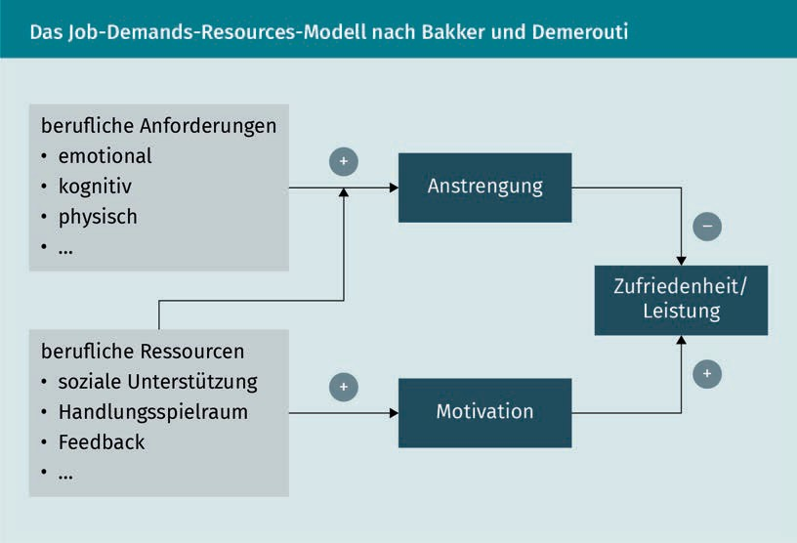

The model is a simplified representation of how positive and negative forces affect employees. Activities have different *demands* on an employee, which can be cognitive, physical, or emotional. In a foundry, for example, physical demands are high because it is usually noisy and hot. A doctor's job in a hospital can be emotionally as well as physically demanding when shifts are long, hectic, and many patients are suffering. As a balancing counterweight, there are occupational resources that have a positive effect on an employee's motivation. For example, this can be a good team cohesion,

autonomy in organizing one's own activities, a strong sense of purpose in activities, or support and backing from a leader. In the JD-R model, a distinction is made between two processes that can also run in parallel under certain circumstances:

* The effort-driven process is induced by high demands. In the short term, employees can increase their commitment and work performance, however, too high demands over extended periods of time lead to overload and a decline in work performance.
* The motivation-driven process is induced by occupational resources and sufficient support that allow employees to happily manage their work, which increases satisfaction and performance in the long term.

Moreover, occupational resources can also absorb the negative effects of high demands, which is what the expression *work hard, play hard* essentially means. Likewise, mastering high demands can also be experienced as enriching and even provide new (creative) strength.

Different occupations and activities have very different levels of demands in themselves. Doctors in hospitals will generally be exposed to higher emotional and physical demands than customer consultants in a bank. Likewise, executives with a great deal of responsibility and travel activities will experience higher demands than internal sales staff. It is important for HR management to take these demands into account and, if necessary, to further expand occupational resources for affected employees. Examples of measures include preventing conﬂicts and harassment, preventing role conﬂicts due to multiple workloads, clear responsibilities, and avoiding task-related uncertainties. Specialized training courses, self-management training, and relaxation techniques can be used to build up resources.

### Work-Life Balance

The term *work-life balance* describes the balance between work and private life and is often used to refer to the compatibility of work and family. Stock-Homburg and Bauer (2007) deﬁne the facets of work-life balance as follows:

* *Work* describes the value of work for the employee, job satisfaction, and the potential conflict between work and private life.
* *Life* describes the value of private life, life satisfaction, and the conﬂict between private life and work.
* *Balance* describes the extent to which the work-life interface is adequately structured as well as satisfaction with the work-life balance.

Stresses, Work-Life Balance, and Self-Management

Two types of conflict can be distinguished when conflicts arise between private life and work. A work-family conflict occurs when private life is *neglected* due to the workload. A family-work conflict occurs when private commitments (e.g., illness of a child) cause problems in the performance of occupational duties.

The different approaches to avoiding these conﬂicts are summarized in the figure below.

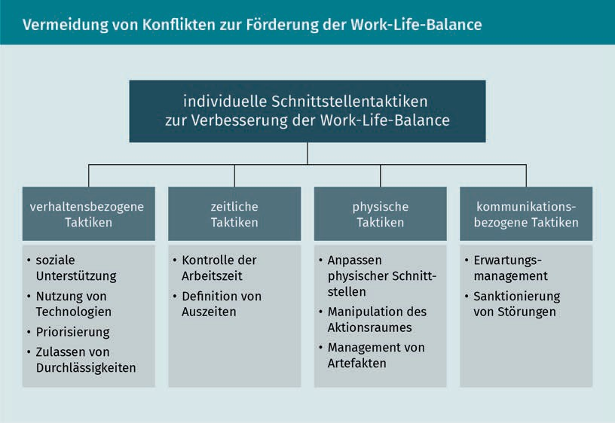

The work-life balance of employees and leaders is becoming increasingly relevant with the increasing dissolution of work boundaries and work intensification. If the work-life balance tips against private life and recreation, a risk of burnout quickly arises. Three components are typical of burnout (Stock-Homburg 2013, S. 794): emotional exhaustion, reduced performance, and depersonalization. The latter includes perceptions of *being outside oneself*, as if the body is heavier than usual, or as if memory is failing. It also includes a derogatory or cynical attitude toward the occupational environment.

In this respect, the work-life balance of employees and leaders should be a high priority for a company’s leadership. This is not only to observe the general and special duty to undertake protective measures in accordance with Section 618 of the German Civil Code (BGB), but also to secure the human capital in a company in the long term and to act in a socially responsible manner.

### Self-Management

Self-management is of particularly high importance for leaders. A leadership position requires responsible use of one's own resources and successful prioritization to complete daily tasks, and it also requires the leader to act as a role model. This section addresses how to handle stress and a high workload, as well as how to identify possible solutions.

###### Stress through Perceived Musts

Perceived Musts

Perfection pressure creates stress. The pressure for perfection is expressed through

perceived musts.

What are known as **perceived musts** are at the core of many stress problems (Hansch, 2009, S. 95ff.). These can relate to an individual, other people, or society. A perceived must in relation to an individual could read as follows: “I must be perfect in every respect. In particular, I must perform at a high level, always and in every way. I must not show weaknesses or make mistakes. Therefore, I must not risk anything and must always be entirely certain when making decisions. If something does not work out for me, I should conceal it and maintain appearances, at the very least. The important thing is to always be right” (Hansch 2009, S. 109). Perfection, however, is an abstraction of the mind and more of an object of desire and a goal than realistically attainable. Wanting to be *perfect* is not expedient.

Instead, it is beneficial to thoroughly know one's own personal idiosyncrasies and utilize personal strengths wherever possible. In the long term, an occupational environment that makes use of each individual's strengths will be healthier and create greater occupational satisfaction. Mistakes should be interpreted as learning opportunities rather than failures, because they often turn out to be helpful for development in the long run. For example, when the 3M company was conducting research into an extremely strong adhesive, the sticking material for Post-it® notes was created. Although this did not result in an ultra-strong industrial adhesive, it did result in an unbeatably successful product.

Perceived musts in relation to other people can be expressed in thoughts such as: “Other people must always behave well, decently, considerately, and fairly. They [...] must fulfill their tasks and obligations perfectly [...]” (Hansch 2009, S. 118). Stress is also pre-programmed into this perceived must, because what constitutes good, decent, or considerate behavior cannot be globally defined. Rather, it depends heavily on subjective ideas – other people are also not perfect and make mistakes too.

Perceived musts in relation to society or the environment often refer to safety culture or fairness, for example: “My living environment [.….] must be completely intact, or at least develop positively, and this must be assured for the foreseeable future. I can only enjoy life and be happy under these conditions” (Hansch 2009, S. 124). In order to cope with such thought patterns, it is helpful to keep in mind that people pay more attention to negative news than to positive news and the negative tends to linger more strongly in

Stresses, Work-Life Balance, and Self-Management

the memory. Attention must be very consciously directed toward positive messages in order to avoid stress and see more positives. Furthermore, in the Buddhist philosophy of mindfulness, the solution to these thought patterns is to pay more attention to the moment, instead of always brooding about the past or the future.

###### Prioritization and Time Management for Stress Management

Stephen Covey's book, “The 7 Habits of Highly Effective People” (Covey 2005), describes a successive approach to more effective self-management by means of stress reduction and prioritization. While this is not an academic work, it does provide a number of practical pieces of advice that have proven effective for time management. With the first *habit*, the reader is encouraged to separate their circle of concern from their circle of influence. Perceived musts in relation to others and the world, as described above, refer to what is called the circle of concern, that is, a circle that affects us, but over which we have no direct influence. Covey therefore advises focusing energy on the direct circle of influence and putting aside anger and complaints about events in the circle of interest. The second *habit* describes the importance of having a clear goal conceptualization or vision. Covey suggests to first clearly deﬁne the goal and work backward from there to the present, thus determining all necessary steps and actions.

The third *habit* is about clearly prioritizing goals and tasks, for which the *Eisenhower Matrix* is proposed. The matrix is named after the U.S. General and later President Dwight D. Eisenhower, who neither created it nor followed it, but inspired its creation with a famous distinction: “I have two kinds of problems, the urgent and the important. The urgent are not important, and the important are never urgent.”

Following this thinking, tasks and goals are prioritized by assigning them to one of the following four fields:

* important and urgent,
* important, but has some time,
* urgent, but not so important, and
* not so important and has time.

Tasks in the first category are *emergencies* that cannot be postponed. An actual prioritization is therefore not possible at all; a multitude of such tasks therefore inevitably leads to pronounced stress. They should be prioritized with an initial *clean-up* so there is time for tasks that are not immediately urgent, but are nevertheless important. Otherwise, the tasks in the second category often remain undone. However, these are typically elementary management tasks (employee appraisals, feedback rounds, etc.) that require necessary care.

Circle of Influence

In contrast to the circle of concern, things can only be actively changed in the circle of influence.

Prioritization

The concept of prioritization requires a distinction between important and urgent.

The fourth through sixth *habits* are about relationships with others, and in the seventh *habit,* Covey describes the principle of self-renewal, which is about sustaining work performance over the long term through healthy and strategic choices.

###### Handling Stresses

Kastner (2014) developed starting points for handling stresses on three levels (work) situation, individuals, and organization, as shown in the table below.

|  |  |
| --- | --- |
| Starting Points for Stress Management | |
| Level | Starting Points |
| (Work) Situation | * Facilitate work activity, workload, work intensity and scope of action * Improve work organization, information, and participation * Eliminate harassment and disturbances in the workplace * Reduce time pressure |
| Individuals | * Promote internal resources such as health awareness, control convictions/perceived musts, competencies. * Promote well-being, life and work satisfaction, promotion of health * Create coherence for sense of purpose, manageability, and explicability |

Stresses, Work-Life Balance, and Self-Management

|  |  |
| --- | --- |
| Level | Starting Points |
| Organization | * Creation of culture of health, systemic leadership, social support, fair work distribution * Increasing autonomy in work scheduling and self-determination of work pace * Job security * Recognition of performance and effort, opportunities for advancement |

Summary

Work and family have always been integral parts of adult life. A growing number of challenges for a healthy work-life balance have emerged with the rising employment of women, decline of extended families, and increasing mobility. Work-family conﬂicts, in which personal life is neglected, and family-work conﬂicts, in which the job is neglected due to private problems, can occur. The job demands-resources model describes how effort-driven and motivation-driven processes contribute to employee satisfaction and performance.

Different interface tactics between work and private life can contribute to an improvement in the work-life balance. Behavioral, physical, communication-related, and time-related tactics can be distinguished.

Healthy and sustainable self-management requires turning away from perceived musts. To reduce stress, clear prioritization is recommended and can be transferred to individual time management. Steven Covey's book (2005) offers a variety of approaches for successful self-management. Various approaches to dealing with stress can be used at the levels of situation, organization, and individuals to prevent or mitigate stress.



# Unit 5

## Motivation, Communication, and Assessment

#### STUDY GOALS

After completing this unit, students will know ...

... what motivation is built upon and how it is created.

... what different models of motivation exist that have special implications for leadership.

... why communication is so important in leadership.

... which communication models have particular relevance for explaining misunderstandings and conﬂicts.

... which requirements and functions assessment processes (should) have in a company and which framework conditions contribute to their success.

DL-D-MMAN02-02-L05

1. Motivation, Communication, and Assessment

### Introduction

Leadership’s task is to influence relationships with employees in such a way that organizational goals are achieved and, ideally, everyone involved is also satisfied with the way they have been achieved. The fine art of leadership, so to speak, is to reconcile the individual interests of employees and organizational goals. This results in leaders being required to motivate employees to achieve those goals. The basis for this is communication between leaders and employees in the form of bottom-up feedback and assessment interviews. Motivation, communication, and assessment are successively discussed in the following sections.

### Motivation

Human action is characterized by striving for effectiveness and is based on varying individual and temporal motives. Motives refer to characteristic value systems and dispositions toward action, which can be related to experience, performance, power, or aggression (Huber 2018). In this respect, motives represent the reasons for specific actions. They are not immediately identifiable, but are consistent over time and across different situations. For example, if a person has a strong status motive, they are likely to attach importance to a fancy car, being well dressed, ensuring that they are not passed over for promotion, and may compete with colleagues for a corner office.

###### Needs according to Maslow

The hierarchy of needs or motives concept distinguishes between deﬁciency needs and growth needs, which can be classified in five levels of needs.

Motivation, Communication, and Assessment

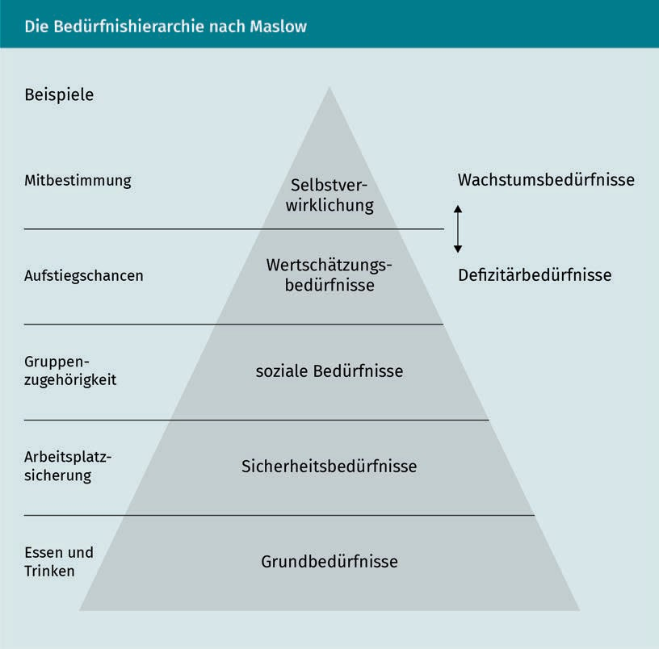

The four **deﬁciency needs** are physiological needs such as food, sleep, comfortable desk chair, etc. These are followed by safety needs such as protection from danger, stable living conditions, and minimum income. This is followed by social needs such as affection, group belonging, and communication. The deficiency needs finish with esteem needs, e.g., self-confidence, competence, respect, opportunities for advancement, and status symbols.

**Growth needs** are motives for self-actualization. These include, for example, the desire for personal development, a challenging job, top performance, participation, cooperative leadership, etc. (Huber 2018, S. 105).

The idea of hierarchy among needs comes from the assumption that needs at the lowest levels must be satisfied first before the next higher needs gain relevance. So, hunger and thirst must be satisfied before job security gains importance. It is only when all deﬁciency needs have been met that the desire for self-actualization comes to the forefront.

Deficiency Needs

The desire to eliminate a lack is referred to as a deﬁciency need.

Growth Needs

The desire for self-actualization is referred to as a growth need.

Leaders should be familiar with this model to better assess the motivational situation of their employees and be able to establish adequate incentives.

###### ERG Theory

Alderfer's ERG theory represents a further development of Maslow's hierarchy of needs. It does not distinguish five classes of needs, rather only three categories of needs:

1. existence needs,
2. relatedness needs, and
3. growth needs.

In addition to these relationships, which are also hierarchically arranged, Alderfer presumes that the lower the degree of fulfillment, the more strongly those needs are activated. (Huber 2018, S. 106).

###### Basic Motivation Model

Motivation can be understood as an individual's activating willingness to behave with a view toward achieving specific goals. It is merely a hypothetical construct and cannot be *measured*. In aptitude diagnostics, however, the strongest motives of a person can be determined in psychological testing. If a person has a strong health motive, it is likely that they will develop motivation for healthy eating and fitness.

Those situations that address needs or motives are called incentives. The behavioral tendency can be expressed with drive or avoidance tendencies. If a task is perceived as very demanding (for example, delivering bad news to a difficult customer), the *peace and quiet* motive (low effort) can create an avoidance tendency, which involves delaying and shifting tasks. Based on the *peace and quiet* motive, the employee has an incentive to delay the unpleasant conversation as long as possible and hope that a colleague will take care of the matter.

Volition is necessary for motivation to be reflected in concrete actions. This term refers to the transformation of motivational tendencies into concrete actions. Volition is referred to as an act of will. In relation to the health motive, volition means packing a bag with sports clothes and going to the gym after work.

Motivation, Communication, and Assessment

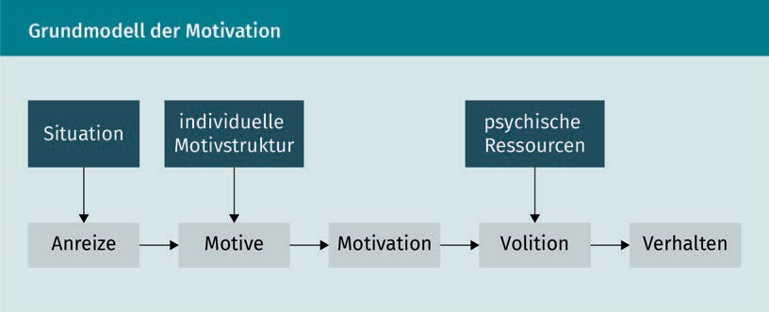

As shown in the figure above, the environment provides certain incentives in a given situation. For example, performing at a high level in the case of variable compensation or postponing unpleasant tasks in the absence of control. The individual motivational structure anchored in the personality provides the motives, which can be related to power, status, leisure, performance, or aggression, depending on the individual. The combination of incentives and motives yields motivation, i.e., the reasoned intention to act. When volition is added, these intended actions are carried out and manifested in behavior.

###### Intrinsic and Extrinsic Motivation

*Motivation problems* among employees are commonly spoken of when the achievement of goals leaves much to be desired. As described above, people have an **intrinsic motivation** structure that is based on specific likes and dislikes. However, these intrinsic goals and values are often in competition with externally imposed goals and values at work. **Extrinsic motivation** is spoken of when employees pursue certain goals and values because external incentives motivate them to do so. For example, car salespersons would have a strong extrinsic motivation if a higher commission was offered for each car sold in a given month. Intrinsic motivation occurs when a particular activity is performed for its own sake and not because of the expected results (Weibler 2012). For example, if a car mechanic switched to sales because they much prefer talking to people, are good at financing cars, and love customer contact, this would be intrinsic motivation for the activity. If an activity has a strong intrinsic motivation, the person can also enter what is referred to as the flow state. This is described as an “oblivious, pleasurable absorption in a smoothly running activity” (Weibler 2012, S. 172).

Extrinsic motivation

If an activity stems from external incentives, it is extrinsically motivated.

Intrinsic motivation

If an activity is performed for its own sake, it is intrinsically motivated.

###### VIE Theory according to Vroom

In the VIE model, motivation is viewed as a function of components of goal achievement. This means that efforts are only accepted if they appear to be rewarding in terms of goal achievement. According to Vroom, three factors have an effect on the motivation situation (Huber 2018, S. 108):

* Valence describes the value of an action outcome in terms of a positive (or negative) affective meaning of the outcome. Anything that has positive valence for a person is pursued, while outcomes with negative valence are avoided.
* Instrumentality describes a value for the degree of connection between action outcome and action consequence.
* Expectancy describes the subjectively perceived probability of a specific action outcome. This expected probability lies between 0 (completely improbable) and 1 (certain to occur).

The theory assumes a connection between the three factors, which then make an assertion about the motivation or action tendency of a person possible:

Action Tendency = Valence of Result · Expectancy

This makes it clear that the outcome must necessarily have a positive valence and the expectancy must not be equal to 0 in order to have a motivating effect on the person. This mathematic connection has made the VIE theory one of the most interesting motivation theories and it is also widely used in empirical research.

### Communication

Conversations represent the most essential form of human communication and are therefore extremely central to the shaping of any relationship. Thousands of words are used every day during communication with each other. Conversations actually take up the majority of leaders’ the time during their daily work; many of these are spontaneous and brief. Alongside this, however, more formal feedback and assessment interviews are often held and are more time-consuming to prepare and conduct.

In addition to quantity, quality plays a very central role in shaping employee leadership. Nevertheless, many leaders are not aware of the complexity and multi-layered nature of communication processes. For a better understanding, the essential models of communication are therefore discussed: the iceberg model, the communication square and transaction analysis.

Motivation, Communication, and Assessment

###### The Iceberg Model

The iceberg model postulates that only about one-seventh of all communication is conscious and spoken, comparable to the tip of an iceberg sticking out of the water. The remaining six-sevenths of communication remain unspoken and the acting persons are often not conscious of them. However, they can manifest themselves in non-verbal communication such as facial expressions, gestures, body posture, and distance to the conversation partner. Silence can also communicate something, e.g., “You're annoying me” or “I don't want to make myself vulnerable”.

###### The Communication Square

Friedemann Schulz von Thun further developed the iceberg model into what is known as the communication square. The intention is that communication and messages not only contain a factual statement, but also three other levels.

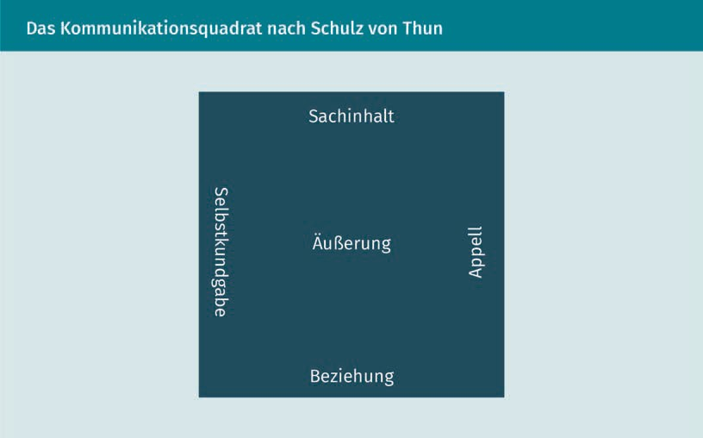

The **communication square** is a very helpful tool for understanding how misunderstandings come about. For example, if the boss says, “The coffee pot is empty” in a meeting, this can be interpreted as: “Please refill it as quickly as possible!” The four sides of a statement say the following:

Communication Square

The communication square offers starting points for clarifying misunderstandings.

* Factual content: The pure information content of a statement that can be classiﬁed as true/untrue, such as that the coffee pot is empty or the traffic light is green.
* Relationship: Provides information about how the speaker relates to the other person and what they think of them, at least in relation to the current topic of conversation. This is supported by facial expressions and gestures, such as frowning, touching, smiling, etc. For example, “A nice, fresh cup of coffee would make our meeting even more pleasant for both of us.”
* Self-disclosure: Provides information about the speaker. If it is noticed that the coffee is empty, it could be indicated that the speaker takes coffee seriously and expects it at the meeting. It resonates with an indication of an individual state: “I'd like to have a coffee!”
* Appeal: Refers to the intention with which a statement is made. If a reproachful undertone comes with holding out the pot to a co-worker to remark that the coffee is empty, it is likely that an appeal is being made to bring more coffee. Also, when the passenger says, “It's green”, the appeal is usually that the driver should continue driving.

Misunderstandings occur when a statement is assigned to a side of the square other than the one the sender was trying to convey. For example, the information “coffee pot empty” can be meant on the factual level, so that others do not reach for the pot in vain. However, it can be understood on the appeal level (“Please go get some”), or also on the relationship level (“As a boss, I don't go get coffee, one of you does that”).

Sensitivity to the different perceptions of statements is extremely important for leaders. No matter how carefully words are chosen, some statements may be received by employees in a completely different way than intended.

###### Transactional Analysis

Transactional Analysis Transactional analysis offers starting points for clarifying conﬂicts.

**Transactional analysis** also provides insight into how misunderstandings or conﬂicts occur in interactions. Eric Berne (1910-1970) developed this model by observing that people communicate from three different *ego states* and react to specific ego states of their counterparts when communicating with them (Schirmer/Woydt 2016, S. 143). There are three different ego states with a total of six characteristics:

* In the parent ego state, learned value judgments are applied. “You shouldn't do that,” “What will others think?” are typical ways of thinking and statements that indicate this state. The parent ego resorts to social control and emotional norms.

Two states can be distinguished in the parent ego state:

Motivation, Communication, and Assessment

* + The critical parent ego (“Of course you're going to hurt yourself!”) leans toward a know-it-all attitude and talking down to people.
  + The caring parent ego (“Shouldn't you go to a doctor for that?”); statements from this state can easily be interpreted as patronizing.
* In the childhood ego state, the focus is on a person's feelings and needs. It is about getting what is wanted and less about giving something. The main motive is to receive attention from others. Three additional states can be distinguished in the childhood ego state:
  + The free childhood ego state is characterized by imagination, wittiness, love, and creativity (“If I win the lottery, I'll go on vacation for six weeks, buy a Ferrari, and invite all my friends over for a big party”).
  + The rebellious childhood ego state is about gaining attention and escaping perceived dictation. Problems with authorities often arise from this ego state.
  + The conformist childhood ego state, is about avoiding tension with authority, yielding, and trying to make “everything right.”
* The adult ego state is predominantly concerned with fact gathering, weighing probabilities, and decision-making. The state is active, probing, objective, and fair. Good leaders predominantly act in this ego state.

As indicated above, conﬂicts can arise through what are referred to as crossover or concealed transactions. Ideally, leaders and employees (or people in general) act in the same ego state. In leadership situations, this would preferably be the adult ego state. A transaction could proceed as follows:

Conversation Example 1

Boss: “Are there any problems with the XY project?”

Employee: “Yes, it was slightly delayed due to technical problems. Everyone is pitching in so we can still meet the deadline.”

Problematic crossover transactions occur when the interaction partners act from different ego states. In this case, the boss is acting from the adult ego and the employee from the rebellious childhood ego:

Conversation Example 2

Boss: “Are there any problems with the XY project?”

Employee: “Is it always my fault when something doesn't go right?!”

Crossover transactions usually take one conversation partner by surprise. In this case, the boss who asks an open question is probably surprised by the employee's aggression. In terms of the communication square, the boss has asked the question on the factual level, but the employee has taken it on the relational level (“You must be incapable”). Crossover transactions can be very frustrating for one or both parties. If one party reacts from the childhood ego, they can be difficult to persuade. External help, e.g., mediation, may be appropriate here.

Concealed transactions can occur when partners believe they are communicating on a factual level, i.e., in the adult ego state, but are actually meeting on a different level:

Conversation example 3

Managing Director: “We won't achieve very much with this team. They're all lazy and calling in sick.”

Production Manager: “All worthless. We could produce much more efﬁciently with a new team.”

What both presumably perceive as a factual exchange is a concealed transaction in the critical parent ego state, which is about social control and a belief that they know better about everything.

The figure below provides an overview of the different transaction forms.

Motivation, Communication, and Assessment

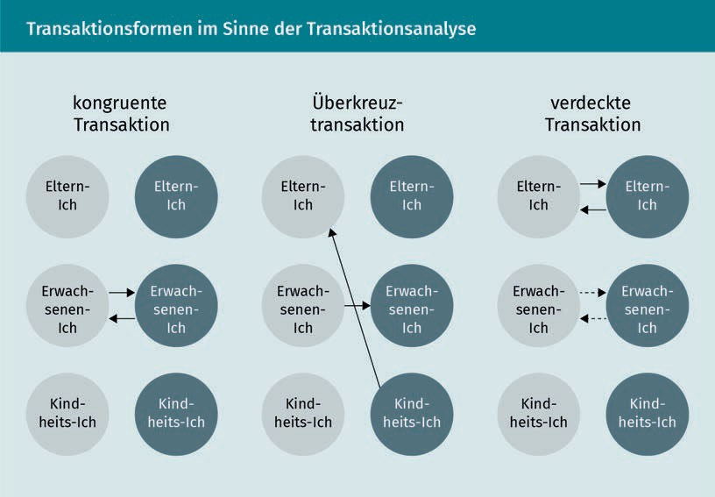

### Assessment

The main objective of assessment interviews is to make the performance and potential of both leaders and employees transparent (Stock-Homburg 2013, S. 360). The assessment interview is a thorough, usually periodic feedback discussion that is conducted according to plan. In many companies with negotiated remuneration agreements, the assessment interview is decisive for remuneration, but assessments also play a significant role for employees without negotiated remuneration agreements.

Assessment interviews fulfill different functions:

* Information function: according to Section 82 (2) of the German Works Constitution Act (BetrVG), every employee has the right to learn the extent that their own performance contributes to the success of the company from their supervisor.
* Diagnostic function: performance and potentials as well as strengths and weaknesses of the person to be assessed are analyzed.
* Coordination function: the definition of uniform quantitative and qualitative performance standards facilitates coordination between leaders and employees and makes performance between employees comparable.
* Motivational function: the coordination makes employees' needs and motives more transparent, enabling leaders to identify effective incentives to achieve goals. According to ERG theory, the feedback employees receive in the assessment interview forms a key factor in the motivation process.
* Control and monitoring function: assessment interviews offer an opportunity for differentiated insights into the activity of employees and allow comparative assessment (cf. coordination function).
* Decision support function: assessments provide information for other HR management processes such as compensation, personnel development, or team and employee leadership.

###### Requirements

Personnel assessment measures must also meet several requirements (Stock-Homburg 2013, S. 364):

* systematic implementation,
* clear reference values,
* relevant content covered,
* high acceptance by those assessed,
* adaptation to different reference objects, and
* high competence of the assessors.

Who will conduct the personnel assessment must be determined before it occurs. Various groups of people can be considered as assessors (in Anlehnung an Stock-Homburg 2013, S. 366): leaders, experts, or supplementary information providers. In the leaders group, the direct leader or a circle of leaders can be considered as assessors. The group of experts includes psychologically trained specialists, coaches, and/or HR personnel. Colleagues or team members, employees or customers and suppliers can be considered as supplementary sources of information.

What is known as the 360-degree feedback is a “process for assessing leaders in which the led employees, colleagues, superiors, and customers provide structured feedback with regard to selected behaviors of the person being assessed” (Stock-Homburg 2013, S. 367). Surveys on which 360-degree feedback is based are generally conducted in writing and anonymously. The main advantages of 360-degree feedback are the rich information that is brought to the assessment by the multiple assessors and the *objectivized* assessments. The main disadvantages are the considerable effort required to achieve the advantages and potential distortions due to certain interests, such as those of employees or suppliers who have had to accept uncomfortable decisions.

###### Time Reference

Assessment interviews often refer to the past, i.e., the employee's performance since the most recent appraisal is taken into account. To be fair in terms of the motivational and coordinating functions, assessments should also make reference to the future. Employee potentials are typical criteria that are assessed in relation to the future.

Motivation, Communication, and Assessment

For example, development potentials for tasks with more responsibility are assessed (motivation function) or development needs for taking over a specific job succession (coordination function) are identiﬁed. Weißenrieder and Kosel have combined the past and future references of an assessment in a performance potential matrix (in Anlehnung an Weißenrieder/Kosel 2005, S. 106):

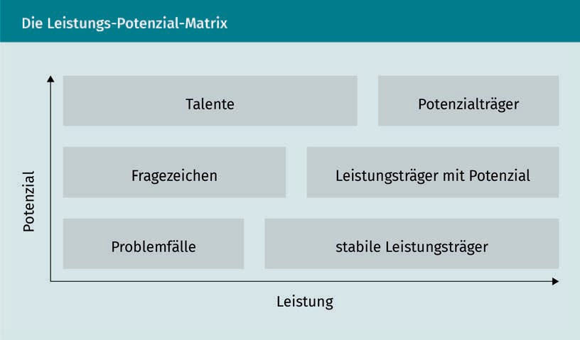

*Problem cases* are employees who are currently performing poorly and have low future potential. In the case of these employees, it is the leader's task to research the causes of these deﬁcits and eliminate them. These are often employees with rather low *maturity* in the sense of the situational leadership model according to Hersey and Blanchard. In this respect, typical causes are often a lack of experience in the job, technical overload, capacity overload, or insufficient qualification.

Although the potential of stable performers is rather weak, they reliably support operations with medium to high performance. For this group, the focus should be on maintaining performance.

If employees have average potential and moderate performance, the focus should be on finding the causes, as in the case of problem employees, in order to evaluate whether they can be developed into talents. High performers with potential are extremely high-performing employees, but they still have potential that needs to be exploited. This is why it is necessary to evaluate the extent to which they can be developed into high-potential employees.

*Talent* is about turning uncut diamonds into brilliant ones. Often, talents are found among career starters and career changers who need specific support in the form of mentoring or development measures in order to be able to realize their full potential.

###### Reference Values for Personnel Assessment

In company practice, performance in the period since the most recent assessment, the goals to be met, and the performance of other employees are used for comparison.

When assessing past performance, the goal is to identify positive or negative deviations compared to previous periods. An assessment model as shown in the figure below is suitable for an assessment. For example, this model can be applied to support the assessment of a sales manager.

|  |  |  |  |  |  |
| --- | --- | --- | --- | --- | --- |
| Exemplary Assessment Scheme | | | | | |
| Exemplary Characteristics | Performance (Before) | Performance (Current) | Deviation | Weight | Points |
| Specialized Knowledge | 11 | 11 | 0 | 1 | 0 |
| Productivity | 9 | 12 | +3 | 2 | +6 |
| Customer Satisfaction | 7 | 7 | 0 | 2 | 0 |
| Leadership Behavior | 6 | 8 | +2 | 2 | 4 |
| Subtotal |  |  |  |  | +10 |

However, it must be considered that there is little *room for improvement* in the case of outstanding employees or leaders, which is why positive deviations can only be very small. In this case, the potential of the employee in question is the decisive factor, and they should be classified as a high performer, a high performer with potential, or a high performer with high potential.

Summary

To motivate employees effectively, knowledge of the motivational and need structure is crucial in order to be able to establish effective incentives. According to Maslow or Alderfer, needs can be divided into different need levels.

Motivation, Communication, and Assessment

Conversations represent the most essential form of human communication and are therefore central to the shaping of any relationship. The iceberg model, Schulz von Thun's communication square, and Berne's transactional analysis all illustrate how misunderstandings and conflicts can arise.

Performance and potential are the key values for employee assessments. Essential requirements must be met in order to provide a fair and goal-oriented assessment. Specifically, these include a very systematic implementation, provision of clear reference values, covering relevant content, and a high level of acceptance by those assessed. The assessment must also be adapted to different reference objects and the assessor must have a high level of assessment competence.



# Unit 6

## Teams

#### STUDY GOALS

After completing this unit, students will know ...

... what distinguishes a group from a team.

... which constituent foundations are relevant for a team.

... which phases describe the life cycle of a team.

... how organizational culture affects cooperation.

... what shared leadership is based on.

... what matters in successful change management.

DL-D-MMAN02-02-L06

1. Teams

### Introduction

Are teams and groups the same thing? Consider two soccer teams as an example (Birker/Birker 2007, S. 9): In Team A, the players try to put themselves in the limelight as much as possible in order to potentially receive a lucrative transfer offer. In risky situations, they prefer to pull back to avoid getting injured, otherwise game bonuses could be lost. They prefer to score goals themselves, because it puts them on newspapers’ front pages and earns them bonuses.

In Team B, the players perform their tasks according to their position (striker, defender, midfielder, etc.) for the benefit of the overall result. In addition, each player shares responsibility for other positions, so the defender helps out in an attack and the goalkeeper also pushes further forward to help the striker.

Team A would be considered as a group of soccer players. In contrast, Team B would be considered as a team, since teamwork is often described “as the optimal design of structures based on the division of labor, making use of the special skills of the team, particularly in the accomplishment of complex tasks” (Birker/Birker 2007, S. 9).

### Team Leadership

As described in the introduction, not every collection of individuals can be considered a team. Specialized literature applies constituent and descriptive characteristics to distinguish teams from groups (Stock-Homburg 2013, S. 555):

|  |  |
| --- | --- |
| Team Characteristics | |
| Characteristics | Description |
| Constituent Characteristics of Teams | |
| Multi-personality | A team consists of at least three members. |
| Goal Orientation | Team members work together with the purpose of achieving common goals. |
| Interdependence | Team members depend on each other to achieve goals. |

Teams

|  |  |
| --- | --- |
| Characteristic | Description |
| Descriptive Characteristics of Teams | |
| Interpersonal Interaction | The team members exchange professional and interpersonal information. |
| Perception of Membership | Team members feel they belong to a social unit within the company. |
| Structured Relationships | Roles, rules, and norms exist to guide and control the behavior of team members. |
| Mutual Influence | Team members influence the attitudes and behaviors of other team members. |
| Individual Motivation | Membership in the team satisfies personal needs. |

There are various types of teams that differ in terms of their performance and cohesion. The respective expressions of the factual and relationship levels are of essential importance.

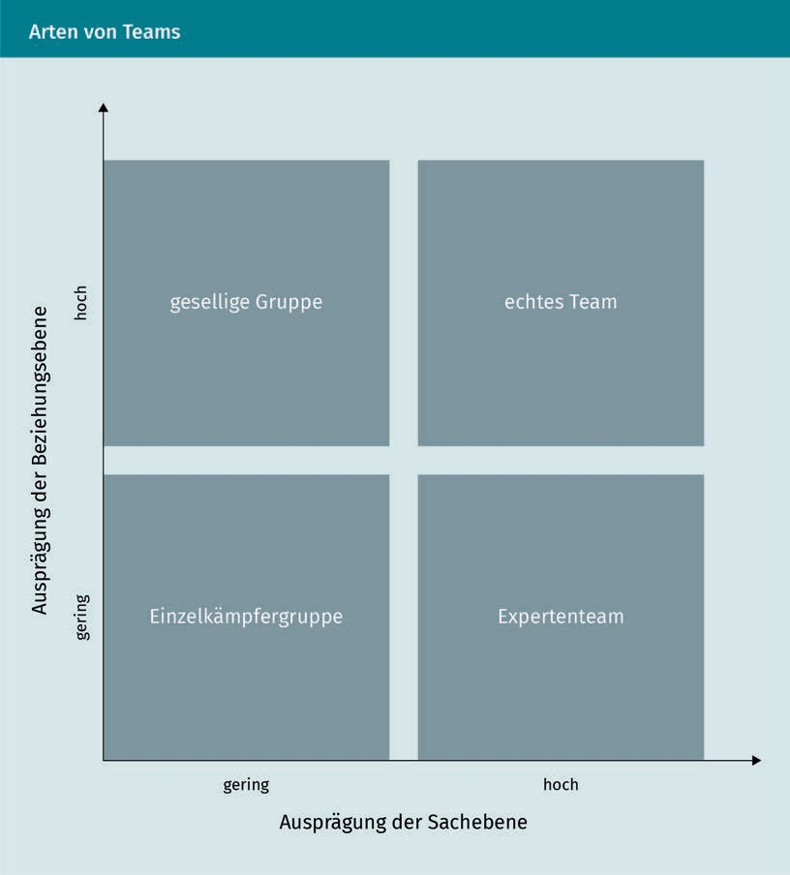

In a *lone wolf group*, there is hardly any emotional cohesion and professional cooperation. In such a constellation, leaders must work in parallel to improve the factual and relationship levels in the team. In a *sociable group*, too much time is spent on relationship care or power struggles. It is therefore the leader's task to encourage the team to strengthen the factual level. If the factual level is high, but the relationship level is low, a team is said to be an *expert team*. Performance is then impaired by the fact that team members support each other only to a very limited extent in personal matters, and difficult situations can cause the team to tear apart due to a lack of emotional cohesion. A *true team* has highly developed factual and relationship levels. In this case, it is the task of the leader to not yield to the “never change a winning team” motto and therefore to inﬂexibility. Instead, the leader should keep the team ﬂexible.

Teams

To create the most productive team possible, it is important to recognize group dynamics and guide them in productive directions. One dynamic process in groups that can have a negative impact on productivity is what is known as the **groupthink** process. Groupthink describes the dynamic of a group in which high loyalty and solidarity prevail to give team peace a higher priority than constructive disagreement (Stock-Homburg 2013, S. 556). This means that teams with a strongly pronounced groupthink have a higher motivation to place peace and unanimity in the team above alternative approaches and discussions.

Leaders can counteract groupthink among team members by ...

* preventing excessive striving for harmony in the team,
* encouraging critical professional discussions about the work process,
* promoting an open approach to professional conﬂicts, and/or
* changing the team composition occasionally.

The opportunities and risks of teamwork for a company are summarized below:

|  |  |
| --- | --- |
| Opportunities and Risks of Teamwork | |
| Opportunities | Risks |
| Better decision quality due to multi-personalities | Groupthink |
| Greater efﬁciency through the use of different skills and strengths | Increased coordination effort |
| Bundling of competencies | Increased risk of conﬂicts |
| Risk reduction through frequent communication and mutual control | Development of a subculture in the team, whereby a differentiation from the company as a whole arises |

###### Leadership of Different Types of Teams

Teams can either be divided into different types according to the phase in the life cycle (i.e., according to how long the team has existed) or according to the characteristics of the factual and relationship levels in the team.

Groupthink

There is a stronger focus on harmony than on productivity in this form of group dynamics.

Team Life Cycle Concept

One of the main goals of teamwork is to increase the effectiveness of a group of employees compared to their individual performance. The question therefore arises as to when a group becomes a team and increases in effectiveness can be recorded.

The life cycle concept of teams is based on the assumption that newly formed teams are not fully effective immediately. Instead, they go through different phases in which effectiveness and productivity develop gradually (Tuckman 1965, S. 384). The progression of the relationship between time and effectiveness is illustrated in the figure below:

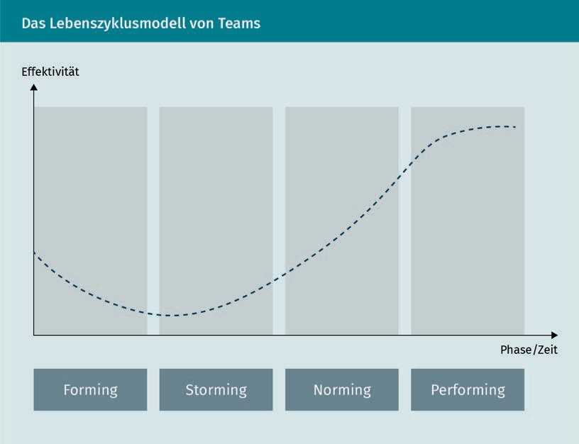

The four different phases each focus on different things. In the forming phase, the focus is on relationship building and thus on the relationship level between the team members. A relatively large amount of time is needed to get to know each other and to build relationships among each other. Initially, the working or factual level is therefore of secondary importance. In the storming phase, the relationship level remains in the foreground, because this is about the distribution of roles and who is *in charge* in the team. In the norming phase, expectations are set for the team members and the effectiveness of the team increases noticeably, because the factual level gains weight and the relationship level loses such weight. Finally, in the performing phase, all necessary group dynamic processes have been completed and the team can work together effectively. The factual and relationship levels are balanced.

Teams

The central statement of the life cycle model is that teams must be managed differently in the various stages, as the table below shows:

|  |  |
| --- | --- |
| Life Cycle Phases Model | |
| Phase | Leadership |
| 1. Forming | Role of the leader: relationship manager  Appropriate measures: informal meetings to get to know each other, identiﬁcation of strengths and potentials. |
| 2. Storming | Role of the leader: mediator  Appropriate measures: deployment of each individual according to their respective strengths and potentials, identiﬁcation of informal *authority figures*, de-escalation of conflicts. |
| 3. Norming | Role of the leader: coordinator  Appropriate measures: agreement on goals and tasks, deﬁnition of guidelines and communication processes, selective performance checks. |
| 4. Performing | Role of the leader: coach  Appropriate measures: transfer of competencies to the team, support through structuring aids, provision of resources. |

### Organizational Culture

Leadership always occurs in the context of an organization. Culture and values as well as the lived identity and *image* of a company are important here (Schirmer/ Woydt 2016, S. 123). While a leader can be effective and successful in one company, they may fail in another.

Company culture is often understood as the *social glue* that holds organizations together. The culture of a company manifests itself in many different areas, such as the fact and nature of a Christmas party or how tardiness in meetings is handled. Is the latecomer ignored, attacked with sharp comments, greeted in a friendly manner, or greeted with companionable banter? Is the Christmas party a dull, obligatory event that many stay away from, or are employees excited and tell each other the best stories about it for months afterward?

The following elements can be counted as constituting elements of an organizational culture (Schirmer/Woydt 2016, S. 110):

* + behaviors (e.g., work schedules, rituals such as Casual Friday, after-work beers, or champagne breaks for birthdays),
  + group norms (e.g., tardy fund, cell phone ban in meetings),
  + professed values, (e.g., set down in a company's vision,
  + philosophy (e.g., “work hard, play hard” or “make the world a better place”),
  + rules of the game (e.g., leaders are hired from outside or must have first gone through a “school of hard knocks” as an executive assistant),
  + climate (e.g., formal *Mr./Mrs./Ms.* or casual *first name* culture, businesslike or cheerful interaction),
  + symbols (e.g., company car policy, office furnishings, art, gym, etc.).

Schein summarizes these elements in a three-level system.

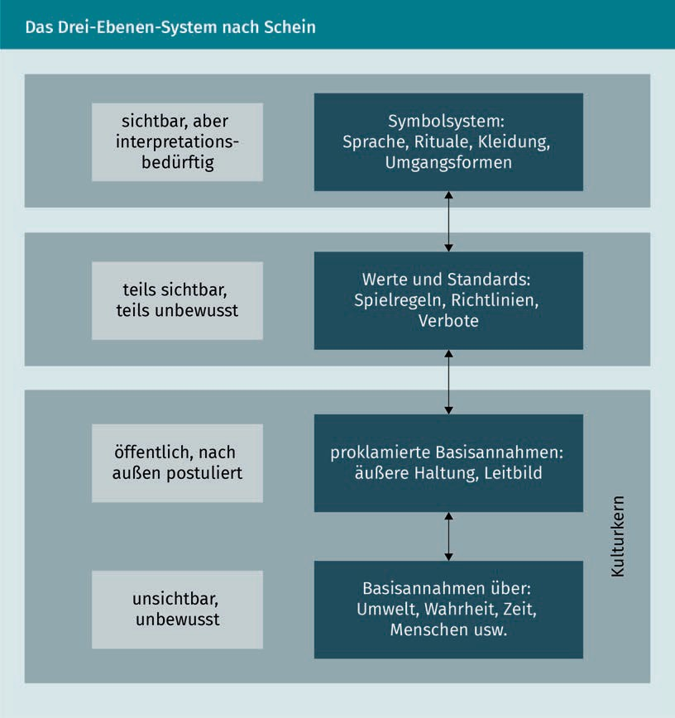

Teams

As shown in the model, the externally proclaimed values and assumptions do not necessarily need to match the prevailing basic assumptions in the company. It is quite common for the proclaimed mission statement to be changed when there is a change in leadership or when a company is taken over and an attempt to change the assumptions and behaviors that have grown over the long term is made. However, this often only has the effect of being *superimposed* (Schirmer/Woydt 2016, S. 110ff.) if these proclaimed basic assumptions are perceived by employees as forced and are therefore not implemented and lived.

At the level of values, rules, and standards, there are norms and guidelines for behavior that are implemented in a company, such as the requirement that meetings always start and end on time. The actual behavior of employees can be observed at the symbol level, e.g., how employees present themselves to the outside world, how they interact with each other, and how employees see themselves as part of an organization.

### Shared Leadership

The *shared leadership* concept emerged after the turn of the century following increasing disillusionment with personality-based, heroic leadership theories. In many cases, leaders and employees still cling to the romantic ideal of the great leader who makes resolute decisions. However, this is at least partially outdated, since various studies show that the contribution of the individual leader to the success and performance of a team is not as essential as once presumed (Bolden 2011).

Uhl-Bien et al. (2007) deﬁne shared leadership as a collective, social process that occurs through the interaction of multiple players. Shared leadership (SL) can also be understood as a counter-design to classic hierarchical top-down leadership. In essence, it is about employees taking on parts of the leadership function that would otherwise be connected with the responsible leader. Shared leadership should not be confused with *leadership from below*, which is a rather conspiratorial action by employees aimed at weakening or overruling the leader.

Shared leadership considers the fact that increasingly complex and highly technical work also requires highly qualified employees. If a team of highly qualified specialists is led, the knowledge and experience gap between the leader and the employees is often only marginal or even non-existent.

The following aspects can be stated as prerequisites for the shared leadership concept:

* minimal technical and competence-based advantages of a leader,
* democratic or participative leadership style,
* willingness of employees to take responsibility,
  + high maturity of employees,
  + positive climate in a company that promotes shared leadership instead of attributing *leadership weakness*.

### Change Management

Change Management

This describes a strategic and operational repositioning and restructuring of a company.

Organizations are constantly exposed to a variety of internal and external change processes. Although they have always been exposed to changing environmental influences, they are currently facing increasing pressure to change. One reason for this is the increase in complexity (Weibler 2012, S. 26ff.), which is characterized by increased diversity, nonlinearity, dynamism, and the introduction of new technologies. The need for coordination also increases through unclear situations when a greater diversity of variants and geographic expansion are pursued at the same time. An additional acceleration of change due to increasingly faster technological progress and shorter development times creates more uncertainty and insecurity. Moreover, there are increasingly paradoxical requirements such as cooperation and competition (e.g., in the joint engine development of Daimler and Audi) as well as stability and flexibility. Customer requirements are also continually changing. In particular, increased quality awareness in saturated markets and higher service demands from customers intensify the pressure on organizations to adapt, which requires **change management**. In this respect, change management encompasses the strategic and operational repositioning and restructuring of a company at the content and process level.

A good example of change management is Apple's successful turnaround that began when Steve Jobs rejoined the company as CEO in 1997. Jobs ended the longstanding enmity with Microsoft and made Microsoft applications work on Apple's Macs. The introduction of iPods and later iPhones and tablets crowned the change process with extraordinary ﬁnancial success.

Employees often initially reject major, albeit necessary, changes. After Microsoft had long been built up as an enemy image among Apple employees, it was difficult to convince employees of the meaningfulness of cooperating with this *enemy*. Long-held convictions are at odds with the imminent uncertainty, feared chaos, and possibly insufficient communication and transparency. This very often leads to resistance among the workforce. A figurative comparison is the idea that the leader is driving a car and the employees are passengers. What looks harmless from the driver's point of view or is a logical maneuver can trigger uncertainty among the passengers. Therefore, communication and transparency are two very essential components of successful change management.

However, in practice, a great number of change processes fail. A prominent example of this is Nokia's slide from its position as world market leader in cell phones following the advent of smartphones. The same applies to Motorola and Blackberry, which failed to keep pace with technological change.

Teams

###### Solution Approaches in Change Management

The first step in the change process is to identify the need for change within a company and to collect ideas and suggestions for adaptations (Welbourne 2014). In the next step, it is important to *bring along* the employees and provide them with information and training offers so they are convinced of the necessity and meaningfulness of the change measures and accept them.

Kotter developed an eight-stage model for change management that is considered a *classic* for change processes (Kotter 1995):

* establish and communicate urgency,
* form coalitions that initiate change,
* create a strategic vision,
* empower an *army of willing supporters*,
* reduce barriers and obstacles,
* strive for *quick wins*,
* maintain momentum, and
* anchor change.

Success factors in leading change processes include the creation of a very clear vision that anticipates the outcome of the change in a business case. In addition, effective communication is extremely important, as described in the example above. It explains and describes the reasons for the change to employees, as well as the benefits to be gained by the individuals from the improvement.

Summary

Not every group is automatically a team, since teams must have certain constituent characteristics. After a new team has been formed, it goes through four typical phases that are characterized by varying degrees of effectiveness.

Organizational culture has a significant influence on cooperation within the company and is evident in various areas such as behavior, climate, philosophy, and symbols. Shared leadership will only be lived in an open, partnership-based culture.

If changes are necessary due to repositioning and restructuring, certain aspects must be considered, for which Kotter proposes an eight-stage process.



# Unit 7

## Current Trends and Debates

#### STUDY GOALS

After completing this unit, students will know ...

... how personality and leadership are connected.

... which personality traits are promising for leaders.

... how narcissism and psychopathy affect occupational careers.

... how toxic workers can be identiﬁed and what impact they have on a company.

... what *management derailment* means, what its causes are and how it can be prevented.

... what *counterproductive work behavior* means and what its implications are for a company.

... what the forms of power are and what they mean for leadership.

... how Generations X, Y, and Z are shaping working life.

DL-D-MMAN02-02-L07

1. Current Trends and Debates

### Introduction

Several topics in leadership research have been controversial in recent years and have even attracted the interest of popular media and daily newspapers. Two of these topics are the phenomena of *narcissists* and *psychopaths* in leadership positions. Research has focused on how people with such *dark* personality traits come to be in leadership roles and to what extent they can succeed or fail despite, or because of, their particular personality structure (*leadership derailment*).

The next aspect, which is controversially discussed in research, is the phenomenon of

*toxic worker*. Many people have groaned about a colleague who causes nothing but discord in a team. Recent research has produced econometric findings and early detection approaches on how to identify and catch *toxic worker*s.

In addition, a detailed examination of power and status in leadership positions and their effects on leaders themselves, their employees, and the wider environment is presented. As a final point in this unit, Generations X, Y, and Z and their respective expectations and influences on working life are discussed.

### Personality and Leadership

Trait theory, also known as the *great man theory*, was one of the early leadership theories that shaped the focus on certain traits of leaders.

Mai and colleagues (2015) summarize the main findings of personality research related to leadership as follows:

Excursus

“Boudreau/Boswell (2001) link the correlation between personality requirements and success by citing the traits of successful managers. The authors explain that the personality of a top manager has a direct and indirect effect on career success via motivation and human capital. Boudreau/Boswell (2001) also identify a high level of optimism, self-confidence, and self-awareness, as well as the pursuit of success and decisiveness as predictive personality traits of managers and thus support a deeper examination of personality. Moreover, Giberson/Resick/Dickson (2005) and Bono/Judge (2004) focus on the analysis of dominant personality proﬁles based on various character traits.

Current Trends and Debates

Shao/Webber (2006) and Judge/Bono (2000) examine the dominant proﬁles among leaders on the basis of the *big five*, which produces a proﬁle similar to those described above. In each case, dominant types emerge from these studies that nevertheless differ in direct comparison within their trait expressions and are rarely only found in one type. With regard to analysis of a dominant proﬁle, Stogdill (1948) concluded early on that the derivation of a uniform personality proﬁle, that is, a generalizable set of traits, is not possible on the basis of trait theory.”

Depending on the psychological tests applied in each case, various studies have revealed different personality traits that are supposed to make successful leaders. The table below provides an overview of selected studies on this subject.

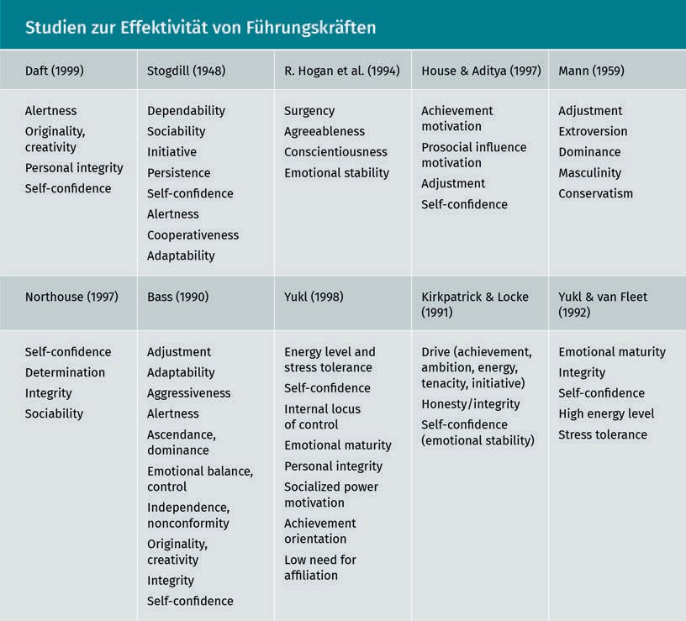

Judge et al. (2002) conducted a meta-analysis due to the inconsistent results of individual studies. In this process, the correlations of several studies are combined and converted into the meta-correlation coefﬁcient ρ. Judge et al. (2002) distinguished two leadership

variables in their analysis: the first is *leadership emergence*, the likelihood that someone will be promoted to a leadership position and second, *leadership effectiveness*, the effectiveness of a leader in their role. The results of the meta-analysis showed a slightly different picture for the probability of being promoted to a leadership position and the subsequent effectiveness of a leader. While emotional stability, extraversion, and conscientiousness played a central role in promotion, extraversion, creativity, and adaptability emerged as the most important traits for the effectiveness of a leader.

This discrepancy in the promotion to and effectiveness as a leader must actually be surprising and lead to questioning the methods applied when selecting leaders. If it is proven that adaptability and creativity play a significant role in leadership success, then of course, leaders should be selected accordingly.

Personality abnormalities such as narcissism and psychopathy are being increasingly discussed in new literature as traits of leaders.

###### Narcissism

The term *narcissism* actually comes from Greek mythology. The myth is about a young man falling in love with his own reflection. Since then, narcissism has stood for an exaggerated love of self and the idea of thinking of oneself as the greatest. Campbell et al. (2011) deﬁne narcissism as a stable individual personality trait based on some degree of delusions of grandeur, self-love, and exaggerated self-worth. Narcissism manifests itself in three different ways (Campbell et al. 2011, S. 269):

1. Narcissistic self-perception is characterized by positive self-evaluations and the perception of being *special*, as well as vanity and the desire for power and achievement.
2. Narcissists typically have little empathy and are incapable of establishing genuine closeness with their fellow human beings. Instead, they often have numerous acquaintances and superficial friendships, many of which are exciting, but are often also manipulative and focused on the benefits to be expected from the other person.
3. Narcissists adopt certain strategies to maintain their exaggerated self-worth. For example, they specifically look for opportunities to excel and show off, and they rarely shy away from taking credit for the work of others. When they can do this without negative consequences, they have high self-esteem and a strong sense of life satisfaction. However, if they cannot justify their excessive self-esteem, they often become aggressive, or their self-esteem turns into depression and anxiety.

Current Trends and Debates

Narcissists can be divided into two different subtypes: the grandiose and what is known as *vulnerable* narcissists. Grandiose narcissists are often found among top leaders (board members, CEOs) who are self-confident, extroverted, dominant, attention-seeking, and charismatic, but can also be incapable of receiving criticism, as well as aggressive, arrogant, and exploitative. In contrast, vulnerable narcissists, tend to behave in a hostile manner because they feel that the whole world is conspiring against them. They are often also arrogant, but have low self-esteem, and are somewhat depressed and withdrawn.

Narcissism plays a special role in leadership and management because grandiose narcissists as described above often strive for power and influence, which is why an above-average number of narcissists are found in leadership positions. Since they are often positively assessed in assessment centers, narcissism also contributes to leadership emergence: They like to talk a lot, dominate group discussions, and are the ones who like to present and stand at the flip chart. However, the traits that make them stand out positively in assessment centers are not exactly those that make them a pleasant colleague or boss. Campbell et al. (2011) describe this as the *chocolate cake effect*: what can be particularly pleasant in very small doses quickly becomes unpleasant in large doses. Yet, as assessment centers became increasingly popular in the 1990’s and early 2000’s, a particularly large number of narcissists are now to be found in leadership positions, precisely because they *stood out* at that time.

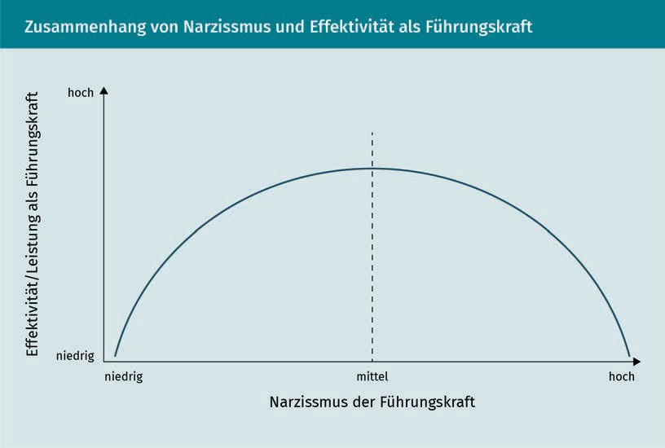Recent **meta-analyses** have looked at the circumstances under which narcissism helps or hinders leaders (z.B., Grijalva et al. 2015). The results showed an inverted U-shaped progression of narcissism and leadership effectiveness, which is also shown in the figure below:

Meta-analyses Studies that summarize previous studies on the same or a similar topic and thus provide an overview of an entire field of research are called meta-analyses.

As the figure above shows, the most effective leaders (across many different studies) are those who exhibit a moderate level of narcissism. Both poles, very high and very low narcissism, equally lead to comparatively low effectiveness as a leader.

###### Psychopathy

Psychopathy, or *antisocial personality disorder*, is deﬁned as a profound pattern of disregard for and violation of the rights of others that begins in early adolescence and persists into adulthood (Dutton 2013). The Diagnostic and Statistical Manual of Psychiatry (DSM) identifies seven factors, at least three of which must have occurred before the age of 15 to make a reliable diagnosis (APA 2018):

* inability to conform to social norms, repeated criminal acts,
* dishonesty, repeated lying to gain advantage,
* impulsiveness and lack of caution,
* irritability and aggression, fights, or assaults,
* recklessness,
* long-term irresponsibility with regard to work or financial matters, as well as
* lack of remorse, indifference, or rationalization of one's own missteps.

Hare (1991) presented the first empirical measurement instrument for the clear identification of psychopaths (Psychopathy Check List Revised, PCL-R). Four dimensions are distinguished: interpersonal, affective, lifestyle-related, and antisocial. The table below provides a more detailed overview of the PCL-R according to Hare.

|  |  |  |  |
| --- | --- | --- | --- |
| The Psychopathy Check List | | | |
| Factor 1 Interpersonal | Factor 2  Affective | Factor 3  Lifestyle-Related | Factor 4 Antisocial |
| Tricky, Articulate, Superficial Charm | Lack of Conscience | Constant Feeling of Boredom | Uncontrolled Behavior |
| Inflated  Self-Esteem | Superficial Feelings | Parasitic Lifestyle | Early Behavioral Conspicuities |
| Constant Lying | Lack of Empathy | Aimlessness | Delinquency in Youth |

Current Trends and Debates

|  |  |  |  |
| --- | --- | --- | --- |
| Factor 1 Interpersonal | Factor 2 Affective | Factor 3  Lifestyle-Related | Factor 4 Antisocial |
| Deceptive Conduct | Rejection of Responsibility | Impulsivity | Violation of Instructions and Restrictions |

Dutton (2013) conducted a descriptive study in which participants were asked about their occupation and their psychopathy score was subsequently measured. The results of this study are summarized in the table below.

|  |  |  |
| --- | --- | --- |
| Occupation and Psychopathy | | |
| Rank | Occupations with Above-Average Psychopathy Scores | Occupations with Below-Average Psychopathy Scores |
| 1 | CEO | Care Aide |
| 2 | Lawyer | Nurse |
| 3 | Media (Television/Radio) | Therapist |
| 4 | Salesperson | Craftsperson |
| 5 | Surgeon | Hairdresser |
| 6 | Journalist | Charitable Organization Worker |
| 7 | Police Officer | Teacher |
| 8 | Clergyperson | Creative Artist |
| 9 | Chef | Doctor |
| 10 | Civil Servant | Accountant |

The table shows that highly paid occupations such as CEO and lawyer seem to attract more psychopathic individuals or that they can flourish in such occupations. Psychopathy also seems to be more of an advantage in sales. Dutton (2013, S. 203) explains this phenomenon: “Psychopathy […] is like a medicine for modern times. If you take it in moderation, it can prove extremely beneficial. It can alleviate a lot of existential ailments that we would otherwise fall victim to because our fragile psychological immune systems just aren’t up to the job of protecting us. But if you take too much of it, if you overdose on it, then there can, as is the case with all medicines, be some rather unpleasant side effects.”

### Leadership Derailment

The term *leadership derailment* means failure in a leadership role. Time and again, the media reports on top managers who were once highly celebrated, but then *crashed*:

“Thomas Middelhoff, who is associated with the bankruptcy of Arcandor and Karstadt/ Quelle, Jürgen Schrempp, who is blamed for the failure of the Daimler-Chrysler merger, Ron Sommer, who is responsible for the bumpy IPO of Telecom, and Klaus Zumwinkel, who sat on the board of Deutsche Post for 18 years, but whose integrity became questionable when he was targeted by the tax investigation.

Various descriptive studies have identiﬁed behaviors, motives, and personality factors that are associated with leadership derailment. These factors are also referred to as *counterproductive work behavior*. Across multiple studies, interpersonal difficulties are shown to be a prominent indicator of leadership derailment (Hogan et al. 2010). In particular, the inability to create a true team with cohesion, mutual trust, and a common goal seem to foster derailment. Lack of management skills, arrogance, egoism, and pursuing one's own agenda instead of a company's goals are other possible factors (Hogan et al. 2010).

Hogan and colleagues (2010, S. 564) distinguish three strategies in the interpersonal domain with varying degrees of promise:

* *moving away* by avoiding contact with others and using intimidation to achieve goals,
* *moving against* by using manipulation and charm to achieve goals, and
* *moving toward* by striving for goals through integration of others and partnerships.

The three different strategies are each preferred by specific personality types, For example, the moving away strategy is preferred by unstable, suspicious, shy, and pessimistic types. The moving against strategy is particularly favored by people who are arrogant, manipulative, eccentric, attention-seeking, and egocentric.

Current Trends and Debates

In contrast, the moving toward strategy is more likely to be applied by people who are careful, conscientious, reliable, and even perfectionistic (Hogan et al. 2010). It can be concluded that the moving toward strategy is likely the most promising approach to building and maintaining sustainable interpersonal relationships. Consequently, the selection process for leaders should be designed in such a way that candidates with the above-mentioned traits, who prefer a moving toward strategy, are hired.

In addition to the moving toward strategy, the following cross-cultural factors have been shown to be protective against leadership derailment (Hogan et al. 2010):

* successfully managing complexity,
* effective guidance and motivation of employees,
* sense of honor,
* pursuit of excellence,
* adeptness in terms of organization and management,
* self-control and dignified appearance,
* sensitivity and empathy, as well as
* smart personnel decisions.

### Toxic Workers

Toxic workers are all those people in a team who frequently display *counterproductive work behavior*. Houseman and Minor (2015) describe them as employees who, in the mildest case, are a poor fit for the company and the respective position, resulting in costly backfilling. In the worst case, sexual harassment, workplace violence, fraud, or other rule violations occur. In addition, toxic workers often perform better, but also qualitatively worse, than average contributors (Houseman/Minor 2015).

The reasons for toxic behavior are diverse. However, it is often due to incentive systems that are not necessarily in line with ethical guidelines. Equally relevant, however, is the selection process to filter out toxic individuals from the beginning (Houseman/Minor 2015). Houseman and Minor (2015) identiﬁed the following factors that lead to more toxic behavior:

* weak service orientation, reflecting disdain for others,
* excessive optimism and a particularly high opinion of oneself,
* multiple contacts with other toxic individuals, and
* low supervision and monitoring of position by supervisors.

Houseman and Minor (2015) provide a comparison of savings when either a *superstar performer* is hired or a toxic worker is removed by firing based on an estimation model with actual company data. The savings from removing a toxic worker come from preventing a further outflow of average or good employees, since colleagues of toxic workers usually feel annoyed by them and leave the company after a certain period of time. In each case, reductions by eliminating a toxic worker in the Houseman and Minor (2015) model lead to a savings of $12,489. In contrast, hiring a superstar performer who is among the top 25% of performers in a company results in a savings of only $1,951. *Savings* from hiring a top performer should be understood to mean that the performer is as productive as 1.3 or 1.5 *average* employees, but costs only one salary (instead of 1.3 or 1.5). If a company hires a *superstar performer* who is in the top percent of performers, $5,303 is saved because they are significantly more productive than average employees, but only cost one salary.

However, as the table below shows, firing a toxic worker is more than twice as efﬁcient as hiring an outstanding employee in terms of cost savings (Houseman/Minor 2015, S. 22):

|  |  |  |
| --- | --- | --- |
| Comparison of Top Performers and the Cost of Toxic workers | | |
| Superstar Rank | Hire a Superstar  (Cost Savings) | Avoid a Toxic Worker  (Cost Savings) |
| Top 25 % | $ 1,951 | $ 12,489 |
| Top 10 % | $ 3,251 | $ 12,489 |
| Top 5 % | $ 3,875 | $ 12,489 |
| Top 1 % | $ 5,303 | $ 12,489 |

### Power in Organizations

Power, status, and influence in companies and organizations can emerge in different ways. The different types of power available to an individual also determine the degree of influence they have. Basically, the concept of power in companies can be broken down into two subdimensions: positional or organizational power and personal power. The figure below shows the different power dimensions.

Current Trends and Debates

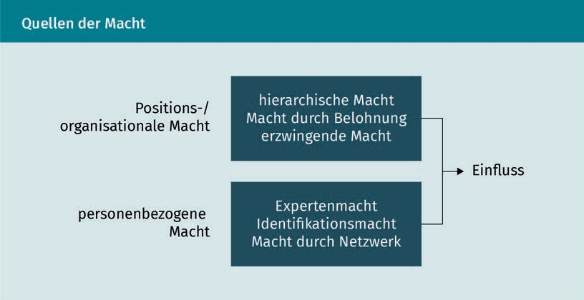

**Organizational power** is divided into three subtypes:

* Hierarchical power occurs through a position in the hierarchy. The placement of the position in the organizational chart shows the extent to which the position is assigned to management, coordination, or supervision functions.
* Power through reward occurs when a leader has the majority of or complete control over variable salary components of employees and can therefore directly influence its amount.
* Enforcing power occurs through direct authority. This often results from the organizational chart, but is specifically never written in a job description.

**Personal power** is also divided into three subtypes:

* Expert power occurs through a broad specialist knowledge. The allocation of power therefore takes place through the knowledge and experience gap of others.
* Identiﬁcation power is often accompanied by charisma and is described as an influence that occurs when other people prefer to identify and associate with this person. Identiﬁcation power is a key component of transformational leadership, which is based on the fact that the leader is perceived by their employees as a role model and convinces them with charisma.
* Power through networking comes from the fact that the leader has many sustainable relationships in different areas of the company and beyond. This can result in an information advantage, symbioses can arise, and synergies can be utilized.

Positional or Organizational Power

Positional power refers to the share of influence that can be exercised through the position assigned by the company and the instruments available.

Personal power

It is not dependent on the position in the hierarchy and the available resources, but only comes from the individual characteristics and efforts.

### Generations X, Y, and Z

Leading people of different age groups with different preferences represents a challenge for leaders. The (real or perceived) differences between Generations X, Y, and Z are frequently discussed. *Generation X* refers to those born between approx. 1970 and 1980. The *Millennials* of *Generation Y* are those born between 1981 and 1996. Accordingly, *Generation Z* consists of those born after 1997 (Bresman/Rao 2017).

A large-scale study of the values and aspirations of the members of these three generations revealed not only a number differences, but also many similarities. In their comparative study of 18,000 people worldwide, Bresman and Rao (2017) find that geography, background, and gender often play at least as important a role as belonging to one of the three *generations*.

This means that leaders must approach their employees individually and should not simply lump them into one *generation box*. Rather, special cultural and personal characteristics, behind which generational affiliation can be secondary, must also be considered. The findings on leadership ambitions, entrepreneurial ambitions, and the targeted match between personality and work are of particular interest.

###### Leadership Ambitions

A full 61% of respondents from Generations Y and Z and 57% of respondents from Generation X see the assumption of leadership responsibility as important. However, there were major regional differences. For example, only 47% of the Generation Y Norwegians surveyed had leadership ambitions, but over 75% of Mexicans and Americans of the same age did. Of course, this is significant for companies. In labor markets with less pronounced leadership ambitions (such as Denmark, Sweden, and France), the challenge may lie more in finding suitable young leaders, while in the other countries, the focus may be more on managing expectations and finding alternative motivators.

Fundamentally, Generations X and Y are particularly attracted to the coaching and mentoring required of a leader during leadership. In contrast, Generation Z is focused on increased responsibility. But here, too, there are strong regional differences: for Generation X in Spain, the role of coach is the most important component of their leadership ambitions, while in Germany, the UK and the US, the challenging scope of the position is in the forefront.

Current Trends and Debates

There are also gender-specific differences: across all generations surveyed, men have stronger leadership ambitions than women. However, the respondents in the younger Y and Z generations are strongly converging: Here, 63% of the men and 61% of the women have a corresponding *leadership ambition*.

###### Entrepreneurial Ambitions

All three generations show a strong interest in their own entrepreneurial activities. As many as one in four Generation Z students surveyed would like to become self-employed. Indeed here, too, there are major regional differences. For example, the desire to become self-employed was by far the strongest in India and Mexico, irrespective of generation.

It certainly must be considered that the respondents in the more developed economies of Europe and North America have more attractive jobs as employees than in the second and third world countries: regardless of age, the share of company founders is higher there due to a lack of alternatives than, for example, in Germany, where the deliberate choice to start a company is in the forefront (*entrepreneurial activity out of necessity* vs. choice), as shown, for example, by the annually published “Global Entrepreneurship Monitor” of the Babson School of Management.

###### Targeted Match between Personality and Work

For the younger generations, it is more important to fit with a company in terms of personality and values (50% vs. 40% of Generation X).

Across all generations, 70% of respondents say that making working hours and work more flexible represents the greatest opportunity over the next ten years. It is worth noting that more respondents from Generation X would take part in an online course than those from Generation Z. In fact, only 13% of Generation Z would choose an online course if they had the alternative of a classroom course.

Summary

Leadership is strongly influenced by personality. However, the exact cause-and-effect relationship has not been clearly established, since different studies have identified various *promising* personality traits. However, the empirical situation is striking with regard to leadership derailment, which is often due to interpersonal problems. Narcissism and psychopathy, although frequently responsible for derailment, are surprisingly common among top leaders. *Counterproductive work behavior* is often exhibited by *toxic* workers.

Empirical studies show that it is much more effective to remove a toxic worker from the team than to hire a particularly productive employee.

Leaders have various forms of power at their disposal that should be utilized according to the situation.

Different generations have various preferences with regard to the world of work. Nevertheless, other parameters such as gender and background must also be considered, since belonging to a generation alone does not establish a definitive difference in the direction of a particular work attitude.



# Appendix 1

## List of References

List of References

APA American Psychiatric Association (2018): *Diagnostisches und Statistisches Manual Psychischer Störungen DSM-5®*.[*Diagnostic and Statistical Manual of Mental Disorders DSM-5 ®*]. 2. Auﬂage. Hogrefe, Göttingen.

Bakker, A. B./Demerouti, E. (2007): *The job demands-resources model: State of the art*. In: Journal of Managerial Psychology, Vol. 22, Issue 3, pp. 309–328.

Bass, B. M. (1985): *Leadership and performance beyond expectations*. Free Press, New York.

Berkel, K. (2007): *Integratives Führen als Wertebalance*. *[Integrative Leadership as a Balance of Values]* In: Westermann, F. (Ed.): Entwicklungsquadrat. Theoretische Fundierung und praktische Anwendungen. [Development Square. Theoretical Foundation and Practical Applications] Hogrefe, Göttingen, S. 207–221.

Birker, G./Birker, K. (2007): *Teamentwicklung und Konﬂiktmanagement*. *Efﬁzienzsteige- rung durch Kooperation*. [*Team Development and Conflict Management*. *Efﬁciency Increase through Cooperation*] 2. Auflage, Cornelsen, Berlin.

Bolden, R. (2011): *Distributed leadership in organizations: A review of theory and research*. In: International Journal of Management Reviews, 13. Jg., Heft 3, S. 251–269.

Bono, J. E./Judge, T. A. (2004): *Personality and transformational and transactional leadership: a meta-analysis*. In: Journal of Applied Psychology, 89. Jg., Heft 5, S. 901.

Boudreau, J. W./Boswell, W. R. (2001): *Effects of personality on executive career success in the United States and Europe*. In: Journal of vocational behavior, Vol. 58, Issue 1, S. 53–81.

Bresman, H./Rao, V. D. (2017): *A survey of 19 countries shows how generations X, Y, and Z are-and aren't-different.* In: Harvard Business Review vom 25.08.2017. (URL: https:// hbr.org/2017/08/a-survey-of-19-countries-shows-how-generations-x-y-and-z-are-and-aren't-different [letzter Zugriff: 17.07.2019]).

Campbell, W. K. et al. (2011): *Narcissism in organizational contexts.* In: Human Resource Management Review, 21. Jg., Heft 4, S. 268–284.

Chen, G. et al. (2011): *Motivating and demotivating forces in teams: Cross-level inﬂuences of empowering leadership and relationship conﬂict.* In: Journal of Applied Psychology, 96. Jg., Heft 3, S. 541–557.

Colquitt, J. et al. (2011): *Organizational behavior: Improving performance and commitment in the workplace*. McGraw-Hill Irwin, New York.

Covey, S. R. (2005): *Die 7 Wege zur Effektivität. Prinzipien für persönlichen und beruﬂi- chen Erfolg.* [*The 7 Habits of Highly Effective People. Principles for personal and professional success]* Gabal, Offenbach.

List of References

Drucker, S. (1996): *Foreword*. In: Hesselbein, F. et al. (Hrsg.): The Leader of the Future New Visions, Strategies, and Practices for the Next Era. Drucker Foundation Future Series, New York.

Duckworth, A. L. et al. (2007): *Grit: perseverance and passion for long-term goals.* In: Journal of Personality and Social Psychology, 92. Jg., Heft 6, S. 1087–1101.

Dutton, K. (2013): *The Wisdom of Psychopaths*. Arrow, London.

Felfe, J. (2014): *Transformationale Führung: Neue Entwicklungen*. In: ders. (Hrsg.): Trends der psychologischen Führungsforschung. Neue Konzepte, Methoden und Erkenntnisse. Reihe: Psychologie für das Personalmanagement. [*Transformational leadership: New developments*. Trends in psychological leadership research. New concepts, methods, and insights. Series: Psychology for human resource management] Hogrefe, Göttingen, S. 39–54.

Fiedler, F. E. (1967): *A Theory of Leadership Effectiveness*. McGraw-Hill, New York.

Friedman, T. L. (2005), *The World is ﬂat. A Brief History of the Twenty-First Century*. Holtzbrinck, Stuttgart.

Giberson, T. R./Resick, C. J./Dickson, M. W. (2005): *Embedding leader characteristics: an examination of homogeneity of personality and values in organizations*. In: Journal of Applied Psychology, 90. Jg., Heft 5, S. 1002.

Grijalva, E. et al. (2015): *Narcissism and leadership: A meta-analytic review of linear and nonlinear relationships.* In: Personnel Psychology, 68. Jg., Heft 1, S. 1–47.

Guldin, A./Gelléri, S. (2014): *Förderung von Innovationen*. [*Promotion of Innovations]* In: Schuler, H./Kanning, U. P. (Hrsg.): Lehrbuch der Personalpsychologie. [Textbook of Personal Psychology] Hogrefe, Göttingen.

Hansch, D. (2009): *Erfolgsprinzip Persönlichkeit*. [Success Principle Personality] Springer, Heidelberg.

Hare, R. D. (1991): *The Hare psychopathy checklist – Revised Manual*. Multi-Health Systems, North Tonawanda/NY.

Hogan, J. et al. (2010): *Management derailment*. In: APA handbook of industrial and organizational psychology, Heft 3, S. 555–575.

Houseman, M./Minor, D. (2015): *Toxic workers*. Harvard Business School Working Paper, no. 16-057. (URL: https://dash.harvard.edu/bitstream/handle/1/23481825/16-057.pdf? sequence=1&isAllowed=y [letzter Zugriff: 29.08.2019]).

Huber, A. (2018): *Personalmanagement*. [*Personnel Management*] Vahlen, Munich.

Judge, T. A./Bono, J. E. (2000): *Five-factor model of personality and transformational leadership*. In: Journal of Applied Psychology, 85. Jg., Heft 5, S. 751.

Judge, T. A. et al. (2002): *Personality and leadership: a qualitative and quantitative review.* In: Journal of Applied Psychology, 87. Jg., Heft 4, S. 765–774.

Kals, E. (2006): *Arbeits- und Organisationspsychologie.* [*Industrial and organizational psychology]*  *Workbook.* Beltz, Weinheim, S. 97–110.

Kastner, M. (2014): *Umgang mit Belastungen und Anforderungen*. [*Handling stresses and demands]* In: von Rosenstiel, L./ Regnet, E./Domsch, M. (Hrsg.): [Leading Employees. Handbook for successful personnel management] Schäffer-Poeschel, Stuttgart, S. 102–111.

Kotter, J. S. (1995): *Leading Change: Why Transformation Efforts Fail*. In: Harvard Business Review, 74th ed. 2, pp. 59-67.

Kotter, J. S. (2011): *Leading Change. Wie Sie Ihr Unternehmen in acht Schritten erfolgreich verändern*. [*Leading Change. How to successfully change your company in eight steps*] Vahlen, Munich.

Kreiner, G. E. et al. (2009): *Balancing borders and bridges: Negotiating the work-home interface via boundary work tactics.* In: Academy of Management Journal, 52. Jg., Heft 4, S. 704–730.

Lawrence, K. (2013) *Developing leaders in a VUCA environment.* UNC Executive Development, S. 1–15. (URL: [https://www.emergingrnleader.com/wp-content/uploads/2013/02/](http://www.emergingrnleader.com/wp-content/uploads/2013/02/) developing-leaders-in-a-vuca-environment.pdf [letzter Zugriff: 17.07.2019]).

Lewin, K. et al. (1939): *Patterns of aggressive behavior in experimentally created “social climates”.* In: The Journal of Social Psychology, 10. Jg., Heft 2, S. 269–299. (URL: https://tudresden.de/mn/psychology/ipep/teachers/resources/files/teaching/teaching-events/teachers_Schueler_Interaction_SS_2011/Lewin_1939_original.pdf?lang=en [letzter Zugriff: 17.07.2019]).

Lieberson, S./O'Connor, J. F. (1972): *Leadership and Organizational Performance: A Study of Large Corporations*. In: American Sociological Review, 37. Jg., Heft 2, S. 117–130.

Luhmann, N. (1984): *Social Systems*. *Grundriß einer allgemeinen Theorie.* [*Social Systems. Outline of a general theory]* Suhrkamp, Frankfurt am Main.

Mai, C. et al. (2015): *Persönlichkeitsprototyp der DAX 30 Vorstandsvorsitzenden: Eine empirische Analyse mittels Attribution anhand des NEO-Fünf-Faktoren-Inventars*. [*Personality prototype of DAX 30 CEOs: An empirical analysis by attribution using the NEO five-factor inventory*] In: Schmalenbachs Zeitschrift für betriebswirtschaftliche Forschung [Schmalenbach Journal of Business Research], 67. Jg., Heft 1, S. 4-34.

Nerdinger, F. W. (2014): *Führung von Mitarbeitern.* [*Leadership of employees]* In: Nerdinger, F. W. et al. (Hrsg.): Arbeits- und Organisationspsychologie [Industrial and Organizational Psychology] 3. Auﬂage, Springer Gabler, Berlin/Heidelberg, S. 83–102.

Neuberger, O. (2002): *Führen und führen lassen. [Lead and Allow to Lead]* UTB, Stuttgart.

Pfeffer, J. (1977): *The Ambiguity of Leadership.* In: Academy of Management Review, 2. Jg., Heft 1, S. 104–112.

List of References

von Rosenstiel, L. (2014): *Grundlagen der Führung*. [*Fundamentals of Leadership*] In: von Rosenstiel, L. et al. (Hrsg.): Führung von Mitarbeitern. Handbuch für erfolgreiches Personalmanagement. [Leadership of Employees. Handbook for successful human resource management] 7. Auﬂage, Schäffer-Poeschel, Stuttgart, S. 3–28.

Rybnikova, I. (2014): *Symbolische Führung. Wie Führungskräfte und Mitarbeiter Sinn stiften*. [*Symbolic leadership. How leaders and employees create meaning*] In: Lang, R./Rybnikova, I. (Hrsg.): Aktuelle Führungstheorien und -konzepte. [Current Leadership Theories and Concepts] Springer Gabler, Wiesbaden, S. 233–252.

Schein, E. H. (1995): *Unternehmenskultur: Ein Handbuch für Führungskräfte. [Corporate Culture: A Handbook for Managers]* Campus, Frankfurt am Main.

Schirmer, U./Woydt, S. (2016): *Mitarbeiterführung*. [Employee Leadership] Springer Gabler,

Berlin/Heidelberg.

Shao, L./Webber, S. (2006): *A cross-cultural test of the 'ﬁve-factor model of personality and transformational leadership'*. In: Journal of Business Research, Vol. 59, Issue 8, S. 936-944.

Silverthorne, C./Wang T. H. (2001): *Situational leadership style as a predictor of success and productivity among Taiwanese business organizations.* In: The Journal of Psychology, 135. Jg., Heft 4, S. 399–412.

Skinner, B. F. (1963): *Operant behavior.* In: American Psychologist, 18. Jg., Heft 8, S. 503.

Stock-Homburg, R. (2013): *Personalmanagement*. *Theorien – Konzepte – Instrumente.*

[Personnel Management. *Theories – Concepts – Instruments]* 3. Auﬂage, Springer, Wiesbaden.

Stock-Homburg, R./Bauer, E.-M. (2007): *Work-Life Balance in Top Management*. In: Aus Politik und Zeitgeschichte, [From Politics and Contemporary History] 55. Jg., Heft 34, S. 25–32.

Stogdill, R. M. (1948): *Personal Factors Associated with Leadership: A Survey of the Literature*. In: The Journal of Psychology, Vol. 25, Issue 1, S. 35–71.

Tannenbaum, R./Schmidt, W. H. (1958): *Leadership styles: continuum of leadership behavior*. In: Harvard Business Review, 37. Jg., Heft 2, S. 95–102.

Tuckman, B. W. (1965): *Developmental sequence in small groups.* In: Psychological Bulletin, 63. Jg., Heft 6, S. 384–399.

Uhl-Bien, M. et al. (2007): *Complexity leadership theory: Shifting leadership from the industrial age to the knowledge era.* In: The Leadership Quarterly, 18. Jg., Heft 4, S. 298– 318.

Weibler, J. (2012): *Personalführung*. [Personnel Leadership] 2. Auﬂage, Vahlen, Munich.

Weißenrieder, J./Kosel, M. (2005): *Nachhaltiges Personalmanagement*. *Acht Instrumente zur systematischen Umsetzung*. [Sustainable Personnel Management. *Eight instruments for systematic implementation*] Gabler, Wiesbaden.

Welch, J./Welch, S. (2005): *Winning. Das ist Management*. *[Winning. This is management*] Campus,

Frankfurt am Main

Welbourne, T. M. (2014): *Change management needs a change.* In: Employment Relations Today,

41. Jg., Heft 2, S. 17–23.

Yukl, G. (2012): *Effective leadership behavior: What we know and what questions need more attention.*

In: Academy of Management Perspectives, 26. Jg., Heft 4, S. 66–85.