12 March 2022

Friends,

Most types of cancer do not respond to immunotherapy. An extensive research effort is aimed at finding ways of turning ‘cold tumors’ into ‘hot tumors’, in order to make them responsive to immunotherapy. I am sharing the following findings and ideas based on my own research and reading, though I am not a medical professional in the field.

‘Cold tumors are cancers that contain few infiltrating T cells and are not recognized and do not provoke a strong response by the immune system.’

Unfortunately, studies have clearly shown that ALK-positive tumors do not respond to immunotherapy. Apart from trying to identify a specific immunotherapy treatment, I was interested in finding examples of research on turning ‘cold tumors’ into ‘hot tumors’ and understanding the progress in this field. I included a general diagram presenting the cancer-immunity cycle at the end of this document.

Below, please find a list of links to interesting, relevant information.

The first link is to a site with a general basic explanation of the topic; the second is a link to a more detailed explanation. Other links are to research studies on the subject of enhancing the immune responsiveness of various types of tumors.

A general explanation for a lay audience:

<https://cellero.com/blog/immunology-for-non-immunologists-hot-vs-cold-tumors/>

A detailed explanation of the topic (including classification and diagnosis of different types of tumors that are irresponsiveness to immunotherapy):

<https://www.frontiersin.org/articles/10.3389/fimmu.2019.00168/full#B1>

Experimental immunotherapy with or without bacterial supplementation (specifically, the CBM-588 bacterial supplement discovered in Japan in the sixties and has been in use since then) with good outcomes. The study included 20 patients.

To quote: ‘RR was significantly higher among patients receiving N/I_CBM-588 vs. N/I alone (59% vs. 11%; P=0.024)’.

<https://ascopubs.org/doi/abs/10.1200/JCO.2021.39.15_suppl.4513>

Radiation therapy and chemotherapy exposing cold tumor cells to the immune system, by Dr. Vonderheide, Director of the Abramson Cancer Center.

<https://ascopost.com/issues/february-10-2019/turning-cold-tumors-into-hot-ones/>

At Dana Farber, injection of virus into tumors to infect and raise response to checkpoint inhibitors (21 patients, very good results, now in phase 3 clinical trial)

<https://blog.dana-farber.org/insight/2018/06/enhancing-immunotherapy-race-make-cold-tumors-hot/>

Using a T-cell Activation Platform. Proprietary of Heat Biologics.

<https://www.nature.com/articles/d43747-020-00673-5>

Polymer nanoparticles (NPs) that potently activate signaling towards a more immunogenic T cell-inflamed phenotype.

<https://www.aacr.org/professionals/research-funding/funded-research/independent-research-grants/su2c-innovative-research-grants/2017-innovative-research-grant-recipients/john-t-wilson/>

Using a vaccine: Neoantigen vaccine spurs immune response in glioblastoma, Dana Farber.

<https://www.dana-farber.org/newsroom/news-releases/2018/neoantigen-vaccine-spurs-immune-response-in-glioblastoma/?utm_source=twitter&utm_medium=social&utm_campaign=neuro&fbclid=IwAR1ruy6E8BQAznQmd-EAhBuHZ4lL0AP6AW_VBrpTMcH76NxCEOP54oMg5hM>

Lastly, an explanation of the cancer-immunity cycle that I found very clear (Chen and Mellman)

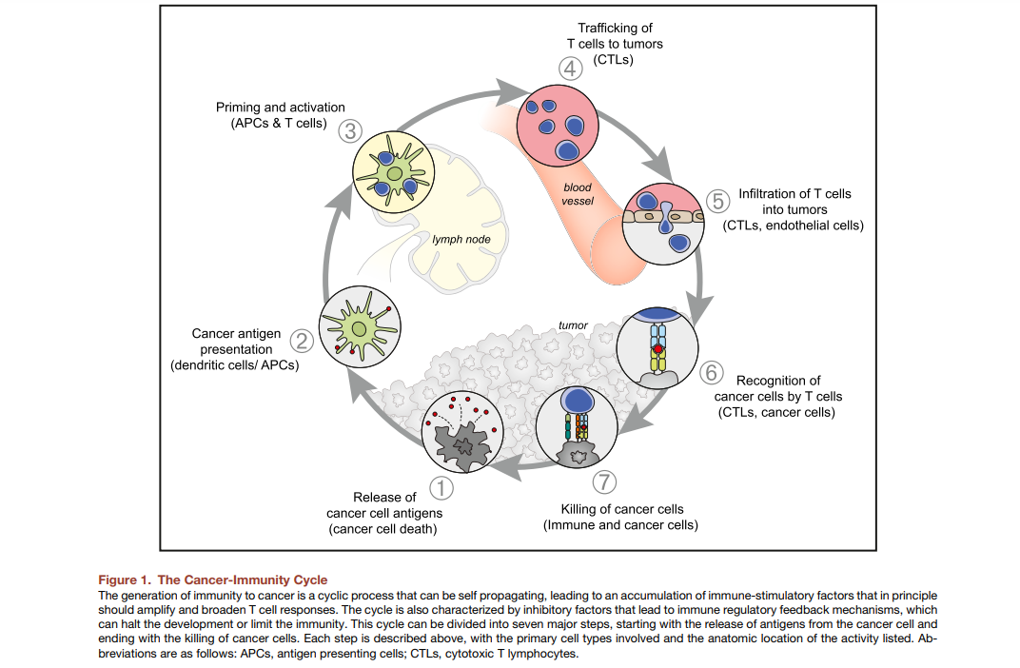

I hope that as a group, we will succeed in promoting ideas and research that would lead to finding therapies for people with ALK-positive tumors.

Yoram Shahar