COURSEBOOK



## Digital Skills

DLBDS01



### Overall learning objectives

Introduction 11



The Digital Skills course first gives you an overview of the basics of Digital Transformation in general and distinguishes between Digitalization and Digital Transformation. You will familiarize yourself with the fundamentals, causes, and technologies of Digital Transformation and learn about its impact on business and society.

One of the relevant skills for Digitalization is Digital Communication, which you will be looking at in the next section. How does Digital Communication differ from analog communication? What does the basic online communication process via the Internet look like? These are two of the questions that will be answered in this course. Collaboration in a digital context will also be addressed. First, you will get to know methods for digital work, such as SCRUM or Kanban. Next, you will be introduced to distributed and collaborative work and learn about distributed and virtual work or tools for knowledge management in this context.

With this understanding of (collaborative) work in the digital space, you will continue to explore private and professional networks in Social Media as well as forms of mobile communication and the use of mobile solutions in companies. You will also learn about the functions and areas of application of technologies such as Cloud Computing, Robotics, or Big Data and develop an understanding of how the further development and connection of such technologies leads to intelligent products or services. These technologies are the basis for various scenarios in companies, e.g., for Digital Marketing or digital HR. A selection of scenarios and their significance for daily work life is also presented. Finally, you will get an outlook and a presentation of trends of current and future importance to the development of Digital Skills.

[www.iubh.de](http://www.iubh.de/)



# Lesson 1

## Digital Transformation

##### LEARNING OBJECTIVES

After completing this unit, you will know ...

... how Digitalization and Digital Transformation are to be distinguished from one another.

... on which foundations and causes the Digital Transformation is based and what consequences result from it.

... which concrete effects the Digital Transformation has on the economy and society.

... which central role infrastructures and technologies play for Digital Transformations.

... which concepts are relevant for Digital Transformation and how they are interrelated.

DL-D-DLBDS01-L01

### Digital Transformation

#### Introduction

It is no longer possible to imagine private and working life without digital technologies. They have fundamentally changed the way we communicate, collaborate, and spend our leisure time. These changes are referred to as Digital Transformation. This lesson provides a precise differentiation between Digitalization and Digital Transformation. Infrastructures and technologies that enable increasing networking of digital devices take on a special significance. This has had a global impact on the economy and society.

This lesson provides an overview of the current effects and status of Digital Transformation. At the end, central concepts of Digital Transformation and their interaction are explained.

#### Basics, causes, consequences

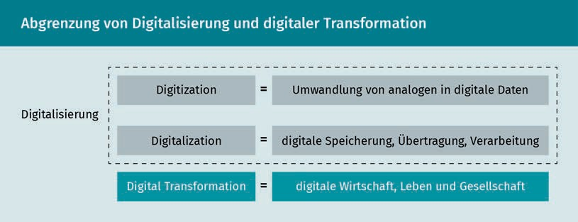Digitalization The spread of new technological solutions is referred to as Digitalization. It can be distinguished from "digitization" which refers to the transfer of analog information into digital form.

The basis of Digital Transformation is the increasing spread of digital technologies. The use of new digital solutions is referred to as Digitalization (Hess 2019, p. 18). Legner et al. (2017, p. 301) distinguish two forms of Digitalization from Digital Transformation, as shown in the figure below. On the one hand, Digitalization can represent the conversion of analog data and information into digital form (using binary digits). In English, this is referred to as "digitization". It forms the basis for the increasing digital storage, transmission, and processing of information through digital technologies which is referred to as "Digitalization ". Digital Transformation is distinguished from this as the result of Digitalization in that digital technology is used widely and contributes to the improvement, expansion, and development of services.

Digital Transformation

Brynjolfsson and McAfee (2016) describe Digitalization as the Second Machine Age. In doing so, they draw parallels to the Industrial Revolution and the profound effects of the technological developments of that time. Just like the steam engine made it possible back then to exceed the previous limits of mechanical energy, Digitalization now makes it possible to expand the previous limits of mental power (ibid., p. 6 et seq.). Digitalization is driving progress and development. As fundamental drivers of this transformation, Brynjofsson and McAfee identiﬁy three forces (ibid., p. 90):

* Continued exponential improvement in data processing,
* Digital information, and
* Recombinant innovation.

Moore's Law is referred to for an explanation of exponential growth. This refers to Gordon Moore's prediction in 1965, based on empirical observations and stating that computing power would double in each period of one to two years (Moore 1998). This assumption proved to be true. Thus, exponential growth is achieved, enabling ever faster and greater leaps in development.

Therefore, graving effects can be expected in the future if exponential growth continues (Kreutzer/Neugebauer/Pattloch 2017, p. 8). Moore's Law thus affects not only computing power, but also many other elements of computer hardware, such as memory or sensors. Moore's Law thus drives the entire economy as a clock generator in the background (Brynjolfsson/McAfee 2016, S. 42). In this way, information technology (IT) is becoming faster, cheaper, smaller, and lighter. Actions can be performed that were previously inconceivable, such as mobile payment with a smartphone.

As a result of this development, digital technologies and thus Digitalization is becoming more and more widespread. Increasing amounts of information are being digitized and processed in digital form. The almost free reproduction of digital information continues to drive development (ibid., p. 61 et seq.), creating new ways of generating knowledge and higher innovation rates. As information becomes increasingly digitized, it can be used for research and development. For example, forecasts can be made on the basis of data that is often freely available, such as search queries, data from Social Media, or digitized historical documents.

One example of data-based forecasting is Google's attempt to predict the course of flu epidemics (Lobe 2018). By matching search terms such as "cough" or "fever" with the actual course of the disease, models were built that were supposed to enable a prognosis for future courses. However, in this case, the models were not sophisticated enough. For example, the seriousness of the swine flu in 2009 was misjudged. The reasons for this were incorrect assumptions about the development of society and conclusions, such as that all people using corresponding search terms actually would fall ill. At the same time,

Moore's Law

Today, it is estimated that it will take 18 months for computing power to double. This exponential growth enables new Digital Business Models and innovative digital products and services.

digital information enables refined evaluation and improved understanding of the past. Improving understanding and predictions ultimately drives innovation.

Basic technologies   
They represent widespread technologies and thus the current standard. All market participants have similar knowledge of these technologies.

These innovations are characterized primarily by the combination of various digital technologies (Brynjolfsson/McAfee 2016, p. 74), which is further accelerated by the growing availability of digital data. At the same time, digital technologies also promote the productivity of new solutions among themselves (Petry 2016, p. 26). Autonomous driving is one example that clearly illustrates how innovations are created through combination. The basic technology of the automobile is combined with the digital data of new sensors and Artificial Intelligence so that completely new solutions can be developed. But the combination of objects and people through the Internet of Things also enables previously unimagined innovative solutions (Kreutzer/Neugebauer/Pattloch 2017, p. 23).

However, Digitalization alone is not a new phenomenon for companies. It has been ubiquitous for decades since the invention of the microprocessor and the Internet (Brucker-Kley/Kykalová/Keller 2018, p. 4). That being said, Digitalization is triggering a transformation that goes beyond technology use. Companies today face a changed environmental situation that can be described by the acronym VUCA (Volatility, Uncertainty, Complexity, Ambiguity) (Bennett/Lemoine 2014, p. 27). In order to remain competitive in a digital world, companies must also deal with aspects of leadership, organization, culture, and training that are changing as a result of Digitalization (Markus 2004). In this context, Digital Transformation emphasizes above all the change that is brought about by Digitalization (Hess 2019, p. 18).

According to Hess et al., Digital Transformation "deals with the changes those digital technologies can bring about in a company's Business Model and that lead to changed products or organizational structures or to the automation of processes" (Hess et al. 2016, p. 124). Krcmar highlights four attributes that characterize Digital Transformation: "inevitability, irreversibility, tremendous speed, and uncertainty in execution" (Krcmar 2018, p. 5). The inevitability arises significantly from social and economic trends. Demographics, urbanization, and globalization necessitate the widespread use of digital solutions. The widespread use of digital solutions leads to habit effects as a result of an increase in convenience. This makes the Digital Transformation irreversible. At the same time, companies must react and adapt to changes ever more quickly (ibid., p. 7).

One example of this speed is the increasing differentiation of product manufacturers via services. For example, various car manufacturers have developed new, system solution-oriented Business Models with car-sharing offers, which focus on mobility rather than the physical product as a benefit (Kreutzer/Neugebauer/Pattloch 2017, p. 127 et seq.). This development

Digital Transformation

was not foreseeable just a few years ago. This shows how unpredictable and uncertain the Digital Transformation is. For example, digital technologies change so quickly that entire industries are completely transformed in a short period of time.

#### Infrastructure and technologies

The Internet has driven networking across corporate and national boundaries. In the 1980s and 1990s, the Internet enabled companies to coordinate and integrate activities with suppliers and customers along the value chain (Porter/Heppelmann 2014, p.4f.). This technology has thus made a significant contribution to increasing the productivity and growth of companies. To this end, value chains in particular have been adapted to date, while the services offered have remained constant for a long time despite technological developments. This can be attributed in particular to the underlying analog and inﬂexible technology of the devices, storage media, and transmission formats, which were individual for each service (Tilson/Lyytinen/Sørensen 2010, p. 748f.).

However, Digitalization is now also expanding strongly to the product level. Technological progress is enabling continuous increases in performance. Components such as sensors, batteries, and memory are becoming smaller and more efﬁcient. Today, for example, computers can be built in as parts of a product. At the same time, software programming is also becoming more efﬁcient thanks to the support of tools. As a result, sensors, for example, are becoming important product components that generate data. The Digital Transformation is thus reflected in new intelligent and interconnected products. To develop these products, companies need a new technology infrastructure with different layers, also called a technology stack, as shown in the following figure (Porter/Heppelmann 2015, p. 98 ).

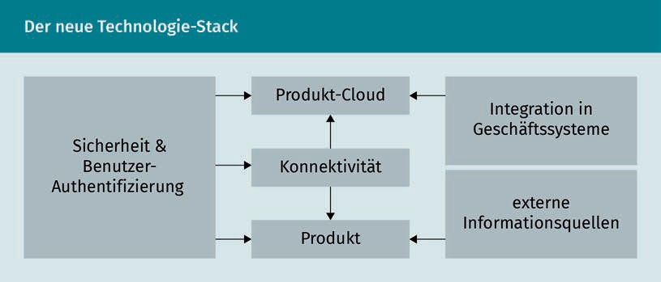

The physical product now also includes components that enable data collection and network communication. In addition, software components and an operating system become part of the product. In this way, it can be linked to the product cloud

Technology stack   
A technology stack describes the technologies used for the development and execution of a specific application. In companies, different technology stacks can be used for different applications.

Cloud A cloud service makes resources such as servers, storage, databases, and software available via the Internet and can be used by various users and applications.

Longitudinal data They are also referred to as time-dependent data. By repeatedly surveying the same units over a deﬁned period of time, time series are studied and forecasts are derived.

which acts as a database and analysis platform. Other products can also be connected to this product cloud in order to combine data from similar product applications. An identity and security structure are implemented across all layers. External data supplements and tools can access and combine data with external data via an additional interface (Porter/Heppelmann 2014, p. 101). This enables the joint collection, analysis, and use of large amounts of longitudinal data generated directly and indirectly during the use of products. This means that data that was previously not available can be used and smart products can be developed through networking. The development of corresponding technology stacks requires major investments and new competencies that have rarely been available in manufacturing companies, such as software development, data analysis, or online security expertise (Por- ter/Heppelmann 2014, p. 101).

In turn, digital infrastructure is required for the networking of products. Networking is made possible through the characteristics of digital data. The conversion of analog information into a digital form is the basis of Digitalization. A practical example of this is the digitization of images. Instead of film rolls, which have to be developed at great expense in order to use the images, the digital data now form the basis of (digital) photography. By being represented in binary digits, all information can thus take the same form. This enables all information to be processed by the same technology. Digitalization thus has the potential to break the previously tight coupling between information types and their storage, transmission, and processing technologies. In this way, new performance models are made possible going beyond those that have prevailed to date (Tilson/Lyytinen/Sørensen 2010, p. 749). Digital infrastructures enable networking and the exchange of digital information. Infrastructures can be deﬁned as shared, unlimited, heterogeneous, open, and evolving socio-technical systems (Hanseth/Lyytinen 2016, S. 105). In the corporate context, digital infrastructures form the basic information technologies and organizational structures that, together with services and facilities, are necessary for the functioning of companies and industries. In this context, infrastructures can be deﬁned on a company- and industry-specific, regional, national, or global basis, according to the organization that they support or enable (Tilson/Lyytinen/Sørensen 2010, p. 748).

Thanks to a ubiquitous digital infrastructure, digital devices are now able to generate, collect, and also communicate various types of data. The Internet as a central digital infrastructure supports every information service. In addition, new Internet protocols are further expanding the address space of the Internet, thus driving networking further and further (Porter/ Heppelmann 2014, p. 6). Convergence, i.e., the linking of previously separate technologies, is thus becoming a key aspect of the Digital Transformation (Kreutzer/Neugebauer/Pattloch 2017, p. 74).

When using digital infrastructures, it is important to consider the high scalability and flexibility that can result in enormous growth in scale and reach. The combination of technologies, data, and capabilities allows for new

Digital Transformation

socio-technical relationships to emerge, making organizational boundaries increasingly blurred (Tilson/Lyytinen/Sørensen 2010, p. 752). In addition, Blockchain technology is gaining importance as a new form of infrastructure. It can be used to regulate a wide range of transactions. Blockchains have now developed far beyond cryptocurrencies and offer an infrastructure for organizing transactions in many areas and applications, e.g., for payment processing in the finance and insurance industry, the tracking of songs in the music industry, and that of waybills in the transport industry (Lumineau/Wang/ Schilke 2020, p. 5).

#### Implications for the economy and society

Digital Transformation is characterized by changes that affect all aspects of life (Stolterman/Fors 2004, p. 689). Thus, the Digital Transformation has an impact on society as a whole and on the economy in particular. Digital technologies have become part of the daily routine in our private and working lives and have fundamentally changed the way we communicate, consume, and create (Piccinini/Gregory/Kolbe 2015, p. 1634). The constantly growing amount of data generated in this way can lead to completely new opportunities and levels of value creation (European Commission 2020a, p. 1). Digital Transformation is thus regarded as the fourth industrial revolution, which, like the preceding revolutions, is triggering fundamental changes in the economy and society (Harwardt 2020, p. 19 et seq.).

The effects of the changes in both areas can be seen in the context of work. For example, employees are the ones who make the opportunities for Digital Transformation possible in the first place through their personal commitment and intellectual flexibility (Malleck/Mecklenbräuker 2017, p. 323). In the work context, for example, constant technological changes must be followed; working without computers, tablets, or smartphones would hardly be conceivable today (Becker/Knop 2015, p. 155). To this end, appropriate knowledge must be continuously built up. Lifelong learning is thus becoming a social task across all generations. In a globalized world, working in virtual teams is also gaining importance. This networked collaboration is an important new form of work, especially for digital natives (Eggers/Hollmann 2018, p. 55).

The term “digital natives” refers to the generations born after 1986 that have grown up with digital technologies and, above all, Social Networks (Nold 2020, p. 121). The social effects are very clearly visible in them. The Digitalization of everyday life is also reflected in the skills and values of these generations. For example, autonomy, flexibility, and the desire for transparency are important values to them (Klaffke 2014, p. 70). On the one hand, representatives of these generations are accustomed to using digital technologies to obtain information promptly. At the same time, they use digital technologies themselves to provide their own content and to comment on other people’s content (Petry 2016, p. 29).

Internet Protocol The Internet Protocol (IP) is the basis of the World Wide Web. On the Internet, every computer has a unique IP address. Using the Internet Protocol, data packets can be sent to a target address within a network. The fourth version of the Internet Protocol (IPv4) is currently the most widely used one. The latest version, IPv6, is becoming increasingly important. This enables longer addresses and thus significantly increases the address space.

Blockchain

Blockchain is an open-source technology. It represents a decentralized database that is stored as a network on several computers in parallel. All transactions in the network

(e.g., contracts or financial transactions) are stored in a chain of blocks, making them transparent at all times.

The increasing use of digital technologies is also reflected in new customer behavior. Digital technologies give consumers better access to information about products and services (Piccinini/Gregory/Kolbe 2015, p. 1635). This increases the level of information consumers have about features and prices. Control over information no longer lies with the company, which passes it on to consumers via marketing channels. Today, customers can create their own content about services and companies, for example through consumer ratings. Customer groups thus have a significant influence on the perception of a company and the services it offers (Petry 2016, p. 33). As a consequence, willingness to pay and purchase decisions are changing. In that way, consumers are developing a digital competence that enables them to handle the entire purchasing process online and without interacting with company intermediaries (Piccinini/Gregory/Kolbe 2015, pp. 1641-1642).

In summary, the effects of the Digital Transformation on the economy and society are represented by the following five dimensions, which the European Commission measures using the Digital Economy and Society Index (DESI). This metric is used to evaluate the digital performance of EU countries as well as the development of their digital competitiveness (European Commission, n.d.). The figures presented herein refer to the period under review in 2019, i.e., before the COVID 19 pandemic. This has once again highlighted the importance of Digital Transformation. It can be assumed, for example, that the number of Internet users will increase in the future (European Commission 2020b, p. 57). At the same time, however, the pandemic has also led to delays in the expansion of connectivity, as the focus had to be placed on other challenges (ibid., p. 44):

* Connectivity,
* Human capital,
* Internet usage,
* Integration of digital technology, and
* Digital public services.

These challenges are explained in more detail below.

Connectivity

This dimension shows both the demand and the supply side of fixed-network and mobile broadband. It illustrates the great importance of connectivity in society and the economy. For example, the European Commission considers the availability of digital connectivity to be a social right (European Commission 2020b, p. 20).

Overall, broadband Internet is available to all households in the EU. However, coverage is not universal in rural areas. 10% of households have no fixed network and 41% no high-speed broadband Internet. At the same time,

Digital Transformation

overall fixed broadband coverage has increased only slightly since 2011, from 95% to 97%. Coverage in rural areas went up from 80% in 2011 to 90% in 2019 (ibid.).

Human Capital

When considering human capital, it is emphasized that access to the Internet is not enough. For the benefits of the digital economy to be realized, Internet access must be combined with appropriate skills (European Commission 2020b, p. 51). Thus, the dimension of human capital is composed of two subdimensions: "Internet user competence" and "advanced skills and development" (European Commission 2020b, p. 51).

Digital Skills range from a basic level that enables people to participate in a digital society and consume digital goods and services to advanced skills allowing workers to develop new digital goods and services. There is a slight increase at all levels of Digital Skills, as illustrated in the table below (ibid.).

|  |  |  |
| --- | --- | --- |
| Human capital indicators | | |
|  | DESI 2018 | DESI 2020 |
| At least basic Digital Skills | 57 % | 58 % |
| Above-average Digital Skills | 31 % | 33 % |
| At least basic software knowledge | 60 % | 61 % |
| Information and communication technology specialists | 3,7 % | 3,9 % |
| Information and communications technology specialists | 1,3 % | 1,4 % |
| Information and communications technology graduates | 3,5 % | 3,6 % |

The main reasons for lack of Internet access are lack of interest (46%) and insufficient skills (44%) (European Commission 2020b, p. 52). The lack of knowledge is named as the most important factor preventing households from accessing the Internet. It has a direct adverse impact on awareness of Digitalization's potential benefits. It could also be due to the lack of knowledge that EU households claim they do not need Internet access at home and hence, do not have it.

Internet usage

This dimension measures how many people use the Internet and what activities they perform online (European Commission 2020b, p. 57). Activities include consuming online content (e.g., entertainment such as music, movies, television, or games, obtaining media-rich information, or participating in online social interactions), engaging in modern communication activities (e.g., participating in video calls), and transactional activities such as online shopping and banking.

In countries such as Denmark, Sweden, and the Netherlands, the vast majority of the population (95%) uses the Internet at least once a week. In some other EU member states, however, more than a quarter of the population still does not use the Internet regularly (33% of Bulgarians and 28% of Romanians) (ibid.). The most active Internet users are young people (97% of the population between 16 and 24 years), people with a high level of formal education (97%), and students (98%). The most common ways people use the Internet are to listen to music, play games, and watch videos (81% of people who have used the Internet in the past three months). Reading the news comes in second place (72%), followed by users who shop online (71%), and users who conduct financial transactions online (66%). Taking an online course is among the least popular online activities (11%). Finland (22%) and the UK (20%) are the only countries where e-learning is widespread.

Integration of digital technology

This dimension measures the Digitalization of companies and e-commerce (European Commission 2020b, p. 63). Digital technologies enable companies to achieve competitive advantages, improve their services and products, and expand their markets. The Digital Transformation of companies opens up new opportunities and promotes the development of new and trusted technologies. The following table shows the development of the integration of digital technologies.

|  |  |  |
| --- | --- | --- |
| Digital integration indicators | | |
|  | DESI 2018 | DESI 2020 |
| Electronic information exchange | 34 % | 34 % |

Digital Transformation

|  |  |  |
| --- | --- | --- |
|  | DESI 2018 | DESI 2020 |
| Social Media | 21 % | 25 % |
| Big Data | 10 % | 12 % |
| Cloud | n. a. | 18 % |
| SMEs sell online | 17 % | 18 % |
| E-commerce sales | 10 % | 11 % |
| Cross-border online sales | 8 % | 8 % |

The leading countries in the Digitalization of companies are Finland, the Netherlands, and Belgium. In the area of "e-commerce", Ireland, the Czech Republic, Denmark, Belgium, and Sweden are the five leading countries.

Digital public services

This dimension measures both the demand and supply side of digital public services as well as open data (European Commission 2020b, p. 74).

Digital technologies are also increasingly placing new demands and expectations on the public sector. Realizing the full potential of these technologies is a key challenge for government organizations. Effective e-government can offer a wide range of benefits, including greater efﬁciency and savings, as well as increasing transparency and openness. The following table shows how each indicator has developed.

|  |  |  |
| --- | --- | --- |
| Public services indicators | | |
|  | DESI 2018 | DESI 2020 |
| E-Government users | 58 % | 67 % |
| Pre-filled forms | 53 % | 59 % |
| Online service processing | 85 % | 90 % |

E-Government Electronic government refers to the increased use of information technology to support and carry out processes between citizens as well as between citizens and government.

|  |  |  |
| --- | --- | --- |
|  | DESI 2018 | DESI 2020 |
| Digital public services for companies | 83 % | 89 % |
| Open data | n. a. | 66 % |

The frontrunners in this field are Estonia, Spain, Denmark, Finland, and Latvia (European Commission 2020b, p. 74). Demand for digital public services has increased steadily in recent years. For example, 67% of EU citizens who had to submit forms to public authorities did so online in 2019. In 2018, this figure was still 64%. Since 2013, it has increased by 26 percentage points, from 41% to 67%.

#### Concepts

Digital Transformation encompasses various concepts that interact when triggered by Digitalization. Literature suggests various models regarding what companies should consider when transforming into Digital Businesses (Appelfeller/Feldmann 2018, p. 3et seq.; Hess 2019, p. 41et seq.). In a review, Vial summarizes the key points in a Digital Transformation framework (Vial 2019). The following figure lists eight components defined in Vial’s document.

Digital Transformation

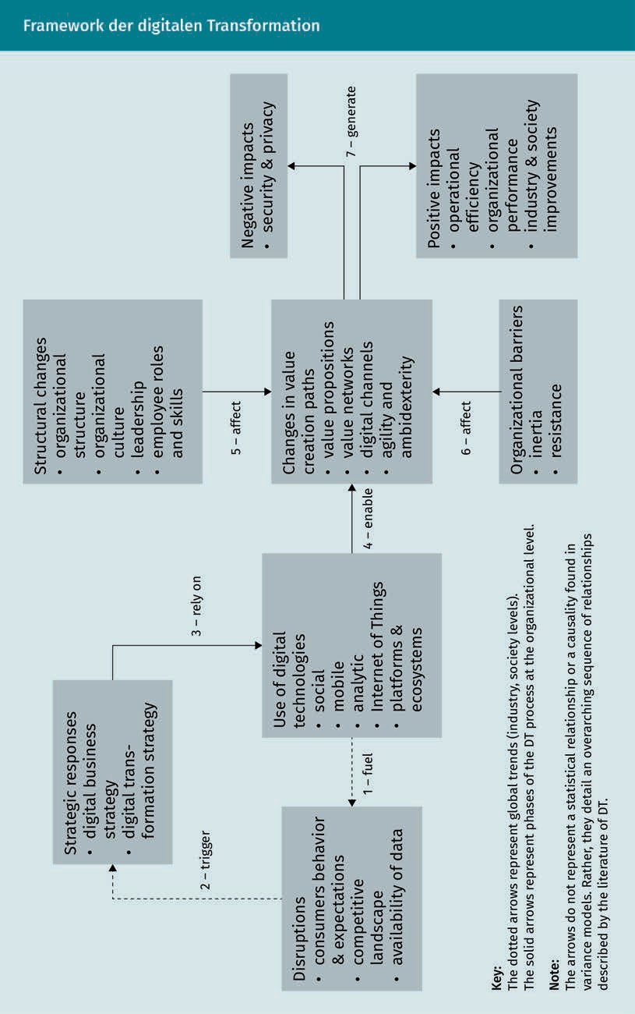

###### Use of digital technologies

SMACIT

The acronym SMACIT stands for Social, Mobile, Analytics, Cloud, and Internet of Things and thus describes digital technologies that can represent both ground-breaking opportunities and existential threats in the context of digital trans- formation (Sebastian et al.

al. 2017).

The use of digital technologies is the focus of attention here. It can be summarized under the acronym SMACIT, which describes various areas of technology use: social, mobile, analytics, cloud, and Internet of Things. In addition, Vial (2019, p. 130) adds platforms as a central element of Digital Transformation. In this respect, digital infrastructures are gaining particular importance as digital platforms. Platforms are deﬁned as digital infrastructures consisting of hardware and/or software that enable a limited or clearly deﬁned number of uses, e.g., for different application programs (Gatautis 2017, p. 586). Platforms are thus the central components of Digital Business Models. Well-known representatives of the so-called platform economy are, for example, trading platforms such as Amazon and Ebay or hotel portals such as Boo- king.com.

The combination of different technologies is also emphasized here as a characteristic of Digital Transformation. In companies, data-driven decision findings are based, for example, on combining multiple technologies. Thus, large amounts of relevant data (Big Data) can be used to detect trends through sensors or algorithms integrated into a variety of technologies. The findings from the Big Data analysis are supplemented with additional individual data, such as data generated by smartphones or vehicles. Even when the causal reasons for the connections are unknown, it is possible to take measures (Newell/Marabelli 2014, p. 6).

###### Disruption

The increase in Digitalization promotes disruption. It can be deﬁned as follows: "From a system perspective, disruption is an event in which a significant proportion of the agents belonging to the system are disrupted. Disruptive innovation is a passive entity that mediates a disruption in a system" (Kilkki et al. 2018, p. 276). Disruptive innovations include corporate, institutional, and user-generated innovations. Christensen (2016, p. 15) focuses on disruptive technologies as the basis of innovation, making disruption more tangible. According to him, disruptive technologies are characterized by the fact that they bring new value propositions to the market that were not available before. Products based on disruptive technologies are usually cheaper, smaller, and more convenient to use. As a result, digital products displace established products from the market and are thus often disruptive.

Massmann (2019, p. 122) divides disruption into three phases: invention, innovation, and transformation. During the first phase, invention, new technologies are developed. The competition usually does not yet pay attention to these technologies. Established companies fear that these new inventions will cannibalize their sales (Christensen 2016, p. 54). In the subsequent phase, innovation, the

Digital Transformation

relevance of the new technology is recognized by innovators and startups. They develop initial services and mostly disruptive Business Models based on the technology (Massmann 2019, p. 122). The risk posed by these new products and Business Models is not recognized by established companies, and potential opportunities are not seized. In the final phase of the transformation, a high level of market penetration is finally achieved and established competitors are displaced. This can have major negative effects on the Business Model of competitors so that they often leave the market.

###### Strategic response

If a new disruptive innovation appears on the market, a strategic response must be found in order to avoid being displaced. This is deﬁned in the Digital Business strategy and/or the Digital Transformation strategy (Vial 2019, p. 133). Established companies must recognize the opportunities offered by new technologies in order to integrate new services into their existing operations. This is done by deﬁning a digital strategy. Sebastian et al. (2017, p. 198) deﬁne this as "a business strategy inspired by the capabilities of powerful, easily accessible technologies (such as SMACIT) and aimed at delivering unique, integrated services in a way that is responsive to ever-changing market conditions. A digital strategy guides leaders' efforts to create new value propositions by combining their organizations' existing capabilities with those enabled by SMACIT and other digital technologies."

Matt, Hess, and Benlian (2015, p. 340) consider the deﬁnition of a dedicated Digital Transformation strategy to be necessary. Based on new technologies, this strategy focuses on the transformation of products, processes, and organizational aspects. This strategy is thus broader in scope and includes activities on the cutting edge of customer groups or entirely on the customer side. A different perspective is adopted here, which no longer considers only the automation and optimization of processes, but the changes and effects on products, services, and Business Models as a whole.

These two forms of strategy close the circle to the increased use of digital technologies, since both strategies rely on them. At the same time, Digitalization is the prerequisite for a change in value creation processes.

###### Change in value creation processes

This change relates to several aspects, namely adapting the value proposition, value networks, and digital channels, and enabling agility and ambidextry (Vial 2019, p. 136).

Invention

An invention is the development of new services, goods, processes, and methods. Commercial exploitation is not taken into account. This distinguishes the invention from the innovation, which builds up on the invention but achieves commercial exploitation.

Agility Corporate agility entails mindsets, practices, and frameworks for flexibly responding to changing requirements.

To this end,

speed, adaptability, customer-centricity, and a value-driven approach are

necessary.

Ambidextry It describes the

ability to simultaneously enable economic efﬁciency (exploitation) and innovative transformation (exploration) to successfully navigate the requirements of the Digital Age in the long term.

In changing the value proposition, a shift from physical to digital products is evident. A prominent example is Netﬂix, which moved from renting physical DVDs to streaming digital movies and series (ibid., p. 137). Value networks integrate business partners and customer groups into the value creation process. Digital technologies enable close cooperation and coordination. An example of this is also Social Networks, which depend almost exclusively on the activities of users. Sales and distribution channels are also being changed as part of the Digital Transformation (ibid., p. 138). On the one hand, this can happen in the form of new customer interfaces, e.g., via Social Media. This allows the digital and physical worlds to be integrated (Hansen/ Siew 2015, p. 62). On the other hand, digital networks enable the use of technology to coordinate value creation activities along with all participating companies in order to optimize the supply chain. Here, too, Internet of Things technologies are used (Vial 2019, p. 139).

Agility is considered a central approach for management in the changing digital world. This is understood to mean speed, adaptability, customer-centeredness, and an agile attitude that pursues an appreciative and equal approach to all organizational members (Fischer/Weber/Zimmermann 2017). Ambidextry makes it possible to pursue both exploration (innovation and ﬂexible exploration of new paths) and exploitation (efﬁcient use of the current offering). This is to enable being both ﬂexible and efﬁcient in the Digital Age (O'Reilly III/Tushman 2013).

###### Structural changes and organizational hurdles

The change in value creation processes is influenced by two factors: structural changes and organizational hurdles. Structural changes include organizational structure, organizational culture, leadership, and employee roles and skills. On the other hand, inertia and resistance act as organizational hurdles to value chain change.

###### Positive and negative effects

This process generates both positive and negative effects. The positive effects lie in improved operational efﬁciency and performance of the organization as well as in the overarching further development of industry and society. Negative effects are seen in the areas of security and data protection (Vial 2019, p. 149).

For a successful Digital Transformation, all eight areas mentioned should be taken into account. In this way, the Digital Transformation into a digital company can succeed on the basis of the use of digital technologies.

Digital Transformation

Summary

Digital technologies have found their way into all areas of life. More and more digital data is being generated, transmitted, stored, and used for new innovative solutions. This is fundamentally changing the way we communicate, consume, and design. This changed digital economy and society represent the digital transformation. It is inevitable, irreversible, tremendously fast, but also uncertain in its execution (Krcmar 2018, p. 5). The European Commission's Digital Economy and Society Index, for example, shows that the digital transformation is progressing steadily. At the same time, however, some countries and parts of society need to catch up, for example in the development of digital skills. In order to successfully master the digital transformation, a number of areas need to be considered in parallel. In this way, it is possible to redesign value creation processes and achieve a positive effect from the digital transformation, spanning the use of digital technologies, the observation of disruptive forces, and the development of digital strategies.



# Lesson 2

## Digital Communication

##### LEARNING OBJECTIVES

After completing this unit, you will know ...

... how the terms communication and Digital Communication can be deﬁned.

... which characteristics Digital Communication exhibits.

... how the basic online communication process works via the Internet.

... what purposes communication tools can serve.

... how bot communication is constituted.

... how text and voice can be distinguished in communicative consistency.

DL-D-DLBDS01-L02

### Digital Communication

#### Introduction

Our everyday interactions are shaped by communication - whether it is professional, private, social, or political. Communication can take place in analog or digital form; whereby Digital Communication has its own specific characteristics and can and must be distinguished from analog communication at certain points.

In this lesson, analog and Digital Communication are first introduced and deﬁned in order to make the characteristics of Digital Communication plausible. Using the online communication process, a model is presented that can be used to assess Digital Communication. Exclusively digital forms of communication, such as those with bots, will also be subject to evaluation. The potential of Digital Communication tools is presented and a current development under the heading "text vs. voice" is highlighted.

#### Basics

Paul Watzlawick, a communication scientist, psychotherapist, psychoanalyst, sociologist, philosopher, and author, coined the statement: "You cannot not communicate" (cited in Bender 2014a). It is one of the five axioms established by Watzlawick to explain human communication. Watzlawick understands communication as synonymous with behavior. Thus, refusing to engage in a conversation and expressing this refusal nonverbally is also a form of communicating (Bender 2014b). Whatever applies ofﬂine also applies online. Not communicating is impossible. Staying away from Social Media channels and other web presences is also a communicative expression (Kropshofer 2017). The possibility of misinterpreting absence or non-response is even greater in the digital space (Bauer/ Müßle 2020, p. 12). In a text message, for example, emoticons or emojis can be used to express emotions and moods, but they do not fully replace nonverbal and paraverbal behavior and leave room for (potentially misleading) interpretation.

The explanations show that communication is a cross-disciplinary part of our everyday lives. Communication takes place in private, professional, political, and social spheres and is also a constituent part of everyday life. Depending on the context, communication results in different actions and situations, such as a face-to-face conversation with a family member, a messenger message to friends for evening planning, or a Zoom meeting with colleagues for professional coordination. These examples demonstrate the omnipresence of communication and, equally, the difficulty of deﬁning the term communication. If communication in its verbal (the spoken word), nonverbal (communicative, non-linguistic actions such as gestures and facial expressions), and paraverbal

Digital Communication

(meaning the individual linguistic properties, such as voice or intonation) execution always takes place in all domains in some form or other, how then can communication be deﬁned (Beck 2017, p. 15)?

According to Beck (ibid.), a distinction should be made between everyday communication and the communication science view of communication. In everyday life, communication stands for "message delivery" or "exchange". This is confirmed etymologically. Derived from the Latin word "communicare", communication stands for "to make common, (to) share, to have a share" (ibid.).

Merten (1999, cited in Beck 2017, p. 15) also identifies characteristics that distinguish communication. Communication is mundane and can be initiated by anyone with little effort. It is also universal and extends into all areas of life. Communication is fleeting, which means that no visible end product is created, but a process is initiated. Moreover, communication exhibits relationality, since the process of communication always involves several elements between which communication takes place and which may change in the course of the process. The following deﬁnition of communication can be derived from the aforementioned: "The meaning of words and everyday understanding take into account the facts that communication (1) is a process and that (2) at least two sides are involved in the process of communication because otherwise, there could be no common ground, no exchange or sharing" (Beck 2017, p. 15).

This basic deﬁnition of communication in everyday use is intended to form the basis for further work on Digital Communication, whereby Digital Communication in this context is understood in relation to communication media. In this sense, Digital Communication is a form of communication that takes place with the help of Digital Media. Digital Communication media can thus be described as a "means to the end of communication [...] between people on a technical basis" (Beck/Jünger 2019, p. 9). In addition to many parallels to communication in the analog space, constituted here by Watzlawick's axiom and Beck's deﬁnition of communication, Digital Communication is characterized by some characteristics that make it distinguishable from analog communication (hereafter after Bauer/Müßle 2020, p. 13). While analog communication takes place synchronously, Digital Communication has the possibility of happening asynchronously.

In an analog setting, such as a meeting with colleagues, communication takes place in the present moment (synchronously). A reaction, even if it is only an annoyed turning away, cannot be postponed. In Digital Communication, a reaction can be postponed technically and socially (asynchronous). When to react to an email, a messenger message or a Social Media post is an individual decision, although it is certainly influenced by the expectations of the other person. There is also the possibility of staging, e.g., planning reactions in advance or choreographing content.

Asynchrony

Asynchrony is understood to mean time-delayed communication. Asynchronous media such as email or text messaging

make it possible to postpone a reaction technically and socially.

Channel reduction  
theory

The channel reduction theory states that computer-mediated communication excludes sensory channels, which, according to this theory, can cause the quality of communication to suffer.

AdBlocker An ad blocker is a program that prevents advertisements from being displayed on websites.

A limitation of Digital Communication is that nonverbal and paraverbal channels can only be used to a limited extent. Although the paraverbal level resonates with a voice message and a nonverbal and often emotional component resonates with the use of emoticons or emojis, the digital space is by its nature technically limited. This leads to a restriction of the communicative diversity known and familiar from analog communication. According to the so-called channel reduction theory, the technical and necessary limitation of the Digital Communication space leads to impoverishments and reductions in the communication process (Petzold 2002).

In addition to the everyday, interpersonal analog, and Digital Communication described above, the area of mass communication will also be considered in connection with Digital Communication. According to Friemel (2017, p. 25f.), mass communication in this context should be understood as mass media communication, i.e., the use of media to communicate with a large number of people and to disseminate content to the public. Mass media include print media as well as broadcasting or online services. In contrast to interpersonal communication, which takes place in a limited, non-anonymous and often private (in the sense of a non-public) social structure, mass communication is public and is aimed at a dispersed, i.e., anonymous, audience. It is one-sided and always technically mediated (ibid., p. 24f.).

With regard to the further development of classic media as well as Digital Media and services, the deﬁnition should be relativized and expanded in some places. When looking at online chat forums, for example, it is obvious that the separation between public and non-public is not always given in the Digital Communication space. Interpersonal communication can take place in public (ibid., p. 25). The attribution of one-sidedness becomes particularly plausible when one looks at classical media, such as radio. A radio or television broadcast is sent from one transmitter (the broadcaster) to many receivers (the listeners or viewers). The message is sent to the dispersed audience without any expectation or hope of receiving feedback. According to Lammenett (2019, p. 317), this process can be described as one-way communication.

In Digital Communication, this possibility also exists, which will be illustrated by the example of Online Marketing. If online banners are chosen as advertising media, users have the option of either clicking on them, ignoring them, or hiding them using an ad blocker. The communication goes in one direction, as the advertisers do not hope for a dialog with this advertising medium. Kreutzer (2018, p. 17) also refers to this orientation as one-to-mass communication and characterizes it as undifferentiated. One-to-many communication involves a differentiated and target-group-specific approach, but this does not per se imply a dialogic principle (Kreutzer 2021, p. 16f.). This is due to, for example, the possibility of target-group-specific mailing, which is both individual and target-group-specific in terms of products presented, but not interactive and dialogical since there is no option to respond to the mail. In one-to-one communication, the customer is addressed at an individual level (Kolano 2017, p. 25; Kreutzer 2021, p. 17).

Digital Communication

This type of individual communication can be found, for example, in Social Media complaint management. A customer sends a message to a company via the Facebook company page and receives a personal, individualized message with a suggested solution from an employee. In many-to-many communication, communication takes place between groups (Kreutzer 2021, p. 17). An example of this is a Facebook group in which fans discuss their favorite product and the community manager of the associated company joins in the discussion in the group. In the context of Social Media, two special communicative features should also be mentioned: Social Media promotes spatially independent, bidirectional communication in real time (Bruhn 2016a, S. 371). When the checkmarks of a WhatsApp chat are blue and it is clear that the message has been read, there is an expectation of immediate feedback. In addition, Social Media (especially, but not exclusively) enables users to switch from their role as consumers to the role of producers and to create content themselves. This phenomenon has given rise to the term prosumer, a neologism made up of "producer" and "consumer" (Kreutzer 2018, S. 7). Communication content produced by users is referred to as user-generated content (Bruhn 2016b, p. 458).

Following the explanations, Online Marketing can be deﬁned from a communicative perspective "as a form of interactive communication in which individuals or masses are communicated with by means of networked information systems [...]" (Lammenett 2019, S. 35). In principle, Digital Communication can be summarized as a technology-based form of communication that can include interpersonal as well as mass communicative actions and situations and that, in addition to many parallels to analog communication, also has its very own characteristics. The latter will be discussed in more detail below.

#### The online communication process

For Digital Communication, it can be stated that although the communication process can be traced back to the original sender-receiver scheme of classic communication, Digital Communication, unlike classic communication, allows for the roles to be swapped at any time or for both roles to be assumed simultaneously (Kollmann 2019, p. 12f.). Customers respond to a company's advertising message, produce content relevant to the company themselves, or exchange information with other customers. "In principle, anyone can communicate with anyone, and once published on the Internet, content can be viewed, manipulated, copied, or commented on by any number of users" (ibid., p. 13). Information can be proactively obtained on the Internet and the information offered can be tailored to one's own needs (ibid.).

User-Generated Con- tent

This term stands for all media content that is not produced by the channel operator itself, but by its users. A channel operator could, for example, be a company that has an Instagram account for which the followers produce content.

Transmitter-receiver-

scheme In classic communication, there is usually only one sender, but many receivers. There are no opportunities for direct feedback within the medium.

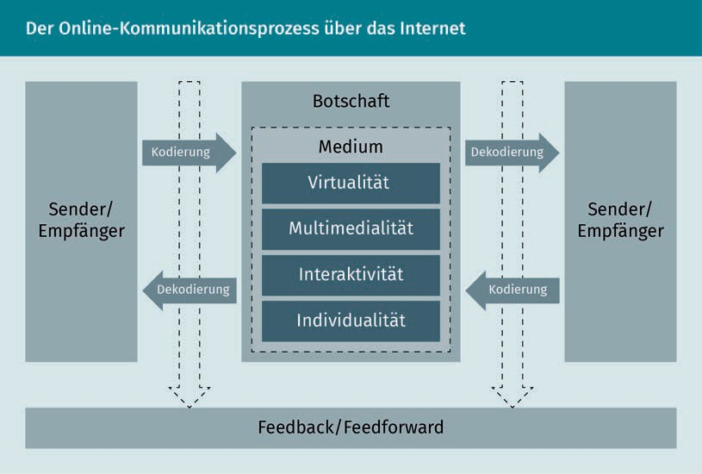

Due to the characteristics of the Internet as a medium, the sender can become the receiver at any time and immediately, and vice versa (hereafter after Kollmann 2019, p. 12f.):

* Virtuality: The Internet as a digital space makes the physical presence of communication partners obsolete. It is used as a medium for sending and receiving a message. A Zoom conference with colleagues in the USA, for example, is part of normal everyday work life. The "anytime/anywhere" principle applies: You can be online at any time and in any place, as long as there is an Internet connection.
* Multimedia: Information on the Internet can be presented in many different ways. The principle of multimedia means that different media or means of communication can be used for an Internet presence. For example, a corporate website usually consists of a combination of text, images, and/or video. The media should be combined in such a way that the information is presented in the best possible manner. If a sender puts a YouTube video online, the recipient can react directly through the media by leaving a comment under the video, for example.
* Interactivity: The characteristic of interactivity refers to the dialogic principle of the online communication process. The process is communicative in both directions: from sender to receiver and from receiver to sender. Both give their message a meaning (encoding), which in turn is decoded by the other side (decoding).
* Individuality: The data that is collected and analyzed online about the users enables an individual and personalized approach tailored to the user's needs. At the same time, an individual approach is

Digital Communication

possible without comprehensive data analysis also if the customer contacts the company directly with a request and if in turn, the company responds with an individual answer.

Within the online communication process, both sender and receiver provide their messages with a meaning (encoding), which in turn is decoded by the other side (decoding). During encoding, the sender encodes the message by, for example, choosing certain phrases and adapting the intended message to the medium (in the case of email as a medium, written text is a prerequisite). The recipient of the message decodes it and uses their own language and character repertoire to do so. The decryption may be the same as the intended message of the recipient or it may deviate little or completely. Especially online, there is a lot of potential for misunderstanding, which can erupt in so-called shitstorms.

Feedback/feedforward refers to the possibility of giving feedback at any time and immediately. Commenting under a company's post, reacting to a YouTube video, or sharing content in the Instagram story are just a few examples. While feedback is directed to the past and assesses the existing, feedforward is directed to the future. This includes user recommendations for the company on what it can do better in their next Social Media posting.

#### Communication tools

In order to simplify dialogue, exchange, or project-related coordination within corporate teams and to make it as efﬁcient as possible, communication tools can be useful. These are apps that can be used as online meeting rooms for teams. These tools respond to the contemporary climate where many teams work remotely, asynchronously, or in different time zones, and where colleagues often do not share an office (Aston 2021). In this context, emails are becoming less and less important, as they are slower and much less transparent. Whether Microsoft Teams, Skype, Slack, Trello, or Podio: there is a wide range of tools on the market, with different focuses and purposes. Since the number of communication tools is extensive and comprehensive, a selection of work contexts and purposes in which the use of communication tools can be useful are listed below (according to Aston 2021):

* + Project management,
  + Email management,
  + Management of teams of all sizes,
  + A unified communications platform for employees who work remotely,
  + Management of external communication,
  + Marketing Communications,

Apps

Apps or applications are system software packages. Apps are not limited to mobile devices such as smartphones or tablets.

* + - Management of internal communication,
    - Communicative management of Web Design and UX design, or
    - Moderation and monitoring of Social Media content.

In addition to structuring and transparency of responsibilities, project management tools such as Trello or Asana have the advantage that communication progressions and discussions on tasks are visible and traceable, thus making it possible to map the process character of communication. Communication tools such as Slack, which are frequently used in internal communication, offer a topic-specific and transparent exchange through the channel structure, which is more ﬂexible and dynamic than email communication, for example. Ideally, communication tools can generally help to simplify and speed up communication, make it more transparent, and prevent misunderstandings, which can improve team performance. A disadvantage is that the use of such tools requires permanent communicative readiness on the part of the employees if the principle of real-time communication is being promoted. Whereas with an email it is hardly possible to check whether the recipient has already read it, communication tools often make it obvious. This can lead to a certain pressure to react, which may take the focus away from other tasks.

#### Bot communication

A bot or chatbot is "in the true sense of the word, software that can accept messages from users and automatically provide appropriate responses to the messages" (Kamps/Schetter 2018, p. 217). Siri, Google Assistant, and Amazon Alexa can also be described as chatbots by origin. Chatbots have the ability to communicate directly and independently with users. They often serve as an interface between users and specific products or services (Meyer/Hannig 2018). Based on text recognition, bots simulate a conversation with the user, provide information, or perform simple tasks (Strzoda 2021). Communication with chatbots is therefore largely automated and completely digital.

###### Types of chatbots

There are two basic types of chatbots: rule-based bots and AI bots. While rule-based bots have a limited repertoire of texts and answers, beyond which no feedback is possible, AI bots are able to become smarter on their own using Machine Learning. They learn from conversations with users. Rule-based bots are easier to develop because they only require a pre-deﬁned set of rules and response options, but AI bots are much more future-proof (Kamps/Schetter 2018, p. 218).

Digital Communication

###### Platforms

Bots are particularly popular in connection with Social Networks, with Facebook Messenger and WhatsApp, which belong to Facebook, being particularly noteworthy (Kamps/Schetter 2018, p. 219). Some organizations, such as Adidas, Nivea, or ADAC, use existing messenger platforms or generate their own bot communication platforms to carry out special campaigns or facilitate customer service (Mehner 2020). For example, ADAC bot Anna supports ADAC website visitors with topics such as travel planning or roadside assistance. The challenge here is that customers are often used to the technological level of Apple, Google, Amazon, or Samsung assistants, which cannot always be matched. In the case of Apple and Google, there is the additional advantage that the assistants are part of the mobile operating systems and are therefore already enormously widespread per se (Kamps/Schetter 2018, p. 220).

###### Ways of communication

Chatbots are based on what is known as pull communication. The principle of pull communication is that users independently obtain information from the Internet. In addition to proactive requests to bots, this also includes, for example, requests to search engines or information searches on YouTube or Facebook (Kreutzer 2018, p. 114). The bot responds to the user's request with a dialog offering, from which the user can ideally extract all relevant information or receive assistance (Mehner 2020). In push communication, the user automatically receives information, whether requested or not. For example, apps can often activate push notiﬁcations that automatically send updates. Advertising Banners or keyword ads are also part of this type of communication (Kreutzer 2018, p. 114). Some messengers, including Facebook or Telegram Messenger, enable this type of communication with users. Companies thus have an additional opportunity to provide users with offers, information, or deals. The prerequisite for this is that the users have subscribed to the corresponding company in the corresponding channel. Push communication is therefore preceded by pull communication (Mehner 2020).

###### Advantages of chatbots

Chatbots have the potential to relieve employees on both an emotional and cognitive level. They are programmed to always display a cheerful and cooperative attitude and respond to a vehement complaint just as cooperatively and transparently as they would to a neutral search for information. The easy scalability of bots means that peak times and a multitude of requests are not a challenge. A well-functioning bot answers simple questions and provides assistance on its own, without requiring the intervention of an employee. Accordingly, customer requests can be identiﬁed at an early stage and taken into account through pattern recognition. If the request cannot be solved by the bot, the

Machine Learning

It refers to a sub-area of Artificial Intelligence in which systems are enabled to become smarter on their own based on algorithms, existing datasets, and pattern recognition.

request gets forwarded to the responsible customer advisor. A bot based on AI technology is able to conduct technical discussions, perform analyses, develop alternative courses of action, and query detailed knowledge (Meyer/Hannig 2018). The aforementioned advantages can lead to an increase in efﬁciency and customer satisfaction and relieve employees, e.g., in the service area. For example, a bot can be used to answer frequently asked questions (FAQs) (Strzoda 2021). In this way, the user is spared telephone waiting loops and does not depend on opening hours. In addition, some bots are capable of displaying information in multimedia form and preparing it in the best possible way, for example with text, images, or video (Mehner 2020).

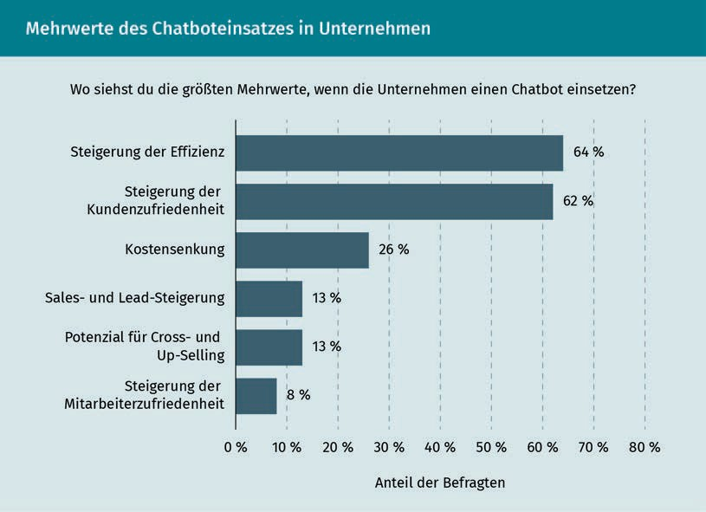

Moreover, bots that provide predeﬁned response options can be used to map the structure of a website or online store, enabling a new form of the shopping experience (Strzoda 2021).

###### Disadvantages of chatbots

A rule-based bot is limited to the user's input in its response and reaction options. The user on the other hand can make full use of their communicative text repertoire and the communicative limitations of the bot can lead to frustration. Thus, before bot programming is initiated, its usefulness should always be checked. A bot that only reproduces information that users can obtain more quickly and easily via an app, for example, offers no added value. An AI bot that can adapt to the user offers more value, but

Digital Communication

for small and medium-sized companies they are often a question of budget, especially since they require continuous further development. In the case of bots equipped with learning algorithms, there is a risk that users will feed them with unwanted, thematically inappropriate, or borderline/transgressive information. For example, the Microsoft bot "Tay" on Twitter featured sexist and offensive comments, among other things (Strzoda 2021).

#### Text vs. voice

The question of text or voice is particularly relevant in the context of mobile communication, since searching by voice command or recording a voice message is usually done via a mobile device such as a smartphone or tablet. According to Rieber (2017, p. 2f.), however, the deﬁnition of mobile is not exclusively linked to the end device, the type of use (because laptops are also used on the move, e.g., on the train), or the form of access. Rather, he emphasizes the ubiquity as a characteristic of mobile: "The smartphone has released the Internet from the computer room and taken it out into the physical world. Users no longer have to ‘sit down at the computer,' 'boot it up,' and 'dial into the Internet'; they can interact directly with information and services from the Internet from anywhere at any time" (Rieber 2017, p. 3). The global popularization of mobile devices means that they are increasingly dominating communication with digital assistants doing so in particular. Digital assistants (aka virtual assistants or voice assistants) are based on NLP software. NLP stands for Natural Language Processing and is a sub-area of Artificial Intelligence (Kreutzer/Vousoghi 2020, p. 1). "NLP enables a digital assistant to understand and process spoken language and to respond in spoken language" (ibid.). Online Marketing is already geared toward this development and has formulated "Voice First" or "Voice Only" to address the challenge (Kreutzer 2018, p. 357; Kreutzer/Vousoghi 2020, p. 1). This means that branding measures should be geared first or exclusively toward speech.

In mere communication terms, mobile use and search by voice input or communication by voice message, therefore, go well together. A study by PricewaterhouseCoopers LLP found that searching via digital voice assistants is becoming increasingly relevant for users. Searching by voice is perceived as smarter and easier, making the organization of everyday matters less complicated. Moreover, it is significantly faster to voice a search query into the smartphone than to type it out (PwC 2018). These changes in users' communicative behavior have an impact on various areas, such as search engine optimization. Voice search SEO, that is search engine optimization for voice, takes a different form than for text. For example, when searching by voice, users express entire sentences or questions, shifting the focus from neatly selected individual keywords to the natural flow of spoken language (Jahn-Firle 2019).

Digital assistants This is advanced software that can process and output natural language.

However, it cannot be assumed that language will completely replace text; rather, different applications will complement each other. After all, voice is not suitable for every occasion; on the contrary, it can sometimes even be disruptive (Kamps/Schetter 2018, p. 219). There is no question, however, that voice in various forms will have a significant influence on Digital Communication, whether, as mentioned, in search engine optimization, in Online Marketing in general, or with regard to the fundamental online communication process via the Internet. With the increase in mobile communication, an increase in voice input and output is to be expected.

Summary

Communication takes place everywhere and at all times - whether in analog or digital spaces. What all forms of communication have in common is that they are process-based and require at least two participants, otherwise no exchange can take place. This applies to relationships between two persons, as well as between person and bot, and person and voice assistant. However, digital communication is characterized by a number of speciﬁcations that make it distinguishable and different from analog communication. These include, for example, asynchrony or the possibility of staging.

It is clear from the basic online communication process via the Internet which characteristics (virtuality, multimedia, interactivity, and individuality) Internet-based communication possesses that enable the reversal of roles or the simultaneity of them: the sender is the receiver, the receiver is the sender. The producer is the consumer, the consumer is the producer. This makes various forms of communication (such as one-to-one or one-to-many) possible in the digital space.

Chatbots are a software solution that can be used to make digital communication more efﬁcient. Without interposing human communication on the part of the company, good chatbots can perform services, provide information, or offer assistance. However, the potential for frustration on the part of users is high because the communicative repertoire of rule-based bots is often in no relation to that of the users. Chatbots provide the basis for voice assistants such as Siri, Google Assistant, or Amazon Alexa. Voice assistants are becoming increasingly popular and a shift away from text and toward voice can be observed. In this context, a voice-only future is already being predicted for digital communication.



# Lesson 3

## Methods for digital work

##### LEARNING OBJECTIVES

After completing this unit, you will know ...

... how to explain relevant methods for digital work and how to overview the use of the methods in a meaningful way.

... how to understand the basic idea of agility and how to classify the agile process models Scrum and Kanban.

... how the phase model of Design Thinking is explained and applied.

... the uses of Game Thinking.

... which goals lean approaches have and how to classify Lean Startup and Lean Management methods.

DL-D-DLBDS01-L03

### Methods for digital work

#### Introduction

The corporate environment in the Digital Age is characterized by complexity, high speed, and low predictability. Which methods can be used sensibly in this context in order to continue to operate effectively and successfully?

This lesson introduces methods that have become established in the context of digital work and enable companies to respond to increased complexity.

Scrum and Kanban are the most common agile approaches. They focus primarily on the development of products and services and offer a structured framework for a ﬂexible, incremental, and iterative approach. Design Thinking uses the mindset of designers to solve complex problems and focuses primarily on interdisciplinarity. Game Thinking is based on the mindset of game developers and thus enables the advantages of games to be applied to business issues. Lean Management aims to optimize processes by reducing waste and creating a continuous flow. This concept is also applied in Lean Startups and transferred to the development of products and Business Models.

#### Agile methods: Agile Basics, SCRUM, Kanban

The term agility has its origins in the Latin "agilitas" and means mobility. Agility combines various concepts. Flexibility and Lean Principles are considered the central basic concepts of agility (Förster/Wendler 2012, p. 31). Flexibility is the ability to deal with unexpected change and uncertainty and to use changes as opportunities (Shariﬁ/Zhang 2000). A more recent deﬁnition by Lin, Chiu, and Tseng (2006) integrates technologies and concludes that the foundation of an agile enterprise is the integration of information systems and technologies, people, business processes, and facilities into a harmonious and ﬂexible organization to be able to address changing circumstances fast.

According to Scheller (2017, p. IX), agility consists of four values that are defined by twelve principles and manifest themselves in a variety of ways. If companies want to use agile methods and frameworks sensibly, it is necessary to understand agility as a holistic approach. It is only through this interaction of mindsets, values, and principles that agile methods, frameworks, and processes can be applied strategically.

Methods for digital work

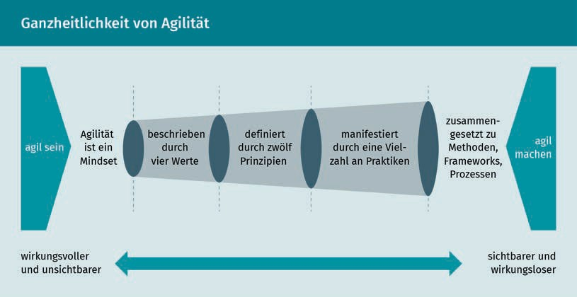

Values provide organizational members with orientation for their actions (Hofert 2018b, p. 128). If a company is to become agile and use agile methods, agile values must first be deﬁned (Kupiek 2020, p. 37). However, values are only put into practice through supplementary principles. It can be understood that values are directional impulses for action, whereas principles are operationalizations of the values (Hofert 2018b, p. 16). Overarching agile values and principles were deﬁned in 2001 by 17 leading software developers in the Manifesto for Agile Software Development (Agile Manifesto) (Beck et al. 2001).

###### Scrum

Scrum is a process model (framework) that was developed in the 1990s. It emerged from various efforts in science and practice (Schwaber/Beedle 2002). The developers of the process model deﬁne it as follows: "Scrum is a lightweight framework that helps people, teams, and organizations generate value through adaptive solutions to complex problems" (Schwaber/Sutherland 2020, p. 3). The Scrum Guide, serving as the central framework, explains the general use of Scrum. Publicly available, it is continuously developed. The team, its composition, and formal events and artifacts are described here.

Scrum Team

A Scrum team is interdisciplinary and consists of a maximum of ten people. This ensures efﬁcient communication and productivity. The team acts in a self-organized manner. Each Scrum team has a Scrum Master, a Product Owner, and several developers who are involved in achieving the project goal incrementally, i.e., step by step. The Product Owner (PO) is responsible for maximizing the value of the ﬁnal product. To do this, this person is responsible for continuous product backlog management. The Scrum Master is responsible for the introduction and effec-

Mindset

The mindset of a person determines their way of thinking and acting. In addition to the individual mindset, there is also the corporate or organizational mindset, which describes the basic logic of thinking and acting in companies and thus also influences the ways in which employees think and act.

Self-organization In classically organized projects, tasks are organized by managers and allocated directly to team members. In agile organizations, the organization of projects is the responsibility of the team members. Self-organization is considered a key prerequisite for successful agile development.

Product backlog All requirements for a service are collected in the backlog. The PO is responsible for the deﬁnition and com- munication of the product goal as well as the comprehensible and transparent presentation of this goal in the product backlog. In addition, this person determines the sequence and thus the prioritization of the backlog items.

tive pursuit of Scrum. Scrum Masters serve both individual Scrum Teams including Product Owners and the entire organization in understanding and following Scrum.

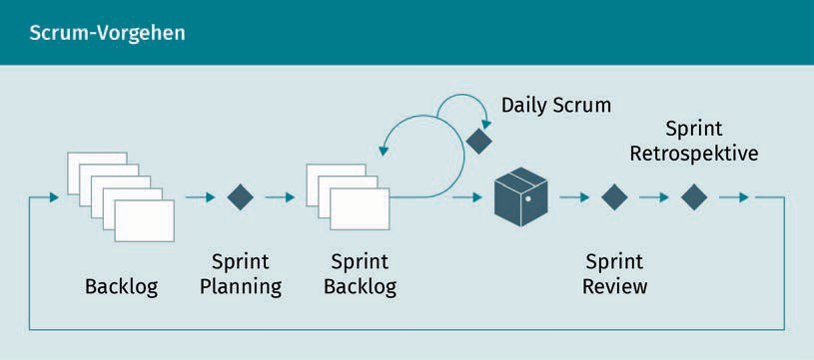

Scrum Events

Sprints represent the overarching framework of all Scrum events and subdivide projects into fixed time intervals. Sprints have a maximum length of one month, which is consistent for all sprints within a project. During each Sprint, the other Scrum Events are carried out. Maximum lengths (timeboxes) are specified for all events in the Scrum Guide (Schwaber/Sutherland 2020).

Sprint Planning: At the beginning of each Sprint, the content and procedure of the Sprint are planned. Based on backlog entries that are classified as priorities, it is discussed ...

1. Why the sprint is valuable, i.e., what the goal of the sprint relevant to stakeholders is.
2. Which entries from the backlog are completed for this purpose within the sprint and

transferred to the Sprint Backlog.

1. How the product backlog entries are implemented and what work is required in that respect.   
   For this purpose, the product backlog entries are broken down into

smaller units.

Daily Scrum: The Scrum Team meets daily to monitor progress against the Sprint Goal and, if necessary, adjust the Sprint Backlog while respecting the Sprint Goal.

Sprint Review: Upon completion of a Sprint, the Scrum team presents the product increment to relevant stakeholders to review it and its progress against the project goal and to determine next steps.

Sprint Retrospective: The Scrum Team analyzes the past Sprint from the perspectives of individuals, interactions, processes, tools, and the Deﬁnition of Done. On the one hand, collaboration, communication, and interaction within the team are considered (individuals and interaction). On the other hand, the application of processes and tools is analyzed, as well as the question of

Methods for digital work

how effective and efﬁcient both areas were in the previous Sprint. The goal is to improve the quality and effectiveness of the Sprint that follows. Adjustments are defined for the follow-up Sprint if necessary.

Scrum artifacts

The Scrum artifacts represent values and include commitments, i.e., quantities against which the artifacts are oriented and can be measured.

Product Backlog: The Product Backlog is the only source of work for the Scrum Team. It is continuously updated and refined. In doing so, it orients itself to the product goal.

Sprint Backlog: The Sprint Backlog consists of the entries of the Product Backlog that are to be completed to achieve the Sprint goal and the plan for implementing the increment. The Sprint Backlog is used to show the progress within the Sprint and is geared toward the Sprint goal.

Increment: The ﬁnal product target of the project is composed of a large number of increments. Being aligned with the DoD, only potentially functional increments are considered valuable.

###### Kanban

Kanban has its origin in the Toyota Production System (TPS), which aimed at continuous improvement. It was developed by Taiichi Ōno. The Kanban method was used in the 1950s to increase flexibility and efﬁciency. In Toyota's production system, cards were used on which all relevant information, such as removal information, transport information, and production information, as well as an identificatory, were listed for all production parts (Ōno 2013, p. 63). This gave rise to the name "Kanban", which in Japanese means "map" (Sichart/Preußig 2019, p. 292). The cards were used to pass on information about the production: only if the subsequent production step signals demand, the corresponding part is manufactured in the upstream step according to demand. This pull principle is a key characteristic of Kanban (Puckett/Neubauer 2018, p. 60).

David J. Anderson is credited with transferring the idea to the management of projects and thus to knowledge work at the beginning of the 21st century (Roock 2010, S. 38). Kanban is also based on values and principles that are used in practices (Kusay-Merkle 2018, p. 215).

Stakeholder

These are all persons, groups, or organizations that are directly involved in a project, influence the course of the project, or are influenced by the course and/or result of the project.

Product increment With each Sprint, a part of the product, the product increment, is completed. Step by step, the product takes shape.

Deﬁnition of Done Scrum teams use the Deﬁnition of Done (DoD) to deﬁne the criteria that must be met for a backlog entry to be considered complete and become part of an increment. Only entries with achieved DoD are part of the Sprint review presentation. The rest goes back into the backlog.

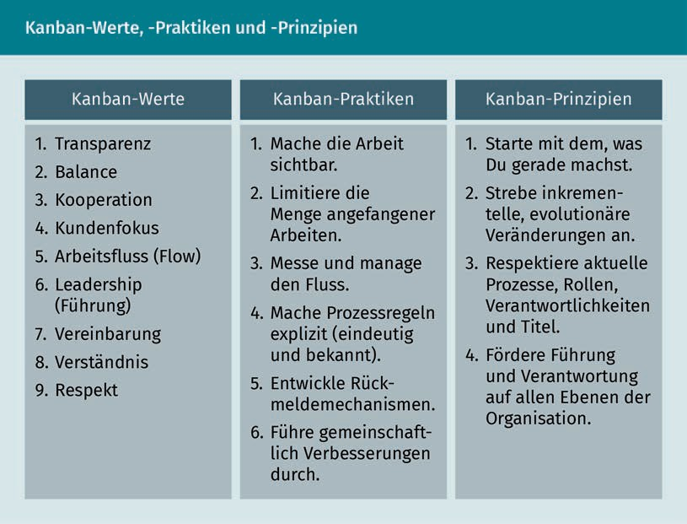

Kanban illustrates how the practices are implemented. As with TPS, cards are used for visualization. All work packages are recorded on cards, see the following figure (Böhm 2019, p. 33). Any number of additional columns depict the respective work process. Team members select individual cards to be processed according to the pull principle. From left to right, they work their way through the columns until the work package is complete.

Methods for digital work

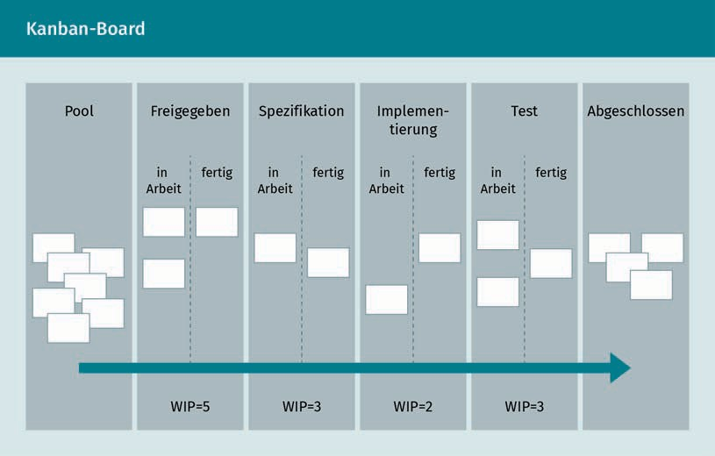

This transparent presentation means that it is always clear which and how many work packages are still open (Kusay-Merkle 2018, p. 207). It also enables quick the identiﬁcation of and reaction to bottlenecks. On the other hand, it limits the number of tasks. This is achieved by a fixed limit of work packages per team member and a limit of work packages per work step (work-in-progress limit, WIP limit). The resulting flow of work is measured in order to control it in the best possible way. The goal is an even flow of work (Timinger 2017, p. 203f.). Context changes are thus reduced and focused work is made possible. Feedback mechanisms allow problems to be identiﬁed and solved on the basis of a Plan-Do-Check-Act cycle, and the procedure as a whole to be improved incrementally and evolutionarily.

###### Comparison Kanban and Scrum

Scrum and Kanban represent agile approaches that share some aspects. Nevertheless, they also show differences in many places. Böhm (2019) compares Scrum and Kanban based on central criteria. The differences are summarized in the following table.

Plan-Do-Check-Act cycle

The PDCA cycle represents a control loop for controlling management tasks.

The principle of the cycle originates from quality management and is used for continuous improvement.

|  |  |  |
| --- | --- | --- |
| Comparison Kanban and Scrum | | |
| Criterion | Scrum | Kanban |
| Cooperation/ Team | * High interaction * Fixed Scrum events | * Optional team interaction * Control of the interactions via the method (the board) |
| Control variable | * Team performance (Velocity) * Realized complexity or benefit per time box | * Lead time of an element through the system |
| Team composition | * Cross-functional teams recommended | * Cross-functional teams or teams of experts |
| Element sizes | * As small as possible - at least small enough that an element can be realized in one sprint | * As small as possible - no size restriction deﬁned |
| Work-In-Progress Limitation (WIP) | * Limitation at the sprint level * Optional for tasks in the team | * Strongly recommended per workﬂow step |
| Estimate | * Complexity or effort estimation per item | * Estimate optional |

Methods for digital work

|  |  |  |
| --- | --- | --- |
| Criterion | Scrum | Kanban |
| Change | * Backlog changes always, sprint backlog changes never | * Always possible |
| Backlog | * One Sprint Backlog per team * One product backlog for several teams possible | * Kanban board for multiple teams possible |
| Rollers | * Scrum Team, Scrum Master, Product Owner | * No roles, responsibilities per work ﬂow step |
| Turnus | * Sprint backlog is renegotiated and rebuilt after each sprint | * Rolling procedure - continuous |
| Prioritization | * The backlog is prioritized by POs according to value creation or customer benefit. | * Prioritization optional in the "To Do" area - responsibility open |

#### Design Thinking

There is no universal deﬁnition of Design Thinking (Pressman 2018, p. 3). Pressman deﬁnes it "as a fundamentally creative process [...] driven by speciﬁc problems and people, but going beyond conventional or obvious solutions" (from English, ibid., p. 4). Meinel, Weinberg, and Krohn (2015) additionally emphasize the complexity of the issues addressed and the interdisciplinary nature of the design team. Thus, according to Kelley and Kelley (2013), the mindset of designers which includes feelings, intuition, and inspiration in the process of solution ﬁndings is applied. Design Thinking can thus be used for problems that cannot be analyzed in a simple way or for which there is insufficient data to guide the approach.

Bauhaus Bauhaus was characterized by the concept of bringing together craft and art.

The origins of Design Thinking lie in the Bauhaus movement of the 1920s, in which various design disciplines worked together to increase the ability and variety of solutions. This was taken up by David Kelley in the context of the "d.school" at Stanford University (Stanford d.school o. J.). It was here that the term Design Thinking was coined. Interdisciplinarity was extended in the courses of the d.school so that all disciplines worked together on solutions. In this way, students from subjects that were perceived as less creative were also empowered to ﬁnd solutions using creativity. While this interdisciplinarity has found its way into many curricula today, it was considered a great innovation at the time. It allowed new creativity to be unleashed, giving students a new human attitude, a new self-image, and a new sense of self-determination (Kelley/Kelley 2013).

Parallel to the d.school, Kelley founded the innovation agency IDEO, which also pursues and shapes Design Thinking (IDEO o. J.).

Convinced by the ideas of Design Thinking, SAP co-founder Hasso Plattner invested in the d.school, which was still in the startup stage at the time. This enabled the d.school to evolve into the Hasso Plattner Institute of Design at Stanford University. In Germany, Design Thinking was established at SAP in parallel and, in the course of further development, the Hasso Plattner Institute, School of Design Thinking (HPI D-School), was founded at the University of Potsdam in 2007 (Hasso Plattner Institute o. J.). The school aims to cooperate with industry and work on concrete practical problems. The HPI D-School focuses on three core elements (Meinel/Weinberg/Krohn 2015):

1. Multidisciplinary teams,
2. Flexible space, and
3. Iterative processes.

Kerguenne, Schaefer, and Taherivand add user-centeredness as another central element of Design Thinking (2017, p. 7). This means that the users of the solution are at the center of attention at all times. From this perspective, the needs of the target group are always the starting point for the search for a solution, as opposed to starting from a technical feasibility perspective.

Multidisciplinary teams are an important prerequisite for bringing together different perspectives and expertise to find solutions.

Flexible spaces are intended to support the teams in their work. On the one hand, the focus is on standing workstations, as this improves the performance of the participants and the teams are faster and more alert (Meinel/Weinberg/Krohn 2015). For this purpose, the HPI D-School developed its own line of furniture to support cooperative work in Design Thinking teams (System 180 n.d.). All elements are movable so that rooms can be ﬂexibly furnished.

Methods for digital work

Every Design Thinking project starts with a problem statement (Design Challenge). Furthermore, Design Thinking often uses a Design Brief, which outlines the scope of the project and thus the problem, while defining the target customer, the project goals, the available materials, and the competition or alternatives, in addition to defining the budget and other constraints as well as the next steps (Lewrick 2018, p. 44). Working through the Design Challenge is an iterative process. This includes, depending on the school of thought, different process steps. In Europe, the HPI D-School process has become established. It first deﬁnes a microcycle based on the six steps explained below (Lewrick/Link/Leifer 2017, p. 30).

* 1. Understand: At the beginning of every Design Thinking project, the task must be understood. For this purpose, it is particularly important to understand the user group, which includes the context, boundary conditions, and possible restrictions and optimization options.

Methods that can be used in this phase are the Empathy Map, personas, or the 6-W questions (Lewrick 2018, p. 45).

* 1. Observe: By observing the user group or the people relevant to the task in real-life situations, their behavior can be analyzed. By sharing the experiences of the users, the assumptions made in the first phase can be verified.

One method that can be used in this phase is the Action, Environment, Interaction, Object, and User (AEIOU) method (ibid., p. 49).

* 1. Deﬁne point of view: This step synthesizes the findings of the previous phases. By evaluating, interpreting, and weighing the findings, a standpoint emerges from which the solution ﬁnding is driven forward. The following template is meant to serve as a scheme for defining a point of view (ibid., p. 54):

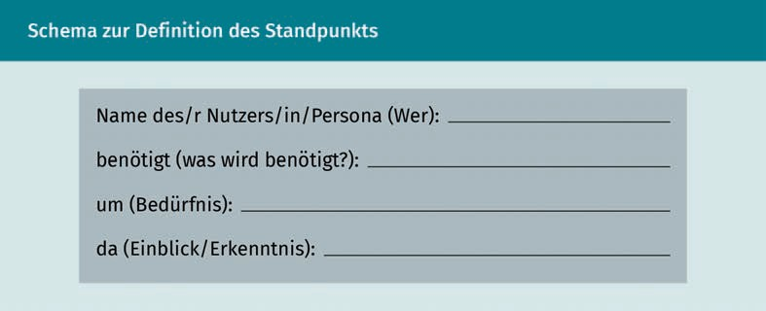

Methods that can be used in this phase are event and experience chains, storyboards, or the hook framework (Lewrick 2018, p. 51).

* 1. Find ideas: Starting from the deﬁned point of view, the process of finding ideas finally starts in this step.

Methods that can be used in this phase include various forms of brainstorming, the Osborn checklist or Substitute, Combine, Adapt, Modify, Put to other uses, Eliminate, and Rearrance (SCAMPER) (ibid., p. 55).

Empathy Map

This method is intended to document the different senses of the users. For this purpose, they are questioned about what they think, feel, hear, say, and see.

SCAMPER

These challenges generate new ideas based on an initial idea or solution.

* 1. Develop prototypes: After ideas have been selected as possible solutions, prototypes are created to test these approaches with potential users.

Methods that can be used in this phase are paper prototypes, sketches, mock-ups, storytelling, storyboards, open hardware platforms, Pinocchio, Minimum Viable Products, and Minimum Viable Ecosystems. Lewrick provides an overview for selecting adequate methods (Lewrick 2018, p. 58).

* 1. Testing: In this step, the previously created prototypes are tested with potential users. The result of the test is qualitative feedback on the solution prototypes. This feedback should be recorded and incorporated into the further iterative development.

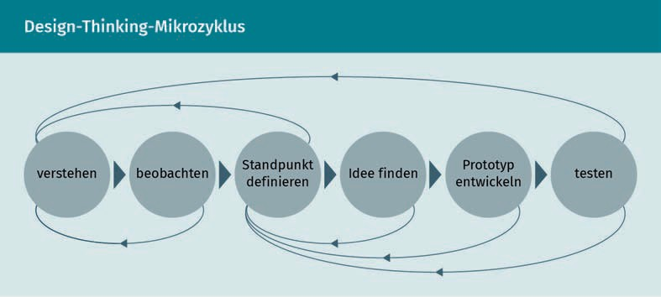

The microcycle is embedded in a superordinate macrocycle that structures the overall project. This macrocycle illustrates the iterative process of diverging and convergent thinking as the foundation of Design Thinking (Lewrick/Link/ Leifer 2017, p. 28). Diverging describes the approach of collecting as many ideas as possible. This applies to both the deﬁnition of the problem space and the solution space. Convergence is the process of selecting individual goals, functionalities, or solutions from a wide variety of ideas. Finding the right moment to move from diverging to converging is a major challenge in Design Thinking (ibid., p. 28). This transition is referred to as the "Groan Zone" (ibid., p. 62).

Methods for digital work

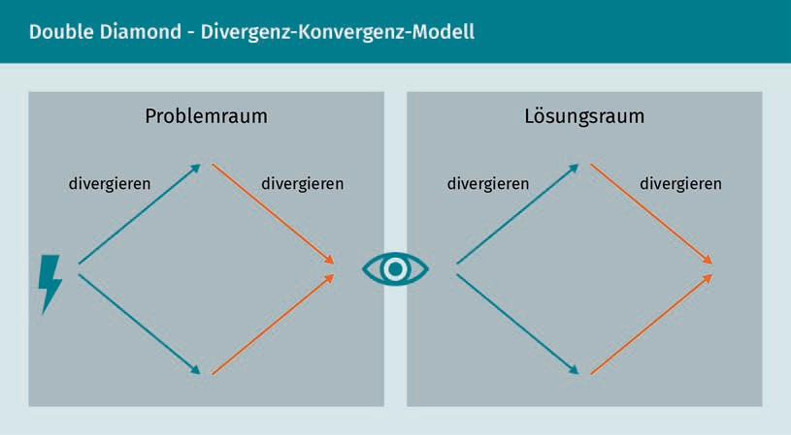

Lewrick (2018) recommends seven phases for the procedure within the macrocycle in order to approach a solution over several iterations. One or more microcycles are carried out in each phase of the macrocycle.

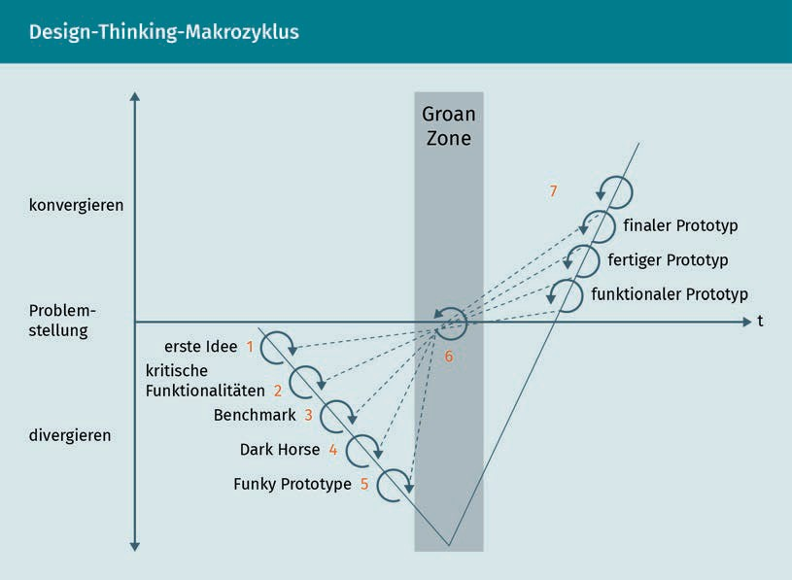

During the first five divergent phases, information is gathered so that the team gains extensive market and problem knowledge. Phases one through five can be followed by the Groan Zone. This depends on the team's level of knowledge. Likewise, the order of the first five phases can be deﬁned individually depending on the issue.

* + - Phase 1 - first idea: This phase is characterized by great openness. First spontaneous ideas are pursued and compared with alternative or competing solutions.
    - Phase 2 - critical functionalities: In this phase, critical functionalities are identiﬁed and considered in detail. The urgently required functionalities can then be incorporated into an initial prototype.
    - Phase 3 - Benchmark (analogies): In a further step, analogies are used to promote new thought patterns. Here, new perspectives are to be adopted and horizons broadened. It is recommended to develop the three most suitable ideas into prototypes and test them with users.
    - Phase 4 - Dark Horse: In this phase, a radical idea is to be developed. Possible limitations and risks that were considered in the previous phases should be disregarded here.
    - Phase 5 - Ad hoc implementation of a "funky prototype": An unconventional ("funky") prototype can be created here by combining ideas from previous phases.  The speed of implementation and the focus on the benefit are important in this respect. Budget restrictions should deliberately not be taken into account.
    - Phase 6 - Groan Zone: The next phase is the transition from divergence to convergence. For this transition, it is recommended to identiﬁcate the most important elements, cluster ideas, and establish relationships between them.
    - Phase 7 - Concretization of the vision in the Prototype Vision Canvas: Once a selected idea has reached maturity, it is presented in the Prototype Vision Canvas. The following five elements are deﬁned for this purpose:
      * One-sentence description of the vision,
      * Target Audience Description,
      * Description of the needs of the target group to be satisfied,
      * Description of the core of the service, and
      * Description of the concrete benefits of the solution.

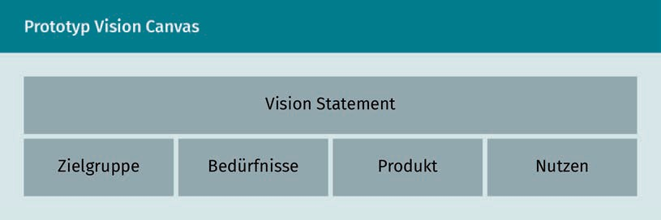

Methods for digital work

Based on the results of the Groan Zone, various prototypes are created with increasing maturity. A completed prototype is reached via an initial functional prototype, which is used to gain further insights that in turn feed into the ﬁnal prototype. Finally, one needs to address "How to bring it home?", i.e., how this product can now be implemented. It is only when a solution is implemented in the market, outside of the scope of Design Thinking, that this question can be answered. Design Thinking, however, as well as the attitude gained through it, provide conducive starting points.

#### Game Thinking

Game Thinking refers to the use of game elements in contexts that do not necessarily include games or Digital Media resources (Lee 2020, p. 1). In Game Thinking, immersive experiences are created by using games and game methodology. In the corporate context, the term "Gamiﬁcation" has been increasingly used since the mid-2010s (Goethe 2019, p. 15). Gamiﬁcation has the power to enhance a User Experience by immersing users in a "gamiﬁzed" system that both engages and stimulates them (ibid., p. 13). In doing so, the mindset of game developers is adopted to pursue different intentions via immersion (Werbach/Hunter 2012, p. 40).

Central uses of Game Thinking and Gamiﬁcation are learning, marketing, and loyalty (Goethe 2019, p. 21). For example, Gamiﬁcation can be used to pursue the goal of increasing commitment and intrinsic motivation to a process, team, or vision. Similarly, Gamiﬁcation can be used as an experimental learning technique to promote engagement with a product, service, or brand (ibid., p. 13). In the corporate context, for example, Gamiﬁcation is used to convey content in a playful way. In the "International Management Simulation" program, Bayer AG's junior employees learn about business concepts.  (Hooffacker/Bigl 2021, p. 130).

Burke deﬁnes common techniques used in Gamiﬁcation (Burke 2012, cited in Goethe 2019, p. 20):

Immersive Experiences

The word refers to an experience, for example a game, that exhibits such realistic representations and behavior that the viewer blocks out the real world and becomes immersed in it (lat. immersio: to immerse, to embed).

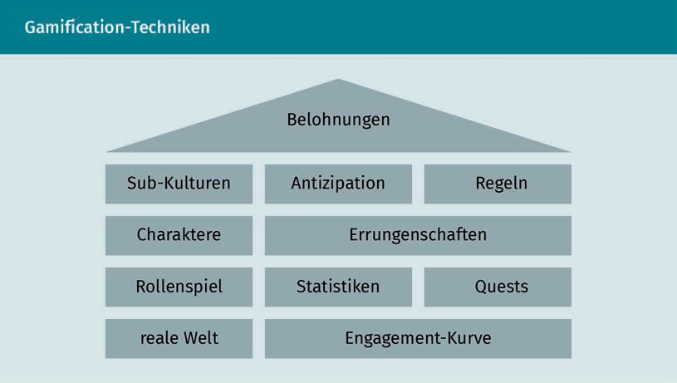

The benefits of these techniques are incorporated into Game Thinking and Gamification. In summary, the focus is on the following positive effects (Werbach/Hunter 2012, p. 41):

* + - The solution of problems is trained and thus intensified.
    - Challenges are broken down into clear individual parts.
    - Players gain a sense of control over the challenge.
    - Games encourage unconventional thinking.
    - The interest of the players is maintained over a long period of time and with increasing expertise.
    - Games adapt to the individual experiences of the players so that different interests and abilities are addressed at the same time.
    - Working in teams is encouraged.
    - Games promote confidence and an optimistic attitude.
    - Fear of failure is reduced so that innovative experimentation is made possible.

Goethe defines a simple Gamification model based on goals, measures, and rewards as the basis for all uses of Gamification (Goethe 2019, p. 15f.).



Methods for digital work

Defining the goals is the starting point. The goal can be to increase the engagement of the user group. For example, employees who are to learn about a new platform or app can be made aware of it through Gamiﬁcation. Alternately, Gamification can guide users in a certain direction. Choosing a goal triggers the definition of actions. Subsequently, these actions can be used to define metrics that can then be used to measure goal attainment. For example, if more engagement is to be achieved, an increased number of posts in a community can be the metric. The measured increase in online content is then rewarded. This reward must be publicly recognized and of consistence.

Furthermore, following the MDA framework is considered critical to the success of Gamiﬁcation (Matallaoui/Hanner/Zarnekow 2017, p. 8). The MDA-framework formalizes the consumption of games, as depicted in the following figure. The game is decomposed into its individual components for this purpose (Rules [Rules], System [System], Fun [Fun]). Likewise, the respective design counterparts are defined: Mechanics, Dynamics, and Aesthetics (Hunicke/ LeBlanc/Zubek 2004).

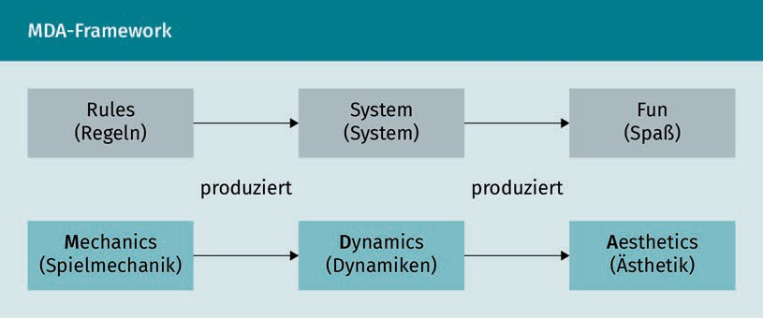

Game mechanics include all aspects of the game, including data representations and algorithms. Dynamics describe the runtime behavior of the mechanics, acting on the player's inputs and the outputs of the other components over time. Aesthetics refers to the desired emotional responses evoked in the player when interacting with the game system (Hunicke/LeBlanc/Zubek 2004). In the context of the three elements of the framework, different perspectives on a game can be taken that are causally related. For example, from the designer's perspective, the mechanics lead to dynamic system behavior, which in turn leads to certain aesthetic experiences. From the player's perspective, the aesthetics provide the framework, which translates into observable dynamics and, ultimately, operable mechanics.

To describe fun as a fundamental goal of a game that can be generated through aesthetics, Hunicke, LeBlanc, and Zubek (2004) introduce the following taxonomy:

* + 1. Sensation: Game as sensationalism;
    2. Fantasy: Game as wishful thinking;
    3. Narration: Game as drama;
    4. Challenge: Game as an obstacle course;
    5. Camaraderie: Game as a social framework;
    6. Discovery: Game as unexplored territory;
    7. Representation: Game as self-discovery;
    8. Devotion: Game as a pastime.

This taxonomy can be used to deﬁne which aesthetic goals a game pursues. Hence, models can be developed to describe its dynamics and mechanics. Dynamic factors such as time pressures and opposing players contribute to the aesthetic goal of the challenge. The aesthetic goal of camaraderie can be created by dynamics such as the need to share information or form teams. Finally, the dynamics of the game are supported by the game mechanics and content (levels, elements, etc.). Mechanics are the various actions, behaviors, and control mechanisms available to the player in a game context. Lastly, the models which are derived based on the taxonomy are used to fine-tune the game experience. Thus, design goals can be articulated, game errors can be discussed, and the progress of the adjustment can be measured (Hunicke/ LeBlanc/Zubek 2004).

Gamification should always have clear goals, according to both the Gamification Model and the MDA framework. Accordingly, the mere use of game elements in an existing system does not yet constitute meaningful Gamiﬁcation (Matallaoui/ Hanner/Zarnekow 2017, p. 15). Game Thinking represents a means for companies to address existing business challenges if the goals are clearly defined and pursued through the use of game elements (Werbach/Hunter 2012, p. 40). The ability to be flexible and agile can be increased through collaboration, co-creation, and lifelong learning (Hooffacker/ Bigl 2021, p. 118). Werbach and Hunter suggest addressing four questions to determine the scope of application of Gamification in order to effectively apply the concept (2012, p. 44):

1. Motivation: How can benefits be derived from promoting behavior?
2. Meaningful choices: Are the target activities of sufficient interest?
3. Structure: Can the desired behaviors be shaped by a set of algorithms?
4. Potential conflicts: Can the game avoid conflicts with existing motivational constructs?

Methods for digital work

#### Lean Startup and Lean Management

Lean approaches originated in early industrialization and, therefore, are initially applicable to production (Helmold 2020, p. 4). There, the focus has so far been on the efﬁcient use of individual machines. In contrast, the Toyota Production System (TPS) developed by Taiichi Ōno focused on the flow of products through the overall process (ibid., p. 7). As part of this discussion, the Kaizen principle for continuous improvement is often mentioned, which also stems from Ōno. The most important component of the TPS is the avoidance of waste (Japanese: muda) by creating a trouble-free continuous flow of production. Waste refers to activities that are inefficient and are to be replaced by value-creating ones (ibid., p. 1). The focus is on high quality and, above all, on pursuing the requirements of customers (Bertagnolli 2020, p. 4). Ōno deﬁned seven types of waste (Womack/Jones 2013, p. 23):

1. Overproduction,
2. Unnecessary movement,
3. Waiting time,
4. Transportation,
5. Process overachievement,
6. Inventories, and
7. Defects, scrap and rework.

Since the TPS led to a large increase in efﬁciency, researchers at the Massachusetts Institute of Technology (MIT) took notice. In 1990 and 1991, they studied the TPS and concluded that Toyota had the most efﬁcient production at that time (Bertagnolli 2020, p. 206).

###### Basics from Lean Production

It was only through this study that the term "lean" was coined by "Lean Production" and "Lean Manufacturing" (Womack/Jones/Roos 1990). One result of the study was the deﬁnition of the following basic principles of lean approaches (ibid., cited in Hüs- selmann/Leyendecker 2019, p. 222):

1. Value Creation,
2. Value Stream Orientation,
3. Flow,
4. Pull, and
5. Perfection.

Value creation focuses on customer requirements. A service is deﬁned as value-creating if a customer benefit is generated and the input on the company side is less than the revenue generated (Womack/Jones 2013, p. 23). The value stream orientation represents the consideration of process chains.

Kaizen

This is a concept that strives for continuous improvement of processes or products. Kaizen can also be understood as a philosophy for work and life. This makes improvement the guiding principle for all actions.

Value Stream Mapping

(VSM)

This is the holistic analysis of process chains using graphical representations of all process steps, from raw materials to delivery to customers. The value stream illustrates the correlations between material and information flows.

Makigami They are used to visualize information flows and business processes in indirect areas. Functions and roles are represented as pathways in order to define the structure and sequence of business processes to identify waste.

Value Stream Mapping, for instance, is used in Lean Management to visualize processes (VSM) (Bertagnolli 2020, p. 22). This illustration of all actions performed for product manufacture serves as a starting point for improving the process chain. On this basis, waste can in turn be identiﬁed. At this point, Makigami is used to provide administrative processes and services. All functions and roles are represented (ibid., p. 231).

The flow principle aims at a uniform flow. This can only be realized through small batch sizes. It focuses on the principle of "one-piece flow," wherein a single product as if in a flow, passes through production (ibid., p. 59et seq.). The flow principle can be applied to all activities, even though in some areas it can be challenging to recognize the flow of a value (Womack/Jones/Roos 1990, p. 67). The goal is to optimize the overall process rather than individual steps. Transparency is created in this way to avoid waste.

This principle is directly related to the pull principle. Customers are therefore always put first and only services that are accepted by them are produced. This avoids overproduction and warehousing costs. A pull principle triggers an impulse to initiate further production only when a product is sold at the end of a process chain. Starting from the end of the process chain, this principle runs through all process steps. Just like warehousing, production must also be reorganized accordingly and processes adapted to a pull principle. This process of continuous improvement is ultimately intended to achieve perfection.

###### Lean Management

Starting with Lean Principles geared toward production, they have steadily gained importance in other areas over the past decades. Thus, Lean Principles are used beyond production in areas such as distribution, service, retail, and even in governments (Helmold 2020, p. 7). These areas support production and are therefore referred to as indirect areas. Lean Management is now described as a holistic approach to various application areas beyond production. "In addition, the human being and the leadership aspect as well as thinking and acting are included. Methods are not the focus; thinking is (lean thinking)" (Bertagnolli 2020, p. 219).

Lean Principles also emphasize optimizing processes in indirect areas. To this end, waste must also be reduced here in order to generate a continuous flow. A new type of waste is added by Lean Management in indirect areas, that is unused employee potential and unused information, in addition to the seven types already defined (Womack/Jones/ Roos 1990, p. 23). Bertagnolli provides examples of these wastes in indirect areas in the following overview:

Methods for digital work

|  |  |
| --- | --- |
| Eight types of waste in the indirect area | |
| Type of waste | Examples |
| Overinformation and overproduction | * Services without customers * More information than requested * Nonsensical tasks, duplication of work, reporting system * Multiple filing, archive |
| Inventories, backlogs | * Orders not processed * Inbox (tray and mail) * Storage space, storage surface, folders * Processing in batches |
| Unnecessary movement | * Long distances in the office, e.g., to office equipment, files * Poor office layout, spatial separation * Ways to meetings/secretariat * Travel times |
| Information transfer | * Complicated ways * Interfaces and media breaks * Long meetings * High mail traffic |
| Waiting time and search | * Waiting for orders, releases, or information * Search for documents and information * Computer and program launch, device availability * Unpunctuality |

|  |  |
| --- | --- |
| Type of waste | Examples |
| Errors and follow-up | * Missing, incomplete, wrong information * Outdated and different information * Ambiguities, queries * Grinding |
| Complicated workflows | * Double commissioning, redundancies * Checks, poor reconciliations * Different priorities * Complex IT/software |
| Unused employee potential and information | * Unsuitable staff deployment, underworked/overworked staff * Ignored information * No knowledge exchange, internal competition * Lack of familiarization |

The application of basic Lean Principles is therefore based on current requirements. Due to the increased importance of knowledge work, Lean is now being used in other non-production areas as well. In the course of the currently increasing complexity and uncertainty of the corporate environment, the Lean Principles are also used in this context. The Lean Startup method takes into account product and Business Model development in an uncertain environment.

###### Lean Startup

In 2011, "The Lean Startup" was published and quickly became a bestseller in the management literature (Ries 2020). Based on his experience in founding various Internet startups, the author Eric Ries had transferred Lean Principles for product and Business Model development to the context of startups. This took into account the special conditions of increased uncertainty in the corporate environment. These are particularly relevant for startups, as they first have to establish their Business Model in the targeted market. In this context, speed is of particular importance (Scheller 2017, p. 263). With the Lean Startup method, companies can address this uncertainty quickly and thus reduce the risk.

Methods for digital work

Ries deﬁnes five central principles for the Lean Startup method, which form the basis of Lean Startup (Ries 2020, p. 15et seq.):

1. Entrepreneurs are everywhere: The term Lean Startup suggests that this method is used exclusively in startups, i.e., in young companies still in the process of being founded. However, Ries deﬁnes startups as follows (ibid., p. 33): "[A startup is] a human institution designed to create new products and services under conditions of extreme uncertainty." Thus, the focus is rather on new development in an uncertain environment, conditions that established companies also face. Hence, the Lean Startup method can also be used in established companies with entrepreneurs, i.e., people who deal with innovative new developments or spin-offs. Since they occupy a special position compared to the classic startup, entrepreneurs in this context are also called intrapreneurs. Entrepreneurs, and thus opportunities to use the Lean Startup method, can be found wherever innovative services are to be developed under uncertain conditions.
2. Entrepreneurship is management: Once again, the special challenges that prevail in the face of great uncertainty are addressed here. They also have an impact on management and leadership competencies. Thus, in startups, competencies are needed that meet the special requirements. Ries (2020) therefore advocates for using the term "entrepreneur" in such a context.
3. Validated learning: The Build-Measure-Learn cycle is designed to enable startups to continuously learn and establish a sustainable Business Model. The strong focus on the learning process distinguishes startups. Pure revenue generation is not sufficient in this context. The efﬁciency of the entrepreneurial vision should be continuously reviewed and improved.
4. Build-Measure-Learn: The Build-Measure-Learn cycle is the basis for all decisions and actions. In order to create successful products from ideas, customers must always be integrated into the learning cycle. The goal of every startup should be to constantly accelerate the cycle.
5. Innovation accounting: Since innovation is the focus, it is also used to measure progress and success. For this purpose, a balance sheet of relevant activities is kept, which is oriented to important milestones.

The Lean Startup method thus follows an iterative and incremental approach. The focus is on testing hypotheses. To this end, feedback is obtained from customers and users at an early stage and in the short term in order to gradually orient further Business Model and product development to the market (Wagner 2018a, S. 105). This method is referred to as customer development (Eckert 2017, p. 17). In the Lean Startup, customer orientation goes beyond the isolated solicitation of feedback. In this process, target groups are integrated into the creation of the product and the development of the Business Model from the very beginning.

Minimum Viable Product (MVP)

The MVP has only the functions and features necessary to test a given hypothesis.

It is a product version that can be tested easily and quickly

throughout the entire Build-Measure-Learn-feedback loop.

Lean Startup also makes use of agile methods as well as the basic Lean Principles (ibid.). This can be seen in the experimental approach, which enables fast action and the avoidance of wasted time and costs (Scheller 2017). Thus, the Build-Measure-Learn cycle forms the guiding principle of the Lean Startup method. An important component of these feedback loops is the use of Minimum Viable Products (MVPs). These threshold products are used to evaluate assumptions and are tested by potential customers. This ensures that products meet the requirements of potential user groups. Going through this learning cycle enables startups to learn from incorrect assumptions and improve the product. Based on newly developed hypotheses, a new cycle can then be started (Ries 2020).

In addition, Lean Startup focuses on operational Business Model development based on the Business Model Canvas according to Osterwalder and Pigneur (2011, p. 16et seq.). This method enables startups to simultaneously drive forward operational Business Modeling during product innovation. The nine building blocks of the Business Model Canvas can be used to demonstrate the logic by which a company generates value (ibid., p. 19):

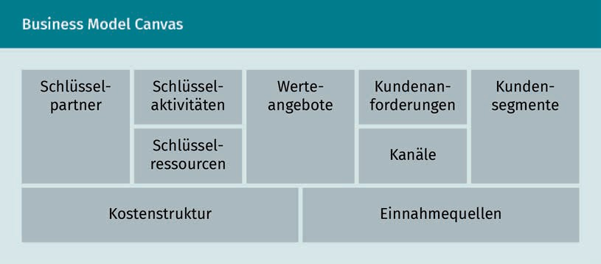

Summary

Digitalization is having an impact on the world of work and on how methods are applied. As part of digitalization, methods for digital work have become established that enable companies to be more flexible, faster, and lighter.

Methods for digital work

Agility is seen as the central foundation for digital work. It represents a holistic approach that is deﬁned by values, principles, and practices. Scrum and Kanban are central process models that enable companies to work ﬂexibly and iteratively based on the needs of their customers.

Design Thinking and Game Thinking are each oriented toward the creative solutionﬁndings of designers and game developers. The Design Thinking method is characterized by phase orientation and interdisciplinarity, which enables structured solutionﬁndings even for complex issues.

Game Thinking uses game development techniques that offer companies starting points for designing positive immersive experiences, especially in the areas of learning, marketing, and loyalty.

Lean Management and Lean Startup are based on principles that aim to avoid waste by creating a trouble-free continuous flow of production. In this context, the focus is on high quality and, above all, the pursuit of customer requirements. While Lean Management focuses on indirect business processes, Lean Startup concentrates on product and Business Model development in the context of startups.



# Lesson 4

## Distributed and collaborative work

##### LEARNING OBJECTIVES

After completing this unit, you will know ...

... what significance distributed and collaborative working has for today's working world.

... how to identify challenges in the collaboration of distributed, virtual teams.

... which suitable tools and systems are available for collaborative, distributed work.

... how to explain approaches and techniques for creating modern websites.

... how to use techniques for creating and giving presentations.

DL-D-DLBDS01-L04

### Distributed and collaborative work

#### Introduction

Laura, Paul, Noemi, and José work in the same company. They currently have the task of working together to develop a concept for a new digital company offering. In three weeks, they will have to present their concept to an innovation committee of the company. The task challenges the four colleagues both professionally and in terms of content.

What's more, they work in different locations: Laura and Paul are at headquarters in Munich, Noemi is in Tokyo, and José in Santiago de Chile. They have not yet met in person. Despite the massive time difference, they try to exchange information regularly in video conferences. While none of them speak English as a native language, it is their language of communication. It is also important to them that everyone has access to the current status of all documents. Only then can the respective team member build on what their colleagues have created. This is all the more important as it is not possible to check in with a colleague on the other side of the world if it happens to be nighttime for them.

In our globalized world, this case study is not unusual; instead, virtual teams in which team members are distributed around the world are increasingly becoming the norm (Hofert/Thonet 2019, p. 166). Even this small excerpt illustrated a series of challenges inherent to distributed and collaborative working (see. e.g., ibid., p. 168f.). In this lesson, we will look at these challenges from different perspectives.

#### Basics

The following sections introduce a basic understanding of distributed and collaborative working, followed by demonstrations of tools, methods, and techniques.

###### Collaborative work

As social beings, humans combine their efforts in many situations to achieve a common goal. In the evolution of mankind, this was sometimes even necessary for survival (Kaats/Opheij 2014, p. 8). Our modern working world has increased both the necessity and the complexity of collaboration (cf. Riemer/Schellhammer 2019, p. 1; Ehmer 2017, p. 1). Collaboration (lat: collaborare - to work together) refers to the active involvement of two or more people in completing a task without prior definition of system boundaries (e.g., Klötzer/Hardwig/Boos 2017, p. 294; Ehmer 2017, p. 1). In completing the task, they mutually influence each other, e.g., by exchanging intermediate results, which in turn feed into each other's work. Due to the lack of fixed system boundaries,

Distributed and collaborative work

collaboration can be highly flexible in terms of content, time, and personnel, as opposed to, say, a project organization.  (Ehmer 2017, p. 2).

Collaboration usually takes place when people want to achieve something they cannot (do) on their own. Collaboration must bring them a benefit (Kaats/Opheij 2014, p. 9). Generally, it is required when people's own knowledge and skills cannot solve the problem, such as a lack of detailed knowledge or the need for specialist expertise from another discipline (e.g., Hofert 2018a, p. 31; Ehmer 2017, p. 1).

Forms of work such as collaboration promote cooperation across departmental and divisional boundaries, as well as the willingness to engage with new perspectives and other ideas for solutions (e.g., Ehmer 2017, p. 5). Working collaboratively requires the right organizational structure, such as small teams that work relatively independently, as well as the framework conditions that allow them to coordinate with other teams doing upstream or downstream work (ibid., p. 6f.).

If teams are going to work together successfully and be more than the sum of their parts, they need a common goal orientation and the understanding that they win or lose together (e.g., Hofert 2018a, p. 32; Sterrer 2014, p. 116). A team differs from groups, as the following overview shows.

|  |  |
| --- | --- |
| Differences between (work) groups and teams | |
| (Work) group | Team |
| Result as the sum of the individual contributions of each group member | Synergy through joint efforts towards a common goal |
| Group members are independent of each other, information exchange primarily serves individual performance | Team members have complementary skills and feel responsible for each other |
| Each group member has their own area of responsibility | Individual and complementary responsibility |
| Individual work products | Collective work products |

According to Ellebracht et al. (2018, p. 205), a successful team has special energy: "There is no need to tell such a team that overtime or other extra work is required. It goes without saying. Even when working at full speed, the top team does not appear stressed but radiates a sense of fun."

Team

It is characterized, among other things, by the joint processing of mostly complete tasks, close communication, and mutual support (e.g., Schiersmann/Thiel 2018, p. 222).

###### Distributed and virtual work

Virtual This term refers to the use of information and communication technologies instead of face-to-face communication.

Due to the Corona pandemic, many employees worked from home in 2020 and 2021. They were thus spatially distributed and not present at a fixed workstation in the office. Nowadays, digital solutions support this form of collaboration (Kauffeld/Handke/Straube 2016, p. 43). One therefore also speaks of virtual teams.

Often, distributed and virtual work is reduced to employees sitting in different places and interacting with computer support (cf. Handke/Kauffeld 2019, p. 35). According to current understanding, however, distance has several dimensions (Ebert 2020, p. 34; Handke/Kauffeld 2019, p. 35; Hofert/Thonet 2019, p. 167). Ebert (2020, p. 34) distinguishes between space, time, and culture and emphasizes that distance exists more quickly than is often assumed. In this way, emails are sent from a distance of 15 meters rather than having to walk to a neighboring office. Hofert and Thonet (2019, p. 167) refer to virtual teams as 4-D teams. 4-D stands for Diverse, Dispersed, Digital, and Dynamic.

Laura, Paul, Noemi, and José from the opening example are such a virtual team: The team members are geographically distributed, work in different time zones, and come from different cultures. They also make intensive use of communication and information technologies to develop the concept for the digital offering.

The flexibility provided by distributed work, such as from home, is valued by employees who can arrange their work hours more flexibly and balance family and career (Handke/Kauffeld 2019, p. 34). They also proﬁt from the time savings, as the commute to work or business trips can be reduced or even eliminated.

Distributed work also has advantages from a company perspective. Key drivers are (Ebert 2020, p. 3et seq.; Handke/Kauffeld 2019, p. 34; Kauffeld/Handke/Straube 2016, p. 43f.; Dulebohn/Hoch 2017, p. 569):

* Flexibility: Incorporating external experts on a project- or task-based basis can quickly provide companies with expertise they do not have internally.
* Innovation: Distributed working also means that companies are present in local markets. Proximity to the customer means that more tailored, innovative solutions can be developed and offered to customers.
* Efﬁciency: By outsourcing tasks to countries with lower labor costs, costs can be reduced. Companies also benefit from lower legal requirements with regard to occupational health and safety and employee protection.

Distributed and collaborative work

As a result of geographical distribution, it is also possible to work around the clock and, for example, to provide continuous customer service.

* + Risk management: By distributing work among partners and suppliers, risks can be shifted.

While distributed work has these advantages, it also has some disadvantages and challenges. Particularly, distributed work adds complexity, since coordinating interfaces requires time and learning (Ebert 2020, p. 13). Agile methods are often recommended for distributed teams (ibid., p. 45; Ehmer 2017).

#### Tools and systems

As a result of Digitalization and modern, Internet-based solutions, there are completely new ways in which spatially distributed teams can communicate, exchange information, and collaborate (Riemer/Schellhammer 2019, p. 1). These solutions are often summarized under the term "Social Collaboration Software" or "Enterprise Social Software" (Jäger/Petry 2021, p. 36). Such tools and systems can be divided into three categories, namely communication, coordination, and knowledge management, although these are not clearly separable (ibid.).

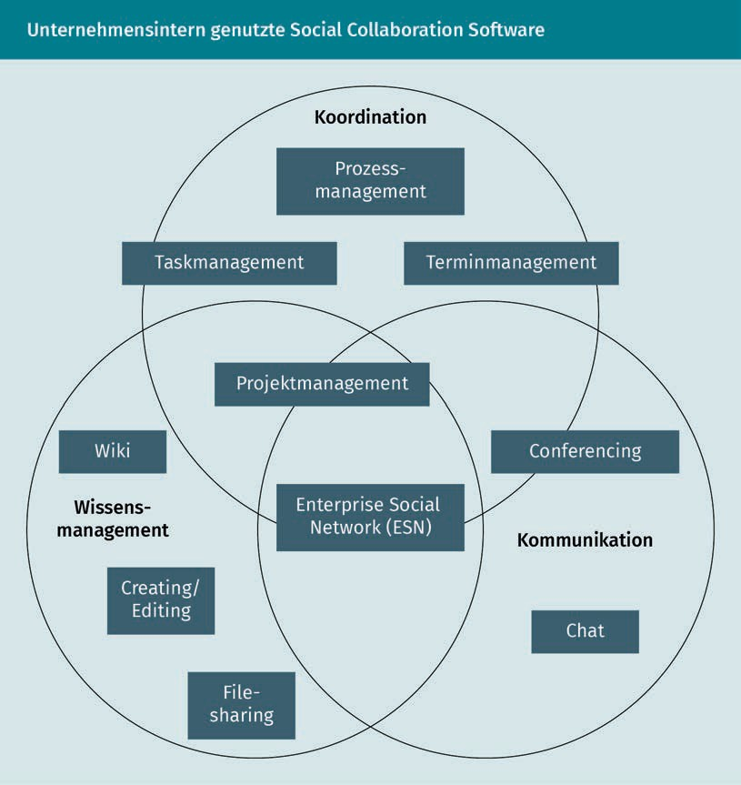

###### Software for coordination

Appointment Management

Software

It facilitates the planning and scheduling of appointments within a company and with customers.

Various tools support the coordination of tasks, appointments, and schedules (Jäger/Petry 2021, p. 37). Examples of Appointment Management Software include the calendar integrated into Microsoft Ofﬁce or Google Calendar. To coordinate upcoming tasks, teams often use tools such as Jira or Trello for task management (Timinger 2017, p. 282). As such, they go far beyond simple to-do lists in terms of planning and coordinating tasks (Capterra n.d.; Albers 2016):

Distributed and collaborative work

* + Create tasks: All tasks and requirements to be implemented are recorded in the tool. They can be linked, for example, to show that feature A must be implemented before feature B can be started.
  + Prioritize tasks: Tasks can be ranked according to their importance. Deadlines indicate by when a task must be completed.
  + Visualize tasks: Lists and graphical representations provide an overview of all tasks. Teams meet virtually on these boards to discuss tasks and their status. Personal dashboards can be conﬁgured in many tools.
  + Distribute tasks within the team: Tasks are assigned to individuals for processing. In self-organized teams, members with availabilities take the next task from a task pool. Tasks can in turn be assigned to colleagues, e.g., to obtain their input, to conduct a review, or to explicitly accept the task.
  + Edit tasks together: To-do lists and documents can be stored and comments added. This gives everyone access to the relevant information from anywhere. Changes are historized. Many teams use a status that shows whether a task is open, already being processed, ready for review, or completed.
  + Track team progress: Task completion can be easily tracked. One can see the status of the task in real time. Secondly, the progress of all tasks can be viewed.

###### Tools and systems for knowledge management

Knowledge management tools support the joint collection, structuring, and further development of knowledge (Jäger/Petry 2021, p. 36). This can take place in various forms, e.g., on websites or in the form of documents. Well-known software solutions for knowledge management are Wikis, such as MediaWiki, which is also the technical platform of Wikipedia. So-called creating or editing tools such as Google Docs or Ofﬁce 365 tools support the creation and editing of documents such as texts, presentations, or tables. With the help of file-sharing tools such as Dropbox, Google Drive, or Microsoft's OneDrive, documents can be shared and edited on any computer, notebook, tablet, or smartphone, regardless of location.

###### Communication tools

Software such as Microsoft Teams or Slack enables a new form of collaboration in project teams. The following features are of relevance in that respect:

Task management Solutions for task management ensure that teams keep track of the tasks at hand and the progress of their processing.

Wiki  
By containing websites whose content can be easily edited by users, Wikis enable participatory knowledge creation.

File Sharing   
File Sharing involves sharing files over the Internet with other users. It is illegal to share protected works without permission.

Web Application   
A Web Application is a software program that can be used via the browser. No separate installation is necessary.

* Real-time conversation: Depending on requirements, team members can coordinate via chats, calls, or video conferences. The screen can also be shared, e.g., to work on a file together. The personal status shows whether someone is currently available, in appointments, or absent.
* Channels: All information on a topic can be bundled in a channel. This can replace email chains. In channels, information is easier to find and all team members, including recently added ones, have access to all information. An email distribution list, on the other hand, is easily incomplete or colleagues are called in too late.

#### (Green) Web Design and Content Management Systems

Every day we use a large number of websites on a wide variety of topics and for a wide variety of purposes (Erlhofer/Brenner 2019, p. 23). Websites range from simple Digital Business cards to information portals and online stores to complex web applications. Some of the tools presented in the lesson so far are web applications.

###### Web Design

Every time one opens a website in the browser, a so-called HTML page is retrieved via the Internet and graphically displayed in the browser (Erlhofer/Brenner 2019,

p. 26f.). Every single website is such an HTML document.

HTML

HTML tags can be used to structure and format text, images, videos, etc. An example is the <p> tag, which marks a new paragraph. Everything that belongs to this paragraph is then displayed within such an opening tag <p> and a closing tag </p>. The following overview shows an example of a simple excerpt from the HTML code, the so-called source code.

|  |  |
| --- | --- |
| HTML example | |
| Source code of a web page | Display in browser |
| <p>  I <b>very much enjoy</b> studying at the  <a href=["https://www.iu.org/">IU](http://www.iu.org/) Inter- national University</a>.  </p> | I really enjoy studying at IU Inter- national University. |

Distributed and collaborative work

This example shows only a tiny section. The combination with techniques like

Cascading Style Sheets (CSS) or Java Script opens up further possibilities.

The design of web pages

The appearance of websites has changed considerably in the 30 years or so since the Internet has been around (Hahn 2020, p. 23f.). In the early days, Flash intros and animated logos were fashionable. Today, new methods and techniques for Website Design as well as devices such as smartphones and tablets offer previously unimagined design possibilities.

In general, the design of a website, i.e., the Web Design, should focus on the user's perspective (Erlhofer/Brenner 2019, p. 24f.): visitors want to find information quickly and easily. While creating an interesting experience, it is also important to keep the user on the page for as long as possible, and perhaps even encourage them to make a purchase. As a provider, you also want to leave a positive impression on the visitor.

In developing new websites, one is essentially faced with a do-it-yourself or buy-it decision (Hahn 2020, p. 49). One must decide whether to program what is needed oneself or to use a Content Management System or other available solutions to create a store or to implement other related functions. The use of a Content Management System for the creation and maintenance of websites is presented in the further course.

###### Green Web Design

Anyone who uses websites, participates in Social Networks, or streams music and movies requires a lot of electricity, and not just the one required for their own computer, laptop, or tablet (Berg/Ramesohl 2020, p. 56). There is also the power consumption in data centers and on their servers. Several methods exist for reducing personal power consumption, like switching off autoplay or downloading albums that are frequently listened to one time and listening to them offline (Pochert 2020).

But even as a provider and operator of websites, you can make your contribution. The aspect of sustainability can already be taken into account when designing websites. Fries (2021) recommends focusing on the front end, as this is responsible for a considerable part of the total carbon footprint on the Internet. As the following comparison shows, there are major differences between websites. For example, calling up the homepage of Wikipedia, which contains only a few style elements and small images, consumes 0.59 grams of CO2. YouTube's homepage, on the other hand, with its thumbnails, advertisements, etc., leads to a consumption of 2.88 grams of CO2, more than four times the amount (Telkmann 2019).

Various measures should be taken to optimize websites in terms of their energy consumption (ibid.). One key aspect is to reduce the information listed on the website to the essentials. Each image

Cascading Style Sheets

Cascading Style Sheets are used to visually design websites. The CSS instructions are embedded in the HTML code of a website.

Java Script

This is a programming language that can be used to implement complex and interactive programs on a website.

Web Design

Web Design is the planning, structuring, design, and implementation of web pages.

Frontend

The frontend is the part of the software that the user sees, such as the graphical user interface.

display should be questioned in terms of necessity. If possible, images should be compressed. This not only reduces the amount of data that has to be transferred. The user benefits from faster loading times and can also ﬁnd desired information more easily. In addition, there are many ways to make websites leaner through clever programming (ibid.; Fries 2021).

###### Content Management Systems

Web Content Management System They are used, for example, for the creation of private or corporate websites.

WYSIWYG

The acronym WYSIWYG stands for "what you see is what you get". It describes an input principle of

text editors.

A Content Management System (CMS) is a software system for managing and providing digital content (Steyer 2016, p. 4). This content can be texts, images, or videos (Shivakumar 2020, p. 36). CMS systems can output this content in various formats, such as HTML, XML, or PDF (Meyer/Helmich 2019, p. 1). If the focus is on the output of HTML (websites), one also speaks of Web Content Management Systems (WCMS). Examples of currently widely used CMSs are WordPress, Joomla!, TYPO3, and Drupal (Steyer 2016, p. 11; Meyer/Helmich 2019, p. 1).

The structure of a CMS

In a CMS, the actual content is separated from the structure and the technical basis (Steyer 2016, p. 5f.). This is the big difference from conventional websites, which combine HTML elements with text and often design. Most CMSs store the content in a database and dynamically generate the website or PDF document that the user sees. This leads to a high degree of flexibility: on the one hand, content can be updated quickly, and on the other hand, the layout can be changed easily and independently.

Advantages and disadvantages of a CMS

CMS usually allows multiple users to work on the content and structures in different roles and to easily put content online (Steyer 2016, p. 6). To do this, little or no programming knowledge is generally required (ibid., p. 9; Meyer/Helmich 2019, p. 1). The WYSIWYG principle is often used, i.e., a text or website is displayed during editing as the user will eventually see it.

Many CMSs log all changes and it is possible to undo them (Steyer 2016, p. 6). Workﬂows for the release of content can also be deﬁned (Shivakumar 2020, p. 36).

A number of extensions are available for CMSs in the form of ready-made modules (plug-ins), such as forums, calendars, and security queries (Steyer 2016, p. 10). Another advantage of CMSs is that different, professionally designed designs are already available in the form of so-called templates and themes, enabling people with no design experience to quickly create a visually appealing website (ibid., p. 9).

Distributed and collaborative work

In addition to these many advantages, CMSs also have disadvantages (ibid., p. 10). The CMS solution, for example, is confined to the scope of its features. If you need something that the CMS does not offer, then you have to integrate your own solution at great expense. It is basically necessary to become familiar with CMSs. Most CMSs are very heavyweight, that is, they provide a large range of functionalities from which only small parts are needed.

According to Steyer (ibid., p. 11), the decisive question in deciding whether to create a website oneself or whether it is better to use a Content Management System is how frequently content is to be updated. If changes are needed frequently, a CMS is the best choice.

#### Presentation techniques

In studies and in professional life, it is almost commonplace to present ideas, proposed solutions, or results to other people (Schulenburg 2018, p. 1; Renz 2016, p. 1). Especially specialists and managers are expected to be able to give good presentations (Herbein et al. 2021, p. 2). Presentation training is therefore an integral part of personnel development measures in companies (Blickle 2019, p. 338). The participants are supposed to learn how to present the contents appropriately and concisely for the respective target group. For this purpose, the appearance should be confident and competent.

###### What is a presentation?

According to Schulenburg (2018, p. 25), a presentation serves to "convey an idea from person to person". A presentation is understood to be a "media-supported, primarily monologue, addressee-oriented speech that aims to inform a target group and/or entertain, convince, or emotionalize them" (Herbein et al. 2021, p. 2).

The practical example from the introduction to this lesson, in which Laura, Paul, Noemi, and José have to prepare a presentation, illustrates this deﬁnition. The four colleagues are to present their concept for a new digital offering to an innovation committee. The committee is therefore their target group. They prepare a PowerPoint presentation for this purpose. As such, their presentation is media-supported. They agree on who will present which parts of the presentation. A question block is scheduled, but the presentation itself is primarily monological. The goal of the presentation is to convince the innovation committee of their concept in such a way that they decide to implement it.

Plug-in

A plug-in is a software extension or add-on module that can be used to easily add certain functionalities to a software system.

Themes

They are also known as skins and bundle design elements and specifications such as icons, buttons, colors, etc., and thus deﬁne the look of a graphical user interface.

###### The preparation of the content

Before starting to create presentation documents such as a PowerPoint presentation, preparation of the content is required. This comprises several steps (Renz 2016, p. 13f.). Once the presentation topic has been determined, the first step is to clarify the framework conditions. The four "Z's" help in that respect (ibid., p. 15):

* Purpose or occasion: Occasions for a presentation are, for example, a lecture, a technical presentation, a product or sales presentation, a speech, or even a speech of thanks (ibid., p. 15f.). The occasion usually already provides a certain framework, such as the type of presentation or the location.
* Listeners: In order to put yourself into the listeners' shoes, it is helpful to ask yourself what the listeners already know about the topic, what challenges they see in it, or what concerns they might have (ibid., p. 16et seq.; Schott 2019, p. 63f.).
* Goals: Presentations must clearly explain their purpose to the audience (cf. Schott 2019, p. 60et seq.; Renz 2016, p. 18f.). Presentation goals can be divided into the following categories: inform, entertain, motivate, and inspire. Usually, more than one of these objectives is pursued.
* Time: Two factors play a role in time planning, namely the presentation time and the available preparation time (Renz 2016, p. 19f.). The latter should not be underestimated.

Outline The outline shows the common thread of the presentation. It should be visible and comprehensible to the audience.

Presentation soft-

ware Presentation software makes it possible to combine text, images, graphics, tables, and diagrams and to present them visually.

The next step is to collect, structure and prioritize ideas and information (ibid., p. 13f.). The selected content is structured and an outline is drafted. After content is clearly defined, a suitable presentation medium is selected and presentation documents are created (ibid., p. 67).

###### Presentation media

During a presentation, various media can be used as visual aids, which are presented below. They help to illustrate what is said, because the audience perceives the presentation by watching and listening (Schulenburg 2018, p. 231).

Presentation software

Microsoft's PowerPoint is the most widely used presentation software in the world (Schott 2019, p. 104). Alternatives include Keynote by Apple or Impress as a free alternative. The use of presentation software has several advantages (Schulenburg 2018, p. 232; Schott 2019, p. 104). One central aspect is good preparation. All slides are created in advance and then presented during the meeting. When creating them, attention can also be paid to an appealing design. Additionally, they serve as handouts after the presentation.

Distributed and collaborative work

However, such presentations also have disadvantages. In particular, there is little flexibility, as slides can hardly be modified during the presentation (Schulenburg 2018, p. 232). In addition, similarly to a slide show, the order in which content is presented is relatively rigid. This problem is rather inconvenient to solve in PowerPoint with the use of the zoom function or jumps based on the slide number (Schott 2019, p. 105f.). The presentation software Prezi offers greater flexibility here, e.g., by selecting and deepening a certain point depending on the conversation and the questions of the audience (Prezi o. J.).

In order to get the audience excited about a presentation, tips and best practices are compiled in the following overview.

|  |  |
| --- | --- |
| Tips for creating and presenting slides | |
| Tips for designing good slides | Tips for the presentation of the slides |
| * Meaningful pictures * As little text as possible * No continuous text, only bulleted lists * Maximum six bullet points per slide * Legible font size and type * Little use of animations | * Spoken words should be complementary to the contents of the slide * No "supervised reading", i.e., no reading aloud of the slides * Address the audience, not the screen * Manage the attention of the audience |

Whiteboard, blackboard, meta plan board, and flipchart

Other visual aids that can be used in presentations include whiteboards, blackboards, meta plan boards (or pin boards), and flipcharts (Schulenburg 2018, p. 240; Renz 2016, p. 78et seq.). They can be used instead of or in addition to presentation software. Their advantage is that spontaneous comments, ideas, or discussion results can be easily recorded. The audience can thus be involved in the presentation whereby the presentation becomes (more) interactive. Content can also be prepared entirely on flipcharts and whiteboards or meta plan boards. This makes it possible, for example, to walk around the room with a group from one object to the next and to present and discuss the content. In addition to the physical whiteboards and meta plan boards found in meeting rooms, there are now also corresponding virtual variants, as already presented above.

When noting points on a whiteboard or flipchart during a presentation or discussion, it is important to write in a legible manner (Schulenburg 2018, S. 241). One advice is to write in block letters rather than writing in cursive. In addition, an appropriate pen should be used.

Summary

Distributed and collaborative working has become an integral part of today's workplace. With the Corona pandemic in 2020, distributed working also became normal for many professionals who were previously present in the office every day. For them and their superiors, this often meant an adjustment. Employees of internationally operating companies were already familiar with this situation in part because they were used to working with colleagues located elsewhere. In addition to the challenges posed by physical distance, cultural differences and different time zones can also come into play.

Of particular importance for distributed workgroups and teams are digital solutions that can be used to intensify team exchanges and collaborate efﬁciently on tasks. Such systems can be divided into three categories: tools for coordination, knowledge management, and communication.

Websites and web applications have become an indispensable part of the modern working world, which is characterized by collaboration and distributed working. From the user's point of view, a website should be easy to use but not boring, and the information required should be quickly accessible. Web Design deals with the planning, conception, and implementation of websites. For the administration of digital content, so-called Content Management Systems are often used, which, among other things, make it possible to create websites without programming knowledge.

When working together in companies and organizations, there are various occasions when things need to be presented, e.g., ideas, concepts, and work results. A presentation can take place in a small circle of colleagues or in front of the entire workforce. There are also many occasions for presentations in the private sphere. Good preparation, including the selection of suitable presentation media and techniques, is essential for a successful presentation.



# Lesson 5

## Social Media and mobile

##### LEARNING OBJECTIVES

After completing this unit, you will know ...

... how Social Media and Social Media Marketing can be deﬁned and how the two differ from each other.

... what types of Social Media channels there are and how they are constituted.

... how an online presence can be optimized for mobile use.

... which possibilities and limitations apps and messengers have.

... what role locality plays in Mobile Marketing.

DL-D-DLBDS01-L05

### Social Media and mobile

#### Introduction

Every day, around 3.6 billion people and thus around 45% of today's population are active on Social Media. Users spend an average of three hours on Social Networks and sending messages (Mohsin 2020). Given these figures, it is hardly surprising that companies want to use Social Media for their corporate purposes in the sense of Social Media Marketing. Among marketers, 73% rate the use of Social Media Marketing as effective or even very effective for the company. This is because 54% of Social Media users use selected Social Networks to research products (ibid.).

The nature of channels like Instagram means that Social Media is largely used on mobile devices. Instagram can be used almost exclusively via a mobile app, with the desktop possibilities being rather limited. With regard to Mobile Web use, this is not a criterion for exclusion; on the contrary, the share of Mobile Web users in Germany was 80% in 2020 (Initiative D21 2021, p. 10). Social Media, Social Media Marketing, and mobile go well together in many respects: "Social Networks are no longer created on desktops, but rather with mobile apps featuring social functions" (Grabs/Bannour/Vogl 2018, p. 27). The differences and similarities between Social Media and Social Media Marketing as well as the characteristics of mobile use will be examined in more detail in this lesson.

#### Social Media and Social Media Marketing

Social Media   
This term is a generic term for Digital Media and technologies that enable users to network and exchange information on the Internet.

The terms Social Media, Social Media Marketing, and Social Networks are often used synonymously in everyday and scientific usage.   Babka (2016, p. 1) describes Social Media as a generic term for Social Networks.  Social Media can also stand for the phenomenon of Social Media, which refers to the change in people's communication behavior through Social Networks. Following the deﬁnition of Kreutzer (2021, p. 406f.), the term Social Media describes the sum of all online media and online technologies that enable users to engage in dialog, information exchange, or online collaboration. Social Networks such as Facebook, Instagram, YouTube, LinkedIn, or TikTok are part of the Social Media potpourri.

Social Networks are virtual communities that make it possible to maintain social relationships via the Internet. Social Networks can be divided into topic-oriented networks, which include business networks such as XING or LinkedIn, and networks that are primarily used for social communication (Lackes/Siepmann 2018a).

Social Media and mobile

The basis for Social Networks and Social Media in general is Web 2.0, which stands not only for a new type of technology, but also for a changed way of using the Internet. The consistent socio-technical further development of the Internet brings user participation in the web to the forefront. They are no longer limited to consuming information, but can produce information and content themselves, such as a post on Facebook, content for their own Blog, or a video for YouTube (Lackes/Siepmann 2018b; Lammenett 2019, p. 428). Social Media has added the relationship aspect to the Web 2.0 phenomenon. In addition to Social Networks, Social Media also includes media-sharing platforms whose purpose is the exchange of media: messengers, Blogs, online forums, and online communities (Kreutzer 2021, p. 406).

What fundamentally characterizes Social Media is the possibility of exchange, dialog, and many-to-many communication. Communication from many to many is demonstrated, for example, in the public expression of liking or disliking a product or service in a Facebook group or in a tweet on Twitter. The dialog in Social Networks is non-linear, which can be represented by the acronym KIIS (Kreutzer 2018, p. 7):

* Collaborative: Users work together. This collaboration can be for the benefit or to the detriment of a company, a brand, or an offer.
* Interactive: Users exchange information with each other and/or with the company.
* Iterative: Dialog on Social Media is characterized by repetition. Users will repeat a request (e.g., a complaint) until it is resolved to their satisfaction.
* Simultaneous: Different communication strands and contents run simultaneously.

The nature of communication in Social Media combined with the changes in usage habits brought about by Web 2.0 make it clear that users use Social Media for much more than just information purposes. Many things are possible, from intensive communication and the submission of ratings to new creations. Users are therefore also referred to as prosumers, as they are producers and consumers at the same time (Kreutzer 2018, p. 7). Social Media is a medium for everyone, as the following illustration of Social Media mechanisms shows:

Social Networks These are the Social Media platforms that make it possible to build and maintain relationships via the Internet. The focus is on communication.

Web 2.0

This term stands for the socio-technical further development of the Internet, in which interactive and collaborative elements are moved to the foreground. Users can not only consume content but also create content themselves.

Thus, the status changes from consumer to prosumer.

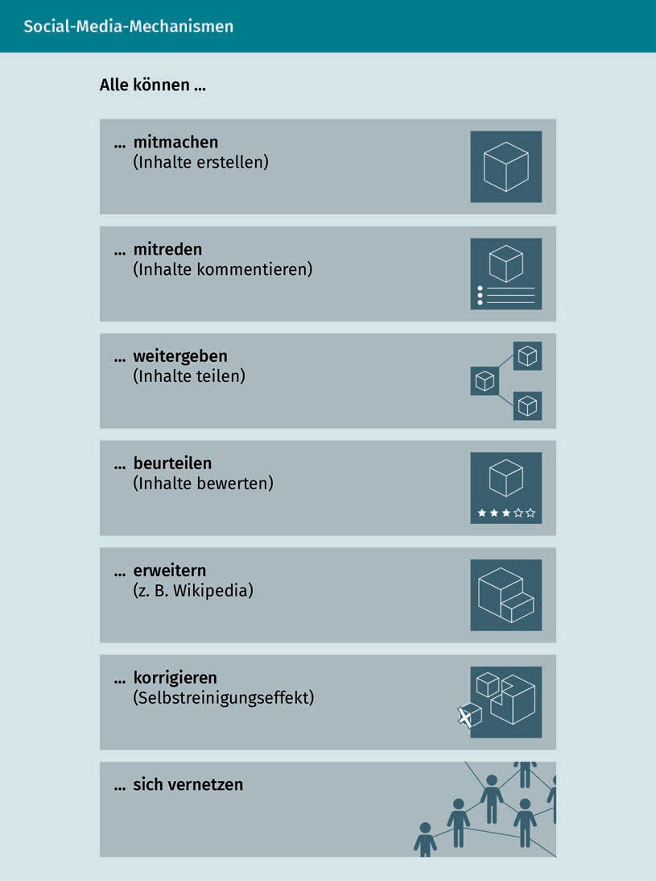

###### Social Media Marketing

Social Media Marketing is about using Social Media and Social Media mechanisms for commercial purposes. Companies and brands present themselves on Social Networks and try to use Social Media to achieve their own marketing goals (Grabs/Bannour/Vogl 2018, p. 27; Kreutzer 2021, p. 406f.).

Social Media and mobile

However, users of Social Media are not per se oriented toward receiving advertising messages. For most, the focus is on private benefits, be it networking with friends on Facebook or sending private messages (Kreutzer 2021, p. 407). Companies should therefore consider the following when integrating Social Media into the marketing mix: "Social Media should not be misunderstood as just another sales, advertising, or PR channel. Rather, Social Media open up interesting new opportunities to enter into dialog with stakeholders, to involve them in creative and evaluation processes, and to provide one-to-one services - and, of course, also, but not only, to generate enthusiasm for one's own offerings!" (ibid., p. 408). Communication should be geared toward pull and not push. We speak of pull communication when users themselves pull content and information from the Internet. On the part of the company, a user can be motivated to make such an active demand, for example, by exposing them to interesting and relevant content. Push communication is when advertising is "pushed" onto the user, as is the case with Advertising Banners (ibid., p. 116). In Social Media, the latter does not work. Users want entertainment, exchange, interesting content, and stories about products and companies. The interests, wishes, and needs of the target group should be the focus (Pein 2020, p. 309).

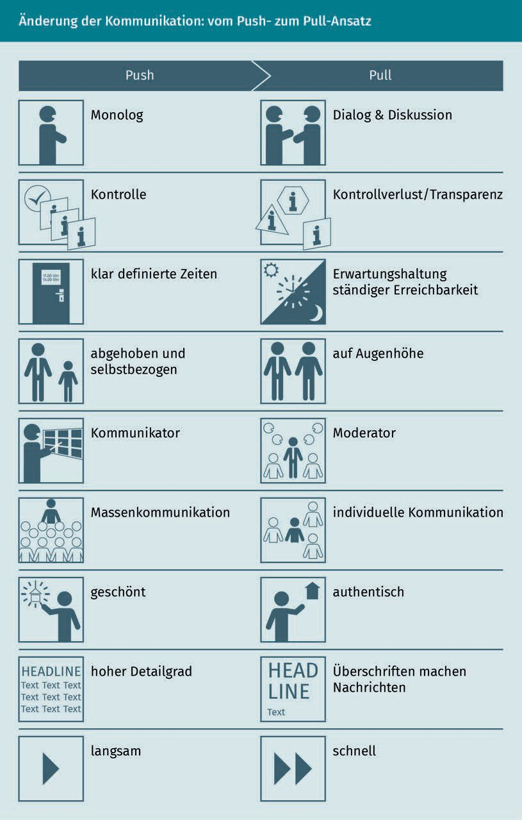

Social Media and mobile

The dialogic principle behind the pull approach in Social Media entails a possible loss of control. Users can express their opinions at any time and often do so with a high degree of dynamism, especially when it comes to negative comments in the form of a shitstorm. Moderating skills are needed here. In contrast to push marketing forms of communication, communication in Social Media should be as authentic as possible and not glossed over. Users want communication at eye level and an individual approach. The expectation of constant accessibility means that Social Media is highly dynamic and fast; users in Social Media are used to receiving responses quickly and expect the same from companies. In order to be noticed among the high volume of Social Media posts, it is important, in addition to providing appropriate and professionally prepared multimedia content, to have concise and attention-grabbing headlines.

#### Social Media channels

In addition to Social Networks, Social Media also includes media sharing platforms, messenger services, Blogs, online forums, and online communities (Kreutzer 2021, p. 406). Kreutzer (2018, p. 7f.) describes these categories of Social Media as application examples that can be assigned to superordinate utility classes. These utility classes are communication, cooperation, and content sharing. Communication includes Blogs, Microblogs (Twitter), messenger services, or Social Networks such as Facebook or Pinterest. Cooperation focuses on the collaboration of users. This includes, for example, the creation and maintenance of Wikis. Content sharing means sharing content via corresponding Social Media platforms such as SlideShare or YouTube.

Shitstorm

The term stands for public and negative criticism of companies or individuals via Social Media.

Blogs

A Blog or weblog is a journal or diary on private or professional topics, usually publicly available on a website.

Microblog

A Microblog is an application in which users can write short text messages. The permitted message length is usually predefined.

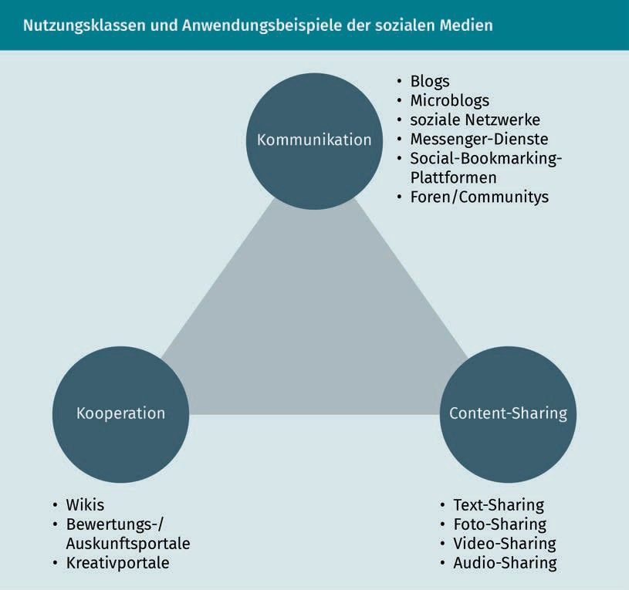

Social Media channels are the platforms that can be assigned to the respective examples of use. In this context, it is important to mention that the transitions between the various Social Media are ﬂuid and assignment is often not entirely clear-cut (Kreutzer 2018, p. 8). YouTube, for example, is primarily a video-sharing platform, but at the same time, it is also a social network, as users can exchange views about the videos via comments. In addition, YouTube has also established itself as a search engine (Babka 2016, p. 7). The following list of Social Media channels is based on Babka's suggestion, and makes a rough categorization for the sake of clarity.

Social Media and mobile

|  |  |  |
| --- | --- | --- |
| Social Media channels and their characteristics | | |
| Social Media channel | Category | Features |
| Facebook | Social network | Facebook allows users to create their own proﬁle and connect with family, friends, and colleagues. Photos and videos can be uploaded. Companies can create their own company page and use it to contact (potential) customers. |
| Twitter | Microblog | As a Microblogging service, Twitter allows users to post texts of up to 280 characters.  In addition, photos and videos can be "tweeted". Anyone can publicly participate in discussions. |
| YouTube | Video Sharing | YouTube is all about videos. Anyone can upload their own videos and make them available publicly or to a deﬁned user group. Videos can be shared, given a thumbs-up or thumbs-down, and commented on. |
| Instagram | Social Network | Instagram is geared toward visual storytelling. Users can share images or videos with their network and use filters to edit the images. |
| Pinterest | Social Network | Pinterest works like a pinboard. Images are pinned to a pinboard and shared with others. There is a lot of visual and creative content on Pinterest, such as recipes or decorations. |
| Flickr | Photo Sharing | Users can upload photos for sharing and archiving. |

|  |  |  |
| --- | --- | --- |
| Social Media channel | Category | Features |
| WhatsApp, Threema, Signal, and Co. | Messenger services | WhatsApp, Threema, Signal, etc. are apps that enable people to engage in one-on-one and group communications. |
| SlideShare | Content Sharing | This is a platform for sharing presentations. One can also follow other users. |
| XING | Social Network | XING is a social network for professional exchange with colleagues and business partners. |
| LinkedIn | Social Network | This is an international Social Network for professional exchange. |
| Spotify | Audio Sharing | Spotify is a music streaming platform and Social Network at the same time, as music lists can be shared and music listened to can be displayed on other Social Networks. |
| Tripadvisor | Evaluation Portal | On Tripadvisor, the user becomes a travel guide by rating hotels, restaurants, activities, etc. from his or her travel destination, thus providing orientation for other users. |
| Wikipedia | Wiki | Wikipedia is based on shared knowledge and functions as an online encyclopedia. Every user can post knowledge and edit content. The contributions are regularly reviewed by administrators and users. |
| Vimeo | Video sharing | Vimeo is comparable to YouTube, but the target group is primarily made up of filmmakers and video producers. |

With the help of such a categorization, it is possible to assess which channels are relevant for the marketing mix in Social Media Marketing. If it is primarily business contacts that are to be reached and not so much end consumers, channels such as XING

Social Media and mobile

or LinkedIn are relevant. A company with strong visual language should not ignore Instagram. In order to not only ﬁnd the right channels with the right target group, but also to address the target group appropriately, it is important to consider the content orientation or tonality of the respective Social Media. Speaking the language of the channels means speaking the language of the users.

Twitter and Snapchat are both very moment-focused platforms, which should be reflected in the language. TikTok uses moments of surprise. Twitch is a live-streaming video portal with a focus on gaming. On Facebook, people enter into a dialog via a commitment to a brand or a product. Instagram and Pinterest thrive on good visual storytelling and strong imagery. XING and LinkedIn are all about the job, whereas YouTube has established itself as a tutorial and video message channel. Tumblr is a Blog platform for users who like to delve deeper into topics (Kreutzer 2021, p. 427f.).

#### Responsive Design and mobile websites

The expression "Mobile First " is on everyone's lips and refers to the fact that a large proportion of users access content via mobile devices and that Web Design, communication, and marketing should be geared toward this. Many Social Media platforms consistently implement this by also providing an app for their use or are even exclusively operable via the app. Nevertheless, Mobile First also applies to websites, due to both the increase in mobile usage by users as well as the emergence of a new era in 2018. In that

Indexing This refers to the inclusion of a website in the database of the search engine. When a user makes a search query, a search engine does not search the Internet but its own index.

Mobile Web This refers to Internet use via mobile devices, regardless of the type of connection.

Mobile data This term refers to the provision of an Internet connection on a mobile device. This includes connections via WLAN, UTMS, GPRS,

or LTE.

Social Web The Social Web (Participatory Web) is a sub-area of Web 2.0 with a focus on relationships and communication.

year, Google changed its criteria for indexing websites. Until 2018, the desktop version of a URL was considered the main ranking factor, but since then, the mobile version has dominated indexing criteria (Lammenett 2019, p. 223f.). Since March 2021, Google has even applied Mobile Only, which means that desktop content has not been indexed or ranked at all since then. In other words: without optimization for mobile devices, there is no website trafﬁc via Google (Tabellion 2020).

###### Developments on the Internet

The Internet is subject to constant change and a high degree of dynamism. Today, the Mobile Internet or Mobile Web is taken for granted. This refers to Internet use via mobile devices such as smartphones or tablets, regardless of whether the user relies on WLAN or mobile data for the connection (Onlinemarketing Praxis o. J.). The first milestone for the Mobile Web was the introduction of the iPhone in 2007, which started the triumphant advance of smartphones (Bühler et al. 2017b, p. 2f.; Rieber 2017, p. 4). With the development from the "read-only web to the Participatory Web" (Bühler et al. 2017b, p. 4), the so-called Social Web emerged as a subsection of Web 2.0 with a focus on social structures and relationships, interaction, and communication (ibid., p. 4; Ryte Wiki n.d.).

The Participatory Web also includes Content Management Systems like Joomla! or Blog software such as WordPress, which enable users to create a website or Blog without programming skills. Whereas Web 1.0, the predecessor of Web 2.0, consisted primarily of static websites without interactive content that experts with programming skills could access, Web 2.0 promotes networking among non-experts who can create and link their own content in Web 2.0 environments such as Content Management Systems or Blogs (Chang 2018). Such tools have the advantage that they already provide ready-made (responsive) templates that can be adapted to individual wishes and needs (Bühler et al. 2017b, p. 4).

###### Mobile websites

For many users today, the smartphone is the central point of access to the Internet. Even though apps and Social Networks dominate usage, the importance of websites should not be underestimated. After all, searches via search engines still largely take place via the browser. A mobile optimized website, a mobile-optimized online store, and discoverability via search engines are also essential in view of the competition. Users are quickly frustrated if a website is not optimized for mobile access (Rieber 2017, p. 47f.).

The multitude of mobile devices, such as smartphones and tablets in their various forms, poses a challenge here, as the website should be displayed equally well, legibly, and visually appealing on every device (Bühler et al. 2017b, p. 3). One solution to this is Responsive Web Design . Responsive websites are designed by the server for all end devices equally.

Social Media and mobile

However, the layout and content are adapted to the respective conditions of the end device. The term "responsive" is derived from the English word response. The website reacts or responds to the technological conditions and adapts to them, which can affect, for example, the screen size or touchscreen use (ibid.; Rieber 2017, p. 49).

In contrast to Responsive Web Design, Adaptive Web Design creates a separate website for mobile use. Subdomains of adaptive websites often have the structure m.website.de. In the case of dynamic playout, an automated decision is made depending on the browser and end device as to whether the user receives the mobile or the classic website. However, the user is usually free to change the view via a link (Rieber 2017, p. 49), which will become less relevant with regard to Mobile First or Mobile Only. While in responsive design the website behaves ﬂexibly and the elements on the page are scaled, in adaptive design a separate display is developed for each display size. As a consequence, a separate variant is required for each device. While responsive design focuses on content and layout, adaptive design focuses on an optimized User Experience by adapting to the respective device (Herzberger 2016).

With Accelerated Mobile Pages (AMP), Google has developed a formatting language as part of an open-source project that enables users to call up content more quickly via their mobile device (Rieber 2017, p. 50f.). The focus here is on the loading speed of the page, which can be accelerated by AMP. The prerequisite is an already mobile optimized page, which becomes even faster and more readable through AMP (Patel n.d.).

#### Apps and messengers

App is the abbreviation for application and refers to a software program "that is used by a mobile device (e.g., a smartphone or tablet PC) and offers a variety of possible uses" (Kreutzer 2021, p. 4). In 2017, more than 94% of private Internet use took place via apps. Apps provide companies the opportunity to land on users' home screens and thus be closer to (potential) customers than is possible via traditional media (Rieber 2017, p. 54).

Apps can be further divided into native apps and web apps. Native apps must be installed on the mobile device, are therefore available on the home screen, and are tied to an operating system. Web apps are available via the browser and only require an Internet connection (Bühler et al. 2017b, p. 4). The common operating systems for native apps are Android and iOS. Hybrid apps are a fusion of native app and web app. Like native apps, hybrid apps are downloaded from the respective store and installed on the device, but they are platform-independent and thus not tied to any operating system. They

Responsive Web De- sign

This refers to a form of design-technical preparation of a website in which the layout and content ﬂexibly adapt to the respective end device.

Adaptive Web De- sign

Adaptive Web Design involves creating multiple versions of a website, with each device getting its own version.

Accelerated Mobile Pages

AMP is a project by Google with the aim of improving the loading speed of mobile sites via shortened HTML tags.

Homescreen

The home screen is the start screen of a mobile operating system.

It contains shortcuts to settings, notifications and apps.

are written with native code and supplemented with web-based elements at appropriate points. Hybrid apps use the advantages of native apps and web apps and are less expensive to develop than native apps (Reichardt 2017).

Websites and apps differ in terms of use in that websites are primarily used for ad hoc use and research, whereas apps are designed for recurring use. Possible uses include, e.g., checking the weather, ordering cabs, or watching shows (Rieber 2017,S. 55). From a commercial point of view, apps can be viewed from different perspectives (in the following, after Lammenett 2019, p. 465):

* Apps that stand alone and have their own purpose: These include games, language learning apps, or apps for scanning documents. The apps are offered for a fee or free of charge. In-app purchases are purchases made within an app, for example, to unlock special features or to advance more quickly in a game.
* Apps that support a business process: These include banking apps for account management or ordering products via the app. The app only generates a benefit in connection with the process.
* Apps that have spawned new Business Models and thus compete with other processes: One example is the app myTaxi, with which a novel model for cab orders was developed.

In addition to securing a place on users' home screens, apps offer other advantages. There are also many that are available offline and require an Internet connection only selectively, like when placing an order. The kind of Internet connection is irrelevant. The spread of mobile devices in society in combination with a ubiquitous Internet connection makes apps very attractive from a business perspective (Lammenett 2019, p. 466). However, it must be remembered that users have high expectations of apps. To ensure that they do not remove them from their devices a short time after installation, apps must offer real added value, be intuitive to use, and be suitable for use (Rieber 2017, p. 54). The selection of apps in both the Apple app store and the Android store is large and an alternative can be found quickly (Lammenett 2019, p. 466).

Much like the creation of a website, a native app is a complex, time-consuming, and often expensive process. To make the app available to as many users of the target group as possible, it must be developed for both Android and iOS. This requires extensive programming skills that are different for each operating system. In addition to the costs of app development, there are also costs for marketing, monitoring, and further development (Rieber 2017, p. 57; Lammenett 2019, p. 466).

Messenger apps include WhatsApp, Signal, Threema, Telegram, or Facebook Messenger, all of which use app technology. Services often provide a native app and a web app, with the latter often requiring the installation of the native app.

Social Media and mobile

Messenger services offer the option of sending text messages as well as text, image, video, and audio files. In addition, location information and contact data can be shared between individuals or in groups. People can network quickly and conveniently all over the world (Rieber 2017, p. 102; Kreutzer 2021, p. 4). A large number of messenger apps are available free of charge for this purpose.

The commercial use of messenger services is also becoming increasingly important. For example, a large number of companies on Facebook can already be reached via messenger, and (potential) customers can use the messenger function to express their concerns to the company. The challenge here is that they are subject to the same demands that users place on chatting with friends: immediate feedback and 24/7 availability. Since companies are often unable to provide such in-person replies, chatbots that can conduct part of the communication automatically and autonomously are increasingly being used. The Chinese app WeChat is often cited as a model for commercial use, and companies in Asia already use it to provide services such as customer service, hotel bookings, product purchases, and money transfers. Messengers have the fundamental potential to overtake hotlines, websites, and apps in terms of usage (Rieber 2017, p. 102f.).

#### QR codes and location-based services

Location-based services and QR codes are ways to elicit as much information about the user as possible in a spatial sense. They are presented here as examples and as representatives of other services, such as Beacons or NFC (Near-Field Communication).

###### QR codes

The term QR code stands for Quick Response Codes. These are two-dimensional graphics that can be scanned with the appropriate apps or just with the smartphone camera. The scan then calls up a website after the code has been decoded. With QR codes, it is easy to establish a link from a physical object, such as a business card, to digital content (Rieber 2017, p. 92).

Beacons

A Beacon is a transmitter or receiver based on Bluetooth technology.

NFC

This is the abbreviation for Near Field Communication.

This is a transmission standard for the contactless exchange of data.

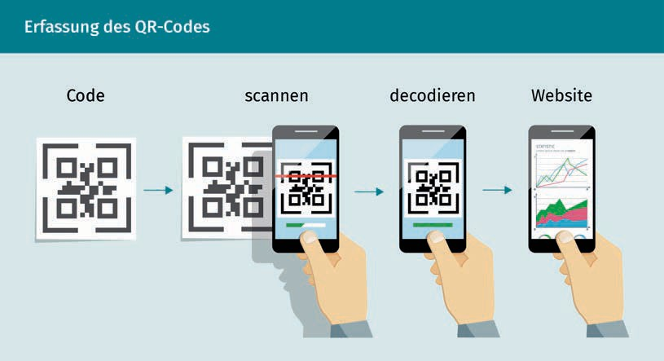

Point of Sale A Point of Sale is a place where a sale is completed.

Location-based

Marketing

This is a Mobile Only marketing strategy that takes the location of the customer into account.

Using a QR code, it is possible to refine the target group approach and thus get closer to the user and their needs. For example, a QR code can lead to a specific landing page that provides tailored content for all those who have scanned the QR code (Kreutzer 2021, p. 160). Social Networks also make use of comparable codes. Snapchat, for example, introduced the so-called Snapcode. The process is very similar to the QR code, allowing users to create their own code (Snapcode) and to connect with other users via a scan (Rieber 2017, p. 93). Whether it is more convenient for a user to access a website via the search engine, via the URL, or via the QR code is an individual decision. In principle, QR codes offer a good way to connect physical objects and digital content, e.g., at a point-of-sale (ibid.). QR codes can be easily generated by the user using so-called QR code writers, which are available free of charge online (Kreutzer 2021, p. 161).

###### Location-based services

"Location-based services are websites and apps that offer users services and information depending on their location, i.e., their current location" (Rieber 2017, p. 88). Location-based services fall under the umbrella term of Location-based Marketing. This is a special feature of Mobile Marketing that is not found in classic Online Marketing (ibid.). Location-based Marketing includes all those marketing measures that are intended to have a regional effect. The location of users can be determined via the GPS capability of mobile devices and taken into account in the measures (Lammenett 2019, p. 470).

In this context, it is important for the company to establish a space within which users are addressed. In Geofencing, an area is invisibly fenced off using a global positioning system (GPS) or RFID technology. When the user enters the area and has activated GPS, they are recorded by the Geofencing system (Pieper 2016). This way, location-based services, for example, can then be offered to the user.

Social Media and mobile

Example: The user moves into the defined radius of their favorite restaurant at lunchtime. They have downloaded the restaurant's own app and activated Push Messages. The restaurant now informs them that a special lunch offer is currently available for them as a regular customer.

Location-based services must be distinguished from Location-based Advertising. In the latter case, the user's location has an influence on the advertising they receive via smartphone (Rieber 2017, p. 88).

Location-based Marketing must also be distinguished from Proximity Marketing. Proximity Marketing includes Beacons, to name just one example. A Beacon uses Bluetooth technology to determine the exact location of a user, such as the aisle of the store they are in (ibid., p. 91). Proximity Marketing is much more granular than Location-based Marketing. Regional coverage is provided by the latter whereas store-level coverage is provided by the former. Proximity Marketing is considered to be a more in-depth form of Location-based Marketing and, in addition to Beacons, relies on technologies such as Near Field Communication (NFC) and WLAN (Pieper 2016).

#### Mobile First and Mobile Only

Mobile Web use is increasing, which is partly due to access to mobile devices and technology. Mobile devices are becoming increasingly powerful, their prices are falling, and the technical infrastructure is constantly improving. Mobile First is now standard in many companies (Kreutzer 2021, p. 9). It is precisely this user behavior and the technological developments that have led to Google using the mobile version of a website as the main indication for its evaluation since 2018. Mobile optimization of websites, be it as a responsive or adaptive variant, is therefore mandatory to have a relevant place on Google's results page. Mobile Web optimization should therefore be a priority. Desktop is not completely excluded from Mobile First but depends on the mobile version of the page in the evaluation (Lammenett 2019, p. 223f.). From a design perspective, this means that the design of the mobile version(s) should be started in order to adapt them to larger screens and other operating concepts in the next step. The increase in mobile usage applies independently of the search engine. Other search engines usually adopt Google's developments. As a result, this phenomenon is not limited to Google, however, in Germany, Google has a market share of 98% of mobile search (NetMarketShare 2020) and is, therefore, trend-setting in many respects.

In March 2021, Google introduced the Mobile Only index. This means that all content that is to be indexed by Google must be integrated into the mobile version, as desktop content is no longer taken into account. The introduction of the Mobile Only index affects all areas of a website, i.e., content, structure, and technology. On the content level, for example, it is essential that the content of the

GPS

The exact position of a person or a vehicle, for example, is determined by satellite.

Geofencing

It denotes a geolocated boundary, whose crossing triggers an action.

Push Messages These are messages on the mobile device that are triggered by an app and displayed directly on the home screen.

Proximity Marketing It is also referred to as Bluetooth marketing. It means the provision of information at specially marked locations.

website versions match. There can be traffic losses if mobile and desktop versions have different content (Tabellion 2020). Large players such as Zalando picked up on this development well before the introduction of the Mobile Only index. The mobile share of Zalando's total online sales was between 60% and 70% in 2017. Zalando relies on a combination of mobile store and app, with 70 to 80% of mobile usage taking place via the app (Heinemann 2017).

A Mobile First strategy, which includes Voice First strategies, should already consider the processing of spoken language in mobile communication, due to the popularity of voice assistants such as Alexa, Siri, and Google Assistant. Future-thinking marketing managers are already mentioning Voice Only Advertising (Kreutzer/Vousoghi 2020, p. 1f.).

Summary

Social and mobile go well together. Many social networks are also or primarily designed for mobile use, such as Instagram. In addition, mobile Internet use is increasing as a result of the improved performance of mobile devices, falling costs, and improved technical infrastructure. Social media are a result of the socio-technical development of the Internet into Web 2.0, the so-called Participatory Web. Users are no longer just consumers, but also producers of content and share texts, images, videos, and more with their community on social media.

If social media is used commercially (social media marketing), awareness of the nature and tonality of the channels is needed on the part of the company in order to speak the language of the (potential) customers and to pick up on their wishes and needs. After all, the focus of social media is on relationships. Mobile Internet usage not only affects social media, but also websites, web stores, etc. Mobile optimization of the online presence is therefore essential, whether as a responsive or adaptive solution.

In mobile marketing, apps, messengers, QR codes, and location-based services (among many others) also play an important role. They can be used to create a proximity to the user in terms of content and/or location that is not possible via other marketing formats. The fact that mobile use is becoming increasingly important is confirmed by developments such as Mobile First and Mobile Only, which involve not only usage but also technological changes, for example at Google.



# Lesson 6

## Selected technologies

##### LEARNING OBJECTIVES

After completing this unit, you will know ...

... how to explain the most important technologies from today's perspective, which will significantly shape our future in all areas of life.

... how to recognize applications and apps in which these technologies are used, often in a way that is not noticed by the user.

... how to demonstrate current usage scenarios in private and business environments.

... how you assess the potential of these technologies, especially in their interaction.

... how you consciously deal with the risks and challenges of these technologies.

DL-D-DLBDS01-L06

### Selected technologies

#### Introduction

Many technologies already shape our lives and work today. We often use them every day without being aware of them. This lesson introduces current technologies and provides important information on how they work and where they are used. This knowledge is fundamental for recognizing future opportunities and risks. It is easy to underestimate or overestimate technologies.

For companies, such a misjudgement can have far-reaching consequences, for example if competitors vanish or new competitors with innovative Business Models enter the market. The technologies presented here do not stand alone. Their combination and rapid further development make a large number of new and intelligent products and services possible (e.g., Thelen/Schorn 2020, p. 42).

#### Cloud Computing

Cloud Computing This means that IT infrastructure and IT services are provided dynamically and on demand via the Internet.

In everyday life, we often use a cloud (Smart Business Cloud 2019), for example, when we take photos or videos with our smartphone, upload them to our DropBox, and share them with friends. When we back up our study work in the OneDrive folder, we are using a cloud, or even when we play music or videos via providers such as Spotify or Netﬂix. The use of Cloud Computing has also become indispensable in many companies (BITKOM/KPMG 2020). Cloud Computing means that resources such as servers, storage, databases, and software are made available via the Internet and can be conveniently used by various users (e.g., Mell/Grance 2011, p. 2; Hentschel/Leyh 2018, p. 3f.).

The term "cloud" is symbolic here. Behind Cloud Computing is a data center in which all the necessary resources and software applications are provided. A cloud can be of private, public, or hybrid nature (Hentschel/Leyh 2018, p. 7f.). From the point of view of a company, a public cloud is offered by an external service provider, while a private cloud environment is operated by the company itself. A hybrid cloud refers to a combined form. Each of these forms has its opportunities and risks, which must be considered when introducing cloud services (Brassel/Gadatsch 2020).

###### Use of Cloud Computing in companies

According to the "Cloud Monitor 2020" study, more than three-quarters of all companies used Cloud Computing services in 2019 (BITKOM/KPMG 2020). The users surveyed saw the greatest advantage in the Digitalization of internal company processes.

Selected technologies

The use of cloud services offers many opportunities (Hentschel/Leyh 2018, p. 14 et seq.). Companies can ﬂexibly deal with an increasing or fluctuating demand for computing power and storage space. If the software is used from the cloud, it no longer has to be installed and operated in the company. There are no investment costs for hardware and software. As a rule, only what is actually used is paid for. Extremely ﬂexible and scalable IT landscapes can be built on this basis. Cloud Computing is therefore of interest not only to large companies, but also in particular to small and micro enterprises (Hentschel/Leyh/Egner 2020, p. 961).

The possibility of using services from the cloud can easily lead to departments and users selecting solutions without the involvement of the IT departments and to the creation of so-called shadow IT (Kopper/Westner/Strahringer 2017). This brings opportunities, but also risks. Together with IT, it should be clarified whether all necessary requirements regarding compliance and IT security are being met. Protection against failure is also essential, especially for mission-critical applications.

###### Everything as a Service (XaaS)

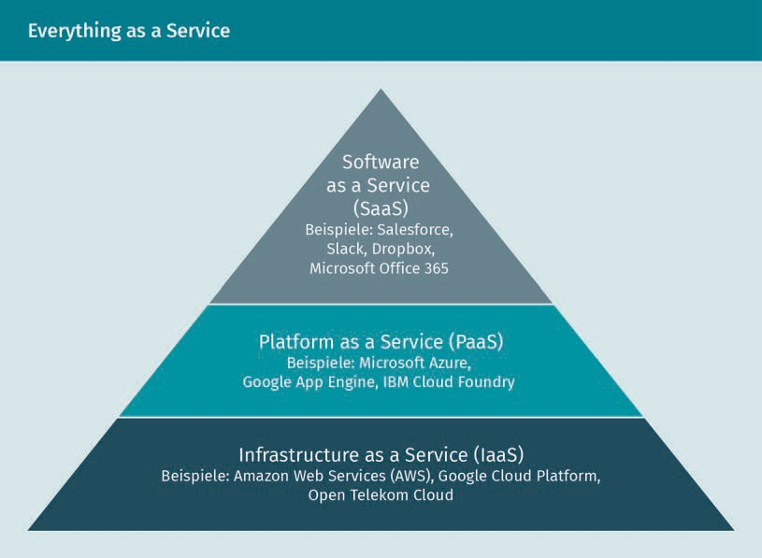Everything as a Service describes the approach of obtaining various types of services from the cloud (Hentschel/Leyh 2018, p. 9).

Hybrid Cloud

A hybrid cloud combines a private cloud with one or more public cloud services. This form is characterized by its high flexibility: the respective form is selected according to need and competitive advantage.

Shadow IT

Shadow IT refers to IT applications that are used in departments without the approval of the IT department. The problem is that these applications have not been tested with regard to the security requirements that apply in the company.

The three basic types of services are (Hentschel/Leyh 2018, p. 9et seq.; Sehgal/ Bhatt 2018, p. 2):

* Infrastructure as a Service (IaaS): IaaS provides the basic physical IT infrastructure, such as storage space and computing capacity. Depending on demand, the required storage space can be expanded or reduced, for example.
* Platform as a Service (PaaS): PaaS offers IT services on which proprietary software can be developed, tested, and executed. Services such as Machine Learning or data analysis are also offered as PaaS.
* Software as a Service (SaaS): SaaS describes a licensing and sales model in which entire software applications can be used as a service over the Internet. Typical examples of SaaS are CRM systems, i.e., systems for customer relationship management. The use of these services is very convenient because the provider maintains and operates the software.

#### Big Data/Data Analytics

We generate data traces everywhere and at all times, e.g., in Social Media, when querying search engines, or when evaluating products (Meier 2019, p. 886). Our smartphones track where we are physically and when we are present. In the meantime, items such as household appliances and machines are also generating data.

Big Data Big Data systems use state-of-the-art computer architectures and specialized software to quickly process and analyze large amounts of data.

Data Analytics It examines existing data for patterns, errors, and peculiarities.

For example, statistical procedures or forecast models are used.

The term Big Data refers to data volumes that are too large or too complex to process using conventional methods and technologies such as classic databases or reporting software. To make Big Data usable, powerful IT solutions and analysis capabilities are required. Big Data is therefore often used in conjunction with the term Data Analytics. The goal is to gain decision-relevant insights from the data. This involves examining data from the past for patterns, correlations, and causalities in order to draw conclusions for the future (Meier 2019, p. 886; Wolan 2020, p. 194).

###### The four Vs

The word "Big" in the term Big Data refers to the so-called four Vs: Volume, Velocity, Variety, and Veracity. This is understood to mean the following (Dorschel 2015, p. 6et seq.):

* Volume: The volume refers to the amount of new data produced every day. From 2018 to 2025, the volume of data generated annually worldwide is expected to increase from 33 to 175 zettabytes (Reinsel/Gantz/Rydning 2018).

Selected technologies

As the volume of data has rapidly increased over the last few years, new methods and techniques had to be developed and constantly refined in order to process and analyze it efficiently.

* + Velocity: Velocity refers not only to the speed at which data is produced, such as by sensors in Internet-of-Things systems but also to the speed at which that data must be processed. Often, this has to be done in real time, for example, in autonomous cars.
  + Variety: Variety refers to the various data sources, such as Social Media, financial transactions, IoT, surveillance cameras, telescopes into space, genome sequences, and more. It also refers to the diversity of data types. The latter includes both structured data, e.g., from application systems used in companies such as ERP systems, and unstructured data such as text files, images, videos, or audio files.
  + Veracity: Veracity refers to the accuracy, completeness, and reliability of the data content. One example where this must be considered is the use of Social Media data. Posts by users contain subjective assessments, for example.

###### Big Data and Data Analytics examples

Companies in all industries are using Big Data technologies (Wolan 2020, p. 195). This is illustrated by two examples. There are also interesting application scenarios in healthcare or in the detection of credit card or insurance fraud.

Big Data in Online Retail

Individual and relevant product recommendations, the reduction of the returns rate, and planning reliability for logistics are topics for which online retailers use Big Data solutions (BITKOM 2015, p. 101 et seq.). A lot of information is collected about the customer for this purpose, such as what products the customer searched for, purchased, and returned. Based on this data, measures are derived, such as supporting size selections, inserting a marketing message, or offering a discount code.

ThyssenKrupp Elevator AG - Intelligent elevators

Who hasn't worried about getting stuck in an elevator? Thyssen Krupp uses Big Data in combination with cloud and IoT solutions to predictively maintain elevators (BITKOM 2015, p. 31f.). For this purpose, sensors in more than one million elevators permanently collect data. Hundreds of pieces of status data are collected from each elevator every minute. Connected to a cloud, this data is analyzed centrally in real time. The aim is to identify when a repair is necessary before a breakdown occurs. Technicians can intervene directly and initiate the necessary measures. This preventive action increases elevator uptime and safety.

#### AI/Machine Learning

Artificial Intelligence (AI) enables machines to see, hear, walk, ﬂy, and learn (see Marr/Ward 2019, p. 1). Some consider AI as the greatest threat to humanity, others as the possibility with which we can solve all problems and challenges.

###### What is meant by AI?

AI

Artificial Intelli- gence (AI) is the generic term for applications in which computers perform tasks such as learning, judgment, and problem solving that require intelligence similar to that of humans.

Algorithms An algorithm describes a procedure to solve a certain task. Using single steps, an input becomes an output.

Machine Learning With the help of Machine Learning, a computer can continuously generate knowledge.

There are many different deﬁnitions for the term AI. This is partly because the term intelligence alone is difficult to deﬁne, and partly because there is little reason to believe that machine intelligence has much in common with human intelligence (Kaplan 2016, p. 1).

AI refers to the ability of computer systems or machines to exhibit intelligent behavior that enables them to act and learn autonomously (Marr/Ward 2019, p. 3f.). In its simplest form, AI applies certain computational rules (called algorithms) to data and then makes decisions or predicts outcomes. For simple tasks, such computational rules can be clearly deﬁned. However, if tasks become more complex or if humans have difficulty explaining the rules behind them, it becomes difficult to implement them in an algorithm. This is where the topic of Machine Learning comes into play.

###### Machine Learning

Machine Learning (ML) means that a computer system is trained with examples and learns to recognize patterns and regularities (e.g., Specht 2018, p. 278). For example, a computer can be trained to recognize from a set of photos those in which a dog is depicted. It is possible to generalize and apply this knowledge to new situations, e.g., an unknown set of images. However, if the computer is to recognize cats instead of dogs, new training is required. This is why we speak here of weak AI rather than strong AI, which develops awareness.

Important approaches in Machine Learning are so-called neural networks, which imitate the functioning of the brain, and Deep Learning as a special form. An artificial neural network consists of many nodes (Russell/Norvig 2016, p. 727f.) and is usually built up in several layers. The input layer takes in information. These nodes pass on the information in a modiﬁed manner, if necessary, namely to the nodes of one or more intermediate layers (hidden layer) up to an output layer (output layer). If the neural network is trained, links between the nodes are strengthened and new connections are created.

Selected technologies

###### The development of AI

AI is not a new technology. Initial developments date back to the 1950s (Marr/Ward 2019, p. 3). Groundbreaking progress and deep disappointment have alternated in the history of AI. Today, we encounter AI in many places in our everyday lives (Kreutzer/Sirrenberg 2019, p. 1). We use translation aids on the Internet such as Google Translate or DeepL, we communicate with Alexa or Siri, and we authenticate ourselves by using our face or our fingerprint. AI is also behind robots, self-driving cars, or ﬂying cabs. In recent years, there has been enormous progress in Machine Learning, for which three factors in particular have been decisive (Cornelius 2019, p. 22et seq.; Marr/Ward 2019, p. 5):

* + Improved algorithms: In particular, there have been major advances in Machine Learning through Deep Learning.
  + Available data sets: In today's era of Big Data, large amounts of data are available which AI-based systems can be trained on.
  + Computing power: The cost of computing power has fallen continuously. In addition, processors have been designed specifically for AI applications, such as Google's Tensor Processing Units (TPUs) (Google o. J.). At the same time, Cloud Computing offers the possibility to store large amounts of data and analyze them in real time.

###### Application areas of AI and Machine Learning

AI and Machine Learning have great potential and are already being used by companies in various application scenarios. Deferred studies confirm the strategic importance of AI (Deloitte 2020, p. 7; IUBH Internationale Hochschule 2021, p. 11). Marr and Ward (2019, p. 6) emphasize the following three areas:

* + New way of interacting with the customer,
  + Offering intelligent products and services, as well as
  + Improvement and automation of business processes.

Additionally, it is important to note that AI often interacts with the other technologies discussed in this lesson, e.g., to enable Smart Services to be created or robots to communicate with their environment.

#### Internet of Things

Internet-of-Things systems (IoT) connect the physical world with the Internet. Basically, IoT works in such a way that objects independently provide and receive data via interfaces and in turn act on their environment (Pistorius 2020, p. 9; Milenkovic/Milan 2020, p. 1).

Weak AI

It describes computer systems that are trained for specific applications.

Strong AI

Like a human being, it can adapt ﬂexibly to new tasks. Today, there is still no AI system that falls into this category.

Deep Learning

This is a subset of Machine Learning techniques and is used, for example, in automatic speech recognition and text and image processing.

IoT The Internet of Things extends the classic Internet by linking physical objects with the virtual world.

Sensor A sensor is a technical component via which data such as temperature, light, or air quality are recorded. Sensors are the eyes

and ears of the objects that are networked in the IoT.

###### IoT in everyday life

We already encounter IoT-based devices in many places in our everyday lives, for example in the form of a smartwatch or a fitness trackers. The latter monitors and tracks the wearer's physical activity (Davenport/Lucker 2015). A "simple" wrist band continuously collects data via sensors. These are evaluated and analyzed to determine, for example, whether a recorded move is an athletic activity or just a short walk to get coffee at the office. Motion sensors provide data to determine the number of steps, which in turn is the basis for determining the distance traveled and calories burned. Optical sensors measure the pulse. The data is synchronized by the fitness tracker with the smartphone via Bluetooth. This makes the fitness tracker part of the IoT. From the smartphone, the data is forwarded to the fitness tracker provider in the cloud. There, it is being analyzed centrally to provide the user with exciting insights into their exercise activities. These insights are then presented in an app. Users can share and compare performance data with other athletes via platforms. At this point, data security and the protection of privacy become more important (Bauer/Eickmeier/Eckard 2018, p. 5f.). This data could also be used by health insurance companies (Campillo-Lundbeck 2016), for example, to offer a more favorable rate or a bonus to insured persons who exercise a lot. But the reverse is also conceivable.

Other examples in the private sphere include smart home applications that, for instance, control the room temperature, select the appropriate light, notify residents in the event of an alarm, or automatically lock the front door in the evening (IuG - Team Internet of Things 2021b). Household appliances such as washing machines and refrigerators are now also "smart." Many IoT systems can also be found in modern cars, through which they are networked with their environment (e.g., IuG - Team Internet of Things 2021a). Their number and use will continue to increase with the development of autonomous driving.

###### IoT in the enterprise

There are many different application scenarios for the IoT in companies. A study conducted by IDG Research with several partner companies regularly surveys companies on the most important areas of application. The top topics in 2020 were quality control, logistics, Industry 4.0, and topics such as networked production, Smart Connected Products, and Predictive Maintenance (IDG Research Services 2020; Mauerer 2021). The focus here is on the optimization of existing processes and products and the associated cost reductions. The study found the potential for developing innovative Business Models and services has not been fully realized (IDG Research Services 2020, p. 16f.). In addition to the manufacturing industry, many other sectors are using IoT applications, e.g., agriculture (Bayer 2020) and healthcare (Bogdan 2018, pp. 70-87).

Selected technologies

###### Challenges for the deployment of IoT solutions

Companies in particular see the challenges for the use of IoT solutions in data protection and security (IDG Research Services 2020, p. 19). For example, it is necessary to be protected against hacker attacks, industrial espionage, or legal concerns. In order to successfully implement IoT solutions, further digital technologies are required in addition to hardware, such as sensors (ibid., p. 23). Cloud Computing platforms offer a scalable infrastructure. IoT devices, data, and applications can be accessed via APIs. Big Data and Data Analytics are the tools to analyze the large amounts of data collected. In combination with Artificial Intelligence and Machine Learning, further applications are conceivable.

#### APIs

As users of digital services, we now take it for granted that different applications are seamlessly connected. On a regular basis, we upload photos from Instagram to Facebook, view a map of nearby stores in a shopping app with Google Maps, or log into an online store directly with a Facebook account. These connections are enabled by open APIs (Siriwardena 2020, p. 1; Kühne 2020). The following figure shows this networking using Uber as an example (Brown 2019; Hoffmeister 2018).

Smart Connected Products

Examples include autonomous cars and freight cars that collect and evaluate information about transport conditions.

Predictive Maintenance

One example of Predictive Maintenance is the use of condition data from machines to identify when they need to be serviced.

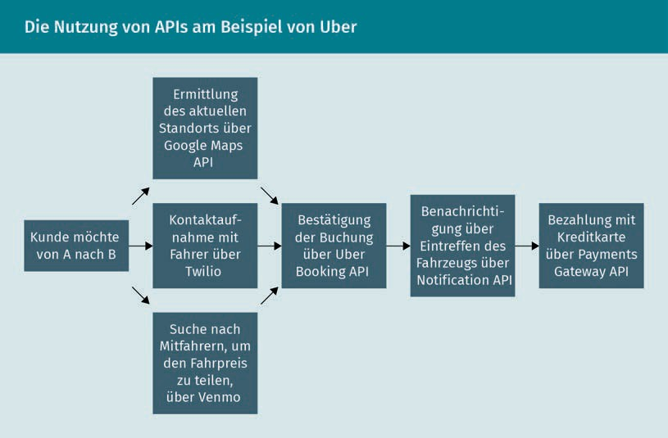

###### What are APIs?

Application Pro- gramming Interface An Application Pro- gramming Interface, API, is a software intermediary that allows other applications or services to send them requests and receive responses to those requests.

API stands for Application Programming Interface. Data can be exchanged between different software applications via such an interface (Luber/Augsten 2017). An API can be thought of as similar to a user interface, except that the API is not designed for a human user, but for another piece of software (Berlind 2015a).

APIs have a long tradition in computer science (Spichale 2019, pp. 19-24). As early as 1948, the concept of reusing operations within software programs was described. A number of APIs have been published since 1968, including those used to connect e-commerce sites (e.g., via the eBay API) and to exchange data between business applications (e.g., Salesforce). Many more APIs were added in the context of Social Media. Today, many software vendors provide open APIs. The special thing about APIs is that the functions are deﬁned independently of the underlying implementation and the respective technologies.

###### API Economy

Companies such as Expedia, Salesforce, or eBay generate a large share of their revenue via APIs (Siriwardena 2020, p. 1). Companies can be providers of APIs on the one hand and their users on the other (Moilanen et al. 2019, p. 23; Spichale 2019,

S. 30). This is referred to as the API economy: Business Models and channels are based on secure access to functionalities and the exchange of data via APIs (Pettey 2016).

By using open APIs, companies can quickly offer digital products and services, as they save themselves the trouble of developing certain functionalities (such as payment by credit card) or building up certain data (e.g., geographical data) in-house. At the same time, they can focus on functionalities on the basis of which they differentiate themselves from the competition and build new Business Models (Taulli 2020; Spichale 2019, p. 30f.; Berlind 2015b). However, a Business Model based mainly on open APIs comes with a high risk (Reselman 2018). APIs can, for example, be shut down or reduced in functionality without prior notice.

#### Smart Services

With the help of Digitalization and the technologies presented in this lesson, "smart" products and services are being created.

Selected technologies

###### What do we mean by Smart Services?

Smart Services link products, processes, and services in an innovative way (Senderek et al. 2019, p. 4; Honné/Moll 2016). The following figure shows the underlying relationships.

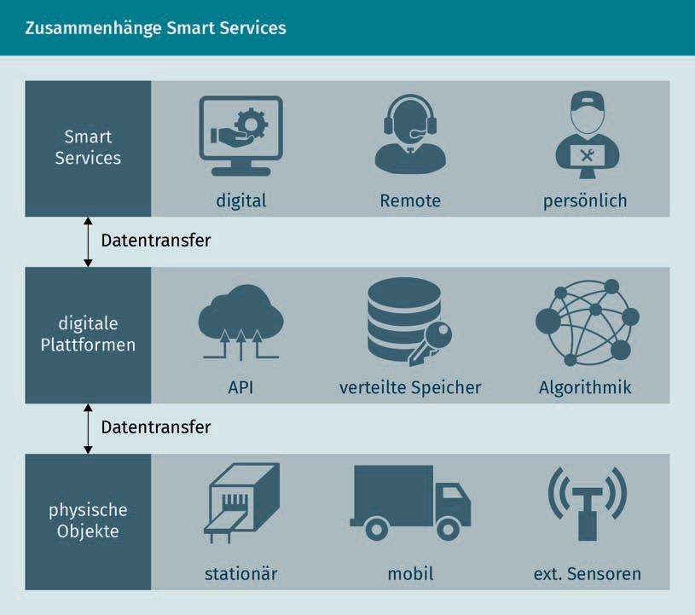

Technologies such as the Internet of Things are used by physical objects to collect data about themselves and their environment. This can be, for example, temperature readings collected by sensors or the positions of a fleet of delivery vehicles.

This data is then sent to digital, cloud-based platforms. The data can be encrypted or anonymized, for example. It is stored on these data platforms and intelligently analyzed and processed with the help of Data Analytics. This processed real-time data forms the basis for Smart Services. APIs can also be used to integrate further data or additional functionalities from third-party providers.

Product-Service Systems  
A Product-Service

System (PSS) is a marketable combination of products and services. It is therefore also referred to as a "hybrid bundle".

Business Model A company's Business Model essentially answers the questions of what exactly the company's offering is, who its target customers are, and what benefits the offering provides to them, as well as how this offering generates revenues.

Smart Services are designed and made available on this basis. Strabel et al. (2019, p. 505f.) distinguish between Smart Services in the narrow sense, where the service is provided purely digitally (e.g., an app to monitor the temperature), and Smart Services in the broader sense, where smart products and services are integrated. These integrated smart products and services are also referred to as smart Product-Service Systems.

###### New Business Models with Smart Services

Smart Services represent a major opportunity for traditional industrial companies to expand their range of physical products by offering suitable, individualized services (Freitag/Korb/Sommer 2019, p. 6; Arbeitskreis Smart Service Welt 2014, p. 5). This makes it possible to create unique selling points and offer customers holistic solutions. Companies are thus conceptualizing so-called data-driven Business Models.

This also makes it possible to offer product functionality as a service (Manhart 2018). One example of this is the British aircraft turbine manufacturer Rolls-Royce, which sells flight hours rather than engines under its "power by the hour" Business Model (Smith-Gillespie et al. 2019). This means that the customer is only billed for the flight hours. Rolls-Royce takes care of service and maintenance itself. Another example is "Print as a Service" (Manhart 2018). In analogy to the Rolls-Royce example, the print jobs that are carried out are now billed. This is particularly common in the field of 3D printing.

#### Robotics

We know robots from various movies and series, such as C-3PO and R2-D2 from "Star Wars" or the talking car K.I.T.T. from the show "Knight Rider". In movies, the cooperation between humans and robots is often fascinating, yet frightening at times. But robots have also become indispensable in our everyday lives and in various industries, especially the manufacturing industry. They relieve humans of burdensome, dangerous, or even simple, repetitive tasks (Wöllhaf 2020, p. 109f.; Wolan 2020, p. 222f.; Müller/Lotter 2018, p. 115).

It is not easy to implement the expectations placed on robots. To achieve this, disciplines such as engineering, computer science, psychology, communication, and social sciences are working together (D'Onofrio/Meinhardt 2020, p. 1089f.). For example, they address challenges from sensor technology and computer vision, i.e., machine vision, and use technologies such as Artificial Intelligence. In addition, they address aspects such as trust, responsibility, and transparency, which play an important role in the acceptance of robots (ibid., p. 1090). The following sections examine in detail the two main categories of robots, namely industrial and service robots (ibid., p. 1091).

Selected technologies

###### Industrial robots

Industrial robots perform handling or manufacturing tasks (Uhlmann/Krüger 2018). For this purpose, they have grippers, tools, or other manufacturing equipment. Compared to other machines, they can be used ﬂexibly and have a larger working space. The International Federation of Robotics determined that around 2.7 million industrial robots were in use worldwide in 2019 (IFR 2020, p. 7et seq.). The automotive industry is leading the way, followed by the electrical/electronics and metal processing industries.

In large production halls, such as in vehicle production, industrial robots are often shielded behind protective enclosures (Müller/Lotter 2018, p. 116et seq.; Wöllhaf 2020, p. 112f.). This spatial separation does not apply if robots directly support humans, for example, when lifting and installing heavy or bulky parts. For this to be possible without danger to humans, powerful collision detection systems are needed so that robot movements can be stopped in good time, for example. This is currently still a major challenge.

###### Service robots

Service robots provide services and assistance of various kinds in a fully or partially automated manner (Schraft/Volz 1996). They are specially designed for their task. In recent years, various service robots, such as vacuuming or mopping robots and lawn mowing robots, have found their way into households (BMBF 2018, p. 4).

The potential uses of service robots go well beyond simple tasks such as vacuum cleaning. Social robots, a type of service robots, are of particular importance. They are designed to interact and communicate with humans or animals (Bendel 2020b). Their use is being intensively discussed and tested, for example, in healthcare and nursing (Korn 2019), amongst other things with the hope of alleviating the existing shortage of skilled workers.

In the context of the Corona pandemic, the diverse uses of service robots have also been shown to reduce the risk of infection and relieve the burden on humans. For example, they can be used for payment, information, reminding people to keep their distance, providing protective measures, or cleaning and disinﬁcation (Stock-Homburg/Wolf 2020; Bendel 2020a, p. 1293f.). In general, the use of service robots raises the question of the extent to which people accept working with robots. A study by Stock-Homburg/Wolf (2020) showed that the acceptance of service robots increased in the wake of the Corona pandemic.

#### Blockchain

Cryptocurrency These are also referred to as digital currencies. The currently best-known cryptocurrency is

the Bitcoin.

Trusted Third Party A Trusted Third Party ensures that the amount is debited to the paying party and that the money is received by the targeted recipient.

Blockchain became known as the technology behind cryptocurrencies. The first Blockchain was created together with the cryptocurrency Bitcoin in 2009. Other cryptocurrencies, as well as new application areas, have been developed since then based on the Blockchain. To better understand what the Blockchain is, let's take a look at its genesis.

###### Bitcoin and the emergence of the Blockchain

The idea behind digital currencies is to enable a direct transaction between two parties without a third party, such as a bank, a credit card institution, or a service like Paypal, being involved in the transaction (Fill/Meier 2020, p. 4; Meinel/Gayvoronskaya 2020, p. 1et seq.). In this way, two anonymous users can send money to each other on the Internet without both having to trust an intermediary, a Trusted Third Party, that guarantees that the transaction is carried out correctly.

The first approaches for such a currency date back to the 1990s (Glücklich 2017, p. 5et seq.). Mathematical procedures, namely cryptographic algorithms, were used to secure transactions. The challenge is to ensure that the target actually receives the agreed amount and that it is not subsequently increased or reduced. In addition, the "double spending problem" had to be solved, i.e., the problem that digital money is not copied and spent twice (or more often). The breakthrough came in 2008 when the position paper "Bitcoin: A Peer-to-Peer Electronic Cash System" was published under the pseudonym Satoshi Nakamoto (Nakamoto 2008). This white paper combines various cryptographic technologies and describes the concept of chaining blocks of transactions (= Blockchain). The first application of this new approach was the Bitcoin currency.

###### How the Blockchain works

The Blockchain represents a specific way of storing data (Fill/Meier 2020, p. 10et seq.). In the case of digital currencies, these are transactions in the sense of "Party A has paid 1 Bitcoin to Party B". Each transaction is recorded and receives its own digital fingerprint. Multiple transactions are combined into a block. When a block is full, the next one is started. This new block refers to the previous one. The process creates a chain of blocks.

Selected technologies

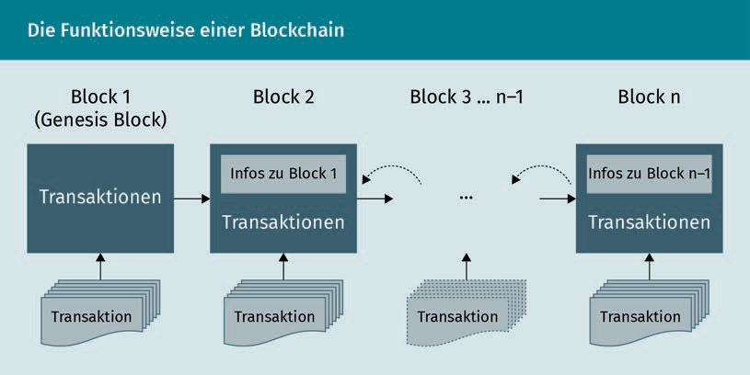

To do this, many distributed computers are interconnected to form a network. Each transaction is checked by the parties involved in the Blockchain and must be confirmed as correct. These parties are referred to as miners and the task as Mining, in analogy to the mining of gold. A transaction cannot be changed after the fact. This makes the Blockchain tamper-proof. Since all transactions are stored in the Blockchain, all transactions of each user are known and their account balance can be calculated. In summary, the Blockchain is a distributed database that stores verified transactions and makes them transparent and traceable for all parties. Because there is no central instance, there is also no central point for cyber attacks. A corresponding attack would require control of more than 50% of the parties involved in the validation of transactions.

###### Application areas of Blockchain technology

At this point, Blockchain is being used as a technology independently of Bitcoin and other cryptocurrencies. The Bitkom study "Blockchain in Germany - Use, Potential, Challenges" (BITKOM e. V. 2019) shows a wide range of possible applications. Companies see great potential in the areas of accounting, finance, and controlling, as well as for logistics and warehouse processes. For example, compliance with cold chains during the transport of temperature-critical products can be documented (BITKOM 2019, p. 50). Sensor data on temperature or other measured values can thus be stored in the Blockchain in a tamper-proof manner. This data is transparent and traceable for the sender, the transporter, and the recipient. Smart Contract s can be generated automatically from this data (Fill/Meier 2020, p. 12f.); i.e., the contract comes into force independently if all deﬁned conditions, such as compliance with the cold chain, are met.

Mining

This means that so-called miners provide massive computing power (and power consumption) for the validation of transactions and are rewarded for this, e.g., in the form of bitcoins.

Smart Contract

A Smart Contract is based on Blockchain technology. Conditions and actions are stored in the program code.

Extended Reality This is the umbrella term for technologies that generate virtual environments or objects.

Augmented Reality Augmented Reality is the interplay between digital and aanalog

life.

#### Virtual and Augmented Reality

In 2016, the general population came into direct contact with the topic of Augmented Reality. The reason was the game Pokémon Go (Hegemann 2017). On the streets and in parks, people could be seen looking spellbound at their smartphones, sometimes stopping abruptly in the middle of the street or turning in circles, and all of that in order to catch fantasy creatures. The smartphone was used to superimpose these fantasy creatures onto the real environment. This is known as Augmented Reality (AR).

AR is not the only way to combine the virtual and real worlds. These different types are grouped under the term Extended Reality (ER), alternatively also under MR (Mixed Reality) or XR, whereby the "X" acts as a placeholder (cf. Dörner et al. 2019, p. 22). However, divergent deﬁnitions can also be found for MR and XR. All of these forms involve immersive technology, i.e., users are immersed into the virtual events. The degree of immersion, i.e., the type and intensity of interaction with the virtual environment, differs. In the following, these different types will be introduced and examples of use will be illustrated.

###### Augmented Reality (AR): Augmented Reality

As described using the example of Pokémon Go, Augmented Reality adds digital content to reality (Dörner et al. 2019, p. 20f.). This involves images, texts, and animations. AR applications do not require any special hardware. A smartphone or tablet is sufficient. This makes AR easy to use. In addition to AR games, videoﬁlters, e.g., in apps or Social Media platforms, are the most frequently used AR application in the private sector (Klöß 2020, p. 35f.). These filters can be used to add virtual hats, beards, etc. to photos of people.

Other application scenarios include the display of a new piece of furniture in one's own home (Fischer 2018). It is also expected that various AR glasses suitable for everyday use will be launched on the market for private users in the next few years, which will display various information to the wearer (Klöß 2020, p. 36). The real environment remains completely visible and is not replaced by a virtual environment. Even if the concept of AR glasses appears harmless at first, fundamental questions still need to be considered (Specht 2018, p. 219). Does an app that displays the associated online proﬁles from various Social Networks for each person violate privacy? And what about an app that hides the clothing of pedestrians and shows them naked?

###### Virtual Reality (VR): Virtual World

In a Virtual Reality (VR) application, the user is immersed in a computer-generated world that the user is supposed to perceive as authentic as possible and with which they can interact (Dörner et al. 2019, p. 12et seq.). The real environment is thereby hidden. VR applications require special hardware displaying the 3D content

Selected technologies

of the computer graphics using three-dimensional displays. Examples of such hardware are displays that are attached to helmets (so-called head-mounted displays), special stereo glasses, or even data gloves. Now, there are also very simple smartphone glasses, where the phone is inserted into a special device (Janssen 2015).

Hearing and touch are often used alongside vision in order to create a Virtual Reality that is almost indistinguishable from the real world for humans.

###### Areas of application

At 79%, computer games are the main application scenario for VR in the private sector (Klöß 2020). In the business context, the fields of application are larger, ranging from research, education, and training to the visualization of simulation results (Dörner et al. 2019, p. 39). Another example is AR applications in the service and maintenance of complex machines (Runde 2020, p. 66et seq.). Here, a service technician carrying out a repair on site can be specifically supported with AR technologies, for example by displaying information with location accuracy (ibid., p. 69). This can, among other things, allow you to see at a glance where a component is located, what steps should be performed next, and what tools are needed.

#### 3D/4D printing

With 3D printers, objects can simply be "printed out". This is exciting for private use, but also for companies, which can use it to easily produce special parts or spare parts, for example. The importance of this technology is evident, among other things, in the number of patents filed. For example, the European Patent Office recorded a strong increase in patent applications in the field of 3D printing from 2015 to 2018, with an average of 36% per year (EPO 2020).

The term 3D printing is used colloquially as an umbrella term for various manufacturing processes in which three-dimensional objects are built up layer by layer from one or more materials (Feldmann/Schulz/Fernströning 2019, p. 7). Due to the additive addition of material, this process is referred to as Additive Manufacturing (AM).

###### Additive Manufacturing as a new production process

3D printing has radically changed the way products are manufactured. In contrast to conventional manufacturing processes, such as forging, casting or machining, Additive Manufacturing involves applying layer by layer and drying, bonding, or melting (Feldmann/Gorj 2017, p. 17et seq.). The materials used for this include

Virtual Reality

It refers to an Artificial Reality created with the help of special hardware and software.

Additive Manufacturing Additive Manufacturing creates a physical object by adding material layer by layer. Syno-

nyms are genera- tive manufacturing and rapid technologies.

CAD

Computer-aided design refers to the use of software for the design, editing, analysis, or optimization of a

product.

plastic, metal, and plaster. This no longer requires any product-specific tools as is the case with conventional processes. It allows the ﬂexible production of different types of objects. 4D printing goes one step further. 4D-printed products can change their shape, color, or size. For example, the shape can change under the influence of temperature changes, humidity, or touch. This makes possible a wide range of new applications (André 2018, pp. 1-14). One such innovative example is new wound dressings for complex wounds that release active substances from the wound wall depending on various parameters (Wagner 2018b).

###### A digital technology

In order to manufacture a new product with a 3D printer, a virtual 3D design is first required (Feldmann/Gorj 2017, p. 27et seq.). This can be created using either 3D CAD software or a 3D scanner. These models can depict very complex shapes, allowing the manufacturing of rather sophisticated products.

The digital model is not the only digital aspect of this technology (EPO 2020). The 3D model can be provided digitally so that a product can be manufactured locally and just in time where it is needed. In addition, the digital model can be easily modiﬁed. This means that a wide range of products can be offered without having to set up complex manufacturing lines. In addition, various digital services can be developed around Additive Manufacturing. For example, various designs, as well as local manufacturing, can be offered to a wide audience on digital platforms.

###### Application areas

The potential applications of 3D and 4D printing are diverse (Feldmann/Schulz/ Fernströning 2019, p. 11et seq.; Lachmayer/Lippert 2016, p. 5et seq.). 3D printing is frequently used for prototyping, i.e., to make ideas quickly and inexpensively tangible in the form of a haptic product. A new product can thus be tested with potential customers at an early stage or presented at a trade fair. 3D printing can also be used to efﬁciently produce individual items or small series. For example, medical technology requires highly individualized products such as implants, medical instruments, or anatomy models for the preparation of operations.

Today, 3D printing is also being successfully used in industrial manufacturing. Aerospace, automotive, and shipbuilding industries, for example, print components such as engine and turbine parts. The benefit particularly stems from the weight reduction that 3D printing brings (Feldmann/Gorj 2017, p. 24). Industries such as the

Selected technologies

consumer goods industry are increasingly relying on 3D printing. 3D printing and, in the future, also 4D printing are thus one of the key technologies for Digital Transformation for many industries.

Summary

The technologies covered in this lesson are already having an impact on all areas of life. This will continue to increase in the coming years. Each of these technologies already has enormous potential in its own right. For example, robots will take over more of people's tasks in the coming years. They will not make careless mistakes, they will not get tired, and they will be able to work in areas that are considered too dangerous for humans. As these application examples show, technologies are frequently combined. This multiplies the possible applications and Business Models many times over (Thelen/Schorn 2020, p. 42).

These technologies harbor great potential, but also risks. Not everything that is technically feasible is also ethically justifiable (Specht 2018, p. 330). In order to create a sensible and sustainable framework for the use of these technologies, laws and regulations, for example, must be adapted to the digital age (cf. ibid., p. 336). For these technologies to actually improve our lives, we need optimism, a conscious approach to the challenges and risks, and the will to shape them. Or to put it in the words of Bill Gates: "We always overestimate the change that will occur in the next two years and underestimate the change that will occur in the next ten. Don't let yourself be lulled into inaction. " (MIT FOKUS 2021).



# Lesson 7

## Digital in the enterprise: Selected scenarios

##### LEARNING OBJECTIVES

After completing this unit, you will know ...

... how to identify areas of Digitalization in business.

... how to understand and classify Digital Marketing and the associated manifestations.

... what the basic understanding of the nature of Digital Design is and how it is distinguished from analog design.

... which opportunities and potentials exist through the use of new digital solutions in the field of Human Resources.

... how the use of AI-based systems in Recruitment marketing and Recruitment is explained.

... how to understand and classify People Analytics.

... which areas of application of digital technologies in Social Work are to be distinguished.

DL-D-DLBDS01-L07

### Digital in the enterprise: Selected Scenarios

#### Introduction

Digitalization and Digital Transformation are ubiquitous. Digital technologies have found their way into the working world across all industries and are shaping everyday life in companies. But what does that mean in concrete terms? This lesson uses selected scenarios to illustrate how Digitalization is affecting various disciplines and areas of work. The respective developments in these areas of Digitalization will be discussed, from Digital Business, Digital Marketing, and Digital Design to Digital HR and Digital and Social. Practical examples are used to show the concrete use of digital technologies and thus provide a comprehensive overview of Digitalization in the corporate context.

#### Digital Business

The use of digital technologies has become established in large parts of the economy, making it so that the digital economy (Digital Business or e-business) is becoming increasingly important (Kollmann 2020, p. 5). Thus, the central areas of activity of a market are supported by electronic networks and platforms. The central areas of the economy, namely purchases, sales, and trade, are now conducted digitally (ibid., p. 8).

E-procurement supports the purchase of services through the use of information and communication technologies. Both strategic and operational purchasing are handled via digital networks. Procurement has been supported by software systems since the 1990s. Thus, employees in purchasing were shifted from the operational to the strategic side of the business (Böhle et al. 2018, p. 408). It has become common knowledge to talk about "Purchasing 4.0", where the operation is fully automated (Groß/Müller-Wiegand/ Pinnow 2019, p. 230). Real-time communication and networking are also used in procurement. This way, the determination of requirements and the ordering process can be automated, e.g., by networking production machines, materials, and warehouses (Kleemann/Glas 2017, p. 18). Processes can also be simplified and accelerated on a strategic basis through the use of intelligent systems. Big Data Analytics can be used to create forecasts and reduce supplier-specific risks (ibid., p. 19).

E-shops enable services to be offered online and sales to be carried out completely digitally (Kollmann 2020, p. 8). At the same time, other models such as cross-channel, multi-channel, and omni-channel are also becoming increasingly important. In that regard, information and communication technologies for cooperation and exchange are gaining in importance. E-communities offer digital networks for the exchange of data and knowledge, e.g., to prepare a purchase decision (Kollmann 2020, p. 8). Various channels such as brick-and-mortar retail and online shopping coexist separately in multi-channel marketing, but they are coordinated together in cross-channel marketing.

Digital in the enterprise: Selected scenarios

Digital technologies enable data to be exchanged across different channels. A holistic view of the customer journey is referred to as omni-channel. By analyzing customer data, sales potential can be leveraged across all touchpoints (Appel/Michel-Dittgen 2013, p. 38). One of the omni-channel pioneers is the company Burberry. The fashion brand's omni-channel approach includes a Social Media channel and an e-shop, which is characterized by high-quality images and digital content as well as service support via live chat and customer service. At the same time, it creates the possibility to customize garments, buy them online, and pick them up in-store. Burberry flagship stores have been equipped with digital screens showing exclusive videos related to the brand, live streaming of events, and runway shows. Burberry has also created the "Burberry Retail Theater" with live shows streamed in stores around the world (Aiolﬁ/Sabbadin 2019, p. 43).

E-marketplaces enable direct trade between suppliers and consumers. Here, information and communication technologies are used as intermediaries between the two sides of a trade (Kollmann 2020, p. 8). Thanks to the Internet and the increasing spread of mobile devices, e-marketplaces can be reached at any time and have thus established themselves as important elements of e-business (Appelfeller/ Feldmann 2018, p. 40). This makes e-marketplaces the center of the platform economy, in which corresponding providers can generate profit scaling effects through Network Effects (Kollmann 2020, p. 200). Well-known representatives include eBay or Amazon. Amazon's range of services now extends beyond the pure marketplace, so that a digital ecosystem of its own has emerged around the company (Appelfeller/Feldmann 2018, p. 181). From the former book trade, Amazon has developed numerous other business segments: its range of services now extends from streaming providers to cloud providers across various industries. Additional value-added services, such as financial services, are characteristics of the digital ecosystem.

E-companies, which are purely virtual companies formed through digital collaboration between companies, are also becoming increasingly common (Kollmann 2020, p. 9). The actual company continues to focus primarily on its day-to-day business while providing financial resources to independently established or external digital startups decoupled from the operating company. This allows the digital companies to concentrate entirely on innovation processes.

#### Digital Marketing

Digital Marketing is a synonym for Online Marketing and includes all marketing activities that take place online. Marketing in general refers to the alignment of a company's activities with the market and/or customer needs (Kirchgeorg 2018). In contrast to Online Marketing, traditional marketing or ofﬂine marketing stands for all those marketing activities taking place ofﬂine and

Touchpoints

Touchpoints represent all points at which customers come into contact with a company. These can be analog or digital touchpoints, such as reading a newsletter or visiting a retail store.

Platform economy The platform economy describes the spread of the digital platform Business Model resulting from the Digital Transformation.

Platforms represent digital infrastructures consisting of hardware and/or software that enable a limited or clearly deﬁned number of uses, for example, for different application programs (Andersson Schwarz 2017, cited in Gatautis 2017).

Network Effects On platforms, Network Effects lead to profit scaling effects. As the number of customers increases, the perceived value of the service grows and so does the number of Network Effects.

World Wide Web   
HTML pages are the foundation of the World Wide Web (www). It uses multimedia, i.e., it can display text, images, sound, and video as well as text.

Advertising Banner

An Advertising Banner is a form of Internet advertising based on graphics or animations. By clicking on the banner, users are taken to the page of the advertiser.

in the analog space (Stoll 2021). The prerequisite for the development of Digital Marketing as a discipline was the increasingly easy access to the Internet for users from 1991 onward, whereby access here refers to both financial and technical resources. From this point on, data could be transferred in a wide variety of forms, such as email or the World Wide Web.

World Wide Web and Internet are often used synonymously, but the World Wide Web represents a system that can be accessed via the Internet (Kreut- zer 2021, p. 6f.). At the beginning, Digital Marketing was limited to static formats such as Advertising Banners or emails due to the technology. The technology (technical requirements such as an Internet connection) was seen by some as a key differentiator from traditional forms of marketing, while others emphasized interactive communication as a differentiator from traditional marketing (Lammenett 2019, p. 34et seq.).

This interactive moment is reflected in particular in the Social Networks that emerged from the beginning of the 2000s, as well as in the fundamental idea of Web 2.0, the Participatory Web. While Digital Marketing was initially regarded as "just" a part of the overall marketing mix, the development of Business Models such as Amazon or eBay, among others, has contributed to the fact that it is now increasingly understood as a discipline in its own right and companies often invest their entire marketing budget exclusively in digital measures. The reason for this is that in the case of Amazon and eBay, the online presence is not just part of the marketing concept, but a core element of the Business Model itself (Lammenett 2019, p. 35f.). Mobile Web, and with it Mobile Marketing, was born with the iPhone in 2007, thanks to its multimedia capabilities and permanent access to the World Wide Web (Bühler et al. 2017b, p. 3f.).

There is now a wide range of channels and forms of Digital Marketing, from the corporate website to email and afﬁliate marketing to Mobile Marketing. Each form has its own speciﬁcations, and at the same time they cannot be completely demarcated from one another. One example: on the one hand, Mobile Marketing is an independent branch of Online Marketing. On the other hand, a website can be accessed via a mobile device in the same way as via a stationary device. One way to classify Online Marketing is via its manifestations and categorization as visible or invisible to the user (Kreutzer 2021, p. 2).

Digital in the enterprise: Selected scenarios

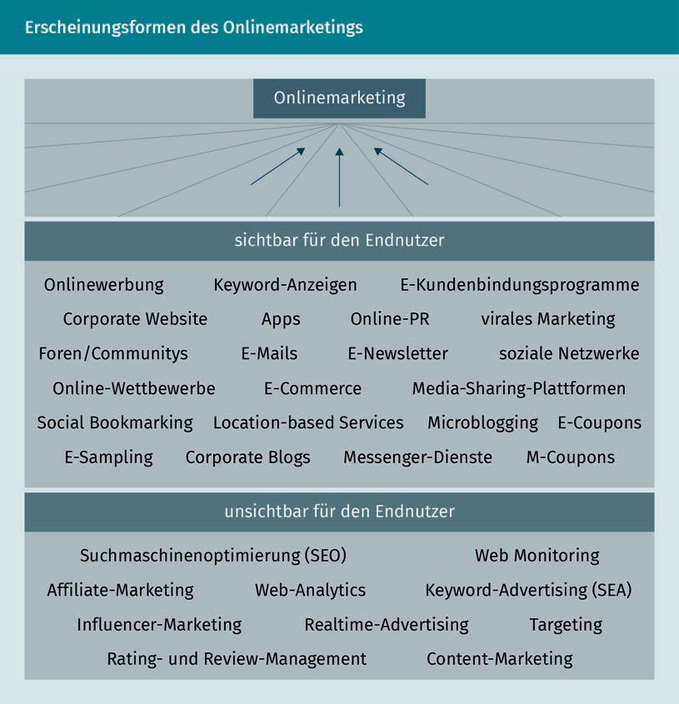

For the user, the type of touchpoint with a company is unimportant. Whether offline or online, visible or invisible: the important thing is that the user does not perceive any media breaks and that the advertising experience with a company runs smoothly. The benefits of cross-media campaigns, that is, campaigns that run across a number of channels and are coordinated in terms of content and design, are well suited to this purpose; for this reason, it is imperative to think carefully about how the channels complement each other. Across all forms and measures, Digital Marketing has characteristics that should be taken into account for a campaign strategy (in the following, according to Kreutzer 2019, p. 97f.):

* Global reach: Digital Marketing can theoretically reach everyone in the world who has access to the Internet and is not subject to country-specific filters. High reach is possible due to local independence.
* Permanent availability: The Internet has no opening hours. This means that Digital Marketing measures can be controlled at any time and made available to users on a permanent basis.

Reach Reach refers to the proportion of target persons who can be reached by an advertising measure.

Cookies Cookies are text files that are stored on the computer via the web browser.

This enables the website operator to obtain certain information about the user.

Viral Marketing This is a form of branding that often uses emotional or unusual storytelling to draw attention to a brand, product, or campaign. Viral Marketing relies on users sharing the campaign, especially on Social Networks, thus generating free reach.

* Short-term adjustments: In Digital Marketing, user reactions can be picked up on and campaigns can be adjusted accordingly. If an ad on Facebook is not clicked, for example, the text and image can be adjusted. This is not possible with ofﬂine measures such as a newspaper ad or a billboard. Once in the public domain, these can no longer be changed.
* Direct feedback: Through clicks, likes, or comments, companies receive direct feedback on their actions. These reactions also support the further dissemination of the content.
* Personal addressing: User-specific data makes it possible in Digital Marketing to address only certain target groups in an ad. Cookies, email addresses, and the entry of user data during log-ins play an important role in this context.
* Low entry costs: Digital Marketing offers the advantage that the budget framework for individual measures can be very individually designed and adjusted at any time. A smaller budget is ideal for testing. However, a certain budget must usually also be invested for a high reach, unless the advertising measure is so well received by users that they share and spread it of their own accord. Viral Marketing aims precisely at this effect.

###### The use of Digital Marketing for (re)branding

The "Umparken im Kopf" (Re-parking in the head) campaign helped the Opel car brand achieve resounding success. With the campaign, which was created in cooperation with the agency Scholz & Friends, Opel achieved a very successful rebranding of the brand. Branding is the establishment of a brand and an image. The aim of branding measures is to ensure that certain messages, symbols or associations stick with users and that they develop a positive emotional relationship with the brand (Onlinemarketing.de n.d.). Rebranding is a revival or rewriting of these associations or references. The Opel brand, which was thought to be dead, presented itself as high-quality and cool with the campaign. The storytelling of the campaign had nothing to do with the brand as such. In the first campaign teasers, Opel boldly presented popular prejudices. The subsequent campaign then had the goal of clearing away the prejudices about the brand itself and getting people to rethink Opel (Scholz & Friends, n.d.).

Digital in the enterprise: Selected scenarios

With this campaign, Opel managed to reach more than 20 million drivers and regain market share after 15 years of declining sales (Scholz & Friends n.d.). There were two main digital touchpoints: the landing page umparkenimkopf.de and the hashtag #umparkenimkopf, which was used to popularize the campaign on Social Networks. In addition, a QR code was implemented that also led to the landing page. The missing sender was intended to make users curious and, in combination with good and cross-channel storytelling, motivate them to click one or more times. The campaign is one of the most awarded and successful creations of all time (ibid.) and shows the potential that the use of Digital Marketing can have for branding or rebranding.

###### Real-time advertising for maximum user relevance

Realtime advertising is a form of Digital Marketing that is not visible to users. In real-time advertising (also known as real-time bidding, programmatic advertising, or programmatic ad buying), fully automated Media Planning takes place on a data-driven basis. Online advertising space is auctioned off in real time and fully automated. The whole thing runs via an auction process in which the advertising space is sold to the highest bidder in milliseconds (Kreutzer 2021, p. 216f.). One advantage of this data-driven form of advertising is that users can be served tailored advertising. For its 2019 "Spar dir den Flug" campaign, Deutsche Bahn, in collaboration with the agency

Media Planning

Media Planning is the planning of the advertising medium, taking into account the target group, the channels, the timing, and the budget.

Geotargeting Geotargeting uses the IP address to draw conclusions about the user's geographic location. Based on this, the website visitor receives location-based advertisements.

Ogilvy, used precisely this principle. A real-time Social Media price comparison was played out on Facebook, based on data from Facebook and Getty Images. The algorithm developed searched Getty for images of travel destinations relevant to the target group and comparable images from Germany. With the help of Geotargeting, the nearest airport was determined for each user individually, as well as the destination airport abroad and the cheapest airfare. The offer was compared in a video ad with the offer of Deutsche Bahn, which presents a visually comparable destination in Germany. The ad was played out in real time, fully automated, and tailored to each user, thus providing maximum relevance for them (Ogilvy n.d.).

#### Digital Design

Digital Design is a sub-area of visual communication (Johnson 2020). "The term visual communication describes that the most important channel of information transmission is sight [...]" (Bühler et al. 2017a, p. 2). The saying "A picture is worth a thousand words" refers to the phenomenon that often, the communication of complicated and complex issues is easier when using pictures or (moving) images rather than pure text. The analog world is no different from the digital world in that respect.

The term Graphic Design refers to visual communication in analog space and means printed products. Digital Design stands for digital content and thus for the digital space. Even though the areas of print and digital are increasingly overlapping and the same techniques are used in many parts, it makes sense to make a terminological distinction. This is because Digital Design must take into account the nature of digital user interfaces and end devices with their different screen sizes, the keyword here being responsive respectively adaptive design. While a magazine, for example, is "only" read, digital artifacts such as websites or online stores are used: users click on buttons, scroll,

Digital in the enterprise: Selected scenarios

click on hyperlinks, or add products to the shopping cart. For this reason, factors such as User Experience and interactivity must be taken into account in Digital Design (Johnson 2020).

When translating a company's presence into the digital world, the Corporate Design usually provides a creative framework. Corporate Design refers to design guidelines that guarantee a uniform corporate image. These include, for example, the corporate colors, the logo, or the font. In addition to the aesthetic aspects, Digital Design also includes the design of the User Experience: "The User Experience (UX) considers the interaction of a user with a (digital) product as well as the feelings and associations, in short, the experience that results from this interaction. The term serves as an umbrella for various categories of digital product design" (van de Sand 2017, p. 8). The classiﬁcation of these categories can look very different and depends on what kind of Digital Design one looks at: Web Design, App Design, Infographics Design, Email Design, Social Media Design, or Powerpoint Design represent a selection from a long list of possible Digital Designs (Johnson 2020). Using Web Design as an example, the following categories of digital product design can be identified (in the following according to Bühler et al. 2017b, p. 5f.):

* + Interface Design: Every digital product has an interface connecting the user and the product. In most cases, this interface is the user interface of a website or an app, for example, which can be operated with the mouse or by voice. The task of interface design is to design this interface in such a way that the user can access it intuitively.
  + Information Design: Unlike a book or a TV show, information in Digital Media is not arranged in a linear fashion. The user does not read through a website from start to finish, but navigates via hyperlinks to the places that they find interesting and relevant. Information Design ensures that the information structure is as comprehensible as possible and arranges the information in such a way that the user can navigate to it easily.
  + Interaction Design: Interaction Design is about how the user can get in touch with the provider of the digital product. Forms are a common solution here. In terms of accessibility, voice input also plays an important role here, for example.
  + Screen Design: Screen Design deals with the aesthetic components. What does the (responsive or adaptive) layout for the website look like? Which graphics, images, and icons should be used? How can the website be optimally integrated into the Corporate Design? Or: Which font(s) should be selected?

User Experience

Also referred to as UX, it stands for all impressions and experiences that the user has or makes during interaction with a digital product.

Interactivity

This is a term for interrelationships for the purpose of an exchange of information between any variables. In the context of Digital Design, interactivity stands for the interaction between the user and the digital product.

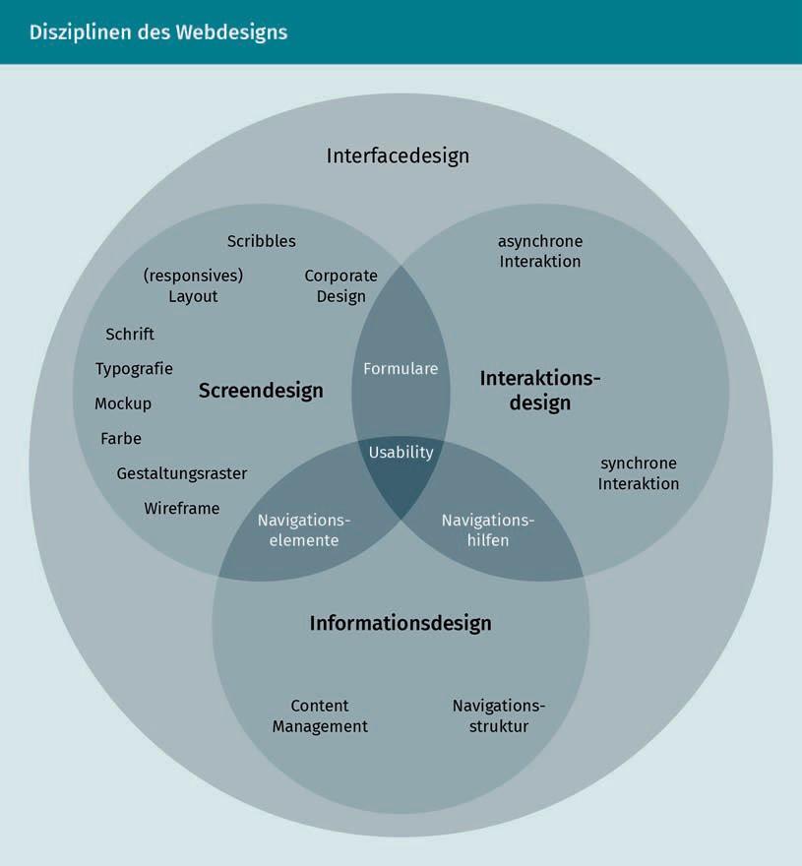

There are numerous concrete scenarios for the implementation of Digital Designs. Apple's online presence is often cited as a positive example in this context, and there are a number of online rankings for the world's worst websites. The Digital Design of a website very much depends on the individual case. So instead of presenting concrete scenarios, two websites that can be used to analyze and design digital products will be shown.

###### Laws of UX

The Laws of UX is a collection of design principles that can help in the design of a user interface, regardless of the type of user interface. They are best practices that address users' visual and perceptual habits and can improve User Experience design through them. A total of 21 principles are presented on the site, four of which will be explained here as examples (hereafter after Yablonski 2021):

* + Law of Conciseness: People interpret ambiguous or complex images or shapes as simply as possible.
  + Law of Proximity: Objects that are in spatial proximity to each other are interpreted as being connected.



* + - Law of Similarity: Objects that have a similar design and shape are interpreted by the human brain as being related.
    - Pareto Principle: The principle states that approximately 80% of the results are achieved with 20% of the total effort.

Digital in the enterprise: Selected scenarios



#### Digital HR

Digitalization does not stop at Human Resources management (HRM). HR faces a double Digitalization challenge (Jäger/Petry 2018, p. 29f.):

1. Participation in the Digital Transformation of the company: Working methods, competence requirements, and management approaches are changing as a result of the Digital Transformation. As the company’s entity responsible for all issues relating to the human factor, HR should play a shaping role int this respect.
2. Digital Transformation of the HR function: HR itself must seize the opportunities of Digital Transformation and improve or redesign its own processes, structures, and systems.

In the following, we will focus on the second point.

###### Shaping the Digital Transformation of HR

Digital technologies such as Social Media, Cloud Computing, Artificial Intelligence, Robotics, and Virtual and Augmented Reality have enormous potential to reshape HR tasks. Human Resources will also see a change in nature, culture, and design of work - just like all corporate divisions. The follow question arises: "How much and what kind of work there will (still) be for people in the future, how will they will want to work, and what will the appropriate work design be?" (Jäger/Petry 2018, p. 32).

Human Resource Management

HR employees take care of all issues related to the company's employees.

Digital Transformation offers the opportunity to make all HR processes more digital, as shown on the process map below. Selected areas are examined in detail below.

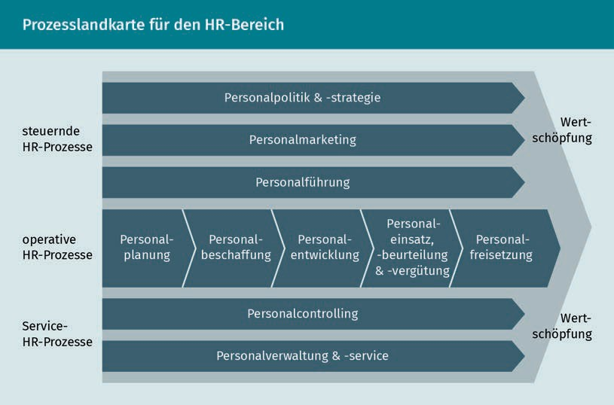

###### Digitalization in recruiting

One of the tasks of HR is to recruit the right employees. To achieve this, potential employees must first be made aware of the company and become enthusiastic about the company and the positions to be filled (Personnel Marketing) (Jäger/Petry 2018, p. 64). Next, it becomes a matter of actually hiring the applicants who are suitable for the advertised position (Recruitment). Social Media and the inclusion of inﬂuencers (e.g., on YouTube or Instagram) are used, among other things, to establish contact with potential candidates.

The use of digital solutions can not only improve Personnel Marketing. AI-based systems in particular offer great potential for rationalization. Chatbots, matching tools, and Robotic Process Automation will take over more and more recruiting tasks in the coming years (Jäger/Petry 2018, S. 66). Artificial Intelligence (AI) can help to increase the number of suitable applicants on the one hand, and on the other hand to select the right applicant from the crowd of applicants, as objectively as possible (Teetz 2018, p. 229). The recruiting process can then made up of various possible applications of AI-based systems, which is illustrated below.

Digital in the enterprise: Selected scenarios

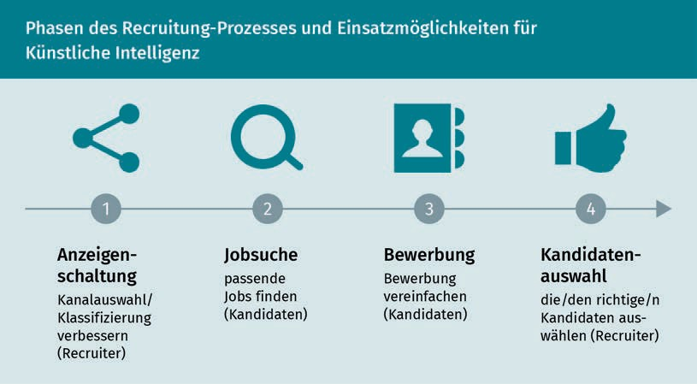

AI-based recruiting systems or Robot Recruiting already support the following tasks today or will do so in the future (Jäger/Petry 2018, p. 66f.; Teetz 2018, p. 230-239):

* + Select the appropriate job boards and Social Media channels for specific job postings;
  + Correct classification of a job posting, e.g., by selecting the appropriate job category or suitable keywords;
  + Use algorithms and software programs for the identiﬁcation of potential candidates in Social Networks (e.g., LinkedIn);
  + Answer applicant questions using chatbots;
  + CV parsing to automatically transfer data from applicants' resumes to the applicant database used by the company;
  + Automated matching, i.e., matching the proﬁle of the candidates with the job proﬁl;
  + Use of advanced matching to ﬁnd alternative jobs currently available within the company;
  + Conduct an automated online assessment;
  + Conduct initial interviews through digital assistants;
  + Carry out an automated personality analysis, whereby recorded conversations are analyzed with regard to language, voice, pitch, pauses, etc.;
  + Prepare the employment contract.

In extreme cases, a recruiter only takes over the final selection (Jäger/Petry 2018, p. 67; Teetz 2018, p. 238f.; Fichtner et al. 2019, p. 284). However, when implementing such systems, it will be important to identify potential errors, especially those in which algorithms are biased based on the training data used and favor certain groups of applicants. Conversely, AI-based systems can keep the individual subjectivity of recruiters out of the process.

Matchingtools

They support an automated comparison between the knowledge and experience listed by an applicant on the one hand and the knowledge and experience required by the job profile on the other.

Robotic Process Automation

RPA makes it possible to automate routine processes with the help of software robots.

Robot Recruiting This refers to processes with which recruiting or sub-processes thereof are automated or supported by automatic data analysis (Haufe Group 2021).

###### People Analytics

People Analytics The aim is to support subjective decisions in Human Resources management with the help of data analyses.

The automated analysis of Big Data also offers HR various new opportunities in terms of automation and as support for personnel decisions (Jäger/Petry 2018, p. 77; Atabaki/Biemann 2018, p. 130; Schwuchow/ Gutmann 2019, p. 251). In the field of HR, this is referred to as People Analytics or HR analytics. Large volumes of HR-related data, for example from employees' emails or Social Media posts, are analyzed and examined. This can be done in relation to praise or criticism in order to determine the mood in the workforce, among others (Jäger/Petry 2018, p. 77).

People Analytics can be used in various HR processes, such as, e.g. in Personnel Planning and Personnel Selection, Personnel Controlling, and Personnel Development (Schwuchow/Gutmann 2019, p. 252; Atabaki/Biemann 2018, p. 130et seq.). Merck, for example, analyzes employee data and uses it to make HR-related decisions (Tolksdorf/Bednarc- zuk/O'Lear 2018, pp. 372et seq.). Examples of such data in HR standard analyses for leading bodies at Merck are:

* Number of employees and fluctuation,
* Performance and talent data,
* Diversity: an overview of gender ratios, nationalities, age structures,
* Compensation, in particular with regard to performance, and
* Effectiveness of the organizational structure.

The use of such analytical tools also changes the role of HR employees (Tolksdorf/Bednarczuk/O'Lear 2018, p. 374): Tasks are less administrative and more strategic in nature. HR advises and supports the business units based on the data. When using AI-based systems and data analysis, it is important that ethical and moral issues are always considered at an early stage in addition to technological feasibility (Fichtner et al. 2019, p. 282f.).

#### Digital and social

Digital technologies are also increasingly being used in Social Work. The increasing volume of data and its analysis as well as the automation of decision-making processes on the basis of algorithms are gaining in importance. "Accordingly, Digitalization isn't just about the Digitalization of previously analog processes and forms of delivery, it is also about establishing sociotechnical arrangements and their implications for individuals and the types of, reasons for, and framework conditions underlying social services" (Kutscher et al. 2020, p. 10). The areas of application of digital technologies in Social Work practice can be divided into three main aspects:

Digital in the enterprise: Selected scenarios

* + 1. Teaching media competence to addressees of Social Work,
    2. Use of digital technologies for communication with the target group, and
    3. Use of digital technologies in organization and social administration (Bera- nek/Hill/Sagebiel 2019, p. 226).

Since Social Work is understood as a person-related service and individual interaction between people, the use of digital technologies is often rejected (Roeske 2018, p. 18). The three areas of Social Work listed below already show useful fields of application for digital technologies. These fields will require increased discussion and competence acquisition by professionals in the future (ibid., p. 19).

Providing media competence

The addressees of Social Work are characterized by a digitalized living and working environment, which entails new tasks for social workers. The focus here is primarily on the use of Digital Media and Social Media, through which topics such as youth media protection and media socialization are gaining in importance. New phenomena that Social Work has to deal with are, for example, cyberbullying, the sending of sexual images (sexting), and public victim stigmatization (Victim Blaming). There is also an increase in addiction issues related to online games and Social Media (Beranek/Hill/Sagebiel 2019, p. 235).

Digital technologies for communication

Digital technologies offer professionals and target groups new opportunities for communication, networking and exchange, e.g., via Social Media. Digital Media offer professionals improved access to the target group. The anonymity of the Internet can also facilitate communication for addressees. At the same time, care must be taken when handling sensitive data, which may be accessed by non-specialist providers of communication solutions. Increased media competence on the part of the professionals is necessary to ensure the Informational Self-Determination of the addressees (Roeske 2018, p. 19).

In addition, the use of digital technologies is also leading to changes in service delivery. For example, the platform economy also offers new opportunities for online care and support in Social Work. Examples include the platform betreut.de, which can be used to acquire care staff, or mitpﬂegeleben.de, a platform that offers information and advice on care. This provides inquirers with a transparent overview of services. This way, the target group gains more competence in choosing services (Seelmeyer/Waag 2020, p. 183).

Digital technologies in the organization

Organizations are increasingly using digital technologies for information processing, such as case documentation or data communication. This is viewed critically due to ethical issues. According to Kutscher (Kutscher et al. 2020, p. 9), the choice of software and the respective structure of the applications have the potential to influence the decisions of professionals.

Media Literacy Media Literacy encompasses the ability to use different media and media content knowledgeably (factual literacy) and in a critical manner (reception literacy). In addition, media competence implies the ability to interact with and use these media (participation competence).

The ability to reﬂect on one's own media use behavior (self-reﬂection competence) is also relevant.

Victim Blaming

Victim Blaming involves making a victimized person responsible for the actions of a perpetrator.

Informational Self-Determination Informational Self-Determination describes the right to determine the use of one's own personal data.

Child Welfare Endangerment

If the physical, mental, and psychological well-being of a child or their financial wealth are endangered, this is referred to as Child Welfare Endangerment .

For example, case documentation and the associated diagnostics can be influenced by the more or less pre-structured forms of a software program. The standards mapped by algorithms in a software can reveal ethical and philosophical problems, since decisions made on classiﬁcations of diseases lead to inclusion and exclusion (Ley/Seelmeyer 2020, p. 381). A concrete example of the use of digital technologies in diagnostics is the California Family Risk Assessment Tool, which is used to calculate the probability of Child Welfare Endangerment. Based on ten items classified by professionals, the probability of Child Welfare Endangerment is calculated. Several studies prove the accuracy of the prognoses (Schrödter/Bastian/Taylor 2018, p. 3).

Another development is the use of Big Data Analytics. Data from Social Media in combination with reported incidents and existing databases of the public administration are suitable for the dynamic calculation of probabilities. An example of the use of Big Data Analytics to predict Child Welfare Endangerment is the Predictive Risk Model (PRM) developed at the University of Auckland (Vaithianathan et al. 2012). Using a variety of data sources, an algorithm calculates the likelihood of endangerment based on 132 variables. By comparing the prediction with the actual process, high predictive ability and thus the usefulness of the PRM were established. Nevertheless, this model is critically discussed in a public and scientific debate. Especially the reliability and validity of the variables in use are questioned (Gillingham 2016, p. 1047). In addition, ethical aspects of discriminatory algorithms (Beranek/Hill/Sagebiel 2019, p. 236) and legal issues are subject to critical debate (Schrödter/Bastian/Taylor 2018, p. 9). In the Social Work field and when making crucial decisions, such as about child endangerment, Digitalization relies on procedures that are not always useful. Here, the unpredictability of human action, which cannot be mapped in binary codes, must also be taken into account. At the same time, the digital storage and processing of sensitive data are still lacking legal clarity in many respects.

Summary

Digital technologies are present in all industries, disciplines, and fields of work. This lesson uses selected scenarios to highlight digitalization in companies.

Across the board, the economy is characterized by the digitalization of purchasing, sales, and trade and is thus becoming a "digital business". The use of digital technologies is presented in these three areas, leading to the development of e-procurement and purchasing 4.0, e-shops, the platform economy, and e-companies.

Digital in the enterprise: Selected scenarios

Increasing digitalization can also be observed in the discipline of marketing. The development and the now diverse manifestations of Online Marketing are presented. Practical examples are used to showcase the possible applications of Online Marketing: an Opel campaign shows the use of Online Marketing for (re)branding, and the example of real-time advertising impressively demonstrates the wide scope of digitalization in marketing.

In this context, Digital Design is another important discipline that shapes interaction and User Experience in the digital space. The various categories of digital product design are presented: from Interface Design and Information Design to Interaction Design and Screen Design. In addition, practical Internet resources are presented as an orientation and inspiration aid for Digital Design: Designtagebuch.de as an expert Blog for Digital Design and Laws of UX as a collection of design principles.

The opportunities and potential of digitalization are also being considered in various areas for the personnel sector, i.e., for HR. On the one hand, the focus is on the use of AI-based systems in Personnel Marketing and Recruitment. On the other hand, People Analytics and the opportunities it offers in various HR processes are examined.

The digital and social area highlights the use of digital technologies in Social Work. The three aspects of media competence are subject to examination: delivering media competence to the addressees of Social Work, using digital technologies for communication with the target group, and using digital technologies in the organization and administration.



# Lesson 8

## Trends and outlook

##### LEARNING OBJECTIVES

After completing this unit, you will know ...

... how the necessary competencies for the Digital Age are being assessed.

... which different measures of qualiﬁcation can be distinguished from one another and how the respective area of application is derived.

... which new learning approaches, learning processes, and learning technologies exist in the Digital Age.

... which drivers for change in collaborative and distributed forms of work are assessed.

... which digital technologies relevant for companies and organizations exist.

... how to justify the importance of digital ethics that deals with the conflicting relationship between what is technologically feasible and what is morally acceptable.

DL-D-DLBDS01-L08

### Trends and outlook

#### Introduction

This lesson provides an outlook on future developments regarding Digital Transformation, Digital Communication, and future forms of collaboration. Trends relating to digital technologies and their areas of application are also considered. Many of these aspects are already relevant in today's work and career environment. At the same time, they continue to develop at high speed and new topics are being added. Confident use of these skills is expected of professionals across all industries. Managers in particular have a role model function in this regard. It is therefore important to keep up to date with the latest Digital Skills and to continue learning.

#### Acquiring and expanding competencies for the Digital Age

Competencies   
They describe the abilities of a person developed through the independent solution of a task.

The complexity of the Digital Age requires new skills in order to meet the changing challenges. The digital world of work is characterized by increasing qualification requirements (Gebhardt/Hofmann/Roehl 2015, p. 17). Various studies show that the required knowledge and skills are still expandable in many places (Hoberg/Krcmar/Welz 2017; McKinsey&Company 2020; IUBH International University 2020). According to a study by Ashoka and McKinsey & Company (2018, p. 8), the skills needed for the 21st century include "Digital Skills" as well as "Human Skills" and "Meta Skills."

Digital Skills address digital competencies and knowledge. The German Society for Human Resource Management (DGFP) defines Digital Skills as "(new) abilities that enable employees to apply digital technologies, to use them within the scope of their task proﬁle, and also to help drive the Digital Transformation of business processes" (DGFP 2016, p. 10). The study by Ashoka and McKinsey & Company breaks down Digital Skills into four development levels. The basis is digital awareness, which is demonstrated by the fact that people communicate via mobile devices, use collaboration tools, save and store files, and are aware of security issues. At the next level, individuals are digitally literate, using digital technologies at work, and accessing information online or with relevant software. As knowledge increases, the next level of digital fluency is achieved, where various platforms and online services can be used, along with programming languages, and thus almost all problems can be resolved with digital technologies themselves. The highest level of digital competence consists of digital experts. They develop IT products and services, manage networks, and optimize search engines (Ashoka Deutschland gGmbH/McKinsey & Company 2018, p. 8).

Trends and outlook

Meta Skills include flexibility and adaptability and the ability to take initiative, be self-directed to achieve goals on time, work independently, and pursue self-directed, lifelong learning. In addition, leadership and responsibility represent essential components of driving change, leading others, and demonstrating accountability to them (ibid.).

Human Skills include abilities that enable people to work creatively with others and to implement innovations. Creativity is important in the Digital Age in order to develop services that meet the requirements of customers and to achieve market maturity quickly. The focus here is on the customer groups, their needs, and their customer experience (Dörr/Albo/Monastiridis 2018, p. 51). Making judgments, making decisions, solving problems, and applying systemic thinking when arguing all rely on the ability to think critically and resolve issues (Ashoka Deutschland gGmbH/McKinsey & Company 2018, p. 8). This also includes analytical skills, which are becoming increasingly relevant as the wealth of available data grows. New techniques for evaluating data, such as Advanced Analytics, are also becoming increasingly important. This involves the use of digital technologies that can help with decision-making and strategy deﬁnition (Petry 2016, p. 175). Another element is social intelligence, which fosters empathy and clear communication. The concept of productivity and a sense of responsibility which enhances project organization and results is also mentioned (Ashoka Deutschland gGmbH/McKinsey & Company 2018, p. 8).

In newly created or existing jobs, these skills are needed in different ways and can be acquired by a variety of means. This results in qualification measures that vary depending on the type of competency (human, digital, meta-skills) as illustrated and explained in the following figure:

Advanced Analytics They are also referred to as business analytics and mean a multifaceted data analysis process that is used for forecasting. Big Data is analyzed to make predictions for the future.

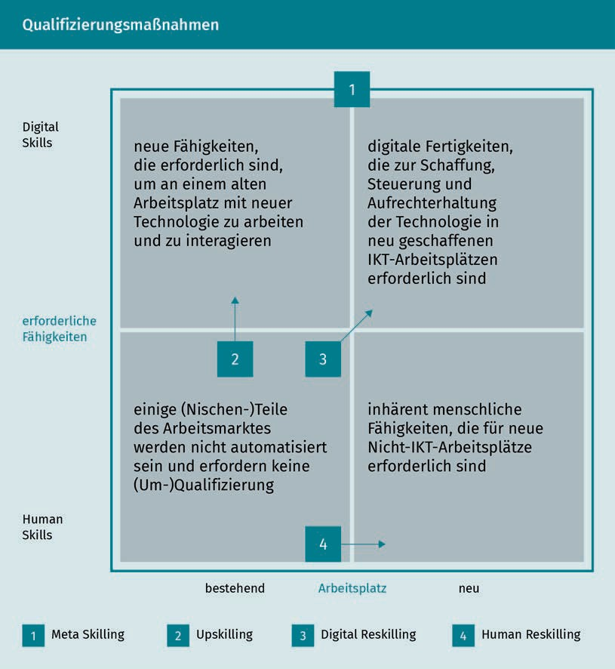

* Meta Skilling: Empowering individuals to develop a new mindset that embraces lifelong learning and cross-cutting life skills (Ashoka Deutschland gGmbH/McKinsey & Company 2018, p. 9).
* Upskilling: Teaching the skills needed for existing jobs in order to perform them with new technologies (ibid.). Upskilling thus always relates to the existing task proﬁle and includes specialist and action-oriented qualiﬁcation (IUBH Internationale Hochschule 2020, p. 5).

Trends and outlook

* Digital Reskilling: Providing skills for programming, designing, or applying technology to complex tasks. Reskilling can thus be understood as a form of retraining that supports employees in building new skills for changing requirements or moving into a new role (McKinsey & Company 2020, p. 2).
* Human Reskilling: Enabling people to (re)discover learning and innovation capabilities, personal strengths, and hidden talents (Ashoka Deutschland gGmbH/McKinsey & Company 2018, p. 9).

These qualiﬁcation measures require new ways of thinking, approaches, and structures in the Digital Age, as the scope, pace, and depth of qualiﬁcation for the digital labor market cannot be implemented using conventional approaches (Ashoka Deutschland gGmbH/McKinsey & Company 2018, p. 10). Thus, agile organizations are increasingly shifting the responsibility for Human Resources development to the employees themselves in the context of Digitalization . Besides new learning content, Jäger and Petry (2018, p. 68) describe three other aspects of HR development that are changing along with Digitalization : 1. learning approaches, 2. learning processes, and 3. technology-based learning.

###### Learning approaches

Learning approaches and personnel development measures must be geared to the new requirements of the VUCA environment. In particular, the previous long-term planning of personnel development is no longer effective in the dynamic Digital Age. According to Petry and Jäger, this results in the following new learning approaches (Jäger/ Petry 2018, p. 69):

* Situation-specific learning (on-demand learning): Learning can no longer be planned in advance over a long period of time, but must be situational and geared to a specific problem. Thus, time and location are becoming less relevant for learning.
* Learning at the workplace (Workplace Learning, Experiential Learning): In addition to situation-specific learning, workplace learning is also becoming more important as learning environments change. In this context, learning is integrated into work and acquires an experimental character through "learning by doing".
* Learning in small portions (Learning Nuggets, Micro Learning): If learning becomes increasingly situation-specific, it makes sense to structure learning content into small parts that can be used to address relevant questions.
* Informal learning: Learning is becoming increasingly informal as a result of small-scale and situation-specific learning in the workplace. No special training is attended for this purpose; instead, learning takes place in everyday working life. This approach should be supported despite the lack of a formal framework in the company.
* Joint or mutual learning (Social Learning, Collaborative Learning, Learning Coaches): With the increasing importance of teamwork and collaboration, learning within the team is also becoming more important. In this way, the collective knowledge of a team can be promoted and made accessible.
  + Lifelong learning: The changing corporate environment constantly places new demands on skills and knowledge, making learning a continuous task.
  + Learner-centeredness: More attention is paid to the individual needs of learners, thus centering the individual "learning experience".

###### Learning processes

The processes of learning are also undergoing change. This is reflected above all in the distribution of roles among those involved. The increased self-organization of employees is having a significant influence on personnel development (Rahn 2018, p. V). Thus, the responsibility for learning and further training also passes from managers to individual employees. In new learning processes shaped by Digitalization , managers assume the role of creating a conducive learning environment (Jäger/Petry 2018, p. 70).

###### Technology-based learning

Digitalization also offers new technical possibilities for learning, an overview of which is given below (Jäger/Petry 2018, p. 71et seq.):

* + Social Media: In general, Social Networks and Wikis are gaining importance in companies. These technologies are also seen as having great potential for continuing education (Petry 2017). For example, Social Media can promote joint and demand-oriented learning (Müller-Vorbrüggen/Radel 2017, p. 268f.).
  + Learning Videos: Learning videos like TED talks and short explanation videos are getting increasingly popular. Massive Open Online Courses (MOOCs) in particular are building a bridge to other learning media in this context.
  + Mobile Learning: Learning apps enable location-independent learning and thus provide the basis for individual and situation-specific learning. This means that waiting and travel times, for example, can be used effectively.
  + Virtual and Augmented Reality: Virtual Reality (VR) and Augmented Reality (AR) offer comparatively fast and cost-effective approaches to training, especially for complex content and environments. Digital twins, or digital images, are used here to represent complex machines for training purposes, for example. Though VR and AR have not yet been widely adopted as learning technologies, they are expected to grow (Petry 2017, p. 14).
  + Learning Assistants: Personal learning assistants can, for example, use Artificial Intelligence and intuitive interaction concepts to make recommendations about the learning path or query the learner's knowledge. The assistants can interact with the learners as chatbots (Hasenbein 2020, p. 81et seq.).
  + Learning platforms: In the context of learning, platforms can be used as a central interface, e.g., in relation to different learning technologies and formats. Learning platforms can provide learners with an essential overview of learning content and progress.

Trends and outlook

#### Trends and outlook for Digital Communication, Social Media, and mobile use

Digital Communication, Social Media, and mobile use are closely related. Simply put, all communication that takes place on Social Media or via mobile devices is digital. For this reason, the areas are linked and an outlook for Digital Communication in social and mobile contexts is given.

In 2020, 88% of the German population was online, 80% of whom were also online on their mobile devices. The growth rate is continuing and it can be assumed that in the medium term the level of Mobile Web use will be on a par with the level of general Internet use - everyone who uses the Internet will also do so on mobile devices (Initiative D21 2021, p. 10). In principle, there is growth in all digital applications in 2020. Utilization is above average among those aged 14 to 29 and below average among those aged 65 and over (ibid., p. 20).

The increase in the use of voice control and voice assistants, which has risen by 11 percentage points to 33% in Germany in 2020 (ibid., p. 21), is particularly interesting from a communication perspective. This confirms the trend toward Voice First or even Voice Only in the long term (Kreutzer/Vousoghi 2020, p. 1), which companies must take into account in their marketing activities (keyword: voice search SEO), and in customer communication ("Voice is the new typing or wiping") (Classen 2019, p. 20; cited in Kreutzer/Vousoghi 2020, p. 1).

Voice control and mobile use go well together, as do mobile use and Social Media use. Social Media use increased by seven percentage points in 2020 and stands at 78%. This means that more than three quarters of the German-speaking population use Social Media, with an increase in communication and entertainment media in particular. WhatsApp use has risen by eight percentage points to 72%, while YouTube use has also increased by eight percentage points to 48%. The number of Facebook users increased by four percentage points to 46% (Initiative D21 2021, p. 22f.).

The COVID 19 pandemic had a significant impact on the change in communicative behavior. Particularly in the first few months, there was a huge increase in the use of Digital Communication tools as people spent more time at home. This applies to the use of Social Media and messenger apps, but especially to video conferencing tools (Nguyen et al. 2020, p. 1f.). Within the German-speaking population, 47% used video conferencing tools (Initiative D21 2021, S. 21). While analog and face-to-face communication may become more and more possible again, scientists believe that the new digital behaviors and communication patterns learned during the pandemic will persist and that people will become aware of when analog and Digital Communication make sense. Video conferencing in particular is expected to remain part of everyday communication. But also, with the

use of Social Media, among other things, it is becoming apparent that increased and changed use will continue, although it is not possible to make a long-term forecast for media usage behavior on this point (Nguyen et al. 2020, p. 4f.).

With a view to media usage behavior, a fundamental customer orientation, and the development of Digital Communication in general, a number of trends are emerging for companies, particularly in the area of Digital Marketing, which are presented in excerpts below (according to Caron 2020):

* The future is mobile: COVID-19 has once again increased the need for mobile communication between customers and companies. Customers spend a large part of their time using apps and messengers. It is important for companies to find out which platforms their customers are using and to offer customized solutions.
* Interactive Messaging: Two important areas of the online communication process are interactivity and individuality (Kollmann 2019, p. 12f.). Customers appreciate personal interaction that is more like a conversation than a mere exchange of messages. Chatbots can provide support with simple questions and light assistance (Meyer/Hannig 2018), but they cannot (yet) replace a genuine customer conversation. Interactive and personalized messaging is becoming increasingly important for building and maintaining customer relationships.
* Artificial Intelligence: In the future, AI-based solutions that analyze patterns and can thus respond more precisely to customer needs will be increasingly sought, for example in chatbots.
* Voice-Enabled Technology: Voice control, voice assistants, but also user-friendly, voice-controlled bots have the potential to improve user and customer experiences.
* Hybrid Models: (Customer) communication is no longer just from person to person, but increasingly from person to machine. These hybrid models are designed to enable humans and machines to work together more efﬁciently. One example of this is the use of bots for certain phases of customer service. Through hybrid models, "customers get the best of both worlds: humans are more sympathetic, while computers can do things more effectively" (Caron 2020).

#### Trends and outlook for distributed and collaborative working

The way people work together in companies and organizations has changed significantly in recent years and will continue to change. In order to better understand the effects and possible recommendations for action, we will first look at the drivers for these changes.

Trends and outlook

###### Drivers for change in the world of work

There are a number of drivers for changes in the nature and design of work. The following Megatrends are particularly important (Appen 2019, p. 24et seq.):

* Megatrend Globalization, characterized by global trade, worldwide networking, and international business relations on the one hand, and trade wars and cyber attacks on the other.
* Megatrend Connectivity, with new possibilities for communication and networking between people, but also between people and machines in the sense of the Internet of Things (IoT) and the resulting data volumes and their analysis possibilities.
* Megatrend Knowledge Culture, with lifelong learning as an integral part of our living and working environment, in order to maintain individual employability on the one hand, and to meet people's natural curiosity on the other.
* Megatrend Gender Shift, as organizations that employ people of different ages, genders, origins, cultural backgrounds, and qualifications are more productive and successful in the long term. An important aspect of this is also to rely on the expertise and leadership skills of women.
* Megatrend New Work, serving as a mirror of the other four Megatrends: On the one hand, the focus is on cooperation, i.e., the joint creation of innovations and problem solving, the active exchange of information, and selective collaboration with competitors. On the other hand, new places of collaboration are emerging, e.g., so-called Co-Working Apaces. When and where work is done is becoming more ﬂexible for many people.

In addition to these Megatrends, there is another factor that is both driving and enabling change in the world of work: Digitalization (Appen 2019, p. 28; Schermuly 2019, p. 36et seq.). Digitalization will fundamentally change entire occupational fields, for example by automating certain tasks. Among other things, it will enable rapid communication and the exchange of data and information between people at different locations, as well as location-independent work, for example through the use of Cloud Computing.

Another driver of the current changes is the demographic change (Appen 2019, p. 29f.; Schermuly 2019, p. 43et seq.). Baby boomers will gradually retire from 2020 onward, which means skilled workers will be missing. As well as the baby boomers, generations X, Y, and Z are also represented in the labor market, each with its own expectations regarding work.

Added to these trends and drivers in 2020/2021 was the COVID-19 pandemic, which resulted in many people having to work from home (Helmold 2021, S. 10). Teams that previously worked together on site had to ﬁnd a new form of virtual collaboration from one day to the next.

Megatrends

They describe developments over decades and mark formative changes (Appen 2019).

New Work

Today, New Work refers to various work and organizational models with a high degree of flexibility in terms of working time and place as well as networked and collaborative working.

Co-working spaces

A co-working space is an openly designed workspace that is mostly rented by startups, freelancers, and creative professionals and used for collaboration ("co-work") and exchange.

Cloud Computing It enables software programs and files to be used via the Internet ﬂexibly and regardless of location.

Virtual teams They are geographically distributed and use information and communication technologies for exchange and collaboration.

###### Recommendations for virtual teams

For virtual teams to work together successfully, various aspects should be taken into account. Helmold (2021, p. 61et seq.) provides the following ten recommendations for virtual teams:

1. Initial and regular physical interactions of all team members: Virtual teams function better when team members meet in-person from time to time.
2. Clearly defined tasks, goals and processes: Distributed teams require greater coordination. Ideally, processes are structured in such way that that tasks can be assigned to groups of two or three.
3. Common team rules for collaboration: Preferred communication channels as well as rules of the game for communication and the design of virtual team meetings should be agreed upon.
4. Use of standardized software tools for collaboration: Well-functioning software tools are needed for coordination, knowledge management, and team communication.
5. Creating a virtual team spirit: For this, a common rhythm is necessary, e.g., common, regularly scheduled appointments. Team members should alternate less convenient times if they work in different time zones.
6. Developing a common understanding: Especially when team members from different cultures work together, it is important to make explicit what each team member understands by a certain statement, e.g., what a "yes" means.
7. Setting up a virtual meeting place: Following the spirit of gathering around the water cooler, there is an opportunity for virtual teams to meet and talk about topics not related to work.
8. Clarify and track commitments: Transparency is needed on who is responsible for which task and by when it is to be completed.
9. Shared leadership: As part of shared leadership, team members should assume responsibility for a sub-project or for familiarizing a colleague with a new subject area.
10. Ensuring feedback and coaching: The manager gives the team members regular feedback on their performance and supports them as a coach. It is important to keep all employees focused on the common goal.

#### Trends and outlook for selected technologies

Various studies regularly (e.g., on an annual or semi-annual basis) survey the degree of Digitalization in individual countries, in specific industries, or in companies of a certain size, such as SMEs. These studies provide an overview of currently relevant technologies, their deployment scenarios, as well as

Trends and outlook

challenges during introduction and application. Examples of such studies include the Digitalization Index for SMEs (e.g., for 2020/2021: Deutsche Telekom AG/techconsult GmbH 2020) or the etventure study on Digital Transformation (e.g., for 2019: etventure 2019).

###### Outlook for digital technologies

These studies show that, as of 2020/2021, companies attach great importance to data analysis. When asked about the technologies and digital developments that will have the greatest impact on their own Business Models, Big Data, Data Analytics, and Artificial Intelligence occupy top positions (etventure 2019, p. 39; Deutsche Telekom AG/techconsult GmbH 2020, p. 12et seq.). Companies are focusing on different types of data:

* + General business data, such as customer or supplier data,
  + Transaction data, e.g., from invoices or warehouse and delivery bills,
  + Log data from IT systems,
  + Data from Social Networks, and
  + Sensor data.

On the one hand, the aim of data analysis is to improve operational processes and thus reduce throughput times and costs. On the other hand, the insights gained enable new business areas to be discovered and developed, customers to be addressed in an individualized manner, or new, data-driven Digital Business Models (data-as-a-pro- duct) to be developed (Deutsche Telekom AG/techconsult GmbH 2020, p. 12f.).

###### Digital ethics

The use of these digital technologies offers many opportunities, but also entails a number of risks. Digital ethics is concerned with how human progress is possible in the Digital Age (Spiekermann 2019, p. 9f.). It is not about ignoring Digitalization or demanding it, but about shaping it consciously. This involves deﬁning the framework for technological innovations and drawing the boundaries between what is technically feasible and what is ethically acceptable (Specht 2018, p. 330). The following three starting points are frequently mentioned (ibid., pp. 336-347):

* + 1. Adapting law and regulations to the Digital Age: This involves various areas of law, from competition law to defining new fundamental and human rights.
    2. Individual and government measures to strengthen digital competitiveness: To be prepared for the digital future, people need a high degree of flexibility and a willingness to engage in lifelong learning. Skill areas with a low probability of automation are also important, i.e., tasks that require a high level of social intelligence or creativity. Good knowledge of

Ethics

A subdiscipline of philosophy, ethics examines the ethical value of human action, i.e., what is right and wrong (Specht 2018, p.329).

IT and technology should be added to this. Appropriate measures are also needed on the government side. One example is funding for startups and for science.

* + 1. Preparing for a possible employment crisis: Increasing Digitalization and automation will eliminate many jobs in the future, not all of which will be replaced by new job profiles. In this context, measures such as an unconditional basic income or new equity participation models are being discussed.

In addition to these three starting points, Specht (2018, p. 347f.) emphasizes the importance of optimism: Everyone can contribute to Digitalization improving our lives!

Summary

This lesson provided an overview of Digital Skills topics relevant for the coming years. An important aspect of this is to actually use the skills in a targeted way in private and professional life and to continuously expand them. In order to remain employable, one must be sufficiently qualified in order to keep up with changes in jobs and the job market as a whole.

Moreover, it is necessary to deal consciously with digital communication technology and media and to critically and constantly evaluate both opportunities and risks. We have created a basic understanding of these aspects in this lesson, which now needs to be applied in various professional contexts.



# Appendix 1

## Bibliography

### Bibliography

Aiolﬁ, S./Sabbadin, E. (2019): *Fashion and New Luxury Digital Disruption: The New Chal- lenges of Fashion between Omnichannel and Traditional Retailing*. In: International Journal of Business and Management, 14. Jg., Heft 8, S. 41. (URL: <http://www.ccsenet.org/> journal/index.php/ijbm/article/view/0/40051 [letzter Zugriff: 30.06.2021]).

Albers, F. (2016): *Agiles Projektmanagement mit Trello*. *[Agile project management with Trello.]* Projektmagazin, Heft 9.

Andersson Schwarz, J. (2017): *Platform Logic: An Interdisciplinary Approach to the Plat- form-Based Economy*. In: Policy & Internet, 9. Jg., Heft 4, S. 374–394.

André, J.-C. (2018): *From Additive Manufacturing to 3D/4D Printing 3. Breakthrough Inn- ovations: Programmable Material, 4D Printing and Bio-printing*. Wiley, Hoboken (NJ).

Appel, W./Michel-Dittgen, B. (Hrsg.) (2013): *Digital Natives. Was Personaler über die Generation Y wissen sollten*. *[Digital Natives. What HR managers should know about Generation Y.]* Springer Gabler, Wiesbaden.

Appelfeller, W./Feldmann, C. (2018): *Die digitale Transformation des Unternehmens. Systematischer Leitfaden mit zehn Elementen zur Strukturierung und Reifegradmes- sung*. *[The digital transformation of the company. Systematic guide with ten elements for structuring and measuring maturity.]* Springer Gabler, Berlin.

Appen, K. S. (2019): *New Work Unplugged. Die Arbeitswelt von morgen heute gestalten*. *[New Work Unplugged. Shaping tomorrow's working world today.]* Franz Vahlen, München.

Arbeitskreis Smart Service Welt (2014): *Smart Service Welt. Umsetzungsempfehlungen für das Zukunftsprojekt Internetbasierte Dienste für die Wirtschaft*. *[Smart Service World. Implementation recommendations for the future project Internet-based services for business.]* (URL: https:// [www.acatech.de/wp-content/uploads/2014/03/Bericht_SmartService_ﬁnal_barriere-](http://www.acatech.de/wp-content/uploads/2014/03/Bericht_SmartService_ﬁnal_barriere-) frei_DE.pdf [letzter Zugriff: 30.06.2021]).

Ashoka Deutschland gGmbH und McKinsey & Company, Inc. (2018): *The skilling chal- lenge. How to equip employees for the era of automation and digitization – and how models and mindsets of social entrepreneurs can guide us*. (URL: https:// [www.ashoka.org/sites/default/ﬁles/atoms/ﬁles/2018_the_skilling_chal-](http://www.ashoka.org/sites/default/ﬁles/atoms/ﬁles/2018_the_skilling_chal-) lenge_ashoka_mckinsey.pdf [letzter Zugriff: 30.06.2021]).

Aston, B. (2021): *Die 15 besten Kommunikationstools für motivierte und effektivere Teamgespräche. [The 15 best communication tools for motivated and more effective team conversations.]* (URL: https://thedigitalprojectmanager.com/de/die-10-besten-kommu- nikationstools/ [letzter Zugriff: 30.06.2021]).

Atabaki, A./Biemann, T. (2018): *Potenziale der Datenanalyse für HR (People Analytics)*. *[Potentials of Data Analytics for HR (People Analytics).]* In: Petry, T./Jäger, W. (Hrsg.): Digital HR. Smarte und agile Systeme, Prozesse und Struk- turen im Personalmanagement. Haufe, Freiburg/München/Stuttgart, S. 125–136.

Babka, S. (2016): *Social Media für Führungskräfte. Behalten Sie das Steuer in der Hand.*

*[Social media for executives. Keep the wheel in your hand.]* Springer Gabler, Wiesbaden.

Backofen, D./Klingenburg, P. (2017): *Vertrauen und Transparenz in Wertschöpfungsket- ten – Blockchain offenbart großes Potenzial für Industrie 4.0*. *[Trust and transparency in value chains - blockchain reveals great potential for Industry 4.0..]* In: manage it, 09.08.2017. (URL: https://ap-verlag.de/vertrauen-und-transparenz-in-wertschoepfungsketten- Blockchain-offenbart-grosses-potenzial-fuer-industrie-4-0/36398/ [letzter Zugriff: 02.07.2021]).

Bauer, C./Eickmeier, F./Eckard, M. (2018): *E-Health: Datenschutz und Datensicherheit. Herausforderungen und Lösungen im IoT-Zeitalter*. *[E-health: data protection and data security. Challenges and solutions in the IoT era.]*  Springer, Wiesbaden.

Bauer, M. J./Müßle, T. (2020): *Psychologie der digitalen Kommunikation. [Psychology in digital communication.]* utz, München.

Bayer, M. (2020): *Was Sie über Landwirtschaft 4.0 wissen müssen. Digital Farming*. *[What you need to know about agriculture 4.0.]* utz, München.

In: Computerwoche, 21.07.2020. (URL: https://[www.computerwoche.de/a/was-sie-ueber-](http://www.computerwoche.de/a/was-sie-ueber-) landwirtschaft-4-0-wissen-muessen,3544215 [letzter Zugriff: 30.06.2021]).

Beck, K. (2017): *Kommunikationswissenschaft. [Communication science.]* utz, München.

5. Auﬂage, UVK, Konstanz.

Beck, K. et al. (2001): *Manifesto for Agile Software Development*. (URL: https://agilema- nifesto.org/ [letzter Zugriff: 01.07.2021]).

Beck, K./Jünger, J. (2019): *Soziologie der Online-Kommunikation. [The sociology of online communication.]* utz, München.

In: Schweiger, W./Beck,

K. (Hrsg.): Handbuch Online-Kommunikation. 2. Auﬂage, Springer, Wiesbaden, S. 7–34.

Becker, T./Knop, C. (2015): *Digitales Neuland. Warum Deutschlands Manager jetzt Revolutionäre werden*. *[Digital terra incognita. Why Germany’s managers are becoming revolutionaries.]* utz, München.

Springer, Wiesbaden.

Bendel, O. (2020a): *Der Einsatz von Servicerobotern bei Epidemien und Pandemien*. *[The use of service robots during epidemics and pandemics.]* utz, München.

In: HMD Praxis der Wirtschaftsinformatik, 57. Jg., Heft 6, S. 1286–1301. (URL: https://doi.org/ 10.1365/s40702-020-00669-w [letzter Zugriff: 30.06.2021]).

Bendel, O. (2020b): *Soziale Roboter. Gabler Wirtschaftslexikon*. *[Social robots. Gabler Wirtschaftslexikon.]* (URL: https://wirt- schaftslexikon.gabler.de/deﬁnition/soziale-roboter-122268 [letzter Zugriff: 30.06.2021]).

Bender, S. (2014a): *Biograﬁe von Paul Watzlawick. [Biography of Paul Watzlawick.]* (URL: https://www.paulwatzla- wick.de/paulwatzlawick.html [letzter Zugriff: 30.06.2021]).

Bender, S. (2014b): *Die Axiome von Paul Watzlawick. [The axioms of Paul Watzlawick.]* (URL: https://www.paulwatzla- wick.de/axiome.html [letzter Zugriff: 30.06.2021]).

Bennett, N./Lemoine, G. J. (2014): *What VUCA Really Means for You*. In: Harvard Business Review, 92 Jg., Heft 1/2, S. 27.

Beranek, A./Hill, B./Sagebiel, J. B. (2019): *Digitalisierung und Soziale Arbeit – ein Dis- kursüberblick*. *[Digitalization and Social Work – a discourse overview]* In: Soziale Passagen, 11. Jg., Heft 2, S. 225–242.

Berg, H./Ramesohl, S. (2020): *Ein Virus als Katalysator*. *[* *A virus as a catalyst.]*  In: Politische Ökologie, 38. Jg., Heft 163, S. 52–58.

Berlind, D. (2015a): *APIs Are Like User Interfaces – Just With Different Users in Mind*. (URL: https://[www.programmableweb.com/news/apis-are-user-interfaces-just-diffe-](http://www.programmableweb.com/news/apis-are-user-interfaces-just-diffe-) rent-users-mind/analysis/2015/12/03 [letzter Zugriff: 30.06.2021]).

Berlind, D. (2015b): *How Web and Browser APIs Fuel The API Economy*. (URL: https:// [www.programmableweb.com/news/how-web-and-browser-apis-fuel-api-economy/](http://www.programmableweb.com/news/how-web-and-browser-apis-fuel-api-economy/) analysis/2015/12/03 [letzter Zugriff: 30.06.2021]).

Bertagnolli, F. (2020): *Lean Management. Einführung und Vertiefung in die japanische Management-Philosophie*. *[* *Lean Management. Introduction and in-depth study of Japanese management philosophy.]*  2. Auﬂage, Springer Gabler, Wiesbaden.

BITKOM – Bundesverband Informationswirtschaft, Telekommunikation und neue Medien e. V. (Hrsg.) (2015): *Big Data und Geschäftsmodell-Innovationen in der Praxis: 40+ Beispiele. Leitfaden*. *[Big Data and business model innovation in practice: 40+ examples. A guide.]*  (URL: https://[www.bitkom.org/sites/default/ﬁles/ﬁle/import/](http://www.bitkom.org/sites/default/ﬁles/ﬁle/import/) 151229-Big-Data-und-GM-Innovationen.pdf [letzter Zugriff: 30.06.2021]).

BITKOM (Hrsg.) (2019): *Blockchain in Deutschland. Einsatz, Potenziale, Herausforderun- gen. Studenbericht 2019*. *[Blockchain in Germany. Use, potentials, challenges. Student Report 2019.]*  (URL: https://[www.bitkom.org/sites/default/ﬁles/](http://www.bitkom.org/sites/default/ﬁles/) 2019-06/190613_bitkom_studie_Blockchain_2019_0.pdf [letzter Zugriff: 30.06.2021]).

BITKOM/KPMG (Hrsg.) (2020): *Cloud-Monitor 2020*. (URL: https://home.kpmg/de/de/ home/themen/uebersicht/cloud-computing.html [letzter Zugriff: 30.06.2021]).

Blickle, G. (2019): *Personalentwicklung*. *[Personnel Development.]*  In: Nerdinger, F. W./Blickle, G./Schaper, N. (Hrsg.): Arbeits- und Organisationspsychologie. Springer, Berlin/Heidelberg, S. 325–355.

BMBF – Bundesministerium für Bildung und Forschung (2018): *Hilf mir mal! Wie Robo- ter den Alltag der Menschen erobern*. *[Give me a hand! How robots are conquering people's everyday lives.]*  Bonn, April 2018. (URL: https://[www.bmbf.de/](http://www.bmbf.de/) upload_ﬁlestore/pub/Hilf_mir_mal.pdf [letzter Zugriff: 30.06.2021]).

Bogdan, B. (2018): *MedRevolution: Neue Technologien Am Puls der Patienten*. *[MedRevolution: New technologies at the pulse of patients.]*  Springer, Berlin/Heidelberg.

Böhle, F./Voß, G. G./Wachtler, G. (Hrsg.) (2018): *Handbuch Arbeitssoziologie: Band 1: Arbeit, Strukturen und Prozesse*. *[Handbook of the Sociology of Work: Volume 1: Work, Structures and Processes.]*  Springer, Wiesbaden.

Böhm, J. (2019): *Erfolgsfaktor Agilität. Warum Scrum und Kanban zu zufriedenen Mitar- beitern und erfolgreichen Kunden führen*. *[Agility as a success factor. Why Scrum and Kanban lead to satisfied employees and successful customers.]* Springer, Wiesbaden.

Brassel, S./Gadatsch, A. (2020): *Einführung von Public Cloud Services – Herausforderun- gen und Lösungsansätze aus der Praxis*. *[Introduction of Public Cloud Services - Challenges and Practical Solution Approaches.]* In: HMD Praxis der Wirtschaftsinformatik, 57. Jg., Heft 5, S. 949–960. (URL: https://link.springer.com/article/10.1365%2Fs40702-020-00652-5

[letzter Zugriff: 30.06.2021]).

Brown, D. (2019): *What is the API Economy & why it matters to your business*. (URL: https://[www.torocloud.com/blog/what-is-the-API-economy-and-why-it-matters-to-](http://www.torocloud.com/blog/what-is-the-API-economy-and-why-it-matters-to-) your-business [letzter Zugriff: 30.06.2021])

Brucker-Kley, E./Kykalová, D./Keller, T. (Hrsg.) (2018): *Kundennutzen durch digitale Transformation. Business-Process-Management-Studie – Status quo und Erfolgsmuster*. *[Customer value through digital transformation. Business Process Management Study - Status Quo and Patterns of Success.]* Springer, Berlin/Heidelberg.

Bruhn, M. (2016a): *Einsatz von Social Media im Rahmen der Dialogkommunikation. [Use of social media as part of dialog communication.]* In: Bruhn, M. et al. (Hrsg.): Handbuch Instrumente der Kommunikation. Grundlagen – Inno- vative Ansätze – Praktische Umsetzungen. 2. Auﬂage, Springer Gabler, Wiesbaden, S. 369–386.

Bruhn, M. (2016b): *Instrumente der Dialogkommunikation: ein Überblick. [Dialog communication tools: an overview.]* In: Bruhn, M. et al. (Hrsg.): Handbuch Instrumente der Kommunikation. Grundlagen – Innovative Ansätze – Praktische Umsetzungen. 2. Auﬂage, Springer Gabler, Wiesbaden, S. 453–480.

Brynjolfsson, E./McAfee, A. (2016): *The second machine age. Work, progress, and prosperity in a time of brilliant technologies*. Norton, New York/London.

Bühler, P. et al. (2017a): *Visuelle Kommunikation. Wahrnehmung. Perspektive. Gestaltung. [Visual Communication. Perception. Perspective. Design.]* Springer Vieweg, Berlin.

Bühler, P. et al. (2017b): *Webdesign: Interfacedesign – Screendesign – Mobiles Webde- sign. [Webdesign: Interfacedesign - Screendesign - Mobiles Webdesign.]* Springer Vieweg, Berlin.

Campillo-Lundbeck, S. (2016): *Hirten für den Schweinehund. Wearables produzieren eine Flut von Biodaten. Das wollen Versicherungen für Smart-Insurance-Angebote nut- zen*. *[Shepherds for the swine. Wearables produce a flood of biodata. Insurance companies want to use this for smart insurance offers.]* In: Horizont – Zeitung für Marketing, Werbung und Medien, Heft 27, S. 54. (URL: https://studylibde.com/doc/11267060/horizont-report-healthcare [letzter Zugriff: 30.06.2021]).

Capterra (o. J.): *Task Management Software Buyers Guide*. (URL: https:// [www.capterra.com/task-management-software/#buyers-guide](http://www.capterra.com/task-management-software/#buyers-guide) [letzter Zugriff: 30.06.2021]).

Caron, S. (2020): *Die Trends der digitalen Kommunikation 2021, die Ihr Unternehmen ankurbeln werden. [The 2021 digital communication trends that will boost your business.]* ni: CM.com, 09.12.2020. (URL: https://[www.cm.com/de-de/blog/die-](http://www.cm.com/de-de/blog/die-) trends-der-digitalen-kommunikation-2021/ [letzter Zugriff: 30.06.2021]).

Chang, D. (2018): *Das Internet kompakt erklärt. Digitale Transformation, künstliche Intelligenz. [The Internet explained compactly. Digital transformation, artificial intelligence.]* (URL: https://abis-cloud.de/blog/das-internet-kompakt-erklaert/ [letzter Zugriff: 30.06.2021]).

Christensen, C. M. (2016): *The Innovator's Dilemma. When New Technologies Cause Great Firms to Fail*. Harvard Business School Press, Boston.

Cornelius, A. (2019): *Künstliche Intelligenz. Entwicklungen, Erfolgsfaktoren und Einsatz- möglichkeiten*. *[Artificial Intelligence. Developments, success factors, and possible applications.]* Haufe, Freiburg.

D’Onofrio, S./Meinhardt, S. (2020): *Robotik in der Wirtschaftsinformatik*. *[Robotics in business informatics.]* In: HMD Praxis der Wirtschaftsinformatik, 57. Jg., Heft 6, S. 1088–1096. (URL: https://doi.org/10.1365/ s40702-020-00686-9 [letzter Zugriff: 30.06.2021]).

Davenport, T./Lucker, J. (2015): *Running on data. Activity trackers and the Internet of Things*. In: Deloitte Review, Heft 16. (URL: https://www2.deloitte.com/content/dam/ insights/us/articles/internet-of-things-wearable-technology/ DR16_running_on_data.pdf [letzter Zugriff: 30.06.2021]).

Deloitte (2020): *KI-Studie 2020: Wie nutzen Unternehmen Künstliche Intelligenz? KI-rele- vante Technologien, Strategien, Skills & Herausforderungen in der Praxis*. *[AI Study 2020: How do companies use artificial intelligence? AI-relevant technologies, strategies, skills & challenges in practice.]* (URL: https:// www2.deloitte.com/de/de/pages/technology-media-and-telecommunications/ articles/ki-studie-2020.html [letzter Zugriff: 30.06.2021]).

Deutsche Telekom AG/techconsult GmbH (Hrsg.) (2020): *Der digitale Status quo des deutschen Mittelstands*. In: Digitalisierungsindex Mittelstand 2020/2021. *[The digital status quo of German SMEs.]* (URL: https:// [www.digitalisierungsindex.de/studie/gesamtbericht-2021/](http://www.digitalisierungsindex.de/studie/gesamtbericht-2021/) [letzter Zugriff: 30.06.2021]).

DGFP – Deutsche Gesellschaft für Personalführung e. V. (2016): *Leitfaden: Kompetenzen im digitalisierten Unternehmen. Ergebnisse aus Expertenkreisen im Rahmen eines BMWi-geförderten Forschungsprojekts*. *[Guide: Competencies in the digitalized enterprise. Results from expert circles as part of a BMWi-funded research project.]*  (URL: https://[www.dgfp.de/ﬁleadmin/](http://www.dgfp.de/ﬁleadmin/) user_upload/DGFP_e.V/Medien/Publikationen/Praxispapiere/201602_Praxispa- pier_Kompentenzen-im-digitalisierten-Unternehmen.pdf [letzter Zugriff: 30.06.2021]).

Dörner, R. et al. (2019): *Einführung in Virtual und Augmented Reality*. *[Introduction to Virtual and Augmented Reality.]* In: Dörner, R. et al. (Hrsg.): Virtual und Augmented Reality (VR/AR). Grundlagen und Methoden der Virtuel- len und Augmentierten Realität. 2. Auﬂage, Springer Vieweg, Wiesbaden, S. 1–42.

Dörr, S./Albo, P./Monastiridis, B. (2018): *Digital Leadership – Erfolgreich führen in der digitalen Welt*. *[Digital Leadership - Leading Successfully in the Digital World.]* In: Grote, S./Goyk, R. (Hrsg.): Führungsinstrumente aus dem Silicon Val- ley: Konzepte und Kompetenzen. Springer Gabler, Berlin/Heidelberg, S. 37–61.

Dorschel, J. (2015): *Praxishandbuch Big Data. Wirtschaft – Recht – Technik*. *[Practical Handbook Big Data. Economy - Law - Technology.]* Springer, Wiesbaden.

Dulebohn, J. H./Hoch, J. E. (2017): *Virtual teams in organizations*. In: Human Resource Management Review, 27. Jg., Heft 4, S. 569–574.

Ebert, C. (2020): *Verteiltes Arbeiten kompakt. Virtuelle Projekte und Teams. Homeofﬁce. Digitales Arbeiten*. *[Distributed work compact. Virtual projects and teams. Home ofﬁce. Digital working.]* 2. Auﬂage, Springer Vieweg, Wiesbaden.

Eckert, R. (2017): *Lean Startup in Konzernen und Mittelstandsunternehmen. Ergebnisse einer Expertenbefragung und Handlungsempfehlungen*. *[Lean Startup in corporations and medium-sized companies. Results of an Expert Survey and Recommendations for Action.]* Springer Gabler, Wiesbaden.

Eggers, B./Hollmann, S. (2018): *Digital Leadership – Anforderungen, Aufgaben und Skills von Führungskräften in der „Arbeitswelt 4.0“*. *[Digital Leadership - Requirements, Tasks and Skills of Managers in the "Working World 4.0".]* In: Keuper, F. et al. (Hrsg.): Disruption und Transformation Management. Springer, Wiesbaden, S. 43–68.

Ehmer, S. (2017): *Paradigmenwechsel in der Zusammenarbeit. Kollaboration – was Füh- rung dazu wissen muss*. *[Paradigm shift in collaboration. Collaboration - what leadership needs to know.]* In: Projektmagazin, Heft 13. (URL: https://www.projektmaga- zin.de/system/ﬁles/imported/articles/13171_Kollaboration-was_Fuehrung_dazu_wis- sen_muss.pdf?hash=XFbXyTrE [letzter Zugriff: 30.06.2021]).

Ellebracht, H. et al. (2018): *Systemische Organisations- und Unternehmensberatung. Praxishandbuch für Berater und Führungskräfte*. *[Systemic organizational and management consulting. Practical handbook for consultants and managers.]*  5. Auﬂage, Gabler, Wiesbaden.

EPO – Europan Patent Ofﬁce (2020): *Patents and Additive Manufacturing. Trends in 3D printing technologies*. München, Juli 2020. (URL: <http://documents.epo.org/projects/> babylon/eponet.nsf/0/C2F0871212671851C125859F0040BCCA/$FILE/additive_manufactu- ring_study_executive_summary_en.pdf [letzter Zugriff: 30.06.2021]).

Erlhofer, S./Brenner, D. (2019): *Website-Konzeption und Relaunch: Planung, Optimie- rung, Usability*. *[Website conception and relaunch: planning, optimization, usability.]*  Rheinwerk, Bonn.

etventure (2019): *Die Zukunftsfähigkeit der deutschen Unternehmen. Studie Digitale Transformation*. *[The future viability of German companies. Digital Transformation Study.]*  (URL: [www.etventure.com/studie2019](http://www.etventure.com/studie2019) [letzter Zugriff: 30.06.2021]).

European Commission (2020a): *Communication from the Commission to the European Parliament, the Council, the European Economic and Social Committee and the Commit- tee of the Regions. Shaping Europe's digital future*. Brüssel, 19.02.2020. (URL: https:// ec.europa.eu/info/sites/default/ﬁles/communication-shaping-europes-digital-future- feb2020_en_3.pdf [letzter Zugriff: 30.06.2021]).

European Commission (2020b): *Digital economy and society index (DESI) 2020*. (URL: https://innogrowth.org/wp-content/uploads/2020/07/DESI-2020.pdf [letzter Zugriff: 30.06.2021]).

European Commission (o. J.): *The Digital Economy and Society Index (DESI)*. (URL: https://ec.europa.eu/digital-single-market/en/digital-economy-and-society-index-desi [letzer Zugriff: 30.06.2021]).

Feldmann, C./Gorj, A. (2017): *3D-Druck und Lean Production. Schlanke Produktionssys- teme mit additiver Fertigung*. *[3D Printing and Lean Production. Lean production systems with additive manufacturing.]* Springer Gabler, Wiesbaden.

Feldmann, C./Schulz, C./Fernströning, S. (2019): *Digitale Geschäftsmodell-Innovationen mit 3D-Druck. Erfolgreich entwickeln und umsetzen*. *[Digital business model innovations with 3D printing. Successfully develop and implement.]* Springer Gabler, Wiesbaden.

Fichtner, U. et al. (2019): *Künstliche Intelligenz: Probieren, lernen, machen*. *[Artificial intelligence: try, learn, do.]* In: Schwu- chow, K./Gutmann, J. (Hrsg.): HR-Trends 2020. Agilität, Arbeit 4.0, Analytics, Prozesse. Haufe, Freiburg, S. 282–290.

Fill, H.-G./Meier, A. (2020): *Blockchain: Grundlagen, Anwendungsszenarien und Nut- zungspotenziale*. *[Blockchain: fundamentals, application scenarios and potential uses.]* Springer Vieweg, Wiesbaden.

Fischer, K. (2018): *Möbelkauf per App: Augmented Reality holt virtuelle Sofas ins Zim- mer*. *[Buying furniture via app: Augmented reality brings virtual sofas into the room.]* In: Heise Online vom 28.05.2018. (URL: https://heise.de/-4059467 [letzter Zugriff: 30.06.2021]).

Fischer, S./Weber, S./Zimmermann, A. (2017): *Was ist Agilität und welche Vorteile bringt eine agile Organisation? [What is agility and what are the benefits of an agile organization?]* In: Personalmagazin, Heft 4. (URL: https://[www.haufe.de/](http://www.haufe.de/) personal/hr-management/agilitaet-deﬁnition-und-verstaendnis-in-der-pra- xis_80_405804.html [letzter Zugriff: 30.06.2021]).

Förster, K./Wendler, R. (2012): *Theorien und Konzepte zu Agilität in Organisationen*. *[Theories and concepts of agility in organizations.]*In: Dresdner Beiträge zur Wirtschaftsinformatik, Heft 63. (URL: https://tud.qucosa.de/api/ qucosa%3A27335/attachment/ATT-0/ [letzter Zugriff: 30.06.2021]).

Freitag, M./Korb, T./Sommer, P. (2019): *Smart Services im Maschinen- und Anlagenbau. Eine Kurzstudie*. *[Smart services in mechanical and plant engineering. A short study.]* Fraunhofer-Institut für Arbeitswissenschaft und Organisation IAO. (URL: <http://publica.fraunhofer.de/eprints/urn_nbn_de_0011-n-5492141.pdf> [letzter Zugriff: 30.06.2021]).

Friemel, T. N. (2017): *Sozialpsychologie der Mediennutzung. Motive, Charakteristiken und Wirkungen interpersonaler Kommunikation über massenmediale Inhalte. [Social psychology of media use. Motives, characteristics, and effects of interpersonal communication via mass media content.]* Herbert von Halem, Köln.

Fries, H. (2021): *Green Webdesign oder #FrontendsForFuture*. In: Informatik Aktuell vom 12.01.2021. (URL: https://[www.informatik-aktuell.de/management-und-recht/digitalisie-](http://www.informatik-aktuell.de/management-und-recht/digitalisie-) rung/green-webdesign-oder-frontendsforfuture-i.html [letzter Zugriff: 30.06.2021]).

Gatautis, R. (2017): *The rise of the platforms: Business Model innovation perspectives*. In: Engineering Economics, 28. Jg., Heft 5, S. 585–591.

Gebhardt, B./Hofmann, J./Roehl, H. (2015): *Zukunftsfähige Führung. Die Gestaltung von Führungskompetenzen und -systemen*. *[Future-proof leadership. The design of leadership competencies and systems.]* Bertelsmann Stiftung, Gütersloh. (URL: https:// [www.bertelsmann-stiftung.de/ﬁleadmin/ﬁles/BSt/Publikationen/GrauePublikationen/](http://www.bertelsmann-stiftung.de/ﬁleadmin/ﬁles/BSt/Publikationen/GrauePublikationen/) ZukunftsfaehigeFuehrung_ﬁnal.pdf [letzter Zugriff: 30.06.2021]).

Gillingham, P. (2016): *Predictive Risk Modelling to Prevent Child Maltreatment and Other Adverse Outcomes for Service Users: Inside the ‘Black Box' of Machine Learning*. In: The British Journal of Social Work, 46. Jg., Heft 4, S. 1044–1058.

Glücklich, A. (2017): *Blockchain für Anfänger. Alles was du über Blockchain, Bitcoin, Smart Contract s und Kryptowährung wissen musst*. *[Blockchain for beginners. Everything you need to know about blockchain, bitcoin, smart contracts and cryptocurrency.]* Selbstverlag.

Goethe, O. (2019): *Gamiﬁcation Mindset*. Springer International, Cham.

Google (o. J.): *Cloud TPU-Dokumentation*. *[Cloud TPU-Documentation.]* (URL: https://cloud.google.com/tpu/docs [letzter Zugriff: 30.06.2021]).

Grabs, A./Bannour, K.-P./Vogl, E. (2018): *Follow me! Erfolgreiches Social Media Marke- ting mit Facebook, Instagram, Pinterest und Co. [Follow me! Successful Social Media Marketing with Facebook, Instagram, Pinterest and Co.]* 5. Auﬂage, Rheinwerk, Bonn.

Groß, M./Müller-Wiegand, M./Pinnow, D. F. (Hrsg.) (2019): *Zukunftsfähige Unternehmensführung. Ideen, Konzepte und Praxisbeispiele*. *[Sustainable corporate management. Ideas, concepts and practical examples.]* Springer Gabler, Berlin.

Hahn, M. (2020): *Webdesign: Das Handbuch zur Webgestaltung*.   
*[Web design: the handbook to web design.]* Rheinwerk, Bonn.

Handke, L./Kauffeld, S. (2019): *Alles eine Frage der Zeit? Herausforderungen virtueller Teams und deren Bewältigung am Beispiel der Softwareentwicklung*. *[All a question of time? Challenges of virtual teams and how to overcome them using the example of software development.]* In: Gruppe. Inter- aktion. Organisation. Zeitschrift für Angewandte Organisationspsychologie (GIO), 50. Jg., Heft 1, S. 33–41.

Hansen, R./Siew K. S. (2015): *Hummel's Digital Transformation Toward Omnichannel Retailing: Key Lessons Learned*. In: MIS Quarterly Executive, 14. Jg., Heft 2, S. 51–66.

Hanseth, O./Lyytinen, K. (2016): *Design Theory for Dynamic Complexity in Information Infrastructures: The Case of Building Internet*. In: Willcocks, L. P./Sauer, C./Lacity, M. C. (Hrsg.): Enacting Research Methods in Information Systems. Volume 3. Palgrave Mac- milla, Cham, S. 104–142. (URL: https://link.springer.com/content/pdf/ 10.1007%2F978-3-319-29272-4_4.pdf [letzter Zugriff: 30.06.2021]).

Harwardt, M. (2020): *Digitalisierung in Deutschland – Der aktuelle Stand*.   
*[Digitization in Germany - The Current Status.]* In: Harwardt,

M. et al. (Hrsg.): Führen und Managen in der digitalen Transformation. Trends, Best Prac- tices und Herausforderungen. Springer Gabler, Wiesbaden, S. 17–34.

Hasenbein, M. (2020): *Der Mensch im Fokus der digitalen Arbeitswelt. Wirtschaftspsy- chologische Perspektiven und Anwendungsfelder*. *[The human being in the focus of the digital working world. Economic-psychological perspectives and fields of application.]*  Springer, Berlin/Heidelberg.

Hasso-Plattner-Institut (o. J.): *Shape the future with Design Thinking*. (URL: https:// hpi.de/school-of-design-thinking.html [letzter Zugriff: 01.07.2021]).

Haufe Group (2021): *Robot Recruiting: Möglichkeiten und Grenzen von künstlicher Intel- ligenz. [Robot Recruiting: Opportunities and Limitations of Artificial Intelligence.]*  (URL: https://[www.haufe.de/personal/hr-management/digitales-recruiting-vor-](http://www.haufe.de/personal/hr-management/digitales-recruiting-vor-) teile-formen-anforderungen/robot-recruiting-und-kuenstliche-intelligenz-im-recrui- ting_80_539712.html [letzter Zugriff: 31.05.2021]).

Hegemann, L. (2017): *Ein Jahr Pokémon Go: Was AR-Firmen von der einstigen Hype-App lernen können*. *[One year of Pokémon Go: What AR companies can learn from the former hype app.]*  In: t3n – digital pioneers, 07.07.2017. (URL: https://t3n.de/news/poke- mon-go-augmented-reality-lehren-836312/ [letzter Zugriff: 01.07.2021]).

Heinemann, G. (2017): *Mobile First hat ausgedient – Mobile Only ist angesagt. [Mobile First has served its time - Mobile Only is the order of the day.]*  In: Inter- net World Business vom 18.10.2017. (URL: https://[www.internetworld.de/e-commerce/](http://www.internetworld.de/e-commerce/) online-handel/mobile-ﬁrst-ausgedient-Mobile Only-angesagt-1393083.html [letzter Zugriff: 26.05.2021]).

Helmold, M. (2020): *Lean Management and Kaizen. Fundamentals From Cases and Examples in Operations and Supply Chain Management*. Springer, Cham.

Helmold, M. (2021): *New Work, Transformational and Virtual Leadership. Lessons from COVID-19 and Other Crises*. Springer, Cham.

Hentschel, R./Leyh, C. (2018): *Cloud Computing: Status quo, aktuelle Entwicklungen und Herausforderungen*. *[Cloud computing: status quo, current developments and challenges.]*  In: Reinheimer, S. (Hrsg.): Cloud Computing. Die Infrastruktur der Digitalisierung. Springer Vieweg, Wiesbaden, S. 3–20.

Hentschel, R./Leyh, C./Egner, M. (2020): *Motivationsfaktoren für oder gegen einen Ein- satz von Cloud-Lösungen in Kleinstunternehmen*. *[Motivating factors for or against the use of cloud solutions in microenterprises.]* In: HMD Praxis der Wirtschaftsinfor- matik, 57. Jg, Heft 5, S. 961–975. (URL: https://doi.org/10.1365/s40702-020-00650-7 [letzter Zugriff: 01.07.2021]).

Herbein, E. et al. (2021): *Konzeptualisierung und Diagnostik von Präsentationskompe- tenz*. *[Conceptualization and diagnostics of presentation skills.]* In: Gruppe. Interaktion. Organisation. Zeitschrift für Angewandte Organisationspsy- chologie (GIO), 2021. (URL: https://doi.org/10.1007/s11612-021-00572-y [letzter Zugriff: 01.07.2021]).

Herzberger, D. (2016): *Strategische Entscheidungshilfe – Responsive vs. Adaptive Web- design. [Strategic Decision Support - Responsive vs. Adaptive Web Design.]* (URL: https://[www.konversionskraft.de/strategie/strategische-entscheidungs-](http://www.konversionskraft.de/strategie/strategische-entscheidungs-) hilfe-responsive-vs-adaptive-webdesign.html [letzter Zugriff: 23.05.2021]).

Hess, T. (2019): *Digitale Transformation strategisch steuern. Vom Zufallstreffer zum sys- tematischen Vorgehen. [Strategically managing digital transformation. From a random hit to a systematic approach.]* Springer Gabler, Wiesbaden.

Hess, T. et al. (2016): *Options for Formulating a Digital Transformation Strategy*. In: MIS Quarterly Executive, 15. Jg., Heft 2, S. 123–139. (URL: https://[www.researchgate.net/publi-](http://www.researchgate.net/publi-) cation/291349362_Options_for_Formulating_a_Digital_Transformation_Strategy [letzter Zugriff: 01.07.2021]).

Hoberg, P./Krcmar, H./Welz, B. (2017): *Skills for Digital Transformation. Research Report 2017*. IDT Survey 2017. (URL: <http://www.corporate-leaders.com/sitescene/custom/user-> ﬁles/ﬁle/Research/sapskillsfordigitaltransformation.pdf [letzter Zugriff: 01.07.2021]).

Hofert, S. (2018a): *Agiler führen. Einfache Maßnahmen für bessere Teamarbeit, mehr Leistung und höhere Kreativität*. *[Lead more agilely. Simple measures for better teamwork, more performance, and higher creativity.]* 2. Auﬂage, Springer Gabler, Wiesbaden.

Hofert, S. (2018b): *Das agile Mindset. Mitarbeiter entwickeln, Zukunft der Arbeit gestal- ten*. *[The agile mindset. Developing employees, shaping the future of work.]* Springer Gabler, Wiesbaden.

Hofert, S./Thonet, C. (2019): *Der agile Kulturwandel. 33 Lösungen für Veränderungen in Organisationen*. *[The agile culture shift. 33 solutions for change in organizations.]* Springer Gabler, Wiesbaden.

Hoffmeister, C. (2018): *Die API-Ökonomie am Beispiel UBER*. *[The API economy by the example of UBER.]* In: Digital Business, 01.12.2018. (URL: https://[www.digitalbusinessmodelling.com/post/die-api-%C3%B6kono-](http://www.digitalbusinessmodelling.com/post/die-api-%C3%B6kono-) mie-am-beispiel-uber [letzter Zugriff: 01.07.2021]).

Honné, M./Moll, D. (2016): *Smart Services gehört die Zukunft*. *[Smart Services are the future.]* (URL: https://blog.vdi.de/ 2016/07/smart-services-gehoert-die-zukunft/ [letzter Zugriff: 30.03.2021]).

Hooffacker, G./Bigl, B. (2021): *Science MashUp. Zukunft der Games. Leipziger Beiträge zur Computerspielekultur*. *[Science MashUp. Future of Games. Leipzig Contributions to Computer Games Culture.]* Springer, Wiesbaden.

Hunicke, R./LeBlanc, M./Zubek, R. (2004): *MDA: A Formal Approach to Game Design and Game Research*. Papers from the AAAI Workshop on Challenges in Game AI. San Jose (CA). (URL: https://[www.aaai.org/Papers/Workshops/2004/WS-04-04/WS04-04-001.pdf](http://www.aaai.org/Papers/Workshops/2004/WS-04-04/WS04-04-001.pdf) [letzter Zugriff: 01.07.2021]).

Hundertmark (2020): *Wo siehst du die größten Mehrwerte, wenn die Unternehmen einen Chatbot einsetzten? [Where do you see the greatest added value when companies use a chatbot?]* In: Statista – Das Statistik-Portal. (URL: https://de-statista- com.pxz.iubh.de:8443/statistik/daten/studie/1133233/umfrage/mehrwerte-des-chatbot- seinsatzes-in-den-unternehmen/ [letzter Zugriff: 01.07.2021]).

Hüsselmann, C./Leyendecker, B. (2019): *Lean-Prinzipien in Projekten–Grundlagen des Lean Project Managements*. *[Lean Principles in Projects-Fundamentals of Lean Project Management.]* In: Linssen, O. et al. (Hrsg.): Projektmanagement und Vorge- hensmodelle 2019. Neue Vorgehensmodelle in Projekten-Führung, Kulturen und Infra- strukturen im Wandel. Gemeinsame Tagung der Fachgruppen Projektmanagement (WI- PM), Vorgehensmodelle (WI-VM) und Software-Produktmanagement (WI-ProdM) im Fachgebiet Wirtschaftsinformatik der Gesellschaft für Informatik e. V. in Kooperation mit der Fachgruppe IT-Projektmanagement der GPM e. V., Lörrach, S. 221–235.

IDEO (o. J.): *We are a global company committed to creating positive impact. About IDEO*. (URL: https://[www.ideo.com/about](http://www.ideo.com/about) [letzter Zugriff: 01.07.2021]).

IDG Research Services (2020): *Studie Internet of Things 2019/2020*. (URL: https:// [www.tuvsud.com/de-de/-/media/de/cyber-security/pdf/allgemein/marketing/](http://www.tuvsud.com/de-de/-/media/de/cyber-security/pdf/allgemein/marketing/) studie_internet-ofthings_2019_2020.pdf?la=de- de&hash=A7B2170BE5F8474914E1458F94D9EF76 [letzter Zugriff: 01.07.2021]).

IFR – International Federation of Robotics (2020): *Welcome to the IFR Press Conference*. Frankfurt am Main, 24.09.2020. https://ifr.org/downloads/press2018/Presenta- tion_WR_2020.pdf [letzter Zugriff: 27.03.2021]).

Initiative D21 (2021): Der *D21-Digital-Index 2020/2021. [The D21 Digital Index 2020/2021] (*URL: https://initiatived21.de/ d21index/ [letzter Zugriff: 01.07.2021]).

IUBH Internationale Hochschule (2020): *Digitalisierung und neues Lernen im Fokus. Trendstudie Upskilling 2020*. *[Focus on digitization and new learning. Trend study Upskilling 2020.]* (URL: https://res.cloudinary.com/iubh/image/upload/ v1615988600/Presse%20und%20Forschung/White%20Papers/Upskilling-Studie_White- paper_Juni2020_pbtcum.pdf [letzter Zugriff: 01.07.2021]).

IUBH Internationale Hochschule (2021): *Artiﬁcial Intelligence. Die Zukunft künstlicher Intelligenz in deutschen Unternehmen*. *[Artiﬁcial Intelligence. The future of artificial intelligence in German companies.]* (URL: https://res.cloudinary.com/iubh/image/ upload/v1615985363/Presse%20und%20Forschung/White%20Papers/202010_AI-Stu- die_Whitepaper_vtnn4i.pdf [letzter Zugriff: 01.07.2021]).

IuG – Team Internet of Things (2021a): *Autonome Fahrzeuge. Das selbständige Auto*. *[Autonomous vehicles. The autonomous car.]* (URL: <http://www.informatik.uni-oldenburg.de/~iug18/iot/autonome_fahrzeuge.html> [letzter Zugriff: 01.07.2021]).

IuG – Team Internet of Things (2021b): *Smart Home. Die Vernetzung und Steuerung von Haushalts- und Multimedia Geräten*. *[Smart Home. The networking and control of household and multimedia devices.]* (URL: <http://www.informatik.uni-oldenburg.de/>

~iug18/iot/smart_home.html [letzter Zugriff: 01.07.2021]).

Jäger, W./Petry, T. (2018): *Digital HR – Ein Überblick*. *[Digital HR - An Overview.]*  In: Petry, T./ Jäger, W. (Hrsg.): Digital HR. Smarte und agile Systeme, Prozesse und Strukturen im Personalmanagement. Haufe, Freiburg/München/Stuttgart, S. 27–100.

Jäger, W./Petry, T. (2021): *Digital HR – Gesamtkomplex im Überblick*. *[Digital HR - Overview of the entire concept.]* In: Petry, T./Jäger, W. (Hrsg.): Digital HR. Smarte und agile Systeme, Prozesse und Strukturen im Personalma- nagement. 2. Auﬂage, Haufe, Freiburg/München/Stuttgart.

Jahn-Firle, P. (2019): *Voice Search SEO – so machst Du Deinen Content für die Sprachsu- che ﬁt. [Voice Search SEO - how to make your content ﬁt for voice search.]* In: Ryte Magazine, 15.05.2019. (URL: https://de.ryte.com/magazine/voice-search- seo-content-sprachsuche [letzter Zugriff: 01.07.2021]).

Janssen, J.-K. (2015): *Mittendrin statt nur 3D. Das Smartphone wird zur Virtual-Reality- Brille*. *[Right in the middle instead of just 3D. The smartphone becomes a pair of virtual reality glasses.]* In: c't, Heft 7, S. 88–91. (URL: https://[www.heise.de/ct/ausgabe/2015-7-Das-Smart-](http://www.heise.de/ct/ausgabe/2015-7-Das-Smart-) phone-wird-zur-Virtual-Reality-Brille-2562140.html [letzter Zugriff: 01.07.2021]).

Johnson, J. (2020): *Was ist digitales Design? Ein genauer Blick auf ein komplexes Feld. [What is digital design? A closer look at a complex field.]* (URL: https://99designs.de/blog/web-digitales-design/digitales-design/ [letzter Zugriff: 01.07.2021]).

Kaats, E./Opheij, W. (2014): *Creating Conditions for Promising Collaboration. Alliances, Networks, Chains, Strategic Partnerships*. Springer, Heidelberg.

Kamps, I./Schetter, D. (2018): *Performance Marketing. Der Wegweiser zu einem mess- und steuerbaren Marketing – Einführung in Instrumente, Methoden und Technik. [Performance Marketing. The guide to measurable and controllable marketing - introduction to instruments, methods and technology.]* Sprin ger Gabler, Wiesbaden.

Kaplan, J. (2016): *Artiﬁcial intelligence. What Everyone needs to know*. Oxford University Press, New York. (URL: <http://pi.cs.oswego.edu/~kbrenna2/Coursework/CSC416/ai.pdf> [letzter Zugriff: 01.07.2021]).

Kauffeld, S./Handke, L./Straube, J. (2016): *Verteilt und doch verbunden: Virtuelle Team- arbeit*. *[Spread yet connected: Virtual Teamwork.]* In: Gruppe. Interaktion. Organisation. Zeitschrift für Angewandte Organisations- psychologie (GIO), 47. Jg., Heft 1, S. 43–51.

Kelley, T./Kelley, D. (2013): *Creative Conﬁdence. Unleashing the Creative Potential Within Us All*. Crown Business, New York.

Kerguenne, A./Schaefer, H./Taherivand, A. (2017): *Design Thinking. Die agile Innova- tions-Strategie*. Haufe, München.

Kilkki, K. et al. (2018): *A disruption framework*. In: Technological Forecasting and Social Change, Heft 129, S. 275–284. (URL: https://doi.org/10.1016/j.techfore.2017.09.034 [letzter Zugriff: 01.07.2021]).

Kirchgeorg, M. (2018): *Marketing.* In: Gabler Wirtschaftslexikon, 15.02.2018. (URL: https:// wirtschaftslexikon.gabler.de/deﬁnition/marketing-39435/version-262843 [letzter Zugriff: 01.07.2021]).

Klaffke, M. (2014): *Millenials und Generation Z – Charakteristika der nachrückenden Arbeitnehmer-Generation*. *[Millenials and Generation Z - Characteristics of the upcoming generation of employees.]* In: Klaffke, M. (Hrsg.): Generationen-Management. Konzepte, Instrumente, Good-Practice-Ansätze. Springer Gabler, Wiesbaden, S. 57–82.

Kleemann, F. C./Glas, A. H. (2017): *Einkauf 4.0. Digitale Transformation der Beschaffung*. *[Purchasing 4.0. Digital Transformation of Procurement.]* Springer Gabler, Wiesbaden.

Klöß, S. (2020): *Die Zukunft der Consumer Technology – 2020. Marktentwicklung, Trends, Mediennutzung, Technologien, Geschäftsmodelle*. *[The future of consumer technology - 2020. Market development, trends, media use, technologies, business models.]* BITKOM, Berlin. (URL: https:// [www.bitkom.org/sites/default/ﬁles/2020-08/200826_ct_studie_2020_online.pdf](http://www.bitkom.org/sites/default/ﬁles/2020-08/200826_ct_studie_2020_online.pdf) [letzter Zugriff: 01.07.2021]).

Klötzer, S./Hardwig, T./Boos, M. (2017): *Gestaltung internetbasierter kollaborativer Team- und Projektarbeit*. *[Designing Internet-based collaborative team and project work.]* In: Gruppe. Interaktion. Organisation. Zeitschrift für Ange- wandte Organisationspsychologie (GIO), 48. Jg., Heft 4, S. 293–303.

Kolano, A. (2017): *Effektivität in der Online-Kommunikation. Eine Untersuchung von Cus- tomer-Online-Journeys. [Effectiveness in online communication. An Investigation of Customer Online Journeys.]* Springer Gabler, Wiesbaden.

Kollmann, T. (2019): *E-Business kompakt. Grundlagen elektronischer Geschäftsprozesse in der Digitalen Wirtschaft mit über 70 Fallbeispielen*. *[E-business compact. Fundamentals of electronic business processes in the digital economy with over 70 case studies.]* Springer Gabler, Wiesbaden.

Kollmann, T. (2020): *Digital Leadership. Grundlagen der Unternehmensführung in der Digitalen Wirtschaft*. *[Digital Leadership. Fundamentals of Corporate Management in the Digital Economy.]*  Springer Gabler, Wiesbaden.

Kopper, A./Westner, M./Strahringer, S. (2017): *Kontrollierte Nutzung von Schatten-IT*. *[Controlled use of shadow IT.]*  In: HMD Praxis der Wirtschaftsinformatik, 54. Jg., Heft 1, S. 97–110.

Korn, O. (2019): *Soziale Roboter – Einführung und Potenziale für Pﬂege und Gesundheit*. *[Social robots - introduction and potentials for care and health.]*   
In: Wirtschaftsinformatik & Management, 11. Jg., Heft 3, S. 126–135.

Krcmar, H. (2018): *Charakteristika digitaler Transformation*.

*[Characteristics of digital transformation.]*  In: Oswald, G./Krcmar, H. (Hrsg.): Digitale Transformation: Fallbeispiele und Branchenanalysen. Springer Gabler, Wiesbaden, S. 5–10. (URL: https://link.springer.com/content/pdf/ 10.1007%2F978-3-658-22624-4_2.pdf [letzter Zugriff: 01.07.2021]).

Kreutzer, R. T. (2018): *Social-Media-Marketing kompakt. Ausgestalten, Plattformen ﬁn- den, messen, organisatorisch verankern. [Social media marketing compact. Design, ﬁnd platforms, measure, and embed organizationally.]* Springer Gabler, Wiesbaden.

Kreutzer, R. T. (2019): *Online-Marketing. Studienwissen kompakt. [Online Marketing. Study knowledge compact.]* 2. Auﬂage, Springer Gabler, Wiesbaden.

Kreutzer, R. T. (2021): *Praxisorientiertes Online-Marketing. Konzepte – Instrumente – Checklisten. [Practice-oriented online marketing. Concepts - Instruments - Checklists.]* 4. Auﬂage, Springer Gabler, Wiesbaden.

Kreutzer, R. T./Neugebauer, T./Pattloch, A. (2017): *Digital Business Leadership. Digitale Transformation – Geschäftsmodell-Innovation – agile Organisation – Change-Manage- ment*. *[Digital Business Leadership. Digital transformation - business model innovation - agile organization - change management.]* Springer Gabler, Wiesbaden.

Kreutzer, R. T./Sirrenberg, M. (2019): *Künstliche Intelligenz verstehen. Grundlagen, Use- Cases, unternehmenseigene KI-Journey*. *[Understanding Artificial Intelligence. Basics, use cases, company's own AI journey.]* Springer Gabler, Wiesbaden.

Kreutzer, R. T./Vousoghi, D. S. (2020): *Voice Marketing. Der Siegeszug der digitalen Assistenten. [Voice Marketing. The triumph of digital assistants.]* Springer Gabler, Wiesbaden.

Kropshofer, K. (2017): *Paul Watzlawicks Lektionen für das digitale Miteinander. [Paul Watzlawick's lessons for digital coexistence.]* In: Der Standard, 15.11.2017. (URL: https://[www.derstandard.de/story/2000067813327/paul-watz-](http://www.derstandard.de/story/2000067813327/paul-watz-) lawicks-lektionen-fuer-das-digitale-miteinander [letzter Zugriff: 01.07.2021]).

Kühne, A. (2020): *API-Economy: Wie Schnittstellen die Customer Journey verbessern*. *[API Economy: How interfaces improve the customer journey.]*  In: Gemeinsam digital, 21.01.2020. (URL: https://gemeinsam-digital.de/api-economy/ [letz- ter Zugriff: 01.07.2021]).

Kupiek, M. (2020): *Digital Leadership, Agile Change und die Emotion Economy. Emotion als Erfolgsfaktor der digitalen Transformation*. *[Digital Leadership, Agile Change and the Emotion Economy. Emotion as a success factor in digital transformation.]*  Springer Gabler, Wiesbaden.

Kusay-Merkle, U. (2018): *Agiles Projektmanagement im Berufsalltag. Für mittlere und kleine Projekte*. *[Agile project management in everyday work. For medium and small projects.]*  Springer Gabler, Berlin.

Kutscher, N. et al. (2020): *Einleitung – Hintergrund und Zielsetzung des Handbuchs*. *[Introduction - Background and objective of the manual.]*  In: Kutscher, N. et al. (Hrsg.): Handbuch Soziale Arbeit und Digitalisierung. Beltz Juventa, Weinheim, S. 9–16.

Lachmayer, R./Lippert, R. B. (2016): *Chancen und Herausforderungen für die Produkt- entwicklung*. *[Opportunities and challenges for product development.]*  In: Lachmayer, R./Lippert, R. B./Fahlbusch, T. (Hrsg.): 3D-Druck beleuchtet. Additive Manufacturing auf dem Weg in die Anwendung. Springer Vieweg, Berlin/ Heidelberg, S. 5–17.

Lackes, R./Siepmann, M. (2018a): *Soziales Netzwerk. [Social network.]*  (URL: https://wirtschaftslexi- kon.gabler.de/deﬁnition/soziales-netzwerk-53177/version-276272 [letzter Zugriff: 23.05.2021]).

Lackes, R./Siepmann, M. (2018b): *Web 2.0.* (URL: https://wirtschaftslexikon.gabler.de/ deﬁnition/web-20-51842/version-274993 [letzter Zugriff: 23.05.2021]).

Lammenett, E. (2019): *Praxiswissen Online-Marketing. Afﬁliate-, Inﬂuencer-, Content- und Email-Marketing, Google Ads, SEO, Social Media, Online inclusive Facebook-Werbung. [Practical knowledge Online Marketing. Afﬁliate, Inﬂuence-, Content and EmailMarketing, Google Ads, SEO, Social Media, Online including Facebook Advertisements.]*  7. Auﬂage, Springer Gabler, Wiesbaden.

Lee, N. (Hrsg.) (2020): *Encyclopedia of Computer Graphics and Games*. Springer, Cham.

Legner, C. et al. (2017): *Digitalization : Opportunity and Challenge for the Business and Information Systems Engineering Community*. In: Business & Information Systems Engi- neering, 59. Jg., Heft 4, S. 301–308.

Lewrick, M. (2018): *Design Thinking: Radikale Innovationen in einer digitalisierten Welt*.

*[Design Thinking: Radical Innovations in a Digitalized World.]*  C. H. Beck, München.

Lewrick, M./Link, P./Leifer, L. (2017): *Das Design Thinking Playbook. Mit traditionellen, aktuellen und zukünftigen Erfolgsfaktoren*. *[The Design Thinking Playbook. Featuring traditional, current, and future success factors.]* Versus, Zürich.

Ley, T./Seelmeyer, U. (2020): *Digitale Technologien als Informationsinfrastrukturen*. *[Digital technologies as information infrastructures.]*  In: Kutscher, N. et al. (Hrsg.): Handbuch Soziale Arbeit und Digitalisierung. Beltz Juventa, Weinheim, S. 376–389.

Lin, C.-T./Chiu, H./Tseng, Y.-H. (2006): *Agility evaluation using fuzzy logic*. In: Internatio- nal Journal of Production Economics, 101. Jg., Heft 2, S. 353–368.

Lobe, A. (2018): *Wie Google in die Zukunft schaut*. *[How Google looks to the future.]*  In: Spektrum vom 07.08.2018. (URL: https://[www.spektrum.de/kolumne/wie-google-in-die-zukunft-schaut/1583404](http://www.spektrum.de/kolumne/wie-google-in-die-zukunft-schaut/1583404) [letzter Zugriff: 30.06.2021]).

Luber, S./Augsten, S. (2017): *Was ist eine API? [What is an API?]* In: Dev-Insider, 08.03.2017. (URL: https:// [www.dev-insider.de/was-ist-eine-api-a-583923/](http://www.dev-insider.de/was-ist-eine-api-a-583923/) [letzter Zugriff: 01.07.2021]).

Lumineau, F./Wang, W./Schilke, O. (2020): *Blockchain Governance—A New Way of Orga- nizing Collaborations?* In: Organization Science, März 2020. (URL: https://www.research- gate.net/publication/340224778_Blockchain_Governance-A_New_Way_of_Organi- zing_Collaborations [letzter Zugriff: 01.07.2021]).

Malleck, H./Mecklenbräuker, C. (2017): *Digitale Transformation, Chancen und Risiken*. *[Digital transformation, opportunities and risks.]*  In: e & i Elektrotechnik und Informationstechnik, 134. Jg., Heft 7, S. 323–325. (URL: https://doi.org/10.1007/s00502-017-0532-0 [letzter Zugriff: 01.07.2021]).

Manhart, K. (2018): *Smart Services. Das IoT ermöglicht ganz neue Geschäftsmodelle*. *[Smart services. The IoT enables entirely new business models.]* In: com! Professional, 22.10.2018. (URL: https://[www.com-magazin.de/praxis/internet-](http://www.com-magazin.de/praxis/internet-) dinge/iot-ermoeglicht-neue-geschaeftsmodelle-1594331.html?page=3_smart-services [letzter Zugriff: 01.07.2021]).

Markus, M. L. (2004): *Technochange Management: Using IT to Drive Organizational Change*. In: Journal of Information Technology, 19. Jg., Heft 1, S. 4–20. (URL: https://jour- nals.sagepub.com/doi/pdf/10.1057/palgrave.jit.2000002 [letzter Zugriff: 01.07.2021]).

Marr, B./Ward, M. (2019): *Artiﬁcial Intelligence in Practice: How 50 Successful Companies Used AI and Machine Learning to Solve Problems*. Wiley, Hoboken (NJ).

Massmann, C. (2019): *Disrupt or get disrupted: Handlungserfordernisse und Chancen der digitalen Transformation erkennen*. In: Fürst, R. A. (Hrsg.). Gestaltung und Manage- ment der digitalen Transformation. Ökonomische, kulturelle, gesellschaftliche und technologische Perspektiven. Springer, Wiesbaden, S. 119–133.

Matallaoui, A./Hanner, N./Zarnekow, R. (2017): *Introduction to Gamiﬁcation: Foundation and Underlying Theories*. In: Stieglitz, S. et al. (Hrsg.): Gamiﬁcation. Using Game Ele- ments in Serious Contexts. Springer, Cham, S. 3–18.

Matt, C./Hess, T./Benlian, A. (2015): *Digital Transformation Strategies*. In: Business & Information Systems Engineering, 57. Jg., Heft 5, S. 339–343.

Mauerer, J. (2021): *IDG-Studie Internet of Things 2021. Optimierte Prozesse vor neuen Geschäftschancen*. In: Computerwoche, 03.02.2021. (URL: https://www.computerwo- che.de/a/optimierte-prozesse-vor-neuen-geschaeftschancen,3550509 [letzter Zugriff: 01.07.2021]).

McKinsey & Company (2020): *Beyond hiring: How companies are reskilling to address talent gaps*. Januar 2020. (URL: https://[www.mckinsey.com/~/media/mckinsey/business](http://www.mckinsey.com/~/media/mckinsey/business)

%20functions/organization/our%20insights/beyond%20hiring%20how%20companies

%20are%20reskilling%20to%20address%20talent%20gaps/beyond-hiring-how-compa- nies-are-reskilling.pdf?shouldIndex=false [letzter Zugriff: 23.07.2021]).

Mehner, M. (2020): *Messenger Marketing und Vertrieb entlang der Customer Journey.* (URL: https://[www.messengerpeople.com/de/conversational-commerce-messenger-](http://www.messengerpeople.com/de/conversational-commerce-messenger-) customer-journey/ [letzter Zugriff: 19.04.2021]).

Meier, A. (2019): *Überblick Analytics: Methoden und Potenziale. [Overview Analytics: Methods and Potentials.]* In: HMD Praxis der Wirt- schaftsinformatik, 56. Jg., Heft 5, S. 885–899.

Meinel, C./Gayvoronskaya, T. (2020): *Blockchain: Hype oder Innovation*. *[Blockchain: Hype or Innovation.]* Springer Vie- weg, Wiesbaden.

Meinel, C./Weinberg, U./Krohn, T. (2015): *Design Thinking Live – Wie man Ideen entwi- ckelt und Probleme löst*. *[Design Thinking Live - How to develop ideas and solve problems.]* Murmann, Hamburg.

Meiren, T./Neuhüttler, J. (2019): *Smart Services im Maschinenbau. Aufgabenbasiertes Referenzmodell*. *[Smart Services in Mechanical Engineering. Task-based reference model.]* In: Werkstattstechnik online, 21.08.2019. (URL: https://www.ingeni- eur.de/fachmedien/wt-werkstattstechnik/industrie-4-0-wt-werkstattstechnik/smart- services-im-maschinenbau-2/ [letzter Zugriff: 01.07.2021]).

Mell, P./Grance, T. (2011): *The NIST Deﬁnition of Cloud Computing. Recommendations of the National Institute of Standards and Technology*. Gaithersburg (MD), September 2011. (URL: https://nvlpubs.nist.gov/nistpubs/Legacy/SP/nistspecialpublication800-145.pdf [letzter Zugriff: 01.07.2021]).

Literaturverzeichnis

Meyer, A./Hannig, R. (2018): „*Bit, Byte, Bot*“ *– Digitale Kommunikation. Was bedeutet das für Serviceprozesse? ["Bit, Byte, Bot" - Digital Communication. What does this mean for service processes?]* General Reinsurance AG, Juli 2018. (URL: https://de.genre.com/ knowledge/publications/rm18-5-de.html [letzter Zugriff: 23.03.2021]).

Meyer, R./Helmich, M. (2019): *Praxiswissen TYPO3 CMS 9 LTS*.

*[Practical knowledge TYPO3 CMS 9 LTS.?]* Heidelberg, O'Reilly.

Miebach, B. (2017): *Handbuch Human Resource Management. Das Individuum und seine Potentiale für die Organisation*. *[Human Resource Management Handbook. The individual and its potential for the organization.]* Springer, Wiesbaden.

Milenkovic, M. (2020): *Internet of Things: Concepts and System Design*. Springer, Cham.

MIT FOKUS (2021): *38 inspirierende Zitate von Bill Gates*. *[38 inspirational quotes by Bill Gates.]* (URL: https://[www.mitfokus.de/](http://www.mitfokus.de/) bill-gates-zitate/ [letzter Zugriff: 01.07.2021]).

Moilanen, J. et al. (2019): *API Economy 101 Changes Your Business*. Books on Demand, Norderstedt.

Mohsin, M. (2020): *Soziale Netzwerke 2021: 10 Statistiken, die jeder Entrepreneur kennen muss. [Social Networks 2021: 10 Statistics Every Entrepreneur Needs to Know.]* (URL: https://[www.oberlo.de/blog/soziale-netzwerke-statistiken](http://www.oberlo.de/blog/soziale-netzwerke-statistiken) [letzter Zugriff: 23.05.2021]).

Moore, G. E. (1998): *Cramming More Components Onto Integrated Circuits*. In: Procee- dings of the IEEE, 86. Jg., Heft 1, S. 82–85. (URL: https://doi.org/10.1109/JPROC.1998.658762 [letzter Zugriff: 01.07.2021]).

Müller, U./Lotter, E. (2018): *Intelligente (smarte) Robotik*. *[Intelligent (smart) robotics.]* In: Wagner, R. M. (Hrsg.): Industrie 4.0 für die Praxis. Mit realen Fallbeispielen aus mittelständischen Unterneh- men und vielen umsetzbaren Tipps. Springer Gabler, Wiesbaden, S. 115–127.

Müller-Vorbrüggen, M./Radel, J. (2017): *Handbuch Personalentwicklung: Die Praxis der Personalbildung, Personalförderung und Arbeitsstrukturierung*. *[Handbook of personnel development: the practice of personnel training, personnel promotion, and work structuring.]* Schäffer-Poeschel, Stuttgart.

Nakamoto, S. (2008): *Bitcoin: A Peer-to-Peer Electronic Cash System*. (URL: https:// bitcoin.org/bitcoin.pdf [letzter Zugriff: 01.07.2021]).

NetMarketShare (2020): *Marktanteile der Suchmaschinen weltweit nach mobiler und stationärer Nutzung im April 2020*. *[Market shares of search engines worldwide by mobile and stationary usage in April 2020.]*  In: Statista – Das Statistik-Potal. (URL: https:// de.statista.com/statistik/daten/studie/222849/umfrage/marktanteile-der-suchmaschi- nen-weltweit/ [letzter Zugriff: 26.05.2021]).

Newell, S./Marabelli, M. (2014): *The crowd and sensors era: Opportunities and challen- ges for individuals, organizations, society, and researchers*. Thirty Fifth International Conference on Information Systems, Auckland 2014. (URL: https://citeseerx.ist.psu.edu/ viewdoc/download?doi=10.1.1.1016.2104&rep=rep1&type=pdf [letzter Zugriff: 01.07.2021]).

Nguyen, M. et al. (2020): *Changes in Digital Communication During the COVID-19 Global Pandemic: Implications for Digital Inequality and Future Research.* In: Social Media + Society, Juli–September 2020. (URL: https://journals.sagepub.com/doi/pdf/ 10.1177/2056305120948255 [letzter Zugriff: 01.07.2021]).

Nold, S. (2020): *Digitale Kommunikation am Beispiel Apothekenmarkt*.

*[Digital communication using the example pharmacy market.]* In: Pfannstiel,

M. A./Da-Cruz, P./Rederer, E. (Hrsg.): Digitale Transformation von Dienstleistungen im Gesundheitswesen VII. Impulse für die Pharmaindustrie. Springer Gabler, Wiesbaden, S. 119–131.

Ogilvy (o. J.): *Spar dir den Flug. Deutsche Bahn. [Save yourself the flight. Deutsche Bahn.]* (URL: https://[www.ogilvy.de/work/db-](http://www.ogilvy.de/work/db-) sommerticket [letzter Zugriff: 01.07.2021]).

Onlinemarketing.de (o. J.): *Branding.* (URL: https://onlinemarketing.de/lexikon/deﬁni- tion-branding [letzter Zugriff: 01.07.2021]).

Onlinemarketing Praxis (o. J.): *Deﬁnition Mobiles Internet. [Defintion Mobile Internet.]* (URL: https://www.online- marketing-praxis.de/glossar/mobiles-internet [letzter Zugriff: 25.05.2021]).

Ōno, T. (2013): *Das Toyota-Produktionssystem*. *[The Toyota production system.]* 3. Auﬂage, Campus, Frankfurt am Main.

O’Reilly III, C. A./Tushman, M. L. (2013): *Organizational Ambidexterity: Past, Present, and Future*. In: Academy of Management Perspectives, 27. Jg., Heft 4, S. 324–338.

Osterwalder, A./Pigneur, Y. (2011): *Business Model Generation: Ein Handbuch für Visio- näre, Spielveränderer und Herausforderer*. *[Business Model Generation: A Handbook for Visionaries, Game Changers, and Challengers.]* Campus, Frankfurt am Main.

Patel, N. (o. J.): *Die ultimative Anleitung für Accelerated Mobile Pages (AMP). [The ultimate guide to Accelerated Mobile Pages (AMP).]* (URL: https://neilpatel.com/de/blog/die-ultimative-anleitung-fur-accelerated-mobile-pages- amp/ [letzter Zugriff: 23.05.2021]).

Pein, V. (2020): *Social Media Manager. Das Handbuch für Ausbildung und Beruf. Das Handbuch für Ausbildung und Beruf. [Social Media Manager. The handbook for training and profession. The manual for training and profession.]* 4. Auﬂage, Rheinwerk, Bonn.

Petry, T. (Hrsg.) (2016): *Digital Leadership. Erfolgreiches Führen in Zeiten der Digital Eco- nomy*. *[Digital Leadership. Successful Leadership in Times of the Digital Economy.]* Campus, Frankfurt am Main.

Petry, T. (2017): *Social & Digital Learning. State of the Art 2017*. Studie der Hochschule RheinMain, 3. Auﬂage, 2017. (URL: https://[www.hs-rm.de/ﬁleadmin/Home/Fachberei-](http://www.hs-rm.de/ﬁleadmin/Home/Fachberei-) che/Wiesbaden_Business_School/Forschungsproﬁl/Forschungsprojekte/ HSRM_WBS_Petry-T_Studie_Social-and-Digital-Learning_2017.pdf [letzter Zugriff: 01.07.2021]).

Pettey, C. (2016): *Welcome to the API Economy*. In: Smarter With Gartner, 09.06.2016. (URL: https://[www.gartner.com/smarterwithgartner/welcome-to-the-api-economy/](http://www.gartner.com/smarterwithgartner/welcome-to-the-api-economy/) [letzter Zugriff: 01.07.2021]).

Petzold, M. (2002): *Psychologische Aspekte der Online-Kommunikation*. *[Psychological aspects of online communication.]* Vortrag auf der Tagung „Hilfe auf den ersten Click“, Köln, 08.11.2002. (URL: [http://www.petzold.home-](http://www.petzold.home-/) page.t-online.de/pub/onlinemanuskript.htm [letzter Zugriff: 01.07.2021]).

Pieper, S. (2016): *Location-Based vs. Proximity Marketing – Gemeinsamkeiten und Unterschiede. [Location-Based vs. Proximity Marketing - Similarities and Differences.]* (URL: https://[www.artegic.com/blog_de/location-based-vs-proximity-](http://www.artegic.com/blog_de/location-based-vs-proximity-) marketing-gemeinsamkeiten-und-unterschiede/ [letzter Zugriff: 25.05.2021]).

Piccinini, E./Gregory, R. W./Kolbe, L. M. (2015): *Changes in the Producer-Consumer Rela- tionship – Towards Digital Transformation*. In: Wirtschaftsinformatik Proceedings, 3. Jg., Heft 4, S. 1634–1648. (URL: https://core.ac.uk/download/pdf/301364734.pdf [letzter Zugriff: 01.07.2021]).

Pistorius, J. (2020): *Industrie 4.0 – Schlüsseltechnologien für die Produktion. Grundla- gen – Potenziale – Anwendungen*. *[Industry 4.0 - Key Technologies for Production. Fundamentals - Potentials - Applications.]* Springer Gabler, Wiesbaden.

Pochert, W. (2020): *Stromverbrauch beim Streaming: So geht es klimafreundlicher*.

*[Power consumption during streaming: Here's how to make it more climate-friendly.]* Aktiv

– Ratgeber für Arbeitnehmer, 19.02.2020. (URL: https://[www.aktiv-online.de/ratgeber/](http://www.aktiv-online.de/ratgeber/) stromverbrauch-beim-streamen-so-geht-es-klimafreundlicher-3996 [letzter Zugriff: 01.07.2021]).

Porter, M. E./Heppelmann, J. E. (2014): *How smart, connected products are transforming competition*. In: Harvard Business Review, 92. Jg., Heft 11, S. 96–114.

Porter, M. E./Heppelmann, J. E. (2015): *How Smart, Connected Products Are Transfor- ming Companies*. In: Harvard Business Review, 93. Jg., Heft 10, S. 96–114. (URL: https:// hbr.org/2015/10/how-smart-connected-products-are-transforming-companies [letzter Zugriff: 01.07.2021]).

Pressman, A. (2018): *Design Thinking. A Guide to Creative Problem Solving for Everyone*. Routledge, London/New York.

Prezi (o. J.): *Warum verstecken Sie sich hinter einer Folie? [Why do you hide behind a slide?]* (URL: https://prezi.com/de/ [letzter Zugriff: 01.07.2021]).

Puckett, S./Neubauer, R. M. (2018): *Agiles Führen. Führungskompetenzen für die agile Transformation*. *[Agile Leadership. Leadership competencies for the agile transformation.]* BusinessVillage, Göttingen.

PwC – PricewaterhouseCoopers (2018): *Prepare for the voice revolution. An in-depth look at consumer adoption and usage of voice assistants, and how companies can earn their trust—and their business.* (URL: https://[www.pwc.com/us/en/services/consulting/](http://www.pwc.com/us/en/services/consulting/) library/consumer-intelligence-series/voice-assistants.html [letzter Zugriff: 19.04.2021]).

Rahn, M. (2018): *Agiles Personalmanagement. Die Gestaltung von klassischen Personal- instrumenten in agilen Organisationen*. *[Agile Human Resource Management. The design of classic human resources instruments in agile organizations.]* Springer, Wiesbaden.

Reichardt, E. (2017): *Die Qual der Wahl: Native App, Web App oder hybride App? [The agony of choice: Native app, web app, or hybrid app?]* In: Inc- loud, 17.05.2017. (URL: https://[www.incloud.de/magazin/wissen-native-app-web-app-](http://www.incloud.de/magazin/wissen-native-app-web-app-) hybride-app [letzter Zugriff: 01.07.2021]).

Reinsel, D./Gantz, J./Rydning, J. (2018): *The Digitization of the World. From Edge to Core*. IDC, Framingham (MA), November 2018. (URL: https://resources.moredirect.com/white- papers/idc-report-the-digitization-of-the-world-from-edge-to-core [letzter Zugriff: 01.07.2021]).

Renz, K.-C. (2016): *Das 1 x 1 der Präsentation. Für Schule, Studium und Beruf*.  *[The 1 x 1 of presentation. For school, studies, and work.]* 2. Auﬂage, Springer Gabler, Wiesbaden.

Reselman, B. (2018): *It's the End of the API Economy As We Know It*. In: Programmable- Web, 05.07.2018. (URL: https://[www.programmableweb.com/news/its-end-api-economy-](http://www.programmableweb.com/news/its-end-api-economy-) we-know-it/analysis/2018/07/05 [letzter Zugriff: 01.07.2021]).

Rieber, D. (2017): *Mobile Marketing. Grundlagen, Strategien, Instrumente.*  *[Mobile Marketing. Basics, Strategies, Instruments.]* Springer Gab- ler, Wiesbaden.

Riemer, K./Schellhammer, S. (2019): *Collaboration in the Digital Age: Diverse, Relevant and Challenging*. In: Riemer, K./Schellhammer, S./ Meinert, M. (Hrsg.): Collaboration in the Digital Age. How Technology Enables Individuals, Teams and Businesses. Springer, Cham, S. 1–12.

Ries, E. (2020): *Lean Startup. Schnell, risikolos und erfolgreich Unternehmen gründen*.

*[Lean Startup. Start a business quickly, risk-free, and successfully.]* 7. Auﬂage, Redline, München.

Roeske, A. (2018): *Digitalisierung Sozialer Arbeit: Widersprüche im fachlichen Handeln. Wahrnehmungen zur Fachlichkeit Sozialer Arbeit in einer mediatisierten Gesellschaft*. *[Digitalization of Social Work: Contradictions in Professional Action. Perceptions of the Professionalism of Social Work in a Mediatized Society.]*  In: Sozial Extra, 42. Jg., Heft 3, S. 16–20.

Roock, A. (2010): *„Scrum funktioniert nicht überall“*. *["Scrum doesn't work everywhere".]* (URL: https://[www.it-agile.de/ﬁle-](http://www.it-agile.de/ﬁle-) admin/docs/veroeffentlichungen/Artikel_OS_02.10_Interview.pdf [letzter Zugriff: 01.07.2021]).

Runde, C. (2020): *VR-/AR-Anwendungsfelder im Produktionskontext*. *["VR/AR application fields in a manufacturing context.]* In: Orsolits, H./ Lackner, M. (Hrsg.): Virtual Reality und Augmented Reality in der Digitalen Produktion. Springer, Wiesbaden, S. 51–74.

Russell, S./Norvig, P. (2016): *Artiﬁcial Intelligence. A Modern Approach*. 3. Auﬂage, Pear- son, Harlow.

Ryte Wiki (o. J.): *Social Web.* (URL: https://de.ryte.com/wiki/Social_Web [letzter Zugriff: 01.07.2021]).

Schaffrinna, A. (2021): *o. T.* (URL: https://[www.designtagebuch.de/](http://www.designtagebuch.de/) [letzter Zugriff: 31.05.2021]).

Scheller, T. (2017): *Auf dem Weg zur agilen Organisation: Wie Sie Ihr Unternehmen dyna- mischer, ﬂexibler und leistungsfähiger gestalten*. *[On the way to an agile organization: How to make your company more dynamic, ﬂexible, and powerful.]*  Franz Vahlen, München.

Schermuly, C. C. (2019): *New Work – Gute Arbeit gestalten. Psychologisches Empower- ment von Mitarbeitern*. *[New Work - Designing Good Work. Psychological Empowerment of Employees.]*  Haufe Lexware, Freiburg.

Schiersmann, C./Thiel, H.-U. (2018): *Organisationsentwicklung. Prinzipien und Strate- gien von Veränderungsprozessen*. *[Organizational Development. Principles and strategies of change processes.]*  5. Auﬂage, Springer, Wiesbaden.

Scholz & Friends (o. J.): *Umparken im Kopf. Das Comeback von Opel: Eine der erfol- greichsten Automobilkampagnen unserer Zeit. [Re-parking in the head. Opel's comeback: one of the most successful automotive campaigns of our time.]*  (URL: https://s-f.com/arbeiten/case/ opel-umparken-im-kopf/ [letzer Zugriff: 01.07.2021]).

Schott, D. U. (2019): *Souverän präsentieren – Die erste Botschaft bist Du. Wie Sie Körper- sprache authentisch und wirkungsvoll einsetzen*. *[Presenting with confidence - The first message is you. How to use body language authentically and effectively.]*  Springer Gabler, Wiesbaden.

Schraft, R. D./Volz, H. (1996): *Serviceroboter. Innovative Technik in Dienstleistung und Versorgung*. *[Service robots. Innovative technology in service and supply.]*  Springer, Berlin/Heidelberg.

Schrödter, M./Bastian, P./Taylor, B. (2018): *Risikodiagnostik in der Sozialen Arbeit an der Schwelle zum „digitalen Zeitalter“ von Big Data Analytics*. *[Risk diagnostics in social work on the cusp of the "digital age" of Big Data analytics.]*   (URL: https:// [www.researchgate.net/publication/323267949_Risikodiagnostik_in_der_Sozia-](http://www.researchgate.net/publication/323267949_Risikodiagnostik_in_der_Sozia-) len_Arbeit_an_der_Schwelle_zum_digitalen_Zeitalter_von_Big_Data_Analytics [letzter Zugriff: 01.07.2021]).

Schulenburg, N. (2018): *Exzellent präsentieren. Die Psychologie erfolgreicher Ideenver- mittlung – Werkzeuge und Techniken für herausragende Präsentationen*. *[Presenting with excellence. The psychology of successful idea communication - tools and techniques for outstanding presentations.]*  Springer Gab- ler, Wiesbaden.

Schwaber, K./Beedle, M. (2002): *Agile software development with Scrum*. Pearson, Har- low.

Schwaber, K./Sutherland, J. (2020): *The Scrum Guide. The Deﬁnitive Guide to Scrum. The Rules of the Game*. (URL: https://scrumguides.org/docs/scrumguide/v2020/2020- Scrum-Guide-US.pdf#zoom=100 [letzter Zugriff: 01.07.2021]).

Schwuchow, K./Gutmann, J. (2019): *Einleitung*. In: Schwuchow, K./Gutmann, J. (Hrsg.): HR-Trends 2020. Agilität, Arbeit 4.0, Analytics, Prozesse. Haufe, Freiburg, S. 251–254.

Seelmeyer, U./Waag, P. (2020): *Hybridisierung personenbezogener sozialer Dienstleis- tungen*. *[Hybridization of person-centered social services.]*  In: Kutscher, N. et al. (Hrsg.): Handbuch Soziale Arbeit und Digitalisierung. Beltz Juventa, Weinheim, S. 180–189.

Sebastian, I. et al. (2017): *How Big Old Companies Navigate Digital Transformation*. In: MIS Quarterly Executive, 17. Jg., Heft 3, S. 197–213. (URL: https://core.ac.uk/ download/pdf/132606601.pdf [letzter Zugriff: 01.07.2021]).

Sehgal, N. K./Bhatt, P. C. P. (2018): *Cloud Computing. Concepts and Practices*. Springer, Cham.

Senderek, R. et al. (2019): *Smart-Service-Engineering. Eine agile Herangehensweise zur Entwicklung datenbasierter Services*. *[Smart Service Engineering. An agile approach to developing data-driven services.]*  In: Stich, V. et al. (Hrsg.): Digitale Dienstleistungsin- novationen. Smart Services agil und kundenorientiert entwickeln. Springer Vieweg, Wiesbaden, S. 3–15.

Shariﬁ, H./Zhang, Z. (2000): *A methodology for achieving agility in manufacturing orga- nisations: An introduction*. In: International Journal of Production Economics, 20. Jg., Heft 4, S. 496–512.

Shivakumar, S. K. (2020): *Build a Next-Generation Digital Workplace. Transform Legacy Intranets to Employee Experience Platforms*. Apress, New York.

Sichart, S./Preußig, J. (2019): *Agil führen. Neue Methoden für moderne Führungskräfte*. *[Leading Agile. New methods for modern leaders.]* Haufe, Freiburg/München/Stuttgart.

Siriwardena, P. (2020): *Advanced API Security. OAuth 2.0 and Beyond*. Apress, New York.

Smart Business Cloud (2019): *Cloud-Wissen: Wo benutzt ihr die Cloud ohne es zu wis- sen? [Cloud knowledge: Where do you use the cloud without knowing it?]* 27.02.2019. (URL: https://[www.smartbusinesscloud.de/cloud-wissen-wo-benutzt-](http://www.smartbusinesscloud.de/cloud-wissen-wo-benutzt-) ihr-die-cloud-ohne-es-zu-wissen/ [letzter Zugriff: 30.06.2021]).

Smith-Gillespie, A. et al. (2019): *Rolls-Royce. A Circular Economy Business Model Case*. (URL: https://[www.r2piproject.eu/wp-content/uploads/2019/05/RollsRoyce-Case-](http://www.r2piproject.eu/wp-content/uploads/2019/05/RollsRoyce-Case-) Study.pdf [letzter Zugriff: 01.07.2021]).

Specht, P. (2018): *Die 50 wichtigsten Themen der Digitalisierung. Künstliche Intelligenz, Blockchain, Bitcoin Virtual Reality und vieles mehr verständlich erklärt*. *[The 50 most important topics of digitalization. Artificial intelligence, blockchain, bitcoin, virtual reality, and much more explained in an understandable way.]* Redline, Mün- chen.

Spichale, K. (2019): *API-Design. Praxishandbuch für Java- und Webservice-Entwickler*.

*[API Design. Practical handbook for Java and web services developers.]* 2. Auﬂage, dpunkt, Heidelberg.

Spiekermann, S. (2019): *Digitale Ethik. Ein Wertesystem für das 21. Jahrhundert*. *[Digital ethics. A value system for the 21st century.]*  Droemer, München.

Stanford d.school (o. J.): *Stanford d.school*. (URL: https://dschool.stanford.edu/ [letzter Zugriff: 02.07.2021]).

Sterrer, C. (2014): *Das Geheimnis erfolgreicher Projekte. Kritische Erfolgsfaktoren im Projektmanagement – Was Führungskräfte wissen müssen*. *[The secret of successful projects. Critical success factors in project management - What managers need to know.]*  Springer Gabler, Wiesbaden.

Steyer, R. (2016): *WordPress. Einführung in das Content Management System*. *[WordPress. Introduction to the content management system.]*  Springer, Wiesbaden.

Stock-Homburg, R./Wolf, F. (2020): *Krisenhelfer Roboter. TU-Studie: Akzeptanz von Robotern steigt in Zeiten der Pandemie*. *[WordPress. Introduction to the content management system.]*  (URL: https://[www.tu-darmstadt.de/universi-](http://www.tu-darmstadt.de/universi-) taet/aktuelles_meldungen/einzelansicht_264320.de.jsp [letzter Zugriff: 02.07.2021]).

Stoll, X. (2021): *Was ist digitales Marketing? [What is digital marketing?]* In: HubSpot, 28.02.2019. (URL: https:// Blog.hubspot.de/marketing/digitales-marketing [letzter Zugriff: 02.07.2021]).

Stolterman, E./Fors, A. C. (2004): *Information Technology and the Good Life*. In: Kaplan,

B. et al. (Hrsg.): Information Systems Research. Relevant Theory and Informed Practice. Springer, Boston, S. 687–692.

Strobel, G. et al. (2019): *Von smarten Produkten zu smarten Dienstleistungen und deren Auswirkung auf die Wertschöpfung*. *[From smart products to smart services and their impact on value creation.]* In: HMD Praxis der Wirtschaftsinformatik, 56. Jg., Heft 3, S. 494–513.

Strzoda, D. (2021): *Chatbots: Vor- und Nachteile automatisierter Kommunikation. [Chatbots: Advantages and disadvantages of automated communication.]* In: Xovi, 22.03.2021. (URL: https://[www.xovi.de/chatbots-die-vor-und-nachteile-automati-](http://www.xovi.de/chatbots-die-vor-und-nachteile-automati-) sierter-kommunikation/ [letzter Zugriff: 02.07.2021]).

System 180 (o. J.): *Design Thinking Line®*. (URL: https://[www.system180.com/design-](http://www.system180.com/design-) thinking-line/ [letzter Zugriff: 02.07.2021]).

Tabellion, N. (2020): *Mobile Only-Index ab 2021: Das erwartet uns! [Mobile Only Index from 2021: This is what awaits us!]* (URL: https:// [www.seowerk.de/news/der-Mobile Only-index-kommt-das-erwartet-uns/](http://www.seowerk.de/news/der-mobile-only-index-kommt-das-erwartet-uns/) [letzter Zugriff: 02.07.2021]).

Taulli, T. (2020): *API Economy: Is It The Next Big Thing?* In: Forbes, 18.01.2020. (URL: https://[www.forbes.com/sites/tomtaulli/2020/01/18/api-economy--is-it-the-next-big-](http://www.forbes.com/sites/tomtaulli/2020/01/18/api-economy--is-it-the-next-big-) thing/?sh=1836500842ff [letzter Zugriff: 02.07.2021]).

Teetz, I. (2018): *Künstliche Intelligenz im Recruiting*. *[Artificial intelligence in recruiting.]*  In: Petry, T./Jäger, W. (Hrsg.): Digital HR. Smarte und agile Systeme, Prozesse und Strukturen im Personalmanagement. Haufe, Freiburg/München/Stuttgart, S. 225–240.

Telkmann, J. (2019): *Grüner gestalten: So geht nachhaltiges Webdesign*. *[Design more green: This is how sustainable web design works.]* In: t3n – digital pioneers, 18.09.2019. (URL: https://t3n.de/magazin/gruener-gestalten-so-geht-248441/ [letzter Zugriff: 02.07.2021]).

Thelen, F./Schorn, M. (2020): *10xDNA. Das Mindset der Zukunft*. *[10xDNA. The Mindset of the Future.]*  Frank Thelen Media, Bonn.

Tilson, D./Lyytinen, K./Sørensen, C. (2010): *Research Commentary—Digital infrastructu- res: The missing IS Research Agenda*. In: Information Systems Research, 21. Jg., Heft 4, S. 748–759.

Timinger, H. (2017): *Modernes Projektmanagement. Mit traditionellem, agilem und hyb- ridem Vorgehen zum Erfolg*. *[Modern project management. Success with traditional, agile, and hybrid approaches.]* Wiley-VCH, Weinheim.

Tolksdorf, M./Bednarczuk, P./O’Lear, J. (2018): *People Analytics ‒ Eckpfeiler der digita- len Transformation bei Merck HR*. *[People Analytics - Cornerstone of digital transformation at Merck HR.]* In: Petry, T./Jäger, W. (Hrsg.): Digital HR. Smarte und agile Systeme, Prozesse und Strukturen im Personalmanagement. Haufe, Freiburg/ München/Stuttgart, S. 363–379.

Uhlmann, E./Krüger, J. (2018): *Industrieroboter*. *[Industry robots.]* In: Grote, K.-H./Bender, B./Göhlich, D. (Hrsg.): Dubbel. Taschenbuch für den Maschinenbau. 25. Auﬂage, Springer, Berlin/ Heidelberg, S. 1655–1663.

Vaithianathan, R. et al. (2012): *Vulnerable Children: Can administrative data be used to identify children at risk of adverse outcomes?* Centre for Applied Research in Economics (CARE), University of Auckland, September 2012. (URL: https://[www.msd.govt.nz/docu-](http://www.msd.govt.nz/docu-) ments/about-msd-and-our-work/publications-resources/research/vulnerable-child- ren/auckland-university-can-administrative-data-be-used-to-identify-children-at-risk- of-adverse-outcome.pdf [letzter Zugriff: 30.06.2021]).

van de Sand, F. (2017): *User Experience Identity. Mit Neuropsychologie digitale Produkte zu Markenbotschaftern machen. [User Experience Identity. Turning digital products into brand ambassadors with neuropsychology.]* Springer Gabler, Wiesbaden.

Vial, G. (2019): *Understanding Digital Transformation: A review and a research agenda*. In: The Journal of Strategic Information Systems, 28. Jg., Heft 2, S. 118–187.

Wagner, D. J. (2018a): *Digital Leadership. Kompetenzen – Führungsverhalten – Umset- zungsempfehlungen*. *[Digital Leadership. Competencies - Leadership Behavior - Implementation Recommendations.]* Springer Gabler, Wiesbaden.

Wagner, K. (2018b): *4D-Druck: Das kann die smarte Technik*. *[4D printing: what smart technology can do.]*  In: Produktion, 07.09.2018. (URL: https://[www.produktion.de/technik/id-4d-druck-das-kann-die-smarte-tech-](http://www.produktion.de/technik/id-4d-druck-das-kann-die-smarte-tech-) nik-109.html [letzter Zugriff: 04.06.2021]).

Werbach, K./Hunter, D. (2012): *For the Win. How Game Thinking Can Revolutionize Your Business*. Wharton, Chicago.

Wolan, M. (2020): *Next Generation Digital Transformation. 50 Prinzipien für erfolgrei- chen Unternehmenswandel im Zeitalter der Künstlichen Intelligenz*. *[Next Generation Digital Transformation. 50 Principles for Successful Business Change in the Age of Artificial Intelligence.]* Springer Gabler, Wiesbaden.

Wöllhaf, K. (2020): *Mensch-Roboter-Kollaboration – Wichtiges Zukunftsthema oder nur ein Hype? [Human-Robot Collaboration - Important Future Topic or Just Hype?]* In: Buxbaum, H.-J. (Hrsg.): Mensch-Roboter-Kollaboration. Springer Gabler, Wiesbaden, S. 109–115.

Womack, J. P./Jones, D. T. (2013): *Lean Thinking. Ballast abwerfen, Unternehmensgewinn steigern*. *[Lean Thinking. Drop dead weight, increase company profits.?]*  3. Auﬂage, Campus, Frankfurt am Main.

Womack, J. P./Jones, D. T./Roos, D. (1990): *The Machine That Changed the World. The Story of Lean Production*. Rawson, New York.

Yablonski, J. (2021): *Laws of UX.* (URL: https://lawsofux.com/ [letzter Zugriff: 02.07.2021]).