African Masters

The Path to Discovery

The exhibition of African masters at the MUZA museum in Tel Aviv is the pinnacle of a journey that began with my arrival in Conakry in early 2009. There I found a dilapidated city just awakening after fifty years of totalitarian regimes, one whose crumbling infrastructure lay witness to years of neglect and the devastating effects of Guinea’s harsh sub-tropical climate.

The lack of land reserves combined with virtually no available modern office space appealed to my vision as a developer. Little did I know of the challenges of building in the sub-Sahara—the Ebola epidemic, military coups, complex codes of conduct, and a concept of time that differed from the one to which I was accustomed. But the long process had its advantages. Since I was an architect, an appreciation of art was in my DNA. I was instantly smitten by my initial glimpses of Baga art, still available at urban markets at the time. A decade ago, the sole reference book on the subject was Lamp’s *Art of the Baga*, which I immediately devoured. Later, other scholars such as Sarro, Berliner, and Curtis joined the ranks. But elaborate and comprehensive as they were, these books did not answer seemingly mundane questions, such as how could a dancer wearing a two-meter-long snake headdress attached to his scalp perform without breaking his neck?

It took years, long-term relationships and friendships with Guinean collectors and scholars before the richness and sophistication of the Baga culture became fully apparent to me.

The Baga

The Baga—in Susu, “inhabitants of the sea” or “those of the frontier land”—are a small, deeply rural community whose population stood at 35,000 in the 1950s.

An indigenous coastal society, documented as living on the Guinean Atlantic coastline since the fifteenthcentury, the Baga were dispersed among some eighty villages set in subtropical mangrove swamps and brackish lagoons, which even today can only be accessed by boat. During the heavy rains, they were virtually sealed off from the mainland. The scenery’s primal magic lies in its pristine beaches, oil palm and huge silk cotton trees, and lush red and white mangroves.

More or less each village was home to three extended families. Public decisions were made after lengthy discussions among the elders of each household. Life was organized according to a cross-section of age and work groups.

Rites of passage, circumcisions, and other religious ceremonies took place mainly late at night, conducted within the natural cathedrals of the ravines created by the gigantic roots of the sacred silk cotton trees.

Social and public family affairs, such as weddings, funerals, etc., were lavishly celebrated and accompanied by dances, performances, and ample palm wine. Nearby villages participated in such events, enabling the formation of larger political and social networks.

The Baga liturgy and paraphernalia united the entire congregation and granted it a cohesion and harmony in which each member was designated and committed to his age group, secret society, and extended family.

A Safe Haven During the Global Slave Trade

Throughout the centuries, the livelihood of the Baga people relied on rice cultivation supported by fishing, hunting, and salt production (“we Baga salt & rice”). Time saw the evolution of a comprehensive labor-intensive irrigation system based on tides and fresh water flow, which enabled the Baga to produce rice in commercial quantities, supplying friends and foes alike.

As working hands were in constant demand, the Baga were always ready to accept newcomers to their ranks. The endemic malaria as well as the virtual inaccessibility of the mangrove swamps created a marginally safe haven from Muslim cavalry, which was always on the lookout for men to satisfy the endless demands of the global slave trade. The Baga territory up the Nunez River was thus proclaimed an asylum, attracting refugees from the mainland.

Culture and Art on the Last Frontier

Two major migration waves formed the Baga culture of the twentieth century.

In the sixteenth century, the Mande invasion of what is today Sierra Leone forced the indigenous high Sapi people to disperse. Those arriving on the Guinea coast brought with them the rich formal vocabulary they had cultivated, traces of which are quite evident in the Baga’s present-day vocabulary. Other groups fleeing jihad and enslavement arrived from the Guinean highlands in the eighteenth century. These refugees from the mainland came from larger, less peripheral communities, and thus contributed to the formation of a complex liturgy.

Much of Baga culture, in which the consumption of palm wine plays a key role and is ceremonially served to elders by youth, has evolved from this people’s standing conflict with and opposition to Islam.

Colonial rule

The Baga did not put up much resistance to their French colonizers. Other than being expelled from Conakry, the capital, they continued to live their lives largely undisturbed. The creation of cantons governed by locals appointed by the colonial authority in the 1920s enabled the Baga to maintain their autonomy.

Under colonial rule, Katako was chosen as the capital of the Baga canton, and Mr. Baki Camara, and later, his descendants, were nominated as chiefs. In 1909, the first Catholic Missionary Church was established.

The Camara family served the French authorities well, especially in the mid-1940s, when it harvested vast quantities of rice for the Vichy regime. “Being pagan was hard work for the youth.”

Baga Art and the West

Although Western culture arrived on the shores of West Africa in the 1930s, it did not enrich the rural mangrove community. Instead, the Baga art exported to Paris ended up influencing Western culture.

Almost all the avant-garde artists of the early twentieth century collected and were influenced by African art. The oversized Baga sculptures with their unique colors and rich morphology had a particular appeal for them.

These artists, especially those of the Dada movement, turned their backs on the Western cultural establishment. They saw African works of art as an alternative and new spiritual forebear, a primary and purer father with whom they could identify. They divorced themselves completely from Western culture—a culture that ultimately led to the atrocities of World War One.

In 1928, Picasso bought a Baga Nimba mask that greatly impacted his search for a new visual language for the twentieth century.

“I experienced my greatest artistic emotions when the sublime beauty of the sculptures executed by the anonymous artists of Africa suddenly became apparent to me.

These religious, passionate, and rigorously logical works are the most powerful and beautiful things the human imagination has produced.”

Without their creators’ knowledge, the works of the “deep rural” Baga, made far from Paris, became “objects of great desire” for French high society. Their display alongside modern art was perceived as a mark of good taste, cosmopolitanism, and sophistication.

The great colonial exhibition of 1931, which attracted over nine million visitors, disseminated and reinforced the connection between modernity and African art, in general, and Baga art, in particular.

Revolution

World War II, the complete collapse of the old order, followed by the abolition of the canton system, and the Brazerville Conference of 1946, led to the end of colonial rule over the Baga, and with it, the gerontocracy of the earlier dynasties. Marxist ideology and pan-African Islam appealed to the younger societies. The generational tension inherent in Baga culture erupted into open rebellion against tradition, which was identified with reactionary pro-colonialism. All this culminated in the Jihad against the Baga elders in the late 1950s.

Iconoclasm

One of the reasons why Baga’s economy could not grow to meet changing times lay in the chronic lack of land. On top of the tropical region’s extreme weather conditions, each village was surrounded by a belt of sacred forest composed of gigantic cotton silk trees and natural flora, a belt deemed off limits to everyone but the initiated elders. Thus, any development necessitated the desecration of the forest.

In February 1957, the Marabou Alseco Sayo was invited by the Baga youth organization to perform a Jihad and get rid of the old regime and its ways.

Sayo stayed in Katako for four months, felling the great cotton silk trees, laying the sacred forest bare. His mob forced the elders to relinquish their masks, symbols of power and tools of sorcery. Sayo burned some of the art, but aware of its commercial value, sold most of the loot to French representatives and Parisian gallery owners such Hellen Leloupe, who accompanied his mob.

Cultural Revolution & Demystification

Guinea’s independence in 1958 as well as the Marxist regime of Sekou Toure marked the beginning of the end of Baga’s religious art. In 1961, all of Guinea’s forest tribes were declared the enemy from within; their cults were restricted and a demystification program was initiated. Theatrical troupes passed through the villages and presented the elders’ tradition and beliefs as degenerate and regressive. The cult and its production of religious paraphernalia were practically banned.

In 1968, a violent campaign—coinciding with the Chinese Cultural Revolution—was declared. The elders of the community were beaten, the old cult and its masks were deemed unlawful, its operators were taken, stripped naked, and exposed as charlatans. The remaining Baga liturgical paraphernalia was confiscated. Some was taken and exhibited at state “museums,” but most was burned.

Since Baga sculptures were viewed in the West as the spiritual forebears of twentieth-century art, every collector and museum tried to display them as “the source”; hence, the Baga Nimba was set on a pedestal looking down at her surroundings as a proud foremother. In Guinea, however, such statues practically disappeared.

The Katako Hoard

In mid 2017, Nkai Sadiki, a master sculptor, scholar, and long-time friend and teacher, informed me that he had been approached by representatives of the Katako’s Baga elders who wished to part with a cache of pre-iconoclasm sacred statues that had been stored in total secrecy. Nkai, a master craftsman who regularly supplied the Baga Women’s Association with modern paraphernalia needed for their gatherings, had known of the statues’ survival and assisted in the day-to-day maintenance of its wood, but had been obliged by the society’s rules to keep their existence a secret.

Thereupon, a hastily organized team embarked on a trip to Katako, which in colonial times, had served as the Baga’s regional administrative capital. Today it is a small, dormant village with a few hundred residents nestled deep among the mangrove swamps of the Nunez River. It took a laborious year before all the parties involved—the spirits, community members, women and men’s associations—were satisfied. The hoard, hidden from sight since the Muslim jihad of 1957, was finally ready to emerge from its underground hideout, deep in the women’s sacred grove and sheltered by a canopy of cotton silk trees, where it had found refuge for over sixty years.

A Time Capsule

The hoard consists of ten sculptures. All are intricately detailed, displaying gestures and finery of a culture long gone.

The pieces, each weighing 20-30 kg, are sculpted from extremely hard and heavy teak wood. All the sculptures have been dated with the help of I.R.S. technology to between 1890 and 1950.

The question of whether all the sacred paraphernalia of the Baga people was truly destroyed had never been answered. Rumor had it that some had been saved and lay hidden. Western scholars working in the area in the 1990s related stories and rumors about statues still in hiding, but none have ever surfaced.

Sekou Toure’s Marxist regime labeled all “Forestiers,” including the Baga, as the enemy from within and conducted a violent and structured twenty-year-long campaign against any manifestation of pagan beliefs. All religious or semi-religious societies still existing at the time were strictly banned.

As early as 1957, the Katako Baga elders knew of the advancing jihad and the devastation of other Baga communities to which the Islamic preachers had already arrived. They sent delegates to the French authorities begging them to prevent Sayo’s entry into the village, but the delegation failed. Whether Maurice Nicoud, who was collaborating with the jihadists and instrumental in their quest, was, in fact, a government official could not be verified. Knowing that the church grounds were deemed off-limits to the jihad and its mob, the Baga elders entrusted their most sacred objects for safe-keeping to the hands of local missionaries serving at Katako’s church.

The abolition of the chiefdoms in late 1957 was followed by Guinea’s independence in 1958. changed the world from which the statues were seeking refuge. Hidden during the twilight of colonial rule, they were returned to their owners at the height of Guinea’s cultural revolution.

The French administration left the country in total disarray, destroying whatever meager infrastructure it had created during its fifty-year reign.

As the Katako Catholic missionaries were regarded as colonial representatives, they were ordered to close down their schools. By 1967, they had all left Guinea. That same year, the government directed a violent “cultural revolution” in emulation of the Maoist one in China. As a result, the hoard was immediately buried deep in the off-limits, sacred wood from which it has now emerged.

In the late 1980s, Katako’s Baga slowly began resuming their practices, though secrecy is part of their culture.

Most of the artifacts in the hoard were created for the ceremonies of the Women's Association, an organization that managed to hold its rank and power even during Sekou Toure’s darkest hours.

Unlike other cultural groups in the Guinean rainforest who were able to send their youth to initiation camps in Liberia and thus maintain their traditions, the Baga people were completely surrounded by the Susu Muslim population. Thus, Baga power slowly diminished, as summarized by their saying: “Once we were Baga, now we are Susu.”

The last Baga initiation camp was held in the early 1950s. Dances and rituals are still maintained in the village, where they are perceived as a tradition and symbol of Baga’s unity, but communal practices in the sacred woods ended long ago. The congregation has aged, while youth is seeking its future elsewhere.

The Nimba, once the Bagas’ main symbol was appropriated to serve as Guinea’s national symbol.

Those of Baga’s elders who were left therefore decided that the old spirits would perform on behalf of their community in one final act of generosity. Then, they would be set free on a journey to seek audiences elsewhere.

Henriette Conte’s estate

In May 2019, Guinea’s former First Lady of twenty-four years (1984–2008) Henriette Conté, passed away.

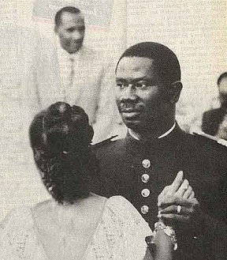Henriette had been Lancana Conté’s first love; the image of them waltzing together while Lancana was a young captain serving at the Guinean border still resonates today.

Although President Conté had three other wives, Henriette, who was known for her honesty, compassion, and integrity, remained at his side and continued to serve as Guinea’s First Lady throughout Lancana’s twenty-four years in office.

During this time, she was often called to mediate between her husband and her countrymen, employing her skills to ease tensions between Guinea’s unions and her husband’s military regime.

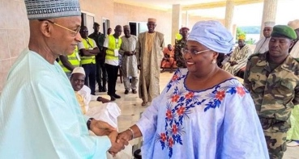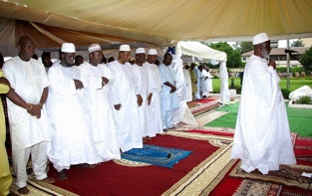Henriette Conté was Guinea’s moral beacon; as such, her death was grieved by all within the Guinean political sphere. Guinean President Alfa Condé attended the state funeral held in her honor, as did Cellou Diallo, head of the Guinean opposition. Lengthy obituaries were published in all the Guinean media.

Being a Baga from Boké, born to the Bangoura of Taigbe, Katako, she advocated for the Baga’s agenda in Conte’s centralist regime in Conakry.

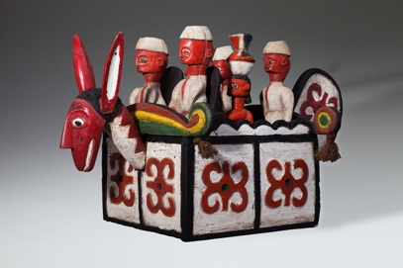Traces of the Guinean government’s close connections to the Baga community can be seen in the assortments of figures riding atop the Sibindel headrests from the 1960s and 1970s, which were used by dancers during receptions honoring government dignitaries visiting the Bagaland.

Henriette, like most of her female rural compatriots, was initiated into the the Baga women’s secret societies.

The various women’s associations of Guinea were the only traditional civil groups to survive Sekou Touré’s twenty-five years of Marxist dictatorship, a time in which the Baga village skyline , which was dominated for centuries by the silhouettes of the sacred cotton trees, gradually gave way to one of mosques and minarets.

These were years in which the male Baga population converted en masse to Islam, the old forest spirits and their advocates became branded as colonial collaborators, and foreign agents and village elders who adhered to the “ancient regime” were arrested and their sacred groves uprooted.

Unlike their male counterparts, 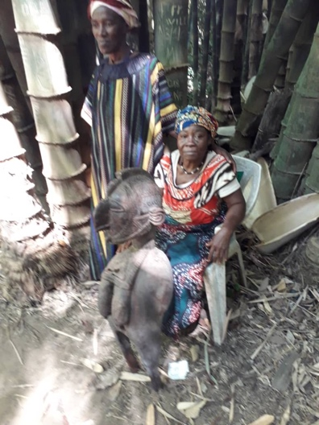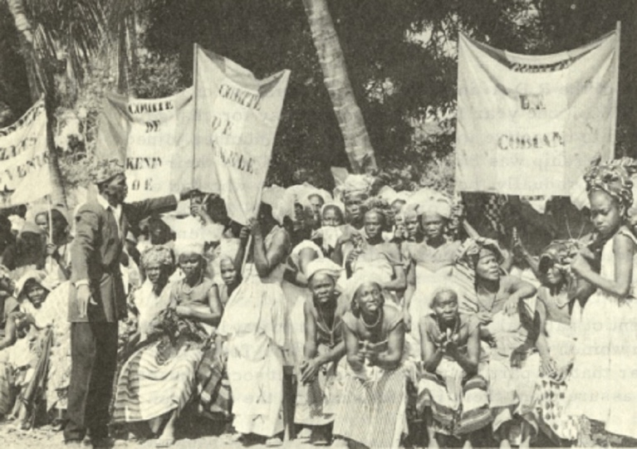the women’s secret associations challenged the revolutionary zeal of the central government. Advocating and maintaining their responsibilities for their community, they managed to retain their power, traditions, and morals. The women’s sacred groves and their domain thus remained virtually untouched.

Throughout her long career, Henriette was approached by delegations and representatives of the Baga women’s association who pressed their cases while bearing gifts., as customary at such meetings. Due to her position as a Baga elder, Henriette was entrusted with major artifacts from the Baga women’s sacred paraphernalia.

Upon her death, due to her status elaborate farewell celebrations were held. Traditionally, the cost of such week-long receptions was covered primarily by the sale of religious paraphernalia held by the deceased. The elder was merely the custodian of the objects entrusted by the community to his/her care, and thus upon his/her death the objects were regarded as communal property. As was customary, I was approached by the Baga elders to mediate the funeral costs and the receptions held in Henriette’s honor.

Slowly, a group of twelve pieces were uncovered, ten of which were masterpieces of the early twentieth century that had been hidden from sight since the iconoclasm of 1957. The final two were later versions of these from the eighties.

As some of the statues were in a progressive state of decay, a major painstaking restoration project led by master Nkai Sidime and Master Morri Curia, a renown Guinean restoration expert, was undertaken.

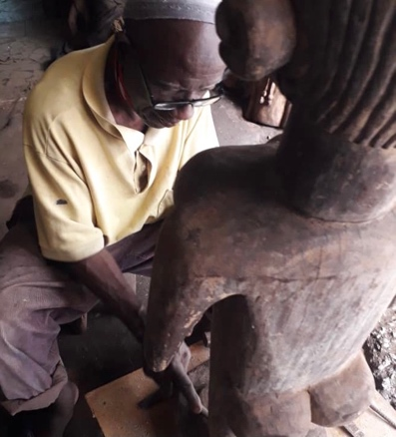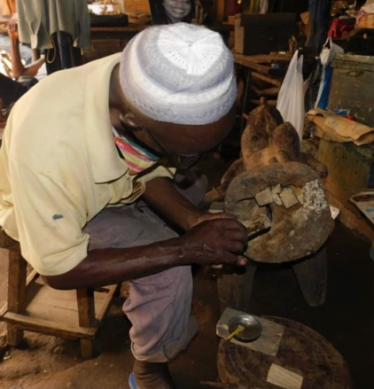

Henriette Conté’s collection, supplemented by the Katako hoard, that was exhibited at the Israel Museum in Jerusalem’s Nimba: Baga Art & the Great Mother exhibition, consists of most of the known oeuvre used by the Baga’s women’s association in the early twentieth century.

It is a cohesive group that represents Baga culture at its zenith.

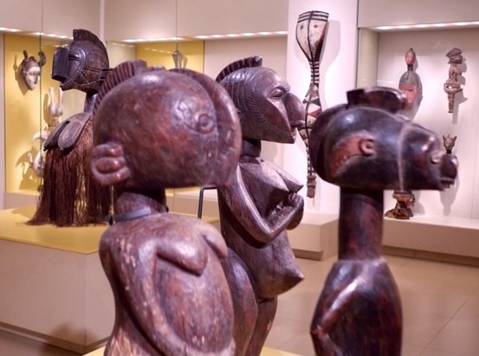

Close examination reveals three distinctive artists within the group, each with his own unmistakable approach, manner, and realm of interests. All operated within the liturgy and canon of Baga paraphernalia, but each employed his own unique and personal artistic vocabulary. The first embarked on a formalist journey toward the abstract. The second aimed at the metaphysical and the spiritual. Finally, the third indulged in his love of the figurative and delight in detail while moving towards realism and portraiture.

The still living Baga elders were approached with questions regarding the artists, their whereabouts, biographies, and other details. Contrary to former Western beliefs, all three artists were known figures, and respected members of their communities. Some were descendants of a long line of masters, whose craftsmanship had been loved, known, and appreciated for years.

Further research facilitated by the Boké governor revealed their years of birth, and more.

The three masters are :

Femori Camara, born in 1885 in Faraba.

Mangue Bangoura, born in 1895 in Camala.

Anadi fote’ Camara, born in 1890 in Taigbe

A comparative study of collections in other Western museums enabled additional attributions to the oeuvre of these three masters. For example, Famori Camara’s distinctive abstract vocabulary enabled the attribution of the following works:

Standing Male and Female Figures, Yale University Art Gallery, acquired 1954.

Nimba Headdress, Rierberg Museum, Zurich.

Janus Head , National Museum van Wereldculturen.

The Baga Artists

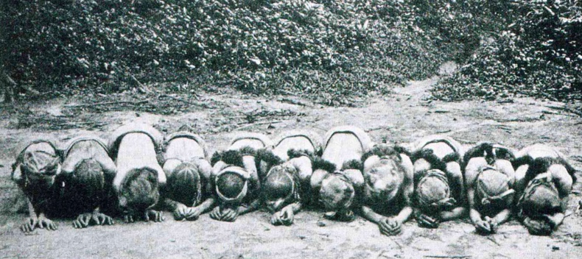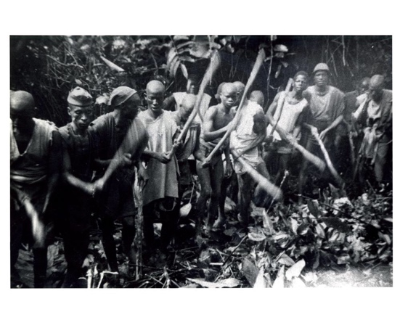Until the 1950s, all youth were sent to the “bush school,” attendance at which was a prerequisite for attaining adult status.

Male youth spent up to three years secluded in the bush, instructed by the elders on all the skills—social and professional—deemed necessary for leading an adult life. Upon returning to the village, they were expected to fulfill the traditional role established by their peers.

The bush school for girls lasted much less time and was held on the premises of the women’s society, an off-boundary secluded hut located at the village’s eastern perimeter. The girls spent several months in seclusion mastering their expected role as wives and mothers, and, most importantly, cultivating interdependence, secrecy, and loyalty to their fellow women. In this way, they came to serve as the backbone of Baga rural society as a unified, coherent labor force and a political group, responsible for the village commerce and social well-being.

The various women’s secret societies maintained their power and secrecy throughout the twentieth century, withstanding the onslaught of Sekou Touré’s Marxist regime. They ceased to operate only at the dawn of the twenty-first century, when the collapse of subsistence farming and the rise of mass Chinese rice imports opened Guinea to global international trade.

As in most acephalic West African societies, the Baga’s position in life was predetermined by birthright—offspring of first wife, second wife, etc.—as well as by the prominence of ancestors or family line. This highly deterministic social structure was balanced by a parallel structure based on age, membership in secret societies, and specific tutelage.

Such an elaborate double structure enabled each member to find his voice while

maintaining the equilibrium on which communal Baga society depended.

The Baga was a society with no concept of personal material accumulation;

wealth and status were measured in people (dependents), needed for political influence.

The society was a verbal one, in which language and conversation were held in high regard. Thoughts and ideas were implied rather than stated directly. Proverbs and elaborate stories were used to make a point. Decisions were reached by elders following lengthy meetings at which all adult members were expected to express their views, each in accordance with his position and rank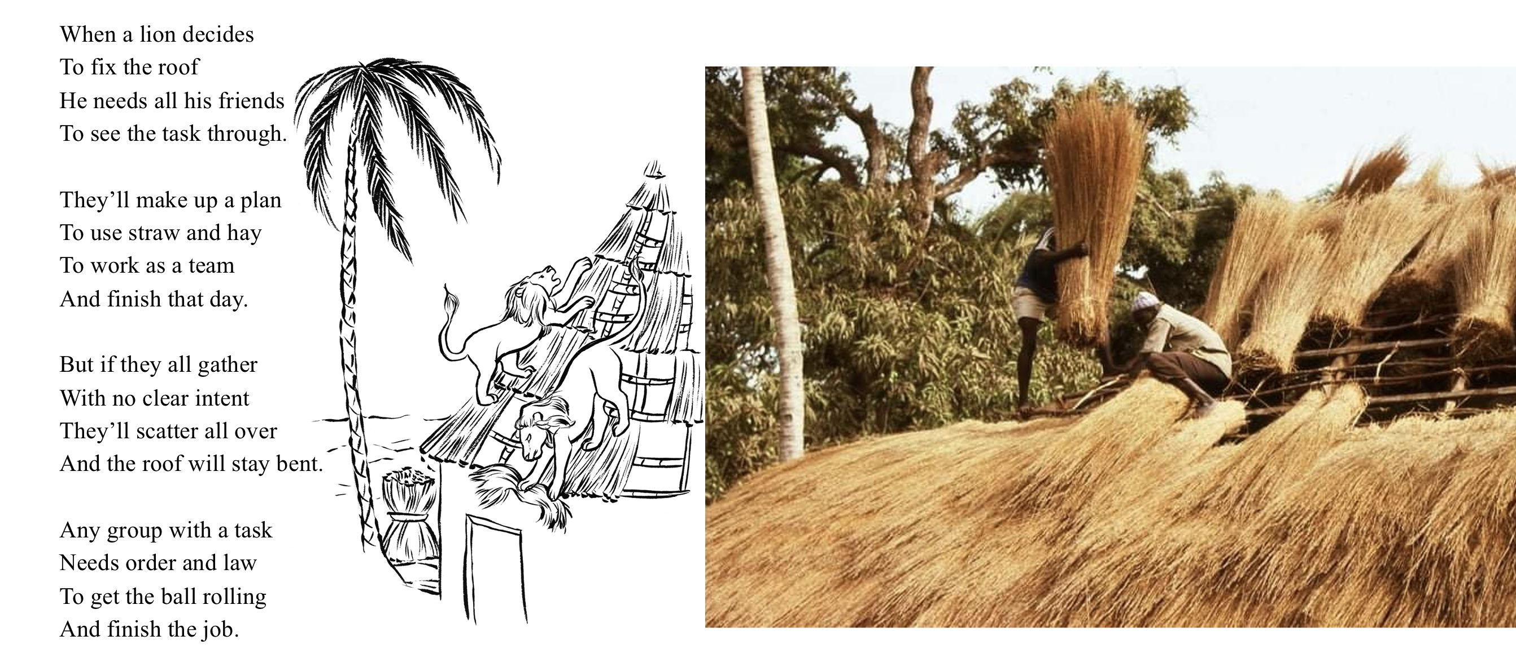.

For a verbal, non-materialistic society such as this, the need for a written text was less acute. This was a society in which ancestors were present, involved in everyday life, and treated with great respect, while people were merely transient. Bagas venerated the all-encompassing forest, nature, and forces of sub-Saharan equatorial Africa, and the only physical manifestations of culture, knowledge, and memory were the three-dimensional objects produced by members of the society with the skills taught primarily at the bush school: wood carvings in the case of boys, and pottery in that of girls. Further study under a known master was pursued only by those so inclined.

Nearly all material objects used in life were produced by members of the group.

Imported objects brought from afar, exchanged at crossroads markets set up by traveling Mandingo merchants, were of a mundane nature: jewelry, garments, medicines, or functional novelties. Everyday utilitarian objects and the customary religious paraphernalia, in contrast, were created by the Baga themselves with skills taught in the bush school,

For the Baga, life and art were totally interwoven. Religious objects accompanied all aspects of life and the celebrations conducted at everyday village gatherings: the setting of the bush school, graduation ceremonies, personal and extended family milestones, weddings and funerals, secret society gatherings, and religious conclaves deep in the woods.

To meet this demand, members produced an abundance of objects adhering to the conventional canon. Religious paraphernalia intended for the village masquerades were usually commissioned from local artisans, while important secret society commissions, such as power objects that proclaimed their members’ stature or the society’s power and were needed to impress new recruits, were commissioned from known masters whose fame as artists extended beyond their village.

At the heights of their powers, some of these artists even managed to replace farming altogether with full time carving . Only a few, however, elevated their practice to high art, and aspired to reach the profound while maintaining a dialogue with tradition and the canon.

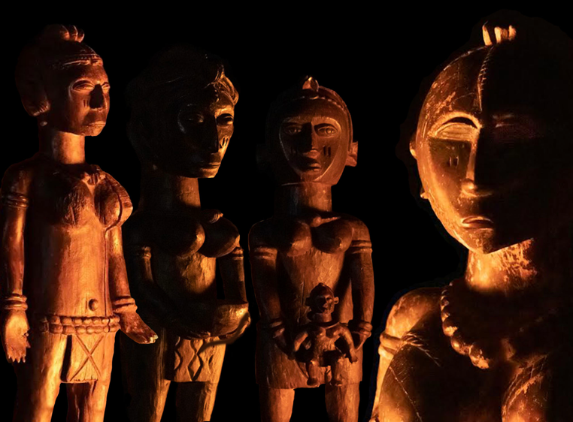The artists were known figures, recognized and appreciated by their peers. Like all artists, they were conscious of their vocation and not devoid of ego. As such, they were eager to leave their personal mark on posterity. Apart from their distinctive style and manner, they, being illiterate, developed a characteristic mark in order to express their authorship, usually a rendering of an ear or eye.

They were also conscious of the fact that once their art was accepted, ordained by the clergy, and consecrated for ritual usage, it would attain divine status. At that point, it would be disassociated from its worldly creators. In the Guinean hinterlands, for example, women’s associations such as the Sande - Sowei masks, were known to appear deep in the woods near a source of running water, and to proclaim their presence to the association members in dreams without naming their male makers.

The desire to create a work that could rise to divine status ruled out the creation of representational portraits; desirable instead were emblematic portraits that relied on symbolic, evocative imagery, though a generalized anthropomorphic approach was the norm.

One can only marvel at the eidetic capabilities demonstrated by these masters, who created highly complex compositions, knowing, as they did, the importance and religious status of their art within their community, and the amount of love, respect, and care that would be bestowed on their works once they were completed.

These masters were able to transform a mentally constructed image into a block of wood, and to carve the final image without any preparatory stages. (Sketches or paper have never been part of traditional West African art.)

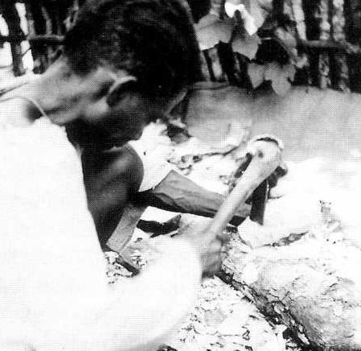Usually the artist chose and felled a tree only after deciding what he needed. The actual image materialized during the carving process.

When commissioning a work from these masters and determining reimbursement, members of the society usually took into account expected delays as well as the time that the artist needed to contemplate and find his vision before producing the piece.

A variety of sub-Saharan adzes were used to carve these monumental works of art.

Sitting or crouching on the ground, the artist carved with one hand, while using the other as well as his lap, thighs, and knees to hold the object in place. The production of such elaborate, precisely crafted sculptures with a simple adze required great concentration and technical skill. Despite the Baga’s long history of trade with the West, they never resorted to industrial tools. (Manipulating Western carving tools requires two hands.)

The artists worked within their tradition, in close geographical proximity to each other, and aware of each other’s accomplishments. All enjoyed the = full artistic license granted them by their community. Their visual language developed from their memory of their own masters’ works.

Once a piece was delivered to the client (women’s association, etc.), the artist never saw it again. A man could never venture into the women’s sacred grove where these idols resided.

The Western concept of a studio that contains multiple works in various stages of completion and enables contemplation was totally alien to these artists. Each new commission had to be drawn from memory and made from scratch. Each work was unique. The artists respected the artistic heritage of their ancestors and considered it sacred.

The bodies of work produced by these artists were organically bound to their community and faithful to their tradition, yet never marred by atavistic rigidity or soulless formalism.

Their creations, in fact, are wonderful examples of artistic license and tradition working in tandem to portray the divine.

It is a great privilege to make this small gesture and replace the customary museum plaques attributing these African masterpieces to anonymous artists with ones that bear actual names.

Each of these artists worked in his community, within the canonical guidelines of his cult, and was attuned to the spirit of his time; each possessed his own artistic manner and a fully developed, personal voice.

**1.**

**El Hadje Ali Manigué Bangoura**

El Hadje Ali Manigué Bangoura, born in Tolkotch, Taigbe Kamala, 1895. 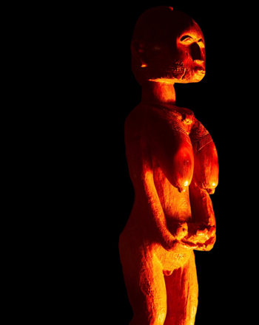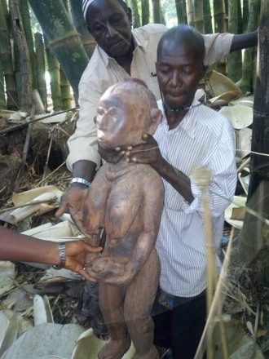

One of the most striking sculptures to emerge from the Katako hoard is that of an elderly female baga, 102 cm tall. The statue, whose face is a blend of human and Nimba, and whose exaggerated breasts and genitalia proclaim age and maturity, depicts the Baga ideal of the great mother; one who has given birth to many and is now an elder nourishing her community.

The figure’s face and breasts have been polished by countless caressing hands, whose ritual repetitive movements from top to bottom, from the cheeks down to the breasts, can be easily traced. When illuminated as intended by the flickering light of natural flames, the true nature and power of the statue becomes apparent: a mother solemnly holding a dead child’s body in her outstretched hands in a gesture of compliance, dignity, and grief.

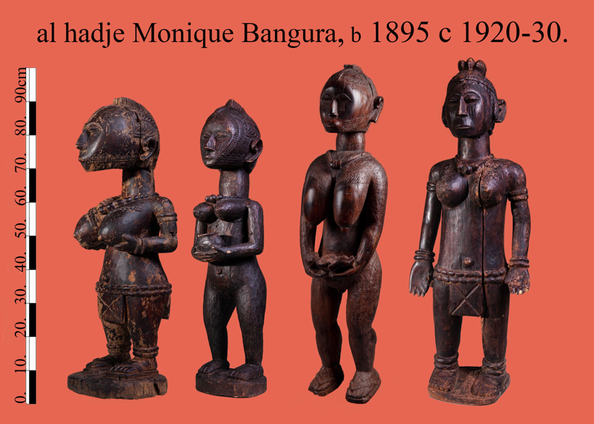This work was later joined by three additional pieces from the estate of Guinea’s First Lady Henriette Conté to form a group of four major works, all clearly crafted by the same hand.

As was common, the unique rendering of a human ear served as the artist’s personal mark, thereby expressing authorship without compromising the work’s liturgical powers. Among the other characteristics portrayed in the sculptures is the quest for human emotion, as evident in the powerful figure of the elder demanding total obedience, or the young disciple solemnly offering a tribute.

The community elders who were consulted identified the artist as Manigué Bangoura, a renowned artist from Faraba, (the River Nunez Delta) who later converted to Islam and made the pilgrimage to Mecca.

On a trip to El Hadje Bangoura’s birthplace, we were fortunate to meet his grandson, Abou Bachar Petro Bangoura, born in 1953, who continues with his grandfather’s profession and supplies local communities with the objects needed to maintain their community traditions.

Petro Bangoura is the son of George Bangoura (El Hadje Bangura’s son), also a known Baga sculptor. Petro Bangoura proudly sees himself as heir to his grandfather’s legacy and takes special pride in using his ancestor’s cherished handcrafted chair.

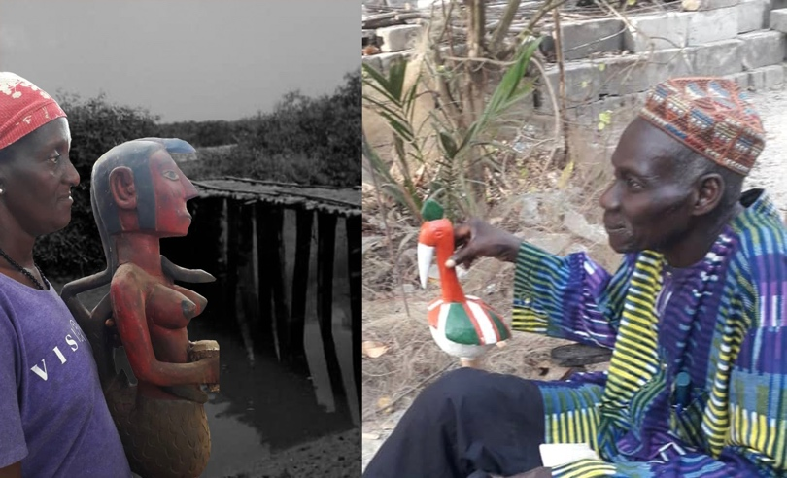

**2.**

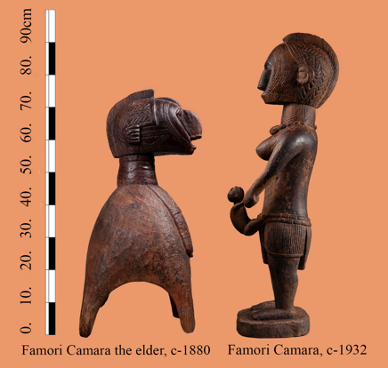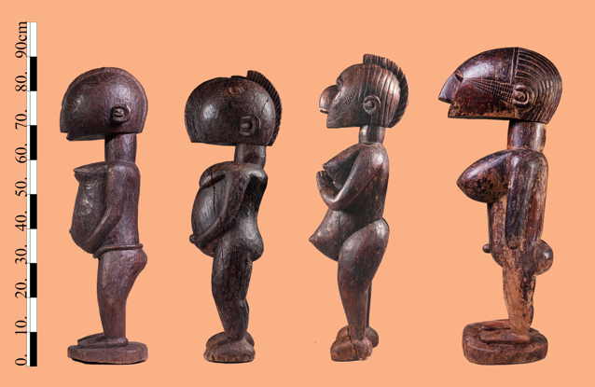**Amani Famori Camara**

Amadi Famori Camara, born in Faraba Guinea in 1890.

Four statues with outstanding abstract characteristics, once part of the Katako hoard were later joined by two additional exceptional pieces from Henriette Conté’s estate. Close examination reveals that all six display characteristics of a unique master hand, a mature artist with a personal vocabulary who commanded a technique to match. Five have been dated with infrared spectrography to circa 1930–1950, while an older small Nimba of extremely condensed wood has been dated to 1880.

All are carved out of dense and heavy African teak, all measure nearly the same height range of 80–90 cm. Theywere immediately recognized by the Baga elders and by master Bangoura as works of the master Famori Camara, a renowned Baga sculptor who was part of the creative hub in Faraba prior to Guinean independence. Master Bangoura proudly aligned himself and his work with that of Camara, and even claimed to be one of his descendants.

An analysis of Camara’s work clearly reveals his language. He possessed the ability to reinterpret and modernize the traditional Baga canon, while using semi-abstract shapes and myriad geometric patterns.

Camara developed a language in which the traditional ornate vocabulary was gradually reduced to a collage of primary shapes. He constructed the orthodox Nimba’s “Fulani” facial ornament from straight and rigorous geometric lines. Camara also reduced the ear to a circle surrounded by a concave half moon. the Baga elders described this feature as “Famori’s personal mark,” an observation further supported by a comparison of it to the ears of works similar to Camara’s that are currently in Western museums, such as those in the Rietberg Museum, the Yale African Art Gallery and the museum of Berg en dal Netherlands—all works that might therefore be claimed as belonging to Famori Camara’s oeuvre.

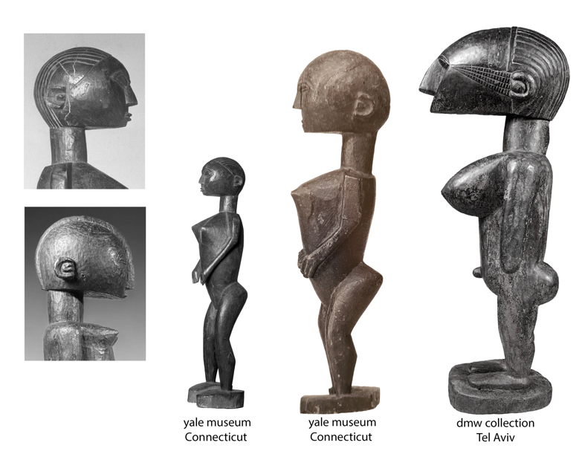

The wonderful small nineteenth-century Nimba, whose right face has been leveled by countless loving strokes of hands during its long years of service, is attributed to Camara’s father (an artist considered by everyone as a forebear of the Katako sculptors ) and has a slightly different ear mark.

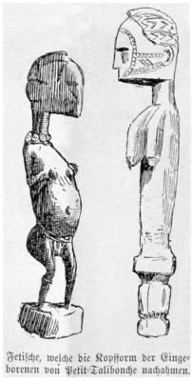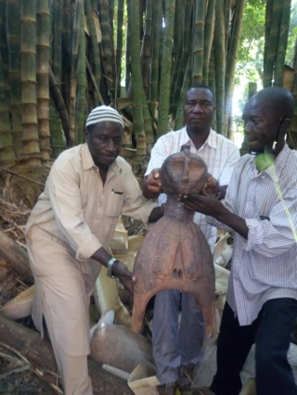A drawing of additional works resembling those made by this hand was published in 1886 by G. Caspar Felix in his account of his trip down the River Nunez, a trip embarked upon again only half a century later by Fred Bowald.

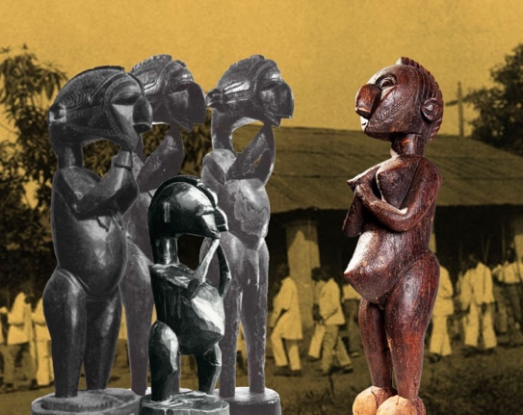Master Famori Camara worked in the the 1930s and 1940s, a time when the colonial regime and its representatives in Katako, the French catholic mission, were at the zenith of their power and Christianity was slowly being integrated into Baga life. A glimpse of how Camara’s art could have evolved had the jihad and the subsequent destruction of Baga culture not occurred can be gleaned by comparing this singular interpretation of a standing Nimba, her hands clasped in a classic Christian gesture of prayer, with eyes turned upwards and her lips smiling, to the traditional Nimba, whose hands are clasped beneath her chin in a vow of silence, her eyes downcast, and her mouth closed to signify secrecy. One is a figure denoting power to whom worship is due, while the other is a mediator between God and her community.

Camara’s work clearly shows that he was preoccupied with formalist and conceptual problems similar in nature to those of fellow Western European modern artists.

His oeuvre challenges the last century’s boundaries between and definitions of traditional versus modern art, White and Black, Western and African.

**3.**

**Foté Camara**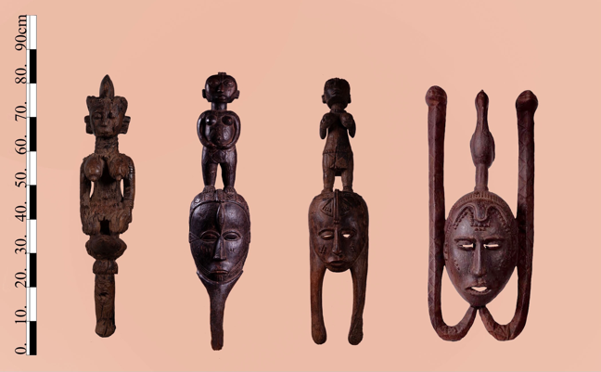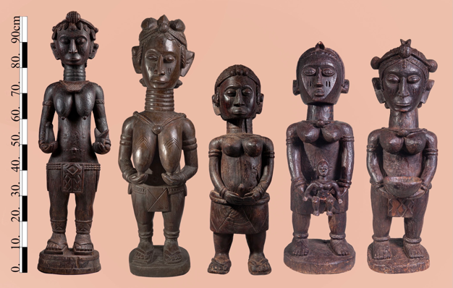

Barbady Foté Camara, born in Tolkotch-Taigbé Falaba 1890.

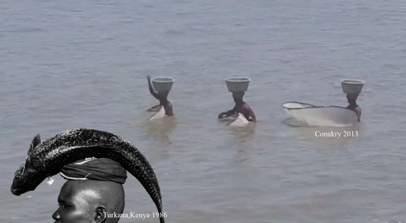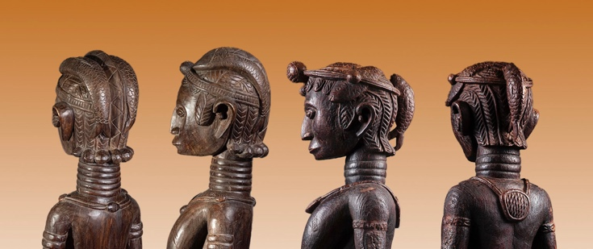Master Foté Camara was one of the most prolific and renowned Baga artists of the first half of the twentieth century. His fame spread widely throughout the Bagaland. Camara’s distinctive figurative style became extremely popular with the women’s secret associations, which, acting as the artist’s patrons, commissioned him to create numerous works for their ritual paraphernalia. Possession of a piece of such caliber and its presentation to new initiates during ceremonies was considered a sign of great status and a symbol of power for the entire secret society.

Many of Camara’s surviving works depict fish interlocked in elaborate female coiffeurs. Such figures have elongated ringed necks symbolizing beauty, downcast eyes, and a closed mouth denoting secrecy and unity. Their braided hair represent self-care and cultivation, and images of fish refer to an abundance of game and fertility (fishing was one of the women’s societies’ duties). Camara’s ability to combine all these symbols in a unified 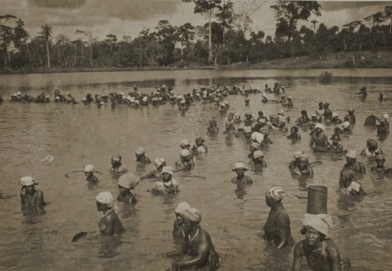sculptural figure is indeed unique.

George Labitte , Nezekore, Guinea, 1940

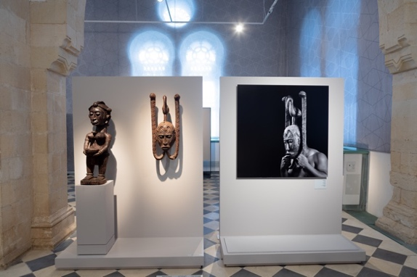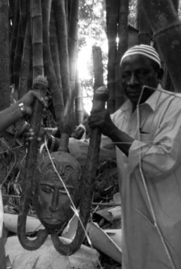Most of the masks of the men’s associations were destroyed in the 1957 jihad since they were regarded as armaments. Targeted by rebellious youth, their destruction was one of the first actions by the revolution. The importance of those that survive (Mask Museum, Scotland ) has never been realized. Three such masks by Camara were uncovered from the Katako hoard. Two of them are featured in the Israel Museum Jerusalem exhibit, Nimba, Baga Art and the Great Mother. A third one is now in the Be’er Sheva Islamic Art Museum’s Gold Road Encounters exhibit.

Camara’s hand and manner are easily recognizable. His compositions are static, frontal, and lavishly decorated, recalling classic European portraits. His beautifully rendered creations embody archaic monolithic omnipotent beings.

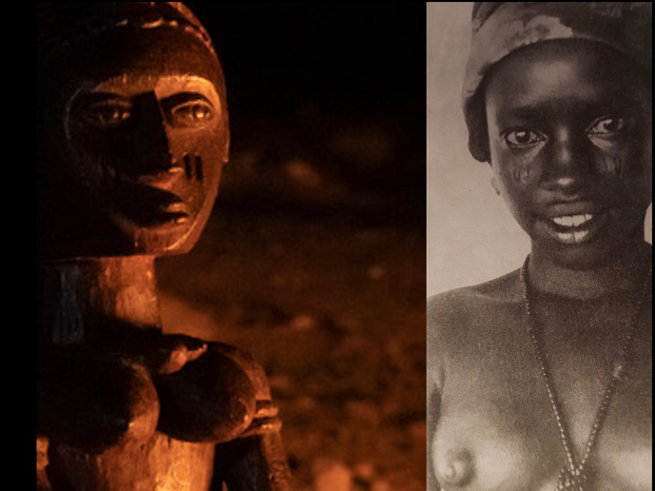Camara’s talent was so unique that his art was recognized by everyone without the help of any distinctive mark as signature. One is always drawn to his naturalistic all-consuming eyes, which, when illuminated by a red cascade of flickering flames (unlike the even, monochrome lighting in the museum), as they were in the women’s sacred forest, immediately spring to life.

Foté Camara’s greatness is evident in his archetypical portraits of Baga females, each representing a specific age group—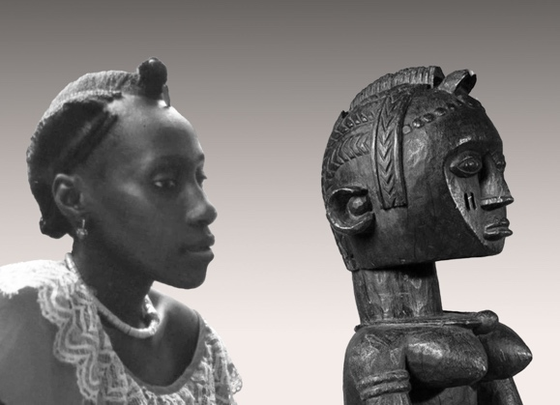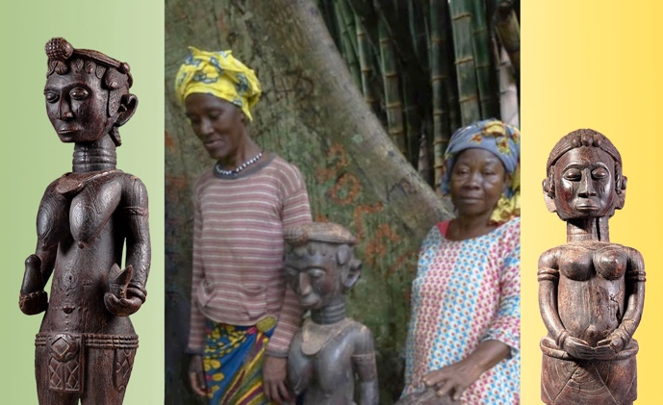young initiates, members, and elders—each typical of the group rather than a portrait of a specific individual.

When the idealized images are set alongside actual photos of Baga members taken years apart ( the statues were made in the 1930s, years before the older and younger members posing with them in Katako’s forest were ever born), Camara’s ability to capture the essence of his Baga patrons becomes apparent.

The works demonstrate incredible eidetic ability, especially bearing in mind that all the statues were carved from extremely hard wood with a single hand equipped with a traditional adze and no preparatory sketches. Camara’s figurative aspirations marked a clear break from tradition, which was usually strictly observed. So, for instance, the sound of the modern flute was banned from all festivities due to its similarly to the sound of a spirit. Nevertheless, Foté Comara’s art was praised by his peers and achieved immense popularity.

Post independence, his art was carefully guarded, kept away from the sight of the uninitiated for more then half a century, and made public only upon Henriette Conté’s death.

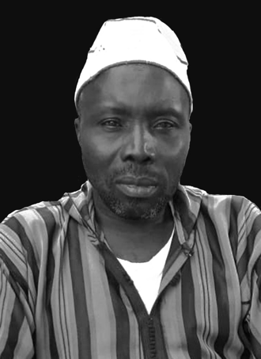Master Camara was succeeded by a son, born in 1930, with whom the practice ended. His grandson, Andre Foté Camara, was happy to recall his illustrious grandfather is a devout Muslim who is making his living by fishing in the River Nunez Delta.

Andre Foté Camara, Faraba, Guinea , 2020.