**A latent profile analysis: teacher-pupil mediation in child sexual abuse and assault**

Yaniv Efrati

Faculty of Education, Bar-Ilan University, Ramat Gan, Israel

___________________________________________________________________

Corresponding author: Yaniv Efrati, Bar-Ilan University, [Faculty of Education](https://www.researchgate.net/institution/Bar_Ilan_University/department/School_of_Education)

Ramat Gan, Israel. Email: [ypefrati@gmail.com](mailto:ypefrati@gmail.com) Phone: +972-545-800-094.

**ABSTRACT**

Although significant advances have been made in the study of, mediation between teachers and pupils on the subject of child sexual abuse and assault, this remains a largely neglected issue in sex education research. In this study, I performed a Latent Profile Analysis (LPA) for estimating distinct profiles in teacher mediation of child sexual abuse and assault (CSAA). Profiles were then compared in terms of quality of communication between pupils and teachers in the area of CSAA, general support, CSAA-related support, age, economic status, perceived severity and susceptibility of pupils to CSAA among teachers, years of education, seniority, pupils’ sense of acceptance and rejection by teachers, teachers’ and pupils’ biological sex, and religiosity. The study surveyed 756 pupils (341 boys and 415 girls), aged 11–18 (M = 15.32, SD = 1.82), and 66 homeroom teachers (21 male and 45 female), aged 25–64 (*M* = 41.88, *SD* = 8.93).Five distinct profiles were identified: moderate-active mediation (*n* = 256); high-active mediation (*n* = 222); high mediation (*n* = 109); minor positive-active-focused (*n* = 86), and no mediation (*n* = 41). The findings provide deeper insights into the ability of teachers to mediate the issue of child sexual abuse and assault and an opportunity to develop more effective sex education programs.

**Keywords:** child sexual abuse**,** mediation, teacher-pupil communication, sexual abuse

**INTRODUCTION**

Child sexual abuse (CSA) has serious consequences for the mental, psychological, physical, and sexual health of sufferers. The World Health Organization (1999) defines the phenomenon as follows:

Child sexual abuse is the involvement of a child in sexual activity that he or she does not fully comprehend, is unable to give informed consent to, or for which the child is not developmentally prepared and cannot give consent, or that violates the laws or social taboos of society. Child sexual abuse is evidenced by this activity between a child and an adult or another child who by age or development is in a relationship of responsibility, trust or power, the activity being intended to gratify or satisfy the needs of the other person.

In this study, the term CSAA is preferred to CSA as I add *assault* to the definition taking into account offenses committed by juvenile and peer offenders.

There has been considerable scholarly attention paid to the prevalence of CSAA (Barth et al., 2013; Singh et al., 2014; Stoltenborgh et al., 2011; Vogeltanz et al., 1999). CSAA is estimated to affect between 8% and 31% of girls and 3% and 17% of boys (Barth et al., 2013). A meta-analysis of the prevalence of CSAA in 22 countries by Pereda et al. (2009) uncovered that 7.9% of men and 19.7% of women had been victims of sexual abuse as minors. A recent Israeli national survey on child abuse in Israel, indicated that 18.7% of Israeli children between the ages of 12 and 17 report that having experienced sexual abuse (Lev-Wiesel et al., 2018). Schein et al. (2000) place the rate at one in four in Israel. CSAA rates were equal across the genders (17.6% for boys and 17.7% for girls) in the Jewish population, while, in the Arab population, boys tend to be targeted at higher rates than girls (28.4% to18.7%) (Lev-Wiesel et al., 2018). The damage caused by child abuse to the mental health of sufferers in both the short and the long term is well established in the literature. CSAA has been linked to post-traumatic stress disorder (PTSD), depression, anxiety, attempted and successful suicide, substance abuse, neurobiological issues, physical health problems, eating disorders, and psychosomatic health problems (Briere & Runtz, 1993; Putnam, 2003).

Given that children spend much of their time at school, teachers can play a pivotal role in preventing or disclosing CSAA; arguably, addressing the issue at school is critical in protecting children’s rights and emphasizing teachers’ responsibilities (Goldschmidt-Gjerløw 2019). Informing children about CSAA in class and one-on-one discussions can help prevent this type of abuse by equipping children with the tools to recognize and report it. Increased awareness among teachers about the signs of violence and abuse in their pupils is also fundamental in facilitating the recognition and disclosure of abusive situations.

To halt the abuse and prevent revictimization, trusted adults must learn how to provide a safe and encouraging environment for children to disclose CSAA. Research indicates that children seldom report being victims of abuse to teachers. A nationwide survey in the United States found that 66.3% of children between ten and 17 did not tell parents or other adults about their abuse. Of those who did report being victims of abuse, 31% told their parents, 19.1% told the police, and 21.8% told a teacher (Gewirtz-Meydan & Finkelhor, 2019). Another study of sufferers of CSAA indicated that 75% of respondents did not disclose abuse when they were children and, out of the remainder, only 7% chose to approach a teacher (Wager, 2015). Alaggia (2010) suggests that teachers are expected to recognize distress in their pupils and to ask them questions to help them talk about a potentially abusive situation.

The findings of these various studies indicate a disturbing fact that children are reluctant to approach teachers and disclose abuse (Schönbucher et al., 2012). Safeguarding children from abuse and assault requires the involvement of adults in various capacities, from parents, teachers, and health care providers to police and magistrates. This study focuses on the role of teachers as a frontline defense against CSAA. Previous studies in this area have tended to analyze the perspectives either of pupils (Schönbucher et al., 2012) or teachers (Goldman & Bradley, 2011; Tener & Sigad, 2019). This study, in contrast, offers an integrated approach, analyzing the gap between pupils and their homeroom teachers’ perspectives on the issue of abuse.

In this study, the CSAA mediation strategies of surveyed teachers are compared to the level of support and acceptance from teachers as perceived by the pupils. the three mediation strategies forming the framework of the analysis are restrictive, negative-active, and positive-active strategies (Boniel-Nissim et al., 2020; Efrati & Boniel-Nissim, 2021; Nathanson, 2016). The restrictive approach to CSAA mediation emphasizes the categoric illegality of sexual abuse and focuses on the establishment of clear rules and boundaries which are subject to debate. A negative-active mediation approach focuses on the damage CSAA causes in victims’ lives. The positive- active approach aims to encourage learning about healthy and enjoyable sexual behaviors, highlighting that consensual sex is a positive value to be clearly distinguished from nonconsensual sexual contact.

Most of the existing research on mediation strategies studies parents (Chen & Chng, 2016; Shin & Li, 2017). Other scholars have examined risk factors related to the media and online behaviors (Livingstone & Helsper, 2008). Studies findings concerning optimal mediation strategies vary, with some suggesting that the best outcomes are achieved with the positive-active approach (Nathanson, 2001) and others finding that a mix of strategies works best (Chen & Chng, 2016).

**This study**

Open discussion between teachers and pupils on the subject of CSAA is widely considered beneficial in terms of preventing abuse or its reoccurrence (Goldschmidt-Gjerløw, 2019; Goldschmidt-Gjerløw & Trysnes, 2020). However, studies indicate that teachers are rarely confided in by pupils regarding CSAA (Gewirtz-Meydan and Finkelhor, 2019; Wager, 2015). This study aimed to identify the profiles of perceived CSAA mediation and the most beneficial profile teachers use to mediate CSAA. I hypothesized that: (a) differences would be found between sociodemographic and latent profiles of perceived CSAA mediation; (b) differences would be found between latent profiles of perceived CSAA mediation in teachers’ measures; (c) differences would be found between latent profiles of perceived CSAA mediation in pupils’ measures.

**METHOD**

**Participants**

**Pupils**

A sample of 756 pupils (341 boys and 415 girls), aged between 11 and 18 (M = 15.32, SD = 1.82) were surveyed. Their school grade distribution was: sixth grade (n= 28), seventh grade (n= 32), eighth grade (n= 135), ninth grade (n= 148), tenth grade (n = 79), eleventh (n = 108), and twelfth grade (n = 226). Most of the surveyed students were native Israelis (94%). In terms of their socioeconomic status, 6.1% reported being lower than average, 58% average, and 36% above average. Students self-reporting as religious constituted 39% of the sample (299 individuals) and 457 individuals, or 70% of the total sample, described themselves as secular.

**Teachers**

The sample of teachers surveyed comprised 66 individuals, 21 of whom were men and 45 were women. The surveyed teachers ranged between 25 and 64 years of age (*M* = 41.88, *SD* = 8.93). The study was approved by the ethics committee and each participant provided informed consent. Of the participants, two (3%) were single, 62 (94%) were married, and two (3%) were divorced. Ninety-five percent of the teachers were native Israelis. In terms of financial well-being, 17 (26%) reported being well off, 47 (72%) said that their finances were good, and 2 (2%) self-reported as being poor. Forty individuals (60%) described themselves as religious and 26 (40%) as secular. Years of education among the participants ranged from 12 to 26 and the average years of education was 17.09 (*SD =* 2.58). Finally, the range in terms of seniority in the teaching profession was between two and 34 years with the mean years of experience being 15.34 (*SD =* 8.86).

**Measures**

**Teacher Instruments**

*Teacher Mediation of CSAA*

For this research we adapted a questionnairebased on Boniel-Nissim et al. (2019). To assess teachers’ strategies for mediating CSAA and protecting children (restrictive, negative-, and positive-active) we administrated the PMP scale. Restrictive mediation was measured with reference to two items (α = 0.81) (e.g., “I set clear rules for my pupils regarding sexual abuse”); Negative-active mediation was measured with reference to three items (α = 0.79) (e.g. “I try to explain to my pupils why sexual abuse is a bad and dangerous thing”). Positive-active mediation was measured with reference to two items (α = 0.83) (e.g. “I try to explain to my pupils about the need to tell and not keep ‘secrets’ with an emphasis on healthy and beneficial sexual behavior”). In this study I omitted co-use mediation because it is not applicable. Teachers were required to self-report the degree of truth of each statement on a 5-point scale ranging from “not at all” (1) to “very much” (5). We calculated three scores for sexual abuse mediation strategies by averaging the teachers’ answers.

*Teacher Perceived Severity of CSAA*

Perceived severity of CSAA was measured with reference to two items (α = 0.81) from an instrument adapted from previous research (Hwang et al., 2017; Kim et al., 2012) to ascertain the teachers’ appraisal of threat. The items were adjusted to the subject matter of sexual abuse. Sample items included “sexual abuse is a serious problem” and “sexual abuse can lead to severe consequences.” The items were rated on a 5-point Likert scale ranging from “strongly disagree” to “strongly agree.”

*Teacher Perceived Susceptibility of CSAA*

Threat appraisal also includes whether the teachers perceive their students to be susceptible to CSAA. Perceived susceptibility was measured with reference to two items (α = 0.83) adapted from previous research (Hwang et al., 2017; Kim et al., 2012) to the subject of sexual abuse. Sample items included “My pupils were susceptible to sexual abuse” and “My pupils were at risk of sexual abuse and sexual assault.” These statements were rated on a 5-point Likert scale ranging from “strongly disagree” to “strongly agree”.

*The Teacher-Pupil CSAA Communication Scale*

The quality of teacher-pupil communication about sexual abuse was assessed using an adaptation and Hebrew translation of the PCS scale (Jaccard, Dittus, & Gordon, 2000). The scale, which, according to Jaccard et al. (2000) is very reliable, contains 16 items that were tested on a 5-point Likert scale (e.g. “My pupils would not want to answer my questions about sexual abuse”). Efrati and Gola (2019) produced the Hebrew translation of the scale. The questionnaire was adapted for teachers and to focus on sexual abuse. A score for communication about sexual abuse was calculated for each teacher by averaging their answers. Cronbach’s alpha of the PCS in this sample was 0.87.

*The Teacher-Pupil Communication Scale*

This scale, based on Barnes & Olson (1982), is made up of two 10-item subscales – the Degree of Openness in Teacher-Pupil Communication scale, and the Extent of Problems in Family Communication scale. The Open Teacher Communication (OTC) subscale measured levels of pupil freedom of expression and understanding on the part of teachers (e.g. “When I ask questions, I get honest answers from my pupils”). The Problems in teacher Communication (PTC) subscale measures negative patterns of interaction and reluctance to confide in teachers (e.g. “My pupils are careful about what they tell me”). Respondents rated their answers on a five-point Likert scale. Scores ranged from 10 to 50 for both subscales. A higher score in the OTC subscale indicated a higher degree of openness in teacher-pupil communication whereas high scores on the PTC subscale indicated communication problems. The questionnaire was adapted to teachers and to reflect a focus on sexual abuse. Cronbach’s alpha of the scale in this sample was 0.83.

*Teacher Support*

This questionnaire was adapted from Zimet et al.’s (1988) Multidimensional Scale of Perceived Social Support (MPSS). The self-report Scale of Perceived Teacher Support had ten items that measure perceived support from teachers (e.g. “My pupil trusts me when things go wrong”). Participants responded to the questions using a 6-point Likert scale (1 – strongly disagree*,*6 – very strongly agree). A total teacher support score was reached by averaging the 10 items (Cronbach’s alpha =.96).

*Teacher CSAA Support*

The questionnaire was adapted from the Multidimensional Scale of Perceived Social Support (Zimet et al., 1988). The Scale of Perceived Teacher Sexual Assault Support had ten self-report items measuring perceived sexual assault support from teachers (e.g. “I am always around when pupils need me about abuse and sexual assault”). Participants rated their agreement with the prompts on a 6-point Likert scale (1 – “strongly disagree”;6 – “very strongly agree”). A total Teacher Sexual Assault Support score was produced by averaging the 10 items (Cronbach’s alpha =.94).

**Pupil measures**

*Teacher Mediation of CSAA*

The same PMP questionnaire (Boniel-Nissim et al., 2020) that was given to teachers was adapted to the pupils’ perspective. Cronbach’s alpha of the PMP in this sample was 0.78 for restrictive mediation, 0.81 for negative-active mediation and 0.80 for positive-active mediation.

*The Teacher-Pupil CSAA Communication Scale*

The same PCS questionnaire (based on Jaccard, Dittus & Gordon, 2000) used for the teachers was adapted to the of pupils’ perspective. Cronbach’s alpha of the PCS in this sample was 0.90.

*The Teacher-Pupil Communication Scale*

The questionnaire (based on Barnes & Olson, 1982) given to teachers was adapted to the pupils’ perspective. Cronbach’s alpha of the DASS-T in this sample was 0.84.

*Teacher Support*

The MPTS questionnaire (based on Zimet et al., 1988) to which the teachers responded was adapted to the pupils’ perspective. Cronbach’s alpha of the MPSS-T in this sample was 0.93.

*Teacher CSAA Support*

The MPTS questionnaire (based on Zimet et al., 1988) that was given to teachers was adapted to the pupils’ perspective. Cronbach’s alpha of the MPSS-T in this sample was 0.94.

*Children’s Appraisal of Teachers as a Secure Base*

This 25-item scale (based on Al-Yagon & Mikulincer, 2006)) assessed pupil’s perceptions of their homeroom teacher as attachment figures on a 7-point scale ranging from “does not apply at all” (1) to “applies very much” (7). Other studies have demonstrated the validity and reliability of this scale (Al-Yagon & Mikulincer, 2006). There are 17 items on the availability and acceptance subscale assessing how caring and available teachers are when needed (e.g. “My teacher is always there to help me when I need her”). Reliability was high: α = .95. The rejection subscale was made up of eight items assessing the extent to which the pupil felt rejected by the teacher (e.g. “My teacher makes me feel unwanted”). Reliability for this scale was also good (α = .90).

**Procedure**

The study was presented to participants as a research project on sexual abuse communication and mediation between 11–18-year-old pupils and their teachers. The participants constituted a convenience sample. Recruitment was multi-channel (bulletin boards; online forums). Questionnaires were uploaded to Qualtrics – an online platform for questionnaires – and distributed by research assistants. Parents and teachers were both informed of the study using the class’s group WhatsApp. Parents who agreed to participate in the study were contacted via email and/or phone and asked to review the questionnaires and sign an informed parental consent form. Informed consent was obtained from teachers too. A link to the online survey was sent to participating pupils who were given assurances that they would remain completely anonymous. Participants were then asked to complete the survey alone in a quiet room in their home where they would not be disturbed. Questionnaires were presented in random order after the consent form was completed. All questionnaires were in Hebrew. Lastly, an online debriefing was given and participants were thanked. The procedure was approved by Institutional Review Board of [masked for review].

**Data Analysis**

Overall, the data was drawn from 756 pupils and 66 teachers (the number of pupils in each class ranged from 1 to 28, *M* = 11.45, *SD* = 7.38). ICC(1) coefficients (i.e. proportion of the total variance explained by the grouping structure) of the main outcome measures (i.e., pupils’ perceived mediation of sexual abuse as being restrictive, active-negative and active-positive) indicated that teacher-level data explained between 9.44% and 14.37% of the variance in the outcome measures . Accordingly, multilevel analyses were selected as the main analytical approach. First, we applied Latent Profile Analysis (LPA) for estimating distinct profiles in pupils’ perception of sexual abuse mediating strategies – restrictive, active-negative, and active-positive, using the *tidyLPA* R package (Rosenberg et al., 2019) with MPlus (Muthén & Muthén, 2019) integration. We examined one to seven possible profiles. The optimal number of profiles was determined by Akogul and Erisoglu’s (2017) Analytic Hierarchy Process (AHP), a bootstrapped likelihood ratio test (BLRT), a sample size of each profile, and theoretical plausibility. The AHP uses the following information criteria in its decision tree: Akaike’s Information Criterion (AIC), Approximate Weight of Evidence (AWE), Bayesian Information Criterion (BIC), Classification Likelihood Criterion (CLC), and Kullback Information Criterion (KIC).

Next, we examined differences between perceived mediation profiles in the study’s continuous measures using a series of nested analysis of variance (ANOVA) using *lme4* (Bates et al., 2015) and *lmerTest* (Kuznetsova et al., 2017) R packages, and using the *glht* function of the *multcomp* package (Hothorn et al., 2008) for post hoc analyses. In these post-analyses, we used Tukey’s Honest Significant Differences (HSD) and Benjamini-Hochberg (BH) adjustment for multiple comparisons. The continuous measures were pupils’ and teachers’ quality of communication, quality of communication on sexual abuse, general support, sexual abuse-related support, age, and economic status. In addition, we examined differences in teachers’ perceptions of the severity of sexual abuse among pupils, susceptibility of pupils to sexual abuse, years of education, and seniority. Finally, we examined differences in pupils’ sense of acceptance and rejection by teachers.

In the final section of the results, we examined differences between perceived mediation profiles in the study’s binary measures of teachers’ and pupils’ biological sex and religiosity (secular, religious) using a series of Bayesian logistic mixed-effects models using the *blme* R package (Chung et al., 2013) and the *glht* function of the *multcomp* package (Hothorn et al., 2008) for post-hoc analyses. Results are presented in Table 2, and significant results also in Figures 2 and 3.

**Results**

**Latent profile analysis**

Results are summarized in Table 1. The latent profile analysis indicated that the 6-profile solution had the lowest AIC, BIC, CLC, and KIC values, yet it did not have the highest entropy (classification efficiency) and had a group with only 21 participants (< 5% of the sample). In contrast, the 5-profile solution had the lowest AWE, the highest entropy and its smallest group had only 41 participants (> 5%). Accordingly, we selected the 5-profile solution as the optimal one (see Figure 1). The five profiles were: high mediation (*n* = 109); high active mediation (*n* = 222); moderate active mediation; (*n* = 256); minor positive-active-focused (*n* = 86), and no mediation (*n* = 41). The high mediation group was comprised of adolescents who perceived all mediation strategies (restrictive and active negative and positive) as highly prevalent; the high and moderate active-focused groups were comprised of adolescents who perceived the active strategies (both negative and positive) as being more prevalent than the restrictive strategy; the minor positive-focused group was comprised of adolescents who perceived low levels of sexual abuse mediation, with the positive-active-focused strategy being higher than the remainder of the strategies; finally, the no mediation group was comprised of adolescents who did not report on any type of sexual abuse mediation.

**Sociodemographic differences between latent profile of perceived sexual abuse mediation**

The instruments revealed that adolescents with different latent profiles of perceived sexual abuse mediation diverged significantly, depending on their economic status. Specifically, adolescents of the no mediation group were of lower economic status than adolescents of the high mediation (*p* = .002); high active mediation (*p* = .004), and moderate active-focused (*p* = .016) groups. Adolescents from the high mediation group were also of higher economic status than the minor positive-focused group (*p* = .016).

The instruments also revealed differences in teachers’ age and biological sex. Specifically, teachers of the “high mediation” (*p* = .022) and “high active-focused” (*p* = .022) groups were younger than teachers of the “minor positive-focused” group. Regarding biological sex, the high mediation group comprised significantly more male teachers than the high active-focused (*p* = .005) and moderate active-focused (*p* = .006) groups and the minor positive-focused group (*p* = .003). The minor positive-focused group also had fewer male teachers than the no mediation group (*p* = .03). Other socio-demographic differences were not significant.

**Differences between latent profile of perceived sexual abuse mediation in teachers’ measures**

The instruments revealed that teachers’ general support was higher for adolescents from the high active-focused group than the moderate active-focused group (*p* = .04). In addition, teachers’ support for sexual abuse was higher for adolescents from the high active-focused and/or high mediation groups than for those from the no mediation (*p* = .003, *p* = .009, respectively) and the minor positive-focused (*p* = .003, *p* = .03, respectively) groups. Adolescents from the high active-focused also received more support for sexual abuse than those from the moderate active-focused group (*p* = .003). Other differences in teachers’ reports were not significant.

**Differences between latent profile of perceived sexual abuse mediation in pupils’ measures**

The instruments revealed significant differences in all pupil measures. Specifically, groups with greater mediation (i.e., high mediation > high active-focused > moderate active-focused > minor positive-focused > no mediation) reported greater perceived general support, and perceived support for sexual abuse (all *ps* < 7.48-5 or lower). Regarding communication, the models indicated that whereas the no mediation and minor positive-focused groups reported the lowest quality of communication and sexual abuse-related communication with their teachers (with no differences between the groups), the other groups had better communication and sexual abuse related communication with their teachers as a function of mediation profile: i.e. high mediation > high active-focused > moderate active-focused > minor positive-focused = no mediation (all *ps* < .03 or lower).

Finally, regarding pupils’ sense of acceptance from teachers, the model indicated that groups with greater mediation (i.e. high mediation > high active-focused > moderate active-focused > minor positive-focused > no mediation) reported a greater sense of acceptance (all *ps* < .03 or lower). Slightly different results emerged for rejection, such that no mediation and minor positive-focused groups reported greater rejection from all other groups (with no differences between them; all *ps* < .012 or lower), and the high mediation and high active-focused groups had the lowest levels of perceived rejection (with no differences between them; all *ps* < .019 or lower). Other differences in pupils’ perceptions were not significant.

**DISCUSSION**

The goals of this study were to identify distinct profiles of teacher mediation of CSAA and to examine how these profiles differed in terms of pupils’ and teachers’ quality of communication, quality of communication on the topic of CSAA, general support, CSAA-related support, age, economic status, teachers’ perceived severity and susceptibility of CSAA among pupils, years of education, seniority, pupils’ sense of acceptance and rejection by teachers, teachers’ and pupils’ biological sex and religiosity. Five distinct profiles were identified. The largest group in the study was the moderate-active mediation (*n* = 256) representing pupils who perceived the active strategies (negative and positive) as being more prevalent than the restrictive CSAA mediation strategy. The second largest group was the high-active mediation group (*n* = 222) representing pupils’ who perceived the active strategies of CSAA (negative and positive) as high. The third largest group was the high-mediation group (*n* = 109), representing pupils’ who perceived all three-mediation strategy of CSAA (restrictive and active negative and positive) as high. The fourth largest group was the minor positive-active-focused group (*n* = 86), representing pupils who perceived low levels of CSAA mediation, with the positive-active strategy being more prevalent than the other strategies. The smallest group was no mediation (*n* = 41) group, representing pupils who did not report on any type of CSAA mediation.

These profiles are encouraging as they indicate the importance of teachers CSAA mediation. While most recent research has attempted to understand the mechanisms of parental mediation (Boniel-Nissim, Efrati, and Dolev-Cohen, 2020; Efrati and Boniel-Nissim, 2021; Hwang, Choi, Yum & Jeong, 2017), this study focused on teacher mediation. The main research goal was to ascertain the most beneficial profile for teacher CSAA mediation. The high active-focused profile seemed to have the highest beneficial mediation use. The high active-focused teacher group was significantly younger in age, exhibited higher general support, higher support for CSAA, and adolescents also received more support for CSAA. This finding is in line with research showing that parents (not teachers) seem to use active mediation more frequently than restrictive mediation (Bybee et al., 1982; Valkenburg et al., 1999; Beyens, Valkenburg, & Piotrowski, 2019). Also, younger teachers use active mediation just as younger parents tend to have more open communication with their children about sex (Jerman & Constantine, 2010).

The findings of the current study also raise several advantages for the high mediation profile. By pupils’ measures, high mediation was found to be greater in terms of perceived general support, and perceived support for sexual abuse, better communication and CSAA-related communication with teachers, greater sense of acceptance, and the lowest score for rejection. I found that as long as teachers discuss and mediate CSAA related issues, regardless of the way they do so, discussion and mediation have a positive effect on pupils. This finding corresponds with earlier studies indicating that both active and restrictive mediation are found to be positively predictive of online self-regulation and emotion regulation among youths, and are negatively predictive of impulsivity levels in a longitudinal study (Chen & Chng, 2016). Moreover, there were more male teachers in this group. Across a variety of situations, men are less verbally expressive, less open to self-disclosure, and less attuned to emotional and relational cues than women (Brizendine, 2011). This difficulty in sharing emotional experiences or discussing potentially embarrassing and sensitive relational topics may inhibit some teachers’ abilities to have open and active mediation concerning CSAA and to use restrictive mediation strategies.

Finally, the minor positive-focused group and no mediation group were associated with lower economic status; the lowest general support and perceived support for sexual abuse; the lowest quality of communication and sexual abuse-related communication with their teachers; the lowest acceptance from teachers, and greater rejection. This finding is important in terms of prevention and intervention strategies for CSAA because it suggests that the strategies could benefit from increasing the level of teacher mediation that pupils perceive. If teachers do not care about their pupils, do not talk to them about their problems, do not help them with school problems, and do not have faith in their capacities, pupils risk greater exposure to CSAA (Topping, & Barron, 2009).

This study offers strong support for the value of CSAA mediation. The findings provide evidence for the effectiveness of comprehensive mediation strategies to prevent CSAA, promote sexual health and well-being, and take positive, affirming, and inclusive approaches to human sexuality across multiple grade levels. This study has important implications for teachers and school communities. Specifically, emulating the model of the high active-focused and high mediation teachers has the potential to improve sexual, social, and emotional health, and prevent CSAA outcomes for pupils.

**Limitations and future studies**

This study has several limitations to be taken into account. Response bias is always a limitation with self-report measurements. This is especially true for intimate subjects such as sex-related discussions and CSAA. The design was cross-sectional and for this reason causal relations between the study variables could not be inferred. Longitudinal studies are necessary to determine the directionality of the associations between teacher mediation of CSAA, teacher’s perceived susceptibility of CSAA, quality of teacher-pupil communication in general and specifically about CSAA, teacher’s support in general and specifically about CSAA, and acceptance or rejection (attachment) by teachers during adolescence. Finally, the research population concerned only Jewish Israeli schools. Future studies should examine other schools and different ethnic and cultural populations to ascertain the replicability and generalizability of the findings.

Table 1

Results of latent profile analysis

|  |  |  |  |  |  |  |  |  |
| --- | --- | --- | --- | --- | --- | --- | --- | --- |
| Smallest profile  [*n*(%)] | Entropy | BLRT | KIC | CLC | BIC | AWE | AIC |  |
|  | 1.00 |  | 6294.72 | 6275.72 | 6313.14 | 6368.58 | 6285.72 | 1 profile |
| 334 (46.78%) | 0.73 | 603.95*** | 5702.77 | 5671.23 | 5735.48 | 5829.73 | 5689.77 | 2 profile |
| 92 (12.89%) | 0.83 | 355.62*** | 5359.15 | 5315.81 | 5406.15 | 5538.49 | 5342.15 | 3 profile |
| 82 (11.48%) | 0.79 | 101.81*** | 5269.35 | 5213.93 | 5330.62 | 5501.32 | 5248.35 | 4 profile |
| 41 (5.74%) | **0.88** | 115.72*** | 5165.63 | 5098.40 | 5241.19 | **5449.99** | 5140.63 | 5 profile |
| 21 (2.94%) | 0.87 | 99.56*** | **5129.12** | **5049.88** | **5218.98** | 5466.05 | **5100.12** | 6 profile |
|  |  |  |  |  |  | Model did not compile | | 7 profile |

Note. *** *p* < .001. AIC = Akaike’s Information Criterion; AWE = Approximate Weight of Evidence; BIC = Bayesian Information Criterion; CLC = Classification Likelihood Criterion; KIC = Kullback Information Criterion; BLRT = bootstrapped likelihood ratio test.

Table 2

Mixed-effects models for studying differences between adolescents with different perceived mediation profiles followed by means and standard deviations

| Measure | No mediation | Minor positive-  focused | Moderate  active-focused | High active-  focused | High mediation | *F* (*R2conditional*) |
| --- | --- | --- | --- | --- | --- | --- |
| Support | 3.21 (1.64) | 3.78 (1.52) | 4.44 (1.22) | 5.05 (1.02) | 5.63 (1.15) | 47.43*** (.26) |
| Support for sexual abuse | 2.08 (1.28) | 3.20 (1.36) | 3.80 (1.19) | 4.77 (1.10) | 5.78 (1.15) | 108.18*** (.41) |
| Communication | 2.93 (0.58) | 2.98 (0.54) | 3.31 (0.52) | 3.45 (0.47) | 3.64 (0.59) | 24.71*** (.22) |
| Communication on sexual abuse | 3.33 (0.98) | 3.29 (0.68) | 3.57 (0.62) | 3.77 (0.53) | 4.08 (0.69) | 20.89*** (.20) |
| Acceptance | 4.09 (1.67) | 4.46 (1.29) | 5.03 (1.08) | 5.65 (0.83) | 6.03 (1.06) | 42.87*** (.29) |
| Rejection | 2.61 (1.82) | 2.51 (1.14) | 2.14 (1.16) | 1.78 (0.90) | 1.79 (1.23) | 8.89*** (.20) |
| Age | 15.28 (1.62) | 15.10 (1.80) | 15.36 (1.90) | 15.36 (1.80) | 15.46 (1.90) | 0.17 (.01) |
| Economic Status | 1.98 (0.61) | 1.81 (0.66) | 1.72 (0.56) | 1.66 (0.58) | 1.60 (0.58) | 4.67** (.11) |
| Teacher’s support | 5.53 (1.18) | 5.51 (0.86) | 5.53 (0.96) | 5.76 (0.76) | 5.57 (0.89) | 2.55* (.01) |
| Teacher’s support for sexual abuse | 4.46 (1.35) | 4.66 (1.12) | 4.80 (1.12) | 5.13 (0.87) | 5.04 (0.99) | 6.34* (.04) |
| Teacher’s communication | 3.79 (0.37) | 3.75 (0.38) | 3.76 (0.36) | 3.83 (0.32) | 3.80 (0.35) | 1.43 (.01) |
| Teacher’s communication on sexual abuse | 3.79 (0.56) | 3.70 (0.57) | 3.76 (0.55) | 3.82 (0.47) | 3.86 (0.40) | 1.60 (.01) |
| Severity of sexual abuse | 3.89 (0.69) | 3.89 (0.48) | 3.98 (0.56) | 4.04 (0.52) | 4.01 (0.46) | 1.45 (.01) |
| Susceptibility to sexual abuse | 3.54 (0.80) | 3.82 (0.76) | 3.80 (0.84) | 3.70 (0.79) | 3.73 (0.75) | 1.27 (.01) |
| Teacher’s age | 43.22 (9.25) | 43.93 (8.89) | 42.08 (9.17) | 40.43 (8.88) | 40.19 (9.27) | 3.51** (.02) |
| Teacher’s Economic Status | 1.78 (0.47) | 1.90 (0.61) | 1.80 (0.51) | 1.72 (0.48) | 1.75 (0.44) | 2.09 (.01) |
| Years of Education | 16.85 (2.80) | 17.03 (2.33) | 16.85 (2.45) | 16.86 (2.28) | 17.32 (3.20) | 0.76 (.00) |
| Seniority | 16.83 (9.52) | 17.09 (9.37) | 15.74 (9.10) | 15.87 (9.08) | 15.07 (8.76) | 0.72 (.00) |
|  |  |  |  |  |  |  |
| Sex |  |  |  |  |  | *χ2* (*R2*model) |
| Boys | 17 (41%) | 27 (31%) | 123 (48%) | 91 (41%) | 62 (57%) | 4.20 (.01) |
| Girls | 24 (59%) | 59 (69%) | 133 (52%) | 131 (59%) | 47 (43%) |  |
| Religiosity |  |  |  |  |  |  |
| Religious | 19 (46%) | 36 (42%) | 103 (40%) | 82 (37%) | 38 (35%) | 7.48 (.01) |
| Secular | 22 (54%) | 50 (58%) | 153 (60%) | 140 (63%) | 71 (65%) |  |
| Teacher’s Sex |  |  |  |  |  |  |
| Female | 24 (59%) | 69 (80%) | 184 (72%) | 163 (73%) | 60 (55%) | 19.56*** (.12) |
| Male | 17 (41%) | 17 (20%) | 72 (28%) | 59 (27%) | 49 (45%) |  |
| Teacher’s Religiosity |  |  |  |  |  |  |
| Religious | 34 (83%) | 59 (69%) | 173 (68%) | 143 (64%) | 77 (71%) | 6.38 (.06) |
| Secular | 7 (17%) | 27 (31%) | 83 (32%) | 79 (36%) | 32 (29%) |  |
| 1Mean (SD); n (%) | | | | | |  |

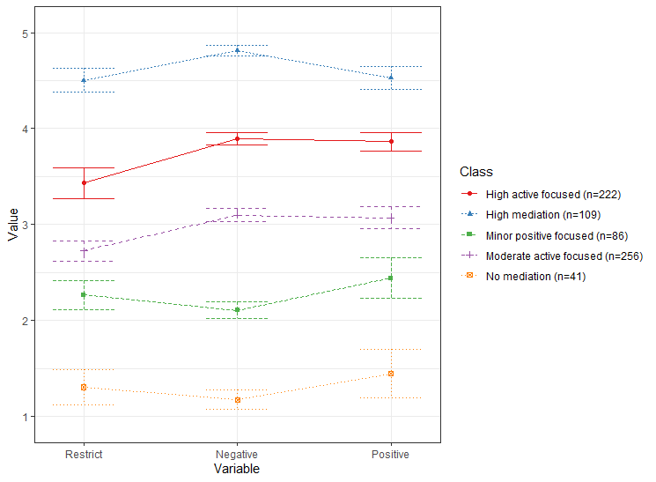

Figure 1. the 5-profile solution of the latent profile analysis.

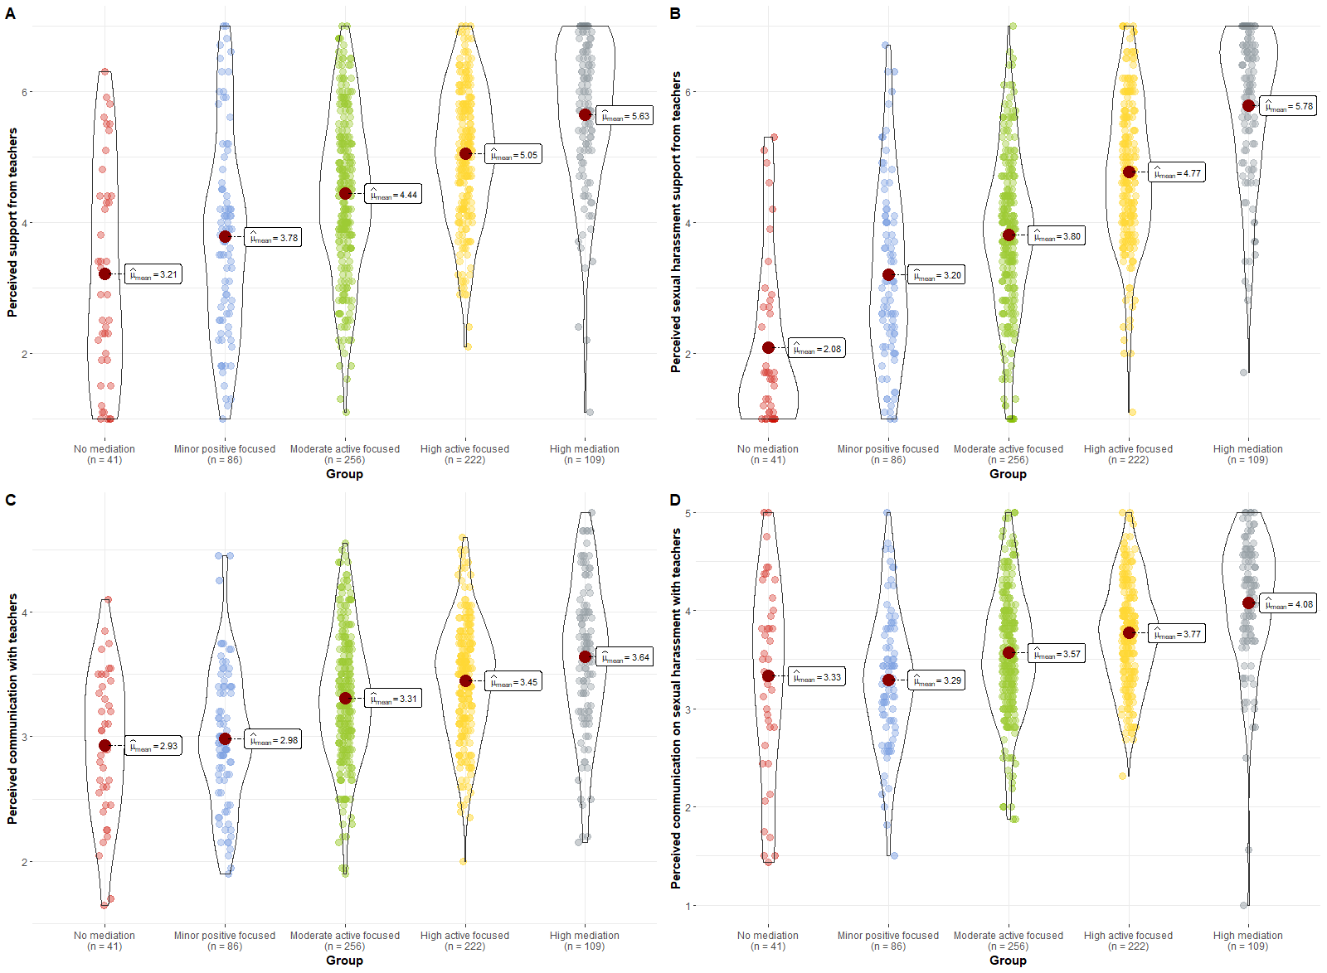

Figure 2. Differences between latent mediation profiles in pupils’ perceived support, sexual abuse support, communication and sexual abuse-related communication.

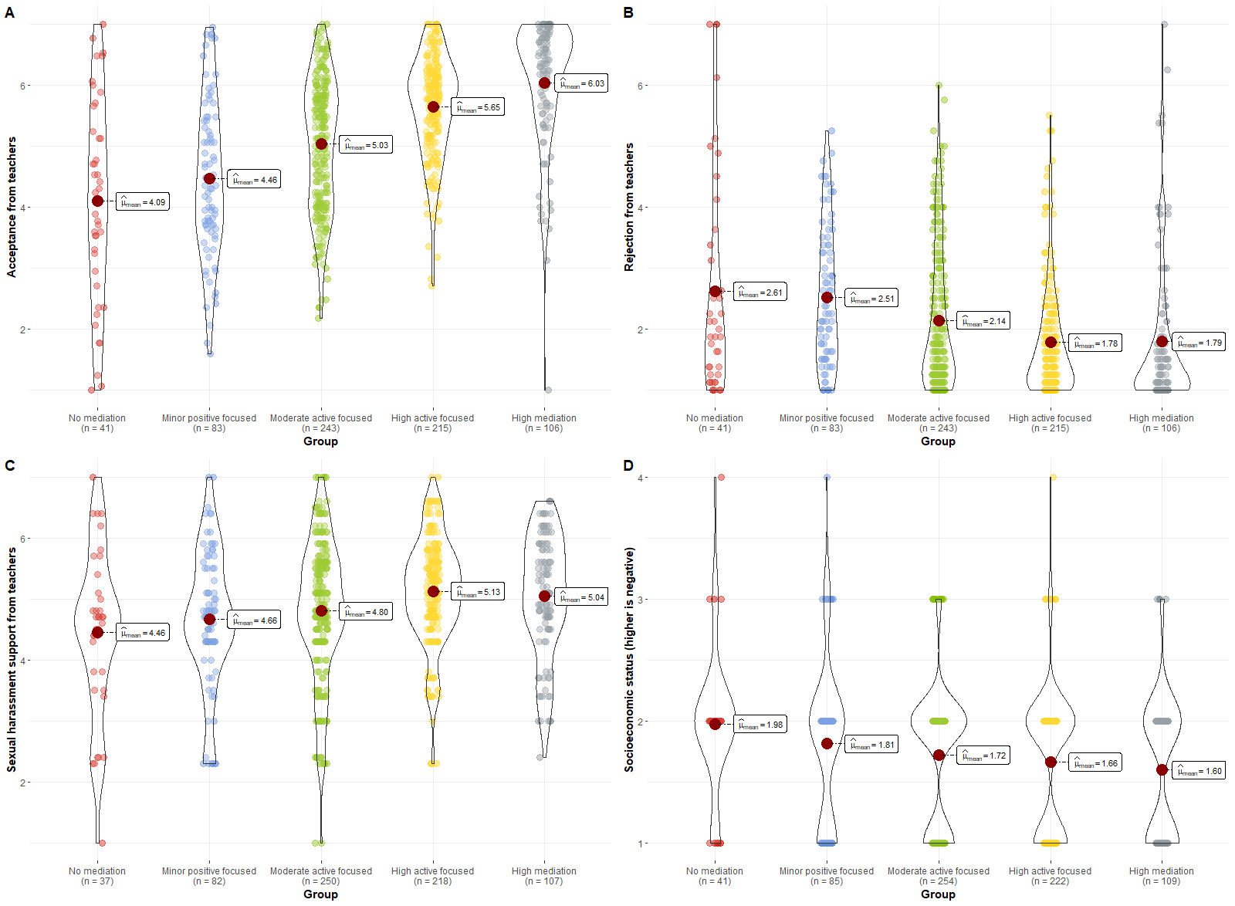

Figure 3. Differences between latent mediation profiles in pupils’ acceptance and rejection from teachers, economic status and teachers’ sexual abuse-related support.

**References**

Akogul, S., & Erisoglu, M. (2017). An approach for determining the number of clusters in a model-based cluster analysis. *Entropy*, *19*(9), 452.

Al-yagon, M., & Mikulincer, M. (2006). Adjustment in middle childhood. *Research in Education*, *75*, 1–18.

Alaggia, R. (2010). An ecological analysis of child sexual abuse disclosure: Considerations for child and adolescent mental health. *Journal of the Canadian Academy of Child and Adolescent Psychiatry*, *19*(1), 32–39. https://www.ncbi.nlm.nih.gov/pmc/articles/PMC2809444/pdf/ccap19_1p0032.pdf

Barnes, H., & Olson, D. H. (1982). *Parent-adolescent communication, family inventories. ‏*. Family social science, University of Minnesota.

Barth, J., Bermetz, L., Heim, E., Trelle, S., & Tonia, T. (2013). The current prevalence of child sexual abuse worldwide: A systematic review and meta-analysis. *International Journal of Public Health*, *58*(3), 469–483. https://doi.org/10.1007/s00038-012-0426-1

Bates, D., Maechler, M., Bolker, B., Walker, S., Christensen, R. H. B., Singmann, H., & Dai, B. (2015). Fitting Linear Mixed-Effects Models Using lme4. *Journal of Statistical Software*, *67*(1), 1–48. https://doi.org/https://doi.org/10.18637/jss.v067.i01

Berger, P. (2020). Teachers’ mediation practice: Opportunities and risks for youth media behavior. *Comunicar*, 47–56. www.revistacomunicar.com%7Cwww.comunicarjournal.com

Boniel-Nissim, M., Efrati, Y., & Dolev-Cohen, M. (2020). Parental Mediation Regarding Children’s Pornography Exposure: The Role of Parenting Style, Protection Motivation and Gender. *Journal of Sex Research*, *57*(1), 42–51. https://doi.org/10.1080/00224499.2019.1590795

Briere, J., & Runtz, M. (1993). Childhood sexual abuse: Long-term sequelae and implications for psychological assessment. *Journal of Interpersonal Violence*, *8*(3), 312–330.

Chen, V. H. H., & Chng, G. S. (2016). Active and restrictive parental mediation over time: Effects on youths’ self-regulatory competencies and impulsivity. *Computers and Education*, *98*, 206–212. https://doi.org/10.1016/j.compedu.2016.03.012

Chung, Y., Rabe-Hesketh, S., Dorie, V., Gelman, A., & Liu, J. (2013). A nondegenerate penalized likelihood estimator for variance parameters in multilevel models. *Psychometrika*, *78*(4), 685-709.

Efrati, Y., & Boniel-Nissim, M. (2021). Parents’ Psychopathology Promotes the Adoption of Ineffective Pornography-Related Parenting Mediation Strategies. *Journal of Sex and Marital Therapy*, *47*(2), 117–129. https://doi.org/10.1080/0092623X.2020.1835759

Efrati, Y., & Gola, M. (2019). Adolescents’ compulsive sexual behavior: The role of parental competence, parents’ psychopathology, and quality of parent–child communication about sex. *Journal of Behavioral Addictions*, *8*(3), 420–431. https://doi.org/10.1556/2006.8.2019.33

Gewirtz-Meydan, A., & Finkelhor, D. (2019). Sexal abuse and assault in a large national sample of children and adolescents. *Child Maltreatment*. https://doi.org/10.1177/1077559519873975

Goldman, J. D. G., & Bradley, G. L. (2011). Assessing primary school student-teachers’ pedagogic implementations in child sexual abuse protection education. *European Journal of Psychology of Education*, *26*(4), 479–493. https://doi.org/10.1007/s10212-011-0059-4

Goldschmidt-Gjerløw, B. (2019). Children’s rights and teachers’ responsibilities: reproducing or transforming the cultural taboo on child sexual abuse? *Human Rights Education Review*, *2*(1), 25–46. https://doi.org/10.7577/hrer.3079

Goldschmidt-Gjerløw, B., & Trysnes, I. (2020). #MeToo in school: teachers’ and young learners’ lived experience of verbal sexual harassment as a pedagogical opportunity. *Human Rights Education Review*, *3*(2), 27–48. https://doi.org/10.7577/hrer.3720

Hothorn, T., Bretz, F., & Westfall, P. (2008). Simultaneous inference in general parametric models. *Biometrical Journal: Journal of Mathematical Methods in Biosciences*, *50*(3), 346-363.

Hwang, Y., Choi, I., Yum, J. Y., & Jeong, S. H. (2017). Parental Mediation Regarding Children’s Smartphone Use: Role of Protection Motivation and Parenting Style. *Cyberpsychology, Behavior, and Social Networking*, *20*(6), 362–368. https://doi.org/10.1089/cyber.2016.0555

Jaccard, J., Dittus, P. J., & Gordon, V. V. (2000). Parent-teen communication about premarital sex: Factors associated with the extent of communication. *Journal of Adolescent Research*, *15*(2), 187–208. https://doi.org/10.1177/0743558400152001

Jerman, P., & Constantine, N. A. (2010). Demographic and psychological predictors of parent–adolescent communication about sex: A representative statewide analysis. *Journal of youth and adolescence*, *39*(10), 1164-1174.‏

Kim, S., Jeong, S. H., & Hwang, Y. (2013). Predictors of Pro-Environmental Behaviors of American and Korean Students: The Application of the Theory of Reasoned Action and Protection Motivation Theory. *Science Communication*, *35*(2), 168–188. https://doi.org/10.1177/1075547012441692

Kuznetsova, A., Brockhoff, P. B., & Christensen, R. H. (2017). lmerTest package: tests in linear mixed effects models. *Journal of Statistical Software*, *82*(1), 1–26.

Lev-Wiesel, R., Eisikovits, Z., First, M., Gottfried, R., & Mehlhausen, D. (2018). Prevalence of Child Maltreatment in Israel: A National Epidemiological Study. *Journal of Child and Adolescent Trauma*, *11*(2), 141–150. https://doi.org/10.1007/s40653-016-0118-8

Livingstone, S., & Helsper, E. J. (2008). Parental mediation of children’s internet use. *Journal of Broadcasting and Electronic Media*, *52*(4), 581–599. https://doi.org/10.1080/08838150802437396

Muthén, L. K., & Muthén, B. O. (2019). *Mplus user’s guide* (8th ed.). Muthén & Muthén.

Nathanson, A. I. (2001). Parent and child perspectives on the presence and meaning of parental television mediation. *Journal of Broadcasting and Electronic Media*, *45*(2), 201–220. https://doi.org/10.1207/s15506878jobem4502_1

Nathanson, A. I. (2016). Identifying and Explaining the Relationship Between Parental Mediation and Children’s Aggression: *Http://Dx.Doi.Org/10.1177/009365099026002002*, *26*(2), 124–143. https://doi.org/10.1177/009365099026002002

Pereda, N., Guilera, G., Forns, M., & Gómez-Benito, J. (2009). The international epidemiology of child sexual abuse: A continuation of Finkelhor (1994). *Child Abuse & Neglect*, *33*(6), 331–342. https://doi.org/10.1016/J.CHIABU.2008.07.007

Putnam, F. W. (2003). Ten-year research update review: Child sexual abuse. *Journal of the American Academy of Child and Adolescent Psychiatry*, *42*(3), 269–278. https://doi.org/10.1097/01.CHI.0000037029.04952.72

Rosenberg, J. M., Beymer, P. N., Anderson, D. J., van Lissa, C., & Schmidt, J. A. (2019). tidyLPA: An R package to easily carry out Latent Profile Analysis (LPA) using open-source or commercial software. *Journal of Open Source Software*, *4*(44), 978.

Schein, M., Biderman, A., Baras, M., Bennett, L., Bisharat, B., Borkan, J., Fogelman, Y., Gordon, L., Steinmetz, D., & Kitai, E. (2000). The prevalence of a history of child sexual abuse among adults visiting family practitioners in Israel. *Child Abuse & Neglect*, *24*(5), 667–675. https://doi.org/10.1016/S0145-2134(00)00128-9

Scholes, L., Jones, C., Stieler-Hunt, C., Rolfe, B., & Pozzebon, K. (2012). The teachers’ role in child sexual abuse prevention programs: Implications for teacher education. *Australian Journal of Teacher Education*, *37*(11), 104–131. https://doi.org/10.14221/ajte.2012v37n11.5

Schönbucher, V., Maier, T., Mohler-Kuo, M., Schnyder, U., & Landolt, M. A. (2012). Disclosure of child sexual abuse by adolescents: A qualitative in-depth study. *Journal of Interpersonal Violence*, *27*(17), 3486–3513. https://doi.org/10.1177/0886260512445380

Shin, W., & Li, B. (2017). Parental mediation of children’s digital technology use in Singapore. *Journal of Children and Media*, *11*(1), 1–19. https://doi.org/10.1080/17482798.2016.1203807

Singh, M. M., Parsekar, S. S., & Nair, S. N. (2014). An epidemiological overview of child sexual abuse. *Journal of Family Medicine and Primary Care*, *3*(4), 430–435. https://doi.org/10.4103/2249-4863.148139

Stoltenborgh, M., Van Ijzendoorn, M. H., Euser, E. M., & Bakermans-Kranenburg, M. J. (2011). A global perspective on child sexual abuse: Meta-analysis of prevalence around the world. *Child Maltreatment*, *16*(2), 79–101. https://doi.org/10.1177/1077559511403920

Tener, D., & Sigad, L. (2019). “I felt like I was thrown into a deep well”: Educators coping with child sexual abuse disclosure. *Children and Youth Services Review*, *106*(April), 104465. https://doi.org/10.1016/j.childyouth.2019.104465

Topping, K. J., & Barron, I. G. (2009). School-based child sexual abuse prevention programs: A review of effectiveness. *Review of educational research, 79*(1), 431-463.‏

Vogeltanz, N. D., Wilsnack, S. C., Harris, T. R., Wilsnack, R. W., Wonderlich, S. A., & Kristjanson, A. F. (1999). Prevalence and risk factors for childhood sexual abuse in women: National survey findings. *Child Abuse and Neglect*, *23*(6), 579–592. https://doi.org/10.1016/S0145-2134(99)00026-5

Wager, N. M. (2015). Understanding children’s non-disclosure of child sexual assault: Implications for assisting parents and teachers to become effective guardians. *Safer Communities*, *14*(1), 16–26. https://doi.org/10.1108/SC-03-2015-0009

Zimet, G. D., Dahlem, N. W., Zimet, S. G., & Farley, G. K. (1988). The Multidimensional Scale of Perceived Social Support. *Journal of Personality Assessment*, *52*(1), 30–41. https://doi.org/10.1207/s15327752jpa5201_2