

**FRAGE 1 VON 312**

**IQSS01_MC_leicht/Lektion 01**



For which of the artifacts listed is dynamic testing possible?

**Choose an answer:**

Test cases.

Business requirements.

Architecture descriptions.

*Program code.*



**FRAGE 2 VON 312**

**IQSS01_MC_leicht/Lektion 01**



Which of the measures listed is **not** part of constructive quality management?

**Choose an answer:**

*Communicative measures.*

Technical measures.

Interpersonal measures.

Organizational measures.



Which of the measures listed is **not** part of the technical measures within constructive quality management?

**Choose an answer:**

Choice of development environment.

Use of tools for code analysis.

Use of modeling languages.

*State-based testing.*



**FRAGE 4 VON 312**

**IQSS01_MC_leicht/Lektion 01**



In quality planning, one works primarily with ...

**Choose an answer:**

the specialist department. the project manager.

*the customer*.

the software user.



Which is the primary reason behind the principle of early error detection and correction?

**Choose an answer:**

To save time in determining the programming language.

To save time in requirements engineering.

To identify all stakeholders.

*To save costs due to lower error correction costs in the early phases.*



**FRAGE 6 VON 312**

**IQSS01_MC_leicht/Lektion 01**



Which of the principles listed relates to the following statement:

“*20% of the test cases must have been executed* *within the first two of four weeks of testing”*?

**Choose an answer:**

Principle of maximum constructive quality assurance. Principle of error accumulation.

*Principle of quantitative quality assurance.*

Principle of early error detection.



For which of the reasons below are the costs **higher** when an error is discoveredin later phases of the software development process than in early phases?

**Choose an answer:**

The project manager must develop a risk plan for errors discovered later on.

If errors are discovered in late project phases, the quality manager must be replaced. Appointing someone else incurs costs.

*If discovered later in the software development process, correcting an error means that* *more phases of the process must be repeated again.*

The errors discovered in later phases are always more extensive.



**FRAGE 8 VON 312**

**IQSS01_MC_leicht/Lektion 01**



The principle of quality assurance during development enables ...

**Choose an answer:**

*quality assurance of artifacts at the earliest possible time*.

improvement of the quality assurance position.

better planning of test resources and better use of infrastructure.

quicker development.



There is a function in your software that frequently renders errors during the initial tests.

What should you do in the next round of testing?

**Choose an answer:**

Test the function to the same extent as before; after all, a sufficient number of errors have been found this way.

Leave the function out of the test: it was sufficiently tested in the last round of testing.

Test the function more extensively: only to verify the errors found and exclude the possibility that a mistake was made in the test execution.

*Test the function more extensively: on the basis of “error accumulation”, more testing is required in the environment of the errors.*



**FRAGE 10 VON 312**

**IQSS01_MC_leicht/Lektion 01**



“*Testing shows the absence of errors.”*

Take a position on this statement.

**Choose an answer:**

*The statement is incorrect: testing shows the presence of errors, but it cannot show* *their absence*.

The statement is correct: testing shows that a function fulfills its purpose.

The statement is correct: complete testing is possible.

The statement is correct, but testing also shows the presence of errors. Absence or presence depends on the module being tested.



For the sentence

“*repetition is not effective.”*

to apply to testing, what conditions must be met in the test?

**Choose an answer:**

Same test cases with the same data on different environments.

Same environment, same data, customized test cases.

*Same test cases with the same data, and on the same environment.*

Same test cases with different data.



**FRAGE 12 VON 312**

**IQSS01_MC_leicht/Lektion 01**



Since testing depends on the environment, one must ...

**Choose an answer:**

make adjustments to each product in the component test. The process changes are only useful from the system test onwards.

*customize the type and scope of testing across all phases for each process*.

tailor each level of testing to your product. The process used to create it is irrelevant. customize the type and scope of the test across all stages for every product and process.



Quality costs involve ...

**Choose an answer:**

all costs incurred for error prevention before delivery and for error elimination after delivery.

*all costs for error prevention, detection, localization, and correction*.

all costs for error correction and localization during development and after delivery.

all costs for error correction.



**FRAGE 14 VON 312**

**IQSS01_MC_leicht/Lektion 01**



Production costs are related to quality costs as follows:

**Choose an answer:**

Production costs do not exist in software development.

*Production costs, in addition to quality costs, are the costs required by software development*.

Production costs include development and quality costs.

Production costs are the costs of producing quality.



Which of the costs below are **not** a component of software quality costs?

**Choose an answer:**

Costs for test tool licenses.

*Costs for software development tools.*

Costs for internal error correction.

Costs for external error localization.



**FRAGE 16 VON 312**

**IQSS01_MC_mittel/Lektion 01**



Select one of the possible reasons why a system with a high level of quality according to ISO 9126 can nevertheless be unusable.

**Choose an answer:**

Its usability is not mature.

Testing shows the presence of errors, therefore the possibility of achieving a high quality level does not exist.

The project manager must first carry out equivalence partitioning, otherwise the quality model will not be properly developed.

*The implemented functionality may cover the specification, but there are significant gaps in the specification*.



Reviewing test cases is a measure within ...

**Choose an answer:**

state-based testing.

dynamic procedures.

*static analysis procedures*.

use-case-based testing.



**FRAGE 18 VON 312**

**IQSS01_MC_mittel/Lektion 01**



One advantage of independent quality assurance is:

**Choose an answer:**

The development team feels more responsible for quality when quality assurance is outsourced.

Developers will write more automated test cases to support the independent testers.

*The independence of the testers promotes objectivity and brings another perspective on the specification during* *the evaluation.*

The independence of the testers allows for outsourcing to another company with less communication overhead for clarifying the specification.



Allowing quality assurance to start with the component test first bears the risk of ...

**Choose an answer:**

there being no possibility of detecting error accumulation in components.

reducing the possibility of independent testing as the communication overhead increases as the project cycle goes on.

*not being able to identify errors early on, and therefore not being able to correct them at earlier phases, such as requirements collection*.

there being no possibility of creating metrics for test coverage.



**FRAGE 20 VON 312**

**IQSS01_MC_mittel/Lektion 01**



You are responsible for testing a software system with four components:

In the first test cycle,...

Component A: 30 errors Component B: 35 errors Component C: 25 errors Component D: 21 errors

In the test case generation for the next test cycle, you place particular emphasis on:

**Choose an answer:**

Component A. Component D. *Component B.* Component C.



Your project manager wants you to increase the quality of the software using your test.

What would be your answer?

**Choose an answer:**

“Of course, I'll be happy to!”

“To do that, I need more resources so I can do a full test.”

“*Unfortunately, that’s not possible. Tests show the presence of errors.”*

“Depending on your development process, we would have to commit more resources than you have.”



**FRAGE 22 VON 312**

**IQSS01_MC_mittel/Lektion 01**



You are to plan the quality assurance of a system without a written specification.

Why will you have increased difficulties here?

**Choose an answer:**

The ability to plan is limited because an accumulation of errors is expected in the more complex components.

*Without quality objectives and requirements, the results of the tests cannot be evaluated*. Complete testing is not possible in such cases.

The lack of a written specification is not a problem as long as the developers are involved in the testing.



As a quality manager, you are expected to ensure cost-optimized quality.

Choose which errors you need to accept:

**Choose an answer:**

Errors not found.

*Errors and risks that are costly to prevent and have lower costs for correction.*

None: errors and risks are not tolerable.

Errors and risks whose correction costs are high and whose prevention costs are low.



**FRAGE 24 VON 312**

**IQSS01_MC_mittel/Lektion 01**



As a starting point for your work, you have a severely faulty system.

Management asks you why the cost of quality is so high for this particular system. Explain why.

**Choose an answer:**

The costs cannot be high: since hardly any measures were taken, presumably there is an error in the data here.

*The cost of error correction is very high because errors in the system were only detected after its delivery*.

The cost can only be so high if your predecessor took the wrong actions.

The cost is so high because the system was even more buggy, and this state is already an improvement, but there is still much to do.



What do you need to consider when correcting errors and eliminating errors in a cost-optimized way?

**Choose an answer:**

Error costs and damage effect of known errors.

*Risks, including their probability of occurrence and consequential costs.*

Probability of occurrence and follow-up costs of known, but unrectified, errors.

Risks including their follow-up costs.



**FRAGE 26 VON 312**

**IQSS01_MC_schwer/Lektion 01**



You are involved in test object determination.

Which option is the best?

**Choose an answer:**

Static testing of requirements, architectures

Dynamic testing of programs and specifications

Static testing of architectures, specifications

Dynamic testing of programs

Static testing of requirements, architectures

Dynamic testing of programs

*Static testing of requirements, architectures, specifications*

*Dynamic testing of programs*



You are familiar with the principles of SW quality assurance according to Balzert.

In what area of your work can they help you?

**Choose an answer:**

The principles should be taken into account during planning. They are rather irrelevant during implementation.

*By applying the assertions in the planning and implementation of your specific quality assurance.*

The principles must be adopted 1:1 in quality assurance.

You only need to be familiar with them. Nothing is derived from them.



**FRAGE 28 VON 312**

**IQSS01_MC_schwer/Lektion 01**



You want to set up your quality planning and are guided by the principle of product-oriented and process-oriented quality assurance.

What do you absolutely need to be able to do this?

**Choose an answer:**

Test tools.

*Defined quality objectives.*

MS Project or another planning software.

Quality measures accompanying the development process.



There are fundamentals and principles in software testing.

Which is the difference between them?

**Choose an answer:**

Principles should be observed in planning and fundamentals in execution.

These are synonyms for the same thing.

Fundamentals must be followed; principles are open to interpretation.

*Fundamentals are fundamental properties; principles are fundamental approaches*.



**FRAGE 30 VON 312**

**IQSS01_MC_schwer/Lektion 01**



You want to achieve cost-optimized quality.

Which parameters do you need to include?

**Choose an answer:**

Costs for distribution of the new software.

Only project management costs.

Costs for external error localization.

*Risks, their probability of occurrence, and their consequential costs.*



In which industry standard is the term “quality management” defined?

**Choose an answer:**

*DIN 9000.*

ISO 6789.

DIN 712.

ISO 9126.



**FRAGE 32 VON 312**

**IQSS01_MC_leicht/Lektion 02**



Quality management has a number of core activities.

Indicate the term in the following list that is **not** one of these activities.

**Choose an answer:**

Quality assurance and improvement.

*Quality inspection.*

Quality control.

Quality planning.



Process-oriented quality management serves to control the quality . . .

**Choose an answer:**

of project artifacts.

of modeling conventions.

of the maintenance phase.

*of the software creation process*.



**FRAGE 34 VON 312**

**IQSS01_MC_leicht/Lektion 02**



The quality objective “usability” according to ISO 9126 consists of three sub-aspects.

Choose the **non**-relevantone provided.

**Choose an answer:**

Operability.

Understandability.

Learnability.

*Maturity.*



For which of the below are software quality models particularly used?

**Choose an answer:**

As an illustration of the quality achieved.

As a modeling aid for the processes in the software to be created.

As an aid in the evaluation of metrics.

*As a specification of software quality for quality target determination.*



**FRAGE 36 VON 312**

**IQSS01_MC_leicht/Lektion 02**



Indicate the applicable statement regarding process-oriented software quality and process-oriented quality management.

**Choose an answer:**

No quantitative statements are necessary for process-oriented software quality.

Process-oriented quality management can only be carried out by the customer.

Process-oriented software quality refers to the artifacts created during the creation, operation, and maintenance of the software.

*In process-oriented quality management, the focus is not on the artifacts created, but rather on the quality of the implementation of the activities planned in the software process*.



Indicate the statement that applies to product-oriented software quality and product-oriented quality management.

**Choose an answer:**

With the aid of product-oriented software quality, only the end products of the overall process are assessed.

Product-oriented quality management can only be carried out by the customer.

*Product-oriented quality management reviews software products for defined quality attributes as well as the intermediate results*.

Product-oriented software quality refers to the process by which software is created and evaluates it.



**FRAGE 38 VON 312**

**IQSS01_MC_leicht/Lektion 02**



The following selection contains dynamic measures that are used in quality assurance.

Identify the **incorrect** activity.

**Choose an answer:**

System test.

Integration test.

Component test.

*Requirements examination.*



You are to write test cases for system testing.

When can this activity begin?

**Choose an answer:**

During the system test.

*As soon as the requirements and architecture specification make this possible.*

As soon as the component test is completed.

Shortly before the system test.



**FRAGE 40 VON 312**

**IQSS01_MC_leicht/Lektion 02**



Activities in the quality assurance process are generally ...

**Choose an answer:**

exactly as planned in the previous project.

carried out and documented by one person.

defined according to project-specific specifications, but matching the organization-specific rules.

*defined according to organization-specific specifications, but are specifically defined for each individual project*.



A “quality gate” examines ...

**Choose an answer:**

whether the artifacts created are of high quality.   
whether the artifacts created are present.

whether the artifacts provided please the customer.

*whether the artifacts created meet established requirements*.



**FRAGE 42 VON 312**

**IQSS01_MC_leicht/Lektion 02**



In TQM, the achievement of high product quality is ...

**Choose an answer:**

only the objective of the quality manager.

*the objective of all project employees*.

only the objective of the project manager.

only the objective of the customer.



The importance of quality control is high, since ...

**Choose an answer:**

quality assurance cannot be conducted without quality control.

*it establishes a link between the implementation quality of QA activities and the product quality*.

product quality cannot be measured without quality control.

tasks not subject to this control are quickly disregarded due to time pressures in a project.



**FRAGE 44 VON 312**

**IQSS01_MC_leicht/Lektion 02**



Choose the appropriate definition of quality control.

**Choose an answer:**

*Quality control is the continuous monitoring of both product and process quality, including responses to change*.

Quality control means active monitoring of the development of the quality level.

Quality control is the process of completing a phase or project to determine the level of quality.

Quality control is the process of improving the development process.



With TQM, the decision on the level of quality is made by ...

**Choose an answer:**

the quality manager. the entire team.

the project manager.

*the customer*.



**FRAGE 46 VON 312**

**IQSS01_MC_mittel/Lektion 02**



You are to prepare the quality planning for a new company app.

Which information do you need to develop this planning?

**Choose an answer:**

You must determine the responsibilities, milestones, schedules, and test tools used, but you do not need to define QA activities.

For quality planning, you only need to determine responsibilities, development tools, static quality assurance tools, and review planning.

*You must determine the responsibilities, as well as the timing of measures in the software process. Furthermore, you must determine the required QA activities as well as which means, methods, and tools are to be used for quality assurance*.

You must determine the development and testing tools used, developers and testers, and vacation time, but responsibilities are not part of quality planning.



Choose the activity that is part of quality control.

**Choose an answer:**

Root cause analysis.

TQM.

Project control.

*Test process control.*



**FRAGE 48 VON 312**

**IQSS01_MC_mittel/Lektion 02**



Which of the following activities does process-oriented quality management examine?

**Choose an answer:**

Review of test case specification.

Review planning and test tool selection.

Procedure for the generation of automatic tests.

*Examination of the test case design procedure.*



Choose the relationship between quality objective determination and a quality model.

**Choose an answer:**

Quality objective determination is the result of the creation of an organization-specific quality model.

A quality model uses quality objectives to assert new requirements.

*A quality model is a tool for determining quality objectives*.

Quality objective determination requires a quality model.



**FRAGE 50 VON 312**

**IQSS01_MC_mittel/Lektion 02**



You are to carry out the testing of the technical specification within the framework of a “quality gate”.

Which criteria should you look for?

**Choose an answer:**

That the functions to be implemented are named; a description is not necessary.

That the technical specification fits the product to be created.

*That the system components to be implemented are described in a scope and level of detail suitable for the architecture and implementation.*

That the specification is available and signed.



You want to introduce “quality gates.”

Which of the **arguments does not** fit your reasoning?

**Choose an answer:**

*Increase in independence between developers and testers.*

Clear regulation of the transfer of responsibility (completion of an activity).

Examination of delivered artifacts against defined criteria.

Capability to examine compliance with directives.



**FRAGE 52 VON 312**

**IQSS01_MC_mittel/Lektion 02**



You are to examine the requirements for a software system by applying a “quality gate”.

Which of the criteria listed are you least likely to test in this framework?

**Choose an answer:**

*Equal participation of all authors.*

Appropriate form of documentation.

Coordination.

Content.



Which of the requirements below does “quality priority” place on your work?

**Choose an answer:**

*It calls for doing the work correctly from the beginning*.

It calls for an increase in constructive quality measures.

It calls for good integration of testing and requirements elicitation.

It calls for better meeting quality.



**FRAGE 54 VON 312**

**IQSS01_MC_mittel/Lektion 02**



Within quality control, you are to identify measures that will improve dynamic quality testing.

Which listed here would be a possibility?

**Choose an answer:**

Introduction of timeboxing for test planning meetings. *Adaptation of the procedure for test case generation.*

Checklist for meeting preparation.

Use of code quality tools.



You are about to hand over to an internal customer: which principle of TQM are you therefore following?

**Choose an answer:**

*Principle of the internal customer-supplier relationship.*

Process-oriented quality.

Primacy of quality.

Principle of the responsibility of all employees.



**FRAGE 56 VON 312**

**IQSS01_MC_schwer/Lektion 02**



You have created your quality plan.

What have you achieved with this?

**Choose an answer:**

Created the test cases for a project.

*Created a specific framework for a project*.

Created a concrete framework for all projects.

Developed the reporting basis for management.



You use ISO 9126 as a quality model.

What additional area of quality management do you need take into account with another quality model or comparable one?

**Choose an answer:**

The process-oriented quality area.

None: ISO 9126 serves as a quality model in the process-oriented and product-oriented quality area.

*The product-oriented quality area.*

The product-oriented as well as the process-orientated areas, neither of which are considered by ISO 9126.



**FRAGE 58 VON 312**

**IQSS01_MC_schwer/Lektion 02**



The functional requirements of a new software release must be tested in December. The functional requirements are measurably defined in a document agreed upon with the stakeholders.

You are responsible for organizational quality planning, which one is still your job?

**Choose an answer:**

*Determine specific techniques and methods.*

Write a test case definition.

Create schedule and resources.

Request modeling conventions.



Review the statements regarding component testing and indicate the correct one.

**Choose an answer:**

Component testing examines an isolated software unit for various criteria, such as load behavior, functionality, and usability.

*Component testing is conducted by the developer during the implementation phase*.

A component test is a type of test that is generally conducted by independent testers.

A component test can only be performed after the components have been integrated into the software system. The scope of component testing here is the individual component.



**FRAGE 60 VON 312**

**IQSS01_MC_schwer/Lektion 02**



As part of your quality control activities, you consider the impact of the most recent changes. You notice that some changes are **not** working as they should, so you modify them.

Which principle are you following?

**Choose an answer:**

Principle of customer orientation.

Principle of the internal customer-supplier relationship,

Principle of the early integration of quality management.

*Principle of continuous process improvement*



How does constructive quality management try to prevent errors?

**Choose an answer:**

Through reviews.

*Through binding specifications and guidelines.*

Through the implementation of “quality gates”.

Through the planning of tests.



**FRAGE 62 VON 312**

**IQSS01_MC_leicht/Lektion 03**



Except for one, the activities listed are part of constructive quality assurance measures.

Please select the **incorrect** activity.

**Choose an answer:**

*Control measures.*

Technical measures.

Organizational measures.

Interpersonal measures.



Combinations of measures are listed below.

Which is the correct one for constructive quality management?

**Choose an answer:**

Qualification, standards, and methods.

Define measures, monitor compliance, examine effectiveness, and adjust if necessary.

Code analysis, reviews, and testing.

*Technical, organizational and interpersonal measures.*



**FRAGE 64 VON 312**

**IQSS01_MC_leicht/Lektion 03**



Interpersonal measures in constructive quality management have the following objective:

**Choose an answer:**

Increasing employee satisfaction.

Identifying necessary technical measures.

Reducing employee turnover.

*Enabling professional collaboration.*



In general, how do checklists support quality management?

**Choose an answer:**

By recording tasks and references to standards and quality models.

Checklists are not part of quality management.

By collecting tips for test case generation.

*By summarizing the activities of standard tasks and reducing the risk of aspects being forgotten*.



**FRAGE 66 VON 312**

**IQSS01_MC_leicht/Lektion 03**



In which quality management activity are measures for constructive quality management defined?

**Choose an answer:**

*Quality planning.*

Quality control.

Quality assurance.

Quality improvement.



Constructive quality management should ...

**Choose an answer:**

only determine test case definitions.

only define metrics.

measure the level of quality.

*help prevent mistakes*.



**FRAGE 68 VON 312**

**IQSS01_MC_leicht/Lektion 03**



The 5-Why method is designed to achieve the following:

**Choose an answer:**

The identification of error symptoms.

The identification of errors.

The identification of process weaknesses.

*The identification of the cause of an error.*



Which of the following points does **not** need tobe taken into account when creating checklists?

**Choose an answer:**

Definition of transparent criteria.

Prevention of compound objectives.

Simple wording.

*Guaranteed achievability within a firmly specified period of time.*



**FRAGE 70 VON 312**

**IQSS01_MC_leicht/Lektion 03**



There is an error in the following checklist. Indicate the error:

“Camping Checklist”:

* Book campsite.
* Print directions to the campsite & validity of passes.
* Have newspaper forwarded.
* Have vehicle inspection done.
* Who waters the flowers?
* Hiking map.

**Choose an answer:**

Spelling mistake.

Criteria not transparent.

*Compound objective listed.*

Not written in clear and simple wording.



Which is the core idea of timeboxing?

**Choose an answer:**

Canceling agenda items that management does not want to occur.

Allocating time to activities and measurement of the deviation after implementation is completed.

*Allocating time to activities or agenda items and consistently monitoring and adhering to the time allotted.*

Allocating time to each speaker: deviations are not controlled.



**FRAGE 72 VON 312**

**IQSS01_MC_leicht/Lektion 03**



Checklists must be continually monitored and adjusted as needed.

Choose the correct statement in relation to these changes.

**Choose an answer:**

This enables changed quality requirements to be reacted to – however, no changes regarding the framework conditions of a current project may be included in the checklists before the project is completed.

*So that changed framework conditions in a project or process or changed quality requirements* can *be addressed.*

So that changed framework conditions in a project or process can be addressed; checklists may not be adapted to address changed quality requirements.

For reasons of traceability, changes may not be made to checklists during an ongoing project.



How are the 5-Why method and root cause analysis related?

**Choose an answer:**

*Root cause analysis is the procedure and the 5-Why method is the technique for it.*

They are not related.

Both are techniques for root cause identification.

These are different words for the same thing.



**FRAGE 74 VON 312**

**IQSS01_MC_leicht/Lektion 03**



The steps of root cause analysis are divided into ...

**Choose an answer:**

error identification and error description.

error classification and future error prevention.

error description and future error prevention.

*error identification and future error prevention.*



Root cause analysis ends with the:

**Choose an answer:**

*evaluation of QA measures for error prevention.*

introduction of QA measures for error prevention.

identification of potential QA measures.

identification of the error.



**FRAGE 76 VON 312**

**IQSS01_MC_mittel/Lektion 03**



You like to work on template improvements.

Which sub-area of quality management are you in?

**Choose an answer:**

“Lessons learned” of software development.

Analytical measures of quality management.

*Organizational measures of quality management.*

TQM principle of the internal customer-supplier relationship.



You have the following objective:

error correction time is expected to be reduced by 50% over the next three months.

Which constructive quality management activity do you need to address first?

**Choose an answer:**

*Determine measures for how to achieve the objective.*

Examine effectiveness and what impact this objective has. Determine metrics.

Monitor compliance with the objective.



**FRAGE 78 VON 312**

**IQSS01_MC_mittel/Lektion 03**



The review of a user manual is part of which aspect of quality assurance?

**Choose an answer:**

*Static, analytical.*

Static, constructive.

Dynamic, constructive.

Dynamic, analytical.



Process models (such as RUP, V-Modell XT, Scrum) are part of quality management . . .

**Choose an answer:**

as the templates in constructive QM.

*as the standards in constructive QM*.

not a part. QM is independent of the process model.

as the analytical measures.



**FRAGE 80 VON 312**

**IQSS01_MC_mittel/Lektion 03**



The definition of using a tool for the configuration management of source and object code is part of . . .

**Choose an answer:**

*the tasks in constructive QM*.

none of the other answers is correct.

the tasks in analytical QM.

the tasks of a project manager.



In root cause analysis, which step follows the identification of errors?

**Choose an answer:**

Elimination of the errors.

None, the process comes to an end when the errors are found. Evaluation of the creator of the artifact.

*Identification of potential QA measures for error prevention.*



**FRAGE 82 VON 312**

**IQSS01_MC_mittel/Lektion 03**



You are a moderator in a meeting that follows timeboxing.

What is your most important right?

**Choose an answer:**

The right to end the meeting if no one else wants to say anything.

The right to interrupt someone.

The right to delete something from the minutes.

*The right to end an agenda item*.



You are to create a checklist to prepare for a quality gate.

Which aspect of quality improvement are you focusing on?

**Choose an answer:**

*The improvement of the process.*

The improvement of employee qualification.

The improvement of artifacts at the quality gate.

The improvement of product liability.



**FRAGE 84 VON 312**

**IQSS01_MC_mittel/Lektion 03**



Can timeboxing only be used for meetings?

**Choose an answer:**

Yes, this measure only exists within meetings.

Timeboxing is not used for meetings at all.

Yes, but only because other activities cannot be limited.

*No, other activities can also be controlled with timeboxing*.



Step 6 of root cause analysis is “evaluation of QA measures”.

Which is included in this evaluation?

**Choose an answer:**

Evaluation of similar artifacts for the same type of errors.

*Evaluation of whether the type of errors found were actually prevented with the measure found.*

Evaluation of the artifacts that were changed due to the error.

This does not correspond to Step 6 of root cause analysis.



**FRAGE 86 VON 312**

**IQSS01_MC_schwer/Lektion 03**



You would like to purchase a foosball table for your team.

The measure falls on deaf ears with management.

Which is your line of argument?

**Choose an answer:**

*Creating a better working environment falls into the constructive measures for quality improvement; quality is increased* *through team spirit.*

The purchase would allow for informal meetings between all team members.

Creating a better working environment falls into the analytical measures for quality improvement; a good team spirit increases quality.

Team performance is good, a reward shows employees their value within the company.



You want to include a new library in your source code.

Which area of quality management does this affect?

**Choose an answer:**

Planning—the duration for creating an artifact decreases, thus integrated quality assurance can also be started earlier.

Implementation—the tester must know that this is an external library.

*Constructive*—the *use of libraries must be regulated here.*

Review—each library used must be considered in a review.



**FRAGE 88 VON 312**

**IQSS01_MC_schwer/Lektion 03**



You are in the process of creating a template for a test management manual.

Your boss is indignant because you are not working on quality improvements. Which do you say?

**Choose an answer:**

Creating templates increases the quality of the documents based on them, because everything in this type of document can always be simply adopted. There are no project specifics here.

Redirect with the fact that while this is indeed a direct quality improvement, it may be helpful when working on the next test management manual.

*Creating templates increases the quality and uniformity of the documents* *based on them.*

Creating templates saves time, although admittedly, it does not improve quality.



You are to work out the cause of an error using a 5-Why method. The following question and answer combinations are available.

Which is your next question?

1. **Why question:**

Why are errors reported?

**Response:**

Because the prices displayed in different currencies are different from each other.

1. **Why question:**

Why do the prices differ?

**Response:**

The conversions are inaccurate.

**Choose an answer:**

**3. Why question:**

Why are the displays inaccurate?

**3. Why question:**

Why are the conversions not up to date?

**3. Why question:**

Why are the prices inaccurate?

***3. Why question:***

*Why are the conversions inaccurate?*



You created a checklist for a function of your software. The developer is pleased: now they can devise their algorithm from it.

Which do you say?

**Choose an answer:**

Of course, my checklist contains all the points and can be used for this.

*Unfortunately, this is not possible. A checklist does not really provide the necessary information for the process*.

Of course, my checklist describes the function sufficiently.

Unfortunately, this is not possible. A checklist is not part of the technical documentation.



**FRAGE 91 VON 312**

**IQSS01_MC_leicht/Lektion 04**



The attributes provided below, except one, apply to static quality assurance measures. Indicate the only one that is **not** correct.

**Choose an answer:**

Analyzing.

*Dynamic.*

Evaluating.

Feasible with pen and paper.



In a conversation, your colleague states that component tests are a static measure.

What would be your objection?

**Choose an answer:**

Inquire about the project environment. Testing is process and product-dependent; no evaluation is possible without this information.

Clarify that a component test is a dynamic measure, since the test object is executed and there is no aspect that is static in this environment.

None, the statement is correct.

*Inquire about whether the colleague means the code analysis that they automate in the component test environment*.



**FRAGE 93 VON 312**

**IQSS01_MC_leicht/Lektion 04**



Which can be examined using the different static quality assurance measures?

**Choose an answer:**

Only activities within the entire software development process.

*Artifacts and activities within the entire software development process.*

Only artifacts within the entire software development process.

Only test cases, architecture plans, and milestone plans.



Choose the main objective of a review follow-up.

**Choose an answer:**

Documentation of the test object status.

*Correction of detected errors.*

Final evaluation of the test object.

Preparation of an error report.



**FRAGE 95 VON 312**

**IQSS01_MC_leicht/Lektion 04**



When planning a review, which must the author also coordinate, in addition to coordinating the scheduling?

**Choose an answer:**

*Examination objectives and criteria for passing the examinations.*

Opportunities for examinations related to the test object.

Confirmation of scheduling by the management.

Coordination of the test object.



In the individual preparation for a review, you find an error in the punctuation of the artifact being analyzed.

You note this in your document to bring it up in the review. Which statement is correct in this regard?

**Choose an answer:**

The procedure is correct if spelling is one of the prescribed test criteria.

*The procedure is correct. Formal deficiencies such as spelling mistakes must also be found and corrected*.

The procedure is wrong. Minor formal deficiencies, such as typographical errors, do not need to be included in the review.

The procedure is incorrect. Only examine using the defined criteria.



**FRAGE 97 VON 312**

**IQSS01_MC_leicht/Lektion 04**



Why do I need metrics to be able to make assertions regarding quality with my measurements?

**Choose an answer:**

*Only with the help of metrics can I assign a value to the measurement that can serve as a comparison value*.

Measurements have high significance even without metrics.

I only need metrics for reports to management. They do not provide an indicator of the quality level.

Metrics are the only way to make myself comparable with competitors. No metrics are necessary internally, for my project.



Choose the correct definition of the term “metric”.

**Choose an answer:**

Metrics are the qualitative results of the measurement of a test object.

Metrics are comparative values for similar methods.

*The function that determines a numerical value from the results of measuring a test object is called a metric*.

Metrics are numerical values for detected errors.

# Choose the values needed to calculate the Halstead metric from the combinations listed.



**Choose an answer:**

*Number of different operators.*

*Number of different operands.*

*Total number of operators used.*

Number of different operators.

Number of different operands.

Size of the alphabet.

Length of implementation.

Length of implementation.

Number of different operands.

Total number of operators used.

Total number of operands used.

Number of different operators.

Number of different operands.

Total number of operators used.

Total number of operands used.



Which does the fan-out metric indicate?

**Choose an answer:**

Metric for components and their inheritance hierarchies.

Metric for a component that determines the number of functions outside a component that access functions of the component under consideration.

Metric for the scope of a class including the methods used from other classes.

*Metric for a component that reflects the number of functions accessed from the component under consideration to other components.*



**FRAGE 101 VON 312**

**IQSS01_MC_leicht/Lektion 04**



Static code analysis **does not** examine ...

**Choose an answer:**

*the source code for specific content aspects*.

the source code for compliance with metrics.

the source code for the absence of semantic errors.

the source code for compliance with programming conventions.



Compliance with programming conventions has several advantages. In the list below, an advantage is indicated that cannot be achieved through compliance with programming conventions.

Which one is it?

**Choose an answer:**

*Finding “dodgy code”.*

Facilitation of work with version control systems.

Promotion of code understanding through increased readability.

Reduction of training time.



**FRAGE 103 VON 312**

**IQSS01_MC_leicht/Lektion 04**



You are to examine your program with PMD.

Which error sources do you still need to examine afterward (which error source will be **not** revealed by PMD)?

**Choose an answer:**

*Compliance with programming conventions.*

Code locations duplicated by copy & paste.

Created, but unused variables.

Empty try/catch blocks.



Different error patterns can be found with the help of static code analysis.

Please choose the item that is **not** one of them.

**Choose an answer:**

Empty statement blocks (try/catch, switch).

Duplicates through copy & paste.

*Incorrect use of query values.*

Complicated if-assertions.



**FRAGE 105 VON 312**

**IQSS01_MC_mittel/Lektion 04**



Static quality assurance does **not** include which of the following?

**Choose an answer:**

Review.

Quality gates.

Inspection.

*Test-driven development.*



There are different roles in an inspection

Choose the correct one from the combinations listed.

**Choose an answer:**

Head of Inspection, Reviewer, Recorder, Author.

*Moderator, Reviewer, Recorder*, *Author*.

Moderator, Reviewer, Recorder.

Head of Inspection, Reviewer, Author, Recorder.



**FRAGE 107 VON 312**

**IQSS01_MC_mittel/Lektion 04**



Which of the following activities is **not** mandatory in the walkthrough?

**Choose an answer:**

*Evaluation.*

Rework.

Review session.

Individual preparation by the reviewers.



You are busy with the reworking of a test object after a review.

Which is your role in this review?

**Choose an answer:**

Test manager. Moderator. Reviewer. *Author.*



**FRAGE 109 VON 312**

**IQSS01_MC_mittel/Lektion 04**



There are special metrics for object-oriented systems

Which of the below is **not** a metric that is **only** used in the object-oriented area?

**Choose an answer:**

Number of immediate subclasses (NOC).

Coupling between objects (CBO).

*Fan-in.*

Depth of inheritance trees.



Which of the listed effects has a high value for the coupling between objects?

**Choose an answer:**

*High coupling of a class increases its testing outlay and potential difficulties in reuse*.

Number of all possible executable methods of a class: this includes the methods that are implemented in the class, as well as the methods that can be accessed (by linkage) in other classes.

A high linkage shows the importance of a class. It is strongly linked to the context, but this has no further effect.

A high level of coupling is synonymous with a low level of functionality.



**FRAGE 111 VON 312**

**IQSS01_MC_mittel/Lektion 04**

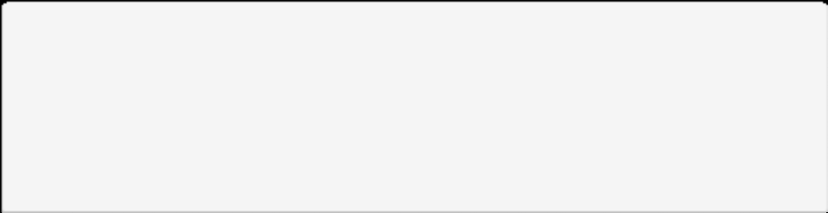

Which is the value for the lines of code metric of the source code shown?

function writeXmlItem(xmlOutput, xmlParent, oItem, sElement)

{

var xmlItem = xmlOutput.addElement(xmlParent, sElement); xmlItem.setAttribute(“Name”, oItem.Name(g_nLoc)); xmlItem.setAttribute(“TypeNum”, oItem.TypeNum()); xmlItem.setAttribute(“ID”, getAttrID(oItem));

return xmlItem;

}

**Choose an answer:**

10

7

*8*

9



You work in a team with a developer. After style and source code analysis, they say that they no longer need to conduct unit tests.

Which do you answer with?

**Choose an answer:**

*No, semantic errors, for instance, cannot be found with the procedure* *mentioned*.

Yes, if they have reviewed the source code analysis.

Yes, that is fine. The source code is now error-free in the component context.

No. In this case, conducting the component tests only verifies the correct integration.



**FRAGE 113 VON 312**

**IQSS01_MC_mittel/Lektion 04**



Why is code analysis a qualitative assessment?

**Choose an answer:**

Because it measures the program code attributes.

Since this is a constructive quality assurance measure, it can only be a qualitative evaluation.

*Because the code is analyzed and evaluated in terms of content.*

Because metrics are collected and evaluated.



Which statement about “quality gates” is **incorrect**?

**Choose an answer:**

The further course of the project is decided on the basis of “quality gates”.

“Quality gates” are very specific decision points.

*“Quality gates” only examine the completeness of the artifacts to be delivered, using a checklist.*

Timeboxing can be used in “quality gates”.



**FRAGE 115 VON 312**

**IQSS01_MC_schwer/Lektion 04**



Which is **not** anobjective of the moderator during the review session?

**Choose an answer:**

Prepare a log of all functional deficiencies that have been identified.

Achieve a documented result.

*Prepare a review report.*

Collect all formal errors without discussing them.



Which two values should be observable with the Halstead metric?

**Choose an answer:**

Class depth and fan-out.

Fan-out and access probability.

Scope and class depth.

*Scope and difficulty level in understanding.*



Determine the fan-out value for the class provided.

(The class is from <http://www.java-forum.org/java-basics-anfaenger-themen/141844-java-> calculator-class-methods.html)

/**

*

* Description

*

* @version 1.0 from 24.09.2012

* @author

*/

public class Calculator {

public double result; private double number1; private double number2; private char operator;

public void calculate() { number1 = giveNumber(); number2 = giveNumber();

operator = giveOperator();

//Start of the actual calculation

if (operator == '+') {

result = addition(number1, number2); System.out.println(“Result “+result);

} else {



**FRAGE 117 VON 312**

**IQSS01_MC_schwer/Lektion 04**

if (operator == '-') {



result = subtraction(number1, number2);

} else {

if (operator == '*') {

result = multiplication(number1, number2);

} else {

if (operator == '/') {

result = division(number1, number2);

}

}

}

}

}

public double giveNumber() {

return Keyboard.readComma;

}

public char giveOperator() { return keyboard.readChar;

}

public double addition(double number1,double number2) { return number1+number2;

}

public double subtraction(double number1, double number2) { return number1-number2;

}

public double multiplication(double number1, double number2) { return number1*number2;

}

public double division(double number1, double number2) { return number1/number2;

}

}

**Choose an answer:**

1

4

*2*

0



**FRAGE 118 VON 312**

**IQSS01_MC_schwer/Lektion 04**



Indicate the error pattern that *Checkstyle does* **not** find.

**Choose an answer:**

*Dodgy code.*

Code sequences duplicated by copy & paste. Correctness.

Bad code.



**FRAGE 119 VON 312**

**IQSS01_MC_leicht/Lektion 05**



Testing means ...

**Choose an answer:**

*executing a system or parts of a system to transfer specific input values and evaluating the system behavior or the result generated.*

determining static information regarding a system and evaluating it.

executing a system to transfer only correct input values and evaluating the system behavior or the result generated.

executing a system or parts of a system, transferring specific input values.



Testing can be described by three of the four adjectives below.

Indicate the term that does **not** apply.

**Choose an answer:**

Dynamic.

Analytical.

Evaluative.

*Static.*



**FRAGE 121 VON 312**

**IQSS01_MC_leicht/Lektion 05**



Black box testing is most often executed at which of the following testing levels?

**Choose an answer:**

Component test and integration test.

System test and component test.

Component test and acceptance test.

*Integration test and acceptance test.*

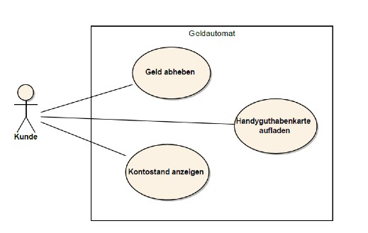

What is the minimum number of test cases you would need to derive from the illustrated use case diagram?

**Choose an answer:**

4

5

*3*

6

**Geldautomat = Cash Machine Geld abheben = Withdraw Cash**

**Kontostand anzeigen = View Account Balance Handyguthabenkarte aufladen = Top Up Cell Phone Balance**



Which of the criteria listed is **not** a criterion to identify particularly relevant use cases for test case generation?

**Choose an answer:**

Frequency of use of the use case.

Required coverage criteria for use cases.

Frequency of errors in the implementation of similar use cases.

*Existing description of the use case.*



**FRAGE 124 VON 312**

**IQSS01_MC_leicht/Lektion 05**



In the context of use-case-based test case creation, activity diagrams serve . . .

**Choose an answer:**

as input for the use case generation.

*as a way to specify use cases more precisely and derive test cases*

as a representation of the code structure of the system to be created.

as an example of the possibilities of the system.



Equivalence partitioning is a technique for ...

**Choose an answer:**

*test data selection*.

test tool selection.

test class selection.

test case selection.



**FRAGE 126 VON 312**

**IQSS01_MC_leicht/Lektion 05**



The reason for applying boundary value analysis is . . .

**Choose an answer:**

the observation that equivalence classes are not sufficient for test case generation.

*the observation that software errors often occur in the boundary region of equivalence classes.*

the observation that software errors occur in clusters.

the observation that limits for random test data should be tested very distinctly.



Which statement regarding equivalence classes is correct?

**Choose an answer:**

*Equivalence partitioning can be used to determine test data for systems that expect input*.

When generating test cases with equivalence classes, only valid equivalence classes must be considered.

Equivalence classes must be disjoint.

Equivalence classes can be best applied to software systems whose function depends on internal states.



**FRAGE 128 VON 312**

**IQSS01_MC_leicht/Lektion 05**



There are different options for creating specifications in a state-based form.

Indicate the option below that is **incorrect.**

**Choose an answer:**

Text.

State table.

*Use case diagram.*

State diagram.



Indicate the major disadvantage of state diagrams.

**Choose an answer:**

State tables can only be derived from state diagrams with great effort.

Test cases are difficult to derive from state diagrams.

Disallowed states are difficult to map.

*Functions that do not change the states of a system* are *quickly forgotten.*



**FRAGE 130 VON 312**

**IQSS01_MC_leicht/Lektion 05**

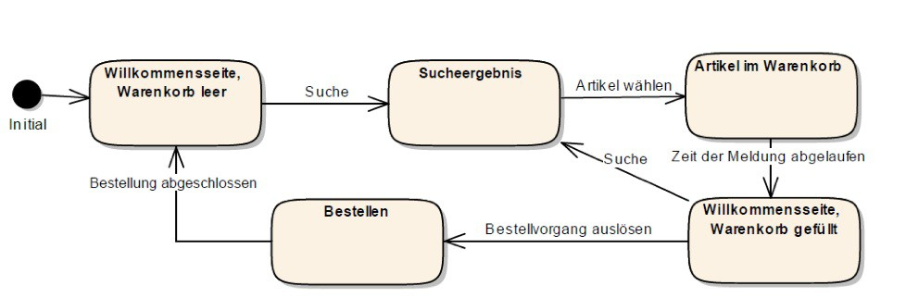

From the states listed, select the state transition that is **not** allowed.

**Choose an answer:**

*Search result—order.*

Search result—item in shopping cart.

Item in shopping cart—welcome page, shopping cart filled.

Welcome page, shopping carts empty—search result.



Choose the greatest disadvantage of using random test data.

**Choose an answer:**

The data generated cannot be used for black box testing.

Data generation is time-consuming.

*The data generated* is *not necessarily realistic.*

The method cannot be used for complex data.



**FRAGE 132 VON 312**

**IQSS01_MC_leicht/Lektion 05**



Choose the basic principle of testing with random test data.

**Choose an answer:**

It is based on the fact that coincidences in input data are often a source of error.

It is based on the fact that a great deal of test data is similar to test data from previous projects.

*It is based on the fact that a value range with valid values exists*.

It is based on the fact that many test data combinations need to be tested.



Choose the correct statement regarding testing with random data:

**Choose an answer:**

This type of testing is particularly widespread in the component testing of software.

*Combined with equivalence partitioning, random test data generation is a technique where many different test data sets can be generated with comparably little effort.*

Automatic test executions must be scheduled for testing with random data.

Testing with random test data is sufficient in the area of user interface testing to execute a qualitative test.



**FRAGE 134 VON 312**

**IQSS01_MC_mittel/Lektion 05**



Branch and condition coverage differ.

Explain how.

**Choose an answer:**

Branch coverage is used to functionally test, end-to-end through the entire functional process. With condition coverage, composite decisions and the system behavior resulting from their behavior are examined.

They differ in their use: branch coverage is used in black box testing and condition coverage is used in white box testing for test case identification.

*Branch coverage means that all decisions and their branches are run through. Condition coverage means that each condition is run through at “true” and “false” respectively*.

Loop passes can be tested several times with a condition test. This is not intended for a branch test.



Indicate the applicable statement regarding black box tests.

**Choose an answer:**

They are generated with knowledge of the program code. The objective is to cover as many of the assertions and control structures (such as if, while, for, switch) implemented in the program code as possible

Black box tests are only used for executing tests. They are not suitable for test case generation.

*They are generally used to test the interaction between various system components. They are often very user-oriented and testing is based on the specification*.

Black box testing requires knowledge of the specification and program code.



**FRAGE 136 VON 312**

**IQSS01_MC_mittel/Lektion 05**



# The activity diagram provided refines a use case.

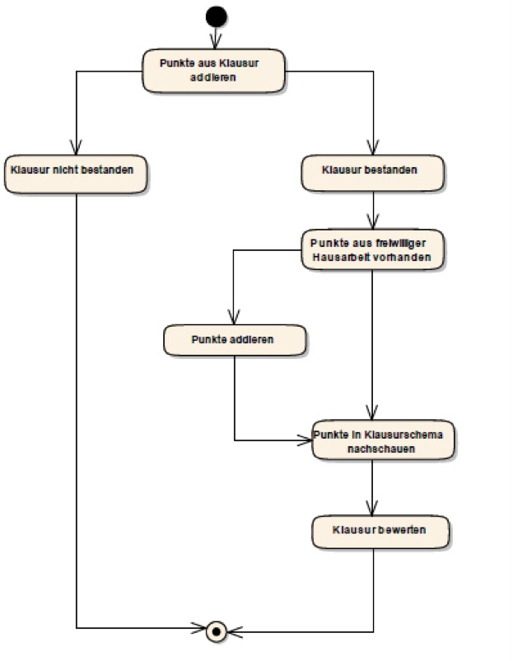

How many test cases are required to satisfy the coverage criterion “*path coverage*”?

**Choose an answer:**

4

7

6

*3*



Choose the applicable explanation for the test case generation procedure with use-case-based testing according to the criteria of selection for typical errors.

**Choose an answer:**

Selection of use cases reflecting typical user errors.

Selection of test cases that have a high potential for damage if typical errors occur.

*Selection of test cases in use cases that frequently have errors in their implementation, or in the execution of which errors frequently occur in competing products.*

Selection of test cases, which often produced misunderstandings during the generation of the test cases.



**FRAGE 138 VON 312**

**IQSS01_MC_mittel/Lektion 05**



The following specification exists for an appointment scheduling tool:

the practice is open between 8:00 a.m. and 5:00 p.m. Monday through Thursday, and between 7:30 a.m. and 12:30 p.m. on Fridays.

Appointments can be made up to fifteen minutes before closing.

From the equivalence classes listed, select the one that is valid for this appointment scheduling.

**Choose an answer:**

Monday through Thursday: 8:00 a.m.—4:59 p.m. and Friday 7:30 a.m.—12:29 p.m.

Mondays to Thursday: 8:00 a.m.—5:00 p.m. and Friday 7:30 a.m.—12:30 p.m.

Friday: 8:00 a.m.—5:00 p.m. and Monday – Thursday 7:30 a.m.—12:30 p.m.

*Monday through Thursday: 8:00 a.m.*—*4:45 p.m. and Friday 7:30 a.m.*—*12:15 p.m.*



Testing with test data from equivalence classes also has some disadvantages. Choose the correct combination:

**Choose an answer:**

Business *dependencies are not taken into account; internal states and resulting dependencies are difficult to include in the representation.*

Tabular representation is more difficult to understand than representation in model form, particularly for larger systems; cause and effect cannot be read in a clear, structured way.

Only technical dependencies are considered; tabular representation is difficult to follow for larger systems.

Internal states and the resulting dependencies are difficult to capture; without boundary value analysis, the test data found is not usable.



**FRAGE 140 VON 312**

**IQSS01_MC_mittel/Lektion 05**



You are to derive test cases from a state transition table.

Why should you **not only** examineerror situations, but rather **all** disallowed state transitions?

**Choose an answer:**

*All non-transitions are examined for non-existence during the examination. Functions that are not triggered with the procedure or are not specified are also errors.*

This is not necessary. There cannot be disallowed state transitions.

This is not necessary, since all disallowed states are also tested with the recording of error situations.

Because with errors, only explicitly anchored error transitions are examined, but all undefined errors are examined with the disallowed ones.



When creating a state transition table from a state diagram, how many columns and rows are needed?

**Choose an answer:**

*One column and one row are created for each defined state in the diagram*.

One column and one row are created for each defined state, except for the initial state, (i.e., total number of states – 1) in the diagram.

One column and two rows are created for each defined state in the diagram.

Two columns and one row are created for each defined state in the diagram.



**FRAGE 142 VON 312**

**IQSS01_MC_mittel/Lektion 05**



Choose the reason for using random test data.

**Choose an answer:**

There are no defined data spaces, therefore the tests only benefit from a wide range of test data.

A great deal of test data is needed. For this reason, more data must be generated.

*There is a prescribed range of values within the limits of which the test data must be generated*.

The characteristics of the test data are not important. Only the quantity of the data is decisive.



Can random test data be used in systems that include more than one type of input, e.g., a website for recording the mailing address of magazine subscribers?

**Choose an answer:**

No. Random test data can only be used with this type of input consisting of one data type, e.g., a postal code. This is not possible in a combination, e.g., with a street.

No. Random test data is not well-suited for user interfaces because the value ranges are not sufficiently specified.

*Yes. Different random test data can also be used in combination, and thus be combined into random test data sets*.

Yes. Random test data can only be used if combinations of individual test data are to be used.



**FRAGE 144 VON 312**

**IQSS01_MC_schwer/Lektion 05**



Running through loops in a program code, sometimes several times, is particularly tested during . . .

**Choose an answer:**

instruction tests.

*condition tests.*

acceptance tests.

branch tests.



You are to specify the test coverage for a white box component test and a black box system test.

Which statement regarding test coverage is correct?

**Choose an answer:**

Test coverage is a measure of tests executed, so a component test and a system test must have already been executed to specify the value.

The value for test coverage is identical in both cases, as it is the measure of completeness of test cases.

The value cannot be determined before the software is delivered, because the number of errors found by the customer is necessary for the determination.

*Test coverage is a measure of the completeness of the test cases. The specific values* *for the two desired test types must be independently compiled.*



**FRAGE 146 VON 312**

**IQSS01_MC_schwer/Lektion 05**



Choose the reason why condition coverage is better than instruction coverage.

**Choose an answer:**

The statement is not correct. Instruction coverage has a higher valence.

In the case of instruction coverage, all conditions are examined at “true” or “false”. Duplicate conditions in combination are also examined.

*In the case of condition coverage, all conditions are examined for “true” or “false”. Duplicate conditions in combination are also examined*.

The statement is not correct. There are no gradations in test coverage. They are all equally good.



“*Boundary values can only be used meaningfully with numeric values.”*

Evaluate this statement.

**Choose an answer:**

The statement is correct. There are no boundary values for texts.

The statement is incorrect. Boundary values can only be used meaningfully with texts.

*The statement is incorrect. Texts can also have equivalence classes, and thus also boundary areas.*

The statement is correct. With text, the principle of error accumulation in the boundary area does not exist. Therefore, boundary value analysis cannot be used meaningfully.



**FRAGE 148 VON 312**

**IQSS01_MC_schwer/Lektion 05**



In the context of state-based test case determination, there are trivial transitions.

Indicate the correct definition of this:

**Choose an answer:**

Trivial transitions are non-existent.

All states that do not require more than one input are trivial.

Trivial transitions are all transitions that do not contain an error message.

*Trivial transitions are transitions that do* *not involve a functionally important decision.*



Indicate the result of test requirement analysis.

**Choose an answer:**

Decision whether to test.

Test cases, without specific test data.

*Very rough description of the test cases or the test object.*

Test planning documents.



**FRAGE 150 VON 312**

**IQSS01_MC_leicht/Lektion 06**



Choose the test level at which test planning generally takes the most time.

**Choose an answer:**

Acceptance test.

Component test.

*System test.*

Integration test.



There are several sources for test data generation.

Choose the **incorrect** one from the sources of origin listed.

**Choose an answer:**

Source code.

*System documentation.*

Architecture description.

Specification.



**FRAGE 152 VON 312**

**IQSS01_MC_leicht/Lektion 06**



Choose the applicable definition of a regression test from the following definitions.

**Choose an answer:**

The first execution of an automatic test of previous, manually executed tests.

The execution of automatic tests.

The execution of tests already performed that have not been passed.

*The execution of tests that have already been passed after the program code has been modified is* *called “regression tests”.*



The following statements refer to test-driven development.

Choose the statement that applies.

**Choose an answer:**

Test-driven development means that no functionality is allowed to go into production that does not have an automated test.

In test-driven development, the test manager is also the development manager.

All automatic tests must be executed after each check-in of source code.

*In test-driven development, an automatic test is first written for each new functionality.*

*If the test is failed, implementation is undertaken*.



**FRAGE 154 VON 312**

**IQSS01_MC_leicht/Lektion 06**



Unit tests should have a few basic attributes.

Choose the non-applicable attribute from those listed.

**Choose an answer:**

Reproducibility.

*Usability.*

Regressability.

Independence.



In the by-value strategy, the component sequence is defined based on . . .

**Choose an answer:**

the technical complexity.

the completion date.

the risk assessment.

*the value amount.*



**FRAGE 156 VON 312**

**IQSS01_MC_leicht/Lektion 06**



The test objective of an integration test is to test the . . .

**Choose an answer:**

interaction of the components via drivers and dummies.

*interaction of the components via their interfaces*.

behavior of always exactly two components based on the specification. internal behavior of the components during integration.



Which integration strategy uses drivers most intensively?

**Choose an answer:**

Top-down.

Big bang.

By-value.

*Bottom-up.*



**FRAGE 158 VON 312**

**IQSS01_MC_leicht/Lektion 06**



A recommissioning test tests:

**Choose an answer:**

The behavior of the software after lengthy idle periods.

*The behavior of the software after system failures.*

Usability after a lengthy break from using the software.

The response time directly after starting up the software.



One of the biggest challenges in system testing is:

**Choose an answer:**

The integration of all software components in a suitable form.

The *generation of test data as a true to the original representation.*

The integration of test automation.

Planning of all types of tests, such as functional, load, and performance tests.



**FRAGE 160 VON 312**

**IQSS01_MC_leicht/Lektion 06**



Various indicators of the performance of the system are measured during a performance test.

Choose the **incorrect** indicator from the following list.

**Choose an answer:**

Throughput.

Transaction rate.

*Recovery time.*

Latency.



The responsibility for executing the acceptance test lies with the ...

**Choose an answer:**

quality manager.

*customer.*

developer.

project manager.



**FRAGE 162 VON 312**

**IQSS01_MC_leicht/Lektion 06**



The test cases for the acceptance test are based on ...

**Choose an answer:**

the implemented functionality of the interfaces.

the specification of the developers.

the wishes of the project manager.

*the acceptance criteria agreed between the customer and the supplier*.



The most significant difference between system and acceptance testing is ...

**Choose an answer:**

the implementation by the developers. the use of equivalence classes.

the negotiations regarding errors that have been discovered.

*the execution in the environment in which the software is to be operated*.



**FRAGE 164 VON 312**

**IQSS01_MC_mittel/Lektion 06**



You can use different sources to determine the test data.

However, with which of the sources below do you have **little** chance of success?

**Choose an answer:**

Program code.

Architecture description.

*Test management manual.*

Specification.



The reproducibility of unit testing depends, among other things, on the following:

**Choose an answer:**

Test sequence including test steps that can be executed at different points of the applications.

*Test data and initial conditions of tests that do not depend on another result.*

Defined initial conditions and final conditions that correspond exactly to those for the subsequent test case.

The chosen framework.



**FRAGE 166 VON 312**

**IQSS01_MC_mittel/Lektion 06**



Choose the most appropriate definition of the term “*component test*” from the those listed.

**Choose an answer:**

*Component tests are white box tests and test the correct execution of individual functions of technical classes and components.*

Component tests are automatic tests generated before test execution.

Component tests describe the developers’ test level.

Component tests are tests of isolated computations of functions.



You create test cases for integration testing.

Which of the test purposes listed is a primary focus of this test launch?

**Choose an answer:**

*Test purpose: examine the correctness of the data transmission.*

Test purpose: correctness of the tax rate calculation.

Test purpose: transaction rate of processing booking data sets.

Test purpose: design and structure of user interface.



**FRAGE 168 VON 312**

**IQSS01_MC_mittel/Lektion 06**



Your customer tells you four functions that are particularly important in their new software. Choose one of the integration strategies listed below to test these particularly extensively.

**Choose an answer:**

Bottom-up.

Big bang.

*By-value.*

Top-down



In which software integration strategy are the selection criteria of component weighting and risk of individual software components particularly important?

**Choose an answer:**

Top-down.

Big bang.

*By-value.*

Bottom-up.



**FRAGE 170 VON 312**

**IQSS01_MC_mittel/Lektion 06**



A few examples of transaction rates are listed.

Choose the example that does **not** fit as a transaction rate:

**Choose an answer:**

*Dialog change time within a web application with simultaneous access of 1000 users.*

Number of booking transactions within the application of a direct bank.

Processing of 1000 data set changes in the database.

Booking time for 1000 incoming XML messages.



You are involved in the planning of an integration test. Within your planning, you need to estimate expenses for various preparatory activities.

For which of the preparatory activities do you have to expect a particularly high expense?

**Choose an answer:**

Adjustment of component test automation. Installation of servers.

Usability tests

*Test data definition and test data generation.*



**FRAGE 172 VON 312**

**IQSS01_MC_mittel/Lektion 06**



A few errors occur during the acceptance test with the customer.

How do you go about billing?

**Choose an answer:**

Acceptance test errors are common and do not need to be corrected prior to invoicing.

Re-enter the system test phase after an error correction phase and repeat the acceptance test.

The acceptance test is generally not mandatory for the accounting office.

*Enter into negotiations with the customer as to* *which errors will be corrected before the go-live.*



You obtain test data for your system test from the program code of the components to be tested.

Which additional consideration should you always carry out to receive good test data?

**Choose an answer:**

Acquisition of the test procedure.

Only equivalence partitioning and boundary value analysis are still necessary. *Additional acquisition of functional specialized cases.*

Generalize the data obtained.



**FRAGE 174 VON 312**

**IQSS01_MC_schwer/Lektion 06**



The following procedure is implemented when generating a unit test:

Set up the user that will be needed in the course of the test.

Access the login function with the user that has been created and the stored password.

Access the function to be tested.

Exit functionality.

Which attribute was damaged here, among other things?

**Choose an answer:**

Reproducibility.

*Regressability.*

Testability.

Error accumulation.



Choose the best description of the difference between drivers and dummies.

**Choose an answer:**

Driver and dummy are synonyms.

*A driver accesses the function* *being tested, while a dummy is accessed by the function under testing.*

A dummy simulates one component, while a driver represents multiple components.

A dummy accesses the function being tested, while a driver is accessed by the function being tested.



**FRAGE 176 VON 312**

**IQSS01_MC_schwer/Lektion 06**



Choose the definition of the term “*latency*”

**Choose an answer:**

Measure of processing speed of defined, complex changes.

Processing speed of functions or data.

Time between opening and closing the application.

*Time period that elapses between a query to the system and a response.*



Select the type of error that is more likely to occur during load testing than performance testing:

**Choose an answer:**

Errors in functionalities that are frequently accessed.

*Errors in restore functionalities after system overload.*

Errors in resource usage.

Errors during high system load.



**FRAGE 178 VON 312**

**IQSS01_MC_leicht/Lektion 07**



ATAM belongs to the class of ...

**Choose an answer:**

test-case-based architecture analysis.

*scenario-based architecture analysis.*

scenario-based requirements analysis.

scenario-based test case analysis.



The following areas are covered by ATAM:

**Choose an answer:**

*Evaluating architectures and finding architectural alternatives.*

Documenting architecture and test planning.

Evaluating architectures and documenting them.

Documenting architectural alternatives.



**FRAGE 180 VON 312**

**IQSS01_MC_leicht/Lektion 07**



Choose the appropriate definition for the term “examination techniques for requirements”.

**Choose an answer:**

Principles that help in the preparation of a test.

*Specific procedures or approaches that will be used to conduct an examination.*

Tools that will be used during an examination.

Umbrella term for root cause analysis and 5-Why method.



Requirements are often subject to a review process for quality assurance measures.

Which of the options listed can still be used to examine requirements?

**Choose an answer:**

Component test. Top-down strategy.

*Experimental design of development artifacts.*

Analytical measures.



**FRAGE 182 VON 312**

**IQSS01_MC_leicht/Lektion 07**



You are planning to conduct a requirements review.

Which do you need to take into account?

**Choose an answer:**

“Invite participants” and “determine recorder” are the only two steps that need to be carried out in the planning process.

Requirements cannot be reviewed.

*The organization of the required infrastructure, the scheduling of all participants and, if necessary, the coordination of external experts.*

Management must be informed and the time entered in the test planning.



Which is the artifact that is reviewed during ex-ante architectural review?

**Choose an answer:**

Actual architecture.

Requirements specification.

*Architecture specification.*

*T*echnical specification.



**FRAGE 184 VON 312**

**IQSS01_MC_leicht/Lektion 07**



ATAM’s objective is ...

**Choose an answer:**

an architecture evaluation and obtaining a component description.

to create only one architectural evaluation.

*an architectural evaluation and the identification of alternatives*.

an architectural evaluation and classification of this.



In which phase of ATAM is the test located?

**Choose an answer:**

Phase 1.

Phase 2.

*Phase 3.*

Phase 4.



**FRAGE 186 VON 312**

**IQSS01_MC_leicht/Lektion 07**



Which is the objective of an ex-post architecture evaluation?

**Choose an answer:**

Examine the selected architecture for its ability to meet the established requirements.

*Examine whether the result of the development work adheres to the specifications established by the architecture definition.*

Proof of suitability of an architecture.

Examine architectural alternatives.



Which is part of reporting according to ATAM?

**Choose an answer:**

Discard all alternatives except the one selected.

A description of the functions that were important to the architectural decision Selection criteria for the alternatives.

*Findings regarding the required quality attributes and the* *architecture decisions based on them.*



**FRAGE 188 VON 312**

**IQSS01_MC_leicht/Lektion 07**



Which process is assessed in the CMMI model?

**Choose an answer:**

The target process.

*The actual process.*

The test case generation process.

The error management process.



The maturity levels in the CMMI model indicate ...

**Choose an answer:**

the next improvement step.

*the current capability level of a process*.

the opportunities for improvement.

the capability level after a process improvement.



**FRAGE 190 VON 312**

**IQSS01_MC_leicht/Lektion 07**



Which activity is **not** part of a process change?

**Choose an answer:**

Identifying improvements.

Introducing process changes.

Training stakeholders.

*Prioritizing changes.*



The reason for the quality assurance of software processes is ...

**Choose an answer:**

the possibility of revealing further requirements for the software to be created.

that artifacts can only be reviewed after they are completed. To make use of the time before they are created, the process can be considered.

that dynamic measures are only possible if the software process contains constructive measures.

*the assumption that there is a relationship between process quality and product quality*.



**FRAGE 192 VON 312**

**IQSS01_MC_leicht/Lektion 07**



After process changes have been introduced during an improvement process for software processes and the stakeholders have been trained, you should first . . .

**Choose an answer:**

prioritize the further improvements.

introduce timeboxing.

reach the next CMMI level.

*review the process changes and adjust* as *necessary.*



Which of the factors listed do **not** influence the examination criteria for requirements?

**Choose an answer:**

Resources planned for this.

Project situation.

*Test tool used.*

Time for the activity.



**FRAGE 194 VON 312**

**IQSS01_MC_mittel/Lektion 07**



When examining requirements, which activity do you **not** need to pay attention to?

**Choose an answer:**

Organization of the required infrastructure.

Documentation of the results.

Coordination of external experts.

*Revision of the requirements.*



The principle of the “separation of error detection and error correction” in requirements examination in software testing creates, among other things?

**Choose an answer:**

Integration of testers into a development team. Implementation of testing mechanisms. *Independence between testers and developers.*

Shorter debugging times.



**FRAGE 196 VON 312**

**IQSS01_MC_mittel/Lektion 07**



The principle of “re-examination” in requirements examination fits with . . .

**Choose an answer:**

the principle of continuous process improvement, e.g., in TQM.

analytical procedures in general.

control mechanisms through project management.

*regression tests*.



Which are scenario-based architectural evaluations?

**Choose an answer:**

Scenarios that are used by the architecture in the context of a best-practice example.

An analytical measure in the context of architecture documentation.

Consideration of the scenarios that can be implemented with the architecture.

*Considerations of the architecture based on the business scenarios in which it is used.*



**FRAGE 198 VON 312**

**IQSS01_MC_mittel/Lektion 07**



What is meant by business drivers in ATAM?

**Choose an answer:**

The most important stakeholders in the project.

The use cases of an architecture to be created.

Non-functional requirements.

*The most important functional activities as requirements, quality requirements, and boundary conditions.*



Which is meant by a utility tree in ATAM?

**Choose an answer:**

Test specification concerning the architecture.

The use cases of anarchitecture to be created.

*Set of scenarios with quality attributes.*

The most important functional activities as requirements, quality requirements, and boundary conditions.



**FRAGE 200 VON 312**

**IQSS01_MC_mittel/Lektion 07**



The following description for a CMMI level describes which level?

*“Process quality can be determined and managed by measuring quantitative process characteristics. By collecting key figures on the activities of the processes and on the results generated, problems can be identified and counteracted accordingly.”*

**Choose an answer:**

*4*

1

2

3



In addition to the process areas and the defined objectives for each level, the CMMI also includes:

**Choose an answer:**

Additional guidance for program managers.

*Procedures for achieving objectives.*

Test guidance.

A quality model.



**FRAGE 202 VON 312**

**IQSS01_MC_mittel/Lektion 07**



Your process reaches level three in CMMI.

What do you need to do next to reach the next level up?

**Choose an answer:**

Establish an independent test team.

Introduce improvement mechanisms. Explicitly define roles and results.

*Introduce metrics to make the process measurable.*



The requirements for your project were never examined.

Many problems occur during the testing phase. Which problem is **not** due to this omission?

**Choose an answer:**

Missing functionalities that prevent process flows.

Unclear requirements that are therefore difficult to test.

Faulty test data.

*Long error correction times.*



**FRAGE 204 VON 312**

**IQSS01_MC_schwer/Lektion 07**



You have set up scenarios that you want to use for architectural examination.

After you have completed your ATAM investigation, you notice that you have forgotten two important scenarios.

Which must you do?

**Choose an answer:**

*Reiterate the ATAM, as business drivers have a major impact on this investigation*.

Inform the architect.

Nothing. The majority of the scenarios were covered.

Nothing. Nothing can be changed after the ATAM has been completed.



Which flow into the overall assessment of ATAM?

**Choose an answer:**

Business driver and quality attribute dependencies.

Only the usage possibilities per business driver.

Testability, business drivers, and the dependency on an architecture variant.

*Dependencies between quality attributes and selected architectures, including risks.*



**FRAGE 206 VON 312**

**IQSS01_MC_schwer/Lektion 07**



Process improvements require an analysis of the current processes.

As an alternative to evaluating criteria, how can you conduct this analysis?

**Choose an answer:**

There is no alternative to this.

Use of CMMI.

*Survey of stakeholders.*

Survey of customers.



Why does the highly pronounced quality attribute “*standardization*” support the “*understandability*” of processes?

**Choose an answer:**

Standardization means, among other things, wide distribution. Thus, the processes are often known.

*Standard processes* *are usually well documented and explicitly defined so that understandability is supported.*

The statement is untrue because both criteria contradict each other.

Standardization brings about a quick completion of the process. Fast processes are easier to understand.



**FRAGE 208 VON 312**

**IQSS01_Offen_leicht_F1/Lektion 01**



Define the term “software quality”.

Please base this on ISO 9126. Provide a reference to the specification.

“*Software quality is the set of characteristics and characteristic values of a software product that relate to its ability to meet specified requirements.* “ (ISO 9126)

The specification determines the requirements and according to the definition, it is not possible to conduct an examination without this.



Provide two examples of the principle of quantitative quality assurance.

What measures do you need to take to ensure that you can carry out quantitative quality assurance?

(Examples providing a reference to a metric of a system or process are correct).

Metrics must be defined so that quantitative quality assurance is possible. Thus, the possibility of measuring certain attributes must also be created in advance.



**FRAGE 210 VON 312**

**IQSS01_Offen_leicht_F1/Lesson 01**



List at least three benefits of independent quality assurance.

Objective error correction.

Additional perspective on the interpretation of the specification.

Use of time for quality assurance, rather than for development

(if the developers have the choice).



**FRAGE 211 VON 312**

**IQSS01_Offen_leicht_F1/Lektion 01**



List reasons why the complete testing of information systems is **not** possible.

Complete testing would require testing with all possible input data combinations, in all environments, under all possible external conditions (power failure, network failure, earthquake, ...).

The combination with all possible system states requires too many resources.



Explain the principle of the “accumulation of errors” and the influence this principle has on test planning.

List three possible reasons for the accumulation of errors.

The principle of the accumulation of errors involves the fact that a location where many errors have occurred has a high probability of there being further errors to be detected still.

In test planning, more extensive test case generation and more time for test execution must be planned for this area of the software, as well as an increase in constructive quality assurance.

Possible reasons:

Poorly trained developers. Insufficient specification.

High complexity of components.

High rate of change of components.



**FRAGE 213 VON 312**

**IQSS01_Offen_leicht_F1/Lesson 01**



Differentiate between the terms “internal error correction” and “external error correction” and classify both in a software quality cost model.

Both software cost types are part of the costs for error correction within the quality costs for software.

Internal error correction is measures to detect and eliminate the sources of errors.

External costs are all costs that arise for external reasons (customers, image ...).



Explain “Repetition is not effective” in relation to a software test.

The repeated execution of the same test cases with the same input data in the same system state and on the basis of the same data set without modifying the program code will not achieve any other effect other than that gained through a single execution of the test cases.

Running the same test several times under identical conditions will therefore not lead to gaining additional knowledge regarding potential errors.



**FRAGE 215 VON 312**

**IQSS01_Offen_mittel_F1/Lektion 01**



Differentiate between the two terms “quality management” and “quality control” by defining the two terms and explaining their differences.

“Quality management” (QM) is a collective term that includes all organized measures that serve to improve the quality of products, processes or services of any kind.

“Quality control” is one of the four typical activities in quality management. The typical tasks of quality control are monitoring, management, and control of quality testing activities in the software development process.



Explain the principle of development-accompanying integrated quality assurance and name the software development process model that most clearly implements it.

The principle of development-accompanying, integrated quality assurance is the consequence of the principle of early error detection.

In order to detect errors as early as possible, quality assurance activities must accompany development activities and be firmly integrated into the software process.

Consistent application of this principle requires deﬁned quality assurance of all artifacts created in the software process, to ensure that errors do not propagate from one activity to the next.

This principle is implemented particularly succinctly by the evolutionary development process model.



**FRAGE 217 VON 312**

**IQSS01_Offen_mittel_F1/Lektion 01**



Explain why the statement “*No errors automatically means a usable system.* “

is a fallacy and provide three examples of this fallacy.

The quality of software, and thus also the formulation of test cases, is based on the specification of the system.

Aspects that may be important to users but were not considered in the specification are usually not tested.

Therefore, even a very thoroughly tested system in which all detected errors have been removed may be unusable from the user’s point of view.

(Examples indicating missing specification aspects are valid).



Put the two principles of software testing,

“*Testing shows the presence of errors.*”

“*Complete testing is not possible.*”

into context with one another and briefly explain what effect this has in test planning.

“Testing shows the presence of errors” means that a point can be found where errors are no longer found, because they have all been found.

Planning is with the assumption that at one point in time, most of the (cost-optimized) points have been found and corrected, the principle “complete testing is not possible” underpins this.

Thus, other end-of-testing criteria must be defined.



**FRAGE 219 VON 312**

**IQSS01_Offen_mittel_F1/Lektion 01**



The graphic shows the quality costs of a system.

Describe what must exist for the two functions. You are welcome to name the color of the graph as an identification criterion.

Describe how a cost-optimized solution would need to be integrated into the graph and define cost-optimized quality.

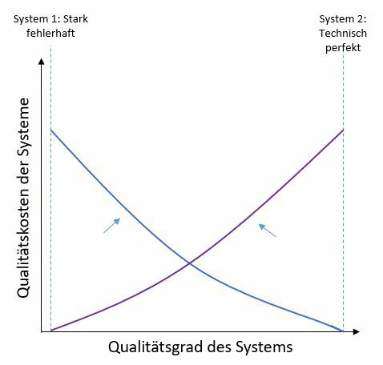

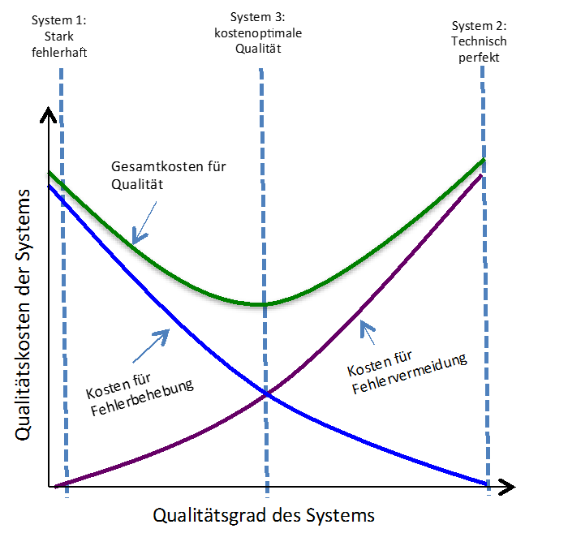

The green line is a system that has been optimally created in terms of quality costs.

The most significant errors were identified and corrected before delivery, but some errors were also identified and corrected after delivery.

The costs for error prevention and error correction are the same for cost-optimized quality.

A risk assessment must be conducted for risks that remain in the product.



Briefly name the activities of quality assurance and quality improvement in quality management.

Then briefly outline how quality improvement can impact quality assurance.

## Quality assurance:

Activities that ensure that specified quality requirements for products, processes, and services are met.

## Quality improvement:

Evaluation of product and process data to improve quality levels.

Measures within quality improvement can be decided, e.g., an increase in automatic unit tests, and must then be implemented in quality assurance.



**FRAGE 221 VON 312**

**IQSS01_Offen_schwer_F1/Lektion 01**



Explain the principle that

“*Testing depends on the environment.* “

and illustrate your explanation with an example of preparing test cases.

All activities—from the conceptual planning and creation to the implementation and evaluation of test cases—are unique for each project.

They are determined on the basis of the requirements for the system, the boundary conditions of the project and the quality objectives that have been formulated.

Test case definition not only differs in the functions that are to be tested, but those that are also different in different project situations, maturity levels, and development method.



List the components of quality costs and deduce why the total cost of software quality is cost-optimized when the system itself is halfway between highly faulty and technically perfect.

Quality costs consist of costs for error prevention and costs for error correction. Error prevention is divided into costs for constructive and analytical quality management, while the costs for error correction are divided into internal and external costs.

The costs for error prevention and error correction are the same for a cost-optimized quality.



Explain the term “software quality management”.

Consider the necessary core activities and briefly describe them.

The term “quality management” is defined in the industry standard ISO 9000 as follows:

“*Coordinated activities for managing and directing an organization with regard to quality, which usually includes establishing quality policy and quality objectives, quality planning, quality control, quality assurance, and quality improvement*.”

The core activities are therefore quality planning, quality assurance and quality control, quality improvement.

Quality planning (detailed in Section 2.2) for a specific software process determines exactly which persons are responsible for which QA activities, which QA activities are required at which point in time in the software process, and with which means, methods, and tools quality assurance is carried out.

In quality assurance activities (see Section 2.3), the measures defined in the quality plan are carried out. The quality plan thus provides the specific framework for action in a project so that every employee in the project knows at all times when which QA activities are due, how the results are documented, and who is responsible for carrying out the activities.

Quality control (see Section 2.4) is a collective term that includes all activities required for monitoring and controlling QA activities. Here, the focus is not on the software system, but on the activities that are carried out for quality assurance. The objective of quality control is to achieve an appropriate level of quality assurance.



**FRAGE** 224 **VON 312**

**IQSS01_Offen_leicht_F1/Lektion 02**



Differentiate between product-oriented and process-oriented quality management and provide two examples of measures for each.

In product-oriented quality management, the focus is on the artifacts created.

In process-oriented quality assurance, the focus is on the process underlying software creation.

Product-oriented quality management can be both static and dynamic; reviews can be used as a static measure, and testing as a dynamic one.

Process-oriented measures can also be reviews. Here, the test object changes from an artifact to a process; specifications on the process are another measure.



**FRAGE 225 VON 312**

**IQSS01_Offen_leicht_F1/Lesson 02**



List and briefly describe four typical activities for quality planning in the software process.

## Define responsibilities and fill roles

Designation and description of all roles that become active in QA activities, as well as assignment of the roles to specific individuals. Description of the organizational structure of the project, if necessary.

## Establish committees and regular meetings

Designate committees and describe their responsibilities; establish regular meetings of these committees.

## Define and prioritize quality objectives

Based on a quality model (e.g., ISO 9126), define and then prioritize the quality objectives relevant to the project. This result serves as one of the most important guidelines for all further activities. In general, coordination with the client is necessary.

## Define QA activities and quality gates in the software process

Specific QA activities such as reviews or software testing are defined and positioned in relation to the constructive activities in the software process. In addition, quality gates are used to integrate very important decision points into the software process. It is at these points that decisions are made regarding the further course of the project on the basis of the measured quality.

## Define acceptance criteria and committees for important result types

In order to ensure that all artifacts created in the project are of the desired quality level, acceptance criteria are defined for important artifacts (such as business requirements, speciﬁcations, source code, test cases, planning documents, etc.). Additionally define the group of people to be involved in preparing the acceptance and the ofﬁcial acceptance.

## Determine constructive QA measures

Constructive measures include all specifications and guidelines that are defined for the activities in the software process in order to prevent the occurrence of errors. Examples of this are checklists, templates, programming guidelines, specification of determined tools, methods, techniques, and procedures.

## Determine analytical QA measures:

Static procedures

Description of the processes and results of static test procedures such as reviews or static code analysis. Since, in principle, all created artifacts can be statically tested, it may be necessary to differentiate the artifacts by type.

Dynamic procedures

Description of the processes and results of dynamic test procedures, typically for each relevant test level. This also specifies how test cases and test data are to be generated.

## Define testing infrastructure

Since industrial information systems are usually operated in a complex application landscape, are connected to other systems via technical interfaces, and often process and store many hundreds of thousands of data sets, the system must run in an environment that is as close to the production environment as possible, depending on the test level. Therefore, the provision of testing infrastructures is often very costly, but indispensable for integration testing and system testing.

## Define build processes

The code fragments created by the individual developers are compiled into an executable system by what is known as a build process.

Automatic software tests can be conducted during compilation. When a build process is initiated, the type of tests to be conducted and how to react in the event of an error is defined in the quality plan.



Explain why requirements testing is significant to software quality.

Describe when requirements should be reviewed in the software project cycle.

Requirements testing occurs fairly early in the project lifecycle.

As soon as the requirements are in a state in which they can be tested. The activity will continue over the duration of the project.

Errors in the requirements are followed by errors in all subsequent activities, which is why errors found in this area are particularly easy to correct.



List the objective of quality gates.

Give four possible quality gates in software development and list the content of the quality gates chosen.

Objective:

ensure that the artifacts meet a defined quality level at a given time.

## QG 1: Requirements reviewed

A technical speciﬁcation may only be created when examined requirements are available. The requirements are ofﬁcially approved.

## QG 2: Specification reviewed

The technical speciﬁcation must first be examined and approved before the creation of the architecture description and the test case generation may begin.

## QG 3: Architecture reviewed

The architectural description is created and the decisions made in the process were positively evaluated in terms of their suitability for meeting the requirements.

## QG 4: Components tested

The components created (or modified) by the development team have been implemented and tested at the module and component test level.

## QG 5: System tested

The system test is complete and all bugs relevant to the current iteration have been corrected.

## QG 6: System accepted

The system has been accepted by the customer and can be put into operation.



**FRAGE 228 VON 312**

**IQSS01_Offen_leicht_F1/Lesson 02**



Under which quality management activity can the TQM principle be classified?

List the principles of TQM and describe two of these principles.

To be classified under quality control, Principle of customer orientation. Principle of quality priority.

Principle of the responsibility of all employees.

Principle of continuous improvement.

Principle of the internal customer-supplier relationship. Principle of process orientation.

## Principle of customer orientation

Satisfied customers are the primary objective, since the customer’s perception determines the quality of the system. Therefore, the development team must know the actual requirements of the customer and the benefits of the system for the customer. In general, this requires support from the customer in formulating the actual requirements.

## Principle of quality priority

All processes are carried out exactly as they are deﬁned. Each person involved in the execution of a process performs their tasks correctly from the beginning—as well as with each repetition. Redoing work and wasting resources should be avoided. If errors are identiﬁed, their cause must be determined and eliminated. Quality improvements are achieved by optimizing the defined software process.

## Principle of responsibility of all employees

Every employee involved in a project is jointly responsible for achieving an appropriate level of quality. Managers must enable employees to produce as few errors in their work as possible and manage all processes from the point of view of process and product quality. For example, responsibility for this cannot be delegated to a QA department.

## Principle of continuous improvement

An organization in general and thus also in software processes never runs perfectly. The principle of continuous improvement means that process quality should be continually improved through small but continuous steps. To this end, weak points and suggestions for improvement can and must be identiﬁed and communicated by all employees throughout the process.

## Principle of internal customer-supplier relationship

Internal service provision is organized in a similar way to an external customer-supplier relationship. Services rendered are accepted and handed over as would be the case for an external customer. Each team is responsible for the quality of its own services. The performance of a team is measured by the satisfaction of internal customers.

## Principle of process orientation

Quality deficiencies and errors are primarily seen as weak points in the development process that are to be identified and eliminated. The review of a product serves as a review of the process quality.



Describe the principle of process orientation within TQM.

Quality deficiencies and errors are primarily seen as weak points in the development process that are to be identified and eliminated. The review of a product serves as a review of the process quality.



Explain why reviews can be used in both process-oriented and product-oriented quality management.

List the steps involved in a formal review process.

Note these steps in chronological order or indicate this.

A review is an assessment of an artifact or a process.

Since both types of test objects can be assessed using a review, it can be used in both process-oriented and product-oriented quality management.

The following steps (graphic not required) apply to formal reviews:

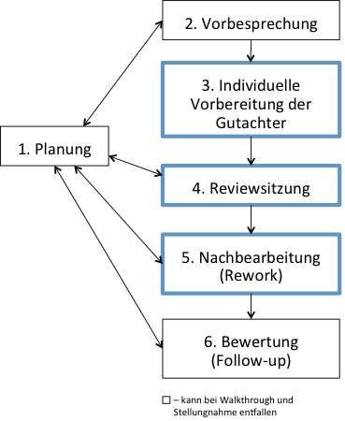



ISO-9126 is a quality model.

Explain what a quality model is and what it is used for.

In addition, list the criteria that fall under software quality according to ISO-9126.

Describe one of the criteria listed in detail.

The basic idea of a quality model is to break down the abstract, broad term

“quality” into different, narrow terms. This breakdown is intended to simplify the determination of quality objectives. This is exactly what the ISO standard does.

The following criteria belong to a software model: Functionality.

Reliability. Usability. Efficiency. Maintainability. Portability.

(When describing the criteria, the 3-4 narrow terms for the particular area should be mentioned).

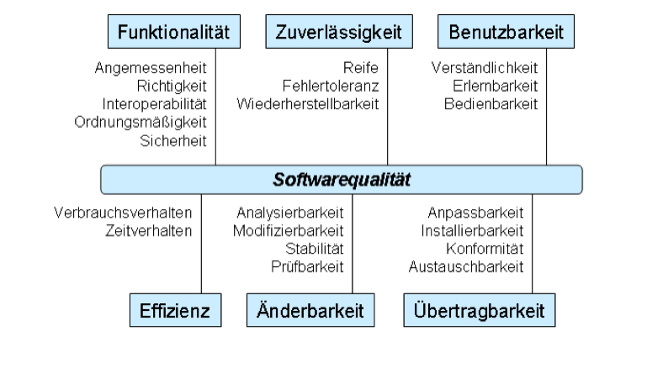



List the terms behind SMART quality objective determination.

Formulate two requirements for software systems that meet all the SMART criteria.

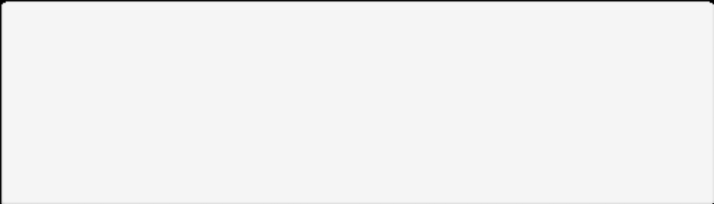

S - Specific

M - Measurable

A - Acceptable

R - Realistic

T - Terminated

The contact data access function (specific) of the software must be finished in 6 sec. for 100 data sets (measurable and realistic), the criterion of response time requires adjustments to existing code, and for this reason, the development time increases (acceptable). The development and testing must be completed by the quality gate (terminated).



Explain the principle of quality gates and relate “SMART criteria” to quality gates.

In quality gates, artifacts are examined for specific criteria.

The objective of quality gates is to ensure that the artifacts created fulfill previously specified attributes at a certain point in the software process. The predefined attributes can best be examined using SMART criteria.

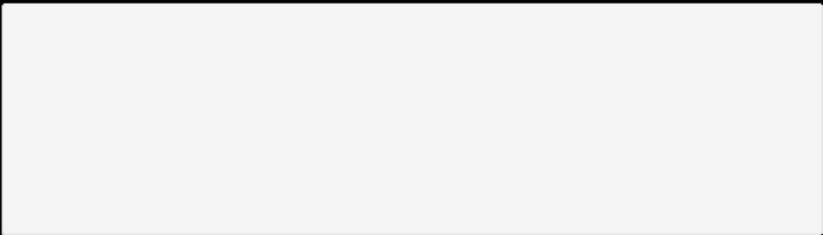

S - Specific

M - Measurable

A - Acceptable

R - Realistic

T - Terminated



**FRAGE 234 VON 312**

**IQSS01_Offen_mittel_F1/Lektion 02**



Explain why the principle of the internal customer-supplier relationship supports quality primacy in TQM.

Use an example to clarify your answer.

The principle of the internal customer-supplier relationship involves the following procedure:

Internal service provision is organized in a similar way to an external customer-supplier relationship.

Services rendered are accepted and handed over as would be the case for an external customer.

Each team is responsible for the quality of its own services, and the performance of a team is measured by the satisfaction of internal customers.

This principle contributes to an increase in quality, since the transfer is carried out in a defined manner and attention is paid to quality during this.





**FRAGE 235 VON 312**

**IQSS01_Offen_schwer_F1/Lektion 02**



List the steps of a quality planning process and explain the roles of three of the activity blocks you listed.

## Define responsibilities and fill roles

Designation and description of all roles that become active in QA activities, as well as assignment of the roles to specific individuals. Description of the organizational structure of the project, if necessary.

## Establish committees and regular meetings

Designate committees and describe their responsibilities; establish regular meetings of these committees.

## Define and prioritize quality objectives

Based on a quality model (e.g., ISO 9126), define and then prioritize the quality objectives relevant to the project. This result serves as one of the most important guidelines for all further activities. In general, coordination with the client is necessary.

## Define QA activities and quality gates in the software process

Specific QA activities such as reviews or software testing are defined and positioned in relation to the constructive activities in the software process. In addition, quality gates are used to integrate very important decision points into the software process. It is at these points that decisions are made regarding the further course of the project on the basis of the measured quality.

## Define acceptance criteria and committees for important result types

In order to ensure that all artifacts created in the project are of the desired quality level, acceptance criteria are defined for important artifacts (such as business requirements, speciﬁcations, source code, test cases, planning documents, etc.). Additionally define the group of people to be involved in preparing the acceptance and the ofﬁcial acceptance.

## Determine constructive QA measures

Constructive measures include all specifications and guidelines that are defined for the activities in the software process in order to prevent the occurrence of errors. Examples of this are checklists, templates, programming guidelines, specification of determined tools, methods, techniques, and procedures.

## Determine analytical QA measures:

Static procedures

Description of the processes and results of static test procedures such as reviews or static code analysis. Since, in principle, all created artifacts can be statically tested, a differentiation by artifact type may be necessary.

Dynamic procedures

Description of the processes and results of dynamic test procedures, typically for each relevant test level. This also specifies how test cases and test data are to be generated.

## Define testing infrastructure

Since industrial information systems are usually operated in a complex application landscape, are connected to other systems via technical interfaces, and often process and store many hundreds of thousands of data sets, the system must run in an environment that is as close to the production environment as possible, depending on the test level. Therefore, the provision of testing infrastructures is often very costly, but indispensable for integration testing and system testing.

## Define build processes

The code fragments created by the individual developers are compiled into an executable system by what is known as a build process.

Automatic software tests can be conducted during compilation. When a build process is initiated, the type of tests to be conducted and how to react in the event of an error is defined in the quality plan.



**FRAGE 236 VON 312**

**IQSS01_Offen_schwer_F1/Lektion 02**



Explain the reasons for adapting quality management activities on a project-specific basis.

Quality management must be adapted to the project because project-specific characteristics influence the steps for planning and execution.



**FRAGE 237 VON 312**

**IQSS01_Offen_schwer_F1/Lektion 02**



Explain the principle of continuous improvement from TQM.

Describe the application of this principle using an example from the field of software development.

## Principle of continuous improvement

An organization in general and thus software processes, too, never runs perfectly. The principle of continuous improvement means that process quality should be continually improved through small, but continuous steps. To this end, weak points and suggestions for improvement can and must be identiﬁed and communicated by all employees throughout the process.

Example:

After a review, a questionnaire is distributed to all participants by the quality representative. The assessment and derivation of the measures is carried out and the effects of the measures are assessed in follow-up meetings. The review and evaluation of the measures occurs in quality control.



Differentiate constructive QM from analytical QM.

Also think about the artifacts that are considered in the context of QM.

Provide two typical examples of each of these categories in software development.

In contrast to analytical QM, the artifacts that were created are not considered in constructive QM.

Artifacts can be specifications of any kind, as well as source code. Constructive QM handles processes, so typical examples would be the process for test case generation, or the test process itself.



**FRAGE 239 VON 312**

**IQSS01_Offen_leicht_F1/Lesson 03**



Name the three activities of constructive quality management and describe the interactions between them.

Define measures.

Monitor compliance.

Check effectiveness and adjust.

In addition to defining the measures, compliance with them must be monitored later during the software process and explicitly enforced, if necessary.

Compliance with the specifications is examined either in the testing activities for each artifact or when deciding whether a quality gate can be passed. In addition, the effectiveness and quality of the specifications must be examined regularly and the specifications adjusted, if necessary.



List the categories of constructive quality measures and provide two examples of each.

(All answers that reflect the image are correct).

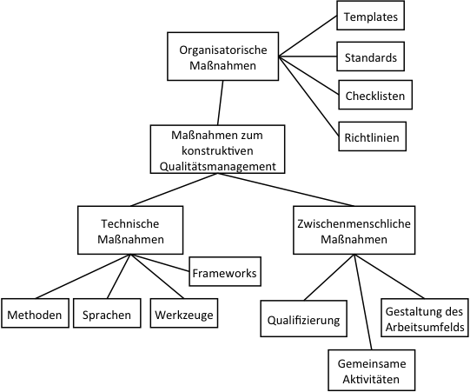



List the steps of root cause analysis in the correct order.

## Step 1:

Collect of all the information available about the error and the erroneous behavior triggered by the error.

## Step 2:

Apply the 5-Why method.

## Step 3:

Identify the places in the program code that must be changed to eliminate the error.

## Step 4:

Identify possible QA measures (constructive and analytical) to prevent the error in the future.

## Step 5:

Introduce of the QA measures.

## Step 6:

Evaluate of the QA measures to determine whether they reliably prevented the errors.



**FRAGE 242 VON 312**

**IQSS01_Offen_leicht_F1/Lesson 03**



Create a checklist with at least 4 entries for creating form letters.

Pay attention to the principles of checklist creation, rather than the checkpoint content.

## Checklist format criteria

One item on the checklist corresponds to exactly one objective; compound objectives should be avoided and divided among several items.

Clear and simple wording of the checkpoints increases readability and understandability. A checklist should not be larger than an A4 sheet of paper so it can be easily printed out with any printer and all checkpoints can be understood at a glance.

The criteria required to fulfill a checkpoint must be transparent; if necessary, sub-checkpoints or separate checklists are created for individual checkpoints.



Using a scenario of your own choosing, describe the use of the 5-Why method.

Answers may vary widely, but they should follow the structure below:

## Why question:

Why are errors reported?

Answer: Because the total amount calculated often deviates somewhat from the total of the individual items.

## Why question:

Why does the total amount differ?

Answer: Because rounding errors occur when calculating discounts for premium customers.

## Why question:

Why do rounding errors occur?

Answer: Because during the internal calculation of intermediate results, these results are not stored with the required accuracy.

## Why question:

Why can’t the accuracy be achieved?

Answer: Because a data type that does not store all decimal places from the 3rd digit was chosen for storage.

## Why question:

Why was this data type selected?

Answer: Because the developer always assumed that no more than 2 decimal places will need to be stored for the amounts.



List the reasons for the requirement that checklists should **not** be larger than DINA4.

List and describe another 3 criteria that good checklists should meet.

## Reasons for size:

A checklist should not be larger than a DIN A4 page so that it can be easily printed with any printer and all checkpoints can be understood at a glance.

## Content points of the list

Organization of all required resources (such as people, appointments, rooms).

Determination of review objectives.

Determination of the criteria to be “passed”.

Designation of the reviewer.

All parties involved receive an overview of the test object and review objectives.

If applicable, breakdown of the review aspects/views of the review among the reviewers.

Distribution of all required documents.

Clarification of organizational and functional issues

## Checklist format criteria

One item on the checklist corresponds to exactly one objective; compound objectives should be avoided and divided among several items.

Clear and simple wording of the checkpoints increases readability and understandability. A checklist should not be larger than an A4 sheet of paper so it can be easily printed out with any printer and all checkpoints can be understood at a glance.

The criteria required to fulfill a checkpoint must be transparent; if necessary, sub-checkpoints or separate checklists are created for individual checkpoints.



Explain the difference between organizational and interpersonal measures in constructive QM and provide two examples per category.

Organizational measures include all non-technical aspects that have an impact on the specific organization of work.

(Examples: templates, standard, checklists, guidelines)

Interpersonal actions are activities that aim for a professional and positive cooperation between the individuals involved in the process.

(qualifications, design of the working environment, joint activities).



**FRAGE 246 VON 312**

**IQSS01_Offen_mittel_F1/Lektion 03**



Which measures are consolidated within the technical measures in constructive QM?

List and briefly describe these measures.

Methods

Language

Framework

Tools

Software engineering methods are techniques and approaches that can be used to complete specific tasks in a structured and systematic manner.

Examples of methods are team estimation (for prioritization), functional equivalence partitioning (for test case generation), and object-oriented analysis (for requirements engineering).

The most important result artifact of a software project is the software system, which is programmed in one or more programming languages. Generally, the choice of languages to be used in the project is therefore specified. In addition to the programming languages for the program logic (such as Java, C#, JavaScript, or Python), the programming languages for very specific components (such as JavaScript for the GUI, SQL for databases) are also determined.

Besides this, modeling languages are also determined (such as UML, E/R diagrams, BMPN, ARIS, Data-flow diagram). The determination of the language also includes the determination of the specific language version or possible dialects or special features to be considered when using it. In addition to the methods and languages, precise specifications for the tools to be used are also defined. Tools are software systems that support the activities in a software process. They include development environments (such as Netbeans, eclipse, Visual Studio), testing tools (such as JUnit, Selenium), and systems to support project management and communication (such as trac, redmine, Microsoft Project, Bugzilla, Jira).

A large part of the functions of a software system are not created by the development team itself. Instead, they are reused by utilizing pre-existing program code, libraries or frameworks. Depending on the maturity and distribution of a programming language, there are often mature frameworks for standard tasks (such as database connections), as well as for special functions (such as visualization). For central functions of a system, the permitted frameworks are often specified so that the degree of heterogeneity within the entire application landscape is kept low.



Explain the difference between templates and checklists, and demonstrate the use of both constructive measures.

Checklists support the achievement of a constant level of quality for activities that cannot be meaningfully described by a process deﬁnition. For example, a checklist contains all activities to be completed for a task and/or the required result or management artifacts.

Templates are generally company or project-specific templates for document structures and content. Templates can be created and prescribed for result artifacts (such as requirements, speciﬁcations, documentation, source code), as well as for management artifacts (such as status report, final report, error message).

Templates are particularly valuable in terms of status reports or document creation specifications, whereas checklists can be created for all activities.



**FRAGE 248 VON 312**

**IQSS01_Offen_mittel_F1/Lektion 03**



List and describe the six steps of root cause analysis.

## Step 1:

Collect all the information available about the error and the erroneous behavior triggered by the error.

## Step 2:

Apply the 5-Why method.

## Step 3:

Identify the places in the program code that must be changed to eliminate the error.

## Step 4:

Identify possible QA measures (constructive and analytical) to prevent the error in the future.

## Step 5:

Introduce the QA measures.

## Step 6:

Evaluate the QA measures to determine whether they reliably prevented the errors.



For your team meeting, you want to use timeboxing for the presentations and discussion.

List the advantages and disadvantages of doing this.

Timeboxing enables better planning of the length of meetings and prevents points from not being addressed. At the same time, it prevents discussions from getting out of hand without opening up new content.



**FRAGE 250 VON 312**

**IQSS01_Offen_schwer_F1/Lektion 03**



Your quality assurance always runs test cases with the same data as a regression test. As an improvement, you introduced the use of different data, taken from data sets in the database table. You defined new measures with this procedure.

What activities relating to this innovation do you now need to devote further attention to?

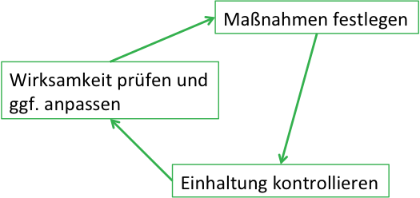

The measures are therefore defined. In order to be able to examine the effectiveness, values would need to be defined (e.g. errors found in the regression test) and, if not available, determined.

Compliance must be examined in the subsequent cycles (are the testers really testing with the new data?), and effectiveness reviewed (am I finding more errors than before?).



**FRAGE 251 VON 312**

**IQSS01_Offen_schwer_F1/Lektion 03**



Explain how checklists enable a consistent level of quality to be achieved.

Checklists are usually created for recurring standard tasks, such as training new employees, setting up a development environment for a project, or examining the current process step at quality gates, thus preventing individual points from being forgotten.



**FRAGE 252 VON 312**

**IQSS01_Offen_schwer_F1/Lektion 03**



Explain why risk assessment can be considered part of quality management!

Risks can be errors in the software that remain in it or they can be assessments for test end criteria and test focus. These decisions have great influence within quality management.



List the difference between constructive and static quality assurance.

In addition, provide three examples of static procedures within software development.

In contrast to constructive quality management, which specifies activities in a software process, static quality assurance measures examine and evaluate the results created in a software process.

## *1: Examination of the business requirements:

Review techniques are used to examine documented requirements with regard to predefined quality criteria.

## *2: Quality gates:

Checklists are used to assess the current situation in the software process and evaluate compliance with required attributes.

## *2: Examination of the technical specification:

Review techniques are used to check the technical specification with regard to predefined quality criteria. Technical data schemas and data structures are also automatically analyzed and evaluated, if required.

## *4: Evaluation of the planned architecture:

Review techniques and scenario-based architecture analysis are used to examine the suitability of the architecture description for meeting the requirements. Detailed technical designs of components and data structures can be automatically analyzed and evaluated, if required.

## *5: Test case generation:

The test cases generated are reviewed using review techniques to determine whether they are suitable for ensuring the level of quality defined for the current project.



Describe the activities that will be conducted in planning the review session.

List the person responsible for the “Planning” review activity.

Organization of all required resources (such as people, appointments, rooms).

Determination of review objectives.

Determination of the criteria to be “passed”.

Designation of the reviewer.

The moderator is responsible for the “Planning” review activity.



**FRAGE 255 VON 312**

**IQSS01_Offen_leicht_F1/Lektion 04**



List the steps that are taken in a review.

Identify the steps that are mandatory in the different types of reviews (inspection, walkthrough, opinion).

Describe two of the steps you mentioned.

For Opinion and Review, all the activities listed below are mandatory; for Walkthrough, only Preparation, Review Session, and Follow-up are mandatory.

Planning

Organization of all required resources (such as people, appointments, rooms).

Determination of review objectives.

Determination of the criteria to be “passed”.

Designation of the reviewer,

Objective

Scheduling agreed with all parties.

Documented review objectives and pass criteria.

Preliminary discussion

(if needed).

All the parties involved receive an overview of the test object and the review objectives.

If necessary, division of the test aspects/views of the review among the reviewers. Distribution of all required documents.

Clarification of organizational and functional issues. Objective

Each reviewer knows the test object, the review objective, and the review criteria for which they are responsible.

Individual preparation of the reviewers

The test object is worked through individually by reviewers and examined using the specified criteria.

Objective

Documented questions by the reviewer, as well as documented content-related deficiencies and formal deficiencies (such as spelling mistakes).

Review session

Joint walkthrough of the test objects by all parties involved.

Discussion and evaluation of the functional deficiencies identified by the reviewers. Objective

Logging of all identified functional deficiencies.

Collection of all formal errors (not discussed in session).

Documented result (no deficiencies, rework necessary, termination due to serious deficiencies).

Rework

Correction of the deficiencies identified.

For inspection: prepare deficiency report and a list of corrections made. Objective

Reworked test object

Deficiency report, to-do list. Evaluation

Examination of whether all corrections have been implemented.

Objective

Final evaluation of the test object. Review report.



Provide five examples of metrics that relate to a software process.

1. Resource consumption.
2. Execution time for process steps.
3. Actions performed.
4. Time between error localization and correction.
5. Time for executing all automatic tests, etc.



**FRAGE 257 VON 312**

**IQSS01_Offen_leicht_F1/Lektion 04**



Explain what constitutes static quality assurance measures.

Static quality assurance procedures are analytical procedures in which the test object is analyzed, assessed, and investigated within the scope of a review. The information obtained in the process is compiled, condensed into metrics or key figures if necessary, and finally evaluated.



**FRAGE 258 VON 312**

**IQSS01_Offen_leicht_F1/Lektion 04**



What is the difference between bytecode and source code analysis?

Explain, with an example, why these two types of analysis **cannot** be subjected to an automatic correction.

The source code must compile successfully for bytecode analysis

Both types of analysis examine the violation of good practices, although deviations from this may be necessary in certain situations.

For example, an empty switch block can be used to indicate that nothing needs to be done in this case, but the case distinction is necessary for the process.



Provide two examples of programming conventions.

If there are supporting tools for this measure, provide an example of each.

Programming conventions and their examination are part of the constructive quality assurance measures.

Examples are:

Correct use of annotations

Compliance with naming conventions for classes, attributes, methods, and variables.

Checking for the presence of comments.

In Java development, this can be checked e.g., by Checkstyle.



You are to create a quality plan for a software development process.

In doing so, list and describe four constructive actions you can incorporate into it.

List these actions in chronological order.

## *1: Examination of the business requirements:

Review techniques are used to examine documented requirements with regard to predefined quality criteria.

## *2: Quality gates:

Checklists are used to assess the current situation in the software process and evaluate compliance with required attributes.

## *2: Examination of the technical specification:

Review techniques are used to check the technical specification with regard to predefined quality criteria. Technical data schemas and data structures are also automatically analyzed and evaluated, if required.

## *4: Evaluation of planned architecture:

Review techniques and scenario-based architecture analysis are used to examine the suitability of the architecture description for meeting the requirements. Detailed technical designs of components and data structures can be automatically analyzed and evaluated, if required.

## *5: Test case generation:

The test cases generated are reviewed using review techniques to determine whether they are suitable for ensuring the level of quality defined for the current project.

**\*6: Component testing:**

Although component tests are not static procedures, measures for static code analysis are carried out in the context of these tests. The program code created is automatically reviewed for compliance with required attributes and error probability analyses are carried out.



List the three types of review techniques and the roles involved in each.

Walkthrough. Inspection.

Opinion.

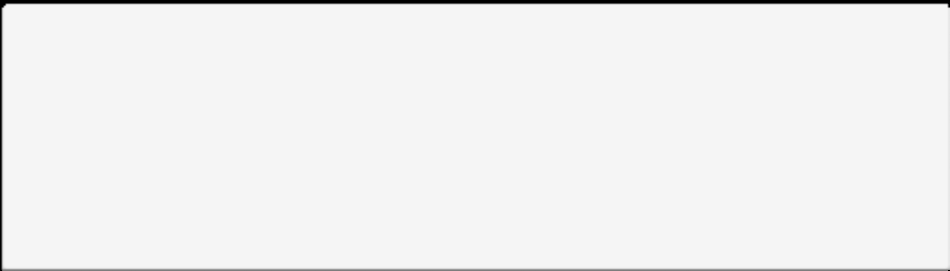

Role name

Inspection Walkthrough

Comment

Moderator

X

X (taken over from the author, if applicable) -

Surveyor

X

X

X

Author

(of the X  
test specimen)

X

X

Recording clerk

X

-

-



**FRAGE 262 VON 312**

**IQSS01_Offen_mittel_F1/Lektion 04**



Explain the limitations of metrics in software processes.

Metrics can only be used to determine measurable attributes of systems or processes. However, assertions about the actual consequence of certain attributes or combinations of attributes are often not possible, particularly with software metrics.

Studies show, for example, that the measured variables of Halstead metrics correlate with the actual reading and comprehension time. However, it is not generally possible to derive reliable, actual consequences on the basis of software measurements. The measurement result that the system is easy to understand and its structural complexity is not very high does not say anything about whether the system meets the customer’s requirements.



Metrics (LOC, Halstead metric, fan-in, fan-out) are named in your quality assurance agreement with the customer.

Explain to your customer why metrics can pose risks.

There is a risk that the fulfillment of the metric will become more important than the fulfillment of the business requirements.



**FRAGE 264 VON 312**

**IQSS01_Offen_mittel_F1/Lektion 04**



You are responsible for the use of Checkstyle.

Specify why its deployment is useful.

What other options are there in the area of static code analysis?

Checkstyle checks the program code for compliance with programming conventions.

The specific conventions to be checked can be conﬁgured in detail, so that in addition to the standard conventions for Javacode, custom conventions can also be created and then automatically checked.

Procedures for static code analysis are used for the qualitative evaluation of program code. In addition to style checks, analyses of the source or byte code for error patterns are also found in this area.



Describe how you would formulate feedback for a GUI if the layout is understandable, but the individual input fields are **not** arranged in series, and the necessary activities for name-checking are missing.

You like the color scheme of the interface and it meets the guidelines provided for delimiting foreground and background color.

Use the feedback burger for feedback.

Following the feedback burger, feedback should begin and end with praise.

Concrete observations, effects and suggestion should be expressed for the two points of criticism. Any explanation that follows this scheme, and thereby responds to the example, is fine.



**FRAGE 266 VON 312**

**IQSS01_Offen_schwer_F1/Lektion 04**



Which effects can be achieved by using metrics in software engineering?

A few system attributes have been measured and provided with values. This can serve as an indicator of understandability, and also for comparisons across different versions of the software.

However, assertions about the actual consequence of certain attributes or combinations of attributes are often not possible, particularly with software metrics. It is not generally possible to derive reliable actual consequences on the basis of software measurements

The measurement result that the system is easy to understand and its structural complexity is not very high does not say anything about whether the system meets the customer’s requirements.



Explain why the definition of programming conventions increases code comprehension, decreases learning time, and makes it easier to work with a version control tool.

Equal alignment, arrangement and use of instruction blocks increases the structure of the code and thus enables faster comprehension of the code points that influence functionality. In addition, this results in a uniform reading image in which the assignment, e.g., {}, does not need to be searched for in each case: instead, it is immediately recognizable.

Consistent formatting leads to fewer formatting changes, such as line indentations, appearing in track changes.



**FRAGE 268 VON 312**

**IQSS01_Offen_leicht_F2/Lektion 05**



Explain why software testing is an analytical process. Please also list the typical test levels in software development.

In testing, the quality is evaluated. In other words, this is an analysis of the given test object.

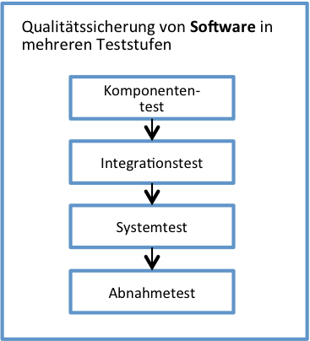



**FRAGE 269 VON 312**

**IQSS01_Offen_leicht_F2/Lektion 05**



You have the following activity diagram for one of your use cases.

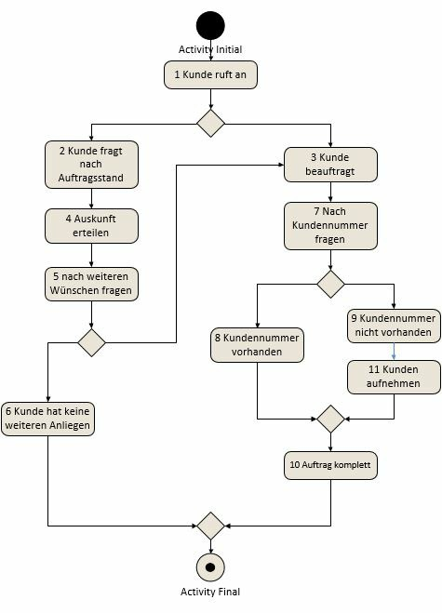

# State the number of test cases if you have “branch coverage” as a requirement.

Next, describe the coverage criteria you are familiar with that can be used with activity diagrams.

3 test cases

## Instruction coverage:

Each function is accessed at least once.

## Branch coverage:

Each control flow is run through at least once.

## Condition coverage:

Each condition is evaluated at least once at *TRUE* and once at *FALSE.*

## Path testing:

Each possible path through the use case is run through completely (“in one piece”), taking possible loops into account.



**FRAGE 270 VON 312**

**IQSS01_Offen_leicht_F2/Lektion 05**



You have use-case-based specifications for the functions of the software you are testing.

List at least five typical criteria to identify relevant use cases for testing.

## Value contribution:

What is the contribution of this function to the value chain?

## Usage frequency:

How many users access the function and how often?

## Damage Potential:

What damage can result from unidentified errors in the function?

## Typical errors:

Which functions frequently contain errors in their implementation? Where are the typical weak points in comparable legacy or competitor systems?

## Required test coverage:

What level of test coverage is actually required for the functional level?



**FRAGE 271 VON 312**

**IQSS01_Offen_leicht_F2/Lektion 05**



List the advantages of equivalence class testing over software testing without the benefit of this method.

When conducting the tests, not all possible input values must be tested: only one arbitrarily selected representative from each respective equivalence class needs to be. With this approach, the number of test data required for each test case can be reduced very significantly.



List and describe the steps of test case generation with equivalence classes.

## Step 1:

Determine and clearly identify equivalence classes for each input parameter of the function or each GUI element of the dialog screen.

## Step 2:

Test cases that cover all valid equivalence classes are generated. The number of test cases required should be kept as low as possible. Therefore, the combination of test data should be chosen in such a way that as many equivalence classes as possible are tested in as few test cases as possible.

## Step 3:

Test cases are generated to cover all invalid equivalence classes. In contrast to the test cases for valid equivalence classes, the test cases for invalid equivalence classes only test one invalid equivalence class per test case. All other test data is taken from valid equivalence classes. Thus, the relevant invalid equivalence class can be more easily identiﬁed in the case of a failed test.

## Step 4:

Specific input data is generated for each test case based on the selected equivalencies.



List and describe the coverage levels for condition-based test case generation.

## All states:

In terms of the state diagram, this test coverage is the minimum objective. For this purpose, sequences of transitions are determined with which each deﬁned state is reached at least once.

## All allowed state transitions:

At this level of test coverage, all transitions defined in the state transition table have been executed at least once.

## All error situations:

Here, in addition to all allowed state transitions, all error situations are also tested for non-implementation.

## All disallowed state transitions:

In addition to the error situations, all disallowed state transitions that are not error situations are also examined for non-implementation.



**FRAGE 274 VON 312**

**IQSS01_Offen_leicht_F2/Lektion 05**



List the advantages of random test data.

In combination with equivalence partitioning, random test data generation is a technique where many different test data sets can be generated with comparably little effort.

Once a suitable test data generator exists, any number of test data sets can usually be generated. Automatic generation ensures that each test data set has the required attributes and human error caused by manual test data generation can be excluded.



List and describe the minimum components of a test case.

Preconditions that must be ensured before the test step.

Test data or test actions that are entered or carried out during the test step.

Post-conditions, the fulfillment of which is examined after the test step

Descriptive data regarding the test case, such as name, ID, relevant component, function, or attribute being tested, use case, or name of the creator.



**FRAGE 276 VON 312**

**IQSS01_Offen_mittel_F2/Lektion 05**



For the activity diagram shown below, create two sets of test cases, one set satisfying the “branch coverage” criterion and the other set satisfying the “path testing” criterion.

# Make a note of the sequence of actions accessed for each test case.



Branch coverage

1-2-4-5-6 & 1-3-7-8-10 & 1-3-7-9-11-10

Paw test additional

1-2-4-5-3-7-8-10 & 1-2-4-5-3-7-9-11-10



Explain why boundary values are often formed for equivalence classes and the functions are then tested with them.

Form boundary values for the following equivalence classes:

A1: 1—8

A2: 0—4.5

A3: Monday, Tuesday, Wednesday. A4: User names without umlauts.

**A1:** 1—8

**A2:** 0—4.5

**A3:** Monday, Tuesday, Wednesday. **A4:** User names without umlauts.

**Sample solution**

The underlying assumption of boundary value analysis is the observation that software errors often lie in the boundary region that represents the transition from valid to invalid input values. That is, at the boundaries of equivalence classes.

**A1:** 0.9

**A2:** -0.1, 4.6

**A3:** Sunday, Thursday.

**A4:** User names with an umlaut.

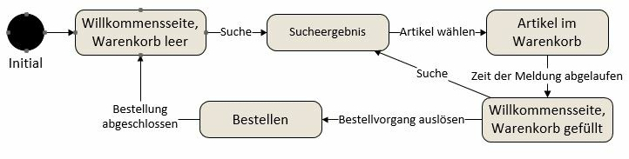

Define test procedures (test steps, test sequence) based on the state graph provided.

Provide an example of each of the following:

1. When each state is reached.
2. When each allowed state transition is reached.
3. When exactly one disallowed state transition is examined.

for a) + b)

Welcome page, shopping cart empty → search result -> items in shopping cart → welcome page for filled shopping cart → order.

for c)

Welcome page, shopping cart empty → items in shopping cart → welcome page for filled shopping cart → order.



Describe random data generation for an input screen that asks for gender, name, and birthday.

Discuss the disadvantages of random test data generation based on your example.

Creating values for the three areas in a databank. Combination of values.

The random generation of test data creates a great deal of different, but not truly realistic, data in every case.

For example, if the address data from the above example is to be automatically checked with address validation, randomly generated but unrealistic test data will not help.

Therefore, before the test data generator is created, the requirements for the structure and content of the test data must be speciﬁed in detail.

Whether the effort and expense required for this is in reasonable proportion to the benefit must be decided for each project individually.



Identify test cases for the following scenario (give a name and a short description for each if the name alone does not get the message across; a diagram is not necessary).

In addition, list three selection criteria for test selection of use cases.

Scenario:

There is a database application that provides the option to add new names (if they do not already exist), display information about existing individuals (search unsuccessful, contact information display), and delete names (error message if the name does not exist).

Use cases:

Create names.

Search (sub-use cases: “Search successful”, “Search unsuccessful”).

Delete person.

Selection criteria:

Importance for the customer. Damage effect.

Access frequency.



You have created valid and invalid equivalence classes.

When creating combinations, how many invalid classes should you combine with the valid ones?

List the reason for this approach and demonstrate this reason in the context of an example.

Thus, the relevant invalid equivalence class can be more easily identiﬁed in the case of a failed test. If several invalid equivalence classes were tested in one test case, it cannot be said with certainty which of the invalid equivalence classes is the cause if a test fails.

Otherwise, when testing a login mechanism, all possible names must be tested.

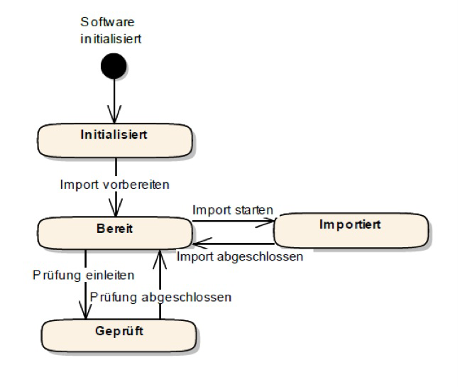

Derive test cases from the state diagram provided.

Specify these test cases in the form of a state table.



Initialized Ready Imported Examined

Initialized ---

----

----

----

Ready

---

--- own state

---- disallowed state transition

|  |  |  |  |  |
| --- | --- | --- | --- | --- |
| Imported | ---- |  | ---- | ---- |
| Examined | ---- |  | ---- | --- |

The test cases correspond to the columns of the table.



List and briefly describe three activities for methodical testing.

## Test requirements analysis

The test requirements analysis is roughly comparable to the requirements analysis of the software system: here, the quality objectives or the quality level to be achieved are determined and the system functions and system attributes to be tested are described.

## Test planning

Depending on what technical or human resources are required for the test execution, these must be planned and their availability assured.

## Test case specification

Create the test case specifications.

## Test data creation

Derive the test data.

## Test execution

Software test execution involves running the specified test cases using the test data sets and logging the results.

## Test evaluation

Once execution has been completed, the test results are evaluated and the quality level of the system is assessed.



Describe the attribute “independence” in relation to the component test and distinguish the term from “reproducibility”.

Unit tests should not have any functional dependencies on each other: The order in which unit tests are executed should not play a role. Each test must individually ensure that the required preconditions are established. For example, this also includes that the required data inventory is first imported into the database before tests are executed, with this inventory then used to execute the test.

If another test is subsequently executed, all changes to the data model and the internal system state must be reverted so the original system state is restored for the execution of a new test.

Once a unit test has been generated, it should be reproducible without restriction. This is achieved, among other ways, by using test data that is permanently deﬁned in the test case and does not depend on the successful execution of other unit tests. Independence goes beyond that, meaning that unit tests should have no functional dependencies on each other: The order in which unit tests are executed should not play a role. Each test must individually ensure that the required preconditions are established.



**FRAGE 285 VON 312**

**IQSS01_Offen_leicht_F2/Lektion 06**



Describe the “top-down” integration strategy.

When using the top-down strategy, the integration of system components starts at the top system level and ends with the integration of the base components.

The last step is to implement the base components as part of a top-down strategy and the remaining dummies are removed upon their integration into the overall system.



Explain why drivers and dummies are needed in integration testing.

Also note the difference between drivers and dummies.

Integration testing starts as soon as components are ready and can be integrated. At this point, not all components are ready, i.e., not ready or not yet integrated, and must be simulated.

Drivers simulate the accessing components and dummies simulate the components accessed.



**FRAGE 287 VON 312**

**IQSS01_Offen_leicht_F2/Lektion 06**



Explain why performance and load tests are **not** already conducted in the integration test.

Integration testing starts as soon as components are integrated, and not all components need to be integrated. Dummies and drivers, whose response times might differ from the real functions, can also be used.



**FRAGE 288 VON 312**

**IQSS01_Offen_leicht_F2/Lektion 06**



List the main difference between a functional test in system testing and a functional test in integration testing.

In contrast to integration tests, in which the interconnection of the individual system components has already been tested, the focus of system tests is on the user’s point of view.

The system is considered entirely as a black box.



Explain why a successful acceptance test often serves as a prerequisite for billing.

Acceptance test by the customer themselves. Requirements can be misunderstood.

Usability can only be explained by the actual users.



**FRAGE 290 VON 312**

**IQSS01_Offen_medium_F2/Lektion 06**



Within test planning, you need to find answers to some questions regarding the test.

Name at least 6 of the questions to be answered.

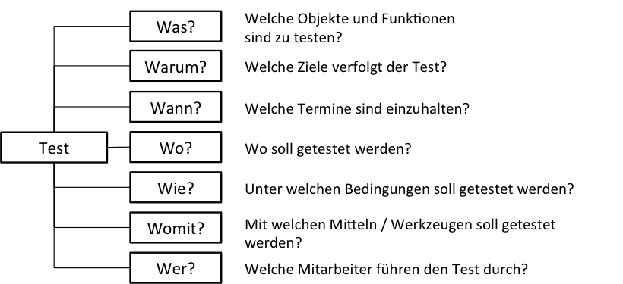



Explain the approach to test-driven development.

The crucial difference from the traditional development of test cases is the generation of unit tests on functions before their method body is programmed.

After the need for a new function in a class or component has been identiﬁed, unit tests are first generated to test the new function to be created.

If these unit tests are executed, they must initially fail because the relevant system functions have not yet been implemented. Their implementation is not started until after the test case has been generated. The system functions are then implemented step by step and tested during the implementation.



**FRAGE 292 VON 312**

**IQSS01_Offen_medium_F2/Lektion 06**



Explain the disadvantages of the top-down strategy and show how they are circumvented in the by-value strategy.

However, the disadvantages of the top-down strategy include the very late integration of base components, which often entails various technology risks. In addition, the test data cannot be entered in a targeted manner.

The first disadvantage is overcome by the by-value strategy in that the components that are to be integrated are given a priority. This is usually worked out in collaboration with the customer, but base components that are used many times are higher on the priority list.



Describe the difference between performance testing and load testing.

List two examples of test sequences for each of the two testing types.

Performance testing carries out measurements under normal loads and measures response time behavior. Load testing carries out tests under particularly high loads, targeted withdrawal of resources, and overload behavior.

Performance measurement e.g., during screen changes; load testing of one of the two web servers during the testing of an internet application.



**FRAGE 294 VON 312**

**IQSS01_Offen_medium_F2/Lektion 06**



List the reasons for the negotiations at the end of the acceptance test.

Do **not** forget to name the negotiating parties.

Not all errors are corrected.

Before the go-live.

Priorities, damage potential are weighed up.

Specifications are rarely complete, so some of the errors found are specification errors. Furthermore, potential for changes is discovered that can be set against error acceptance.

Negotiating parties: customer and software creator.



Briefly list the characteristics of test automation in the area of component testing.

List the features required for good test automation and describe two of them.

Unit tests are generated and executed by developers to test the quality of the program code they have created themselves. Unit tests examine the correct execution of individual functions of technical classes and components. Unit tests are generally carried out before a developer’s work result is integrated into the pre-existing program code. The objective to be achieved with the use of automatic unit testing is the greatest possible test coverage of the instructions and control structures in the program code that has been created. Unit tests are white box tests.

The following three properties are needed for good, automated component testing: Reproducibility.

Independence.

Regressability

## Reproducibility

Once a unit test has been generated, it should be reproducible without restriction. This is achieved, among other ways, by using test data that is permanently deﬁned in the test case and does not depend on the successful execution of other unit tests.

## Independence

Furthermore, unit tests should not have any functional dependencies on each other: the order in which unit tests are executed should not play a role. Each test must individually ensure that the required preconditions are established. For example, this also includes that the required data inventory is first imported into the database before tests are executed, with this inventory then used to execute the test. If another test is subsequently executed, all changes to the data model and the internal system state must be reverted so the original system state is restored for the execution of a new test.

## Regressability

Particularly with software processes in which systems are developed in an evolutionary manner, i.e., new functions are added to the system step by step, the required level of quality must be ensured before a new system version is released at the end of an iteration. For unit testing, this means that all unit tests that have already been successfully run must also be successfully executed after a revision. The execution of tests that have already been passed after changes to the program code is called regression tests. At the end of an iteration, all previously generated and all new unit tests must be successfully run. This is the reason why test automation is an important prerequisite for evolutionary software development.



Describe the advantages and disadvantages of the bottom-up strategy and derive the best area of application for this deployment strategy.

Briefly outline the best use case for top-down strategies.

Bottom-up first develops the basic functionalities, which are in close proximity to hardware and infrastructure. The tests here do not occur in a user-like state.

No dummies.

Late availability of the complete system.

Best use:

When the system is used by a few users and the correctness of calculations is very important, such as with highly technical devices, e.g., medical equipment. In contrast, top-down strategies start with a user interface: intensely surface-heavy systems, or systems where usability is a high priority, are the widely used systems here.



**FRAGE 297 VON 312**

**IQSS01_Offen_schwer_F2/Lektion 06**



Explain two of the challenges of system testing with examples and present why these challenges occur specifically in system testing.

Hardware and software environment in which the system is operated.

The software systems with which the system under testing has technical interfaces.

Realistic utilization and user behavior

Real data sets, if possible.

(Examples involving any of the four items are valid).



List and describe the test criteria for requirements.

## Examine the content.

The central question to be answered by the criteria for the quality aspect of content is, *mutatis mutandis*: “Are all the relevant requirements documented in the required level of detail so they can be understood?”

## Examine the documentation.

The criteria for examining documentation are aimed at the use of appropriate forms of documentation and the quality of documentation. The criteria for examining documentation answer the central question: “Are they documented in an understandable manner and in compliance with the instructions for documentation?”

## Examine criteria for coordination.

The criteria for examining the coordination of documentation are intended to answer the question: “Do all the relevant stakeholders agree with the documented requirements and have any known conﬂicts been resolved?”. Gaining new knowledge during the software process, in particular, enables new requirements to be identiﬁed that contradict those already documented.



Name and describe the four steps for the coordination of requirements.

## Set test criteria.

There are three types of testing criteria: Examine the content.

Examination criteria for coordination. Examine the documentation.

1. **Select examination principles and examination techniques. Principle 1:** Involvement of the right stakeholders.

**Principle 2:** Separation of error detection and error correction.

**Principle 3:** Testing from different points of view.

**Principle 4:** Appropriate change in the documentation form. **Principle 5:** Design of development artifacts.

**Principle 6:** Re-examination.

## Conduct examination and document results.

It is important to concentrate on documenting the test results. Error correction and revision of the documented requirements occurs afterward and is not part of the examination.

## Coordinate requirements/conflict management.

The activities for coordinating requirements are intended to achieve a common and consistent understanding of the set of requirements among the stakeholders.



List six testing principles for requirements.

## Principle 1: Involvement of the right stakeholders.

Stakeholders set the requirements, requirements discovered late or missing requirements can result in an enormous effort and expense for changes, or even cause an unusable system.

## Principle 2: Separation of error detection and error correction.

Independence of the testers for objectivity reasons.

## Principle 3: Examination from different points of view Principle 4: Appropriate change in the documentation form.

Description, model, or similar depending on the type of artifact.

## Principle 5: Design of development artifacts.

**Principle 6: Re-examination.**

Continuous improvement.



**FRAGE 301 VON 312**

**IQSS01_Offen_leicht_F2/Lektion 07**



List and explain the two time-related options for quality assurance of architectures.

“ex ante” and “ex post”

The evaluation of an architecture before its implementation (ex ante) is intended to provide an assertion regarding the suitability of an architecture for meeting the requirements of a system.

The evaluation generally correlates with the fulfillment of quality attributes and constraints, since these types of requirements have the strongest influence on the choice of a suitable architecture.

The purpose of examining the architecture during implementation and/or after implementation has been completed is to ensure that the result of the development work adheres to the specifications established by the architectural deﬁnition.



Describe the “investigation and analysis” phase of ATAM.

Using the findings from the first phase, the architecture team creates various architecture variants based on the basic architecture that can be used to fulfill the functions and attributes required by the system.

With regard to the evaluation of the architecture, application scenarios are created and prioritized before being used to describe the quality attributes specifically required. The set of scenarios with quality attributes is referred to in ATAM as a utility tree. In the last step of this phase, the architecture variants created are roughly analyzed in terms of their fulfillment of the scenarios derived. This involves analyzing the extent to which the different architecture variants support the set of quality attributes in the utility tree. The result of this rough analysis is a prioritized list of architecture variants that is used as input for the next phase.



**FRAGE 303 VON 312**

**IQSS01_Offen_leicht_F2/Lektion 07**



Explain why process improvements are also the focus of quality management.

Describe how the need for change in software processes can be determined.

The basic assumption behind quality assurance and improvement of software processes is that there is a relationship between process quality and product quality.

To identify the need for change in software processes, a process analysis must first be carried out. This can be done quite pragmatically by surveying the stakeholders involved in the process. Another possibility is the structured evaluation of various quality criteria, for example, by the stakeholders in the software process.



Describe three possible process characteristics of software processes.

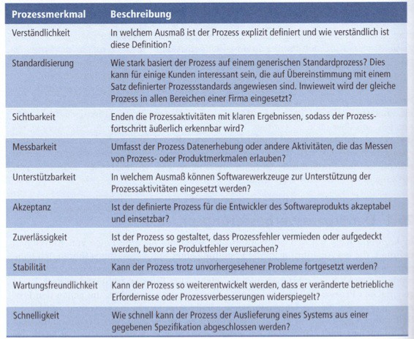



**FRAGE 305 VON 312**

**IQSS01_Offen_medium_F2/Lektion 07**



Explain why stakeholder selection has an important role in the coordination of requirements.

The selection of stakeholders is of great importance because the requirements cannot be determined without them. If stakeholders or stakeholder groups are overlooked, the result may even be an unusable system, as functionalities that are fundamentally required have not been implemented.



What conflicts can arise when coordinating requirements? Provide an example with regard to a software system for flight bookings.

Different stakeholders may express conflicting requirements.

In the case of a flight booking program, for example, one stakeholder group may want to allow only airport cities in the flight search, while the other may want to determine the nearest airports from the input information.



**FRAGE 307 VON 312**

**IQSS01_Offen_medium_F2/Lektion 07**



List the phases of ATAM and the steps associated with two phases.

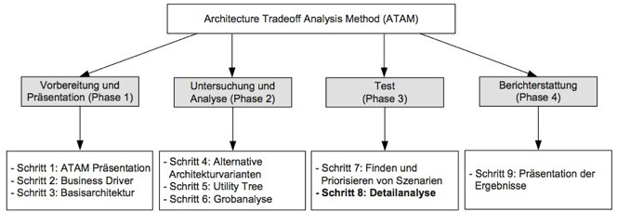



List and describe the CMMI model levels.

## Level 1—Initial:

There is no process deﬁnition; activities ﬁrst take place ad hoc or are performed chaotically. The process is usually not repeatable.

## Level 2—Managed:

The process is repeatable. The scope and outcome of the activities to be completed are known to the team members. However, there is no detailed process that explicitly deﬁnes activities, roles, results, and their dependencies.

## Level 3—Defined:

There is a deﬁned process in which activities, roles, and results are documented in a binding manner. The process contains specific methods and approaches for the individual software engineering activities.

## Level 4—Quantitatively managed:

Process quality can be determined and managed by measuring quantitative process characteristics. By collecting key figures on the activities of the processes and on the results generated, it is possible to identify potential disasters and take suitable countermeasures.

## Level 5—Process optimization:

Process and product measurements are continuously collected and used for process improvement. Depending on the value measured, the process can be adapted to current requirements.



Depict a relationship between process quality improvement and software process quality characteristics.

List three examples of software process quality characteristics.

To identify the need for change in software processes, a process analysis must first be carried out.

This evaluation can be done by determining the values for the quality attributes of the software process.

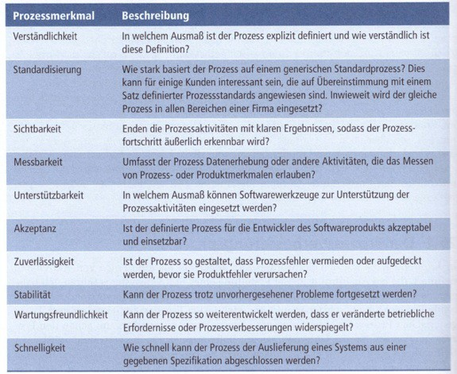



List the three different quality aspects for requirements testing and explain one of them.

Create an example from the field of software development that you will use to demonstrate your chosen activity.

## Examine the content.

The central question to be answered by the criteria regarding the quality aspect of content is, *mutatis mutandis*: “Are all the relevant requirements documented in the required level of detail so they can be understood?”

## Examine the documentation.

The criteria for examining documentation are aimed at the use of appropriate forms of documentation and the quality of documentation. The criteria for examining documentation answer the central question: “Are they documented in an understandable manner and in compliance with the instructions for documentation?”

## Examine criteria for coordination.

The criteria for examining the coordination of documentation are intended to answer the question: “Do all the relevant stakeholders agree with the documented requirements and have any known conﬂicts been resolved?”. Through gaining new knowledge during the software process, in particular, new requirements can be identiﬁed that contradict those already documented.

(Example must be comprehensible).



Explain the “architecture compliance check.”

In doing so, work out what the exact examination object of this technique is. At what point can this approach be used?

After development, a model of the application is created, which is compared with the model before the start of implementation. Possible deviations are analyzed and can reveal weaknesses in the implementation.

The procedure examines whether the actual implementation corresponds to the planning.

Its deployment depends on the existing planning models, if class models are present, components can be examined. If activity diagrams of interface processes are present, models can be created and examined after the components have been integrated.



**FRAGE 312 VON 312**

**IQSS01_Offen_schwer_F2/Lektion 07**



Explain the “standardization” feature of software processes.

Provide a simple example and go on to explain why a high level of standardization has benefits for a customer.

Standardization describes how closely a process approaches one that is considered standard (e.g., implementing a shopping cart solution for making purchases on a website).

The advantage of using standard processes is that they have already been tested by other users, are familiar to the potential user, and options for implementation may be known.